Using Risk Disclosures of Large GCC Bank To Evaluate Information Content?

Abstract
This paper evaluates the risk disclosure made by GCC banks based on the belief that the information they release is meaningful to investors, regulators, and market participants. We researchers assess how well their disclosure captures variation in risk exposure, across banks and over time. We find that both the Core Capital and Market Risk Capital Ratios are key indicators. Specifically, these ratios contain information not reflected in at least five traditional risk metrics about the size of a bank (1) trading account, (2) derivatives positions (3) Value-at-Risk, (4) individual risk components (credit, market and operational), and (5) volume of risk-weighted assets. These observations lead us to conclude that disclosing these ratios adds transparency to GCC banks because their level is both informative and meaningful to evaluate risk across banks and over time. This paper complements and reinforces current supervisory efforts in the GCC to foster safe and sound institutions and a stable banking system.

- Introduction and Objective
One of the important lessons learned from the financial crisis is the recognition that the financial system needs to be much more resilient. A key factor to strengthen market discipline is to require more frequent and meaningful bank disclosure.
The Basel committee has made considerable progress to push and promote public disclosure and ensure banks capture their risk in a prudent manner. The original Basel Capital Accord of 1988 only set minimum capital requirements against credit risk (Basel Committee on Banking Supervision, 1988). The accord was amended in 1996 to include a charge for market risk (Basel Committee on Banking Supervision, 1996). Basel II extended capital requirements to operational risk (Basel Committee on Banking Supervision, 2006). Basel III highlighted the importance of stress testing and market liquidity risk. Basel III rules do not, for the most part, supersede the guidelines of Basel I and II but work alongside them. The key rules of Basel III were agreed upon by the members of the Basel Committee on Banking Supervision in 2010–11, and were scheduled to be introduced from 2013 until 2015 but their implementation has now been delayed until March 2018. These rules were developed in response to the deficiencies in financial regulation revealed by the financial crisis and were intended to strengthen bank capital requirements, increase liquidity, and decrease leverage. With the introduction of a tougher definition and level of capital under Basel III, pressures are exerted on banks today to understate their risk-weighted assets.
Specifically, the current risk rating system suffers from several gaps. One flaw of the current market risk framework allows banks to arbitrage between their banking and trading portfolios and retain certain flexibility in how they measure exposure, how they approach risk-weighting their assets, and how they engage in hedging and risk mitigation activities. Another weakness of the current rules is that, from the regulatory perspective, instead of the 8% hard capital banks are required to hold under Basel II, many banks are holding only 2% in hard capital because of regulatory adjustments they are permitted to make to items such as “goodwill.” A third deficiency is attributed to the set of capital rules that governs trading book exposures. In the U. S., banks could build massive illiquid credit exposures in their portfolios without violating their risk capital measure based on the value-at-risk (VaR) regime. As a result, today significant apprehension exists about the value of the risk information banks disclose in their financial statements.
In October 2012, the U. S. Financial Stability Board (FSB) published a report presenting a series of recommendations on how banks can enhance their risk disclosure. The FSB believes that banks can better serve the broader economy if investors gain a better understanding of their risks and of the complexity of their business models. This recommendation will help restore trust in the financial system and make the cost of capital for banks more reflective of their real risks. The need for investors to understand banks’ risks and how they manage them is more important when losses following a bank default are borne by the bank’s investors and government bailout is not an option. The FSB report concluded that a major step towards restoring confidence in the banking system can be accomplished through enhanced disclosure of risks undertaken by individual institutions.
The story of the banks in the Gulf Cooperation Council (GCC) region is vastly different from its counterparts in the U. S. and Europe because its capitalization generally exceeds its international peers. The risk-adjusted capital (RAC) of GCC banks, a measure of capital adequacy, ranged between 12% to 13% at the end of 2011. This percentage of risk compares with 7.4% average risk-adjusted capital of the 100 largest banks worldwide when they were measured at the end of September 2011. The higher capitalization ratio is driven, in part, by bank regulators in the GCC (except Saudi Arabia) who require that all institutions maintain a regulatory capital adequacy ratio above 10%. Another distinction between GCC banks and their Western counterparts is the critical role these institutions play in the real economy and the funding they provide for project finance. In most, if not all GCC countries, underdeveloped capital markets suggest that limited alternatives are available to non-bank financing for infrastructure and other long-term projects. The size of the funding is often substantial. Today over $2.5 trillion worth of construction projects are projected in the GCC. Judging from past experience, approximately 60% of these projects are expected to be financed with bank lending. With the Basel III requirements on liquidity, the GCC banks will likely find these projects more difficult to finance. Specifically, under Basel III, banks will be required to revamp their short-term liquidity position to make them more resilient to the potential closure of the money markets. The new rules introduce a liquidity coverage ratio that measures a bank's ability to convert assets into cash within 30 days. With this requirement, banks are likely to favor more tradable assets such as government bonds and avoid illiquid corporate loans and long-term project financing.
Another feature of GCC banks is that, despite a higher capitalization, they tend to suffer from a high risk concentration. Their risk profile includes sizable single-name borrowers, sector concentration, and geographic concentration in countries that have higher economic risks than more mature markets in the U. S. and Europe. While the top banks in the GCC have come a long way in disclosing specific risk metrics about their portfolios, the value of this information and its accuracy is open to question because the change in transparency is not organic to the institution but is driven primarily by the Central Bank or the regulator where the bank operates. To put world market-risk disclosures in perspective, a recent study by the World Bank (Huang, 2006) of 180 countries worldwide, found that Kuwaiti banks ranked 62nd worldwide in terms of their disclosures. The ranking included disclosure indices for loans, earning assets, deposits, and income. The ranking for Saudi Arabia was 54th, while Lebanon was ranked 26th. Qatar and Bahrain were ranked among the highest in the GCC.
Against this backdrop, we as researchers propose a study to analyze the value of the risk disclosures of the top banks in the GCC. We ask the following question: Do capital ratio figures that banks disclose provide information about the evolution of their risk exposures over time or across institutions beyond what they already report?
- Literature Review
The literature on risk disclosures by banks is relatively broad. For example, Jorion (2002) shows that disclosed VaRs help to predict the variability of future revenues. The opaqueness of bank assets and disclosure is discussed by Flannery et al. (2004) in the context of U. S. banks. Berkowitz and O’Brien (2002) published the first direct evidence on the performance of U. S. banks’ internal VaR models. These authors show that aggregate VaR estimates are conservative and that they do not outperform forecasts based on simple econometric models, such as a GARCH model applied to profits and Losses (P&Ls) of a bank. Using a sample of international banks, Perignon and Smith (2007) report that the VaR computed using historical simulation contains little information about future trading revenue volatility. Berkowitz et al. (2009) use daily VaR and P&L data generated by four separate business lines from a large international commercial bank. These researchers find that the accuracy of the VaR is rejected in two of the four separate business lines of the bank. Since the Basle Accord currently adopts no formal back-testing method for VaR accuracy, it recommend(s) improving the regulatory scheme and providing guidance about which unified VaR calculation method to use.
Using a sample of 24 U. S. commercial banks, Chen and Gao (2010) examine the relationship between the VAR of trading activities of a bank and its cost of equity capital. They find support for the claim that VAR captures the trading risk of a bank effectively.
The risk disclosures of U. S. and International banks have been examined by Perignon and Smith (2009) who study both the level and accuracy of their reported VaR figures. Using a panel data over the period 1996–2005, the authors find an overall upward trend in the quantity of information released to the public. However, the quality of VaR disclosure shows no sign of improvement over time.
Studies on bank disclosure in other countries include Hossain (2008) for banks in India, and Frolov (2006), in Japan. More recent studies on the risk disclosure of banks in the MENA countries include Abu El Hajja and Al Hayek (2012), who assess the operational risk disclosed by Jordanian banks. The authors find evidence that Jordanian banks primarily meet the requirements of the central bank of Jordan despite the existence of many discrepancies.
This paper complements the existing literature on risk disclosure by examining banks in the GCC without restricting itself to focus only on operational risk because, on average, this category only represents 10% of the total risk that banks disclose. In the GCC, the major risks that banks face are either credit or market driven. Large banks in the GCC have been required to hold capital sufficient to cover the market risks in their trading portfolios. The capital amounts that each bank must hold, disclosed to the public in their annual and quarterly reports, appear to offer new information about the market- risk exposure undertaken by these banks. Our empirical analysis evaluates whether this information is useful. We assess whether the market risk capital ratio and the core capital ratio provide information about differences in exposure across institutions or over time conveyed through the following metrics: (1) relative size of the bank trading account and (2) derivative positions, (3) disclosures about VaR, (4) other risks, and (5) risk-weighted assets. Specifically, if the market risk or core capital ratios are uncorrelated with the risk metrics that banks disclose, we consider this data as initial evidence that these ratios contain information not reflected in the risk metrics. As a result, the disclosures of these capital ratios would help investors and regulators distinguish between the risks of these banks and realign the cost of capital of each institution with the risks it carries.
The paper takes a lead in the disclosures of these ratios, as this research is the first attempt to evaluate the risk disclosure of banks in the GCC. For comparative purposes, this study encompasses two other large institutions in the MENA region with a long banking history in which the regulatory authorities were early to embrace the guidelines of the Basel Accord: These institutions are the Arab Bank in Jordan and Audi Bank in Lebanon.
- Data and Methodology
The top banks in the GCC we investigate are as follows:
- Qatar National Bank, Qatar
- National Commercial Bank, Saudi Arabia
- National Bank of Abu Dhabi, Abu Dhabi
- Samba, Saudi Arabia
- National Bank of Kuwait, Kuwait
- Riyad Bank, Saudi Arabia

We complement this analysis by evaluating the risk data of two non-GCC large banks from countries in MENA with a long tradition in banking. They are as follows:

- Audi Bank, Lebanon
- Arab Bank, Jordan

Our source of data is derived from publicly disclosed regulatory report information on minimum regulatory capital requirements of the eight banks previously mentioned. Since 2004, the banks in the GCC have been subjected to a new set of regulatory, minimum capital standards intended to cover the market risk in their trading portfolios. This information is provided annually, so our analysis covers eight years (2004–2012) of observations.
The analysis examines two risk metrics banks currently disclose. These metrics represent the dependent variables of two proposed regression models:
- Market Risk to Capital Ratio: equals the minimum regulatory capital for market risk divided by total capital. The market risk is defined as the risk of loss from adverse movements in financial rates and prices, such as interest rates, exchange rates, equity and commodity prices. This measure is consistent with the definition provided by Hirtle (2003).
- Core Capital Ratio: the minimum amount of capital that a bank must have on hand in order to comply with Basel guidelines and local authority regulations.
The independent variables of the models consist of the following five risk metrics:
- Trading to Assets Ratio: equals trading account assets plus liabilities divided by total assets. This ratio includes securities a bank has purchased with the intent of selling them within a short period of time (usually less than one year).
- Derivatives to Assets Ratio: equals the sum of the gross notional amount of derivatives contracts (long and short positions) divided by total assets.
- Value-at-Risk (VaR) Ratio: A measure and quantification of the level of financial risk within the bank portfolio over a specific time frame, generally 60 days, divided by total assets.
- All Risks to Assets Ratio: The sum of credit, operational, and market risks to which the bank is exposed divided by total assets.
- Risk Weighted Assets Ratio: equals assets or off-balance sheet exposures, weighted according to risk. This calculation is used in determining the capital requirement or Capital Adequacy Ratio for a bank. The Capital Adequacy Ratio is divided by total assets to yield a percent.
Because our data contains information on cross sectional units (banks) observed over time, a panel data estimation technique is adopted. Using this technique allows us to perform statistical analysis either over time (fixed-effects) or across banks (random effects). The model takes the following form:

(A)

(B)

where i = 1,2, . . . N cross sections and periods t =1,2, . . . T, with T = 12 annual periods (2004–2012) and N = (8 banks), and x_{it} is a vector of independent variables or risk metrics chosen from variables one (1) through five (5) above. Two possible ways exist to estimate regressions A and B. Assuming that α_{it} is fixed over time, but differs across banks (cross-sections), each regression can be estimated using fixed effects. Furthermore, if α_{it} can be decomposed into a common constant α and a bank specific random variable (ξ_{i}) so that α_{it} = α + ξ_{i} , then each regression can be estimated with random effects.
We run regressions (A) and (B) across banks using average values for each institution over the sample period (across-banks) and, using a fixed-effects specification, we run regressions for each bank over time (within banks). The within-banks sample period can be interpreted as capturing the average correlation between the capital ratios and each of the five risk metrics over time. The across-banks sample period is interpreted as the correlation between the capital ratios and each of the five risk metrics across different banks in the study. A statistically significant variable would suggest a high degree of correlation with the dependent variable and therefore the information provided by the independent variable is not adding value to market participants. In this case, disclosure of this risk metric by the bank is not informative, nor meaningful.
- Empirical Results
Table 1 compares the Core Requirements for banks across Basle I, II, and III. The same table shows the gradual increase in the number of ratios that banks have been required to meet. Several ratios under Basel III are not yet enforced but will be required from banks after 2018. Table 2 shows the descriptive statistics of our sample data. From that table, we notice that the capital requirement for market risk represents a small share of the total regulatory capital for most banks. Depending on the bank and the reporting year, market risk capital represents between 0.01% and 38% (3% for the median bank) of the total capital of a bank. Another observation is that the GCC banks did not report the market risk capital prior to 2004 even though the standards came into effect in the U. S. in 1998. Many gaps in the data exist because banks are not consistent in reporting their information.
With the exception of the Qatar National Bank, all the institutions in our sample report a line item for Credit Risk in their annual report. In addition, the market risk disclosures were introduced as a supplement to the existing capital standards for credit risk primarily for banks with large trading portfolios. The disclosures for market risk are not based on a specific regulatory formula or a standardized risk weight. Instead the market risk figures are the result of the internal risk management models that a bank uses and therefore they are expected to reflect more accurately the actual risks a bank is facing.
We provide a formal definition of the individual variables used in the study in Table 4.
Figures 1–4 provide a plot of the risk ratios for several key banks during the study period. Table 3 shows the evolution of capital ratios over time for GCC and non-GCC banks, in which it is clear that the former category has enjoyed a higher ratio since 2004. The difference in capital ratios for banks in the GCC relative to banks elsewhere was negative before 2008 and positive after 2008 signifying how the financial crisis prompted GCC banks to enhance their safety. This fact suggests that the GCC banks became more conservative, less risk tolerant, and increased their compliance with Basel III requirements after 2008.
We now turn to evaluating the information contained in the market risk capital amounts that banks report. Our goal is to assess the relation between the market risk capital and the regulatory information on the size of a bank trading, its derivative positions, and other independent measures of risk. We make this assessment over time using fixed effects and across banks using random effects.
The panel study estimation results are summarized in Tables 5 and 6. Regression (A) is reported in Table 5 and ten (10) individual regressions are run, five (5) for each of the fixed and random effects model. The dependent variable in Table 5 reflects regression (A) and consists of the Core Capital Ratio. When we look at the results over time (fixed effects), all the five risk metrics that banks disclose are statistically insignificant with respect to the dependent variable. Except for the regression constant, the p-values for the (1) derivative positions, (2) trading account, (3) Value-at-Risk, (4) All Risks (the sum of credit, market, and operational risk components), and (5) relative volume of risk-weighted assets are all high. Therefore, the information conveyed in these five independent variables is uncorrelated with the core capital ratio. This result suggests that the level of the core capital ratio has an additional value to the public beyond what is disclosed in these five risk metrics. So, comparing the changes over time for each of these five factors is insufficient and regulators and investors should also seek the evolution of the core capital ratio year-to year. As a result, banks that disclose their capital ratios and these five risk metrics are more transparent. This added transparency is non-trivial. It is informative and meaningful.
A different story emerges however, when we look at the results across banks (random effects). From that perspective, our results show that not all the five risk metrics are useful because, in some cases, their effects are already reflected in the Capital Ratio. For example, the size of the derivatives and trading accounts are both correlated and significant with the Capital Ratio. So these variables are not providing relevant information across banks to market regulators and market participants. These two risk metrics are not useful to compare banks across one another and the variation of the core capital ratio already reflects their information. The VaR, the All Risks Ratio, and Risk Weighted Assets continue to be useful and contribute to distinguish between the risks of individual banks, not only over time, but also across banks.
The same preceding hypotheses are retested in Table 6 (Regression B) by replacing the dependent variable with the Market Risk Capital Ratio, or the amount of capital banks are required to set aside for market risk. In that table, we test whether any benefit exists in reporting the same five risk metrics beyond what is currently reflected in the Market Risk Capital Ratio. The results show that none of the five risk metrics variables is correlated with the dependent variable (sometimes even the constant is not statistically significant). This result suggests that the variation in the Market Risk Capital Ratio over time and across banks is unexplained by the size of a bank trading account, derivatives positions, VaR, All Risks (the sum of credit, market, and operational risk components), and Risk Weighted assets. These five metrics are all useful, their disclosure is informative, and their levels are meaningful. They are not redundant and complement the information in the Market Risk Capital Ratio. This conclusion applies when we look at the variation of the Market Risk to Capital Ratio over time or across banks (both fixed and random effects).
- Conclusion and Policy Implications
Banks release a considerable volume of their financial data to the public. Knowing which information is meaningful or redundant is useful to regulators, investors, and bank analysts. The emphasis on the risk disclosure of GCC banks is predicated on the belief that the information these banks provide in their annual report is meaningful to investors and market participants. Our paper evaluates whether this disclosure is informative and captures variation in risk exposures, across banks and over time.
Our analysis focused on two key ratios: the Core Capital and the Market Risk Capital Ratios. Our analysis revealed that these two ratios are important indicators of leverage and risks because they contain information not reflected in at least five traditional risk metrics: the size of (1) the trading account, (2) derivatives positions (3) the Value-at-Risk, (4) the individual risk components (credit, market and operational), and (5) the relative volume of risk-weighted assets. The variation in these two capital ratios (Core capital and market risk to capital) is not explained by the last three risk metrics. Therefore, the disclosure of these ratios is useful to distinguish between individual banks during a specific year, or evaluate one individual bank over time, because they reflect unique and useful information about risk and the degree of leverage. However, in some cases, it appears that the disclosure of the size of a bank trading account and derivatives positions is partially redundant because this information is already reflected in the Core Capital Ratio. That is, investors and regulators can tell a lot about the relative importance of the core capital required from a bank simply by knowing the size of its trading and derivative accounts in relation to its overall assets. But in general, all the risk and capital measurements reviewed in this paper and which the GCC banks release annually, were found to be relevant. These results lead us to conclude that the added disclosure by the GCC banks is generally informative and useful to distinguish between the risk levels at banks.
Investors and analysts can use these ratios to better understand the banks’ risks and how they manage them and realign the cost of capital for a particular bank to become more reflective of the real risks of that institution. This analysis is particularly important to investors and analysts if losses from a failure of a GCC bank are borne by the bank’s investors and government bailout is not an option. More relevant disclosure is also necessary because of the current flaws in the market risk framework under Basel II that allows banks to retain certain flexibility in how they measure exposure, how they go about risk-weighting their assets, and how they engage in hedging. To that end, enhancing the disclosure of risks undertaken by individual banks instills greater confidence in the banking system.
The Basel Committee on Bank Supervision considers transparency a key element in effective and prudential bank supervision. Meaningful public disclosures allow a better comparison of the risks and return prospects of individual banks and facilitate a more efficient allocation of capital. To that end, our paper complements and reinforces current supervisory efforts to foster safe and sound banks and a stable banking system in the GCC. Meaningful and accurate disclosures facilitate market discipline and improve public scrutiny, which in turn provides a bank with strong incentives to (1) conduct its business in a safe, sound and efficient manner, (2) maintain sound risk management practices and internal controls, and (3) enhance the stability of real asset prices.

References
- Abu El Hajja M.F. and Al Hayek A.F. (2012). Operational Risk Disclosures in Jordanian Commercial Banks: It’s Enough. International Research Journal of Finance and Economics, Issue 83.
- Basel Committee on Banking Supervision International Convergence of Capital Measurement and Capital Standards, Basel, July 1988. http://www.bis.org/publ/bcbs04a.pdf
- Basel Committee on Banking Supervision International Convergence of Capital Measurement and Capital Standards, A Revised Framework Updated November 2005. http://www.bis.org/publ/bcbs118.pdf
- Basel Committee on Banking Supervision International Convergence of Capital Measurement and Capital Standards, A Revised Framework (Comprehensive Version: June 2006 http://www.bis.org/publ/bcbs0128.pdf
- Berkowitz, J. and O’Brien, J. (2002) “How Accurate Are Value-at-Risk Models at commercial Banks?” The Journal of Finance, Vol. LVII, No. 3, 1093–1112.
- Berkowitz, Christoffersen, and Pelletier (2009). “Evaluating Value-at-Risk Models with Desk-Level Data” Management Science, Articles in Advance, pp. 1–15. http://erm.ncsu.edu/az/erm/i/chan/library/pelletier-research-partners-2009.pdf.
- Chen H, and Gao Z (2010): Value-at-Risk Disclosure and Cost of Equity Capital, Global Economy and Finance Journal Volume 3. Number 2. September 2010. Pp. 61-75
- Flannery M.J., Kwan S.H., and Nimalendran M. (2004): Market Evidence on the Opaqueness of Banking Firms’ Assets, Journal of Financial Economics, 71 (3) , 419–460.
- Frolov M. (2006): Is Information Disclosure by Banks Useful for Predicting Their Failure? Keio Business Review, No. 43, pp 1–22.
- Gulf Banks' Capital Positions Compare Well With Those Of Global Banks, Standard & Poor's, June 2012.
- Hirtle B. (2003): What Market Risk Capital Reporting Tells Us About Bank Risk, Federal Reserve Bank of New York, Economic Policy Review, September 2003
- Hossain M. (2008) The extent of Disclosure in Annual Reports of Banking Companies, European Journal of Scientific Research, Vol 23 No. 4., pp 659–680.
- Huang Rocco: Bank Disclosure Index: Global Assessment of Bank Disclosure Practices, 2006 the World Bank, available at: http://www.docstoc.com/docs/94924334/Bank-Disclosure-Index
- Jorion, P. (2002) “How Informative Are Value-at-Risk Disclosure? The Accounting Review, Vol. 77, No. 4, pp. 911–931.
- Perignon C. and Smith D. (2008): The Level and Quality of Value-at-Risk Disclosure by Commercial Banks, American Finance Association Annual Meetings, New Orleans.
- Perignon C, Deng Z. Y., and Wang Z. J. (2008): Do banks overstate their Value-at-Risk? Journal of Banking & Finance 32 (2008) 783–794.
- Wellink N. (2010): A new Regulatory Landscape, Remarks at the 16th International Conference of Banking Supervisors, Singapore 22, 2010.
- Yahya Al Yahya: Gulf International Bank, Presentation delivered at the Arab Economic Forum, 20–21 May 2010, Beirut Lebanon.

Table 1
Comparison of Basel I, II and III Core Requirements
Requirements | Basel I | Basel II | Basel III
Minimum Ratio of Total Capital To Risk Weighted Assets (RWAs) | 8% | 8% | 10.50%
Minimum Ratio of Common Equity to RWAs | None | 2% | 4.50% to 7.00%
Tier I capital to RWAs | None | 4% | 6.00%
Core Tier I capital to RWAs | None | 2% | 5.00%
Capital Conservation Buffers to RWAs | None | None | 2.50%
Leverage Ratio | None | None | 3.00%
Countercyclical Buffer | None | None | 0% to 2.50%
Minimum Liquidity Coverage Ratio | None | None | TBD (2015)
Minimum Net Stable Funding Ratio | None | None | TBD (2018)
Systemically important Financial Institutions Charge | None | None | TBD (2015)
Source- http://www.allbankingsolutions.com/Banking-Tutor/Basel-iii-Accord-Basel-3-Norms.shtml

Table 2
GCC Banks 2004-2012
Capitalization and Risk Metrics
Summary Statistics
Variable | Mean | Median | Minimum | Maximum
Core Capital Ratio | 15% | 16% | 10% | 21%
Market Risk to Capital Ratio | 8% | 3% | 0.01% | 38%
Trading to Assets Ratio | 15% | 1% | 0.02% | 157%
Derivative to Assets Ratio | 23% | 1% | 0.04% | 324%
Risk Weighted Asset Ratio | 61% | 64% | 0.04% | 100%
VaR to Assets Ratio | 16% | 0.14% | 0.001% | 70%

Table 3
Capital Ratio by Year 2004-2012
 | 2004 | 2005 | 2006 | 2007 | 2008 | 2009 | 2010 | 20111 | 2012
GCC Banks | 15.8% | 16.2% | 18.0% | 15.3% | 18.5% | 15.1% | 18.2% | 18.2% | 17.2%
Non-GCC Banks | - - | 16.5% | 21.3% | 15.4% | 14.4% | 13.5% | 14.2% | 12.8% | 13.3%
Difference | -- | -0.3% | -3.3% | -0.1% | 4.1% | 1.6% | 4.0% | 5.4% | 3.9%

Table 4
Trading | Securities the bank has purchased with the intent of selling them within a short period of time (usually less than one year) divided by total assets
Derivative (Positive/Negative) | Derivative positions in which the bank is long (+) or short (-) divided by total assets
Total Assets | The sum of all cash, investments, loans, furniture, fixtures, equipment, receivables, intangibles, and any other items of value.
Total Liabilities | The aggregate of all debts, deposits, a bank is liable for.
Value at Risk (VaR) | A measure and quantity of the level of financial risk within a bank portfolio over a specific time frame, generally 60 days, divided by total assets
Core Capital Ratio | The minimum amount of capital that a bank must have on hand in order to comply with Basle guidelines and local authorities regulations as a percent of total assets
Market Risk Capital Ratio | The minimum regulatory capital for market risk divided by total capital. The market risk is defined as the risk of loss from adverse movements in financial rates and prices, such as interest rates, exchange rates, equity and commodity prices
All Risks | The sum of credit, operational, and market risk to which the bank is exposed divided by total assets
Risk Weighted Assets | In terms of the minimum amount of capital that is required within banks and other institutions, based on a percentage of the assets, weighted by risk. The total is divided by total assets to yield a percent.

Figures 1-4
Capital Ratio, Trading to Assets Ratio and Derivative to Assets Ratio Over time For a Sample of GCC and non-GCC Banks

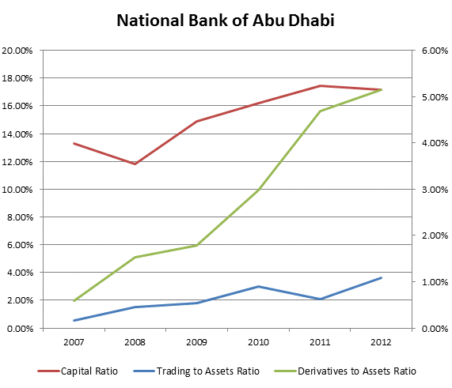
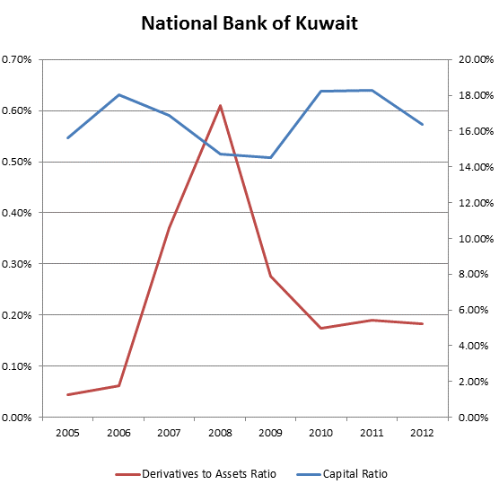
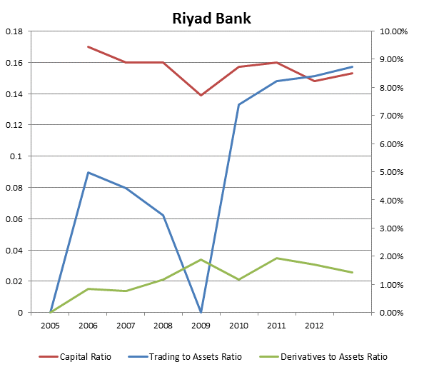
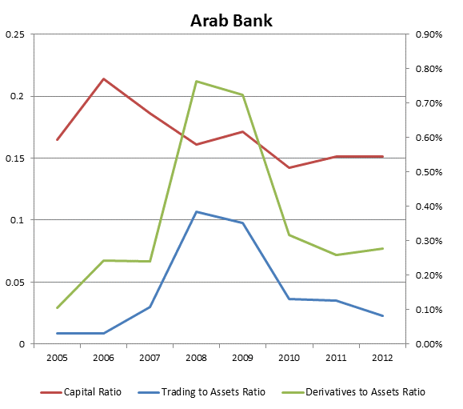

Table 5
Panel Data Estimation. Dependent variable: Core Capital Ratio
Fixed Effects | Coefficient | std. error | t-ratio | p-value
Model 1: 41 obs.
const | 0.151 | 0.00536 | 28.17 | 0.0000 | ***
Trading to Assets Ratio | 0.00030 | 0.0022 | 0.1349 | 0.8935
Model 2: 50 obs
Const | 0.154 | 0.004 | 42.24 | 0.0000 | ***
Derivatives to Assets Ratio | -0.00002 | 0.010 | -0.00259 | 0.9979
Model 3: 18 obs
Const | 0.1416 | 0.0072 | 19.68 | 0.0000 | ***
VaR to Assets Ratio | -0.9881 | 14.89 | -0.06637 | 0.9481
Model 4: 48 observations
Const | 0.164 | 0.011 | 15.04 | 0.0000 | ***
All Risks to Assets Ratio | -0.021 | 0.019 | -1.141 | 0.2609
Model 5: 50 observations
Const | 0.176813 | 0.0215956 | 8.187 | 0.000 | ***
Risk Weighted Assets | 0.0383 | 0.03545 | 1.080 | 0.2863
Random Effects (GLS) | coefficient | std. error | t-ratio | p-value
Model 6: 41 obs
Const | 0.157 | 0.005 | 33.4 | 0.0000 | ***
Trading to Assets Ratio | -0.033 | 0.010 | -3.34 | 0.0019 | ***
Model 7: 50 obs
Const | 0.158 | 0.004 | 38.99 | 0.0000 | ***
Derivatives to Assets Ratio | -0.017 | 0.005 | -3.623 | 0.0007 | ***
Model 8: 18 obs
Const | 0.1416 | 0.0072 | 19.68 | 0.0000 | ***
VaR to Assets | -0.9881 | 14.89 | -0.0664 | 0.9481
Model 9: 48 obs
Const | 0.1518 | 0.0098 | 15.4300 | 0.0000 | ***
All Risks to Assets Ratio | 0.00002 | 0.0123 | 0.0014 | 0.9989
Model 10: 50 obs
Const | 0.1360 | 0.01278 | 10.64 | 0.0000 | ***
Risk Weighted Assets | 0.028 | 0.0192 | 1.455 | 0.152
All Ratios are calculated with respect to total assets. The All Risks Ratio is calculated as the sum of credit, operational, and market risks disclosed by banks with respect to total assets for that particular year.
*, **, *** Significant at 10%, 5%, or 1%

A statistically significant independent variable here suggests a high degree of correlation with the dependent variable and therefore the information provided is not adding value to market participants.

Table 6
Panel Data Estimation
Dependent variable: Market Risk to Capital Ratio
Fixed Effects |  | coefficient |  | std. error |  | t-ratio |  | p-value
Model 1: 41 obs.
const | 0.0906 |  | 0.0225 |  | 4.025 |  | 0.0005 |  | ***
Trading to Assets Ratio | 0.00191 |  | 0.0863 |  | 0.022 |  | 0.982
Model 2: 50 obs
Const | 0.0757657 |  | 0.01199 |  | 6.32 |  | 0.0000 |  | ***
Derivatives to Assets Ratio | 0.000132 |  | 0.0271 |  | 0.0049 |  | 0.9961
Model 3: 18 obs
Const | 0.11014 |  | 0.02301 |  | 4.787 |  | 0.0004 |  | ***
VaR to Assets Ratio | 67.0863 |  | 44.376 |  | 1.512 |  | 0.1565
Model 4: 48 observations
Const | 0.1624 |  | 0.1186 |  | 1.369 |  | 0.1802
All Risks to Assets Ratio | 0.1424 |  | 0.1946 |  | 0.7317 |  | 0.4695
Model 5: 41 observations
Const | 0.2141 |  | 0.1117 |  | 1.917 |  | 0.064 |  | *
Risk Weighted Assets Ratio | 0.2309 |  | 0.1860 |  | 1.241 |  | 0.2234
Random Effects (GLS) |  | coefficient |  | std. error |  | t-ratio |  | p-value
Model 6: 32 obs
Const | 0.1021 |  | 0.03659 |  | 2.791 |  | 0.0091 |  | ***
Trading to Assets Ratio | 0.052 |  | 0.0583 |  | 0.892 |  | 0.378
Model 7: 41 obs
Const | 0.0847 |  | 0.0331 |  | 2.561 |  | 0.014 |  | **
Derivatives to Assets Ratio | 0.0124 |  | 0.02255 |  | 0.551 |  | 0.585
Model 8: 16 obs
Const | 0.1067 |  | 0.0559 |  | 1.910 |  | 0.0768 |  | *
VaR to Assets Ratio | 46.4 |  | 42.61 |  | 1.089 |  | 0.295
Model 9: 41 obs
Const | 0.07842 |  | 0.0581 |  | 1.35 |  | 0.185
All Risks to Assets Ratio | 0.00333 |  | 0.0719 |  | 0.046 |  | 0.963
Model 10: 41 obs
Const | 0.0759 |  | 0.0713 |  | 1.064 |  | 0.294
Risk Weighted Assets Ratio | 0.00765 |  | 0.1027 |  | 0.074 |  | 0.941
All Ratios are calculated with respect to total assets. The All Risks Ratio is calculated as the sum of credit, operational, and market risks disclosed by banks with respect to total assets for that particular year.

*, **, *** Significant at 10%, 5%, or 1%.
A statistically significant independent variable here suggests a high degree of correlation with the dependent variable and therefore the information provided is not adding value to market participants.

For a criticism of the current regime, see for example, Wellink N. (2010).
VaR is a widely used measure of the risk of loss on a specific portfolio of financial assets. For a given portfolio, probability and time horizon, VaR is defined as a threshold value such that the probability that the market-to-market loss on the portfolio over the given time horizon (banks use 30 days) exceeds this value.
A copy of the full report is available at: https://www.financialstabilityboard.org/publications/r_121029.pdf.
Gulf Banks' Capital Positions Compare Well With Those Of Global Banks, Standard & Poor's, June 2012.
Yahya Al Yahya (2010)
Huang Rocco (2006)

