Customer Satisfaction, Service Quality and Scope of Knowledge Sharing in Retail Branch Banking of Small and Medium Enterprises (SME) in India: An Analysis through Data Visualization

Abstract
Retail branch banking is one of the key business segments for banking industry. With recent changes like demonetization and digitization, banking industry in India has undergone major changes. Rising consumer demands and stiff competition have resulted in product and service quality offerings of banks. There are various factors which determine the customer satisfaction level and service quality in retail branch banking. Small and Medium Enterprises (SME) in India are growing at a substantial rate. They are the potential key customers for the banking industry. The present study consists of the factors which small and medium enterprises consider while choosing the bank. In this work, data visualization is being used as a tool to compare the customer oriented performance of the 5 largest (in terms of market capitalization) banks of India. This literature also attempts to explore, using data visualization, the major pain points of SMEs in dealing with the banks. Further, it gives the scope of knowledge sharing to improve customer satisfaction, service quality and reduce the service quality gaps.
Keywords.
Customer Satisfaction, Service Quality, Knowledge Sharing, Retail Branch Banking, SME, Banking Services, Service Delivery Gaps, Data Visualization
1. Introduction
Customer satisfaction is the key to the success for any business (Taylor and Baker, 1994). Customer satisfaction is based on customer expectations before purchasing the product and an assessment of product or services after purchase (Oliver, 1997). It is nearly impossible to identify the exact level of customer satisfaction because of high population and varied customer experiences. Still, researchers have proposed two aspects of customer satisfaction. The first is result or end-product specific aspect (e.g. Quality of product) and the second is process specific (e.g. Ease of handling or ordering, tangibility, customer grievances management) (Parasuraman et al., 1991). Each day customers come across various products, services and offers. With such high number of alternatives, competitors and offers, customers always look for efficient and cost-effective alternatives. Companies spend huge chunks of money to inform the customer about their products, services and offers. This adds to the cost of customer acquisition. Cost of customer acquisition is almost five times that of the cost of customer retention (Reichheld and Kenny, 1990). Customer satisfaction plays an important role in customer retention (Taylor and Baker, 1994). Customer satisfaction leads to positive word of mouth, competitive advantage to the company, increased brand loyalty and repeat buying behaviour of customers.
Service quality is another such parameter which affects the customers’ purchase decision (Spreng and Mackoy, 1996). Although service quality and customer satisfaction are two different concepts, they are closely interrelated (Parasuraman et al., 1991). Service quality is analysed basing on the comparison between expected service quality and customer perceived experience (Shah et al. 2000). It is important for an organization to determine the perceived service quality of their product or services in minds of existing as well as potential customers. Potential customers might have formed preconceived notions based on available information sources like word of mouth or blogs or reviews on websites. Customer perceived experience of the service quality may depend on interaction which customer has with the organization at different service levels (Bitner and Hubert, 1994).
Knowledge management is an effective handling of available data for the betterment of the commercial institution. It mainly consists of three parts: knowledge transfer, knowledge sharing and knowledge barriers (Paulin and Suneson, 2012). Knowledge sharing is an efficient way of sharing the data across the organization for their superior utilization. Knowledge sharing will increase the team efficiency and help in understanding the different perspectives & insights of the same data. Knowledge sharing improves the overall company efficiency, helps in identifying the service delivery gaps and helps in determining the possible solutions to the problems (Wang and Noe, 2010).
Banking industry is a customer centric industry where customer service plays a key role. Over the years, banking services have changed drastically subjected to change in the dynamics of banking industry. Technological advancements, market volatilities, rising customer expectations and furious rivalry amongst competitors are few key challenges faced by banking industry (Lovelock, 2001). Banking industry in India has evolved over time significantly to reach total worth of Rs. 83 trillion (IBEF, 2017). Public sector banks are responsible for controlling around 80% of the total Indian banking sector. Technological developments have reduced the operational cost significantly while developing the potential revenue sources for the banks (Forbes, 2017). Cost of transaction in branch banking is Rs 70-75 while the cost of the same transaction in net banking is around Rs 2. Net banking and mobile banking have increased the customer convenience and reduced the human errors substantially as well.
Retail branch banking, has turned out to be an important department of banks as it is the first point of contact of customers. The key objective of this mass-market banking is to advance consumer oriented services offered by commercial banks. It has been essential these days to improve first impression bank has in the minds of the customer (Chakravarty, 1996).
An attempt has been made in this paper to undertake detailed qualitative research on the consumer insights, customer satisfaction and service quality in retail branch banking of India. This paper mainly focuses on the parameters that small and medium enterprises consider while choosing the bank, service delivery gaps, if any, the small and medium enterprises face while dealing with the banks as well as the relationship between the service quality and the market share of the banks. The research aims at exploring, using data visualization techniques, the possible suggestions for the banks to acquire the untapped market and to retain the existing customers by increasing the customer satisfaction and quality of services.
The Section 2 of this paper systematically probes into the background and motivation for carrying out this study by considering the holistic study of Indian market. As a part of background study, structured analysis of Indian banking industry has been carried out. Detailed research methodology, consisting of segmentation, different research approaches and challenges faced during research are presented in Section 3. Section 4 contains research findings and analysis visualizing the data collected during the research using data visualization tool, Tableau. Sections 5, 6, and 7 cover the detailed discussion, managerial implications, limitations and future scope respectively.
2. Background & Motivation
Service industry contributes 53.66% of GVA (gross value added) of India (IBEF, 2017). Banking services are one of the key components of service industry in India. Indian banking sector deposits grew at a CAGR of 12.03% from 2006 to 2017 to reach the` total valuation of US $1.54 trillion. It is expected to reach the total valuation of US $28.5 trillion by the year 2025 (Statistic Times, 2017).
To counter the problems like black money and fake currency, on 8th November 2016, the Government of India implemented demonetization of Rs1000 & Rs500 currency notes (CNBC, 2017). The Government has taken several initiatives during the past few years to strengthen the banking sector of India. The Government has been keen on promoting cashless economy and digitization of transactions over the past couple of years. Internet banking and mobile banking are the add-on services provided by all the banks. Use of prepaid payment instruments and mobile wallets has increased to Rs 277 billion and Rs 532 billion respectively (Forbes, 2017). The Government has recently launched an app, “Bharat Interface for money” (BHIM), and has been promoting it aggressively on all platforms to provide the unified payment interface to enable convenient fund-transfer from different banks (The Hindustan Times, 2017).
Small and Medium Enterprises (SME) are the key drivers of the Indian economy with 45% of the total Indian industrial output (EISBC, 2017). SME sector is growing at an annual rate of 8% while creating employment for 1.3million people annually (EISBC, 2017). Government of India has implemented various schemes like “Make in India”, “Start-Up India” etc. to promote and create nurturing environment for the SMEs (Indian Start-up News, 2017). Government has planned to improve manufacturing sector growth by 12-14% while increasing its contribution to GDP to 25% by the year 2025 (The Economic Times, 2017).
As SMEs are growing at a significant rate, they are the potential high revenue generating wings of the banking sector. Thus, it is important to interact with current customers to know about their banking service requirements. Identifying their pain points and understanding the factors they consider while choosing the bank will definitely help the Indian banking sector to increase the customer satisfaction, identify the service delivery gaps and improve the service quality.
2.1 Indian Banking Industry Scenario
Indian banking industry consists of 3 types of banks – Commercial Banks, Co-operative banks and Development Banks. The Indian banking network is growing by keeping its pace with the country's economy and has around 53726 branches and 162543 ATMs (IBEF. 2017).
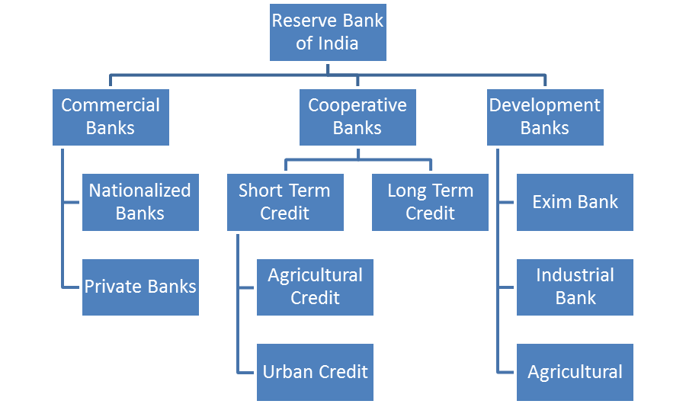
Fig 1: Indian Banking System (Source: Banking Regulation Act, 1949)
Commercial banks, based on the reason of their origin, deal with the SMEs. So for our work, we have chosen to limit ourselves to the commercial banks. We focused to analyze the performance of the top 5 banks, in terms of market capitalization, of the Indian commercial banking industry, in dealing with the SMEs through their retail branch banking.
2.1.1 HDFC Bank Limited
Founded in 1994, HDFC Bank is one of the leading private sector banks in India. It has its headquarters in Mumbai, Maharashtra. By 31st March 2017, HDFC Bank has around 4715 branches across India with 12260 ATMs in 2657 cities (HDFC, 2017). Along with India, HDFC Bank also has its presence in Bahrain, Hong Kong and Dubai. Even though HDFC Bank is one of the largest lending banks in India, Non-Performing Asset ratio of the bank is around 0.2% which is the lowest in industry (Moneycontrol, 2015). It is the only bank which is showing 18-20% rise in profit Q to Q since the last 20 years. According to Finance Asia polls, HDFC Bank was included in the list of “Best managed public Companies in India”. Also, as per Brandz, HDFC Bank ranked 69th in top 100 most valuable global brands. In 2016, Global brands magazine awarded HDFC Bank with the title of “Best Banking Performer India” (FinanceAsia, 2015).
2.1.2 ICICI Bank
Industrial Credit and Investment Corporation of India (ICICI) is the second largest bank in India in terms of total asset valuation. It has its headquarters in Mumbai, Maharashtra. ICICI Bank has around 4850 branches across India with 14404 ATMs (ICICI, 2017). It operates in 19 countries worldwide. It was listed in NYSE in the year 2000 becoming the first Indian bank to get listed in NYSE. In the year 2016, ICICI Bank was awarded with the title of “Best Retail Bank in India” consecutively for three years in a row at Asian Banker International Excellence (BSE India, 2016).
2.1.3 Axis Bank
Axis bank is the third biggest private bank in India followed by HDFC Bank and ICICI Bank. It has its headquarters in Mumbai, Maharashtra. Axis Bank has around 3300 branches with 14003 ATMs distributed in India (Axis Bank, 2017). It has the highest rating on employee satisfaction parameters. They spent US $420 million on employee benefits in 2013 (Annual Report, 2013). Axis Bank employees are young with average age of around 29 years. Axis Bank was awarded “Most Promising Bank Award” by The Economic Times in 2015 (Best Media Info, 2015).
2.1.4 The State Bank of India
The State Bank of India (SBI) is one of the biggest public-sector banks in India. In 2017, SBI announced merger of its 5 associate banks for the largest banking entity in India with 24,000 bank-branches and 59,000 ATMs spread across India. In 2016, SBI ranked 232 in Forbes list of top 500 companies in the world (Forbes, 2017). SBI accounts for 20% of total market share of loans and deposits in India (LiveMint, 2009).
2.1.5 Kotak Mahindra Bank
Formed in 2003, Kotak Mahindra is a private sector bank in India. It has its headquarters in Mumbai, Maharashtra (Kotak, 2017). It has 1,368 branches with 2,163 ATMs spread across India. Kotak Mahindra Bank has brand rating of AA+ (Smart Investor, 2014). The Bank ranked 245th in the list of world banks with brand valuation less than half-a-billion in a study carried out by Brand Finance Banking 500 (Kotak Mahindra, 2014).
3. Research and Methodology
Qualitative and quantitative research was carried out to gauge the consumer insights. Qualitative research is generally used to understand the perspective of group of people towards certain things whereas, quantitative research is used to analyse the population opinion and insights in a measurable way (Hancock et al. 2007). Combination of both qualitative and quantitative research will help us overcome the limitation of one method with the strength of the other (Singh, 2007). As a part of qualitative research, exploratory research was carried out. Exploratory research gives us a way to explore the research problem. It helps us to analyse the different perspectives of the problems. It also gives us different insights of different stakeholders in the research problem. It doesn’t give us the final solution or conclusion but it gives us a chance to determine the nature and depth of the problem (Saunders and Thornhill, 2012). As a part of quantitative research, a structured questionnaire was floated among the participants to understand the customer insights and perceptions.
3.1 Research Objectives
Objective of the research is to understand, using data visualization, market potential of Small and Medium Enterprises (SME) and the product or services they majorly avail from the bank. The research was undertaken to have an in-depth insight, through visualization, into their pain points and factors they consider while choosing the bank so as to determine the market reach of the top banks in India in SME market. This study is also carried out to analyse experiences of SME customers in retail branch banking, to understand the service quality offered by the banks to the SMEs and to determine the service delivery gaps in SME market.
3.2 Data Collection
For the data collection, Western Mumbai, India was chosen as a target area. Mumbai is the financial hub of India. It is ranked 42nd in the Global Financial Ranking worldwide (Indian Express 2016). Being the financial backbone of India, diverse range of businesses is carried out here. The majority of SMEs is located or has headquarters in Mumbai. Most of the commercial banks also have their headquarters in Mumbai. Choosing Mumbai as the target area for the research has given the holistic approach to the research. 600 interviews were conducted and the details were recorded. Basic analysis was done on the 600 records collected for initial analysis. The initial sets of 600 records were reduced to 300 quality records after rounds of reviews. The 300 quality records are then processed further to get them ready for data visualization.
3.2.1 Segmentation
Segmentation was the important part while carrying out this research. This research consisted of two main segmentations: Geographic and Demographic.
Mumbai western suburbs are spread over the area of around 405 sq. km. We divided the suburb majorly into 7 areas named Andheri, Goregaon, J B Nagar, Jogeshwari, Kandivali, Malad, Marol and focused on gathering data from the SMEs present in those areas.

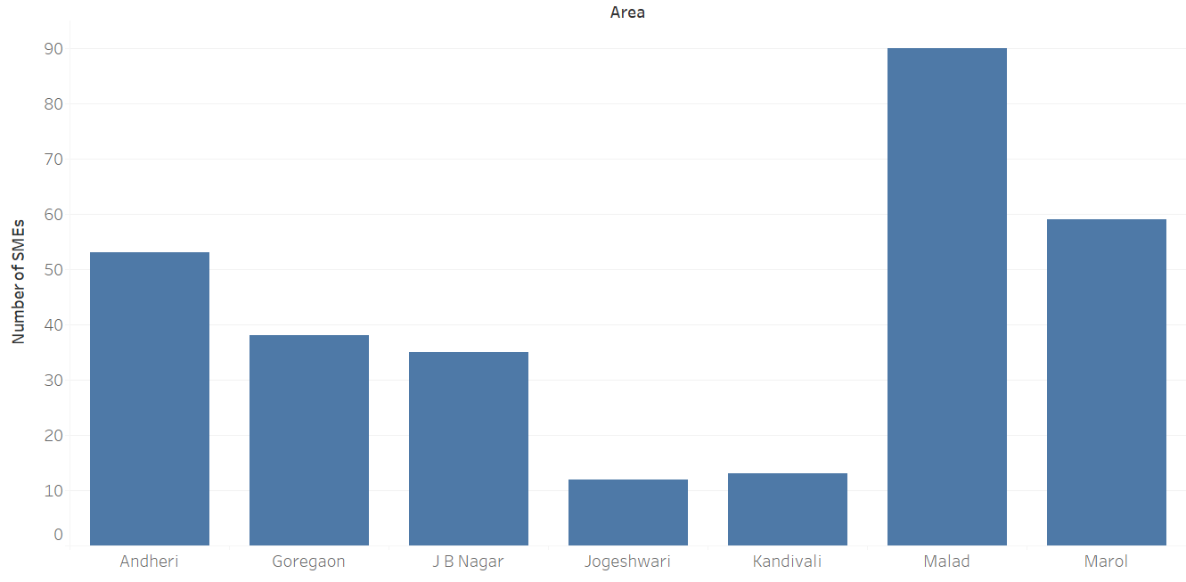
Fig 2: SMEs concentration by Area.
It was observed that Malad, Marol, and Andheri area have a good concentration of SMEs.
In the present research, demographic segmentation was based on company size and total number of employees. Company size was based on the total revenue of the company in a financial year. Also, total number of employees there in the company determines the size of the company. Company avails the services based on its size and requirements. Also, banks have the criteria while providing the services to the customers. For example: To open salary account with HDFC bank, the total number of employees should be 25 or the average salary should be around 25000 (HDFC, 2017).
3.2.2 Primary Research
After gathering the list of potential participants, these potential participants were approached by the means of cold calling or direct visits. Cold calling was done primarily to set up an appointment with the participants. People from the accounts and HR departments were approached as they were the key personnel dealing with banks. Semi-structured interviews of the available and willing participants were taken.
Participants were asked the questions about their company size, employee numbers, banking activities, key requirements and previous experiences. Sample questionnaire is as follows:
- What is the size of the company?
- How many employees are there in the company?
- Who are the key financial decision makers of the company?
- What are the current banking services availed by the company?
- What are the major pain-points while availing the banking services?
- What is the role of bank Relationship Manager in service delivery?
- Which bank is your company dealing with currently?
- How long is your company dealing with this bank?
- Why have you decided to choose this bank?
- Is your company satisfied with the bank they are dealing with?
- Which banks are being dealt with personally?
- What differences have you noticed in the quality of services offered to you personally and to your company?
- What are the service quality gaps that you have observed?
- What areas a bank should focus on to improve the quality of service?
3.3 Privacy Policy for organizations:
Before conducting the interviews, participants were assured that the data or the information that they are sharing will be confidential and will be used for the research purposes only. They were asked to skip the questions where they thought the company security and confidentiality might be compromised. Participants were given a choice of withdrawing from the interview at any point of time. It was also ensured that the identity and designations of the people interviewing for the research would be kept confidential.
A few challenges were faced during the research. First, it was difficult at times to get entry in big commercial complexes. Sometimes they considered us as salesmen and prohibited us from entering the commercial complexes. Also, the security staffs at big commercial complexes didn’t let us enter without any prior appointment. Industrial estates were huge and mainly consisted of the manufacturing units of the companies. Secondly, few of the offices that we visited had their headquarters in other cities like Gurgaon, Bangalore, and Hyderabad etc. They had their sales offices in Mumbai. As the decision taking authorities weren’t there, it was difficult to do get the exact information about the service delivery. And lastly, in some of the offices, the authors have been told that the person concerned isn’t available.
4. Research Findings and Analysis
Over the period of 6 months during the research, the authors visited around 1000 offices in Mumbai. They managed to get around 600 responses and interviews. Based on the qualitative and quantitative research, the authors observed five major factors SMEs to consider while choosing the bank.
Comfort and Proximity: Comfort and proximity is one of the prime reasons while selecting the bank. Nearer the bank branch, the more comfortable it is for the businesses. It was observed that most of Axis and ICICI bank branches were right below the commercial buildings whereas HDFC bank branches were in the residential buildings.
Minimum Balance: For some of the customers, minimum balance was the important factor. Minimum balance required for the Current Account in HDFC bank was higher as compared to other banks. This was one of key reasons why small industrialists refused to maintain CA with HDFC bank. There is also a strict penalty for not maintaining average Monthly Balance/average Quarterly Balance requirement.
Services and Offers: Types of services offered by the bank is one of the important parameters while selecting the bank. Kotak 811 is giving a stiff competition to HDFC bank net banking software and digital banking platform Chillr.
Promptness and Behaviour of Relationship Manager (RM): Quality of services offered by RM is one of the reasons for choosing the bank. Some businesses maintain the account with the same bank because they have received an exceptional service from their RM.
Previous Experiences: Because of the previous bad experiences, few customers had closed their accounts with the bank. It is difficult to convince the customer to opt for the same bank with which they had bad experiences.
4.1 Comparison within the Banking Industry
Based on these 5 parameters, companies rated the top 5 commercial banks in India. The findings of the consumer insights about these top banks are as follows:

Fig 3. Proximity and Comfort Fig 4. Minimum Balance

Fig 5. Services and Offers Fig 6. Behaviour of Relationship manager

Axis Bank had highest rank in terms of proximity and comfort as it was observed that Axis Bank branches were present right there below the commercial complexes. HDFC Bank was ranked 3rd behind Axis Bank and ICICI Bank. Small and Medium Enterprises look for comfort and proximity while making the banking decision. It makes it convenient for the company to make day-to-day transactions and payments.
Kotak Mahindra with their “811” marketing strategy ranked well above its competitors with 72% of the people ranking it 1st in terms of minimum balance criterion. A minimum balance criterion is one of the crucial parameters while choosing the bank. Every bank has its own average monthly balance (AMB) or average quarterly balance (AQB) standards. Failing to maintain minimum balance calls for a hefty penalty and hidden charges. These penalties are one of the key reasons for the customer dissatisfaction. Zero monthly balance account is the key solution to this issue. It has helped Kotak Mahindra to increase its customer satisfaction index significantly.
HDFC Bank was ranked the highest in terms of services and offers followed by ICICI Bank and the SBI. HDFC Bank offers various products like salary accounts, attractive offers on credit cards which are very popular among customers. HDFC Bank has numerous partners with the help of which they provide different services and offers. Option to choose always attracts the customers. It is also the offer which is one of the ways to maintain the customer loyalty. Services include the user-friendly interface and smooth banking activities. Kotak Mahindra Bank has developed a convenient banking process and smooth interface which has given them the competitive advantage.
Relationship Manager plays an important role in customer retention and improving customer experience. HDFC Bank was rated highly in terms of behaviour and services offered by the Relationship Manager. All the banks spend heavily to recruit the best talents for the position of the Relationship Manager. Every Relationship Manager holds a portfolio of around 100 high net-worth individuals (HNIs).
Knowledge management consists of analysis of existing customer data to understand the customer pain points. Banks must have received a large quantity of structured data like customer locations, customer complaints against penalties, feedback of the relationship managers, ratings of products/ services offered by the banks etc. Systematic analysis of this data will help banks to identify the customer pain points. Knowledge sharing across the departments will give the banks a possible way to find a structured solution to these major customer pain points.

Fig 7. Previous Experiences
Previous experiences last in the minds of the customer for a long time. Customers who have received bad experiences refuse to work with the same bank again. ICICI Bank hold the highest rating in terms of good previous experiences. With its instant account opening solutions, door-to-door services and technologically developed platforms, ICICI Bank has created a strong image in the mind of the customers, which definitely helps them in maintaining loyal customer base. ICICI Bank has implemented knowledge management strategies since 2000. Continuous upgradation based on the available data to provide customer-centric services has given them a competitive advantage over other banks. HDFC Bank has lost some of its key customers because of the bad experiences customers have received. Public sector banks always lack quality of services as compared to private sector banks. The SBI has the lowest rating in terms of previous experiences. Because of the nature of work process which public sector banks follow, customers have had bad experiences.

Fig 8: Customer Satisfaction Index
Customer satisfaction index was mainly based on quality of services offered by the bank and the level of satisfaction companies feel about their current bank. It was observed that overall 78% of the customers were satisfied with the bank and banking services that they have availed. Kotak Mahindra Bank had the highest customer satisfaction index but their customer base was low as compared to other banks. Axis Bank and HDFC Bank had comparable satisfaction index. The SBI had recorded the lowest customer satisfaction index. Public sector banks are often regarded as slow working and time-consuming banks. Majority of the private sector banks have the knowledge sharing tools to study the customer data. Based on the customer experiences and feedbacks private banks continuously improve their services and offerings.
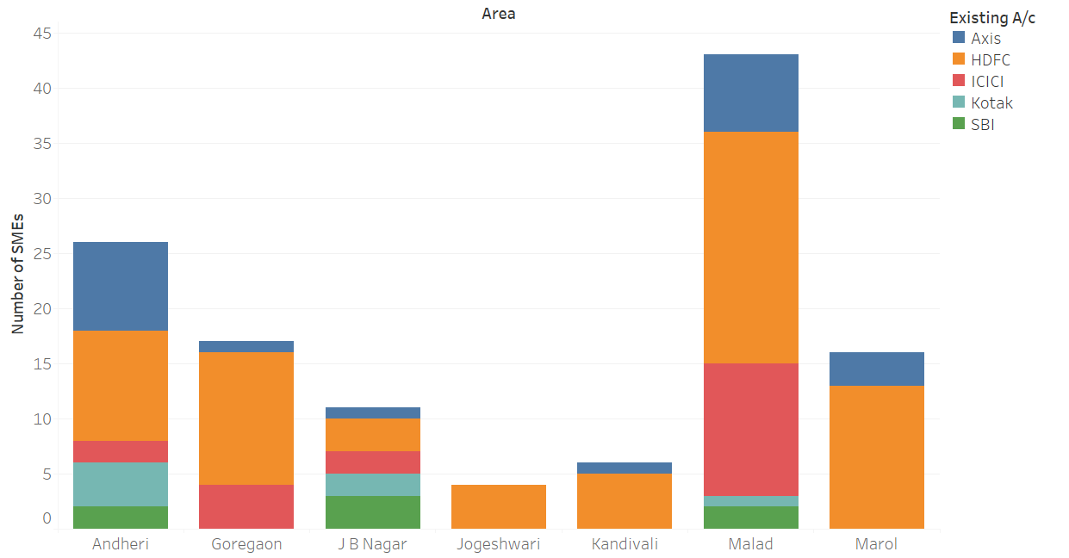
Fig 9: Market Presence of Banks
Market presence of the banks is gauged by the number of SMEs the bank handles single handed i.e. the SME doesn’t have an existing account in any other bank rather the banks being studies. HDFC bank was a market leader in most of the areas of Western Mumbai followed by ICICI Bank and Axis Bank. HDFC Bank has acquired market based on the superior quality of service and strong CASA (current account/savings account) base. Kotak Mahindra Bank is slowly catching up with its competitors because of strong marketing campaigns and innovative service offerings. Public sector bank SBI is still one of the strong market players despite low customer satisfaction index and minimal presence in the SME sector. Customers feel secure while dealing with public sector banks as compared to private sector banks and this is one of the reasons why SBI having lowest Customer satisfaction index still manages to have presence in the demanding SME sector. Andheri, Goregaon and Malad are the places with higher number of industrial estates and commercial complexes. HDFC Bank has acquired the majority of the market share in this area followed by ICICI Bank and Axis bank.
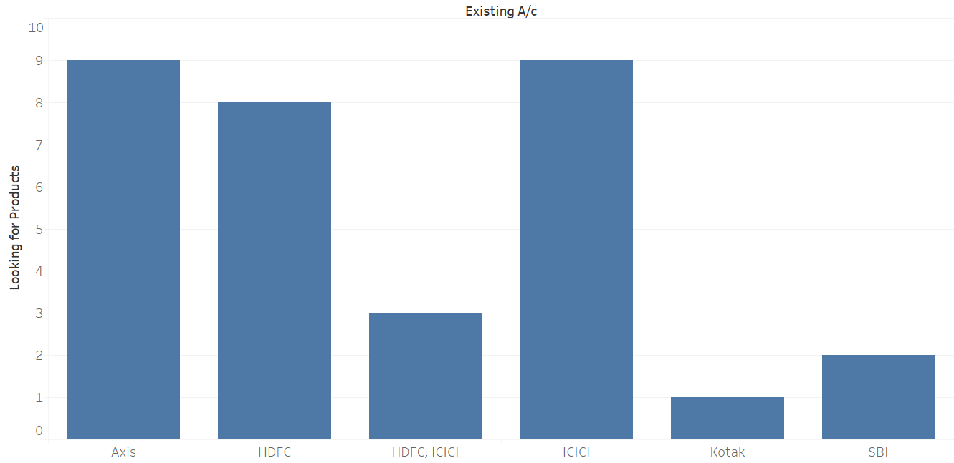
Fig 10: Dissatisfied SMEs of their existing banker
However, we were able to find that though most of the customers were satisfied with their existing banking experience, still there are around 11% customers who are not completely serviced by their existing banks. The numbers of service deficiencies found were the most in case of Axis and ICICI followed by HDFC. Kotak on the other hand is able to satisfy almost all the needs of its customers. The growing demand for better service is evident from the fact that some of the SMEs having account in both HDFC and ICICI are still not fully serviced by the banks and still looking for other services. For example, customers already having accounts in HDFC are still mostly looking for having salary accounts for their employees. HDFC bank has to look into the customer pain points and quickly resolve the issue by providing salary accounts to the SMEs. Similarly existing customers of ICICI bank are looking for mostly current accounts services. ICICI bank has to look into the issue of customer need and dissatisfaction and provide the service proactively rather than losing the customer, as well as the business. This analysis can be used by the banks to satisfy the costumer need proactively by having better client relationship rather than acting reactively.
5. Discussion
Comfort and proximity is one of the key parameters that the customers consider while choosing the bank. Commercial banks should consider opening a branch in the nearby vicinities of the commercial complexes and industrial estates. Strategic positioning of the branches based on the potential customer mapping should be done.
Kotak Mahindra Bank has started offering new service of zero minimum balance to increase their CASA base. Zero minimum balance is one of the key features the customers look for. This facility has helped Kotak Mahindra Bank to increase its customer base substantially.
Customers always need more options while choosing the product. Offering varied products and services would definitely attract more customers. HDFC has been offering various offers with the help of its numerous partners. Kotak Mahindra has improved the customer ease of handling services by launching a new service “811”. User-friendly interface and easily accessible services will be appealing to the larger customer base.
Relationship Managers (RM) are the single point of contact for the customers to the bank. The quality of services offered by RMs determines the customer satisfaction level. Maintaining strong relationship with the customer should be a primary focus of the Relationship Manager. RM should notify the customers about the new offerings and services. Banks should consider taking timely feedback from the customers about the quality of service offered by the RM. Hidden charges and penalties are one of the customer pain points that have been observed in this study. Customers should be made fully aware of the potential penalties and banks should avoid keeping hidden charges as customers feel betrayed once they come to know about such hidden charges. An automated service should be started in order to make the customer aware of the upcoming penalties.
Cost of acquiring a new customer is always high. Every customer lost is a waste of money spent to acquire that customer. Banks should consider contacting such customers to hear their grievances and should try to solve their problems to get them on board again. Some small enterprises feel ignored by the top private banks as they are low revenue generating customers for the banks. Such small enterprises always have the potential to grow exponentially and could turn out to be a key customer for the bank. Thus, banks shouldn’t ignore such customers. Banks should address the customer issues as soon as and try to provide the required services before customers move away to the competitors
Knowledge sharing using business intelligence is one of the solutions to improve the service quality and customer satisfaction. It will also help in reducing the service delivery gaps. Analysis of customer locations will help banks to identify the cluster of existing customers as well as the cluster of potential customers. Based on this analysis banks can consider opening a suitable location to increase the proximity and convenience for the customers. Monitoring the existing customers’ banking activities will also give the banks an idea about the possible product/services and offer requirements of the customers. This knowledge could be shared with the sales team to generate more customers and also, it will help in strengthening the relationships with the customer. This will also increase the efficiency of the Relationship Managers. Business intelligence will also help in analysing the prospective penalties levied on the customers. Automated notifications could be sent to the customers and the respective Relationship Managers could be informed through knowledge sharing about these penalties so that they can keep their customers updated about it. This will help in reducing the customer churn rate and help in building loyal customer base.
6. Managerial Implications
It is a tough task for the managers to quantify the customer satisfaction and quality of services offered in the retail branch banking. Managers should focus on retaining the customers as customers with the previous bad experiences don’t want to avail themselves of the services of the same bank again. It is important for the managers to build a strong relationship with the customers by providing the exceptional service as this strong relationship would lead to acquiring a loyal customer. Providing customers with exceptional products/services and offers is one of the key parameters of maintaining the existing customers and acquiring the new customers. Managers should make the customers aware about the penalties and hidden charges as this is one of the prime reason of customer dissatisfaction. Private commercial banks are leading in terms of satisfaction and service quality as compared to public sector banks. Public sector banks should improve the product/service offerings and service quality to increase the customer satisfaction and customer retention. Knowledge sharing is an effective tool which can help managers to do the cross functional collaborations within the organization. It is important for the managers to learn the data analysis techniques to utilize this data better.
7. Limitations and Future Directions
There are few limitations of this study which could be taken care of in future researches. This study had geographical limitations as it was limited to Mumbai area only. Research findings and insights may change with the change of geography. Also, for the research purposes only five major players were considered. There might be other banks which have superior service quality and products. Study was limited to small and medium enterprises only. Decision making parameters might change based on the size of the organizations. Also, some of the interviewees had limited time to answer the research questions which might have affected the resulted data. In future studies, customers other that SMEs could be targeted. Customer satisfaction index and service quality gaps in Hospitals, Hotels, Entertainment Industry could be a potential future way of research. Also, effect of demonetization and digitization on the service quality of the banks could be analysed in future researches. Technology is getting updated day-by-day and these technological advancements will improve the knowledge sharing. It will be interesting to analyse the effect of such knowledge management systems on the customer satisfaction and service quality of retail branch banking.
8. Conclusion
Indian banking industry is going through major changes because of demonetization and digitization. Customer expectations are increasing while competition is getting stiff. In such a tough situation, Banks should focus on increasing customer satisfaction and improving service quality to retain the existing customers and create a loyal customer base. The present study has made some contributions towards understanding the customer pain points in the banking sector by performing a comparative analysis, using data visualization, of the five largest banks of India. This work also explores huge scope Knowledge sharing has, to overcome customer pain points. Systematic and structured knowledge sharing initiatives will increase the efficiency of banks while handling the customer grievances.

9. References
- Taylor, S. A. and T. L. Baker, (1994), "An Assessment of the Relationship Between Service Quality and Customer Satisfaction in the Formation of Consumers' Purchase Intentions". Journal of Retailing, Vol. 58, No. 2, pp. 163-178.
- Oliver Richard L (1997), Satisfaction: A Behavioural Perspective on the Customer. New York: Irwin/McGraw-Hill.
- Parasuraman, A., V. Zeithaml, and L. Berry. (1991), “Understanding Customer Expectations of Service”. Sloan Management Review, Vol. 39, Spring, pp. 39‐48.
- Reichheld F F. and D. Kenny, (1990), "The Hidden Advantages of Customer Retention". Journal of Retail Banking, Vol. 7, No. 4.
- Spreng, R.A. and R.D. Mackoy, (1996), “An Empirical Examination of a Model of Perceived Service Quality and Satisfaction”. Journal of Retailing, Vol. 72, pp. 201‐14
- Shah, A., C. Zeis, H. Regassa, and A. Ahamadian, (2000), “Expected Service Quality as Perceived by Potential Customers of an Educational Institution”. Journal of Marketing for Higher Education, Vol. 9, Issue 3.
- Bitner, M.J. and A. R. Hubert. (1994), “Encounter Satisfaction Versus Overall Satisfaction Versus Quality: the Customer’s Voice”, in Service Quality: New Directions in Theory and Practice. Rust, R.T. and Oliver, R.L. (Eds). London: Sage Publications, pp. 72‐94.
- Paulin, D. and K. Suneson, (2012), “Knowledge Transfer, Knowledge Sharing and Knowledge Barriers – Three Blurry Terms in KM.” The Electronic Journal of Knowledge Management, Volume 10, Issue 1, pp81-91
- Wang, N. and R. Noe, (2010), “Knowledge Sharing: A Review and Directions for Future Research”. Human Resource Management Review, 20 pp.115–131
- Lovelock, Christopher. (2001), Services Marketing: People, Technology, Strategy. 4th Edition, Prentice Hall.
- IBEF (2017), “Banking in India” retrieved from https://www.ibef.org/industry/banking-india.aspx
- Forbes (2017), “Digital Revolution in Indian Banking Sector” retrieved from http://www.forbesindia.com/article/weschool/digital-revolution-in-the-indian-banking-sector/47811/1
- Chakravarty, S W R. (1996), "How Moment of Truth Define Bank-Customer Relationship". Journal of Retail Banking Services, Vol. 18, No. 1, pp. 29-34.
- Statistics times (2017), “Sector-wise GDP contribution of India” retrieved from http://statisticstimes.com/economy/sectorwise-gdp-contribution-of-india.php
- CNBC (2017), “India’s demonitized currency back in system but can we still call it a success” retrieved from https://www.cnbc.com/2017/09/01/indias-demonetized-currency-back-in-the-system-but-can-we-still-call-it-a-success.html
- The Hindustan Times (2017), “PM Modi to launch BHIM-Aadhaar app today, push Indians towards ‘less-cash’” retrieved from http://www.hindustantimes.com/tech/pm-modi-to-launch-bhim-aadhaar-app-on-april-14-push-indians-to-less-cash/story-66vF4OzoTnuMcxYtwOpftJ.html
- EISBC (2017), “definition of Indian SMEs” retrieved from http://www.eisbc.org/definition_of_indian_smes.aspx
- Indian Start-up News (2017), retrieved from https://inc42.com/buzz/indian-startup-news-20/
- The Economic Times (2017), “Indian SME trends year gone by year and 2017” retrieved from http://economictimes.indiatimes.com/small-biz/sme-sector/indian-sme-trends-the-year-gone-by-and-2017/articleshow/56254240.cms
- HDFC, (2017) retrieved from https://www.hdfcbank.com
- Moneycontrol, (2015), “Top Companies in India by Market Capitalization – BSE”. Retrieved from http://www.moneycontrol.com/stocks/marketinfo/marketcap/bse/banks-private-sector.html
- FinanceAsia, (2015) Limited, H. M. (n.d.). Asia's Best Managed Companies, Part 3. Retrieved July 24, 2017, from http://www.financeasia.com/News/395561,asias-best-managed-companies-part-3.aspx
- ICICI, (2017) retrieved from www.icicibank.com
- BSE India (2016) “Company Annual Report” retrieved from http://www.bseindia.com/bseplus/AnnualReport/532174/5321740316.pdf
- Axis Bank (2017), retrieved from https://www.axisbank.com/
- Axis Bank (2013), retrieved from https://www.axisbank.com/download/Annual-Report-2013.pdf
- Best Media Info (2015), “Most promising Brands of 2015” http://bestmediainfo.com/2015/03/economic-times-most-promising-brands-2015-unveiled/
- LiveMint (2009), “SBI and ICICI profits rise on higher bond investment returns” retrieved from http://www.livemint.com/Money/klPIcNelruNlRbJkbg9DkL/SBI-ICICI-Bank-profits-rise-on-higher-bond-investment-retur.html
- Kotak Mahindra (2017), retrieved from https://www.kotak.com/en.html
- Smart Investor (2014) “top banks on a smaller peer to do better brand finance study” retrieved from http://smartinvestor.business-standard.com/common/srchoutdet-interim%20budget-Top_banks_on_a_slide_smaller_peers_do_better_Brand_Finance_study.htm
- Kotak Mahindra (2014), retrieved from http://www.kotak.com/annualreport2013-14/awards-accolades.html#.W1_8_tUzbX4
- Hancock, B., K. Windridge, and E. Ockleford (2007), “An Introduction to Qualitative Research”. The NIHR RDS EM / YH, 2007
- Singh, K. (2007) Quantitative Social Research Methods. SAGE Publications, p.64
- Saunders, M., P. Lewis, & A. Thornhill, (2012), Research Methods for Business Students. 6th edition, Pearson Education Limited
- The Indian Express (2016) “Mumbai moves up in global financial centre ranking” retrieved from http://indianexpress.com/article/cities/mumbai/mumbai-moves-up-in-global-financial-centre-ranking-2777158/

