**Contraction Mapping of Linear and Quadratic Backward SOR Iteration for Newton Operator.**

**Stephen Ehidiamhen UWAMUSI**

**Department of Mathematical Sciences, Kogi State University, Anyigba, Kogi State.**

Email: Stephen_uwamusi@yahoo.com

Abstract. The contraction mapping of Linear and Quadratic backward SOR iteration matrix for Newton operator in the nonlinear system of equation is presented. It is showed that if the computable reachable set of linear backward SOR method is lower chain-reachable to the outer computable chain-reachable Quadratic SOR method, the quadratic backward SOR method is not only finer in topology but also logarithmically faster than backward linear SOR method if the arithmetic computational complexity involved in the execution of backward quadratic SOR is overlooked.

Keywords: nonlinear system, newton method, SOR iteration matrix

 **Introduction**

The solution of nonlinear system of equation has been from time immemorial to a large extent governed by Newton method [1] and [2] provided the analytic derivatives of the function

, (1.1)

are easily available.

This means that  and,, the Frechet derivative in an open ball  remains valid. Newton method is attractive for the solution of nonlinear system (1.1) because of its global convergence for any choice of. Abstractly, Newton method is given by the equation



whose sequence of iterates, converges to the desired solution. An indication that method 1.2 is a self mapping- that is , a contraction mapping in the sense of Banach, which maps smaller elements from a larger domain to itself with the purpose of achieving the same results . Fundamentally, method (1.1) is hardly solved in the form it is presented rather, we often transform to an equivalent linear system

 , (1.3)

where the matrixis assumed to be a non singular Jacobian matrix. The solution in general for system 1.1 is given by

 (k=0,1,…, ) (1.4)

where  is in form 1.3.This means, there is a closed balanced absorbent subset  of a linear topological space that is ultrabarrelled for which the sequence , a closed balanced absorbent subsets of E for the graph of F, is necessarily closed in  since its topology is finer than that of .The sequence  is a defining sequence for S wherefrom, any inductive limit of countably globally convex ultrabarrel space generated by Newton method is convex, [3]. It follows that on a linear space of countable dimension, the finest linear topology generated by Newton method is the only one topology for which it is Hausdorff ultrabarrel space.

In abstraction, equation 1.4 may be viewed in the form

 (1.5)

of (E,u) onto (E,u) as a homeomorphism. By further adoption of Miranda’s theorem, it asserts that Mean value theorem on the function F implies that  is a base of neighbourhoods of  in (E,u) for which contraction mapping holds ,and ;that induces the toplogy generated by method 1.4 to be -complete, assuming Krein-Smulian theorem remains valid in that : every Frechet space is strictly hyper complete [3].

Newton method is quadratically convergent in that for any  there holds the estimate

 (1.6)

A philosophical consideration now will be ’’ if Newton operator of equation 1.4 is quadratically convergent, what is the nature of shrinkable neighbourhoods in Hausdorff space?’’ It is known that Newton operator is monotone and has a shrinkable base of balanced neighbourhoods in (E,D) for which . As the base is shrinking, it forces the sequence  converges to zero, as k approaches infinity, a consequence of Banach contraction mapping of a fixed point.

In [4], it was showed that Hansen-Sengupta method diverges if there are multiple paths crossing a single point. This was demonstrated on Trapezoidal Newton method. In other word, the shrinkable base neighbourhood failed to hold thereof an indication of not only leading to stagnation point other than the solution  being sought but also diverging to infinity. It was a motivation of the above preambles that adoption of the following theorems will be found useful as a tool in our work.

Definition 1.1,[1]. A sequential k-step process will be called stationary with iteration function G if and .

Definition 1.2,[1]. An iterative process  is a k-step method if p=k and the maps given in general form:

 . Such k-step process is sequential if the iterates are generated by . Thus, generated sequences are either downhill  or uphill.

The remaining section in the paper is arranged as follows. In section 2, a class of SOR iteration method feasible in Newton operator is discussed. The aforementioned linear and quadratic backward SOR methods make use of relaxation parameter in their calculations, a brief review for the construction of over relaxation parameter  in the interval was again visited in section 3.Section 4 gives numerical illustration of the presented methods and then conclusion is drawn at end of the paper based on our findings.

** Experimental Approach to the Described Process.**

As stated earlier at the beginning of this paper, Newton method for nonlinear system consists of successive linearization of the system 1.1 in the form:

 (2.1)

Where , and  is to be found. The existence of system 2.1 is based on the non singularity of the matrix. In a well organized sense, the generalized class of stationary linear iterative solver to which equation 1.3 conforms is in the form:

 (2.2)

Where  is arbitrary, and for some non singular matrix H, there exists a splitting matrix  such that:

 (2.3)

The matrix appearing in equation 2.3, is a preconditioner matrix, further reference on the matrix H can be found in [5] and [6].

From the iteration matrix defined by the equation

 , (2.4)

a convergent sequence  of vector iterates can be constructed provided regularity conditions for the matrix A are fulfilled.

Various matrix splitting are well documented in [7] namely, taking:

1. the null preconditioner i.e., the Richardson method.
2. the block Jacobi preconditioner
3. the symmetric successive over relaxation preconditioner
4.  the SOR preconditioner

Stationary matrix iterative method will converge the faster the product  approximates identity matrix. Following this discussion there holds:

If the linear backward SOR method as a reachable set is lower computable at what iterative point is it equal outer computable Quadratic Backward SOR method in the chain reachable set? This inspires the following theorem.

Theorem 2.1,[8]. ‘’It is possible to compute lower approximations to the reachable set of a lower-semi-continuous system, and outer approximation to the chain-reachable set of an upper semi-continuous system if this set is compact. It is impossible to compute arbitrary –precision approximations to the reachable set of a continuous system if the closure of reachable set does not equal the chain reachable set.’’

We situate theorem 2.1 with well known [3] Hahn-Banach extension theorem which relates that: if E is a Hausdorff locally convex space and  be a linear subspace of E, then any continuous linear functional on  has a continuous linear extension to all of E provided that non zero functional of equation 1.1 is not exotic.

The concept of -chain is now defined which relates that if  is a metric space and  is a multivalued map, a sequence of points  is an -chain if there exist with such that for i=0,1,…,n-1. Thus a point x is chain reachable from  if there is an -chain from  to .

To steer our discussion in the right senses, the quadratic functional iteration for which SOR method is applicable is now presented in the form:

 (2.5)

Equation 2.5 is a stationary one point method with double over head cost. Nevertheless, if we ignore the extra computational cost in the evaluation of quadratic functional iteration per step and instead, taking into consideration the gains in terms of finer toplogy it generates, which is co-arser in toplogy than that of linear backward SOR method, it can be derived in an analogous way [10] that the quadratic backward SOR method is logarithmically faster than the linear SOR method as attested in the presented figure 1 in section 4.

Practically we now present the application of method as promised. First consider the well known linear SOR method in the form:

 (2.6)

In matrix notation, this will take the form:

 (2.7)

Using the above information we now model the quadratic backward SOR method in the form:

 (2.8)

The point Jacobi iteration matrix to which method 2.6 subscribes to,has eigenvalues given by. Thus by a well known theorem **.**

In general, Newton backward SOR will be in the form:

 (2.8)

.

To compare the rate of convergence of the linear and quadratic backward SOR iteration matrices, let  and  be two real matrices which correspond respectively to linear and quadratic backward SOR iteration matrices, see e.g., [5] and[11]. Assuming for some positive integer m, for which  , then

 (2.12)

Will be the average rate of convergence for m iterations of the matrix . Now assuming  then will be [5] iteratively faster, for m iterations than .

A measure of average reduction factor per iteration for m iterations for the successive error norms as a quantity, will be determined by

 , m=0,1,2,…, (2.13)

Therefore, application of equation 2.13 lies in the fact that  has the exponential decay rate for a sharp upper bound for the average reduction  per iteration to be bounded by  provided.Overall, the number of iterations required to reduce the norm of the initial error by a factor is calculated by

 , and  always for any convergent SOR method. Further discussion on this can be found in [6].For this reason we omit.

 **The construction of  for SOR method**

The theoretical determination of  can be found in [5],[6]) and,[12]. For easy accessibility we review here as presentation since theoretical determination of is a crucial step in the implementation of the described methods. Let the iteration matrix for SOR be denoted by .Then we set as

 (3.1)

The spectrum of is described by the relation  which is in the open set and  for which any  can be detailed.

Let  where B is the Point Jacobi iteration matrix. It was derived that

 (3.2)

To obtain a region of interval for, set as follows

 , (3.3)

 , (3.4)

and ,

 (3.5).

Subtracting equation 3.5 from 3.4 we have

 (3.6)

The quadratic equation  has the solution

= (3.7)

Equation 3.7 is the optimal relaxation parameter in the classical SOR theory.

 Numerical Results

The sample numerical problem is taking from [13]:





Let m be the number of iteration required for the backward SOR method to attain its accuracy when tolerance for Newton iteration is met (see Table 1).

Tolerance for the outer iteration (Newton iteration) was fixed to be  while allowing variation for tolerance in the inner iteration (Backward SOR) methods), it was observed that at tolerance value of , the results are the same for both linear Backward SOR and quadratic Backward SOR methods. This happened at the fifth successive iteration for linear Backward SOR method to attain the same accuracy of tolerance of  when it was at the third successive iteration for quadratic Backward SOR to attain the same tolerance of .

As for outer iteration (the Newton iteration) ,the final results were obtained for both methods which use Newton method to approximate the zeros ofat the third iteration. The Tables 1 and 2 below explain further.

Table 1 showing numerical results.

|  |  |  |  |  |
| --- | --- | --- | --- | --- |
| TOL | Linear Backward SOR | M | Quadratic Backward SOR | M |
|  | 0.50000000000705  0000002441339  -0.52359846437847 | 1 | 0.50000000000708  0.00000000080787  -0.52359877498707 | 1 |
|  | 0.50000000000708  0.00000000080736  -0.52359877498722 | 2 | 0.50000000000708  0.00000000080736  -0.52359877498722 | 1 |
|  | 0.50000000000708  0.00000000077583  -0.52359877557722 | 3 | 0.50000000000708  0.00000000077579  -0.52359877557801 | 2 |
|  | 0.50000000000708  0.00000000077579  -0.52359877557801 | 5 | 0.50000000000708  0.00000000077579  -0.52359877557801 | 3 |

Table showing number of iterations versus Tol.

|  |  |  |  |  |  |
| --- | --- | --- | --- | --- | --- |
| Linear  M | Backward SOR  K | Newton | Tol.  SOR | Quadratic  M | Backward SOR |
| 1 | 3 |  |  | 1 | 3 |
| 2 | 3 |  |  | 1 | 3 |
| 2 | 3 |  |  | 1 | 3 |
| 3 | 3 |  |  | 2 | 3 |
| 3 | 3 |  |  | 2 | 3 |
| 3 | 3 |  |  | 2 | 3 |
| 5 | 3 |  |  | 3 | 3 |

.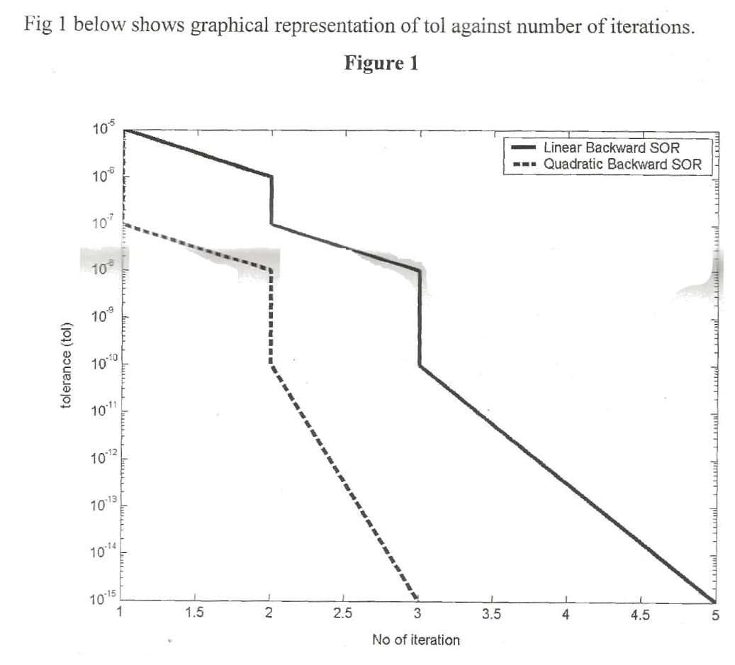

 Conclusion

The paper presented contraction mappings for both linear and quadratic SOR methods feasible in Newton operator to approximate the desired roots of nonlinear system of equation. After preliminaries studies on convergence behaviour of both methods, it was showed that quadratic Backward SOR method which uses Newton operator is not only finer and coarser in topology but also logarithmically faster than the Classical Linear Backward SOR method which also uses Newton operator for the same purpose to approximate zeros of nonlinear system of equation. Figure 1 above explains further. The presented results for the two methods are in agreement with results earlier obtained in [13] it is available in Selected IntLAB.Ref , [www.ti3.tu-harburg.de/rump/intlab/INTLABref.pdf](http://www.ti3.tu-harburg.de/rump/intlab/INTLABref.pdf) .Further reference to [13] can be found in citeseerx.ist.psu.edu . If we neglect extra work involved in executing Quadratic Backward SOR method the proposed approach studied in the paper is worth the trouble.

**References**

[1] Ortega JM and Rheinboldt WC (2000). Iterative Solution of Nonlinear Equations in Several Variables, Classics in Applied Mathematics, SIAM Series 30, Philadelphia USA.

[2] Ostrowski AM (1960).Solution of Equations and Systems of Equations, Second Edition, Academic Press, London.

**[3] Iyahen S.O (1998). The Closed Graph Theorem, Osaruwa Educational Publications, First Edition, Benin City.**

[4] Uwamusi SE (2011). Effects of repeatedly used preconditioner on computational accuracy for nonlinear interval system of equation. International Journal of the Physical Sciences Vol. 6(33), pp. 7505-7511. http://academicjournals.org/IJPS

[5] Varga RS (2000). Matrix Iterative Analysis, Springer Verlag, Berlin, Germany.

[6] Young DM (1971).Iterative Solution of Large linear Systems.Acadmeic Press, New York.

[7] Aschraft CC and Grimes RG(1988). On Vectorizing Incomplete Factorization and SSOR Preconditioners. SIAM Journal of Scientific and Statistical Computing, 9(1), PP. 122-151.

[8] Collins P (2005) . Continuity and computability of reachable sets, Theoretical Computer Science 341, 162-195.

[9] Hageman LA, Luk FT and Young DM (1980). On the equivalence of certain iterative acceleration methods, SIAM Journal of Numerical Analysis, 17(60), 852-873.

[10] Hormigo J, Villalba J and Schulte MJ (2001). Variable precision exponential evaluation. Scientific Computing, Validated Numerics, Interval methods,Edited by Kraimer Wolff von Gudenberg, Kluwer Academic/ Plenum Publishers, New York.

[11] Voigt RG (1971). Rates of convergence for a class of Iterative Procedures, SIAM Journal of Numerical Analysis, 8(1).

[12] Neuman M and Varga RS (1980).On the Sharpness of Some Upper Bounds for the Spectral radii of SOR iteration Matrices, Numer.Math., 35, 69-79.

[13] Uwamusi S.E. (2007). Towards the Acceleration of Rump’s fast and parallel circular interval arithmetic for enclosing solution of nonlinear systems of equations. Scientific Research and Essay, Vol.2, No.11, pp 476-481. Available online at <http://www.academicjournal.org/SRE>, In INTLAB ref, [www.ti3.tu-harburg.de/rump/intlab/INTLABref.pdf](http://www.ti3.tu-harburg.de/rump/intlab/INTLABref.pdf) ).citeseerx.ist.psu.edu