Multi-period PD calibration framework for LDP portfolios.

Denis Surzhko, Ph.D, PRM
Head of credit risk-model development unit,
OJSC VTB Bank

The intention of this paper is to propose PD calibration framework for low default portfolios (LDP) that allows producing smooth non-zero PD estimates for any given time horizon within the length of economic cycle. The approach produces PDs that are consistent with two main anchors – PIT and TTC PD estimates and are subject to smooth, monotonic transition between those two anchors. In practise, proposed framework could be applied to risk-based pricing of LDP portfolio deals. Moreover, according to the author opinion, the approach is generally compliant with the new IFRS 9 requirements regarding PD term-structure calibration for provisioning.

Introduction.

Let us assume that some rating system with $R$ rating grades was implemented in a bank $T$ years ago. Our task is to calibrate PD for risk-based pricing purposes given available default statistics. Hereinafter we assume that risk part (risk-premium) of a loan-pricing system is based on expected losses equal to PD multiplied by loss-given-default value for a transaction (LGD). LGD part of risk-premium is not covered by the paper, for PD part we assume that PD should be the same for all transactions of a given counterparty.

In case of a low default portfolio (LDP), the most common problems with PD calibration are:
- Unstable (high volatile) historical default rates by rating grades.
- Absence of historical defaults in high-grade (investment grade) rating geades.
- Absence of enough historical default data for PD term-structure calibration.

Despite these LDP portfolio issues, PD calibration approach for risk-based pricing purposes should comply with the following requirements:
- Produce, non-zero monotonic PDs, even if there were no historical default cases in a given rating grade.
- Be able to produce PD-term structure. Deals with different maturities should be assigned different risk-premiums.
- Allow to take into account current market (economic) conditions. Average through-the cycle PD (TTC PD, for details see (Ozdemir & Miu, 2008)) produces wrong risk- premiums almost in each point of economic cycle: during expansion periods it overestimates risk-premiums leading to non-market prices and portfolio shrinkage, during recession it underestimates expected defaults leading to uncovered by risk-premiums losses.
- Be transparent to business units: any additional components of the price always attracts significant attention from the business side.
- Should not be too conservative. It is possible to be on a safe side and use statistically based conservative approaches, such as proposed by (Pluto & Tasche, 2005). However, usage of such approaches for risk-based pricing purposes leads to conservatively high risk-premiums that will push business units to move from low default portfolios to more risky segments, which is generally undesirable consequence.
- Closely related to PD for other purposes, such as TTC PD for economic capital purposes.

Possible idea is to use ratings of international rating agencies for PD calibration purposes. Obstacle to this approach could be limited coverage of a given portfolio by external ratings, which is quite usual in emerging markets. Moreover, recent research papers (Forest, Chawla, & Aguais, 2015) argues for time inconsistency of such external benchmarks.

The simplest PD calibration method is to use historical migration matrix$M (dimention R×R)$ of a given term (usually 1 year). One year PD could be estimated as a probability to migrate in a «default» rating grade. PD term structure is produced by matrix multiplication (Engelmann & ‎Rauhmeier , 2011). Unfortunately, in case of LDP portfolio, none of above-mentioned requirements is met. Because of scarce default statistics we would produce non-monotonic, usually partly zero risk premiums.

More advanced, so called «duration», approach to migration matrix treatment was proposed by (Lando & Skødeberg, 2002). The approach is based $R×R$ generator or intensity matrix $Λ$. Based on generator matrix, migration probability matrix $M\left(t\right)$ for a given term t could be found as:
$$M\left(t\right)= e^{Λt} (1),$$
where the exponential is a matrix exponential, and the entries of $Λ$ satisfy $λ_{ij}≥0 ∀ i ≠j;{ λ}_{ii}=-λ_{i}=-\sum_{i≠j}{λ_{ij}}$. These entries describe the probabilistic behaviour of the holding time in state $i$ as exponentially distributed with parameter $λ_{i}$, where ${ λ}_{ii}=-λ_{i}$ and the probability of jumping from state $i$ to $j$ given that a jump occurs is given by $\frac{λ_{ij}}{λ_{i}}$. To estimate the elements of the generator under an assumption of time-homogeneity we use the maximum likelihood estimator:
$${\tilde{λ}}_{ij}=\frac{N_{ij}\left(T\right)}{\int_{0}^{T}{Y_{i}\left(s\right)ds}}(2)$$
where $Y_{i}\left(s\right)$ is the number of firms in rating grade $i$ at time$s$ and $N_{ij}(T)$is the total number of transitions over the period from$i$ to $j$, where i $i ≠j$. The numerator counts the number of observed transitions from $i$ to $j$ over the entire period of observation. The denominator has the number of ‘firm-years’ spent in state i. Any period a firm spends in a state will be picked up through the denominator.

«Duration» approach meets requirements of non-zero PDs and PD term structure calibration. Nevertheless, this approach could not solve non-monotonic PD problem and is hardly connectable to current market environment.

The alternative to migration matrixes could be an approach based on more robust risk indicators, such as average default rate in the portfolio (at time $t$):
$${DR}_{t}=\frac{D_{t}}{C_{t}}(3)$$
The conception of average default rate in the portfolio has the following advantages:
- Most robust and stable measure of risk in the portfolio.
- Easy to recover and calculate historically.
- Is not connected to a particular rating system.
- Is possible to extrapolate in order to recover data for the whole economic cycle.

Obviously, ${DR}_{t}$ at time $t$ depends on the phase of the economic cycle, that leads to a conception of so-called TTC (through-the cycle) PD and PIT (point-in-time) PD as described in (Ozdemir & Miu, 2008), (Basel Committee on Banking Supervision, Working paper №14 «Studies on the Validation of Internal Rating Systems», 2005). To avoid confusion, we will use $DR$ to denote the factual default rate in the portfolio and $PD$ to denote model estimate of a $DR$. The conception of PIT and TTC is described on the Figure 1, where $\overline{PD}$ denotes the average PD in the portfolio:
$$TTC \overline{PD}=\frac{1}{T}\sum_{t=1}^{T}{PIT \overline{PD}\left(t\right)(4)}$$

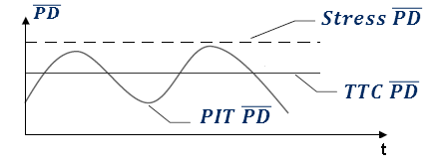
Figure 1. PIT and TTC PD conception
The goal of the paper is to propose a consistent framework for a PD estimation for risk pricing purposes which is based on the conception of mean portfolio PD.

PD calibration framework.

Proposed PD calibration framework is based on the following assumptions:

- Probability of stress event within the period equal to economic cycle is close to 1, the probability of two or more stress events within the same time frame is close to 0. This is equal to the “from crisis to crisis” definition of the economic cycle.
- Stress event always comes unexpectedly: it is impossible to predict the exact date of the economic crisis. Nevertheless, we could use a macro-forecast in order to decrease our uncertainty about the stress event probability in the nearest future.
- Cumulative probability of the stress event is always non-decreasing function of the time. For example, the probability of an economic crisis within next 5 years should be always greater than the probability of an economic crisis within next 12 months.

For convenience, we can classify deals into three buckets according to their maturity:

- Long-term deals – maturity is close or equal than the economic cycle.
- Short-term deals – maturity is within macroeconomic forecast.
- Mid-term deals – maturity extends beyond the time horizon that you can reasonably predict but still does not cover a full economic cycle.

Let us elaborate economically reasonable way to set risk-premiums for each maturity bucket given above mentioned.

Asymptotically we expect a pool of Long-term deals (maturity is close or equal than the economic cycle) to pass through all stages of an economic cycle, therefore averaging it’s default rate by time (year of economic cycle) we would come to a $TTC \overline{PD}$ estimate, as described by equation (4). Therefore, it is reasonable to calibrate risk-premiums for Long-term deal to average through the cycle $TTC \overline{PD}$.

$PIT \overline{PD}$ tends to fluctuate in accordance with economic cycle, e.g. to be higher for stress periods and lower for expansion time. In order to be always «in the market» for Short-term deals, we should use $PIT \overline{PD}$ as an average estimate of default rate for this pool. Usage of $TTC \overline{PD}$ for that pool produces wrong risk-premiums almost in each point of economic cycle: during expansion periods it overestimates risk-premiums leading to non-market prices and portfolio shrinkage, during recession it underestimates expected defaults leading to uncovered by risk premiums losses. Exact realization of default rate in a given period is unpredictable, nevertheless, one can use available macro-forecast in order to decrease uncertainty in the $PIT \overline{PD}$ value for the next period. The simplest way to do it is to calibrate a linear model with log odds of $PIT \overline{PD}$ as a dependable variable and dynamic of forecasted macro-variables as predictors:

$$Ln\frac{PIT \overline{PD}(t)}{1-PIT \overline{PD}(t)}=\sum_{i=1}^{N}{{β_{i}M}_{i}}(t)+β_{0} (5)$$
, where $M_{i}(t)$ - i-th macro-variable for the time period t, $β_{i}$ – weight of i-th macro-variable, $PIT \overline{PD}(t)$ – value of average portfolio PD for the time period t.

In case our data set does not cover the whole economic cycle, model (5) can also be used for recovering missed default rate values based on historical time-series of macro-variables. Recovered default rates could be used under Quasi-TTC approach (Financial Service Authority, 2009). Quasi-TTC approach is based on correction of $TTC \overline{PD}$ estimate using ration of average default rate in the portfolio including recovered period and without it.

For Mid-term deals, the longer the maturity of the deal, the lower the reliability of the forecast of states of economy that the loan passes through across its lifetime. In case we are not anticipating stress event in our forecasting horizon, it is reasonable to assume that the probability to catch a stress in increasing with the time until it become one at maturity equal to economic cycle duration (and therefore such loan will be prices at $TTC \overline{PD}$).

On the other hand, in case we anticipate stress, it is reasonable to assume that after a stress event, values of $PIT$ $\overline{PD}(t)$ should decrease due to assumption of only one stress event during the timeframe of economic cycle. As the result, with the time, decreased series of average annual default rate in the portfolio ${\overline{PD}}^{t}$ should converge to $TTC \overline{PD}$.

Thus, disregard of macro-forecast, for Mid/long-term deals it is reasonable to interpolate from $PIT$ $\overline{PD}$ rates towards $TTC$ $\overline{PD}$. In case of invert ${\overline{PD}}^{t}$ curve ($PIT \overline{PD}> TTC \overline{PD}$) one should verify consistency of model parameters by checking positivity of forward PD estimates ($PIT \overline{PD}\left(t\right)>0)$. The check could be done numerically by testing inequality for each duration within the length of economic cycle T:
$${{(1-\overline{PD}}^{t-1})}^{t-1}>{{(1-\overline{PD}}^{t})}^{t} t=2..T (6)$$

It is possible to use different approaches to interpolation $\overline{PD}\left(t\right)$ for Mid-term deals, in the paper we propose Convergence factor approach and compare it to Hazard function approach.

Convergence factor approach is based on the assumption of the following dependence:

$${\overline{PD}}^{t}=PIT \overline{PD}+\left(TTC \overline{PD}-PIT \overline{PD}\right)∙Convergence factor\left(t\right) (7)$$

where ${\overline{PD}}^{t}$ - is a term structure of annual average default rates (spot PDs) for the portfolio.

By definition, convergence factor should be close to 0 for t = 1 and close to 1 for t equal to the maturity of the economic cycle (T). One of the simplest implementation of the Convergence factor is the following:
$$Convergence factor\left(t\right)= 1-e^{-λ(t-1)} (8)$$

The speed of convergence λ could be calibrated in two ways: based on the assumption of the duration of the economic cycle and market-based approach.

In case we are fixing economic cycle duration T, we should require the convergence factor to be smaller than some reasonable threshold since we approach duration equal to T, therefore we can find a low bound estimate $\tilde{λ}$ for the λ:
$$1-e^{-\tilde{λ}\left(T-1\right)}≥1-Ths (9)$$

One of the reasonable ways to calibrate the threshold $Ths$, is to require the precision of convergence to be equal or higher than the precision of the pricing system (for example, 1 b.p.). Because the Convergence factor influences only second summand in formula (7), the $Ths$ could be found as:

$$Ths≥\frac{Required precision}{TTC \overline{PD}-PIT \overline{PD}} (10)$$

Therefore, using (9) and (10) convergence speed is equal to:

$\tilde{λ}= -ln\frac{\frac{Required precision}{TTC \overline{PD}-PIT \overline{PD}}}{T-1}$ (11)

Table 1. PD term structure duration based example.
Time (years) | 1 | 2 | 3 | 4 | 5 | 6 | 7 | 8 | 9 | 10
Expansion | 2,00% | 2,97% | 3,47% | 3,73% | 3,86% | 3,93% | 3,96% | 3,98% | 3,99% | 4,00%
Stress | 6,00% | 5,03% | 4,53% | 4,27% | 4,14% | 4,07% | 4,04% | 4,02% | 4,01% | 4,00%

Table 1 illustrates example with assumptions of $T=10, TTC \overline{PD}=4\%, Expansion PIT \overline{PD}=2\%, Stress PIT \overline{PD}=6\%.$

The second, market based approach, estimates λ by fitting market quoted PD term structure using function (8). For example, one could use CDS spreads term structure as a market benchmark. In that case, short term (1 year) CDS is a proxy for a $PIT \overline{PD}$, while the long term CDS spread (10 years) approximates average default rate over the whole economic cycle. High volatility of market indicators could be a problem under these approach, possible mitigations could be:
- Averaging of the CDS quotes for a significant time horizon;
- Usage of the most liquid instruments in the market (as a last resort, convergence of the most liquid instruments like LIBOR rates could be taken as a proxy).
Therefore, after simple fitting procedure, we get market based speed of convergence λ.

The calibration procedure is quite simple. Let’s denote by $\tilde{CDS\left(t\right)}$ CDS value for t-years term divided by some LGD estimate (for example, 75%), therefore $\tilde{CDS\left(1\right)}$ becomes $PIT \overline{PD}$ market proxy, $\tilde{CDS\left(10\right)}$ becomes $TTC \overline{PD}$ market proxy. One could find λ estimate for each term using (7) and (8):
$$λ_{market}\sim -\frac{\ln\left(1-\frac{\tilde{CDS}\left(t\right)-\tilde{CDS}\left(1\right)}{\tilde{CDS}\left(10\right)-\tilde{CDS}\left(1\right)}\right)}{t-1}(12)$$

Averaging (12) through the term structure would give us optimal $λ_{market}$ in terms of quadrating loss function. In order to avoid numerical problems, we could omit t = 1 point from (12) because PIT PD is fitted with zero loss function by construction. $λ$ for TTC PD (t=10) point could be replaced by (11) given $\tilde{CDS}\left(10\right)= TTC \overline{PD}, \tilde{CDS}\left(11\right)= PIT \overline{PD}, T=10$, due to convergence of ${\overline{PD}}^{t}$ to $TTC \overline{PD}$ with the with precision $Ths$.

Figure 2 illustrates results of fitting market data (CDS spread on Russia with assumption of 75% LGD) using above proposed methodology.

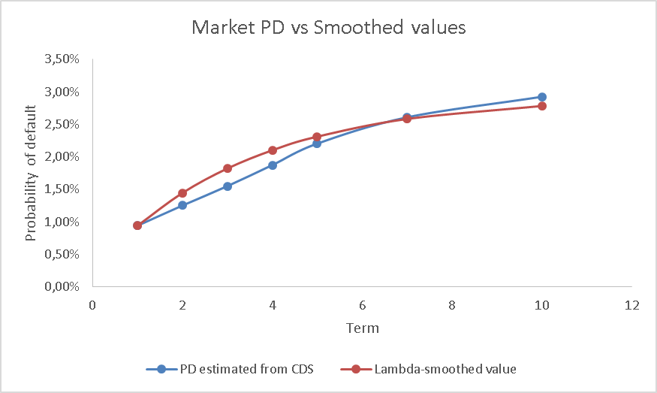
Figure 2 Market PD vs $λ_{market}$ Smoothed values

Figure 3 illustrates results of ${\overline{PD}}^{t}$ calibration given the same inputs using market and cycle duration approach. Market data approach $λ_{market}$ estimate is 0.293, while cycle duration approach given the same inputs produces $\tilde{λ}$ equal to 0.6351.
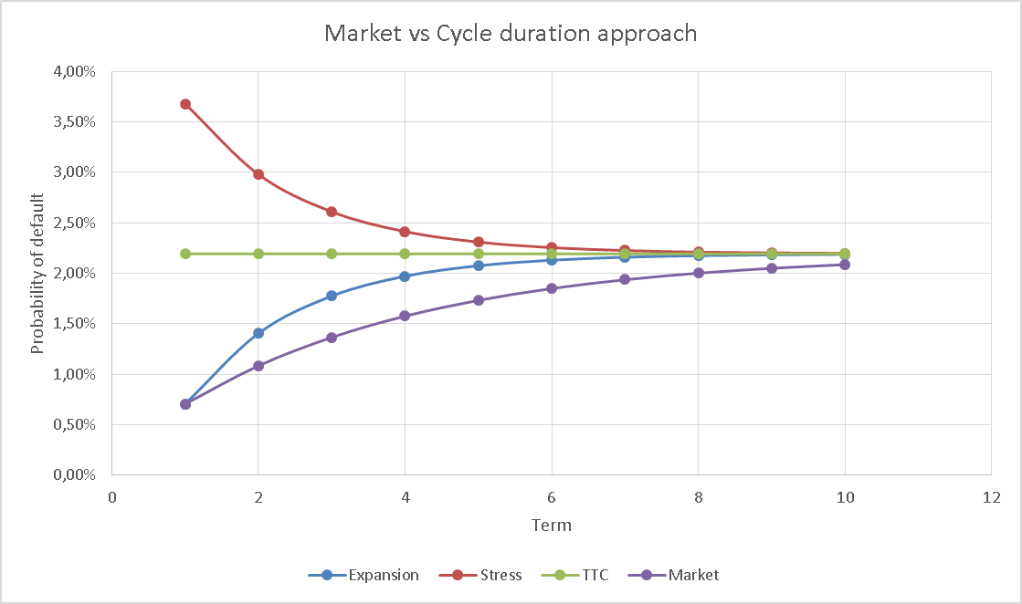
Figure 3 Market vs Cycle duration approach

The other possible way to calibrate PD term structure is to use hazard function approach. Let’s assume that based on some hazard function $h\left(u\right)$ we are able to estimate cumulative probability of default for any given term T > 0:
$$PD \left[0, T\right]=1-e^{-\int_{0}^{T}{h\left(u\right)du}}(13)$$

Given two fixed points $PID \overline{PD}, TTC \overline{PD}$, we are able to unambiguously calibrate hazard rate function of two parameters using the following system of equations:
$$\left\{\begin{aligned}1-e^{-\int_{0}^{T}{h\left(u\right)du}}=1-{\left(1-TTC \overline{PD}\right)}^{T} \\ 1-e^{-\int_{0}^{1}{h\left(u\right)du}}=PIT \overline{PD}\end{aligned}(14)\right.$$

The simplest two parametric function is a liner function, for the convenience purposes given as:

$$h\left(u\right)=-2au-b (15)$$

In case of linear hazard rate function (15), parameters could be found as a closed form solution:

$$\left\{\begin{aligned}a=\frac{\ln\left(1-TTC \overline{PD}\right)-ln⁡(1 -PIT \overline{PD})}{T-1} \\ b=\frac{\ln\left(1-PIT \overline{PD}\right)∙T-ln⁡(1 -TTC\overline{PD})}{T-1}\end{aligned}\right. (16)$$

The differences between PDs produced by proposed approaches are presented ($T=10, TTC \overline{PD}=4\%, Expansion PIT \overline{PD}=2\%,$) on Figure 4 and Figure 5.

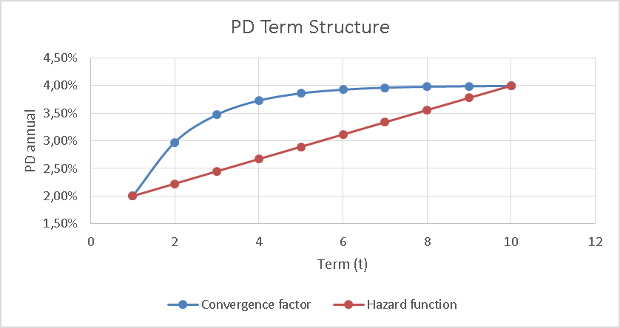
Figure 4 PD term structure Convergence factor vs Hazard function

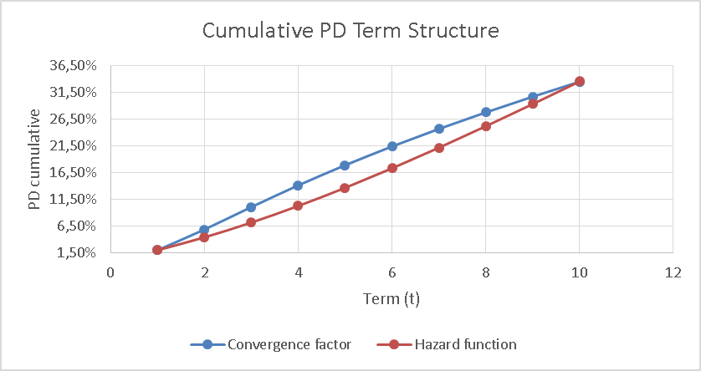
Figure 5 Cumulative PD term structure Convergence factor vs Hazard function

Each of the approaches has its advantages and drawbacks :
- Hazard function (HF) approach is a very widespread approach, especially in the field of market data modeling (CDS spreads).
- HF approach is more mathematically rigorous, while Convergence factor (CF) approach is an econometric model that aims to fit a convexity PD term structure in a transparent and intuitive for model users way.
- Non-linear PD term structures could be fitted by both approaches. In HF approach change of $h\left(u\right)$ to a non-linear function leads to significant complications in model calibration, including numerical solve of system of non-linear equation. Searching for a convenient $h\left(u\right)$ functional form could be also a challenge for a modeler. On the other hand, CF could fit non-liner convex PD term structure in an easy and transparent way. The function form of dependence could be easily changed, given only two restriction for the function (convergence to 0 at t = 1, and to 1 at t on the infinity).
- CF approach has additional parameter $λ$, that is responsible for convergence speed. $λ$ could be used for benchmarking or validation purposes against market data or other similar portfolios.

The final step of the pricing framework is to decompose the ${\overline{PD}}^{t}$ for each duration to rating structure. That could be done using any of a central tendency calibration approaches (for details see
(Tasche, 2009)).with the replacement of TTC PD by ${\overline{PD}}^{t}$ in each duration bucket (year).

For each of the central tendency calibration approaches, we should make two assumptions:
- changes in rating structure of the portfolio.
- changes in accuracy ratio (AR) of the model with the time;
Changes in rating structure of the portfolio could be smoothed averaging thought historical rating structure. Another option is to forecast changes in rating structure using by applying migration matrixes to the current portfolio paired with business plan of portfolio growth in each rating grade.

Possible approach to AR time decay estimation could be subtraction from the mean of AR value it’s standard deviation value multiplied by some time-dependent coefficient (for example, square root of time). This approach leads to less convex PD estimates for Long-term deals than for short term. This effect is reasonable, because the longer horizon we have, the worse is the predictive power of our model.

Conclusions.

The result of this paper is a PD calibration framework that has the following advantages:
- Produces non-zero monotonic PD-values, even if there were no default cases in a given rating grade.
- Produces PD-term structure, even in case of scarce default statistic (LDP portfolios).
- Produces PD values that takes into account current market (economic) conditions.
- Is transparent to model users.
- Does not put additional conservative margins even in case of LDS portfolios.
- Is related to PD to TTC PD estimates usually used for economic capital purposes.
According to author point of view, this approach is especially useful for PD calibration in LDP portfolios for risk-based purposes. The other potential implementation field for the approach could be PD term structure calibration for the IFRS 9 requirements.

Список литературы
Basel Committee on Banking Supervision. (2005). Working paper №14 «Studies on the Validation of Internal Rating Systems».
Basel Committee on Banking Supervision. (2006). International Convergence of Capital Measurement and Capital Standards.
Burgt, M. J. (2008). Calibrating low-default portfolios, using the cumulative accuracy profile. Journal of Risk Model Validation, 1(4), 17-33.
Engelmann , B., & ‎Rauhmeier , R. (2011). The Basel II Risk Parameters: Estimation, Validation, Stress Testing - with Applications to Loan Risk Management,. Springer.
Financial Service Authority. (2009). A regulatory response to the global banking crisis.
Forest, L., Chawla, G., & Aguais, S. (2015). Biased benchmarks. Journal of Risk Model Validation 9(2), 1-11.
Lando, D., & Skødeberg, T. (2002). Analyzing Ratings Transitions and Rating Drift with Continuous. Journal of Banking & Finance, 423-444.
Ozdemir, B., & Miu, P. (2008). Basel II Implementation: A Guide to Developing and Validating a Compliant, Internal Risk Rating System. McGraw-Hill.
Pluto, K., & Tasche, D. (2005). Thinking Positively. Risk, 72-78.
Tasche, D. (2009). Estimating discriminatory power and PD curves when the number of defaults is small. Working paper, Lloyds Banking Group.

