The Firm without Subordinations
  - martin.vlcek@efunctionality.eu

Abstract
The firm is one of last totalitarian structures. On the other hand, the position of an entrepreneur with its freedom and responsibility is the most productive one.
All known successful structures in the nature are by contrast established on concurrence and relative freedom.
The presented paper devises on the basis of analogies a structure of a firm, what will not be totalitarian and will respond to existing structures in the nature. At the same time positions of employees are as close as possible to the position of an entrepreneur.

Introduction
The identification of existing structures started through a long-lasting study on the level of macro-economy. By the help of a non-econometric model, the controlling structures of the economy and of the whole society were successively discovered. Termination of this work was made upon data from the New York Stock Exchange. Thus it is possible to summarize that the proposed structure into the firm corresponds to the relations among firms in USA.

Control of the Firm

New Quality
Today firm is not yet an object of a new quality, it is only a wrapped up structure around the position of a director and his will and thus the unity of the control is realized by a pyramid of totalitarian relations.
New quality originates only from the new structure of the control. It has three new parts taking over their functions from the old management, what persists in the firm but only with residual functions - coordination mainly.
All new controlling structures of a firm work with the satisfaction. The satisfaction of employees solves the controlling part EM0. The satisfaction of the firm as whole, its successfulness, but not only the profit – solves EM1. The control of the old management ensures part ENE.
Besides the notion of satisfaction the notion of successfulness is also used. The satisfaction concerns only one input, sometimes the notion of demand is also used. The successfulness is a broader notion defined by a satisfaction of all employees with one concrete employee, if they are consumers of one of his outputs. Depending on circumstances this successfulness can be expressed as a simple sum of all satisfactions or as an average over one consuming employee.

Followed up Quantities
The satisfaction of employees is detected depending on particular possibilities in a firm. There is no one unique correct way, but the maximal fidelity is important. Therefore more sources can be used together with the questionnaire as one of them. There are other more objective methods not burdening an employee, but may be not so specific. In addition, they don’t respond to the spirit of a new firm, where the maximum of freedom, the freedom of evaluation and of the choice of inputs as a sequel is given to employees.

Principles of the Control
The control goes on analogically in all controlling structures. Measured out values of a followed up quantity are grouped into subsets, for example depending on the structure of the firm. The volatility and the average of subsets are pursued. The intervention will occur on the basis of a subset with the highest volatility and the highest average altogether. Weights of these two values, volatility and average, change perhaps depending on the state of the firm. When the value of one of them growths all over the firm, its weight will probably growth together.

Old Management

Old Management and the Coordination of the Work
The structure connected with the flow of energy, it means with the dynamics of the firm, is a residue of the original totalitarian management. The engagement of an employee into the productive process, this is its function. This is a coordination of his activities with other employees, the control of intensity of the work included. Hereafter it will be named as an old management, TOT. Its architecture was submitted to substantial changes.
When a new employee wants to be engaged into the production, he must become a consumer of a coordinative control from TOT. But for every employee there is a possibility of the choice - there is a concurrence inside the TOT.
TOT has a special relation with the group of employees of the sale. It goes not about the coordination but about the feedback there, describing how different outputs – goods or services – are demanded.

Control of the Old Management
Beside TOT rises another structure called ENE, with a function of controlling TOT. ENE carries out the reconstruction of the structure of TOT and at the same time, realizes the influence of other controlling structures.

Reconstruction of TOT
ENE stems from the knowledge of the structure of the firm and from the satisfaction of consumers of services of TOT. For particular workrooms rise subsets of successfulness (non-averaged out) and ENE makes the reconstruction on the basis of their volatility and average. The reconstruction consists in establishing a new position with same relations beside the employee from TOT with the highest successfulness, means a concurrence. After on TOT locates into a new employee and the system expects an equalization of successfulness.
Besides the activity of employees from TOT with substantially lower successfulness is weakened, until their positions are eventually totally cancelled.

Higher-level Influences over ENE
There are influences from the control connected with the satisfaction of employees – EM0 and from the control connected with the satisfaction of the firm as whole – EM1. Altogether, these influences are expressions of an equalization of inputs. Through them, the intensity of the reconstruction and of the activity of TOT itself is influenced.
Through these influences, the general philosophy of existence of an object is realized. It means that the activity leading to a change is suppressed at a state where relations with the environment become more stabilized and therefore the border smoother, and vice versa. EM1 traces the balance of relations and the smoothness of the border of the firm, EM0 traces the balance of inputs of employees. Therefore it is necessary to realize their influence over ENE and throughout over TOT.

Information and the Freedom of the Entrepreneurship
There rises a new department in the productive structure, what is devoted to a certain advertisement into the firm. Its goal is to spread information concerning activities of individual employees in a manner to be at disposal of other employees. This is a necessary supposition for the approach of their activity to the activity of an entrepreneur, means to be maximally free on the basis of information.
But the space for the freedom of the entrepreneurship of employees cannot cross over certain limits and this is perhaps all concerning the activity of TOT, it means the coordination of the work.
The main manifestation of the freedom of entrepreneurship of the employee is the possibility of influencing his working relations through their constant evaluation, thus nearly by their purchase, and the freedom of a choice of concurring inputs.

EM0

Principle of Activities
The task of EM0 – shortly „empathyzer 0“ – is to solve the reconstruction of the firm in a manner to maximally equalize the satisfaction of employees with their inputs and to get it on a highest level. At this activity, the satisfaction can be understood as a demand for a particular input.
EM0 solves this task by establishing new positions near the most demanded ones, and by offering the most demanded relations into other positions. It means, throughout investments into new positions and new relations.
EM0 gets information about the satisfactions of all employees by the already mentioned method of questionnaire. Besides this source, different values obtained more objectively can be used, e.g. indicators of productivity, consumption of energy etc.

Detection of Satisfaction
Information concerning satisfaction tells how an individual employee is satisfied with particular working inputs, how they contribute to his overall working success. From the market point of view this contribution to the success is possible to be understood as a demand of a concrete employee for individual inputs – see fig. 2.

Investments into Positions and Relations
EM0 groups successfulness into particular subsets and searches critical spots. These are subsets the most volatile and in the same time, with the highest average value.
Then EM0 establishes a new position beside the highly demanded one and the demand is thus weakened. In the same way, it reaches a weakening of the demand by offering relations from a very demanded position to other positions and thus forming presuppositions for new relations in the structure of the firm. Here it is to note, that in the case of relations the normalised successfulness over one relation is used.
Liquidation of positions with the lowest successfulness happens concurrently with the formation of new positions. The same holds for relations, too.

EM1

Shoppers and the Border
Specialised employees – later on named shoppers –influence supplies of certain entities into the firm. It can concern the engagement of a position by an appropriate employee – then the shopper is an employee of the personal department. It can concern the shopping of a material for the production, etc. The majority of shoppers need for their work some financial resources, funds. The personal department needs wages’-fund, the shopping department funds for the provision of the production, etc. On the other side, they receive the feedback in the form of information about the satisfaction of consumers.
As result of the activity of shoppers, there is a different concentration of peoples, goods and services in the firm in comparison with the environment. Shoppers thus form the border between the firm and the environment.

Satisfaction and Tension
Let two similar goods a supplied into the firm. But let the satisfaction with them between two consumers or two groups of consumers is substantially different. Such a phenomenon is later on named as tension. It is a difference between similar inputs and dissimilar satisfaction, or demand. Throughout the control of the border the task of EM1 is to remove such tensions.
At the same time, the total distribution of tensions over the border, its smoothness, and the average satisfaction over the border define the satisfaction or successfulness of the overall firm.
EM1 searches subsets with a high tension, it means with a volatile demand. The subset in EM1 is defined as a group of shoppers of similar inputs. EM1 searches not only subsets with a high tension, but also with a high level of demand and steps into the solution on their basis.

Investments and Distribution of Funds
The redistribution of funds through investments is an instrument of solution. Investments are directed to a position in the border, it means to a shopper, where is a high demand and thus a new position is formed and also a concurrence for this shopper. The used part of the fund can be got from the spot with a lower demand, conversely. Thanks to this redistribution of the fund the lowering of the tension happens.
In general it is possible to say that the activity of EM1 is connected with the distribution of funds for purpose of a lowering of the tension. It concerns the wages’-fund, fund for shopping material inputs, etc. Finally, the redistribution among funds is also on the principle of minimisation of the tension.

Investment as a Movement
EM1 by establishing another position of a shopper for a certain input makes an elementary movement, a reconstruction of the border. It can be e.g. a formation of another input just in the area, where these inputs are of a better quality or cheaper.
But what about the searching of a better quality or a better price, this is the role of the shopper, not of EM1.

Wages
The task of HR is to ensure for every position an employee. They fulfil this task by setting the level of the wage in a manner to be sufficiently attractive for interested persons of the environment. When the amount of leaving persons is the same as the amount of coming ones, the level of equilibrium happens.
Thus the basic, nominal wage is determined objectively, it means through the comparison with the environment and on the basis of the tension on the border. Besides this every wage has a part of a personal evaluation what is a function of the successfulness of the employee in the firm. It is a result of a periodical evaluation of satisfaction - see fig. 2 - and is perhaps already a task for EM0.

For Conclusion

Transfer to a New Quality
It is probable that the transfer of the firm to a new structure of organization can be made gradually, without necessity of establishing quite a new firm. The first step towards is a start of evaluation of satisfaction of employees.
The second step ought to be a partial transfer to the new principles of evaluation of wages, namely of the personal part. Only a part of the wages’-fund can be devoted to this new principle. After this step an evaluation of effectiveness ought to happen. If the effectiveness of the firm is higher, the transformation has to continue.
In other steps it is possible to gradually transfer to the control of parts of other funds through EM1 and similarly for the EM0. After every step the effectiveness is evaluated and the transformation continues only in the case of an amelioration of indices of the firm. The goal is not only the higher profit but a profit sustainable, means an equally distributed profit among more consumers, etc.

Profit
The new structure of the firm is not build only upon the satisfaction of employees and thus against the profit of the firm, as could be an impression. The satisfaction has its beginning in the share on profit of employees of the sale, as was mentioned in fig.2. The satisfaction, what is from another point of view a demand for inputs, spreads over the structure of the firm. The role of the profit is yet strengthened through the fact of a variation of point being to the disposal of an employee for evaluation, depending on previous results. And this is its successfulness in the firm, means the share on the created profit.
Because all interventions of EM0 and EM1 are oriented to the strengthening of satisfaction, they eventually strengthen the profit.

References
1. Vlcek, M.: Functioning of the Object, unpublished material, 2008
2. Vlcek, M.: Functioning of the Brain, in ISB2010 proceedings, Su Zhou, China, 2010
3. Vlcek, M.: Movers of the Economy - Model of Interactions, in Developments in Economic
Theory and Policy proceedings, Bilbao, Spain, 2010
4. Vlcek, M.: New Object Discovered through the Stock Market, in International Conference on
Economics and Finance Research proceedings, Seoul, South Korea 2014
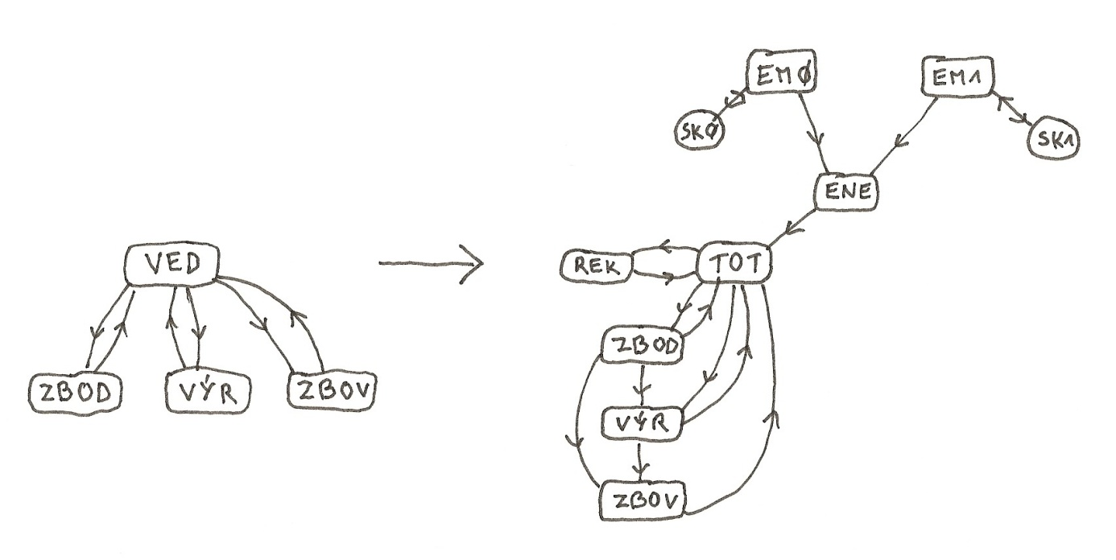
Fig. 1: Development of the Control of a Firm. The original management – VED is transformed into TOT, what is controlling at time the input of goods – ZBOD, the production – VÝR and the sale of goods – ZBOV. At the same time it is deprived of part of competences and yet influenced by another control, realised by ENE. EM0 evaluates the satisfaction of employees – SK0, EM1 the satisfaction of the firm as whole – SK1. REK is a new position in the firm – the advertisement and its goal is to intermediate information about activities of employees throughout the firm.
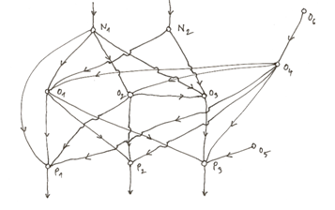
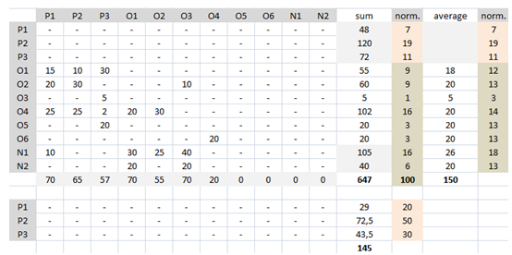
Fig. 2: The Basis for Satisfaction Monitoring. Working relations among employees – positions - are showed in a model structure – see graph. Every employee, in the frame of evaluation of satisfaction, fills in values for input relations. E.g. employee O2 will evaluate positions O4 and N1, himself is evaluated by P1, P2 and O3. Every employee receives for evaluation 100 points. Sum of evaluations is a value showed in the column sum and after a normalisation in the column norm. This value represents the successfulness of every employee in a given model structure. At the next evaluation – e.g. weekly – the employee will receive for new 100 points or only the value received as result of the previous evaluation. Thus, the employee N2 would receive only 40 points, but the employee N1 105 ones. For employees from P1 till P3 – these are outputs – a technical calculation of successfulness is used, using their share on the profit of the firm.
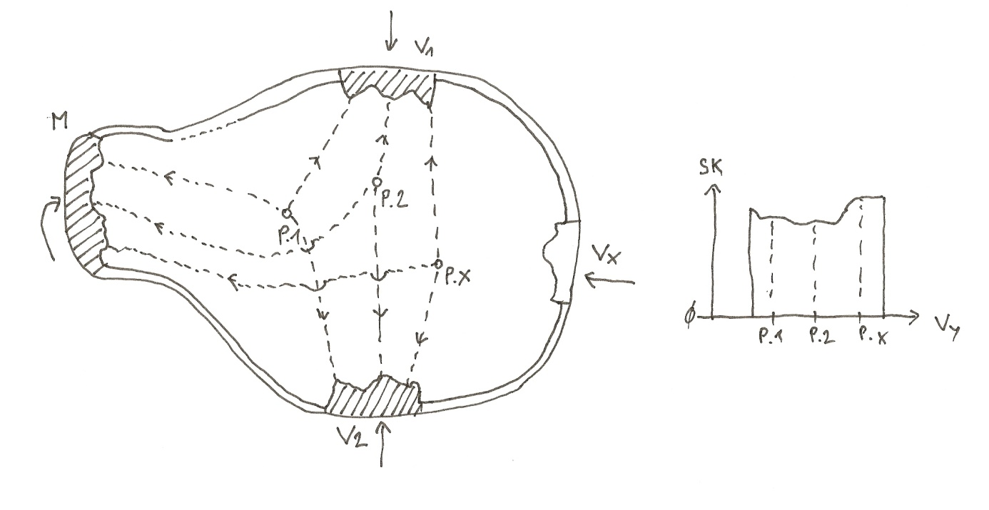
Fig. 3: Work of EM1. The satisfaction SK of employees in positions P.1 till P.x is monitored through unequal values of different inputs V1 till Vx, and also through unequal wages M. For every monitoring, a similar graph as is shown at the right part for input Vy rises. Let for example input Vy for P.x is got from a different shopper than P.2. There are near values but nevertheless there is a high enough difference in the satisfaction, thus there is a tension. That is why EM1 will form a new position “beside” P.x, it means a better input from the environment and P.2 will be eventually canceled. The wage is solved by a similar manner.

