**Pilot study of the performance of organic and clay-based sun creames**

Roland Pusch1, Thao Hoang/Minh2, Ting Yang1,

1 Luleå University of Technology, Sweden; 2 VNU University of Science, 334 Nguyen Trai road, Thanh Xuan district, Hanoi, Vietnam.

**Abstract**

Sun protection creams based on smectite (S) and mixed-layer (IS) clays in glycerol emulsions were compared to commercial organic creams with respect to UV penetration. For very thin cream films the organic creams were superior while for thicker films the clay creams gave lower UV penetration. The investigated I/S mixed-layer clay gave more effective protection than Fe-poor S-clays because of better particle alignment and thicker particles. The content of iron compounds was found to be of greatest importance as demonstrated by tests with different amounts of Fe2O3.

**Key words:** clay, organic fluid, shearing, suncreame, thixotropy, UV protection

**1 Scope**

UV radiation is a major reason for skin cancer that is expected to be increasingly common due to the ongoing degradation of the earth’s ozon layer [1, 2]. It has recently been reported that the most popular sun protection creams on the market reduce penetration of UV radiation only by a few tens of percent and Swedish medical authorities have recommended manufacturers to develop more effective products. A possible way of doing so is to use clay minerals as exemplified by numerous literature references and concluded from two experimental studies described here, a pilot test for comparing the UV reduction of mixed-layer I/S/Chl clay cream containing glycerol for preparing emulsions and a common commercial organic suncream, and a comprehensive study of the performance of creams of kaolinite- and montmorillonitic clays containing glycerol and other emulsifiers.

**2 Physical background**

Focusing here on the penetrability of UV radiation through suncreames of inorganic type it is basic that the microstructural organization of the platy stacks of lamellae of phyllosilicates plays a role because of the effective reflexion of the radiation if the alignment is very good, and that absorption of the energy of radiation is favoured by the content of heavy elements like iron. The firstmentioned function is one of imposing large uni- or biaxial shear strain, the other being related to the crystal composition of the mineral particles and to the content of accessory minerala.

**2.1 Microstructural strain**

The original microstructural constitution of a cream or paste of smectitic clay (S), including montmorillonite and mixed-layer minerals composed of illite, smectite and chlorite (I/S/Chl), is characterized by aggregation and isotropic orientation of the aggregated particles but large shear strain imposed by smearing them on skin involves alignment of the stacks of lamellae as indicated in Fig.1. The microstructural response to shearing is that the overall deformation of the network of particles changes by disintegration, translation and rotation of weaker aggregates while denser and larger ones retain their strength better [3].The laminated structure is the reason for the Newtonian rheology of smectite clay undergoing large strain (Fig. 2). The clay behaves as a fluid.

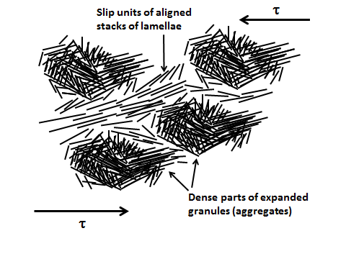

Fig. 1.Late stage of evolution of shear strain of networks of clay particles under a macroscopic shear stress **. Slip domains are formed by breakdown of weak microstructural units (cf. [4]).



Fig. 2. Creep strain rate of smectite-rich clay (montmorillonite) MX-80) with a density at saturation with distilled water of 1500 kg/m3. The strain rate recorded for the shear stress 23 kPa is constant after 3 days [5].

As soon as the smearing is over and the smectite cream left to rest it undergoes thixotropic strength regain associated with coagulation, which again gives the clay and aggregated structure (Fig.3).

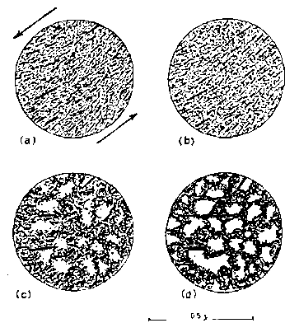

Fig. 3 Transition from sol to gel form of smectite clay after shearing (After Arnold).

The return from aligned to irregular orientation of the majority of the smectite stacks means that the reflexion of UV radiation becomes less good, which suggests that this kind of clay/water mixes are not ideal for UV protection of the skin. Mixing the clay with a suitable conditioning substance like glycerol can change this since the reorientation and movement involved in the thixotropic regain is then retarded by the viscosity of this substance, which is 1500 times higher than of water.

The basic requirement for reflexive rejection of radiation is still possible to achieve if some other clay material with tabular particle shape is used like talc or kaolinite and one can think of kaolinite and talc but they lack potential of spontaneous gelation, which is required for preparing a homogeneous cream. Another possibility is mixed-layer clay with a montmorillonite content of 25-50 % like the Friedland clay, which was therefore one of the candidates used in the experimental studies that will be described in this document.

**2.2 Composition of candidate clays**

Tables 1 and 2 summarize the element composition in oxide form of natural montmorillonite-rich clay with Na as major adsorbed cation (“MX-80”),

Table 1. Typical composition of buffer materials tested in the current research work. Weight percentages of oxides.

|  |  |  |  |  |  |  |  |  |  |  |
| --- | --- | --- | --- | --- | --- | --- | --- | --- | --- | --- |
| Clay | Smectite type | Elements | | | | | | | | |
| SiO2 | Al2O3 | Fe2O3 | MgO | CaO | K2O | Na2O | S* | LOI** |
| MX-80 | Na montm. | 63.8 | 19.8 19.8 19.8 | 5.0 | 3.2 | 3.1 | 1.0 | 2.8 | 0.12 | 7.2 |
| Friedland | Mixed-lay montm/mica | 57.2 | 18.0 | 5.5 | 2.0 | - | 3.1 | 0.9 | 0.3 | 7 |

Table 2. Summary of data on the content of inorganic constituents of smectitic buffer materials tested by Swedish Nuclear Fuel and Waste management Co (SKB).

|  |  |  |  |  |  |  |  |  |
| --- | --- | --- | --- | --- | --- | --- | --- | --- |
| Clay | Smectite | Quartz | Chlorite | Feldspar | Mica | Carbonates | Pyrite | Others |
| MX-80 | 75 | *** | (*) | ** | * | * | (*) | * |
| Friedland | 45 | *** | ** | ** | ** | * | * | - |

*** Abundant (>10%)

** Moderately abundant (3-10%)

* Traces (< 3%) ¨

The major difference between the two clays is that MX-80 (“Wyoming bentonite”) contains very little illite and almost no chlorite in contrast with the less montmorillonitic mixed layer I/S Friedland clay. Since the thixotropic gel-forming potential is significantly lower of the lastmentioned clay and the stacks of lamellae are thicker than in montmorillonite-rich clay its UV-protection capacity is expected to be higher.

**3 Experimental**

**3.1 Pilot test**

**3.1.1 Components**

The commercial organic clay termed “Tone” here is taken to be a representative of typical organic sun-creames. It is manufactured by a US company claiming that it has, like many other commercial sun-protective creams, the following major active ingredients: homosalate, ethylhexyl, p-methoxycinnamate, 2-ethylhexyl salicylate, and oxybenzene. Inactive”fillers” are: water, propylene glycol, PVP/eicosene copolymer, glyceryl stearate, cetyl alcohol, dimethicone, myristyl myristate, DEA-cetyl. Phosphate acrylates/C10-30, alkyl acrylate crosspolymer, methylparaben, sodium hydroxide, disodium EDTS, BHT, diazolidinyl, and urea.

Two clay-based non-commercial creams were tested. One is termed MD1 (014/99) andis light-greyish and composed of montmorillonite-rich smectite (Keramont) and glycerine (glycerol, 1,2,3-propantriol) in proportions 100 g clay with 9 % water content and 125 ml glycerine. The specific density of dehydrated smectite is 2780 kg/m3 while the water-free glycerine has a density of 1.27 g/cm3. The density of the mixture was 1500 kg/m3. The second cream MD2 (015/99)is dark-greyish and composed of I/S mixed-layer (illite/chlorite/montmorillonite) Friedland clay (Fig. 4) and glycerine (glycerol, 1,2,3-propantriol) in proportions 100 g clay with 1.5 % water content /105 ml glycerine. The density of the mixture was 1640 kg/m3.

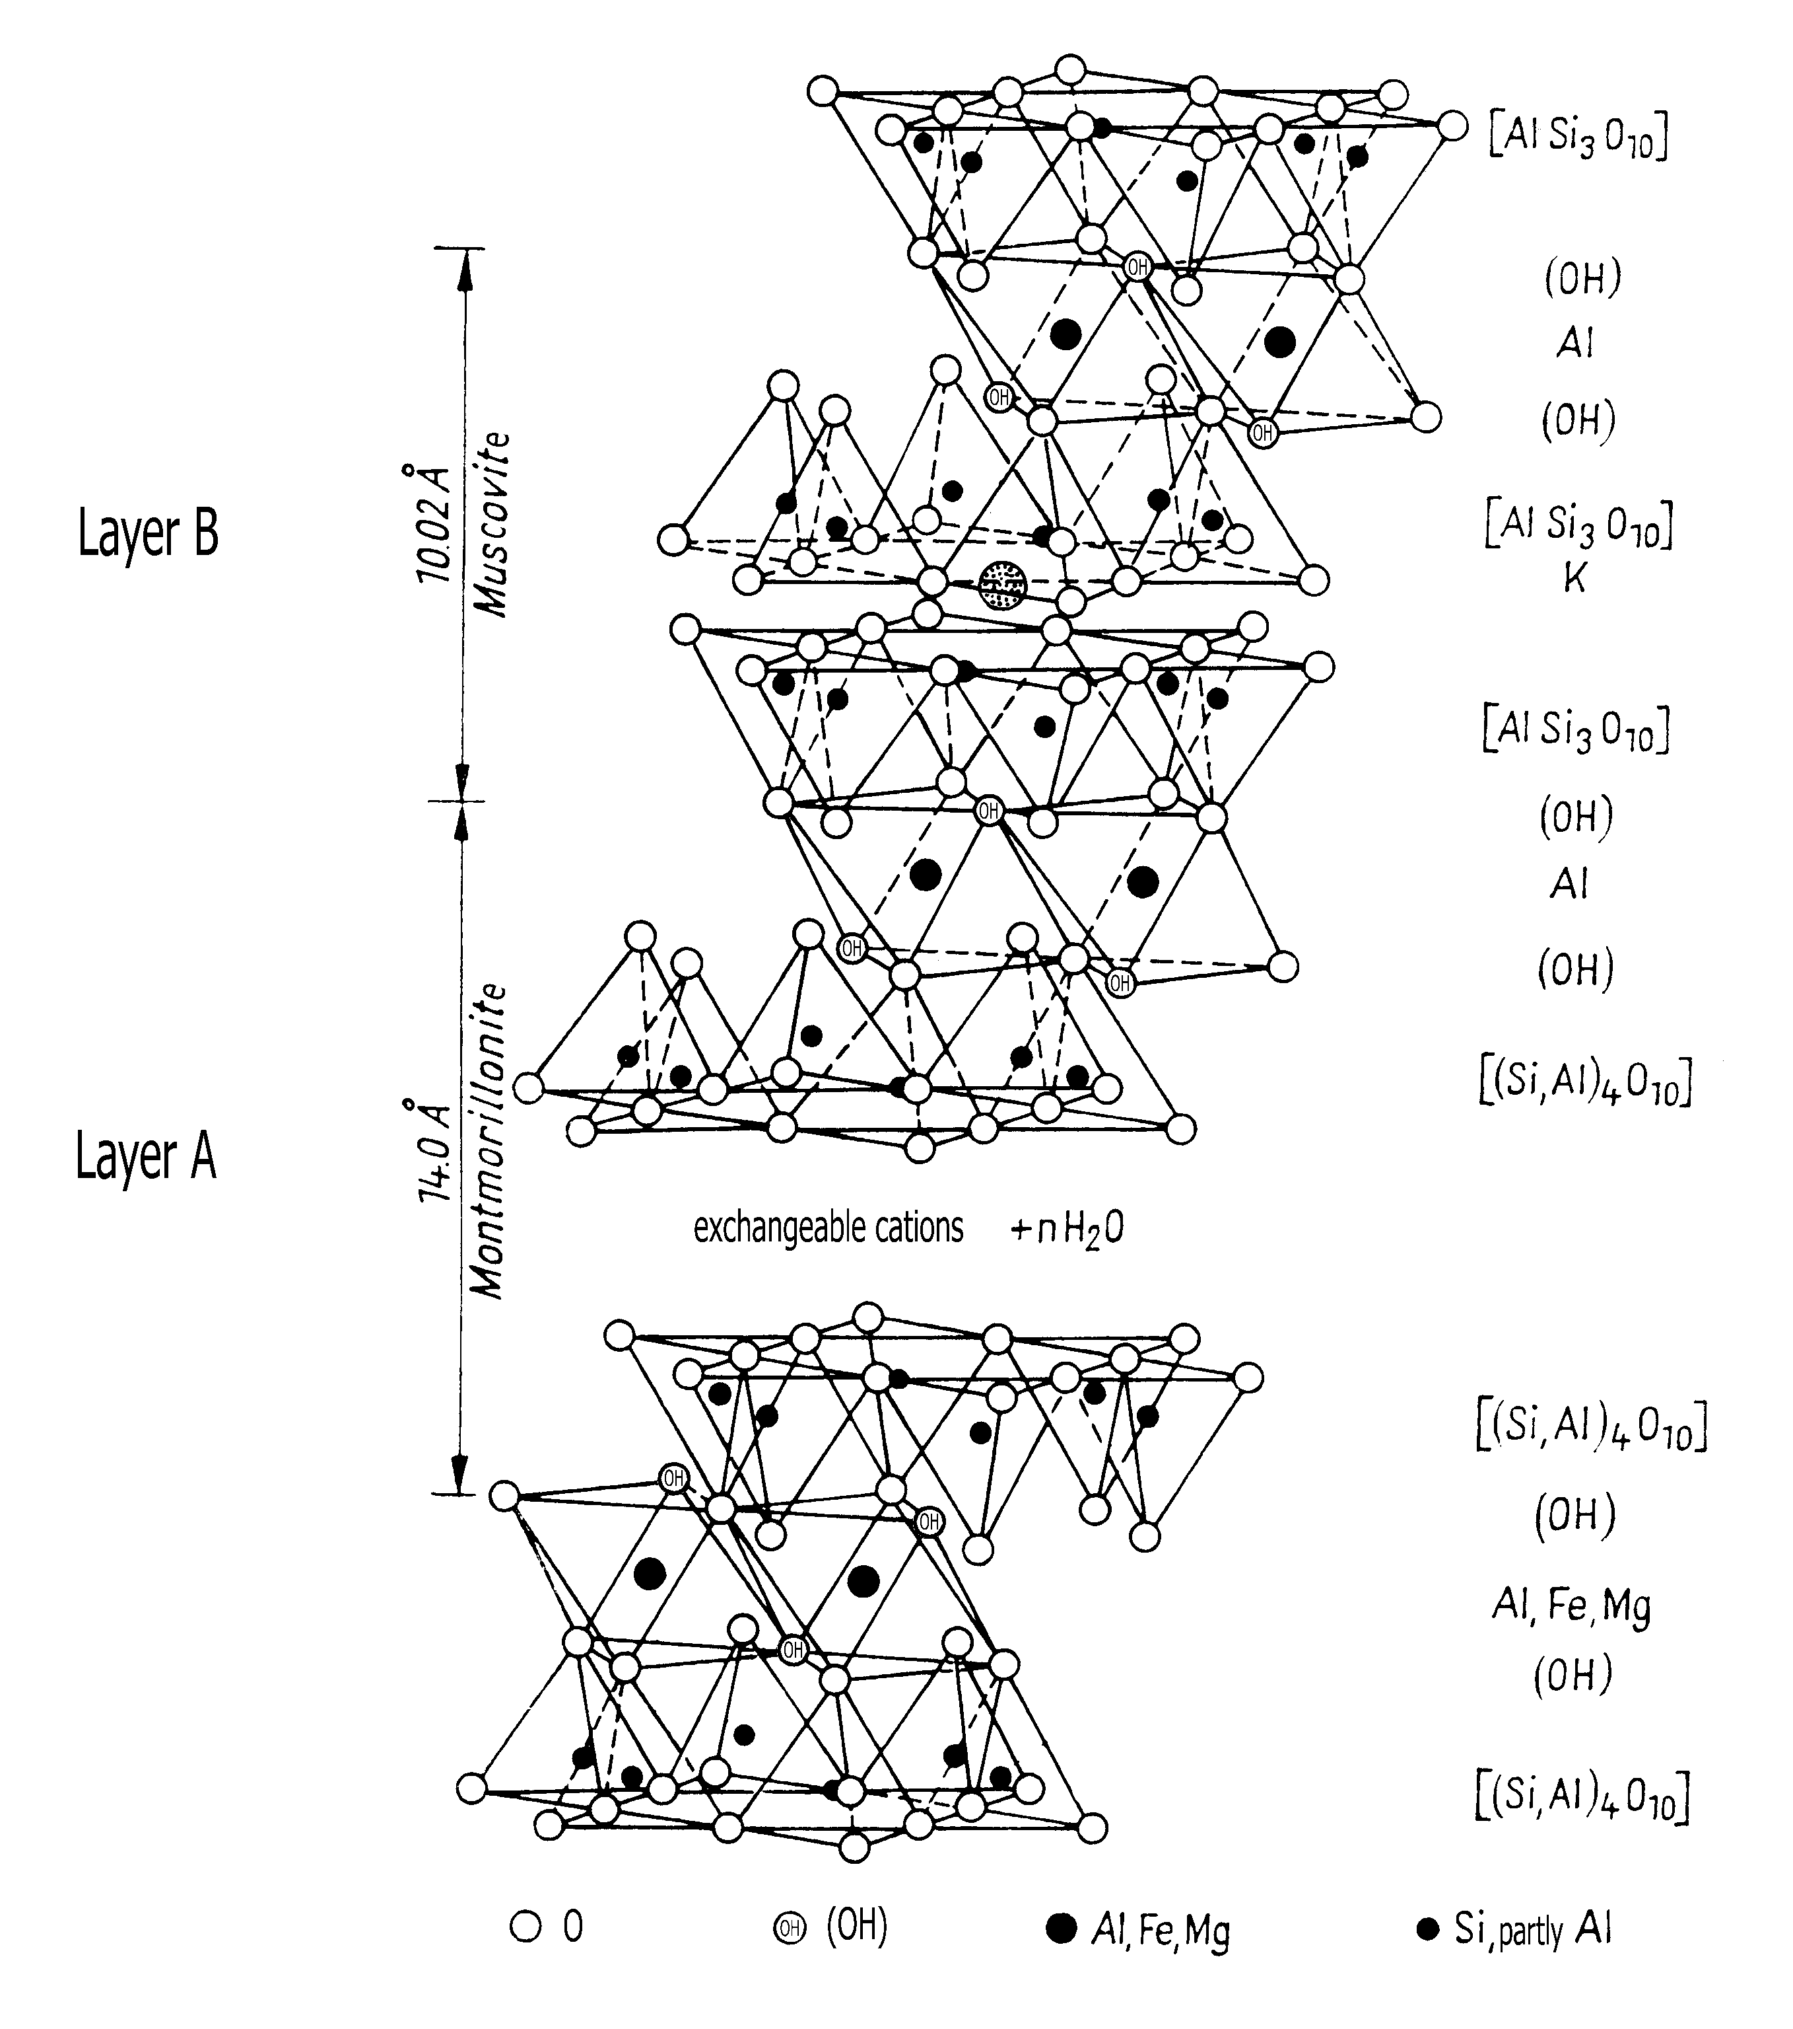

Fig. 4. Crystal structure of Friedland Ton muscovite-montmorillonite. It can be described as a system of alternating layers of irregular sequences (e.g. …AABAAABBABAAABAA…). The proportion between A and B is 70 % A (montmorillonite) to 30 % B (muscovite).

**3.1.2 Pilot experiments**

A UV-radiation unit of type” isel-UV-Belichtungsgerät 1” with 32 W power, and a sensor of type”Digital Luxmeter LX-101” were used for the experiments [6]. The samples were applied in 2 m foils with very low UV-absorption capacity, and mangled to give films of uniform thickness: 10-15, 20-30 and 40-60 m. The samples were exposed to radiation for 50 s while recording the penetrated radiation. The average wavelength was 3650 Å (365 nm), which represents the upper part of the UV range (140-3900 Å). UV radiation with lower wavelength than 2900 Å is almost totally absorbed by the atmosphere and by the most shallow, dense skin. The thicknesses correspond to the amount of cream normally applied to the skin: 10 m is estimated to represent a minimum while 60 m is a rather thick coating.

While “Tone” can form extremely thin films, the smectite-rich “MD1” cream was too stiff to form thinner films than 40-50 m, hence requiring softening for serving as sun-protection cream. The MD2 cream based on Friedland clay has a lower surface potential than the montmorillonite-rich clay and hence higher fluidity and less thixotropy for the same glycerine content. It could therefore form a 10-15 m film, which appeared brownish in the foil.

The application of a cream must take place with a minimum of friction and deformation of the skin. This calls for a low viscosity, which was determined for the three of the candidate creams.

pH of UV creams is a matter of debate with no clear recommendation other than it should be neutral or weakly alkali. The problem is that pH changes with the skin temperature and excretion of sweat. pH of freshly prepared candidate creams were determined and are given in the report.

**3.1.3 Test results - pilot tests**

*UV radiation*

Fig. 5 shows the results from testing of the commercial sun protection cream and the MD2 cream, both with 10-15 m film thickness, while Fig. 6 shows the corresponding results of the testing of 40-60 m films [6]. The diagrams give the data from the test of the commercial Tone cream as well. One finds that the penetrating UV radiation increases somewhat with the time after onset of radiation, the”normalized” value being taken as the 50 s reading. For 10-15 m films the flux was 292 lux for “MD2” and 433 lux for Tone, while it was 490 lux for the cream-free reference test. A major result of the thin film testing is hence that Tone reduces UV penetration by only about 12 % - which supports the critics of Swedish medical expertise – while MD2 reduces the penetration by about 40 %. A thin film of the latter is thus about 3 times as effective as one prepared by use of “Tone”.

Using 40-60 m films the 50 s flux reading was 290 lux for Tone and 185 lux for MD2. The thick Tone film thus reduced the flux by about 40 % while MD2 reduced it by about 60 %. For these films, which were about 4 times thicker than the thin ones, the reduction in penetrated UV radiation of the “MD2” cream was hence about 1.5 times stronger than of the Tone cream. The 50 s reading of “MD1” gave the value 410 lux, which represents a reduction of UV radiation by 80 lux, or 16 %, which is too little to make this cream a competitive candidate.

Fig.5. UV-penetration of 10-15 m thick films of tested sun protection creams. Upper curve:”Reference” test with no clay. Middle: “Tone”. Lower: “MD2”.

Fig.6. UV-penetration of 40-60 m thick films of tested sun protection creams. Upper: ”Reference” test with no clay. Middle: “Tone”. Lower: “MD2”.

For 20-30 m films the UV flux was 260 lux for MD2 and 320 lux for Tone. The medium-thick Tone film thus reduced the flux by about 35 % while MD2 reduced it by about 50 %. For these films the reduction in penetrated UV radiation of the MD2 cream was hence about 1.5 times stronger than of the Tone cream.

*Viscosity*

The recorded viscosities and pH conditions are given by Tables 3 and 4.

Table 3. Viscosity of candidate creams determined by standard viscometry.

|  |  |
| --- | --- |
| Cream | Viscosity, mPas |
| Tone | 510 |
| MD1 | 520 |
| MD2 | 2980 |

Table 4. pH of candidate creams determined by use of a precision pH meter.

|  |  |
| --- | --- |
| Cream | pH |
| Tone | 6.2 |
| MD1 | 8.5 |
| MD2 | 7.9 |

**3.1.4 Conclusions from pilot tests**

The major conclusions of the study were:

* The MD1 cream based on montmorillonite had a very low UV reduction potential, while MD2 representing I/S clay gave significantly better UV reduction than the montmorillonite-rich MD1 and the organic Tone cream. For 10-15 m film thickness, which is a minimum value in practice, the I/S-based cream gave a reduction in UV penetration by about 40 %. This is about 3 times more than the organic cream could provide. For 20-30 m films the corresponding reduction of the clay cream was about 50 %, and for 40-60 m films it was about 60 %,
* The reason for the efficiency of the I/S clay MD2 is believed to be its content of the heavy, dark mineral chlorite (about 11 %) and the high content of sheet-structured phyllo-silicates like mica and illite, which provide it with a strong reflexion ability when smeared on a plane surface. The montmorillonite-rich MD1 clay should be nearly as effective or even better because of the alignment of the very large number of flaky particles but its poor performance is believed to be caused by the conversion of this physical state to the flocculated gel form in the thixotropic hardening process,
* The organic cream has the desired viscosity at smearing and the montmorillonite-rich clay MD1 behaves similarly while the I/S clay MD2, being less thixotropic, is stiffer but still easily smeared on the skin,
* The relatively low pH of the organic “Tone” cream may explain the commonly noted irritation of the eyes on contacting them with this type of creams. The montmorillonite-rich MD1 cream is significantly alkaline as all smectite clays and may be even less well accepted by the skin. The I/S clay MD2 is weakly alkaline and not expected to cause pH-related skin reactions.

**3.2 Comprehensive study**

In recent years more extensive investigations have been made on the UV-protection capacity of clays by numerous investigators (cf. [7]). A study by Hoang-Minh [7] has helped to clarify the function of UV-protecting clays in several respects, referred to here as “Comprehensive study”. These investigators focused on kaolinite, smectite, mixed-layer clay and mica-dominated clay for protection against ultraviolet (UV) radiation in the range 250-400 nm wave length with special respect to the bulk Fe2O3 content.

**3.2.1 Testing**

The air-dry materials were milled to <63 m and mixed with glycerol to a mass ratio of 1:2. The materials were then mixed with wool-wax-alcohol to a mass ratio of 10 % and 20 % and stirred to become homogeneous. The UV-investigated thin samples had a thickness of only 3 m and the measurements were made by use of an AnalytikJenaAG SPECORD 50 photometer, equipped with a UV lamp as light source giving wavelengths of 250-400 nm, hence covering the entire UV-B and UV-A spectral ranges. The light transmission was evaluated by applying the following equation:

*T* = (*I*×100)/*I*0 (%) (1)

where: *I*0 is the intensity of the incident UV ray; *I* is intensity of the UV ray after passing through the sample. The listed and plotted transmission values were evaluated by subtracting from the I-values those represented by the organic constituents.

**3.2.2 Test results - comprehensive study**

Fig. 7 shows the UV-transmission of four creams with 20 % content of clay of different types and of a popular organic cream (fine-dotted curve). One finds that the transmission of the very thin clay creames was similar for the kaolinites and the I/S clay and for all bentonites except for the relatively iron-rich Garfield smectite clay, which is in fact iron-bearing nontronite. The graphs also tell that the commercial organic clay let nearly no UV radiation through for higher wavelengths than about 250 nm. The poor performance of smectite-rich creames hence underlines that the content of heavy minerals like Fe2O3 reduces UV transmission especially for mica-dominated clays (Fig. 8).

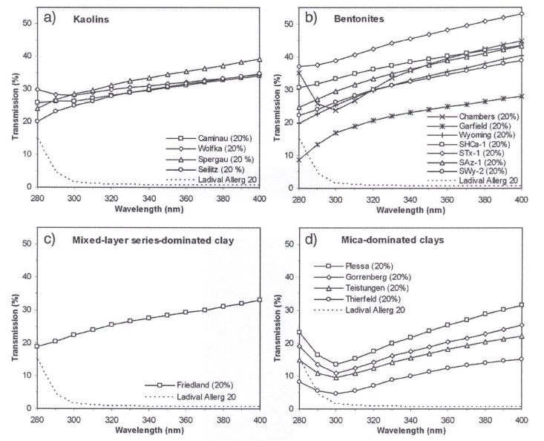

Fig. 7. UV-transmission of creames with 20 % kaolin (a), bentonites (b), I/S mixed clay (c), and mica-dominated clay (d), [8].

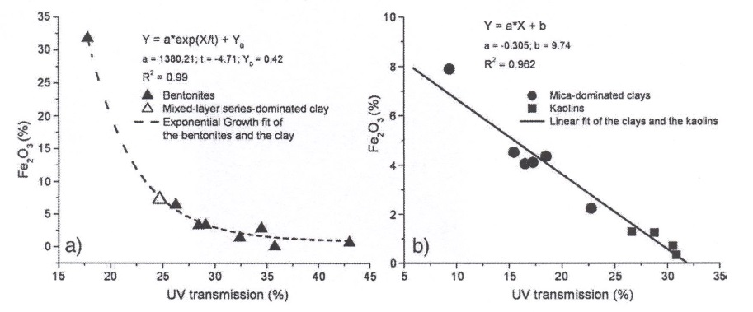

Fig. 8. Impact of bulk Fe2O3 on the average transmission value of investigated clay creames. a) expandable (bentonites and I/S clays), b) non-expandable (kaolinite and micaceous clay), [8].

**4 Conclusions**

Three factors appear to be of greatest importance for the UV-protection capacity of clay-based suncreams according to the presented studies: *i)* thickness and density, *ii*) alignment of particles, and *iii*) Fe content.

The impact of density is primarily the workability and placeability of the creams for which the viscosity is a determinant. The density span can be 1100-1500 kg/m3 of the clay mixtures and they should undergo gel/sol transition for easy smearing and subsequent stiffening, i.e exhibiting thixotropy. Alignment of particles maximizes reflexion of UV radiation and is obtained by smearing the creams on the skin but the coagulation leading to irregular particle orientation that is caused by very strong thixotropic behaviour causes loss of this property. The clays should hence be moderately thixotropic, which is typical of mixed-layer I/S minerals like the German Friedland clay. The thickness of the smeared cream film is anything from 3 to several hundred micrometers and for thicker films than about 10 micrometers the UV protection of smectitic clay/glycerol mixtures is better than for equally thick organic creams.

The content of Fe in the crystal structure, as in nontronite, or as iron compounds like Fe2O3 is of greatest importance, for more than 10 % of this oxide the clay cream let no UV radiation through. However, such components undergo hydration and cause cation exchange from Na in the virgin state, representing good ductility and homogeneity of the cream, to Fe by which syneresis effects involving fissuring and loss of UV protection capacity can occur.

**5 References**

[1] Setlow, R.B., 1974. The wavelengths in sunlight effective in producing cancer: a theoretical analysis. Proceedings of the National Academy of Sciences U.S.A. 71:3363-3366.

[2] WHO, 2002. Global Solar UV Index: A Practical Guide 2002. World Health Organization.

[3] Pusch, R., Yong, R.N., 2006. Microstructure of Smectite Clays and Engineering Performance. Taylor

& Francis, London and New York. (ISBN10: 0-415-36863-4).

[4] Pusch, R., Feltham,P., 1980. A stochastic model of the creep of soils, Géotechnique, 30.4:497-506.

[5] Pusch, R., 2008.Geological Storage of Radioactive Waste. Springer Verlag Berlin Heidelberg, (ISBN:Springer Verlag Berlin Heidelberg, (ISBN: 978-3-540-77332-0).

[6] Mediton, 2003. Internal report, Mediton Co, Neubrandenburg, Germany.

[7] Hoang-Minh, T., Le, L., Kasbohm, J., Gieré, R., 2011. Substituting non-natural agents in UV- protection cream by a mixture of clay with Ganoderma pfeifferi extract,” Appl Clay Sci, 53: 66–72.

[8] Hoang-Minh, T., Le, L., Kasbohm, J., Gieré, R.,2010. UV-protection characteristics of some clays, Appl Clay Sci, 48.3:349-357.