**Evaluation of Geothermal Energy Potential in Parts of the Lower Benue Trough, Nigeria, Using Aeromagnetic Data**

**Chukwudi C. EZEH and Chukwuebuka J. MAGBO**

**Department of Geology and Mining**

**Enugu State University of Science and Technology, Enugu, Nigeria**

**Email: ebukajohn421@gmail.com**

**ABSTRACT**

Nine sheets of Regional Aeromagnetic data of parts of Lower Benue Trough were evaluated through the use of Centriod and forward modelling of the spectral peak methods with a view to delineating structures and basin geometry of the Southern (Lower) Benue Trough of Nigeria. Geological cross sections were used to determine the number of anomalies from the residual magnetic map after which the Discrete Fourier Transform method was applied in calculating and computing the depth to the top (Zt), depth to the bottom (Zo), Curie point depth (CPD), Geothermal gradient and heat flow. From the results, the depth to the top of the magnetic source ranges between 0.5km and 12.5km with the highest points towards the south - western part of the study area. The depth to the bottom of magnetic source (centriod depth) ranges from 2km to 54km and the highest areas are located towards the north-eastern part of the study area. The geothermal gradient ranged between 21oC/Km to 29.5 oC/Km, Ogoja, Oturkpo, and Katsina –Ala are situated within the region of high geothermal gradients (>26.5 oC/Km). The heat flow values from 22mW/M2 to 74 mW/M2 and the area with the high heat flow values are Makurdi, Ogoja, Gboko and Katsina –Ala areas. The results also show that the Curie temperature isotherm within the study area is not a horizontal level surface, but it is undulating. The study also identified high sedimentary thickness and considerable geothermal potential which could serve as a basis for hydrocarbon accumulation and geothermal exploitation.

**Key words: Geothermal Gradient, heat flow, Crustal Temperature, Geothermal Potentials.**

**INTRODUCTION**

Due to the increasing need for sustainable energy resources, developed and developing countries of the world are looking for an alternative energy resources that is clean and renewable. Geothermal energy can be developed as an alternative to fossil fuel, thereby mitigating the negative impact of fossil fuelling on the environments.

Abraham and Nkitnam (2017), observed the presence of thermal and warm springs to be situated in the northern and central portions of the Cretaceous Benue Trough. Geothermal energy is a huge reservoir of thermal energy in the earth interior whose surface manifestation are volcanoes, geyseys, ground and hot springs (Shah et al, 2015).

Aeromagnetic survey works on the principle that variations in the measured magnetic field of an area reflect the distribution of magnetic minerals in the Earth’s crust (Anakwuba *et al*, 2010). There are varieties of reasons for which the survey is undertaken. They include; geologic mapping, mineral and oil exploration, environmental and groundwater investigations. They are also useful in the detection, location and characterization of magnetic sources. In addition, the use of aeromagnetic data to estimate Curie point depth through which the thermal structure of the earth’s crust in various tectonic settings is determined and several authors (Okuba *et al.*, 1985; Blakely, 1988; Okubo and Matsunaga, 1994; Hisarti, 1996; Onwuemesi, 1997; Tanaka *et al.*, 1999 and Dolmaz *et al.*, 2005;Ikumbur *et al.*, 2013; Chinwuko *et al.,*2013; Ofor and Udensi, 2014; Nwankwo and Abayomi, 2017) have written extensively on the thermal structure of the crust involving the curie point Depth estimations and geothermal energy potential of some parts of Nigeria.

This research work focuses on the evaluation of high resolution Aeromagnetic data through the use of centriod and forward modelling of the spectral peak method, with a view of delineating structures and basing geometry of the southern (lower) Benue trough, Nigeria. Residual Aeromagnetic data was used to determine the depth to the top of the sediment, depth to the bottom (centriod depth), Curie isotherm, geothermal gradient and Heat flow. Areas with high heat flow and geothermal gradient has high geothermal reservoirs. This study evaluates the geothermal potential in the study area using heat flow and geothermal gradients by the use of Aeromagnetic data.

**Location and geology of the study area**

The geology of the study area is presented in figure 1. The study area is bounded by latitudes 6o 001N and 7o 201N and longitudes 10o 301 E and 11o 101E of the lower Benue trough. . The total coverage area was about 27,225 square kilometres. The Benue Trough is a major geological formation underlying a large part of Nigeria and extending to about 1000km northeast from Bight of Benin to Lake Chad. The Trough is divided into Lower, Middle and Upper regions. The Anambra Basin in the west of the region is more recent than the rest. The Trough was formed by rifting of the central West African basement beginning at the start of the cretaceous. The Lower Benue Trough comprise of the Abakaliki Anticlinorium towards the Anambra Basin, and Afikpo syncline. The Asu River group found in the Abakaliki-Afipko basins is Albian to Cenomanian, comprising of fluvial regressive akosic sandstones lying directly on the crystalline basement; this is overlain by the transgressive Eze-aku formation of Turonian age. The Ezeaku formation consists of black shale and siltstones which sits unconformably at the Precambrian Gneiss to the north of Ugep.



**Figure 1. Geological map of Nigeria and locations of the study area (Modified After Obaje *et al*., 2004).**

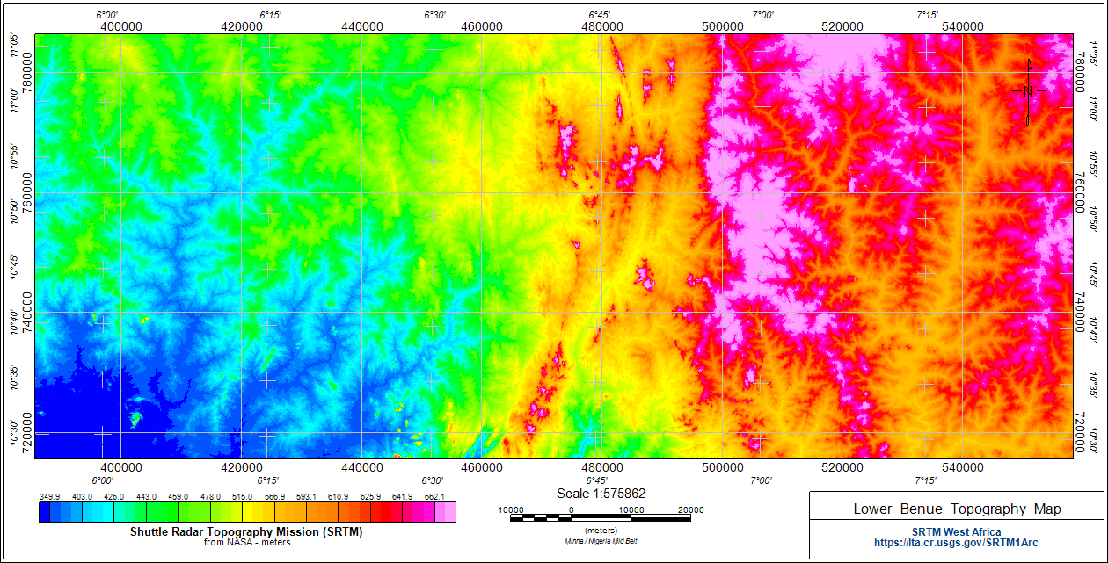

**Fig2. SRTM Topographic map**

The SRTM (Short Radar Topographic Mission) map shown above displays the topographic nature of the stud area. It ranges from 439.9m to 662.1m. From the map, it is revealed that the eastern (north and south) part of the map has the highest elevation while the north western part of the map reveal moderate elevation and the south western part of the map reveals areas of low elevation

**METHODOLOGY**

**Data acquisition and processing**

Nine Aeromagnetic Data sheets comprising of sheet numbers 250 (Agana), 251 (Makurdi), 252 (Akwana), 270 (Oturkpo), 271 (Gboko), 272 (Katsina-Ala), 289 (Ejekwe), 290 (Ogoja), 291 (Obudu), were obtained from the Nigerian Geological Survey Agency. The data was acquired and measured by Fugro Airbone Survey (2006)-(2007) on a scale of 1:250,000 series. The survey was carried long Northwest-Southeast lines with a spacing of 500m and flight elevation of 150m above sea level. The magnetic data was obtained from digitization of the total magnetic intensity contour maps on a scale of 1:100,000. The total coverage area was about 27,225 square kilometres. The Aeromagnetic data was compared or Geo-referenced to the universal Transverse Mercator coordinate system to ensure effective comparison with other digitized maps of the area.

The procedure involved in this study are digitization of Aeromagnetic map, separation of magnetic data, production of magnetic anomaly and first vertical derivative maps, analysis and modelling of magnetic anomaly data.

The Discrete Fourier Transform is applied to regularly spaced data such as the aeromagnetic data. The Fourier Transform is summarized by (Onwuemesi, 1997).

From spectral analysis results, curie isotherm is calculated using Bhattacharyya and Leu, (1975) method. The first step according to Bhattacharyya and Leu, (1975) is to estimate the depth to centroid (Zo) of the magnetic source from the slope of the longest wavelength of the spectrum that is given below:

$In\left[\frac{ρ(\sqrt{S})}{/S/}\right]=InA-2π/S/Z_{o}$ (1)

where,

P(s) is the radially averaged power spectrum (natural log of amplitude) of the anomaly /**s**/ is the wave number (Nyguist frequency) and A is a constant.

The second step is the estimation of the depth to the top boundary (Zt) of that distribution from the slope of the second longest wavelength spectral segment (Okubo *et al*., 1985),

$In\left[\frac{ρ(\sqrt{S})}{/S/}\right]=InB-2π/S/Z_{t}$ (2)

where,

B is the sum of constants independent of **/s/.**

Then, the basal depth (Zb) of the magnetic source was calculated from the equation of Bhattacharyya and Leu, (1975) as shown below:

$Z_{b}=2Z_{o}-Z_{t}$ (3)

The obtained basal depth (Z**b)** of magnetic sources in the study area is assumed to be the Curie point depth according to Bhattacharyya and Leu, (1975).

Hence, the heat flow and thermal gradient value was calculated in the study area using an equation expressed by Fourier's law as follows:

$\text{ q=λ}\frac{dT}{dZ}$ (4)

where,

*q* is the heat flow and λ is the coefficient of thermal conductivity.

According to Tanaka *et al*, (1999), the thermal gradient (dT/dZ) can be estimated using equation 4.9, where we have the Curie temperature (θ) and the Curie point depth (Zb) available: $\text{θ=}\left[\frac{dT}{dZ}\right]Z_{b}$ (5)

**QUANTITATIVE INTERPRETATION OF AEROMAGNETIC DATA**

In other to evaluate depths to basement across the study area, five (5) profile lines were taken on the residual map in perpendicular to the direction of the magnetic anomalies, namely A-A1, B-B1, C-C1, D-D1, E-E1 (fig. 2.). The profile lines in the residual map revealed a total of 24 anomalies. The anomalies were subjected to spectral analysis to estimate the depth to the magnetic source and other parameters like Curie point depth, geothermal gradient and heat flow within the study area.

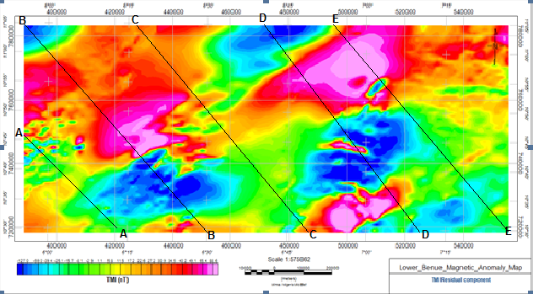

**Figure 3, Residual anomalous map with Profile line**

**Table 1. Analysis of the profile Lines**

|  |  |  |  |  |  |  |  |  |  |
| --- | --- | --- | --- | --- | --- | --- | --- | --- | --- |
| Profile A-Al | | Profile BBl | | Profile CCl | | Profile DDl | | Profile EEl | |
| x(km) | y(km) | x(km) | y(km) | x(km) | y(km) | x(km) | y(km) | x(km) | y(km) |
| 0 | 40 | 0 | 80 | 0 | 0 | 0 | 100 | 0 | 80 |
| 0.1 | 20 | 0.25 | 100 | 0.4 | 0 | 0.4 | 80 | 0.25 | 100 |
| 0.25 | 20 | 0.3 | 120 | 0.65 | 20 | 1 | 80 | 0.5 | 100 |
| 0.7 | 40 | 0.35 | 140 | 0.85 | 40 | 1.1 | 100 | 0.65 | 100 |
| 0.85 | 60 | 0.5 | 160 | 1 | 60 | 1.3 | 100 | 1.25 | 100 |
| 1 | 60 | 0.6 | 160 | 1.5 | 60 | 1.5 | 80 | 1.4 | 80 |
| 1.2 | 60 | 0.75 | 140 | 1.6 | 80 | 1.6 | 60 | 1.8 | 60 |
| 1.25 | 40 | 1.1 | 120 | 2 | 80 | 1.9 | 40 | 2 | 60 |
| 1.45 | 20 | 1.25 | 140 | 2.25 | 60 | 2.2 | 20 | 2.15 | 40 |
| 1.65 | 20 | 1.5 | 140 | 2.5 | 60 | 2.45 | 20 | 2.3 | 40 |
| 1.88 | 20 | 1.75 | 120 | 3.2 | 80 | 3 | 40 | 2.5 | 60 |
| 2 | 20 | 2 | 100 | 3.6 | 80 | 3.9 | 20 | 3.15 | 60 |
|  |  | 2.75 | 80 | 3.9 | 100 | 4.3 | 20 | 4 | 40 |
|  |  | 2.85 | 60 | 5 | 100 | 4.4 | 0 | 4.5 | 40 |
|  |  | 3 | 40 | 6.75 | 100 | 4.5 | -40 | 4.9 | 40 |
|  |  | 3.6 | 40 | 7.4 | 80 | 5 | -40 | 5.15 | 20 |
|  |  | 4.75 | 80 | 8 | 80 | 5.25 | 0 | 5.35 | 0 |
|  |  | 5.25 | 100 | 8.6 | 80 | 5.4 | -20 | 5.6 | -20 |
|  |  | 5.35 | 100 | 9 | 80 | 5.5 | -40 | 5.85 | -40 |
|  |  | 5.75 | 80 | 9.5 | 60 | 5.75 | 0 | 6 | -60 |
|  |  | 6 | 60 | 10 | 60 | 6 | 40 | 6.2 | -60 |
|  |  | 6.25 | 40 | 10.25 | 80 | 6.25 | 100 | 6.65 | -40 |
|  |  | 6.5 | 20 | 10.5 | 80 | 6.6 | 100 | 6.75 | -20 |
|  |  | 6.75 | 0 | 10.75 | 60 | 6.75 | 80 | 7 | 0 |
|  |  | 7 | -20 | 11 | 40 | 7.25 | 80 | 7.2 | 20 |
|  |  | 7.1 | -40 | 11.25 | 40 | 7.9 | 80 | 7.5 | 40 |
|  |  | 7.2 | -40 | 11.5 | 20 | 8.2 | 100 | 7.9 | 60 |
|  |  | 7.3 | -20 | 12 | -20 | 8.5 | 100 | 8.15 | 80 |
|  |  | 7.5 | 0 |  |  | 9 | 80 | 8.9 | 100 |
|  |  | 7.75 | 20 |  |  | 9.25 | 60 | 9.15 | 100 |
|  |  | 7.85 | 40 |  |  | 10 | 40 | 9.35 | 80 |
|  |  | 8.1 | 60 |  |  | 10.4 | 40 | 9.5 | 60 |
|  |  |  |  |  |  | 11.3 | 60 | 10 | 40 |
|  |  |  |  |  |  | 12.7 | 60 | 11 | 40 |
|  |  |  |  |  |  | 12.8 | 40 | 12 | 60 |
|  |  |  |  |  |  | 12.9 | 20 | 12.3 | 80 |
|  |  |  |  |  |  | 13 | 0 | 12.9 | 80 |
|  |  |  |  |  |  | 13.1 | -20 | 13.1 | 60 |
|  |  |  |  |  |  | 13.2 | -20 | 13.3 | 40 |
|  |  |  |  |  |  | 13.7 | -20 | 13.4 | 20 |
|  |  |  |  |  |  | 13.95 | -20 | 13.7 | 20 |
|  |  |  |  |  |  | 14.2 | 0 | 13.8 | 40 |
|  |  |  |  |  |  | 14.45 | 20 | 13.8 | 60 |
|  |  |  |  |  |  | 14.7 | 40 | 13.9 | 80 |
|  |  |  |  |  |  | 14.6 | 40 | 14 | 80 |
|  |  |  |  |  |  | 14.95 | 20 |  |  |
|  |  |  |  |  |  | 15 | -20 |  |  |
|  |  |  |  |  |  | 15.15 | 0 |  |  |
|  |  |  |  |  |  | 15.3 | 60 |  |  |
|  |  |  |  |  |  | 15.5 | 80 |  |  |
|  |  |  |  |  |  | 15.75 | 80 |  |  |

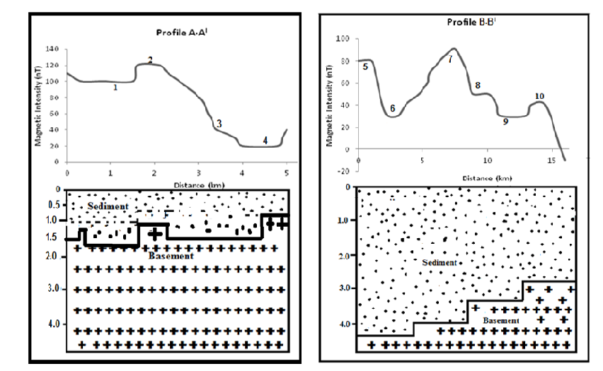

**Figure 4, Model Profile anomaly along A-AI. Figure 5, Model Profile anomaly along B-BI**

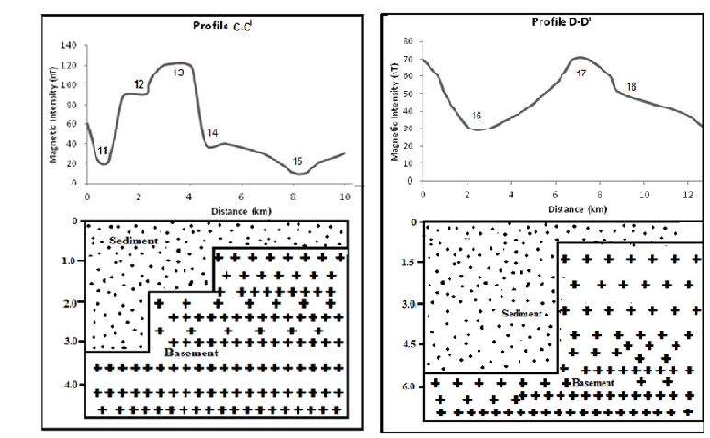

**Figure 6, Model Profile anomaly along C-CI  Figure 7, Model Profile anomaly along D-DI**

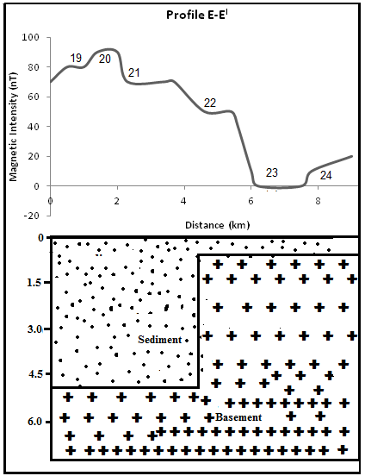

**Figure 8, Model Profile anomaly along E-EI**

**Table 2. Depth calculation Result from Spectral analysis**

|  |  |  |  |  |  |
| --- | --- | --- | --- | --- | --- |
| Anomaly | Depth to the Top (km) | Depth to the Bottom (km) | Curie Point Depth (km) | Geothermal gradient  oC/km | Heat Flow(mWm2) |
| 1 | 12,77460 | 12,2 | 11,05 | 23,4452 | 61,4509 |
| 2 | 11,67320 | 13,13 | 13,7 | 29,1422 | 70,3425 |
| 3 | 9,93425 | 8,76 | 25,03 | 22,2346 | 58,4511 |
| 4 | 9,29714 | 10,53 | 22,99 | 23,2299 | 60,69958 |
| 5 | 2,61886 | 5,76 | 29,04 | 29,3566 | 70,23496 |
| 6 | 4,04175 | 5,14 | 24,97 | 24,2452 | 57,86541 |
| 7 | 4,16683 | 4,81 | 23,45 | 21,1343 | 59,11938 |
| 8 | 2,78819 | 5,76 | 23,17 | 25,6753 | 65,56423 |
| 9 | 1,76618 | 6,09 | 29,66 | 29,6544 | 24,66543 |
| 10 | 1,83936 | 9,06 | 30,01 | 21,4533 | 23,42341 |
| 11 | 2,89119 | 3,08 | 22,26 | 26,1674 | 56,45324 |
| 12 | 2,38351 | 2,79 | 21,72 | 24,2456 | 59,4342 |
| 13 | 0,67320 | 1,38 | 30,76 | 21,4335 | 30,24532 |
| 14 | 0,71833 | 9,88 | 33,34 | 24,2918 | 54,25188 |
| 15 | 1,81228 | 8,78 | 23,97 | 29,5693 | 74,06542 |
| 16 | 1,46625 | 6,14 | 20,69 | 27,1517 | 70,13242 |
| 17 | 1,19508 | 7,96 | 23,93 | 24,6507 | 68,4327 |
| 18 | 2,03137 | 8,12 | 27,84 | 28,0235 | 63,54637 |
| 19 | 2,00309 | 54,61 | 23,55 | 24,248 | 63,56341 |
| 20 | 1,21583 | 9,02 | 24,76 | 23,5143 | 64,67549 |
| 21 | 2,10640 | 8,34 | 24,25 | 25,0522 | 60,6549 |
| 22 | 2,72369 | 9,07 | 20,66 | 28,0875 | 58,5679 |
| 23 | 2,93912 | 9,56 | 23,61 | 25,8891 | 69,54657 |
| 24 | 2,64870 | 4,98 | 24,61 | 23,3761 | 60,56438 |
| Average | 3,65452 | 9,372917 | 24,12583 | 25,21964 | 58,58129583 |

**RESULTS AND DISCUSSION**

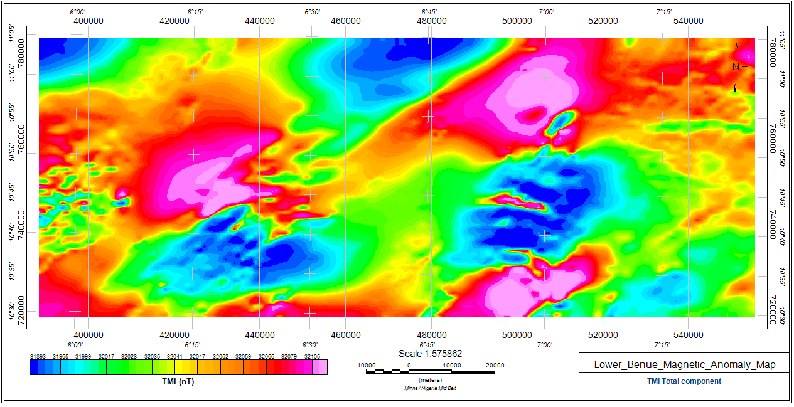

**Figure 9a. TMI Magnetic map of the study area**

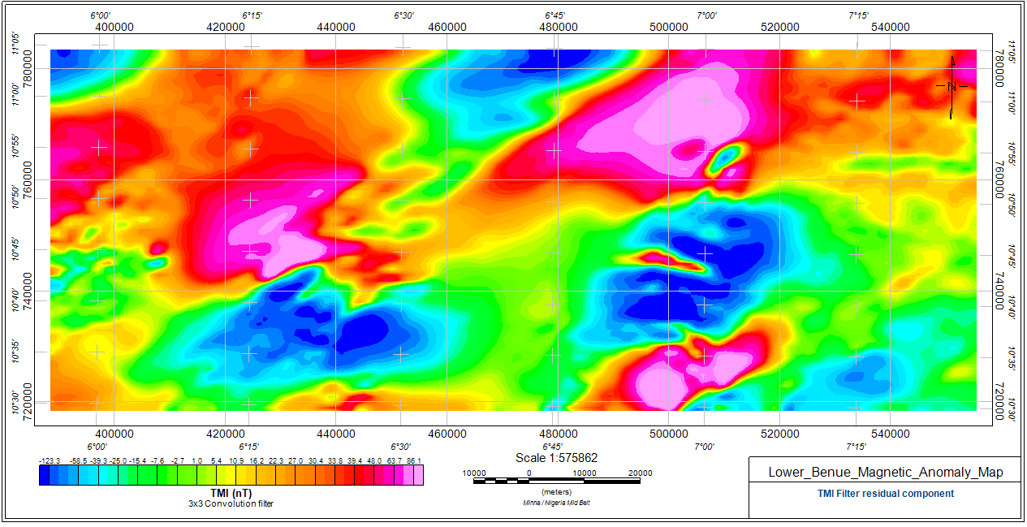

**Figure 9b. Residual filtered map of the study area.**

Figures9a and b shows the maps of the total magnetic intensity and the residual maps. The maps indicate that the total magnetic intensity field ranges from 31893-32105nT, while the residual maps ranges from -127 to 88.6nT. Both maps show areas with low and high magnetic fields. The two maps revealed that at the North eastern and north western parts of the maps comprising of Akwana, Agana, Oturkpo, there is strong evidence of higher magnetic intensity as well as numerous anomalous bodies within those areas. The contours lines in these areas are closely spaced signifying that the depths to the basement around these areas are relatively shallow according to visual interpretation. The central and south western parts of the study area has contours that are widely spaced signifying that the depth to basement is relatively high in these areas and their magnetic field values are also low. The study area is also faulted and the major fault is trending East-West (E-W) according to Chinwuko et al 2012.

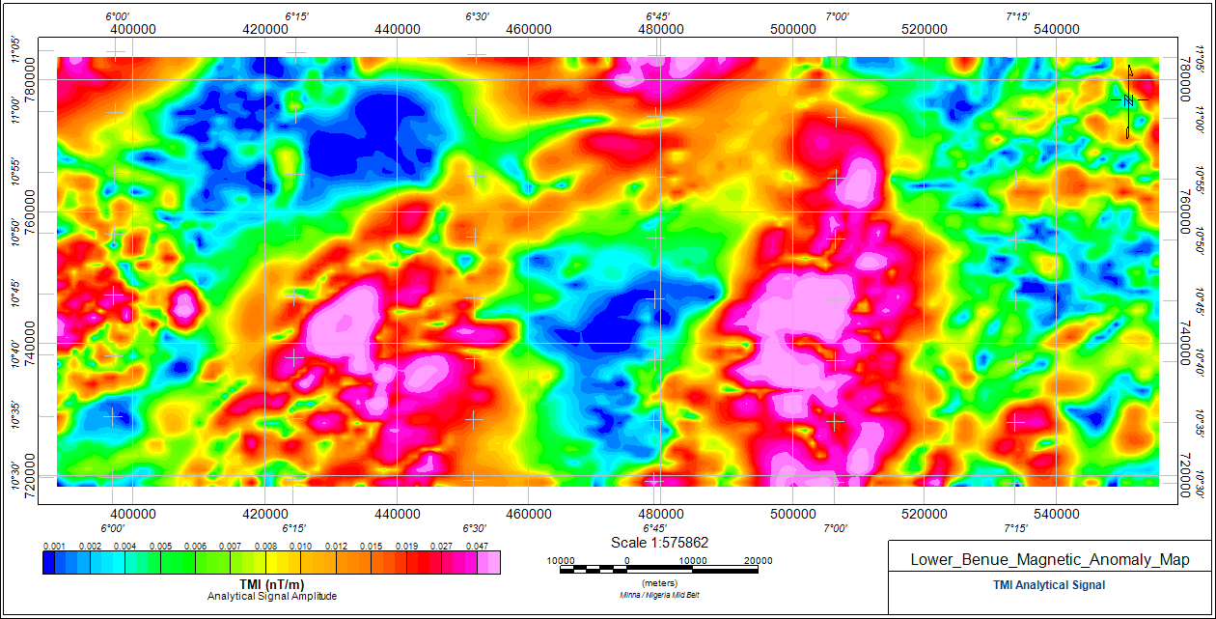

**Figure 9c, TMI Analytical Signal Amplitude**

The analytical signal amplitude map (fig. 9c.) shows the major anomaly trend within the study area. The trend shows NE-SW, SW-NW and W-E directions respectively. The analytical signal amplitude values ranges from 0.001nT/m to 0.047nT/m.

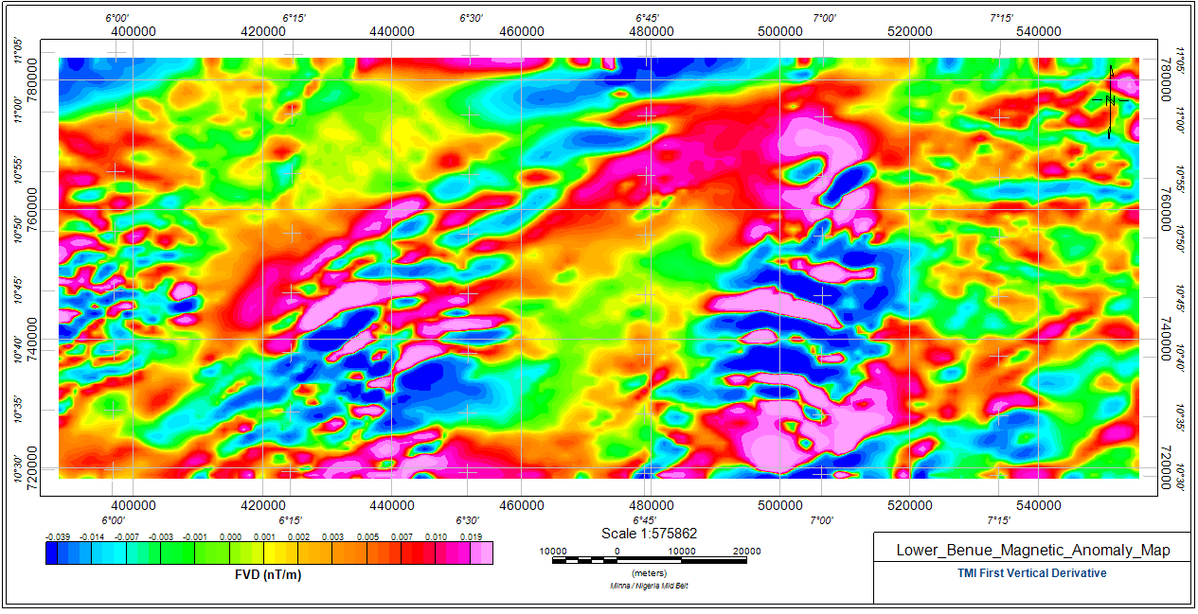

**Figure 9d, First vertical derivate map**

The first vertical derivative (FVD) map (fig. 9d.) yielded both positive and negative values. The positive values ranges from 0.001nT to 0.019nT and this could be caused by the presence of the mafic (Basaltic) rocks in the study area. While, the negative values ranges from -0.039nT to -0.001nT and this also could be attributed to the presence of felspathic rocks with high concentration of feldspar, silica and minerals like quartz, muscovite and so on. From the FVD map, the south eastern, south western and north eastern parts of the shows massive occurrences of mafic and felspathic rocks. While the north central parts of the map is sparsely scattered.

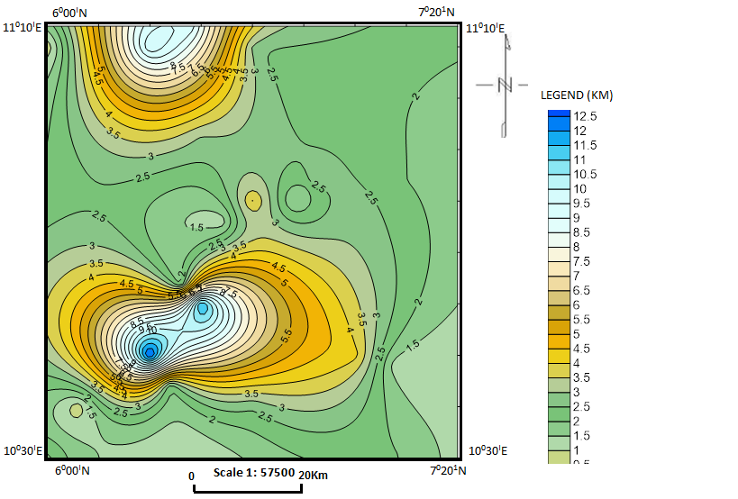

Agana

Makurdi

Akwana

Oturkpo

Gboko

Katsina-Ala

Ejekwe

Ogoja

Obudu

**Figure 10, Depth to the top of the anomalous body map (Contour interval~ 1km)**

From the spectral depth map of the depth to the top of the anomaly (fig.10), it can be observed that the deepest depth is within the south western and north western parts of the map (2D map) ranging from values of about 12km. the area comprises of Ejekwe, Ogoja, Agana and Markudi area. While the north eastern part and south eastern part of the map reveals areas with shallow depth to the top of the anomalous body.

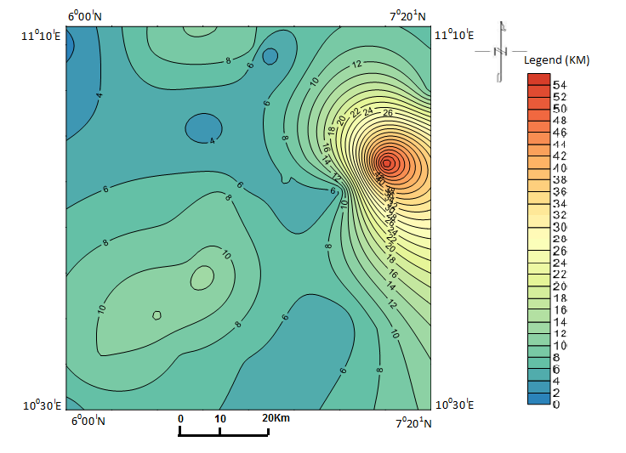

**Scale: 1: 57500**

Agana

Makurdi

Akwana

Oturkpo

Gboko

Katsina-Ala

Ejekwe

Ogoja

Obudu

**Figure 11, Depth to the bottom of the anomalous body map (Contour interval~ 1km**

The map of the depth to the bottom of the anomalous body (fig.11) reveals that the area with the highest depth to the bottom of the anomalous body is within the north eastern part of the map comprising of Katsina-Ala and part of Akwana areas. The depth value ranges from about 20km to 50km. while the remaining portion of the map has moderate to shallow depth to the bottom of the anomalous body.

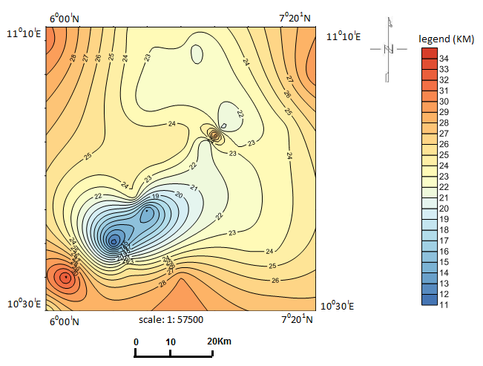

Agana

Makurdi

Akwana

Oturkpo

Gboko

Katsina-Ala

Ejekwe

Ogoja

Obudu

**Figure 12. Curie Isotherm depth map of the study area**

The Curie point depth (fig. 12.) of an area is generally dependent on the geological make up of the area, presence of geological structures like faults and synclines. It is also dependent on geological processes like tectonic activities, volcanic eruptions and presence of basement complexes. From the Curie isotherm depth map (fig.12), it can be observed that the trend of the increment is in NE-SW direction and the area with the shallowest depth is within the south western part of the map with a value range of about 11kn-19km. while the entire north eastern and north western part including the south eastern parts of the map has high curie isotherm depth values ranging from about 20km to 32km. according to Tanaka et al 1999, Curie point depth shallower than 10km is for volcanic and geothermal fields, from 15km to 25kn predicts island arcs and ridges, deeper than 20km predicts plateaus and trenches. He also said that the areas comprising of high heat flows and high curie depth values corresponds to areas of volcanic, basement complex, metamorphic regions etc.

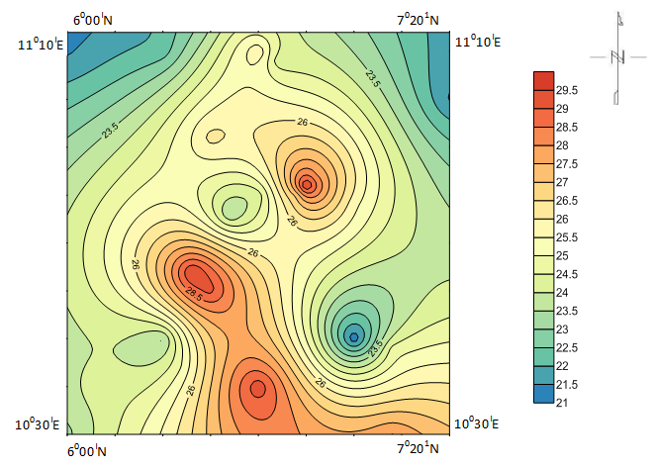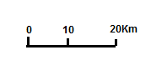

**Scale 1: 57500**

Agana

Makurdi

Akwana

Oturkpo

Gboko

Katsina-Ala

Ejekwe

Ogoja

Obudu

Legend (oC/km)

**Figure. 13. Map of Geothermal gradient of the study area**

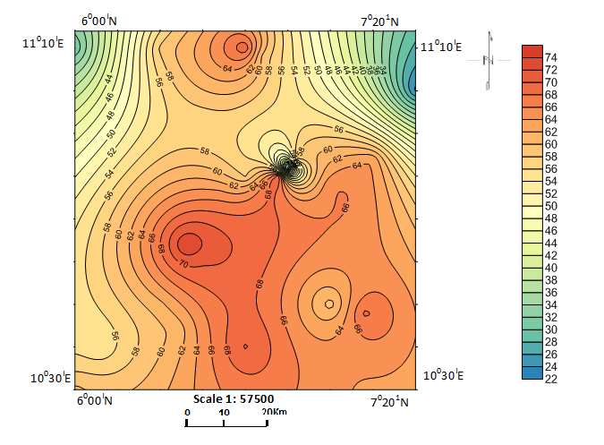

Agana

Makurdi

Akwana

Oturkpo

Gboko

Katsina-Ala

Ejekwe

Ogoja

Obudu

Legend mW/m2

**Figure 14. Heat flow map of the study area**

Correlation between geothermal gradient and heat flow shows a positive relationship which means that areas with high geothermal values will likely have high heat flow values. From both map (fig.13, and fig.14), it is revealed that south eastern portion of the study area and north central areas has both high geothermal gradient and heat flow values. The geothermal gradient ranges from about 250C/km to about 28.50C/km within the area and the heat flow value ranges between 54mW/m2 and 70mW/m2 in this area two. Then, the eastern and north western part of the maps reveals areas of both moderate to low geothermal gradient and heat flow values. The low to moderate geothermal gradient values ranges from 210C/km to 240C/km while the low to moderate heat flow value ranges from 22mW/m2 to 48 mW/m2 respectively.

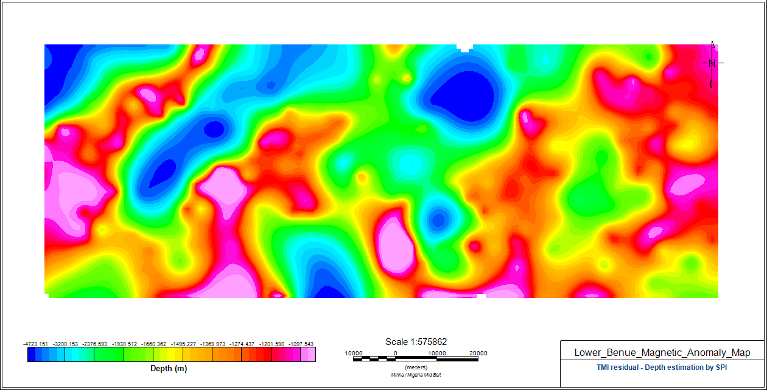

Agana

Makurdi

Akwana

Oturkpo

Gboko

Katsina-Ala

Ejekwe

Ogoja

Obudu

**Figure 15. TMI Depth Estimation map of the study area from Spectral analysis**

**SUMMARY AND CONCLUSION**

Generally, basement depth within the study area was estimated along 5 profile lines using Discrete Fourier Transform of Aeromagnetic data. The TMI depth estimation map (fig.15) reveals that the depth to the basement generally has ranges in depth and they include the area with low depth, moderate depth and high depth (thicknesses). The area with low depth includes the Oturkpo area and part of Makurdi axis. While the areas with moderate depths (thickness) are around Gboko and Katsina-Ala areas. The area with high depth (thickness) is seen around Ogoja, Akwana, Obudu and Ejekwe areas. However, based on the computed sedimentary thickness (fig.10 and fig.11), the geothermal gradient (21-29.5 oC/Km) (fig.13), and heat flow (22mW/M2 - 74 mW/M2) (fig.14), there is possibility of geothermal energy generation within the areas of high TMI depth values (fig.15) and they are around the south eastern –north eastern part of the map and some portion of the south western part of the map (fig. 15).

The high sedimentary thickness and presence of prevalence fractures within the study area which may serve as a migratory pathway for hydrocarbon and geothermal fluid that generates the geothermal energy. These pathways could make possibility of hydrocarbon generation in the study area feasible, Emujakporue and Ekine (2014). The areas with low sedimentary thickness (low geothermal potential) could possibly house the mineral ore deposits located within the study area.

**REFERENCES**

Abdullahi, B.U., Rai, J.K., Olaitan, O.M. and Musa, Y.A., 2014. A Review of the correlation between geology and geothermal energy in North-Eastern Nigeria, Journal of Applied geology and geophysics, 2(3):74-83.

Abraham, E.M., Lawal, K.M., Ekwe, A.C., Alile, O., Murana, K.A. and Lawal, A. A., 2014. Spectral analysis of aeromagnetic data for geothermal energy investigation of Ikogosi Warm Spring–Ekiti State, South-Western Nigeria, Geothermal Energy, 2(6): 1-21.

Abraham, E.M. and Nkitnam, E.E. (2017). Review of Geothermal energy researve in Nigeria; the Geo Science fonts, International journal of earth science and Geophysics, 13, 15.

Anakwuba, E. K., and Chinwuko, A. I.2015. One Dimensional Spectral Analysis and Curie Depth Isotherm of Eastern Chad Basin, Nigeria. Journal of Natural Sciences Research, 5(19):14-22.

Anakwuba, E.K., Onwuemesi, A.G., Chinwuko, A. I. and Onuba, L. N. 2011.The Interpretation of Aeromagnetic anomalies over Maiduguri – Dikwa depression, Chad Basin Nigeria: A Structural View. Scholars research library. Archives of Applied Science Research, 3(4):499-508.

Bhattacharryya, B.K., and Leu, L.K., 1975. Spectral analysis of gravity and Magnetic anomalies due two dimensional structures. Geophysics, 40:993-1031.

Bhattacharyya, B.K., 1966. Continuous spectrum of the magnetic field anomaly due to a rectangular prismatic body. Geophysics, 31:121.

Chinwuko, A. I., Onwuemesi, A. G., Anakwuba, E. K., Okeke, H. C., Onuba L.N., Okonkwo, C.C. Ikumbur, E. B., 2013. Spectral Analysis and Magnetic Modeling over Biu – Damboa, Northeastern Nigeria. IOSR Journal of Applied Geology and Geophysics, 1(1):20- 28.

Chinwuko, A.I., Onwuemesi, A.G., Anakwuba, E.K., Onuba, L.N., and Nwokeabia, N.C., 2012**.** The Interpretation of Aeromagnetic Anomalies over parts of Upper Benue Trough and Southern Chad Basin, Nigeria. Advances in Applied Science Research,3(3):1757-1766.

Emujakporue, G. O and Ekine, A. S., 2014. Determination of Geothermal Gradient in the Eastern Niger Delta Sedimentary Basin from Bottom Hole Temperatures, Journal of Earth Sciences and Geotechnical Engineering, 3(2014):109-114.

Obaje, N.G.J, Wehner, H., Hamza, H., Scheeder, G., 2004. New geochemical data from the Nigerian sector of the Chad Basin: Implications on hydrocarbon prospectively. Journal of African Earth Sciences, 38(5):477-487.

Okubo, Y.J., Graf, R., Hansen, R.O., Ogawa, K., Tsu, H., 1985. Curie point depth of the Island of Kyushu and surrounding areas. Japan Geophysicics, 53: 481-491.

Onwuemesi, A.G., 1995. Interpretation of magnetic anomalies from the Anambra Basin of southeastern Nigeria. Ph.D thesis, Nnamdi Azikiwe University Awka, Nigeria:12-55.

Onwuemesi, A. G., 1997. One dimensional spectral analysis of aeromagnetic anomalies and curie depth isotherm in the Anambra Basin of Nigeria. Journal of Geodynamics, 23(2):95-107

Saibi, H, Aboud, E. and Azizi, M., 2015. Curie point depth map for Western Afghanistan deduced from the analysis of aeromagnetic data, Proceedings World Geothermal Congress 2015, Melbourne, Australia: 19-25.

Tanaka, A.Y., Okubo, Y. and Matsubayashi, O., 1999. Curie point depth based on spectrum analysis of the magnetic anomaly data in East and Southeast Asia, Tectonophysics, 396:461-470.

Telford, W.M., Geldart, I.P. and Sheriff, R.E., 1998. Applied Geophysics, Second Edition, Springer, Berlin: 770

Wright,J.B., 1981. Review of Origins Evolution of the Benue Trough in Nigeria. Earth Evolution Science,2: 98 -103.

Wright, J. B.; Hastings, D.; Jones, W. B. and William, H.R., 1985. Geologyand Mineral resources of West Africa. George Allen and Urwin, London, England: 12-19