Patent trend analysis: Extended reality (XR) and future virtual adventure
Liu, Li-Lun, Ph.D¹, Chiang, Chung Hang² ,Chen, Shu Hui, Ph.D³.,

¹Professor, Department of Business Administration, College of Business, Chung Yuan Christian University, Taoyuan City, Taiwan.
²Candidate of Ph.D, College of Business, Chung Yuan Christian University, Taoyuan City, Taiwan.
³Ph.D, Department of International Business, Chung Yuan Christian University, Taoyuan City, Taiwan.

Correspondence
Chiang, Chung Hang, Chung Yuan Christian University, Taoyuan City, Taiwan.
Email: lawrence_chiang@cycu.edu.tw

Key words: Extended reality (XR), augmented reality (AR), virtual reality (VR) and mixed reality (MR), Patent trend

Abstract
Patent trend analysis plays an effective and important role in innovation tendencies and investigating high-tech progressions among technology field. The interdisciplinary applications of XR technology have led to scattered scholarly works and fragmentary insights to be translated into practice. XR is an umbrella term that encompasses both virtual reality (VR), augmented reality (AR) and mixed reality (MR), among others. Despite the promising outlook, this nascent technology has been shrouded by uncertain possibilities, making the adoption of XR technology much slower than expected. Thus, there is a demanding need for a critical review and synthesis XR patent analysis in order to support this emerging field in information system (IS). To accomplish this goal, the study analysis the current patent trend from 2016 to 2021 total of 412 patents through the software of INNOVUE. In summary, this study identifies the major trends in development and forecasts the future of XR adoption.

Introduction
Patent analysis plays an effective and important role in innovation trends and investigating high-tech progressions in a certain field ( Jee et al., 2019; Nguyen et al., 2020; Devarajan et al., 2021). Patent trend analysis is assuming a statistical analysis of the rate of publication of patents pertaining to a certain field or assigned to a certain company or country which is able to provide information about technology maturity and corporate technology strategies (Bigwood, 1997). Some scholars even claim that patent analysis is a meaningful methodology way to inspect current developments in science and technology (Musyuni et al., 2021; Petralia, 2020). In the past few decades, the market saw a new group of users of patent information emerging. These users are not only managers working in companies with strategic departments but also people who try to seek new opportunities on any platform. Their needs that target patent information from a strategic perspective are different from the needs of patent experts. From the primary patent analysis, we derived the following desired functionality to support trend analysis and technology management based on patent developments.

A granted patent can provide protection to the invention in the country where the patent was granted (Yetisen & Volpatti, 2014). The invention is not protected in countries where patent applicants did not seek protection. Thus, most major inventions apply for patents in some major countries. According to such logic, we need to know the dedicated application area for important discoveries to understand where the most competitive battlefield for important discoveries falls. Through the observation of time intervals, it analyzes the rise and fall of the "XR" patent published we are able to observe the overall "XR" technology development. Extended reality (XR) has refurbished the way people experience physical to virtual environments and from observation to immersion. XR technologies have ushered in the next era of human connection and it is dramatically changed our life. It remedies distances between people and opens the gates to countless unprecedented new opportunities. You may find XR applications in IT, media, healthcare, education, training, military, and mobility. Anyone could find AR in their modern smartphones and desk tables, simply buy VR headsets, or just play games with MR which sits nicely between AR and VR. These XR technologies have already changed the way people live their lives, if you like these devices as a communication platform you may allow the physical and virtual worlds to merge and make distance disappear. Moreover, the pandemic gives XR development a considerable lift. While constraints driven by the pandemic fast-tracked XR interest, the innovation was growing and evolving on its own. New categories like entertainment, tech, auto, education, medication, and beyond these fields will continue to explore the possibility of how XR helps drive growth across businesses. XR’s trajectory will continue to rise with new products, innovation, and use cases.

In this paper, the author is trying to trace the patent route of extended reality (XR) and find out how this technology has transformed the world. Through the literature review, this study gained a preliminary understanding of XR technology development. After setting the necessary keywords and setting the search criteria, 536 patents were obtained through the INNOVUE system software, and 412 patents were obtained after manual filtering and deducting of non-relevant patents. Accordingly, based on the number of annual patents published, we learned the trend development by year. Conferring to IPC patent classification, we can identify which patents are most valued. Based on the development status of the relevant patents in the countries, we determined the five countries with the highest number of patents respectively. We also categorize the companies with the highest number of patent invention, and classify the organizations that are currently investing the most R&D experience in XR technology. Finally, the R&D experts with the most patents are acknowledged as the companies where they work, so that we can understand the dynamics of the people who have the core technology. By combining the above studies, we can conclude the trend of XR's patent development and forecast the future progress of XR technology.
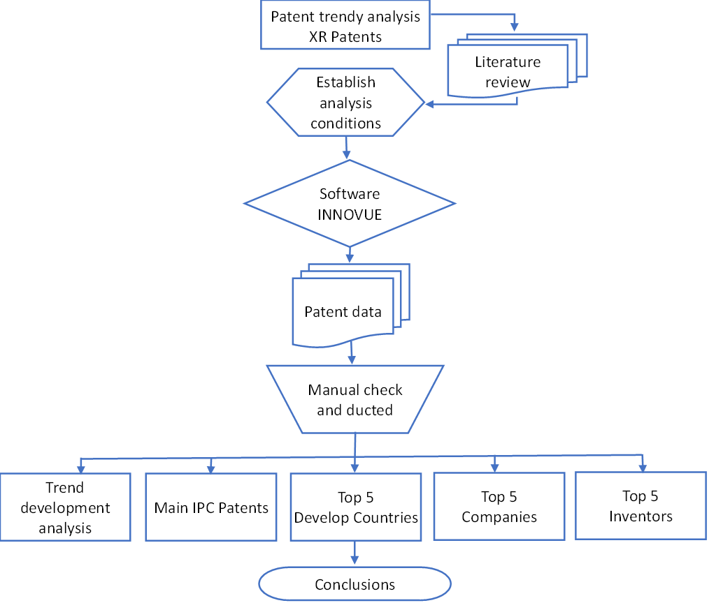
Figure 1: Research flow
Literature review
Introduced by Paul Milgram (Milgram et al., 1994), extended reality (XR) is a technical term that refers to all real-and-virtual combined environments and human-machine interactions generated by emerging technologies and encompasses immersive technologies, such as augmented reality (AR), virtual reality (VR) and mixed reality (MR). XR is a rapidly growing field being applied in a wide range of entertainment, marketing, real-estate, training and remote work. According to Grajzova et al., (2021), the Extended Reality (XR) Market is expected to register a CAGR of 57.91% over the forecast period (2022-2028). According to research by Markets & Markets, the market size of all extended reality technologies combined is expected to reach USD 125.2 billion by 2026, at a compound annual growth rate (CAGR) of 30.6% between 2021 and 2026. XR would be able to link digital, and physical worlds, and transformative spaces to create a world to fulfill various imaginations. The widespread adoption of new technology, such as VR, AR, and MR brings with it a vast landscape filled with opportunities for new category leaders to be created. With the increasing need to address the significance of mental health, it evokes the flourishing of XR technologies acceleration of human life and potential.

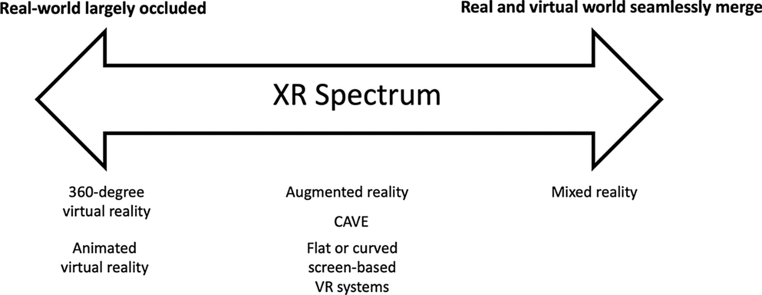
Figure 2: XR spectrum
Source: Le Noury et al., (2022)

VR, AR and MR difference
According to Noury et al. (2022), the real world is full of various information in 360-degree virtual reality and animate virtual reality. XR Spectrum will seamlessly merge the real and virtual worlds (Figure 2). While Virtual reality (VR) is completely virtual Augmented reality (AR) uses a real-world setting. VR users are controlled by the system and AR users can control their presence in the real world. VR requires a headset device, but AR can be accessed with a smartphone. VR only enhances a fictional reality while AR enhances both the virtual and real world. MR emerged in the real and virtual worlds in such a manner that a window is created between VR and AR (Rokhsaritalemi et al., 2020). As a result, a real-world object could interact with a virtual object to accomplish practical scenarios for the user.

Virtual reality (VR)
Virtual reality is a computer-generated simulation of an alternate world or reality. It creates simulations implies a complete immersion experience that shuts out the physical world envelope or “immerses” the viewer via computers with sensory equipment such as using VR devices like HTC Vive, Oculus Rift, or Google Cardboard. Users can be transported into a number of real-world and imagined environments such as the middle of a roaring dinosaur colony or even the back of a primitive mob. Apart from games and entertainment, virtual reality has also long been used in training, education, science, and marketing. For instance, IKEA recently released an interactive VR experience (IKEA Place) that allows customers to virtually redecorate and remodel their living rooms or kitchens with more than 2,000 furniture items (Stumpp et al., 2019). Automotive companies like Volvo, and Audi offer car shoppers a fully immersive test drive experience using a smartphone, and Google Cardboard headset puts shoppers in the driver’s seat and takes them on a ride through the country.

Augmented reality (AR)
Augmented reality technology has been assumed to be one of the top innovations opening up new growth points for businesses around the world. AR allows digital content to apply 2D and 3D such as audio and video files, textual or even tactile information that can be incorporated into users’ perceptions to be seamlessly overlaid and mixed into our perceptions of the real world (Yuen et al., 2011). Rather than seeming out of place, these augmentations can serve to aid and enhance individuals’ knowledge. The digital markups inherent in AR along with ‘added’ data, as a single, seamless environment can let users perceive the real world in a very diverse way. More precisely, AR is to “virtualize” the cybernetic image into real space, creating a completely simulated space around the user's eyes to replace the real space (Huang et al.,2018). Augmented reality (AR) adds digital elements to a live view frequently by using the camera on a smartphone. Examples of augmented reality (AR) experiences include Snapchat lenses, TikTok’s video apps, and the game Pokemon Go (Rose, 2021).

Mixed Reality (MR)
MR is one of the potential technologies that have gained attention in recent times. MR offers a unique environment as it combines real and virtual objects, is interactive in real-time, and is registered in three dimensions. In a Mixed Reality (MR) experience, which combines elements of both AR and VR, real-world and digital objects interact. Mixed reality does not exclusively take place in either the physical world or the virtual world, but is a hybrid of augmented reality and virtual reality. There are three terms for MR characters, namely immersion, interaction, and information (Rokhsaritalemi et al., 2020). Immersion refers to the real-time processing and interpretation of the user interaction with MR space without any controller but using natural communication modes (ie., gestures, voice, and gaze). Information refers to virtual objects being registered in time and space in the user environment which allows the user to interact with real and virtual objects in the user environment (Parveau & Adda, 2018)

To sum up, (XR) displays a veridical match to the information provided by the real world. XR experience caters to business issues and creates innovative solutions to add efficiency and increase productivity to meet critical client needs. It is inevitable that the next-generation computing platform-extended reality (XR)– has changed the way we work, learn, connect, and play by bridging the physical world to a digital one (Rauschnabel et al., 2017). Moreover, Huawei even revealed a "new Moore's Law" for the XR industry to guide capability expansion for carriers and industry partners in MWC Barcelona 2022 runs from February 28 to March 3 in Barcelona, Spain (PALADIN news, 2022).

Patent data collection and analysis
A patent data analysis was considered an essential approach to evaluating innovation
(Abraham & Moitra, 2001), monitor and forecast the development trends of technologies (Li et al., 2019; Trappey et al., 2011). This study is trying to analyze the granted patent of the XR technology to monitor its recent development. Understanding the up-to-date development patent trend is crucial for academic or practical researchers to plan their future research strategies. Also, the study of the XR patent trend could provide some insight for companies who are competing in the field advice and warming for their competition. The author contributed to the existing literature by providing a profile of XR technology progress by countries, companies, innovators, and IPCs. To enable content-oriented interactive analysis of patent material, patent data are aggregated and processed in a data pipeline that consists of the following major clarification stages: 1. Review and select background information for keywords identification. In this patent mining, we applied 4 keywords (XR, AR, MR, VR). 2. concept extraction from patents using advanced Natural Language Processing (NLP) software-INNOVUE. 3. Manual combination and detection of patents with respect to the IPC pyramid. 4. Assessment of the similarity between patents and deduct the irrelevant patents. 5. Determination and explanation of the key concepts behind them. The above steps were combined to conduct this study and analyze the current development trend of XR technology in order to provide research results for the reference of related units.

Finding of the Patent trend
The data presented in Figure 4 illustrate the steady growth of the total number of patents appearing in the INNOVUE database from 2016 to 2021. It can be seen from the figure in 2016, patents of XR-related technologies have begun to sprout, and the number of patent-published items has grown exponentially in the next two years. The amount of patents has developed steadily since 2017, however, the develop trend has instigated to raise slowly from 2020 to 2021. Taking the growth signs of patents as an example, the rapid growth in the past five years indicates the related industry has received its attention, and the development prospects of this industry can be seen in this picture as very futuristic. The reason for the slowdown in patent growth might cause by the COVID-19 pandemic that occurred since 2019, which instigated slowed down the original pace of growth. In addition, the moderate growth patent trend might also be the reason for the increasing barrier of entry for investors in XR and the relatively slow development of technology investment. However, the growth trend of patents is obvious and is expected to show a rising peak in the near future.

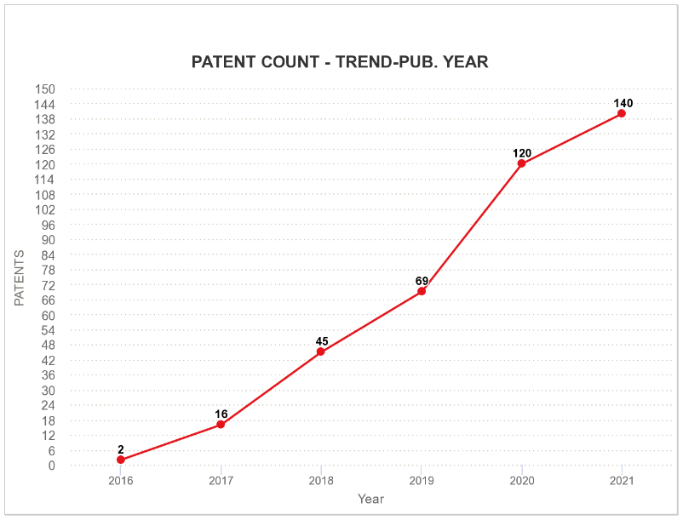
Figure 3: Patent trend development

The present legal status
On the whole, since the development of XR technology is still in the initial stage, the amount of the related patent has not yet achieved a considerable quantity. In figure 4, one can notice 2016 is the initial year for the patent related with XR technology. The following three years (from 2017 to 2019), valid patents of each year have reach over 20 items per year, but steady decrease since then. This might because of the influenced by the COVID-19 to slow down the research strength. By contrast, the patent publish rate were increase sharply in 2019 and 2020. This could because the patent owner eager to claim their right to protect their research territory. In 2021, both the publish and valid patent rate have steep declined. It will be interesting to perceive if the figures might rebound in following years as covid lockdowns are unblock throughout the world or the figures will indicative of a sharp drop off in XP patent activity.

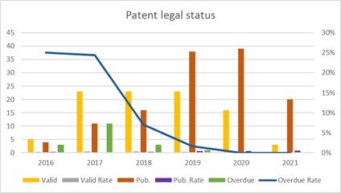
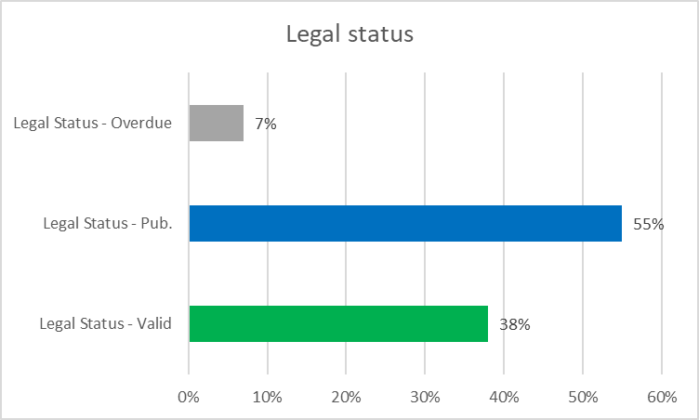

Figure 4: Patent legal status from by year Figure 5: Legal status percentage

As noted in figure 5, the majority of the patent status is published patents (55%). The proportion of valid patents is also very high, as high as 33%, while the proportion of invalid patents is only 7%. Such a proportion of patent expiration shows that this emerging technology is currently in the early stage of development. In this early stage of technology development, technology must be recognized by the innovator in order to prove to other potential users that the new product can work. The circumstance indicates the prospect of XR technology patent is promising, companies who are interested in this patent will give priority to the disclosure of the currently pending patent with the purpose of asserting sovereignty. The publication can be used for defensive purposes, e.g., to prevent others from gaining patent protection for your invention. By taking advantage of what’s known as “provisional rights” in the invention claimed to be a published application.

International patent classification (IPC)
This report describes our patent analysis of XR main patent classification system by applying the International Patent Classification (IPC). The International patent classification, abbreviated as IPC, was established by the Strasbourg Agreement of 1971. It creates a hierarchical system of language-independent symbols for the classification of patents and utility models according to the different technical fields to which they belong (Kemeneva, 2015). IPC patent trend analysis is mainly to examine the time point of "XR" investment of the main technique in the technical field. Identifying the IPC patent enables us to extract the trends in applicants’ technological inventions and to track the main development in the new technology innovative patterns. Table 1, provides the classification of the major IPCs, and explains the definitions in their classification. The description in Table 1 provides a convenient comparison of the content of each major IPC with the relevant content of patent analysis.

Table 1: IPC code definitions
IPC Code: | Definition statement
G06F | Electric digital data processing
G06T | Image data processing or generation, in general
G02B | Optical elements, system or apparatus
H04N | Pictorial communication, e.g., Television
G06K | Recognition of data; presentation of data; record carriers; handling record carriers
G06Q | Data processing systems or methods, specially adapted for administrative, commercial, financial, managerial, supervisory or forecasting purposes; systems or methods specially adapted for administrative, commercial, financial, managerial, supervisory or forecasting purposes.
H04R | Loudspeakers, microphones, gramophone pick-ups or like acoustic electromechanical transducers; deaf-aid sets; public address systems
H04L | Transmission of digital information, e.g. telegraphic communication
H04W | Wireless communication networks
A63F | Card, board, or roulette games; indoor games using small moving playing bodies; video games; games not otherwise provided for

Top 10 Main IPC patents
Through the observation of the main IPC, it analyzes the most important technique of "XR" technology investment and observes the concentration overall "XR" technology. As can be seen in figure 6, G06F is the main technique that arise the most attention. Its content technology input devices used to convert the data to be processed into a form that can be processed by the computer, output devices used to transfer data from the origin processor to the output device, such as interface devices, data computing devices, or data processing devices specialized for specific functions, and internal control program control devices, such as internal control devices, etc. Only second to the former, the G06T patent has attracted high attention from the industry. The patent includes computer graphics devices and 3D model image manipulation, image analysis, animation and image tracing, etc. The G02B patent is the third most important patent in XR's technology. This patent covers optical lighting systems or related devices. The fourth patent is H04N, the patent covers electrical communication systems with propagation paths employing beams of corpuscular radiation, acoustic waves, or electromagnetic waves, e.g., radio or optical communication. The fifth patent G06K class covers the recognition of data, presentation of data, record carriers, and handling of record carriers. For the other patents, please refer to the above table for descriptions, and we will not discuss them in more depth.
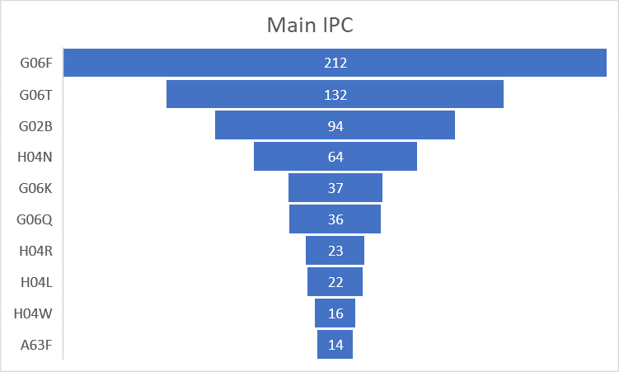
Figure 6: Numbers of main IPC
IPC interaction
In figure 7, each color represents the patent it is labeled with. A patent group is illustrated by a branch and the overlapping patent groups signify the interrelationship between the patents. In this figure, as can be observed that the top four patents G06F, G06T, G02B, and H04N have many connections with each other. The linking between G06F and G06T is stronger (as shown by the overlap between the largest patent group of G06T and G06F). Similarly, H04N, G06, and H04L are most relevant to the G06F patent. The connection of G02B with G06F and G06T is very identical. H04R is most closely related to G02B, while H04W and G06K are most closely related to G06T. The top 10 patents are all intricately related to each other. No single patent can be independent of other patents, and each technology is related to other technologies.

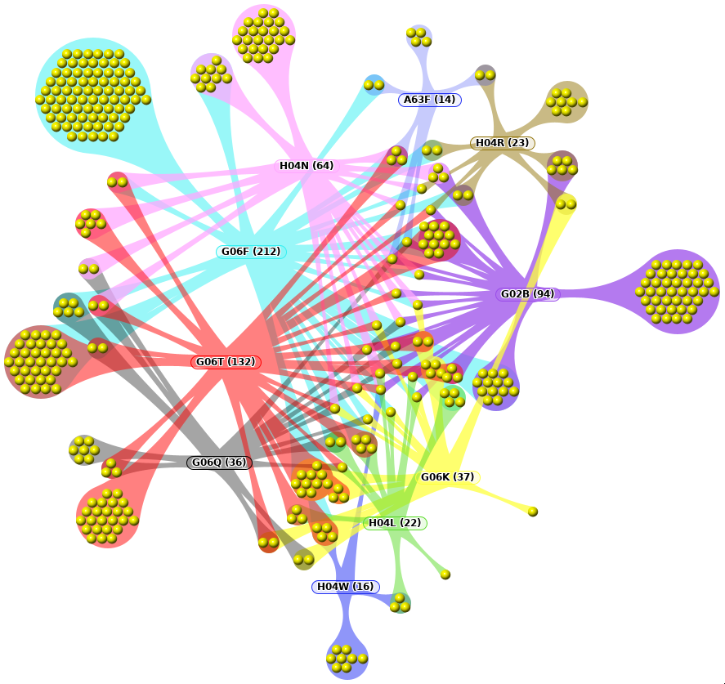
Figure 7: Main IPC patent interaction

IPC trend development
The IPC patent trend analysis is a point-in-time analysis of the main "XR" input technology areas. Through the observation of the time interval, we can analyze the evolution of "XR" technology investment and observe the overall "XR" technology development trend, which can be used as a basis for analysts to examine the accuracy of the data and also provide a technical reference value for decision makers to make technology investment.
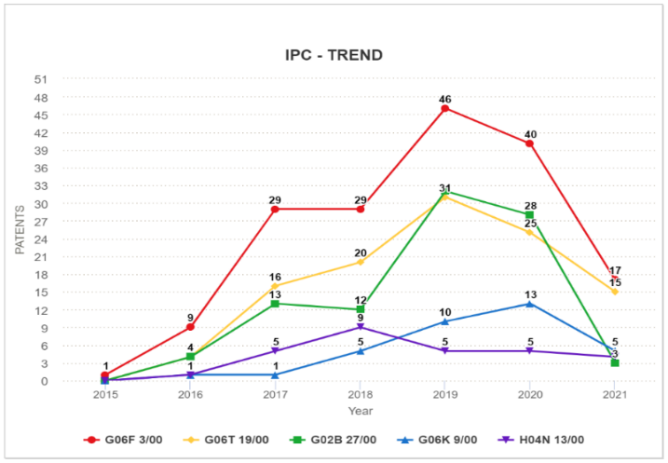

Figure 7: IPC trend development

In figure 7, the number of G06F-related patents has shown a rapid growth trend since 2015, with a peak in 2019, followed by a slow decline in 2020, and a continuous decline in 2021. The G06T-related patents have been developing at a relatively high rate since 2017. Although G02B-related patents were ahead of G06T-related patents for the first time in 2019, there was a dramatic and significant decrease after 2020. Accordingly, G06T is the second most important technology among the XR-related patents, while G02B is the third most important technology. In addition, the fourth important technology is G06K. Since 2015, the number of patents of G06K in the fourth place and H04N in the fifth place has been increasing in relation to each other. The fifth-ranked H04N was once ahead of G06K in 2018 but showed relative weakness in 2019. In general, all five major patents showed weakness after 2019, which is suspected to be related to the COVID-19 outbreak in 2019.

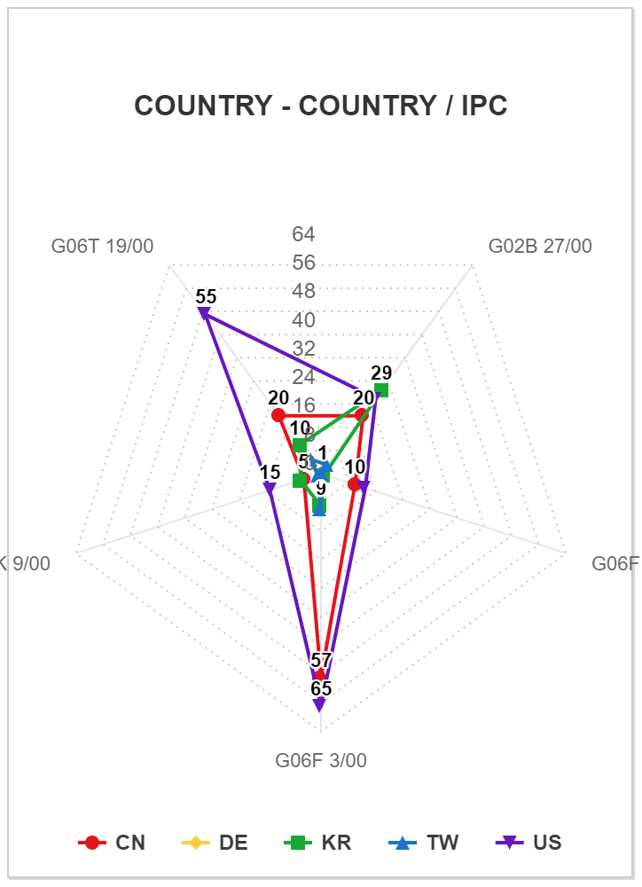
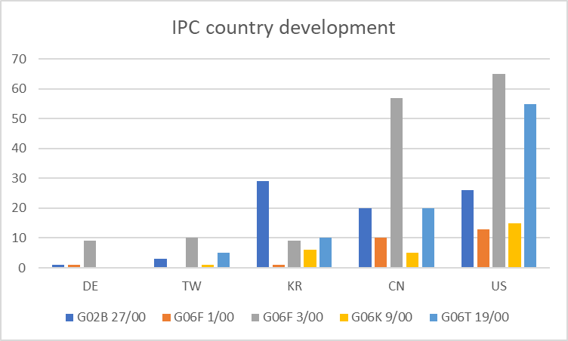
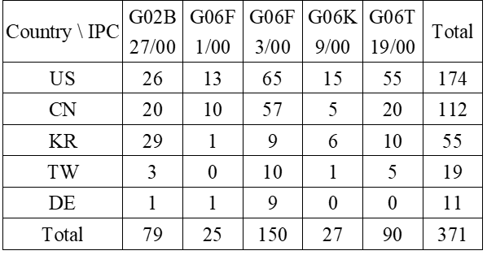

Figure 8: IPC country development

IPC development by Country
This investigation reveals the comparative analysis of IPC technology categories among the top five competing countries in XR. The application of major IPC technologies in each country can monitor the trend of technology development in the top five countries. Also, this information can reveal the fact that whether the development of XR technology is the mainstream technology direction among these countries. In figure 8, we can observe that the U.S. has the highest number of patents in all XP-related technologies. In particular, the patent of G06 3/00 (Electric digital data processing) is the majority, followed by the patent of G06T 19/00 (electric digital data processing). Among the major IPCs, except for the patent related to G02B 27/00 (optical elements, system, or apparatus), the U.S. is ahead of other countries in the other four IPCs. Next to the U.S., China's patent performance is also very impressive. China, same with the U.S., has the largest amount number of G06F 3/00 patents, G02B 27/00 and G06T 1/00 have a similar number. Followed by G06F 1/00, China has the least number of G06K 9/00 patents. Korea is the third country with the largest number of patents on XR-related technologies, the number of G02B 27/00 related patents is ahead of other countries. The fourth-ranking country, Taiwan, also performed well in the G06F 3/00 patent. Taiwan seems trying to catch up with other countries in the number of patents, however, it is obvious that they pay less attention to patent G06F 1/00. As can be seen in figure 7, the fifth-ranking country - Germany only focuses on G06F 3/00-related patents, and the rest of the patents do not attract their attention.

Table 2: Company development
Company | G02B 27/00 | G06F 3/00 | G06T 19/00 | H04S 7/00 | H04N 21/00 | Total
Huawei Technologies CO., LTD. | 4 | 5 | 6 | 0 | 0 | 15
LG Electronics INC. | 10 | 2 | 0 | 0 | 0 | 12
Qualcomm Incorporated | 0 | 4 | 0 | 5 | 1 | 10
Samsung Electro-Mechanics CO., LTD. | 7 | 1 | 1 | 0 | 0 | 9
Microsoft Technology Licensing, LLC | 0 | 3 | 3 | 0 | 0 | 6
Total | 21 | 15 | 10 | 5 | 1 | 52

Top 5 Companies on patent development
This company development analysis is a differentiated analysis of the major competitor companies' investment in XR technology (Table 2). Analyze the capability of each competitor and technology development strategy. In this discussion, we are able to analyze investment and internal patent layout policy on "XR" technology to assist whoever is concerned to create the maximum competitive power. In Table 2, we can observe that five companies are more advanced in XR-related technologies namely Huawei, LG, Qualcomm, Samsung, and Microsoft. The patented technologies that each company emphasizes are slightly different. Huawei attaches more importance to the technologies of G02B, G06F, and G06T, and it seems they value the degree of importance is equally. Along with the previous main IPC patent, it can be understood that Huawei has core mastery of XR's most popular core technologies. LG and Samsung are similarly devoting more effort to the technology related to the G02B patent. It seems Korea considered the progress of optical system-related technology as the core development and has high expectations for it. Qualcomm, on the other hand, has a unique observation on the mastery of the core technology of G06F and H04S (electric communication technique). Unlike other companies, Qualcomm has chosen to invest in different technology niches and has unique observations on the mastery of core technologies. On the other hand, Microsoft has dedicated its effort to the G06F and G06T patents. Following the top five XR core technology companies, the future of these companies' XR-related technology development is worthy of attention.

Table 3: Top 5 companies in XR patent
Company | Patents | Others Citing | Self-citing | Inventor Count | Patent Age | Activity Year | Relative R&D capabilities
Huawei Technologies Co., Ltd. | 24 | 0 | 0 | 74 | 2 | 4 | 100%
LG Electronics Inc. | 20 | 0 | 0 | 38 | 3 | 1 | 70%
Microsoft Technology Licensing, LLC | 11 | 0 | 0 | 45 | 3 | 5 | 51%
Samsung Electro-Mechanics Co., Ltd. | 10 | 0 | 0 | 38 | 3 | 4 | 44%
Qualcomm Incorporated | 10 | 0 | 1 | 16 | 3 | 4 | 33%

Companies on R&D capacities
The analysis of the detailed data on the R&D capability of each company includes the number of patents issued by each major company, the number of inventors, the number of self-citing and other citing, the patent age, and the activity year of related patents. Patent activities years means activities related to the preparation, filing, prosecution, and maintenance of the Licensed Patents and initiation of and participation in obstructions, reexaminations, rereleases, interferences, and post-grant reviews. From patent activities years, we are able to have an idea of the activity of the company’s response to relevant patents. To observe the organization’s patent production in XR technology and observe the time and resources that each company has invested in the research and development of this industry. Patent age shows the value obtained by dividing the sum of the year of each patent by the number of patents. The shorter the average patent age, the longer the technology has been protected by the patent, and the longer the technological exclusivity advantage is enjoyed. Through the above information, we can evaluate the competitive strength and manpower investment of each company in this technology, so that we can know which company is the most active in the research of this patent.

In Table 3, Huawei Technology has 24 patents and has 74 experts listed as inventors and is rated as the company with the strongest R&D capability. The average patent age of Huawei is only 2 years, which is the shortest among the top five research companies with the same type of patent. As mentioned above, the shorter the average patent term, the longer the time for the patent to be protected in the future. In other words, the longer the time that the company enjoys the technological exclusivity on the patent. It can be seen that the company has invested the largest amount of invertor manpower (74) in the research of this kind of patent, this may be the reason for the company's top position. It is worth noting that LG Electrics, which has 20 patents and 38 inventors, has been active for 3 years and only one year in the year of activity. The company's R&D manpower is only half of that of Huawei, but it has been able to obtain a similar number of patents as Huawei, which represents the superior quality of the company's talents and its future development potential is worthy of expectation. This fact means that Microsoft is a company that has the ability to make the best use of the patent. This fact means that Microsoft is a forward-looking company and has already invested in relevant research and development at an early stage, but at present, the number of patents obtained may be temporarily stagnant due to certain factors, and the company's future research and development is still worthy of attention. The fourth place is Samsung, which comes from Korea with LG, and LG has invested more or less the same amount of R&D manpower, but the number of years of living has been four years. Qualcomm is one of these five companies that have self-referenced. The subsequent patent cites its own patent indicating that its R&D autonomy is strong. The more a company's patents are cited, the more likely it is to be a technology leader in the 'AR/VR/MR' technology field.

Top 5 innovator and their companies
From Table 4, this inventor analysis includes the inventor, the number of patent applications by the inventor, and the inventor's works company. Through the inventor analysis, we can grasp the information of the key inventions in this industry, correspondingly able to use this information as an important basis for monitoring the technological development of XR in the future. In other words, by observing the dynamics and information of important inventors, we can perceive the trend of the output of each technology, and it is important information for the technological development of the company where the inventor works. From Table 4, we can see that the top 5 inventors of XR-related patents are all from China, belong to the same company, and jointly published 10 patents. The 10 patents invented by these 5 persons accounted for 8% of the total patent inventions in China. This is considering a high proportion of the total amount of patents in China. From this, we can understand that this team is very profound in the research of the patent and is the leader in this field. The future development of Fuzhou Bei Lan Network Technology Co Ltd. in this field is very promising.

Table 4: Top 5 inventors of XR patents
Inventor | Company | Patents
Zuo Yuying (左鈺瀅) | Fuzhou Bei Lan Network Technology Co Ltd | 10
He Kaiwei (何開偉) | Fuzhou Bei Lan Network Technology Co Ltd | 10
Xiao Ling (肖凌) | Fuzhou Bei Lan Network Technology Co Ltd | 10
Xiao Xiaosong (肖曉松) | Fuzhou Bei Lan Network Technology Co Ltd | 10
Chen Houyi (陳厚宜) | Fuzhou Bei Lan Network Technology Co Ltd | 10

From Table 4, we can see that the top 5 inventors of such patents are all Chinese and belong to the same company, and jointly published 10 patents. The 10 patents invented by these 5 persons accounted for 8% of the total patent inventions in China, which is a very high percentage. This is a very high percentage of the total number of inventions in China. From this, we can understand that this team is very profound in the research of the patent and is the leader in this field. The future development of Fuzhou Bei Lan Network Technology Co Ltd. in this field is very promising.

Conclusion
Regarding this patent technology, we can observe that the growth of the number of publications from 2016 to 2021 shows a straight-line increase, which means that this kind of technology is gaining more and more attention. Among them, two major IPCs, G06F and G06T, are worthy of attention, and it is found that these two types of technologies are most related to other technologies and influence each other. Among the major IPC development trends, the number of G06F and G06T related technologies is also becoming similar, which means that the public attention to these two IPCs is becoming more and more consistent. Among the countries developing such patents, the U.S. and China ranked first and second. The U.S. pays particular attention to the development of two related patents, namely G06F and G06T, and the development of other related patent technologies is comprehensive. The U.S. and China ranked first and second among the countries. For the companies that focus on this kind of development, Huawei of China has the strongest R&D capability and the most patents at present. However, LG and Samsung of Korea also have strong R&D capabilities and strengths, and Microsoft and Qualcomm of the United States also have strong capabilities and are very developed companies in this field. In this study, it is observed that Fuzhou Bei Lan Network Technology Co Ltd of China owns 10 patents, and the highest patent inventors among all inventors are serving this company. Therefore, the future development of this company is also worthy of public attention.
Reference
- Grajzova, L., Janik, S., Cambal, M., & Mlkva, M. (2021). ANALYSIS OF THE CURRENT APPLICATION OF AR IN THE CONTEXT OF TPM IN SLOVAKIA ORGANIZATIONS. Annals of DAAAM & Proceedings, 10(2).
- Milgram, P., Takemura, H., Utsumi, A., & Kishino, F. (1994). Mixed reality (MR) reality-virtuality (RV) continuum. Systems Research, 2351, 282-292.
- Hughes, C. E., Stapleton, C. B., Hughes, D. E., & Smith, E. M. (2005). Mixed reality in education, entertainment, and training. IEEE computer graphics and applications, 25(6), 24-30.
- Huang, T. K., Yang, C. H., Hsieh, Y. H., Wang, J. C., & Hung, C. C. (2018). Augmented reality (AR) and virtual reality (VR) applied in dentistry. The Kaohsiung journal of medical sciences, 34(4), 243-248.
- Le Noury, P., Polman, R., Maloney, M., & Gorman, A. (2022). A Narrative Review of the Current State of Extended Reality Technology and How it can be Utilised in Sport. Sports Medicine, 1-17.
- Abraham, B. P., & Moitra, S. D. (2001). Innovation assessment through patent analysis. Technovation, 21(4), 245-252.
- Li, X., Xie, Q., Jiang, J., Zhou, Y., & Huang, L. (2019). Identifying and monitoring the development trends of emerging technologies using patent analysis and Twitter data mining: The case of perovskite solar cell technology. Technological Forecasting and Social Change, 146, 687-705.
- Bigwood, M. P. (1997). Patent trend analysis: Incorporate current year data. World Patent Information, 19(4), 243-249.
- Stumpp, S., Knopf, T., & Michelis, D. (2019, September). User Experience Design with Augmented Reality (AR). In European Conference on Innovation and Entrepreneurship (pp. 1032-XXVI). Academic Conferences International Limited.
- Trappey, C. V., Wu, H. Y., Taghaboni-Dutta, F., & Trappey, A. J. (2011). Using patent data for technology forecasting: China RFID patent analysis. Advanced Engineering Informatics, 25(1), 53-64.
- Rokhsaritalemi, S., Sadeghi-Niaraki, A., & Choi, S. M. (2020). A review on mixed reality: Current trends, challenges and prospects. Applied Sciences, 10(2), 636.
- Rose, D. (2021). Supersight: What augmented reality means for our lives, our work, and the way we imagine the future. BenBella Books.
- Paladin IT solutions, High technologies Reliable solutions, https://www.paladin-group.ru/en/newsevents/news/14542/
- Parveau, M., & Adda, M. (2018). 3iVClass: a new classification method for virtual, augmented and mixed realities. Procedia Computer Science, 141, 263-270.
- Kameneva, N. A. (2015). Developing technological innovations on the bases of the world patent information. Journal of Engineering Science and Technology, 10(4), 434-441.
- Yetisen, A. K., & Volpatti, L. R. (2014). Patent protection and licensing in microfluidics. Lab on a Chip, 14(13), 2217-2225.
- Yuen, S. C. Y., Yaoyuneyong, G., & Johnson, E. (2011). Augmented reality: An overview and five directions for AR in education. Journal of Educational Technology Development and Exchange (JETDE), 4(1), 11.

