Behavior of Reinforced Sub-base Layer on Dried Expansive Soil under Cyclic Loading

Mohammed Y. Fattah ¹ Aqeel S. Aladili² Hussam F. Yousif³
- Professor, Building and Construction Engineering Department, University of Technology, Baghdad, Email: myf_1968@yahoo.com
- Professor, Building and Construction Engineering Department, University of Technology, Baghdad. aqeeladili@hotmail.com
- Graduate student, Building and Construction Eng. Dep., University of Technology.

Abstract
Reinforced pavement layers have been gaining popularity in the field of civil engineering due to their highly versatile and flexible nature. With the advent of geosynthetics in civil engineering, reinforced earth technique has taken a new turn in its era. The practice of reinforced earth technique became easy and simple with geosynthetics. This research required providing the materials and manufacturing of the loading machine (loading test apparatus). Materials include soil (bentonite), granular subbase, sand, and geogrid. The testing program consists of preparing of nine models that represent layers beneath flexible pavement layers (subgrade and subbase layers), the model dimensions are 800x800x800 mm, subgrade layer is 400 mm thick and subbase layer 300 mm thick. The model tests include using geogrid reinforcement at the interface of the subgrade and subbase layer and in the centre of subbase layer. The tests were conducted under cyclic load, in dry state. It was concluded that the load carrying capacity of the pavement system significantly increases for geogrid reinforced subbase stretch compared to unreinforced subbase layer on expansive subgrade soil. This is reflected in the values of failure load which is greater in reinforced subbase layer model than in unreinforced model. There is a reduction in displacement for this model by about 4.7-7.7% compared with unreinforced model while the third model showed a reduction in displacement of about 4 – 6.1% only.
Keywords: Granular subbase; geogrid reinforcement; dry soil; cyclic load; settlement.
Introduction
The factors affecting the flexible pavement performance are divided in two types, external and internal factors. External factors such as traffic loads (contact pressure, wheel load, axle load, moving loads, repetition of loads), environment (moisture and temperature), and design considerations affect pavement damage over time, plays a key role in deterioration. Trucks are the major consumers of the pavement network, applying the heaviest loads to the pavement. Truck loads are transferred to the pavements through various combinations of axle configurations depending on the truck type. These effects lead to a failure which occurs in layers of flexible pavement and can be divided into three types, traffic loads, structural models and environmental factors. Traffic loads lead to the following types of distresses, cracking (longitudinal, fatigue, transverse, reflective, block, and edge), deformation (rutting, corrugation, shoving, depression,) and deterioration (delamination, potholes, patching, ravelling, stripping, polished aggregate, pumping). Internal factors include pavement material and subgrade. Pavement material such are subbase, base course, binder course, surface course. Subgrades are the most important material affecting the pavement design when it include expansive soil, (Rao et al., 1996).
Swelling soils are highly plastic clays and clay shales that often contain colloidal clay minerals such as the montmorillonite. Soils that exhibit greatest volume changes from dry to wet state usually possess a considerable percentage of montmorillonite. Since expansive soils have a tendency to change their volume to a large extent, they cause heavy distress to engineering constructions. The light weight structures are severely affected due to high swelling pressure exerted by these soils. Such type of large-scale distress, due to expansive shrinking nature of expansive soil, can be prevented by either obstructing the soil movement and reducing the swelling pressure of soil or making the structure sufficiently resistant to damage from soil movement, (Chen, 1975).
Swelling soils are known to cause damage mostly to light structures, such as residential dwellings and road pavements. The losses due to extensive damage to highways running over expansive soil subgrades are estimated to be in billions of dollars all over the world (Jones and Holtz, 1973, and Steinberg, 1992).
Swelling and shrinkage of sub-grade soils are critical factors contributing to increases in roughness and degradation of serviceability of highway pavements. Expansive soil shows recurrent volume changes with the changes in moisture content, causing serious problems to the civil engineering structures such as road pavements resting on them. Flexible pavements constructed on these soils show signs of damage continuously during the service life of the pavement which causes an increase in the maintenance costs. Numerous methods are available in the stabilization of expansive subgrade soil. Many researchers have made an attempt with the chemical stabilization technique, it has gained prominence due to its easy applicability and adaptability.

Problem of pavement layers over swelling soil
The problem is more in case of light structures like roads; those cannot counteract the upward thrust posed by expansive soils. The damage will be apparent, usually, several years after construction. The soil below will exert swelling pressure both upwards and laterally. As a result, the subgrade of road and floor slab is lifted up. Expansive soil is one of the problematic soils that face many geotechnical engineers in the field (others include collapsible soil, quick clays, etc.). The expansive soil is known to cause severe damage to structures leading to cracking roads and floor. Cracking is normally evident at the surface texture of roads. The ensuing leakage further aggravates the situation. Roads that pass through expansive soil sub-grade are subjected to heaving and shrinkage settlement of these treacherous soils, (Tiwari et al., 2012).
Kinney and Fu, (1996) described a full scale testing research program conducted at the University of Alaska that used a 20 kN moving wheel load to determine the benefit of using a stiff biaxial geogrid between the base and subgrade of a flexible pavement system. The results confirmed that, stiff biaxial geogrid reinforcement placed between a poor clay subgrade and a base course aggregate of a flexible pavement subjected to highway traffic loads can substantially increase pavement performance.
Black and Holtz (1999) conducted research on the performance of geotextile separators five years after installation on soft silty subgrades with pavements having a history of rutting and fatigue. They found that aggregate damage due to construction methods cause fraying in non- woven geotextiles and breakage or separation of the woven geotextiles. They also found that no one type of geotextile was performing out others when it came to the migration of fines into the pavement.
Moayedi et al., (2009) provided geo-grid reinforcement into paved road to improve the performance of the transportation. Geogrid reinforcement was provided at three different positions i.e. at a distance of 0.5 m, 0.25 m and at 0.05 from the bottom of the model. It was found that maximum shear stress and normal stress increase when the geo-grid is placed at a distance of 0.5 m from the bottom. It was also observed that the vertical deflection under the centre of the load reduces with the use of geo-grid just under the asphalt layer and hence it was concluded that the effectiveness of geo-grid is more pronounced when it is placed at the bottom of the asphalt concrete improved if an effective bending is maintained between the asphalt concrete and geo-grid.
Evaluation studies on flexible pavement system were also carried out by Prasad and Kumar (2010) using different reinforcement materials in the gravel subbase courses laid on expansive soil subgrades. Six alternative test tracks (Geogrid reinforced subbase, Bitumen coated Chicken mesh reinforced sub base, Bitumen coated bamboo mesh reinforced subbase, Waste plastics reinforced subbase, Waste Tyre Rubber reinforced subbase and Untreated sub base) were prepared on expansive soil subgrade with gravel subbase materials separately. Cyclic load tests were carried out in the field by placing a circular metal plate on model flexible pavements. It was observed that the maximum load carrying capacity associated with less value of rebound deflection is obtained for geogrid reinforced stretch followed by bitumen coated chicken mesh, bitumen coated bamboo mesh, waste plastics and waste tyre rubber reinforced stretch in the flexible pavement system laid on expansive subgrades.

Choudhary et al., (2011) placed multiple layers of reinforcement namely geo-grid and geo-textile within the sub-grade. It was found that the expansion ratio decreases when the soil is reinforced with single layer and goes on decreasing with an increase in number of reinforcing layer, but this decrease is significant in case of jute geo-textile and marginal in the case of geo-grid which means the insertion of reinforcement controls swelling of the soil. The California Bearing Ratio value of the soil also increases with increase in number of reinforcing layers. It was found that geo-grid offers better reinforcing efficiency than jute geo-textile but it can be gainfully exploited in low cost road project.
Evaluation studies on the laboratory model flexible pavement system were carried out by Prasad et al., (2011) using the different reinforcement materials in the gravel/fly ash subbase courses laid on expansive soil subgrade. It was observed from the laboratory test results of direct shear and CBR, that the optimum percentage of waste plastics and waste tyre rubber are equal to 0.3% and 5% for gravel subbase material and 0.4% and 6.0% for fly ash subbase materials. Cyclic Load tests were carried out in the laboratory by placing a circular metal plate on model flexible pavements. It was observed that the maximum load carrying capacity associated with less value of rebound deflection is obtained for geogrid followed by Bitumen Coated Bamboo Mesh (BCBM), Waste Plastics (WP) and Waste Tyre Rubber reinforcements in the model flexible pavement system.
Kumar and Rajkumar (2012) studied the effect of introducing geo-textile layer between sub-grade soil and base course layer and found that the resistance to penetration increases with the introduction of geo- textile layer. The equation given by Koerner (2005) for calculating the reinforcement ratio, i.e., load with geo-textile to load without geo-textile was used and it was found that the reinforcement ratio is more than one throughout the test. Hence, it was concluded that the use of geo-textile is most advantageous in road with soft sub-grade at higher penetration. The term Reinforcement Ratio suggested by Koerner (2005) was used.
The present study is intended to investigate the beneficial effects of reinforcing the subbase layer with a single layer of geogrid at different positions and thereby determination of the optimum position of reinforcement layer. The optimum position shall be determined based on the swelling and loading tests. A laboratory model representing the flexible pavement layers is built, and subjected to different loads. Experiments are carried out to study the best depth to place the geogrid, in dry condition.
Experimental Work
The study depends on the representation of pavement layers (subgrade and subbase) and using geogrid for reinforcement of pavement layers to improve the performance of the flexible pavement. The consistency and other physical properties of the reinforcement by geogrid were studied by a series of model tests. Pavement layers (subgrade and subbase) are suggested to overcome the problems of swelling and shrinkage in the subgrade layer.

Materials used
Expansive soil
Bentonite was used as a swelling soil, it was mixed by 70% weight, with 30% sand (70:30 bentonite to sand) and this mixing is represents the soil which used in this research to prepare the expansive subgrade soil in the model. The soil sample was used in the model and subjected to routine laboratory tests, the soil properties were determined by routine tests which include liquid limit and plastic limit, maximum dry unit weight, one dimensional swell, swell potential and swell pressure, and specific gravity. Table 1 shows results of the physical properties of the expansion soil, while Table 2 presents the chemical properties of bentonite and sand.
Table 1: The physical properties of the soil used.

Physical tests | Index value | Specification
Specific gravity (Gs) | 2.63 | ASTM D 854-00
Optimum moisture content % | 18.5 | ASTM D1557-02
Liquid limit (L.L) % | 89 | ASTM D 4318
Plastic limit (P.L)% | 31 | ASTM D 4318
Plasticity index (P.I) | 59 | ASTM D 4318
Maximum dry unit weight KN/m³ | 16.6 | ASTM D 698-12
California Bering ratio (CBR) | 3.1 | ASTM D1883-99
Swell potential % | 12 | ASTM D 4546-03
Expansion index | 120 | ASTM 4829-03
Swell pressure (kPa) | 125 | ASTM D 4546-96
Organic matter (O.M.) (%) | 0.305 | B.S 1377

Table 2: The chemical properties of soils used.

Chemical properties | Bentonite | Sand
SO3 Content (%) | 2.42 | 0.113
Organic matter (O.M.) (%) | 3.5 | 0.06
Gypsum (%) | 5.2 | 0.24
Total dissolved salts (TDS) (%) | 6.3 | 0.14
PH value | 9.12 | 8.58

The procedure for conducting the compaction test is described in ASTM D1557-02. The test is conducted in order to obtain the measurement of the degree of compaction in terms of its dry unit weight. The optimum water content can be found out. According to the principle of compaction, compaction means compaction to make the soil particles closer together by mechanical effort by getting rid of the air voids. In spite of that, in the real situation, compaction can only reduce the air voids as much as possible instead of removing entirely all the voids in the soils (Fattah et al., 2016). At least five density values are required before the optimum moisture content is obtained. The dry density of the soil is computed and plotted versus moisture. Instead of known in the optimum moisture content and maximum dry density of soil, the determination of optimum moisture content and maximum dry density of the soil by drawing the moisture-density relationship is shown in Figure 1. The optimum moisture content and maximum dry density are given in Table 1.

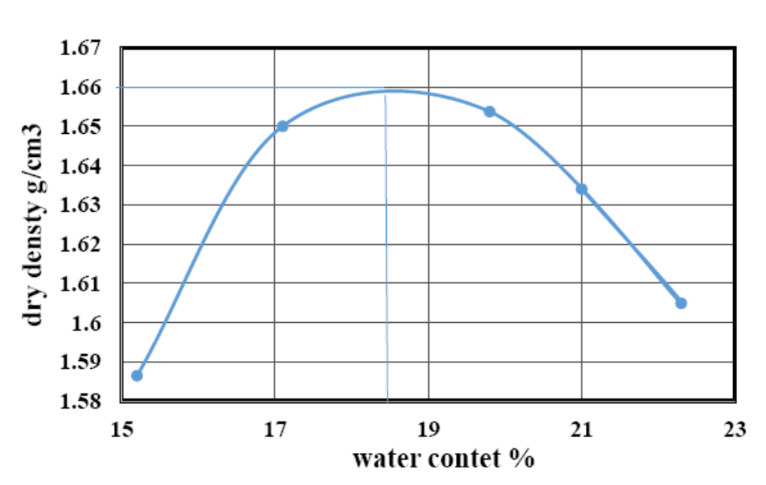
Fig. 1: Moisture-density relationship for subgrade soil used.

The modified free swell index suggested by Nelson and Miller (1992) was evaluated to get an indication about the swelling potentials of the soil used. This test involves obtaining an oven-dried soil with a mass of about 10 grams. The soil mass was transferred into a 100-ml graduate cylinder containing distilled water and measuring the swelled volume after it has completely settled. The free swell of the soil is determined as the ratio of the change in volume to the initial volume, expressed as a percentage. Two tests were carried out on bentonite (B1 and B2) in addition to two samples of sand- bentonite mixture (BS1 and BS2).
Table 3 shows the results of the swelling potential, expansion index and swelling pressure obtained from the swelling test which was carried out for each soil using two different initial water contents.
The swelling potential is calculated as:
Swelling potential% = ΔH/ Hi x100 ---------- (1)
Where: ΔH = the change in sample height,
Hi = the initial sample height,
D₁ = the initial dial readin, mm, and
D₂ = the final dial reading, mm.
But the expansion index (EI) can be found according to ASTM 4829-03 as follows:
EI = ΔH/Hi x1000 ------------- (2)
The results show that the swelling percent increases with increase the initial void ratio due to decrease in the initial water content which is the main factor for the capability of swelling because its capacity to absorb water deceases with increase in its degree of saturation as stated by Murthy, (1989).
Table 3: The results of the swelling test.

Sample ID | Swelling Potential % | Expansion Index | Swelling Pressure (kPa)
B1 | 16 | 160 | 200
B2 | 14 | 140 | 162.5
BS1 | 12 | 120 | 125
BS2 | 9.3 | 93 | 87.5

The results of the modified free swell index presented in Table 4 which shows that the potential of soil for swelling increases with increase in the plasticity index of the soil which leads to an increase in the soil activity and the specific surface for swelling. The classification of soil with free swell index according to Prakash (2000)is given in Table 5.
Table 4: The results of the modified free swell index.

Type of soil | Plasticity  index (%) | Modified free  swell index (%) | Type of soil according to Sivapullaih et al., (1996)
Pure  bentonite | 81 | 23 | Very high
B:S, 70:30 | 58 | 19 | High

Table 5: Qualitative classification of expansive soils, (Prakash, 2000).

Modified free swell index (%) | Swelling potential
< 2.5 | Negligible
2.5-10 | Moderate
10-20 | High
> 20 | Very high

Subbase granular material
The subbase is brought from Badra area, east of Wasit governorate in Iraq; this type is used as a base layer in flexible pavement construction. The subbase sample was subjected to routine laboratory tests to determine its properties. The tests included, sieve analysis, dry unit weight, California bearing ratio with compaction to 95% of the maximum dry density, according to the specification of the State Organization of Roads and Bridges, (Standard Specification for Roads and Bridges SORB, 2003). Table 6 presents the physical properties of subbase material with the corresponding specification.

Table 6: Physical properties of the subbase granular material used with the specification of SORB (2003).
Gradient test |  |  | Type requirements
Sieve No. | Sieve opening mm | Passing% | A | B | C
3 | 75 | - | 100 | - | -
2 | 50 | 100 | 95-100 | 100 | -
1 | 25 | 81 | - | 75-90 | 100
3/8 | 9.5 | 71 | 30-60 | 40-75 | 50-85
No. 4 | 4.75 | 51 | 25-55 | 21-47 | 35-65
No. 8 | 2.36 | 42 | 16-42 | 21-47 | 26-52
No. 50 | 0.3 | 26 | 7-18 | 14-28 | 14-28
No. 200 | 0.075 | 13.7 | 2-8 | 5-15 | 5-15
Dry unit weight, g/c𝑚3 |  | 2.231 | - | - | -
Optimum moisture content % |  | 5.2 | - | - | -
CBR |  | 40 | 35 Min | 30 Min | 20 Min
L.L. % |  | 15 | 25 Max
P.I. % |  | 4 | 6 Max
Corrosion mechanical % |  | 7 | 45 Max
SO3 % |  | 0.342 | 5 Max
Total soluble salts (1:50)% |  | 1.535 | 10 Max
Gypsum (CaS𝑂4 𝐻2𝑂) |  | 0.736 | 10.75 Max
Organic % |  | 0.056 | 2 Max

Sand
The sand was brought from Al-Ekeider area in Karbala governorate in Iraq, the sand sample was subjected to routine laboratory tests to determine its properties. These tests include sieve analysis. The results are shown in Table 7. The sand used in the work was sieved on a sieve with an opening of 2.36 mm, and the passing sand was used by mixing with bentonite by a ratio of 30:70. The sand passing sieve 2.36 mm was used to produce the mixed material.

Table 7: Sieve analysis for sand used, according to (AASHTO T27-2012).

Sieve ( mm) | Passing % | Type requirements (Zone)
Sieve ( mm) |  | No 1 | No 2 | No 3 | No 4
10 | 100 | 100 | 100 | 100 | 100
4.75 | 97 | 90-100 | 90-100 | 90-100 | 95-100
2.36 | 69 | 60-95 | 75-100 | 85-100 | 95-100
1.18 | 41 | 30-70 | 55-90 | 75-100 | 90-100
0.6 | 33 | 15-34 | 35-59 | 60-79 | 80-100
0.3 | 11 | 5-20 | 8-30 | 12-40 | 15-50
0.15 | 4.6 | 0-10 | 0-10 | 0-10 | 0-15

Geogrid reinforcement
One type of geogrid was used in this study. The geogrid was manufactured by Al-Latifia Factory for plastic mesh having engineering properties (imported from Saudi Arabia). The sheet of geogrid used from test to test but was replaced whenever any of the strands become visibly overstressed. Figure 2 shows the geogrid reinforcement used.

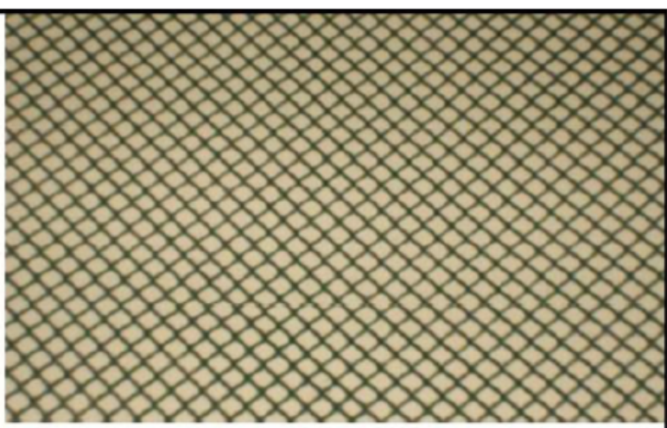
Fig. 2: Geogrid used.

Method of work
This robust represents a testing machine which can be used for various tests under load and on displacement control, the four column frame is fitted with an upper beam which can set at various heights depending on the adjusted arm connected to jack, it is driven by an AC drive controls 3 hp (hour power) motor which controls the arm movement. The device allows for the tests to be carried out in two ways. The first way by applying static monotonic loads at a constant rate of 1 mm/min with a possibility of changing, the speed of the descent of load is 0-3 mm / min. The second method is by cyclic load, the load descends every 5 seconds and then the load is released and re-load cyclic is started, and a rate of descent of load is 1 mm / min with a possibility of changing the speed of change between 0-3 mm /min..

Components of the loading machine

The steel container was manufactured for this study to include the pavement layers (subgrade and subbase) with dimensions of 0.8m x 0.8m x 0.8 m. It is made of 2 mm thick steel plate and reinforced by three steel angles of 2 in (50 mm) section, as shown in Figure 3. Load cell with capacity of 10 ton as shown in Figure 4 was used to measure the applied load, it was connected with loading arm at a part of gear box to produce a controlled movement, and from its base connected with load arm from down, and connected also with digital loading indicator.
Screw bevel gear box jack is used, it is a mechanical device used to apply move than 100 kN force, it employs a screw thread for giving a liner movement for loading arm at low or medium speeds, it was connected directly to an electric motor creating a compact line around shaft driver. Standard 3 phase motor was used, as shown in Figure 5.
A digital load indicator was used for displaying the load amount “SEWHA, Korea” model SI 4010, with an input sensitivity of 50 gm. The digital weighting indicator was connected with a load cell by wire to read the load applied to the model.
AC drive is a device that was used to control the speed of an electrical motor. The speed is controlled by changing the frequency of the electrical supply to the motor, the three-phase voltage in it was connected to a motor creating a rotating magnetic field, the rotor of the electrical motor will follow this rotting magnetic field, and that controls the speed of the motor, it was used as a speed control. Standard 3 phase motor with high horsepower was connected, it has capacity to apply high torques, as shown in Figure 6. It can control the speed of rotation through AC drive (regulator of speed). It is connected by a shaft to the mechanical jack.

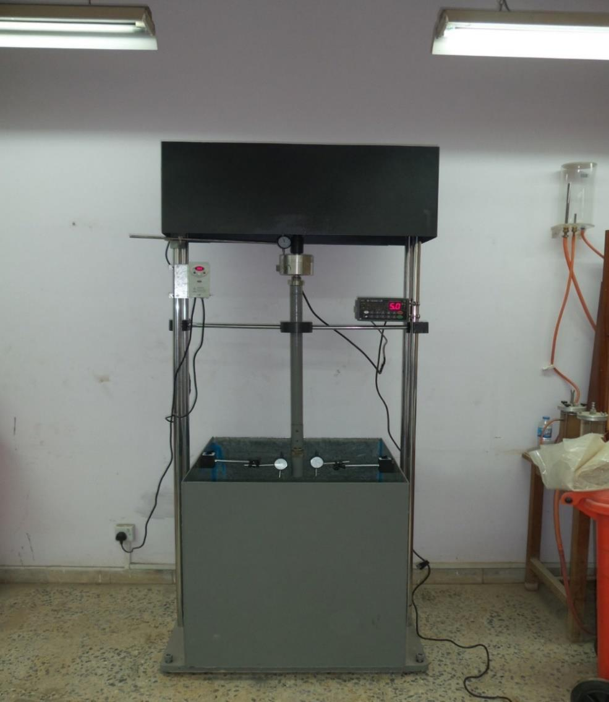

Fig. 3: Loading machine.

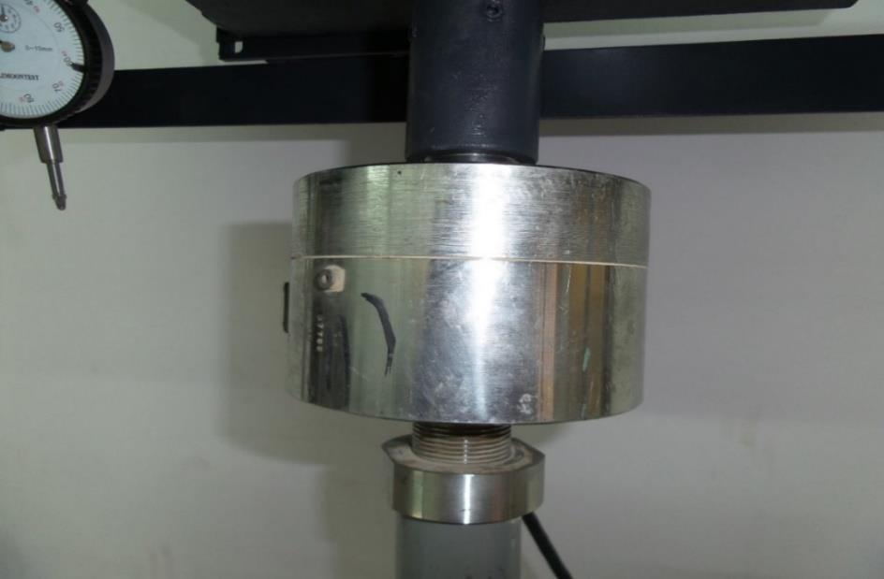

Fig. 4: Load cell.

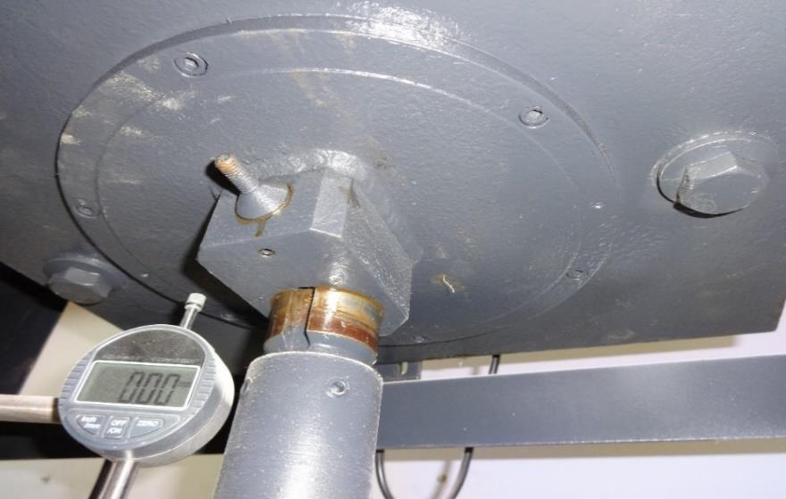

a. Connection with the frame from top.

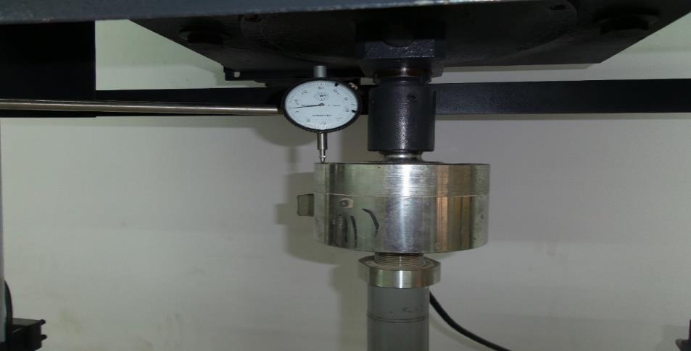

b. Connection with the load cell.
Fig. 5: Load jack.

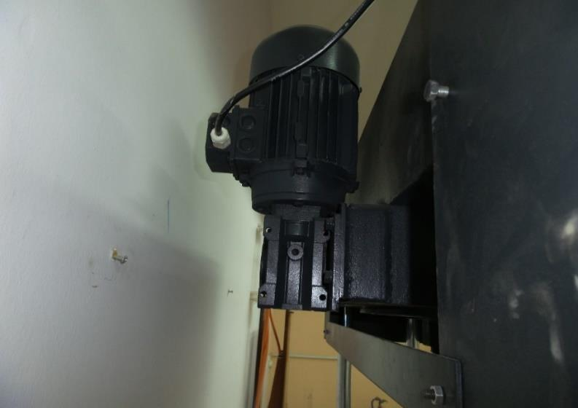

Fig. 6: Three – phase motor.

The model footing is a circular metal disk with diameter of 100 mm connected to the loading jack by the transfer arm adjustable, as shown in Figure 7.
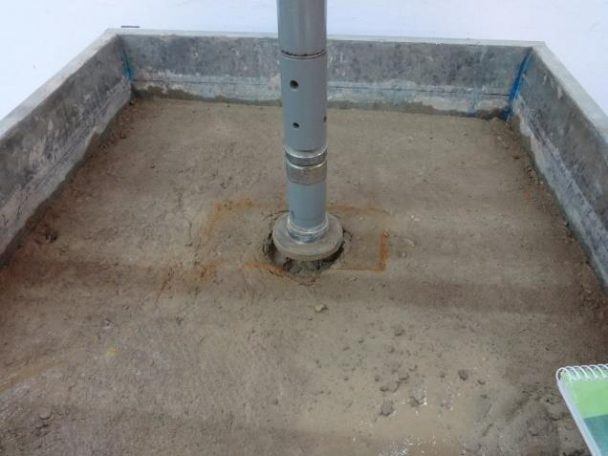

Fig. 7: Model footing connected to the transfer arm.

Model preparation
The subgrade layer was prepared by mixing 14 kg of bentonite and 6 kg of sand (70% bentonite by weight and 30 % of sand) by mixer and adding water to conform to the optimum moisture content. The mixed materials have been stored for 5 days in closed sack bags for the purpose of getting uniformity of moisture.
The subbase layer preparation was made by weighing 25 kg of subbase, which was then placed in a mixer, the water was added by optimum moisture content 5.2%, the required quantity was prepared and put in the model above the soil layers, compaction was made in two layers, the thickness of a single layer is 150 mm, and the thickness of the overall class is 300 mm.
There are three types of models, without geogrid, with geogrid at the interface between the subgrade layer and subbase layer, and with geogrid at the centre of the subbase layer. The model preparation was done by compaction of subgrade in four layers each layer 10 cm thick; the compaction was maintained at 95% of the maximum dry density as shown in Figure 8. Each layer was compacted alone, then the second layer was added and rework the same was done for the rest of the layers, the total thickness of subgrade is 40 cm.
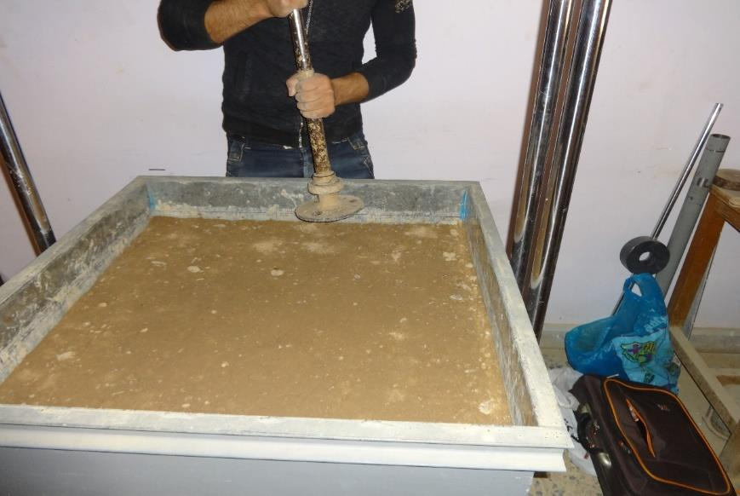

Fig. 8: Compaction process.

Testing procedure
In this test, the load was applied at a cyclic period of 5 sec and a load speed of (1 mm/min), the cyclic test continued for 20 sec. The control of test was done by control devices, all the formal tests in the static load were repeated in cyclic load, Figure 9.

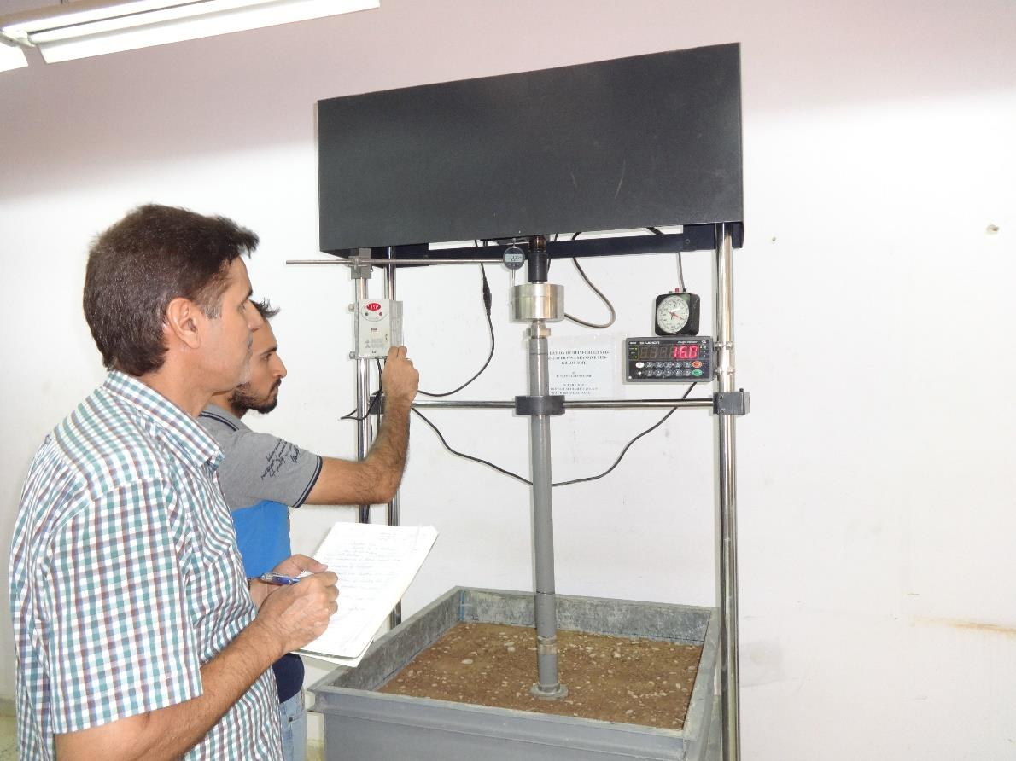

Fig. 9: Carrying out cyclic load test.

Results and Discussion
The series of cyclic tests consists of three models. For each stage, the models were prepared; without geogrid reinforcement, with reinforcement at the interface of the subgrade and subbase layers and with reinforcement in the centre of subbase layers.
The load is applied for five seconds (5 sec) and then released for a period of (10 sec), and then repeated as shown in Figure 10.
Dry soil tests
The first group of models was tested directly after preparation, it consist of three models as mentioned above. Figure 11 presents the load-time relations for the first 100 sec. and 20 sec. for the dry model. Figure 12 shows the load -displacement behavior of the unreinforced model subjected to cyclic loading in addition to variation of load and surface displacement with time. Figures 13 and 14 present the same relations for models reinforced at the interface and centre of subbase layer respectively.
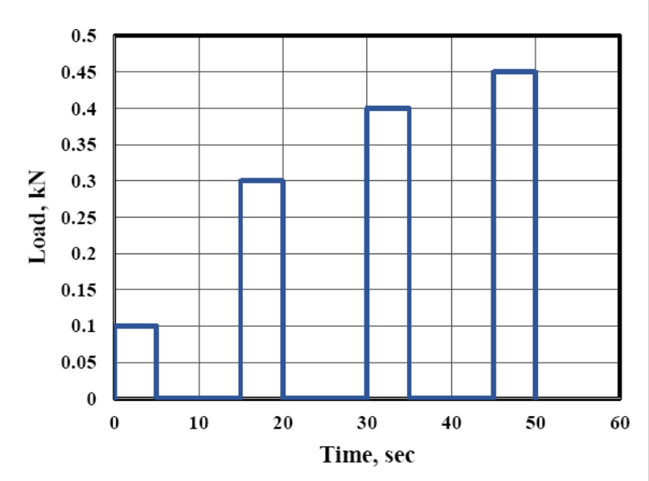
Fig. 10: Applied cyclic load.
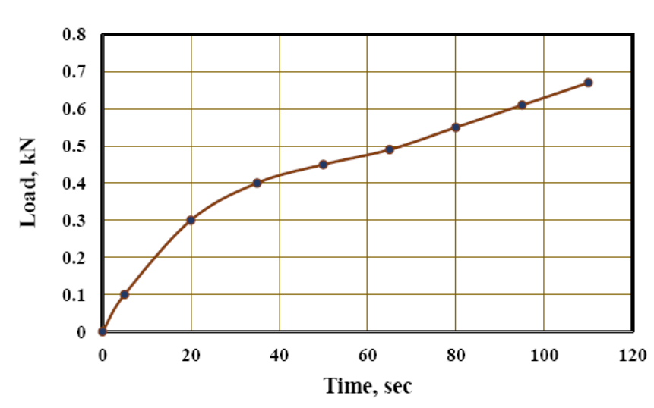
- First 100 sec.
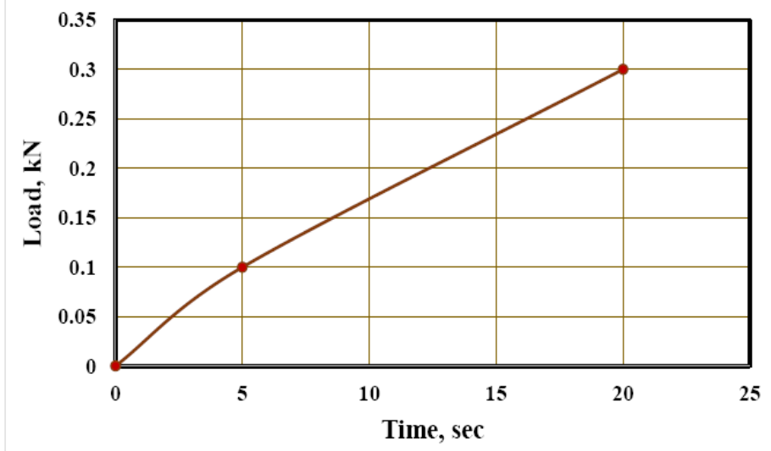
- First 20 seconds.
Fig. 11: Variation of the applied load with time.

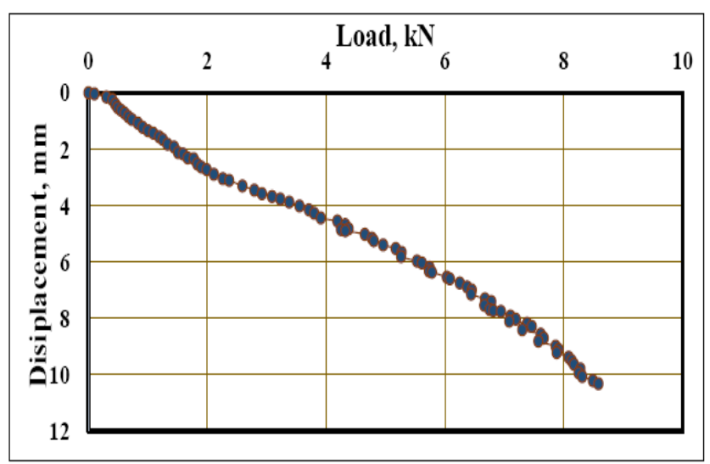
a.
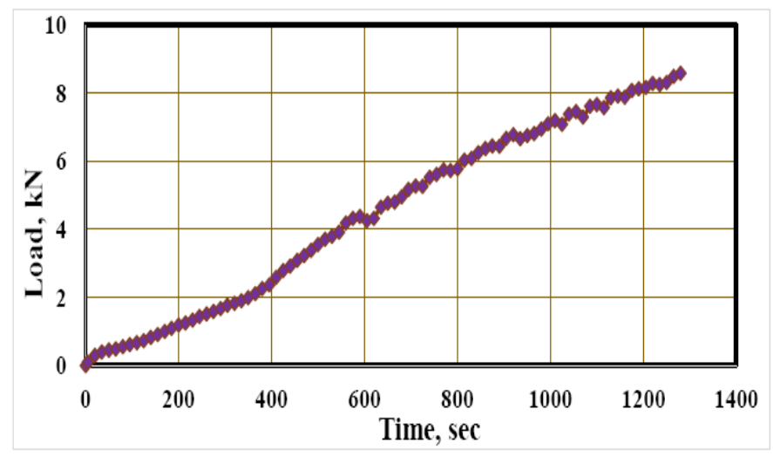
b.
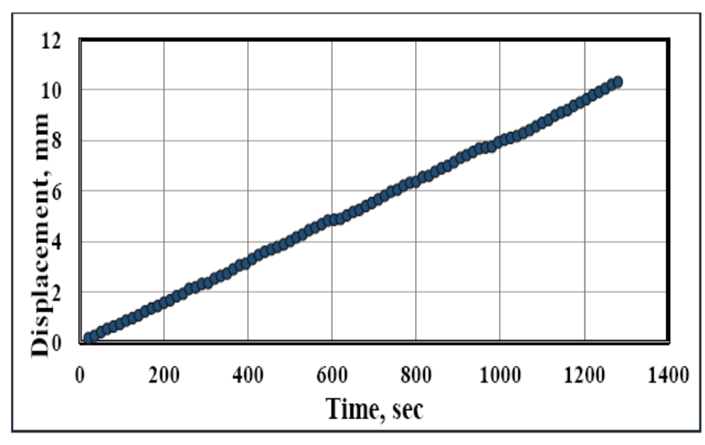
c.
Fig. 12: Load-displacement, load-time, and displacement-time relationships for an
unreinforced model of pavement layers subjected to cyclic loading.
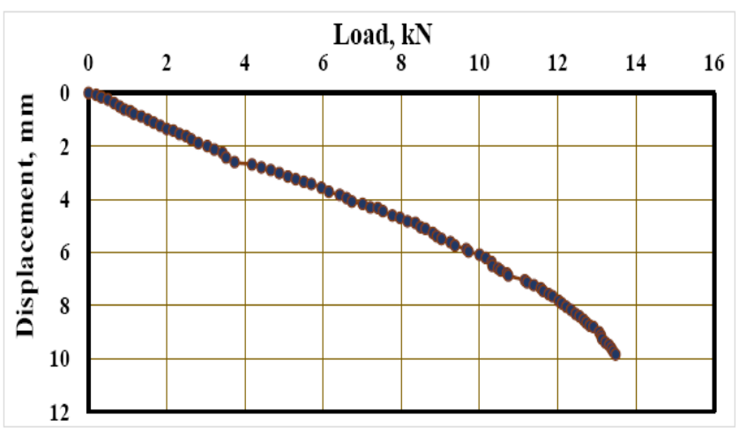

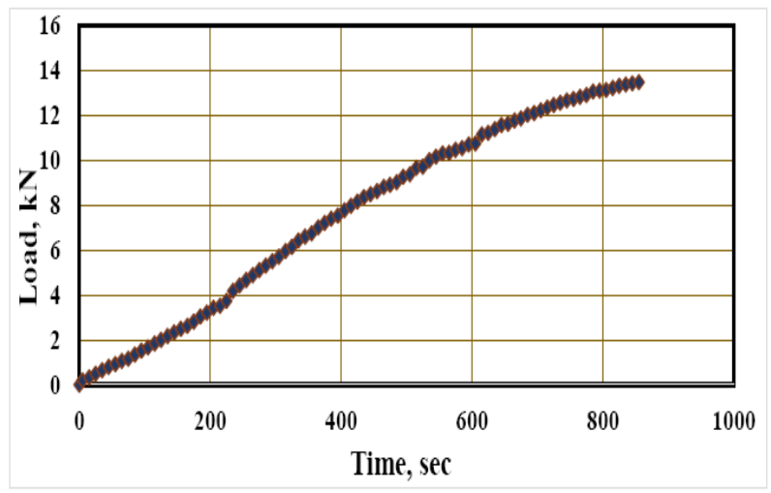
b.
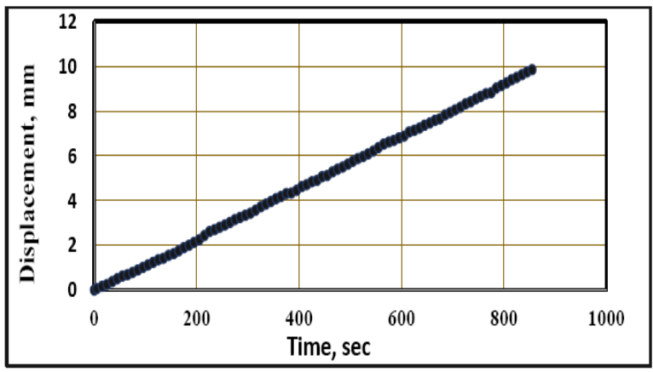
c.
Fig. 13: Load-displacement, load-time, and displacement-time relationships for a model
with geogrid reinforcement at interface of subgrade and subbase subjected to cyclic loading.
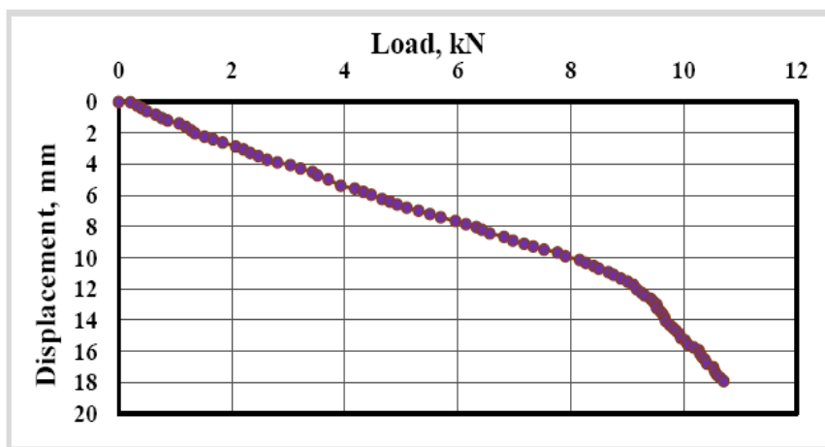

a.

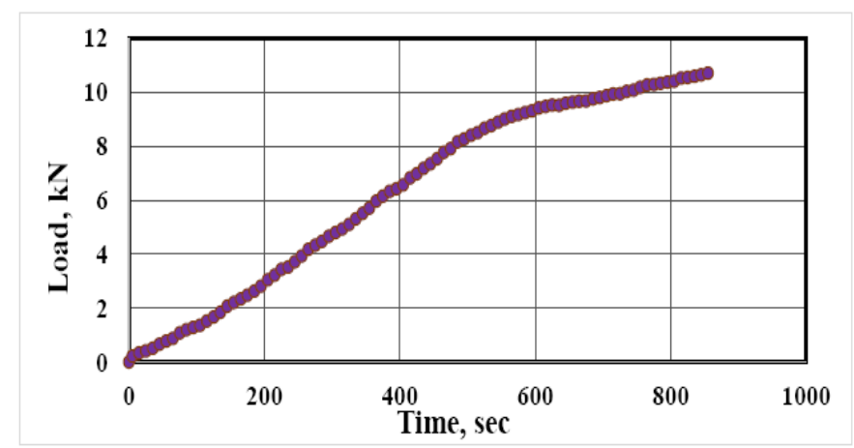

b.

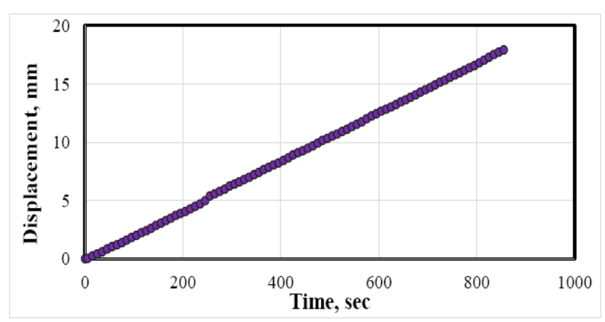

c.
Figure 14: Load-displacement, load-time, and displacement-time relationships for a
model with reinforcement geogrid in the centre of subbase layer subjected to cyclic loading.

Table 8 summarizes the displacement and load transferred to different models at selected times; 200, 800, and 1280 seconds. It can be observed that the model with geogrid reinforced subbase reinforced at the interface with subgrade layer reveals the lowest displacement and transferred the maximum load. There is a reduction in displacement for this model by about 4.7-7.7% compared with unreinforced model while the third model showed a reduction in displacement of about 4 – 6.1% only.
The deformed geosynthetic, sustaining normal and shear stresses has a membrane force with a vertical component that resists applied loads, that is; the deformed geosynthetic provides a vertical support to the overlying soil mass subjected to loading. This action of geosynthetics is popularly known as its "membrane effect". The use of geogrids has another benefit owing to the interlocking of the soil through the apertures (openings) between the longitudinal and transverse ribs, generally greater than 6.35 mm (1/4 inch)) of the grid known as interlocking effect.
Table 8: Response of different models to cyclic loading, (Untreated soil tests).

Case | Time (sec) | Load (kN) | Displacement (mm)
Unreinforced subbase | 200 | 1.19 | 2.59
Unreinforced subbase | 800 | 5.78 | 10.86
Unreinforced subbase | 1280 | 8.58 | 17.88
Geogrid reinforcement at interface of subbase layer | 200 | 2.17 | 2.39
Geogrid reinforcement at interface of subbase layer | 800 | 10 | 10.33
Geogrid reinforcement at interface of subbase layer | 1280 | 13.48 | 17.04
Geogrid reinforcement in the centre of the subbase layer | 200 | 1.84 | 2.43
Geogrid reinforcement in the centre of the subbase layer | 800 | 8.76 | 10.42
Geogrid reinforcement in the centre of the subbase layer | 1280 | 10.71 | 17.17

From the results reached in this research and former researches, it can be concluded that the improvement in load carrying capacity can be attributed to decrease in the shear stresses transferred to the subgrade and vertical confinement provided by the geogrid subgrade outside the loaded area where heave happens, reinforcement of the layers of pavement inclusion leads to increase the bearing capacity of subsurface aggregates, by transferring part of the shear stresses induced in the subsurface to the geogrid, which is able to accept tensile forces and distribute them over a large area.
The tensile stresses developed along the geogrid due to a distributed load on the surface. Tensile stresses as that developed at the interface between the geogrid and the surrounding material promote an increase in the frictional resistance and an overall increase in bearing capacity of the pavement system.
The modification of the shear failure surface and the effective increase in the angle of friction caused by the interaction between the aggregate and the geogrid cause the bearing capacity of the entire pavement system to increase. The other advantage of geogrid reinforcement an improved vertical stress distribution result from tensile stress in a deformed membrane. However, subsequent investigations have shown that reinforcement benefits are obtained without significant deformation of the pavement section. Thus, lateral restraint has been identified as the primary reinforcement mechanism, followed by the improved bearing capacity and the tensioned membrane effect.
The improvement in the load carrying capacity could be attributed to improved load dispersion through reinforced subbase on to the subgrade. This in-turn, results in lesser intensity of stresses getting transfer to subgrade, thus leading to lesser subgrade distress.
This improvement in the load carrying capacity returns to several factors, the first factor, transferring part of the shear stresses induced in the subsurface to the geogrid, which is able to accept tensile forces and distribute them over a large area, the second factor, the geogrid reinforcement can decrease the shear stresses transferred to the subgrade and provide vertical confinement to the subgrade outside the loaded area where heave happens, thus decreasing the shear strain near the top of subgrade and limit subgrade rutting and upheaval. The third factor improve vertical stress distribution resulting from tensile stress.
It can be seen that heaving of the expansive soil considerably decreases the load carrying capacity of the pavement system. The improvement in the load carrying capacity could be attributed to the improved load dispersion through stabilized subbase on to the subgrade. This in turn results in lesser intensity of stresses getting transferred on to subgrade, thus leading to lesser subgrade distress. Geogrid functions in two ways: reinforcement and separation which are the techniques of improving poor soil with geo-grid, to increase the stiffness and load carrying capacity of the soil through frictional interaction between the soil and geo-grid material. A geogrid reinforced soil is stronger and stiffer and gives more strength than the equivalent soil without geo-grid reinforcement. Geogrids provide aggregate interlock in stabilizing road infrastructure through subbase restraint reinforcement applications. Geogrid reinforcement provided between the base course and sub-grade soil carries the shear stress induced by vehicular loads.
Generally, geogrid reinforces the subbase or subgrade materials by providing lateral restraint (minimizing spread), tensile membrane support and increase in bearing capacity.
Shear stress developed between the base course aggregate and the geosynthetic provides an increase in lateral confining stress within the base. Granular materials generally exhibit an increase in elastic modulus with increased confining stress. The second base (or subbase) reinforcement component results from an increase in stiffness of the base (or subbase) course aggregate, when adequate interaction develops between the base (or subbase) and the geosynthetic. The increased stiffness of this layer results in lower vertical strains in the base. An increase in modulus of the base would also be expected to result in lower dynamic, recoverable vertical deformations of the roadway surface, implying that fatigue of the asphalt concrete layer would be reduced (Berg et al., 2000).
Geogrid mesh provides better interlocking with the soil particles thus ensuring adequate anchorage during loading. The improvement in the load carrying capacity could be attributed to improved load dispersion through reinforced subbase on to the subgrade. This in turn, results in lesser intensity of stresses getting transfer to subgrade, thus leading to lesser subgrade distress.
The presence of a geogrid layer in, or at the bottom, of the base can also lead to a change in the state of stress and strain in the subgrade. For layered systems, where a less stiff subgrade material lies beneath the base (or subbase), an increase in modulus of the base (or subbase) layer results in an improved, more broadly distributed vertical stress on the subgrade. In general, the vertical stress in the subbase or subgrade directly beneath the geosynthetic and applied load should decrease as the base (or subbase) layer stiffness increases. The vertical stress on the subgrade will become more widely distributed, meaning that surface deformation will be less and more uniform. Hence, a third reinforcement component results from an improved vertical stress distribution on the subgrade (Berg et al., 2000).
Another reinforcement component results from a reduction in shear strain in the subgrade soil. It is expected that shear strain transmitted from the base (or subbase) course to the subgrade would decrease as shearing of the base transmits tensile load to the reinforcement (Berg et al., 2000).
Conclusions
A series of model experiments was conducted to determine how incorporating geogrid reinforcement into a granular subbase layer placed over swelling subgrade affects the behavior of pavement layers. The following conclusions are drawn from this study:
1. A geogrid reinforced subbase material is stronger and stiffer and gives more strength than the equivalent subbase material without geo-grid reinforcement. Geo-grids provide improved aggregate interlock in stabilizing road infrastructure through subbase restraint and base reinforcement applications.
2. Geogrid reinforcement provided between the subbase course and subgrade soil carries the shear stress induced by vehicular loads and thus it reduces the load transferred to the subgrade and the volume changes induced by swelling of the subgrade soil.
3. The load carrying capacity of the pavement system significantly increases for geogrid reinforced subbase stretch compared to unreinforced subbase layer on expansive subgrade soil. This is reflected in the values of failure load which is greater in reinforced subbase layer model than in unreinforced model.
4. The displacement and load transferred to different models at selected times; 200, 800, and 1280 seconds showed that the model with geogrid reinforced subbase reinforced at the interface with subgrade layer reveals the lowest displacement and transferred the maximum load. There is a reduction in displacement for this model by about 4.7-7.7% compared with unreinforced model while the third model showed a reduction in displacement of about 4 – 6.1% only.

References
ASTM D 1883-99, "Standard Test Method California Bearing Ratio of Laboratory-Compacted Soils, American Society for Testing and Materials.
ASTM D 422-02, "Standard Test Method for Particle-Size Analysis of Soils", the Annual Book of ASTM Standards. Copyright ASTM, Vol.4, No.8, American Society for Testing and Materials.
ASTM D 1557-02, "Standard Test Methods for Laboratory Compaction Characteristics of Soil Using Standard Effort (600KN-m/m³)", the Annual Book of ASTM Standards. Copyright ASTM, Vol.4, No.8, American Society for Testing and Materials.
ASTM D 854-00, "Standard Test Methods for Specific Gravity of Soil Solids by Water Pycnometer", the Annual Book of ASTM Standards. Copyright ASTM, Vol.4, No.8, American Society for Testing and Materials.
ASTM D 4318-00, "Standard Test Methods for Liquid Limit, Plastic Limit and Plasticity Index of Soils", the Annual Book of ASTM Standards. Copyright ASTM, Vol.4, No.8, American Society for Testing and Materials.
ASTM D 4546-03 "Standard Test Methods for One-Dimensional Swell or Settlement Potential of Cohesive Soils", American Society for Testing and Materials.
ASTM D 4829-03 "Standard Test Method for Expansion Index of Solis" Reprinted from the Annual Book of ASTM Standards. Copyright ASTM, Vol.4, No.8, American Society for Testing and Materials.
AASHTO T27-78," Standard Test Method for Sieve Analysis for Sand", American Association of State Highways and Transportation Officials.
Berg, R.R., Barry, Christopher, B. R., and Perkins, S.W. (2000), "Geosynthetic Reinforcement of the Aggregate Base/Subbase Courses of Pavement Structures", Geosynthetic Materials Association, Prepared for AASHTO Committee 4E, Report No. 2, p. 190.
Black, P. J., and Holtz, R. D., (1999), "Performance of Geotextile Separators Five Years after Installation".
B.S 1377:1990 "Methods of Test for Soils for Civil Purposes Chemical and Electro-chemical Tests".
Chen, R.H., (1975) “Foundations on Expansive Soil,” 2nd edition, Elsevier Scientific Publishing Company, New York.
Choudhary, A.K., Gill, K.S. and Jha, J.N. (2011), “Improvement in CBR Values of Expansive Soil Sub-grades using Geo-synthetics”, Indian Geotechnical Conference December 15-17, 2011, Kochi (Paper No. J-233).
Fattah, M. Y., Salim, N. M., Irshayyid, E. J., (2016), "Experimental Study on Compressibility, Volume Changes, Strength and Permeability Characteristics of Unsaturated Bentonite-Sand Mixtures", Engineering and Technology Journal, University of Technology – Iraq, Vo. 34 Part (A), No. 7, pp. 1308-1323.
Fredlund, D.G. (1969), "Consolidometer Test Procedural Factors Affecting Swell Properties", 2nd International Conference on Expansive Clay Soils, Texas, U.S.A., pp. 435-456.
Jones, D.E. and Holtz, W.G., (1973), “Expansive Soils- the Hidden Disaster”, Civil Engineering, Vol. 43, No. 8.
Kinney T.C. and Fu X., (1996), “Full Scale Highway Load Test of Flexible Pavement Systems with Geogrid Reinforced Base Courses”, Geosynthetics International, Vol. 3, No. 4, pp. 537-549.
Koerner, R.M. (2005) “Designing with Geosynthetics,” 5th Ed., Pearson Prentice Hall, Upper Saddle River, New Jersey.
Kumar, P. S., and Rajkumar, R., 2012, Effect of geotextile on CBR strength of unpaved road with soft subgrade, Electronic Journal of Geotechnical Engineering (EJGE), 17, pp. 1355 – 1363.
Lee, M. S., Choi, Y. S., Prezzi, M., (2012), "Quality Assessment of Geogrids Used for Subgrade Treatment", Joint Transportation Research Program, Indiana Department of Transportation and Purdue University, Report FHWA/IN/JTRP-2012/27, DOI: 10.5703/1288284315034.
Moayedi, H., Sina Kazemian, Prasad S., Huat, B.B.K. (2009), “Effect of Geo-grid Reinforcement Location in Paved Road Improvement”, EJGE Vol. 14 [2009], Bund. P.
Murthy, V. N. S., (1989), "Soil Mechanics and Foundation Engineering", 3rd. Edition, Bangalore.
Nelson, J. D., and Miller, D. J., (1992), "Expansive Soils Problems and Practice in Foundation and Pavement Engineering", John Wiley & Sons, Inc., New York, NY.
Prasad, D.S.V., Anjan, K. M., Prasada, R.G.V.R., Kondayya, V., (2010), "Behaviour of Fly ash Reinforced Sub-bases on Expansive Soil Subgrades under Cyclic Loading", Indian Geotechnical Conference–2010, GEOtrendz December 16–18, IGS Mumbai Chapter & IIT Bombay, pp. 727-730.
Prasad, D.S.V. and Kumar, M. A., (2010), "Behavior of Reinforced Sub- bases on Expansive Soil Sub-grade", Global Journal of Research in Engineering, Vol. 10, No. 1, pp. 1-8.
Prasad, D.S.V., Anjan, K. M., Prasada, R.G.V.R., Kondayya, V., (2011), "Evaluation of Different Reinforced Subbase on Expansive Soil Subgrade –a Laboratory Model Study", Proceedings of Indian Geotechnical Conference December 15-17, 2011, Kochi (Paper No.H-234), pp. 457-460.
Radhakrishnan G., Kumar M. A., and Prasada Raju GVR. (2014). "Swelling Properties of Expansive Soils Treated with Chemicals and Fly ash", American Journal of Engineering Research (AJER), Vol. 3, Issue 4, pp. 245-250.
Rao R. M., Scott Wilson, S. and Veeraragavan A. (1996), "Effect of Commercial Traffic Overloading Enforcement on Pavement Performance".
Sivapullaiah, P. V., Sridharan, A., and Stalin, V. K., (1996), "Swelling Behavior of Soil- Bentonite mixtures", Canadian Geotechnical Journal, Vol. 33, pp. 808-814.
Specification of the State Organization of Roads and Bridges, Standard Specification for Roads and Bridges (SORB, 2003), Ministry of Construction and Housing, Iraq.
Steinberg, M.L., (1992), “Geogrids as a Rehabilitation Remedy for Asphaltic Concrete Pavements”, TRR-1409, pp. 54-62.
Tiwari K., Sahil Khandelwal, S. and Jatale, A., (2012) "Performance, Problems and Remedial Measures for the Structures Constructed on Expansive Soil in Malwa Region, India" International Journal of Emerging Technology and Advanced Engineering Website: www.ijetae.com, Certified Journal, Vol. 2, Issue 12.

