Title:
Modeling effect soil properties for Prediction of energy consumption for land leveling Irrigation
Short title:
Prediction of energy consumption for land levelling
Authors:
Isham Alzoubi¹, Farhad Mirzaei²
Affiliation:
¹ Department of Surveying and Geometric Eng., Engineering Faculty, University of Tehran, Iran
² College of Agriculture and Natural resources, University of Tehran, Iran
*Corresponding author:
Isham Alzoubi
Complete Postal Address:
¹ Department of Surveying and Geometric Eng., Engineering Faculty, University of Tehran, Iran
E-mail contact:
alzoubi@ut.ac.ir

Abstract
Land leveling is one of the most important steps in soil preparation for agricultural processes. In this regard, different considerations are required to satisfy energy consumption and environmental urges as well as financial aspects. On the other hand, energy conservation is regarded as one of the most important factors in agricultural sector due to its relation to pollution which is a result of fossil fuel (particularly gasoline) usage. The objective of this research was to develop three methods including artificial neural network (ANN), regression and adaptive neural fuzzy inference system (ANFIS) to predict soil properties on the environmental indicators in land leveling and to analysis the sensitivity of these parameters. So, several soil properties such as, cut/fill volume, soil compressibility factor, specific gravity, moisture content, slope, tillage depth, forward speed, cone index and soil swelling index in energy consumption were investigated. A total of 90 samples were collected from 3 land areas with the selected grid size of (20m×20m). The acquired data were used to develop accurate models for fuel energy (FE), total machinery cost (TMC) and total machinery energy (TME). By applying the four mentioned analyzing methods, the results of regression showed that only four parameters of tillage depth, forward speed, cone index and cut/fill volume had significant effects on energy consumption. According to the obtained results, the models regression, ANFIS and ANN had satisfactory performance in predicting aforementioned parameters in the various field conditions. The ANN had the most capability in FE prediction according to the least RMSE and the highest R² values 0.0206 and 0.9983, respectively. The ANFIS model had the most capability in prediction of the environmental and energy parameters with the least RMSE and the highest R² for TMC, 0.0287 and 0.9966, and for TME, 0.0157 and 0.9990, respectively.
Keywords: Energy; ANFIS; Regression; ANN; Land levelling; Soil properties.

1. Introduction
Agriculture, which is the most important sector in the production of food in the world, is also a big consumer of energy. Energy is needed in agriculture to produce food to feed the ever increasing world population. Tillage operation and cultivation in a farming season consists of plowing, preparing the seed bed, leveling, cultivating, covering the seed, making the irrigation furrow and sometimes application of fertilizer. Machines used for these types of operation consist of different kinds of plowshare, land leveling, planter and forever. Each of the mentioned equipment has to be attached to the grader and used in farmland to accomplish the specified operation. In the agricultural sector, like other fields, energy is regarded as one of the most important parameters. However, the inherent disadvantage of using fossil fuels (particularly gasoline) as an energy source is pollution. Finding the relationship between energy consumption and land leveling parameters is necessary for prediction and optimization of the amount of the needed energy in a particular land and achieving sustainable agriculture and also for reducing the ensuing pollutions. It is anticipated that environmental conservation and market globalization would be dependent on food security in the future (Jat et al., 2006). Even if developing and improving strategies continue and led to some worthwhile effects, there would be some undesirable effects remaining (Rezaia–Moghaddamet al., 2005).
Several studies have been developed for FC predicting in diverse sections in agricultural operations which uses power like draught, tillage implements and tire resistance. (Al-Janobi, 2000; Sahu and Raheman, 2006; Serrano et al., 2003, 2007). Grisso et al. (2008) developed a new method for predicting FC for individual tractors. Their results showed that the new methodology had an improved prediction ability (88%) for the tested tractors. The FC during soil tillage operation varies widely due to various parameters that affect the FC such as soil texture, relative humidity, tractor type (2WD or 4WD), tractor size and implements. Depending on the soil strength, the FC increases by 0.5 to 1.5 L.ha⁻¹ per centimeter of ploughing depth (Filipović et al., 2004; Moitzi et al., 2006). Therefore, the FC is not a constant parameter and varies in different situations, so it can be reduced through proper matching of related parameters (McLaughlin et al., 2008). Reducing the FC in cropland agriculture is a complex and multifactorial process, whereas farm management plays a key role (Safa et al., 2010).
In recent years, ANN approach has demonstrated to be effective as an exciting alternative method concerning complex system. Since agricultural systems and technologies are quite complex and uncertain, many researchers focused on ANN method for modeling of different component of agricultural systems (Cakmak and Yıldız, 2011; Zarifneshat et al., 2012; Çay et al., 2013; Aghbashlo et al., 2012; Khoshnevisan et al., 2014; Young et al., 2013; Safa and Samarasinghe, 2013). For example, Aghbashlo et al. (2012) developed a supervised ANN and mathematical models for determining the exergetic performance of a spray drying process. It was concluded that the multi-layer perceptron ANN approach for exergetic prediction of spray drying process is capable of yielding good results that can be considered as an alternative to traditional regression models and other related statistical approaches. Cay et al. (2013) investigated use of ANN modeling to predict break specific fuel consumption and exhaust emissions of a spark ignition engine which operated with methanol and gasoline. Quasi-Newton back propagation and Levenberg-Marquardt algorithms have been used for modeling.
ANFIS has been employed in various agricultural studies. Akbarzadeh et al. (2009) developed an ANFIS model for soil erosion estimation. In another research, conducted by Krueger et al. (2011), ANFIS model was evaluated in characterizing root distribution patterns under field conditions. Kisi and Shiri (2013) compared ANN and ANFIS models for prediction of long-term monthly air temperature using geographical inputs. They illustrated that the maximum and minimum of R² values were calculated as 0.995 and 0.921 for ANN model and computed as 0.999 and 0.876 for ANFIS model. Mohaddes and Fahimifard (2015) used ANFIS in forecasting three perspectives (1, 2, and 4 years) ahead of Iran’s agricultural products export. Taghavifar and Mardani (2014) reported a modeling tool based on ANFIS to assess prediction of vertical stress transmission in soil profile. It was deduced, in terms of performance evaluation criteria, that the Gaussian function was the best membership one for all the ANFIS models.
Khoshnevisan et al. (2014) used several ANFIS models to predict wheat grain yield on the basis of energy inputs. Moreover, several ANNs were developed and the obtained results were compared with ANFIS models. The results illustrated that the ANFIS model can predict the yield more precisely than ANN. Taghavifar and Mardani (2014) assessed the potential of ANFIS for prediction of energy efficiency indices of driving wheels (i.e. traction coefficient and tractive power efficiency). The output parameters were affected by the tire parameters of wheel load at three different levels, velocity at three different levels and slippage at three different levels with three replications forming, a total of 81 data points.
Since, land leveling with machines requires considerable amount of energy, optimizing energy consumption in this operation is of a great importance. So, three approaches comprising ANN and ANFIS as powerful and intensive methods and regression as a fast and simplex model have been developed and tested to predict the environmental indicators for land leveling and to determine the best method. Hitherto, only a limited number of studies associated with energy consumption in land leveling have been done. In mentioned studies energy is a function of the volume of excavation (cut/fill volume). Therefore, in this research, energy and cost of land leveling are functions of all the properties of the land including slope, coefficient of swelling, density of the soil, soil moisture, special weight and swelling index which will be thoroughly mentioned and discussed. In fact, predicting minimum cost of land leveling for field irrigation according to the field properties is the main goal of this research which is in direct relation with environment and weather pollution.
2. Materials and methods
2.1. Case study region
In order to verify the accuracy and feasibility of the proposed linear programming model, a case study was specified based on the proposed land leveling project in the district of Karaj city, Alborz province, Iran. The study farm was a 70 ha area and located in the west of Iran, between 31° 28' 42'' north latitude and 48° 53' 29'' east longitude. Topography of the farm was done at a scale of 1:500. The outputs of the plan were length, width and height of points (coordinates of x, y and z). The grid size in the region was 20 m×20 m and samples were collected from two plantation sites at two different depths including surface soil (0−10 cm) and subsurface soil (10−30 cm). A total of 90 samples (30 from each plantation site and 15 from each soil depth) were collected from 3 land areas. Then every five samples were mixed together to prepare one sample. In this way, a total of 90 samples were reduced to 18 composite soil samples for convenient laboratory analyses. In the laboratory, collected moist soil samples were firstly sieved through 10 mm mesh sieve to remove gravel, small stones and coarse roots and then passed through a 2 mm sieve. Then the sieved samples were dried in room temperature and then moisture content of the soil samples were determined. At this time, soil texture, soil bulk density and soil optimum density were determined.
2.2. ANN model
ANNs known as a computational approach have certain performance characteristics and simulate the methodology by the biological neural networks of brain ad solve the problems (Movagharnejad and Nikzad, 2007; Mohammadi et al., 2009). The structure types of ANN models may be so different. In this study, we used a multi-layer perceptron (MLP) structure which uses the feed forward back propagation (BP) algorithm. MLP structures have the advantage of being able to learn complex relationships between input and output patterns, finding such these relationships is difficult by applying the conventional algorithmic approaches (Azadeh et al., 2008). An ANN structure usually necessarily consists of one input and one output layer. Moreover, it may have one or more hidden layers. Each layer consists of several nodes. An input node denotes input variables which are the observations. On the other hand, the output nodes determine the forecasted values for the output variables. Process of information received by input variables is done by the hidden nodes; each of them is functioned by using a nonlinear transfer function. The following formulated model presents a typical ANN model (Azadeh et al., 2008):
, j= 0, 1,…, n and i= 0, 1, …, m (1)
where f denotes a sigmoid transfer function, m denotes the number of input nodes, n presents the number of hidden nodes, the vector of weights and the weights from the hidden to output nodes are presented by α_{j} and β_{ij}, respectively. α₀ and β_{0j} represent weights of arcs leading from the bias terms which have values always equal to 1 (Shakibai and Koochekzadeh, 2009). Multiple layers of neurons with nonlinear transfer functions make the network capable of finding the linear and nonlinear relationships between input and output parameters (Tiryaki, 2008). By using a sigmoid function for the output layer, the outputs of the network will be only in a limited range; while, using a linear function for the output layer allows the model to take any values even outside the range −1 to +1. In this study, after consulting with experts and also reviewing the literature, the input variables were considered to be cut soil, specific gravity, density, moisture content, slop, soil type and inflation rate. On the other hand, the output variables were considered to be some environmental indicators including fuel energy, machinery energy, labor power energy, total cost, and energy consumption. In this study, for regression modelling all of the available data sets were used. While, for developing the ANN models, the available data set was randomly divided into two groups of training data subset (70% of the dataset for training, 15% for model cross validation and15% for testing.) (Diamantopoulou, 2005). Several structures of MLP type were investigated aiming to find one that could result in the best overall performance. The learning rules were considered to be Momentum and Levenberg Marquart. No transfer function for the first layer was used. For the hidden layers, the sigmoid and hyperbolic tangent transfer functions were tested. While, for the output layer a linear transfer function was applied. Also, a number of different network sizes and learning parameters have been tried.
2.3. ANFIS model
ANFIS is a suitable and well known technique for modelling complex systems which confront with uncertainty (Sengur, 2008a; Übeyli, 2008). By using hybrid learning methodology, it gives the mapping relation between the input and output data and specifies the best distribution of membership functions (Ying and Pan, 2008). By combining the ANN and fuzzy logic, ANFIS has many advantages of fuzziness (Avci, 2008). Combination of these two techniques makes the ANFIS modeling to be more systematic and also to be less dependent to expert knowledge (Sengur, 2008a; Übeyli, 2008). The ANFIS technique developed by Jang (1997) is the implementation of a fuzzy inference system to adaptive networks for developing fuzzy rules with proper membership functions to have required inputs and outputs. ANFIS relies on the fuzzy if-then rule statements, as the main problem in formulating fuzzy systems, to develop an effective tool, which uses ANN learning ability for automatically creating such fuzzy statements and optimizing the parameters. In fact, the ANFIS model is a neural-fuzzy approach. For the sake of simplification, it can be assumed that the inference system has two inputs, (soil, cut/fill volume, soil compressibility factor, specific gravity, moisture content, slope, tillage depth, forward speed, cone index and soil swelling index) and Y, and an output ( fuel energy (FE), total machinery cost (TMC) and total machinery energy (TME) ). For a first-order takagi-sugeno fuzzy model, a set of basic rules can be founded upon two rules, if the fuzzy system shows the following:
𝑧₁ = 𝑝₁𝑥 + 𝑞₁𝑦 + 𝑟₁ (2)
𝑧₂ = 𝑝₂𝑥 + 𝑞₂𝑦 + 𝑟₂ (3)
Rule 1: if X is equal to A₁ and Y is equal to B₁, then 𝑧₁ = 𝑝₁𝑥 + 𝑞₁𝑦 + 𝑟₁
Rule 2: if X is equal to A₂ and Y is equal to B₂, then 𝑧₂ = 𝑝₂𝑥 + 𝑞₂𝑦 + 𝑟₂
Were p_{i}, Q_{i}, and r_{i} (i=1, 2) are the linear parameters in the consequent part of the first-order Takagi-Sugeno fuzzy model. The tagaki-sugeno type fuzzy inference system (T-S FIS) is generally the heart of an ANFIS model. Sequential mapping procedure of ANFIS as a multilayer feed-forward network, with two inputs, is shown in Fig. 1. Basic first order ANFIS architecture consists of 5 layers. For simplicity, the ANFIS with two inputs x and y and one output f is illustrated in Fig. 2. The first layer (input nodes): each layer of this node produces membership values belonging to each of the fuzzy sets via membership function:
𝑂_{1, i} = 𝜇_{𝐴} 𝑓𝑜𝑟 𝑖 = 1, 2 (4)
where x and y are non-fuzzy inputs related to me, A_{i} and B_{i} (small, large, etc.) as linguistic labels which are respectively identified through 𝜇𝐴𝑖 and 𝜇𝐵𝑖 appropriate membership functions. At this stage, Gaussian falsification and bell-shaped functions are usually used. The parameters of these member functions, which are recognized as primary parameters, should be the first identified. Second layer (rule nodes): in the second layer, the operator “AND” is used to find the output (firing strength) which represents the antecedent of the rule. Firing strength is used to describe the degree to the antecedent satisfies a fuzzy rule, shaping the output function of the same rule. As a result, O₂, _{k} outputs of this layer are the results of the multiplication of the degrees related to the first layer. Third layer (average nodes): the main purpose in the third layer is to determine the ratio of me-the rule firing strength to the total firing strength. Therefore, 𝑖, the normalized firing strength would be as follows:
𝑂₃, _{i} = 𝑊_{𝑖} =$\frac{W_{i}}{\sum_{k=1}^{4}{W_{k}}}$ i=1,…, 4 (5)
Fourth layer (consequent nodes): the node function of the fourth layer calculates the distribution of me-the rule in the final output, defining it is as the following relation:
𝑂₄, _{i} = 𝑤_{𝑖}𝑓_{𝑖} = 𝑤_{𝑖} 𝑥 + 𝑞_{𝑖} 𝑦 + 𝑟_{𝑖} i=1,…,4 (6)
where 𝑤_{𝑖} is the output of I-the node from the previous layer, {p_{i}, Q_{i}, R_{i}} are coefficients of this linear combination as well as the set of parameters of the consequent part of the Takagi-Sugeno fuzzy model.
Fifth layer (output nodes): this single node computes the total output by submitting all of the input signals. As a result, in the layer of the defuzzification process, the fuzzy results are converted into non fuzzy formats.
$O_{5,i}=W_{i}f_{i}=\frac{\sum_{i=1}^{4}{w_{i}f_{i}}}{\sum_{i=1}^{4}{w_{i}}}$ (7)
This network is trained based on learning under supervision. Thus, the focus of this study is based on training adaptive networks capable of estimating unknown functions resulted from training information and finding accurate values for the above parameters.
3. Results
3.1. Results of regression
3.1.1. FE regression
Table 1 shows the results obtained by carriying out using Design Expert software to determine significance effects of cut-fill volume, moisture content, cone index and tillage depth on FE. The results indicated that each of these parameters had a significant effect on FE at various probability values (lower than 0.0001). Also, the results revealed FE augmented with increasing the moisture content, cut-fill volume, depth of tillage and forward speed whereas the results of FE were the counteractive with increasing cone index. Fig. 3 shows the interactions influence of the depth of tillage, forward speed and cut/fill volume on FE. FE decreased by 10% when the cone index increased from 102 kPa to 1160 kPa that is due to increase of soil strength with increasing cone index which leads to reducing the energy lost due to slip and rolling resistance thus reducing fuel consumption. The results demonstrated a linear relationship among FE and depth of tillage and forward speed. FE increased by 44% when the depth of tillage increased from 10 to 20 cm, while increasing the forward speed increased fuel consumption by 54%. In other hands, the greatest FE was reached at a depth of 21 cm and machinery engine speed 2000 rpm. Increasing the cut-fill volume of a soil will lead to an increase in all the number of the required machinery, work hour, number of labors and also total cost of operation. It is obvious that these in turn will intensify the energy consumption in all four evaluated parameters. Embankment and excavation are the most part of the land leveling operation such as preparing lands for irrigation, building infrastructures and airports and road constructions. So, it is sensible to minimize the energy consumption of this operation. A proper solution for reducing the amount of required energy for soil cut/fill volume during land levelling operations will diminish the cost of such operations. The findings are in agreement with other researches (Adewoyin and Ajav, 2013; Moitzi et al., 2006; Moitzi et al., 2014). The overlap effect between forward speed and tillage depth on FE had greater impact on rising of fuel consumption where was recorded 12.23 L/h at forward speed 1.56 m/s and depth 20 cm. Fig. 3 shows the perturbation plot of parameters affecting on FE. The results revealed that the most influential factor in fuel consumption is the forward speed, followed by the cut-fill, depth of tillage and cone index, while the effect of soil swelling index and soil moisture were the lowest among the effective factors.
3.1.2. TME regression
The experiment was carried out using Design Expert software to determine the level of significance effects of the cut-fill volume, soil compressibility factor, specific gravity, moisture content, slope, cone index, tillage depth, forward speed and soil swelling index on TME. Table 2 shows a significance effect of the moisture content, cone index, tillage depth, cut/fill volume and the forward speed on TME at the probability value (equal to 0.0001). Soil compressibility factor, specific gravity, moisture content, slope, forward speed and soil swelling index had no significant effect on TME. Drawbar pull increased by 266% when depth of tillage increased from 15 to 20 cm. This is due to the increased volume of the distributed soil by mouldboard machinery with increasing depth of tillage that subsequently results increasing of TME. Another reason is that increasing of leveling soil depth would cause an increase of soil tear, bulk and mass, so that more power is needed to cut the soil. Increasing the soil mass gathered around the moldboard causes the lateral pressure on the leveling soil, consequently the friction between runner and furrow surface increases. These results are in agreement with the findings of other researchers (KarimiInchebron et al., 2012; Abbaspourgilandeh et al., 2006; Raper and Sharma, 2004). While an increase of forward speed from 0.35 to 1.55 m/s led to increase in TME by 74%. Drawbar pull increased by 32% when the cone index increased from 107 to 1165 kPa. Cone index is an indicator of soil strength and cutting force of soil from moldboard plow would raise with increasing cone index which led to increasing of TME. When moisture content increased from 6% to 23% led to increase TME by 5%. These results are in agreement with the findings of other researchers (KarimiInchebron et al., 2012; Raper and Sharma, 2004). By increasing cut soil volume, time of machinery used increases, and consequently it increases fuel energy. Also, the obtained results demonstrate that the interaction between depth of tillage and forward speed had the biggest effect on TME from rest of parameters. Fig. 4 shows the perturbation plot of parameters affecting TME. The perturbation (or trace) plot facilitated to contrast the impact of all of the independent variables at a particular point in the design space. The results revealed that the most influential factor in TME is the depth of tillage, cut-fill volume, followed by the forward speed and cone index. Also the results demonstrated that the soil compressibility factor, specific gravity, slope, sand percent, and soil swelling index had no effect on TME.
3.1.3. TMC regression
Table 3 shows the result related to the effects of cut-fill volume, soil compressibility factor, specific gravity, moisture content, slope, cone index, tillage depth, forward speed and soil swelling index on TMC. Results showed that all parameters had significant effect except soil compressibility factor, specific gravity, moisture content and slope. Also, interaction of soil moisture content-soil swelling index, cone index, cut-fill volume and forward speed on TMC were significant. While interaction between soil compressibility factor, specific gravity and slope was not significant effect. Fig. 5 shows effect of studied parameters in this study and their interaction among them on TMC. This goes back by increasing of soil moisture content as the hardness of soil decreases. Consequently, the friction force between wheels of machinery and surface of soil decreased. The results also indicated increasing cone index from 105 kPa to 1161 kPa led to reduce fuel consumption by 40% leading to reduce TMC. This attributed considering cone index indicator for strength of soil and reflected arising cohesion of soil particles and friction which lead reducing the amount of required energy for soil cut-fill volume during land leveling operations, consequently diminish the cost of such operations. Avoiding excessive cut/fill volume and lessening the displaced volume of soil would directly reduce the amount of required energy and cost, causing decreasing of TMC. The effect of soil swelling index on TMC was positive.

3.2. Results of ANFIS
3.2.1. FE

Table 4 shows result of ANFIS modeling of FE using different learning methods. As it is shown in Table 4, the lowest RMSE (0.01604) and highest R² (0.9399) values are attributed to the ANFIS with hybrid method. This statistical performance indicates that the ANFIS model fitted very well to the measured data of FE. On the contrary, the back propagation learning produced weak performance for predicting FE with RMSE of 0.13049 and R² of 0.4491. Fig. 6 illustrates the forecasted data by ANFIS with hybrid learning versus experimental data. Correspondence between predicting ANFIS values and experimental values are shown in Fig. 7.
3.2.2. TME
Table 5 demonstrated the statistical indicators (RMSE and R²) for two type of learning methods (Hybrid and back propagation). The results revealed that both methods used in this study had a satisfactory performance for modeling TME. As presented in Table 5, statistical criteria for prediction of TME reveals that the FIS model is better than to back propagation model. Average R2 value in FIS model for prediction of TME was found to be 0.9948 and 0.9944 in Mamdani and Sugeno models, respectively. While, in back propagation model it was calculated as 0.9921 and 0.9921, respectively. Moreover, Fig. 8 shows the predicted values by ANFIS versus experimental values. Close scattering around unity slope line confirms the satisfactory performance of developed model. Fig. 9 shows the mapping between experimental and simulated values by ANFIS in the case of 86 testing data points. There is a satisfactory mapping which approves the promising applicability of ANFIS model for the modeling TME.
3.2.3. TMC
Table 6 illustrates the best learning method and statistical parameters of ANFIS model for predicting TMC. Statistical criteria for prediction of TMC reveals that FIS model is superior to back propagation model. Average R² value in FIS model for prediction of total machinery cost was found to be 0.9921 and 0.9922 in Mamdani and Sugeno models, respectively. While, in back propagation model it was calculated as 0.9894 and 0.9895, respectively. Fig. 10 shows mapping between experimental and predicted values by ANFIS. Conformance between experimental and predicted values confirms the satisfactory performance of developed model. Fig. 11 shows the regression between predicted and actual values of TMC under different field conditions for the test and all data sets. There is a little difference between the predicted and actual values that confirmed the accuracy of the ANFIS in predicting the TMC.

3.3. Results of ANN
3.3.1. Fuel energy (FE)
As shown in Table 7, among adopted models, the ANNs with Bayesian regulation and Levenberg-Marquardt training algorithms had the best results for FE. But Levenberg-Marquardt algorithm yield the least error (RMSE= 0.000783) and reached to the minimum error at epoch 88, faster than Bayesian regulation (Epoch 96). On the other hand, the Bayesian regulation had greater R² value (0.940) than Levenberg-Marquardt (0.929). Among the training algorithm, the gradient descent with momentum had the weakest performance with MSE of 0.02881 and R² of 0.894. Fig. 12 illustrates result of 6-10-1 structured analysis. Result of neural network training based on RMSE for FE 6-10-1 predictor is illustrated in Fig. 13.
3.3.2. TME
The optimum structure and statistical parameters of developed ANN models using different training algorithms are presented in Table 8 for TME. It is apparent from Table 8 that the Bayesian regulation algorithm had the highest speed compared with the others, so that there was no considerable reduction in RMSE values after crossing 46 epochs (a single pass through the entire training set, followed by testing of the verification set). Prediction performance showed that all the training algorithms provide a quite satisfactory accuracy. The Levenberg–Marquardt training algorithm has the best performance with topology 6-8-1 and RMSE and R² of 0.000514 and 0.997, respectively. After that, the Bayesian regulation was the best training algorithm with topology of 6-6-1, RMSE of 0.000757 and R² of 0.993. Moreover the gradient descent with momentum was the slowest training algorithm with topology 6-8-1, RMSE of 0.0417 and R² of 0.846. The regression plots represent the relationship between actual and predicted values of the ANN, in the training, validation and test sets are illustrated in Fig. 14. The closeness of the scattered data to the unity slope line is the representative of the satisfactory performance of the optimal model. In Fig. 15, the RMSE variations are shown for training and validation samples during number of epochs. In general, these results indicate that the ANN model successfully learned from the training data set to enable correct interpolation of TME.
3.3.3. TMC
Table 9 illustrates the best topology and statistical parameters of ANN models using various training algorithms for slippage. As a whole, all training algorithm demonstrated satisfactory results. Bayesian regulation produced the premium performance with RMSE of 9.3621×10⁻⁸ and R² of 0.9999. Moreover this performance was occurred at epoch of 100. Hence, the best model for slippage prediction of tractor at various field conditions is Bayesian regulation with structure of 6-8-1. The results also indicated that Levenberg-Marquardt yielded the same performance. But it had greater RMSE than Bayesian regulation. The weakest among training algorithms was gradient descent with momentum with topology 6-7-1, epoch of 100, R² of 0.789 and RMSE of 0.03206. Fig. 16 shows the regression between actual and predicted values of slippage of tractor under different field conditions for the training, validation, test and all data sets. The inconsiderable difference between the predicted and actual values corroborated the reliability of the network in predicting the slippage. Fig. 17 illustrates the regression result of neural network training for RMSE of all epochs.
Comparative results for ANN, ANFIS and regression for prediction of FE, TMC and TME parameters are presented in Table 10. For the error analysis, R² and RMSE parameters were considered. The results of FE prediction revealed that ANN model can predict FE by a relatively high R² and lowest RMSE. So, this model is considered as the best one for the prediction of FE. On the other hand, regression model showed the highest error and lowest R² value in prediction of FE. The results of TMC prediction revealed that ANFIS model can predict TMC by a relatively high R² and low RMSE. So, this model is considered as the best one for prediction of TMC. On the other hand, regression model showed the highest error and lowest R² value in prediction of TMC. The results of TME predictions also revealed that ANFIS model can predict TME by a relatively high R² and the lowest RMSE. The results of FE prediction revealed that ANN model can predict FE by a relatively high R² and the lowest RMSE.
As it is shown in Fig. 18, among three applied methods to predict FE, TMC and TME according to three selected input parameters (soil cut/fill volume, specific gravity and soil compressibility factor), RMSE of TMC are less than FE and TME. In fact, using ANFIS and ANN based prediction methods have a more accurate prediction for TMC in comparison to FE and TME. On the other hand, as it is shown in Fig.18b, R² of TMC and TME is more than FE. According to the comparison of the R² for three methods, it is revealed that among these methods, ANFIS has the maximum R² value in TME and (TMC). Also it is revealed that among these methods, ANN has the maximum R² value in FE. Fig.18 a shows the RMSE value of all methods. As it is shown in this diagram, the regression algorithm has the maximum RMSE value among all methods. The results show that although the output values are acceptable by applying these three methods, but, it is noted that as the neural networks were run 1000 times, regression has definitely the least prediction capability in FE, TMC and TME. Although, the ANFIS has a good prediction ability for TME and TMC, but, ANFIS is also a good predicting method between mentioned techniques regarding that this method has the least predicting capability for FE.
4. DISCUSSION
Drawbar power increased by 4% by increasing moisture content from 6 to 23%. Also, by increasing soil moisture content, drawbar pull considerably increased. These results are in agreement with the findings of other researchers (Raper and Sharma, 2004; Abbaspourgilandeh et al., 2006; KarimiInchebron et al., 2012). Al-Hamed et al., 2013 developed an ANN model for predicting draft and energy requirements of a disk plow. Their results showed that correlation coefficients for testing points were 0.934, 0.933 and 0.915 for draft, unit draft and energy requirements, respectively. Also Akbarnia et al. (2014) showed that using a 3–7–1 neural network is capable of predicting draft requirement of winged share tillage tools in the loam soil under varying operating conditions as indicated by high R (0.95), and low MSE (0.049). Siami-Irdemoosa and Dindarloo (2015) used ANN technique to predict fuel consumption per cycle of operation. Mean absolute percentage error (MAPE) of 10% demonstrated applicability of ANN in prediction of the fuel consumption. Bietresato et al. (2015) assessed the predictive capability of several configurations of ANNs (different layouts and transfer functions) for evaluating indirectly the performance (torque, BSFC) of diesel engines employed in agricultural tractors, starting from the EG/lubricant temperature and from the rpms. The results proved ANNs with the outlined characteristics to be useful and reliable tool for correlating EG temperature and rpms with torque and BSFC. Rahimi-Ajdadi and Abbaspour-Gilandeh (2011) obtained similar result in fuel consumption prediction of tractor. They assumed that fuel consumption to be a function of engine speed, throttle and load conditions, chassis type, total tested weight, drawbar and PTO power. They adopted back propagation ANN models with different training algorithms and reported that the highest performance was obtained for the network with two hidden layers each having 10 neurons which employed Levenberg–Marquardt training algorithm with R² of 0.986.
The selected ANFIS model performs very well compared to measured machinery energy. Comparison between this study and other similar researchers reveals that the obtained model in terms of statistical criteria is more accurate. For example, the RMSE and R² values for the best ANFIS model are better than those obtained by Taghavifar et al. (2013) who used ANN. These results emphasize a promising ability of ANFIS-based modeling for drawbar power prediction and its applicability under various field conditions. The results are similar to finding by Taghavifar et al. (2015). They reported that ANFIS model yielded satisfactory results for predicting drawbar power with RMSE and R² values of 0.00236 and 0.995, respectively. It is evident that the selected ANFIS model has an acceptable estimation power and the selected ANFIS model performs very well compared to measured values. The obtained results are in agreement with results of Taghavifar and Mardani (2014). They reported that ANFIS model produced good results for prognostication of tractive efficiency with RMSE of 1.567 and R² of 0.97.
5. Conclusion
In this research, an approach was proposed to find the correlation between energy and cost of land leveling that are dependent on other properties of the land including the slope, coefficient of swelling, soil density and soil moisture. For uniform distribution of water on field irrigation it is necessary to ensure the optimal slope for water movement across a field. The designed slope for graded irrigation methods should be equal to or less than the maximum recommended irrigation grade of the particular soil, to model and predict the environmental indicators for land leveling and to analysis the sensitivity of these parameters under various field conditions. To perform a comparison among ANFIS, regression and ANN and to choose the optimum and most suitable model the field data were used to elicit an accurate model for FE, TMC and TME. The mentioned methods have shown acceptable performance with statistical criteria (RMSE and R²) for predicting all parameters studied in this work. Statistical analysis was performed and RMSE as well as R² of the models were determined as a criterion to compare the selected models. According to the results, 1-8-6, 6-10-1, and 6-8-1 MLP network structures were chosen as the best arrangements and were trained using Levenberg-Marquet algorithm. The results showed that using regression method for FE, TMC, and TME models only four variables including of moisture content, cone index, tillage depth, and cut-fill volum had significant effects on environmental indicators. The results revealed that using ANFIS for prediction of labor energy, fuel energy, total machinery cost and total machinery energy can be demonstrated successfully. The ANFIS models with hybrid optimization method and Sugeno FIS type showed better performance than the back propagation and Mamdani ones. The other methods have more ability to predict the environmental and energy parameters which ANFIS has the most prediction capability according to the least RMSE and the highest R² for TMC and TME which these mentioned appropriate algorithms can be used for energy consumption prediction in land leveling. Using ANFIS and ANN lead to an economical land leveling operation in farm lands. Furthermore, implementing this techniques on heavy operations such as land leveling will help in protecting the environment. These implications are consistent with the aim and findings of this study.
References
Abbaspourgilandeh, Y., Khalilian A., Alimardani R., Keyhani A.R., and Sadati S.H. (2006). “A comparison of energy requirements of uniform-depth and variable-depth tillage as affected by travel speed and soil moisture”, Iranian Journal of Agricultural Sciences, 37(4),573-583 (in Persian).
Adewoyin, A. O., and Ajav, E.A. (2013). “Fuel consumption of some tractor models for ploughing operations in the sandy-loam soil of Nigeria at various speeds and ploughing depths”, CIGR Journal, 15 (3).
Aghbashlo, M., Mobli, H., Rafiee S, Madadlou A. (2012). “The use of artificial neural network to predict exegetic performance of a spray drying process: a preliminary study”, Computers and Electronics in Agriculture, 88,32-43.
Akbarnia, A., Mohammadi, A., Farhani F., and Alimardani R. (2014). “Simulation of draft force of winged share tillage tool using artificial neural network model”, Agricultural Engineering International, 16(4), 57-65.
Al-Hamed, S. A., Wahby, M. F., Al-Saqer, S. M., Aboukarima, A. M., and Sayedahmed, A. A., (2013). “Artificial neural network model for predicting draft and energy requirements of a disk plow”, Journal of Animal and Plant Sciences, 23(6).
Al-Janobi, A. (2000). “A data-acquisition system to monitor performance of fully mounted implements”, Journal of Agricultural Engineering Research, 75, 167-175.
Avci, Engin. (2008). “Comparison of wavelet families for texture classification by using wavelet packet entropy adaptive network based fuzzy inference system”, Applied Soft Computing, 8(1),225-231. doi.org/10.1016/j.asoc.2007.01.003
Azadeh, A., Ghaderi, S.F., and Sohrabkhani, S. (2008). Annual electricity consumption forecasting by neural network in high energy consuming industrial sectors”, Energ Convers Manage, 49,2272-2278.
Bietresato, M., Calcante, A., and Mazzetto, F. (2015). “A neural network approach for indirectly estimating farm tractors engine performances”, Fuel, 143, 144-154.
Cakmak, G., and Yıldız C. (2011). “The prediction of seedy grape drying rate using a neural network method” Computers and Electronics in Agriculture, 75,132-8.
Çay, Y., Korkmaz, I., Çiçek A., and Kara, F. (2013). “Prediction of engine performance and exhaust emissions for gasoline and methanol using artificial neural network”, Energy, 50,177-86.
Diamantopoulou, M.J. (2005). “Artificial neural networks as an alternative tool in pine bark volume estimation”, Computers and Electronics in Agriculture, 48,235-244.
Filipović, D., Kosutić, S., and Gospodarić, Z. (2004). “Energy efficiency in conventional tillage of clay”, Energy Efficiency and Agricultural Engineering, 85-91.
Grisso, R. D., Vaughan, D. H., and Roberson, G.T. (2008). “Fuel prediction for specific tractor models”, Applied engineering in agriculture Journal, 24, 423-428.
Jang, J.S., Sun, C.T., and Mizutani, E. (1997). ‘Neuro-fuzzy and soft computing-a computational approach to learning and machine intelligence [Book Review”, IEEE Transactions on automatic control, 10,1482-4.
Jat, M.L., Gupta, R.K., and Rodomiro, R.S. (2006). “Diversifying the intensive cereal cropping systems of the Indo- Ganges through Horticulture”, Chronica Horticulturae, 46 (3), 27-31
KarimiInchebron, A., Mousavi Seyedi, S., and Tabatabae, K. (2012). ‘Investigating the effect of soil moisture content and depth on the draught, specific draught and drawbar power of a light tractor”,International Research Journal of Applied and Basic Sciences, 3 (11), 2289-2293.
Khoshnevisan, B., Rafiee, S., Omid, M., and Mousazadeh, H. (2014). “Development of an intelligent system based on ANFIS for predicting wheat grain yield on the basis of energy inputs”, Information processing in agriculture, 1,14–22.
Kisi, O., and Shiri, J. (2013). “Prediction of long-term monthly air temperature using geographical inputs”, Int. J. Climato. http://dx.doi.org/10.1002/joc.3676.
Krueger, E., Prior, S. A., Kurtener, D., Rogers, H. H., and Runion, G. B. (2011). “Characterizing root distribution with adaptive neuro-fuzzyanalysis”, Int Agrophys, 25,93–96.
McLaughlin, N. B., Drury, C. F., Reynolds, W. D., Yang, X. M., Li, Y. X., Welacky, T. W., and Stewart, G. (2008). “Energy inputs for conservation and conventional primary tillage implements in a clay loam soil”, Transactions of the ASABE, 51, 1153–1163.
Mohaddes, S.A., and Fahimifard, S. M. (2015). ‘Application of Adaptive Neuro-Fuzzy Inference System (ANFIS) in Forecasting Agricultural Products Export Revenues (Case of Iran’s Agriculture Sector)”, Journal of Agricultural Science and Technology, 17, 1-10.
Mohammadi, A., Rafiee, S., Keyhani, A., and Emam-Djomeh, Z. (2009). “Modelling of kiwifruit (cv.Hayward) slices drying using Artificial neural network. 4th International Conference on Energy Efficiency and Agricultural Engineering”, Rousse, Bulgaria. 1-3 , 397-404
Moitzi, G., Haas, M., Wagentrist, H., Boxberger, J., and Gronauer, A. (2013). “Energy consumption in cultivating and ploughing with traction improvement system and consideration of the rear furrow wheel-load in ploughing”, Soil & Tillage Res, 134,56-60.
Moitzi, G., Wagentristl, K., Refenner, H., Weingartmann, G., Piringer, J., Boxberger, A., and Gronauer, H. (2014). “Effects of working depth and wheel slip on fuel consumption of selected tillage implements”, CIGR Journal, 16 (1), 182–190.
Moitzi, G., Weingartmann, H., and Boxberger, J. (2006). “Effects of tillage systems and wheel slip on fuel consumption”, Energy Efficiency and Agricultural Engineering, 237-242.
Movagharnejad, K., and Nikzad, M. (2007). “Modeling of tomato drying using artificial neural network”, Computers and Electronics in Agriculture, 59, 78-85.
Rahimi, A. F., and Abbaspour, G.Y. (2011). “Artificial neural network and stepwise multiple range regression methods for prediction of tractor fuel consumption”, Measurement, 44 (10) 2104–2111.
Raper, R. L., and Sharma, A. K. (2004). ‘Soil moisture effects on energy requirements and soil disruption of sub soiling a coastal plain soil”, Transactions of the ASAE, 47(6),1899-1905.
Rezaia–Moghaddam, K., Karami, E., and Gibson, J. (2005). “Conceptualizing Sustainable Agriculture Iran as an Illustrative Case”, Journal of Sustainable Agriculture, 27(3), 25-56. DOI: 10.1300/J064v27n03_04
Safa, M., and Samarasinghe, S. (2013). “Modelling fuel consumption in wheat production using artificial neural networks”, Energy, 49,337-343.
Safa, M., Samarasinghe, S., and Mohssen, M. (2010). “Determination of fuel consumption and indirect factors affecting it in wheat production in Canterbury, New Zealand”, Energy, 35, 5400-5405.
Sahu, R. K., and Raheman, H. (2006). “Draught prediction of agricultural implements using reference tillage tools in sandy clay loam soil”, Biosystems Engineering, 94(2), 275-284.
Sengur, A. (2008a). ‘Wavelet transform and adaptive neuro-fuzzy inference system for color texture classiﬁcation”, Expert Sitst Apple, 34,2120–2128. oi.org/10.1016/j.eswa.2007.02.032
Serrano, J. M., Peca, J. O., Pinheiro, A., Carvalho, M., Nunes, M., and Ribeiro, L. (2003). “The effect of gang angle of offset disc harrows on soil tilth, work rate and fuel consumption”, Biosystems Engineering, 84(2), 171-176.
Shakibai, A.R., and Koochekzadeh, S. (2009). “Modeling and predicting agricultural energy consumption in Iran”, American-Eurasian Journal of Agricultural & Environmental Sciences, 5, 308-312.
Taghavifar, H., and Mardani, A. (2013). “Investigating the effect of velocity, inflation pressure, and vertical load on rolling resistance of a radial ply tire”, Journal of Terramechanics, 50 (2), 99–106.
Taghavifar, H., and Mardani, A. (2014). “A comparative trend in forecasting ability of artificial neural networks and regressive support vector machine methodologies for energy dissipation modeling of off-road vehicles”, Energy, 66,569-76.
Taghavifar, H., Mardani, A., and Hosseinloo, H. (2015). “Appraisal of artificial neural network-genetic algorithm based model for prediction of the power provided by the agricultural tractors”, Energy, 93,1704-1710.
Tiryaki, B. (2008). “Predicting intact rock strength for mechanical excavation using multivariate statistics, artificial neural networks, and regression trees”, Engineering Geology, 99,51-60.
Ubeyli, E. D. (2008). “Adaptive neuro - fuzzy inference system employing wavelet coefficients for detection of ophthalmic arterial disorders”, Expert Syst Appl, 34(3),2201-2209. doi.org/10.1016/j.eswa.2007.02.020
Ying, L., and Pan, M. (2008). “Using adaptive network based fuzzy inference system to forecast regional electricity loads”, Energy Conversion and Management, 49(2),205-211. doi.org/10.1016/j.enconman.2007.06.015
Young, J. S, Lin, Y. P., and Shih, P. W. (2013). “Neural network approach to gain scheduling for traction control of electrical vehicles”, Applied Mechanics and Materials, 392:272-6.
Zarifneshat, S., Rohani, A., Ghassemzadeh, H. R., Sadeghi, M., Ahmadi, E., and Zarifneshat, M. (2012). “Predictions of apple bruise volume using artificial neural network”, Computers and Electronics in Agriculture. 82:75-86.

Table 1. Analysis of variance for FE Model.
Source | Sum of  Squares | df | F Value | p-value  Prob > F
Model | 0.41 | 5 | 704.41 | < 0.0001
MC | 0.00062 | 1 | 9.66 | < 0.0001
Depth | 0.04 | 1 | 626.55 | < 0.0001
Vt | 0.08 | 1 | 1829.35 | < 0.0001
Cut-Fill Volume | 1.78 | 1 | 1.78¹³ | < 0.0001
Soil Swelling Index | 3.28¹⁰ | 1 | 24.73922519 | < 0.0001

Table 2. Analysis of variance for TME Model.
Source | Sum of  Squares | df | F Value | p-value  Prob > F
Model | 1.24¹¹ | 5 | 5523.914 | < 0.0001
MC | 4.27×10⁻⁴ | 1 | 53.29 | < 0.0001
Depth | 0.17 | 1 | 21341.17 | < 0.0001
Vt | 0.013 | 1 | 1639.60 | < 0.0001
Cut-Fill Volume | 1.21 | 1 | 16149.7 | < 0.0001
Soil Swelling Index | 2.61 | 1 | 34.70285 | < 0.0001

Table 3. Analysis of variance for TMC Model.
Source | Sum of  Squares | df | F Value | p-value  Prob > F
Model | 0.32 | 5 | 479.13 | < 0.0001
MC | 0.00056 | 1 | 8.39 | < 0.0001
Depth | 0.08 | 1 | 1233.57 | < 0.0001
Vt | 0.19 | 1 | 2820.81 | < 0.0001
Cut-Fill Volume | 1.13 | 1 | 13881.29 | < 0.0001
Soil Swelling Index | 2.21 | 1 | 27.00684 | < 0.0001

Table 4. Calculated statistical criteria for prediction of FE using different combination of optimization methods and FIS types.
Optimization method | Fis type | MSE |  |  |  |  | R²
 |  | Min. | Ave. | Max. |  | Min. |  | Ave. | Max.
Hybrid | Mamdani | 0.0012 | 0.0018 | 0.0037 |  | 0.985 |  | 0.993 | 0.995
 | Sugeno | 0.0011 | 0.0017 | 0.0039 |  | 0.984 |  | 0.992 | 0.995
Backpropagation | Mamdani | 0.0012 | 0.0027 | 0.0056 |  | 0.977 |  | 0.989 | 0.995
 | Sugeno | 0.0012 | 0.0027 | 0.0056 |  | 0.977 |  | 0.989 | 0.995

Table 5. Calculated statistical criteria for prediction of TME using different combination of optimization methods and FIS types.
Optimization method | Fis type | MSE |  |  |  |  | R²
 |  | Min. | Ave. | Max. |  | Min. |  | Ave. | Max.
Hybrid | Mamdani | 0.0006 | 0.0012 | 0.0035 |  | 0.986 |  | 0.995 | 0.997
 | Sugeno | 0.0006 | 0.0012 | 0.0036 |  | 0.985 |  | 0.995 | 0.998
Backpropagation | Mamdani | 0.0008 | 0.0018 | 0.0039 |  | 0.984 |  | 0.992 | 0.997
 | Sugeno | 0.0008 | 0.0018 | 0.0039 |  | 0.984 |  | 0.993 | 0.997

Table 6. Calculated statistical criteria for prediction of TMC using different combination of optimization methods and FIS types.
Optimization method | Fis type | MSE |  |  |  |  | R²
 |  | Min. | Ave. | Max. |  | Min. |  | Ave. | Max.
Hybrid | Mamdani | 0.0012 | 0.0019 | 0.0039 |  | 0.984 |  | 0.992 | 0.995
 | Sugeno | 0.0012 | 0.0018 | 0.0039 |  | 0.983 |  | 0.992 | 0.995
Backpropagation | Mamdani | 0.0014 | 0.0025 | 0.0046 |  | 0.980 |  | 0.989 | 0.994
 | Sugeno | 0.0014 | 0.0025 | 0.0046 |  | 0.980 |  | 0.989 | 0.994

Table 7. Different ANN structures for rolling FE.
Training algorithm | Optimum topology | Epochs | RMSE | R²
Levenberg-Marquardt (trainlm) | 6-10-1 | 88 | 0.000783 | 0.928
Bayesian regulation (trainbr) | 6-8-1 | 99 | 0.000880 | 0.940
Resilient (trainrp) | 6-7-1 | 96 | 0.001153 | 0.988
scaled conjugated gradient (trainscg) | 6-9-1 | 78 | 0.001200 | 0.913
Gradient descent with adaptive learning rate (traingda) | 6-4-1 | 100 | 0.003740 | 0.947
Gradient descent with momentum and adaptive learning rate (traingdx) | 6-7-1 | 79 | 0.004436 | 0.943
gradient descent with momentum (traingdm) | 6-8-1 | 100 | 0.028810 | 0.894

Table 8. Optimum structure ANN models developed by different training algorithms for TME.
Training Algorithm | Optimum topology | Epochs | RMSE | R²
Levenberg-Marquardt (Trainlm) | 6-8-1 | 100 | 0.00051 | 0.997
Bayesian regulation (trainbr) | 6-6-1 | 46 | 0.000757 | 0.993
scaled conjugated gradient (trainscg) | 6-7-1 | 99 | 0.001288 | 0.990
Resilient (trainrp) | 6-9-1 | 96 | 0.001293 | 0.993
Gradient descent with adaptive learning rate (traingda) | 6-1-1 | 99 | 0.003956 | 0.973
Gradient descent with momentum and adaptive learning rate (traingdx) | 6-9-1 | 100 | 0.004436 | 0.970
gradient descent with momentum (traingdm) | 6-8-1 | 100 | 0.041728 | 0.846

Table 9. Different ANN structures for Machinery Cost prediction.
Training algorithm | Optimum topology | Epochs | RMSE | R²
Bayesian regulation (trainbr) | 6-8-1 | 100 | 9.3621E-08 | 0.9999
Levenberg-Marquardt (Trainlm) | 6-6-1 | 100 | 1.734E-06 | 0.9999
scaled conjugated gradient (trainscg) | 6-5-1 | 99 | 0.000837 | 0.992
Resilient (trainrp) | 6-6-1 | 100 | 0.001856 | 0.978
Gradient descent with adaptive learning rate (traingda) | 6-4-1 | 100 | 0.005269 | 0.932
Gradient descent with momentum and adaptive learning rate (traingdx) | 6-3-1 | 100 | 0.005635 | 0.965
gradient descent with momentum (traingdm) | 6-7-1 | 100 | 0.032068 | 0.789

Table 10. Comparison of sensitivity analysis and ANN and ICA-ANN models.
Response | Regression |  | ANFIS |  |  | ANN
 | RMSE | R² | RMSE | R² |  | RMSE | R²
FE | 0.8562 | 0.1971 | 0.0322 | 0.9982 |  | 0.0206 | 0.9983
TMC | 0.8581 | 0.1946 | 0.0248 | 0.9972 |  | 0.0287 | 0.9966
TME | 0.8437 | 0.1892 | 0.0151 | 0.9994 |  | 0.0157 | 0.9990

Figure 1. ANFIS mapping procedure.
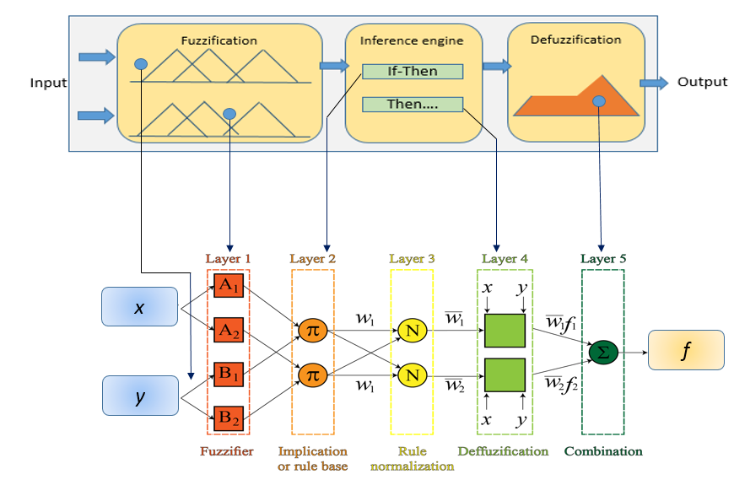

Figure 2. ANFIS model structure.

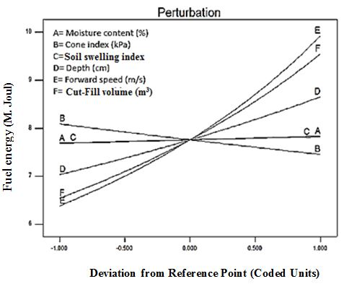
Figure 3. Perturbation plot of FE.
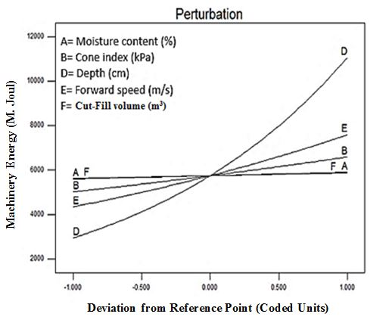
Figure 4. Perturbation plot of TME.

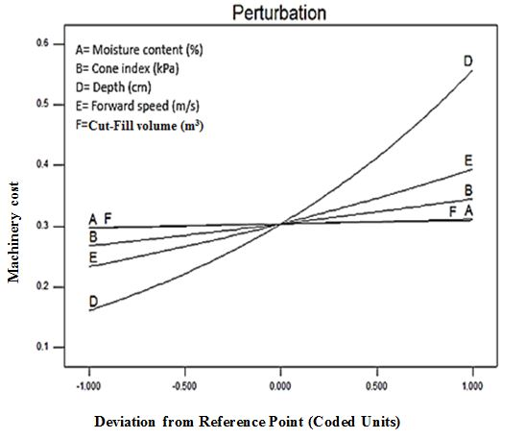
Figure 5. Perturbation plot for TMC.

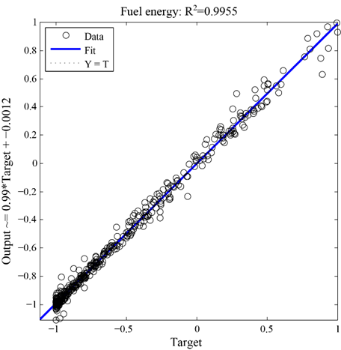
Figure 6. Scatter plot for the predicted model and actual values of FE.
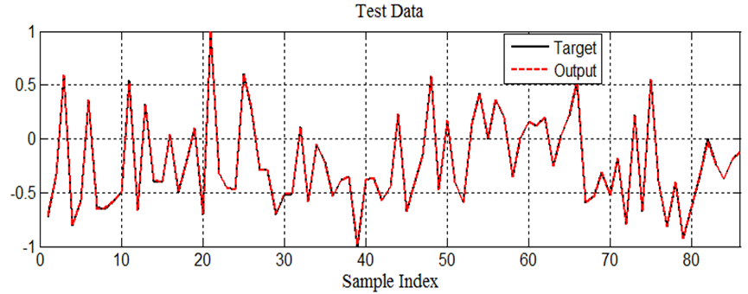
Figure 7. Mapping between experimental and predicted values of FE by ANFIS algorithm in the case of 86 data points.

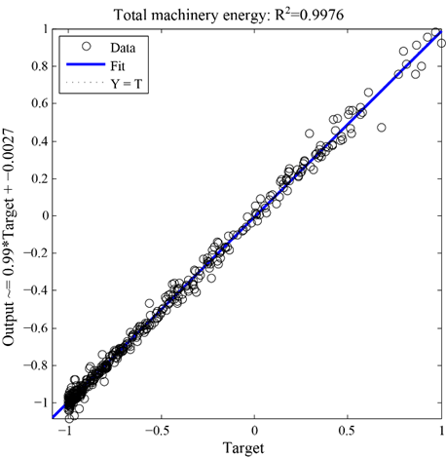
Figure 8. Scatter plot for the predicted model and actual values of TME.
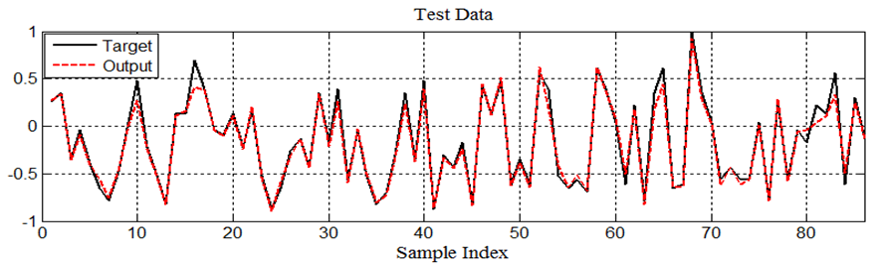
Figure 9. Mapping between experimental and predicted values by ANFIS algorithm in the case of 86 data points for TME.

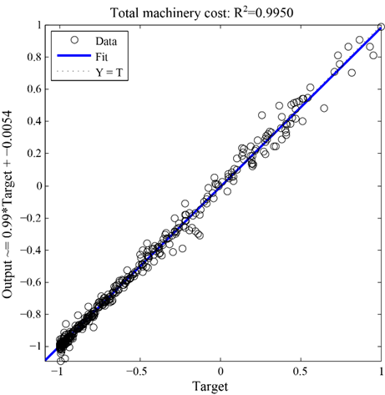
Figure 10. Scatter plot for the predicted model and actual values of b) total machinery cost
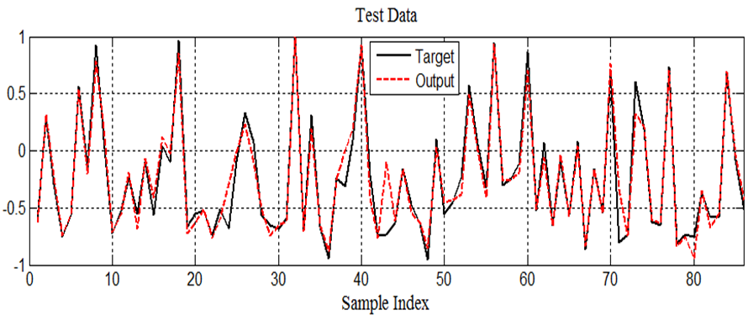
Figure 11. Mapping between experimental and predicted values by ANFIS algorithm in the case of 85 data points for TMC.

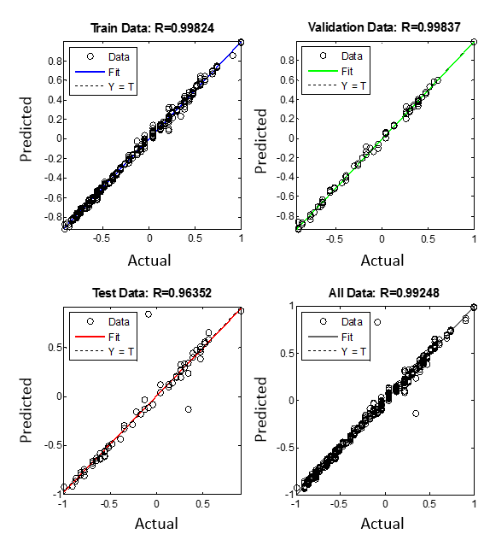
Figure 12. Result of regression analysis for FE based 6-10-1 structure and Levenberg-Marquardt training algorithm.

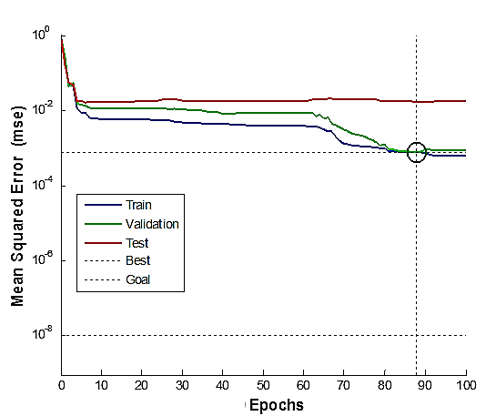
Figure 13. Regression result of neural network training for MSE of all epochs for FE.

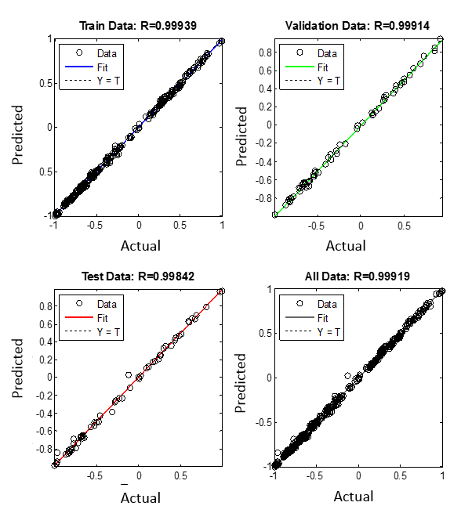
Figure 14. Output of the best ANN model for TME prediction using Levenberg–Marquardt training algorithm.
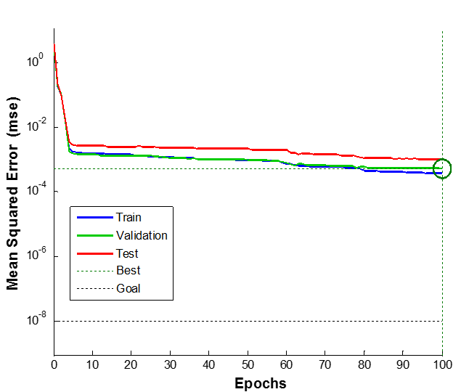
Figure 15. Regression result of neural network training for MSE of epochs for TME

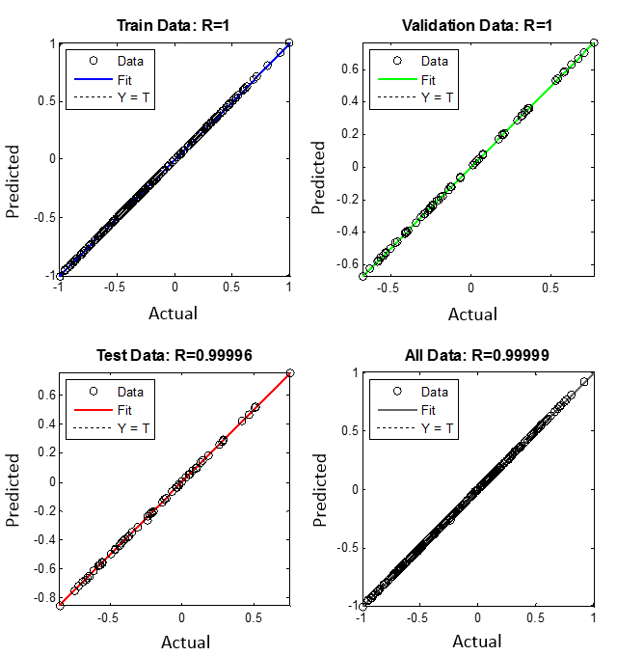
Figure 16. Result of regression analysis for TMC predictor based 6-8-1 structure and Bayesian regulation training algorithm.
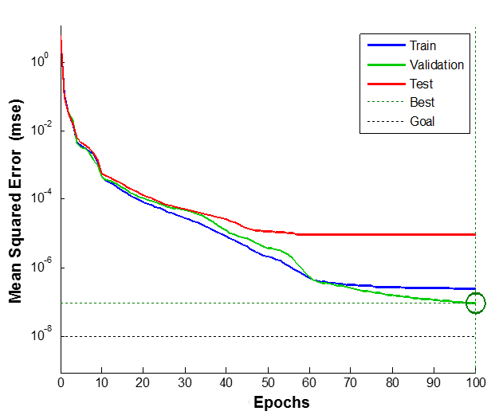
Figure 17 Regression result of neural network training for MSE of all epochs for TMC

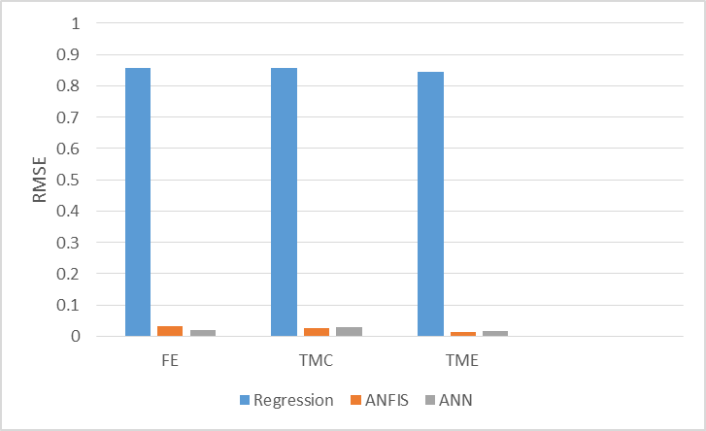
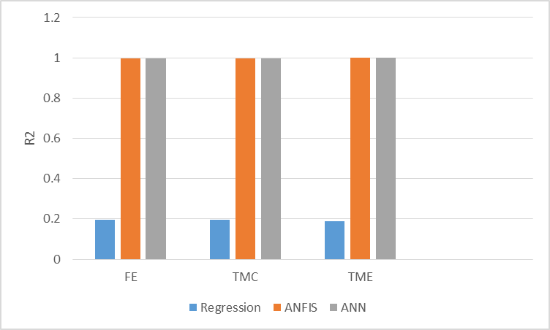

Figure 18. RMSE (a) and R² (b) of four prediction algorithms.

