Estimating Dependence Structure and Risk of Financial Market Crash

A. J. Ogunyiola¹ P.N Mwita² and C.N. Njenga
¹Pan African University Institute For Basic Science, Technology and Innovation
Email : ayoogunyiola@yahoo.com
²Jomo Kenyatta University of Agriculture and Technology,
Department of Statistics and Actuarial Science, Kenya;
Email : petermwita@fsc.jkuat.ac
Strathmore University, Kenya
Email : cnjenga@strathmore.edu

ABSTRACT
In this paper, we estimate the dependence structure between international stock markets using copulas. Different relationships that exist in normal and extreme periods were estimated using Clayton copula. The Inference Functions for Margins method was used in estimating the clayton copula parameter thereby obtaining dependence estimates used in estimating Value-at-Risk. The results revealed that during the crisis period, the maximum possible loss of market value is 75.9% and 77.6% with a confident interval of 90% for the Kenya-Nigeria and Kenya-South Africa portfolios respectively. This implies that the Kenya-South Africa portfolio has the highest risk.

Keywords: Copula, Asymmetric Dependence, Value-at-Risk

- INTRODUCTION
Dependence structure between random variables is crucial in multivariate analysis. In finance, the dependence structure between financial markets are critical in order for investors, policymakers and researchers to make informed decision about investing their resources and making correct investment strategies (Ling, 2006). This is because in general, interest rates and equity prices move in opposite directions but in times of extreme stress, they both move in the same direction.
The extent of interconnectedness and interdependence of the financial system was highlighted by 2007- 2009 financial crisis (Aloui et al., 2011). The studies of Dennis (2013); Nguyen and Nguyen (2014) suggest and further confirm that financial markets are likely to be more correlated in period of burst than periods of booms. When dependence structure of financial markets (stock, bond, exchange rates and money markets) are closely related, they tend to be faced with a possibility of a market crash.
Until recently, extreme events (financial crisis) were regarded as outliers and often excluded from statistical analysis of financial market (Wu et al., 2012). The financial turmoil has highlighted the importance of analysing extreme events in investment decision, pricing of financial assets as well as risk management (Aloui et.al, 2011). Therefore, extreme events are likely to alter the dependence structure of financial market which could have implications for investment decisions and ability to estimate the risk of financial markets crashing.
Market crashes are considered catastrophic events for instance when the values of equity market suddenly decline, exchange rates depreciate rapidly as well as when there is a credit default. When these rare events occur, they could lead to instability of the financial system and exposure to systemic risk. In recent times, extreme events in financial market are no longer considered as just an outlier having a negligible probability. Modelling of extreme events is now important in order to reduce financial market risk.
Analysing extreme events with a normality assumption might be misleading (Chen et al., 2004). Restriction to elliptical distributions such as t – student and Gaussian distribution, implies dealing with measures which only captures dependence in the linear sense (Aloui et.al., 2011). Linear correlation models however, from empirical literature have been found not to be appropriate for measuring non normal distributions (Nelsen, 2006). Since financial market data exhibit heavy tails as a result, linear correlation models cannot capture the structure of dependence (Embrechts et al., 2002). Financial decision based on linear correlation models may be misleading as it is not robust in modelling of nonlinear dependence (Boyer et al., 1999).
The drawback of linear correlation models can lead to underestimation of the risks that could be associated with financial market crash. Therefore, it is pertinent to use models which capture financial market non-linearity. The aim of this paper is to estimate dependence structure and estimate the risk of market crash.
The remainder of the paper is organized as follows: section 2 explains the theoretical framework. Empirical results are analysed and discussed in Section 3 and our conclusion and policy implications are provided in Section 4.
- THEORETICAL FRAMEWORK
Assume a portfolio of two financial market index. The initial value of the portfolio is
$P_{0}=n_{1}A_{1}+n_{2}A_{2} (1)$
where $n_{1} and n_{2}$ are the number of units of the two financial markets index, which are valued at $A_{1 }and A_{2}$ at the beginning of a period. We denote $A_{1}^{'} and A_{2}^{'}$ their values at the end of the period. The new value of this portfolio at the end of the new period is given by
$P_{1}=n_{1}A_{1}^{'}+n_{2}A_{2}^{'} (2)$
$$=n_{1}A_{1}e^{x} +n_{2}A_{2}e^{y}$$
to get log returns on the individual financial market index, we denote
$$X=log\left(\frac{A_{1}^{'}}{A_{1}}\right) (3)$$
and
$$Y=log\left(\frac{A_{2}^{'}}{A_{2}}\right) (4)$$
The log return of the portfolio is given by
$$R=log\left(\frac{A}{A_{0}}\right)=\log\left(\frac{n_{1}A_{1}}{n_{1}A_{1}+n_{2}A_{2} }e^{X}+\frac{n_{1}A_{1}}{n_{1}A_{1}+n_{2}A_{2} }e^{Y}\right)$$
$$=log\left(λ_{1}e^{X}+λ_{2}e^{Y}\right) (5)$$
Where $λ_{1} and λ_{2 }$ are the individual market index.

In order to apply copula model and afterwards estimate the risk of financial market crash, we filter our log returns to obtain independent and identically distributed (i.i.d) data using the GARCH (1,1) model. The GARCH filtering provides us with a standardized residual of returns series which we use in estimating the marginal distribution. The standard GARCH (p,q) model by Bollerslev (1986) is given by

$$σ_{t}^{2}=ω+{\sum_{i=1}^{q}{α_{i}}}_{}ε_{t-i}^{2} \sum_{j=1}^{p}{β_{j}}σ_{t-j}^{2} (6)$$
$σ_{t }^{ 2}$is conditional variance and $ε_{t}$ is the innovation or residual returns defined as $ε_{t}$= $σ_{t}e_{t}$, $e_{t}\sim N(0,1)$are standardized residual returns.
To measure dependence among the financial market returns, the filtered residuals are joined together applying copula function modelling. The joint distribution function of the random variable $X and Y$ is given by

$$F_{XY}\left(x,y\right)=P_{r} \left(X≤x,Y≤y\right) (7)$$

Using the theorem of Sklar (1959), gives us a connection between marginal distribution and copulas to the joint distribution. In this case, let $F_{XY}$ represent a bivariate cumulative distribution function with marginal distribution $F_{X}$ and $F_{Y}$, then there exist a two dimensional copula cumulative distribution function $C$ on ${[0,1]}^{2}$, such that for all $\left(x,y\right) ϵ R^{2}$ $F_{XY}\left(x,y\right)=C\left(F_{X}\left(x\right),F_{Y}\left(y\right)\right)$ holds. For continuous $F_{X}$ and $F_{Y}$, $C$ is uniquely determined by

$$C\left(u,v\right)= F_{XY}\left(F_{x}^{-1}{\left(u\right),F}_{Y}^{-1}\left(v\right)\right) (8)$$
the random variables $u=F_{X}(x) and v=F_{Y}\left(y\right)$, are obtained by the probability integral transformation uniformly distributed on $\left[0,1\right]$, where $F_{Y}^{-1}\left(u\right) and F_{X}^{-1}\left(v\right)$ are the generalised inverse distribution functions of marginal.

The Joint density function of (X Y) is given by
$$f\left(x,y\right)=C\left(F_{X}\left(x\right),F_{Y}\left(y\right)\right) f_{X}\left(x\right),f_{Y}\left(y\right) (9)$$

Literature offers several copulas such as Gaussian, Gumbel and Clayton which can be used in modelling dependence structure of a relationship described above (Kjersti, 2004). However, of interest to this study is the Clayton Copula. The Clayton copula is an asymmetric copula, exhibiting greater dependence in the negative tail than in the positive. Mathematically, the bivariate Clayton copula is expressed as
$C_{θ}\left(u,v\right)=(u^{-θ}+v^{-θ}-1)^{-\frac{1}{θ}} (10)$
its generator is
$φ_{θ}\left(X\right)=\frac{1}{θ}\left(x^{-θ}-1\right) (11)$
Where $u and v$ are random variables, $0<θ<∞$ is a parameter controlling the dependence. Perfect dependence is obtained if $θ→∞, while θ→0$ implies independence. Therefore, markets crashing jointly can be modelled using the Clayton approach which is the main focus area of this research as it can tell about market risk in periods of extreme financial events.

Estimating Copula Parameters
We use the inference function for margins method (IFM) to fit copula and estimate the structure of dependence. The IFM is based on the pioneering work of (Joe and Xu, 1996). The estimation method of IFM is presented below:

Assume we observe $n$ independent observations $X_{t}=\left(x_{t1},x_{t2}, …, x_{tp}\right)$ from a multivariate distribution, which can be constructed with $p$ marginal distributions and a copula function $C\left(F_{1}\left(x\right), …,F_{n}\left(x\right);θ\right)$ with parameter $θ$. The probability distribution function (PDF) of the marginal distributions is defined as $f_{i}(x;θ_{i})$ with a cumulative density distribution (CDF) as $F_{i}(x;θ_{i})$, where $θ_{i}$ is the parameter of marginal distributions. The IFM method estimates the parameters of the marginal distribution in the first step.

The log-likelihood function of the first step can be written as

$$Logl\left(θ\right)=\sum_{i=1}^{n}{}\sum_{j=1}^{p}{log }f_{i} \left(x_{ij};θ_{i} \right) (12)$$

The estimation of the parameter $θ=\left(θ_{1}, …,θ_{n}\right)$ of marginal distribution can be made through maximizing the log-likelihood function.

$${\hat{θ}}_{i}=argmax\sum_{i=1}^{n}{}\sum_{j=1}^{p}{log }f_{i} \left(x_{ij};θ_{i} \right) (13)$$
The parameter $θ$ of the copula function is estimated in the second step of IFM, with the parameter $\hat{θ}$ of the p marginal distributions.

$$\hat{θ}=argmax\sum_{t=1}^{n}{log C }\left(F_{1} \left(x_{i1};{\hat{θ}}_{i} \right), …,F_{p} \left(x_{ip};{\hat{θ}}_{p} \right);θ\right) (14)$$

The IFM is given by a vector $θ^{IFM}=\left(\hat{θ},{\hat{θ}}_{IFM}\right)$

where ${\hat{θ}}_{IFM}={(\hat{θ}}_{i},{\hat{θ}}_{p},θ)$

Asymptotic Properties of Inference function for Margin Estimator

We use theorem 1 to show consistency and asymptotic normality of the IFM estimator${\hat{θ}}_{IFM}$.
Theorem 1. Let $X_{1}, …,X_{n}$ be independent and identically distributed random vectors with density $f_{θ}$. Let $θ ϵ Θ$ and $x ϵ S$ : = $supp\left(f_{0}\right) ⊆R^{2}$ where $supp\left(f_{0}\right)$ is the support of $\left(f_{0}\right)$. Assuming the following conditions hold:
- The parameter space $Θ$ $⊆$ R is an open interval
- The Support $S$ is independent of $θ$
- $f\left(x;θ\right)$ is three times continuously differentiable with respect to $θ$
- $El_{θ }{\left(X:θ\right)}^{2}+El_{θθ }\left(X:θ\right)=0 and \int_{s}{\frac{∂}{∂θ}}f\left(x:θ\right)dx=\frac{∂}{∂θ}\int_{s}{f\left(x:θ)dx=0\right)}$
- The fisher Information $I\left(θ\right)=El_{θ}{(X:θ)}^{2}= -El_{θθ}\left(X:θ\right)$ is positive and finite
- For all $θ_{0} ϵ Θ$ and $θ ϵ Θ$ and $θ ϵ U_{δ}\left(θ_{0}\right)$ there exists a measurable function $M_{θ_{0}}$ with $E_{θ_{0}}\left(M\left(X:θ_{0}\right)\right)< ∞$ such that $\left|l_{θθθ}\left(y:θ\right)\right|≤M\left(x:θ_{0}\right)$ for all $x ∈$.
Imposing the regularity conditions from (White 1994 and Patton 2006b) to the marginal likelihood in equation (12), and the copula likelihood function, equation (14), a joint normality condition holds such that as $n→∞$,

$$\sqrt{n}\left(\left( {\hat{θ}}_{IFM}\right)-θ\right) →N \left(0, \hat{G}\right)$$
where ${\hat{G}}_{}$ is the estimator of the Godambe Information matrix (Joe, 1997).
G is defined as $G={{(D}_{g}}^{-1}M{{D_{g}}^{-1})}^{t}$, where $D_{g}=E\left(\frac{∂g^{t}(X,η)}{∂η}\right)$ and $M_{g}=E\left(g^{t}\left(X,η\right)g \left(X,η\right)\right)$.

Estimating Market Risk
In estimating financial market risk, the literature offers several risk measures. However, we reviewed Value at Risk (VaR). Value-at-Risk measures the minimum loss we would expect over a given time horizon. Carmona (2004) defined ${VaR}_{q}$ as the ${100}_{q}$-th percentile of the loss distribution given as:

$$q=P \left\{-R≥r\right\}= P\left\{R≤-r\right\}=F_{R}\left(-r\right) (15)$$
Where $q$ is the percentile, $P$ is the probability $R$ is the random variable and $r$ is the losses.

From our earlier setting of a portfolio with two financial index and log returns denoted by $X and Y$, we solve for $r$ in equation (15) to get our VaR with our copula parameter inputted in the VAR (Copula –VAR) by computing the CDF of the log return $R.$ The latter can be expressed analytically as

$$=\iint_{\left\{\left(x,y\right);λ_{1}e^{x}+λ_{2}e^{y}\right\}≤e^{-r}}{f{\left(X,Y\right)}^{\left(x,y\right)dxdy } (16)}$$
where $λ_{1}e^{x}+λ_{2}e^{y}$ are log returns of the portfolio from equation (5) and $f(X,Y)$ is the CDF of the returns.
$$=\int_{-∞}^{-r-logλ_{1}}{dx}\int_{-∞}^{log⁡(e^{-r}/λ_{2}- λ_{1}/λ_{2}e^{x})}{c\left(F_{X}\left(x\right), F_{Y}\left(y\right)\right)f_{X}\left(x\right)}f_{Y}\left(y\right)dy (17)$$

$$=\int_{0}^{F_{X}(-r-logλ_{1})}{du}\int_{0}^{F_{Y}(log⁡(e^{-r}/λ_{2}- λ_{1}/λ_{2}e_{X}^{F^{-1} \left(u\right)}))}{dv c\left(u,v\right)} (18)$$
$$=\int_{0}^{F_{X}(-r-logλ_{1})}{du} \frac{∂}{∂u}C\left(u,v\right)|_{v=F_{Y}(log⁡(e^{-r}/λ_{2}- λ_{1}/λ_{2}e_{X}^{F^{-1} \left(u\right)})) } (19)$$
The steps for inputting copula parameter into VaR is given in Appendix I.

In order to estimate the VaR in the given framework, we estimate the copula dependence parameter from a sample of pairs of log returns. The estimated parameter is then used to compute the VaR quantiles at different confidence levels which gives estimates for VaR.

EMPIRICAL RESULTS

In the analysis of financial market dependence, monthly data were collected from January, 2000 to March, 2016 from stock exchange websites of countries namely; Nigeria, Kenya and South Africa. Consideration for proxy is All Share Index. Data was divided into three periods; Pre-crisis, crisis and Post crisis periods which captured financial market extreme events (2007-2009). We used negative log returns obtained as:

$$r_{t}=- In\left(\frac{A_{t}}{A_{t-1}}\right) (20)$$

where $A_{t}$ is today’s index and $A_{t-1}$is the previous day’s index.
The summary statistics for each log return index are reported in Table 1. A glance at the results from the Jarque-Bera test, reveals none of series returns are normally distributed. Figure 1 gives the trend and log returns of each index.

Table. 1: Monthly Summary Statistics for Each Index
Index | Mean | Standard Deviation | Skewness | Kurtosis | Jarque-Bera
NSE20 | 0.0026 | 0.0404 | -0.474 | 2.502 | p < 0.00005
NASI | 0.0076 | 0.0719 | -0.509 | 5.360 | p < 0.00005
JSE | 0.0097 | 0.0490 | -0.3149 | 0.563 | p < 0.00005
Tables 1 gives a summary statistic for the negative log returns of Kenya, Nigeria and South Africa stock markets. The p − values of Jarque-Bera normality test are shown in the last column. The sample period on a monthly basis covers from January 2000 to March 2016. Observations are 195, collected from various stock exchange websites. NSE20 -Kenya Stock Market Index, NASI: Nigerian Stock Market Index and JSE: South African Stock Index.

Figure 1: Monthly Stock Market Evolution and Log Returns

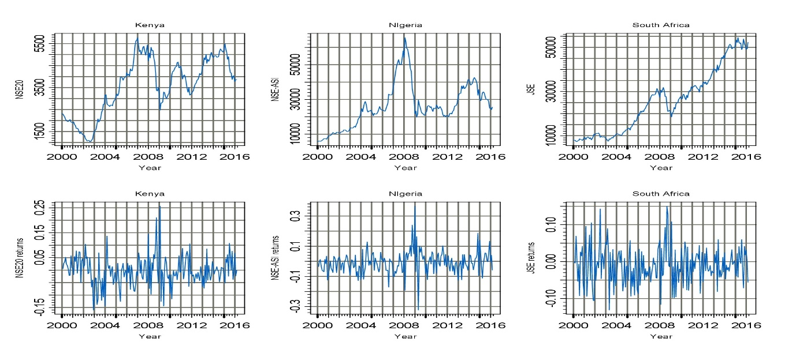

Figure 1 reveals that stock market index for Kenya, Nigeria and South Africa was trending upwards which can be described as a pre-crisis period from around 2003 to 2006 for Kenya, 2000 -2006 for Nigeria and 2000-2006 for South Africa. Between 2007-2009 a downward trend is seen for all index (crisis) and from 2010-2016 a post crisis period.

3.1. Copula Fitting
We report results from fitting Clayton copula. Figure 2 gives a visual display of the dependence between market pairs.
Figure 2: Scatter plots of Stock Market Pairs
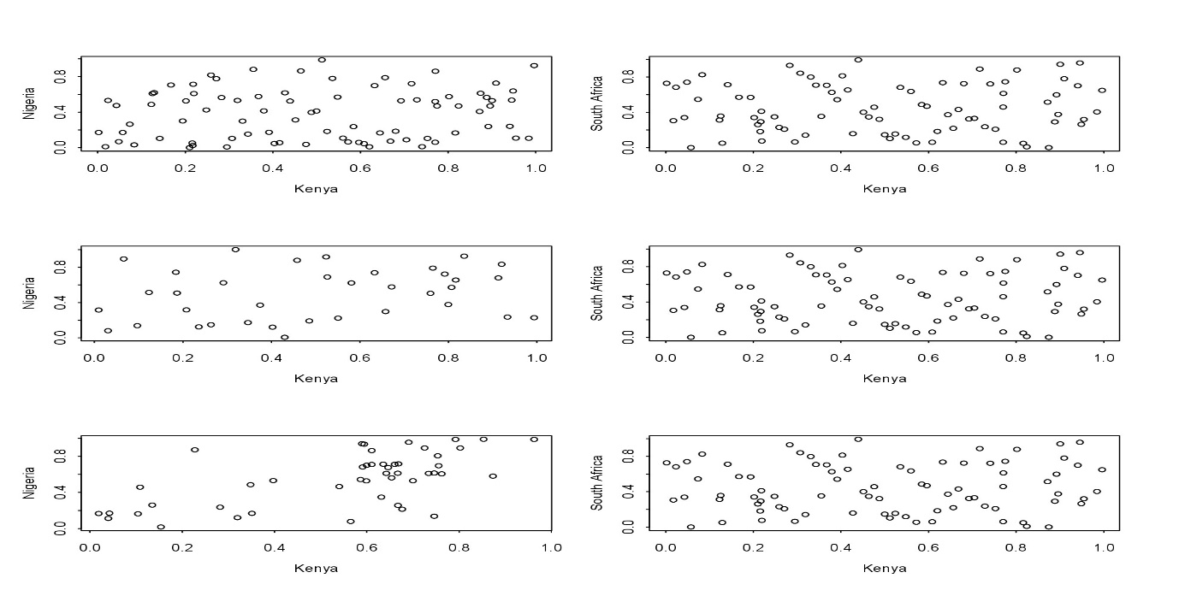
The first row gives a scattered plot for the fitted copula, showing patterns of dependence between Kenya and Nigeria stock market between 2000-2006 and Kenya and South Africa in the same period. The second row in a similar manner shows the scattered plot for Kenya and Nigeria between 2007-2009 and Kenya South Africa Between 2007-2009. The observation shows a dependence originating from the low side of the plot.
Figure 3: Contour Plot of Clayton Copula (Crisis Period)
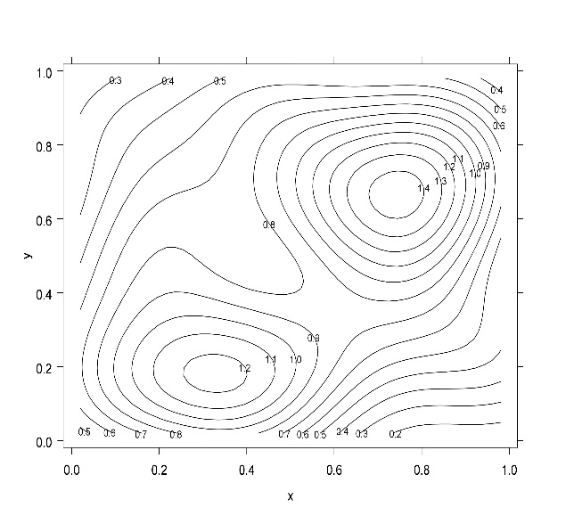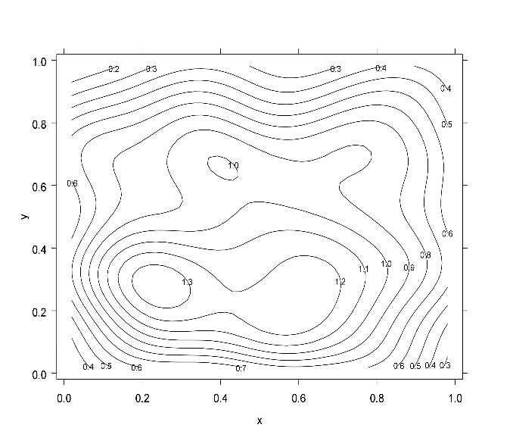
Figure 3 gives us a contour plot for Kenya-Nigeria pair on the left and for Kenya-South African pair on the right.
Table 2 gives estimates from fitting clayton copulas to stock market pairs for a period considered as pre crisis between 2000-2006. The table reports the parameter of the copula and also the linear parameters estimates of the relationship between these pairs.
Table. 2: Empirical Fitting of Copula 2000-2006 (Pre Crisis Period)
Kenya -Nigeria (Market Pair)
Copula | Parameter
 | $$θ$$ | LogLike | AIC | Kendall’s | Spearman
Clayton | 0.1574 (0.1374) | 0.8471 | 0.3048 | 0.0729 | 0.1670
Kenya - South Africa (Market Pair)
Copula | Parameter
 | $$θ$$ | LogLike | AIC | Kendall’s | Spearman
Clayton | 0.09943 (0.1259) | 0.36285 | 0.1673 | 0.0473 | 0.0709

Table 2 gives a summary of copula fit for Kenya-Nigeria stock market index pair and Kenya-South Africa stock market index pair. $θ$is the dependence parameter for clayton copula during the pre-crisis period. The Kendall’s tau reports a dependence of 0.072 and Spearman rho of 0.167 for Kenya-Nigeria stock market pair, while a dependence of 0.0473 and 0.070 for Kendall’s tau and Spearman are reported for Kenya-South Africa market pair.

Table 3: Copula Fitting for 2007-2009 (Crisis Period)
Kenya -Nigeria (Market Pair)
Copula | Parameter
 | $$θ$$ | LogLike | AIC | Kendall’s | Spearman
Clayton | 0.2863 (0.2486) | 0.9114 | 0.1771 | 0.1252 | 0.1865
Kenya - South Africa (Market Pair)
Copula | Parameter
 | $$θ$$ | LogLike | AIC | Kendall’s | Spearman
Clayton | 0.9201 (0.3189) | 6.6607 | -11.3215 | 0.3151 | 0.4542

Table 3 gives an overview of fitting clayton copula to stock market pairs in an extreme period considering the 2007-2009 period. In this period, the dependence parameter $θ$ between Kenya –Nigeria stock market index is 0.286 and for Kenya–South Africa market index is 0.9201. The Kendall’s tau reports a dependence of 0.125 and Spearman rho of 0.186 for Kenya-Nigeria stock market pair, while a dependence of 0.315 and 0.452 for Kendall’s tau and Spearman are reported for Kenya-South Africa market pair.

Tab. 4: Copula Fitting for 2010-2016 (Post Crisis Period)
Kenya -Nigeria (Market Index Pair)
Copula | Parameter
 | $$θ$$ | LogLike | AIC | Kendall’s | Spearman
Clayton | 0.4307(0.1847) | 3.328 | -4.657 | 0.2536 | 0.3727
Kenya - South Africa (Market Index Pair)
Copula | Parameter
 | $$θ$$ | LogLike | AIC | Kendall’s | Spearman
Clayton | 0.3469 (0.159) | 3.1707 | -4.3414 | 0.1478 | 0.2196

In Table 4, we report the fitting of clayton copula to stock market pairs in the post crisis period. In this period, the dependence between Kenya–Nigeria stock market pair is 0.430 and for Kenya –South Africa is 0.346. The Kendall’s tau reports a dependence of 0.253 and Spearman rho of 0.37 for Kenya-Nigeria stock market pairs, while a dependence of 0.147 and 0.219 for Kendall’s tau and Spearman are reported for Kenya-South Africa.

3.2. Estimating Market Risk
After estimation of copula parameter $θ,$ we substituted the dependence parameter into the VaR functions to estimate risk measures at 90%, 95% and 99% using the corresponding quantiles 0.01, 0.05 and 0.10 respectively. The VaR estimates are used in measuring the maximum possible loss of market value over a holding period. The VaR is computed as 0.759 at 90%, 0.784 at 95% and 0.837 at 99% confident interval which implies the losses from holding the Kenya-Nigeria portfolio is 75.9%, 78.4% and 83.7% at the respective confidence interval as shown in table 5. Simultaneously, VaR estimates computed for Kenya – South Africa portfolio reveal a 0.776 at 90%, 0.795 at 95% and 0.855 at 99% confident interval which implies the losses from holding the Kenya-South Africa portfolio is 77.6%, 79.5% and 85.5% at the respective confidence interval.
Table. 5: Value at Risk Estimates Using Clayton Copula
Crisis Period: Clayton Copula
NSE20-NASI | 90% VaR | VaR 95% | VaR99%
 | 0.759 | 0.784 | 0.837
NSE20-JSE | 90% VaR | VaR 95% | VaR 99%
 | 0.776 | 0.795 | 0.855

4. CONCLUSION AND RECOMMENDATION
Knowledge of multivariate distribution is important in financial applications such as selection of portfolio and diversification of market risk management. We focused on stock markets (Kenya, Nigeria and South Africa) using the concept of copula, which revealed the estimates of dependence structure of stock markets during pre-crisis, crisis and post-crisis periods. We estimate clayton copula parameters using the Inference function for margins method to obtain the dependence parameter. To measure VaR, we input the dependence parameter into the VaR framework. The results revealed that during the crisis period, the maximum possible loss of market value is 75.9% and 77.6% with a confident interval of 90% for the Kenya-Nigeria and Kenya-South Africa portfolios respectively. This implies that the Kenya-South Africa portfolio has the highest risk. A further implication is that dependence during crisis period imply that opportunities for portfolio diversification are reduced than at periods of booms.

5. REFERENCES

Aloui, R., Aissa, M., and Nguyen, D. (2011). Global financial crisis, extreme interdependences, and contagion effects: the role of economic structure? Journal of Banking and Finance, page 35.

Boyer, B., Gibson, M., and Loretan, M. (1999). Pitfalls in tests for changes in correlations, Board of Governors of the Federal Reserve System. Inter- national Finance Discussion Paper, 24:597.

Carmona (2004). Statistical Analysis of Financial Data in S-Plus. Springer Verlag. http://www.princeton.edu/rcaroma/safd
Chen, Fan, Y., and Patton, A. (2004). Simple Test for Models of Dependence between Multiple Financial Time Series, with Application to U.S. Equity Returns and Exchange Rates). London Economics Financial market group, 43(483).
Dennis, E. (2013). Developing country vulnerability in light of the global financial crisis: Shock therapy. Review of Development Finance, 3:61–83.
Embrechts, P., McNeil, A., and Straumann, D. (2002). Correlation and dependence in risk management: Properties and pitfalls. Cambridge University Press, pages 176–223.
Joe, H. and Xu, J. (1996). The Estimation Method of Inference Functions for Margins for Multivariate Models. Department of Statistics, University of British Columbia, (166).

Joe, H., (1997). Multivariate Models and Dependence Concepts. Chapman & Hall, London
Kjersti, A. (2004). Modelling the dependence structure of financial assets: a survey of four copulas. Applied research and development.
Ling, H. (2006). Dependence patterns across financial markets: A mixed copula approach. Applied Financial Economics, 717-729. Applied Financial Economics, pages 717–729.
Nelsen, R. (2006). An introduction to copulas. Computational Statistics and Data Analysis, (6):272.
Nguyen, C. and Nguyen, T. (2014). Analysing Dependence Structure of Equity, Bond and money Market by using time varying Copula. International Journal of Economics and Finance, 6(3):787–815.
Patton, A. 2006b. Modelling asymmetric exchange rate dependence.
International Economic Review 47(2): 527–556.
Poon, S., M, M. R., and Tawn, J. (2004). Extreme Value Dependence in Financial Markets: Diagnostics, Models, and Financial Implications. Review of Financial Studies, 17:581–610.
Sklar, A. (1959). Fonctions de repartitiona n dimensions et leurs marges. Publication de l’Institute
de Statistique de l’Universite de Paris, 8.

Vaart A. W., (2000). Asymptotic Statistics. Cambridge University Press.

White H. (1994). Estimation, Inference and Speciﬁcation Analysis. Econometric Society Monographs No. 22. Cambridge University Press: Cambridge.

Wu, Zhang, Z., and Zhao, Y. (2012). Study of the Tail Dependence Structure in Global Financial Markets Using Extreme Value Theory. Journal of Reviews on Global Economics, (1):62–81.

Appendix I

We show how we input $θ,$ the copula parameter into VaR. From the definition of VaR. Carmona (2004) defined ${VaR}_{q}$ as the ${100}_{q}$-th percentile of the loss distribution given as:

$$q=P \left\{-R≥r\right\}= P\left\{R≤-r\right\}=F_{R}\left(-r\right) (15)$$
We solve for $r$ in equation (15) to get our VaR, we computing the CDF of the log return $R.$ The latter can be expressed analytically as

$$=\iint_{\left\{\left(x,y\right);λ_{1}e^{x}+λ_{2}e^{y}\right\}≤e^{-r}}{f{\left(X,Y\right)}^{\left(x,y\right)dxdy}} (16)$$

Now for a continuous case, the continuous distribution function (CDF) is given by

$$F\left(X,Y\right)=\int_{-∞}^{x}{}\int_{-∞}^{y}{f\left(a,b\right)da db}$$
Note: For double integral, we assume that one variable is constant and the other is varying. So here we assume $X$ to be the only variable and $Y$ as a constant. The above generates the upper limit of $X$ as follows.
$$log\left(λe^{x}+λe^{Y}\right)≤ -r⇒λe^{x}+λe^{Y}≤e^{-r}$$
When $Y$ is considered a constant, we then have

$$λ_{1}e^{X}≤⇒λ_{1}≤\frac{e^{-r}}{e^{x}}⇒λ_{1}≤e^{-r-X}⟹log\left(λ_{1}\right)≤-r-X≤-r-log{ λ}_{1}$$
Hence, the upper limit for $X$ is $-r-logλ_{1}$

Then for $Y,$ we vary both $x and Y.$ This is because we cannot assume $X$ to be constant as we have already assumed $Y$ to be one but now we integrate with respect to X.
So we have,

$$λ_{1}e^{X}+ λe^{Y}≤e^{-r}⇒\frac{λ_{1}e^{X}}{λ_{2}}+\frac{λ_{2}e^{X}}{λ_{2}}≤\frac{e^{-r}}{λ_{2}}-\frac{λ_{1}e^{X}}{λ_{2}}⇒Y ≤\log\left(\frac{e^{-r}}{λ_{2}}-\frac{λ_{1}}{λ_{2}}\right)$$

As the upper limit for $Y.$ Which gives of the equation (17 ) below

$$=\int_{-∞}^{-r-logλ_{1}}{dx}\int_{-∞}^{log⁡(e^{-r}/λ_{2}- λ_{1}/λ_{2}e^{x})}{c\left(F_{X}\left(x\right), F_{Y}\left(y\right)\right)f_{X}\left(x\right)}f_{Y}\left(y\right)dy (17)$$

Change of variables and integration
Now, we do a change of variables so as to integrate in a mathematically correct way. So recall that for copulas, $F\left(x_{1},x_{2},…,x_{n}\right)=C\left(F_{1}\left(x_{1}\right),F_{2}\left(x_{2}\right),…,F_{n}\left(x_{n}\right)\right)$ from Sklar Theorem (1959),

Recall also that
$$F\left(X,Y\right)=\frac{f_{\left(X,Y\right)}(x,y)}{f_{x}(x)f_{Y}(y)}=C\left(F_{X}\left(x\right),F_{Y}\left(y\right)\right)$$

To bring in $u$, we do a transformation,
$$u=f(X)$$
Such that when $X=-∞$, $u$=0 and when $X=-r-logλ_{1}$,$u=F_{X}\left(-r-logλ_{1}\right)$
For $v, v=f\left(Y\right)=F_{Y}\left(y\right)$ such that when $Y=-∞, v=0$ and when
$$Y= \frac{e^{-r}}{λ_{2}}-\frac{λ_{1}e^{X}}{λ_{2}},$$
$$v=F_{Y}\left(\frac{e^{-r}}{λ_{2}}-\frac{λ_{1}e^{F_{X}^{-1}(u)}}{λ_{2}}\right)$$

$$=\int_{0}^{F_{X}(-r-logλ_{1})}{du}\int_{0}^{F_{Y}(log⁡(e^{-r}/λ_{2}- λ_{1}/λ_{2}e_{X}^{F^{-1} \left(u\right)}))}{dv c\left(u,v\right) (18)}$$

By integrating equation (18) we

$$=\int_{0}^{F_{X}(-r-logλ_{1})}{du} \frac{∂}{∂u}C\left(u,v\right)|_{v=F_{Y}(log⁡(e^{-r}/λ_{2}- λ_{1}/λ_{2}e_{X}^{F^{-1} \left(u\right)})) } (19)$$

