Mystery of Mosul Dam the Most Dangerous Dam
in the World:
Experts Proposals and Ideas on Mosul Dam

Nasrat Adamo⁴, Nadhir Al-Ansari, Issa E. Issa³,Varoujan K. Sissakian4
and Sven Knutsson⁵

Abstract
During and after the construction of Mosul Dam, in Iraq, all the studies expressed a clear concern on the fact that the region of the dam suffers from extensive presence of soluble rock formations that might undermine the safety of the dam with its large reservoir. Most of the studies dealt with foundation treatment and safety hazards due to the dissolution of gypsum and anhydrite. To overcome the problem, grouting operations were performed. The seepage of water continued and this highlighted the possibility of the dam failure. Different grouting techniques and methods were suggested but the results were the same. Finally, it was decided to limit the maximum operation water level to EL. 319 m (a.s.l.) instead of EL. 330 m (a.s.l.). This recommendation has remained in force up to now with the loss of sizable storage of irrigation water and power potential.

Key words: Mosul Dam, Iraq, Sinkholes, Seepage, Dam Foundation

- Introduction
During the early 50’s of the last century, Iraq embarked on a very ambitious program of development including advancing the agricultural sector. This included the extension of irrigated areas in large swaths in the north, middle and south of the country. Constructing dams on the river Tigris and its tributaries was required to provide the extra water needed. The construction of Mosul Dam was; therefore, contemplated in 1951; investigations and studies were ordered then. Various studies and reports were conducted during the following 30 years by many specialized international firms covering various locations upstream of Mosul city and providing different alternative designs.
All the studies expressed a clear concern on the fact that this region suffers from extensive presence of soluble rock formations that might undermine the safety of a high dam of a large reservoir such as Mosul Dam. A very refined study that was carried out later by a team from Baghdad University [1] on a very large area surrounding the reservoir showed a lot of anomalies and karstic solution phenomena. Having known these facts before, could have affected the decision on the selection of the present location of the dam or even introducing the idea of building a series of smaller dams in this reach of the river. This study utilized air photos, satellite imagery and magneto metric measurements, which were not in use during the planning stage of Mosul Dam. Such methods could be utilized in planning of future dams in areas of similar nature.

2 During Construction and Impoundment
Extensive amount of literature is available on Mosul Dam at this period comprised of the writings of experts involved in the construction activates of the dam or visiting as expert panels to review these activities or even commissioned to find solution to a particular problem. Foundation problems took prominence among these writings. From the reports of the International Board of Experts for Mosul Dam it is clear that the Board was worried on the nature of the dam foundations since its first meeting and through to the end of construction. In more than thirty reports, the nature of the foundation, foundation treatment and safety hazards due to the dissolution of gypsum and anhydrite took the bulk of those reports. It is worth to mention that this Board was formed by The Ministry of Irrigation of three top world dam experts to follow the planning, design and construction of the dam.
In the Board's first report for reviewing the draft planning report prepared by the designers in 1979, states the following:-
“The presence of gypsum and anhydride in the marl would be particularly detrimental in zones where high seepage flows could develop, i.e. mainly at the contact with cavernous limestone. This will require a special attention in avoiding high velocities, induced by high hydraulic gradients”, and it even goes on to recommend allowing ample cost in the cost estimate for foundation treatment as it was very difficult to come up with a good estimate in such difficult rock conditions as in Mosul Dam [2].
It must be remembered that, this report was written while geological investigations were going on and a clear picture of the behavior of rock with grouting was not established yet. One area of major interest was the treatment of the dam foundations, the work on which had started in 1982. This was initiated by drilling deep exploratory holes and performing pressure water tests to define the details of the grouting program. The work was continued by the grouting contractor’s engineers, the designers’ engineers with the constant following and suggestions of the IBOE to come up with the required Method Statement answering for both blanket and deep curtain grouting. This included the definition of the acceptance criteria of the finished work, techniques and methods and sequences of implementation. As expected, many difficulties were encountered in the deep grouting part, especially at the chalky series over GB layers and in Jeribe Formation. The years from 1985 to 1987 and 1988 were full with surprises and setbacks. The seriousness of the matter was magnified by the rising levels of the reservoir after river closure in 1985. This situation called for the advice and guidance from grouting experts, specialized grouting and engineering firms. Of these it is worth mentioning the report of [3], which was concentrated on examining the quality of the completed blanket grouting, the right bank curtain, the left bank curtain and the ongoing work on the left extension curtain. It also gave recommendation on the use of silica gel for the grouting of the left bank curtain in order to reduce seepage appearing in the left bank.
Another important study concentrated on the grouting of the deep grout curtain under the main dam. This study was completed in order to assist the discussion of the problem of achieving a satisfactory dam foundation [4].The study report explored the very high take of cement grouts and the sand and gravel mixes in a number of zones caused concern. Solution channels and cavities were developing at such rate that the grouting program was not capable of maintaining an adequate curtain. The question raised was whether the dissolution in gypsum/anhydride beds was taking place at a faster rate than the sealing effect of grouting processes. A theoretical analysis of enlargement of small passage within a soluble rock, which was included showed that a flow in a pipe of dia. 60 mm (60 mm is chosen as 3 x 19 mm, the maximum size of gravel used) the flow rate was calculated as 0.0028 m³/ sec, a velocity about 1 m/ sec, the calculation showed that the pipe enlarges to a diameter of 125 mm in a year. It also follows from the study that the equivalent pipe volume is proportional to the cube of the solution potential, so that if the concentration of sulfate is for example 500 mg/ l instead of the 750 mg/ l assumed in the analysis representing the typical concentration opposite problematic sections, then the pipe would enlarge from 60 mm to 300 mm. As a conclusion, the dissolution that had occurred since impounding was substantial, but not so great as to preclude a successful completion.
The study continues to suggest methods to be used for attaining adequate treatment by using gelling cement grouts or trying the injection of hot bitumen or diesel oil and bentonite mixture or even the addition of cotton flock or similar fibrous material (such mixture was used to staunch high velocity flow at Dokan Dam in 1960’s in Iraq). Other alternatives involving in the construction of physical barriers were also examined.
Recognizing the two basic engineering problems;
a) Pre-existing karstified ground at a depth as great as 110 m.
b) Flowing water at these depths capable of dissolving gypsum beds, which may be enlarging the flow paths.
Then; admitting the fact that, high grout takes associated with large channels have been found between Sec.75 and Sec.93; the study examined the possibility of emptying the reservoir to relief the foundation from the existing artesian pressure to enable a better performance of grouting operations. This was overruled since the curtain should later resist even greater pressure at full impoundment of the reservoir. So this led to another line of thinking by considering three basic approaches;
a) General filing of seepage paths by precipitation of insoluble materials from ground seepage water. This envisages the fact that injecting a fluid such as of sodium chloride and utilizing common ion effect then insoluble precipitant would fill and close the seepage paths. This was rejected by the fact that the precipitant volume will not be enough to fill seepage paths of various sizes plus the other fact that the injected fluid may flow in an unpredicted manner by varying seepage flows.
b) Sealing gypsum/anhydride surface; processes which can protect gypsum or anhydride surfaces against dissolution and serve as valuable aid as seepage control measure. There are two approaches; the first is by maintaining a saturated or super saturated solution with SO₄ against the rock surfaces, which requires a continuous supply of solution to seepage water probably from an upstream gypsum blanket. The indicated quantities of removed gypsum daily from the foundation and the uncertainty of directions taken by seepage flow path make this an unattractive proposition. The second is to provide a chemical solution, which reacts with CaSO₄ to form a highly insoluble coating. “Washing” the calcium sulfate rock surfaces within the seepage passage with such a solution might line them with a protective coating against further dissolution. This idea suggests using calcium oxalate, but the problem facing this solution is the tenacity and durability of such coating against further seepage and the uncertainty and difficulties of judging the performance with time. There are also the known toxic effects of oxalate to animals and humans and the large volumes required to be released in ground water. All those give a strong argument against this solution also.
c) Barriers: The following types were suggested:
i) Blanketing
Blanketing of the dam and reservoir is illustrated in figure 1. Effective blanket would affect the piezometric profile in the foundations. Impervious upstream blankets would normally be installed only by drawing down the reservoir. Their success depends on the entry points of seepage to the foundations and lengthening of seepage paths.
Blanketing the bed can be done without drawing down the reservoir but by dropping the lining materials through pipes lowered to the bottom of the pond. Bentonite pellets are dropped in place first, and as bentonite absorbs water a highly impervious layer is formed. Sand is placed on top to hold the clay in place against any disturbances. But, as far as it is known this method has been used for small ponds and not for a reservoir of this size.
ii) Positive-Cutoffs
The use of cutoffs is illustrated in figure 2. Difficulties in using this method result from the combination of depth and hardness of strata between the pervious surface and the impervious bed beneath the karstification zone. This may make trenching operations very problematic. The depth of the required trench has a great effect on the cost. A location near the upstream toe of the dam would require the least depth but it requires the drawing down of the reservoir. A trench from the crest through the core is a tricky operation and it extends for a considerable depth into the foundation, which may be technologically questionable and very costly.

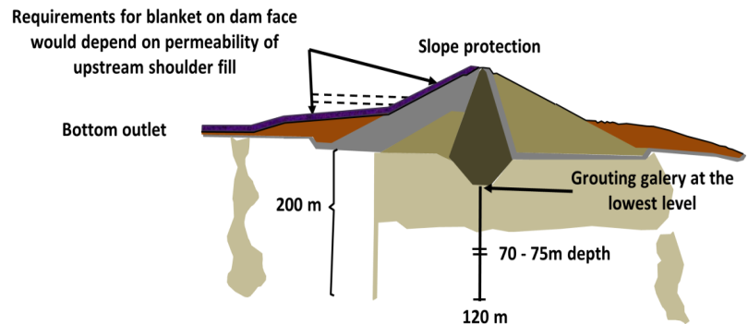

Fig. 1: Illustration of upstream blanketing arrangement.

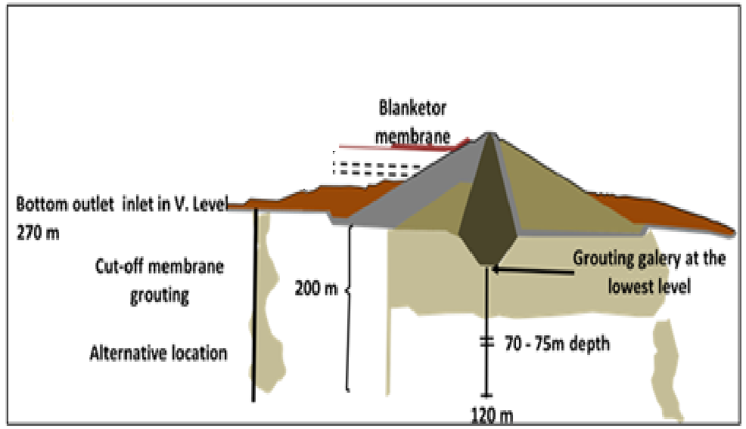

Fig. 2: Illustration of upstream cut-off arrangement.

iii) Construction of a new curtain.
If new curtain is constructed as a direct reinforcement to the present one, this assumes it should be done in a better geological location in the upstream direction of the dam if it would provide any improvement. But, such better geology does not exist and because the construction requires the drawing down of the reservoir then such proposal has no value.
This study showed that all the discussed alternatives were not practical and some of them were even not feasible. The logical conclusion was to continue the works on the present curtain by improving the mixes and injection procedure to combat large take areas, sealing large pipes and channels, providing a new array of piezometers taping the known solution areas especially the contact between the pervious limestone and GB0 layers to monitor the efficiency and the long term performance of the curtain in these soluble layers where windows were most likely would develop.
A new concept was formulated by the study; that is a satisfactory cut-off may be deemed either as one which had been so tightly grouted as to allow negligible dissolution in the long term or one in which dissolution may take place but is kept under control by comprehensive, appropriate and effective maintenance grouting. Means to facilitate and guide maintenance grouting work must be developed.
The three major consequences of the study were:
1. It gave a new dynamics to the “groutability test program” described in the previous section.
2. It introduced the concept of “Maintenance Grouting” as a long term safety procedure.
3. It emphasized the importance of piezometry as a mean of checking local solution areas for prioritizing the repair works.
At the same time, two more studies were available to the IBOE. The first one was presented by Dr. Aladdin Hamdi from Mosul University who had performed basic research on gypsum and anhydrite. The work covered:
-Physical properties with particular attention to mechanical strength criteria.
-Dynamic properties with sonic properties and changes after impounding of reservoir.
-Petrographic properties, normal and changes.
-Creep under load.
An interesting aspect was the changes in stress-strain relationship to anhydrite, the effect of increasing porosity (by solution) on sonic wave velocities leading to relationships of sonic properties versus percentage of solubility. In situ condition was simulated by tri axial testing under high confining pressure [5]. The importance of this study stems from the fact that it represented a forerunner of needed knowledge, especially the way the strength qualities of both gypsum and anhydrite rock layers deteriorates at depth leaving behind much doubt about their stability and their susceptibility to collapse.
The second study presented to the Board was concerned with the grouting of problematic areas in the gypsum/anhydride beds [6].The prescribed procedure was to replace sand-gravel mixture in the cement grout mix by heavier material that would readily settle in low spots during conditions of turbulent flow. The suggested materials were barite (BaSO₄) with a specific gravity of 4.2 – 4.5 or hematite (Fe₂O₃) with specific gravity of 5.0 – 5.2. It was also suggested to use 15 mm diameter grout holes to place large volumes of this grout. The advantages of this method were discussed and agreed upon, but this meant the procurement of new equipments such as heavy drilling rigs, new casings…. etc., which would entail additional costs and require much time to deliver.
With the continuation of repeated efforts to keep the integrity of the curtain using massive grouting, the question of looking for other alternatives remained a constant worry to the owner (Ministry of Irrigation). The ministry called for the help of another specialist (Mariotti) to examine the condition of the curtain and give suggestions. Mr. Mariotti’s report was submitted to the IBOE at the end of 1988, the following proposals are found with the Board commentary [7]:
a) In the context of strengthening the grout curtain in the problematic areas where massive grouting had to be repeated widening the curtain was recommended. Additional rows of boreholes ought to be drilled consisting of one row upstream of the present curtain and slightly inclined towards the upstream, another row in the downstream of the present curtain and inclined towards downstream, and finally a central vertical row in between. The central row was to be grouted first followed by the upstream row and then the downstream. Finally, the central row would be re-drilled and fine grouting to be performed using silica gel .The Board did not object to this proposal as machinery and grouting capacity were available.
b) The second solution was to construct a tunnel as long as the length of the chalky series from which grouting would be performed. The Board thought that such work was very specialized and would need an expert studies to check its feasibility.
c) The third solution was to construct a series of tunnels and galleries to replace risky material. This alternative received the same comments as in (b) above.
d) The fourth alternative was to construct a diaphragm wall from the upstream berm, with a sloping concrete facing from the top of diaphragm to the top of the dam, Fig (3). Or even to remove part of the top of the dam and install the diaphragm through the core in a location upstream of the gallery. This arrangement was neglected due to the unavailability of machines that could cut to the desired level. In a later update, the removal of the dam top was thought unnecessary due to new development in diaphragm machines. The Board; however, judged this solution undesirable due to the required lowering of the reservoir level, which may extend 2-3 years in addition to the very high cost.

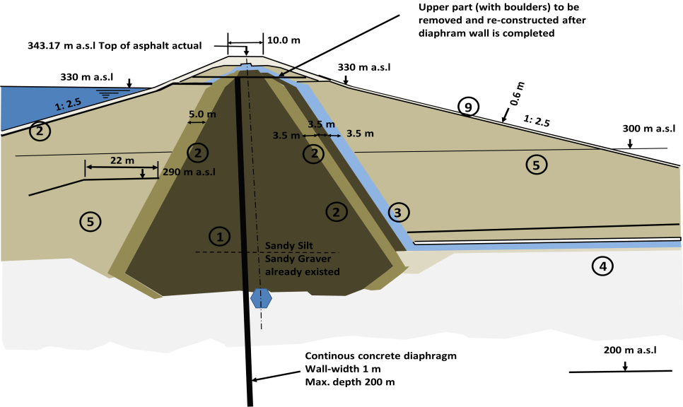

Fig. 3: Proposed Diaphragm driven from the dam crest.

3 Badush Dam
The years 1986 - 1988 were years of uncertainty and worries over the Mosul Dam foundation. The catastrophic consequences of the dam failure were already explored and quantified by the "Mosul Dam Flood Wave Study" [8]. The Ministry of Irrigation was advised then to take some protective measures to secure the safety of the downstream area and its’ population. The design and construction of Badush Dam was initiated in 1988 using fast track method to complete the dam within four years.
The Badush Dam site is located on the Tigris River, approximately 40 km downstream from Mosul Dam site and approximately 15 km upstream of Mosul city, Fig 4.

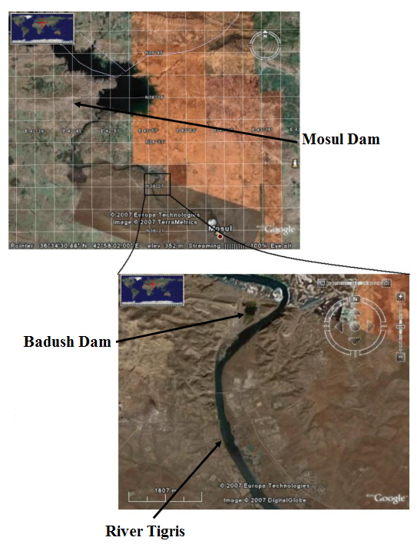
Fig. 4: Badush Dam location in relation to Mosul Dam [9].

The main function of the dam was the protect the downstream region of the Tigris River valley against the effect of potential Mosul Dam failure, due to any possible reason. Other functions were included to add other benefits in order to improve the economic feasibility of the project. These benefits were namely power generation, by using water discharged by Mosul Dam and by the regulating scheme power plants. Badush Dam power station was to have an installed capacity of 170 Mw. Therefore, about 15 m head is provided for Badush hydroelectric power plant and for normal regime flood protection (up to 1/10000 year flood). The Badush Dam could guarantee the operation of the Mosul power plant as well as of the power plant of the regulating scheme by discharging variable quantities of water, limited to 8000 m³.sec-1 for the safety of Mosul City [10].
The design of the dam allowed a free volume of 61.5 m height between EL. 245.4 m (a.s.l.), which is the normal operation water level, and EL. 307.0 m (a.s.l.), which is the maximum water level in case of Mosul Dam failure. This volume is enough to contain the flood wave resulting from the worst scenario of the Mosul Dam flood wave study. The foundation of Badush Dam was of massive limestone and no dissolution of soluble rock was anticipated.
The construction of the dam began in 1988 at the time when no final solution was in sight for Mosul Dam .The construction; however, was halted in 1991 due to the economic sanctions that were imposed on Iraq as a direct result of Iraqis’ occupation of Kuwait. The percentage of completed works is 40%, and the resumption of this work is waiting the decision of the Ministry of Water Resources (ex Ministry of Irrigation). It is disappointing to know that the ministry has revised the design of the dam in 2007 by lowering the maximum pool water level and the height of the dam so as to eliminate the flood wave protection.

- Studies Carried out During the Operation of the Dam
While the maintenance grouting continued during 1986 and the following years using normal mixes and massive mixes, consumption of both types and the total consumption were sizable indicating continuous washing away of some areas of the curtain. No general review of the dam safety was carried out until 1995. A general inspection of the dam and a review of all the available reports and recorded measurements were conducted by two Bulgarian Specialists who stayed for two months at the site and then submitted their report with their findings [11]. The report covered all aspects of the dam performance that far, but it did not attempt to analyze the grouting process implications on the dam foundation. It is useful; however, to summarize here conclusions and recommendations:
i) Observing the area in the right bank at 200 m upstream of the dam, there was a big crack, which indicated the movement of a sliding block. The observation system looked good and regular measurements were recorded. It was necessary to continue this logging.
ii) At a distance of 2 – 3 km from the main dam in the upstream right bank, there were many subsiding planes indicating the formation processes of sinkholes. The belief was expressed that such sinkholes were contributing to seepage under the dam at the higher levels of the reservoir. It is worth mentioning here that these and other sinkholes have been discussed thoroughly during many IOBE meetings, but no firm conclusions were formed then.
iii) The width of the deep grout curtain was checked according to Russian Code No.CH-ИП 2.02.85, 1988 (Table7), and the Bulgarian Code No.2.07.03, 1985. The check results showed that this width was on the minimal side and the curtain requires widening at depth; therefore, it was recommended to drill a new row of inclined grout holes at the back of the downstream row of the present curtain in order to strengthen it.
iv) Checking of piezoelectric observations revealed that 90% of the piezometers were giving good results, while the remaining 10% of the piezometers were giving erroneous results and need to be flushed.
v) The piezometric observation records of all piezometers located in the grouting gallery from Sec.78 to Sec.94, and calculating efficiencies using the same efficiency equation that had been used by the Swiss Consultants, showed efficiency values averaging between 65% to 70% at a maximum reservoir level of 328 m (a.s.l.), while lower values were recorded under maximum water level of only 310 m (a.s.l.) in the years 1987 and 1988. The conclusion was that the curtain was judged good. In this argument, this report overlooked the fact that average values over this long reach could not give judgment on the whole length, especially that minimum efficiencies as low as 42% were also experienced in that year in local spots. The report also did not mention the fact that almost 43000 tons of solids were injected in the grout curtain during the years 1988 – 1995.
vi) The seepage quantities and soluble salts' concentrations recorded in the previous period from 1986 up to 1995 showed great reduction in seepage quantity and salts concentrations at point No.1. This was affected by the construction of a deep grout curtain during 1990 of 500 m length parallel to and at 10 m distance from the spillway chute. At point No.3, seepage quantity had increased between 1985 to 1995 from 75 l/ sec to 140 l/ sec, and salts' concentrations rose between 1990 and 1995 from 800 mg/ l to 1200 mg/ l, which was attributed to the rise of water level of the reservoir. Seepage quantities and soluble salts' concentrations from the access tunnel remained constant at their previous level in 1985.
vii) Checking the results of the extensometers placed in the body of the dam and the geodetic measurements for the dam at the crest showed that the displacements were within acceptable limits. Similar conclusion was drawn regarding the grouting gallery. Pore pressure cells gave also normal readings for the dam core and dam shell at the locations where they were installed.
In the general conclusions and recommendations the study goes on to state the following;
i) The present state of the dam (1995) is judged to be good, but the operation of the reservoir should not attempt impoundment at level 330 m (a.s.l.), only in emergencies and for a very short time.
ii) While total seepage quantities and dissolved salts in point No.1 are reduced due to the completion of grout curtain parallel to the spillways’ chute, these quantities in the other measuring points seem to increase at high reservoir water levels.
iii) The analysis of the recorded data of the functioning extensometers, pore pressure cells, geodetic measurements shows acceptable values.
iv) Additional rows of grouting holes as described above are required for the reasons given. But, the construction of a diaphragm wall as proposed by Mariotti-GEOCONSEL was rejected.
v) The Maintenance grouting program of the deep grout curtain; started in 1990 (in fact 1988) should continue. This program may be needed for the whole operating life of the dam.
vi) More piezometers are required to be installed along about 2000 m downstream shell of the dam in order to observe seepage in the dam foundation.
vii) Performance of a new static and dynamic analysis of the dam is required by using updated information (water levels, seepage rates and quantities, vertical displacements of the dam body, pore pressure measurements in the dam body).
During the following years, no rigorous evaluation of the dam safety was performed. Only annual reports of the recorded data of the instruments, piezometric observations, reservoir water levels, water releases and monthly consumption of grout mixes and locations of treated sections were presented.
In 2003, Iraq was occupied by the allied forces and a site visit by USAC team was made in order to assess the magnitude of the threat that the dam posed to the occupation forces. This was followed by the signing of a contract with WII/J&B.JV, in order to carry out thorough engineering evaluation of the existing problems in need of correction, define potential and alternative solutions and identify and come up with concrete recommendations to improve them. The scope of the work was to carry out an initial assessment with site visits and submission of a preliminary report, collecting and documenting all available studies, designs and reports, formation of a panel of top geotechnical experts (POE) to study the foundation treatment and presenting solutions in a final report.
The initial report conducted under the contract [12] gave an overall picture of the geology of the site and foundation conditions, grouting activities, current seepage conditions, and description of the sinkhole phenomena. The report was concluded by some general analysis and recommendations for further discussion by the POE, which was already formed of four geotechnical experts. The activity of collecting all available data on the dam was also going on at that time and took some considerable time and effort. Some 10500 pages of documents were compiled and recorded on CD’s. These data were collected from the Dam Management Office, Dams and Reservoir Office in Baghdad, Consultants’ office in Switzerland and other Consultants offices in Britain. This comprehensive library was put at the disposal of the POE who continued their discussions and meetings.
In the following deliberations the Panel concentrated on the study of seepage and dissolution of gypsum/anhydrite beds. The Panel confirmed that the “Enhanced Grouting Program “of the grout curtain maintenance was fully justified considering the annualized probability of dam failure. But, this program would not reduce this probability to acceptable limits. According to the USBR guidelines, the annualized probability of risk when human lives are at stake should not be higher than 10⁻². Although this annualized risk would be improved considerably by continuation of this maintenance program, but it will not reach with the foundation to such acceptable annualized risk.
In viewing the current program, the Panel could not overlook some of the positive aspects, as progressive benefits were being achieved, e.g. reduction in the frequency of sand-cement injection, general reduction in average grout consumption, favorable piezometric response….etc. In addition, the training of an efficient team of experienced work force was looked at as a good asset. In foregoing, the Panel confirmed the appropriateness of introducing “New Technologies” in grouting techniques, such as “IntelliGrout” systems were mentioned. The panel did not fail to study the feasibility of the construction of a concrete wall as a positive cutoff, which was performed in great details. The Panel; however, rejected this proposal for the following reasons:
a) Maximum depth attempted on any existing dam was 130 m at that time. Only one case of 150 m was recorded.
b) Mechanical Limitations, wall panel deviation and the foreseeable task of having to retrieve stuck equipment from great depth render the prospects of a wall deeper than 130 m practically impossible.
c) The maximum unconfined compressive strength of rock material, which is possible to excavate with a wall cutting machine may be as high as 200 MPa in a rock masses, which are highly fractured or thinly bedded. However, the limit will be much lower if rock is massive (perhaps 70M Pa).
d) Construction under full reservoir conditions is feasible if the slurry can be maintained at least 1 m above lake elevation continuously throughout the construction of each individual panel.
e) When there is potential for loss or lateral movement of slurry during construction, then pre-grouting of rock masses is necessary (as would be the case in Mosul Dam).
f) Such a cutoff wall cannot be built from a small gallery, which is subject to hydrostatic head as is the case at Mosul Dam.
g) Deep diaphragm walls in rock (when constructible) would cost on the order of $3000 per square meter (price levels of 2005) and only 3 square meters per hour per machine could be anticipated.
It was understood by the Panel that the reservoir could not be drawn down below EL 306 m (a.s.l.) for any significant period of time due to the power station’s operation. This eliminates the possibility of constructing of such wall from a reduced starting elevation on the upstream berm of the dam, where water depth would be less. The impermeable structural connection details for connecting the top and ends of the cutoff wall to the dam core would present a design challenge that could well be impossible to resolve.
In support of its decision of rejecting the diaphragm alternative, the Panel, explained that this rejection also stems from the following considerations:
-Would be extremely costly and with severe technological limitations.
-Would take a great deal of time and resources.
-May not be geometrically feasible (since the pre-treatment would have to project upstream, which is not possible from the gallery) as the vertical wall would have to avoid the gallery.
Furthermore, the potentially adverse effects on modified water movement pattern in the foundation that may result from creating a virtually impermeable concrete wall of an undetermined depth and length is not known, and may not be identified with sufficient precision, to date, the seepage rates and locations are not known. Such information is essential for the contemplation of a shallow “hanging” wall and only penetrating 30 m in the impermeable rock.
In considering the previous suggestion of using hot bitumen for the injection works, the Panel explained that such work would demand the use of highly specialized equipment and require a new set of facilities, such as specialized bitumen storage, pumping and delivery infra-structure that may not be logistically possible in a gallery situation and when dealing with high artesian heads. Based on these, the Panel recommended that no further consideration be given to the use of this material in the gallery of Mosul Dam.
Sinkholes were the other area of interest of the Panel, which had received its share of attention and consideration as a dangerous threat to the dam. The mode of formation of the previous sinkholes and their locations was studied in relation to their geological setting. The Panel did not possess; however, any data whether the sinkholes were formed under the downstream shell of the dam or not. Although the prediction of sinkholes formation as well as the solution conduits beneath the embankment was obviously (and still is) a critical issue, but the technical options are in reality extremely limited and much would depend on the implementation of the modified drilling and grouting processes as well as the continuing analysis of data from existing(and new) piezometers.
A great bulk of data on the monitoring of instruments and observation systems were examined. But, the opinion of the Panel was that efforts should concentrate more on the critical family of systems; such as the geodetic survey system on the crest of the dam and in the gallery, Piezometers in the downstream shell of the dam and in the gallery, and on the seepage measurement weirs located at the downstream left bank. The conclusion was that the monitoring program was in need of re-evaluation and revision. Emphasize should be given to the aspects just mentioned. More piezometers should be installed in the downstream shell of the dam. They should aim at the gypsum/anhydrite layers directly under the dam and other layers, which had experienced considerable grouting takes in shallow depths. The present number of piezometer in the whole area of concern downstream of the dam was minimal. For this area, about 500000 square meters only 1 piezometer in 11 acres (about 40000 sq. meters) was provided, this is not enough to give a clear picture of all seepage paths existing or in the process of development there. In the river channel downstream the dam, no more seepage points could be observed on the surface as the presence of such points would be masked by the existing re-regulating pond downstream this leaves another unknown to the seepage picture.
Two other safety issues were also given attention; the first one was the magnitude of scour at the bottom outlets Roll-Crete lining of the plunge pool resulting from the operation of these bottom outlets at high floods. This was causing worry about the integrity of the foundation of the bottom outlets downstream control structure. Mathematical analysis of this hydraulic problem was carried out and the results showed that such erosion would not cause a threat to the stability of the outlets control structure foundations, especially that the analysis gave similar results to the hydraulic model test results during the design stage. No protection using H-piles were needed as thought previously. The second question was the stability of the spillway chute. Large seepage quantities were reported in the spillway bucket area in 1986 and in the following years. It was thought then that part of this flow was coming under the spillway chute from the right side into the left side. This structure was founded partly on the gypsum layer GB3. In 1990, the seepage quantities were considerably reduced after the completion of the grout curtain parallel to the chute and along its length. The question of the foundation integrity remained a worrying question. Considering this matter, the Panel observed that the available data at hand was inadequate to make a meaningful assessment, and recommended the following to be carried out in the future;
- To study the historic data from preconstruction through to current day operation of the spillway including all exploration bore holes and grouting records.
- Conduct field observation and analyze flow measurements with respect to lake levels.
- Review all survey data on the structure to detect any permanent deformation or settlement.
- Perform crack surveys of the concrete structure itself.
- Assimilate and analyze the data with the objective of determining whether corrective measures should be initiated to reduce the leakage, or deciding that the threat to structural integrity of the chute requires remedies by drilling and grouting techniques [13].
As a summary this study has proved so far as the most through and comprehensive one carried out on Mosul Dam conditions. The stated recommendations were very clear and realistic. Among these recommendations, the completion of Badush Dam was considered the only long term solution that can provide acceptable level of risk to the population downstream that could result from Mosul Dam failure.
In this respect, it is worth to mention here that the Ministry of Water Resources of the Iraqi Government has committed a grave mistake in two unfortunate steps in disregarding to this recommendation; namely the redesign of Badush Dam as a low dam eliminating its large protective storage volume, and signing in 2006 a memorandum of understanding with a German company [14] to build diaphragm machine(s) and construct a diaphragm wall at a cost of 2.6 billion US dollars. Signing the contracts was pending the availability of funds. Both decisions are reversible and the Ministry must be brought to the understanding to where the best interests of the Iraqi people lies.
In late 2005, the Ministry of Water Resources commissioned another Board of Experts to carry out an independent evaluation of the dam, but the IIW/B&V report and their Panel study was so comprehensive that this new Board could not come up with any new fundamental finding. The worry about the seepage under the dam was the same and led this Board to advise on increasing the number of piezometers in the same way that was advised before and to carry out a geo-radar survey in the left bank in an attempt to understand the seepage water regime. This was performed and all required instruments were purchased and site geologists were trained to carry on such surveys. The results were not conclusive and the Board decided to limit the maximum operation water level to EL. 319 m (a.s.l.) instead of EL. 330 m (a.s.l.).
This recommendation has remained in force hitherto; with the loss of sizable storage of irrigation water and electric power potential.

5 Conclusions

In view of the fact that Mosul Dam was constructed on highly karstified beds of the Fatha Formation, large numbers of problems were encountered during the construction and operational phases of the dam. These were related to the seepages under the foundation of the dam due to the dissolution of gypsum and anhydrite. This fact enforced the concerned Iraqi authorities to ask expert from national and international levels to find a sound solution to the problem.
All the studies expressed a clear concern on the fact that this region suffers from extensive presence of soluble rock formations that might undermine the safety of the dam with its large reservoir. To overcome the problem, grouting operations were performed. The seepage of water continued and this highlighted the possibility of the dam failure. Different grouting techniques and methods were suggested; such as 1) using gelling cement grouts, 2) trying the injection of hot bitumen, 3) diesel oil and bentonite mixture, 4) even the addition of cotton flock, 5) similar fibrous material. Other alternatives involving in the construction of physical barriers were also examined. Ideas suggested involved general filling of seepage paths by precipitation of insoluble materials from ground seepage water or sealing gypsum/anhydride surface or using Barriers (this includes blanketing, Positive-Cutoffs, Construction of a new curtain). Other suggestions were strengthening the grout curtain in the problematic areas; where massive grouting had to be repeated widening the curtain was recommended or to construct a tunnel along the length of the chalky series from which grouting would be performed or to construct a series of tunnels and galleries to replace risky materials; or to construct a diaphragm wall from the upstream berm. Finally, it was decided to limit the maximum operation water level to EL.319 m (a.s.l.) instead of EL.330 m (a.s.l.). This recommendation has remained in force up to now with the loss of sizable storage of irrigation water and power potential.

Acknowledgements

The authors would like to thank all individuals for their help and assistance in this work. Special thanks are forwarded to Mr. Mohammed Dhari, the Construction Advisor of the Iraqi Ministry of Water Resources for his kind assistance, encouragement and support.
The research presented has been financially supported by Luleå University of Technology, Sweden and by “Swedish Hydropower Centre—SVC” established by the Swedish Energy Agency, Elforsk and Svenska Kraftnät together with Luleå University of Technology, The Royal Institute of Technology, Chalmers University of Technology and Uppsala University. Their support is highly appreciated.

References
[1] Al-Ansari, N. A., Barazanje, A., Al-Jabbari, M. and Gayara, A., Geological Investigation of Mosul Dam Site, Ministry of Irrigation, Baghdad, Iraq, 1984.
[2] IBOE, International Board of Experts, First meeting report, Ministry of Irrigation, Baghdad, Iraq, April 1979.
[3] Luga R., Report on Visit in February 1986 Concerning Grouting Works, GEOCONSEIL, Ministry of Irrigation, Baghdad, Iraq, 1986.
[4] Binnie and Partners, Mosul Dam Foundation Cut-off, Report, Ministry of Irrigation, Baghdad, Iraq, Sept. 1987.
[5] Hamdi, A., Research paper on Gypsum and Anhydride properties, University of Mosul, Mosul, Iraq, Sept 1988.
[6] Al-Rawi, I. A., Grouting Gypsum beds under Mosul (Saddam) Dam, Mosul Dam Supervision Staff Report, Ministry of Irrigation, Baghdad, Iraq, Sept 1987.
[7] IBOE, International Board of Experts, Interim Meeting report, Ministry of Irrigation, Baghdad, Iraq, January 1989.
[8] Swiss Consultants Consortium, Security Measures II, Addendum 3 Flood Wave Studies.Task2 Mosul Flood Wave, Volumes 1, 2, 3 .Feb. 1984, Ministry of Irrigation, Baghdad, Iraq, 1984.
[9] Al-Adily, A., Khasaf, S. and Ajaj, A., Hydrological Impacts of Iraqi Badush Dam on Ground Water, International Water Technology Journal, 4, 2, 90- 106, 2014.
[10] Energoproject, Badush Dam Project 265, Feasibility Study, Preliminary Report, Ministry of Irrigation, Baghdad, Iraq, 1988.
[11] Markov, G. and Dimitrov, N., Experts site visit report, Agrocomlekt-Sofia”, Ministry of Irrigation, Baghdad, Iraq, Dec.1995.
[12] Wheeler, A., Mosul Dam assessment- Report on Site Visit, Washington Group International and Black&Veach J.V, Ministry of Water Resources, Baghdad, Iraq, Sept.2004.
[13] WII/JV, Mosul Dam Final Report,Aug.2005.AppendixB, Mosul Dam Assessment Second Report of Panel of Experts”August 2005, Ministry of Irrigation, Baghdad, Iraq.
[14] Pipes, D., The latest on Mosul Dam, 2011. http://www.danielpipes.org/blog/2007/11/the-latest-about-mosul-dam November,2011

1 Consultant Engineer, Sweden. e-mail: nasrat.adamo@gmail.com 2^{,3,5} Dept. of Civil, Environmental and Natural Resources Eng., Luleå University of Technology. e-mail: nadhir.alansari@ltu.se, issa.elias@ltu.se, sven.knutsson@ltu.se
4 Consultant Geologist, e-mail: varoujan49@yahoo.com Article Info: Received :

