Mystery of Mosul Dam the most Dangerous Dam in the World: Problems Encountered During and After Impounding the Reservoir

Nasrat Adamo^{1,} Nadhir Al-Ansari2, Issa E. Issa³Varoujan K. Sissakian4, Sven Knutsson⁵

Abstract
Mosul dam was built on the River Tigris northern part of Iraq during the period 25th January, 1981 and finished on 24th July, 1986. The foundation of the dam lies on the Fatha Formation. This formation is composed of alternating beds of marls, limestone, gypsum and clay. The beds of this formation are highly karstified. After impounding, several sinkholes developed within the vicinity of the dam site. The surface expression of the sinkholes suggests that they are caused by underground collapse. The appearance of the downstream sinkholes is most likely related to fluctuations in the tail water level of the main dam during operation of the dam and the downstream regulating reservoir. In addition, water seepage also was noticed in various areas indicating the dissolution of gypsum and anhydrite from the foundation. During the period February-August, 1986 the dissolution intensity ranged from 42 to 80 t /day.
Keywords: Mosul Dam, Iraq, Sinkholes, Seepage

1. INTRODUCTION
The first impounding of Mosul Dam reservoir started in 1986. The river section had been closed during the previous summer and the flow was diverted through the two diversion tunnels, while the dam section at the river channel was being built. By the end of 1985 the dam had been raised to such a height that the two diversion tunnels could be converted to the two gated bottom outlets and control could be exercised over the impounding operation.
At the end of the 1986 flood season the reservoir level reached 316.4 m a.s.l.The reservoir was filled to the normal operation water level of 330 m a.s.l.for the first time after the wet season of 1988 and this continued during most of the following years. The stored water was used during the dry seasons for irrigation and power generation as planned. This meant drawing down the reservoir level during the months from June through October each year before the start of the next wet season.
The new dynamics of the ground water which were created by the first impounding and then by the operation of the reservoir triggered and accelerated the sinkholes formation activity around the dam site, seepage and springs development downstream the dam and the deterioration of the deep grout curtain under the dam was observed. This curtain was already suffering from deficiencies during construction due to the inability of closing certain areas in the curtain within the gypsum brecciated layers. The open gaps in the curtain were called “windows”.
- Sinkholes Formation
In September 1986, an inspection of the reservoir rims was carried out when water level had been drawn to El.309 m a.s.l. From El.316.4m a.s.l.which had reached during the previous flood season. The inspection revealed the development of series solution channels and sinkholes at the right bank at many points at about 150 meters from the contact with the right abutment of the dam. One sinkhole was also observed at about 1 kilometer or so away. These solution channels showed dramatic dissolution of the gypsum layers which were exposed on the shore line [1]. Observations and further studies gave two possibilities for the future development of these sinkholes and underground solution channels. The first possibility is that they could progress in a direction parallel to the dam axis in this case there would be no adverse effect on the dam, or whereas the second possibility is the development might cross the dam axis. In such event the right abutment of the dam would be endangered. In view of the uncertainty and to avoid any possibility of failure an intensive program of grouting was carried out to strengthen the right bank grout curtain extension and to elongate it further to the right. This work was carried out in 1987.
After Impounding of the reservoir, it seems that the sinkholes were developed after a considerable time downstream of the dam. Sinkholes were observed on the right bank about 900 m downstream of the toe of the embankment. Four sinkholes have appeared in a linear arrangement (Fig.1): SD2, SD2S, SD3-2 and SD4 (the largest). The sinkholes are not circular and have a characteristic elongated shape with a maximum dimension of up to 70 m and about half that in the normal direction. The longer dimension is aligned in the general line of the sinkhole alignment which is approximately parallel to the dam axis in a northwest-southeast alignment.

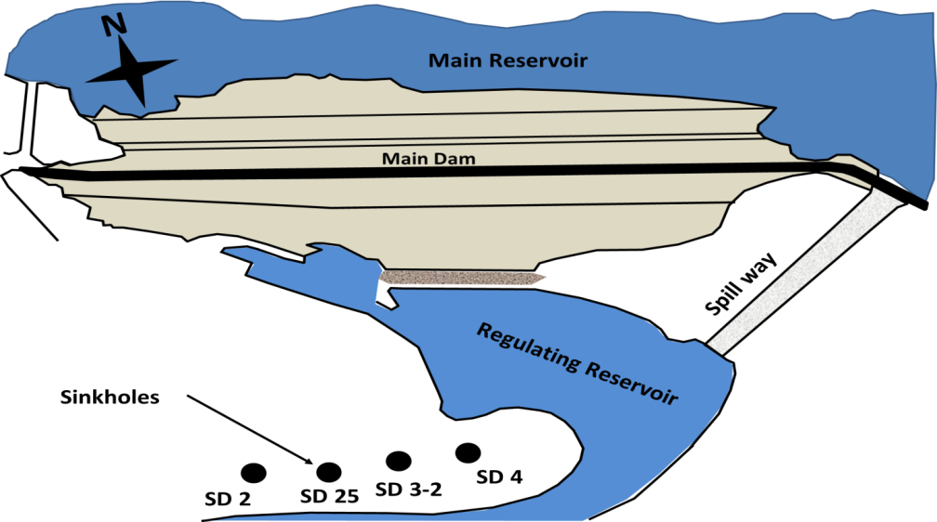

Fig.1: Sinkholes Downstream Mosul Dam –Right bank.
The sinkholes seem to be developed and appeared in 1992 and settled at a consistent rate until about 1998, when reduction in the settlement rate was observed to around half or less of the initial rate. The maximum measured settlement was about 5m, and generally it was between 3 m and 3.5 m. In areas where the sinkholes are located beneath the concrete pavement, the deformed concrete may be bridging over settled ground at a lower level (Fig. 2). The average annual settlement was about 0.25 m per year, although for SD4 the average annual settlement was 0.38 m per year.

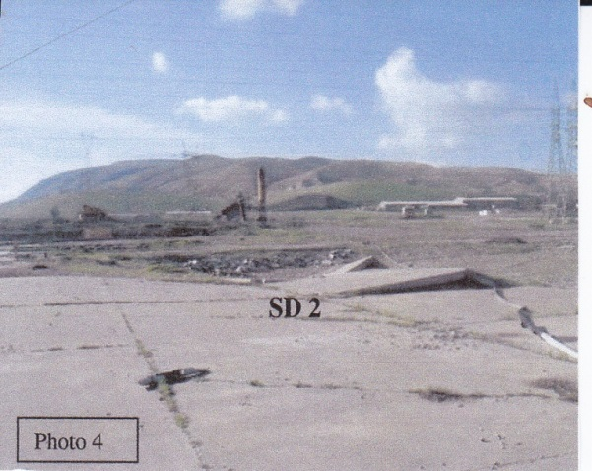

Fig.2: Sinkholes located beneath the concrete pavement.

The surface expression of the sinkholes suggests that they are caused by underground collapse. Concentric tension cracks appear to have developed around the central void as the sinkholes have developed progressively.
Sinkhole SD4 was excavated and left opens for one year, allowing the site’s staff to observe and measure water levels in it. It was found that the water level in the sinkhole does not respond to the changes in the water level of the main reservoir, however, it fluctuated with changes in the tailwater level. Three factors tend to dominate when sinkhole activity is initiated or increased:
1) Increasing the infiltration rate of water at the ground surface.
2) Decreasing the groundwater piezometric level in the rock significantly below the soil-rock interface so as to provide an easy exit for the downward percolating water.
3) Repeated fluctuations of the groundwater below the soil-rock interface that alternately saturates and drains the soil.
The appearance of the downstream sinkholes is most likely related to fluctuations in the tailwater level of the main dam during operation of the dam and the downstream regulating reservoir. It has been suggested by the site engineers that the sinkholes may be connected to the Darmellah aquifer on the right bank of the reservoir because before the impounding of the reservoir, substantial flows on the order of 360 l/sec were encountered from a gypsum layer found during excavation of the tailrace tunnel for the pumping storage scheme to the west (further right) of the known sinkholes (Fig. 3); the water had a high sulphate content (which was different from the reservoir water).

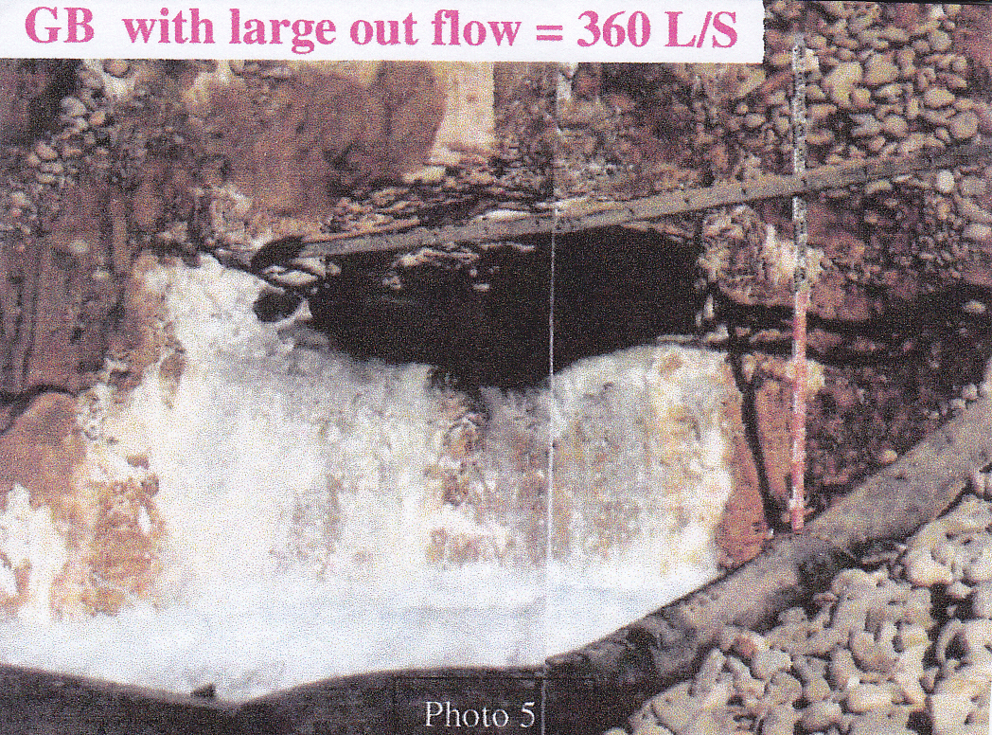

Fig. 3: Flows with order of 360 l/sec were encountered from a brecciated gypsum layer found during excavation of the tailrace tunnel for the pumping storage scheme to the west.

It also appears that the karst features within the bedrock may be better developed on the right side of the valley. Further evidence for connection of the sinkholes to the Darmellah aquifer is suggested by the appearance of a spring on the right side of the river channel. This spring, referred to as the right side spring (RSS) (Fig. 4), is in line with the sinkholes and appeared after erosion of the right bank during operation of the main spillway. The erosion has removed the alluvial deposits of unconsolidated silts and gravels; about 4 m thick overlying cemented conglomerate. When the conglomerate was initially exposed a spring appeared issuing from a fissure in the rock. The spring water had high sulphate content, and a flow estimated at 360 L/sec, similar to the spring that issued from the gypsum bed in the tailrace tunnel. The water chemistry was very different from the reservoir water and the existing springs on the left bank. The spring is reported to be generally not visible as it is below the water level of the regulating reservoir. For its approximate location refer to the arrow in figure 4 below.

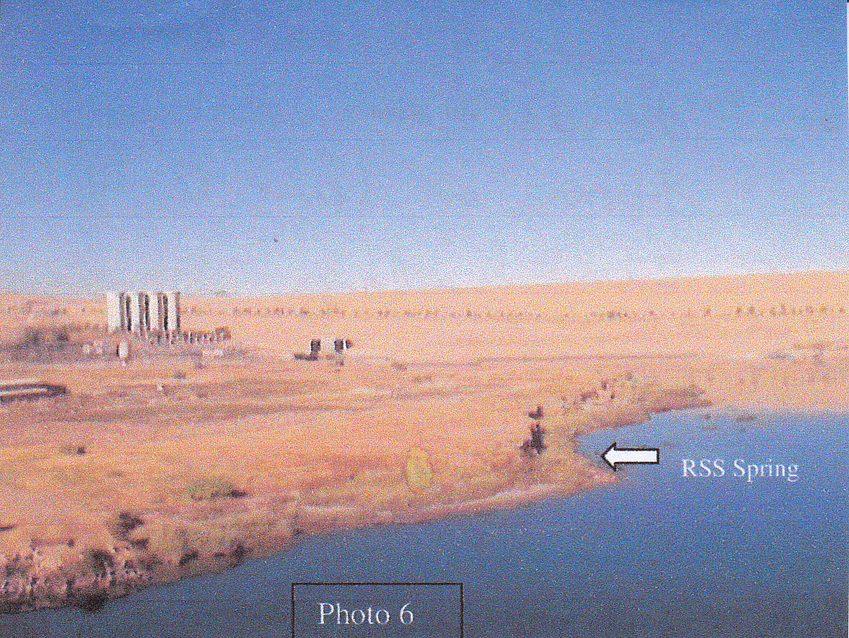

Fig. 4: spring on the right side of the river channel.

Some 100 m upstream of the dam right abutment and on the slope above the end of the launching ramp (Fig. 5), the ground surface shows clear fracture. This fracture is caused most probably due to a subsurface karstification and cavern development. However, a slope failure may show same fracture, but then the fracture should be in crescent shape, not a straight one, as it is the case, as a result of fluctuating reservoir levels and residual high pore pressures in the slope. The concrete foundation for the steel fencing is also buckled and deformed. The only performed monitoring in this area was for vertical settlement; no measurements were performed that would indicate lateral movement of the existing three survey markers. The maximum cumulative settlement recorded was 2.46 m. Dye tracer tests did not establish a connection between the upstream depression and the downstream sinkholes.
Further upstream, on the next promontory on the right side of the reservoir a large conduit (small cave) was found in March 2002 within a gypsum/anhydrite layer, which crops out in the reservoir; it is unclear whether it is the GB1 or GB2 horizon. The maximum height of the cave is 1.3 m and it has clay infill on the floor (Fig. 6). The elevation of the cave floor is approximately 315m compared to a normal top water level of the reservoir at elevation 330 m. Both the cave inlet and outlet are within the reservoir pool and are normally submerged from January each year for about 8 months of the year.
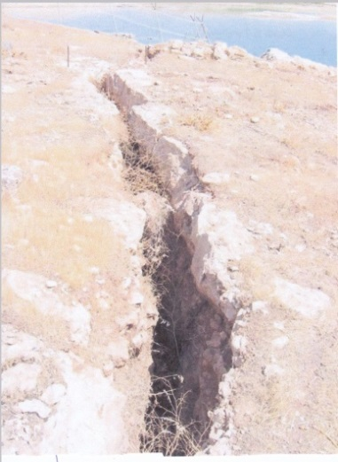
Fig. 5: Open fissure resulting from slab slide upstream right abutment of the dam.

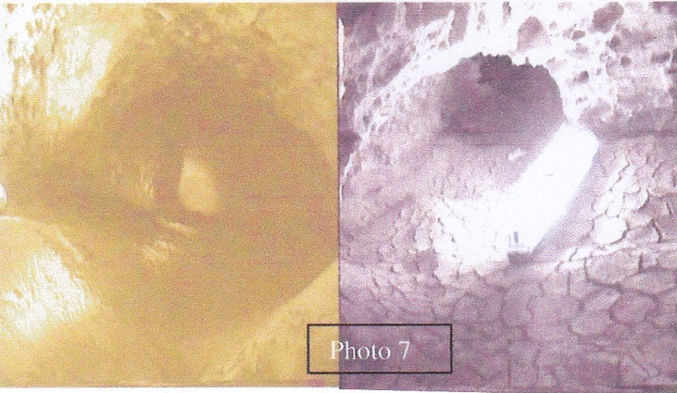

Fig. 6: Large conduit (small cave) was found in March 2002 within a gypsum/anhydrite layer on the right side of the reservoir.

Al-Ansari et.al. and Issa et al. [2,3] conducted a bathymetric survey during (2011) and concluded that "After 25 years of the dam operation following; the thalweg bed slope of the River Tigris had changed from 0.65 m.km⁻¹ before dam construction to 0.71 m.km⁻¹ during the 2011 survey. The sedimentation rate in the upper section of the reservoir where the River Tigris enters the reservoir was the largest and gradually decreased toward the Mosul dam site. The maximum deposition thickness was 17.6 m in the upper zone of the reservoir. Furthermore, there are many areas like the middle and lower parts of the reservoir that are believed to have suffered from dissolution of gypsum/anhydrite beds forming sinkholes that might reach about 20 m in diameter and 9.6 m in depth. The conducted survey also confirms the presence of sinkholes and other karst forms within the reservoir, which are active, and continuously increasing in size, and exerting hazards to the Mosul Dam.
The sinkholes on the right abutment have developed progressively with initial manifestation by surface cracking and ground settlement. By contrast a sinkhole on the left bank of the reservoir in the local tourist village appeared without any indication and developed rapidly with depth of 15 m and a 15m diameter depression overnight in February 2003 (Fig. 7). The sinkhole was dry, located on a slope on the northern side of a valley feature. The deposits at the surface standing vertically appear to be superficial silty soils, with perhaps bedded marls below. Although the initial sinkhole was filled with 1200 m³ of loose sandy gravel material and fenced off, the settlement was continued. A further 3000 m³ of material was required to fill the settled surface of the sinkhole in two separate filling operations in May 2003 and October 2004. By March 2005 there has been a small settlement of the ground surface for about 0.5 m.

Fig.7: Sinkhole at left bank of the reservoir.

The surface expression of the collapse with the absence of concentric tension cracks and sudden appearance suggests that the collapse resembles a crown hole. It was reported that during the drilling of a piezometer hole near the sinkhole a rod drop had occurred. There was no water encountered in the hole so the piezometer was not installed and the hole was grouted, consuming 250 tons of grout. The suggestion has been made that the sudden appearance of the sinkhole is related to seepage water passing through the left abutment of the reservoir and the sinkhole lies close to the end of the left extension of the original grout curtain. Though possible, an increase in infiltration of surface water, perhaps from heavy rain, could cause a collapse into an existing void by destabilizing the ground. Since the appearance of this sinkhole the grout curtain has been extended eastwards but the grout consuming was not high.
Voids at the surface as evidences for the presence of sinkholes and ground settlement are of substantial size, and suggest large voids have been present below the surface to allow the ground surface to settle. An initial impression of these sinkholes is that they are not directly related to the deep foundation issues beneath the dam. There have been no reports of large rod drops indicative of big voids. Clearly some of the grout consumption reported suggests that there must be some Interconnection of conduits or voids associated principally with gypsum karst or that voids are being developed either by erosion or by solution.
A common feature of the sinkholes is that they are found to be associated with natural valley features. It appears that the known sinkholes are geologically controlled rather than related to seepage. Ground collapse may have been initiated by changes in groundwater levels due to impounding of water in the regulating reservoir for those in the valley downstream of the main dam. The alignment of the sinkholes downstream of the dam strongly suggests a geological (structural) control and relatively near surface phenomenon. However, it has not been possible to verify this either by carrying out detailed geological field studies at the site or by obtaining high quality aerial photographs or Landsat images. The recent collapse in the tourist village on the left bank has the characteristics of a crown hole formed by sudden collapse into a pre-existing void. The trigger for the collapse is not clear; it might have been purely time dependent, or due to some external factor such as rainfall, or changed ground water regime due to reservoir impounding.
The locations of all sinkhole suggest a linear arrangement crossing the valley downstream of the dam (Fig. 8), although it has yet to be determined what that feature might be. The site personnel have noted initial indications of what may be possible indications for development of sinkhole in future; further east along this line. In terms of the impact of sinkholes on the dam, we are not aware of any current technology that could be used to detect the presence or the future development of voids or potential sinkholes beneath the dam embankment structure, either from the surface or from within boreholes. Vertical extensometers below the grouting gallery might give some indications for settlements of the strata that might occur below the gallery; however, the best way of detecting changes in the foundations remains “the use of piezometers”. The use of multi-point piezometers would improve the monitoring of groundwater changes in the foundations and permit sampling of the groundwater for groundwater chemistry and flow studies. In the downstream area and village it is conceivable that a seismic reflection and/ or microgravity study [4,5] array may detect large caverns or voids in the subsurface that could develop into sinkholes.
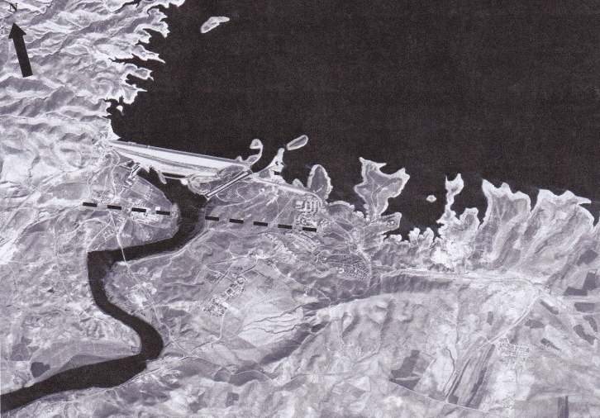

Fig. 8: Mosul Dam, the dashed line shows approximate alignment of the sinkholes.
- Seepage and Dissolution of Gypsum.
In winter 1986, the reservoir level started to rise and impounding for the first time began to take a rapid tempo. At the same time percolation through the dam foundation manifested itself by the occurrence of six major springs on the left bank at different elevations along the 1.5km long stretch. Seepage was also occurring under the dam in the deep river section which was submerged by tail water. Safety concerns required adequate surveillance of seepage and checking of the dissolution of gypsum from the foundation.
Measurements of the discharge of the surface springs were systematically observed and measured. Permanent discharge measurement weirs with water level gauges were built at all important surface spring areas. The seepage quantity in the river channel was measured by converting coffer dam no.6 which was used during river diversion in to a measuring pond with an overflow weir built in to it. Water samples were also taken at two weeks interval and analyzed for their mineral content to establish the quantities of gypsum being leached from the foundations. Results of seepage surveillance from February10, 1986 to August16, 1986 showed that the recorded seepage through the Main dam foundations and the left bank increased from 500 l/s to 1400 l/s in which water head had increased from 49m to 65m .Springs (Sa ) and (Sd ) in the left bank alone had increased from 150 l/s to 900 l/s (Fig.9).The submerged springs at the river channel showed an increased transmissibility by 40% during the same period ( from 630 cubic meter per day to 880 cubic meter per day) [6].

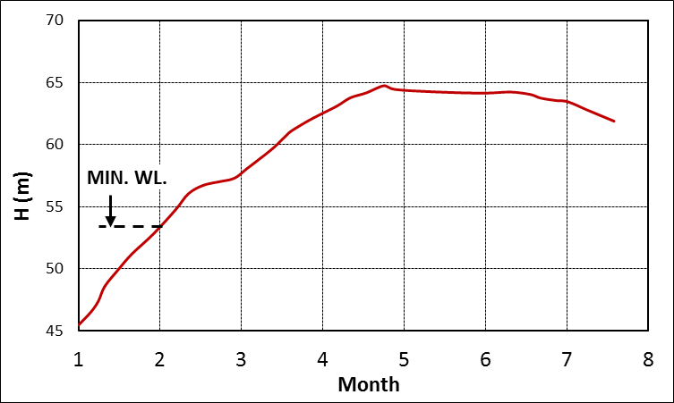
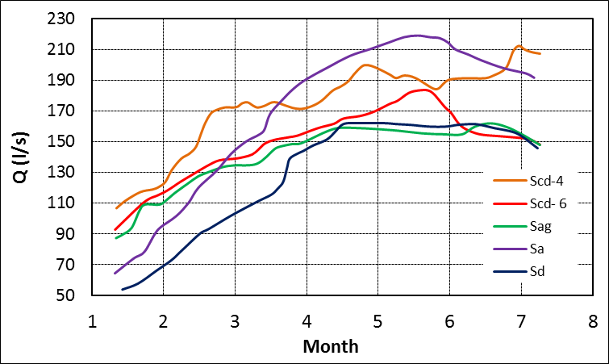

Fig. 9: Left: Spring discharge and Right: Reservoir water level for the period February-August, 1986.

Dissolution of minerals from Dam foundations was established through the difference in the content of dissolved minerals in seepage water in relation to the water in the main reservoir (amounting to 250 mg/l as the average). The total mineral content of the seepage’s water by individual spring zones is presented in (C) and (D) of Fig.10). Analysis of these results yielded that 13 000 tons of minerals were leached from the dam foundations at this period and that 70% of this quantity originates from the submerged springs. The dissolution intensity ranged from 42 to 80 t /day.

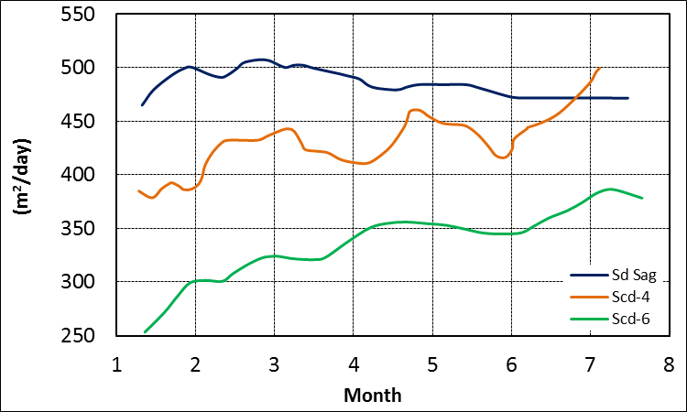
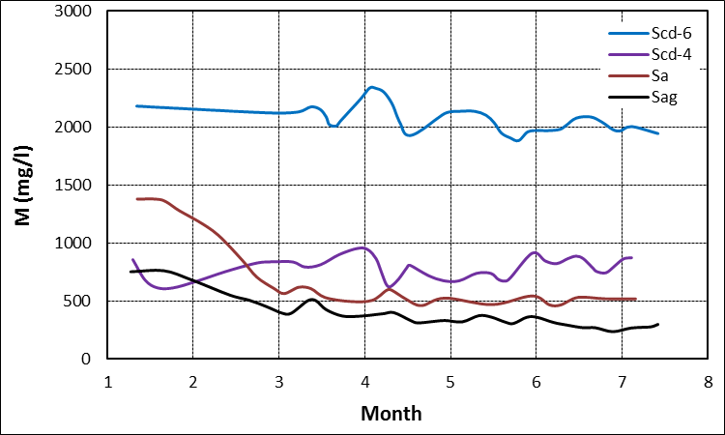

Fig. 10: Left: Spring transmissibility and Right: Soluble salt concentration for the year 1986.

These chemical analysis results pointed out to significant dissolution of gypsum and anhydride followed by noticeable increase in the permeability and leakages through foundation. Analysis of mineral content of seepage water pointed out to the Gypsum and anhydride and other minerals were being washed out from joints and fractures crossing insoluble rocks and it was expected in view of the repeated maintenance grouting that all gypsum present in joints would be washed away from the zone of grout curtain. Bearing in mind that some of the rocks in the foundation are erodible then this dissolution of gypsum which is present along fractures and faults could initiate further erosion along those discontinuities also across the zone of the deep curtain.
Direct dissolution of gypsum and anhydrite layers, which could occur at the contact of these layers with permeable rocks (such as limestone) will result in the formation of caverns extending upstream and could by the progress of time jeopardize seriously vital project structures. On the other hand, the dissolution may occur along fractures in layer or bank of gypsum or anhydride within impervious layers leading to a dangerous situation especially when the layers are in contact with the reservoir and tail water. In such case karstification processes would begin on the upstream side and move progressively in the downstream direction.
In view of the above, much concern was raised over the dam safety and were followed closely by the International Board of Experts for Mosul Dam [1]. During the following two years ,many remedial measures were recommended and put in to action which included additional grouting along the dam axis in the left embankment by deepening and strengthening the grout curtain, elongation of the curtain extension beyond the left end of the dam and constructing a new grout curtain alongside the left side of the spillway bucket to cut off the seepage flow from the left passing under its foundation which is in contact with gypsum- breccia layer (GB3).
The deep grout curtain also received its share of attention and works were intensified in an attempt to improve its quality which remained an open question up to now. Other minor works were also performed such as collecting the flow of the springs in thee measuring points, (Fig. 11), in addition to the coffer dam number 6 measuring pond, and covering seeps and wet areas by filter material. From figure 11, it can be noticed that:
a) Point (1), at the right side of the spillway at the end of a collection channel which collects seepage water from under the spillway that seems to originate from left side.
b) Point (2), at left side of the spillway collects springs between seepage from under the dam further left and around the left side.
c) Access Gallery end point collects seepages from under main dam from the river section to the spillway.
d) Coffer dam no.6 measuring pond measuring seepage under the deep section of dam.

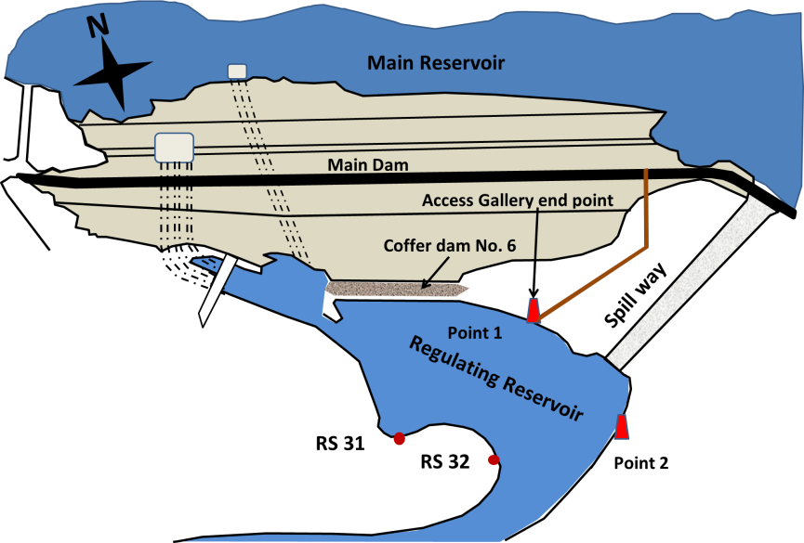

Fig.11. Seepage water Collection Points at Left Bank and cofferdam no.6 Measuring pond [7].

Measurements of seepage quantities and mineral content of water have been conducted over all these years .These measurements show stable conditions and no adverse effects, but they also indicate strong correlation with the reservoir water levels. Dissolution under the dam and its close proximity also continues at smaller rates due to the nature of the foundation [8].

- Conclusions
Mosul dam was constructed on the River Tigris about 60 km north of Mosul city. The duration of the construction started on the 25th January, 1981 and finished on 24th July, 1986. The foundation of the dam lies on the Fatha Formation. This formation is composed of alternating beds of marls, limestone, gypsum and clay. The beds of this formation are highly karstified. The first impounding of Mosul Dam reservoir started in the winter of 1986. In September, 1986, seepages and sinkholes development were noticed within the vicinity of the dam.
Series of solution channels and sinkholes at the right bank at many points at about 150 meters from the contact with the right abutment of the dam were recognized late 1986. Four more sinkholes appeared in the right bank downstream of the dam in 1992 and settled at a consistent rate until about 1998. The surface expression of the sinkholes suggests that they are caused by underground collapse. Downstream sinkholes are most likely related to fluctuations in the tail water level of the main dam during operation of the dam and the downstream regulating reservoir. They might be connected to the Darmellah aquifer on the right bank of the reservoir because before the reservoir was impounded, substantial flows on the order of 360 L/sec were encountered from a gypsum breccia layer found during excavation of the tailrace tunnel for the pumped storage scheme to the west of the known sinkholes and the water had a high sulphate content (which was different from the reservoir water). Further evidence for connection of the sinkholes to the Darmellah aquifer is suggested by the appearance of a spring on the right side of the river channel. It appears they are geologically controlled rather than related to seepage. In terms of the impact of sinkholes on the dam, we are not aware of any current technology that could be used to detect the presence or the future development of voids or potential sinkholes beneath the dam embankment structure, either from the surface or from within boreholes.
Six major springs on the left bank at different elevations along the 1.5km long stretch occurred after the impounding in 1986. It was also noticed that the seepage through the main dam foundations and the left bank increased from 500 l/s to 1400 l/s in that year. It was evident that minerals (mainly gypsum and anhydrite) were leached from the dam foundation at an intensity ranging from 42 to 80 t /day. These minerals were washed out from joints and fractures crossing insoluble rocks and it was expected in view of the repeated maintenance grouting that all gypsum present in joints would be washed away from the zone of grout curtain. Later, the dissolution under the dam and its close proximity also continues at smaller rates due to the nature of the foundation.

Acknowledgements
The authors would like thank all individuals for their help and assistance in this work. Special thanks to Mr. Mohammed Dhari, the Construction Advisor of the Iraqi Ministry of Water Resources for his kind assistance, encouragement and support.
The research presented has been financially supported by Luleå University of Technology, Sweden and by “Swedish Hydropower Centre—SVC” established by the Swedish Energy Agency, Elforsk and Svenska Kraftnät together with Luleå University of Technology, The Royal Institute of Technology, Chalmers University of Technology and Uppsala University. Their support is highly appreciated.

References
[1] IBOE, International Board of Experts, The IBOE 22nd meeting report, Ministry of Irrigatio, Baghdad, Iraq, 1987.
[2] Al-Ansari, N.A., Issa,E.I., Sherwani, G. and Knutsson, S., Sedimentation in the Mosul Reservoir of Northern Iraq, J. Environmental Hydrology, 21, 7, 1-10, 2013.
[3] Issa, E.I., Al-Ansari, N.A. and Knutsson, S., Changes in Bed Morphology of Mosul Dam Reservoir, J. Advanced Science and Engineering Research, 3, 2, 86-95, 2013.
[4] Hijab, S.R., Al-Qadir, A.S.O. and Musa, A.S. , Geophysical Investigation on Mosul Dam, Second Stage. Detailed Geophysical Survey. Iraq Geological Survey Library. internal report, 2007.
[5] Hijab, S.R. and Al-Jabbar, M,A., Geophysical Investigation on Mosul Dam Area, Stage One. Emergency Microgravity Survey. Iraq Geological Survey Library. internal report, 2006.
[6] Guzina, B., Saric, J. and Petrovic,N., Seepage and dissolution at Foundation of a Dam During the First Impounding of Reservoir, ICOLD meeting, Vienne, Austria, 1991.
[7] Public Authority of Dams and Reservoirs, Mosul Dam Report, Ministry of Irrigation, Baghdad, Iraq, 1995
[8] National Council of Iraqi Dams Safety, Report on Mosul (Saddam) dam safety, Ministry of Irrigation, Baghdad, Iraq, 2002.

Consultant Engineer, Sweden. e-mail: nasrat.adamo@gmail.com 2^{,3,5} Dept. of Civil, Environmental and Natural Resources Eng., Luleå University of Technology. e-mail: issa.elias@ltu.se, nadhir.alansari@ltu.se, sven.knutsson@ltu.s ⁴Consultant Geologist, e-mail: varoujan49@yahoo.com

