**CORRELATION ANALYSIS OF MINOR FAULT ZONES IN ONDO AND IJEBU ODE USING VERTICAL ELECTRICAL SOUNDING METHOD.**

**1Ikusika, A and** **2Owoyemi S.I**

1Department of Physics, Adeyemi College of Education, Ondo.

2Department of Integrated Science, Adeyemi College of Education, Ondo.

**Abstract**

Precisely identifying and characterizing minor fault zones within geological formations carries significant importance for a range of scientific, engineering, and environmental evaluations. This study employs correlation analysis to investigate minor fault zones in the Ondo and Ijebu Ode regions utilizing the Vertical Electrical Sounding (VES) method. The research involves the collection of VES data across selected sites within the study areas, followed by rigorous processing and interpretation using established geophysical inversion algorithms. The primary objective is to determine the extent of correlation between the VES results and the presence of minor fault zones, thus assessing the reliability of the method in fault detection. Furthermore, the alignment of identified minor fault zones with on-site observations was carried out. The outcomes of this study revealed a significant positive correlation between the VES-derived interpretations and known geological structures. The correlation analysis effectively highlights the presence of minor fault zones that coincide with previously identified fault lines. The integration of VES outcomes with complementary geological and geophysical data reaffirms the accuracy of minor fault zone identification.

**Keywords:** correlation, fault zones, geophysical data, inversion algorithms, VES

**Introduction**

The geological characterization and understanding of fault zones play a critical role in the assessment of subsurface structures and potential seismic hazards. Faults are fractures in the Earth's crust along which there has been displacement of rock masses. These fractures have varying implications on hydrogeological systems, structural geology, and engineering endeavors. In Nigeria, a country situated within the West African Craton and characterized by complex tectonic settings, the investigation of fault zones holds significant importance due to their potential impact on various geotechnical and environmental aspects.

Among the various methods employed to study fault zones, Vertical Electrical Sounding (VES) has proven to be a valuable geophysical technique. VES involves measuring the Earth's subsurface electrical resistivity variations at different depths, which in turn can provide insights into the geology and potential presence of fault zones. This non-intrusive method has been widely utilized to delineate subsurface structures, understand groundwater dynamics, and identify geological discontinuities such as fault zones (Garcia and Diaz, 2016). In a study conducted by Somvir et al. (2021), vertical electrical sounding was used to investigate the subsurface structures associated with the active faults in the Garhwal Himalaya region of India. The authors found that the fault zones were characterized by low resistivity values, indicating the presence of water and/or clay minerals. Asghar et al. (2010), used vertical electrical sounding to investigate the subsurface structures associated with the active faults in the Tehran-Qom region of Iran. The authors found that the resistivity variations in the subsurface layers could be used to identify the location and extent of active faults. Olayinka et al. (2016) used VES to investigate the subsurface structure of a part of the southwestern Nigeria and identified the presence of faults and fractures in the study area. In a study conducted by Al-Amoush et al. (2020), vertical electrical was used to investigate the subsurface structures associated with the active faults in the Wadi Araba area of Jordan. The authors found that the resistivity variations in the subsurface layers could be used to identify the location and extent of active faults. The authors found that the resistivity variations in the subsurface layers could be used to identify the location and extent of active faults.

This study focuses on two distinct regions in Nigeria: Ondo and Ijebu Ode. These regions are known for their geological complexity, with evidence of minor faulting. The correlation analysis of minor fault zones in these regions using Vertical Electrical Sounding aims to provide insights into the subsurface geology, fault distribution, and possible implications for hydrogeology and geological hazard assessment.

**Geological Settings**

Southwestern Nigeria is located within the Dahomey Basin, which is a sedimentary basin that extends from southwestern Nigeria to the Republic of Benin and Togo. The basin is bounded to the east by the Nigerian Basement Complex and to the west by the West African Craton. The sedimentary sequence in the Dahomey Basin is divided into four major lithostratigraphic units: the Cretaceous, the Eocene, the Paleocene, and the continental Quaternary deposits.

The Cretaceous unit consists of the Abeokuta Formation, the Imo Formation, and the Ewekoro Formation, which are composed of sandstones, shales, and limestones. The Eocene unit is composed of the Akinbo Formation, the Agbada Formation, and the Benin Formation, which are made up of sandstones, shales, and limestones. The Paleocene unit consists of the Patti Formation, which is composed of sandstones and shales. The Quaternary deposits include alluvial deposits, beach sands, and lagoonal deposits.

The basement complex in southwestern Nigeria is composed of Precambrian rocks that are over 2.5 billion years old. The rocks include the granites, gneisses, and schists. The basement complex is overlain by the sedimentary rocks of the Dahomey Basin.

The geology of southwestern Nigeria is characterized by several faults, folds, and fractures, which have influenced the development of mineral resources, groundwater systems, and hydrocarbon deposits. The region is known for its mineral resources, including gold, tin, columbite, tantalite, and gemstones. The hydrocarbon potential of the region is also significant, with several oil and gas fields discovered in the area.

In summary, the geology of southwestern Nigeria is characterized by a complex mixture of rocks of different ages and lithologies, including metamorphic and igneous rocks of the Basement Complex, sedimentary rocks of the Sedimentary Basins, and unconsolidated sands and gravels of the Coastal Plain Sands.

**Methodology**

The electrodes N and M are potential electrodes that are used to measure voltage; the electrodes A and B are current electrodes that are connected to a current source. Direct current or low frequency alternating current is employed as the source. The apparent resistivity values served as the foundation for the interpretation. The distance between the current electrodes determines how in-depth the inquiry will be. The apparent resistivity can be calculated by using

$ρ_{a}=2π\left({AM}^{-1}-{AN}^{-1}-{BM}^{-1}+{BN}^{-1}\right)(\frac{V_{MN}}{I_{AB}})$ where $ρ_{a}$ is the apparent resistivity in Ohm.m; AM and AN are the distance between current electrode A and potential electrodes M and N, respectively in meter; BM and BN are distance between current electrode B and potential electrode M and N respectively in meter; VMN is the potential drop between potential electrode and M and N in mV; IAB is the electrical current injected between current electrodes A and B in mA

**Discussion of Results**

The results are presented as sounding curves, table sand geo-electric sections. The VES stations show two main terrains that include sedimentary and crystalline rock. The sedimentary rocks are interpreted as part of the Eastern Dahomey Basin while the crystalline rocks are part of basement complex terrain of southwestern Nigeria (Ganiyuet., al. 2021). The typical sounding curves obtained from Ondo and Ijebu Ode vary from H, A, AA, QH, KH, HKH and KHKH. The H, A, K and AA-type curves reflect fairly thin to thick weathered layers while the other type curves such as KH, HKH and KHKH etc. contain fractured/fault basement (Olorunfemi and Meshida, 1987; Olorunfemi and Fasuyi, 1993). The general signature of the curves obtained in sedimentary terrain suggests alternate sequence of conductive-reflective, resistive-conductive layers, reflecting the unconsolidated nature of the Quaternary coastal plain sequence, characterized by intercalation of sands and clay/shale horizon (Omosuyi et al., 1998). Field curves often mirror-image (geoelectrically) the nature of the successive lithologic sequence in a place.

**Table1:** VES Interpretation Results along Profile A-A’(Ondo)

|  |  |  |  |  |
| --- | --- | --- | --- | --- |
| Profile A-A’  (Ondo)  VES Stations | Resistivity (Ω-m)  ρ1/ρ2/ ρ3/….ρn | Thickness (m)  h1/h2/h3… hn | Depth(m)  d1/d2/d3… dn | Type  curves |
| 1 | 305/508/1337 | 2.1/24.2 | 2.1/26.2 | A |
| 2 | 69/2708/376/992 | 0.5/1.3/17 | 0.5/1.8/18.8 | KH |
| 3 | 15/70/161/∞ | 1.6/11.6/10.6 | 1.6/13.2/23.9 | AA |

**Table 2:** VES Interpretation Results along Profile A-A1 (Ijebu-Ode)

|  |  |  |  |  |
| --- | --- | --- | --- | --- |
| Profile A-A’  (Ijebu Ode)  VES Stations | Resistivity (Ω-m)  ρ1/ρ2/ ρ3/….ρn | Thickness (m)  h1/h2/h3… hn | Depth(m)  d1/d2/d3… dn | Type  curves |
| 1 | 959/366/1239/139/∞ | 0.8/3.2/2.7/46.5 | 0.8/3.9/6.7/53.1 | HKH |
| 2 | 505/136/887/53/∞ | 0.9/2.2/4.4/25.3 | 0.9/3.2/7.6/32.9 | HKH |
| 3 | 510/1873/8051 | 1.9/17.6 | 1.9/19.5 | A |
| 4 | 1788/529/2879/19959/3893 | 3.4/9.0/26.1 | 0.3/3.6/12.6/38.7 | HAK |
| 5 | 484/1196/6022 | 2.2/9.2 | 2.2/11.3 | K |
| 6 | 431/621/5830 | 1.0/6.3 | 1.0/7.3 | A |

**Figure 1**: Typical Sounding Curve along Ondo (a) A (b) KH (c)AA

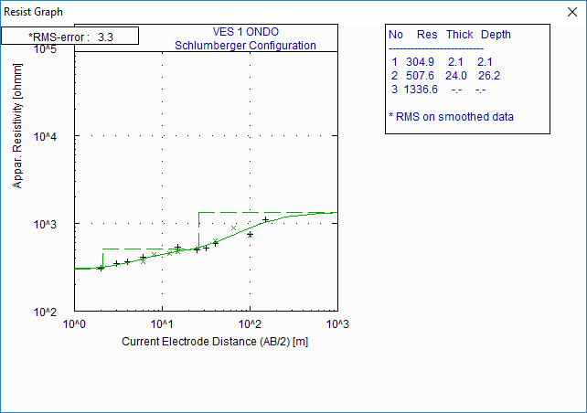

(a)

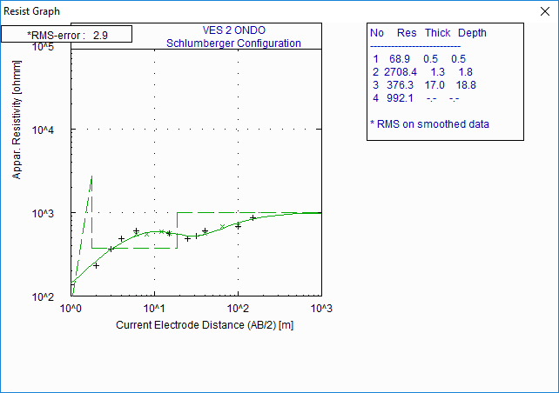

(b)

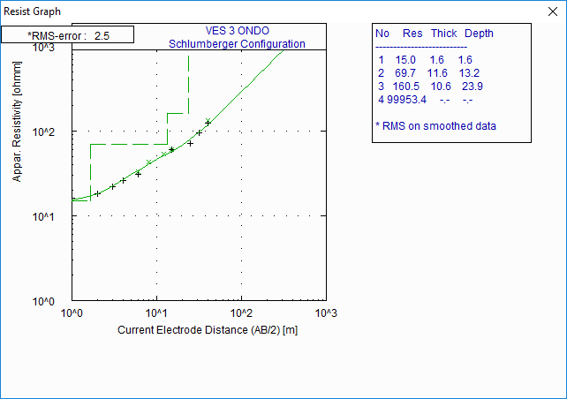

(c)

**Figure 2**: Typical Sounding Curve along Profile AA1 (Ijebu Ode) (a) HKH (b) HKH (c) A (d) HAK (e) K (f) A

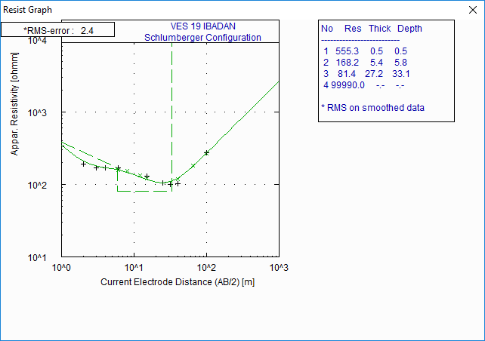

(a) 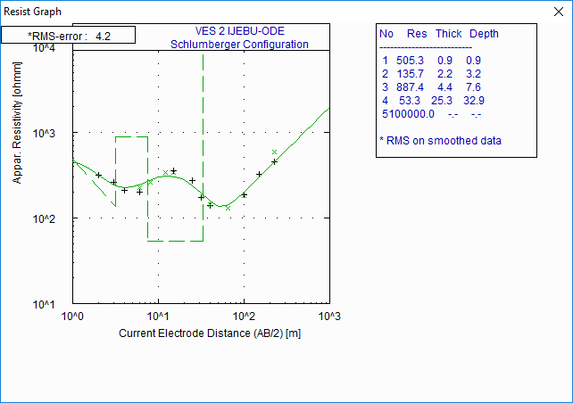

(b)

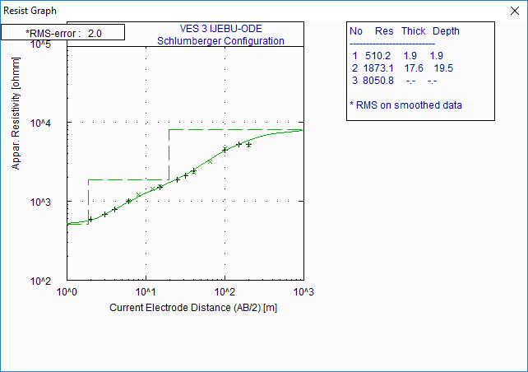

(c)

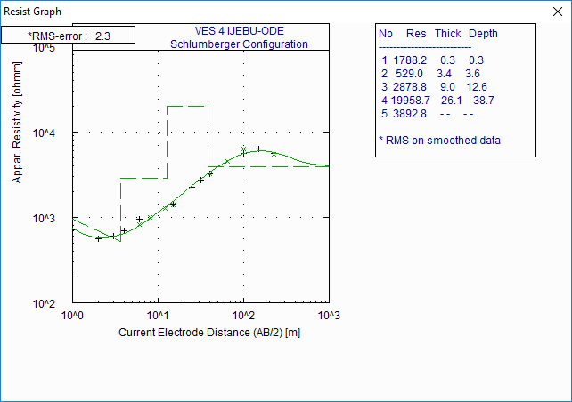

(d)

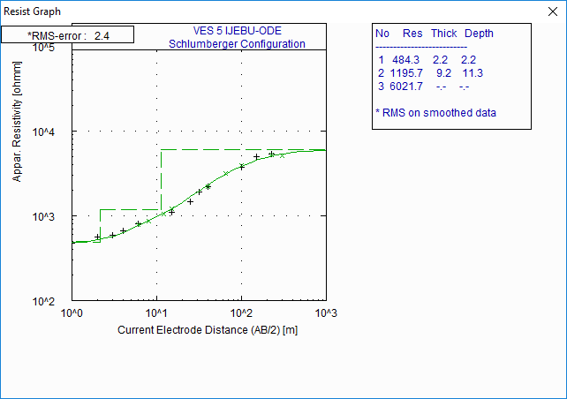

(e)

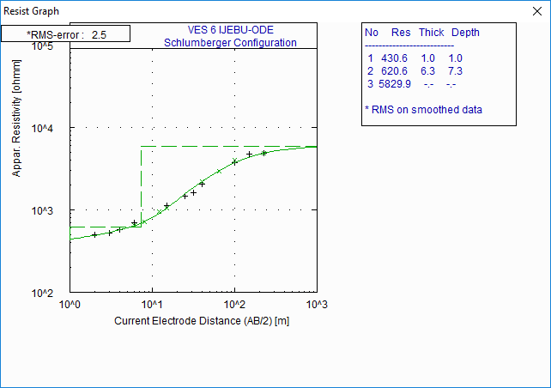

(f)

**Geoelectric Sections**

The parameters obtained in the form of layer thickness and resistivity values from the interpretation of the field curves were utilized in generating geoelectric sections.

Figure 3 illustrates the geoelectric-section along profile A-A’(Ondo) comprising of three VES stations which are VES 1, VES 2, and VES 3. Four (4) geoelectric layers were delineated. The topsoil exhibits resistivity values that range from 15 to 305Ω-m, with thickness varying between 0.5 and 2.1 m. The composition of this layer is sandy clay clayey sand and clay. The thickness of the layer varies between 10.6 m and 24 m. The third layer in this sequence is the partially weathered/fractured basement. Resistivity values of the third layer is 376 Ω-m with thickness of 17 m. The fresh basement resistivity ranges between 992Ω-m and ∞ Ω-m, with a depth to bedrock range of 18.8 m to 26.2 m. The VES 2 point at the northwestern flank are target area of fracture/fault(thick fractured column of 17.0 m). The southeastern flank comprising of VES points1 and VES 3, consist of thick overburden (10.4 and 23.9 m) layers suggestive of fairly favorable hydrogeologic setting.



**Figure 3: Geoelectric Section along profile A-A’ Ondo**

Figure 4. Shows the geoelectric-section along profile A-A1 (Ijebu-Ode). The section consists of VES 1, 2, 3, 4, 5 and 6. In these sections, four to five subsurface layers were delineated. In the first layer, (top soil) resistivity values range from 136Ω-m to 959 Ω-m, while thickness vary from 0.8 m to3.2 m. The second layer consists of highly resistive (887Ω-mto 19956 Ω-m) and highly compacted clay layer. The thickness varies from 4.4 m to 26.1 m. The third geoelectric layer delineated composed of sandy clays and fine-medium sand with resistivity values ranging from 53Ω-m to 139 Ω-m and thickness of 32.9 m and 46.5 m. The bedrock resistivity values vary from 8051Ω-m to ∞ Ω-m, with depth to bedrock range of 7.3 m and 53.1 m. The weathered layer thickness decreases in the southeast direction while VES points 1 and 2 show fairly thick aquiferous zone/fault column in the northwest direction.



**Figure 4: Geoelectric Section along profile A-A1Ijebu Ode**

**Conclusion**

The correlation analysis of minor fault zones in Ondo and Ijebu Ode using the Vertical Electrical Sounding (VES) method has provided valuable insights into the subsurface geology of these regions. This study has demonstrated the effectiveness of VES as a geophysical tool for characterizing and understanding fault zones, which are critical geological features that can influence groundwater flow, land stability, and seismic hazards. The results of this research have revealed the presence of minor fault zones in both Ondo and Ijebu Ode, and their geological significance has been elucidated. By analyzing the resistivity profiles obtained through VES, researchers and geologists can better comprehend the subsurface structures and their potential impact on various aspects of the local environment.

**References**

Adagunodo T.A. (2012): Interpretation of Groundmagnetic and Vertical Electrical Sounding Data in the Study of Basement Pattern of an Industrial Estate in Ogbomoso, Southwestern Nigeria. M.Tech Thesis, Ladoke Akintola University of Technology, Ogbomoso, Nigeria.

Adelusi A.O, Adiat K.A.N, and Amigun J.O. (2009): Integration of subsurface electrical prospecting methods for fracture detection in Precambrian Basement rocks of Iwaraja area Southwestern Nigeria, Ozean Journal of Applied Sciences. 2(3): 265-280.

Alagbe O.A. (2005): Integration of Electrical Resistivity Techniques and Lineament analysis in Hydrogeological investigation of parts of Ogbomoso, South – Western Nigeria. M.Tech Thesis, Ladoke Akintola University of Technology, Ogbomoso, Nigeria.

Ammar, A.I., Kamal, K.A. (2018). Resistivity method contribution in determining of fault zone and hydro-geophysical characteristics of carbonate aquifer, eastern desert, Egypt. *Appl Water Sci* **8**, 1 <https://doi.org/10.1007/s13201-017-0639-9>.

Asghar Azadi • Khaled Hessami • Gholam Javan-Doloei (2010) Integrated geophysical methods for determining geometry of the Kahrizak Fault, Tehran, Iran. *Natural Hazard* 54:813–825.

Cooper GRJ (2000) Magnetic modeling and inversion, mag2dc software. School of Geosciences, University of the Witwatersrand, Johannesburg 2050

Dahlin, T., and Zhou, B., (2004). A numerical comparison of 2D resistivity imaging with ten electrode arrays. Geophysical Prospecting, 52, 379–398.

Kim, J. H., Yi, M. J., Park, S. G., and Kim, J. G., (2009). 4D inversion of DC resistivity monitoring data acquired over a dynamically changing earth model. Journal of Applied Geophysics, 68, 522–532.

Olorunfemi, M.O. and Fasuyi, S.A. (1993) Aquifer Types and the Geoelectric/Hydrogeologic Characteristics of Part of Central Basement Terrain of Nigeria (Niger State). *Journal of African Earth Sciences*, 16, 309-317.http://dx.doi.org/10.1016/0899-5362(93)90051-Q

Olorunfemi, M. O. and Mesida, A. (1987) Engineering geophysics and its application in engineering site investigations (Case study from Ile-Ife area). *The Nigerian Engineering*, 22(2), 57-66.

Ritz J.F, Nazari H, Ghassemi A, Salamati R, Shafei A, Solaymani S, Vernant P (2006) Active transtension inside central Alborz: a new insight into northern Iran–southern Caspian geodynamics. Geology 34:477–480.

Van Toan, Dinh & Harder, Steven & Huang, Bor-Shouh & Trinh, Viet-Bac & Doan, Van-Tuyen & Hop Phong, Lai & Tran, Anh-Vu & Nguyen, Hong & Nguyen, Van-Duong. (2018). [An overview of northern Vietnam deep crustal structures from integrated geophysical observations](https://www.researchgate.net/publication/323933182_An_overview_of_northern_Vietnam_deep_crustal_structures_from_integrated_geophysical_observations). *Terrestial Atmospheric and Oceanic Sciences* Vol 29 pg 1-17.

Somvir Singh, Param K. Gautam, Debasish Bagchi, Sashikant Singh, Sushil Kumar, Suresh Kannaujiya (2021). 2D Electrical resistivity imaging for geothermal groundwater characterization and rejuvenation of the Gaurikund hot spring in the Main Central Thrust (MCT) zone of the Garhwal Himalaya, Uttrakhand, India. *Groundwater for Sustainable Development,*

Volume 15, Article 100686.