Assessment of Shoreline Changes on Victoria Island in Eti-Osa Local Government Area, Lagos State, Nigeria.

1Julius Adekunle Olanibi 2 Gabriel Esan Ajayi and 3 Michael Ajide Oyinloye,

1, 3Department of Urban and Regional Planning,

2Department of Surveying and Geoinformatics

School of Environmental Technology,

Federal University of Technology, Akure, Nigeria.

[1olanibijulius@gmail.com](mailto:1olanibijulius@gmail.com) [2g.ajayi@ntworld.com](mailto:2g.ajayi@ntworld.com); 3[micnicjide@yahoo.com](mailto:micnicjide@yahoo.com);

*Abstract:-*Coastal zone managers are faced with difficult and complex choices about how best to reduce property damage in the shorelines. One of the problems they face is error and uncertainty in the information available to them on the processes that cause erosion of beaches.This study looks at the socio-economic impact of shorelines changes on Victoria Island in Eti-Osa Local Government Area, Lagos State, Nigeria. Data were collected through the instrumentality of structured questionnaires. There were 3248 buildings in the study area which constitute the research population. The sample size of 10% was adopted, hence 325 copies of questionnaires was administered in the study. Data for shoreline changes were obtained from satellite imagery. Topographical map of 1962 was used as the base map; Landsat TM of 1984, ETM+ 2000 and 2011 of Eti-osa were acquired for this study respectively. The study employed maximum likelihood supervised classification method using ILWIS 3.1 and ArcGIS 9.3. The topographic map of 1962 and the imagery of 1984 was glued and crossed; 1984 and 2000; and the 2000 and 2011 were also crossed to get the changes in the shorelines in these years. The capability of remote sensing (RS) and geographic information systems (GIS) have been explored to generate digital elevation models (DEM), slope maps and shoreline change maps which give useful information about the terrain. DEM map shows that the study area is between 0-33.33m, while the slope map shows the Elevation range, revealed that about 90% of the study area is between the heights of about 0-16.667. The results of the analysis reveal that between 1962 and 1984 there was loss in landmass while between 1984 and 2011 there was increase in land gain overtime. About 31.4% of landmass was lost between 1962 and 1984 while between 1984 -2000 and 2000-2011 there was gain in landmass of about 81.89% and 62.11% respectively. In our opinion, the information provided by these technologies can significantly improve strategic decision-making processes in shoreline changes worldwide.

*Keywords:* Socio-economic, Shoreline, Remote sensing, GIS, Victoria Island.

1 Introduction

Shoreline change, which refers to the gradual movement of shorelines and dune features in a landward direction, though not necessarily with any decrease in size or perceptible erosion. The causes of shoreline change are both natural and human-induced. Many factors caused shoreline changes on the beaches. The most important factors according to [13];[5].that caused these changes are: Human activities; lack of sand deposits in the nears shore area; increase in tropical storm occurrence in the vicinity of the island; local wave regimes; flood events of all magnitudes and frequencies; and the presence of submarine canyons. Coastal erosion due to sea level rise along the shoreline is becoming especially in developing countries such as Nigeria. Historically, the mean sea-level is increasing and this is impacting affected communities through increase flood risk and submergence, sanitization of surface and ground waters and morphological changes such as erosion and wetland loss [6].

The natural character of sandy beaches is to change shape constantly and to move landward (retreat) or seaward (advance). The changes are caused by changes in the forces that move the sand, namely; wind, waves, and currents, and by the supply of sand. Short- and long-term relative sea-level changes also control shoreline movement. The setting of the shoreline and the supply of sand determine how the shoreline changes at a particular location. Setting refers to whether a beach is sheltered from waves, adjacent to a tidal or storm channel, or next to a jetty or seawall [1].

Shoreline change that occurs over about ten years or less and that may be in the opposite direction of the long-term trend is difficult to understand and predict. These short-term shoreline changes can also be quite variable alongshore. One portion of the coast may be experiencing retreat while just a few kilometers away stable or advancing conditions may prevail. A shoreline that has retreated over the last 100 years may have experienced periods of shoreline advance. It is important, however, for coastal residents to understand that even though a particular beach may have been advancing or stable over the last several years, if it has been retreating for the previous decades, then retreat will eventually resume. An exception to this rule would be if something fundamental, such as a “permanent” increase or decrease in the sand supply, has changed in the system [1].

Shoreline retreat is not always a continuous and steady process with a little more of the beach eroded each year. There is often dramatic recovery for months and years following a storm, but it is usually incomplete, and the shoreline remains significantly landward of its presto position. Even though shoreline change rates are given as annual rates, they must be considered “average” annual rates. The indirect impacts of sea-level rise can be felt in fishery activities through loses of coastal wetlands which plays vital role in the life cycles of many important aquatic lives. Declining wetlands from the sea-level rise would impact fisheries and aqua-based resources. Long-term historical data are required for coastal analysis to identify the coastal sections with shoreline changes [7]. Attempts to stabilize the shore can greatly influ­ence the rates of shoreline change. Activities such as beach nourishment or emplacement of shoreline stabilization structures tend to alter coastal processes, sediment transport, and shoreline position. For example, beach nourishment artificially causes rapid, temporary shoreline accretion. Depending on the frequency of beach nourishment, the placement of large volumes of sand on the beach will bias the rates of observed shoreline change toward accretion or stability, even though the natural beach, in the absence of nourishment, would be eroding.

The summary of identifiable beach nourishment projects in the Gulf Coast region had been conducted before 1996. These records were used to identify shoreline segments that had been influenced by beach nourishment. Beaches along the west coast of Florida are some of the most frequently nourished beaches in the U.S. The frequent nourishment is reflected in the slow rates of shoreline retreat or stability, even though the natural rates of erosion may be higher [12].

The location of the shoreline and its changing position over time is of fundamental importance to coastal scientists, engineers and managers. Present day shoreline monitoring campaigns provide information about historic shoreline location and movement, and about predictions of future change [12]. More specifically the position of the shoreline in the past, at present and where it is predicted to be in the future is useful for in the design of [coastal protection](https://en.wikipedia.org/wiki/Coastal_protection), to calibrate and verify [numerical models](https://en.wikipedia.org/wiki/Computer_simulation) to assess [sea level rise](https://en.wikipedia.org/wiki/Sea_level_rise), map hazard zones and formulate policies to regulate coastal development. Accurate and consistent delineation of the shoreline is integral to all of these tasks. The location of the shoreline also provides information regarding shoreline reorientation adjacent to structures, [beach](https://en.wikipedia.org/wiki/Beach) width, volume and rates of historical change [12].

Geographic Information Systems (GIS) and Satellite Remote Sensing (SRS)are useful tools for management and monitoring of Shoreline Changes [1]. Obtaining the same information by field surveys would take a long time and considerable human resources. In addition, GIS/SRS “Satellite Remote Sensing data allow us to see changes in the spatial distribution of various land resources, which is otherwise difficult to keep updated on a local scale [9].

The aim of this paper therefore is to assess shoreline changes and its socio-economic implications on the Victoria Island, Lagos using GIS technique. The objectives are to;

1 assess the socio-economic impact of shoreline

changes in the study area

2 assess the extent and implications of the shoreline

changes at different periods between

using GIS techniques

3 assess the effects of shoreline changes on the socio-

economic characteristics of the residents in the

study area

4 devise a workable framework for managing

shoreline changes problems in the study area.

2 The study area

Lagos state lies between longitude 3021’24” E and latitude 60 35’8”N. It lies in the South-Western Nigeria on the Atlantic coast in the gulf of Guinea (see figure 1) and has a population of about 7,937,932 [8]. The rainfall is usually very heavy, especially during the rainy season (April to October). The rainfall pattern in the study area can be explained in terms of the movement of the ITCZ. This movement explains the observed double rainfall maxima which characterizes the study area. Eti-osa is one of the 16 local government areas in Lagos State as shown in figure2, which has a population of about 283,791 [1]. while figure 3 shows Victoria Island (the study area. The study area was divided into four (4) zones demarcated by major roads as shown in figure 4. The geological history accounts for the almost flat terrain, where most land areas are between 18 and 25 meters above the sea level. Victoria Island and the entire axis are surrounded by Atlantic Ocean. Expectedly, the areas drained by the various water bodies are low lying.

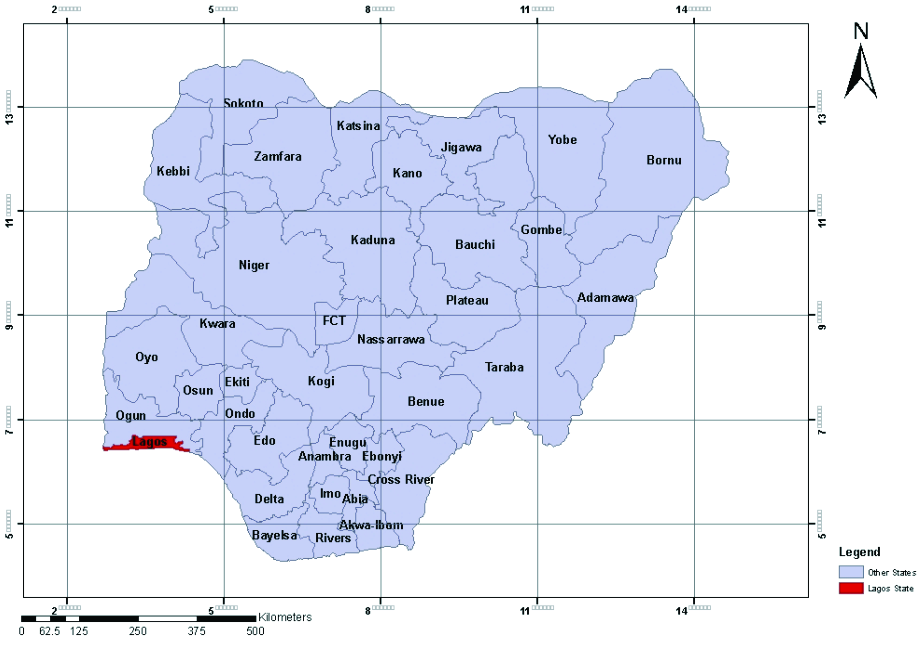

Fig. 1: Map of Nigeria showing Lagos State



Fig. 2: Map of Lagos State, showing Victoria

Island in Eti-Osa Local Government Area



Fig. 3: Map of Eti-Osa Local Government, showing

the Study Area (Victoria Island)

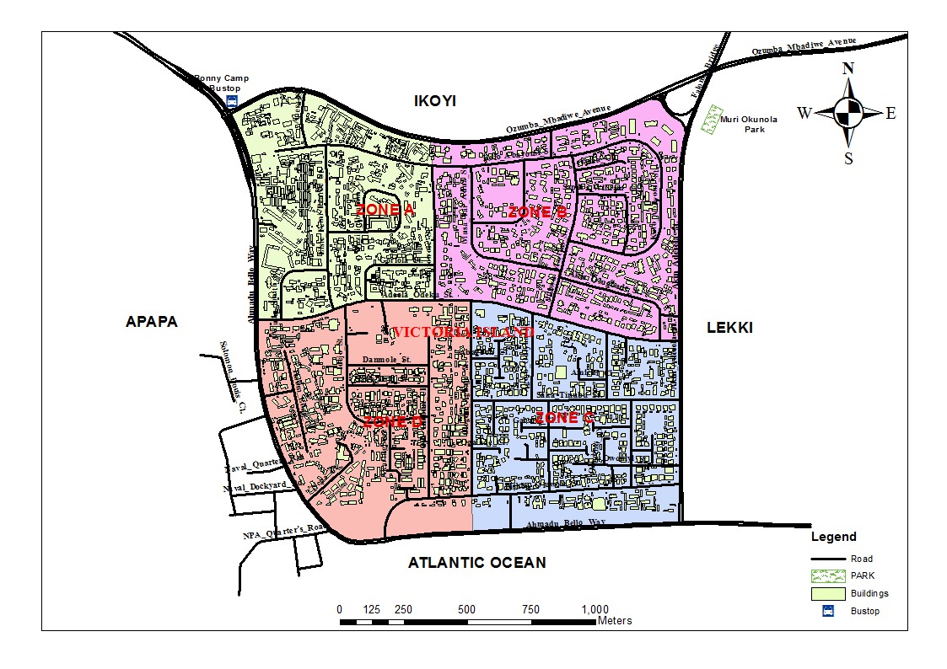

Fig. 4: Map showing the four zones of the study

area.

Source: http://www@googleearth.com (Digitized

by the authors)

3 Data acquisition and preparation

The study was interested in the analysis of the socio-economic impact of shoreline in the study area. The capabilities of GIS and remote sensing (RS) were used to determine the impact of shoreline in the study area. The GIS software was used to acquire satellite imageries of the study area. This includes acquiring the Landsat imagery of the study area associated with shoreline change at different period intervals. Landsat satellite imageries of the shoreline of Eti-osa local government area were acquired for the years 1984, 2000, and 2011. These set of maps were helpful for the shoreline changes analysis on time series, collated and crossed with the use of GIS. Also, the geographic data of the study area was captured from Google website (http://www.google.com). The SPOT image of Eti-Osa LGA as posted online was imported into GIS environment where further processing was carried out in order to make the acquires image useful for analysis. The image was able to shows clearly the various shoreline change maps that were generated in the study area.

The questionnaire method was used to generate socio-economic data in the study area. The study area was divided into four (4) zones demarcated by major roads. Zone 1 has 799 buildings, zone 2 has 813, zone 3 has 749 and zone 4 has 887 buildings. 10% of the total buildings in each zone serve as the number of questionnaires administered in each zone. Three Hundred and twenty-five (325) samples were taken from all the four zones of the study area. The data collected was processed using the statistical package for social scientists software. Results were presented in the form of charts, tables and graphs among others.

4.0 Results and Discussion

The results of administered questionnaire and the GIS outputs are presented below:

4.1 Socio-economic Traits of the Respondents

The age structure of the respondent shows that, 16.6% of the respondents were 35 years below, 37.2% falls within the ages of 36-45 years and 46.2% were 46 years and above. It was observed that majority of the respondents were 46 years and above. This implies that majority of the respondents were house hold heads who are experienced about the incidence of flood in the study area.

The level of education of the respondents reveals that, 1.5% of the respondents are not educated, 16.9% attained the level of primary education, 32.9% secondary education and 48.6% attained the level of tertiary education. Critically looking at the level of education of the respondents, it is revealed that 48.6% of them attained the tertiary education level. This may be as a result of the fact that the study area is a civilized community where it is expected that most of the residents should be educated.

The monthly income of the respondent shows that 1.5% of the respondents received below N20,000 monthly, 15.4% received between N20,000-N30,000, 35.4% received between N40,000-N50,000 while 47.7% received above N50,000 monthly. The level of monthly income of the respondents shows that majority of the respondent still live below one dollar per day as indicated by the United Nation and this may affect the people’s standard of living, their ability to demand for standard housing and requirement for other services.

4.2 Socio-economic Impact of shoreline changes on Building

Table1 shows the distance of buildings from the flood plain. The study revealed that 5.8% of the sampled buildings fall between the distances of 20-50m from the flood plain while 94.2% of the buildings were 50m away from the flood plain. This revealed that most of the buildings in the study area have set backs above 50m from the flood plain. This may be as a result of the compliance to the building to stream set back standards that the minimum distance between a building and a stream or other water body or a gorge shall be determined by the peculiar circumstance of each case, but shall not be less than 30metres in any case.

Table1 Distance of Building to flood plain

|  |  |  |
| --- | --- | --- |
| Distance of Building to flood plain | Frequency | Percentage |
| between 20-50m | 19 | 5.8 |
| Above 50m | 306 | 94.2 |
| Total | 325 | 100.0 |

Source: Author’s Fieldwork, 2014

Table2 shows the views of the respondents on the impacts of flood on the buildings in the study area. It was gathered that 17% of the respondents viewed that, the impact of flooding as causing damage and deterioration of buildings, 16% viewed it as causing deterioration of environmental infrastructure,2% viewed it as carrying away of building, 11% claimed that it results to homelessness, 9% claimed that it results to dirty environment, 14% claimed that it results to soaking and making water mark on the wall of the building while 15% viewed that it causes prevalence of malaria disease and 16 % of the respondents claimed that flooding obstruct movement and economic activities.

Table 2: Impacts of flood on the Study area

|  |  |  |
| --- | --- | --- |
| Impacts of flooding | Frequency | Percentages |
| Damage and deterioration of buildings | 56 | 17 |
| Deterioration of environmental infrastructure | 52 | 16 |
| Carrying away of building by flood water | 7 | 2 |
| Result to homelessness | 37 | 11 |
| Result to dirty environment | 30 | 9 |
| Soaking / water mark on the wall of the building | 44 | 14 |
| Prevalence of malaria disease | 48 | 15 |
| Obstruction of movement and economic activities | 51 | 16 |
| Total | 325 | 100 |

Source: Author’s Fieldwork, 2014

The implication of this is that, damage and deterioration of buildings, deterioration of environmental infrastructure, continuous soaking and wetting of the wall of a building gradually weakens the wall and this may reduce the life span of the building and finally result to the unexpected collapse of the building.

Table 3 shows the respondents observations on the number of buildings that have been affected by flood in the study area. It was revealed that 2.8% of the respondents observed less than ten (10) buildings, 6.2% observed between 10-20 buildings, 21.5% observed between 21-30 buildings while 69.5% observed more than 30 buildings. However, analysis shown that more than 30 buildings have been affected in one way or the other by flood (see figure5).

Table 3: Number of buildings that have been affected by floods

|  |  |  |
| --- | --- | --- |
| Number of Buildings Affected by Flood | Frequency | Percentage |
| less than 10 | 9 | 2.8 |
| 10-20 | 20 | 6.2 |
| 21-30 | 70 | 21.5 |
| more than 30 | 226 | 69.5 |
| Total | 325 | 100.0 |

Source: Author’s Fieldwork, 2014.

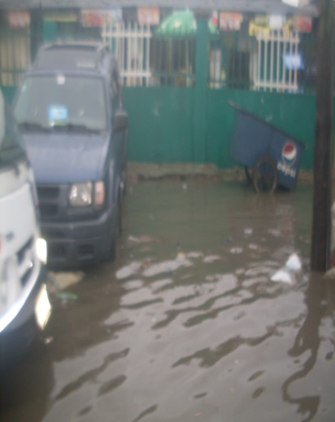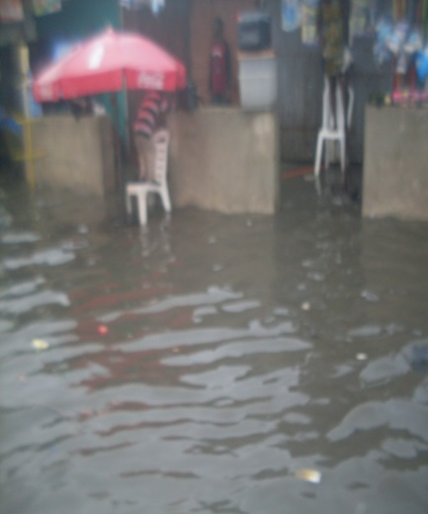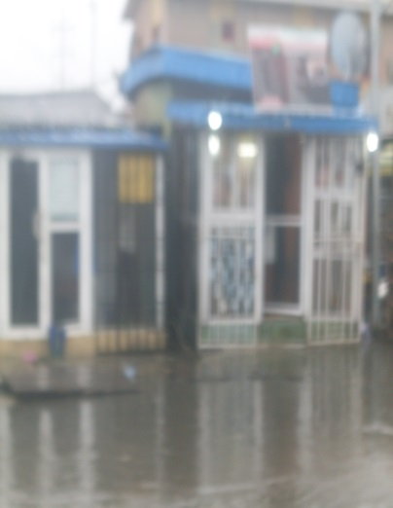

Fig. 5: Flooded building in the Study Area

4.3 GIS Analysis of shoreline changes in Eti-Osa

4.3.1 Eti-Osa Shoreline in the Years 1962 and

1984

Figure 6 shows the positions of shoreline in Eti-osa in the years 1962 and 1984. The base map of the shoreline position of 1962 was glued and crossed with the Eti-osa coastline supervise classified Landsat TM of the shoreline position in the year 1984, to analyze the variation in the shoreline position between these two years. From figure 6, the water body-coastland is the volume of water that have been reclaimed to land between these years, water body- water body is the volume of water that remain unchanged, coastland- water body is the landmass in the coast that has been lost to water body while the coastland-coastland is the amount of the landmass that remain unchanged between these years.

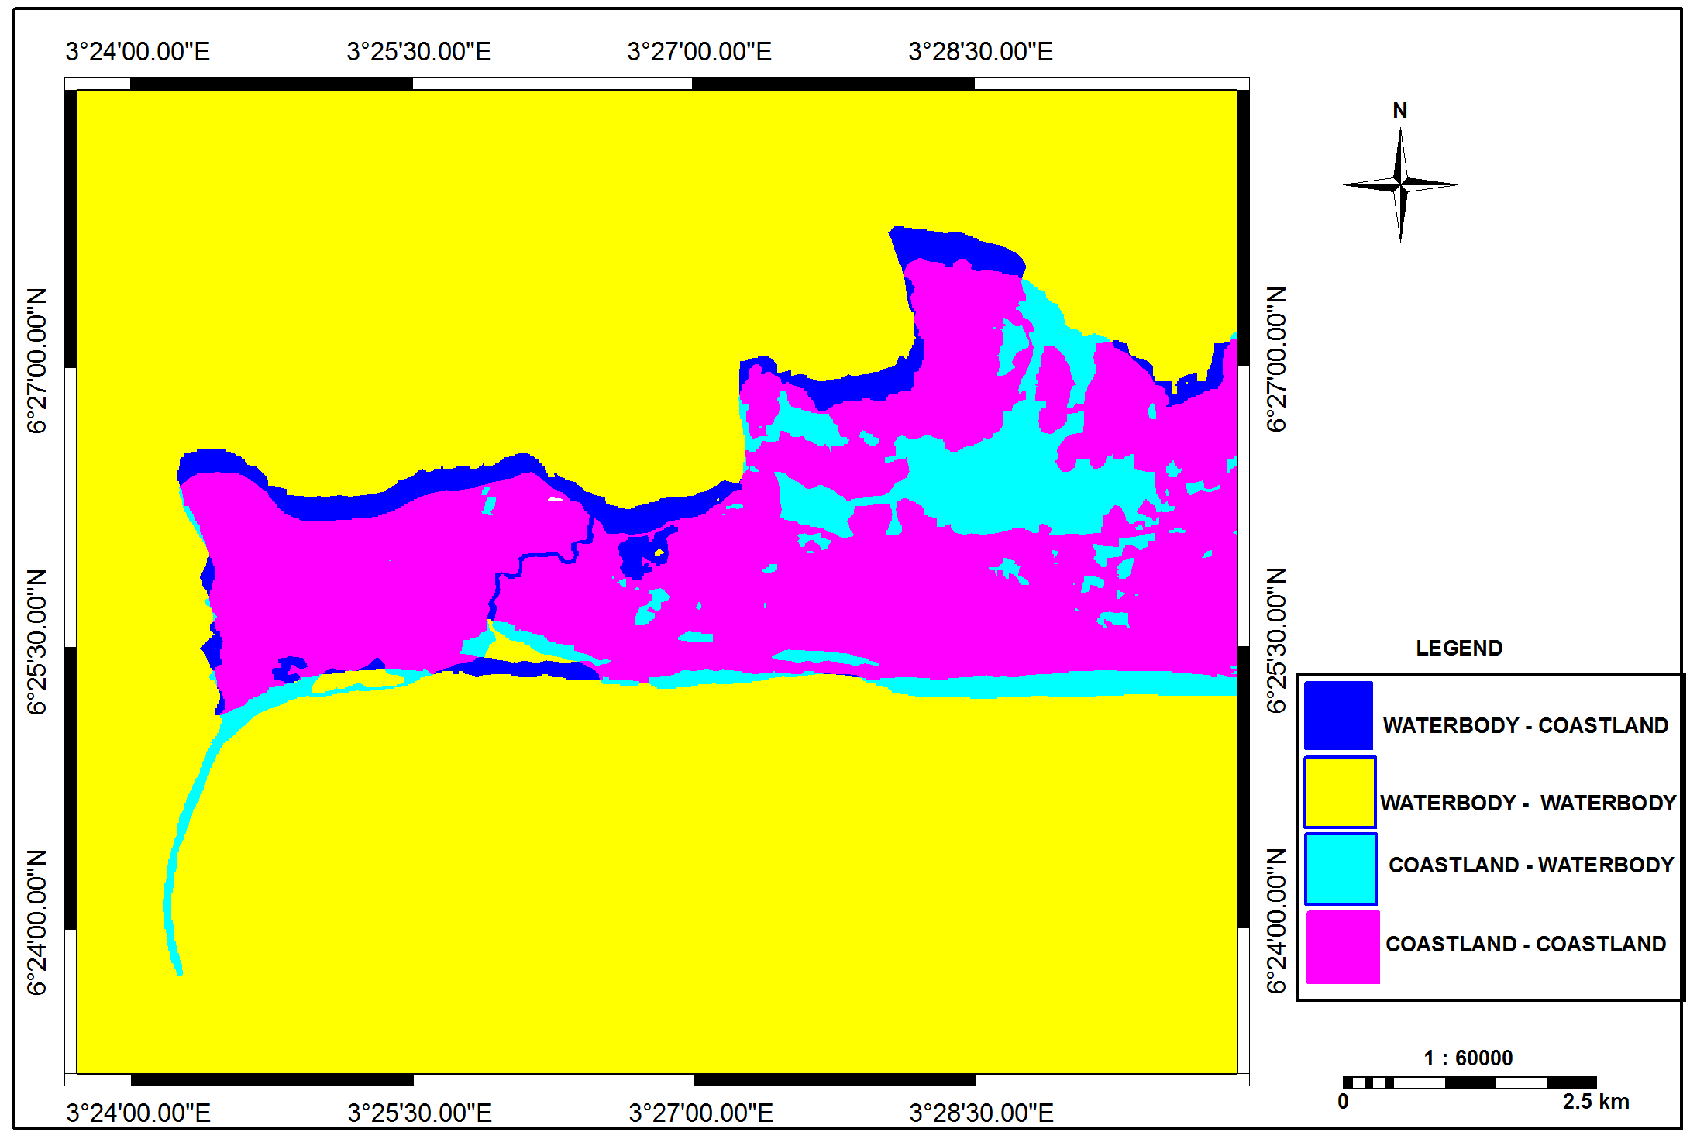

Fig. 6: Shoreline position of Eti-osa (1962 and 1984)

Source: http://www@googleearth.com (Digitized by the author).

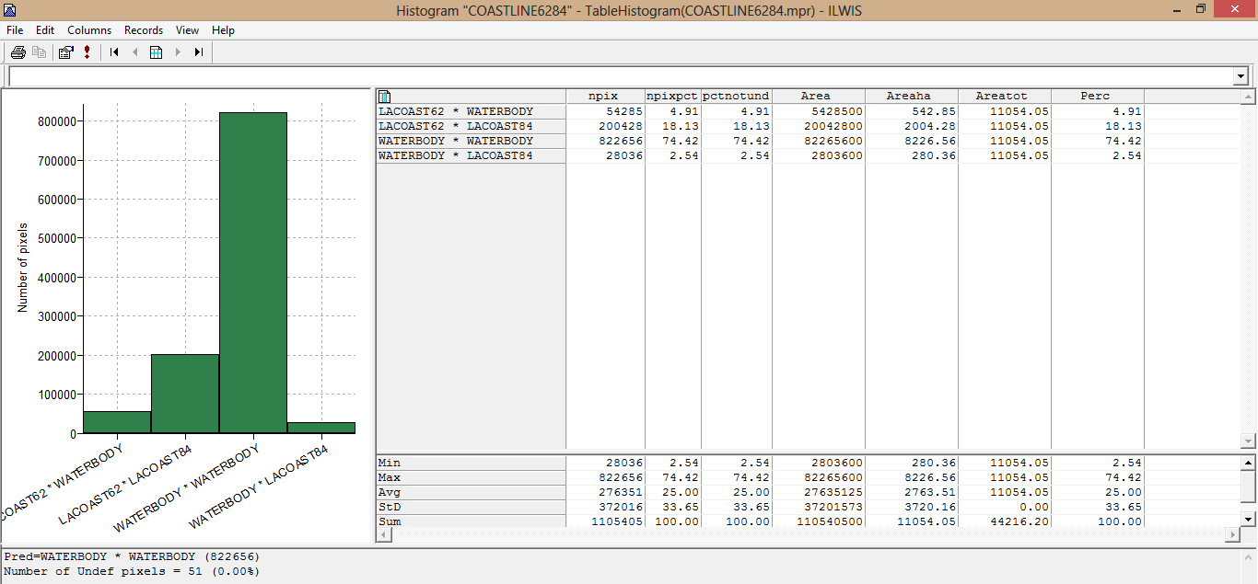

Fig.7: Analysis of the positions of shoreline in Eti-osa in the years 1962 and 1984

Source: Author’s Field Work 2014.

Fig. 7 shows the analysis of the changes in shoreline between the years 1962 and 1984. From the analysis it was discovered that in the year 1964, 542.65 ha (4.91%) of land of the total landmass of 11054 hectares was lost to water-body in the year 1984, 2004.28 ha (18.13%) of landmass in 1962 still remains the same till the year 1984, 8226.56 ha (74.42%) of water-body in 1962 still remain unchanged till the year 1984 while 280.36 ha (2.54%) of water-body in the year 1962 was gained as landmass in the year 1984. Critical examination of the analysis revealed that, between 1964 and 1984, 542.65 ha (4.91%) of land was lost to water-body, while 280.36 ha (2.54%) of water-body was gained as landmass. From the above analysis, it was discovered that between the years 1962 and 1984, about 542.65 ha (4.91%) of landmass (shoreline) was lost to water-body than the landmass gained. The landmass lost to water between these years may be as a result of dominating fluvial deposits of mostly fine grained and loose sediments. Erosion by wind, propelled ocean waves that hit the shores forcefully may also account for coastline erosion and influences sea-level rise. Extensive dredging also aggregate channel activities disturb coastal features thereby disturbing the natural equilibrium between the sources of beach material and the littoral drift that often account for frequent coastal retreat (loss) [11].

4.3.2 Eti-Osa Shoreline in the Years 1984 and 2000

Fig. 8 shows the positions of shoreline in Eti-osa in the years 1984 and 2000. The Eti-osa coastline supervised classification of Landsat TM shoreline position of 1984 was crossed with the supervised classification of Landsat ETM+ shoreline position in the year 2000, to analyze the variation in the shoreline position between these two years. From the figure, the water body-coastland is the volume of water that has been reclaimed to land between these years, water body-water body is the volume of water that remain unchanged, coastland- water body is the landmass in the coast that has been lost to water body while the coastland-coastland is the amount of the landmass that remain unchanged between these years.

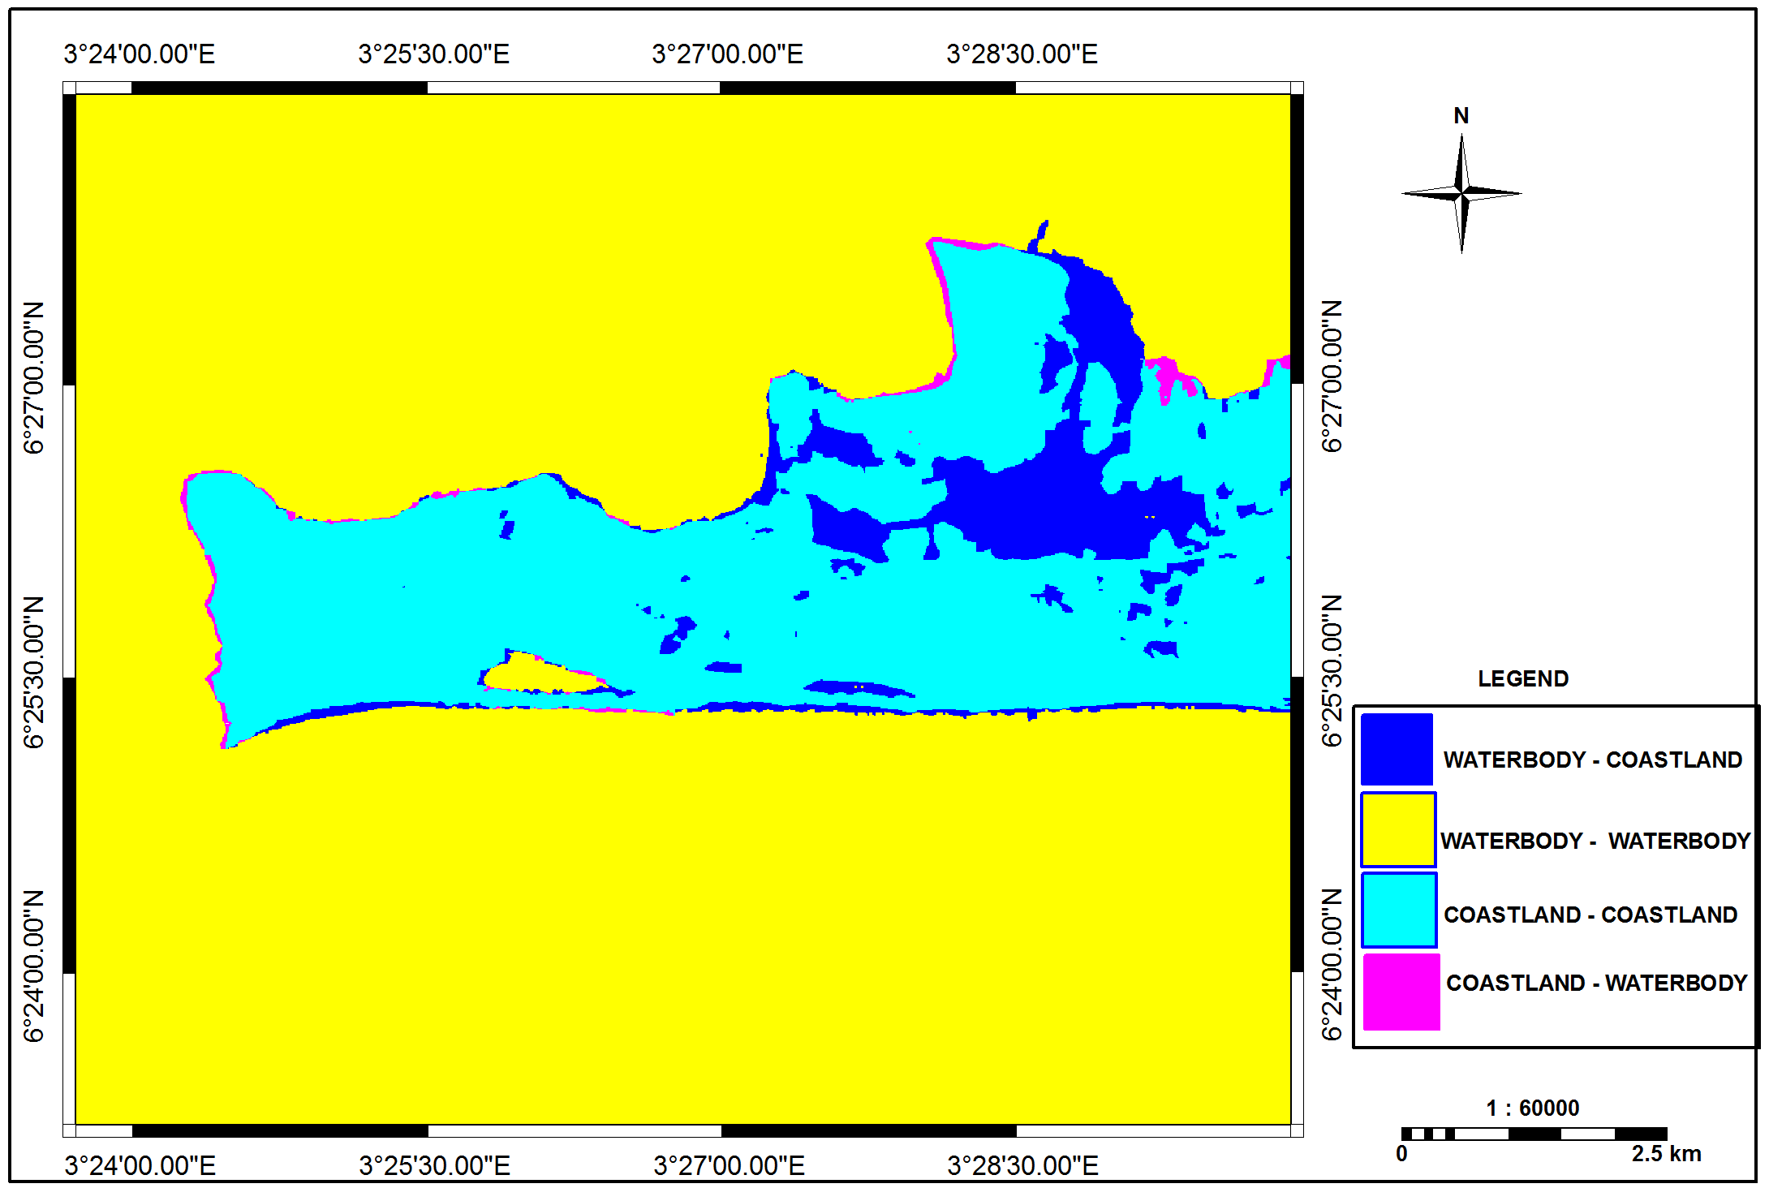

Fig 8: Shoreline position of Eti-osa (1984 and 2000)

Source: http://www@googleearth.com (Digitized by the author).

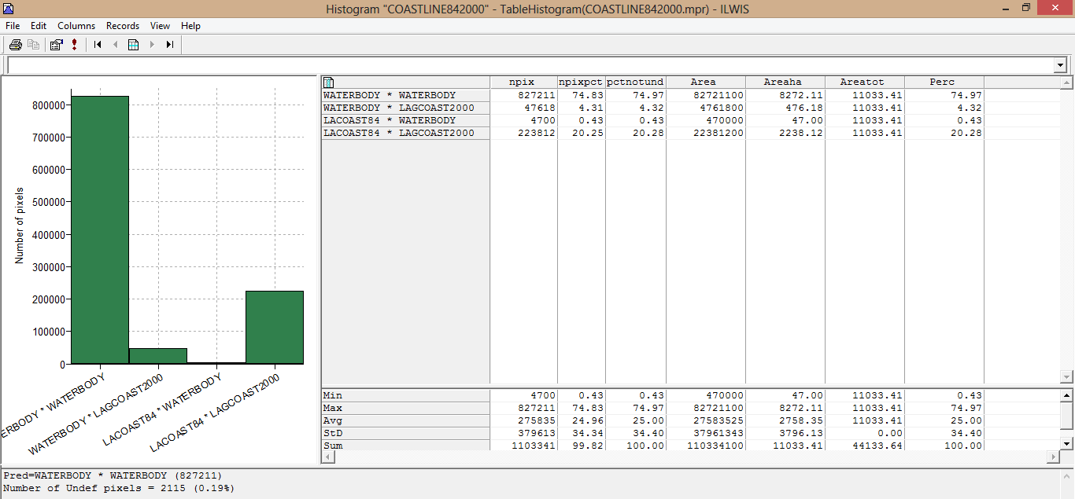

Fig. 9: Analysis of the positions of shoreline in Eti-osa in the years 1984 and 2000

Source: Author’s Field Work 2014.

Fig. 9 shows the analysis of the changes in shoreline between the years 1984 and 2000. From the analysis it was discovered that in the year 1984, 8272.11 ha (74.97%) of water body in 1984 still remain unchanged from the total landmass of 11033.41 ha till the year 2000, 476.18 ha (4.32%) of water body in the year 1984 has been reclaimed to landmass in the year 2000, 47.00 ha (0.43%) of landmass in 1984 has been lost to water body in the year 2000 while 2238.12 ha (20.28%) of landmass in 1984 still remains unchanged till the year 2000. The analysis revealed that, between the years 1984 and 2000, there was 476.18 ha (4.32%) landmass gained from water body while 47.00 ha (0.43%) of landmass was lost to water body. From the above analysis, it was discovered that between the years 1984 and 2000, about 476.18 ha (4.32%) of water body was reclaimed to landmass than the landmass lost to water body. This more gain in landmass between these years may be as a result of spatial expansion and land reclamation exercise for different purposes especially for industrial and building purposes by the Lagos State government [3].

4.3.3 Eti-Osa Shoreline in the Years 2000 and

2011

Fig. 10 shows the positions of shoreline in Eti-osa in the years 2000 and 2011.The Etiosa supervise classified Landsat ETM+ showing the shoreline position of the year 2000 was crossed with the supervise classified Landsat ETM+ of shoreline position for the year 2011, to analyze the variation in the shoreline position between these two years. From the figure, the water body- coastland is the volume of water that have been reclaimed to land between these years, water body- water body is the volume of water that remain unchanged, coastland- water body is the landmass in the coast that has been lost to water body while the coastland-coastland is the amount of the landmass that remain unchanged between these years.

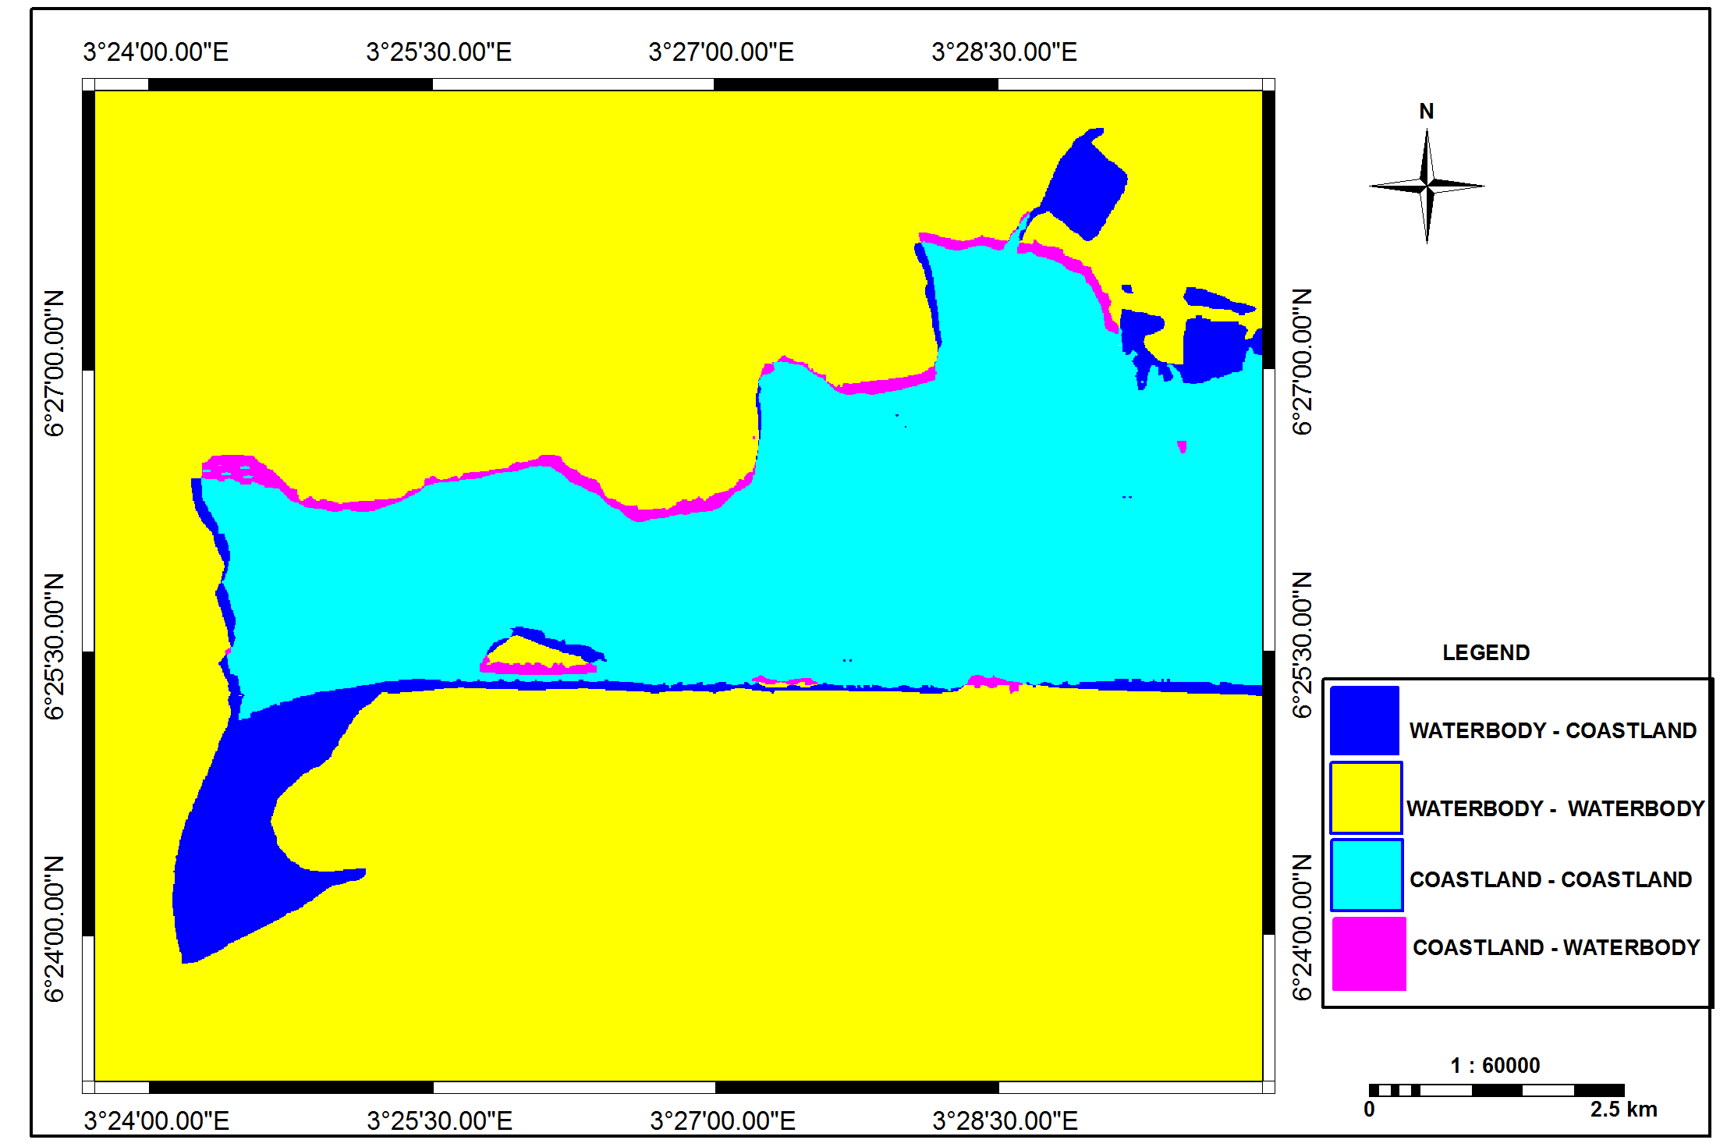

Fig. 10: Shoreline position of Eti-osa (2000 and 2011)

Source: http://www@googleearth.com (Digitized by the author).

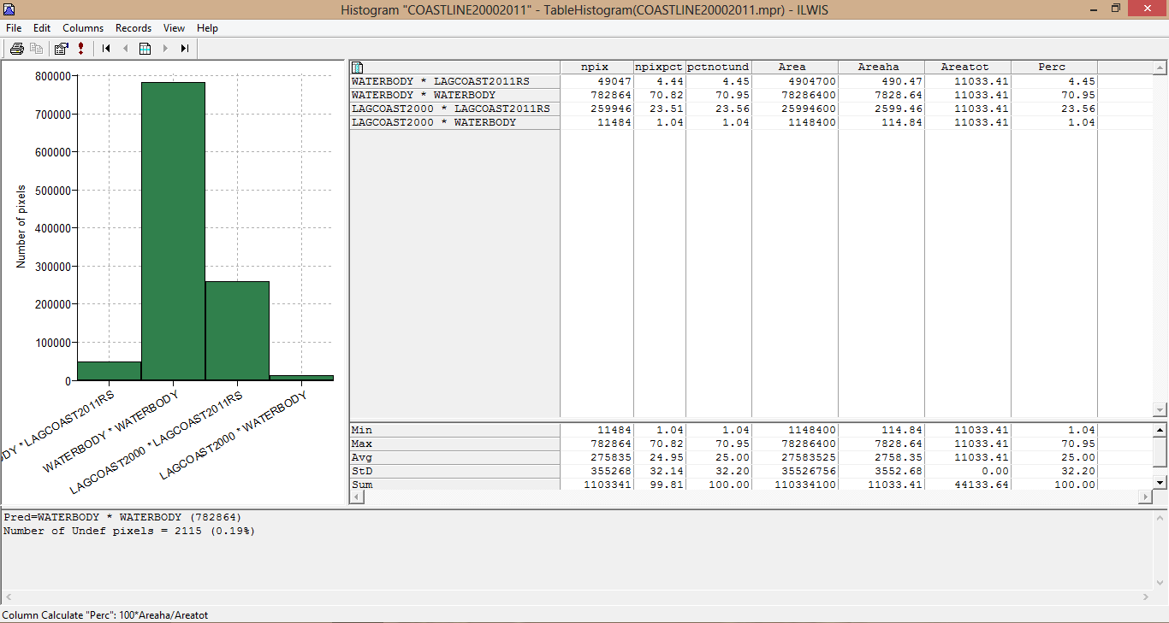

Fig. 11: Analysis of the positions of shoreline in Eti-osa in the years 2000 and 2011

Source: Author’s Field Work, 2014.

Fig. 11 shows the analysis of the changes in shoreline between the years 2000 and 2011. From the analysis, it was revealed that in the year 2000, 490.47 ha (4.45%) of water body has been reclaimed to landmass in the year 2011, 7828.64 ha (70.95%) of water body in 2000 still remain unchanged till the year 2011, 2599.46 ha (23.56%) of landmass in 2000 still remains the same till the year 2011 while 114.84 ha (1.04%) of landmass from the total landmass of 11033.11 ha has been lost to water body in the year 2011.The above analysis shows that, between 2000 and 2011, about 490.47 ha (4.45%) landmass was gained from water body, while 114.84 ha (1.04%) of landmass was lost to water body which means that 114.84 ha (1.04%) landmass has been lost to water body. From the analysis, it was discovered that between the years 2000 and 2011, about 490.47 ha (4.45%) of water body was gained (reclaimed) to landmass than the landmass lost to water body. This more gain in landmass between these years may be as a result of the on-going land reclamation exercise in Lagos State especially in Victoria Island Atlantic Ocean and other areas of Etiosa by the Lagos State government.

4.3.4: Summary of the Analysis of Shoreline Changes in Eti Osa between 1962-2011

Table 4 shows the summary of the analysis of shoreline changes in Eti Osa between 1962-2011. From the table it shows that between the years 1962 and 1984, about 542.95 ha (4.91%) of landmass has been changed to water body which reveals landmass loss, about 2004.28 ha (18.13%) landmass remains unchanged, 8226.56 ha (74.42%) of water body also remains unchanged while about 280.36 ha (2.54%) of water body changed to landmass which means gain in landmass. This revealed that between these years more land was lost to water body than the landmass gained. Also between the years 1984 and 2000 about 47.00 ha (0.43%) of landmass has been changed to water body, this reveals landmass loss, about 2283.12 ha (20.25%) landmass remains unchanged, 8272.11 ha (74.97%) of water body also remains unchanged while about 476.18 ha (4.32%) of water body changed to landmass which means gain in landmass. This revealed that between these years more land was gained than the landmass lost. While between the years 2000 and 2011 about 114.84 ha (1.04%) of landmass has been changed to water body which reveals landmass loss, about 2599.46 ha (23.56%) landmass remains unchanged, 7828.62 ha (70.82%) of water body also remains unchanged while about 490.47 ha (4.45%) of water body changed to landmass which means gain in landmass. This revealed that between these years more land was also gained than the landmass lost.

Table 4: Summary of the Analysis of Shoreline Changes in Eti Osa between 1962-2011

|  |  |  |  |  |  |  |
| --- | --- | --- | --- | --- | --- | --- |
| CHANGING ELEMENTS | YEARS | | | | | |
| 1962-1984 | | 1984-2000 | | 2000-2011 | |
| (ha) | (%) | (ha) | (%) | (ha) | (%) |
| Landcoast - Waterbody | 542.95 | 4.91 | 47.00 | 0.43 | 114.84 | 1.04 |
| Landcoast- Landcoast | 2004.28 | 18.13 | 2283.12 | 20.25 | 2599.46 | 23.56 |
| Waterbody- Waterbody | 8226.56 | 74.42 | 8272.11 | 74.97 | 7828.62 | 70.82 |
| Waterbody- Landcoast | 280.36 | 2.54 | 476.18 | 4.32 | 490.47 | 4.45 |
| TOTAL | 1105405.00 | 100.00 | 1103341.00 | 100.00 | 1103341.00 | 100.00 |

Source: Author’s Field work, 2014

4.3.5 Temporal Shoreline changes in Etiosa between 1962-2011

Table 5 shows the summary of the statistics of the Temporal Changes of Shoreline in the entire Etiosa. During the period between 1962 and 1984, the entire shoreline shifted seaward (gain) with 280.36 ha (2.54%) while the shore shifted landward (lost) with about 542.65 ha (4.91%), resulting to shoreline difference of 262.26 ha (2.37%). As a result of this 31.87% of landmass was lost to water body. Between 1984 and 2000, the shoreline shifted seaward (gain) with 476.18 ha (4.32%) while the shoreline shifted landward (lost) with 47.00 ha (0.43%), amounting to shoreline difference of about 429.18 ha (3.89%). As a result of this, 82.03% of land was gained. Also between the years 2000 and 2011, the shoreline shifted seaward (gain) with 490.47 ha (4.45%) while 114.84 ha (1.04%) has shifted landward (lost), resulting to shoreline difference of 375.63 ha (3.41%).

As a result of this, about 62.06% of landmass was gained. From the above analysis, it was discovered that, the shoreline situation was totally different between 1962 and 1984 because during these years, the shoreline shifted landward with percentage loss in landmass of about 31.4%. They concluded that, the land lost to water may be due to the loss of dominating fluvial deposits of mostly fine grained and loose sediments [3]. Erosion by wind, propelled ocean waves that hit the shores forcefully, may also account for the coastline erosion and influences sea-level rise.

5 Conclusion

This study has highlighted the socio-economic impact of shoreline changes in Victoria Island in Eti-Osa Local Government Area of Lagos State, Nigeria and its implication on the environment, the people and buildings of the area. Findings revealed that between the years 1962 and 1984, the entire shoreline shifted seaward (gain) with 280.36 ha while the shore shifted landward (lost) with about 542.85 ha, resulting to shoreline difference of 262.49 ha (2.37%), therefore 31.4% of land was lost. Between 1984 and 2000, the shoreline shifted seaward (gain) with 476.18 ha while the shoreline shifted landward (lost) with 47.00 ha, amounting to shoreline difference of about 429.18 ha (3.89%). Therefore resulting to about, 81.89% gained of land, while between the years 2000 and 2011, the shoreline shifted seaward (gain) with 490.47 ha while 114.84 ha shifted landward (lost), resulting to shoreline difference of 375.68 ha (3.41%), as a result of this about 62.11% of landmass was gained. From the above it was discovered that, it was only between the years 1962 and 1984 that there was lost in land mass, because during these periods, the shoreline shifted landward resulting to the percentage lost in landmass of about 31.4%. Proper shoreline change analysis requires a thorough understanding of the coastal processes that cause the change as well as the coastal mapping methods. Coastal erosion is generally related to wave energy, shoreline material, coastal topography, and the direction of the approaching waves with respect to the shoreline direction [10].

Therefore the capability of GIS in flood and shoreline monitoring is adopted for Victoria Island in Eti-osa. The results show that the study area is almost the same level with the sea level thereby making it prone to incessant flood hazard. The results also show an unstable coastal area with changes in shoreline considering the different years, with loss of landmass (retreat) between the years 1962 and 1984, while landmass gain (advance) between the years 1984 and 2011.

6 Recommendations

Based on these findings therefore, some recommendations are made as a way of curbing coastal retreat that lead to shoreline changes in order to solve the problem of loss of lives, property and coastal biodervisities to flooding. Sea level rise threatens to flood some of the coastal environment with daily or weekly tidal flooding. To address this risk, the government should increase the height of vulnerable coastal edges with bulkheads, beach nourishment and other measures over time. This adaptive strategy allows for ongoing monitoring of sea level rise and investment, where needs arise which will eventually reduce coastal flooding due to sea level rise.

It is also recommended the Hard Structural Engineering options should be constructed on the beach such as the seawalls, groin, breakwaters/artificial headlands or further off shores (offshore breakwaters). These Options influence coastal processes to stop or reduce the rate of coastal erosion. Also the construction of Soft Structural Engineering Options will help to Prevent Coastline/ Shoreline Changes. These include beach nourishment/feeding, dune building and vegetation.

There is need to embark on dune building/Reconstruction to reduce coastline changes. Sand dunes are unique among other coastal landforms as they are formed by wind rather than moving water. Dunes are ridges or hills of sand, it represents a store of sand above the landward limits of normal high tides where their vegetation is not dependent on the flooding of seawaters for stability [4].They provide an ideal coastal defence system; vegetation is vital for the survival of dunes because their roots systems bind sediments and facilitate the buildup of dune sediments. Coastal vegetation is also another way to reduce coastline changes. Based on studies and scientific results, the presence of vegetation in coastal areas improves the slope stability, consolidation of sediments and reduces wave energy moving on-shore, therefore it protects the shoreline from flooding and erosion.

*References*

[1] Apisit Eiumnoh (2007): Integration of Geographic Information Systems (GIS) and Satellite Remote Sensing (SRS) for Watershed Management; School of Environment, Resources and Development Asian Institute of Technology; Klong Luang, Pathumthani 12120, Thailand, 2000-07-01.

[2] Beason, S.R. and Kennard, P.M. (2006): Environmental and Ecological Implications of Aggradation in Braided Rivers at Mount Rainier National Park, Pages 52–53 in J. Selleck, editor. Natural Resource Year in Review- 2006. Publication D-1859. National Park Service, Denver, Colorado.

[3] Eludoyin, O., Obafemi, A and Oduore, T. (2013): Comparative Analysis of Shoreline Changes of Bonny and Andoni Islands, Nigeria using Remote Sensing and Geographic Information System. *Lagos Journal of Geo-Information Sciences (LJGIS)* 2 (1), 6-15.

[4] French, P.W.(2001): Coastal Defences; Processes, Problems and Solutions. Flourence, K.Y, USA, Routledge. <http://site.ebrary.com/>

[5] Milne, G. A., Gehrels, W. R., Hughes, C. W. and Tamisiea, M. E. (2009): Identifying the causes of sea-level change, *Nature Geoscience,* 2(7).

[6] Morton, R.A. and Miller, T. L. (2005): National Assessment of Shoreline Change: Part 2: Historical Shoreline Changes and Associated Coastal Land Loss along the U.S. Southeast Atlantic Coast: U.S. Geological Survey Open-file Report 2005.

[7] Moran, and Emilio F. (2005): “Human-Environment Interactions in Forest Ecosystems: An Introduction.” In Moran, Emilio F. and Elinor Ostrom (2005). Seeing the Forest and the Trees: Human-Environment Interactions in Forest Ecosystems. Cambridge, Massachusetts and London England: The MIT Press, pp. 3-22.

[8] National Population Commission (2006): National Population Census (NPC) 2006, Fedral Government, Printer, Lagos

[9] Okude A.S. (2006): Implications of the Changing Pattern of Land Cover of the Lagos Coastal Area of Nigeria. *America- Eurasian Journal of Scientific Research* 1(1), 31-37

[10] Olanibi J. A. (2015): ‘Socio-economic Impact of Coatal Flooding and Shoreline changes on Victoria Island, Lagos State, Nigeria: An unpublished M.Tech thesis submitted to the Department of Urban and Regional Planning, Federal University of Technology, Akure, Nigeria

[11]Poulos, S.E. and Chronis, G. (2001): Coastal Changes in Relation to Long-shore Sediments Transport and Human Impact, Along the Shore of Kato Achaia (NW Peloponnese, Greece) Mediterranean Marine Science, 2(1), 5-13.

[12]Psuty, N. P. and Silveira, T. M. (2011): Monitoring Shoreline Change along Assateague Barrier Island: The First Trend Report. *Journal of Coastal Research, SI 64 (Proceedings of the 11th International Coastal Symposium) Szczecin, Poland.*

[13]Trembanis, A.C. and Pilkey, O. H. (1998): Summary of beach nourishment along the U.S. Gulf of Mexico shoreline: *Journal of Coastal Research,* 14, 407-417