The Effect of Some Meteorological Parameters on Particulate Matters Concentration Over Iraq using Remote Sensing dataset

Sabah Hussein Ali¹ Amina Basil Mohammed²
¹Remote Sensing Center
²College of Environmental Sciences
University of Mosul, Mosul, Iraq
E-mail: sabah196004@uomosul.edu.iq

Abstract
Rapid urbanization and industrialization in recent years has increased air pollution, particularly particulate matter (PM2.5), which is defined as particulate matter having an aerodynamic diameter of less than 2.5 µm. Numerous countries have built urban stations for monitoring the amount of PM2.5 in the atmosphere. In Iraq, there aren't enough stations to monitor PM2.5 pollution levels across all governorates. As a result, satellite remote sensing data is used in the majority of studies aimed at monitoring PM2.5 and the impact of other factors on it. The current study aimed to analyze the spatial and temporal distribution of (PM2.5) and its relationship with the meteorological parameters.(Air temperature, Relative humidity, Precipitation and wind speed) in Iraq during two periods (2001 and 2022). The dataset adopted in the study were downloaded from the Giovanni user interface which is based on satellite remote sensing data and reanalysis by MERRA-2model which produce by NASA. The output results shows that, the seasonal and annual PM2.5 concentration values increased from 2001 to 2022 due especially in the center and south of Iraq with the highest values of PM2.5 concentration recorded in the summers of 2001 and 2022 being 172.41 µg/m³ and 190.06 µg/m3 (increased 10.24%), respectively. Because of the low average temperature and the influence of northeasterly winds bringing continental air from Central Asia, PM2.5 values in northern and northeastern Iraq are lower than those in the center and southern regions. in 2001, they ranged from 8.41 to 12.6 µg/m³, whereas in 2022, they ranged from 9.02 to 15.98 µg/m3 throughout the year. Rainfall during the cold months in the north and northeast is an essential factor in cleaning the air of PM2.5. Also, study results indicate that the max. of PM 2.5 values have consistently exceeded the upper limits of PM2.5 quarterly standards set by both the US and Iraqi regulations, for the years 2001 and 2022, but the min. PM2.5 values are within both standards.

Keywords: GIS , PM2.5, Iraq, Air Pollution, Giovanni
1. Introduction
The term "pollution" refers to an undesired changes in the physical, chemical, or biological features of the air, water, or land that may have an impact on people's health, ability to survive, or other organisms' activities (Minsi et al, 2007, World Health Organization European, 1997). Therefore, the population of the Earth faces a variety of pollution problems, such as water, air, and soil contamination. All of these pollution types have a recognized negative impact on both human health and the Earth's ecosystem. Air pollution is considered the more dangerous kind than water and soil pollution due to the limited amount of air on this planet and the fact that people cannot survive for more than a few minutes without air (Ruqayah et al, 2021). Additionally, air pollution has been identified as the fifth global health risk factor. (Ramin & Mostafa, 2019).
Particles of solid, liquid, and certain gases that are suspended in the air caused air pollution. These gases and particles may come from factory emissions, dust, pollen, mold spores, volcanoes, wildfires, and vehicle and truck exhaust which is classified as an outdoor air pollution. Toxic gases released by cooking fuels (wood, crop wastes, charcoal, coal, and dung), moisture, mold smoke, chemicals released by cleaning goods, and other factors are the primary causes of indoor air pollution. However, the most significant air pollutants are often; Carbon Monoxide, Nitrogen Oxides, Ozone, Sulfur Dioxide, Dioxide Carbon, Particulate Matter (PM) with an aerodynamic diameter (particularly PM2.5 and PM10, which have diameters of less than 2.5 and 10 µm, respectively) (Aslam et al, 2020). Coarse particles matter (PM 2.5-10) can deposit in the upper respiratory tract, while PM2.5 (less than 2.5μm) may remain in the lung and reach the bloodstream over time. (Sabah et al, 2018). Therefore, PM exposure has become an international problem, accounting for 8.8 million deaths worldwide each year(Li et al, 2015).However, the health implications of PM outweigh the other environmental impacts, hence the most worrying fact about PM is its health impact (Said, 2017, WHO, 2003). PM2.5 levels are affected not only by their emission sources, but also by meteorological factors such as temperature, precipitation, wind speed, and relative humidity (Amina, 2022). The amount and composition of PM2.5 varies by region, depending on background levels and emission sources. Of course, more particulate matter in the atmosphere has an adverse effect on a number of natural processes, including decreasing the rate at which clouds precipitate, decreasing visibility, and causing a host of health issues. (Muhammad et al.,2023).As a result, it is essential to perform local monitoring and modeling investigations in order to make educated decisions about local air quality management.
In Iraq, the most significant sources of PM2.5 air pollution are electricity production, oil refining, natural gas flaring, transportation, and population (IEA, 2012).These sources contribute to Iraq's poor air quality, especially in major cities like Baghdad, Mosul, and Basra. Additionally, one of the main causes of PM pollution is the fuel consumption of cars, which has a detrimental effect on the environment and economy. The current study focuses on the seasonal and annual effect of some meteorological parameters on the PM2.5 concentration level in Iraq by using remote sensing dataset for the periods of ( 2001 and 2022). The results of the study could be provide insights into air pollution control management in Iraq.

2. Material and Methods
2.1. Study area
The Republic of Iraq is a country located in southwest Asia, bordered on the north by Turkey, on the east by Iran, on the west by Jordan and Syria, and on the south by Saudi Arabia and Kuwait. It lies between (29°5' to 37°15' ) N latitudes and (38°45' to 48° 45') E longitude as shown in Fig.1.Iraq total area is 437,072 km². Land forms 432,162 km², while water forms 4,910 km²of the total area. According to the results of the official census, which were announced by the Iraqi Ministry of Planning in January 2021, the population of Iraq was 42 million and 150 thousand people. Iraq's urban population is 70% of the total population (Bassim, 2020). The country's population is concentrated in the north, center, and east, with numerous big urban agglomerations along large section of the Tigris and Euphrates rivers; much of the west and south are poorly populated or uninhabitable.
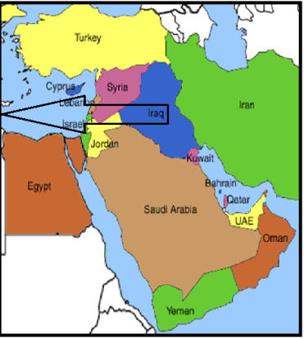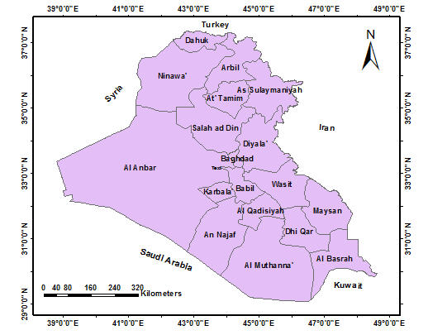

Figure 1: location of the study area
Topographically, the country is divided into four distinct regions: the Mesopotamian plain between the Tigris and Euphrates rivers, which makes up 20% of the country's total area; the Plateau and Hills Regions, which make up 15% of the country's total area; and the desert to the west and south, which makes up 60% of the country's total area. The mountains are located in the country's north and northeast, which occupied 5% of the total area, (Nadhir, 2021, KAPITA, 2022).
Iraq has a dry, hot summer and cooler winters due to its subtropical continental climate, which is arid to semi-arid. The average annual temperature is 22.97ºC. The temperature range for summer is 16ºC to 49ºC, and the temperature range for winter is 8.5ºC to 14ºC. (Iqbal, 2016).In the northern mountains, precipitation ranges from 350mm to 900mm. As one proceeds west and south, the annual precipitation decreases, and it can fall below 100mm (Sabah, 2022).

2.2 Dataset Sources
The both dataset of PM2.5 concentration dataset used in the present study was downloaded from NASA Giovanni user interface (https://giovanni.gsfc.nasa.gov/) which is based on satellite data, because most Iraqi governorates lack to an integrated network to monitor PM2.5or other pollutants. Giovanni is an online platform that facilitates the display, visualization, and analysis of specific geophysical characteristics. It allows users to readily access the provenance, or data lineage, of the data. The Giovanni user interface provides a globally consistent and comprehensive dataset that allows estimations for air pollutants for which there are no direct observations from monitoring stations or where observation data coverage is limited, as in Iraq. The atmospheric satellite dataset of the Giovanni were reanalysis by Modern-Era Retrospective analysis for Research and application version 2 (MERRA-2) which is an atmospheric reanalysis produced by NASA Global Modeling and Assimilation Office (GMAO) using the Goddard Earth Observing System Model (GEOS) version 5.12.4 (https://disc.gsfc.nasa.gov/datasets/M2TMNXFLX_5.12.4/summary).
3. Dataset Analysis
The adopted dataset in the present study was downloaded from NASA Giovanni user interface in the form of Network Common Data Files (NetCDF). NetCDF is an interface to a library of data access functions that stores and retrieves data in the form of an N-dimensional array. (Layali and Sabah, 2021).The general description of the PM2.5 and meteorological dataset after reanalysis by MERRA-2 model through NASA Giovanni was listed in Table (1). In the present study, the spatial coverage of the study area ( in decimal degree) is (29.0833 to 37.2500) N to (38.7500 to 48.7500) E, and the temporal coverage is ( 2001 and 2022). Also, the PM2.5 unit was converted to (µg/m3).
Table (1) : Summery of MERAA- 2 dataset descriptions
Parameters | Description
Shortname | M2TMNXFLX
Longname | MERRA-2 tavgM_2d_flx_Nx:2d,Monthly mean,Time-Averaged, Single-Level, Assimilation, Surface Flux Diagnostics V5.12.4
DOI | 10.5067/0JRLVL8YV2Y4
Version | 5.12.4
Format | netCDF
Spatial coverage | -180.0, -90.0 to 180.0, 90.0
Temporal coverage | 01-01-1980 to present
File size | 380 MB per file
Spatial resolution | 0.5⁰ * 0.652⁰
Temporal resolution | 1 month
Unit | Kg/m³
To visual, geospatial and temporal analysis, and mapping Giovanni dataset, ArcGIS desktop package are used, ArcGIS is a powerful package for geographical and statistical analysis, it offers many important toolboxes and functions. In first step, the NetCDF file for each month was downloaded in the form of 2- dimensional map of spatial resolution (0.5⁰ * 0.652⁰ ) or ( about 55.5 km * 69.375km) for each pixel in the map. Next, by using the ArcGIS / Multidimensional tool, the monthly NetCDF files were added to the ArcGIS to design geo-gridded maps. Then, each monthly PM2.5 raster map was extracted according to the shapefile of Iraq. ArcGIS / Raster calculator tool was applied for seasonal and annual mapping of the PM2.5 and meteorological dataset adopted in the study.
4. Results and Discussion
The regional distribution of PM2.5 levels varies seasonally due to weather fluctuations. Iraq has four seasons: (1) a cold and rainy winter (December to February), (2) a moderate transitional time of spring (March to April), and at the end of spring, the temperature gets noticeably hotter across the country's varied geographical regions.(3) a hot and dry summer (June to August), (4) the transitional autumnal season (September to November), during which there is a more pronounced drop in temperature and a greater chance of precipitation, particularly in the northern and central regions of the country. South and Southeasterly Sharqi winds, which are dry dust winds that can cause dust storms, can have an impact on Iraq in late winter and early spring. These winds can also occasionally occur in autumn and winter. In contrast, the shamal winds, a moderate northwesterly wind that is hot and dry during the long summer months, can cause fast dehydration and, at higher intensities, can generate dust or sand ( https://www.climatestotravel.com/climate/iraq ).
Fig. 2 depicts the spatial distribution of PM2.5 in Iraq as a function of season for the years 2001 (left) and 2022 (right). It is noted that the PM2.5 concentration values increased from 2001 to 2022 due to the high rate of population growth and what followed from the increased use of fossil fuels in homes and automobiles, which have increased dramatically throughout the country over the last two decades, as well as the enormous number of oil fields, especially in the southern of Iraq. Fig. 2 indicates a general tendency of growing geographical dispersion in the middle and south of Iraq across all seasons, with the highest values of PM2.5 concentration recorded in the summers of 2022 and 2001 being 190.06 µg/m3 and 172.41 µg/m3 (increased 10.24%), respectively. In the remaining study regions, the PM2.5 concentration value decreased, reaching 9.02µg/m3 in winter 2022 and 8.41µg/m3 in winter 2001 (increased 7.25%).

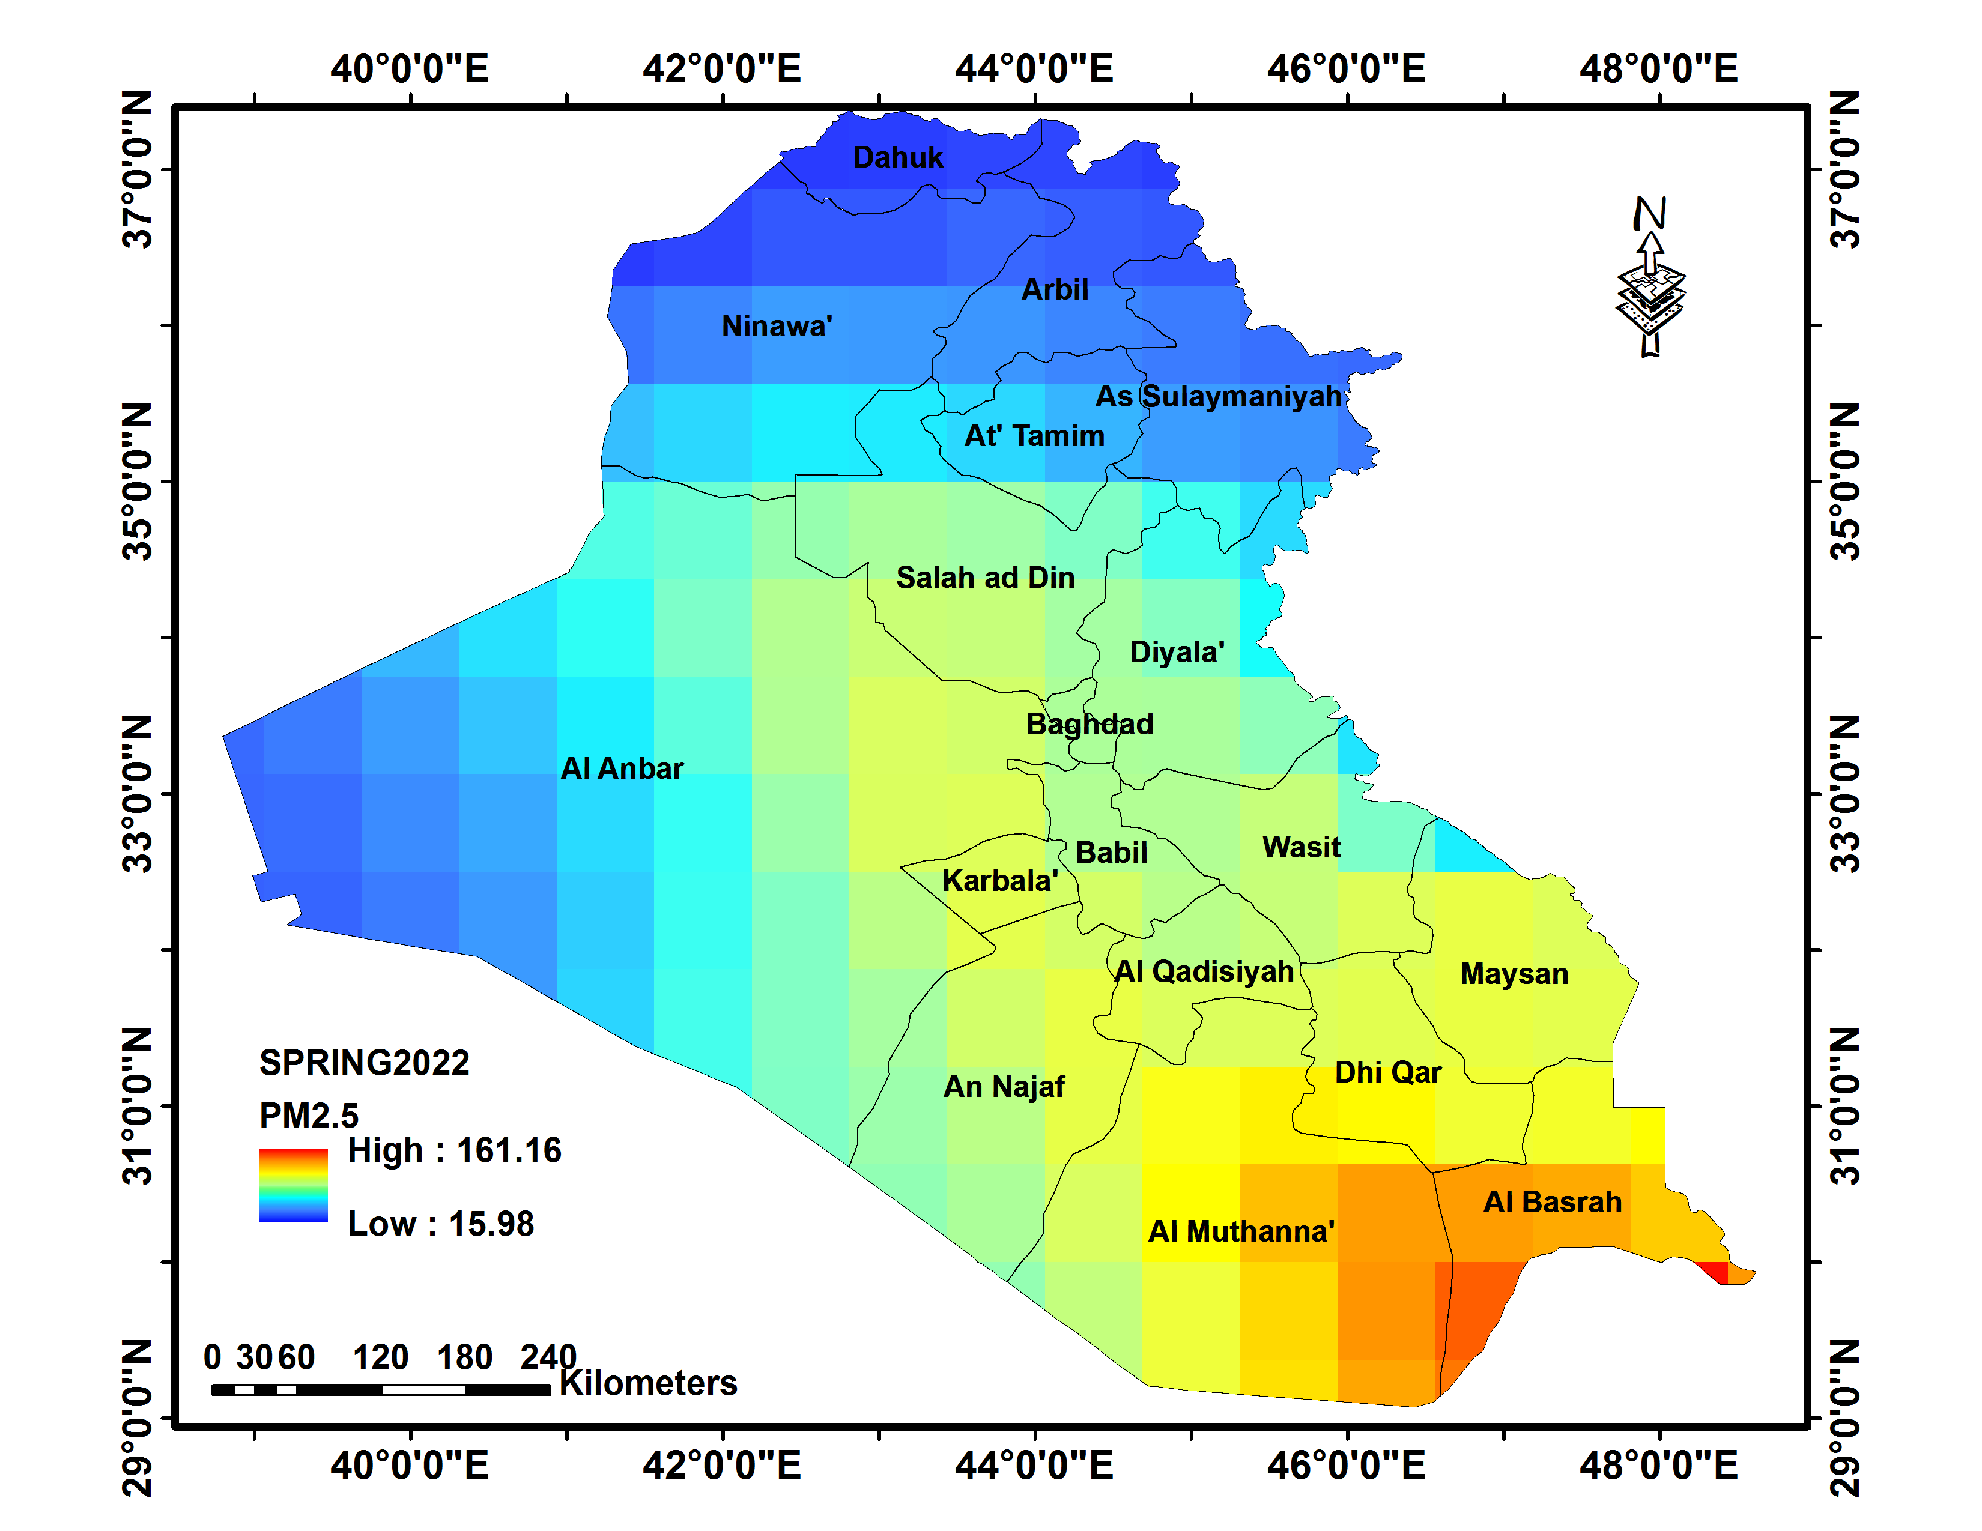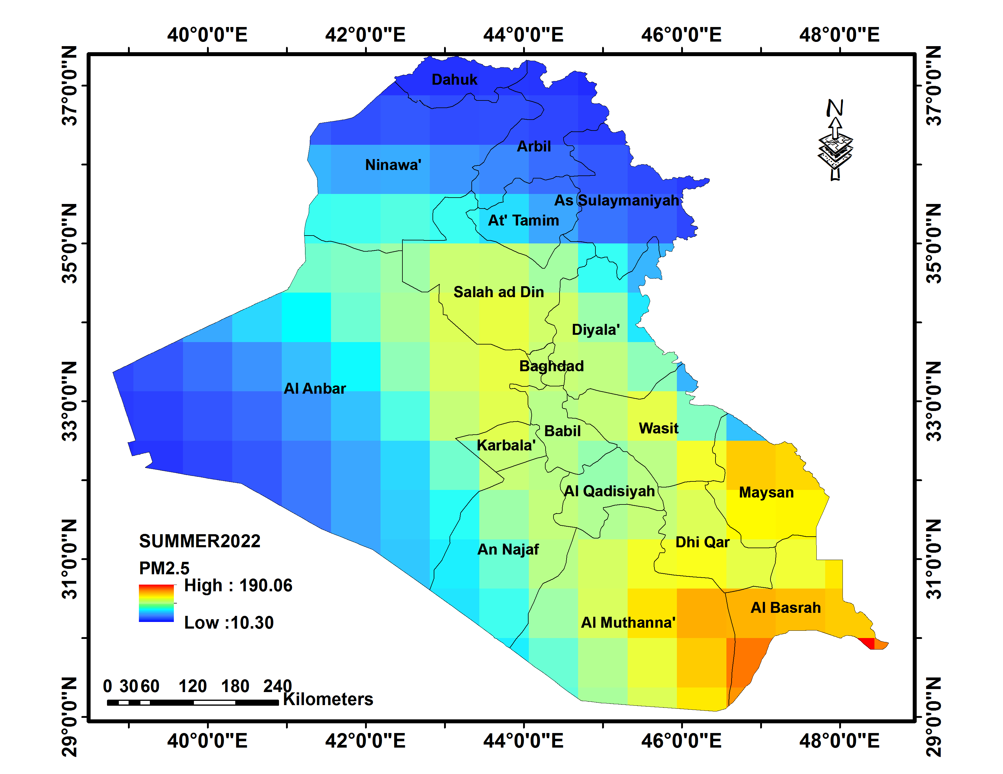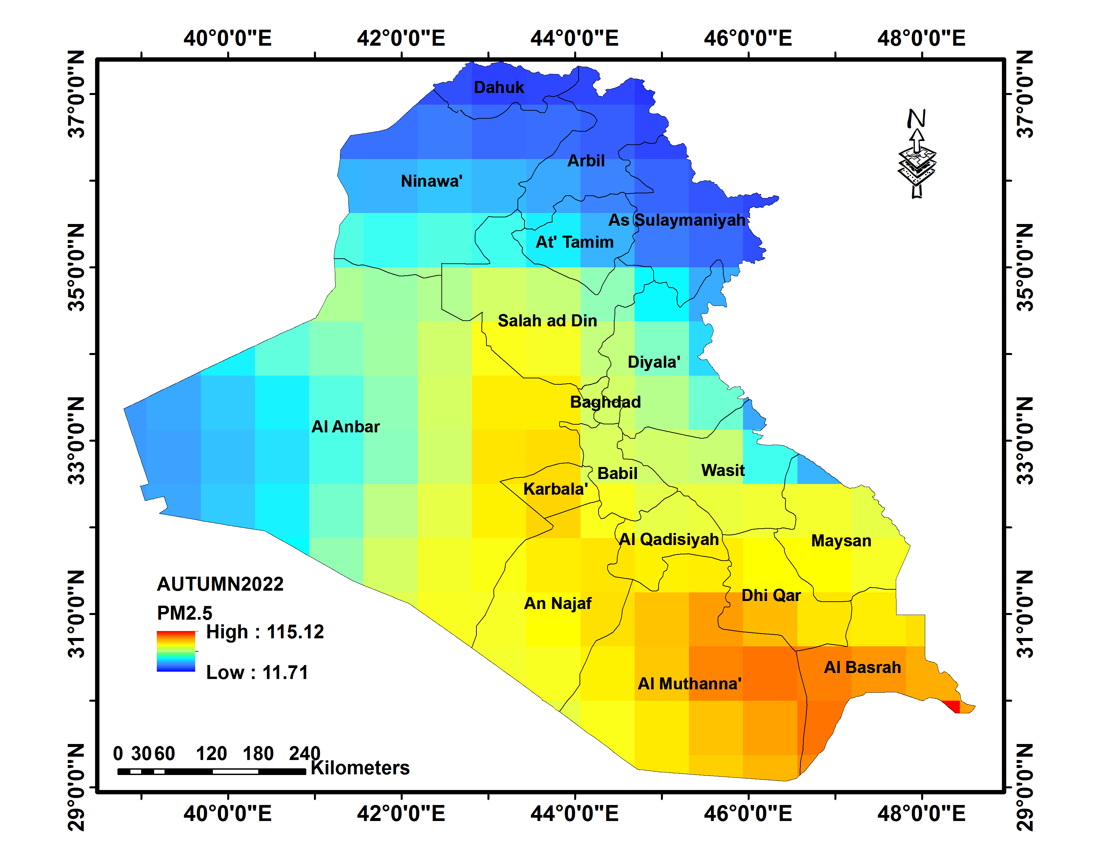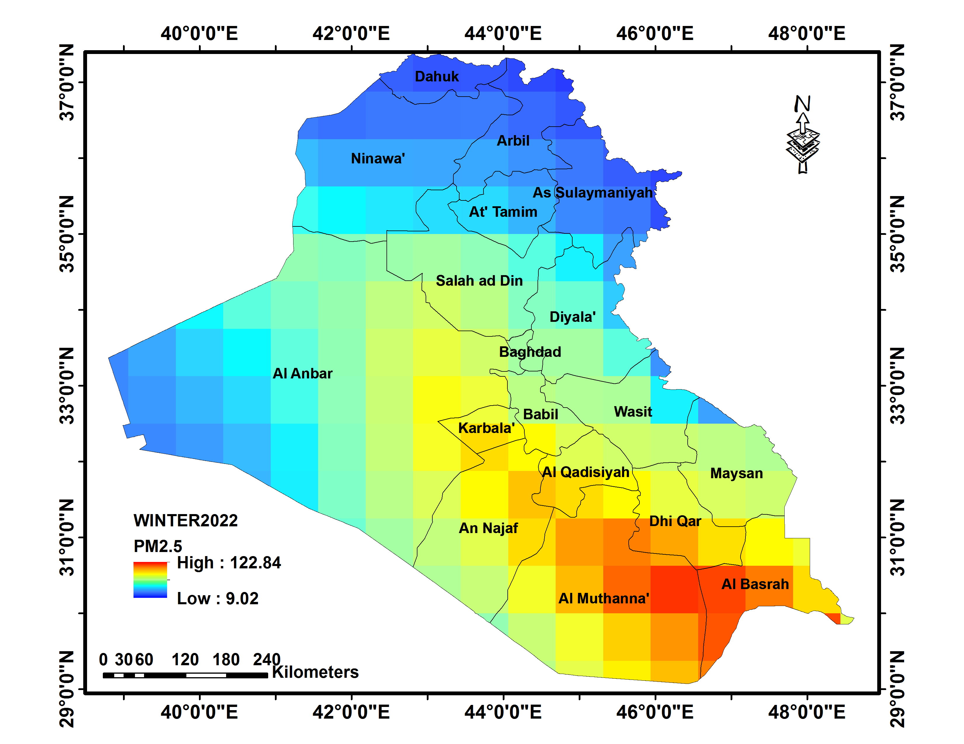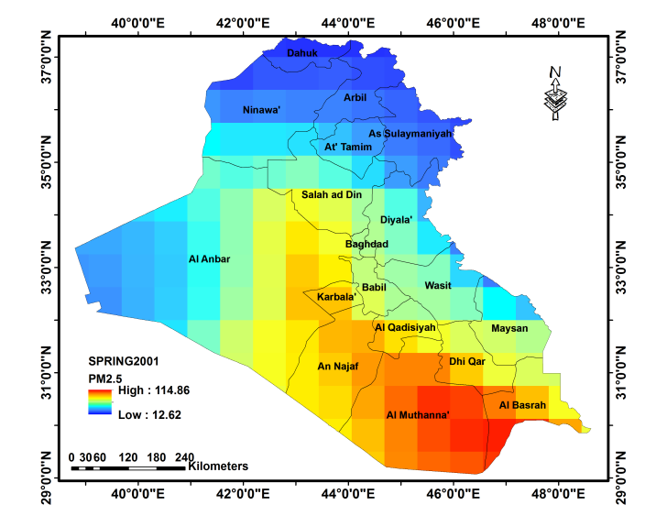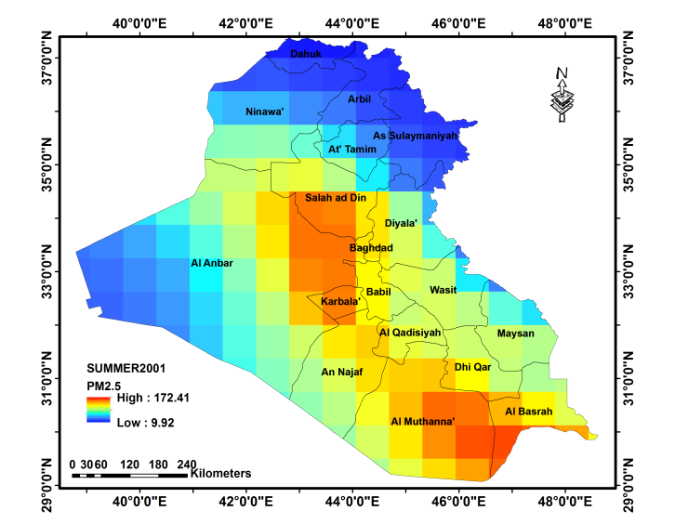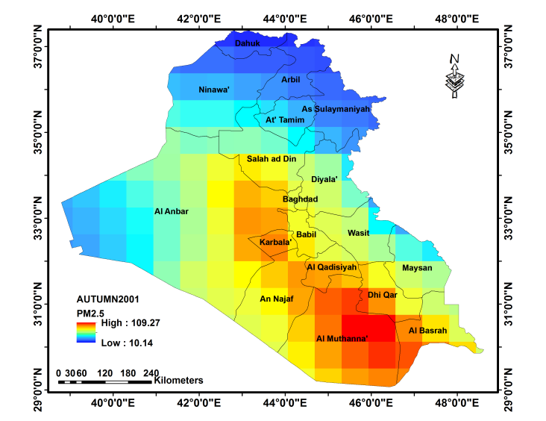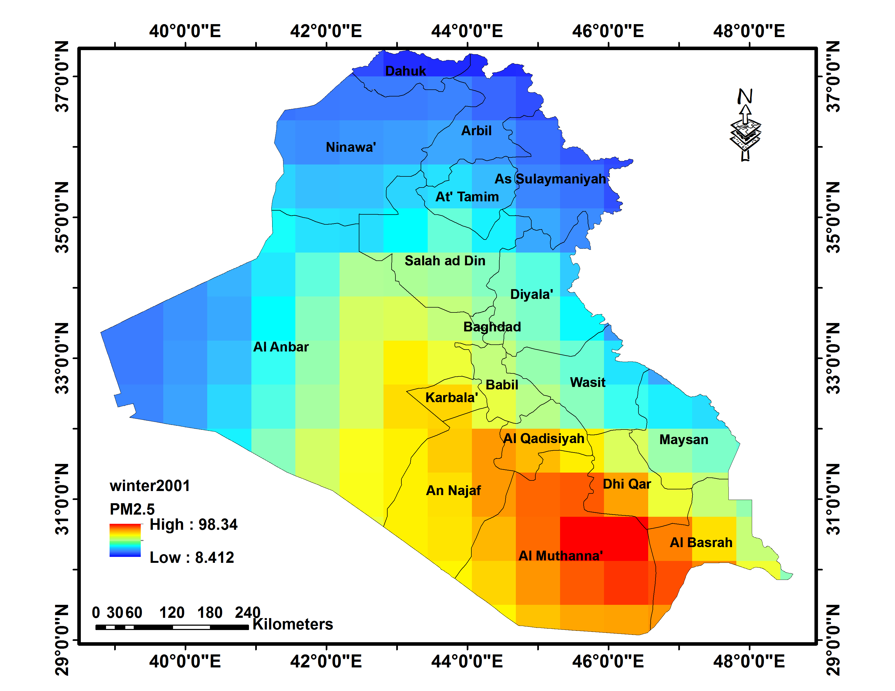

Figure 2: The PM2.5 seasonal distribution in Iraq at the years of 2001 and 2022
The center and south of Iraq have desert climates, with warm winters and hot summers. The southern of Iraq consistently has some of the hottest cities during the summer, from June to August, with July and August having temperatures above 50 °C on a regular basis ( Waqed and Forqan, 2020).When the temperature increases, more excess moisture in the air evaporates, helping to dry off the dust particles, reducing their weight and increasing the chance that they may volatilize. Consequently, when temperatures rise, so does the concentration of PM2.5 (Sabah, 2022). Additionally, a concentration of sea salt imported from the Arabian Gulf may eventually contribute to PM2.5 emissions in the southern part of Iraq. During the winter, westerly atmospheric depressions spanning the Middle East shift southward, bringing rain to southern Iraq and causing particulate matter to wash out of the air, leading to low PM2.5 values in the study area. As a result, the concentration of PM2.5 is observed to be lower in the winter than in the summer. PM2.5 levels in northern and northeast Iraq were consistently low throughout the year. The summer is shorter than in the center and south of Iraq, lasting from June to September, whereas the winter is much longer. The summer is often dry and hot, but average temperatures are 3-6 °C lower than in the center and south of Iraq. Winters can be cold due to the region's high relief and the effect of northeasterly winds bringing continental air from Central Asia. (Nadhir 2021). Hence, the PM2.5 values are lower than those in the center and the southern regions; in 2001, they ranged from 8.41 to 12.6 µg/m3, whereas in 2022, they ranged from 9.02 to 15.98 µg/m3 throughout the year. Rainfall during the cold months in the north and northeast is an essential factor in cleaning the air of PM2.5. Figures 3 and 4 show the comparison of the maximum and minimum PM2.5 levels for the years 2001 and 2022, respectively.
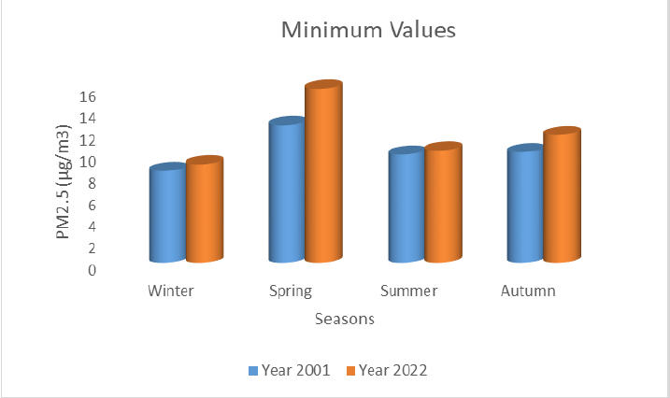

Figure 3: The Min. PM2.5 levels for the years 2001 and 2022
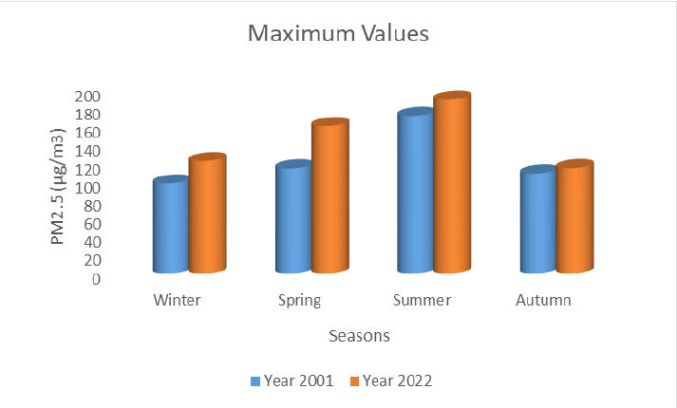

Figure 4: The Max. PM2.5 levels for the years 2001 and 2022

Fig.5 shows the average annually spatial distribution of PM2.5 for the years 2001 (left) and 2022 (right). It is important to note that total PM2.5 readings increased between 2001 and 2022.The majority of Iraq's center and south have high PM2.5 levels, which reached maximum values in the south with values of 117.65 µg/m3 in 2001 and 143.06 µg/m3 in 2022 (increased 21.59%). However, due to low concentrations of natural aerosols, the northern and northeast regions have the lowest PM2.5 levels, with values of 10.97 µg/m3 in 2001 and 12.58 µg/m3 in 2022 (increased 14.68%) .

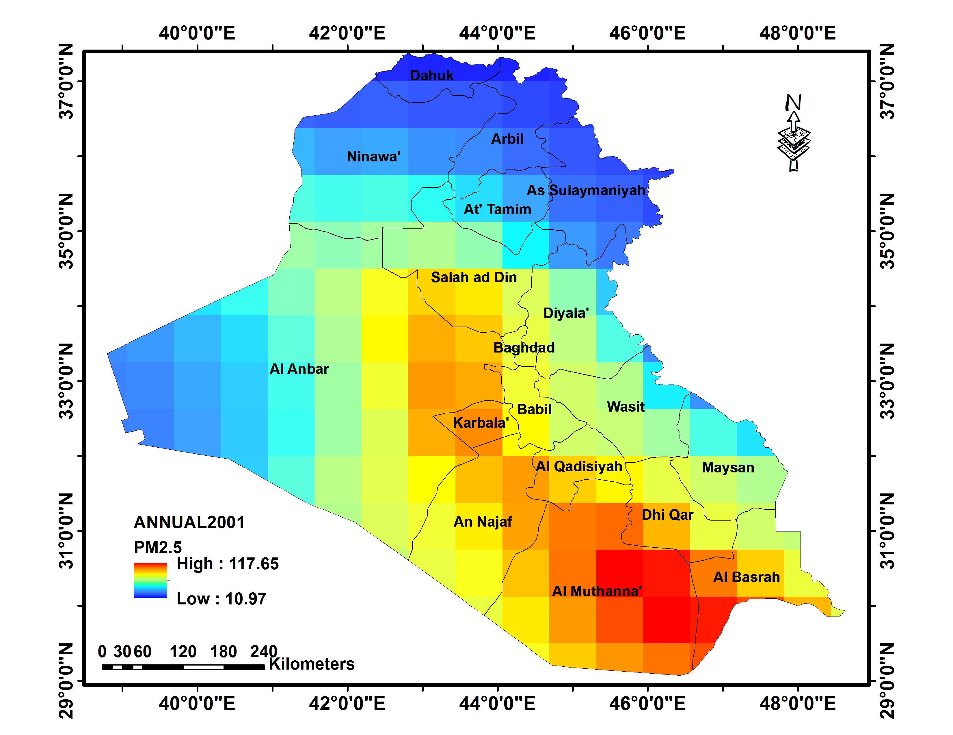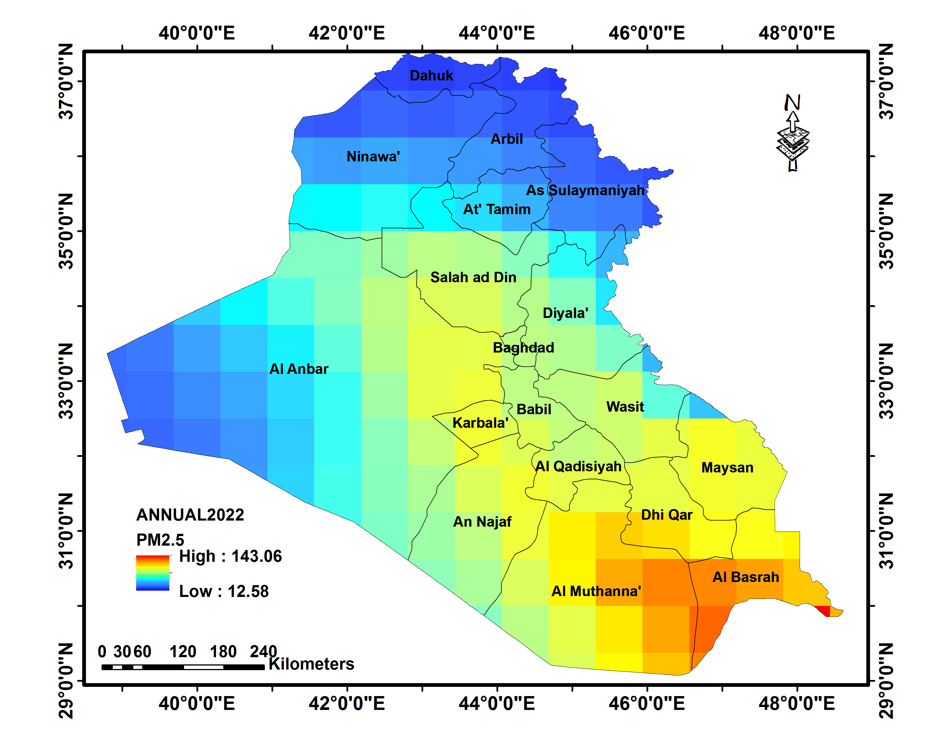

Figure 5: The average annual PM2.5 distribution in Iraq at the years of 2001 and 2022

Fig. 6 shows that maximum PM 2.5 values have consistently exceeded the upper limits of annually PM2.5 standards set by both the US and Iraqi regulations (which are 15 and 10 µg/m3, respectively) (Profile on Environmental and Social Considerations in Iraq, 2011) (ENVIRONMENTAL PROTECTION AGENCY,2020), for the years 2001 and 2022. The minimal PM2.5 values are within both the US and Iraqi annual standards.
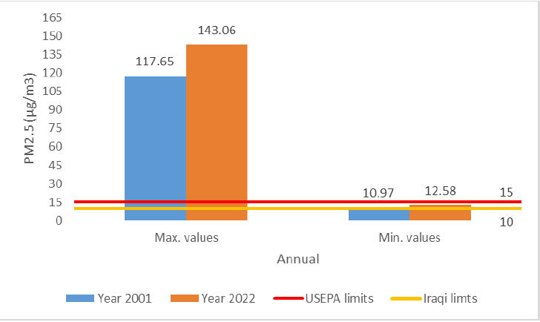

Figure 6: PM2.5 concentration level with the USEPA and Iraqi standard limits

5. Conclusion
The current study investigates the spatio-temporal distribution of PM2.5 concentrations, as well as the influence of meteorological conditions on this particulate matter for Iraq , using seasonal and annual datasets from the NASA Giovanni user interface for the years 2001 and 2022, and draws the following conclusions:
1- The seasonal and annual PM2.5 concentration values increased from 2001 to 2022 due to the high rate of population growth and what followed from the increased use of fossil fuels in homes and automobiles, which have increased dramatically throughout the country over the last two decades, which in turn contributed to climate change in the country.
2- Central and southern Iraq, the most affected by the PM2.5, due to the high temperatures which causes more excess moisture in the air evaporates, helping to dry off the dust particles, reducing their weight and increasing the chance that they may volatilize. The PM2.5 concentration values recorded in the summers of 2001 and 2022 being 172.41 µg/m³ and 190.06 µg/m3 (increased 10.24%), respectively
3- South and Southeasterly Sharqi winds, which are dry dust winds that can cause dust storms, can have an impact on Iraq in late winter and early spring. These winds can also occasionally occur in autumn and winter.
4- Rainfall during the cold months in the north and northeast is an essential factor in cleaning the air of PM2.5 due to low temperatures, high humidity, and rain, which will lead to particulate matter washing out of the air.
5- The shamal winds, a moderate northwesterly wind that is hot and dry during the long summer months, can cause fast dehydration and, at higher intensities, can generate dust or sand.
6- The average annually PM2.5 values was increased between 2001 and 2022, especially in the center and southern of Iraq at the rate of (21.59%). However, due to low concentrations of natural aerosols, the northern and northeast regions have the lowest PM2.5 levels with rate of ( 14.68%) .
7- The max. PM 2.5 values have exceeded the upper limits of annually PM2.5 standards set by both the US and Iraqi regulations ( which are 15 µg/m³ and 10 µg/m³, respectively), while the min. PM2.5 values are within both the US and Iraqi annual standards.

Acknowledgments
We are grateful to NASA Giovanni user interface for the PM2.5 dataset. We also gratefully thank University of Mosul for the scientific supporting of the study.
References
Amina, B., Mohammad, Sabah, H., Ali., & Riyad, A., F. ( 2022).Using Remote Sensing Techniques and GIS to Study of PM2.5 and PM10 Concentrations in the Atmosphere of Mosul City, Iraq. Iraqi National Journal of Earth Science, 22(1), 15-26. (In Arabic). DOI: 10.33899/earth.2022.174661.
Aslam, A., Ibrahim, M., Shahid, I., Mahmood, A., Irshad M.K., Yamin, M., Shamshiri, R.R. ( 2020) . Pollution characteristics of particulate matter (PM2.5 and PM10) and constituent carbon acetous aerosols in a South Asian future megacity. Applied Sciences,10(24), 8864. https://doi.org/10.3390/app10248864.
Bassim, M., H., Saadi, K., Al-Naseri, Ali, Al-Maliki, Nadhir, Al-Ansari. (2020). Impact of COVID-19 lockdown on NO2, O3, PM2.5 and PM10 concentrations and assessing air quality changes in Baghdad, Iraq. Science of the Total Environment 754 141978. https://doi.org/10.1016/j.scitotenv.2020.141978

ENVIRONMENTAL PROTECTIONAGENCY: EPA. (2020). Review of the National Ambient Air Quality Standards for Particulate Matter. Federal Register / Vol. 85, No. 244 /Rules and Regulations. 65P.
IEA (International Energy Agency). ( 2012). Iraq Energy Outlook: World Energy Outlook Special Report, p. 142. Retrieved fromhttp://www.worldenergyoutlook.org
Iqbal, H. A. ( 2016). Assessing of Climate Chang on Iraq using Meteonorm
Weather Generator, IOSR Journal of Applied Physics (IOSR-JAP),8(6), Ver. II, 55-61. DOI: 10.9790/4861-0806025561
KAPITA, (2022) . Climate Change Overview: Impacts, Mitigation, andAdaptation in Iraq, 62 p. Retrieved from: https://kapita.iq/storage/app/media/New%20Research%20Publications/Climate%20Change%20Overview.pdf,
Layali Y. S., Sabah, H. A., Monitoring and Evaluation of Tropospheric NO2 Columns Density and Ultraviolet Aerosol Index (UVAI) over Iraq During the Outbreak of COVID-19 Using Remote Sensing and GIS. (2021).Indian Journal of Ecology, 48(2), 607-614.
Li, R., Gong, J., Chen, L., Wang, Z. (2015). Estimating ground-level PM2.5using fine-resolution satellite data in the megacity of Beijing,China. Aerosol Air Qual Res 15,1347–1356. doi: 10.4209/aaqr.2015.01.0009.
Minsi, Z., Yu, S. & Xuhui, C. (2007) . A health-based assessment of particulate air pollution in urban areas of Beijingin 2000-2004.Science of the Total Environment, 376 (1), 100-108.doi: 10.1016/j.scitotenv.2007.01.085
Muhammad, K.,· Salman, T., Zia, U. (2023). Variations in the aerosol index and its relationshipwith meteorological parameters over Pakistan using remote sensing. Environmental Science and Pollution Research,30:47913–47934. https://doi.org/10.1007/s11356-023-25613-5

Nadhir Al-Ansari. (2021). Topography and Climate of Iraq. Journal of Earth Sciences and Geotechnical Engineering, 11(2),1-13. https://doi.org/10.47260/jesge/1121
Profile on Environmental and Social Considerations in Iraq, 2011,Japan International Cooperation Agency (JICA), ANNEX CR(5)-11-018: 156.

Ramin, N., Mostafa, H. (2019) . Developing codes for validation of PM10, PM2.5, and O3 datasets using R programming language. Journal of Air Pollution and Health, 4(1), 73-80. DOI: https://doi.org/10.18502/japh.v4i1.604

Ruqayah, A. G., Shahla, N. A. Al-Azzawi, Osamah, J., … Ahmed, Alkhayyat. (2021). Analysis of Air Quality Index Distribution of PM10 and PM2.5Concentrations in Ambient Air of Al-Hillah City, Iraq, IOP Conf. Series: Materials Science and Engineering, 1058, 012014. doi:10.1088/1757-899X/1058/1/012014.
Sabah, H. Ali. (2022). Evaluation of Particulate Matter Air Pollution over Iraq using Copernicus Dataset and GIS. European Multidisciplinary Journal of Modern Science, 13, 12-20. https://emjms.academicjournal.io/index.php/emjms/article/view/842/944

Sabah, H. Ali, Mohamed, A. N., Rehab, T. A.(2018) Using GIS Techniques for Mapping the Pollution of Particulate Materials in Kirkuk. Sustainable Resources Management Journal,3(2), 58-66. http://doi.org/10.5281/zenodo.1287926.

Said, M., Turki, M. H., Atef, M.F. , Essam, A. M., Mohammad, R., & Kawsar A. (2017). Analyzing PM2.5 and its Association with PM10 and Meteorology in the Arid Climate of Makkah, Saudi Arabia, Aerosol and Air Quality Research, 17, 453–464, doi: 10.4209/aaqr.2016.03.0117.
Waqed, H. H., Forqan, S. H. (2020). The efect of climate change on the maximum temperature in Southwest Iraq using HadCM3 and CanESM2 modeling. SN Applied Sciences, 2:1494, https://doi.org/10.1007/s42452-020-03302-z

World Health Organization European. (1997). Regional office for Europe, Copenhagen. Air Quality Guidelines for Europe, Series no 23.Retrieved from: https://apps.who.int/iris/handle/10665/272951.
WHO. (2003). Health Aspects of Air Pollution with Particulate Matter, Ozone and Nitrogen Dioxide. Report on a WHO Working Group Bonn, Germany. Retrieved from https://apps.who.int/iris/handle/10665/107478.

