Information Content of the Risk-free Rate for the Pricing Kernel Bound

Milad Nozari

Abstract

The pricing kernel bound is a function of the risk-free rate. We unconditionally incorporate the fluctuation in the risk-free rate to tighten the restrictions on the admissible pricing kernel space. This semi-parametric framework improves the minimum discrepancy information bound and can be used to test various asset pricing models. In this study, variations in the risk-free rate are attributed to two possible states of the economy. The proposed approach identifies these states and improves the pricing kernel bound.

JEL classification: C1; C5; G5
Keywords: Pricing Kernel; Divergence Measure; Information-Theoretic Bound
Pricing Kernel Bound
We can present most of the asset pricing models in the form of the following fundamental valuation equation:
 | $$E\left(m_{t}R_{t} | Z_{t-1}\right)=1$$ | (1)
where the random variable $m_{t}$ is the pricing kernel (PK) and maps the vector of returns $R_{t}$ to the prices. Here, $Z_{t-1}$ is the vector of instruments at time$t-1$ , and the pricing is conditional on this information. The stochastic discount factor (SDF) is a similar concept as the pricing kernel, however the later is mainly a mathematical notion. While Equation (1) is in the historical world (probability measure), we can also formulate the valuation equation in the risk-neutral (RN) world.
Any feasible value of the pricing kernel is subject to some restrictions. Originally, Hansen and Jagannathan (1990) propose a lower bound (HJ bound) for the variance of any SDF which satisfies the fundamental valuation equation. The HJ bound identifies the feasible region on the mean-standard deviation plane of pricing kernel, where the lower variance bound of the pricing kernel is a function of its mean (or equally the expected risk-free return).
The PK bounds are used to test various asset pricing models. In other words, if a candidate stochastic discount factor (SDF) obtained from a proposed asset pricing model cannot satisfy the HJ bound, it fails to satisfy the fundamental valuation equation in the first place. Moreover, the PK bounds are useful to evaluate the contribution of return data for pricing assets, and also to measure the performance of investment vehicles such as hedge funds. In addition, they can assist in predictability studies, variance spanning, and market integration tests.
Finding more restrictions on the admissible PK space provides us with more powerful tests to evaluate the asset pricing models. Therefore, some studies have proposed improvements for the PK bound. Gallant, Hansen, and Tauchen (1990) and Bekaert and Liu (2004) use the conditional information to improve the PK bound. In addition, Snow (1991) and Chabi-Yo (2008) focus on the higher moments of assets return and propose better restrictions on the moments of SDF.
Gallant et.al. (1990) develop a strategy to utilize conditioning information efficiently. They construct a new payoff space with combining the primitive set of asset payoffs and the conditioning information. Their suggested bound (GHT bound hereafter) is derived by computing the variance of the unconditional projection of the pricing kernel onto this new space. They use the semi-nonparametric methodology introduced by Gallant and Tauchen (1989) to estimate the conditional distributions of asset payoffs, and also to infer conditional moments. The GHT procedure has not been used very much in practice. Instead, in many studies returns are scaled with predictive variables in the information set in order to augment the space of the available payoffs, and then the standard HJ bound for the augmented space is computed. Look at the studies by Cochrane and Hansen (1992), Bekaert and Hodrick (1992) for some examples.

Bekaert and Liu (2004) use the conditioning information to effectively increase the dimension of the available asset payoffs. Their optimally scaled bound is efficient and leads to sharper bounds. Unlike GHT bound, their proposed bound is robust to the misspecification of the conditional mean and variance. They argue that the scaling only improves the HJ bound if the weight $Z_{t}$has information about the future return.
There is another strand of literature which proposes a new variation in computing the PK bound by employing information criteria. This strand emphasizes the link between the historical and risk-neutral probability measures. For example, based on the minimization of Kullback-Leibler Information Criterion (KLIC), Stutzer (1995) introduces the information bound, and shows the equivalence of the bound problem to the portfolio optimization problem under CARA utility function. In contrast to the HJ bound, the information bound incorporates the positivity of state price densities (SPD). The benchmark (optimal) SPD is selected by minimizing the KLIC distance between the set of RN and historical probability measures. When the RN probability measure diverges from the historical probability measure, the information bound is larger.
Similar to the variance bound, the information bound has a minimum distance interpretation. In order to construct the variance bound, one can find SDFs as a particular affine combination of returns which is closest, in the mean square distance, to any admissible SDF (an admissible SDF satisfies the fundamental valuation equation). Equivalently, to derive the information bound, one can find the KLIC-closest SPD to any feasible SPD. To generalize the information bound, Almeida and Garcia (2008, 2012) employ another information criterion to measure the distance between the risk-neutral and historical probability measure.
Almeida and Garcia (2008, 2012) improve the information bound using the minimum contrast measure of Cressie and Read (CR) (1984) and show the duality of their solution with the portfolio optimization problem under a general HARA utility function. This method considers higher moments of the return distribution. Unlike the PK bound suggested by Snow (1991), their measure puts implicit weights on a potentially infinite number of the higher order moments. The associated dual portfolio problem also corresponds to the Generalized Empirical Likelihood estimator, and some of its specific solutions correspond to the Empirical Likelihood or Exponential Tilting estimator, which are alternatives to the GMM.
The alternative interpretation for the information bound comes from the Bayesian perspective. For building an information bound, we choose the RN measure with incorporating the prior knowledge of the actual probability measure and the moment conditions. Stutzer (1995) describes that it is reasonable to consider a measure which does not embody irrelevant information other than the moment conditions. Hence, minimizing the information gained by the change of measure while satisfying the moment condition is the final objective of this strand of literature.
Risk-free Rate and PK Bound
Documented facts suggest regime switching (RS) behavior in assets return (e.g. Ang and Bekaert (2002); Ang and Timmermann (2011) among others). RS models can match abrupt changes in financial markets, which persist for several periods. Some behaviors of financial series such as fat tails, heteroskedasticity, time-varying correlations, and skewness can be captured by these models. To illustrate the effect of this feature of data on the SDF bounds, Bekaert and Liu (2004) formulate a regime-switching version of the unconstrained VAR model with the consumption growth, stock and bond returns as the variables of the VAR process. They define regimes based on the consumption growth and use RS models with constant and time-varying transition probabilities to calculate the conditional moments. They propose a new bound by optimally choosing the scaling vector which depends on the conditional moments of the return. The scaling vector augments the payoff space and delivers the best (tightest) HJ bound. They find that the bounds generated by RS models are indeed sharper than the simply scaled bound. Indeed, the sharpest bound is generated by the most nonlinear model with time-varying transition probabilities.
The idea of incorporating the fluctuation in the risk-free rate in this study is inspired by this literature of the regime switching models and also empirical findings of Bekaert and Liu (2004). Moreover, our suggested approach is closely related to deciding about the status of the short rate in the framework of Bertholon, Monfort, and Pegoraro (2008). In the same spirit as their framework, this paper focuses on the status and importance of the risk-free rate for defining the relationship between historical and risk-neutral (RN) dynamics.
Bertholon et. al (2008) introduce the RN constrained framework as a part of their econometric asset pricing modeling (EAPM) approach. Their approach has three main ingredients, namely historical dynamics (which depends on the information in the economy), stochastic discount factor (which they consider to be an affine function of the information), and finally, the RN dynamics (which is a function of the other two). In their framework, the short rate can be exogenous or can be a function of the information in the economy and its status should be clearly decided before moving to the next steps. The next step is to constrain the historical and RN dynamics to belong to a given family and after that, the affine estimation of the discount factor and its relation to the information in the economy can be obtained. The short rate in their model can belong to a parametric family, but due to the nonparametric nature of our study, we assume that the risk-free rate in any time belongs to one of two possible states in the economy with a fixed expected rate in each state.
Our methodology is mainly based on the minimum discrepancy (MD) bound of Almeida and Garcia (2008, 2012), which focuses on the historical and RN probability measures to construct the PK bound. Employing their methodology provides us with a setup to unconditionally implement the fluctuations in the risk-free rate and also solve the numerical optimization problem with extending their proposed dual of the solution. The challenge of the study is in preserving the unconditional structure of the bound. We use a simple specification of the historical dynamics and constrain the RN dynamics by minimizing the discrepancy between the historical and RN probability measures.
Our findings are as follows. First, we obtain more restriction on the admissible pricing kernel space by considering a potential shift in the risk-free rate. In other words, with adding a possibility for the value of the risk-free rate to fluctuate over time, a sharper PK bound can be obtained. Second, there is a clear difference between the average risk-free rates in the states of the economy we identify. Finally, we observe that the state of the economy with a lower risk-free rate contributes more to the restriction of the admissible pricing kernel space.
The proposed improvement for the minimum discrepancy bound is also noteworthy because of many nice properties of the original bound. First, the original formulation of the problem considers higher moments in the distribution of returns and is suitable to analyze nonlinearities in asset pricing models and trading strategies. For example, hedge funds have dynamic trading strategies and their return exhibits nonlinear patterns, and the MD bound can capture nonlinearities and measure the alpha performance of hedge funds. Second, the solution of MD bound corresponds to an optimal portfolio problem under the HARA utility function which has a convenient economic interpretation. The special cases of HARA utility function include CARA, CRRA, and quadratic utility functions. The HARA utility function has a decreasing absolute risk aversion and decreasing absolute prudence, and this feature makes it a better choice comparing to the quadratic utility function, which is embedded in the dual problem for the HJ bound.
Unlike Bekaert and Liu (2004) or Chabi-Yo (2008) who include the regimes to compute the conditional moments in a parametric way, we use the potential information included in the fluctuation of the risk-free rate in a nonparametric setup. However, the only estimated parameter in each step is the Lagrange multiplier of the optimization problem, which indeed makes this approach semi-parametric.
Naive MD Information Bound
Before introducing the time-varying risk-free rate, we need to review the basic model. Almeida and Garcia (2008, 2012) suggest a nonparametric estimate of the SDF bound which considers higher moments in the distribution of return. Their bound employs the minimum discrepancy (MD) measure of Cressie and Read (1984), hereafter CR to restrict the risk-neutral (RN) probabilities. Formally, for an admissible pricing kernel$(m)$, we have
 | $$E\left[mR_{i}\right]=1 i=1,…,N$$ | (2)
the Euler equation, for all $N$ basis gross assets returns,$R_{i}$. This unconditional moment is obtained by applying the law of iterated expectations to Equation (1). Divide the above equation by the PK mean, $E\left(m\right)=a$:
 | $$E\left[R_{i}\frac{m}{E\left(m\right)}\right]=\sum_{j=1}^{T}{p_{j}R_{i}\frac{m_{j}}{E(m)}=\frac{1}{a}}$$ | (3)
where $p_{j}$ is the historical probability measure. In order to have an adjustment for risk, it is possible to compactly write:
 | $$E_{q}\left[R_{i}\right]=\sum_{j=1}^{T}{q_{j}R_{i}=\frac{1}{a}}$$ | (4)
where $q$ is the risk-neutral or implied probability measure. In other words, the risk-adjusted expectation of the assets rerun is equal to the risk-free rate. In Equation (4), the risk-free rate corresponds to $1/a$, which is the reciprocal of the PK mean. Therefore, we implicitly have the following change of the probability measure:
 | $$q_{j}=\frac{m_{j}}{E(m)}p_{j}$$ | (5)
In the Bayesian paradigm, there is an intention of choosing a RN measure, while using the prior knowledge of the actual probability measure and the moment condition (4), which defines the risk neutrality. As described by Stutzer (1995), it is reasonable to consider a measure which does not embody irrelevant information other than the moment conditions. Therefore, minimizing the information gained by the change of the probability measure while satisfying the moment condition leads us to this objective. While Stutzer (1995) uses KLIC to measure the information gain, Almeida and Garcia (2008, 2012) use the minimum contrast measure of Cressie and Read.
Cressie and Read (1984) introduce a multinomial goodness-of-fit test, which includes power divergence test statistics to evaluate the fit of observed frequencies to expected frequencies. As a special case, their test corresponds to Pearson's chi-squared test. This test statistic can also be used to test the goodness-of-fit of two probability distributions. Almeida and Garcia (2008, 2012) use CR family of discrepancies to measure the information gain due to the change from true (historical) to implied (risk-neutral) probability measure. Their measure as a specific case includes the KLIC used by Stutzer (1995). In discrete form, the CR discrepancy measure between two probability measures $p$ and $q$ is:
 | $$I\left(q,p\right)=\frac{1}{γ(γ+1)}\sum_{j=1}^{T}{q_{j}\left({\left(\frac{q_{j}}{p_{j}}\right)}^{γ}-1\right)}$$ | (6)
The MD pricing kernel bound can be obtained by solving the minimization problem (7) subject to the moment constraint (4).
 | $$q^{MD}={argmin}_{q} I(p,q)$$ | (7)
The solution of this minimization problem is obtained by identifying the risk-neutral measure. The objective function in Equation (7) is a function of the pricing kernel, and hence it is possible to formulate everything as a function of the pricing kernel. Our constraints are the sample form Euler equation and the strict positivity of pricing kernels, which the later is needed by construction and because of the non-negativity of state price densities ( $\frac{q_{j}}{p_{j}}=\frac{m}{E(m)}$). When the true probability measure is uniformly distributed, or in other words, for a flat prior equal to $1/T$ ($T$ is the time horizon), Almeida and Garcia (2008, 2010) solve:
 | $${\hat{m}}_{MD}=argmin \frac{1}{T}\sum_{j=1}^{T}{ϕ(m_{j})}$$ | (8)
where $ϕ$is the general discrepancy function, and is obtained from substituting Equation (5) in Equation (6). The Problem (8) belongs to a space with the dimension equal to $T$, and is impractical to solve. The practical solution with a much smaller dimension,$N$, can be realized from the following dual problem:
 | $${\hat{λ}}_{γ}={}_{λ∈Λ_{CR}}^{arg sup} \frac{1}{T}\sum_{j=1}^{T}{(\frac{a^{γ+1}}{γ+1}-\frac{1}{γ+1}{\left(a^{γ}+γλ^{'}\left(R_{j}-\frac{1}{a}1_{N}\right)\right)}^{\frac{γ+1}{γ}}}) \\ Λ_{CR}=\left\{λ∈R^{N}, s.t. for j=1,…,T:1+γλ^{'}\left(R_{j}-\frac{1}{a}1_{N}\right)>0\right\}$$ | (9)
The solution of the optimization problem corresponds to an optimal portfolio selection with the HARA utility function. For some fixed values of $γ$ or as a limit to zero or one, important one-step alternatives to GMM can be obtained such as Empirical Likelihood or Exponential Tilting estimators. Generally, solutions of the mentioned optimal portfolio problem correspond to the Generalized Empirical Likelihood estimator of Smith (1997).
Solving for $λ$in (9), we can also have the minimum discrepancy pricing kernels:
 | $${\hat{m}}_{MD}^{j}=a\frac{{(a^{γ}+γ{\hat{λ}}_{γ}\left(R_{j}-\frac{1}{a}1_{N}\right))}^{\frac{1}{γ}}}{\frac{1}{T}\sum_{j=1}^{T}{{(a^{γ}+γ{\hat{λ}}_{γ}\left(R_{j}-\frac{1}{a}1_{N}\right))}^{\frac{1}{γ}}}}, j=1,2,…,T$$ | (10)
Since there is no knowledge of agent's risk-adjusted expectation of return, or in other words, no knowledge of the risk-free rate, we need a grid of the PK mean. For a meaningful grid of the PK mean,$A=\left\{a_{1},…, a_{K}\right\}$, the minimum discrepancy pricing kernel frontier is given by the following expression:
 | $$I_{MD}\left(a_{k},γ\right)=\frac{1}{T}\sum_{j=1}^{T}{\frac{{({\hat{m}}_{MD}^{j},a_{k})}^{γ+1}-a_{k}^{γ+1}}{γ(γ+1)a_{k}^{γ+1}}, k=1,2,…,K}$$ | (11)

Time-varying risk-free rate and MD Information Bound
As mentioned, the idea of incorporating the fluctuation in the risk-free rate is inspired by the regime switching models and also empirical findings of Bekaert and Liu (2004). In addition, our proposed approach to incorporate the fluctuations of the risk-free rate is closely related to the concept of deciding about the status of the short rate in the EAPM framework of Bertholon et al. (2008). In the same spirit as their study, our approach focuses on the status of the risk-free rate and its connection to the available information in the economy to define the relationship between historical and risk-neutral (RN) dynamics.
For our setup, we constrain the RN dynamics by using the Cressie and Read (CR) minimum discrepancy measure to minimize the difference between the historical and RN probability measures. Here, the historical dynamics is a flat prior equal to $1/T$ ($T$is the time horizon). Intuitively, we assume that there are two states of the economy with different and constant risk-free rates.
We assume that there exist two subsets of time, $D_{1 }$and$D_{2 }$, (not continuous necessarily) with the respective risk-free rate equal to ${1/a}_{k,1}$ and ${1/a}_{k,2 }$satisfying the following conditions simultaneously:
 | $$E\left[m_{i}|i∈D_{s}\right]=a_{k,s} s∈\left\{1,2\right\}, i∈\left\{1,…,T\right\}$$  $$E[m_{i}|i∈D_{1}∪D_{2}]=a_{k}$$ | (12)
Note that the expected value of the risk free rate (or the reciprocal of the pricing kernel mean) on the entire time horizon ($D_{1}∪D_{2}$) is${ 1/ a}_{k}$. Hereafter we call the overall mean, $a_{k}∈A$, the ‘base’ pricing kernel mean. Same as before, $A$ is a meaningful grid of the PK mean. There is no knowledge of the risk-free rate. However, we assume that there are two possibilities for the value of the risk-free rate over the entire time horizon. This assumption helps us extract more relevant information associated with the potential variation in the rate.
The probability of being in each state of the economy depends on the share of that state from the entire time horizon. For $R_{s}$, $T_{s}$, $p_{s}$ and $q_{s}$ ($s∈\{1,2\}$) respectively denoting the return matrix, data set size (length), true and RN probability measure in each subset of entire time horizon, we can write:
 | $$a_{k}=\frac{1}{T}\sum_{s=1}^{2}{T_{s}a_{k,s}}$$ | (13)
 | $$E_{q}\left[R\right]:=\frac{1}{a_{k}}=\sum_{s=1}^{2}{\frac{T_{s}}{T}\frac{a_{k,s}}{a_{k}}}E_{q_{s}}\left[R\right]$$ | (14)
See Appendix A1 for the derivation. As formalized in the Equation (13) and (14), the overall risk-adjusted return is the weighted average of the risk-adjusted return in each state of the economy. While $a_{k,1}$ and $a_{k,2 }$ can be different, condition (13) binds them together for each $a_{k}$in a meaningful grid of the ‘base’ PK mean, $A=\left\{a_{1},…, a_{K}\right\}$.
The CR discrepancy measure between the overall historical probability measure $p$and the RN probability measure $q$ is:
 | $$I\left(q,p\right)=\sum_{s∈\{1,2\}}{\frac{1}{γ(γ+1)}\sum_{j∈D_{s}}{\frac{T_{s}}{T_{1}+T_{2}}}q_{j,s}\left({\left(\frac{\frac{T_{s}}{T_{1}+T_{2}}q_{j,s}}{p}\right)}^{γ}-1\right)}$$ | (15)
where for the overall data set, the RN probability measure $q$is equal to $\frac{T_{s}}{T_{1}+T_{2}}q_{j,s}$and $p$ is the flat prior of $1/ (T_{1}+T_{2})$. Here, the RN measure depends on the states of the economy. Now, it is possible to obtain the CR discrepancy measure over the total data set by dividing the entire time horizon into two subsets and separately compute the CR measures in each subset. In the next section, we discuss how we split the data to form the subsets. It is possible to show that the overall discrepancy measure can be obtained by using the weighted average of the discrepancy measures in each subset:
 | $$I\left(q^{'},p\right)=\sum_{s∈\{1,2\}}{\frac{T_{s}}{T_{1}+T_{2}}\frac{1}{γ(γ+1)}\sum_{j∈D_{s}}{q_{j,s}\left({\left(\frac{q_{j,s}}{p_{s}}\right)}^{γ}-1\right)}}$$ | (16)

Therefore, the optimization problem can be split into two disjoint parts. For minimizing the overall discrepancy measure in Equation (16) we just need to minimize the discrepancy measures in each state of the economy (subset of the time horizon) separately and then add up the measures together. Same as before, we need to solve for the dual of the optimization to reduce the dimension of the problem from estimating $T$pricing kernels to just $N$ Lagrange multipliers, where $N$ is the number of assets in the return space.
Estimating the Improved MD Bound
The next step in our setup is considering all possible assignments of the data points to the states of the economy. Consecutive observations are more probable to belong to the same state, as we usually see clustering of the same feature in any return data. For this reason and for simplifying the numerical calculation, we divide the time horizon into $n$ partitions and each partition could potentially belong to any of the two possible states of the economy, where the risk free rates are different. These partitions are pairwise disjoint and their union forms the entire time horizon. While someone can consider partitions with different sizes, we divide the entire time horizon into $n$ equal length partitions, which is sufficient to show the strength of our method.
Since each partition can belong to any of the two possible states, the entire time horizon can be split between these states with $2^{n}-2$possible combinations. We call each of these combinations a ‘partitioning order’. As $n$ increases, borders between the states of the economy can be identified more accurately. On the other hand, large $n$ means small partitions and this raises questions concerning the small sample size. In addition, the numerical optimization with a large $n$ can last forever. Nevertheless, our objective is not identifying the states of the economy with the high precision but incorporating more relevant information to improve the MD pricing kernel bound. The exact identification of the states of the economy might provide us with the best improvement of the bound, however, we find that even a very simple identification of these states can improve the PK bound significantly.
In another step in our setup, we let $a_{k,s}$ vary in a neighborhood around $a_{k}$and then for each possible partitioning order and arbitrary $a_{k}$we identify which $a_{k,s}$ gives the highest information gain. Finally, within the meaningful grid of the PK mean,$A=\{a_{1},…,a_{K}\}$, we identify a partitioning order which improves (tightens) the MD bound better than any other. Therefore, for any possible partitioning order (allocating data subsets to the states of the economy), we track how likely is that the naive bound is improved. The partitioning order with the tightest restriction provides us with the best-improved bound. This is in line with the routine used in Bekaert and Liu (2004).
The byproduct of this process is the identification of the states of the economy (subsets of time horizon). There is no unique partitioning order that can outperform in all the possible base mean of pricing kernel. However, it is always possible to identify some partitioning orders which improve the MD bound in all the possible base mean of pricing kernel and then select one which provides a better restriction on average.
[Figure 1 to be placed here]
The numerical optimization is time-consuming in this approach and hence, we add just few selected assets to build the return space. Consequently, to estimate the bound, we just use the portfolio of large firms following Almeida and Garcia (2008). We consider three largest size portfolios in the ten deciles size portfolios constructed by Fama and French as large firms. As it is shown by Almeida and Garcia (2008), the information content of large firms is a good proxy for both small and large firms. In other words, the small firms do not add much information to restrict the admissible pricing kernel region. The return data in our test is value weighted and monthly from July 1926 to December 2012.
[Figure 2 to be placed here]
Figure 1 shows the minimum discrepancy information bound obtained by the naive method of Almeida and Garcia (2012, 2008) and by incorporating the information content of the risk-free rate. In this test, we partition the data into eight equally sized subsets ($n=8$) and then compute the possible improvements for any combination of subsets and also risk-free rate shifts around the baseline. The dashed line is the naive MD pricing kernel bound and the solid line is our improved MD bound which restricts the admissible region more than the naive one. In Figure 2, we construct the same bound and compare it to the benchmark for $n=10$. Not all possible partitioning orders put more restriction on the admissible region, and this is due to the irrelevant information content of assigning data points to an inappropriate state of the economy.
[Figure 3 to be placed here]
The restriction, that each state of the economy (subset of data) provides, is illustrated in Figure 3. The characteristics of these states are in Table 1, where we see a clear difference between the risk-free rate in the identified subsets. In Figure 3, the solid line is the improved MD bound and the information content (restriction) of different subsets of data is shown by the dashed lines. The line with the diamond markers provides more restriction and belongs to a subset of data with a lower risk-free rate. Including this subset of data causes the main restriction on the admissible pricing kernel region.
[Table 1 to be placed here]
Table 1 shows the identified states of the economy where the identification of these states is the byproduct of our optimization problem. The risk-free rates are different in these two subsets of time horizon (states of the economy). We believe, the same results for larger values of $n$ can be achieved, however, the numerical optimization may be very time-consuming.
Conclusion
In order to introduce more powerful tests for evaluating arbitrage-free asset pricing models, several academic studies have suggested various approaches to tighten the restrictions on the admissible pricing kernel space. While some use the original Hansen and Jagannathan bound, and try to scale the return space or incorporate higher moments, another strand of literature concentrates on historical and risk-neutral probabilities in order to build new bounds with better economic intuition. In the later strand, different measures of discrepancies between probability measures lead to various pricing kernel bounds, with different properties and dual representations that contain distinct economic meanings.
The status of the risk-free rates is important in defining the link between historical and risk-neutral probability measures. We unconditionally incorporate the informational content of the risk-free rate in order to tighten the pricing kernel bound. Our method identifies the variation in the risk-free rate in different subsets of time, which enables us to introduce better restrictions on the pricing kernel space. This method is based on the Cressie and Read divergence measure (1984) and improves the minimum discrepancy bound introduced by Almeida and Garcia (2012).

Appendix A:
A-1.
The following equations show how the pricing kernel means in different subsets are related to the ‘base’ pricing kernel mean.
$$E[m_{i}|i∈D_{1}∪D_{2}]=\sum_{i=1}^{T}{\frac{1}{T}m_{i}=\sum_{i∈D_{1}∪D_{2}}{\frac{1}{T}m_{i}}=a_{k}}$$
$$E\left[m_{i}|i∈D_{s}\right]=\sum_{i∈D_{s}}{\frac{1}{T_{s}}m_{i}}=a_{k.s} s∈\left\{1,2\right\}, i∈\left\{1,…,T\right\}$$
Since $D_{1}$ and $D_{2}$ are disjoint, we can write:
 | $$E\left[m_{i} | i∈D_{1}∪D_{2}\right]=\frac{1}{T}\sum_{s=1}^{2}{T_{s}a_{k,s}}=a_{k}$$ | (A1)

A-2.
The following section shows how RN probabilities in different subsets are defined.
Using historical probabilities we can write:
 | $$1=E\left[mR\right]=\sum_{i=1}^{T}{p_{i}m_{i}R_{i}}=\sum_{i∈D_{1}}{p_{i}m_{i}R_{i}}+\sum_{i∈D_{2}}{p_{i}m_{i}R_{i}}=\frac{T_{1}}{T}\sum_{i∈D_{1}}{\frac{1}{T_{1}}m_{i}R_{i}}+\frac{T_{2}}{T}\sum_{i∈D_{2}}{\frac{1}{T_{2}}m_{i}R_{i}}$$ | (A2)
The risk neutral probability can be defined as
$$q_{i}=\frac{m_{i}}{E(m_{i}|i∈D_{s})}p_{i} s∈\left\{1,2\right\}, i∈\left\{1,…,T_{s}\right\}$$
where $p_{i}=\frac{1}{T_{s}}$ in each subset of time, $D_{s}$. We can rewriting Equation (A2) as:
 | $$1=\frac{T_{1}}{T}\sum_{i∈D_{1}}{E\left[m_{i}|i∈D_{1}\right]q_{i}R_{i}}+\frac{T_{2}}{T}\sum_{i∈D_{2}}{E\left[m_{i}|i∈D_{2}\right]q_{i}R_{i} }$$ | (A3)

References:
Almeida, C. A. and Garcia, R. (2008). "Empirical likelihood estimators for stochastic discount factors." EFA 2008 Athens Meetings Paper.
Almeida, C. A. and Garcia, R. (2010, November). Robust economic implications of nonlinear pricing kernels. In Financial Economics in Rio 2010.
Almeida, C. A. and Garcia, R. (2012)."Assessing misspecified asset pricing models with empirical likelihood estimators." Journal of Econometrics 170.2, 519-537.
Ang, A. and Bekaert, G. (2002). International asset allocation with regime shifts. The Review of Financial Studies, 15(4), 1137-1187.
Ang, A. and Timmermann, A. (2011). Regime changes and financial markets (No. w17182).
Bekaert, G. and Hodrick, R. J. (1992). Characterizing predictable components in excess returns on equity and foreign exchange markets. The Journal of Finance, 47(2), 467-509.
Bekaert, G. and Liu, J. (2004). Conditioning information and variance bounds on pricing kernels. The Review of Financial Studies, 17(2), 339-378.
Bertholon, H., Monfort, A. and Pegoraro, F. (2008). Econometric asset pricing modelling. Journal of Financial Econometrics, 6(4), 407-458.
Chabi-Yo, F. (2007). Conditioning information and variance bounds on pricing kernels with higher-order moments: Theory and evidence. The Review of Financial Studies, 21(1), 181-231.
Cochrane, J. H. and Hansen, L. P. (1992). Asset pricing explorations for macroeconomics. NBER macroeconomics annual, 7, 115-165.
Cressie, N. and Read, T. R. (1984). Multinomial goodness‐of‐fit tests. Journal of the Royal Statistical Society: Series B (Methodological), 46(3), 440-464.
Gallant, A. R., Hansen, L. P. and Tauchen, G. (1990). Using conditional moments of asset payoffs to infer the volatility of intertemporal marginal rates of substitution. Journal of Econometrics, 45(1-2), 141-179.
Gallant, A. R. and Tauchen, G. (1989). Seminonparametric estimation of conditionally constrained heterogeneous processes: Asset pricing applications. Econometrica: Journal of the Econometric Society, 1091-1120.
Hansen, L. P. and Jagannathan, R. (1991). Implications of security market data for models of dynamic economies. Journal of political economy, 99(2), 225-262.
Smith, R. J. (1997). Alternative semi‐parametric likelihood approaches to generalised method of moments estimation. The Economic Journal, 107(441), 503-519.
Snow, K. N. (1991). Diagnosing asset pricing models using the distribution of asset returns. The Journal of Finance, 46(3), 955-983.
Stutzer, M. (1995). A Bayesian approach to diagnosis of asset pricing models. Journal of Econometrics, 68(2), 367-397.

Figures:
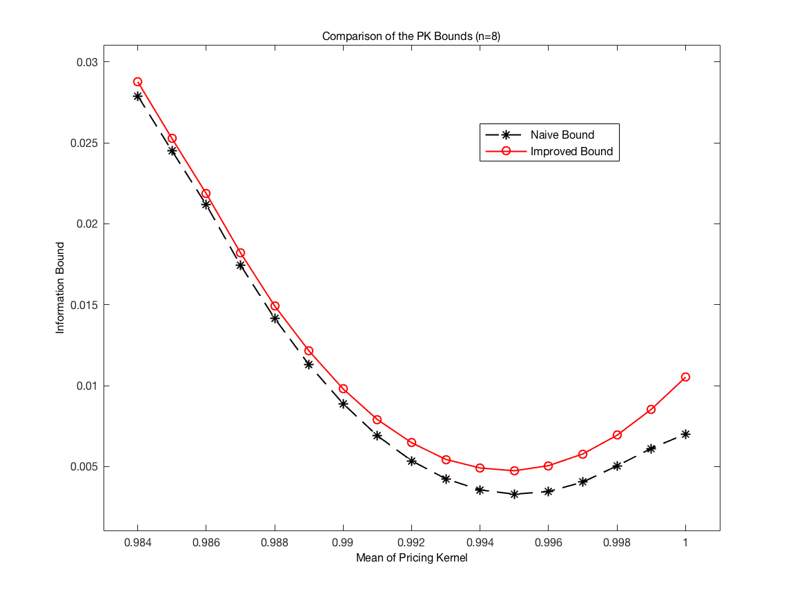
Figure 1: Comparison of the minimum discrepancy pricing kernel bounds (n=8).

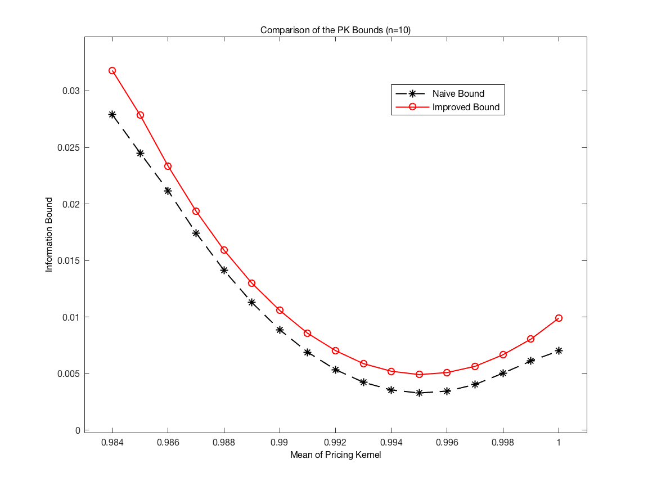
Figure 2: Comparison of the minimum discrepancy pricing kernel bounds (n=10).

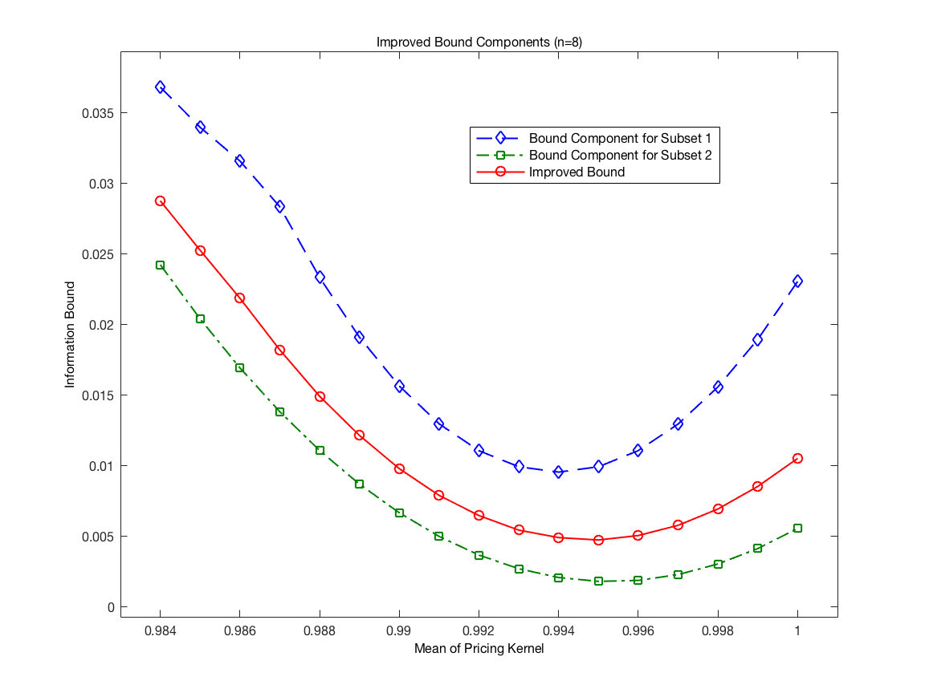
Figure 3: Components of the improved bound (n=8).

Tables:

 | Total data set | Subset 1 | Subset 2
Size | 1038 | 393 | 645
Time horizon | 1926:07-2012:12 | 1947:12-1969:05 | 1926:07-1947:11
 |  | 2001:08-2012:12 | 1969:06-2001:07
Real risk-free rate | 0.0343% | -0.0025% | 0.0568%
Table 1: Observed monthly risk-free rate for the identified states of the economy (n=8).

International Center for Finance, Yale School of Management, CT, USA.

