Viscous Dissipative Effect on Free Convection Flow past a Semi-Infinite Flat Plate in the Presence of Magnetic Field

O.A. Oyem^{1†}
¹ Department of Mathematical Sciences, Federal University Lokoja, Lokoja, Kogi, PMB 1154, Nigeria
†Corresponding Author Email: onyekachukwu.oyem@fulokoja.edu.ng, reallityo@yahoo.co.uk

Abstract
In this work we considered the effect of viscous dissipation in the presence of magnetic field on free convection flow of an incompressible viscous laminar fluid past a continuously moving semi-infinite flat plate. A similarity transformation is used to reduce the governing partial differential equations into a system of ordinary differential equations, which is solved numerically. The effect of Grashof number, Prandtl number, Eckert number, Schmidt number and magnetic field parameter on two-dimensional flow and results for the velocity, temperature and concentration distribution as well as the skin-friction and rate of heat transfer and Sherwood number with pertinent results on the effect of various parameters controlling the system are shown graphically and presented in tabular form.

Keywords: Heat transfer; viscous dissipation; magnetic effect; Nusselt number; Sherwood number.

1. introduction
The problem of heat and mass transfer in the boundary layers of a continuously moving semi-infinite flat plate has gained the attention of many researchers due to its numerous industrial, engineering and environmental applications in study production, metal spinning, glass blowing, continuous casting of metals, thinning of copper wire, etc.
Cortell [1] worked on viscous flow and heat transfer over a non-linearly stretching sheet. He further investigated on the effects of viscous dissipation and radiation on the thermal boundary layer over a non-linearly stretching sheet [2]. Omowaye and Koriko [3] discussed steady Arrhenius laminar free convective MHD flow and heat transfer past a vertical stretching sheet with viscous dissipation. The analysis of inherent irreversibility in hydromagnetic boundary layer flow of viscosity fluid over a semi-infinite flat plate under the influence of thermal radiation and Newtonian heating was discussed by Makinde [4]. Varshney and Singh [5] studied the effect of stratified viscous fluid on MHD free convection flow past a vertical porous plate with heat and mass transfer in the presence of radiation and heat source, taking viscous and Darcy resistance into account. Combined effects of heat generation and viscous dissipation on MHD natural convection flow of an electrically conducting fluid over an isothermal sphere with variable thermal conductivity was studied by Haque et al. [6]. Kishan and Amrutha [7], studied two-dimensional steady nonlinear MHD boundary layer flow of an incompressible, viscous, electrically conductive and Boussinesq fluid flowing over a vertical stretching surface in the presence of uniform magnetic field by taking into account the viscous dissipation with heat, mass transfer chemical reaction and thermal stratification effects. Mansuor et al. [8] considered a steady two dimensional nonlinear MHD boundary layer flow of an incompressible, viscous and electrically conducting fluid in the presence of a uniform magnetic field with heat, mass transfer and chemical reaction in a porous medium. Mamun et al. [9] investigated combined effect of conduction and viscous dissipation on magnetohydrodynamic free convection flow along a vertical flat plate. Steady state flow of Newtonian liquid with exponential temperature-dependent viscosity and substantial viscous heat generation between symmetrically parallel heated walls with walls at different temperature was investigated by Adegbie and Alao [10]. Geetha and Moorthy [11] investigated the steady free convection and mass transfer flow past a continuously moving semi-infinite flat plate by taking into account the viscous dissipation effect.
In most of the studies mentioned above, the effects of magnetic field on steady MHD free convective flow have not been dealt with adequately and density is often neglected within the viscous dissipation term. Hossain et al. [12] studied the laminar boundary layer equations for the unsteady free convection flow over a horizontal semi-infinite porous plate. The solutions obtained in their work showed that a small value of suction or blowing play a vital role on the patterns of flow and temperature fields as well as on the coefficients of skin friction and heat transfer. Rao et al. [13] examined the radiation effects on unsteady heat and mass transfer flow of a chemically reacting fluid past a semi-infinite vertical plate with viscous dissipation. Vasu et al. [14] analysed the effect of radiation and mass transfer on the transient free convection flow of a dissipative fluid past semi-infinite vertical plate with uniform heat and mass flux, taking into account the effect of viscous dissipation.
In this paper, we want to study the effects of viscous dissipation and heat and mass transfer on free convection flow past a semi-infinite flat plate in the presence of magnetic field.
2. problem formulation
Consider a two-dimensional, incompressible free convection flow past a continuously moving semi-infinite flat plate with magnetic field. The physical co-ordinates are chosen such that -axis is taken along the plate and the -axis is normal to the plate.
u
v
g
y
x

Figure 1. Schematic representation of the problem

Under the usual Boussinesq and boundary layer approximation, the flow is governed by the continuity, momentum, energy and concentration equations as follows [11]:
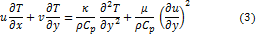
along with the boundary conditions:
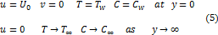
where are the velocity components in directions respectively and is the scale of free stream velocity. – density of the fluid, – the kinematic viscosity, – the acceleration due to gravity, – electrical conductivity, is the wall dimensional temperature and is free stream dimensional temperature, is the concentration on the surface of the plate, is the dimensionless concentration, is the diffusion coefficient and is the thermal conductivity of the fluid flow.
The above set of partial differential equations is converted into ordinary differential equations by using the stream function and the following similarity variables:
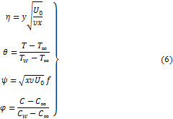
where is the dimensionless stream temperature and is the dimensionless velocity parameter. By stream function, the continuity equation (1) is satisfied and the final transformed equations (2) – (4) and the boundary conditions (5) using the similarity variable (6) is:
with the boundary and initial conditions as:
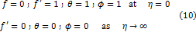
where prime is the differentiation with respect to , the non-dimensional numbers are defined as viscous dissipation parameter by is the local Grashof number, is the Prandtl number, is the Eckert number, Schmidt number is given by and is the local magnetic field parameter.
3. numerical computation
The set of equations (7) – (9) together with boundary conditions (10), have been solved numerically by Runge-Kutta fourth order scheme along with shooting method implemented using MATLAB. A step size is used to obtain the required accuracy for the numerical solution with criterion of convergence. From the process of numerical computation, skin-friction coefficient, the local Nusselt number and the Sherwood number, which are respectively proportional to , and is also, sorted out and their numerical values are presented in tabular form.
The physical quantities of principle interest are the Nusselt number and the local Sherwood number respectively. They are given by:
The ordinary differential equations (7) – (9) along with the boundary conditions (10), are solved by giving approximate initial guess values for the initial conditions of , , and these values are matched with the corresponding boundary conditions at , and .
4. results and discussion
In this paper, we have been able to studies the effect of viscous dissipation and magnetic field on free convection flow past a continuously moving semi-infinite flat plate. The effect of the parameters and on flow characteristics have been studied and shown graphically in figures 2 – 16.
Table 1 shows the numerical values of the governing parameter effects on , and . The velocity, temperature and concentration profiles for various values of at , , and is shown in figures 2 – 4. It was observed that as increases, both velocity and temperature increases respectively but the concentration distribution decreases with increasing values. From figure 5 - 10, the velocity distribution profiles for and is presented. Figure 5 show that Schmidt number has very little significant increase with increasing values in velocity. But velocity decreases with increasing values in as shown in figure 6. Also, with values , , and , it was observed that as increases, velocity decreases towards the boundary layer from figure 7, while in figure 8, as increase, velocity profile decreases also. Temperature profile for show that increase in Schmidt number, results in a decrease in boundary layer thickness from figure 9. With increasing values in number, the concentration distribution decreases spontaneously from the plate to the free stream as presented in figure 10. Figure 11 depicts temperature distribution for different values of Prandtl number . It is observed that as increases, temperature decreases away from the free stream but increases the thermal boundary layer towards the free stream with increasing as displayed in figure 12. Furthermore, it is observed from figure 13 and 14 that the thermal boundary layer thickness increases with increasing values in magnetic field parameter . Figure 14 represent the temperature profile for different values of . The increase in , leads to an increase in temperature but decreases in concentration towards the plate away from the free stream in figure 16.
5. Conclusions
The effect of viscous dissipation in the presence of magnetic field on free convection flow of an incompressible viscous laminar fluid past a continuously moving semi-infinite flat plate is considered. The dimensionless governing equations are transformed using similarity variables and the numerical solutions were obtained. The results are presented graphically to illustrate the velocity, temperature and concentration with various parameters. The conclusions of the study are as follows:
- Increase in the viscous dissipation parameter resulted in increase in velocity and temperature but a decrease in concentration distribution
- An increase in heat transfer coefficient results in the increase in but decreases with increase in and
- Sherwood number decreases with increase in and and also increases with increase in and .
Acknowledgements
The author thanks all contributors and reviewers for their candid comments and support.
References
Adegbie, K.S. and Alao, F.I. (2007), Flow of Temperature-dependent viscous fluid between parallel heated walls: exact analytical solutions in the presence of viscous dissipation, J. Math. Stat. 3, 12–14.
Cortell, R. (2007), MHD flow and heat transfer of an electrically conducting fluid of second grade in a porous medium over a stretching sheet subject to chemically reactive species, Chemical Eng. Process. 46, 721–728.
Cortell, R. (2008), Effects of viscous dissipation and radiation on the thermal boundary layer over a non-linearly stretching sheet, Phys. Letters A. 372, 631 – 636.
El-Amin, M.E. (2003), Combined effect of magnetic field and viscous dissipation on a power-law fluid over plate with variable surface heat flux embedded in a porous medium, J. of Mag. and Mag. Mat. 261, 228–237.
Geetha, P. and Moorthy, M.B.K. (2011), Viscous dissipation effect on steady free convection and mass transfer flow past a semi-infinite flat plate, J. of Comp. Sci. 7, 1113 – 1118.
Haque, Md. R., Alam, Md. M., Ali, M. M. and Sheikh, M. A. N. (2014), Effects of viscous dissipation on MHD natural convection flow over a sphere with temperature dependent thermal conductivity in presence of heat generation, European Sci. J., 10(15), 364–376.
Hossain, M.M.T., Mojumder, R. and Hossain, M.A. (2011), Solution of natural convection boundary layer flow above a semi-infinite porous horizontal plate under similarity transformations with suction and blowing, D. Int. J. of Sci. and Tech., 6, 43 – 51.
Kishan, N. and Amrutha, P. (2010), Effects of viscous dissipation on mhd flow with heat and mass transfer over a stretching surface with heat source, thermal stratification and chemical reaction, J. Naval Archit. Marine Eng. 7, 11–18.
Mamun, A.A., Nur, H.M. and Maleque, A.M. (2007), Combined effect of conduction and viscous dissipation on magnetohydrodynamic free convection flow along a vertical flat plate, J. of Naval Arch. and Marine Eng. 4, 87–98
Mansour, M.A., El-Anssary, N.F. and Aly, M.A. (2008), Effect of chemical reaction and viscous dissipation on mhd natural convection flows saturated in porous media with suction or injection, Int. J. of Appl. Maths and Mech. 4(2), 60–76.
Omowaye, A.J. and Koriko, O.K. (2014), Steady arrhenius laminar free convective mhd flow and heat transfer past a vertical stretching sheet with viscous dissipation, J. of the Nig. Math. Soc. 33, 259–271.
Rao, V.S., Babu, L.A. and Raju, R.S. (2013), Finite element analysis of radiation and mass transfer flow past semi-infinite moving vertical plate with viscous dissipation, J. of Appl. Fluid Mechanics, 6, 321–329.
Varshney, N.K. and Singh, R.S. (2012), Effect of stratified viscous fluid on mhd free convection flow with heat and mass transfer in the presence of radiation and heat source, Int. J. of Eng. Sci. and Tech. 4(3), 1095 –1106.
Vasu, B., Prasad, V.R. and Reddy, N.B. (2011), Radiation and mass transfer effects on transient free convection flow of a dissipative fluid past semi-infinite vertical plate with uniform heat and mass flux, 4, 15 – 26.

Table 1. Numerical values of governing parameters effects on , and
1 |  | 0.71 | 0.1 | 0.3 | 1 | 0.4619 | 0.3152 | 0.2766
2 |  |  |  |  |  | 1.5891 | -0.1645 | 0.3384
2.5 |  |  |  |  |  | 2.5916 | -1.1565 | 0.3836
 |  | 7 |  |  |  | 0.1109 | 0.8110 | 0.2324
 |  | 10 |  |  |  | 0.0788 | 0.9282 | 0.2298
 |  |  | 1 |  |  | -0.3500 | 0.2543 | 0.2217
 |  |  | 2 |  |  | -0.8706 | 0.0954 | 0.1936
 |  |  |  | 0.6 |  | 0.4619 | 0.3152 | 0.4232
 |  |  |  | 0.8 |  | 0.4619 | 0.3152 | 0.5005
 |  |  |  |  | 1.5 | 0.5413 | 0.2216 | 0.2858
 |  |  |  |  | 2 | 0.6417 | 0.0810 | 0.2965
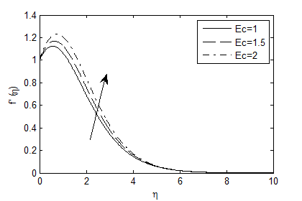
Figure 2. Velocity profile for different values of

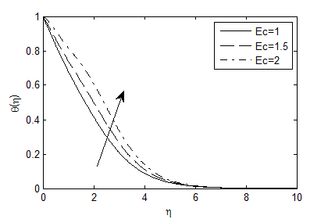
Figure 3. Temperature profile for different vales of Eckert number

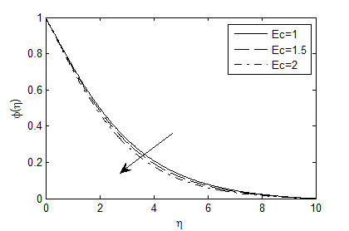
Figure 4. Concentration profile for different values of
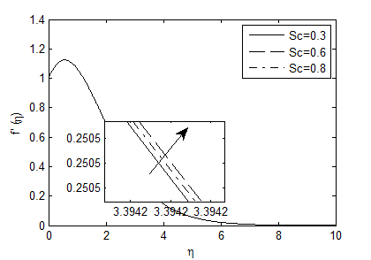
Figure 5. Variation of against for different values of
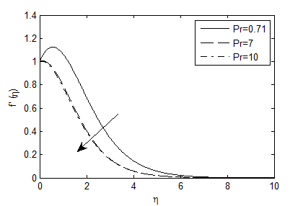
Figure 6. Velocity profile for various values of
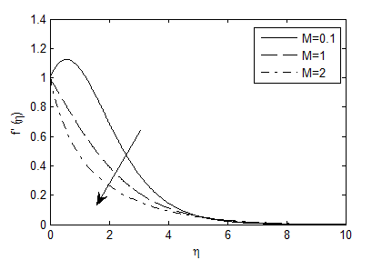
Figure 7. Variation of velocity against
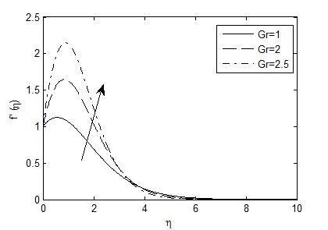
Figure 8. against for various values of
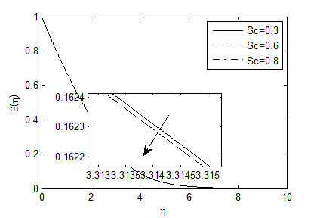
Figure 9. against for various values of
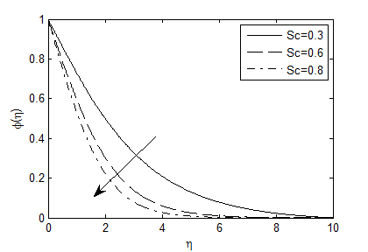
Figure 10. against for various values of
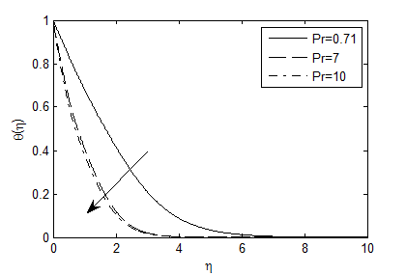
Figure 11. Temperature distribution for various values of
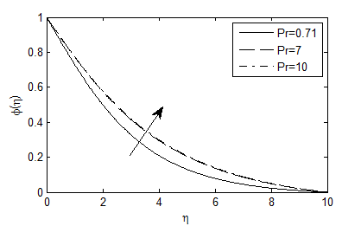
Figure 12. Concentration distribution for various values of
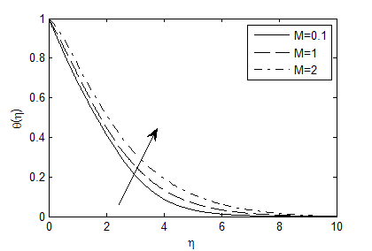
Figure 13. Temperature distribution for various values of
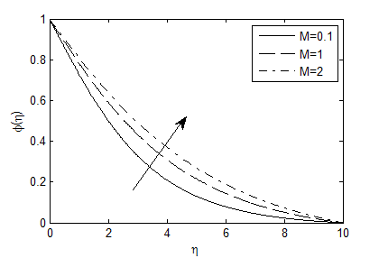
Figure 14. Concentration profile for various values of
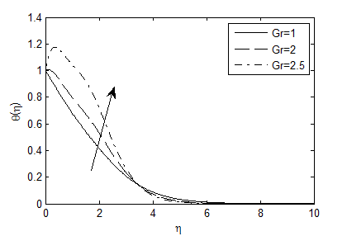
Figure 15. Temperature profile for various values of
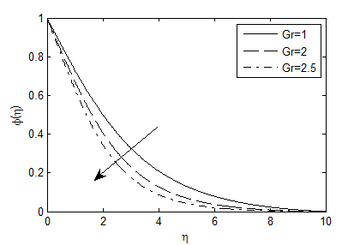
Figure 16. Concentration profile for various values of

