Origins and Utilizations of the Main Natural Depressions in Iraq

Varoujan K. Sissakian , Nadhir Al-Ansari, Nasrat Adamo³ and Jan Laue4

Abstract

Many natural depressions occur in Iraq with different origins, sizes, shapes and utilization. In this study, nine main depressions are studied and discussed, especially their origins, they are: Tharthar, Hab’baniyah, Raz’zazah, Ga’ara, Umm Chaimin, Salman, Slaibat Dukan, and Derbendikhan. The study was achieved by using satellite images of high accuracy, geological maps and reports, historical and irrigation data. All the mentioned depressions; apart from Salman and Ga’ara depression are used for irrigation uses, especially for flood control; others are used for electric power generation; or has no any use. The study revealed that some of the depressions are formed due to karstification, others due to tectonic activity and some due to combination of karstification and tectonic activity. However, the role of fluvial and wind erosion cannot be ignored in the development of the depressions.

Keywords: Tharthar; Hab’baniyah; Raz’zazah; Ga’ara; Umm Chaimin; Salman; Slaibat; Dukan; Derbendikhan.
1 Introduction
Iraq occupies the northeastern part of the Arabian Plate which is in collision with the Iranian Plate (e.g. [1,2,3,4,5,6]). The collision has formed anticlines and thrust faulting which decrease in intensity southwest wards; accordingly, the topographic relief decreases in the same direction. The northern and northeastern parts of Iraq are mountainous reaching up to 3664 m (a.s.l.), more towards south and southwest wards, the topography changes to hilly terrain. The central part of Iraq is the Mesopotamian Plain which is almost flat plain decreasing in elevation southeast wards until traches the sea level in the gulf. West and south of the Mesopotamian Plain are the Iraqi Western and Southern deserts, respectively (Fig. 1). These differences in topography have developed different morphological forms and features; among them are many large depressions which are the target of this study.

The aim of this study is to discuss the origin of the presented nine main depressions in Iraq, how they were developed, the role of geological conditions in their development and their utilizations (if any). The studied nine depressions are distributed geographically and physiographically in all parts of Iraq (Fig. 1).

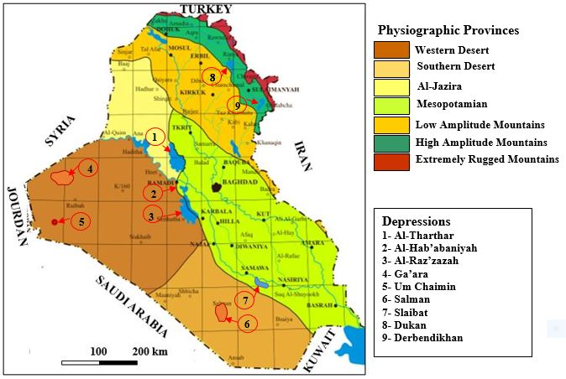
Figure 1: Physiographic map of Iraq showing the studied nine depressions
(The provinces are from [6]).

2 Previous Work

Different studies were carried out explaining some of the presented depressions in this study, some of them are mentioned hereinafter.

[7] described the Umm Chaimin Depression as a meteorite impact, whereas [8,9] described the depression as a volcanic origin. [10] conducted irrigation project in the Tharthar Depression and gave an idea about the origin of the depression to be tectonic associated with wind erosion. [11] mentioned the Tharthar Depression was formed due to karstification. However, he mentioned that it might be formed due to an earthquake in the year 1423. [12] carried out magnetic and gravity measurements to indicate the origin of the Umm Chaimin crater, they suggested that ground-water action on limestone rocks is responsible for the present depression. They, however, didn’t ignore the possibility of a crypto volcanic origin. [13] carried out magnetic and gravity measurements and some electrical measurements at the Umm Chaimin Depression and concluded that an erosional process probably by ground-water action should be considered as possibly responsible for the depression. [14] carried out geological mapping at Umm Chaimin vicinity and drilled a borehole in the floor of the depressions and concluded that the depression was most probably related to gas explosion that took place during Quaternary, a volcanic vent, however, was not excluded. [15] studied the Umm Chaimin Depression and evaluated the previous studies; he concluded that the origin is related to gas explosion. John (1899) in [11] mentioned that the Tharthar Depression has formed due to successive earthquakes. [16] considered the development of the Tharthar Depression due to karst origin, although tectonic origin could not be ignored. [17] mentioned that the Ga’ara Depression is not an anticline and it is formed due to erosional effects. [18] compiled the Geomorphological Map of Iraq at scale of 1: 1000000 and considered the Salman Depression was developed due to karstification. Jassim and Buday in [5] mentioned that the depression is originated from gas explosion, which could be seeped from Paleozoic sandstones through fractures and accumulated in reservoirs below Late Cretaceous shales. An explosion followed when gas pressure exceeded hydrostatic pressure. [19] mentioned that the Ga’ara Depression is formed due to climate changes. [20] mentioned that the Ga’ara Depression is formed due to different fault systems. [21] studied the Tharthar Depression and mentioned it is developed due to karstification and tectonic forces. [22] studied the Salman Depression and concluded that it is developed due to karstification. [23] studied the Dukan Depression and concluded that it is developed due to tectonic forces. [24] studied the Ga’ara Depression and concluded that it is developed due to tectonic uplift. [25] studied the reservoirs in natural depressions and concentrated on their roles in water management.
From reviewing the previous works carried out on the main depressions in Iraq, it is clear that the Derbendikhan, Raz’zazah and Slaibat depressions are not studied as their origin is concerned.
3 Materials and Methods
In order to perform the current study, the following data have been used:
- Geological, tectonic and topographic maps of different scales,
- Satellite images of high resolution,
- Irrigation data,
- Relevant publications which are concerned with the studied depressions and other in Iraq,
- Historical data concerning the development of the studied depressions and their estimated ages.

Geological maps [6,26,27,28,29] of different scales and satellite images were used to indicate the regional and local geological conditions of the studied depressions. Tectonic map [30] was used to indicate the tectonic framework at the areas where the studied depressions exist. Whereas the topographic maps were used to deduce the dimensions of the studied depressions. Some historical and irrigation studies [11] were used to indicate irrigation data in those depressions which are used for irrigation purposes; such as Dukan, Derbendikhan, Tharthar, Hab’baniyah and Raz’zazah. Data from [31] is used to indicate depressions of karst origin. Whereas data from [32], [33] and [34] are used to indicate rate of sedimentation and accordingly to estimate the age of some depressions. However, data from [35] and [36] were used in indicating the development of canyon-shaped valleys and the rate of soil erosion in semi-arid regions, respectively.

4 Results
Nine main depressions are studied and are presented systematically including: General data, origin, geology, dimensions, and utilization.

4.1. Tharthar Depression
Tharthar Depression is one of the largest closed depressions in Iraq; it is located in the central western part of Iraq, between the Jazira and Mesopotamia plains, west of the Tigris River (Fig. 1). It is oriented almost N – S direction, then southwards changes to N35° W – S35° E direction, it has a pearl shape.

The exposed rocks in the near surroundings of the depression belong to the Fatha (marl, red claystone, limestone and gypsum) and Injana (sandstone and claystone) formations, with Al-Fatha Alluvial Fan sediments (conglomerate capped by gypcrete) in its eastern bank [6]. Tectonically, it is located in the Mesopotamia Foredeep of the Unstable Shelf, forming the contact between the Jazira and Mesopotamia Plains [30]. Geomorphologically, it is a large depression with a floor of – 3 m, below the sea level. The estimated age of the Tharthar Depression is most probably Holocene [21].

The Tharthar Depression covers about 2050 km2, the maximum length and width of the depression are 120 and 48 km, respectively. The eastern rim of the depression is higher than the western one; the heights of both rims are 90 and 75 m, respectively. The estimated volume of the depression using GIS technique is about 85.2 X 10 9 m3, when measured at elevation of 60 m (a.s.l.).

The Tharthar Depression since 1956 is changed to an artificial reservoir to collect the over flooded water of the Tigris River, during flood seasons, therefore, was called Tharthar Lake. The Tigris and Euphrates Rivers, however, are linked to the depression by means of two artificial canals. The inlet canal, however, is from the Tigris River, regulated by Samarra Regulator Dam, which controls the divergent excess water from the Tigris River, by means of the inlet canal.

4.2. Hab’baniyah Depression
The Hab’baniyah Depression is a shallow depression filed by slightly saline water, separated from the Euphrates River to the north by the two ridges called Asibi and Dhiban ridges. It is located 20 km southeast of Ramadi City (Fig. 1). It has rectangular shape with curved corners, oriented in NW – SE direction which is almost parallel to the trend of the Euphrates River.

The exposed rocks and Quaternary sediments in the near surroundings of the Hab’baniyah Depression belong to the Injana Formation, with wide spread cover of gypcrete, especially in its northwestern, western and southwestern banks. In the eastern part, rocks of the Injana Formation are exposed, whereas in the northeastern and southeastern parts clastic rocks of the Injana Formation are exposed. The northern part is covered by the flood plain sediments of the Euphrates River [6]. Tectonically, it is located in the Mesopotamia Foredeep of the Unstable Shelf, forming the contact between the Inner Platform (Stable Shelf) and the Mesopotamia Plain [30]. Geomorphologically, it is a small semi closed depression surrounded from all sides except the northern side by cliffs. Many small valleys drain into the depression from the western part. The estimated age of the Hab’baniya Depression is most probably Holocene.

The Hab’baniyah Depression covers about 358 km2, the maximum length and width of the depression are 28.5 km and 20 km, respectively at elevation of 54 m with periphery of 96.8 km. The northern rim of the depression is 48 m (a.s.l.) which is lower than all other surroundings; therefore, earth-fill embankment was constructed in the northern rim to have a close depression. The estimated volume of the depression using GIS technique is about 2.72 X 109 m3.

The Hab’baniyah Depression has been used since 1956 for storing floodwater from the Euphrates River with storage capacity of 3 000 000 000 m3; it now provides water for irrigation as well. An earth-fill embankment was constructed in the northern part to close the depression and separate it from the Euphrates River. A barrage called Sin Al-Dhiban southeast of Ramadi City diverts excess water from the Euphrates River through Al-Saqlawiyah channel at the lake’s northwestern tip. Other channel carries water from the southeastern tip to a second storage depression called the Raz’zazah Depression or Abu Dibs Depression. Moreover, the reservoir is used for touristic uses and a large tourism complex was built along the northern bank of the reservoir in 1979.

4.3. Raz’zazah Depression
The Raz’zazah Depression is another large natural depression located 10 km west of Karbala City (Fig. 1). It is also called in Arabic “Bahir Al-Milih” which means Salt Sea and called Hor Abu Dibis. It is oriented almost in N – S direction, then in its extreme southern part changes to N30° W – S30° E direction; it has a pearl shape, which resembles the same shape of the Tharthar Depression (Fig. 1).

The exposed rocks and Quaternary sediments in the near surroundings of the Raz’zazah Depression belong to the Nfayil (green marl and limestone) and Injana formations, with wide spread cover of gypcrete (Highly gypseous soil), especially in its eastern and western banks. In the southwestern part, rocks of the Nfayil Formation are exposed, whereas in the northern, northeastern and southeastern parts rocks of the Injana Formation (sandstone and claystone) are exposed. Moreover, a thin longitudinal strip of the Injana Formation is exposed along the eastern bank below the gypcrete [6]. Tectonically, it is located in the Mesopotamia Foredeep of the Unstable Shelf, forming the contact between the Inner Platform (Stable Shelf) and the Mesopotamia Plain [30]. Geomorphologically, it is a large and closed depression in which tens of the valleys which drain the Iraqi Western Desert like Al-Ubaidh and Tab’bal. The estimated age of the Tharthar Depression is most probably Holocene.

The Raz’zazah Depression covers about 1562 km2, the maximum length and width of the depression are 58 and 37 km, respectively at elevation of 33 m (a.s.l.). The western rim of the depression is higher than the eastern one; the heights difference between both rims is about 5 m. The estimated volume of the depression using GIS technique is about 10. 153 X 109 m3.

The Raz’zazah Depression is also used since seventies of the last century as a natural storage of excess water during floods of the Euphrates River which flows from the Hab’baniyah Depression diverted through a controlled escape channel called Al-Maj’jara. The depression is rather shallow and water levels change with the seasons. Due to the salt accumulation and the changing water levels, this largest freshwater lake has lost its importance as a fresh water lake.

4.4. Ga’ara Depression
The Ga’ara Depression is a large natural depression developed in the western part of the Iraqi Western Desert (Fig. 1), and one of the largest depressions in Iraq. It is located 100 km north of Rutbah town and has irregular shape.

The exposed rocks in the Ga’ara Depression range in age from Permian to Eocene. The oldest rocks belong to the Ga’ara Formation of Permian age (mainly sandstone and claystone) overlain by Upper Triassic rocks of Mulussa Formation (limestone and dolostone) and Zor Hauran Formation (yellow marl and limestone). Jurassic rocks are absent in the depression as well as the Lower Cretaceous. The Upper Cretaceous rocks are represented by four formations: Rutbah (mainly sandstone), Hartha (conglomerate, sandstone, limestone, and dolostone), Tayarat (conglomerate, sandstone, mar, siltstone, reddish limestone followed upwards by papery marl) and Digma (limestone, dolostone with phosphorite horizon and green to ochre papery shale, with oyster shell horizon). The Paleocene rocks are represented by the Akashat Formation (conglomerate, claystone, limestone, dolostone and phosphorite). The Eocene rocks are represented by the Ratga Formation (nummulitic limestone, phosphorite and phosphatic limestone, with several chert horizons). It is worth to mention that not all the mentioned formations are present in the four rims of the depressions successively as the age is concerned. The floor of the depression is covered by thick (up to 5 m) calcrete, terraces and large alluvial fan sediments [6]. Tectonically, the depression is located in the Inner Platform being part of the Hail – Rutbah Arch [20,30]. Geomorphologically, the depression is semi-closed; since tens of valleys of different sized drain into the depression, whereas only one outlet exists in the northeastern tip of the depression called Al-Halqoom which is the beginning of a very large valley called Al- Ratga which is the only valley which drains out the whole depression. The depression is surrounded by four rims which exhibit different types of mass wasting processes and tens of alluvial fans of different sizes. The southern rim is the highest and steepest, whereas the eastern one is the lowest with gentle slopes. The maximum and minimum elevations in the floor of the depression are 513 m and 482 m (a.s.l.), respectively, whereas the relief difference in the four rims is 35 m, 11 m, 156 m and 96 m in the northern, eastern, southern and western rims, respectively. The age of the Ga’ara Depression is estimated using [36] method. To calculate the required time for eroding of the rocks of the depression, the calculated weight of the rocks is divided by the calculated eroded weight of the rocks per year and that will be about 540655 years. This calculated time interval indicates Middle Pleistocene age for the depression

The coverage area of the Ga’ara Depression is about 1383 km2, it is of rectangular shape but with irregular edges; elongated in E – W direction. The maximum and minimum length and width of the depression are 58.5 km and 25 km, respectively.

The Ga’ara Depression represents a unique opportunity to the geologists and rangers in the Iraqi Western Desert due to its unique geological setting and natural beauty of the landforms and landscape. An attempt was carried out by the Natural History Research Center and Museum, Baghdad to consider the depression as a national park, but the attempt was in vain. The Ga’ara Depression is a potential area for many industrial rocks and minerals with economic potential; among them are: quartz-sand, kaolinite, palygorskite, iron stone, phosphorite and gold?. Many open pit mines occur in the depression where many of the mentioned minerals were mined until 2003 [37].

4.5. Umm Chaimin Depression
The Umm Chaimin Depression is an outstanding and conspicuous geomorphic feature in the southwestern part of the Iraqi Western Desert. It is located 95 km southwest of Rutbah town (Fig. 1). It is almost circular in shape (Fig. 2), with surface area of the depression as measured from the highest closed contour (850 m) is about 5.73 km². It has steep rims and no embankments, whereas the surrounding area is quite flat with elevation of (850 – 860) m (a.s.l.), therefore it is almost invisible, unless from very close distance. It can be reached from Rutbah town via H3 Oil pumping station along a paved road that passes few tens of meters westwards of the depression.

The exposed carbonate rocks on the surrounding of the Umm Chaimin Depression and along the rims belong to the Ratga Formation (Eocene). The beds dip off the depression. Large rock fragments of different sizes occur near the rims, some of them are Middle Paleocene in age. To estimate the age of the depression, the method of [33] in calculation the rate of sedimentation was used. The thickness of the penetrated fluvial sediments in the drilled borehole at the floor of the depression is about 75 m [14], by dividing the thickness over the assumed depositional rate, a time interval of about 50000 years is indicated. Accordingly, early Late Pleistocene age can be estimated.

The Umm Chaimin Depression is a circular in shape bowl like. The longest diameter is 2.9 km in N – S direction and the shortest one of 2.5 km in E – W direction, with depth of (28 – 38) m. The surrounding area is quite flat with elevation of (850 – 860) m (a.s.l.), therefore it is almost invisible, unless from very close distance from the depression.

Due to the remoteness of the Umm Chaimin Depression from inhabited areas; therefore, it is not used for any purpose. However, the Ministry of Water Resources tried to use it as a storage for rain water by means of digging a channel and constructing small earth-fill dam on Al-Walaj valley (Fig. 2) to convert the flowing rain water during floods to the depression. But the attempt was in vain. However, during the rainy seasons, a lot of water is accumulated in the depression. The local inhabitant uses the water for their domestic uses and for their animals.
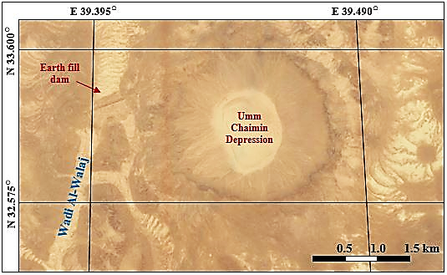
Figure 2: Satellite image of Umm Chaimin Depression. Note the constructed earth-fill dam on wadi Al-Walaj

4.6. Salman Depression
The Salman Depression is one of the largest depressions in the Southern Desert of Iraq (Fig. 1). It is located 120 km southwest of Samawa City. The shape of the depression is oval but with irregular curved edges.

The exposed rocks in the Salman Depression belong to the Dammam Formation (Eocene) consists of well bedded limestone and dolomite. Whereas the floor of the depression is covered by the Zahra Formation (Pliocene – Pleistocene) consists of limestone and sandstone, and Pleistocene sediments mainly calcrete.

The Salman Depression has oval shape. The northern half part has NE – SW trend whereas the southern half has N – S trend. The edges of the depression are irregular; however, still show crescent-shaped and/ or half circular shape witnessing karst origin. The length of the depression is 20 km, whereas, the width is variable, it is (6.5, 10 and 4.5) km, in the northern, central and southern parts, respectively, whereas, the depth ranges from (5 – 35) m.

Due to the presence of the depression in the Iraqi Southern Desert and being remote from the civilized parts of Iraq, the depression has almost no any use. However, since early thirties of the last century a large prison was constructed in the center of the depression where the political oppositionists were exiled it was called “Nugrat Al-Salman”. The old prison was abandoned at early eighties of the last century and new one was constructed in late eighties (Fig. 3) and the latter was abandoned in 2003.

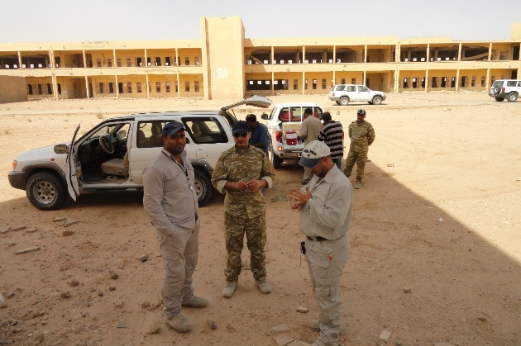

Figure 3: The abandoned most notorious prisons in Iraq (Nugrat Al-Salman)
which was constructed late eighties.
(The persons in the photo are geologists, 2012; Iraq Geological Survey, Baghdad).

4.7. Slaibat Depression
The Slaibat Depression has elongated shape but with irregular edges. The depression lies 52 km southeast of Samawa City and 45 km south west of Nasiriyah City being parallel to the Euphrates River (Fig. 1). The Slaibat Depression is covered totally by Quaternary sediments represented by the flood plain sediments of the Euphrates River of Holocene age [6].

The Slaibat Depression covers 175 km2, its length and width are 50 km and 13 km, respectively. The average depth of the depression is 6 m and the total volume is about 1050 X 10 6 m3.

The Slaibat Depression was used as artificial storage for the flood water of the Euphrates River as construction an earth fill embankment on its northern part during mid-nineties of the last century. The excess flood water can be diverted to the depression through an artificial channel which stars 5 km west of Samwa City. It was also used to divert the water of the Euphrates River into the depression instead of flowing to the marshes as an attempt for drying the marshes during the last decade of the last century.

4.8. Dukan Reservoir (Depression)
The Dukan lake is a large triangular shape depression with the head facing downwards (southwards). The Lesser Zab River was flowing through the depression before construction of Dukan Dam during (1954 – 1959) and now it is called Dukan Lake (reservoir). The lake is located 80 km NW of Sulaimaniyah city (Fig. 1) and can be reached by a paved road through different directions.

The exposed rocks in the Dukan Depression belong to many formations ranging in age from Lower Jurassic up to Upper Cretaceous [6]. The following formations are exposed: The oldest rocks belong to the Sarki Formation (Lower Jurassic) which consists of thinly bedded, light grey dolomitized limestone. The Sehkaniyan Formation (Lower Jurassic) consists of massive dark dolomite. The Sargelu Formation (Middle Jurassic) consists of thinly bedded shaley black limestone and shale. The Naokelekan Formation (Upper Jurassic) consists of laminated shaley limestone followed by black shales. The Barsarin Formation (Upper Jurassic) consists of black and brown bituminous dolomitic shales and thin dolomitic limestone. The Balambo Formation (Lower Cretaceous) consists of thinly bedded limestone alternated with marl. The Sarmord Formation (Lower Cretaceous) consists of thinly bedded marly limestone and marl. The Qamchuqa Formation (Lower Cretaceous) consists mainly of massive limestone and dolomite. The Dukan Formation (Lower – Upper Cretaceous) consists of light grey limestone. The Gulneri Formation (Lower – Upper Cretaceous) consists of black shales. The Kometan Formation (Lower – Upper Cretaceous) consists of well bedded limestone. The Shiranish Formation (Upper Cretaceous) consists of well bedded marly limestone overlain by dark blue to grey shale. The Tanjero Formation (Upper Cretaceous) consists of black and dark green shale. Geomorphologically, the depression is a large depression limited by anticlinal ridges along which tens of alluvial fans of different sizes and ages are developed. Tectonically, the depression is located in the High Folded Zone and include many anticlines; Ranya, Makook, Palewan, Kamusk, Khalikan and Sarta [28]. Many faults with NE – SW trend dissect some of the anticlinal ridges.
The Dukan Depression has surface area of about 260 km2. The height at the surface of the reservoir when filled to normal operational level is 511 m (a.s.l.); however, the depression is surrounded; almost from all sides by high mountains that range from (800 – 1300) m (a.s.l.). The Dukan Dam was built between 1954 and 1959, whereas its power station became fully operational in 1979. The dam is 360 m long and 116.5 m high, width at the base and crest is 34.3 m and 6.2 m, respectively with reservoir volume of 370 000 m3. The total capacity of the reservoir is 6.970 x 10 6 m3, the active capacity is 6.100 x 10 6 m3, whereas the inactive capacity is 790 x 10 6 m3. The hydroelectric power station has a maximum capacity of 400 MW. The Dukan Lake is used for irrigation, flood control, power generation and tourism purposes.

4.9. Derbendikhan Reservoir
The Derbendikhan Depression is a small depression with very irregular shape. The Sirwan (Diyala) River was flowing through the depression before construction of Derbendikhan Dam during (1956 – 1961) and now it is called Derbendikhan Lake (reservoir). The lake is located 55 km SE of Sulaimaniyah city (Fig. 1) and can be reached by a paved road through different directions.

The exposed rocks in the Derbendikhan Depression belong to many formations ranging in age from Lower Cretaceous up to Pleistocene [29]. The following formations are exposed: The oldest rocks belong to Shiranish Formation (Upper Cretaceous) consists of well bedded marly limestone overlain by dark blue to grey shale. The Tanjero Formation (Upper Cretaceous) consists of black and dark green shale. The Kolosh Formation (Paleocene) consist of dark clastics. The Sinjar Formation (Eocene) consists of well bedded limestone. The Gercus Formation (Eocene) consist of red clastics. The Pila Spi Formation (Upper Eocene) consists of well bedded limestone. Oligocene rocks consist of well bedded limestone. The Euphrates Formation (Lower Miocene) consist of well bedded limestone. The Fatha Formation (Middle Miocene) consist of red clastics with rare limestone and gypsum. The Injana Formation (Upper Miocene) consist of red clastics. The Mukdadiya Formation (Upper Miocene – Pliocene) consist of grey clastics. The Bai Hassan Formation (Pliocene – Pleistocene) consist of conglomerate alternated with red claystone and rare sandstone.
Geomorphologically, many anticlinal ridges exist near the depression, especially the southern part, whereas the middle and northern parts are surrounded by bad lands developed due to the exposure of weak rocks. Tectonically, the depression is located in the High Folded Zone and include many anticlines; Bamo, Shmee Ran, Balambo, Derbendikhan and few other small anticlines [29]. Many faults with NE – SW trend dissect some of the anticlinal ridges.

The Derbendikhan Dam is a rock-fill embankment type with a central clay core. The dam is 128 m high and 445 m long (535 m if the spillway section is included). Its crest is 17 m wide and at an elevation of 495 m. The structural volume of the dam including rock, clay and filters is 7,100,000 m3. The dam collects water from a catchment area that covers 17,850 km2. Its reservoir has a storage capacity of 3,000 X 106 m3. Of that capacity, 2,500 X 106 m3 is active (or useful) storage while 500 X 106 m3 is dead storage. At a normal elevation of 485 m, the reservoir covers an area of 113 km2 with very long periphery which is 165 km. The height at the surface of the reservoir when filled to normal operational level is 485 m (a.s.l.); however, the depression is surrounded from southern side by high mountains that range from (800 – 1550) m (a.s.l.). The hydroelectric power station has a maximum capacity of 249 MW. The Derbendikhan Lake is used for irrigation, flood control, power generation and tourism purposes [38].

4.10. Other Depressions
It is worth to mention that there are many other natural depressions in Iraq but they are not considered in the article. This is because they have not utilized for any use; however, some of them exhibit real geological hazards to infrastructures (Sissakian and Ibrahim, 2005 and Sissakian et al., 2011). Among those depressions are:
a) Habbariyah Reservoir Depression: It is located in the eastern part of the Western Desert. A longitudinal depression trending almost N – S; its length is about 140 km, whereas the width ranges from (25 – 43) km. The elevation at the northern part is 282 m (a.s.l.), whereas at the south is 207 m (a.s.l.). The height difference between the western and eastern side ranges from 64 m at the northern part to 28 at the southern part; the western side being higher. Majority of the valleys which drain the Western Desert east of latitude 40○ drain to the depression. However, only Wadi Al-Ubayidh and wadi Al- Ghadif leave out the depressions and drain into Al-Raz’zah Depression. It is a natural depression most probably related to Abu Jir Active Fault Zone?. The main road between Kilo 160 and Al-Najaf passes through this depression longitudinally. The culverts and a main bridge constructed along the road suffer from severe erosion and damages through main floods.
b) Hor Al-Shuwaicha: It is located in the eastern part of the Mesopotamian Plain. A longitudinal depression trending almost N – S; its length is about 70 km whereas the width ranges from (5 – 25) km. The elevation at the northern part is 27 m (a.s.l.), whereas at the south is 10 m (a.s.l.). The height difference between the western and eastern side ranges within (1 – 3) m, occasionally one side is higher than the other. Majority of the valleys which drain between Mandili and Barda towns like Wadi Al-Nafut, Galal Harran and Galal Tursaq drain into this depression. It is a natural depression most probably formed due to the erosion of the soft sediments of the Mesopotamian Plain by the action of the flowing streams and valleys from the highlands at the eastern borders of Iraq with Iran. The constructed culverts along the main road suffer from severe erosion and damages through main floods.
c) Abu Jir Depression: This is a longitudinal depression trending NW – SE and consists of a series of small depressions conjugated together and developed tectonically within Abu Jir Active Fault Zone. It extends from Najaf city to Nasiriya city. The length of the depression is about 230 km, whereas the width ranges from (4.5 – 20) km. The height at the north western part is 27 m, whereas at the south eastern part is only 10 m. The height difference between the two sides is about 10 m, the south western side being the higher. Large Aeolian sand accumulations occur with the depression either as sand dunes or sand sheets. Parts of the depression, especially the north western part is locally occupied as agricultural lands for rise cultivation.
d) Marshes (Hors): These are natural depressions within the Mesopotamian Plain covering different irregular areas which attains more than few hundred square kilometers. They are fed either by Tigris and/ or Euphrates river or the distributaries of the Tigris River; depending on the geographical location of the marsh (Hor). They are covered by water and reeds. However, part of them may be dry seasonally, others were dried artificially. They are formed due to the erosion of the soft sediments of the Mesopotamian Plain.

5 Discussion

The ages and origins of the studied nine depressions are discussed hereinafter in details using the best available data.

5.1. Al-Tharthar depression
The age of Al-Tharthar Depression according to the historical data should be during the 17th Century, which means late Holocene, because the historians Yaqoot Al-Hamawi (1226), Abin Al-Haq (1338) and Al-Idrisi (1664) in [11] do not mention the presence of the depression. When the conventional geological factors are assumed, then the authors claim Holocene age. This is attributed to the presence of gypcrete layer covering the plateau in the eastern side and along the eastern cliffs of the depression. The depression must be developed after the formation of the gypcrete, otherwise the gypcrete would not be present only along the cliffs.

The origin of Al-Tharthar Depression is of multi genesis formed mainly by karstification due to dissolving of gypsum beds of the Fatha Formation, and continuous sinking of subsurface graben. At least two main karst forms were conjugated together to form the bowl shape of the present depression. This is confirmed by measuring different aspects like the depth/ width ratio, length/ width ratio and the width at top/ width at bottom ratio. The measured parameters, depth/ width ratio, length/ width ratio and width at top/ width at bottom ratio range from 0.017: 0.125, 27.6: 300, and 2: 4.5, respectively [21]. Such ratios assume either collapse or solution doline, of multi origin [31]. The results according to[31] give the depression a term of doline and "solutionally widened fractures of various sources" [21]. Continuous sinking of depressions, due to the presence of subsurface grabens and karstification, and conjunction of more than one circular karst form together is a common phenomenon in the Jazira Area, west and northwest of Al-Tharthar Depression. Good examples are Snaisla and Ashqar Salt Marshes, which are located about 150 km and 120 km northwest of Al-Tharthar Depression, respectively. Although the depression is filled by water, but still some escarpments in the floor can be seen (Fig. 4 Left) indicating the developed karst forms However, [11] mentioned that the depression originally consists of two depressions: A southeastern one called Al-Rafa'i, with floor elevation of 42 m (a.s.l.) and a northwestern one called Umm Al-Rahal with floor elevation of – 3 m (a.s.l.). He also mentioned that the two depressions were merged together forming the present depression, he attributed the merging process to collapses of the barrier between the two depressions. Moreover, he added many earthquakes accelerated the rate of collapsing. This assumption was also confirmed by [10]. The authors are not in accordance with the assumption of [10,11] about the development of the Tharthar Depression due to the earthquakes. Because, all the present data did not show any earthquake epicenters, neither in the depression, nor in near surroundings, beside the recorded seismicity concerned zones, which show that there is no any seismic hazard in the involved area (Al-Sanawi, 2006 in [5]).

5.2. Al-Hab’baniyah Depression
The estimated age of Al-Hab’baniyah Depression using Exposure Dating Method [39] is Late Pleistocene – early Holocene. This assumption is based on the age of the developed Ox bow lakes when the river achieved its maturity and started meandering, and with continuous migration of the river course, tens of Ox bow lakes were developed.

The origin of the Hab’baniyah Depression is a large abandoned meander south of the nowadays course of the Euphrates River in form of ox-bow lake, which was separated from the river due to the migration of the river course continuously northeast wards; accordingly, a large isolated depression was formed. The migration of the river is clear from the existing traces of Ox bow lakes (Fig. 4 Right). Another evidence for this assumption is that Al-Hab’baniyah Depression is not a closed depression, it was open from the extreme northern side where an earth fill barrier was constructed (B in Fig. 4 Right) to have a closed depression.

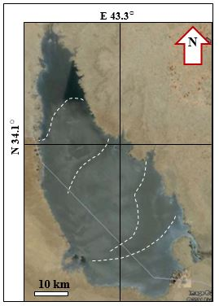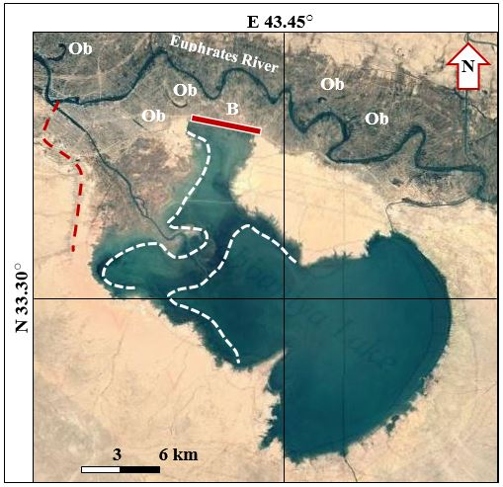

Figure 4: Satellite images, Left) Al-Tharthar Depression, note the escarpments marked by dashed white lines, Right) Al-Habbaniyah Depression, note the constructed barrier (B), traces of ancient courses of the Euphrates River (Dashed white lines and brown dashed lines), and Ox bows (Ob).
5.3. Al-Raz’zazah Depression
The estimated age of Al-Raz’zazah Depression using Exposure Dating Method [39] is Pliocene as indicated from the developed Najaf – Karbala Alluvial Fan (Fig. 5 Top) which has dissected the depression into two parts. The northern one called Al-Raz’zazah Depression and a southern one (B M in Fig. 5 Top) called Baher Al-Milih. The alluvial fan is of Pleistocene age; accordingly, the depression should be older.

The origin of the Raz’zazah Depression is not studied. However, [40] mentioned that the Euphrates River was crossing the depression after crossing the Hab’baniyah Depression and then following the nowadays course of the river southeast of Najaf City (Fig. 1). He also mentioned that the depression was the limits of the Arabian / Persian Gulf during the Pleistocene. However, the origin of Al-Raz’zah Depression is most probably related to Abu Jir Active Fault Zone which runs in NW – SE direction and passes through the area (Fig. 5 Top). As an active fault zone which forms the contact between the so called Stable and Unstable shelves of Iraq (example, [5,30, 41,42 ]); sag depressions and pressure ridges will exist in the concerned area. The presence of both Tar Al-Sayed and Tar Al-Najaf (TrN, and TrS, respectively in Fig. 5 Top) are good indications for this assumption [43].

Al-Raz’zazah Depression was the out flow of main valleys which drain the Western Desert towards east, among them are Wadi Al-Ghadif and Wadi Al-Ubayidh after crossing Al-Hab’bariyah Depression (Fig. 5 Top). The abnormal change of Wadi Al-Ubaidh when it merges in the depression is a good indication for the growth of the alluvial fan; moreover, the trace of the valley before being dissected due to the growth of the alluvial fan is still clearly visible east of the depression (TU in Fig. 5 Top). Then, the depression was divided into two parts by the growing alluvial fan and due to the activity of Abu Jir Active Fault Zone, the southern relics is still visible (BM in Fig. 5 Top). Due to the shortage of running water in the Euphrates river during the last 2 decades, the coverage area of the depression is drastically reduced (Fig. 5 Bottom).

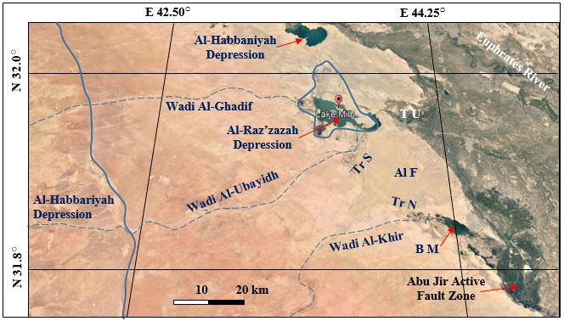
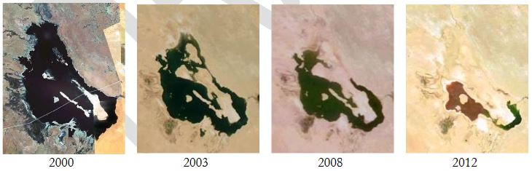

Figure 5: Al-Raz’zazah Depression, Top) Satellite image showing the depression and related features. AlF = Najaf – Karbala Alluvial Fan. TrS = Tar Al-Sayed, TrN = Tar Al-Najaf,
TU = Trace of Wadi Al-Ubaidh, Bottom) Four scenes of the depression showing drastic decrease in the coverage area.

5.4. Ga’ara Depression
The youngest exposed rocks in the Ga’ara Depression are of the Upper Eocene age, which means after that no more deposition. Therefore, the authors do believe; according to the mentioned data that the Ga’ara Depression started to be developed during the Oligocene and reached its nowadays form during the Late Pleistocene, as the majority of the present landscapes are developed. Moreover, the presence of thick calcrete (up to 7 m) in the floor of the depression is a good indication that the depression was existing before Pleistocene. This is assumption is based on the age of the calcrete, which is Early Pleistocene in the Western Desert [19,44]. However, to estimate numerical age for the development of the Ga’ara Depression, the opinion of [43] is adopted. They considered the rate of erosion of the rocks in semiarid climate depending on [36]. They calculated a rate of erosion in bare rocks under semiarid climate to be 2.55 tons/ hectare/ year that means 255 tons/ km²/ year. The coverage area of the Ga’ara Depression is 1383 km² with average depth of about 60 m. Therefore, the volume of the depression is about 82. 9 km³. The weight of the eroded rocks will be 190.67 X 10¹⁰ tons; assuming 2.3 gm/ cm³ specific gravity for the rocks. To calculate the required time for development of the Ga’ara Depression, the erosion rate of 255 tons/ km²/ year [36] is used. The rate of erosion is multiplied by the coverage area of the depression (1383 km²) to calculate the weight of the eroded rocks over the depression per year, which will be 352665 tons/ Ga’ara area/ year. And to calculate the required time for eroding of the rocks of the depression, the calculated weight of the rocks is divided by the calculated eroded weight of the rocks per year and that will be about 5406550 years. This calculated time interval indicates Pliocene [45].

The origin of the Ga’ara Depression is very complex. It is formed due to four reasons: 1) continuous erosion by means of water and wind as erosional agents, 2) accelerated by mass wasting processes along its four rims, 3) tectonic contribution and 4) the role of the exposed geological formations. The continuous uplifting and down warping of different parts of the involved area with different rates; since the Permian has formed intense cross jointing (shear and tension) (Fig. 6), beside long lineaments, which were occupied by valleys of different directions (SW – NE and SE – NW). The intense cross jointing system beside the crossed lineaments have accelerated and facilitated the weathering and erosion of the covering rocks, especially the soft and fairly hard rocks of the Ga’ara, Zor Horan, Rutba, Hartha, Digma and Akashat formations.

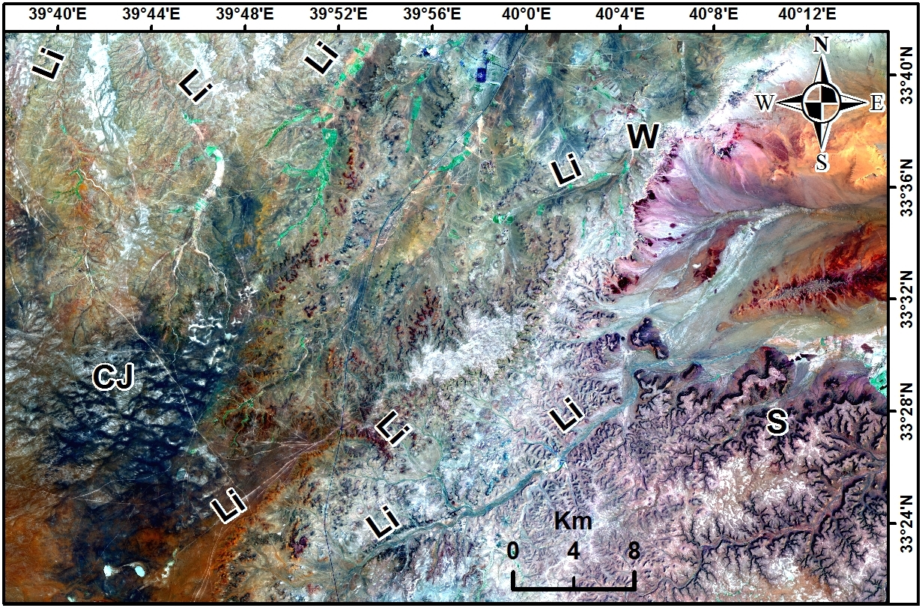

Figure 6: Landsat 8 OLI image showing intense cross jointing system (CJ) and the presence of lineaments (Li) west (W) and south (S) of the Ga’ara Depression (After [24])
5.5. Umm Chaimin Depression
The estimated age of the depression is a matter of debit. [15] estimated the age of the depression to be (50000 – 100000) years. This was based on a rate of deposition of 2 mm/ year, but he mentioned not to take this assumption as strict dating. [46] assumed post Eocene age. In this study, the estimated age by [47] is adopted. They used average rate of sedimentation in fluvial sediments in estimating the age of the depression. Accordingly, a sedimentation rate of 1.5 cm/ 10 years is assumed, depending on the assumed rate of 3.2 cm/ 10 years for fluvial sediments in littoral margins [33], this assumption is based on the fact that the Umm Chaimin Depression is a closed basin with very limited catchment's area. The thickness of the accumulated fluvial sediments at the floor of the depression is about 75 m; as indicated from the drilled borehole in the depression [14] By dividing the thickness of the penetrated fluvial sediments over the assumed depositional rate, a time interval of about 50000 years is indicated. In reviewing the geological time scale [45], then the age of the depression can be assumed as early Late Pleistocene, within the first humid phase of the Late Pleistocene. But, this dating cannot be considered as accurate dating.

The origin of the Umm Chaimin Depression is a matter of debate. Meteorite crater is suggested by [7], Volcanic origin is suggested by [8,9,12]; however, they suggested more erosional origin rather than volcanic. Gas explosion origin is suggested by [14,15,46]. [47] suggested karst origin. The current authors adopted the karst origin for the depression because the indication used by [31] confirms the karst origin. The used indications depend on many ratios of the depression as presented below:
The ratio of the diameter at the top of the depression to the diameter at the bottom of the depression [31] is: W_{t}/ W_{b} = 2.9/ 1.8 = 1.6
whereas, the depth / width ratio is: d/ W_{t} = 33/ 2900 = 0.001 and if the true depth (down to the fluvial fill) is considered, then: d/ W_{t} = 130/ 2900 = 0.045
where, W_{t} is the width in the top, W_{b} is the width in the bottom, and d is the depth.
From reviewing the indicated values and compared with those mentioned by [31], it can be concluded that the depression has collapse doline shape, which resembles the "tiankengs".

5.6. Al-Salman Depression
[48] claimed Pliocene age for Al-Salman Depression. However, the current authors adopted the estimated age by [22] which is Pliocene and may be even uppermost Late Miocene. This estimation depends on many facts: 1) The presence of the Zahra Formation (Pliocene – Pleistocene) in the floor of the depress, which means the depression was present before deposition of the Zahra Formation, 2) The development of such huge depression and many others in near surroundings, with surface area of about 200 km² and volume of about (1 – 7) × 10⁹ m³ needs very long time to be developed, after dissolving of the rocks and collapsing of the roof. Therefore, the uppermost Late Miocene age seems to be more relevant than Pliocene. However, the collapsing was not totally developed during Late Miocene, but most probably had started during Late Miocene; accelerated during Pliocene and reached the climax during the successive wet phases during Pleistocene and is still in progress, as the dissolution is in progress, but with lower degrees of karstification [22].

The origin of the Salman Depression is a karst of doline type. The continuous dissolution of the evaporate rocks of the Rus Formation and the carbonate rocks at the lowermost parts of the Dammam Formation lead to the subsidence of the upper layers of the Dammam Formation, then collapsing of the uppermost layers of the exposed Dammam Formation. Consequently, a large collapse doline was developed, which is called Al-Salman Depression (Fig.7). Development of such large karst forms due to solution of carbonate and/ or evaporite rocks, then collapsing of the overlying rocks (the roof) is a well-known phenomenon worldwide (White and White, 2006). Figure (7) shows many other depressions developed in the surroundings of Al-Salman Depression like Al-Had’daniyah, Al-Sa’a. The contour lines in Figure (7) clearly indicate conjugation of many depressions to form one large depression. Moreover, many others are still under development.
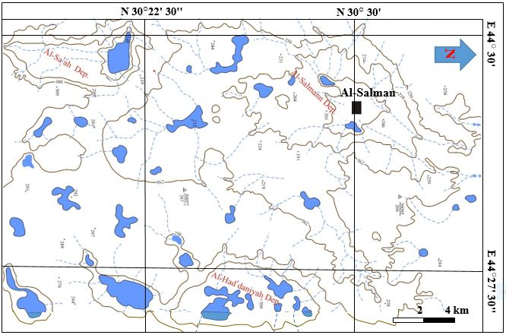

Figure 7: Topographic map showing Al-Salman Depression with other surrounding depressions. The blue colored areas are ponds which are inundated during rainy season.
(After [22]).

5.7. Al-Slaibat Depression
The age of Al-Slaibat Depression is estimated using Exposure Dating Method [39]. Figure (8) shows the location of Al-Slaibat Depression where there is an abandoned course of the Euphrates River which runs almost along the northern rim of the depression. This can be a good indication that the depression was like a big meander of the river and was abandoned after migration of the river northwards. Accordingly, the age of the depression is middle or late Holocene more likely. This is attributed to the fact that the flood plain is of Holocene in age and since the flood plain is effected then the depression should be younger than the flood plain.

The origin of Al-Slaibat Depression is not clear. It might be an isolated sag depression of Abu Jir Fault Zone as many others are present along the zone; for example, Sawa Lake which is located in the zone 75 km NW of Al-Slaibat Depression. Another possibility for the origin of the depression is; it is a large meander of the Euphrates River which was abandoned due to the migration of the river north wards and traces of an abandoned river course can be seen hitherto (Fig. 8). The northward movement of the river is attributed to the growth of the subsurface Samwa anticline.

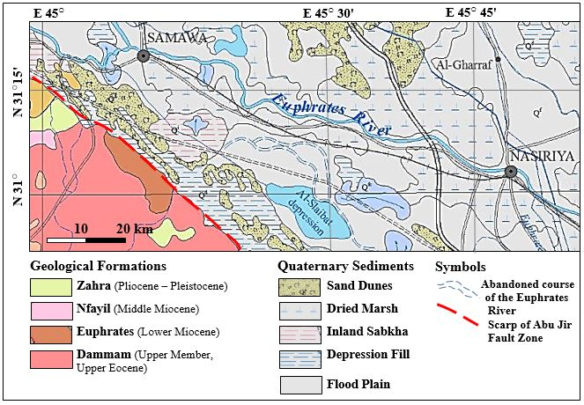

Figure 8: Geological map of Al-Slaibat Depression and surrounding area
(Modified from [6])

5.8. Dukan Reservoir (Depression)
The age of Dukan Depression is estimated using Exposure Dating Method (Keller and Pinter, 2002). Figure (9) shows Dukan Reservoir (Depression or lake) with many faults which have dissected the ridges of Ranya, Makook, Pallewan, and Khalikan anticlines. Consequently, large gaps appeared on the ridges along the fault planes (For example, points A and C, Fig. 9). Moreover, locally the whole ridge was moved down the ground surface (Point B Fig. 9); accordingly, the depression was formed. From those formed gaps in the ridges; some valleys have shifted from their original location. Many of those valleys were and some of them still are feeder channels for large alluvial fans. Those alluvial fans are of Pleistocene age[6,49,50] (; therefore, the faulting should be older; otherwise the valleys wouldn’t flow through the formed gorges along the anticlinal ridges. Accordingly, the age of the depressions which is formed due to faulting is Pliocene and can be older?.
The Dukan Depression is structurally controlled; it is developed by dissection of many ridges in its north western part by a set of faults in step form which caused down ward movement of the ridges; accordingly, the depression was developed [23]. All the faults have NE – SW trend, the longest fault is that which passes through point C (Fig. 9) and is responsible for development the western rim of the depressions almost in a straight line. During 2012 when the water level in the lake was drastically decreased, the continuation of the northwestern limb of Ranya anticline appeared along the rim.

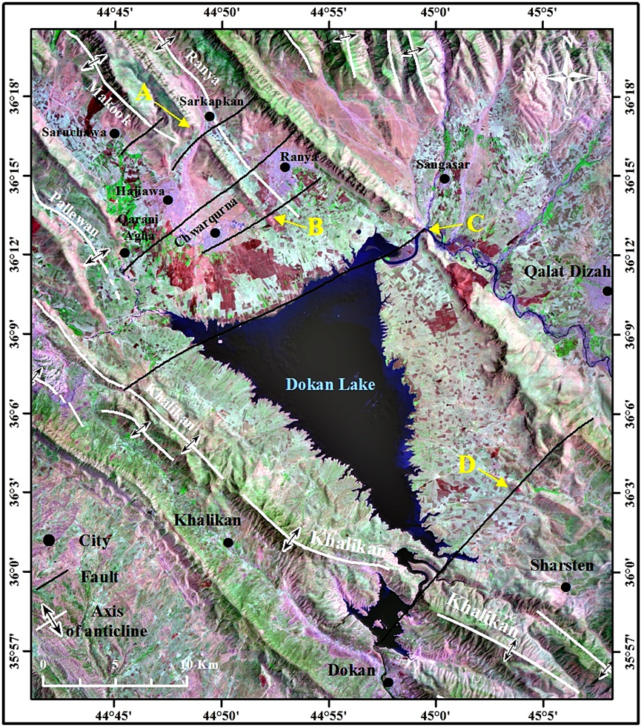
Figure 9: Landsat 5 TM image of Dukan Reservoir showing the supposed normal faults

5.9. Derbendikhan Reservoir (Depression)
The age of Derbendikhan Depression is estimated using Exposure Dating Method [39]. Figure (10) shows the geological map of Derbendikhan Reservoir (Depression or lake), it can be seen that the reservoir (originally depression) extends along Sirwan (Diyala) River and it can be divided into two parts. The lower part extends along the river across a set of anticlines and synclines, whereas the upper part extends in a gentle depression which is filled with Quaternary sediments. A deep seated fault runs along the Sirwan River [41] which has almost a straight shape course. This can be seen along the eastern bank of Derbendikhan Lake (Fig. 10). The fault has dissected many folds (inside the reservoir area and southwards), within the folds rocks up to Pleistocene age are exposed and dissected by the fault. Accordingly, the fault is younger than Early Pleistocene; therefore, the fault and the depression are most probably Middle Pleistocene or slightly younger.

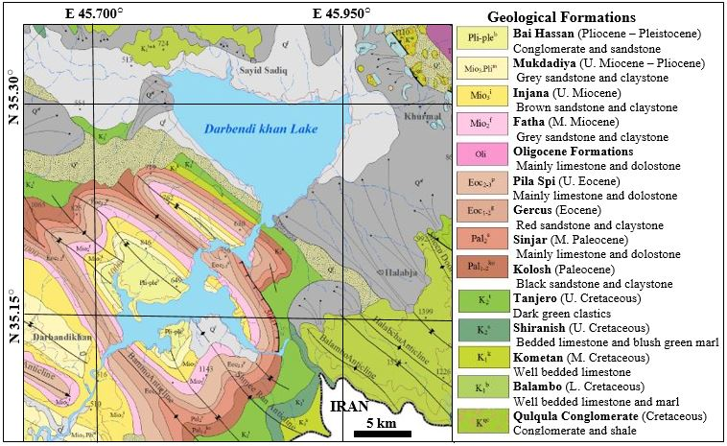
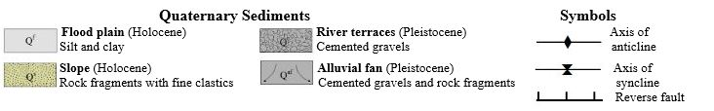

Figure 10: Geological Map of Derbendikhan Reservoir (Lake)
(After [29])

The Derbendikhan Depression is structurally controlled. The lower part extends along Sirwan deep seated fault besides the synclinal areas (Fig. 10). Whereas, the upper part extends in very broad and shallow syncline which is developed northeast of Halabcha anticline (Fig. 10) and extends northwest wards (the general trend of the folds) where the soft rocks of Shiranish and Tanjero formation are easily eroded and covered by flood plain and alluvial fans sediments (Fig. 10).

6 Conclusion

Tens of natural depressions are developed in Iraqi territory with different shapes, sizes, ages and origins. Some of them are structurally controlled; others are developed due to karstification. Majority of them have Pleistocene age; as indicated by using Exposure Dating Method, however, Ga’ara Depression is of Pliocene age. Almost all the mentioned depressions have utilized, especially for water management, others like Ga’ara, Umm Chaimin and Al-Salman are not because they are located in desert areas. Many other depressions like Habbariya, Hor Al-Shuwaicha, Abu Jir, marshes are very briefly mentioned.

References
[1] Colman-Saad, S.P., 1978. Fold development in Zagros simply folded belt, southwest Iran. AAPG Bulletin 62, 984-1003.
[2]Numan, N.M.S., 1997. A plate tectonic scenario for the Phanerozoic succession in Iraq. Geol. Soc. Iraq. Jour, Vol. 30, No. 2, p. 85 – 110.
[3]Blanc, E.J.P., Allen, M.B., Inger, S. and Hassani, H., 2003. Structural styles in the Zagros Simple Folded Zone, Iran. Journal of the Geological Society, London, Vol. 160, p. 401 – 412.
[4]Alavi, M., 2004. Regional stratigraphy of the Zagros Fold – Thrust Belt of Iran and its proforeland evolution. Amer. Jour. Sci., Vol. 304, p. 1 – 20.
[5]Jassim, S.Z. and Goff, J., 2006. Geology of Iraq. Dolin, Prague and Moravian Museum, Brno, 341 pp.
[6]Sissakian, V. and Fouad, S.F., 2012. Geological Map of Iraq, scale 1:1000000, 4th edition. Iraq Geological Survey Publications, Baghdad, Iraq.
[7]Marriam, R. and Holwerda, J.G., 1957. Al-Umchaimin, a crater of possible meteoritic origin in Western Iraq. Geog. Jour., Vol. 123, p. 231 – 233.
[8]Mitchell, R.C., 1958. The Al-Umchaimin crater, Western Iraq, Geog. Jour., Vol. 124, p. 578 – 580.
[9]Al-Naqib, K.M., 1967. Geology of the Arabian Peninsula. USGS Professional paper No. 560-g, 54 pp.

[10]NEDECO, 1959. Report on Wadi Tharthar study. Iraq Geological Survey Library Report No. 153.
[11]Soosa, A., 1966. Floods of Baghdad in History, Vol.3. Al-Adeeb Press, Baghdad, Iraq (in Arabic).
[12]Al-Din, T.S., Al-Sanawi, S.A. and Matolin, M., 1970. Al-Umm Chaimin Depression, Western Iraq. Not an Astrobleme. Jour. Geol. Soc. Iraq, Vol. III, No. 1.
[13]Blizkovisky, M., 1971. Geophysical measurements in the area of Al-Umm Chaimin topographic depression. Iraq Geological Survey Library Report No. 494.
[14]Hagopian, D.H., 1979. Regional geological mapping of Nahidain – Tinif area. Iraq Geological Survey Library Report No. 983.
[15]Jassim, S.Z., 1980. Umm Chaimin Depression, Western Desert. Iraq Geological Survey Library, manuscript report.
[16]Sissakian, V.K., Al-Kadhimi, J.A.M., Abdul Husain, A.A. and Hussien, B.M., 1991. Final Regional Report, Site selection of Nuclear Power Plant in Iraq, Baiji – Samarra Area. Iraq Geological Survey Library Report No. 2026.
[17]Tamer Agha, M.Y., Numan, N.M.S. and A-Bassam, Kh.S. 1996. The Ga’ara anticline in Western Iraq, a structural fiasco. Rafidian Journal of Science, Vol. 8, No. 2, p. 56 – 70.
[18]Hamza, N.M., 1997. Geomorphological Map of Iraq, scale 1: 1000 000. Iraq Geological Survey Publications, Baghdad, Iraq.
[19]Hamza, N.M., 2007. Geomorphology. In: Geology of the Western Desert. Iraqi Journal of Geology and Mining, Special Issue No. 1, p. 9 – 28.
[20]Fouad, S.F., 2007. Tectonic and Structural Evolution. In: Geology of the Western Desert. Iraqi Journal of Geology and Mining, Special Issue No. 1, p. 29 –50.
[21]Sissakian, V.K., 2011. Genesis and Age Estimation of the Tharthar Depression, Central West Iraq. Iraqi Bulletin of Geology and Mining, Vol. 7, No. 3, p. 47 – 62.
[22]Sissakian, V.K., Mahmoud, A.M. and Ali M. Awad, A.M., 2013. Genesis and Age Determination of Al-Salman Depression, South Iraq. Iraqi Bulletin of Geology and Mining, Vol. 9, No. 1, p. 1 – 16.
[23]Sissakian, V.K., Abdul Ahad, A.D., Al-Ansari, N., Hassan, R. and Knutsson, S., 2016. The Regional Geology of Dokan Area, NE Iraq. Journal of Earth Sciences and Geotechnical Engineering, Vol. 6, No. 3, p. 35 – 63.
[24]Sissakian, V.K., Shihab, A.T. and Al-Ansari, 2018. The Geology and Evolution of the Ga’ara Depression, Iraqi Western Desert. Journal of Earth Sciences and Geotechnical Engineering, Vol. 8, No. 1, p. 65 – 90.
[25]Abdullah, M., Al-Ansari, N. and Jan Laue, J., 2019. Water Resources Projects in Iraq: Reservoirs in the Natural Depressions. Journal of Earth Sciences and Geotechnical Engineering, Vol. 9, No. 4, p. 137 – 152.
[26]Hassan, H.M. and Hassan, E.A., 1995. Geological Map of Rutbah Quadrangle, scale 1:250000. Iraq Geological Survey Publications, Baghdad, Iraq.
[27]Barwary, A.M. and Slaiwa, N.A., 1995. Geological Map of H1 Quadrangle, scale 1:250000. Iraq Geological Survey Publications, Baghdad, Iraq.
[28]Sissakian, V. and Fouad, S.F., 2014a. Geological Map of Erbil and Mhabad quadrangles, scale 1: 250000, 2nd edition. Iraq Geological Survey Publications, Baghdad, Iraq.
[29]Sissakian, V. and Fouad, S.F., 2014b. Geological Map of Sulaimaniyah Quadrangle, scale 1: 250000, 2nd edition. Iraq Geological Survey Publications, Baghdad, Iraq.
[30]Fouad, S.F., 2012. Tectonic Map of Iraq, scale 1:1000000, 3rd edition. Iraq Geological Survey Publications, Baghdad, Iraq.
[31]White, W.B. and White, E., 2006. Size scales for closed depression landforms: The place of tiankengs. Speleogenesis and Evolution of Karst Aquifers. The Online Scientific Jour., ISSN 1814-294X.
[32]Jado, A.R. and Zofl, J.G., 1978. Quaternary Period in Saudi Arabia, Vol.2. Springer Verlag, New York, p. 280 – 294.
[33]Bookstrom, A.A., Stephen, E.B., Fousek, R.S., Wallis, J.C., Kayser, H.Z. and Jackson, B.L., 2004. Baseline and historic depositional rates and lead concentration in flood plain sediments, Lower Coeur d`Alene River, Idaho. USGS, Open file Report, 2004/ 1211, Internet Data.
[34]Gradstein, F.M., Ogg, J.G. and Smith, A.G., 2004. A new Time Scale. Episodes, Vol. 27, No. 2.
[35]Bull, W.B., 1979. Threshold of critical power in streams. Bulletin of Geology of Society of America, 90, p. 453 – 464.
[36]Balasubramani, K. Veena, M., Kuaraswamt, K. and Sravanbavan, V., 2015. Estimation of soil erosion in a semi-arid watershed of Tamil Nadu (India) using revised universal soil loss equation (rusle) model through GIS. Modeling Earth Systems and Environment, October, 2015, 1:10. DOI: 10.1007/s 40808-015-0015-4.
[37]Al-Bassam, Kh. S., 2007. Mineral Resources. In: Geology of the Western Desert. Iraqi Journal of Geology and Mining, Special Issue No. 1, p. 145 –168.
[38]World Bank, 2006. Dokan and Derbendikhan Dams Inspections. https://en.wikipedia.org/wiki/Darbandikhan_Dam
[39]Keller, E. A., and Pinter, N. 2002. Active Tectonics, Earthquakes, Uplift and Landscape, 2nd edition. New Jersey: Prentice Hall.
[40]Al-Sakini, J.A., 1993. New look on the history of old Tigris and Euphrates Rivers, in the light of Geological Evidences, Recent Archeological Discoveries and Historical Sources. Publication of Oil Exploration Co. Baghdad, Iraq, 93 pp (in Arabic).
[41]Buday, T. and Jassim, S.Z, 1987. Tectonic Map of Iraq, scale 1:1000000, 1st edition. Iraq Geological Survey Publications, Baghdad, Iraq.
[42]Al-Kadhimi, J.A.M., Sissakian, V.K., Fattah, A.S. and Deikran, D.B., 1996. Tectonic Map of Iraq, 2nd edit., scale 1: 1000 000. GEOSURV, Baghdad, Iraq.
[43]Sissakian, V.K., Abdul Jab'bar, M.F., Al-Ansari, N. and Knutson, S., 2015. The origin of Tar Al-Say'ed and Tar Al-Najaf, Karbala – Najaf vicinity, Central Iraq. Journal of Civil Engineering and Architecture, Vol. 9, p. 446 – 459. doi: 10.17265/1934-7359/2015.04.008.
[44]Sissakian, V.K., 1988. Engineering Geological Report on Al- Rutbah – Kilo 160 – H1– Akashat –Tinif area. Iraq Geological Survey Library Report No.1 745.
[45]I.C.S. (International Committee on Stratigraphy), 2016. Stratigraphic Chart. Geological Time Scale Foundation and International Stratigraphic Commission. www.stratigraphy.org.
[46]Al-Hashimi, H.A., 1982. Contribution to the origin of Umm Al-Chaimin depression, Western Desert, Iraq. Jour. Geol. Soc. Iraq, Vol. 15, No. 1, p. 35 – 39.
[47]Sissakian, V.K. and Abdul Jab’bar, M.F., 2008. Using Remote Sensing and GIS Techniques in Detecting the Origin of Umm Chaimin Depression, West Iraq. Iraqi Bulletin of Geology and Mining, Vol. 4, No. 2, p. 51 – 72.
[48]Ma'ala, Kh.A., 2009. Geomorphology: In the Geology of the Iraqi Southern Desert. Iraqi Bulletin of Geology and Mining, Special Issue, No. 2, p. 7 – 33.
[49]Sissakian, V.K. and Al-Jiburi, B. M., 2014. Stratigraphy. In: Geology of the High Folded Zone. Iraqi Bulletin of Geology and Mining, Special Issue No.6, p. 73 – 161.
[50]Sissakian, V.K., Kadhum, T.H. and Abdul Jab'bar, M.F., 2014. Geomorphology. In: The Geology of the High Folded Zone. Iraqi Bulletin of Geology and Mining, Special Issue No. 6, p. 7 – 56.

University of Kurdistan Hewler, KRG, Iraq, f.khajeek@ukh.edu.krd
Lulea University of Technology, Lulea 971 87, Sweden. nadhir.alansari@ltu.se ³ Consultant Engineer, Norrköping, Sweden, nasrat.adamo@yahoo.com ⁴ Retired Senior Chief Geologist, iyda1955@yahoo.com

