Old Alluvial Fan Relics in North and Northeast Iraq

Varoujan K. Sissakian 1, Hala. A. Al-Mousawi², Nadhir Al-Ansari³, Sven Knutsson⁴

ABSTRACT
The southern part of Sulaimaniyah Governorate and northern parts of Erbil, Kirkuk and Diyala Governorates are mountainous and hilly areas, the relief difference ranges from (50 – 500) m. Tectonically, they represent the contact between the Low Folded and High Folded Zones, which is marked by an outstanding geomorphological feature that is a continuous limestone ridge represented by the Pila Spi Formation (Late Eocene). The ridge form the southwestern limb of tens of anticlines that have NW – SE trend.

The continuous ridge faces; south and southwest ward a highly dissected plain, which is covered by clastics of Injana, Mukdadiya and Bai Hassan formations, the plain forms typical badland morphology. Moreover, the Pila Spi Formation is overlain mainly by the Fatha Formation (Middle Miocene), it consists of clastics alternated with rare limestone and gypsum. However, locally, the Pila Spi Formation is overlain by Oligocene and Early Miocene rocks, mainly of carbonate.

During Pleistocene, due to wet phases, the flat plain was a favorite depositional basin for the flowing rivers, streams and valleys from the north and northeast to deposit their carried loads after gradient changes. Accordingly, huge amount of sediments were laid down in form of alluvial fans that are usually capped by calcrete. The developed fans were covering vast areas that extend southwards; about 45 Km from the main ridge of the Pila Spi Formation.

The thickness of the alluvial fans is highly variable, it ranges from (3 – 15) m. The main constituents are also variable; either consists mainly of carbonates that are derived from the Pila Spi Formation cemented by calcareous and sandy materials, or consists of pebbles; derived mainly from the Bai Hassan Formation, which are carbonates and silicates, with subordinate amounts of igneous and metamorphic rocks cemented by calcareous and sandy materials with rare gypsuous materials too. The size of the clasts is also variable, in the former case they reach up to 50 cm, whereas in the latter case, they reach up to 30 cm.

During Holocene, most probably late Holocene, the alluvial fans have suffered from intense erosion, consequently large parts were eroded and washed out by the developed dense drainage system. The remaining parts nowadays, are in form of relics capping folded rocks of Fatha, Injana, Mukdadiya and Bai Hassan formations. Those which are nearby the main ridge form plateaus of different sizes, with gentle inclination manifesting the paleo-relief. Whereas, those which are far from the main ridge; form almost flat areas, occasionally are occupied as agricultural fields.
Key words: Alluvial fan, Plateau, Pleistocene, Iraq

------------------------------------------------------------
¹ Consultant Geologist, Iraq, Erbil Ainkawa
² Assistant Chief Geologist, Iraq Geological Survey, Baghdad, Iraq
^{3&4}Lulea University of Technology, Sweden.

1. INTRODUCTION
Relics of old alluvial fans can be seen in different parts of north and northeastern parts of Iraq, within Sulaimaniyah, Erbil, Kirkuk and Diyala governorates, covering considerable areas within the folded rocks of the Fatha, Injana, Mukdadiya and Bai Hassan formations, in areas forming typical badlands. The alluvial fans witness wet phases during Pleistocene that have caused their deposition; however, they were subjected to intense erosion during late Holocene, leaving them as relics that form either small plateaus or rounded hillocks.

The aim of this study is to discuss the origin of the present relics of alluvial fans, their types and geographic extends. Moreover, to deduce their main constituents and their relation with the pre-Quaternary exposed rocks.

The location of this study extends in three governorates at the northern and northeastern parts of Iraq (Fig.1). The coverage area of this study is about 5000 Km².

40 Km

Fig.1: Approximate location of the studied area.

  - Materials Used and Methodology

To achieve the aim of this study, the following materials were used:
- Geological maps, at scale of 1: 100 000, 1: 250 000 and 1: 1000 000
- Topographical maps, at scale of 1: 100 000
- Google Earth, DEM and Satellite images
- Relevant published articles and reports

The geological and topographical maps with the Google Earth, DEM and Satellite images were used to recognize the coverage areas of relics of alluvial fans in the studied area.

Field work was carried out in August - October, 2014 to acquire interesting data, like type of sediments; their description, thicknesses, and inclination of slopes; many interesting and representative land forms and geomorphological units were photographed too. Some structural data were also reviewed to elucidate the relation between the orientation of the valley and the present structural features.

Within GIS and Digital Elevation Model (DEM) applications, spatial analysis and hydrological tools of Arc GIS were used to calculate coverage areas of some geomorphological forms and their inclinations.

  - Previous Studies
Although many worker dealt with the study area, but none of the existing works have mentioned about the details of the relics of alluvial fans. The hereinafter works have dealt with different geological aspects in the studies area.
- Hamza (1997)[1] compiled the Geomorphological Map of Iraq at scale of 1: 1000 000, but did not represent the Quaternary sediments in the studied area.
- Sissakian (1993)[2] compiled the Geological Map of Kirkuk Quadrangle, at scale of 1: 250000 and presented some slope sediments instead of relics of alluvial fans.
- Barwary and Slewa (1994)[3] compiled the Geological Map of Khanaqin Quadrangle, at scale of 1: 250000, but did not present the alluvial fans.
- Barwari et al. (2003)[4] compiled the Quaternary Sediments Map of Iraq, scale 1: 1000 000, but did not represent the Quaternary sediments in the studied area.
- Sissakian and Fouad (2012)[5] compiled the Geological Map of Iraq at scale of 1: 1000 000, but did not represent the Quaternary sediments in the studied area.
- Sissakian and Fouad (2014)[6,7,8] updated the Geological Map of Kirkuk, Erbil and Mahabd, and Sulaimaniyah Quadrangles, scale 1: 250 000, and presented the relics of the alluvial fans.

2. GEOLOGICAL SETTING
The geological aspects of the studied area are described hereinafter; briefly, based on Sissakian and Fouad [5,6,7,8].

  - Geomorphology
The most significant geomorphological features in the studied area are:
    - Alluvial Units: These are represented by: Alluvial fans, Pediments, Calcrete, River terraces, Infill valley sediments and Flood plain sediments. They all are well developed with huge thicknesses that exceed 3 m and locally more than 10 m.

The alluvial fan sediments and calcrete are emphasized on because they form the scope of this study.
Alluvial Fans: These are developed mainly along the slopes of the Pila Spi Formation, which represents the first continuous ridge being the contact between the High Folded and Low Folded Zones, and on top of folded rocks of the Fatha, Injana, Mukdadiya and Bai Hassan formations. Some of them ate more than 45 Km far from the aforementioned ridge. The youngest alluvial fans are coalescent forming Bajada, whereas the old fans are very large. The clasts are derived mainly from the Pila Spi Formation, up to 50 cm in size, but generally range in size from (5 – 15) cm in the apex part, and finer in the proximal parts. Spherical in shape, rounded to well rounded, in the proximal part, whereas sub-angular to sub-rounded at the apex part. However, those which are far from the ridge of the Pila Spi Formation, consist mainly of pebbles derived from the Bai Hassan Formation, the pebbles range in size from (1 – 10) cm and may reach to 40 cm.

Calcrete: Almost all alluvial fans near the ridge of the Pila Spi Formation are covered by calcrete with thickness ranges from (1 – 3) m; however, locally the thickness reaches more than 5 m, like in Sartaq Bammu area [9]; south of Derbendi Khan town. The main constituent of the calcrete is derived from the Pila Spi Formation, the clasts range in size from (1 – 15) cm (Fig.2, Left), and rarely may exceed 1 m, mainly angular. The cement is calcareous materials with fine clastics forming very hard cement. The vast extension of the calcrete in the studied area (Figs.2. Right) indicates that the whole area was covered by calcrete during the Pleistocene, consequently indicating wet phase. The calcrete cover; however, started to be disintegrated due to erosion by dense rills (Figs.1, Right) leading the exposure of the alluvial fan sediments, which are less resistant to erosion, as compared to the calcrete and/ or the underlying formation.

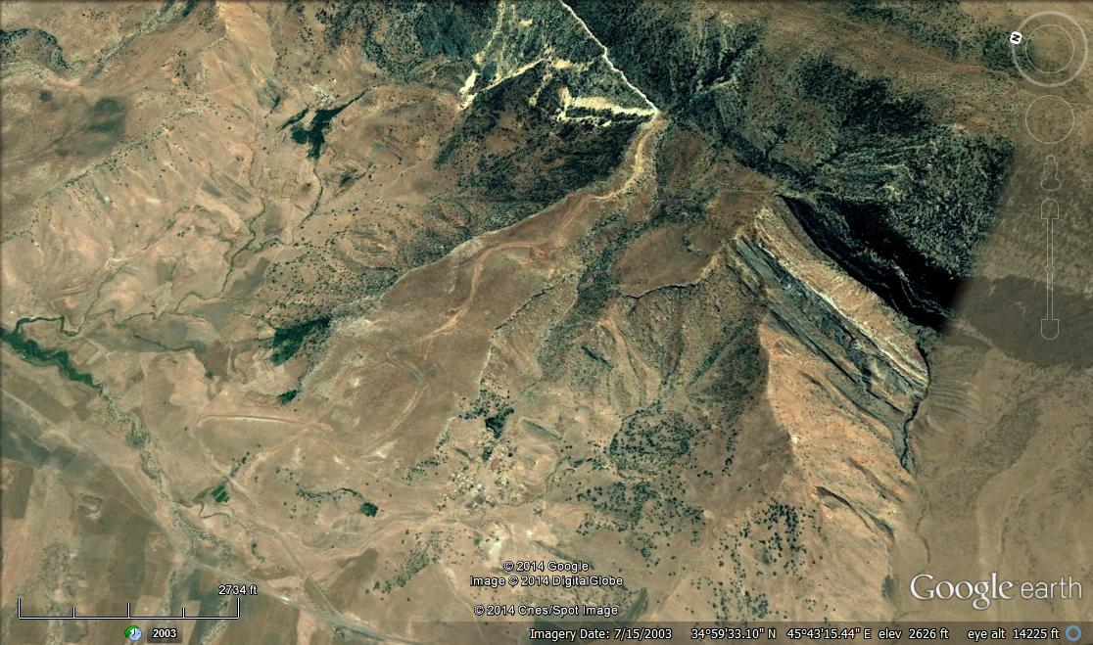
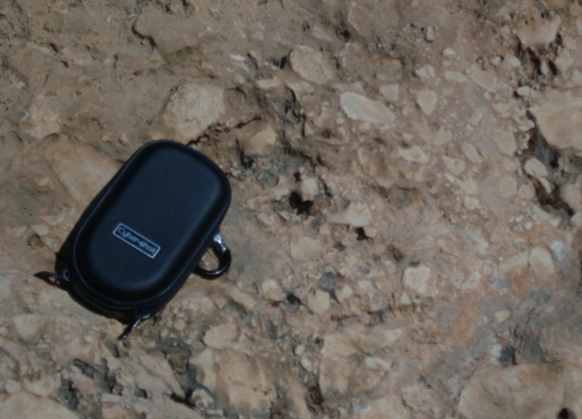
1 Km

C

Fig.2: Left) Details of calcrete in Sartaq Bammu area (After ]9])
Right) Google Earth image facing west, of calcrete (C) capping alluvial fan
in Sartaq Bammu area, southeast of Sulaimaniyah

2.1.2. Structural – Denudational Units: Among these units the best developed are: Cuestas and Hogbacks (Fig.3), which are well developed in Fatha, Injana, Mukdadiya and Bai Hassan formation. Flat irons are also well developed in well bedded Pila Spi Formation. Dissected slopes are well developed within all exposed formations in the studied area. Bad land form is developed locally, within the Bai Hassan Formation.

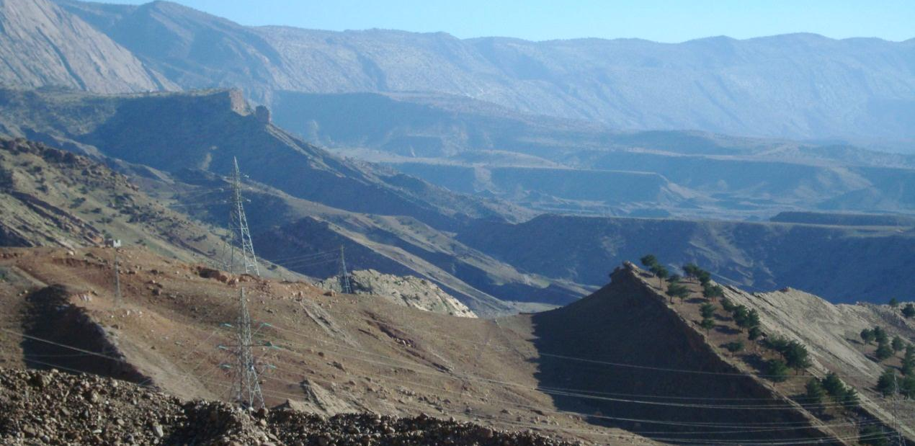
2
1
2
1

Fig.3: Hogbacks in Injana Formation capped by old alluvial fan, topped by calcrete
with two levels (1 and 2); in Sartaq Bammu, southeast of Sulaimaniyah.
In the back ground is the ridge of the Pils Spi Formation.

2.2. Tectonic and Structure
The studies area is located mainly within the Low Folded Zone and small parts within the High Folded Zone of the Unstable Shelf [10, 11; however, according to Fouad [12] both zones are located within the Outer Platform, which belongs to the Arabian Plate. The High Folded Zone is characterized by NW – SE trending long and narrow anticlines separated by shallow and wide synclines. Whereas, the Low Folded Zone is characterized by long and narrow anticlines, some of them exhibit thrusting of their northeastern limbs over the southwestern limbs, causing disappearance of the axis and part of the southwestern limbs too.

2.3. Stratigraphy
The exposed geological formations in the studied area range in age from Eocene to Pliocene with different types of Quaternary sediments [3, 5,6,7,8]. The exposed formations in the valley are briefly described hereinafter.

2.3.1. Pila Spi Formation (Middle – Late Eocene)
The Pila Spi Formation is exposed along the contact area of the High Folded Zone with the Low Folded Zone. It forms a continuous ridge with conspicuous outstanding geomorphological feature. The formation consists of well bedded, white and grey limestone and chalky marl with chert nodules, underlain by well bedded, hard, porous, poorly fossiliferous limestone with dolomitic limestone. The thickness of the formation varies between (50 – 120) m.

2.3.2. Fatha Formation (Middle Miocene)
The Fatha Formation is exposed widely in the studied area; it consists of cyclic repetition of red claystone, marl, gypsum and occasional interbeds of limestone and sandstone. The red bed claystone and sandstone are dominated on the other facies. The marl and/ or claystone beds are reddish brown in color rather than green. It is characterized by prevailing siltstone and sandstone horizons of reddish brown color. The thickness of the formation is less than 100 m.
2.3.3. Injana Formation (Late Miocene)
The Injana Formation is exposed widely in the studied area; it consists of grey and brown sandstones interbedded with brown claystones and reddish brown siltstones in cyclic nature. Besides, the sandstone horizons have cross-bedding and clay balls sedimentary structures. The thickness of the formation is 150 m.

2.3.4. Mukdadiya Formation (Late Miocene – Pliocene)
The Mukdadiya Formation is exposed widely in the studied area; it consists of alternation of yellowish grey to brown claystones with grey pebbly sandstones and brown to grey siltstones. Some of the sandstone horizons are pebbly, the pebbles increase in abundance upwards. Besides, the sandstone horizons have cross-bedding; clay balls and channel fill sedimentary structures. The thickness of the formations is 400 m.

2.3.5. Bai Hassan Formation (Pliocene – Pleistocene)
The Bai Hassan Formation is youngest formation, which is exposed at studied area covering vast parts and representing a main source for the alluvial fans. The formation consists of thick and coarse conglomerates (up to 80 m thick) alternating with thick brown claystones and thin sandstones. The pebbles of the conglomerates are well rounded, almost spherical in shape; composed of silica, and carbonates, with less abundant igneous and metamorphic rocks. The size of the pebbles reaches 30 cm, but the usual size is (5 – 10) cm. The cementing materials are calcareous with quartz grains matrix. The exposed thickness of the formation is about 1500 m.

2.3.6. Quaternary Sediments
The studied area is relatively rich in Quaternary sediments. They are formed due to the continuous denudational processes during Pleistocene to the present day. Quaternary sediments are of different types; locally they are merging into each other.

3. CLIMATE
The climate plays very big role in formation of alluvial fans. The role of the climate in formation of alluvial fans is discussed by different authors, among them are [13,14,15].They all believe that the climatic changes influence the weathering, stream flow, mass movements and sediment supply in the drainage basin above the fan; as well as the gullying, and soil development on fan deposits, besides the base-level of a closed basin. Therefore, the role of the climate in formation of alluvial fans is essential, and it is one of the main and major factors that play role in their formation.

The relics of the alluvial fans of the studied area indicate prevailing of a wet climate that had caused the formation of the existing alluvial fans through running water in the streams down the main ridge od the Pila Spi Formation. This is true, because water is the creative force that builds the alluvial fans through surges of water down slope [16]. Although the present climate is quite different from that, which was prevailing during the formation of the alluvial fans; drier climate prevails until now, but, still recent alluvial fans can be seen in the studied area, which are active and are supplied by recent sediments. This is because "the supply of the sediments to develop alluvial fans is possible even in scarce rainfall" [16]. Moreover, "the fan characteristics can only be explained by cyclic changes in processes by climatic changes and thus, every fan has trace properties unrelated to the present conditions acting on the fan system" [15].
4. ALLUVIAL FANS
  - General
Alluvial fans are apron-like deposits of granular debris that extend from the base of a mountain front to a low land below. Each fan radiates from a single source channel, and has fan-like shape in plain view. Its transverse profile is arched, and the longitudinal profile is slightly concave. Slopes are usually less than 10º. The fans are best developed in semiarid deserts, where elongate mountain ranges that are tectonically active (basin-and-range topography) and lack protective vegetation cover, are subjected to erosion by episodic heavy rain precipitation [14]. In the study area, the main ridge of the Pila Spi Formation is the source area for formation of the alluvial fans; it forms an elongated continuous ridge with different elevations, which range in relief difference rage from (50 – 150) m, almost with poor vegetation cover, forming the range topography. In front of the ridge, is the depositional basin, where the alluvial fans are formed, usually covered by rocks of the Fatha, Injana, Mukdadiya and Bai Hassan formations [2,3,5,6,7,8]. Therefore, the "basin- and- range topography" is typically formed in the study area.

  - Formation of Alluvial Fans
Alluvial fans are formed due to decrease of gradient of a stream; due to drop in local base level, hence the coarse grained solid materials carried by the water are dropped. As this reduces the capacity of the channel, the channel will change direction over time; gradually building up a slightly mounded or shallow fan shape. Therefore, the sediments are usually poorly sorted (Fig.4). "The fan shape can also be explained with a thermodynamic justification: the system of the sediment introduced at the apex of the fan will trend to a state, which minimizes the sum of the transport energy involved in moving the sediment and the gravitational potential of material in the cone" [16]. Therefore, there will be iso-transport energy lines forming concentric arcs about the discharge point at the apex of the fan. Thus, the materials will tend to be deposited equally about these lines, forming the characteristic cone shape [17]. The shape of the fans is related to grain size. Fans built of boulders and cobbles have a high pronounced arch, whereas, those built of silt, sand and fine gravels have broad, flattened profiles [14]. However, this study deals with the relics of old alluvial fans; therefore, the true shapes are already vanished due to weathering and active erosion.

4.3. Relics of Alluvial Fans
In the studied area, the components of the alluvial fans, like Active stream channels that originate in the mountains and which transport detritus to areas of deposition as well as cut into, erode, or override previous deposits, Abandoned and locally elevated older areas of deposition, which lie between channels, Internally formed dendritic channels within older deposits that erode the developed surfaces and redistribute the debris to depositional areas down slope, active depositional lobs, and "bar and swale" micro-topography, [14] are all almost vanished because only relics of the fans are dealt in this study.

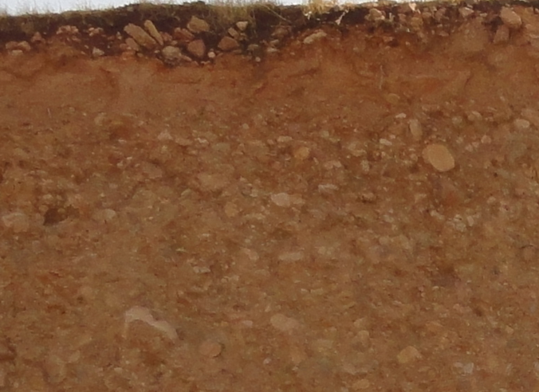
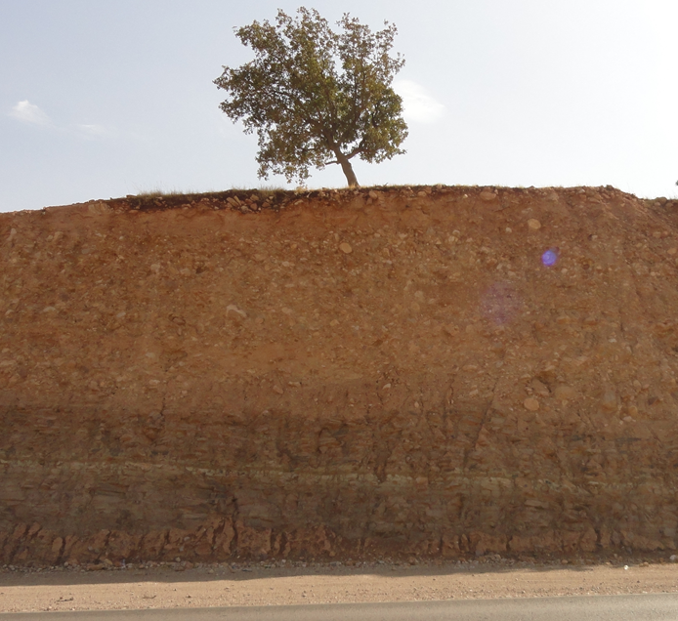

Fig.4: Badly sorted sediments of an alluvial fan, along Kirkuk – Sulaimaniyah road

  - Types of Alluvial Fans
In the studied area, according to the lithological constituents, three types of alluvial fans are developed; these are: 1) The clasts are mainly derived from the Pila Spi Formation, 2) The clasts are derived mainly from the Bai Hassan Formation, and 3) The clasts are mixed of recent disintegrated materials of different rock types. However, according to their ages, only two types are present. These are: 1) Pleistocene alluvial fans and 2) Recent alluvial fans. It is worth mentioning that Sissakian and Abdul Jab'bar [18] have classified alluvial fans in Iraq, accordingly all the existing alluvial fans in the studied area are of Single Stage alluvial fans, with Small, Medium and Large Sizes, some of them are capped by calcrete, others by soil.

In this studied, the tone of the alluvial fans are used to differentiate between old and recent fans, since light tone parts of alluvial fans are the younger and active parts of the fans (USGS, 2004). Besides, the presence of the calcrete and soil cover on the top that are also characteristics and can be used for differentiation.

  - Genesis
According to the genetic sense, fans are classified by Blair and McPherson in [19] into two types: Type I and II. The classification depends mainly on: grain size; their shape and sorting, feeder channel length, drainage basin size, bed rock lithology and average slope. Following these parameters, though not all of them are present, the alluvial fans of the studied area could be classified as Type I, for the fans derived from the Pila Spi Formation and Type II, for those derived from the Bai Hassan Formation (Fig.5).

The water/ sediments ratio also plays big role in defining the size of the transported materials, consequently defining the shape of the fan [19]. In the Type I fans, because the transporting energy was very large, due to high gradient; therefore, the transported materials were large with high concentration, consequently the water/ sediments ratio was low, leading to highly viscous transporting media. This highly viscous transporting media had transported large boulders (up to 0.5 m) for a distance of (2 – 6) Km in form of "Transitional flow" and very rarely in form of "Debris flow". Therefore, the Type I fans have typical fan shape, as can be deduced from the bottom morphology of the overlying calcrete (Fig.6). On contrary, the water/ sediments ratio in the Type II was high, because the gradient was low; consequently the size and concentration of the transported materials were low. Therefore, the transportation media was as "Stream flow" and the deposited materials were of fine size (Fig. 4); consequently the shape of the fans was not typical fan shape, but longitudinal; therefore they cover vast areas (Figs.7 and 8). It is worth mentioning that all the alluvial vans underwent erosion now.

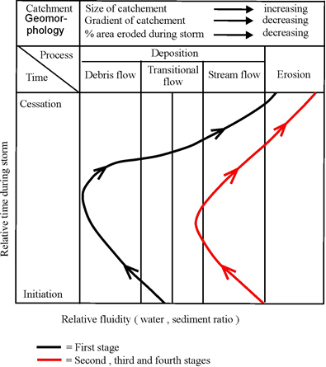
Type I
Type II

Fig.5: Conceptual model showing the change in the water/ sediments ratio, the sequence of depositional and erosional events and associated flow conditions, in the alluvial fans derived from the Pila Spi (Type I) and Bai Hassan formations (Type II) (modified after [19])

  - Constituents of the Alluvial Fans
The constituents of the alluvial fans are higly different. In the Type I, which are derived from the Pil Spi Formation, the pebbles consist mainly of dolomite and dolomitic limestone cemented by calcareous cemnet, subangular to subrounded and range in size from (1 – 50) cm (Fig6). Whereas, in the Type II, which are derived from the Bai Hassan Formation, the pebbles consists of carbonates and silicates with less abundant igenous and metamorphic rocks, cemented by calcareous and sandy cement, pebbles are ronded and range in size from (1 – 40) cm. Therefore, the cement of the first type is harder than the second type. Moreover, the fans of the first type are always capped by calcrete (Figs.2 and 7), whereas those of the second type are capped by soil, lost their fan shape and usually occupied as agricultural lands (Figs.4, 8 and 9). The thickness is variable, it ranges from (3 – 15) m, with some exceptions.
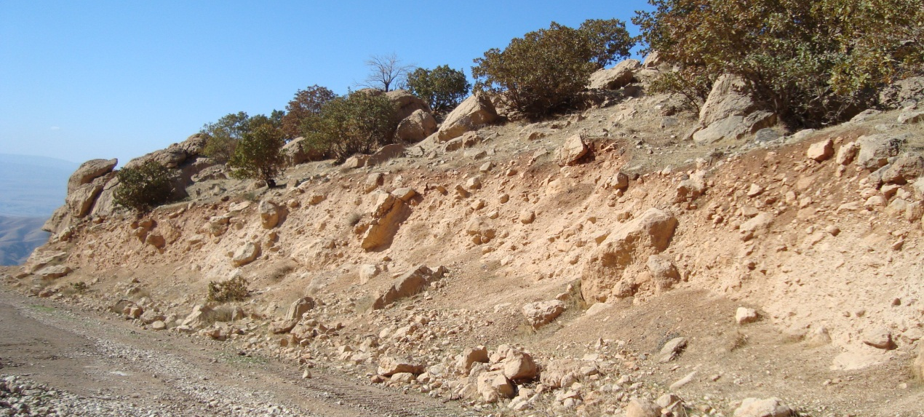
Fig.6: Constituets of alluvial fan along Bammu Mountain, SE of Sulaimaniyah city,
1 Km

2 Km

capped by brocken pieces of calcrete
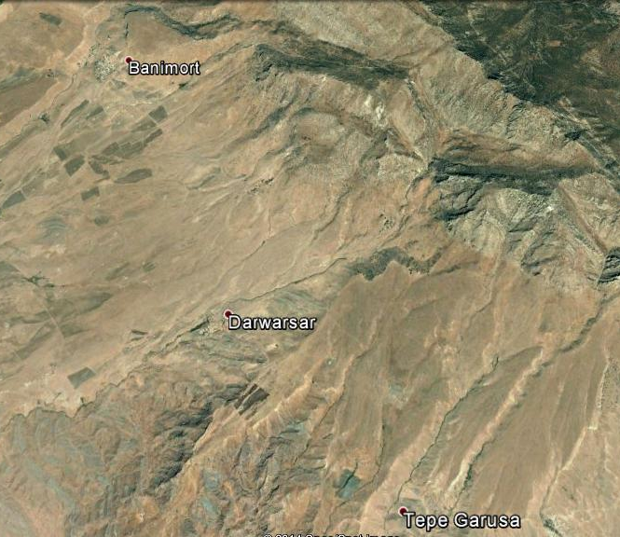
Fig.7: Google Earth images, relics of alluvial fans derived from the Pila Spi Formation
Left) Along Qra Dagh antilcine, Right) Along Bammu anticline

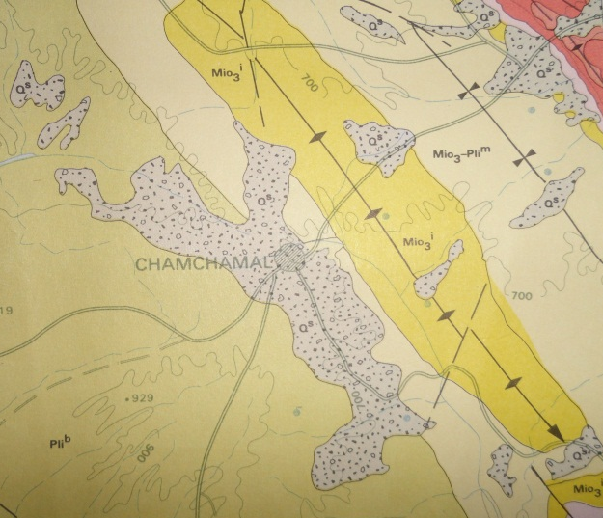
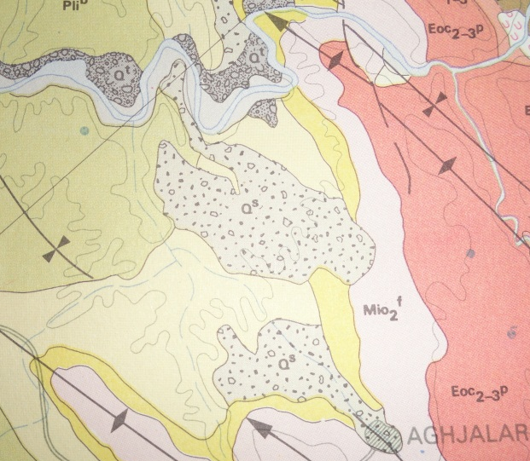
Fig.8: Geological map of Kiruk Quadrangke, scale 1: 250000 (After [2]. Relics of alluvial fans. Left) Near Agh Jalar, Right) Near Cham Chamal

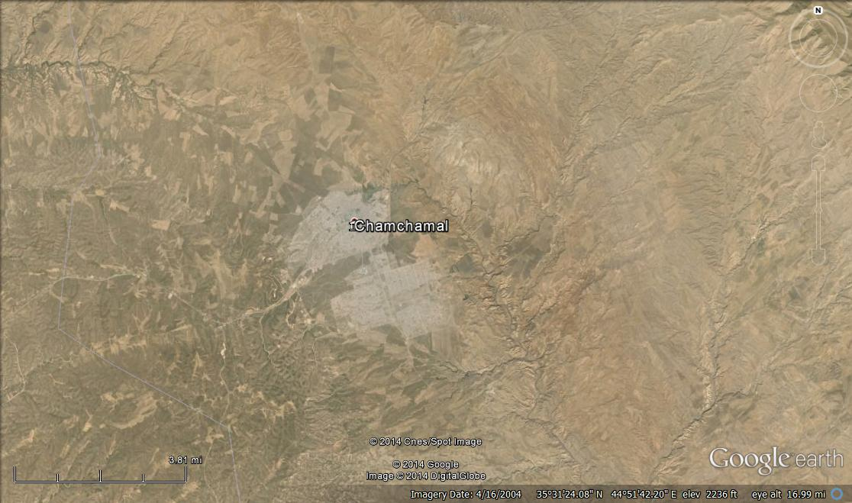

2 Km

Fig.9: Google Earth image of alluvial fan relics of the second type
in Cham Chamal town; part of it is covered by soil and occupied as agricultural fields

  - Dating of the Alluvial Fans
The majority of old alluvial fans in the studied area and even in the whole Iraqi territory are of Pleistocene age [4,6,7,8,18,20,21,22,23,24,25,26], and some of them may be even older, of Pliocene age.

Since no accurate dating technique is not available to the authors; therefore, they have used exposure dating method [27], for age estimation of the alluvial fans in the studied area. As aforementioned, only the old alluvial fans are dealt in this study, which are preserved as relics; therefore, the recent alluvial fans are not concerned.

Because during Pleistocene wet climate was prevailing for many phases all over the studied area and near surroundings [15]; therefore, it was favourable environment for formation of alluvial fans. One of the main areas where basin- range morphology was present to form alluvial fans [14,19,28] is the continuous ridge of the Pila Spi Formation (Late Eocene) [6], which represents the contact between the High Folded and Low Folded Zones [12,24] and which was and still represents the break in the gradient before and after the ridge; therefore, all valleys those cross the ridge, drop their carried sediments after the ridge in the sloping plain forming alluvial fans. Other favourable places where alluvial fans were developed are the ridges of the Bai Hassan Formation (Pliocene – Pleistocene) [5], which consists mainly of thick and hard conglomerates interbedded with thick claystones [29] forming high ridges of the hard conglomerates. The weathering of the conglomerates and soft claystones had supplied the developed alluvial fans.

The alluvial fans, which are derived from the Pila Spi Formation are; therefore, Pleistocene in age and possibly older; Pliocene. Whereas those derived from the Bai Hassan Formation should be younger; therefore are most possibly Late Pleistocene and/ or early Holocene. These age estimations are also confirmed by the presence of thick calcrete capping the first type (Figs. 2 and 7), whereas those of the second type are covered by soil (Figs. 4 and 9).

GIS Applications
GIS programme version 9.3 was used to draw the limits of some alluvial fans in the area and measure their coverage areas. The used satellite images are of 14 m resolution. The alluvial fans were drawn by the editor then their areas were calculated from their polygon attributes. Figure (10) is an example for two selected areas to represent both types of existing alluvial fans. Figure (10 Left) is an example of many old alluvial fans of the first type along Bammu anticline; the coverage area is 9 Km². Figure (10 Right) is an example for the second type, which forms almost flat area near Cham Chamal town; the coverage area of one single fan is 33 Km².

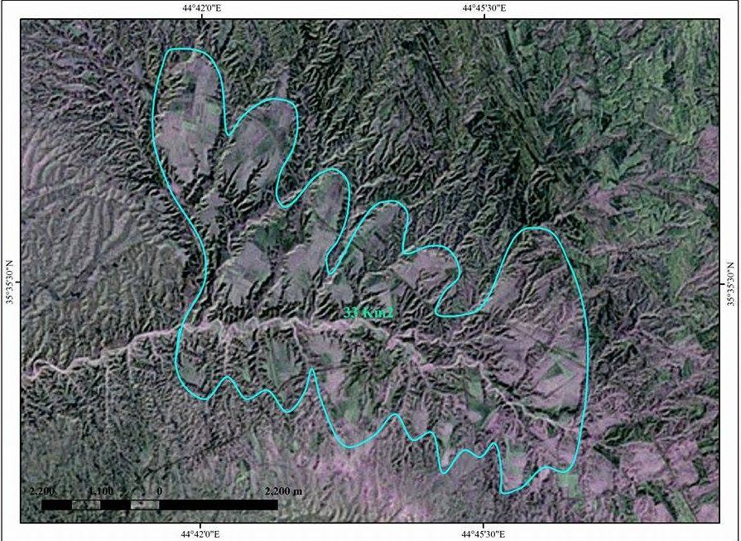
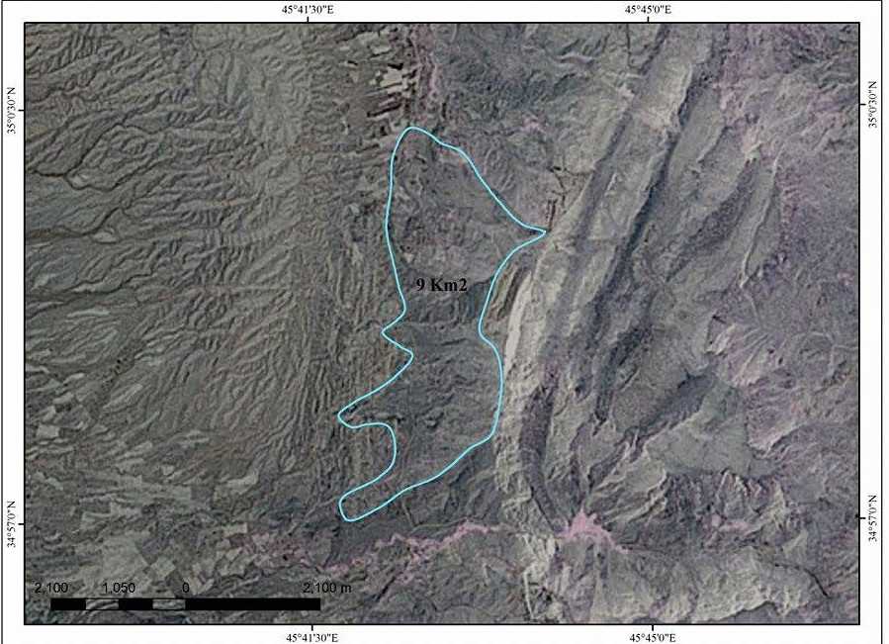
4400 m
4200 m

Fig.10: Satellite images of 14 m resolution of old alluvial fans' relcses.
Left) Second type; near Cham Chamal town, Right) First type; near Sartaq Bammu

5. DISCUSSION
The main sources of the alluvial fans, in the studied area, are the Pila Spi Formations, in the first type, whereas for the second type is the Bai Hassan Formation. Therefore, the best developed alluvial fans of the first type are along the main ridge of the Pila Spi Formation (Figs.11 and 12). Moreover, the main ridge of the Pila Spi Formation since represents the contact between the Low Folded and High Folded Zones; therefore it represents active tectonic area, which is one of the favorable conditions for development of alluvial fans, since "fans are better developed in tectonically active areas" [14, 19].

The alluvial fans of the second type; derived from the Bai Hassan Formation are developed along the existing ridges formed by the Bai Hassan Formation. Since the hard conglomerates of the formation are interbedded with weak claystones; therefore, longitudinal ridges were developed due to differential weathering, and since the climate was wet; therefore lot of valleys were crossing the conglomerate ridges and depositing their carried loads as alluvial fans. The same scenario is repeating nowadays in formation of recent alluvial fans derived from the Bai Hassan Formation (Fig.13).
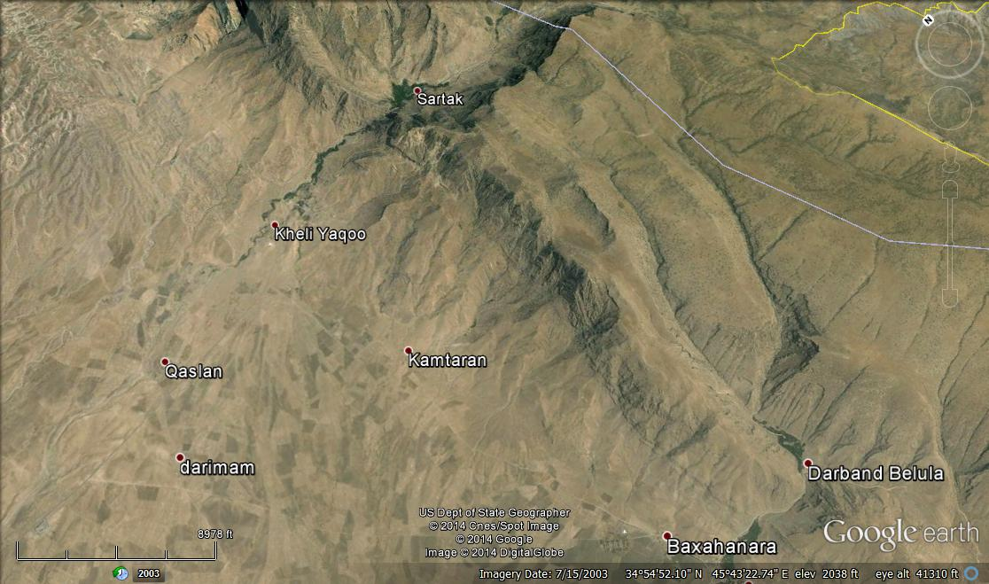

2 Km
AF
AF
PS
PS
C
C
C

Fig.11: Google Earth image facing NE. Note the relics of the old alluvial fans capped by calcrete (C) along the main ridge of the Pila Spi Formation (PS), southwestern limb of Bammu anticline, SE of Sulaimaniyah city,
and note recent alluvial fans (AF).

2 Km
AF
AF
C
PS
C

Fig.12: Google Earth image facing NE. Note the relics of the old alluvial fans capped by calcrete (C) along the main ridge of the Pila Spi Formation (PS), southwestern limb of Qara Dagh anticline, SE of Sulaimaniyah city,
and note recent alluvial fans (AF).

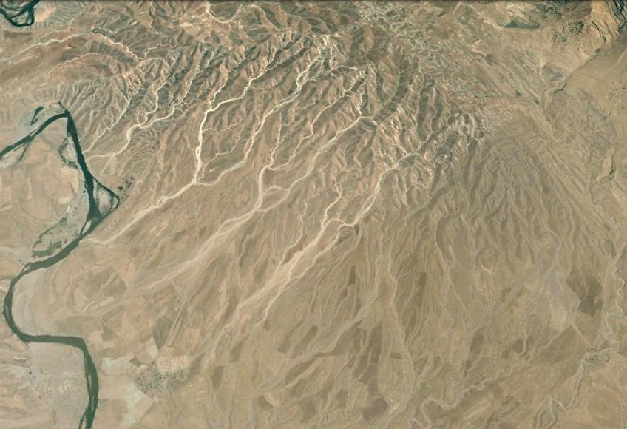
1 Km

Fig.13: Google Earth image facing NE. Note development of recent alluvial fans along the ridges of the Bai Hassan Formation, southwestern limb of Bammu anticline

The break in gradient of the second type of alluvial fans; derived from the Bai Hassan Formation is gentle. This is the main reason why the fans of this type have no typical fan shape (Figs. 8 and 9), because the constituents are of fine size, and since "the size of the sediments is function of the shape" [14,16]. The low gradient also causes drop in transporting energy, consequently the iso-transport energy lines will lose their concentric shapes [17,28].

The water/ sediments ratio also plays big role in defining the size of the transported materials, consequently defining the shape of the fan [19]. In the first type fans, because the transporting energy was very large, due to high gradient, therefore, the transported materials were large with high concentration, consequently the water/ sediments ratio was low, leading to highly viscous transporting media. This highly viscous transporting media had transported very large boulders (up to 0.5 m) for a distance of (0.5 – 4) Km in form of "Transitional flow" and very rarely in form of "Debris flow". Therefore, this type of fans has typical fan shape. On contrary, the water/ sediments ratio in the second type of fans was high, because the gradient was low; consequently the size and concentration of the transported materials were low. Therefore, the transportation media was as "Stream flow" and the deposited materials were of fine size; consequently the shape of the fans is not typical fan shape, but longitudinal and the relics are irregular. It is worth mentioning that all types of alluvial fans underwent erosion now, consequently started to lose their shapes and sizes and preserved as relics, indicating very wet conditions during Pleistocene and even early Holocene.

The fans of the first type; derived from the Pila Spi Formation have preserved their shapes better than those of the second type; derived from the Bai Hassan Formation, this is attributed to: 1) The first type is almost capped by hard calcrete (Figs. 2 and 7), whereas those of the second type are always capped by soil (Figs.4 and 9), 2) The clasts of the first type are sub-angular to sub-rounded (Fig.6), whereas those of the second type are rounded to sub-rounded, this will decrease the friction and cohesion in the second type, consequently are easily disintegrated; as compared to the first type, and 3) The cement of the first type of fans is mainly calcareous materials, whereas the cement of the second type of fans is calcareous and sandy; therefore, the disintegration of the cement of the second type is more easy; as compared to the cement of the first type; due to the presence of quartz grains, which leave voids upon disintegration that will accelerate the loosening of the cement.

6. CONCLUSIONS
The following can be concluded from this article:
- The old alluvial fans are preserved as relics in different parts of the studied area.
- The old alluvial fans are of two types, either derived from the Pila Spi Formation or from the Bai Hassan Formation.
- Genetically, the old alluvial fans are also of two types; based on Blair and McPherson (1994) they are of Type I and Type II.
- In Type I of alluvial fans, the water/ sediments ratio was low; the transported materials were large with high concentration, leading to highly viscous transporting media in form of "Transitional Flow" and very rarely as 'Debris Flow".
- In Type II of alluvial fans, the water/ sediments ratio was high, the size and concentration of the transported materials were low, and the transportation media was as "Stream Flow".
- In the first type of alluvial fans, the clasts were sub-angular to sub- rounded with size ranges from (0 – 50) cm, whereas in the second type, the clasts were rounded to sub-rounded, with size ranges from (0 – 40) cm.
- The shape of the alluvial fans in the first type is fan shape, whereas in the second type is not fan shape, but longitudinal.
- The first type of alluvial fans is almost capped by calcrete, whereas those of the second type are capped by soil.
- The age of the first type of alluvial fans is Pleistocene and may be older; Pliocene, whereas those of the second type are of Late Pleistocene and Holocene age.

7. REFERENCES

[1] Hamza, N.M., Geomorphological Map of Iraq, scale 1: 1000 000. Iraq Geological Survey (GEOSURV) Publications, Baghdad, Iraq,1997.
[2] Sissakian, V.K., Geological Map of Kirkuk Quadrangle, scale 1: 250000. Iraq Geological Survey Publications. Baghdad, Iraq,1993.
[3] Barwary, A.M. and Slewa, N.A., Geological Map of Khanaqin Quadrangle, scale 1: 250000. Iraq Geological Survey Publications. Baghdad, Iraq,1994.
[4] Barwari, A.M., Yacoub, S.Y. and Buni, Th.J., Quaternary Sediments Map of Iraq, scale 1: 1000000. Iraq Geological Survey (GEOSURV) Publications, Baghdad, Iraq, 2003.
[5] Sissakian, V.K. and Fouad, S.F., Geological Map of Iraq, scale 1: 1000000, 4th edit. Iraq Geological Survey (GEOSURV) Publications, Baghdad, Iraq, 2012.
[6] Sissakian, V.K. and Fouad, S.F., Geological Map of Kirkuk Quadrangle, scale 1: 250 000, 2nd edit. Iraq Geological Survey (GEOSURV) Publications, Baghdad, Iraq, 2014.
[7] Sissakian, V.K. and Fouad, S.F., Geological Map of Erbil and Mahabad Quadrangles, scale 1: 250 000, 2nd edit. Iraq Geological Survey (GEOSURV) Publications, Baghdad, Iraq, 2014.
[8] Sissakian, V.K. and Fouad, S.F., Geological Map of Sulaimaniyah Quadrangle, scale 1: 250 000, 2nd edit. Iraq Geological Survey (GEOSURV) Publications, Baghdad, Iraq, 2014.
[9] Sissakian, V.K., Calcrete development in Sartaq Bammu area, NE Iraq. Iraqi Bulletin of Geology and Mining, (Scientific note),8,1, 93 – 98, 2012.

[10] Al-Kadhimi, J.A.M., Sissakian, V.K., Sattar, A.F. and Deikran, D.B., Tectonic Map of Iraq, scale 1: 1000000, 2nd edit. Iraq Geological Survey (GEOSURV) Pblications, Baghdad, Iraq, 1997.
[11] Jassim, S.Z. and Goff, J.C., Geology of Iraq. Dolin, Prague and Moravian Museum, Brno, 2006.
[12] Fouad, S.F., Tectonic Map of Iraq, scale 1: 1000 000, 3rd edit. Iraq Geological Survey (GEOSURV) Publications, Baghdad, Iraq, 2012.
[13] Melton, M. A., The geomorphic and paleoclimatic significance of alluvial deposits in southern Arizona. Journal Geology 73: 1–38,1965.
[14] Bull, W.B., Geomorphic Responses to Climate Change. Oxford University Press, 1991.
[15] Given, J., The climatic paradigm: The correlation of climate to dry land alluvial fan evolution and morphology, Geography, 689, Internet data, 2009.
[16] USGS, Desert Working Group, Knowledge, Science Incorporation, Alluvial Fans. Internet data, 2004.
[17] American Geological Institute, Alluvial Fan. Dictionary of Geological Terms. New York, Dolphin Books. Wikipedia, the Free Encyclopedia,1962.
[18] Sissakian, V.K. and Abdul Jab'bar, M.F., Classifications of alluvial fans in Iraq. Iraqi Bulletin of Geology and Mining, 10, 3, 43 – 67, 2014.
[19] Ritter, D.F., Kochel, R.C. and Miller, J.R., Process Geomorphology. McGraw Hill, Higher Education, 560, 2002.
[20] Yacoub, S.Y., Geomorphology. In: Geology of Mesopotamia Plain. Iraqi Bulletin of Geology and Mining, Special Issue 4, 47 – 82, 2011.
[21] Yacoub, S.Y. Othman, A.A. and Kadhum, T.H., Geomorphology. In: Geology of the Low Folded Zone. Iraqi Bulletin of Geology and Mining, Special Issue 5, 7 – 38,2011.
[22] Sissakian, V.K., Alluvial fans of Sinjar Mountain, NW Iraq. Iraqi Bulletin of Geology and Mining, 7, 2, 9 – 26, 2011.
[23] Sissakian, V.K., Geomorphology and morphometry of the Greater Zab River Basin, north of Iraq. Iraqi Bulletin of Geology and Mining, 9, 3, 21 – 49, 2013.
[24] Sissakian, V.K., Geological evolution of the Iraqi Mesopotamia Foredeep and Inner Platform, and near surrounding areas of the Arabian Plate. Journal of Asian Earth Sciences, Elsevier Publication, Journal homepage: www.elsevier.com/locate/jeseas, 2013.
[25] Sissakian, V.K. and Abdul Jab'bar, M.F., Geomorphology and Morphometry of the three tributaries of Adhaim River, Central Part of Iraq. Jour. Research in Environmental Science and Toxicology, 2, 3, 2013.
[26] Sissakian, V.K. and Abdul Jabbar, M.F., The alluvial fans of Hab'bariyah Depression, Iraqi Western Desert. Iraqi Bulletin of Geology and Mining, 9, 2, 27 – 45, 2013.
[27] Keller, E.A. and Pinter, N., Active Tectonics, Earthquakes, Uplift and Landscape, 2nd edit. Prentice Hall, 362 pp, 2002.
[28] National Aeronautics and Space Administration, Geomorphology From Space; Fluvial Landforms, Chapter 4. Internet data,2009.
[29] Sissakian, V.K. and Saeed, Z.B., Lithological Map of Iraq, Compiled using GIS Techniques. Iraqi Bulletin of Geology and Mining, 8, 3, 1 – 13, 2012.

