Non-parametric detection Method of multiple breaks
in the time series of exchange rates:
Application to MENA countries

lotfi kechim & Samir Maktouf
Quantiitative methods Department, University of Management and Economics Tunis, , Tunisia
E-mail:, kechilotfi@@yahoo.fr

Abstract
The detection and estimation of behaviour change in economic series consists in locating the moments or certain characteristics of the series change. Changes in the characteristics of these series can be observed at the mean, variance or mean and/or variance level. For example, it may involve detecting the moments of transition from one equilibrium to another in an economic series or locating the transitions of variance and covariance structure of these univariate or multivariate economic series. Changes can generally be transitory or instantaneous
We place this problem in a statistical framework where instantaneous changes are then called ruptures. prediction, etc. Quality control of manufactured products is one of the applications behind failure detection (Shewart.1931) The 1950s are an important step in the evolution of the formalisation of the problem.
Keywords: exchange ratre , reserves , multiple breaks , non parametric Detection method

1. Introduction

From the practitioner’s point of view, procedures for the detection of ruptures are of great interest because the process that generates the data being studied is unknown. In addition, economic data are usually non-stationary, and it may be interesting to approximate an unknown process, and may be non-stationary, by stationary local processes; see for example Dalhaus [1997].
Since then the detection of ruptures has aroused a growing interest among the community in can cite the works of Basseville and Nikiforov [1993], Brodsky and Darkhovsky [1993], Csörgö and Horváth [1997], Chen and Gupta [2000]. Articles by Giraitis and Leipus [1992,1990], Hawkins [1977, 2001], Chen and Gupta [2004], Mia and Zhao [1988], and Sen and Srivastava [1975] among others are also of interest
The occurrence of a single break on real data is rather rare, as economic, financial, hydrological, biological, electrotechnical, etc., data present multiple breaks: see for example Schechtman and Wolfe [1985], Braun et al. [2000]. A statistical procedure capable of detecting multiple breaks is therefore of practical interest. It has often been argued that test procedures for single ruptures can be extended to the case of multiple ruptures using the Vostrikova binary segmentation procedure [1981 ], which consists of applying the single rupture detection procedure on the complete sample, then divide the series in half at the point of failure detected, and iteratively apply the break detection procedure on both segments until no break is found.
Two types of fracture detection methods can be distinguished: sequential methods (generally oriented to monitoring) and non-sequential methods (more specifically dedicated to posteriori analysis). The fundamental difference between these two families is the constraint on the detection time. It should be as short as possible for sequential methods, hence a decision has each observation. On the contrary, non- sequential methods (for example for descriptive purposes) are not necessarily constrained by the urgency of detection. Therefore, treatment is performed after the full observation phase. Whereas non-sequential methods are evaluated by their probability of not detecting and their probability of false alarm the assessment of the performance of the sequential methods must also take into account the detection time.
It should be noted, however, that the boundary between these two types of methods is not as clear to the extent that sequential methods can be used on non-sequential problems and vice versa. Examples include Brandt (1983) and Delyon et al (1988) Andre Brecht (1993) where sequential fault detection methods are applied to the segmentation of speech signals. The scope covered by failure detection has expanded considerably. The subjects involved in monitoring are very diverse in nature. Indeed, this may concern industrial infrastructures, hydrological, biological, electrotechnical data, etc., which may be subject to natural vibrations or hazards, etc. Applications to biomedical signals can be oriented surveillance when it comes to monitoring an individual’s physiological state But they can also be oriented analysis when the signal is segmented into stationary areas for a descriptive purpose.
Other applications exist in growing areas such as the exchange rate market and financial markets in general. Rupture detection can be used as a time segmentation method prior to a segment recognition phase. Recent work on the segmentation of an economic series can be found in Benoît Perron (2004), and Delgado and Hidalgo (2000).

The purpose of this application is to provide formal and methodological benchmarks on the detection of breaks in financial series, in particular the exchange rate series.

In section 2, we first introduce the necessary formalism and then define the type of study approach. We end with a presentation of examples of known methods that are references in the construction literature of advanced warning systems.
Section . 3 is devoted to the segmentation method proposed in this application.
Section 4 describes the interpretation of the results found. Finally, an annex summarizing all the results found in the form of tables and graphs

2. Formulation de la détection et estimation des ruptures :
Either a discrete time m-dimensional process that changes abruptly and is characterized by a parameter Ө that remains constant between two breaks.

It is assumed that there are moments = such that the process is stationary over each time interval with the convention =0. The homogeneity in the segment, a hypothesis, is thus modelled by the stationarity of the process.
The moments are the moments of change of stationary distribution of the process and are called moments of breaks.

We note is an observation of the variable .
The detection and estimation of ruptures consists in locating the possible moments of ruptures on a sequence of observations d’observations ( ) of the process Y. The criteria for classifying problems of detection and estimation of ruptures are multiple To retain only those which seem to us the most essential,
Examples include:
Knowledge a priori about segment distributions:
distributions of segments belonging to an unknown family,
distributions of segments belonging to a parameterized family, described by a continuous parameter, no prior information on segment distributions.
Knowledge a priori on the distribution of moments of rupture:
moments of random breaks
deterministic moments

We present, respectively, some non-sequential and sequential methods of rupture detection.

2..1. Non-sequential methods
A non-sequential method is the detection and estimation of possible ruptures after a complete observation phase of the process.... Two types of methods can be distinguished ;the overall approaches which attempt to estimate the breaks parameters jointly and directly from the observations ( ) of the Y process and on the other hand the local methods which propose to reduce themselves locally to the case of a single possible rupture and to process the signal as it is processed

2..2 Sequential Methods:
A sequential method of break detection is a method which, at each observation moment, makes a decision of absence or presence of a rupture (with a possible delay ,or intrinsic delay ). Sequential methods are better suited to some monitoring problems, although they also apply to other failure detection problems. The theoretical framework of these methods is that of the sequential tests presented for example in [ Siegmund, 1985], [Basseville and Nikiforov, 1993]. the Sequentially is not a concern of this work. We shall mention the principle of two well-known sequential rupture detection algorithms in the literature: the Brandt algorithm [Brandt, 1983 ], and the divergence algorithm [André- Obrecht ,1983] [Basseville and Nikiforov, 1993] [Delyon et al ,1988]

3. Proposed Segmentation Method

The purpose of this section is to detail the method for detecting statistical breaks on various united time series proposed in this work. The formalism and ratings are identical to those introduced at the beginning of this part.

First, we present the motivations of the proposed approach, which is then described, and finally, we present experiments in detecting breaks in the various economic series, in particular in the exchange rate series.

3.1.Motivations
The statistical break detection methods discussed above are generally based on a break detection statistic calculated at each moment followed by the extraction of a criterion from which the break moments are estimated rupture must have good properties which are most often guaranteed by comparing observations before and after the current moment. The calculation of the rupture criterion allowing the extraction of the rupture moments is very often the most delicate phase to be implemented.

3.2.PROPSED METHOD :
3.2.1 Description of the proposed basic method:
A single break in actual data is rather rare, as economic, financial, l, biological, etc., data have multiple breaks: see for example Schechtman and Wolfe [1985], Braun et al. [2000].
A statistical procedure capable of detecting multiple breaks is therefore of practical interest. It has often been argued that test procedures for single ruptures can be extended to the case of multiple ruptures using the Vostrikova binary segmentation procedure [1981], which consists of applying the single break detection procedure on the complete sample, then divide the series in half at the point of break detected, and iteratively apply the rupture detection procedure on both segments until no further rupture is found.
Recent studies have addressed the problem of comparing global and local detection procedures, and found that the use of local detection procedures to detect multiple ruptures using the binary segmentation method was misleading and led to an overestimation of the number of ruptures
A global approach means that all ruptures are detected simultaneously. These breaks are estimated by minimizing a penalized contrast function J ( ,y) + pen( ) (see [Birge, L., and Massart, P. (2001). Yao, Y.C. (1988). ]).
Here, J ( , y) measures the fit of the model whose sequence of breaks is with the observed series y. Its role is to locate breaks as accurately as possible. To detect breaks in the mean and/or covariance matrix of multivariate series, the contrast function J ( , y) is defined from the logarithm of the Gaussian likelihood function, even if the observations are not Gaussian
The penalty term pen( ) depends only on the K( ) dimension of the model and increases with K( ). The penalty parameter adjusts the compromise between the minimization of J ( , y) (obtained with a large dimension of ) and the minimization of pen( ) (obtained with small dimension of ).
We will see that this approach is also very useful for practical applications, to detect breaks in the mean and/or variance of multivariate series, with the restriction that these series have a common segmentation . An adaptive method is proposed to estimate the number of ruptures.

3.2 .2THE ADAPTATIVE METHOD
The proposed method requires careful inspection of the {li} length sequence but is difficult to automate. An alternative approach to selecting the model that provides very good results and is much easier to automate for practical applications.

The idea of this method is to model the decay of the suite {}when there is no break in the series { } and to look for which value of K this model adjusts the series of observed contrasts.
Without a break in the variance, the joined distribution of the sequence {}is very difficult to calculate analytically, but some Monte-Carlo simulations show that this sequence decreases as K + K log (K).
Algorithme 1for i = 1, 2, . . .,
model fit:
= K + K log (K) + ,
to the series, {, K Ki}, , assuming {}is a series of centered and i.i.d.Gaussian random variables
ajustement du modèle :
= K + K log (K) + ,
à la série {, K Ki}, en supposant que {} est une suite de variables aléatoires gaussiennes centrées et i.i.d.,
assessment of the probability that follows this model also, i.e. estimate the probability
under the estimated model

.=,
Then the estimated number of segments will be the largest value such that the P-value is smaller than a given threshold. 20 20 in numerical examples
3.2.3 DATA DESCRIPTION
The model is estimated using monthly data from January 1980 to March 2014 for 7 MENA countries: Tunsia, Algeria, Marroc, Egypt, Turkey, Jordan and Saudi Arabia (a total of 410 observations) for countries. The bulk of the data was provided on the International Monetary Fund (IMF) International FinancialStatistics (IFS) CD-ROM.The results founded using the Matlab software will be discussed in the following section
4.Analysis and results:
In this section we confine ourselves to a preliminary analysis of the results provided by the Matlab software by applying the adaptive method described above for the case of Tunisia. The results are provided by the following tables and graphs:

Case of Tunisia :

Table1.A :Detection of multiple breaks in the mean of the exchange rate series (1980M1-2014M3)
K | l(K) | p(K) | g(K)
1 | Inf | 5.0e-005 | 1.00
2 | 6.0 | 3.3e-013 | 9.11
3 | 1.3 | 1.6e-009 | 2.04
4 | 0.2 | 9.9e-002 | 0.37
7 | 0.1 | 1.4e-004 | 0.18
8 | 0.1 | 3.8e-005 | 0.14
10 | 0.1 | 3.2e-002 | 0.09
15 | 0.0 | 1.1e-002 | 0.02
change-points with 8 segments: 16 41 70 206 242 276 383
p-value = 3.81e-005
fitted function: J(K) = 3.315 -0.1053 K log(n/K)

Table1.B :Detection of multiple breaks in the variance of the exchange rate series (1980M1-2000M9)
K | l(K) | p(K) | g(K)
1 | Inf | 5.0e-005 | 1.00
2 | 34.2 | 7.3e-006 | 2.10
5 | 10.6 | 1.9e-005 | 0.60
9 | 3.7 | 1.3e-001 | 0.24
13 | 1.7 | 2.9e-002 | 0.19
17 | 1.4 | 3.6e-001 | 0.15
change-points with 5 segments: 26 206 241 276
p-value = 1.9e-005
fitted function: J(K) = 2509 -9.363 K log(n/K)

Tableau1.C :Detection of multiple breaks in the mean and variance of the exchange rate series (1980M1-2000M9)
K | l(K) | p(K) | g(K)
1 | Inf | 5.0e-005 | 1.00
2 | 215.5 | 7.2e-010 | 3.07
3 | 89.5 | 1.5e-006 | 1.27
4 | 14.4 | 2.4e-001 | 0.21
5 | 13.5 | 4.3e-001 | 0.34
10 | 12.5 | 4.5e-003 | 0.18
16 | 3.0 | 1.1e-001 | 0.05
change-points withsegments: 15 233
p-value = 1.5e-006
fitted function: J(K) = 2750 -37.06 K log(n/K)

Figure 1.A : detection of multiple breaks in the mean of the exchange rate series:
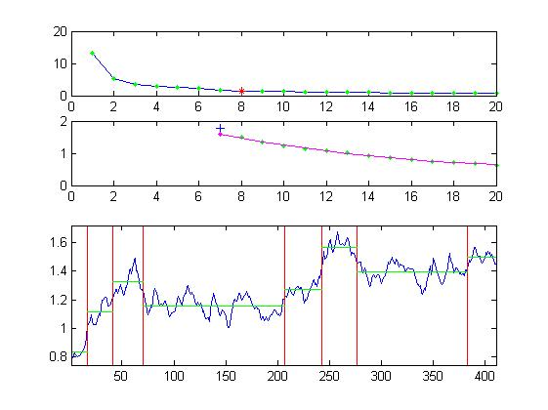

Figure 1.B :detection of multiple breaks in the variance of the exchange rate series:
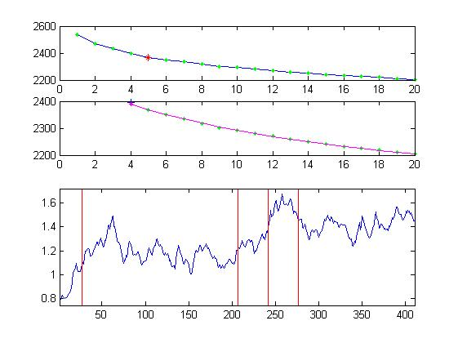

Figure 1.C : detection of multiple breaks in the mean and variance of the exchange rate series:
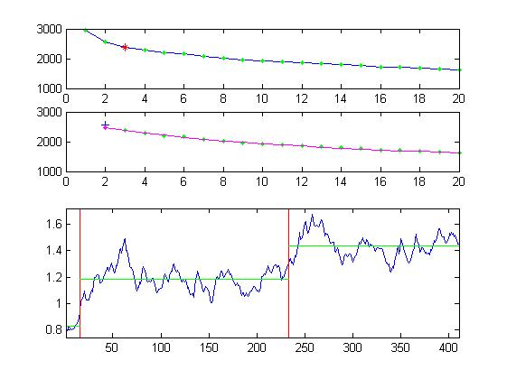

Figure 2.A : detection of multiple breaks in mean of the series of reserves

Figure 2.B : detection of multiple breaks in the variance of the series of reserves:

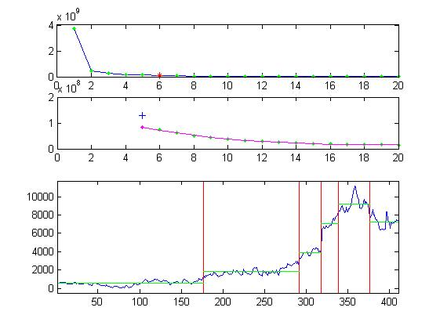

Figure 2.C : detection of multiple breaks in the mean and variance of series: of the reserve:
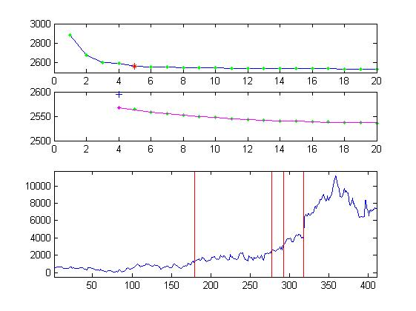
The method applied to 410 observations on the exchange rate over the period January 1980 to March 2014 makes it possible to detect possible breaks in mean, variance and mean and variance.
Table 1.A allows us to detect the sequences of turning points in the series of exchange rates, we see that this series on average is characterized by a number of sequences of breaks K whose length l (K) is zero and a very low P-value.
However, Table 1.B describes the number of breaks and their corresponding dates in terms of the variance which detects a break for the date t = 60 which corresponds to the month of November 1984.
We have considered the 410 observations for the series of exchange rates taken as first difference, algorithm 1 using Matlab software provides us with the figures below.

Figure 1.A below depicts the series with estimated break points represented by a vertical line. We note the absence of breaks in this case.
The one at the top translates the sequence of contrasts which are indicated by the + sign, the fitted function is drawn by a solid line and JK is represented with a circle.

Figure 1.A below depicts the series with estimated break points represented by a vertical line. We note the absence of breaks in this case.
The one at the top translates the sequence of contrasts which are indicated by the + sign, the fitted function is drawn by a sol
Figure 1.B allows us to see a break at point t = 60 or M11 1984, the middle curve describes the sequence of contrasts, a vertical line in this case indicates the estimated number of segments.
The estimation results for the rest of the countries studied are provided by the following graphs:

Cas du Maroc :

Figure 1.A detection of multiple breaks in the mean of the exchange rate series:

(1980 M1 – 2014 M3)
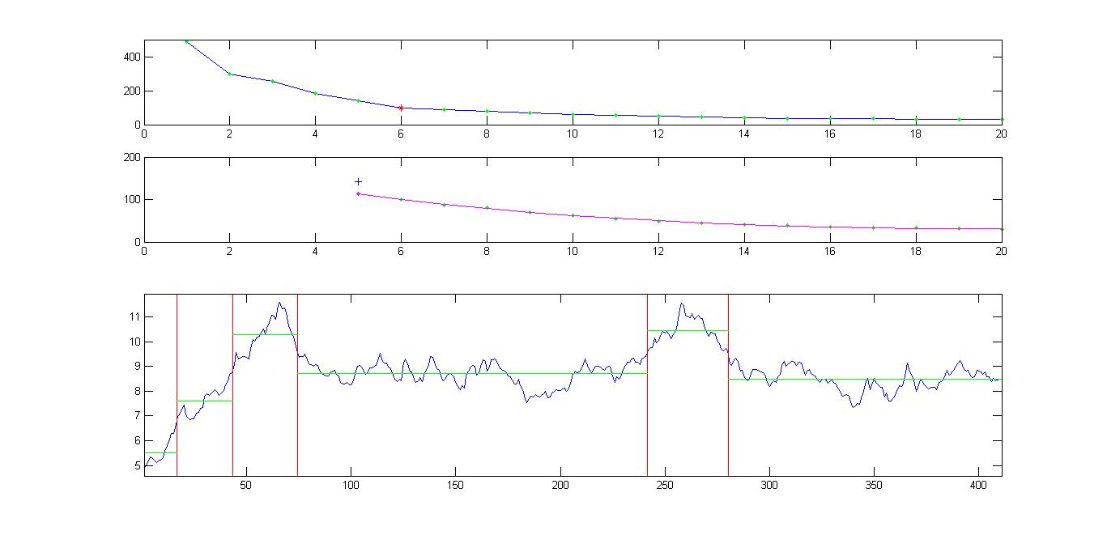

Figure 1.B detection of multiple breaks in the variance of the exchange rate series (1980 M1 – 2000 M9)
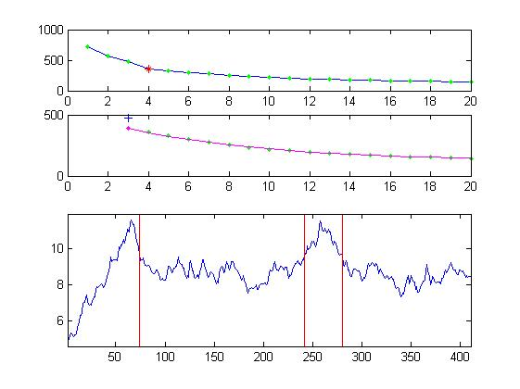

Figure 1.C detection of multiple breaks in the mean and variance of the exchange rate series (1980 M1 – 2000 M9)
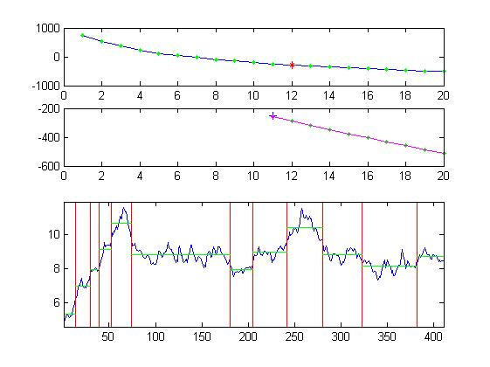
Cas de l’Algerie :

Figure 1.A detection of multiple breaks in the mean of the exchange rate series:

(1980 M1 – 2014 M3)
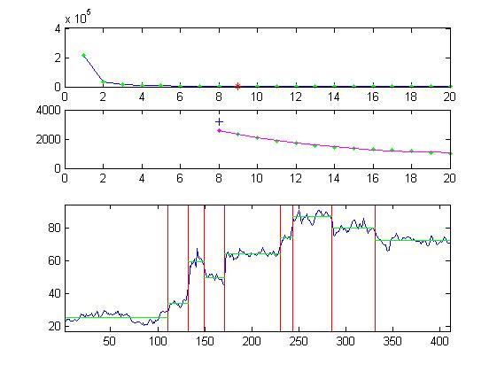

Figure 1.B detection of multiple breaks in the variance of the exchange rate series (1980 M1 – 2000 M9)

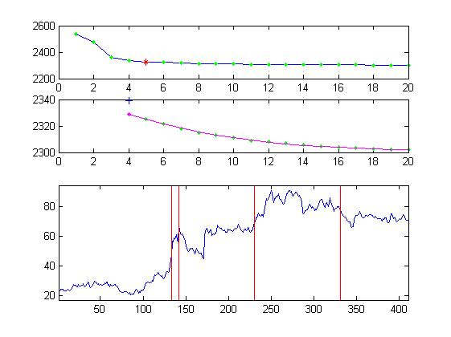

Figure 1.C detection of multiple breaks in the mean and variance of the exchange rate series (1980 M1 – 2000 M9)

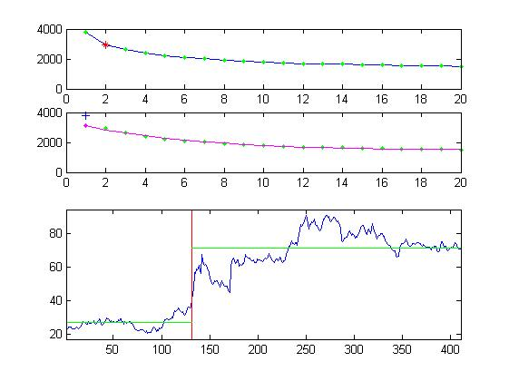

Cas de l’Egypte :

Figure 1.A detection of multiple breaks in the mean of the exchange rate series:

(1980 M1 – 2014 M3)

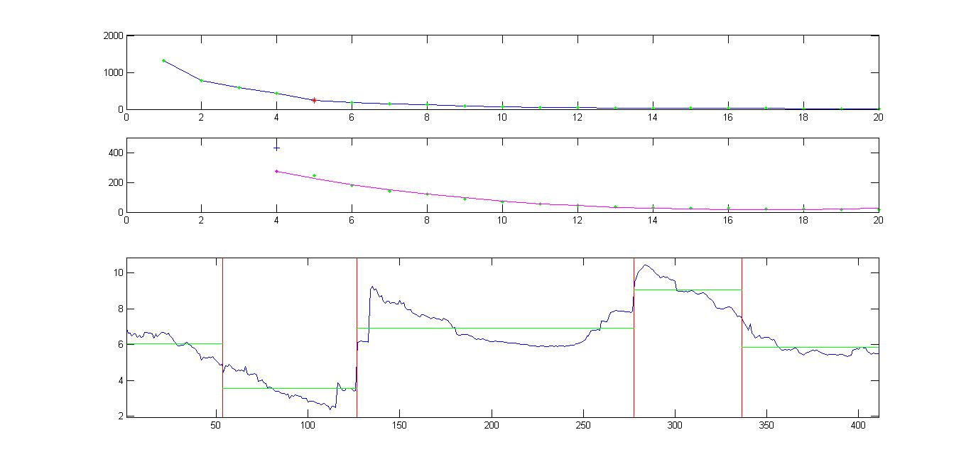

Figure 1.B detection of multiple breaks in the variance of the exchange rate series (1980 M1 – 2000 M9)

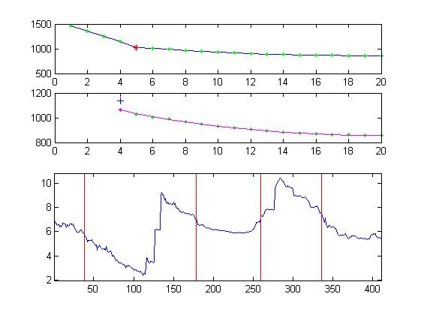

Figure 1.C Détection des ruptures multiples dans la moyenne et la variance de la série de taux de change (1980 M1 – 2000 M9)
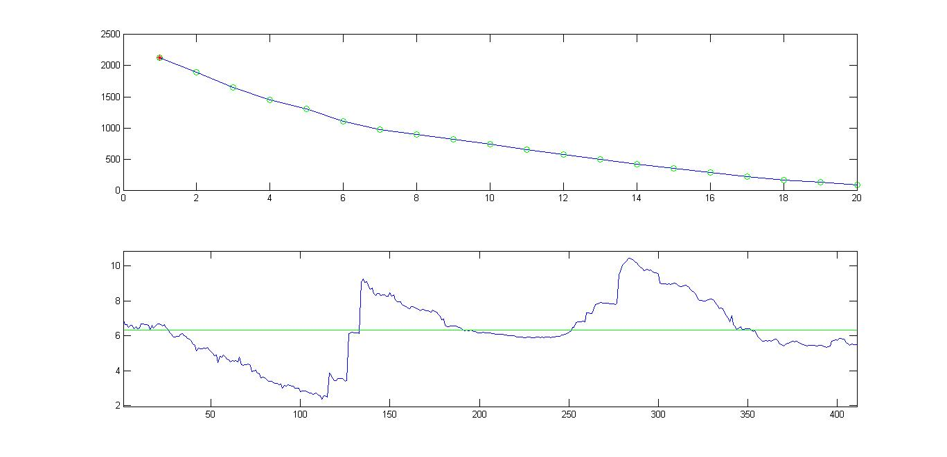

Cas de la Jordanie :

Figure 1.A detection of multiple breaks in the mean of the exchange rate series:

(1980 M1 – 2014 M3)

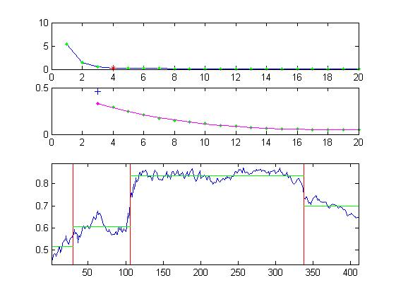

Figure 1.B detection of multiple breaks in the variance of the exchange rate series (1980 M1 – 2000 M9)
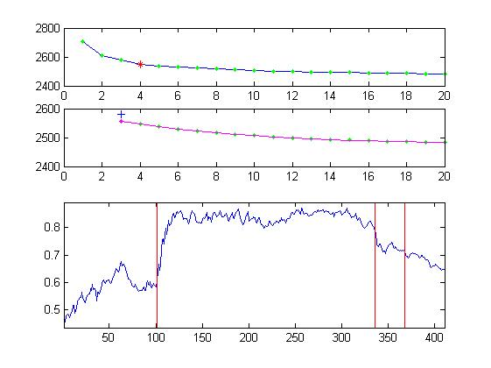

Figure 1.C detection of multiple breaks in the mean and variance of the exchange rate series (1980 M1 – 2000 M9)

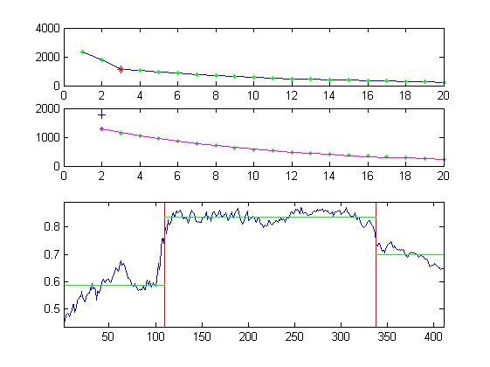

Cas de la Turquie :

Figure 1.A detection of multiple breaks in the mean of the exchange rate series:

(1980 M1 – 2014 M3)
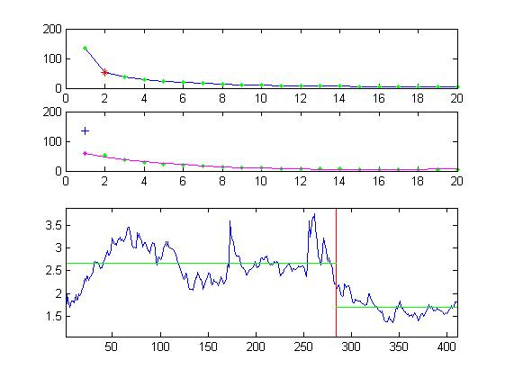

Figure 1.B detection of multiple breaks in the variance of the exchange rate series (1980 M1 – 2000 M9)
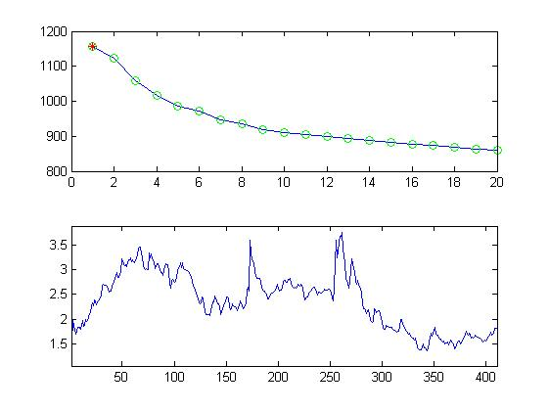

Figure 1.C detection of multiple breaks in the mean and variance of the exchange rate series (1980 M1 – 2000 M9)
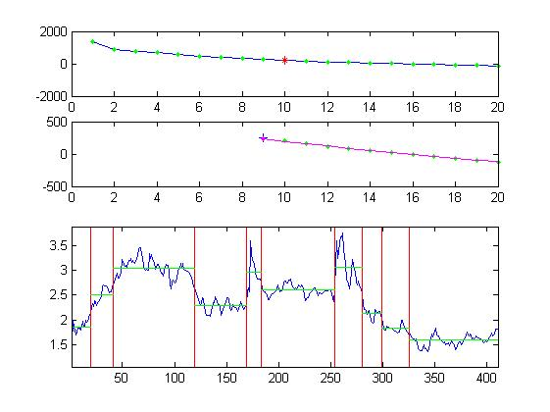

Cas de l’Arabie Saoudite :

Figure 1.A detection of multiple breaks in the mean of the exchange rate series:

(1980 M1 – 2014 M3)
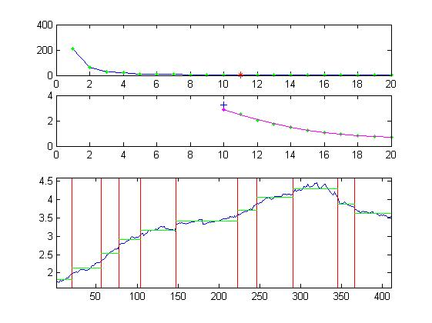

Figure 1.B detection of multiple breaks in the variance of the exchange rate series (1980 M1 – 2000 M9)
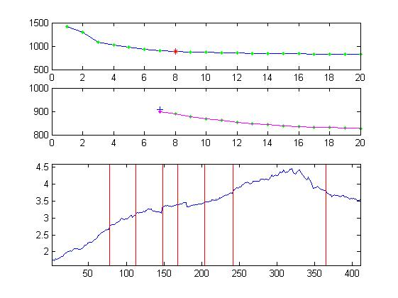

Figure 1.C detection of multiple breaks in the mean and variance of the exchange rate series (1980 M1 – 2000 M9)
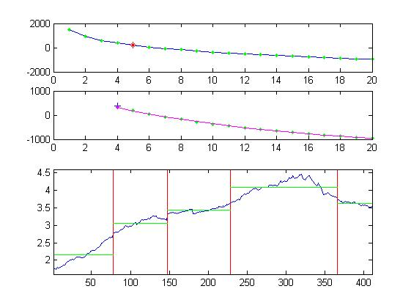

BIBLIOGRAPHIE

Abumustafa, Naser I ( 2006 ),« Development of an Early Warning Model for Currency Crises in Emerging Economies :an empircal study among Middle Eastern Countries » .International Journal of Management; Sep; 23, 3 part1 ; P403-411.
Ali ABDALLAH (2007) «Taux de change, ouverture et croissance économique au Maghreb », Projet de communication soumis au colloque international : «Enjeux économiques, sociaux et environnementaux de la libéralisation commerciale des pays du Maghreb et du Proche–Orient» Commission Economique pour l’Afrique des Nations Unies (UNECA) Rabat – Maroc, 19-20 octobre 2007.
Ali Ari (2012) ,« Early warning systems for currency crises: The Turkish case » ,Economic Systems 36, P391-410.
Ali Ari and Rustem Dagtekin (2010)« Early Warning Indicators of the2000-2001 Turkish Financial crisis »,MPRA Paper N° 25856, P 35-50.
Altissimo, F., Bassanetti, A., Cristadoro, R., Forni, M., Lippi, M., Reichlin, L. and Veronese, G. (2001), « EuroCOIN: a real time coincident indicator of the euro area business cycle »,CEPR (Center for Economic Policy Research) Discussion Paper no. 3108.
Alaa EL-Shazly(2011) « Designing an early warning system for currency crises : an empirical treatment »,Applied Economics 43:14,1817-1828.
Arnaud Latinier (2005), « Indicateurs de crise de change : enseignements théoriques » CA Flash Eco - Problèmes économiques n.2876 ,P 1-2.
Artis M.J., Bladen-Hovell R.C., Osborn D.R., Smith G. and Zhang W.( 1995) « Predicting Turning Points in the UK Inflation Cycle »,The Economic Journal 105, 1145-64.
Asian Development Bank 2005, Early Warning Systems for Financial Crisis – Applications to East Asia. Palgrave Macmillan
Auerbach, Alan J. (1982)« The Index of Leading Indicators: .Measurement Without Theory. Thirty-Five Years Later », Review of Economics and Statistics 64, pp. 589.595.
Aziz J,.Caramassa F and.Salgado R (2000) «Currency crises in search of common elements », IMF Working Paper, N°67.
Bengi Kibritcioglu , Bulent Kose and Gamze Ugur(1999) « A Leading Indicators Approach to the Predictability of Currency Crises: The Case of Turkey »
Berg A. ,and.Patillo C .(1998) «Are currency crises predictable? A test », IMF Staff Papers, Vol 46, N°2.
Berg, Andrew, Eduardo Borensztein, and Catherine Pattillo, 2004, "Assessing Early Warning Systems: How Have They Worked in Practice?" IMF Working Paper (Washington: International Monetary Fund),
Bodart V., Candelon B.( 2000) « Appréhender la conjoncture à l’aide de la méthode de Stock-Watson : une application à l’économie belge »,Economie et Prevision 146.
Burkart, O., Coudert, V. (2002) « Leading indicators of currency crises in emerging economies», Emerging Markets Review 3 (2), Juin.
Burns, A.F., and W.C. Mitchell (1946) « Measuring Business Cycles », New York : National Bureau of Economic Research.
Calvo, G.A., Mishkin, F.S., 2003. “The mirage of exchange rate regimes for emerging market countries”. Journal of Economic Perspectives 17, 99e118.
Camacho, M., and G. Pérez-Quiros, (2002) « This is what the leading indicators lead », Journal of Applied Econometrics, 17: 61-80.

Camba-Mendez, G., R. J. Smith, G. Kapetanios, and M. R. Weale (2001) «An Automatic Leading Indicator of Economic Activity: Forecasting GDP Growth for European Countries », Econometrics Journal, 4:556-590.
Cartapanis A.,Dropsy V. , Mametz S.(1998) « Crises de Change et Indicateurs de Vulnerabilité » Economie Internationale N° 76 , 4eme Trimestre,69-92.
Cartapanis, A., Dropsy, V., Mametz, S. (1999) « Indicateurs d’alerte et crises de change : Analyse comparée des économies d’Europe centrale et orientale (1990-1997) et d’Amérique latine et d’Asie de l’Est (1971-1997) », Revue Économique 50 (6), novembre.
Cartapanis, A., Dropsy, V., Mametz, S. (2002) « The Asian currency crises: Vulnerability, contagion or unsustainability ? », Review of International Economics 10 (1), février.
Chang, R., Velasco, A. (2001) « A Model of financial crises in emerging markets» The Quarterly Journal of Economics, Mai
Cheung and Friedman, 2005. “Speculative Attacks: A Laboratory Study in Continuous Time” Department of Economics. University of California, Santa Cruz
Chauvet M.(1998) «An Econometric Characterisation of Business Cycle» International Economic Review 39,969-96.
Chauvet M.(1998/9) « Stock Market Fluctuations and the Business Cycle», Journal of Economic and Social Measurement 25,235-258.
Chauvet M and Potter S. (2000) «Coincident and Leading Indicators of the Stock Market», Journal of Empirical Finance 7, 87-111.
Chauvet M and Dong F ( 2004) « Leading indicators of country risk and currency crises: the Asian experience” » , Federal Reserve Bank of Atlanta Economic Review, First Quarter, 25-37.
Chaouachi .S (2013) «Regimes Markov models with endogenous transition probabilities :Modelling fluctuations in Tunisia» Journal of Economics and International Finance , Vol5(6) ,239-247.
Christian Deblock (2000) « Le cycle des affaires et la prévision économique », Notes et Études en EPI (Janvier).
Clayton-Matthews, A and J.H. Stock, (1998/1999) « An application of the Stock/Watson Index Methodology to the Massachusetts Economy»,Journal of Economic and Social Measurement, 25, 183-233.
Clements M. P. and Krolzig H. M. (1998) « A comparison of the forecast performance of Markov-switching and threshold autoregressive models of US GNP», Econometrics Journal, vol. 1, pp. 47-75.
Clements M.P.,and Hendry.D.(1998) « Forecasting economic time series »,Cambridge, Cambridge University Press.
Collins, Susan M., 2001. "A Model of the Timing of Currency Crises." Georgetown University, unpublished manuscript, August.
Dehove, M.(2003) « Crises financières: deux ou trois choses que nous savons d’elles », Document de travail du Conseil d’Analyse Économique, Paris, avril
Del Negro M. (2001) « Turn, turn, turn: predicting turning points in economic activity » Economic Review: Federal Reserve Bank of Atlanta 86,(2).
Diebold, F.X., and Rudebusch G.D.( 1989) «Scoring the leading indicators », Journal of Business 62, 369-402.
Diebold, F. X., and Rudebusch G. D.. ( 1991d.) «Turning Point Prediction with the Composite Leading Index: A Real-Time Analysis. », In Leading Economic Indicators: New Approaches and Forecasting Records, eds. Kajal Lahiri and Geoffrey H. Moore. New York: Cambridge University Press, pp. 231-256.
Diebold, F X., and Rudebusch G. D. (1991e.) «Forecasting Output with the Composite Leading Index: An Ex Ante Analysis », Journal of the American Statistical Association 86, pp. 603- 610.
Diebold F. X. and Rudebusch G. D. (1996) « Measuring business cycles: a modern perspective », Review of Economics and Statistics, vol. 78, n° 1, pp. 67-77, reprinted in : Business Cycles: Durations, Dynamics and Forecasting, Princeton University Press, Princeton, 1999.
Diebold F. X. and Rudebusch G. D. (1999) « Business Cycles: Durations, Dynamics and Forecasting », Princeton University Press, Princeton.
Dina Rofael , Rana Hosni( 2015),« Modeling Exchange Rate Dynamics in Egypt: Observed and Unobserved Volatility » Modern Economy, 2015, 6, 65-80.
Dua, P. and Banerji A. (1999) «An Index of Coincident Economic Indicators for the Indian Economy », Journal of Quantitative Economics, 15, 177-201.
Edison Hali J. 2000. “Do indicators of Financial Crises Work? An evaluation of an Early Warning System”. International Finance Discussion Paper no. 675. Board of Governors of the Federal Reserve System Washington D.C , July.
Eichengreen B., Rose A.and Wyplosz C.(1996) «Contagious currency crises »,NBER Working Papers,N°5681.
Eichengreen, Barry, Andrews Rose and Charles Wyploz, 1994. “Speculative attacks on pegged exchange rates: An Empirical Exploration with special reference to the European Monetary System” NBER Working Paper 4898 (October 1994)
Elena –Ivona Dumitrescu(2009) « Using a Markov Switching Approach For Currency Crises Early Warning Systems :an E valuation Framework »,AENORM, Vol 17(66) December , 31-34.
Essa Alhanom(2016), « DETERMINANTS OF TRADE BALANCE IN JORDAN », NG-Journal of Social Development, VOL. 5, No. 2, January 2016 , 24-34.
Estrella, Arturo, and Gikas Hardouvelis( 1991) «The Term Structure as a Predictor of Real Economic Activity », Journal of Finance(June), pp. 555-76.
_______ and Frederic S. Mishkin, « Predicting U.S. Recessions: Financial
Variables as Leading Indicators », NBER Working Paper 5379, 1995.
Ernst.Boehm A.(2001) «The Contribution of Economic Indicator Analysis to Understanding and Forecasting Business Cycles » Melbourne Institute Working Paper N°.17/01.
Fabio Comelli (2014) ,« Comparing Parametric and Non-parametric Early Warning Systems for Currency Crises in Emerging », Market Economies Review of International Economics, 22(4),P 700–721.
Fabio Comelli (2014 ) ,« Comparing the Performance of Logit and Probit Early Warning Systems for CurrencyCrises in Emerging Market Economies » IMF Working Paper.WP1465.
Fabio Nieto H and Luis Melo F. ( 2001) « About coincident index for the state of the economy » , Borradores de Economia N°19, Banco de la Republica , Colombia.
Fonds monétaire international (1998a) « World Economic Outlook », FMI, Washington, DC. Mai.
Fonds monétaire international (1998b) «International Capital Markets: Developments, Prospects and Key Policy Issues», FMI, Washington, DC. September.
Frankel J. and Rose A. (1996) « Currency crashes in emerging markets: an empirical treatment », Journal of International Economics, November.
Fukuda, S. and Onodera T. (2001) « A New Composite Index of Coincident Economic Indicators in Japan: How Can We Improve Forecast Performances?», International Journal of Forecasting, 17: 483-498.
Goodness C. Aye, Mehmet Balcilar ,Adél Bosch Rangan Gupta , Francois Stofberg (2013), « The out-of-sample forecasting performance of nonlinear Models of Real exchange rate behaviour: The case of the South African Rand », The European Journal of Comparative Economics Vol. 10, n. 1, pp. 121-148.
Goldstein M., Kaminsky G. and Reinhart C. (2000) « Assessing financial vulnerability: An early warning system for emerging markets», Institute of International Economics, Washington DC.
Gochoco-Bautista S. M., 2000. “Periods of Currency Pressure: Stylized Facts and Leading Indicators” Journal of Macroeconomics Vol 22 (1)
Ghosh, S., Ghosh, A., 2002. “Structural vulnerabilities and currency crises”. IMF Working Paper WP/02/09, Washington D.C.
Gourlaen J.P., B. de Séverac, (1997) «Structure par terme des taux d’intérêt : les nouvelles théories », Encyclopédie des marchés financiers, ed. Yves Simon, Economica, vol 2, p1759-1818.
Gumain.P ,Tom .R «Vulnerabilities du système financier : une approche fondée sur des indicateurs avancés»,Revue de la Babque du Canada ,Automne 2013, 11-22.
Hamilton J. D. (1989) « A new approach to the economic analysis of nonstationary time series and the business cycle », Econometrica, vol. 57, n° 2, pp. 357-384.
Hamilton J. D. (1994) « Time Series Analysis », Princeton University Press, Princeton.
Hamilton J. D. and Perez-Quiros G. (1996) « What do the leading indicators lead?», Journal of Business, vol. 69.
Harm Bandholz and Michael Funke( 2003) « In Search of Leading Indicators of Economic Activity in Germany »,Journal of Forecasting 22, 277–297.
Harvey C, A ( 1989 ) « Forecasting , structural time series models and the Kalman filter », Cambridge, Cambridge University Press.
Hawkins, John, and Marc Klau, 2000. "Measuring Potential Vulnerabilities in Emerging Market Economies." BIS Working Paper No. 91, October.
IMF (1998) « Financial crises: Characteristics and indicators of vulnerability », World Economic Outlook , Chapter IV, May.
Jeanne, O. (1997) « Are currency crises self-fulfilling? A test », Journal of International Economics 43.
Jeanne, O. (2000) « Currency crises: A perspective on recent theoretical developments», Special Paper in International Economics 20, Princeton, mars.
Jeanne, O. (2000) «Modèles de crise de change : un essai de synthèse en relation avec la crise du franc de1992-1993» Encyclopédie des Marchés Financiers,ed. Yves Simon. Economica.
Jeanne, O. (2003) « Comprendre les crises financières internationales», Revue d’Économie Financière 70 (I).
Jbili, Abdelali and Vitali Kramarenko.( 2003). “Should MENA Countries Float or Peg?”, Finance and Development, March 2003, Volume 40, number 1, International Monetary Fund, Washington D.C.
Kamar, Bassem. (2003). “The Political Economy of MENA Exchange Rates”, Background note for then “Economic trends in the MENA Region 2005-2006”, ERF, Cairo.
Kamar, Bassem and Damyana Bakardzhieva.( 2003). “Economic Trilemma and Exchange Rate Management in Egypt”, Paper presented at the 10 th Annual Conference of the ERF, December 16-18, 2003, Marrakesh.
Kim C.-J. (1994) « Dynamic Linear Models With Markov-Switching », Journal of Econometrics 60, 1-22.
Kim, Myung-Jig, and Ji-Sung Yoo. (1995) «New Index of Coincident Indicators: A Multivariate Markov Switching Factor Model Approach », Journal of Monetary Economics 36, 607-630.
Kim, C.-J., and Nelson C.R. (1998) « Business Cycle Turning Points, A New Coincident Index, and Tests of Duration Dependence Based on a Dynamic Factor Model with Regime Switching »,Review of Economics and Statistics 80, pp. 188-201.
Kim, C.-J., and Nelson C. R. (1999c) « State-Space Models with Regime-Switching: Classical and Gibbs-Sampling Approaches with Applications », Cambridge and London: MIT Press.
Kim, C.-J., and Nelson C. R(2001) « A Bayesian Approach to Testing for Markov-Switching in Univariate and Dynamic Factor Models», International Economic Review .vol 42.N°4.November.
Kim C.-j., PigerJ. (2002) «Common Stochastic Trends, Common Cycles, and Asymmetry in Economic Fluctuations», Journal of Monetary Economics 49,1189 -1211.
Kaminsky G., Lizondo S. and Reinhart C. (1998) «Leading indicators of currency crises», IMF Staff Papers, Vol 45, N°1.
King, R., C. Plosser, J.H. Stock, and M.W. Watson (1991) « Stochastic Trends and Economic Fluctuations », American Economic Review, 81. 819- 840.
Krugman P.(1979) « A Model of Balance -of-Payments crises », Journal of Money, Credit and Banking 11 (3) , 311-325.
Kumah Y.F (2011) « A Markov Switching approach to measuring exchange market pressure»,International Journal of Finance and Economics 16,114-130.
Kumar, M., Moorthy, U., and Perraudin, W.( 2002) «Predicting emerging market currency crashes», IMF Working Paper, WP/02/7.
Lahiri ,K. and Moore,G.H( 1991) « Leading economic indicators : New approaches and Forecasting records », Cambridge, Cambridge University Press.
Lahiri K. and Wang J. G. (1994) « Predicting cyclical turning points with leading index in a Markov switching model », Journal of Forecasting, vol. 13, 245-263.
Layton A. P. and Katsuura M. (2001) « A new business cycle turning point signalling system using the Markov Switching model »,Empirical Economics.
Lemoine M.,Pelgrin F.(2003) « Introduction aux Modeles Espace –Etat et au Filtre de Kalman», Revue de l’OFCE 86 , Juillet.
Lopez .C « Penser « changements de régime » pour accroitre la flexibilté de la gestion » Asset Managment , bulletin mensuel Avril 2013.
Luc Eyraud (2000–2001),« Attaques spéculatives et défense du change » Travail de recheche sous la direction de Roger Guesnerie.
Nael Al-Anaswah and Bernd Wilfling ( 2009)« Identification of speculative bubbles using state-space models with Markov-switching » SSRN ELECTRONIC JOURNAL JANUARY.
Nil R. Gunsel, Turgut Tursoy and Husam Rjoub (2010) « An empirical analysis of currency crises, fundamentals and speculative pressure » African Journal of Business Management Vol. 4(6), June, pp. 972-978.
M. El-Shagi , T. Knedlik, G. von Schweinitz (2013), « Predicting ﬁnancial crises: The (statistical) signiﬁcance of the signals approach ». Journal of International Money and Finance 35 , 76–103.
Marc Lavielle , Gilles Teyssiere (2006) «Détection des ruptures multiples des series temporelles multivariées»,lietuvos Matematikos Rinkings , vol 46,1-24.
Mariano R.S., Murasawa Y. (2003) «A New Coincident Index of Business Cycle Based on Monthly and Quarterly Series », Journal of Applied Econometrics.
Mariano, Roberto S., Abdul Abiad, Bulent N. Glutekin, Tayyeb Shabbir and Agustine H. H. Tan, 2003. “Markov Chains in Predictive Models of currency Crises – With Applications to Southeast Asia.” Taiwan Economic review 31:4 (December 2003),401-437
Martinez-Peria, Maria Soledad, 1999. A Regime Switching Approach to Studying Speculative Attacks: A Focus on European Monetary System Crises. Washington, DC:World Bank, Development Research Group working paper; June.
McNees, S. K. (1991) « Forecasting cyclical turning points: the record in the past three Recessions », In Lahiri, K. and G.H. Moore (eds.), Leading Economic Indicators: New Approaches and Forecasting Records, Cambridge University Press.
Mehmet Balcilar and Kemal Bagzibagli ( 2010),« Sources of Macroeconomic Fluctuations in MENA Countries » MPRA Paper No. 44351, Online at http://mpra.ub.uni-muenchen.de/44351/.
Megna R., Xu Qiang,(2003) « Forecasting the New York State Economy: The Coincident and Leading Indicators Approach », International Journal of Forecasting,19. 701 -713.
Meltem Gulenay Chadwick , Fatih Fazilet «Understanding the common dynamics of the emerging countries »,Economic Modelling , Vol 49 , 120-136.
Mohammad Alawin (2010),« The Validity of Monetary Exchange Rate Model: The Case of Jordan » ,Dirasat, Administrative Sciences, Volume 37, No. 1, 2010 .262-271
Mohamed Daly Sfia (2011) « The choice of exchange rate regimes in the MENA countries: a probit analysis » Int Econ Econ Policy 8:275–305.
Morel .T « bulles et regimes :deux approaches complementaires »Amundi Asset Management , special focus , Juin 2013, 1-5.
Mostaghimi M. (2004) « Monetary Policy, Composite Leading Economic Indicators and Predicting the 2001 Recession », Journal of Forecasting . 23, 463–477
Mostaghimi M. ( 2001).« Are the new U.S. composite leading economic indicators more informative? »” Indian Economic Review 36(1), 205–213.
Mostaghimi M. (2004a.) « The performance of the new composite leading economic indicators and predicting the 2001 recession. In Analysis of Business Cycles » Dua P (ed.). Oxford University Press: Oxford .
Mostaghimi M. (2004b.) « Predicting the 2001 recession, composite leading economic indicators, structural change, and monetary policy ».
Nag, Ashok, and Amit Mitra, 1999, "Neural Networks and Early Warning Indicators of Currency Crisis," Reserve Bank of India Occasional Papers 20(2), pp. 183-222 (Monsoon).
Nitithanprapas, Ekniti, and Thomas D. Willett, 2000, "A Currency Crisis Model that Works: A Payments Disequilibrium Approach." Claremont Colleges Working Papers in Economics No. 2000-25
Nobert .F(1996) « La vulnérabilité des regimes de taux de change fixes :le role des facteurs fondamentaux economiques»,Revue économique de l’OCDE n° 26/1
Neftci S. (1982), « Optimal predictions of cyclical downturns », Journal of Economic Dynamics and Control, vol. 4, pp. 307-327
Neftci, S.D., (1982) « Optimal prediction of cyclical downturns », Journal of Economic Dynamics and Control 4, 225 -241.
Obstfeld M(1984) « Balance -of-Payments crises and Devaluation» Journal of Money,Credit and Banking .16, 208-217.

Obstfeld M(1994) « The Logic of Currency crises», NBER Working Papers,N°4640.
Obstfeld, M. (1996b). « Models of currency crises with self-fulfilling features», European Economic Review 40, avril.
Osband, Kent, and Caroline Van Rijckeghem, 1998, "Vulnerability to Currency Crises," IMF StafPapers 47(2), pp. 238-58.
Robert H.McGuckin and Ataman Ozyildirim (2004) « Real –Time Tests of the Leading Economic Index: Do Changes in the Index Composition Matter », Journal of Business Cycle Measurement and Analysis Vol.1, N° 2. 171 -191.
Pindyck R,S. and Rubinfeld D. L.(1998) « Econometric Models and Economic Forecasts », McGraw-Hill. Fourth Edition.
Rana Hosni(2015), « An Assessment of the Real Exchange Rate Misalignment in Egypt: A Structural VAR Approach » . Applied Economics and Finance Vol. 2, No. 3; August 2015 .37-50
Sedillot F. (1999) « La pente des taux contient-elle de l’information sur l’activité économique future ? », Bulletin de la Banque de France, 1er trimestre.
SERGE REY(2006), « Effective Exchange Rate Volatility and MENA Countries Exports to the EU», Journal of Economic Developpment Volume 31, Number 2, December 2006
Stock, J. H., and Watson M. W. (1989) « New Indexes of Coincident and Leading Economic, Indicators », NBER Macroeconomics Annual 1989, 351-394.
Stock, J. H., and Watson M. W. (1991), « A Probability Model of the Coincident Economic Indicators”, in K. Lahiri and G. H. Moore (eds.), Leading Economic Indicators: New Approaches and Forecasting Records, Cambridge University Press, Cambridge, 63-89.
Stock J.H., and Watson M.W., (1993) « A procedure for predicting recessions with leading indicators: econometric issues and recent experience », In Stock J., and M. Watson (eds.), Business Cycles, Indicators, and Forecasting, The University of Chicago Press: Chicago.
Stock, J. H. and M. W. Watson, 1998, « A Comparison of Linear and Nonlinear Univariate Models for Forecasting Macroeconomic Time Series », NBER Working Paper Series 6607.

Stock, J.H., and M.W. Watson (2002a) « Macroeconomic forecasting using diffusion
Indexes », Journal of Business and Economic Statistics 20 , 147-162.
Philip Hans Franses, Dick van Dijk (2005) « The forecasting performance of various models for seasonality and nonlinearity for quarterly industrial production », International Journal of Forecasting 21, 87– 102.
Pesenti, P.,Tille, C.( 2000) « The economics of currency crises and contagion: An introduction», Federal Reserve Bank of New York Economic Policy Review, september.
Remzi Uctum (2007) «Econometrie des modeles à changements de regimes : un essai de de synthèse»,Actualité Economique , ecole des hautes etudes commerciales , 2007(halshs-00174034).
Tobias .knedlik , Rolf Scheufele 2006« Three methods of forecasting currency crises :Which made the run in signalling the South African currency crisis of June 2006»,the Twelfth Annual conference on Econometric Modelling in Africa , Cap Town .
Unay Tamgac (2011) ,« Crisis and self-fulﬁlling expectations: The Turkish experience in
1994 and 2000–2001 ». International Review of Economics and Finance 20. 44–58.
Yin-Wong Cheung and Ulf G. Erlandsson (2005),«Exchange Rates and Markov Switching Dynamics », Journal of Business & Economic Statistics, 23:3, 314-320
Zhang, Zhiwei, 2001, "Speculative Attacks in the Asian Crisis,"(unpublished, Working Paper, UC-San Diego, May).
Zarnowitz,V., and Ozyildirim A. (2002) « Time series decomposition and measurement of business cycles, trend, and growth cycles », Working paper 8736, National Bureau of Economic Research.
Zarnowitz, V. and Boschan C. (1975) « Cyclical Indicators: An Evaluation and New Leading Indexes », in Handbook of Cyclical Indicators, Government Printing Office, Washington, D.C.
Zenon G. K., (2001) « Analysis of the US Business Cycle with an Vector-Markov-switching Model », Journal of Forecasting. 20, 47-61.

