**THE GRAPHICAL NATURE OF THE LOGISTIC FUNCTION AS A NONLINEAR DISCRETE DYNAMICAL SYSTEM**

**Patrick AkwasiAnamuah Mensah1, W. Obeng-Denteh2, Ibrahim Issaka3Effah-Poku Samuel4, Isaac Owusu Mensah5**

**1,2,3,4Department of Mathematics, Kwame Nkrumah University of Science and Technology, Kumasi, Ghana**

**5Department of Science Education, University of Education, winneba, Mampong-Ashanti. Ghana**

[**nanaamonoo12@yahoo.com**](mailto:nanaamonoo12@yahoo.com)**,** [**obengdentehw@yahoo.com**](mailto:obengdentehw@yahoo.com)**,** [**Issahim6@gmail.com**](mailto:Issahim6@gmail.com)

[**Seffahpoku@gmail.com**](mailto:Seffahpoku@gmail.com)**,** [**isaacowusumensah@gmail.com**](mailto:isaacowusumensah@gmail.com)

**Abstract**

The logistic function as nonlinear function/equation has behaviors that translate from one regime to another regime. The behaviors move from periodic to chaotic depending on the parameter in the function. The purpose of this research is to use graphs to show the behavior of the function and the route it takes to chaos.

**Keywords**: logistic function, graphical nature, period, chaos, nonlinear discrete dynamical system,

1. **Introduction**

The discrete logistic equation as a model is written as: $x_{n+1}=rx_{n}(1-x_{n})$ where $n=0,1,2,3……$, $x_{n}$ is the state at the discrete time $n$ and $r$ is the control parameter which operate within any given range and as a very simple example for nonlinear map in dynamics, it changes in behavior moving from one regime to another regime depends on the adjustment or variation of the control parameter.

Diagrammatically, bifurcation as commonly used in nonlinear dynamics gives a better behavior of the logistic map in dynamics as the control parameter $r$ is varied. So, ideally in this research I seek to determine each periodic solution of range of the parameter $r$ values by performing analysis for the periodic orbits so as to get a very good understanding of the bifurcation that are encountered in the logistic map. (mensah, 2016)

1. **Main work**

The logistic map is defined as; $x_{n+1}=rx_{n}(1-x_{n})$,where $n=0,1,2,3…$ and $x_{n}$ denote the state of the discrete in time $n$

Let $x_{n+1}=f(x_{n})$, then $f(x_{n})$ = $rx_{n}$ (1 $- x_{n}$), $x_{n}∈\left[0,1\right]$ and $r∈\left[1,4\right]$. By setting the parameter $r=1$, the logistic equation becomes; = (1) = – 2

**2.1 The graphical display of the iteration of the logistic function and its analysis**

Taking, where () =– 2 and with the range, $1≤r≤4$. The graphical display of this function makes it easier to analyze the behavior of the map. Now taking $r=1$, the function, () =– 2  have its graph to be

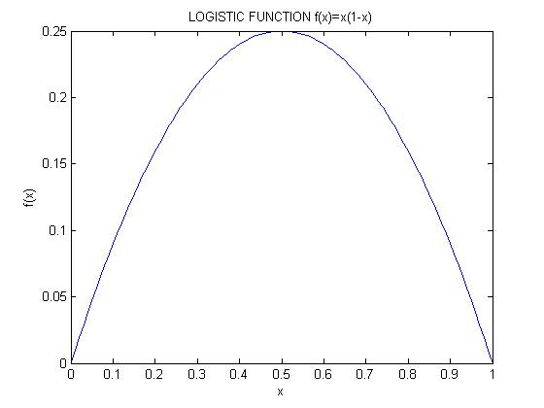

**Figure 1.0: graph of () =– 2**

Graphically, the function $f(x_{n})$ = $x_{n}(1-x_{n}$) is made up of two common features,

1. The roots of $x$ in the function. Thus $x=0, x=1$.
2. The maximum point of $x$ occurring at $x=\frac{1}{2}$.

**2.2 The graphical solutions/locations of the logistic function**

The logistic function $f(x_{n})$ = $x_{n}(1-x_{n}$) have it solution occurring at a point when a linear function $y$ = $x$ is impose on it. Thus, $y$ = $f(x_{n})$

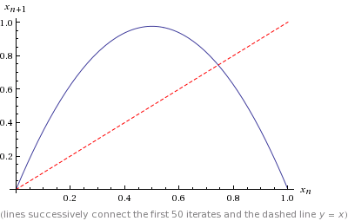

**Figure 1.01: graphical display of a diagonal line y = $x$ no the graph of = – 2**

Clearly, there is an intersection between the diagonal line and the function as indicated on the diagram above with dash red line. So it intersect at, $x$ = $\frac{r-1}{r}$ or $x$ = 0

**2.3 The fixed points of the logistic function**

According to (mensah, 2016) the fixed points of the logistic function occurs when it intersect with another function. That is from the solutions of the logistic function; 0 = 0 and 0 = which is the outcome of the intersection of the diagonal line and the function.

By considering the graphical representation of orbits of the fixed point $x_{0}=\frac{17}{27}$ the vertical red line in the figure below is directed from the point of intersection to a number on the x-axis is the fixed point $x_{0}$ of the logistic function $f\left(x_{n}\right)=2.7x_{n}(1-x_{n})$.

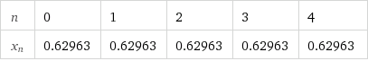

Table 1.00: Iteration of $f(x_{n})$ = 2.7 $x_{n}$ (1- $x_{n}$) with $x_{0}=0.62963$

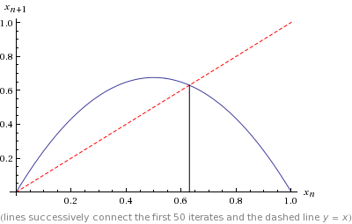

**Figure 1.02: The graph of fixed point 0 =**

So the fixed points of the logistic function are the input value that comes out unchanged as the output value after a number of iterations.

**2.31 The graphical nature of the fixed point of the logistic function**

Theoretically, it has been proven and shown in (mensah, 2016) that at the fixed point $x_{0}$ =0 there is attracting and stable at -1 < $r$ < 1 for period-1 orbit of the logistic function but repelling at $r$ > 1 or $r$ <1. Also at the fixed point $x_{0}$ = $\frac{r-1}{r}$ the function is attracting at $1<r<3$ and repelling at $r<1 or r>3$. We then use graphical illustrations to analyze this two type of periodic points that is attracting and repelling.

**Illustration**: of the attracting point when $r< 3$

It is obvious that using $x_{0}$ = 0.10 as initial point and $r$ =2.3 < 3, the algebraic iterations shows that the outcomes get closer to the fixed point 0.57

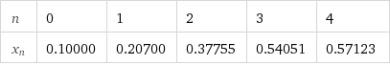

**TABLE 1.10: Iteration for = 2.3 – 2.32 at = 0.10000**

**2.32 Graphical illustration of the attracting nature of the logistic function and the diagonal (dash) line $y$ = $x$ when $r$ =2.3 < 3 with 0 = 0.10**

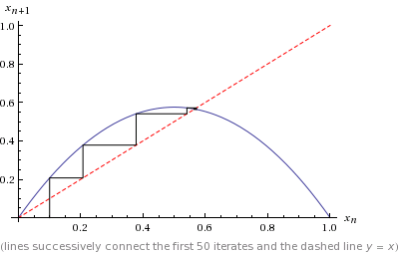

**Figure 1.03: attracting fixed point 0.57 at =2.3, 0 = 0.10**

From the graph the point of intersection as display in Figure 1.03 is 0.57. By iterating the function using $x_{0}$ = 0.1 as an initial point for $f(x_{n})$, and upon continues iteration it move gradually and converges to 0.57 as indicated by the black line, hence attracting when $r$ lie within 0 and 3. Clearly $x_{0}$ = $\frac{r-1}{r}$ is asymptotically stable for $r ∈$ [1, 3] that is attracting fixed point as in the Figure above.

**Illustration**: of the fixed point when $r>3$

It can be noticed that frequently iterating the function, the outcomes keep moving away from the fixed point 0 = 0.71.

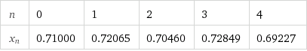

**Table 1.20: The iteration of = 3.5 – 3.52 at 0 = 0.71000**

**2.33 Graphical illustration of repelling state of the logistic function and the diagonal line $y$ = $x$ when $r$ =3.5 > 3 with a fixed point 0 = 0.71**

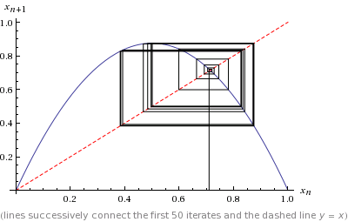

**Figure 1.04:Repelling fixed point =3.5, 0 = 0.71**

Clearly, the point of intersection of the graph in Figure 1.04 is 0.71.

Taking $x$ = 0.10 as an initial point, and frequently iterating the function keeps moving away from 0.71 and then diverges as shown clearly with the black line. Hence repelling when $r$ is greater than 3 or less than 1. Hence, x0 = is a repelling fixed point when $r∈$ [0, 1) $∪$ (3, 4] as shown in the Figure above.

***2.4 The period-2orbit of the logistic function and the bifurcation diagram***

The second iterations of the logistic function with the fixed point give the period $-$ 2 Orbits. And as shown in (mensah, 2016) that it occurs at $r>3$

**Example 4:** Considering the function or map = 3.2 – 3.22 for  
 (0, 1), let 0 = 0.5

By iteration of the function $f$ ($x$) the following sequence was obtain; at 0 = 0.5, 1 = (0) = 0.80, 2 = 2(1) = 0.51, 3 = 3(2) = 0.80, 4 = 4(3) = 0.51, 5 = 5(4) = 0.80

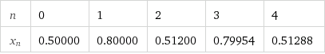

Table **1.30: Iteration of = 3.2 – 3.22 with 0 = 0.50000**

Clearly, the iteration of the function = 3.2 – 3.22 is a repeat of numbers that alternate between two values. Thus Orb = {0.51, 0.80} for the Orbits for the function = 3.2 – 3.22 with 0 = 0.5 as the initial point. This point 0 is a period $-$ 2 points for the map

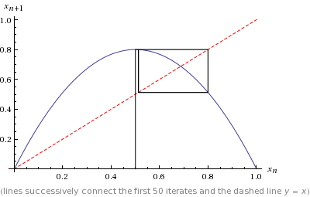

**Figure 1.05: graphical display of = 3.2 – 3.22**

**2.41 Graphical illustration of the Solutions/locations for the logistic function/map on its second iteration (period-2orbits/points)**

let = – 2 then ,for the period-2 point that is the second iteration 2() of the logistic function implies that we iterate the function twice and impose the line 2() = on it.

That is, 2() =

This give us the double-humped logistic and this four different locations or solutions shows up.

That is $x$ = 0, $x$ = $\frac{r-1}{r}$ and $x$ = $\frac{±\sqrt{r^{2}-2r-3}+r+1}{2r}$ are the solutions or the fixed points for period-2 point/orbits for the logistic function (mensah, 2016)

Graphical illustration of the four solutions when $r$ =7 is used in the function with 2() =



**Figure 1.06**:2() = where =7 and 2() =

Hence the four main solutions for the second iterations function 2() (period-2) when $r$ = 7 are $x=0$**, $x=0.7$, $x=1.5$ and $x=1.8$**

**2.5 Bifurcation diagram of the logistic function**

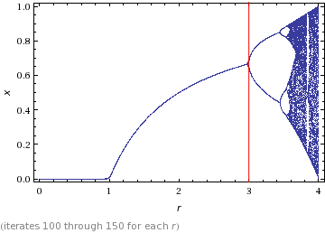

**Figure 1.06: Bifurcation diagram of $r$ and $f(x)$**

It can be seen that, from figure 1.06; the logistic function $f(x)$ approaches 0 when $r$ lies between 0 and 1. I.e. $f(x)$ →0 when 0 $≤r≤1$ and converges to a single point ranging from 0 to approximately 0.625. This is to show that when we change the parameter, there is a change in behavior in the logistic map. And this change in behavior as shown diagrammatically is called the bifurcation.

Hence, we can notice in the figure 1.06 above that there is a split (or bifurcation) when $r$ >3, this bifurcation represents the number of periods an initial value has when $r$ is a certain value/ number.

**2.51 Bifurcation diagrams at $r$ =3, $r$ =3.45, $r$ =3.544 and $r$ =3.56 respectively**

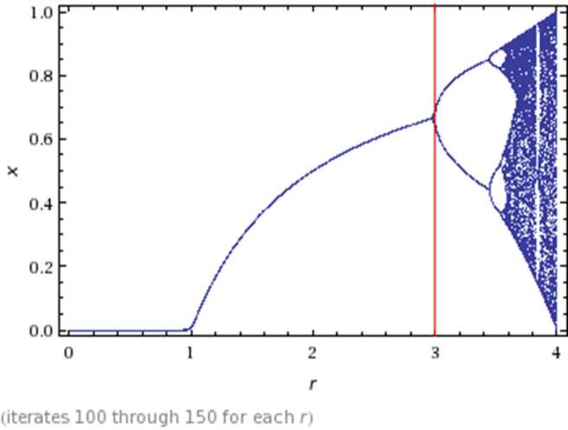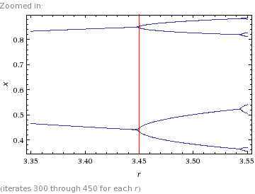

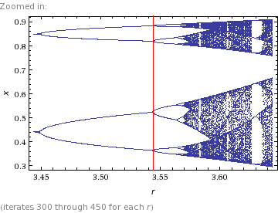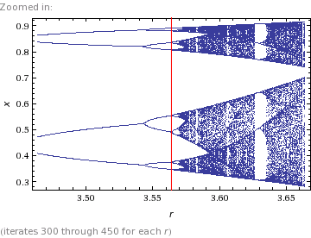

It can be deduce from the table and the bifurcation diagrams that period $-$ 2 points of $f(x)$ occur when 3< $r$ <3.44 and period-4 points occurs when 3.44< $r$ <3.54. But period $-$ 3 points appear in a strip of small open space that occur before $r$ =4. (Mensah, 2016)

It can also be noticed that the map/function becomes unstable as we get a bifurcation with two stable orbits of period $-$ 2 corresponding to the two stable fixed points of the second iteration of $f$ ($x$).



**Figure 1.07**: Bifurcation diagram for the quadratic/logistic map (adapted from Nicholas B. Tufillaro, Tyler Abbott, and Jeremiah P. Reilly, 2013)

So it more clear that when $r$ is greater than 3.45 there are different types of periodic alternations arranging from 8, 16, 32, 64, … as shown in figure 1.07 above.

**2.6Chaos**  
Chaotic as an unpredictable behavior is a non-periodic and is uncorrelated.

**2.61 The chaotic nature of the logistic map**

The last behavior of the logistic function is the chaotic behavior and to see this behavior graphically we looking into the transition of the periodic points. That is if period-3 exits then all period exits which leads to chaos.

**2.62 Graphical display of the period-3 points of the logistic map (bifurcation diagram)**

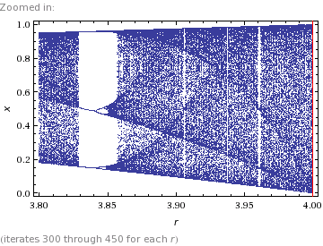

**Figure 1.08: Bifurcation diagram for 3.8 < $r$ < 4.0**

It is also very clear that for period-3 points there are some indications of small open space which break beyond a certain point hence periodic leading to chaos. (Mensah, 2016)

In figure 1.06 of the bifurcation diagram of the logistic map, it is shown that a fairly open gap exists shortly after $r$ =3.8 and by enlarging this bifurcation diagram as shown in figure 1.08 above, we see that there is a period-3 points in this gap. Hence it is obvious that, period-3 points in logistic map exists

***2.62 Graphical iteration of the logistic maps $f$ (x), when $3.8≤r≤$ 4 into a chaotic orbit***

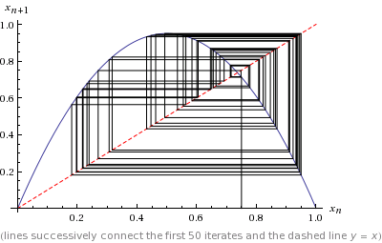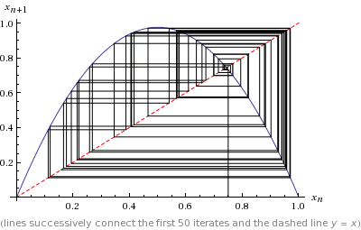

**Figure 1.09: $f(x_{n})$ = 3.8 $x_{n}$ (1- $x_{n}$) Figure 1.10: $f(x_{n})$ = 3.9 $x$ (1- )**

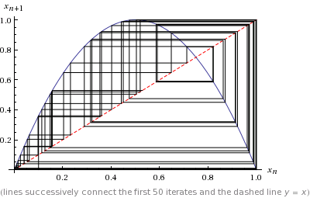

**Figure 1.11: $f(x_{n})$ = 4 $x_{n}$ (1- $x_{n}$) figure 1.12: $f(x_{n})$ = 4 $x_{n}$ (1- $x_{n}$)**

**Remarks:** Clearly the visual display of the graphical iteration of the logistic map leading to a chaotic orbit on a successive number of iterations can be seen in figure 1.09, figure 1.10, figure 1.11 and figure 1.12 for the logistic function $f(x_{n})$ at $r$ =3.8, $r$ =3.9 and =4 with 0=0.75 as the initial condition. Clearly at figure 1.12 the logistic function moves beyond a periodic behavior to a non periodic behavior as it filled up the whole space making it unpredictable.

1. **Conclusion**

In the various bifurcation diagrams, we found out that the route to chaos moves faster or closer when the control parameter $r$ keeps on increasing. This makes the logistic function/map exhibits various types and kinds of periodicity at higher points/orbits. It was shown that for period $-$ 3 points, there are some open spaces which break beyond a certain points hence periodic leading to chaos

In the graphical analysis of the logistic map, chaos keeps on occurring in way of filling almost the whole image upon a maximum number of iteration beyond 50 as displayed in figure 1.12

Graphically the function moves faster to chaos as shown in figure 1.09, figure 1.10, figure 1.11 and figure 1.12. When the parameter $r$ =4 and we keep on iterating beyond 50. Clearly chaos fills almost the whole image as a result of the faster movement which is uncorrelated in figure 1.12.

Hence it is clearly shown in the figures above that; chaotic regime has no correlations, unpredictable and non-periodic. Therefore at 3.8 $≤r≤$ 4 the logistic function is chaos, most especially at $r=$ 4

**Reference**

[1] Mensah, P. A. A. (2016).The nature of the logistic function (as a nonlinear discrete dynamical system) in topological dynamical system. Mathematics Dept. KNUST, kumasi, Ghana.

[2] Rak, R. &Rak, E. (2015), Route to Chaos in Generalized Logistic Map. University of Rzeszow, PL-35-959, Rzeszow, Poland. Retrieved from <http://www.researchgate.net/publications/271771394>

[3] Tufillaro ,N.B., Tyler, A., Jeremiah, P. R. (2013), An Experimental Approach to Nonlinear Dynamics and Chaos. Vol. 2.0 alpha.