New Tectonic Finding and its Implications on Locating Oilfields in parts of the Gulf Region
Varoujan K. Sissakian, Ahmad T. Shihab, Nadhir Al-Ansari^{3,} and Sven Knutsson

Abstract
Oilfield in southern part of Iraq, Kuwait and Saudi Arabia represent subsurface anticlines within the folded zone. Iraq forms the extreme northeastern parts of the Arabian Plate. It is divided into two main tectonic units which are Inner and the Outer Platforms. The former covers the southern and western parts of Iraq and is less affected by tectonic forces than the Outer Platform, which has, and still is, affected by tectonic compressional forces. The contact between the Inner Platform and outer Platform is delineated by the Abu Jir - Euphrates Active Fault Zone. Its northwestern extension is clearly visible while the southeastern extension is less clear since it is hidden under Quaternary sediments. The delineation of the contact in this part of the fault zone is the main scope of this study. Geophysical and different types of Digital Elevation Models, Landsat images, Quick Bird images, GIS and remote sensing techniques were used to delineate the contact, besides other relevant geological data such as the location of subsurface oil fields, structural contour maps on top of Cretaceous rocks and the drop in surface gradients represented by Al-Batin Alluvial Fan. Therefore, the contact is likely to be more precisely located. The concerned contact has regional interest, since it forms the contact between the folded and unfolded areas within the Arabian Plate. The folded area represents the existing subsurface anticlines that form oil fields in the southern part of Iraq, and Kuwait and more southwards to Saudi Arabia.
Keywords: Oilfields; Abu Jir Active Zone; Tectonic boundaries;Arabian Plate; Iraq

- Introduction
The earliest Alpine movement in the Zagros – Taurus Range was proposed to be in Late Cretaceous times [1,2,3]. The principal and most important period of folding was in the Pliocene [1,4,5]. Iraq represents the northern and northeastern margin of the Arabian Plate. Tectonically, Iraq is divided into two main units. The first, which almost covers the whole country, belongs to the Arabian Plate (Figure 1). The second one is confined to a very small area in the extreme northeastern part of the country, which belongs to the Eurasian (Iranian) Plate; it is called Shalair Terrane [6] (Figure 2). The main part of the Iraqi (Arabian Plate) is divided in turn into two main parts: The Inner Platform (Stable Shelf/ part) and the Outer Platform (Unstable Shelf/ part) (Figure 2). The contact between the two platforms is presented in the extreme western part by the Anah Graben Fault and extends southeastwards where it is represented by Abu Jir – Euphrates Active Fault Zone [7,8,9].
The contact between the Inner Platform and Outer Platform, which represents one of the main tectonic contacts between two major tectonic units in Iraq, was dealt with in previous compiled tectonic maps of Iraq, although different terminologies have been used by different authors. Buday and Jassim [10], for example, compiled the first Tectonic Map of Iraq using the Euogeosynclinal Theory (Figure 3 A). They used Stable Shelf and Unstable Shelf terminology. Al-Kadhimi et al. [11] adopted the same terminology and theory as used by [10] and compiled a Tectonic Map of Iraq, but included more detail, although the main tectonic contacts were shown to be the same (Figure 3 B). [12] studied the structural elements of onshore Kuwait and constructed a structural contour map on top of the Late Cretaceous and also on the Kuwait Arch. Later, [13] compiled a Tectonic Map of Saudi Arabia and didn’t show any details that would indicate the presence or otherwise of the concerned contact. The USGS [14] compiled a map that shows the regional distribution of oil provinces. Some of the boundaries of those provinces coincide with some of the tectonic contacts in Iraq and neighboring countries. Jassim and Goff [15] also compiled a Tectonic Map of Iraq using almost the same terminology as that used by [15], but with slight differences, which did not depend on the Euogeosynclinal Theory, but the Plate Tectonic Theory; moreover, [15] included the Mesopotamian Zone within the Stable Shelf (Figure 3 C). Aqrawi et al. [16] presented the concerned contact in a compiled Structural Elements Map of Iraq depending on various sources. The map was published in the book “The Petroleum Geology of Iraq”. The concerned contact exhibits acute change in the main trend towards SSE. Stern and Johnson [17] studied the continental lithosphere of the Arabian Plate depending on geological, petrological and geophysical data and represented the possible extension of the Abu Jir Fault Zone towards Saudi Arabia. Fouad [6] compiled the fourth version of the Tectonic Map of Iraq depending on the Plate Tectonic Theory and using more advanced data; consequently, a new terminology was used with different geographic extensions of the main tectonic units (Figures 2 and 3 D). Arian [18] compiled the Physiographic – Tectonic Zoning Map boundaries of Iran’s Sedimentary Basins and recognized the Zagros – East Taurus Hinterland and Persian Gulf – Mesopotamian Foreland Basin, which is the equivalent of the Mesopotamia Zone or part of the Unstable Shelf or Outer Platform as presented in Iraqi Tectonic Maps. Chitransh [19] compiled the Regional Tectonic elements in Kuwait but did not show any contact or zone that has direct and/ or indirect relation with the concerned contact.

The aim of this study is to elucidate the exact southeastern extension of the contact between the Inner Platform and the Outer Platform of the Arabian Plate (it will be referred to in this study as the “concerned contact” within Iraq, eastwards of Al-Slaibat Depression (south of Al-Nasiriyah), which represents the Abu Jir – Euphrates Active Fault Zone and to follow the contact outside of the Iraqi border into neighboring countries. Moreover, we attempt to delineate the most relevant contacts (outside of Iraqi borders) that coincide with the ‘concerned contact’ in Iraq (Figure 1). In addition, this will highlight the possibility of locating oil fields because the subsurface anticlines are restricted within the folded zone in southern Iraq, Kuwait and Saudi Arabia.

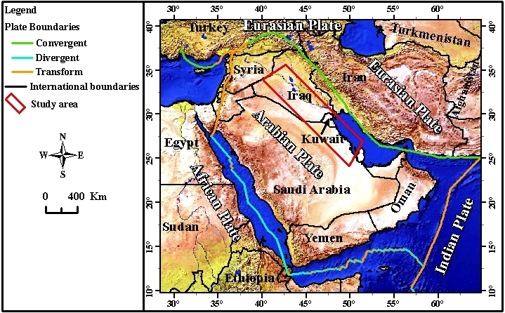

Figure 1: Natural earth shaded relief image showing the location of the studied area.

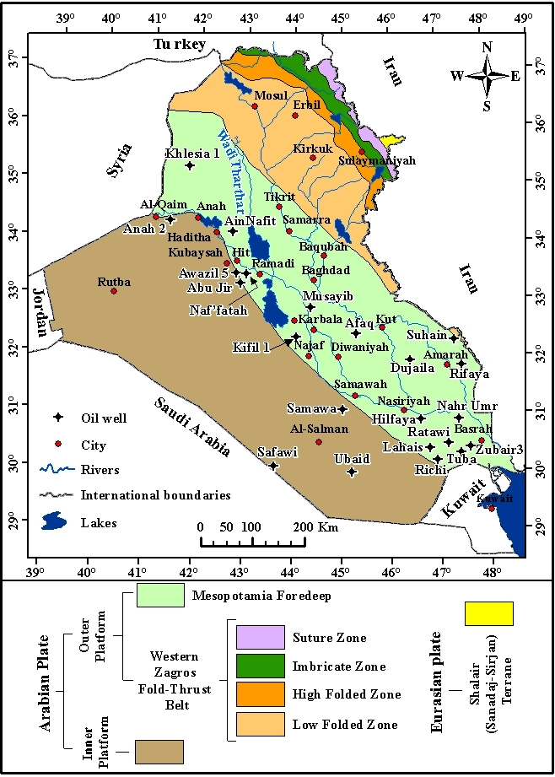
Figure 2: Tectonic Map of Iraq (after [6,20])
2 Materials and Methods
Landsat 8 Operational Land Imager (OLI) and QuickBird images, relevant Geological and Tectonic maps of Iraq and neighboring countries as well as relevant GIS and remote sensing techniques were used in this research. Eight scenes of Landsat 8 Operational Land Imager (OLI) with spatial resolution of 30 m for multispectral bands were preprocessed. These images have been acquired in March to May 2015. The preprocessing of OLI images were applied such as radiometric correction to prepare acceptable reflectance bands (except bands 8 and 9). The Landsat 8 sensors (OLI and TIRS) capture reflected solar energy, which is converted to radiance, and then this data was rescaled into digital numbers (DNs). Each raw of these data have 12-bit datum from OLI or TIRS stored across two eight-bit bytes (16-bit DNs) unsigned integer format with a range from 0 and 65536 [21]. The DNs of these data have been manually converted to reflectance, rather than radiance. The first step has been done by converting DNs of Multispectral bands to sensor radiance. The second step included implementation of Flash Atmospheric Correction Model, which is applied depending on the information provided in the product metadata (MTL) file that is provided with each scene data. The results represented at surface reflectance data.
However, it may contain negative values, so it is better to get rid of them by multiplying the output value by 10000 rescaling factor, which is applied using band math tool. Thus, the results were obtained at surface reflectance with floating values between 0 and 1. The main target of these steps is to remove the noise generated from the effect of atmosphere and thus we have obvious images with less resulting problems; during the mosaicking images. Moreover, seven bands of OLI data were stacked for each scene and all scenes were mosaicked together using Environment for Visualizing Images (ENVI), V. 5.1 software. The mosaicked images were used to display false color composite to obtain regional scale and clear visual interpretation of different locations along the Abu Jir – Euphrates Active Fault Zone.

3 Geological Setting

The contact between the Inner Platform (Stable Shelf) and the Outer Platform (Unstable Shelf) in Iraq is considered by the aforementioned authors using different concepts. [10, 11,15, 22] all used the same concept in terms of defining the contact. They all considered that the Tharthar valley represented the northern part of the contact between the two main tectonic units, attributing that to the Tharthar Active Fault, which was suggested by [23]. The continuation of the contact, south and southeastwards was considered by Abu Jir – Euphrates Active Fault Zone (Figure 3), which is very clear active zone as there are many indications, such as the alignment of water springs, lineaments, located sag points, and active depressions with bitumen seepages. The presence of the Tharthar Fault; however, was questioned by [24, 25,26]. Fouad [6] considered that the contact between the two main tectonic units is represented in the extreme western part by the Anah Active Fault and the Anah Grabben, and then follows the Abu Jir – Euphrates Active Fault Zone (Figures 2 and 3 D). Moreover, [6] considered the Mesopotamia Foredeep to be the main tectonic unit of the Outer Platform that is in contact with the Inner Platform, and the contact between them is represented by the Abu Jir – Euphrates Active Fault Zone, being the contact under concern.

The concerned contact has a special regional interest, since it forms the boundary between the folded and unfolded parts in Iraq and the extension of the contact in Kuwait and more southwards into Saudi Arabia. The main interest of the concerned contact is that it forms the western limits of the folded area, which includes all the existing subsurface anticlines that form oil fields in the southern part of Iraq, and Kuwait and more southwards to Saudi Arabia.

Identification of the extreme southeastern extension of the concerned contact, which is the main objective of this study, where the last surface indications for the Abu Jir – Euphrates Active Fault Zone exist, was considered to be acutely inclined southwards from its southeast [10,11,15, 22]. They were depending on the existence of subsurface anticlines in Basrah vicinity such as Zubair, Nahr Umr, Richi, Tuba oil fields (Figure 2). Fouad [6] however, extended the contact as a continuous line along the same extension (Figure 2). All those authors did not mention clearly how and why they extended the contact after the last surface indication for the location of the Abu Jir – Euphrates Active Fault Zone (apart from using geophysical data), which is represented there by the eastern rim of the Al-Slaibat Depression.
The concerned contact however, is not indicated on the tectonic maps of Kuwait and/ or Saudi Arabia, although both countries are located within the Arabian Plate. This means that the contact between the two main tectonic units in Iraq has no extension out of the Iraqi borders; consequently, both units (Inner and Outer Platforms, or Folded/ Unstable and Unfolded/ Stable units) will merge outside of the Iraq, which is clearly not possible. The two tectonic units were not shown to exist in Kuwait and/ or Saudi Arabia. However, the Tectonic map of Iran shows zoning of the tectonic units (Figure 4) and identifies a contact that coincides scientifically with the contact between the two main units in Iraq [18]. The contact identified by [18], however, is shifted more to the north than those drawn by [6,10,11,15, 22]. The Unstable Shelf [10,11, 15,22] and the Outer Platform [6] was referred to as the “Persian Gulf – Mesopotamian Foreland Basin” by [18] (Figure 4). The concerned contact on the map produced by [18] ends in the Arabian Gulf at the point where the Iraqi – Kuwaiti international borders meet near the gulf (Figure 4). This means that all the existing subsurface anticlines that are mainly oil fields in Iraq, Kuwait and Saudi Arabia will be located in stable/ unfolded part of the Arabian Plate, which is not possible.
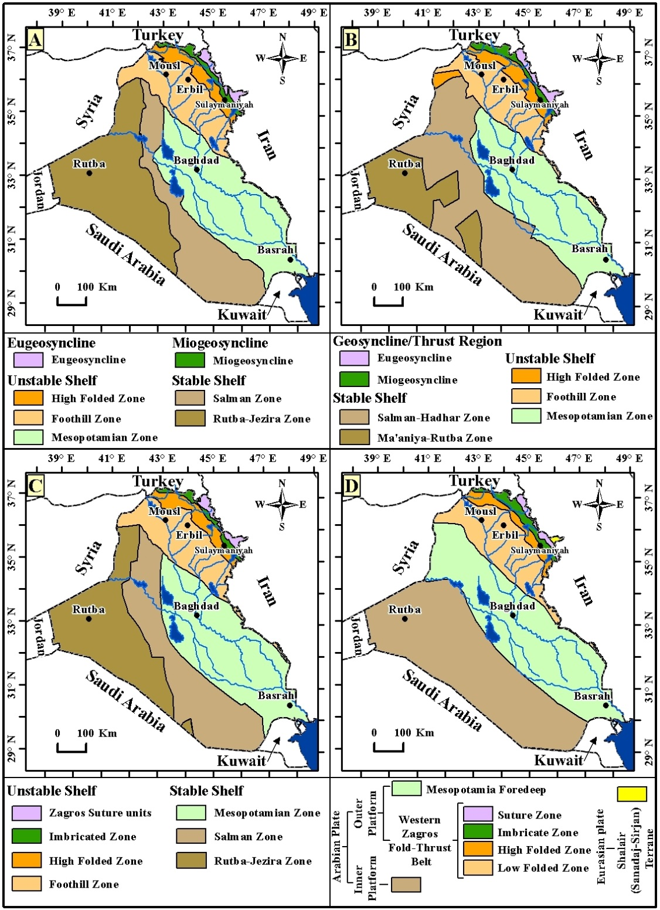
Figure 3: Main tectonic division zones of Iraq, A) after [10,22], B) after [11] C) after [15] and D) after [6, 20].

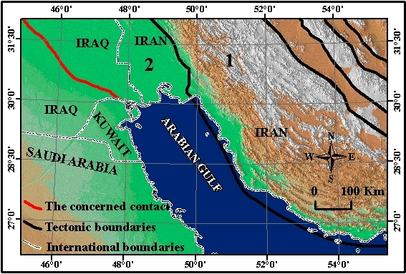
Figure 4: Color coded of DEMs adopted from Global Multi-resolution Terrain Elevation Data 2010 (GMTED 2010) 30 arc-second spatial resolutions, overly by the part of Physiographic – Tectonic Zoning Map boundaries of Iran’s Sedimentary Basins (after [18]). 1) Zagros – East Taurus Hinterland,
2) Persian Gulf – Mesopotamian Foreland Basin

4. Discussion

4.1. Arguing the Present Contacts
The contact between the Inner Platform (Stable Shelf) and Outer Platform (Unstable Shelf) is mainly considered to be located along the Abu Jir – Euphrates Active Fault Zone, which has very clear surface indications along its northern, central
and southern parts. Among the surface indications are:
1) The presence of numerous springs aligned along a line, which represents the concerned contact zone [27];
2) The presence of many sag depressions, bitumen and gas seepages, especially in the northern part of the zone between Hit – Kubaisa – Awazil [6,9,20] (Figure 5);
3) The straight outcrop pattern of the exposed rocks along Abu Jir – Euphrates Active Fault Zone [28] (Figure 6),
4) The development of Karbala – Najaf Alluvial Fan (Point A in Figure 6) and both Tar Al-Sayed and Tar Al-Najf [29] (Tar is a local term for a cliff).
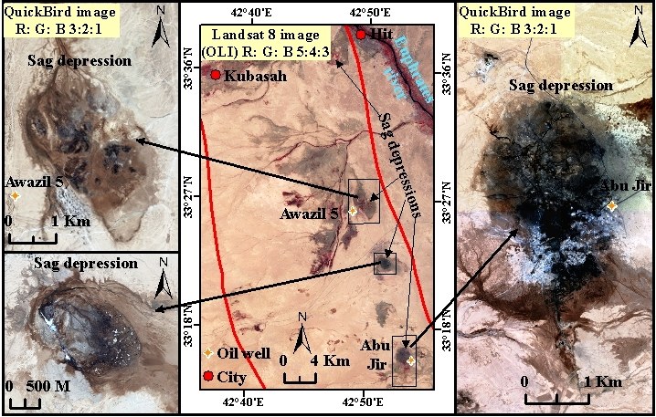
Figure 5: Landsat 8 image, Operational Land Imager (OLI) and QuickBird image showing bitumen seepages, note their distribution along Abu Jir – Euphrates Active Fault Zone (Limited between two red lines)

The extreme southeastern part of the contact is concealed under thick Quaternary sediments that hinder identification of the exact location of the contact (Figure 6). Therefore, the available tectonic maps of Iraq [6,10,15,,22] (Figure 3) show different extensions for the contact that do not coincide with each other in the four mentioned maps, as well as the one constructed by [18] (Figure 4). The last certain position for the contact is the last outcrops of the Nfayil Formation along the eastern margin of Al-Slaibat Depression (Figure 6).

The Contact in Versions 1, 2 and 3 of the Tectonic Map of Iraq
The concerned contacts identified by [10,11,15,22] are presented in Figure 3, A, B and C, respectively, which divides the main two tectonic zones in Iraq. However, [15] also added the Mesopotamian Zone to the Stable Shelf. The constructed contacts depend mainly on geophysical data (gravity and magnetic surveys?) and that is why three different contacts which do not coincide with each other were presented. The difference is attributed to the different geophysical interpretations given by the different authors. Jassim and Goff [15] mentioned clearly that the southern part of the contact (the main objective of this study) is “defined by a N – S gravity gradient in southern Iraq. However, some surface data were also used in defining the contact. Some of the the differences could also partly be attributed to the cartographic portrayal of the contact zone.

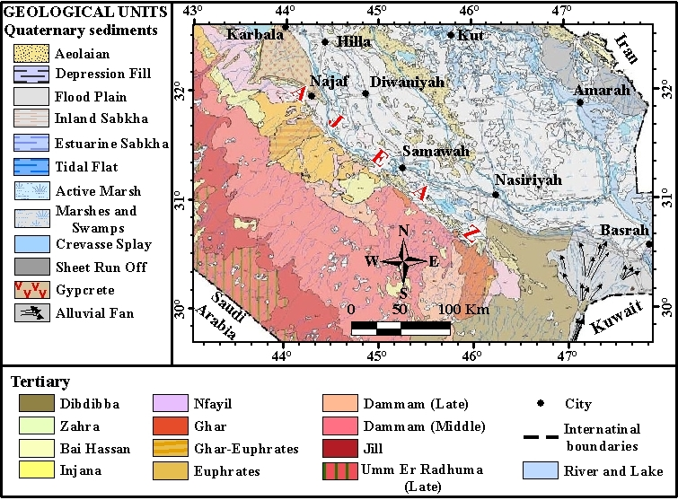
Figure 6: Geological map of Iraq (After [28]). Note the straight outcropping pattern along Abu Jir – Euphrates Active Fault Zone (AJEAZ).

The Contact in Version 4 of the Tectonic Map of Iraq
The concerned contact identified by [6] is quite different from the contacts previously mapped by the three authors referred to above and depends on the “Abu Jir Fault System from Al-Batin lineament (Figure 7), southwest of Basrah, extending more than 600 Km northwestwards along the Euphrates River valley, through Samawa, Shithatha, Abu Jir, Awazil, Hit, Al-Baghdadi, and Haditha” [30] (Figure 2). This means that Fouad has used surface data more than geophysical data although he has used seismic data instead of gravity and magnetic data in the interpretation and definition of the location of the concerned contact. Fouad [30] used the Al-Batin lineament in extending the concerned contact southeastwards and eastward from Al-Slaibat Depression but it has a NE – SW lineament (Figure 7), whereas the direction of the concerned contact is NW – SE (Figures 2 and 3 D) and the, Al-Batin lineament appears to have no relation to the concerned contact.

20 Km

Al-Batin Lineament

Figure 7: Al-Batin lineament (Landsat 7 image, TM Band 1) (after [19])
The Concerned Contact after Aqrawi et al. [16]
Aqrawi et al. [16] have compiled Structural Elements Map of Iraq depending on various sources (Figure 8), which was included in a written book “The Petroleum Geology of Iraq”. They also considered the Abu Jir – Euphrates Active Fault Zone to represent the concerned contact. However, they shifted the contact from its main NW – SE trend; in its extreme southeastern part where its identification is hindered by thick Quaternary sediments.

The Concerned Contact on the Iranian Tectonic Map
The Physiographic – Tectonic Zoning Map boundaries of Iran’s Sedimentary Basins [18] show the contact between Zagros – East Taurus Hinterland and the Arabian (Persian) Gulf – Mesopotamian Foreland Basin (Figure 4), which is the equivalent of the Unstable Shelf [10,11, 22] and Stable Shelf [15], and Outer Platform [6] in Iraq. The concerned contact also does not coincide with that presented by the aforementioned four versions of the Tectonic Map of Iraq.
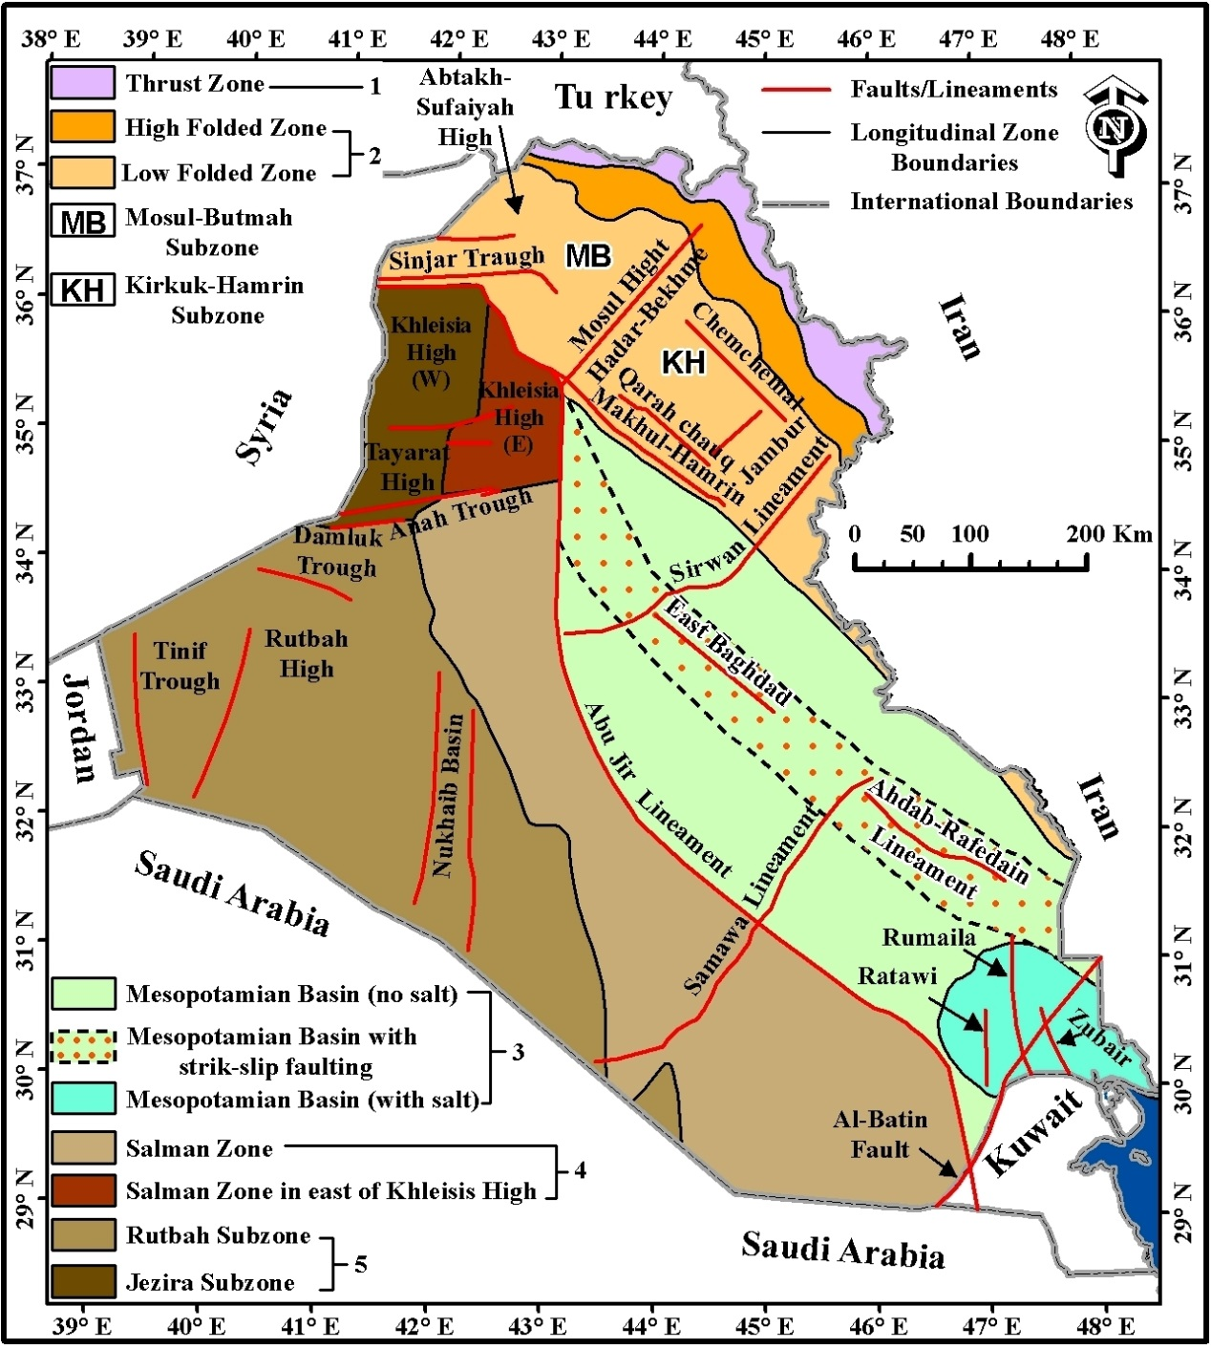

Figure 8: Structural Elements Map of Iraq (after [16])
It is believed that the constructed contact by [18] is extrapolated in its extreme south-eastern part to coincide with the western rim of the Arabian Gulf (Figure 4). Arian (2013) mentioned the Persian Gulf – Mesopotamian Foreland Basin and stated: “From tectonics view, it contains the south margin of simple fold belts of Zagros that formed on the northeastern part of Arabian plate’s passive margin. Persian Gulf has continued to end of Mesopotamian area in central Iraq and have named Persian Gulf – Mesopotamian Foreland Basin. Persian Gulf – Mesopotamian Foreland Basin is the northern margin of the Outer Platform of northern margin of Arabian Craton”. It is clear that the Unstable Shelf [10,11, 22] or Outer Platform [6] is the equivalent of the Persian Gulf – Mesopotamian Foreland Basin [18].

The Concerned Contact on the Saudi Arabian and Kuwaiti Tectonic Maps
The tectonic Map of Saudi Arabia [13] (Figure 9) and that of Kuwait [19] (Figure 7) show no indication of the concerned contact and the related tectonic zones that means they have not differentiated the folded/ unstable part from the unfolded/ unstable part of the Arabian Plate. The Zagros Fold Belt, however, is the same as that referred to as the Unstable Shelf or Outer Platform [6,10,11, 22].

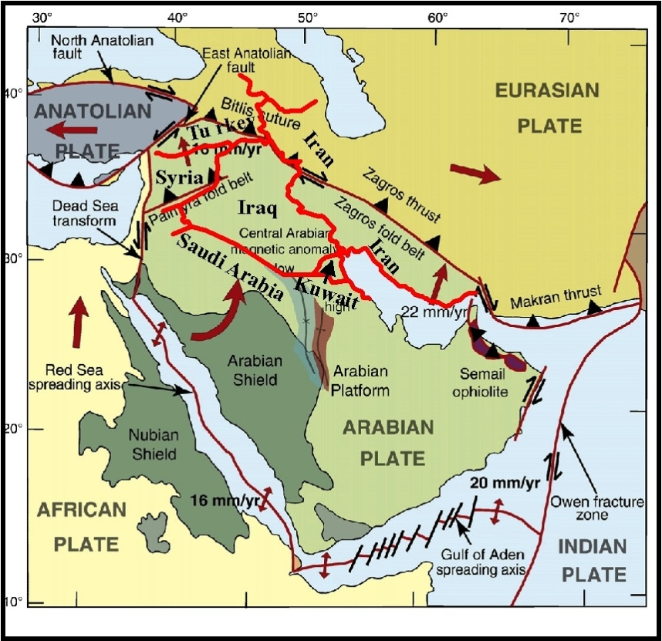

Figure 9: Tectonic Map of Saudi Arabia (after [13]).
Stern and Johnson [17] studied the continental lithosphere of the Arabian Plate depending on geological, petrological and geophysical data and represented the possible extension of the Abu Jir Fault Zone towards Saudi Arabia (Figure 10). The authors, however, are not in agreement with the “possible suture (Abu Jir trend)” presented by [17] because the trend of the Abu Jir Fault Zone is very well known with clear surface expressions until it reaches Al-Slaibat Depression where its location is made difficult because of the presence of thick Quaternary sediments (Figures 2, 3, 5 and 6). Moreover, the possible N-S trend trend suggested by [17] (Figure 10) does not coincide with the main tectonic contacts and main elements not only in Iraq, but even in the near surroundings the trend is NW – SE.

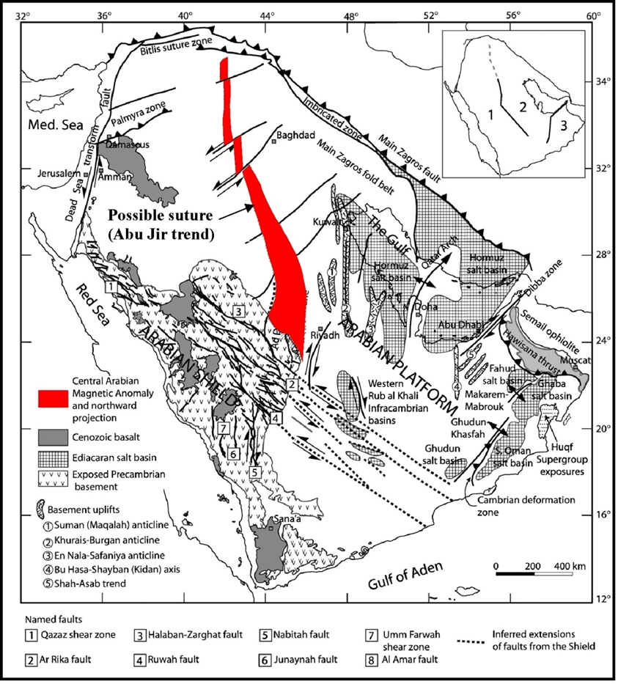

Figure 10: Selected structural and tectonic features of the Arabian Plate,
compiled after [17].

4.2 The Suggested Extension of the Concerned Contact
The existing tectonic maps of Iraq presented by [6,10,11, 16, 22] (Figures 3 and 8) show different trends for the concerned contact, especially in its extreme south-eastern part and eastwards from Al-Slaibat Depression. This is attributed partly to the lack of accurate surface and subsurface data in the area and partly to the difference in the concept of the tectonic divisions and zonation in Iran, Kuwait and Saudi Arabia (Figures 4, 7 and 9) by the authors concerned.
Figure (11) shows the locations of the concerned contacts as constructed by different authors. It is clear that after the last surface exposures to the east of the Al-Slaibat Depression (Figures 6 and 11) the concerned contact was extrapolated by the authors depending either partly or totally on geophysical data [10,11,15, 22] or on the imagination of the authors [6,18].
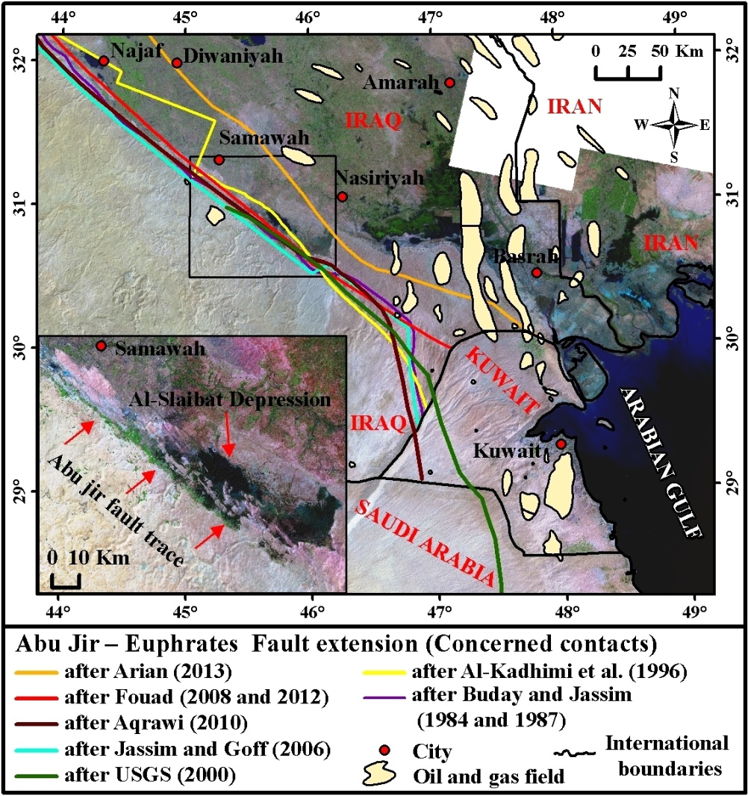
Figure 11: Landsat 8 image (OLI) R: G: B 7:5:3 showing the locations of the concerned contacts, as constructed by different authors

The Gradient of Global Multi-resolution Terrain Elevation Data 2010 (GMTED2010) (Figure 12) and natural earth shaded relief image (Figure 13) were used as a base to delineate the trace of the concerned contact. Figure (12) illustrates the heights by colors, of the concerned contact. Beyond the Al-Slaibat Depression it runs almost parallel to a height of approximately 50 – 75 m (shown as the white/ green color).
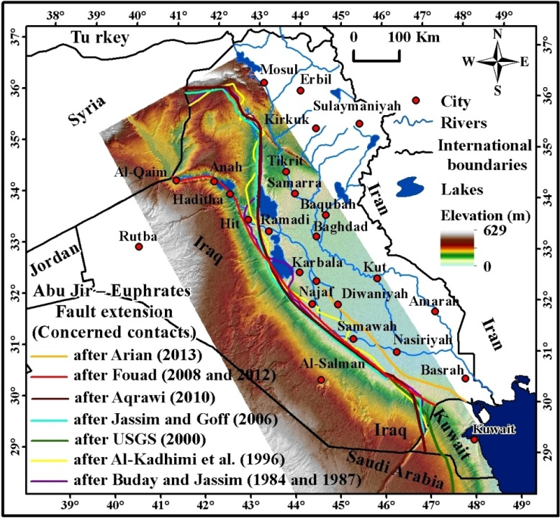

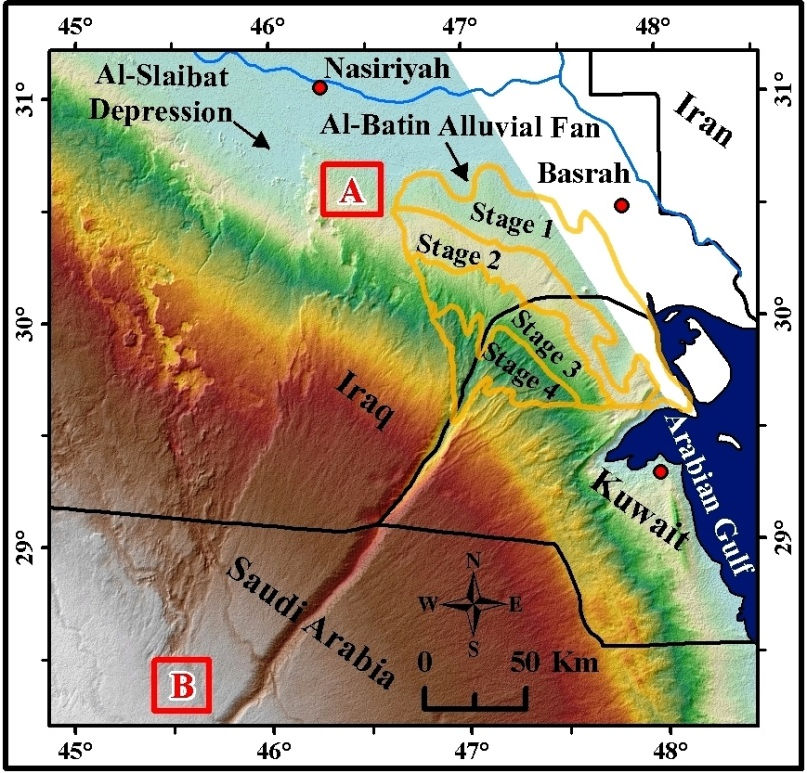

Figure 12: Gradient map of the Global Multi-resolution Terrain Elevation Data 2010 (GMTED2010) 7.5 arc-second spatial resolutions, Top) the locations of the concerned contact, as constructed by different authors, Bottom) enlarged part showing the fault (A B) and Al-Batin alluvial fan’s stages (after [31])

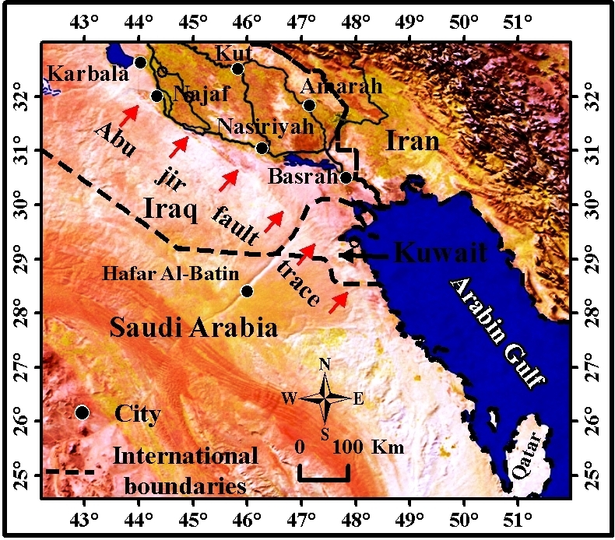
Figure 13: Natural earth shaded relief image showing the trace of the
concerned contact.

South of Al-Nasiriyah city, a clear fault exists with a N – S orientation that changes southwards to a NNE – SSW orientation (Figure 12 Bottom). The fault is most probably of a strike slip type with the eastern block being moved northwards. However, the fault may be of the wrench type with upward movement in its southern part and downward movement in its northern part. Because the fault runs within Quaternary sediments its type cannot be predicted precisely.

The aforementioned fault (Figure 12 Bottom); however, has no influence on the concerned contact; as it is clear in the DEM image (Figure 12). This is attributed to the depth of the concerned contact and thick Quaternary sediments cover, which means that the fault has affected only the Quaternary sediments and is a shallow fault indicating neotectonic activity.

The authors dispute the location of the constructed contact shown by [18] (Figure 4), because its western limit coincides with the western limit of the Arabian Gulf in its extreme northern part. This means that all of the oil fields in the vicinity of Basra (Figure 2) and those in Kuwait (Figures 11 and 15) are located within the stable part of the Arabian Plate, consequently indicating an extensively folded areas; due to the presence of subsurface anticlines, then this should be included within the stable part of the Arabian Plate, which cannot be, because it is the unfolded part of the Arabian Plate.
The authors have considered the top of the Albian – Cenomanian structure map (Figure 14) for extending the concerned contact for the following reasons:

1) During the Late Cretaceous, a major and significant tectonic collision closed the Neo-Tethys and the Zagros Foreland Basin, which forms the external (western and southwestern) limits of the unstable part of the Arabian Platform in Iraq, began to develop;
2) The development of the subsurface structures in N – S trend in the vicinity of Basrah (Figure 11) and which extend inside Kuwait (Figure 14),
3) The suggested line (Figures 14 and 15) forms the western limit of the developed N – S anticlines, which are mainly oil fields. Moreover, [12] mentioned that the Ahmadi Ridge is a rare north – northwest contraction trend probably related to the
Zagros Orogeny and traps oil where it overprints the Kuwait Arch trend.

The Kuwait Arch (Figure 15) is clearly shown on the Bouguer anomaly map; it almost coincides with the same suggested location of the concerned contact by the current study. The authors have considered this assumption as sound evidence that indicates the location and trend of the concerned contact in its extreme south-eastern part, and its extension out of the Iraqi borders inside Kuwait and Saudi Arabia.
The accurate extension of the concerned contact based on the subsurface data; as the top of Albian – Cenomanian structure map will enhance regionally the extension of the possible areas for subsurface oil fields in Iraq, Kuwait and Saudi Arabia. Moreover, it will define more accurately where the promising areas for investigation of oil are. Since the concerned contact represents the contact between the folded and unfolded parts of the Arabian Plate; therefore, the accurate location of the contact will facilitates the studying of the stress regime and its intensity limitations exerted by the continuous collision between the Arabian and the Eurasian Plates.
The oil provinces map (Figure 16, [14]) shows some boundaries that limit different oil provinces as well as some tectonic zones. Part of the drawn contact inside Iraq (Figure 16) coincides partly within the concerned contact (Figures 2 and 11), which forms the western limit of the subsurface oil fields that represent the folded part of the region as shown by the presence of the anticlines. This aspect is also considered in the current study when locating the concerned contact. The drawn boundaries of the oil provinces (Figure 6) can be enhanced using the concerned contact; consequently, the extension of the oil provinces will be enhanced and delimited more precisely.
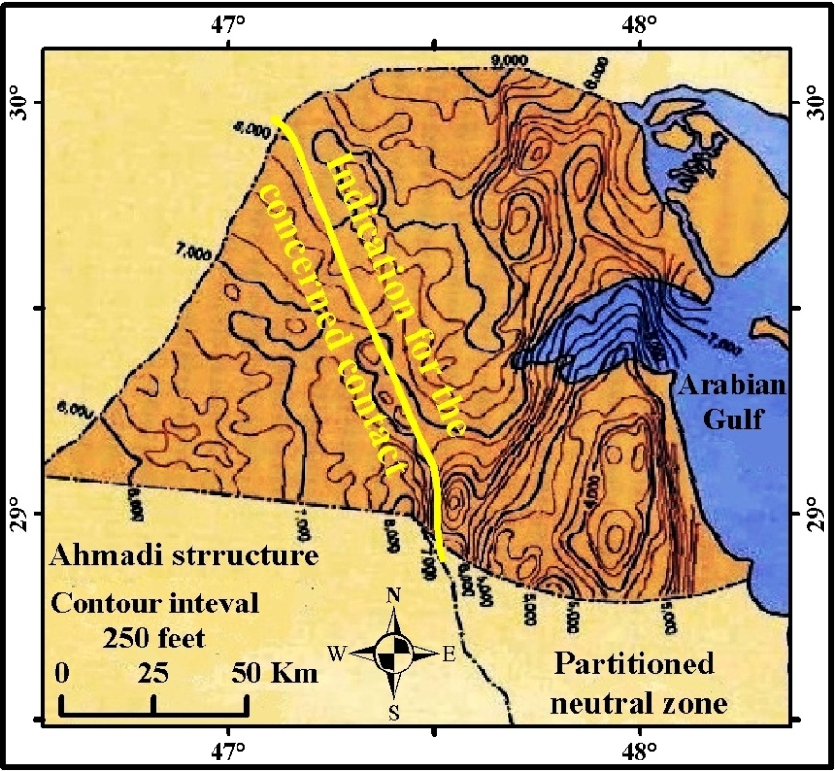
Figure 14: Top Ahmadi Formation (Albian – Cenomanian) structure top map
(after [12]).
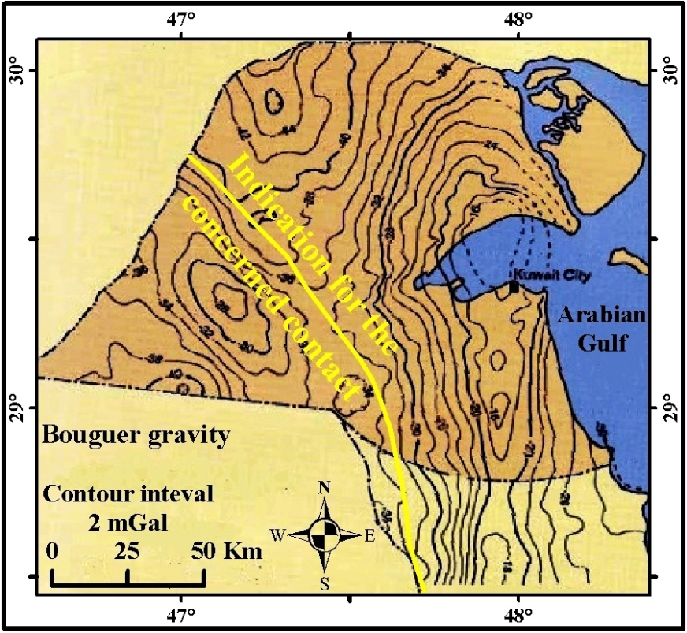
Figure 15: Bouguer anomaly map showing the location of Kuwait Arch, which coincides with the concerned contact (after[12]).
The location of the concerned contact; in this study is based on:
1) The already existing constructed contacts (Figure 11),
2) Following the traces of the concerned contact on the constructed DEM image (Figure. 13),
3) Consideration of the top Albian – Cenomanian depth structure map (Figure. 14) (Carman, 1996),
4) The Bouguer anomaly map (Warsi, 1990; in [12]) (Figure 15), which shows a clear arch known as the Kuwait Arch (Warsi, 1990; in [12]),
shows a clear arch known as the Kuwait Arch (Warsi, 1990; in [12]),
5) The first drop in the gradient of Al-Batin Alluvial Fan [31] (Figure 12), and
6) The data furnished in the constructed oil provinces map [14] (Figure 16).

Moreover, geophysical and different types of Digital Elevation Models, Landsat images, Quick Bird images, and GIS and remote sensing techniques were used to delineate the contact.

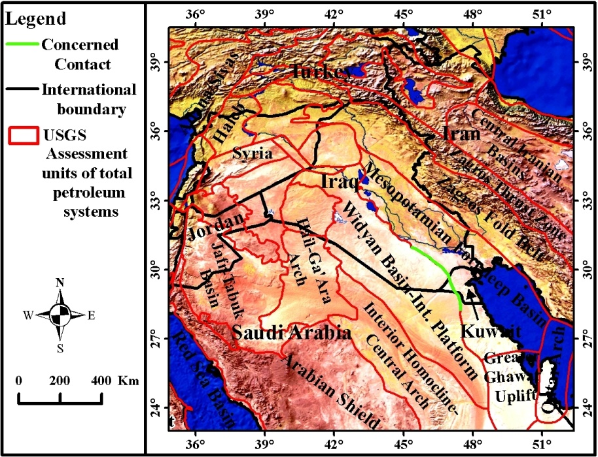

Figure 16: The concerned contact projected on natural earth shaded relief image overly by assessment unit boundaries of the petroleum systems (after [14])

All the aforementioned data were used as integrated survey to delineate the concerned contact, which were super imposed over a DEM image, and then the best matching contact was drawn., Therefore, the concerned contact is more precisely located using more sound data, as compared to previously located contacts by different authors (Figures 2, 8, 9, 10, 11 and 13). It is worth mentioning that the majority of the previous studies have not extrapolated the contact outside of Iraq therefore, the extension of the concerned contact in the area where no surface outcrops exist was not as precise.
The authors have delineated the most likely location for the concerned contact based on the best data sets currently available (Figure. 17) based on both surface and subsurface structures.

5 Conclusions
The contact between the Inner Platform (Stable Shelf) and the Outer Platform (Unstable Shelf) which in this study is referred to as “the concerned contact”, has almost the same trend (Abu Jir – Euphrates Active Fault Zone) as that constructed by five previous studies in Iraq. However, in its extreme southeastern part where its location is hidden under thick Quaternary sediments, the five constructed contacts by five authors are not the same, although some of them coincide partially.
The current study has located the hidden part of the concerned contact from the best and varied information as possible. It has included surface and subsurface information (exposures, outcrop pattern, water springs and sag depressions), and subsurface (partly geophysical and structure contour maps) data.
The tectonic and structural divisions in neighboring countries (Iran, Kuwait and Saudi Arabia) have also been considered in locating the concerned contact. This is attributed to the fact that the concerned contact extends south eastwards into Kuwait and then into Saudi Arabia.
GIS and remote sensing data are used in following the concerned contact inside Iraq, as well in Kuwait and Saudi Arabia, especially when it is hidden under Quaternary sediments.
The locations of the subsurface oil fields, which represent anticlines, are also used in locating the concerned contact since the presence of anticlines indicates folded areas, which means that they are most likely located on part of the Outer Platform (Unstable Shelf). The extreme western limit of the oil fields is considered as the end of the folded area, which indicates the concerned contact.

ACKNOWLEGMENT
The authors would like to thank Professor Ian Foster of Northampton University, UK for reading the manuscript and fruitful discussions.

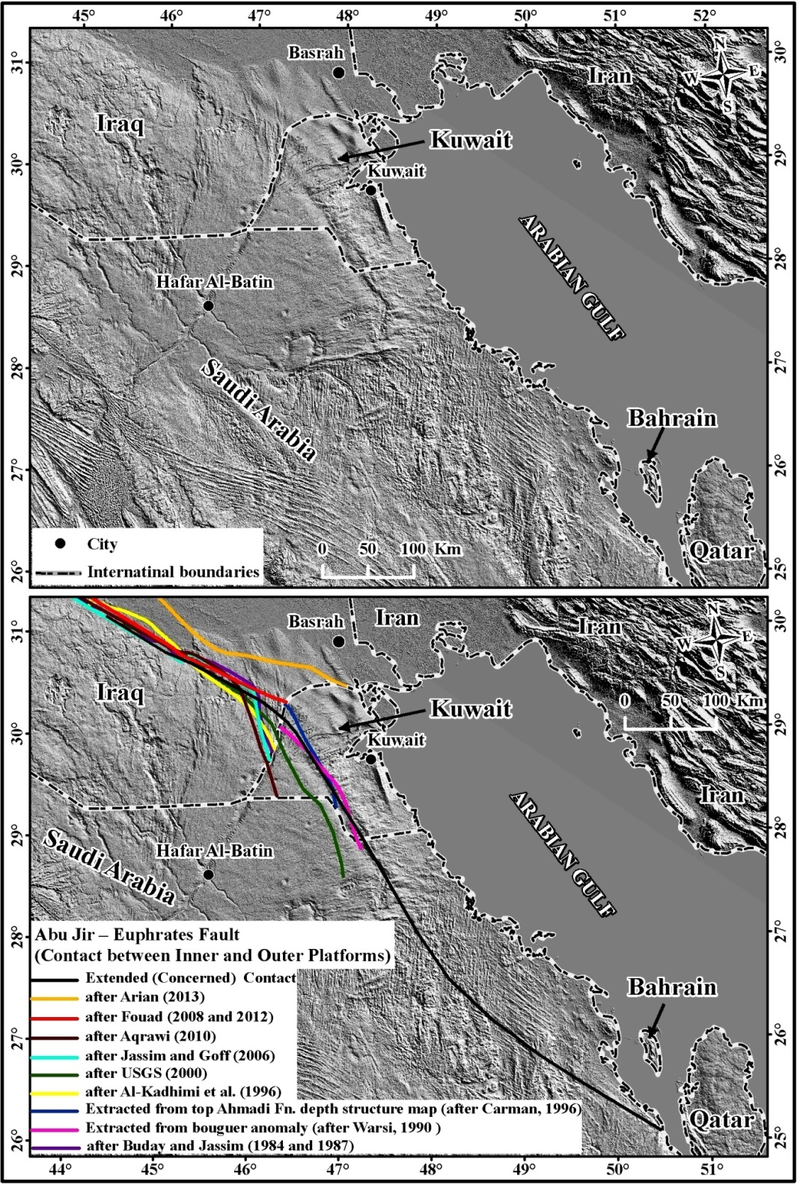

Fig. 17: Hillshade image extracted from (GMTED2010) 7.5 arc-second spatial resolutions showing the previously drawn contacts and the recently constructed concerned contact

References

[1] Lees, G. M , and F. D. S., Richardson 1940. “The geology of the oilfield belt of S. W. Iran and Iraq.” Geol. Mag., 67, 227-252.
[2] Lees, G. M. 1953. “The Middle East.” Science of Petrol., 6, 67-72.
[3] Mitchell, R. C. 1960. “Reconnaissance structural and tectonic studies of part of northern Iraq.” 21st. International Geol• Qong-, Copenhagen, part 18, 149-166.
[4] Lees, G. M. 1950. “Some structural and stratigraphical aspects of the oilfields of the Middle East.” 18th International geological cong., Great Britain, part 6, 68-73.
[5] Lees, G. M. 1955. “Recent earth movements in the Middle East.” Geol. Rundschau, 43, 221-226.
[6] Fouad, S.F.A. 2012. “Tectonic Map of Iraq scales 1: 1000 000.” Iraq Geological Survey (GEOSURV) publications, Baghdad, Iraq.
[7]Fouad, S. F. A. 1997. “Tectonic and Structural Evolution of Anah Region. West Iraq.” Unpublished Ph.D. Theses, College of Science, University of Baghdad, Baghdad. Iraq.
[8] Fouad, S.F. 2006. “Fault geometry and depth of detachment in Anah Graben, West Iraq.” Iraqi Bulletin of Geology and Mining, 2, 1, 13 – 29.
[9] Fouad, S.F. 2007. “Tectonic and structural evolution of the Western Desert.” In: Geology of Iraqi Western Desert. Iraqi Bulletin of Geology and Mining, Special Issue No. 1, 29 – 50.
[10] Buday, T., and S.Z. Jassim. 1987. “The Regional Geology of Iraq. Vol. 2. Tectonism, Magmatism and Metamorphism.” In: M.J., Abbas and I.I., Kassab (Editors). Iraq Geological Survey (GEOSURV) Publications. Baghdad, Iraq. 352 pp.
[11]Al-Kadhimi, J., Sissakian, V.K., Fattah, A.S. and D.B. Deikran. 1996. “Tectonic Map of Iraq, scale 1: 1000 000.” 2nd edition. Iraq Geological Survey (GEOSURV) Publications. Baghdad, Iraq.
[12] Carman, G.J. 1996. “Structural elements of onshore Kuwait.” GeoArabia, 1, 2.
[13] Johnson, P.R. 1998. “Tectonic Map of Saudi Arabia.” Ministry of Petroleum and Mineral Resources, Saudi Arabia.
[14]U.S. Geological Survey 2000. “U.S. Geological Survey World Petroleum Assessment 2000– DESCRIPTION AND RESULTS.” Digital Data Series (DDS) 60, U.S. Geological Survey Digital Data Series DDS-60, U.S. Geological Survey, Denver, CO. Online links: http://pubs.usgs.gov/dds/dds-060/
[15] Jassim, S.Z. and J. Goff (Editors). 2006. “The Geology of Iraq.” Dolin and Moravian Museum, Brno.
[16] Aqrawi, A.M., Horbury, A.D., Goff, J.C. and F.N. Sadooni. 2010. “The Petroleum Geology of Iraq.” Scientific Press Ltd. UK, 424PP.
[17] Stern, R. and P. Johnson 2010. “Continental lithosphere of the Arabian Plate:A geologic, petrologic, and geophysical synthesis.” Earth-Science Reviews, 101, 29 – 67.
[18] Arian, M. 2013. “Physiographic-Tectonic Zoning of Iran’s Sedimentary Basins.” Open Journal of Geology, 3, 69 – 177. doi:10.4236/ojg.2013.33020. Published Online July 2013 (http://www.scirp.org/journal/ojg).
[19] Chitaransh, S. 2014. “Multi-Scale Lineament and Geological Mapping Elucidates Subsurface and Regional Tectonic Influences in Kuwait.” Adapted from poster presentation given at AAPG International Conference & Exhibition, Istanbul, Turkey, September 14-17, 2014
[20] Fouad, S.F.A. 2008. “Tectonic Map of Iraq, scale 1: 1000 000.” Symposium on the 3rd edition of the Tectonic Map of Iraq, Erbil. Iraq Geological Survey (GEOSURV) Library, Baghdad. Iraq.
[21] Irons, J. R., Dwyer, J. L., and Barsi, J. A. 2012. “The next Landsat satellite: The Landsat Data Continuity Mission”. Remote Sensing of Environment, 122, 11-21.
[22] Buday, T. and S.Z. Jassim. 1984. “Tectonic Map of Iraq, scale 1: 1000 000.” Iraq Geological Survey (GEOSURV) Publications. Baghdad, Iraq.
[23] ATOMENERGEXPORT. 1985. “Feasibility study of site selection for Nuclear Power Plant location in Iraq.” Book 3. Ex-Iraqi Atomic Energy Commission library, Baghdad, Iraq.
[24] Yacoub, S.Y., Sissakian, V.K. and D.B. Deikran 1991. “Final Geological Report of NPPP.” Iraq Geological Survey (GEOSURV) Library report No. 2022.
[25] Sissakian, V.K., Yacoub, S.Y., Deikran, D.B., Al-Kadhim, J.A.M., Abdul Husain, A. and M.H. Bayan 1992. “Final Report of the Earth Sciences Activities.” Iraq Geological Survey (GEOSURV) Library report No. 2027.
[26] Fouad, S.F.A. and W.A.A. Nasir. 2009. “Tectonic and Structural Evolution of Al-Jazira Area.” Iraqi Bulletin of Geology and Mining, Special Issue on Geology of Al-Jazira Area, 33 – 48.
[27] Al-Juburi, H.T. and Al-Basrawi, N.H., 2007. Hydrogeology. In: Geology of the Iraqi Western Desert. Iraqi Journal of Geology and Mining, Special Issue No. 1, 125 – 144.
[28]Sissakian, V.K. and S.F. Fouad 2012. “Geological Map of Iraq scales 1: 1000 000.” 4th edition, Iraq Geological Survey (GEOSURV) publications, Baghdad, Iraq.
[29] Sissakian, V.K., Abdul Jab’bar, M.F. Al-Ansari, N.A and S. Knutsson 2015. “The Origin of Tar Al-Say’ed and Tar Al-Najaf, Karbala-Najaf Vicinity, Central Iraq.” J. Civil Engineering and Architecture, 9, 446-459. doi: 10.17265/1934-7359/2015.04.008.
[30] Fouad, S.F.A. 2010. “Tectonic and structural evolution of the Mesopotamia Foredeep, Iraq.” Iraqi Bulletin of Geology and Mining, 6, 2, 41 – 53.
[31] Sissakian, V.K. Shihab, A.T., Al-Ansari, N. and S. Knutsson 2014. “Al-Batin Alluvial Fan, Southern Iraq.” Engineering, 6, 699 – 711. Published online, October, 28, 2014 in SciRes. http://www.scirp.org/journal/ eng. http://dx.doi.org/10.4236/3ng.2014.61 1069. DOI: 10.4236/eng.2014.611069

Private Consultant, Erbil, Iraq. e-mail: varoujan49@yahoo.com
Assistant Chief Geologist, Iraq Geological Survey, e-mail: ahdsat1975@gmail.com
Lulea University of Technology, Lulea, Sweden. e-mail: nadhir.alansari@ltu.se, Sven.Knutsson@ltu.se Article Info: Received :

