To,
The Editor
Journal of Computations & Modelling
Subject: SUBMISSION OF A MANUSCRIPT FOR EVALUATION
Dear Editor,
I am enclosing herewith a manuscript entitled “COMSOL Multiphysics Analysis of Temperature Distribution of Structural Material Specimens in High Temperature Gas-Gap Irradiation Capsule of FBTR " for publication in “Journal of Computations & Modelling", Scienpress Ltd for possible evaluation.
With the submission of this manuscript I would like to undertake that the above mentioned manuscript has not been published elsewhere and will not be published anywhere till the final decision comes from your journal.
Submitted manuscript is an Original Article. I am the corresponding Author for this submission. This paper could be very useful in design and development of Non-Instrumented Gas gap capsule for studying desired temperature irradiation properties of structural material specimens by COMSOL Modeling.
Regards,
N. Mahendra Prabhu
Scientific Officer -D,
MMG/RIRD/IDEAS,
IGCAR,
Kalpakkam – 603102, INDIA.
mahendra@igcar.gov.in , Phone No: +91-44-27480500 Ext:23371.

COMSOL Multiphysics Analysis of Temperature Distribution of Structural Material Specimens in High Temperature Gas-Gap Irradiation Capsule of FBTR
N. Mahendra Prabhu*, Sadu Venkatesh, P. K. Chaurasia, S. Murugan and G. Amarendra
Metallurgy and Materials Group (MMG)
Indira Gandhi Centre for Atomic Research (IGCAR)
Kalpakkam-603 102, Tamilnadu, India
*mahendra@igcar.gov.in
Mobile: +91 9003675304
Abstract:
The main aim of this work is to determine the required gas composition of He-Ar gas mixture to attain the target temperature of irradiation specimens in a high temperature irradiation gas gap capsule arrangement setup. The distinct composition of helium and argon gas mixture will be filled in between each sub capsule and the outer tube. Irradiation specimen’s desired temperature will be achieved by adjusting the gas composition in each gas gap. In this present analysis, by using COMSOL Multiphysics analysis the desired gas compositions have been determined with considering other parameters such as coolant temperature, reactor/leaner power and location of the ring. The COMSOL simulated results have been compared with the target irradiation temperature of specimens in the sub capsule from bottom to top. The specimens temperatures to be achieved in the gas gap capsule is closer to the target temperature.

1.0 Introduction
It is proposed to irradiate structural material specimens in FBTR to determine the changes in their mechanical properties due to exposure to radiation using high temperature irradiation capsule with gas gap arrangement. The irradiation capsule will contain five sub capsules arranged one over the other. Tubular specimens and disc specimens for determination of mechanical properties and swelling are proposed to be irradiated. Specimens will be kept in the sub capsules surrounded by static sodium. The gap between the each sub capsule and the outer tube will be filled with a distinct composition of helium and argon gas mixture. During irradiation, the specimen temperature will depend on the nuclear heating rate at the location of irradiation and temperature of sodium flowing around the irradiation capsule. Due to attenuation of gamma rays and neutrons on the specimens, heat will be generated in the specimens. Gas composition in the gas-gap will be adjusted to attain a desired temperature of irradiation in the specimens. In this present work we assumed that irradiation location is 3rd ring of FBTR. Target irradiation temperatures of specimens in the sub capsules from bottom to top are 400, 450, 600, 550 and 500°C [1].
It can be noted that the gas-gap irradiation capsule should be designed for specific nuclear heating values and coolant temperatures around the capsule to achieve the targeted temperatures in the specimens. These parameters will in turn depend on the location/ ring of FBTR and the reactor power/ linear power level. In the present analysis, the gas composition in the gas-gap has been adjusted to attain a desired temperature of irradiation in the specimen [2].
2.0 Types of specimens
Following specimens are assumed to be incorporated in the irradiation capsule for the purpose of analysis;
- Tubular specimens machined from D9 material (6.6 mm OD, 0.45 mm wall thickness, 60 mm length).
- Specimens of size 8 mm diameter and 0.5 mm thickness; materials are P92 and RAFM (These specimens will be used for determination of void swelling, and later as shear punch specimens).
Fig. 1 shows the sketch of tubular specimen and specimen for void swelling & shear punch test.

3.0 Details of irradiation capsule and arrangement of specimens
There will be five sub capsules arranged one above the other in an irradiation capsule. The specimens will be arranged inside the sub capsules. Inner diameter of sub capsule is around 14.5 mm. Sodium will be filled in the sub capsules around the specimens to have nearly uniform temperature in all the specimens during irradiation. The annular space between each sub capsule and irradiation capsule will be filled by helium/ argon/ helium and argon gas mixture. The annular spaces are not interconnected and hence gas composition filled in each annular space will be specific to that sub capsule [2]. Detailed view of a sub capsule containing specimens and arrangement of sub capsules in an irradiation capsule are shown in fig.2. This irradiation capsule will be locked in a special steel subassembly and loaded in reactor.
Inlet temperature of sodium is 400°C. The temperature of sodium around the irradiation capsule will rise due to flow of heat from the irradiation capsule containing specimens and the hexagonal blocks. The temperature of sodium flowing around the irradiation capsule has been determined. The temperature of sodium, without orifice in a special steel subassembly in the middle region of five sub capsules will be 400, 403, 414, 427 and 433°C respectively (from bottom most sub capsule to top most sub capsule).
4.0 Location of irradiation
The special steel sub assembly will be loaded in FBTR in the 3rd ring.
5.0 Temperature of specimens in the sub capsules
The target temperatures of irradiation are 400, 500, 600, 550 and 460°C in the five sub capsules along the length of the irradiation capsule. The gas composition will be suitably chosen to get specimen temperature equal to target temperature. The gas composition to be filled around each sub capsule will depend on target temperature, nuclear heating rate at that location, mass of material in the sub capsule, temperature of sodium flowing around the irradiation capsule at that location and the gas-gap between sub capsule and irradiation capsule. Table-1 shows the nuclear heating rate and target temperature of this irradiation sub capsules.
These are non-instrumented capsules without any temperature monitoring. Temperature can be determined by calculations only. Selection of proper gas mixture in the gas-gap region will give the specimen temperatures to attain target temperatures.

6.0 COMSOL Analysis
The computer code COMSOL is a multi-physics simulation software and can be used to solve problems of heat transfer. By using 3D CAD Design Software SOLIDWORKS the 3D design of the irradiation capsule was done. The problem is considered in COMSOL as 3D CAD import module from SOLIDWORKS design software. In COMSOL, the interfaces are suitable for modeling heat transfer in solids in 3D models. The default dependent variable is the temperature (T). Axial heat transfer between the sub capsules has been considered in the analysis. The dimensions of the capsule, heat generation rate, sodium temperatures, gas-gap and composition of He-Ar gas mixture in the gas-gap region are given as input to the code. The details and method of approach of the computer code is explained below.

Fig.3 and 4 show the sub capsule arrangement setup and simulated sub capsule from COMSOL multiphysics. The nuclear heating rates at the sub capsule locations are 1.2, 5.53, 8.91, 5.94 and 1.13 W/gm from bottom most sub capsule to top most sub capsule, and the temperature of sodium, without orifice in a special steel subassembly, in the middle region of five sub capsules will be 400, 403, 414, 427 and 433°C respectively. Here, the nuclear heating rate and the sodium temperatures are constant. The composition of He-Ar gas mixture has been varied in the irradiation capsule. In each sub capsule different composition of gas mixture has been filled and simulated to attain target temperatures.
6.1 Governing equations
The heat transfer is governed by Fourier equation which is solved in COMSOL using the following formulation:
$$ρC_{P}\frac{∂T}{∂t}-∇.\left(k∇T\right)=Q$$
Where T is the absolute temperature, ρ is the density, $C_{P}$ is the specific heat capacity, k is the thermal conductivity and Q is the energy generated in the material per unit volume. This equation is solved in solid computational domains of the model.
6.2 Boundary conditions
The initial temperature of all the domains in the design model is set to room temperature. Each components in the model are allowed to expose to the nuclear heating and sodium temperature as per capsule position in sub assembly.
Sodium temperature and nuclear heating rates are taken independently for each sub capsule as per the Table -1. Each sub capsule has been designed to restrict the axial heat transfer. However, there will be axial heat transfer through the outer capsule, and due to that axial heat transfer has been considered in the analysis.
Polynomial computational equations of thermal conductivity and density are taken as temperature dependents as follows:

Helium
$k=0.144{\left(\frac{T}{T_{O}}\right)}^{0.71}$ W/(m.K) [3] │ $ρ=\left(\frac{48.814}{T}\right)+\left(\frac{19.533}{T^{2}}\right)$ Kg/m³ [4]
Argon
$k=\frac{1.5359×{10}^{-3}×T^{\frac{3}{2}} }{150.12+T}$ W/(m.K) [4] │ $ρ=\frac{485.33}{T}+\frac{545.52}{T^{2}}$ Kg/m³ [4]
Sodium
$k=90.6038-(0.048523×(T-273.15))$ W/(m.K) [5] │
$ρ=949-(0.223×\left(T-273.15)\right)-(1.75×{10}^{-5}×{\left(T-273.15\right)}^{2}$) Kg/m³

He-Ar gas mixture
Thermal conductivity of helium – argon gas mixture is determined using the following relation [6].
where
K_{mix} - Thermal conductivity of gas mixture (W/m.k)
K_{Helium} - Thermal conductivity of helium (W/m.k)
K_{Argon} - Thermal conductivity of argon (W/m.k)
₁ - Volume fraction of helium in gas mixture
₂ - Volume fraction of argon in gas mixture

Density of helium – argon gas mixture is determined using the following relation.
$$ρ_{mix}= \frac{ρ_{He}.V_{He}+ρ_{Ar}.V_{Ar}}{V_{tot}}$$
$ρ_{mix}$- Density of gas mixture (Kg/m³)
$ρ_{He}$- Density of helium gas (Kg/m³)
$ρ_{Ar}$- Density of Argon gas (Kg/m³)
$V_{He}$- Volume of Helium gas in the sub capsule (m³)
$V_{Ar}$- Volume of Argon gas in the sub capsule (m³)
$V_{tot}$- Volume of the sub capsule (m³)

7.0 Result and Discussion
Fig.5 shows the simulation results by COMSOL. The argon gas proportion has been varied in the Helium and Argon gas mixture in the interspaces between the sub capsules and outer capsule. Here we noticed that, the specimen temperatures have increased due to increase in the argon gas percentage in He-Ar gas mixture Table-2 shows the results obtained through simulation technique.
Fig. 6 shows the graph comparing the target temperature and simulation temperature. By varying the gas composition of He-Ar gas mixture in each sub capsule the desired target temperatures are achieved. The specimens temperatures are almost in the acceptable range compared to target temperatures, since the gas mixtures with a step of 5%Ar in composition were proposed to be used.

8.0 Conclusion
- Desired He-Ar gas composition for each sub capsules have been arrived.
- Capsules gas mixture has been adjusted to attain a desired irradiation temperature.
- The uncertainty in the estimation of temperature has been reduced by using COMSOL.
- COMSOL is possible to simulated the heat transfer in a gas gap irradiation capsule.
References
- Murugan S, Karthik V, Gopal K.A, Muralidharan N.G, Venugopal S, Kasiviswanathan K.V, Kumar P.V and Baldev Raj, “Irradiation Testing of Structural Materials in Fast Breeder Test Reactor”, in IAEA Technical Meet (TM – 34779) on Research Reactor Application for Materials Under High Neutron Fluence, IAEA Headquarters, Vienna, Austria, 17-21 November, 2008.
- Development of Non-Instrumented Gas-Gap Type Irradiation Capsule for Irradiation of Specimens at Higher Temperatures in FBTR, IGC annual report-2009.
- Helge Petersen, The Properties of Helium Density Specific Heats Viscosity and Thermal Conductivity at Pressures from 1 to100 bar and from Room Temperature to about 1800 K, Riso Report No. 224, 1970.
- McQuillan F.J., Culham J.R. and Yovanovich M.M., Properties of some gases and liquids at one atmosphere (Ar, CO2, He, N2, H2 O_{(l)}), UW/MHTL 8407,G-02, July 1984.
- Material properties for design, IGC report-1999.
- Yamnikov V S and Malanchanko L L, Variation of thermal conductivity of a gas mixture under the fuel-element jacket during burn-up, Soviet Atomic Energy Vol.42(1977).l

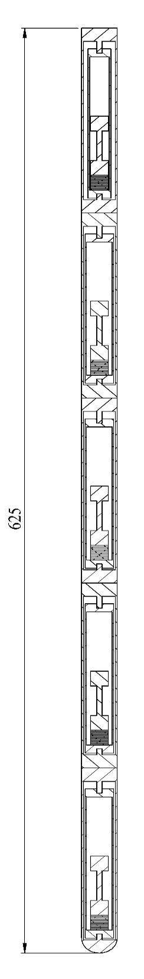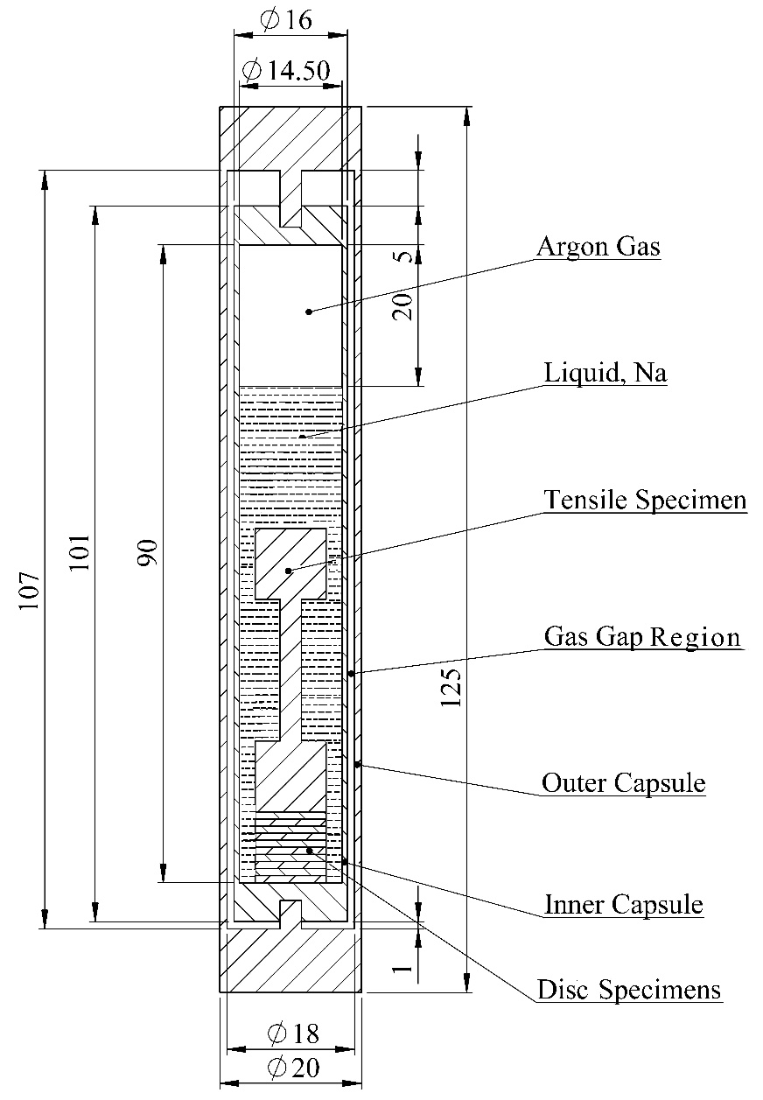
(a) (b)
Fig. 1 Schematic of Gas-gap irradiation capsule : (a) Arrangement of sub capsules in an irradiation capsule (b) Sub capsule containing specimens

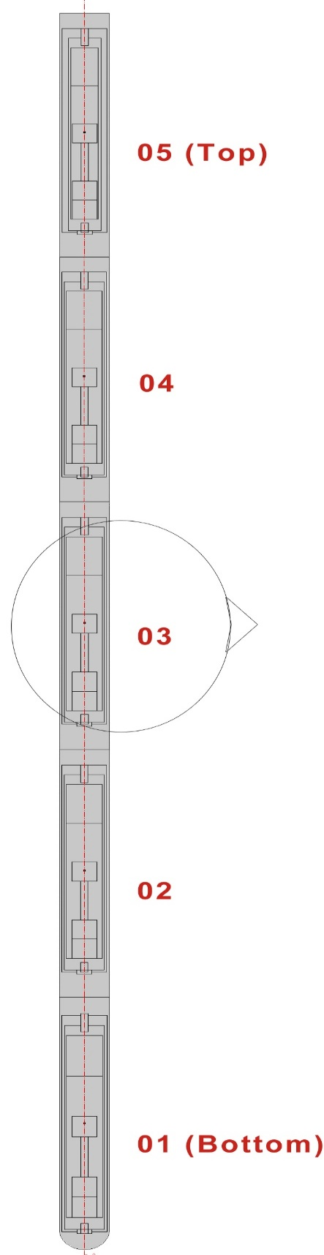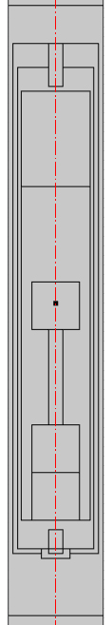

(a) (b)
Fig. 2 Capsule designs in COMSOL : (a) Assembly of an irradiation capsule (b) one of the sub capsule
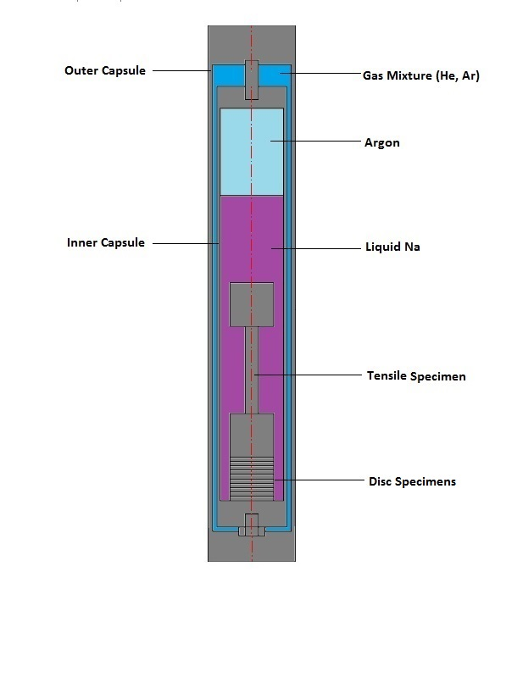
Fig. 3 Details of sub capsule
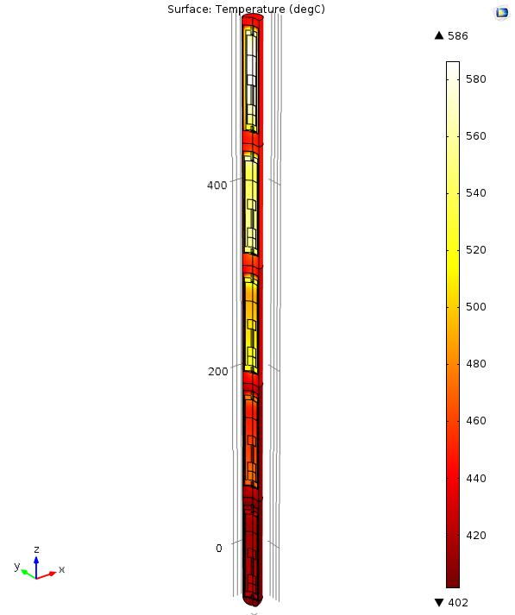
Fig. 4 Simulation results of Gas-gap capsule

Fig. 5 Comparison of results

Sub Capsule No: | 1 (Bottom) | 2 | 3 | 4 | 5 (Top)
Typical radial gas gap between sub capsule and irradiation capsule, (mm) | 0.5 | 0.5 | 0.5 | 0.5 | 0.5
Nuclear heating rate at the sub capsule location (W/gm.) | 1.2 | 5.53 | 8.91 | 5.94 | 1.13
Temperature of sodium flowing around the irradiation capsule (⁰C) | 400 | 403 | 414 | 427 | 433
Target temperature (⁰C) | 420 | 500 | 600 | 550 | 460
Table -1. Nuclear heating rates and target temperatures.

Sub Capsule No: | 1 (Bottom) | 2 | 3 | 4 | 5 (Top)
Typical radial gas gap between sub capsule and irradiation capsule, (mm) | 0.5 | 0.5 | 0.5 | 0.5 | 0.5
Nuclear heating rate at the sub capsule location (W/gm.) | 1.2 | 5.53 | 8.91 | 5.94 | 1.13
Temperature of Na flowing around the irradiation capsule (⁰C) | 400 | 403 | 414 | 427 | 433
Target temperature (⁰C) | 420 | 500 | 600 | 550 | 460
Composition of helium and argon in the gas mixture | 95% He -5% Ar | 100% He | 90% He -10% Ar | 90% He - 10% Ar | 85% He - 15% Ar
Obtained Temperature by  simulation (⁰C) | 423.41 | 498.0 | 587.97 | 545.19 | 459.04
Table -2. Results obtained through COMSOL

