INTEGRATED APPROCHES TO DEPTH TO BASEMENT ENHANCEMENT OF IJEBU ODE, A LOCATION IN SOTHWESTERN NIGERIA USING AEROMAGNETIC DATA.
¹Ikusika, A and ²Joshua E.O
Department of Physics, Adeyemi College of Education, Ondo, Ondo State, Nigeria.
Department of Physics, University of Ibadan, Ibadan, Oyo State, Nigeria.
Email address: akintayodavies@gmail.com
Abstract.
The depth to basement enhancement using a singular method is not sufficient enough to ascertain and determine the true depth to anomalies of aeromagnetic survey work carried out. This work adopted different approaches to locate the depth to magnetic basement of Ijebu Ode. The high resolution aeomagnetic data acquired was subjected to downward continuation filtering, Euler deconvolution at different spectral indices and the radial power spectrum analysis to determine the depth to underground vault. The various values gotten for the depth using these different methods were compared and this shows that there were similarities in the results of the depth estimation using all these approaches. For the downward continuation filtering, the depth to basement was estimated at 500 m, and using spectral analysis technique, it was found out to be in the range of 5m and 410 m and using the Euler deconvlution at various spectral indices the values ranges between 6m and 502 m. The depth to basement was confirmed to be at shallow depth using these different approaches.
KEYWORDS: Aeromagnetic data, Anomalies, Depth, Enhancement, Filtering.

Introduction
Depth to basement determination is one of the objectives of using aeromagnetic survey method in the discovery of spot of magnetic minerals and geological features of a study area. Okpoli and Eyitoyo (2016), in the mapping of inland extension of Chain Fault zones of Okitipupa, south western part of Nigeria, using aeromagnetic survey data used the Euler Deconvolution and the radial power spectrum to determine depth to basement. Olurin et al., (2016) interpreted aeromagnetic data over Abeokuta and its environs, Southwest Nigeria, using spectral analysis. Bello (2017) interpreted the aeromagnetic anomalies over Abeokuta, Southwest Nigeria, using spectral depth technique. Onwuemesi (1997) used one-dimensional spectral analysis of aeromagnetic anomalies and curie depth isotherm in the Anambra Basin of Nigeria. Attention should be drawn to the fact that spectral depths are in general average depths and individual depth projected may have values which is at variance from one another. Therefore, the need for emphasis on integration of different methods to delineate the possible depth to basement in order to reduce the chances of errors especially the use of downward continuation filtering technique as a tool for depth determination in order to give more precise value to depth estimation.
The work is aimed at depicting depth to basement using aeromagnetic data and the sole objective is to use integrated approaches to delineate depth to basement of the study area introducing downward continuation filtering technique.

Geological Setting of the Study Area
Ijebu Ode is located in Ogun state, south western Nigeria within latitude 6⁰ 40N and 7⁰ 00’N and longitude 3⁰ 00E and 3⁰ 30’E. It is positioned on a geological switch zone from the Precambrian migmatite gneiss rocks and Cretaceous sedimentary rock units of Abeokuta group. It is a basement crystalline rocks region which includes gneiss complex, migmatite biotite gneiss, biotite granite gneiss and quartz schist (Oyawoye 1964, McMurry and Wright 1977, Rahaman 1988)
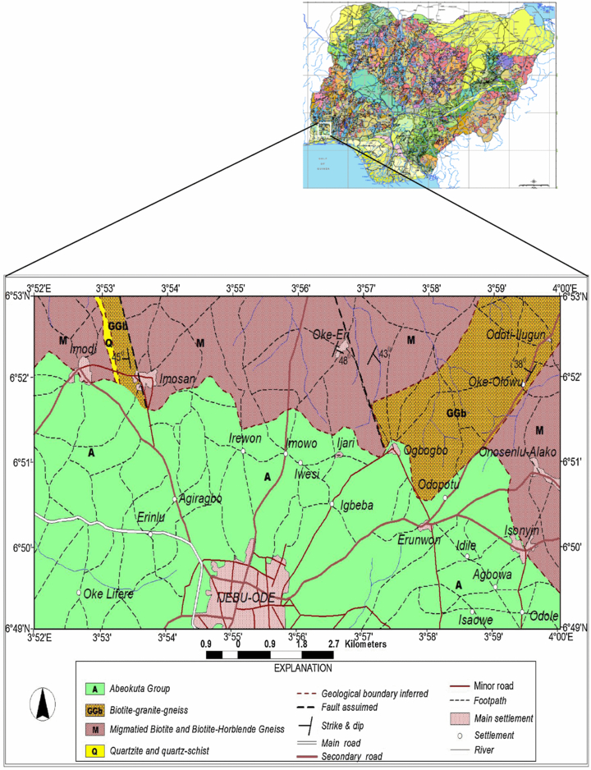
Figure 1: Geological Map of Ijebu Ode (Osinowo, O.O and. Olayinka, A.I, 2012)

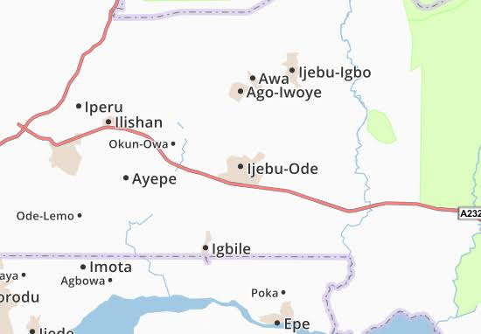
Figure 2: Road and Accessibility map of Ijebu Ode

Material and Method
Aeromagnetic sheets of the survey area labelled sheet 280 were acquired during the high resolution airborne geophysical surveys of Nigeria between 2003 and 2009 by Fugro Airborne Survey Limited for the Nigeria Geological Survey Agency (NGSA, 2009). This sheet is the sheet for, Ijebu Ode. To interpret the local field, the data were corrected for International Geomagnetic Reference Field, gridded at an appropriate cell size that enhances anomaly details and reduces possible noise and latitude effects (Patterson and Reeves, 1985). This sheet was assembled and analyzed. The data are made available in the form of contoured maps. The residual aeromagnetic intensity map of the study area was subjected to series of data filtering and processing tools involving Gaussian filter, downward continuation, Analytical signal, and Euler Deconvolution at different spectral indices.
Gaussian filter is a smooth filter that is often used for low pass or high pass application to remove blur images and noise.
$L\left(k\right)=[1-e^{-(\frac{k^{2}}{2{k_{0}}^{2}})}$] ………………………………………………………...(1)
For downward continuation,
$g\left(x,y,0\right)=\frac{h}{2π}\int_{-∞}^{∞}{\int{\frac{∆g(ξ,ŋ,h)}{((x-ξ)^{2}+(y-ŋ)^{2}+h^{2})^{3/2}}}}dξ$…………………………….…..(2)
Downward continuation concept is to adjust altitude of the observations to a set of data as an aid to the interpretation of a survey and also to increase the resolution of anomalies and their sources by continuing the field that are least severely compromised due to the quality of data. The procedure includes smoothening the original data by attenuating the long wavelength or low frequency anomalies relative to their short wavelength of high frequency (Feumoe et al. 2012; Langenheim and Jachens, 2014), in order to categorize if the anomalies are coming from deeper source of shallow depth.
Extended Euler deconvolution was adopted to establish the depth to the magnetic basement from profiles at predictable level of certainty (Reid et al., 1990). This method is more complex, and more rigorous in determining the depth to magnetic sources. Euler’s homogeneity relation can be written:
$\left(x-x_{0}\right)\frac{dT}{dx}+\left(y-y_{0}\right)\frac{dT}{dy}+(z-z_{0})\frac{dT}{dz}$ = N(B-T) ………………………….(3)
Where (x₀, y₀, z₀) is the location of a magnetic source, whose total field magnetic anomaly at the point (x, y, z) is T and B is the regional field. N is the Euler’s Structural Index (SI) which characterizes the source geometry (Reid, 1997).
Geological Model Table
Geological model | Number of dimensions | Structural Index (SI)
Sphere | 0 | 3
Pipe | 1(Z) | 2
Horizontal cylinder | 1( X or Y) | 2
Dyke | 2(Z and X or Y) | 1
Sill | 2(X and Y) | 1
Contact | 3(X,Y and Z) | 0

Table 1: Structural Indices for various geological models( Adapted from Amigun et al; 2012b; Olasehinde et al; 2012; Yaghoobian et al;2009; GETECH,2007 and Reid et al;1990.
Results
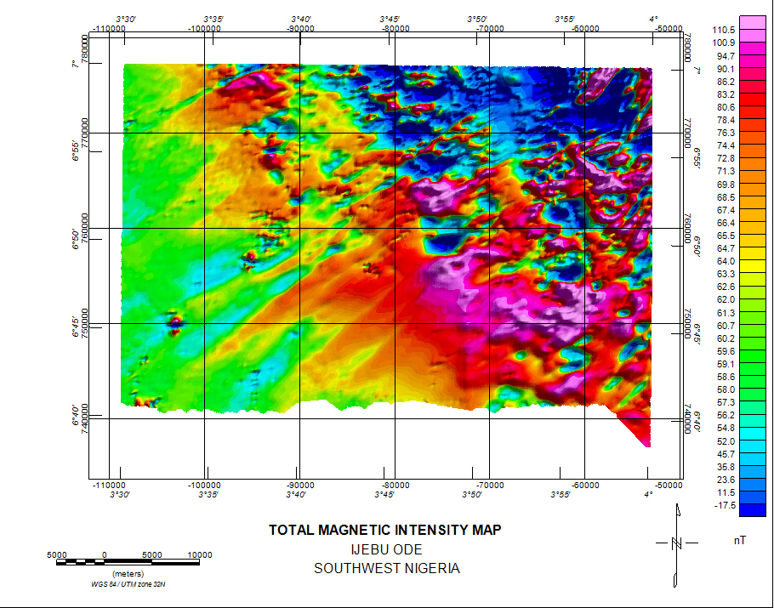
Figure 3: The Total Magnetic Intensity Map of Ijebu Ode
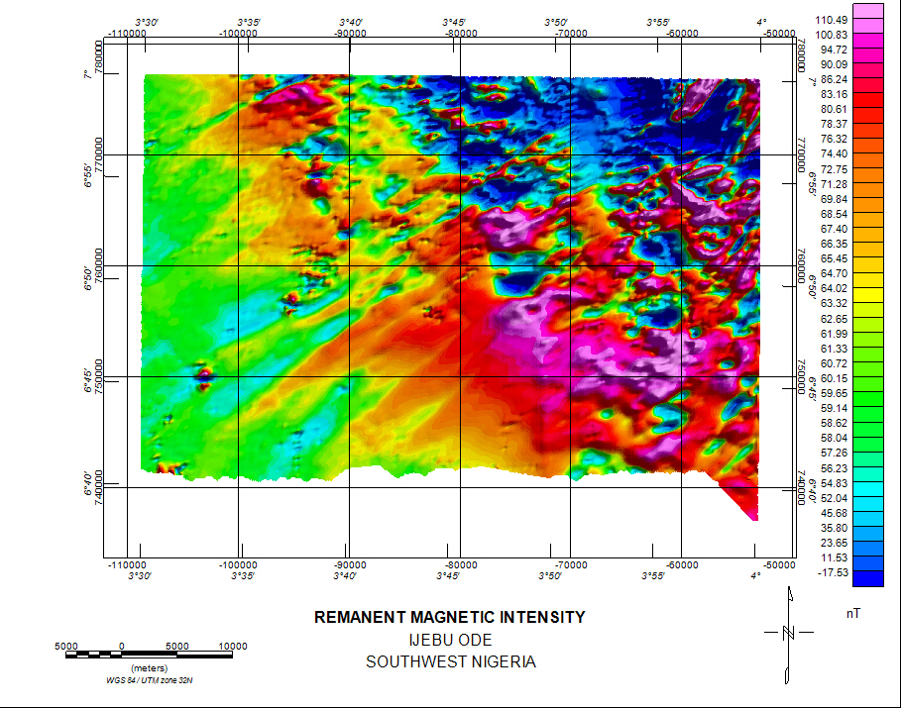

Figure 4: The Remanent Magnetic Intensity Map of Ijebu Ode
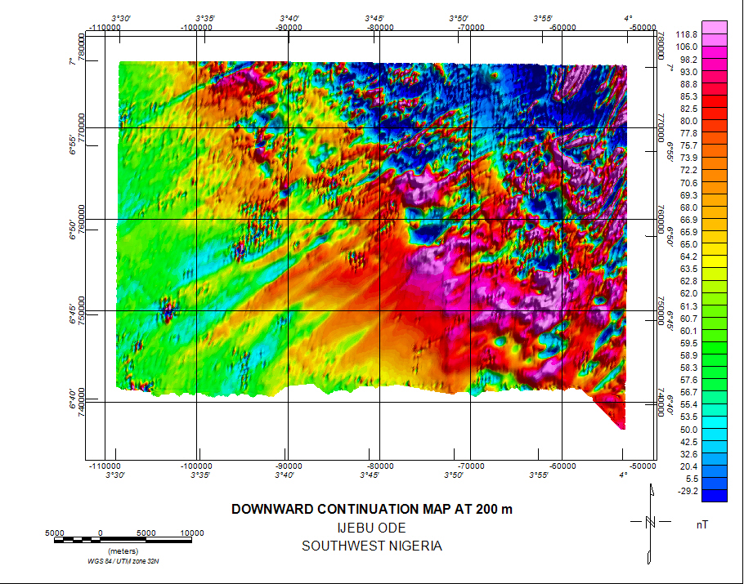
Figure 5: The Downward Continuation Map at 200 m depth
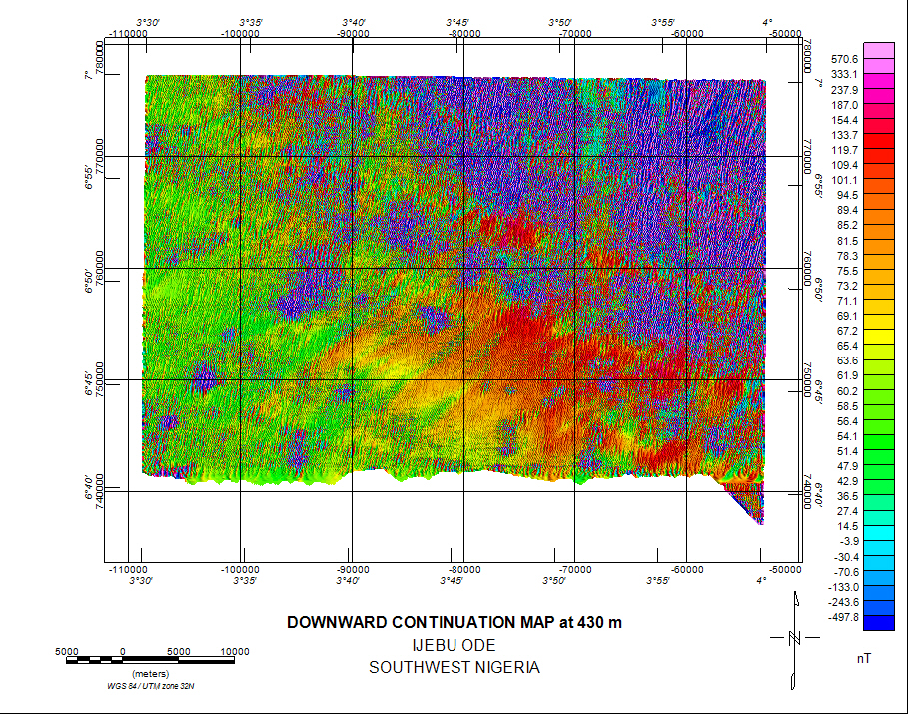
Figure 6: The Downward Continuation Map at 430 m depth
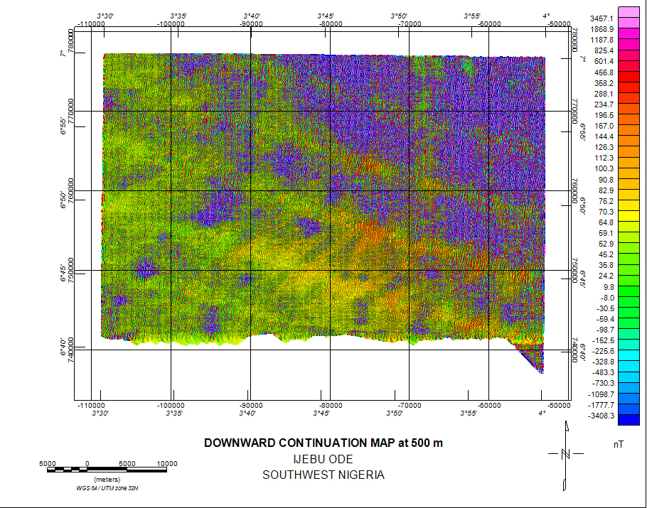
Figure 7: The Downward Continuation Map at 500 m depth

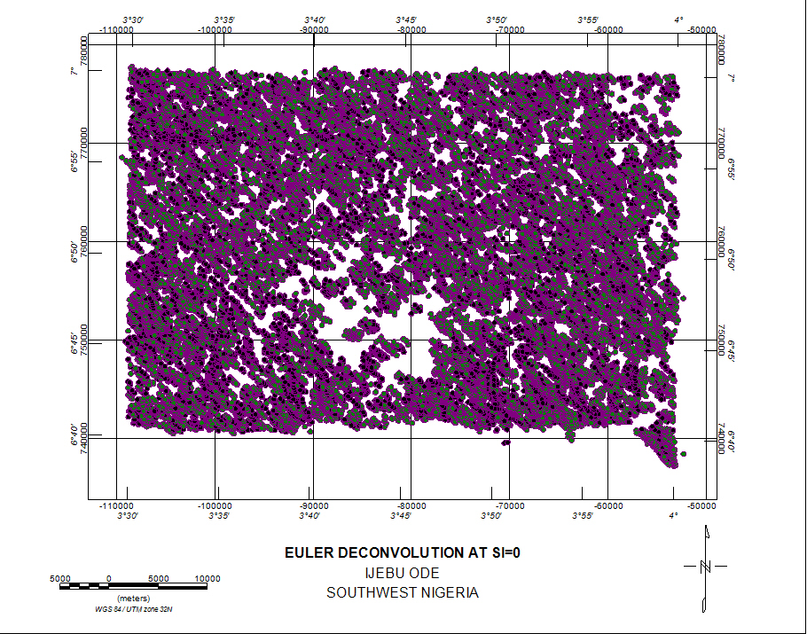
Figure 8: The Euler Deconvolution at Structural Index of 0
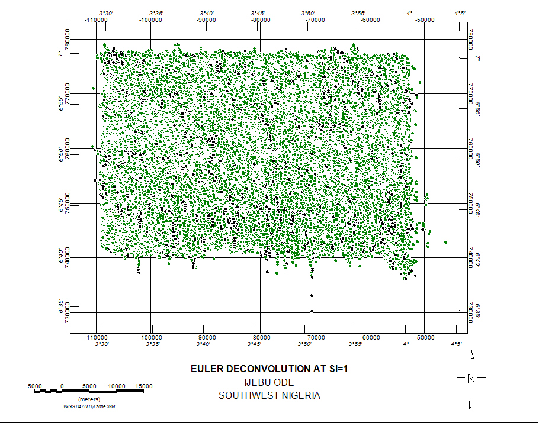
Figure 9: The Euler Deconvolution at Structural Index of 1

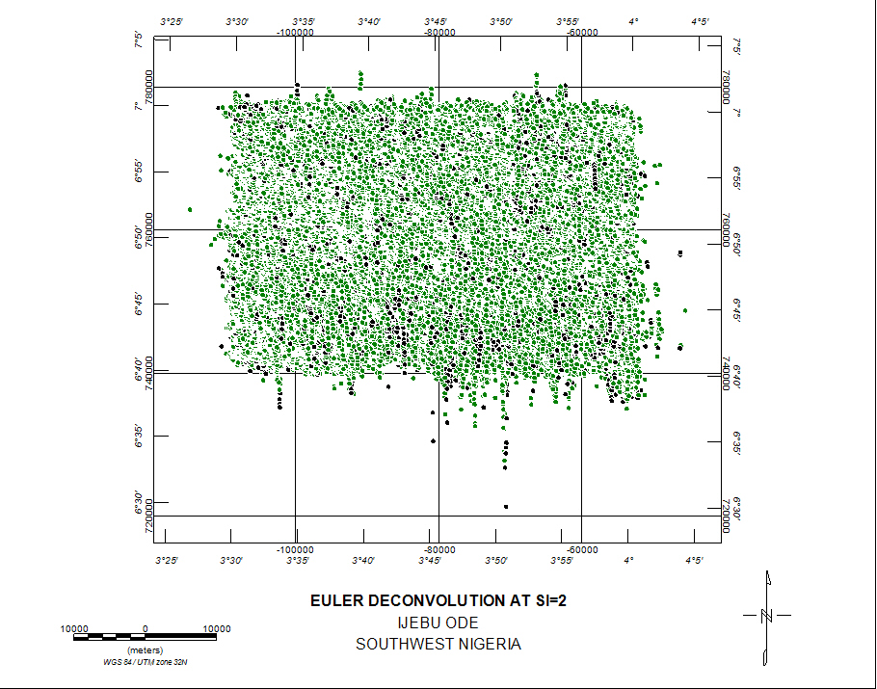
Figure 10: The Euler Deconvolution at Structural Index of 2
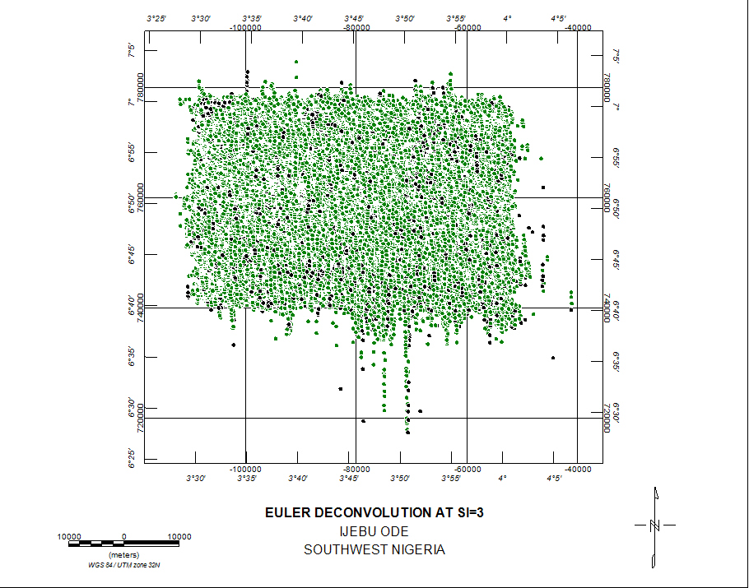
Figure 11: The Euler Deconvolution at Strcutural Index of 3
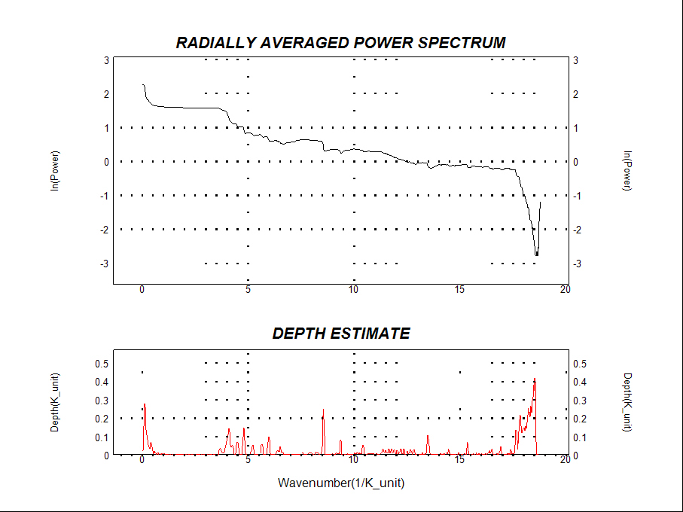
Figure 12: The Power Spectrum Analysis of the depth to basement

Discussion of Results
The total magnetic intensity of the study area (Ijebu Ode) is depicted above (Figure 3). The coloured maps (TMI) aided the visibility of a wide range of anomalies in the magnetic map and the ranges of their intensities. The strong positive anomalies areas (pink) indicate a higher concentration of magnetically susceptible minerals. The strong magnetic regions (86.2nT to 110.5nT) contain minerals which brings about the major anomalies and this corroborates (Sunmonu et al., 2014). Similarly, areas with extensive magnetic lows (blue) are likely areas of low magnetic concentration and hence a lower susceptibility and also it coincides with an existing fault (Mattsson and GeoVista 2010). The magnetic anomaly of magnitude between 23.6 nT and -17.5 nT appears as the lowest point with relatively low magnetic intensity (blue colour). It is predominant in the Northeastern and little traces in the Northwestern and Southeastern part of the study area.
For the Remanent Magnetic Intensity, the low-pass Gaussian filtering technique was adopted for this case to smoothen the input data by the application of convolution filter (depth-dependent linear filtering) data so that all data is treated by the filter equally and to remove regional anomalies from the magnetic data. The filter is called low-pass because it allows low wave numbers (low frequencies) to pass to the output channel. Features in the data that are shorter than the short wavelength cut off were removed.
The magnetic zone with high intensity of 0.13 nT to 0.07 nT which are basically the pink region from north towards the east and south while the low intensity of 0.002 nT at the centre and towards the southwest.
When the Total Magnetic Intensity map was downward continued at a depth of 200 m, there was presence of magnetic anomalies and further to a depth of 430 m (figure 5 and 6) until it reaches a depth of 500 m (figure 7) where the the anomalies disappear. This suggests that the depth to basement is estimated at around 500 m and probably a little above.
The solutions obtained from the estimated values of Euler deconvolution using various structural index values ranging from 1 to 3 were depicted (Table 1). The values for structural index (SI) of 0, gives a range of 7 m to 573 m, structural index(SI) for 1 gives range of 10 m to 545 m, structural index (SI) for 2 gives a value between 6 m and 530 m and structural index (SI) for 3 gives 10 m to 560 m. The SI numbers from 0, 1, 2 and 3 was adopted and this matches in relation to the geological results and hence accepted as solution because it is a good match as there are clusters around some notable anomalies in Ijebu Ode.
From figure 13, the depicted radially power spectrum of the study area shows a depth of a little above 400 m. The depth obtained from Euler deconvolution when compared with the power spectrum graph (Salem and Ali, 2014) shows little variation in the value of the depth to basement.
Conclusion
This work examines the comparison of various approaches to investigating the depth to basement using the Euler Deconvolution method (ED), Power Spectrum Analysis (SPA) and downward continuation filtering technique which corroborate the results obtained from the ED and SPA using aeromagnetic sheet labelled 280 of Ijebu Ode. The data obtained was processed using Oasis Montaj 6.4.3.(HJ). The results obtained showed that there were similarities in the values obtained by each method and hence more information on the depth to basement is depicted. These depths specify obviously the extent of variations in depth of both the basement topography and other intrusive in this area and these values of depth to basement spread over the study area. The accepted Euler Deconvolution structural index for 0, 1, 2 and 3 indicate contact, sill, sill/dyke, horizontal cylinder, horizontal cylinder/pipe and sphere geological model respectively and these are the solutions to the Euler deconvolution technique.

REFERENCES

[1] Alkali., S.C. Gaiya., S. and Abba Musa. B. 2012. Depth Estimation of Digitized Aeromagnetic Data of the Western Part of the Younger Granite Rocks of North Central Nigeria, Research Journal of Applied Sciences, Engineering and Technology,(4)15, pp.2444- 2450.

[2] Barbosa, V. C. F., Silva, J. B. C. and. Medeiros, W. E. 1999, Stability analysis and improvement of structural index estimation in Euler deconvolution: Geophysics, 64, 48–60.

[3] Barongo, J. O., 1985. Method for depth estimation and aeromagnetic vertical gradient anomalies: Geophysics, 50, 963–968.

[4] Clarke, G. K. C., 1969. Optimum Second Derivative and Downward Continuation Filters: Geophysics, 34, 424–437.

[5] El Dawi, M.G., Tianyou, L. Hui, S. and Dapeng, L. 2004. Depth Estimation of 2-D Magnetic
Anomalous Sources by using Euler Deconvolution Method. American Journal of Applied Sciences, 1(3), 209–214.

[6] Femoe, A.N.S., Ndougsa-Mbarga, T., Manguelle-Dicoum, E., Fairhead J.D. 2012. Delineation of tectonic lineament using aeromagnetic data for the south-east Cameroon area. Geofizika 29(2), 175-192
[7] Fraser D .C. 1969. Contouring of VLF-EM data Geophysics , vol. 34 pg. 958 -967.

[8] Huang, D., and Versnel, P. A. 2000. Depth estimation algorithm applied to FTG data: 70th Annual International Meeting, SEG, Expanded Abstracts, 394–397.

[9] Kasidi, S. and Ndatuwong, L.G. 2008. Spectral Analysis of Aeromagnetic Data over Longuda Plateau and Environs, North-Eastern Nigeria. Continental Journal Earth Sciences; 3, 28–32.

[10] Lanhenheim, V.E., Jachens, R.C., 2014. Aeromagnetic Data, Processing and Maps of Fort Irwin and vicinity, Califoniia, Chap. 1 of Buesch, D.C., ed., Geology and Geophysics Applied to Groundwater Hydrology at Fort Irwin, Califonia; US Geological Survey Open-file Report 2013-1024.

[11] Nwosu, O.B, and Onuba, L.N. 2013. Spectral re-evolution of the magnetic basement depth over part of middle Benue Trough Nigeria using HRAM. 2(5), pp 97-111.

[12] Okpoli C.C. and. Eyitoyo F.B. 2016. Aeromagnetic Study of Okitipupa Region Southwestern Nigeria. International Basic and Applied Research Journal Vol.2 No.7 pp1-20

[13] Onwuemesi A.G 1997. One-dimensional spectral analysis of aeromagnetic anomalies and curie depth isotherm in the Anambra Basin of Nigeria. Journal of Geodynamics 23: 95-107.

[14] Osinowo, O.O. and Olayinka, A.I. 2013. Aeromagnetic Mapping of Basement Topography around the Ijebu-Ode Geological Transition Zone, Southwestern Nigeria. Acta Geodaetica et
Geophysica, 48(3), 451-470.

[15] Oyawoye M.O. 1964. The geology of Nigeria basement complex J. Min. Geol. pg. 87 - 102.

[16] Mattsson, H. and A.B. GeoVista, 2010. Geological survey of Sweden and Wahlgren C-H. Interpretation of Detailed Ground Magnetic data, Resistivity and Topographic data from Äspö. SKB, Svensk Kärnbränslehantering AB, pp10 - 49.

[17] McMurry P., & Wright J.B. 1977. Geochemistry of calc-alkaline volcanics in northwestern Nigeria, and a possible Pan-African suture zone Earth Planet. Sci. Lett. , vol. 37 pg. 9 - 6.

[18] Milligan, P. R, Reed, G., Meixner T., and FitzGerald D. 2004. Towards automated mapping of depth to magnetic/gravity basement‐examples using new extensions to an old method, Australian Society of Exploration Geophysicists 17th Geophysical conference and Exhibition, Sydney.

[19] Mushayandebvu M. F., Van Driel, P.. Reid, A. B and.Fairhead J. D, 2001. Magnetic source parameters of two-dimensional structures using extended Euler deconvolution,” Geophysics,
vol. 66, no. 3, pp. 814–823,

[20] Nabighian MN 1972. The analytic signal of two-dimensional magnetic bodies with polygonal cross-section—its properties and use for automated anomaly interpretation. Geophysics 37:507–517.

[21] Olurin O.T., Ganiyu S A., Hammed O S. and Aluko T J. 2016. Interpretation of aeromagnetic data over Abeokuta and its environs, Southwest Nigeria, using spectral analysis (Fourier transform technique). RMZ – M&G Vol. 63 pp. 199 – 212.

[22] Paterson N.R, Reeves C.V .1985. Application of gravity and magnetic surveys: the state of the art in 1985. Geophysics 50:2558–2594

[23] Rahaman M .A. 1988. Recent advances in the study of the basement complex of Nigeria ,
Precambrian Geology of Nigeria Oluyide P O, et al. Kaduna Geological Survey of Nigeria Publication (pg. 11-43) pp 11–43.

[24] Reid, A.B., Allsop, J.M. Granser, H., Millett, A.J. and Somerton, I.W. 1990. Magnetic Interpretation in Three Dimensions Using Euler Deconvolution. Geophysics, 55, 80-91.

[25] Reid, A. B. 2003. Euler magnetic structural index of a thin-bed fault. Geophysics, 68(4), 1255-1256.

[26] Roest W.R, Verhoef J, Pilkington .M 1992. Magnetic interpretation using the 3-Danalytic signal. Geophysics 57(1):116–125

[27] Salako, K. A. (2014). Depth to Basement Determination Using Source Parameter Imaging (SPI) of Aeromagnetic Data: An Application to Upper Benue Trough and Borno Basin, Northeast, Nigeria. International Journal of Science and Research, 2(8), pp.48-55.

[28] Salem, A, & Ali, M., 2014. Mapping basement structures in the nortwestern offshore of Abu Dhabi from high resolution aeromagnetic data In: Extended Abstract, 76th EAGE conference & Exhibition, EarthDoc.

[29] Sunmonu, L.A., Adagunodo T.A, Olafisoye E.R., and Oladejo O.P. 2012. Interpretation of
groundmagnetic data in Oke-Ogba Area, Akure, Southwestern Nigeria, Advances in Applied Science Research, 3(5), 3216-3222.

[30] Udensi, E.E. and Osazuwa, I.B. 2003. Spectral determination of the depths to the buried magnetic rocks under the Nupe Basin. Nigerian Journal of Physics (NJP), 15 (1). PP. 51 – 59.

[31] X. Li, 2003. On the use of different methods for estimating magnetic depth. The leading edge: The meter reader (coordinated by John W. Peirce), vol. 22 (11), pp.1090‐1099.

