Multinational Effects of Foreign Exchange Rate in Stock Index with Classification Models for Medium-term Investment

Hsien-Ming Chou, Kuo-Chen Li, Shih-Ming Pi

Department of Information Management, Chung Yuan Christian University, Taiwan

Abstract
This research builds prediction models based on classification algorithms to propose a novel method, which provides research and practical guidelines and answers research questions we proposed in this field. Based on extant classification approaches and their limitations, the proposed method integrates multinational stock index and foreign exchange rate of main trading countries and builds effectively self-learning models to adjust behaviors of the medium-term investment dynamically. The proposed approach is unique in several aspects. First, the classification algorithms approach, a type of machine learning technologies, automatically generates patterns of medium-term stock index trend based on big data analysis. The method overcomes the problem of medium-term investment risks. Second, we evaluate foreign exchange rate to prove that it is a significant factor for stock index. Third, incorporating foreign exchange rate into multinational stock index has significant improvement on accuracy of prediction. This paper utilizes popular machine learning algorithms such as SVMs to improve the effectiveness of the proposed method. The results of the evaluation via a medium -term data analysis indicate that the approach shows advantages in the accuracy of stock index prediction in comparison with existing methods only considering stock index.

Keywords: Stock Index, Foreign Exchange Rate, Machine Learning Technologies, Big Data

- Introduction
Stock index prediction is one of the most important research topics and regarded as a challenging task of finance analysis field [1], especially for medium-term investment, because effectively predicting the future stock index for the medium term helps the decision makers such as investors apply artificial intelligence to reduce high-risk forecasts for most individual investors [2, 3].

For the medium-term prediction, usually we use fundamental and technical analysis to judge 30 days line trend of stock index and the fundamental analysis could get more concerns on prediction because the medium-term stock index represents overall operating conditions for those listed companies in financial markets. The fundamental analysis relies on the statistics of macroeconomic data such as foreign exchange rates. However, it is more difficult to quantify many unstructured factors to reap the benefits from each of dynamic market movements for the medium-term than the long-term observation [4, 5].

Over the past three decades, there has been growing literature on applications of machine-learning algorithms to financial domains, especially in stock forecasting. Although some studies have reported promising results in successfully, applying various types of machine-learning algorithms for predicting stock returns [6]. However, for the medium-term trend prediction, it continue to be a challenging issue because it is difficult to find out relevant factors such as macroeconomic data to stock index.

In recent years, the Central Banks of Taiwan have kept interest rates at very low levels to reduce the impact of changing exchange rates and a volatile stock market. Therefore, adjusting exchange rates could have impacts on stock index because the export trading is one of important factors in Taiwan overall economics [7]. However, extant studies in stock index prediction ignore this important factor, which could have significant impacts on stock index prediction.

There are several issues with stock index prediction due to the interruption of trade partners such as neighboring countries, which could have impacts on stock index of Taiwan. Therefore, the first research question is described as follows:

RQ1: Is the multinational stock index relevant to the stock index of Taiwan?

The lack of an empirical process on foreign exchange rate will lead to missing important factors. For the medium-term trend, even though other countries of stock index could detect ongoing movements based on 30 days’ time lines, it maybe not working as well if we only consider the multinational stock index factors. Therefore, the second research question is described as follows:

RQ2: Is the multinational foreign exchange rate relevant to the stock index of Taiwan?

An effective prediction system should be able to learn itself based on environment variability. Therefore, the third research question is described as follows:

RQ3: How to enable self-learning mechanism to the stock index prediction?

The main purpose of this paper is to find a more accurate and reliable forecasting model of the stock index prediction for the medium term. We use much wider variety of factors such as foreign exchange rate to forecast the stock index of Taiwan. The remainder of this paper is organized as follows. The next section presents literature reviews and the third section describes the research model and hypotheses development; in the fourth and fifth section, the proposed method is evaluated, and then followed by a result section. The last section concludes some important findings, contributions, limitations, and future works.
- Literature Review
Although many existing studies commit a low accuracy of stock prediction methods because of too many irrelevant factors. However, even some factors have been found relevant to the prediction, for the medium term, those factors could be changed dynamically. In addition, different machine-learning algorithms could have different impacts on prediction models. Therefore, it is necessary to find out strengths and limitations of existing approaches. We categorize existing methods of the stock index prediction into two categories: clustering and classification algorithms.

Clustering is one of the unsupervised learning methods in the field of machine learning, and it includes various algorithms (e.g., K-means), which may significantly differ in the cluster analysis and efficiently find out factors in similar features. K-means could use Euclidean distance to measure intra or inter-distance between two elements. There has been significant progress in the field of machine learning bordering on its application to the areas of medicine, natural language processing, software development and inspection, financial investing [8], stock market applications, and so on.

For example, Edwin [9] used cluster analysis to group related documents for browsing, to provide a grouping of spatial locations prone to the research target. In FinTech area, clustering is often used for finding the relationship between customers and products, although stock features also can be identified with significant trading frequencies, however, only using clustering is not sufficient to sense all factors, due to an excess of exceptions. In addition, stock data could provide an amount of training and testing data through supervised learning, clustering could be inappropriate for an effective prediction.

Classification algorithms are widely used in financial applications [10, 11]. For example, Bogle et al. used SVMs (Support Vector Machines) to predict the Jamaica stock. They investigated the impact of sentiments on medical marijuana legalization on relevant stock indices by social media comments.

Classification algorithms have proved effectiveness on some specific stock markets. In addition, a variety of classification algorithms can be interactively used for comparison and dynamically adjusted based on different predictive goals to increase the accuracy of prediction. However, there are still remaining two main limitations for those studies. First, financial services through technologies have generated a big impact on international financial markets, only focusing on local markets is not sufficient to sense all relevant factors for predicting the stock index of Taiwan. Second, overall economy may influence fundamentally objects corresponding to the medium-term activities such as foreign exchange rate. Therefore, it is necessary to generate classification models based on macroeconomics including multinational stock index and foreign exchange rate in order to create the medium-term prediction models effectively.
- The Research Model and Hypotheses Development
This research builds prediction models based on classification algorithms to propose a novel method, which provides research and practical guidelines and answers research questions we proposed in this field. Based on extant classification approaches and their limitations, the proposed method integrates multinational stock index and foreign exchange rate of main trading countries and builds effectively self-learning models to adjust behaviors of the medium-term investment dynamically.

Extant studies consider that the performance of clustering methods is worse than classification method [12-14] in stock prediction because some classification algorithms such as SVMs can handle multidimensional time series with high level of noise and make coordinated multi-resolution forecast [10]. Some studies mention that the foreign exchange rate represents current import and export trading status of companies, so it could be related to stock market [15].

Although machine-learning techniques can learn automatically based on great variety amounts of data, the main problem of classification methods is too many unclear attributes related to stock index. In addition, from the aspect of overall economy, multinational foreign exchange rate can provide more features to represent indicative macroeconomics. However, most extant studies do not consider the significances of multinational overall economy to apply those possible terms from the aspect of the medium term for building the prediction models of stock index.

This study would evaluate some tasks that are associated with the extant advantages and their research limitations by: 1) examining the impact of foreign exchange on stock index; and 2) examining the impact of the multinational stock index and foreign exchange rate on the accuracy of stock index prediction. Therefore, this research will not only determine relevant attributes including stock index and foreign exchange rate of main trading countries, but also incorporate those factors in classification algorithms for improving the accuracy of stock prediction. The research model is shown in Figure 1.

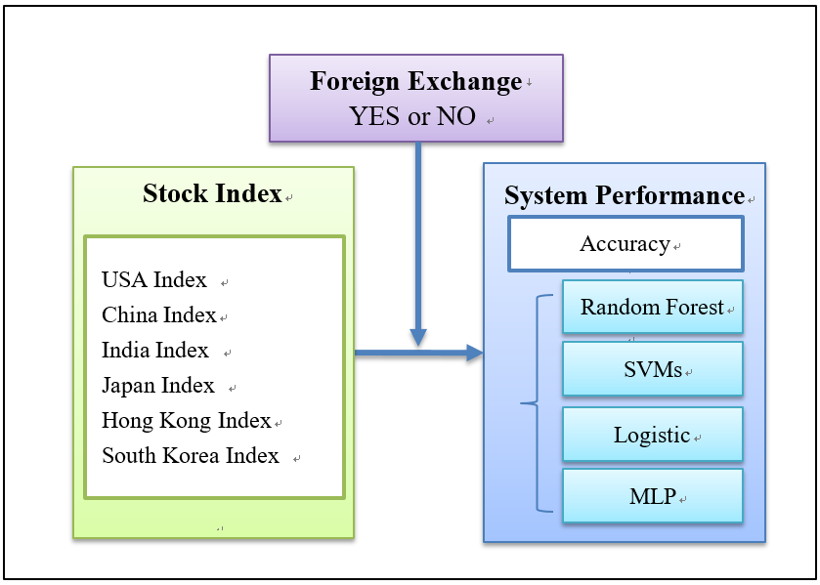
Figure 1. The Research Model

To address the challenge of the research questions we proposed at beginning, this paper investigates the existing studies of stock index prediction to try to determine all possible approaches and trading partners, and then examines the impact of those countries on stock prediction.

In the research model, the trading partners include USA, China, India, Japan, Hong Kong, South Korea with stock index and foreign exchange rate. The multinational stock index is treated as the baseline to compare against our proposed overall economy information.

This study proposes the new method to incorporate all relevant factors as the overall economy in this research model. Because this study focuses on the interaction between main trading index and medium-term daily activities, machine-learning algorithms including Random Forest, SVMs, Logistic, and MLP are appropriate for measuring system performance. AI technologies utilize a large number of financial information for training, so it may change the effect of system performance.

There is no existing work on incorporating multinational and medium-term stock index and foreign exchange rate into the machine-learning system for evaluation. As previously described, those financial factors could be useful to improve the accuracy of stock index prediction. Therefore, this study predicts that multinational stock index and foreign exchange rate could be relevant to stock index prediction. The first hypothesis is proposed as follows:

H1. Incorporating the foreign exchange rate of (a) USA, (b) China, (c) India, (d) Japan, (e) Hong Kong, (f) South Korea and the stock index of (g) USA, (h) China, (i) India, (j) Japan, (k) Hong Kong, (l) South Korea will have a positive impact on the performance of Taiwan stock index for the medium term.

The main purpose of this study is to propose a new method, the multinational stock index and foreign exchange rate to compare with existing methods only including stock index to prove that the multinational overall economy is better than the stock index only. Based on this, the proposed method should compared with existing methods on the accuracy of stock index prediction. Therefore, the second hypothesis is proposed as follows:

H2. In the medium term, adding foreign exchange rate will lead to the better performance for stock prediction.
- Research Methodology
This study adopts quantitative measures for getting an accuracy rate of stock index prediction with machine-learning algorithms including Random Forest, SVMs, Logistic, and MLP. The hypotheses were tested through time series daily data, which is collected from Federal Reserve website including USA, China, India, Japan, Hong Kong, South Korea with stock index and foreign exchange rate from 2000 to 2018 year based on the medium-term (30 days) line movement.

This study is separated into two parts for evaluation: the first part is to find out relevant factors to stock index of Taiwan; and the second part is to measure the performance of adding foreign exchange rate compared to stock index only. In the first part, independent variables include the foreign exchange rate of USA, China, India, Japan, Hong Kong, South Korea and the stock index of USA, China, India, Japan, Hong Kong, South Korea; the dependent variable is the stock index of Taiwan. In the second part, the independent variable is the level of financial factors used in the stock index prediction, which is operationalized by two levels: 1) stock index and 2) foreign exchange rate. The dependent variable is the performance of the stock index prediction.

Binomial logistic regression was used to measure variables including the foreign exchange rate of USA, China, India, Japan, Hong Kong, South Korea and the stock index of USA, China, India, Japan, Hong Kong, South Korea, which is described in the first hypothesis. In statistics, logistic regression includes two levels (e.g. yes or no) of a binary dependent variable. Therefore, it is an appropriate method to measure the first hypothesis.

As to measuring the second hypothesis, machine-learning algorithms, including Random Forest, SVMs, Logistic, and MLP were used with 10-fold cross validation to obtain the accuracy of stock index prediction with two levels of financial factors used. A single subsample was retained as the validation data for testing the model, and the remaining 9 subsamples were used as training data. All observations were used for both training and validation, and each observation was used for validation exactly once. These algorithms were chosen because they are popular machine learning algorithms and have been widely used [16-18].

For classification tasks, true positive (TP), true negative (TN), false positive (FP), and false negative (FN) rates assess the results of classifiers with observations. The terms positive and negative refer to a classifier's prediction, and the terms true and false refer to whether that prediction corresponds to the observation. Accuracy is the number of correct predictions divided by the total number of stock index prediction (i.e., accuracy = (TP+TN) / (TP+TN+FP+FN)).
- Results
The results of financial factors to the stock index for the medium term are presented in the following table.

Table 1. Results of Medium-term Financial Factors
Financial Factors | Significance
USA_Foreign Exchange Rate | 0.000**
China_ Foreign Exchange Rate | 0.000**
India_ Foreign Exchange Rate | 0.000**
Japan_ Foreign Exchange Rate | 0.089
Hong Kong_ Foreign Exchange Rate | 0.142
South Korea_ Foreign Exchange Rate | 0.025*
USA_Stock Index | 0.000**
China_Stock Index | 0.382
India_Stock Index | 0.000**
Japan_Stock Index | 0.000**
Hong Kong_Stock Index | 0.000**
South Korea_Stock Index | 0.000**
*p < 0.05; **p < 0.01 (The mean difference is significant at the 0.05 level.)

The results of medium-term financial factors indicate that significantly factors to stock index are USA_FER (FER: foreign exchange rate), China_FER, India_FER, South Korea_FER, USA_Stock Index, India_Stock Index, Japan_Stock Index, Hong Kong_Stock Index, and South Korea_Stock Index. Therefore, hypotheses H1 (a), H1 (b), H1 (c), H1 (f), H1 (g), H1 (i), H1 (j), H1 (k), and H1 (l) are supported.

Training datasets can be categorized into two categories, which use a clear gap as wide as possible to find the best decision boundary between different categories. For example, SVMs can correspond to determining the boundary that largest possible gap between different classes is obtained and thus a good generalization result is achieved [16, 18].

The accuracy of machine-learning algorithms is shown in Figures 2. For stock index only, the accuracy of Random Forest is 81.82; SVMs is 79.89; Logistic is 78.95, and MLP is 79.54. For adding foreign exchange rate, the accuracy of Random Forest is 86.15; SVMs is 81.82; Logistic is 80.13, and MLP is 83.34.

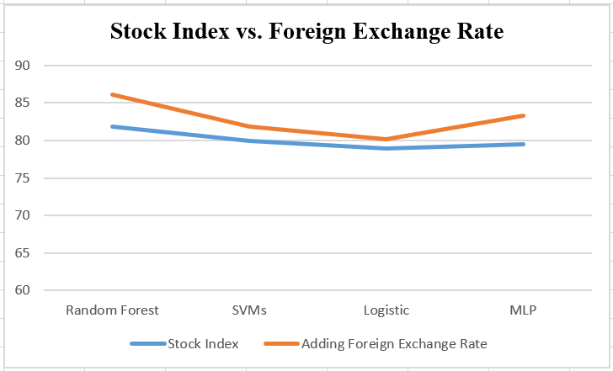
Figures 2. The Accuracy of Machine-learning Algorithms

ANOVA was used to examine whether the level of financial factors utilized in a stock index prediction positively influenced the accuracy of direction prediction for the medium term. LSD test was carried out for multiple comparisons. The main effects of stock index prediction is setting with 10 groups from one day to 30 days in order to process multiple comparisons. If we only consider the difference between stock index only and adding foreign exchange rate for the medium term, which is based on 30 days line movement, as previously described, the ANOVA table information (F(9,39) =29.45, p < 0.01) presents significant difference. Therefore, the second hypothesis is supported.
- Conclusion
There are several major findings of this study. First, main trading partners based on their stock index and foreign exchange rate factors can significantly relate to stock index of Taiwan for the medium term. The results strongly indicate that providing multinational stock index and foreign exchange rate enables investors to generate medium-term investment interests and suggestions. Second, the foreign exchange rate has the significant impact on system performance in stock index prediction of Taiwan as we expected.

This paper contributes to the stock index prediction in a number of ways: First, we systematically investigate the critical issue of medium-term investment to find out relevant financial factors to the stock index of Taiwan. Second, we propose an improved method by adding foreign exchange rate compared with existing methods.

There are a few limitations with this study. First, this study focuses on multinational impacts on the stock index of Taiwan, however, semantic social media such as ontologies of financial market could be one of important factors in macroeconomics. Second, multinational stock index and foreign exchange rate are evaluated by using medium-term line movement, however, this method could not reflect a real trend movement if compared to a short-term effectiveness. Therefore, this study will continue to enable trend ontologies to the stock index and offer a direction to further research in the future.

References
1. Atsalakis, G.S. and K.P. Valavanis, Forecasting stock market short-term trends using a neuro-fuzzy based methodology. Expert Systems with Applications, 2009. 36: p. 10696-10707.
2. Ghiassi, M., D.K. Zimbra, and H. Saidane, Medium term system load forecasting with a dynamic artificial neural network model. Electric Power Systems Research, 2006. 76: p. 302-316.
3. Kavussanos, M. and D. Dimitrakopoulos, Market risk model selection and medium-term risk with limited data: Application to ocean tanker freight markets. International Review of Financial Analysis, 2011. 20(5): p. 258-268.
4. SK., S. and W. AK., Short and long-term forecasting using artificial neural networks for stock prices in Palestine: a comparative study. Electron J Appl Statist Anal, 2017. 10(1): p. 14-28.
5. Bebchuk, L.A., A. Brav, and W. Jiang, The Long Term Effects of Hedge Fund Activism. Columbia Law Review 115, 2015.
6. Kara, Y., M.A. Boyacioglu, and O.K. Baykan, Predicting direction of stock price index movement using artificial neural networks and support vector machines: The sample of the istanbul stock exchange. Expert systems with Applications, 2011. 38(5): p. 5311-5319.
7. J., P., et al., Predicting stock and stock price index movement using trend deterministic data preparation and machine learning techniques. Expert Systems with Applications, 2015. 42: p. 259-268.
8. Suganthi, R. and P. Kamalakannan, Analyzing stock market data using clustering algorithm. International Journal of Future Computer and Communication, 2015. 4(2): p. 108-111.
9. Lughofer, E., Hybrid active learning for reducing the annotation effort of operators in classification systems. Pattern Recognition, 2012. 45: p. 884-896.
10. Bogle, S.A. and W.D. Potter. SentAMaL: A sentiment analysis machine learning stock predictive model. in Proceedings on the International Conference on Artificial Intelligence (ICAI). 2015. Las Vegas, USA: WorldComp.
11. P., D.S. and P. S., Support Vector Machines for Prediction of Futures Prices in Indian Stock Market. International Journal of Computer Applications, 2012. 41(3): p. 22-26.
12. L, Y., et al., Evolving least squares support vector machines for stock market trend mining. IEEE Transactions, 2009. 13(1): p. 87-102.
13. Setty, D.V., T.M. Rangaswamy, and K.N. Subramanya, A Review on Data Mining Applications to the Performance of Stock Marketing. International Journal of Computer Applications, 2010: p. 24-34.
14. Hajizadeh, E., H.D. Ardakani, and J. Shahrabi, Application of data mining techniques in stock markets: A survey. Journal of Economics and International Finance, 2010: p. 109-118.
15. Huang, W., Y. Nakamori, and S.Y. Wang, Forecasting stock market movement direction with support vector machine. Computers & Operations Research, 2005: p. 2513-2522.
16. Kremic, E. and A. Subasi, Performance of random forest and SVM in face recognition. International Arab Journal of Information Technology, 2016. 13(2): p. 287-293.
17. Jahangiri, A. and H.A. Rakha, Applying Machine Learning Techniques to Transportation Mode Recognition Using Mobile Phone Sensor Data. Intelligent Transportation Systems, 2015: p. 1-12.
18. Chou, H.-M., et al., CaCM: Context-aware Call Management for Mobile Phones, in IEEE International Conference on Collaboration and Internet Computing. 2017: San Jose, CA. p. 1-7.

https://en.wikipedia.org/wiki/K-means_clustering
https://www.federalreserve.gov

