The Miocene Sequence in Iraq, a Review and Discussion, with emphasize on the Stratigraphy, Paleogeography and Economic Potential

Varoujan K. Sissakian, Sahira A. Karim , Kifah N. Al-Kubaisyi Nadhir Al-Ansari⁴ and Sven Knutsson⁴

Abstract
The Miocene Sequence (23.03 – 5.33 Ma), in Iraq has large diversity in lithofacies, biofacies, depositional environments, tectonic effect, and geographical distribution. The Savian movements caused development of broad and shallow basins, which had covered large areas in the Iraqi territory, as compared with the earlier Oligocene sequence, which was characterized by great sea level drop causing very limited depositional basins, the main intraplate basin became narrower due to the tilting of west Arabia.
The Miocene Sequence, in Iraq includes 11 stratigraphic units, some of them have not formation order, and these are: Serikagni, Euphrates, Ghar, Dhiban Anhydrite, Jeribe, Fatha, Nfayil, Injana, Mukdadiya, Govanda Limestone and Red Bed Series. However, some of these units have age that is not limited to the Miocene, they have range of either younger or older than Miocene.
The main major event that had occurred during the Miocene was the change from the dominating marine phase in the Early Miocene to continental phase during the Late Miocene. This main change is attributed to the major thrusting, which occurred during the collision of the Sanandaj – Sirjan Zone with the Arabian Plate. This event also is considered as the beginning of the Neotectonic effect in Iraq. Many formations were terminated; others were started with different lithological and depositional environments, as well as different faunal assemblages.
The faunal assemblages, depositional environments, paleogeography, lithology of each exposed stratigraphic units are reviewed and discussed. Moreover, the tectonic effect on each exposed unit in different tectonic zones is discussed too, beside the mutual relation between the exposed units. Key words: Al-Ajeej, Jagh Jagh, Al-Jazira, Sinjar, Iraq
Key words: Miocene, Lithofacies, Marine sediments, Arabian Plate, Savian

- Introduction
The Miocene Sequence (23.03 – 5.33 Ma) in Iraq is characterized by diversity in the lithofacies, faunal content, depositional environments, tectonic effects, as well the mutual relation between the exposed stratigraphic units. The sequence includes 11 stratigraphic units; some of them have not formation order and they need to be more precisely studied to achieve their exact rank and position in the Iraqi stratigraphic column.

The aim of this study is to review and discuss; in details the Miocene Sequence in Iraq with its all exposed stratigraphic units. Hence many units have completely different characters at different parts in Iraq, but still they bear the same formation's name. This is a courageous attempt to shade light on different ambiguous cases with many recommendations to overcome those ambiguities, with reasonable facts and clues.

The study is restricted to areas, which include exposures of the Miocene Sequence (Fig.1). The involved areas were delineated from Sissakian and Fouad (2012) and adopted from Sissakian and Al-Khalidy [1]. The coverage area of the Miocene Sequence within the Iraqi territory is about 100 000 Km², which means slightly less than 25 % of the total coverage area of the Iraqi territory [1].

- Materials Used and Methodology
To achieve the main aim of this study, the following materials were used:
- Geological maps of different scales
- Geological reports of different aspects
- Relevant published geological articles and books
- Google Earth and satellite images of different scales
The mutual relation between the 11 exposed stratigraphic units, within the Miocene Sequence; was studied from reviewing geological maps of different scales and Google Earth and satellite images. The diversity in the lithofacies, faunal assemblage, depositional environment, nature of the contacts, paleogeography and thickness changes, beside the tectonic effects on the exposed stratigraphic units were indicated from reviewing tens of relevant geological reports, published articles and books.
This study presents the paleogeography of each unit within the Miocene Sequence, and then each unit is discussed from different geological aspects, which are related directly and/ or indirectly to the stratigraphic position of each unit.

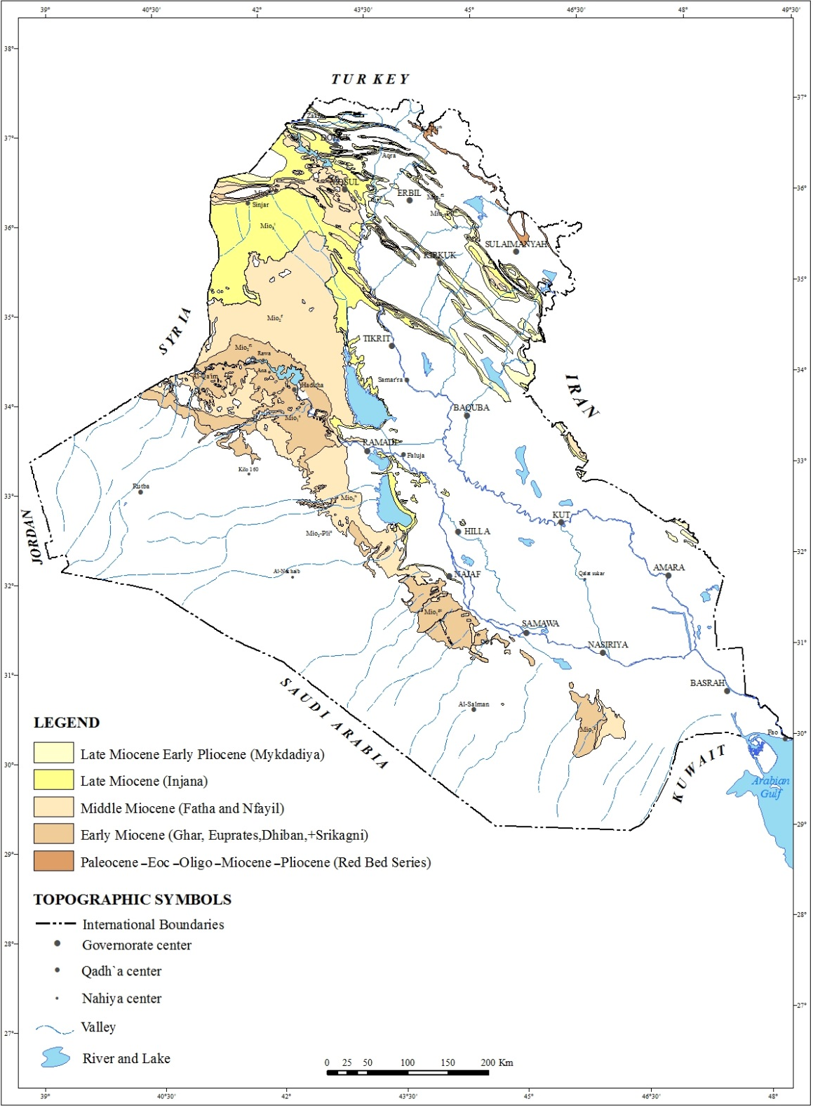
Fig.1: Location map of the exposed stratigraphic units within the Miocene Sequence (after [1] ).

- PALEOGEOGRAPHY
The paleogeography of each stratigraphic unit within the Miocene Sequence in Iraq is reviewed; for simplification, the Miocene Period is divided into stages, as mentioned hereinafter.

2.1 Aquitanian – Burdigalian
Within this stage four formations are present within the stratigraphic column of Iraq; they are exposed in different parts of the Iraqi territory (Fig.2), and are described hereinafter.

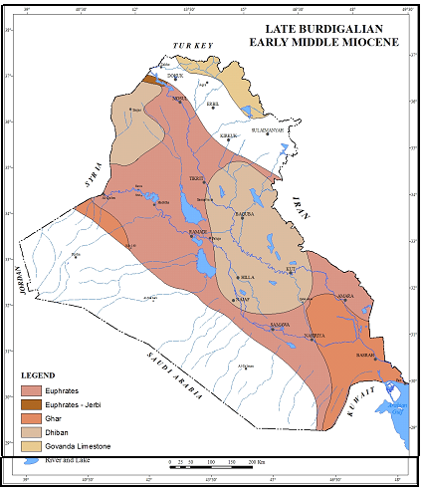
Fig.2: Paleogeographic map of Miocene sediments (After [2])

2.1.1 Serikagni Formation (Aquitanian – Early Burdigalian)
A narrow NW – SE basin represents the only seaway connection between the western and eastern regions of the Tethys ocean during the Aquitanian – Early Middle Miocene, and it was the last marine condition encountered, its northeastern shoreline runs from Duhok, Demir Dagh, Ashdagh, Jambour and north of Khanaqin, while the southwestern shoreline is running from Al-Khirish – Al-Qaim Area passing to Ramadi, Karbala, Nasiriya, then changing southwards towards Iraqi – Kuwaiti – Saudi Arabian borders.
The Basinal Serikagni Formation has a limited exposure distribution, it is found in Sinjar Anticline North West of Iraq [3, 4, 5, 2, 6, 7 and 8]). However, recently few meters of Serikagni/ Euphrates formation were found for the first time in Sulaimaniyah district by Khanqa et al. [9] and later on by Kharajiani [10]. Moreover, the Serikagni Formation was mapped in Mandili vicinity (Personal communication, Amer Al-Waisi, 2015)
The Early Miocene was a time of accelerated evolution among marine plankton and mollusks with many groups showing increase in diversity, and this holds true in the case of Serikagni and Euphrates formations.
The Serikagni Formation is characterized by abundant planktonic foraminifera like Globigerinoides spp., Globoquadrinas spp., Globorotalias spp., Catapsydrexs spp., and benthonic foraminifers, like Bolivinas, Bulliminas, Uvigerinas, and Lenticulinas (Plates 1 and 2). These Aquitanian – Early Burdigalian faunas indicate an open marine condition of bathyal depth the. The presence of deep basins during the Early Miocene is documented in Turkey [11]), Iran [12], all these faunas indicate the presence of seaway connection with the Tethys Ocean.

2.1.2 Euphrates Formation (Burdigalian)
Towards the Late Burdigalian Stage; Zone N6 (Catapsydrex stainforthi/ Catapsydrex dissimilis Zone) of the Serikagni Formation, sea level began to drop leading to the deposition of shallow marine (neritic) condition resulted in the deposition of the Euphrates Formation as a tongue within the basinal Serikagni Formation, in Sinjar area [13 and 8]). The same is found in the south of Sulaimaniyah, northern Iraq [9]. The Euphrates Basin in this area was separated from the Red Bed Series Basin by the uplifted Butmah – Cham Chamal Subzone [2].
The Late Burdigalian (Euphrates Formation) is a period of wider and shallower basin of the proper Euphrates Formation, which covers a vast area in the Western and Southern Deserts, and was exposed during the Aquitanian stage.
The shallow marine (neritic) sediments of the proper Euphrates Formation of the Western Desert of Iraq is rich with Miogypsinas spp., Borelis melo melo, abundant miliolids, Peneroplis spp. together with pelecypods like, Cadium spp., Gastropods, like Oliva sp., Divaricella ornate, Natica sp., Conus sp., and Zaria (Turretalla) sp. [14 and 15] (Plate 3). These faunas are Tethyan faunas indicating the continuous presence of the seaway connection with the Tethys Ocean during this stage, and it coincides with the findings of Islam Oglu and Taner [16] and Matsumara et al. [17] from southwest of Turkey [18] and Hasani and Vaziri [19] from southwestern Iran.

1.Globoquadrina dehiscens dehiscens (CHAPMAN, PARK and COLLINS), Umbilical view, X70
2. Globoquadrina baroemoenensis (LEROY), Umbilical view, X70
3. Globoquadrina altispira globularis BERMUDEZ, Umbilical view, X140.
5. Globigerinoides quadrilobatus altiapertura BOLLI, a- Spiral view, X70. b- Umbilical view, X70
6. Globigerinoides quadrilobatus trilobus (REUSS), a- Spiral view, X70, b- Umbilical view, X70
- . Globigerinoides obliqua BOLLI, a- Umbilical view, X70. b- Spiral view, X70
Globigerinoides quadrilobatus immaturus LEROY, Umbilical view, X70

Plate 1: Fossils from the Serikagni Formation

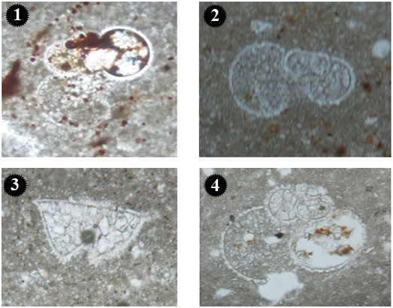
1.Paragloborotalia kugleri BOLLI, X10,
2.Paragloborotalia siakensis LEROY, X10
3.Globorotalia miocenica, PALMER , X10
4.Globigerinoides primordius BOLLI and BANNER, X10

Plate 2: Fossils from the Serikagni Formation

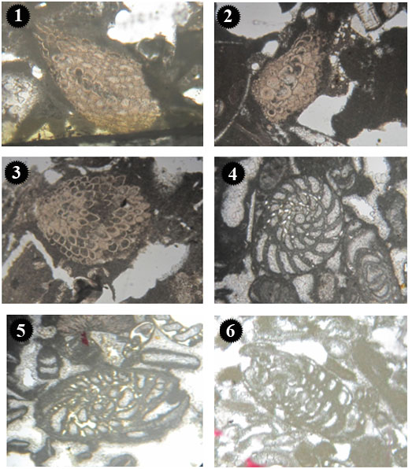

Plate 3: Fossils from the Euphrates Formation. (1. Miogypsina globulina (MICHELOTTI), X5, 2. Miogypsina complanta SCHLUMBERGER, X5, 3. Miogypsina sp., X5, 4. Peneroplis farsensis HENSON, X5,5. Peneroplis evolutus HENSON, X5 and 6. Peneroplis sp., X5)

1. Charaphytes, X10,

2. Charaphytes and gastropods, X4,

3. Planorbis sp. (gastropods), X10,

4. Charaphytes and thin shell fragments, X4

Plate 4: Fossils from the Ghar Formation

2.1.3 Dhiban Formation (Late Burdigalian)

During the Late Burdigalian, the Tethyan Sea way was closed due to the collision of the African/Arabian Plate, and Iranian (Eurasian) Plate [20]; consequently this led to the deposition of lagoonal (Dhiban) facies.

According to Jassim and Karim [2], and Jassim and Goff [21] "One of the main features of the Late Burdigalian is the presence of two evaporitic centres that belong to the Dhiban Formation. The northeastern one occurs around Sinjar and extends into Syria, in which the type locality of the Dhiban Formation is located, and the southeastern one, which occurs around Baghdad, extending northwards to Jambour area, southwards to Diwaniya, and eastwards towards Iran". These two closed basins are formed due to the collision of the African/Arabian, Plate and the Iranian (Eurasian) Plates [20], which resulted in temporary closing of the seaway connection to the Tethys Ocean. These two closed basins are rich with thick anhydrite sediments. Most occurrences of the formation are of a subsurface nature, it is almost encountered in all oil wells, like Injana 5, Hamrin 1, Pulkana 1, all Jambur oil wells, Musayib 1, Gullar 1, Ain Zala 22, Khlaisia 1, Mashura 1, Najma 2, and Qayara 17 [22].

The Dhiban Formation has a very limited exposure in Sinjar area and Makhuol anticline [23, 24, 25 and 6] and in southwestern Iran [10].

2.1.4 Ghar Formation
Along the southwestern shore line of the shallow Euphrates Sea, three main bodies of sands were found of deltaic origins; these are in Al-Khirish Area, near the Iraqi – Syrian borders, in the west of Najaf area, and west of Samawa – Bussayah area, then swings towards the south to the Iraqi – Saudi Arabian borders. The last one is the largest clastics body encountered; as far as Amara area in the southeast, and given the name Ghar Formation. Jassim and Karim [2] and Jassim and Goff [21] believe that the presence of three main rivers flowing from the southwest towards northeast is the source of the deltaic sediments (Fig.2). These three deltas are of Late Burdigalian – Early Middle Miocene stage, and found to be interfingering with the Burdigalian Euphrates Formation in subsurface sections in the Southern Desert.

The formation represent fluvio – marine sediments, composed of sandstone, siltstone, and limestone; rich with mixed fauna of fresh water Charaphytes, fresh water Ostracods, and very small fauna, like Quinqueloculina, and shell fragments [26, 27 and, 28] (Plate 4).

1. Charaphytes, X10,
2. Charaphytes and gastropods, X4,
3. Planorbis sp. (gastropods), X10,

4. Charaphytes and thin shell fragments, X4

Plate 4: Fossils from the Ghar Formation

The Ghar Formation is exposed only in the Inner Platform within the Western and Southern Desert [6], they also reported its absence in the drilled wells out of this area except in oil well Dujaila 1; at drilling depth of (1635.15 – 1665.44 ft); south of Kut city, within the Mesopotamia Plain. Recently studied subsurface sections in Najaf area (Southern Desert) showed that the Ghar Formation interfingers with the Euphrates Formation [29].
2.2 Langhian (early Middle Miocene)
Within the Langhian Stage, three stratigraphic units are present within the stratigraphic column of Iraq; all of them are exposed in different parts of the Iraqi territory. Formations of early Middle Miocene age are restricted to the marine platform mainly of the Inner Shelf; they represent one of the last deposited marine sediments with a very narrow connection with the Tethyan realm, before the final closure of the seaway connection with the Tethys, due to the collision of the Arabian Plate with the Iranian Plate (Sanandaj – Serjan Zone). The three formations are described hereinafter.

2.2.1 Jeribe Formation
The Jeribe Formation has a wide distribution in the subsurface; as encountered in tens of oil wells, it is almost present wherever the Euphrates Formation is encountered, with the exception of the southeastern Iraq, or Basrah vicinity. The authors attributed the wide subsurface distribution of the Jeribe Formation to the basin configuration during the early Middle Miocene as it represents continuous shallowing of the sea, and the starting deposition of the Fatha Formation of semi-closed lagoons in the Iraqi territory.
At Langhian Stage, the basin of the Jeribe Formation started to become shallow warm marine of higher salinity. The exposures of the formation in Sinjar anticline are clear example for this environment, the faunas represent an inner shelf marine condition with sea depth of less than 50 m, rich with Miliolids, Borelis melo curdica, abundant shell fragments, and very rare small Globorotalia bareseinesis (index species of Langhian stage) [14, 8, 30 and 31] (Plate 5).

In the Iraqi Western Desert, due to lithological similarity with the Euphrates Formation, and the presence of very thin brecciated dolomitic limestone at the contact with the underlying Euphrates Formation; makes it difficult to differentiate between; therefore, Jassim et al. [5] used the name Euphrates – Jeribe formations of Burdigalian – Langhian stage, and stated that the last few meters represent a very shallower marine condition. The authors recommend more petrological and sedimentological study should be carried near the contact of the Euphrates – Jeribe formations.

Recently, an exposure of the Jeribe Formation is documented by Kharajiani [10] in Ashdagh anticline south of Qara Dagh anticline, at Sulaimaniyah vicinity, unconformably overlying the Euphrates Formation, with Borelis melo curdica (Plate 5), he assigned the formation to the Middle Miocene age.

2.2.2 Govanda Limestone
The shallow marine basinal deposition continued during Langhian, a narrower shallow basin to the northwest with abundant Borelis mello cudica, Miogypsina intermia, Spiroloculinas, Pyrgos, Ostrea cf. latimarginata, Alagal reef, suggest a continuous seaway connection with the Tethys Ocean. This unit is exposed in the north and northwestern parts of Iraq, within the Imbricate and Zagros Suture Zone, extending from north of Merga Sur, south eastwards; near Penjween town [2, 5 and 6].

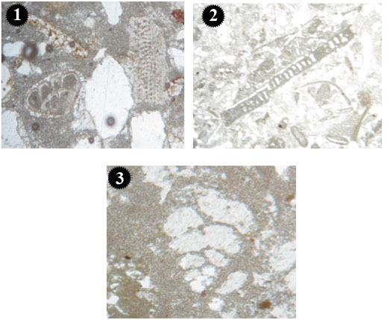

Plate 5: Fossils from the Jeribe Formation (1. Ammonia beccarii LINNE and bryozoa, X5, 2. Archaias sp., X5, 3. Textularia sp., X5).

2.2.3 Red Beds Series
The Red Beds Series Basin is restricted to the northern and northeastern parts of Iraq, within the Imbricate Zone and partly within the Zagros Suture Zone. The beds are of lenticular shape received terrigenous carbonate rocks. It is believed that the Lower Member of the Red Beds Series represents the Oyster bank of Govanda Limestone [2], while the Upper Member clearly represents brackish – fresh water sediments. The unit represents the last sediments of Langhian – Early Serravallian stage, which most likely coincides with the deposition of the Nfayil Formation in the western and southern parts of Iraq.

2.3 Serravallian (Middle Miocene)
Within the Serravallian Stage, only two formations are exposed, other one is recommended for announcement. It is suggested to be called "Sar Sang Formation" [7].

2.3.1 Fatha Formation
The Fatha Formation is one of the most wide spread formations within the Miocene sequence. The formation is exposed widely in the Low Folded Zone, and the Jazera Area (Plain); western part of the Mesopotamia Foredeep. This lagoonal evaporitic formation is also found over the Butmah – Cham ChAmal Subzone of the Low Folded Zone, and margin of the High Folded Zone in northeastern Iraq [2], it is also encountered almost in all drilled oil wells, like Khashab 1, Tal Ghezal 1, Balad 3, Baghdad East 43, Nahrawan 1, Ahdab 1, Dhafiriyah 1, Fakkah 1, Badrah 1, Halfayah 1, Majnoon 1 [32].

The thickness variation of the formation, shows two main areas of increased thickness; the northeastern one, which is present in the Jazira area, roughly west of Sinjar – Sharaf divide (Jazira – Sinjar Basin), and extends into Syria [2]. According to Ma'ala [3], the thickness of the Fatha Formation in Sinjar anticline reaches to 600 m, while in the southeastern extent from Mosul (Kirkuk Basin), towards Kirkuk and Khanaqin and extending into Iran, has a thickness exceeding 1000 m. The thickness is reduced towards the north and south; corresponding roughly to the Mosul High and Salman Zone [2] and also due to the basin configuration and tectonic activities in the depositional basin during the Middle Miocene.

The Fatʹha formation is characterized by cyclic nature, it is composed of repetition of carbonate (limestone/ dolomite) anhydrite, gypsum, salt, and marl, these cycles are due to either vertical block movements or Eustatic water level in the lagoon, these two factors can play an important role for the development of these cycles [33], this repetition is also found in the southern Mesopotamian basin, as stated by Aqrawi [34].

The formation is divided into two members: Lower Member, it is composed of green marl, limestone commonly oolitic/ pelletic, rich with shell fragments, miliolids and Ammonia beccarri, which indicate semi-closed lagoon, and Upper Member, it is composed of anhydrite, gypsum, salt, and marl, red claystone; sometimes with sandy marl or sandstone, which indicate a closed basin-sabkha condition during the Upper Serravallian Stage.

In many localities, the marl replaces the anhydrite and gypsum beds. The present authors believe that both the eustatic water level with the vertical block movements have caused the closure and isolation of the basin; which consequently caused in filling of the central basin with anhydrite, and the repetition of the sediments.

2.3.2 Nfayil Formation
This recently announced Middle Miocene stratigraphic unit [35] includes two members, both of cyclic deposition nature; of coarsening upwards cycles for the Upper Member, they are:

2.3.2.1 Lower Member: Consists of three cycles, each starts with green marl and grey fossiliferous limestone, while the upper cycle ends up with oyster bed, usually the deltaic cycles end with fossiliferous horizons.

2.3.2.2 Upper Member: Consists of coarsening upward cycles, each starts with reddish brown claystone, siltstone and sandstone; occasionally with thin horizons of limestone and green marl in the lowermost parts. This is one of the distinguishable aspects of deltas that led to define them in sedimentary record, which are "silt, mud and coquina and fossiliferous sandstone are the coarsening upward cycles in delta".

The fossils found in the limestone horizons of the Lower Member of the Nfayil Formation are Peneroplis, Miliolids, Quinquiloculina, Borelis melo curdica, Ostrea, Clausinella (Plate 6), all these faunas are indicative of shallow marine condition. The authors believe that at the Middle Miocene Epoch there was a set of rivers flowing from southwest to northeast just like the ones in Ghar Formation [2], but in a younger stage. This formation seems to be similar to the Govanda Limestone in fossils and age, and also to the Lower Member of the Red Beds Series.
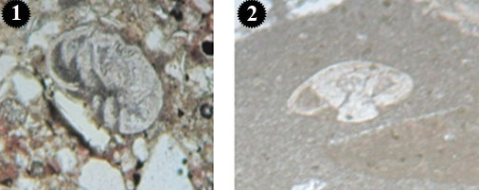
Plate 6: Fossils from the Nfayil Formation (1.Ammonia beccarii (LINNE), X, 2. Rotalia sp., X5).

2.4 Upper Miocene – Pliocene
Within this age range, two formations are present within the stratigraphic column of the Iraqi territory, they are:

2.4.1 Injana Formation
At the end of the Middle Miocene, a final regression of the Miocene Sea had occurred due to the collision of the Arabian Plate with the Iranian Plate. As the sea regressed, a trail of shore line sediments deposited on the newly emerged land area, clastics sediments of marine origin followed by fluvital sediments, assigned to the Injana Formation (Upper Fars); this is also confirmed by Jassim and Karim [2].

The Injana Formation is widely exposed in the Low Folded Zone and Jazira Area of the Mesopotamia Foredeep, as well as in the Mesopotamia Plain [6 and 36]. The formation has a constant lithology (sand stone, claystone, thin evaporite, and very thin beds of fresh water limestone, except in the northern parts within the High Folded Zone and Imbricate Zone; there the formation is composed only of sandstone followed by claystone. Basi [37] stated that the Injana Formation is composed of fining upward cycles; these cycles are most probably related to the tectonic activity in the source area. Further northwards, the Injana Formation represents the cyclic nature of fluvital condition; the basal part is composed of sandstone rich with common occurrences of heavy minerals like garnet, amphibole, pyroxene, mica, feldspar, also chert, and lithic fragments, which might indicate semihumid environment [38]. According to the same author, this is followed by claystone rich with illite, kaolinite, palygorskite, and chlorite, which indicates derivation of this unit from nearby sources. No occurrence of limestone or evaporate beds occur, except some thin beds in the lowermost part of the formation.

In the Folded Zagros Zone of southwestern Iran, the Upper Miocene Agha Jari Formation is similar to the Injana Formation, it also consists of terrigenous rocks, i.e. coarse, medium and fine; as a major lithofacies, and evaporite mixed silisiclastic carbonate; as a minor lithofacies. The formation shows sedimentary features typical of fluvial deposition [39].

2.4.2 Mukdadiya Formation
The Late Miocene fluvital cyclic sediments of Mukdadiya Formation (ex-Lower Bakhtiari Formation) are composed of alternation of pebbly sandstone and claystone; it is of fluvital fining upward cycles [37]. The authors believe that the repeated cycles are the result of tectonic pulses.

The Mukdadiya Formation covers a large area in the Low Folded Zone, and in Mesopotamia Plain (as subsurface extension), but it has a restricted exposure area within the High Folded Zone, its presence in the Jazira Area and west of Tigris River is doubtful. The authors attributed the limited distribution of Mukdadiya Formation as compared with the Injana Formation to the following reasons.

1-The tectonic pulses played a role in transporting the sediments and deposited them in the basin were less than those of Injana Formation, may be they were less intensive than the pulses during the deposition of the Injana Formation, which was deposited during the initial phase of the major thrusting that changed the marine phase to continental one. At the end of the deposition of Mukdadiya Formation a stronger more active tectonic pulses led to the transportation and deposition of huge conglomerate bodies at the lower part of the younger formation (Bai Hassan Formation).

2- The basin within the Mesopotamia Foredeep was continuously subsiding in a faster rate than the sediments supply of the Mukdadiya Formation; this is indicated by the depth of the lower contact of the Mukdadiya Formation in the Mesopotamia Plain, and this is clearly shown in the Neotectonic Map of Iraq, where the depth ranges from (250 – 2750) m, but in the northern part of the plain it ranges from (250 – 1750) m [32]; therefore, the coverage areas are smaller; as compared with those of the Injana Formation, on contrary, in Derbendi Khan Area (Northern Iraq) the thickness of the Mukdadiya Formation reaches up to 2500 m and more, whereas the Injana Formation is 250 m only [40].

It is important to note that by the end of the Miocene a diver's event began, and established our modern world; the global on shore tectonic and ocean atmospheric event provide the foundation for our recent world. Potter and Szalmari [41] stated that "At the end of Miocene much of our world landscapes, (except for the changes by the Pleistocene continental glaciation) would be recognizable to us today".

3 LOWER AND UPPER CONTACTS
The lower and upper contacts of the Miocene sequence; as a whole are described hereinafter; briefly.

3.1 Lower Contact
The Miocene sequence is usually underlain unconformably either by Eocene rocks or Oligocene; in both cases the contact is unconformable with clear indication presented by a basal conglomerate.

In the Western Desert, the lower part of the Miocene sequence is represented by the Ghar or Euphrates formations. The Ghar Formation is underlain unconformably by Ratga (Eocene), Shurau and Sheikh Alas (Lower Oligocene) formations, in Muger Al-Dheeb vicinity (extreme western part of Iraq) and northeastwards; the contact is marked by a basal conglomerate [42]. In wadi Hauran, Hussainiyat and Qasir Muhaiwir vicinities, it is underlain unconformably by the Najmah (Upper Jurassic), Nahr Umr, Mauddud and Rutbah (Lower – Middle Cretaceous) formations, the contact is always sharp and clear, either due to presence of basal conglomerate and/ or lithological difference [43]. The Euphrates Formation in the type locality is underlain unconformably by Anah Formation (Upper Oligocene) [44 and 14], From Al-Qaim to Al-Baghdadi areas, it is underlain unconformably by the Anah Formation; the contact is sharp and indicated by a basal conglomerate [45, 46 and 47). In wadi Hauran it is underlain unconformably by the Sheikh Alas, Shurau (Lower Oligocene), and Dammam formations (Eocene) [46]. In wadi Hauran, southeast of H₁, it is underlain unconformably by the Nahr Umr Formation (Middle Cretaceous) [48].

The contact is marked by a basal conglomerate; the pebbles are derived from the Ratga Formation (Eocene) and/ or other Oligocene formations; cemented by sandy calcareous cement, when the underlying rocks are of Oligocene age, then green marl is developed with the cement materials. Locally, in Anah vicinity, red paleosoil is developed as a cement material. The thickness of the basal conglomerate ranges from (0.5 – 3.5) m, exceptionally may reach 5 m.

In the Southern Desert, the Miocene Sequence is represented mainly by the Euphrates Formation, which is underlain unconformably by the Dammam Formation (Eocene); the pebbles are derived from the Dammam Formation and cemented by sandy calcareous cement. The contact is sharp and clear, marked by basal breccia and/ or conglomerate, which is (4 – 6.5) m thick and occasionally reaches 8 m, the cement being eroded leaving Dammam boulders only. The fragments are subrounded, reaching in size up to 20 cm, cemented by sandy carbonate materials. The pebbles represent the whole Eocene Period; but mainly of the Middle Eocene rocks; as indicated by the presence of Nummulites gizehensis. The loose boulders, which cover very large areas as scattered boulders of the Dammam Formation were considered by Al-Mubarak and Amin [48]; during the regional geological mapping as the Dammam Formation, consequently, very complicated stratigraphic sequence was considered, locally faults were assumed to solve the abnormal contacts; not only with the Euphrates Formation; but also with the younger Nfayil, Zahra and Dibdibba formations. This situation was discovered during the detailed geological mapping executed during 2009 – 2012 and the results were utilized by Sissakian and Fouad [6]. The fragments of the breccia are composed of white marly nummulitic limestone, recrystallized, and silicified with some chert fragments.

In Sinjar – Mosul – Erbil vicinity, the Miocene sequence is underlain by different formations. The lower part of the Miocene sequence is represented either by the Serikagni Formation, which in the type locality is underlain unconformably by the Jaddala Formation; the unconformity is demonstrated by the absence of Oligocene rocks [44]. In Sinjar anticline, it is underlain unconformably by the Jaddala Formation, the contact is based on the bottom of a conglomeratic limestone and chert, in Goulat anticline; east of Sinjar, calcareous sandstone including glauconite is present instead if the conglomerate [3] very thin horizon of Upper Oligocene within the unconformity is encountered, which indicates its presence and erosion [13].

When the Euphrates Formation forms the lower part of the Miocene sequence, different formations are underlain the sequence. In Dahqan anticline, south of Dohuk city; the Euphrates Formation is underlain unconformably by the Pila Spi Formation (Late Eocene); the contact is based on the top of the last chert bearing limestone. In Mushurah anticline, northwest of Mosul city; it is underlain unconformably by the Avanah Formation (Late Eocene) (the contact is based depending on the fossils record) [49]. West of Mosul vicinity, the lower contact of the formation is not exposed except in Atshan anticline; there, the formation is underlain unconformably by the Avanah Formation (Late Eocene); the contact is marked by 15 m thick breccia [50]. In Ain Sifni anticline, east of Mosul city; the formation is underlain unconformably by the Pila Spi Formation (Upper Eocene), the contact is marked by a conglomerate bed (about 2 m thick); the pebbles are mainly of the Pila Spi Formation, when the conglomerate is absent, then the contact is based on the bottom of the first grey claystone or marl [51]. In Makhoul anticline, it is underlain conformably by the underlying Kalhur Gypsum; the contact was based on the bottom of the thick limestone bed [23]. In Qara Chouq structure, south of Erbil city; it is underlain unconformably by the Anah Formation (Upper Oligocene), the contact is marked by (2 – 3) m thick basal conglomerate [52 and 53].

In Maqloub, Ba'shiqa and Ain Al-Safra anticlines, east and northeast of Mosul city; the Fatha Formation represents the lower part of the Miocene sequence and it is underlain by the Pila Spi Formation (Eocene); the contact is marked by a basal conglomerate bed, which consists of dolostone pebbles of different sizes, rounded, subrounded and subangular shapes, cemented by calcareous materials [54]. In Khanaqeen, central northeast of Iraq; Youkhanna and Hradecky [55] mentioned that the Fatha Formation is underlain unconformably by the Oligocene formations, the contact is marked by about 1.5 m thick basal conglomerate that includes pebbles up to 1 m of Oligocene rocks, except in Bezniyan anticline, where the contact is based on the bottom of the first oolitic limestone above the Anah Formation. In Salah Al-Deen – Koi Sanjaq vicinity, north and northeast of Erbil city; the Fatha Formation is underlain by the Pila Spi Formation, the contact is unconformable and marked by a conglomerate bed, about (1 – 4) m thick. The pebbles are mainly limestone derived from the Pila Spi Formation cemented by red and green clayey and calcareous materials, the size of the pebbles range between (3 – 8) cm. In areas where the conglomerate is missing the contact is based on the bottom of the first reddish brown claystone overlying the limestones of the Pila Spi Formation [56].

In majority of the High Folded Zone, which forms the northeastern and northern parts of Iraq; the Fatha Formation represents the lowermost part of the Miocene sequence. The Fatha Formation is underlain unconformably by the Pila Spi Formation (Upper Eocene). However, locally Early Miocene rocks may underlie the Fatha Formation, and then the contact is conformable, this special development was found in the extreme southeastern marginal parts of the zone, and may be present in other localities, but not recorded because the Euphrates Formation was mapped with the Pila Spi Formation as one unit. In Shaqlawa – Koi Sanjaq vicinity, the contact between Fatha and the Pila Spi formations is unconformable, locally is marked by a basal conglomerate, which attains 4 m in thickness, like in Topzawa village near Koi Sanjaq and at the northwestern plunge of Permam anticline. In other areas, red claystone marks the contact, which may represent fossil soil; like on the top of Permam anticline, along the road between Salah Al-Deen and Sara Rash [56].

From the aforementioned data, it is obvious that the lower contact of the Miocene Sequence is usually unconformable, either the whole Oligocene is missing or the uppermost part of the Eocene is missing. However, locally even the Lower Miocene (Euphrates Formation of Burdigalian age) is missing too; indicating large non-depositional and/ or erosional episodes.

3.2 Upper Contact
The upper contact of the Miocene Sequence is clearer as compared with the lower contact. The details of the contact are mentioned hereinafter.

In the Western and Southern Deserts, the Late Miocene sequence is not present, except in restricted areas, like between Karbala and Najaf vicinities; along both Tar Al-Sayed and Tar Al-Najaf where the Injana Formation (Upper Miocene) is present above the Upper Member of the Nfayil Formation (Middle Miocene). There, the Injana Formation is overlain by the Dibdibba Formation of Pliocene – Pleistocene age. The details of the contact are obscure due to lack of fossils in both formations. Farther northwestwards, red clastic sediments are exposed as the uppermost part of the Miocene sequence. Jassim et al. [5] called them as Habbaniyah Beds; however, the authors are in accordance with Sissakian and Fouad [6] in considering them as the Upper Member of the Nfayil Formation of Middle Miocene age. It is worth mentioning that the authors are also in accordance with the assumption of Sissakian and Fouad [6] in considering the exposed Injana Formation along Tar Al-Sayed and Tar Al-Najf as the Upper Member of the Nfayil Formation. In certain areas, within the Western and Southern Deserts, the Miocene sequence is overlain unconformably by the Zahra Formation of Pliocene – Pleistocene age. The whole Late Miocene is missing; the contact is very sharp and clear, due to the presence of red claystone beds within the Zahra Formation.

In all other areas in Iraq, where the uppermost part of the Miocene sequence is exposed represented by the Mukdadiya Formation of Late Miocene – Pliocene age, the contact is conformable, gradational and diachronous with the Pliocene and even with the Pleistocene rocks; represented by the Bai Hassan Formation of Pliocene – Pleistocene age. The contact is also gradational and diachronous. However, in restricted areas; like west of the Tigris River, where the Mukdadiya Formation is not present, and Injana Formation represents the uppermost part of the sequence, then the upper contact of the Miocene sequence is unconformable with different types of overlying Quaternary sediments.

4 SEQUENCE STRATIGRAPHY
The Miocene sequence forms the middle part of the Megasequnece Latest Eocene – Recent (AP 11) established by Sharland et al. [57]; starting from the Aquitanian to the top of Zanclian.

4.1 Maximum Flooding Surfaces (MFS)
As it is aforementioned about the lower and upper contacts of the Miocene sequence, the lower contact is more complicated being witnessing large unconformities with the underlying rocks, especially when the the whole Oligocene and Early Miocene (Burdigalian) rocks are missing. Therefore, only the lower contact is involved with the sequence stratigarpahy, because mainly the upper contact of the Miocene sequence is overlain conformably by the Pliocene rocks. And because lesser importance is attached to parasequence boundaries, however, there is a suggestion that flooding surfaces representing parasequence boundaries may be more laterally extensive leaving more evidence than sequence boundaries because the coastal plain has a lower gradient than the inner continental shelf [58].

The Miocene Sequence includes four main MFS [57 and 21]; these are Ng 10, Ng 20, Ng 30 and Ng 40. However, Aqrawi et al. [59] suggested another MFS and called it Ng ? to be existing between Ng 10 and Ng 20, within the Jeribe Formation.

The first MFS; Ng10 represents the beginning of the Miocene sequence where a large unconformity can be seen everywhere; in Iraq at the base of the sequence, indicated by a basal conglomerate and/ or breccia, either representing the break between the Eocene and Miocene Epochs or between the Oligocene and the Miocene Epochs. It is one of the main and clear unconformities all over the Iraqi territory.

The second MFS; Ng 20 represents almost the contact between the Aquitanian and the Burdigalian Stages, which is within the Jeribe Formation (Middle Miocene). This MFS; Ng 20 although is not so clear, as compared to the MFS; Ng 10, but it can be recognized by the partial absence of the Jeribe Formation (Figs.3 and 4) in vast areas within the Iraqi territory. Aqrawi et al. [59], however suggested the presence of another MFS, Ng ?, between Ng 10 and Ng 20. The authors have no indications for this MFS and consequently cannot give explanation for that. However, the presence and/ or the absence of the Dhiban Formation may refer to the suggestion of Aqrawi et al. [59].

The third MFS; Ng 30 is present in the middle of the Burdigalian Stage, and marks the contact between the Jeribe and Fatha Formations. This MFS is also clear in Iraq from recognizing the absence of the Jeribe Formation and underlying of the Fatha Formation directly by the Euphrates Formation; although no basal conglomerate or any lithological indication for the unconformity.

The fourth MFS; Ng 40 is present in the middle of the Serravallian Stage and is marked by the contact between the Fatha Formation and the overlying Injana Formation, beside the major change in the depositional environment from the marine to continental. This MFS as one of the major and very clear surfaces can be seen all over the Iraqi territory; however, no any indication for break in sedimentation can be seen between the two formations.

Three main sea level drops can be seen coinciding with three MFS represented by Ng 10, Ng 30 and Ng 40, whereas the MFS; Ng 20 did not show so clear sea level drop (Fig.3). Moreover, from MFS; Ng 40 and upwards, the sea level is almost either in constant zero level or below zero level (Fig.3).

A special diagram is constructed, which shows the relation of the Miocene sequence with the underlying and overlying rocks (Fig.3). The diagram also includes different MFS levels as well the Miocene sea oscillation, adopted from Jassim and Goff [21]. Moreover, the megasequences constructed by Sharland et al. [57] are also included in the diagram to show the relation of different formations of Miocene Epoch with the MFS, oscillation of the sea level and to which part of the megasequence they belong. The in between unconformities (within the Miocene Epoch) are also marked in the diagram representing (Fig.3).

4.2 System Tract
The concept of system tract evolved to link the contemporaneous depositional systems. System tract forms subdivision in a sequence. Different kind of system tracts are assigned on the basis of stratal stacking pattern, position in a sequence and in the sea level curve and types of bounding surfaces [60].

Although the authors have no sufficient data to define the system tracts within the Miocene sequence, but following the main definition and concepts, it can be concluded that each MFS separates Transgressive and Highstand Systems Tracts, which means that there are four Highstand and Transgressive Systems Tracts within the Miocene sequence. Moreover, each transgressive system tract is underlain by a low stand system tract and each highland system tract is overlain by falling-stage system tract.

From reviewing the aforementioned data, it is very clear that the megasequence AP10 established by Sharland et al. [57] includes four sequences separated by four main sequence boundaries indicated by four unconformities (Fig.3). However, among the mentioned four sequence boundaries, the sequence boundary represented by MFS, Ng 20 is not so clear, as compared to other three sequence boundaries.

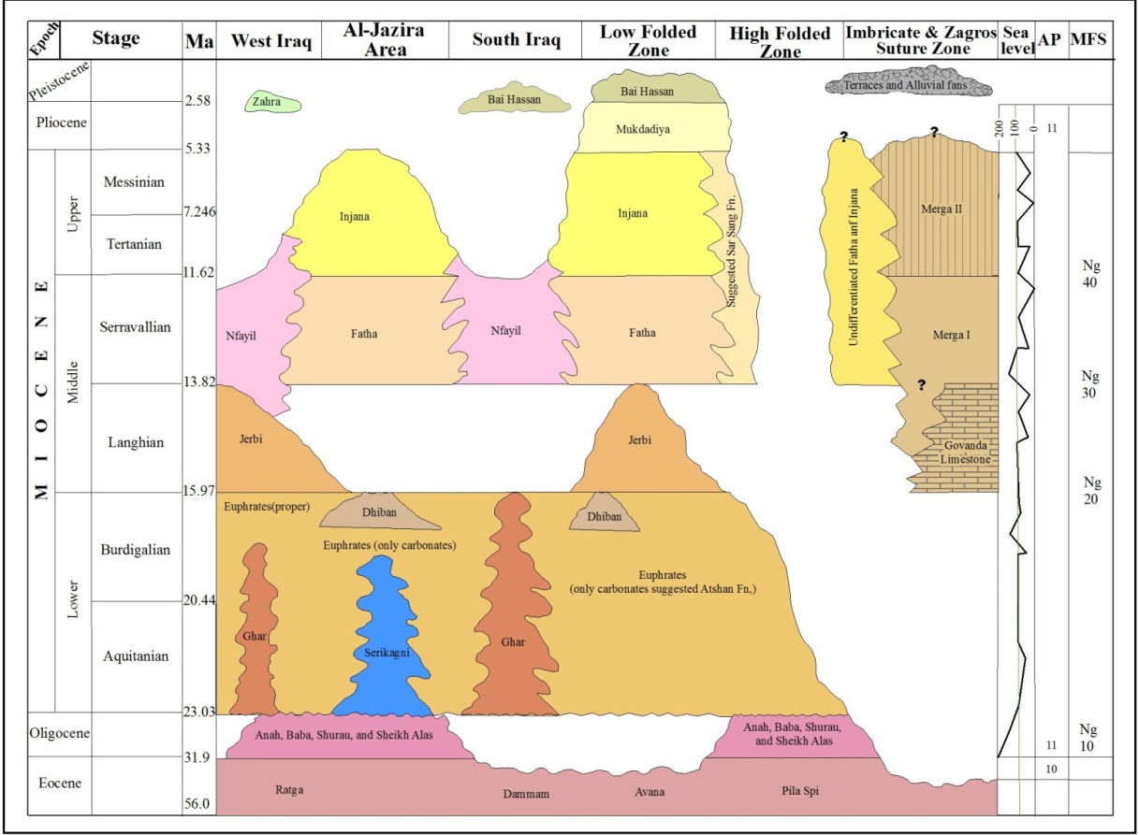
Fig.3: Tenttaive orrelation diagram of the Miocene Sequence in Iraq.
The AP and sea level is adoprted from Jassim and Goff [21].
The MFS is adopted from Aqrawi et al. [59].
5 ECONOMIC POTENTIAL
The Miocene formations include different economic aspects; locally some of the aspects are already utilized. Hereinafter is a brief review.

Although the Miocene sequence is not an important potential for oil; however, in Jambour oil field, southeast of Kirkuk oil field, the Jeribe formation is considered as a pay zone with less extent to the Euphrates Formation. Many drilled oil wells; like Ja 4, Ja 6, Ja 7 and Ja 12 have the Jeribe Formation as a first pay zone, whereas oil wells like Ja 2, Ja 3, Ja 5, and Ja 10 have the Euphrates Formation as the first or the second pay zone, depending on the locations of the drilled oil wells in the structure [22].

Moreover, the Fatha Formation is considered as the cap rock in the oil fields in the central and northern parts of Iraq. The presence of thick beds of gypsum and/ or anhydrite alternated with green marl and/ or red claystone plays a big role in capping the oil in the reservoirs. Among the produced oil fields in which the Fatha Formation forms the cap rock are: Kirkuk oil field with its three domes (Baba, Avana and Pulkhana), Jambur, Bai Hassan, Taq Taq, Cham Chamal, Khanaqeen, Ain Zala, and Butmah. The thickness of the gypsum beds is highly variable; the maximum recorded thickness of gypsum is in Kifri, within Pulkhana anticline, where 43 m of gypsum beds are recorded without interruption [61].

The limestones of the Euphrates Formation are used in cement industry in different parts of Iraq. The CaO content varies from (50 – 54) %, which make them very favourable for the cement industry. Moreover, the limestone is locally used as building stone; it is also crashed and used as aggregate in concrete industry.
,
The gypsum of the Fatha Formations is very widely used in plaster industry in different parts of Iraq. Many factories exist for producing this material, which is used as a cementing material in constructions, beside hundreds of small primitive factories, which use the gypsum for the same industry. Gypsum is also used as a decorative stone.

Another significant economic importance of the Fatha Formation is the sulphur, which is present in Mishraq Mine, south of Mosul city. Sulphur is extracted using Frash method with enormous amounts.

6 DISCUSSION
The exposed formations within the Miocene Sequence are discussed hereinafter. The lithofacial changes of each formation within different tectonic zones are argued and delineated too. A fence diagram (Fig.4) is constructed to show the main areas where the lithofacies of different formations change to other facies, which did not resemble the original facies of the formation in the type section. Consequently, many new formations are suggested for announcement. However, for announcement of the suggested new formations, much work should be carried out before the announcement.

6.1 Serikagni Formation
The Serikagni Formation is exposed only in Sinjar anticline [6], where its type locality is located [44], within the Low Folded Zone and small exposure south of Sulaimaniyah city [9]. Moreover, recently detailed mapping showed the presence of the formation in Madili vicinity (Amer Al-Waisy, personal communication, 2015). However, the formation is encountered in many oil wells, among them are: Najmah 29, Pulkhana 5, Injana 5, Hamrin 1, Jambur oil wells, Sasan 1, Ibrahim 1, Adaiyah 1, Hbbarah 1 (Fig.5). Nevertheless, in some oil wells the formation was not distinguished from the Euphrates Formation; therefore, the term Serikagni – Euphrates Formation was used [22]. The Serikagni Formation was not encountered in any oil well out of the Low Folded Zone. Moreover, even within the Low Folded Zone, where it is only developed, it has restricted and regular distribution, mainly present; as subsurface development along the extreme southern limits of the zone, and locally in the western part; east of its exposure areas.

The distribution areas; surface and subsurface, of the Serikagni Formation show it is not developed wherever the Euphrates Formation is, or it is present in undifferentiated form from the latter. However, in Sinjar vicinity, the Euphrates Formation is developed as tongues within the Serikagni Formation [3 and 13]. This is attributed to the difference in the depositional environment of the two formations.

The depositional environment of the Serikagni Formation is deep water, basinal facies of warm sea with normal salinity (upper bathyal zone) [4, 8, 26 and 30]. The depositional environment of the formation (marine basinal) and its distribution indicates the development of broad and shallow basins, in which carbonates were deposited, during Savian movements, and were restricted in small areas (Fig.5), which means the developed basins were mainly narrow and small; therefore, the Serikagni Formation has very restricted coverage areas.
Another assumption is, in areas where the Serikagni Formation was not precisely differentiated from the Euphrates Formation, as encountered in some oil wells [22], those areas represent the boundaries between the deep and shallow basins developed during Early Miocene. Moreover, the presence of the formation alongside the southern limits of the Low Folded Zone is attributed to the thrusted tectonic nature of the contact with the adjacent Mesopotamia Foredeep, which had developed a deep basin in which the Serikagni Formation was laid down.

Other restriction, concerning the presence of the Serikagni Formation in some parts of the Low Folded Zone, is its total absence in Kirkuk Embayment, where the Oligocene Kirkuk Group is well developed, overlain by the Euphrates Formation. This is attributed to the presence of shallow basin, where the reefal Oligocene Group (approximately of not more the 200 m deep), is overlain by shallow marine carbonates of the Euphrates Formation, and the sea level continued to drop; as indicated by the deposition of the Fatha Formation in a shallow lagoons.

The same scenario is repeated in Bai Hassan and Qara Chough vicinities. Moreover, in Kirkuk Embayment the presence of thick salt or saliferous beds within the Fatha Formation, which forms the detachment of the thrusted anticlines, is another prove for the presence of the shallow basins there, otherwise, the salt beds wouldn't be deposited.

6.2 Ghar Formation
The Ghar Formation is exposed only in the Inner Platform, within the Western and Southern Deserts [6]; it is not encountered in the drilled wells out of the mentioned zone, except in Dujaila 1 (drilling depth 1635.15 – 1665.44); south of Kut city, within Mesopotamia Zone. However, it was not encountered in drilled wells in near surroundings; such as Kifl 1, Musaib 1, Afaq 1, but encountered in all other drilled oil wells in Basra vicinity and westwards [22]. Moreover, locally the formation interfingers with the Euphrates Formation; south of Al-Najf and south of Al-Nasiriyah vicinities [22 and 6].

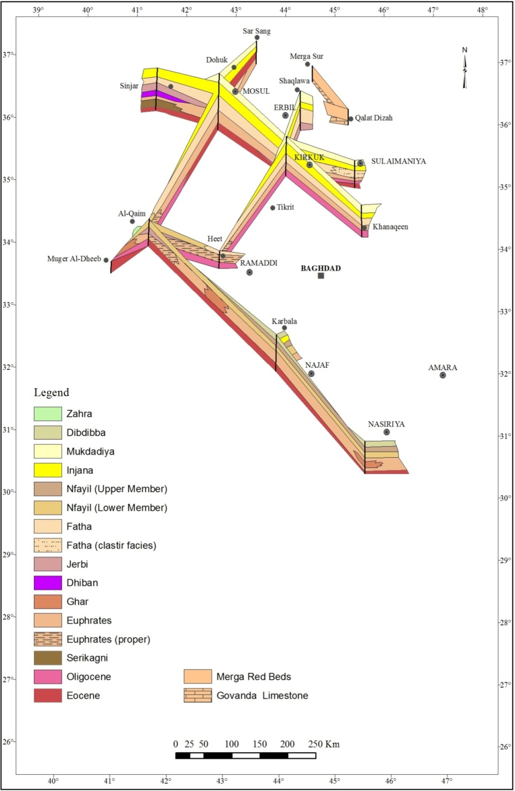
Fig.4: Fence diagram of the Miocene Sequence in Iraq

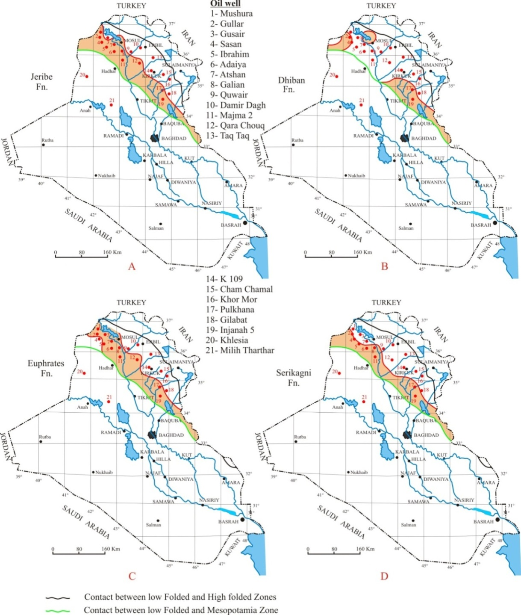

Fig.5 (A, B, C and D): Geographical distribution of Jeribe, Dhiban, Euphrates and Serikagni formations in subsurface sections in the Low Folded Zone of Iraq
(Oil well data after [22]) (After Sissakian and Al-Jiburi [7])

The rocks of the Ghar Formation are the only non-pure marine sediments within the Early Miocene sequence. The rocks were deposited in fluvio-marine environment possibly of deltaic origin, ranging from delta top to inner shelf conditions [26 and 27]. The interfingering exposures with the marine Euphrates Formation confirm its deposition in deltaic regions. A good example is the outcrops southwest of Al-Najaf vicinity [28], where both formations show excellent interfingering pattern, hence the formations cannot be differentiated from each other. The age of the formation as claimed by Jassim et al. [5] is Early Miocene (Upper Burdigalian) on surface sections.
The presence of the Ghar Formation only within the Inner Platform, except that encountered in oil well Dujaila 1 [22], is a good prove that during Upper Burdigalian (about 17 – 15.97 Ma), only small parts of the nowadays Western and Southern Deserts were forming the deltaic part of the Miocene Sea, and before the last major thrusting that had occurred between Sanandaj – Serjan Zone with the Arabian Plate, which terminated the marine phase; during the Middle – Late Miocene (Tortonian – Messinian, 11.608 – 5.33 Ma). However, the presence of the Ghar Formation in Dujaila 1 oil well; can be attributed to the presence of a small elevated area within the Miocene Sea in which deltaic sediments of the Ghar Formation were laid down.
In the Southern Desert, the outcrops of the Ghar Formation are almost restricted to a narrow zone alongside the Abu Jir – Euphrates Fault Zone [62, 63, 64, 65 and 28]. This could be a good prove for the activity of the zone, especially where interfingering between the Ghar and Euphrates formation is developed. Due to the active movements, the Marine Sea was depositing deltaic sediments of the former and shallow marine sediments of the latter. In the Western Desert, however, the exposures of the Ghar Formation are also restricted to a narrow and longitudinal zone, which is almost parallel to the Miocene Sea shore line, starting from about 13 Km east of Hauran valley, near Qasir Muhaiwer and extending NW inside the Syrian territory [6]. The absence of the interfingering between the two formations in the Western Desert is a solid prove for the absence of tectonic disturbances in Inner Platform; during Early Miocene (Late Burdigalian, about 2 Ma), where the Euphrates Formation is underlain by the Ghar Formation, towards the shore line of the Miocene Sea. The presence of these deltaic sediments indicates the presence of rivers flowing from the southwest to Northeast (Fig. 2).

6.3 Euphrates Formation
The Euphrates Formation is of Early Miocene age Burdigalian, 20.43 – 15. 97 Ma); deposited in shallow marine, warm tropical to subtropical, with reef – back reef (10 – 50 m) depth [5]. The type locality is in the western part of Iraq at Anah vicinity [44]. However, in the type locality, the Euphrates Formation is not developed as in other exposure areas; therefore, Jassim et al. [5] recommended a supplementary type section at wadi Chab'bab, in Anah vicinity for the Lower and Middle Units (A and B) and another supplementary type section, at wadi Rabi, in Anah vicinity for the Upper Unit (C). Later on, the Upper Unit (C) was found to belong to a new formation of Middle Miocene age; including index Borelis melo curdica which was named as the Nfayil Formation [35].

The Euphrates Formation is one of the most wide spread surface and subsurface extents in the Iraqi territory. However, along the contact between the Low Folded and High Folded Zones, the Euphrates Formation was missed and not mapped; due its large similarity with the underlying Oligocene and Eocene rocks. It is worth mentioning that those areas were covered by photo-geological maps [66]. Nevertheless, many workers have identified the Euphrates Formation along the aforementioned contact zone, among them are: [9, 67, 6 and 10].
In this study, the authors will name the Euphrates Formation as "proper" Euphrates Formation only in those areas where the lithology resembles that of the type locality [44 and 5].
The proper Euphrates Formation includes basal conglomerate; derived totally from the Anah Formation, followed upwards by shelly limestone, chalky like limestone; partly oolitic, brecciated marly limestone and capped by undulated limestone. This succession is developed only in the upper reaches of the Euphrates River, starting from the Iraqi – Syrian borders; downstream, where Hauran valley merges in the river, it disappears then re-appears in A-Baghdadi vicinity, and then pinches out to subsurface sections ?. The lithofacies of the proper Euphrates Formation extends north of the Euphrates River; at the Jazira Area; for the whole exposure areas. However, in the Jazira Area, Ibrahim and Sissakian [68] considered the Brecciated Unit and the overlying Undulated Limestone Unit as the lower part of the Fatha Formation. Unfortunately, the available subsurface data to the authors does not show where the lithofacies of the proper Euphrates Formation extends. However, the authors believe the formation's subsurface extent is restricted nearby to those areas where the proper formation is exposed. This assumption is based on the fact that in all other exposure areas no indications for deformations exist within the rocks, besides their assumption that the deformation is closely related to the tectonic unrest alongside the contact zone between the Inner and Outer Platforms.
In the junction area of Hauran valley with the Euphrates River and upstream in the valley, and the whole exposures of the Euphrates Formation in the Western and Southern Deserts, and elsewhere have completely different lithofacies, which never resemble the lithofacies of the proper Euphrates Formation. The main lithology is basal conglomerate, in which the pebbles consist mainly of the Dammam Formation (Eocene), or Oligocene rocks; overlain by fossiliferous and chalky limestone. No subdivisions can be traced similar to the case of the proper Euphrates Formation, as were mapped by Al-Mubarak [45, 42 and 46]. Moreover, Mahdi et al. [69] and Fouad et al. [70] presented detailed lithofacial changes at different localities in Haditha and Anah vicinities, respectively. However, none of the former workers gave any explanation for those essential lithofacial changes. Nevertheless, Bolton [71], Fouad [72], Fouad and Sissakian [73] and Sissakian et al. [74] attributed the presence of the brecciated marly limestone and the overlying undulated limestone to shocks caused by earthquakes during the deposition; syn-sedimentary deformation of soft sediments. The deformed sediments are restricted to areas, alongside the contact between the Inner and Outer Platforms, in the extreme western parts of Iraq; therefore, the authors attributed the deformation to tectonic unrest alongside the contact area. Nevertheless, deformations due to earthquake shocks cannot be ignored in soft sediments during deposition.
It is worth mentioning that Al-Mubarak and Amin [48] divided the Euphrates Formation into three units: Lower, Middle and Upper. The first one consist of basal conglomerate; the pebbles are derived totally from the Dammam Formation, the second one is mainly of fossiliferous and chalky limestone, whereas the third one consist of green marl and limestone, which was introduced as a new formation of Middle Miocene age and was called as the Nfayil Formation [35], it is the same sequence called as "Unit C" by Jassim et al. [5].
The vast coverage areas by the exposures of the Euphrates Formation is attributed to the subdivision of the formation by Al-Mubarak and Amin [48], which was adopted by Jassim et al. [75 and 76] and had confused Al-Mubarak and Amin [48] for assuming tens of faults to solve the unexplainable exposures pattern of the Dammam and Euphrates formations. Because the basal conglomerate covers vast areas, and because the cementing materials are washed out; therefore, only large boulders of the Dammam Formation (three members of Early, Middle and Late Eocene age, respectively) are remained, which are considered as Sarir and Hamada of the Dammam Formation by Al-Mubarak and Amin [48]. However, Sissakian [67] and Sissakian and Fouad [6] have separated the upper unit of the Euphrates Formation (Unit C) following Sissakian et al. [35] and have considered it as the Nfayil Formation; therefore, the coverage area of the Euphrates Formation is reduced. It is worth mentioning that Jassim and Buday (Fig.1-2, p.25) in Jassim and Goff [21] have separated the third unit of the Euphrates Formation but still considered it as Lower Miocene unit without referring to the Nfayil Formation. Moreover, Bolton [78] represented the whole Miocene sequence south and west of the Euphrates River as the Euphrates Formation, consequently, the coverage area was extremely large, as compared with that presented by Sissakian [67] and Sissakian and Fouad [6].
The authors attributed the phenomenon of the deformed sequence within the uppermost part of the proper Euphrates Formation, to tectonic unrest during the deposition of the formation along the contact zone between the Inner and Outer Platforms; the latter is represented by the Mesopotamia Foredeep; the Jazira Plain; in the northwestern part, where the Anah anticline stands as a significant morphological and structural feature in the involved area. Apart from this area, towards south and southeast and alongside the left bank of the Euphrates River, the same lithofacies of the proper Euphrates Formation is developed, also nearby the contact between the Inner and Outer Platforms. Moreover, the growth of the Anah anticline, which is an inverted graben [78 and 79] also, had contributed in the present deformations in the sediments of the proper Euphrates Formation; such deformations are well known worldwide [80, 81 and 82]. Therefore, the Euphrates Formation; not only in the Western and Southern Deserts, but also elsewhere in the exposed areas, has different lithofacies, which does not resemble the proper Euphrates Formation and which indicate typical deposition in a quiet shallow marine basin of (10 – 50) m depth [5] , without any tectonic influences. It is worth mentioning that Sissakian and Mohammed [83], and Sissakian and Al-Jiburi [7 and 84] recommended establishing a new formation in areas where the proper Euphrates Formation is not developed. The present authors are in full accordance with this recommendation and suggest the name of "Atshan Formation", where it is exposed in Atshan anticline with a thickness of about 50 m; being underlain by the Avanah Formation of Eocene age [50].
The lithofacies of the proper Euphrates Formation extends inside Syria too and it is capped by alternation of green marl and limestone of Middle Miocene age [85], also alongside the Euphrates River, which forms the continuation of the contact zone between the Inner and Outer Platforms. It is worth mentioning that the alternation of the green marl and limestone was called as 'Unit B" of Middle Miocene age by Al-Jumaily [42], Tyracek and Youbert [46]. The middle Miocene age was proved by Prazak [86] due to the presence of index fossil Borelis melo curdica. This succession was later on identified as a new formation within the Iraqi stratigraphic column, and named as the Nfayil Formation [35]. Nevertheless, Jassim et al. [5] assumed that the "Khirish Beds", which consist mainly of sandstone, conglomerate and capped by limestone, overlie "Unit C" of the proper Euphrates Formation and pass laterally into the Fatha Formation. The authors shade light on this assumption, since the "Khirish Beds" were mapped in the Khirish – T 1 oil pumping station – Hadith – Hit area by Al-Jumaily [42] and Tyracek and Youbert [46] as informal units and called them as "Units C and D" overlying informal units "B, A and A₁" , in descending order. From regional and detailed geological mapping results, it was found that "Unit B" represents the Lower Member of the Nfayil Formation; the clastics of the lower part of "Unit C" represent the Upper Member of the Nfayil Formation, "Unit A" represents Jeribe Formation and "Unit A₁" represents the Upper Member of the Euphrates Formation (Brecciated Unit and Undulated Limestone Unit) [69 and 83]. Therefore, the "Khirish Beds" do not pass to the Fatha Formation, moreover, Karim et al. [31] and Salman [87] have found that both informal Units (C and D) represent the Zahra Formation and are of Pliocene – Pleistocene age.
In all other exposure areas, out of the aforementioned areas; in the type locality and alongside the northwestern part of the contact between the Inner and Outer Platforms, the Euphrates Formation has not only different lithofacies from the proper formation, but also has reduced thickness; not more than 20 m, but the average thickness ranges from (6 – 12) m [3, 49, 50, 55 and 56]. Moreover, Khanqa et al. [9] and Kharajiani [10] have proved the reduced thickness; not more than (2 – 4) m in Aj Dagh anticline, south of Sulaimaniyah vicinity. These reduced thicknesses are attributed to the basin configuration, especially along the marginal parts of the basin, like those areas, which represent the contact between the Low Folded and High Folded Zones.

6.4 Dhiban Formation
The Dhiban Formation (Early Miocene) has the least exposures [6] and subsurface extent [22] within the Miocene Sequence. It is encountered in few oil wells, like Injana 5, Hamrin 1, Pulkhana 1, all Jambur wells, Musayib 1, Gullar 1, Ain Zala 22, Khlesia 1, Mushora 1, Najma 2, Qaiyara 17. From the mentioned oil wells, it is clear that its subsurface extents is irregular, as well the surface exposures, hence it is exposed only in Sinjar anticline; the type locality and small exposures in Makhoul anticline [23] and in Ashdagh anticline [10]. These restricted and irregular extents are attributed to the depositional environment of the formation, which represents a closed lagoonal – evaporitic condition [25 and 24], or in basin-centered Sabkhas and salines [21].
The authors believe that during the Early Miocene; due to the Savian Orogeny, the Miocene Sea was either deep or shallow, as already discussed, and because the Dhiban Formation was deposited in a closed lagoon basins; therefore, its extent is very restricted. This is attributed to very rare existence of closed lagoons in which the Dhiban Formation was deposited.

6.5 Jeribe Formation
The Jeribe Formation is of Middle Miocene age; consists mainly of carbonates, deposited in marine platform, mainly of inner shelf lagoonal facies, of calm and warm water, with relatively high salinity [44 and 30], or in shallow, near shore warm marine conditions [23].
The mapped exposures all over the Iraqi territory did not represent its true exposure areas [6]. This is attributed to very large lithological resemblance to the underlying Euphrates Formation; therefore, the two formations were mapped as one unit, and presented as the Euphrates Formation.
The Jeribe Formation has wide subsurface extents, as encountered in tens of oil wells. It is almost present, wherever the Euphrates Formation is encountered in oil wells, with some exceptional cases, like in the following oil wells: Abu Jir 1, Awasil 5, Hit 5, Nafatah 1, Ain Zala wells, Khlesia 1, Kifil 1 [22]. However, the formation is not present in the southeastern parts of Iraq, at Basrah vicinity; as well the Euphrates Formation.
The Jeribe Formation was not identified in many areas, especially in extreme western part of the upper reaches of the Euphrates Formation. Al-Jimaily [42], and Tyracek and Youbert [46] mapped Middle Miocene; well bedded carbonates as "Unit A", overlying Early Miocene rocks. The most characteristic feature is the presence of a coquina bed showing cross bedding; it was considered as a marker bed during the mapping. Mahdi et al. [69] and Fouad et al. [70] mapped the same beds without referring to the Jeribe Formation too; the formers called them "Ahmar Unit"; referring to Wadi Ahmar; southeast of Haditha, where it shows the best development for about 40 m. Sissakian and Mohammed [83] considered the Middle Miocene beds, at the same locality to represent the Jeribe Formation. The present authors are in full accordance with them; this is attributed to the fact that the Euphrates Formation is overlain; mainly by the Jeribe Formation. Moreover, when the Dhiban Formation is not present, then the differentiation between the Euphrates and Jeribe formations; in the field is almost impossible, due to large resemblance in the lithology of both formations.
The same holds good for the presence of the Jeribe Formation Formation overlying the Euphrates Formation elsewhere in the Iraqi territory, only when the Dhiban Formation is not present. Recently, Kharajiani [10] recognized the Jeribe Formation overlying the Dhiban Formation, which in turns overlies the Euphrates Formation in Aj Dagh anticline; south of Qara Dagh anticline, Sulaimaniyah vicinity. He identified the index fossil Borelis melo curdica; therefore, called the sequence as the Jeribe Formation. Moreover, he recognized the coquina bed with cross bedding too (Fig.6).
The authors attributed the wide subsurface extent of the Jeribe Formation; as encountered in many oil wells [22] to the basin configuration during Middle Miocene, as it was continued since the Early Miocene, as shallow marine, before starting the development of closed lagoons in which the Fatha Formation was deposited. The recognized cross bedding in the coquina bed within the Jeribe Formation (Fig.6) is good indication for shallow marine near shore deposition, where still the current effect can influence the deposition by agitated water [88 and 89], consequently cross bedding was developed within the sediments.

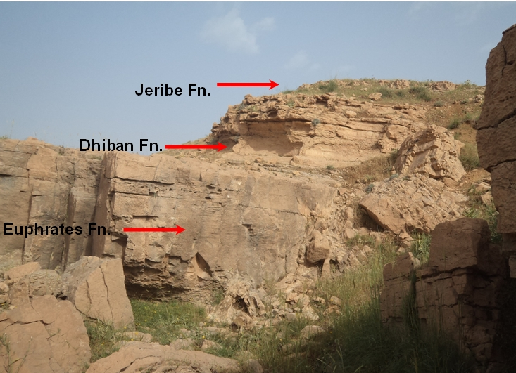

Fig.6: Left) Coquina bed in the Jeribe Formation, Right) Normal Miocene succession in Aj Dagh anticline (after Kharajiani, [10])

6.6 Govanda Limestone
The Govanda Limestone; also called as "Chama limestone" and "Lailuk Limestone" (Morton, 1951 and Dunnington, 1956, respectively in Bellen et al., [44]) is of Early Miocene age (Burdigalian?), consists of basal conglomerate (6 m) with rounded pebbles of red to buff radiolarian and other cherts, silty and sandy detrital limestones with abundant derived Maastrichtian fossils (19 m), and capped by fore-reef shoal and algal reef limestones (102 m) [44]. The Govanda limestone is deposited in shallow marine back-reef environment strongly affected by clastic supply from a nearby landmass (Jassim and Buday in Jassim and Goff [10]).
The Govanda Limestone is found only in the northeastern parts of Iraq, within the Imbricate and Zagros Suture Zones. It extends from north of Merga Sur town; southeast wards to Penjween town, with clear decreasing in thickness, from about 125 m to about10 m, and may be less.
The presence of Borelis melo curdica is clear index for Middle Miocene age (Langhian; 15.97 – 13.65 Ma). Moreover, the presence of Ostrea sp. bed within the Govanda Limestone emphasizes on the correlation with the Nfayil Formation of Middle Miocene ages; in the Western and Southern Deserts. According to Bellen et al. [44], the Govanda Limestone passes "into red-brown marly and silty clastics with occasional thin marine limestones. These sediments have been termed "Undifferentiated Fars" in unpublished reports. Though lithologically comparable with the Upper Fars Formation, they are probably stratigraphically equivalent to part of the Lower Fars Formation of the main Miocene sedimentary basin of Iraq". The authors shade light on the Govanda Limestone and the overlying clastics, both have the same lithological character of the Lower Member of the Nfayil Formation (three cycles, each consists of green marl overlain by limestone, the middle cycle includes Borelis melo curdica and Ostrea sp., as a marker), which is overlain by reddish brown marly and sandy clastics; called as the Upper Member of the Nfayil Formation [35]. The clastic sequence is well developed in the Southern Desert and eastern part of the Western Desert [62, 63, 64, 65 and 28], as well along Tar Al-Sayed and Tar Al-Najaf, between Karbala and Najaf cities, central part of Iraq. Moreover, along the cliffs in Habbaniyah vicinity, where Jassim et al.[5] called them as the "Habbaniyah Beds" and at Khirish vicinity in extreme central western part of Iraq, where Jassim et al. [5] called them as "Khirish Beds".
The Govanda Limestone was deposited in shallow marine basins formed in intermontane semi-closed basins, mainly over Cretaceous rocks; as indicated from the basal conglomerate, which includes clasts of Cretaceous rocks and chert; derived from the Qulqula Formation, as well the presence of reworked Cretaceous fauna within the limestone. Therefore, it overlies unconformably on different Cretaceous formations, especially the Tanjero Formation, beside Qamchuqa and Qulqula formations. The longitudinal exposures pattern of the Govanda Limestone; with NW – SE trend may also indicate its deposition in intermontane basin, which is almost parallel to the nowadays trend of the Imbricate and Zagros Suture Zones.

The Govanda Limestone is "usually overthrust by metamorphosed Tertiary or Upper Cretaceous rocks of the "thrust-mountain zone" [44]. The overthrust took place during the last collision of the Sanadaj – Serjan Zone of the Eurasian Plate with the extreme northeastern margins of the Arabian Plate, represented by the Outer Platform, during last phases of Savian Orogeny. The described three to four conglomerate beds within the Govanda Limestone at Ranya vicinity [90], may indicate tectonically active basin during the deposition and during the last collision of the Arabian and Eurasian Plates, at the end of Middle Miocene, which terminated the marine phase and the beginning of the continental phase. The passing of the Govanda Limestone into reddish brown clastics [44] may support this assumption, since the upper parts of the clastics are of non-marine origin.

6.7 Fatha Formation
The Fatha Formation is of Middle Miocene age; deposited in closed lagoon of hypersaline condition [44]. However, in areas where the Fatha Formation was mapped as "Undifferentiated", the lagoons were not closed, especially in their lower part where a narrow sea way connection was still active and were in direct contact with the open sea [7]. The formation is characterized by its cyclic nature, which is developed due to vertical block movements, which were the main factor in the cyclicity and frequent isolation of the Middle Miocene Basin [91]. Each ideal cycle in the Fatha Formation consists of green marl, limestone and gypsum, in the upper half part of the formation; reddish brown claystone is developed in the cycles above the green marl, in the uppermost cycles; reddish brown fine sandstone occurs too. The formation is divided into two members, depending on the presence of the reddish brown claystone beds [5].
The Fatha Formation is one of the most wide spread formations within the Middle Miocene Sequence. The formation is exposed widely in the Low Folded Zone and the Jazira Area; western part of the Mesopotamia Foredeep. It is locally present in the High Folded Zone and the Imbricate Zone. In the Mesopotamian Plane, it is encountered almost everywhere in the drilled oil wells, like Khashab 1, Tar Ghazal 1, Balad 3, Baghdad East 43, Nahrawan 1, Ahdab 1, Dhafiriyah 1, Badrah 1, Fakkah 1, Halfayah 1, Majnoon 1 [32].
In the Low Folded Zone at Kirkuk embayment, only the Upper Member of the Fatha Formation is exposed [6]. The present authors attribute this phenomenon to the presence of salt beds within the Fatha Formation, which have behaved as the detachment for the thrust faults that occur in all the anticlines within the Kirkuk embayment, like: Kirkuk Structure, Bai Hassan, Jambour, Pulkhana, Qumar, Chia Surkh, Himreen South, Naft Khana anticlines. However, in the remaining parts of the Low Folded Zone, the Fatha Formation has almost constant lithological facies, with few exceptions of development and absence of some cycles and/ or large differences in the thicknesses. These changes are attributed by the authors to the basin configuration and tectonic activities in the depositional basin during the Middle Miocene, like Mosul High, which had played a great role in the thickness decreasing and changing of the main present lithofacies in the formation.

In the Jazira Area and Mesopotamia Plain, the Fatha Formation has constant lithological facies; the differences in the thicknesses are also constant; depending on the shape of the basin, indicating deposition in basins of quiet tectonic nature. It is worth mentioning that the Fatha Formation passes to Nfayil Formation in the extreme southern margins of the Jazira Area, and west and southwest of the Mesopotamia Plain, as indicated from the surface exposures in Hit vicinity and along Abu Jir – Euphrates Fault Zone, the gypsum disappears from the Fatha Formation with great decrease in the thickness; indicating change in the depositional environment to "shallow marine environment with normal salinity, changing upwards to near shore environment with some deltaic influences (fining upwards and reddish brown color) of the upper most part of the formation" [35]. The authors attribute these changes in the depositional environment and thickness to the activity of Abu Jir – Euphrates Fault Zone during the Middle Miocene, which had opened the closed lagoons; therefore, no gypsum was deposited in the basins, which were very shallow and very far from the sediments supplying source.
It is worth mentioning that within majority parts of the Low Folded Zone of Iraq, Iraq Geological Survey's (GEOSURV) geologists mapped the abandoned Middle Fars Formation as a separate mapable unit and it is presented on the geological maps at scale of 1: 25000 and 1: 20000. However, Jassim et al. [5] merged the formation with the ex-Upper Fars Formation and renamed them together as the Injana Formation. Jassim et al. [75 and 76], Sissakian [67] and Sissakian and Fouad [6] adopted this idea during the compilation and updating of the Geological Map of Iraq at scale of 1: 1000 000.
In the extreme northern parts of the Low Folded Zone, the whole High Folded and Imbricate Zones, the Fatha Formation passes to different lithological facies of open shallow marine environment with clear influence of deltaic sediments. The gypsum beds disappear towards north, northeast and northwest, as well the green marl, whereas the limestone beds are present only in the lowermost parts of the formation. The change from typical lithofacies of the Fatha Formation to shallow marine lithofacies is gradual; it starts from north of Mosul, Ain Al-Safra, Ba'shiqa [52], Maqloub, Ain Al-Safra anticlines [54], south of Safin and Bana Bawi anticlines [56], Ain Sifni [51] and continues along the contact between the Low Folded and High Folded Zones. These lithological changes have caused many misleading results, all over the mentioned areas. Locally, unconformable contact was assumed between the Injana Formation and the underlying rocks, and the absence of the Lower Member of the Fatha Formation was assumed too. In the extreme northwestern, northern and northeastern parts of Iraq, the term "Undifferentiated Fars Formation" is used [92, 93, 94, 95, 96, 97, 98, 99, 100, 101, 102, 103 and 104]. It is worth mentioning that Sissakian and Al-Jibouri [7 and 84] recommended establishing a new formation to represent those sediments and suggested the name of "Sar Sang Formation"; the present authors are in full accordance with this recommendation.

The authors believe that the main changes in the lithology and thickness of the Fatha Formation; northwards is attributed to shape of the basin in which the abnormal sediments of the formation were deposited during Middle Miocene. The basins were isolated from the main depositional basin, which was covering the whole Jazira Area, Low Folded Zone area (except the northern marginal parts) and the whole Mesopotamia Plain, they were intermontane basins; with direct contact with the Miocene Sea, occupying its marginal shores. The authors also believe that the contact between the Fatha Formation and the overlying Injana Formation, at those areas is contemporaneous and dated slightly earlier than Middle – Late Miocene. This assumption is based on the type of the sediments (almost the same lithology) of the two formations, as compared with those in normal cases; south of the involved area. The source of the sediments, in those areas is most probably the Red Beds Series, which was exposed during the deposition of the Fatha Formation, with its clastics lithofacial type. The main thrust, which occurred during Middle – Late Miocene, due to the collision of the Arabian and Eurasian Plates, and had changed the marine phase to continental one; had effected on this part of the Iraqi territory slightly earlier. It was gradually increasing in stress, less than that on the neighboring areas, where the normal Fatha Formation was deposited; therefore, the change in the sediments of the formations is also gradual, continuously changing from marine to deltaic and continental deposition.

6.8 Nfayil Formation
The Nfayil Formation is a recently added to the stratigraphic column of Iraq and given Middle Miocene age; it is divided into two members: Lower and Upper. The former consists of three cycles; each consists of green marl overlain by fossiliferous limestone deposited in shallow marine environment, whereas the latter consists of reddish brown clastics deposited in near shore environment with deltaic influence [35].
The Nfayil Formation is the time equivalent of the Fatha Formation with very clear lateral change between both of them. The change from the closed lagoons (Fatha Formation) into open shallow marine basin (Nfayil Formation) occurs along the Euphrates River in the extreme western part. Very clear example is near Hit – Kubaisa area (Fig.4), since no exposures of the Fatha Formation exist along the Euphrates River, northwest of Hit, except small one near Al-Ubaidy; east of Al-Qaim town, and southeastwards from Hit; along the Euphrates River.
The authors believe that the exposures pattern of the Fatha and Nfayil formations; along their laterally passage areas, which is almost parallel to the contact between the Inner and Outer Platforms [36] depends on the activity of the contact zone. This zone is highly affected by the Anah inverted graben and Abu Jir – Euphrates Fault Zone, which by their movements have isolated the closed lagoons (north and east of the Euphrates River) form the shallow marine basins (in the Western and Southern Deserts). Moreover, the gradual change from the marine phase to the deltaic phase is also well presented in the sediments of the Upper Member of the Nfayil Formation, which show clear deltaic influence.
In the extreme western parts of the exposure areas of the Nfayil Formation along the upper reaches of Al-Ma'nai, Ratgah, Akash and Swab valleys, the uppermost part of the Ghar Formation shows lateral and upward changes to the Nfayil Formation. This relation may indicate that the age of the Ghar Formation may extend to the early Middle Miocene. It is worth mentioning that the relation between the Nfayil and Euphrates formations is discussed in details in the paragraph of the latter.

6.9 Red Beds Series
Among this series, the Merga Beds are of Miocene age?; at least the lower part, which is called Merga I Beds with Late Miocene age [102]; however, Buday [105] claimed late Middle Miocene age for the beds. The Merga I Beds consist of red calcareous and silty shales, interbedded with gritty; and locally pebbly sandstone, which occasionally pass into conglomerates too. The beds deposited in shallow water; probably fresh water environment, though they may pass eastwards into marine or brackish sediments too [102]. The beds are exposed only in the Imbricate Zone and partly within the Zagros Suture Zone, especially between Rawanduz and Ranya.
The mutual relation of the Merga I Beds is obscure, Bolton [102] mentioned that the beds have lenticular form and often are absent. Even the relation with Merga II Beds is not so clear. However, the Merga Beds I may pass downwards to the Govanda Limestone [105].
The authors believe that the Merga I Beds and even Merga II Beds are the equivalents of the Fatha and Injana formations (Undifferentiated Fars Formation), respectively, but with their special developments, which clearly differ from the true Fatha and Injana formations. This assumption is based on the regional characters of the main lithofacies of the Fatha and Injana formations, which change northwards to the special lithofacies that represent the lithofacies of the Merga Beds. Moreover, the status of the Nfayil Formation with its both members supports this assumption. The authors also believe that the tectonic complexities of the involved areas, beside the regional scale of the work during the establishments of the Merga Beds, have led to these ambiguities in the mutual relation between Merga Beds and so called 'Undifferentiated Fars Formation". Therefore, the authors recommend deleting the term Merga Beds and sticking to the recommended "Sar Sang" Formation and Injana Formation.

6.10 Injana Formation
The Injana Formation is Late Miocene in age, consists of cyclic sediments, each cycle consists of sandstone, siltstone and claystone; all reddish brown in color forming fining upward cycles. Very thin (not more than 0.5 m) fresh water limestone beds may occur in the lowermost part of the formation, and very rarely thin gypsum (not more than 0.2 m) may occur too. The sediments are clearly of molasse type, deposited in fluviolacustrine environment, with local playas that have deposited the gypsum beds [39].
The Injana Formation is widely exposed in the Low Folded Zone of Iraq and the Jazira Area [6] of the Mesopotamia Foredeep [36], as well in the Mesopotamia Plain, almost at the same subsurface coverage areas of the Fatha Formation, and very locally in the High Folded Zone [6]. The formation over all its exposure areas has almost constant lithofacies character, except in the extreme northern parts of the exposure areas, within the High Folded, Imbricate and Zagros Suture Zones of Iraq, at those areas, the limestone and gypsum beds are totally missing. The authors believe the reason of missing the limestone and gypsum beds is that the Middle Miocene Sea, which was changed into continental depositional phase; was forming intermontane basins; therefore, when were changed into continental depositional basins were not favorable areas for deposition of limestone and gypsum beds, even fresh (limestone) as thin beds.
In the extreme central western part of the Mesopotamia Plain, along Tar Al-Sayed and Tar Al-Najaf, all the present geological maps show exposures of the Injana Formation overlying the Nfayil Formation. The authors believe that the beds represent the Upper Member of the Nfayil Formation not the Injana Formation. This assumption is based on the presence of olive green marly limestone and clayey limestone beds (well-known cave forming beds along both cliffs, Fig.7) in the lowermost part of the sediments, which indicate marine sediments not continental. Moreover, the sandstone beds include "rounded coarse quartz and stable heavy minerals such as rutile and zircon" [21], the authors believe the found quartz, rutile and zircon are most probably derived from the Arabian Shield; exposed towards south, in Saudi Arabia. Nevertheless, the authors attribute the absence of the Injana Formation in the involved vicinity and near surroundings to the activity of the Abu Jir – Euphrates Fault Zone, which is known to be active [72 and 106]. The active fault zone was acted as an obstacle for receiving the sediments of the Injana Formation, and instead the Upper Member of the Nfayil Formation was deposited. It is worth to mention that many attempts were performed during the detailed geological mapping south and west of Al-Najaf vicinity (2010 – 2011) to study the age of the clastic sediments, mapped as the Injana Formation, but all attempts were in vain.

6.11 Mukdadiya Formation
The Mukdadiya Formation is of Late Miocene – Pliocene in age; therefore it is added to the Miocene Sequence in Iraq. The formation consists of cyclic sediments of fining upward nature, each cycle consists of sandstone, siltstone and claystone; mainly of grey color, some of the sandstone beds are pebbly, occasionally very fine conglomerate beds may occur too. The formation is deposited in fluvial environment; rapidly subsiding foredeep basin [21].
The Mukdadiya Formation covers large areas in the Low Folded Zone, as well in the Mesopotamia Plain, and restricted areas within the High Folded Zone; while its presence in the Jazira Area and west of the Tigris River is doubtful.

The coverage area of the Mukdadiya Formation within the Iraqi territory, as compared with the underlying Injana Formation is smaller. The authors attribute the limited distribution of the Mukdadiya Formation to: 1) The tectonic pulses by means of which the sediments were transported and deposited in the depositional basins were less than those of the Injana Formation, which was deposited during the initial phase of the major thrusting that changed the marine phase to continental one. The pulses were continuously increasing and decreasing, as it is clear in the sediments of the overlying Bai Hassan Formation, which witnesses increasing pulses leading to the deposition of huge conglomerate bodies, followed by thick claystone beds; witnessing reduced tectonic pulses, 2) The basin within the Mesopotamia Foredeep was subsiding continuously in a faster rate than the sediments supply of the Mukdadiya Formation; therefore, the coverage areas were smaller; as compared to those of the Injana Formation, on contrary the thickness is more in the former than the latter. A good example is in Derbendi Khan Area, where the thickness of the Mukdadiya Formation attains 2500 m and more, whereas that of the Injana Formation does not exceed 200 m [40]. The high subsiding rate is indicated from the depth of the lower contact of the Mukdadiya Formation in the Mesopotamia Plain, which is indicated from the Neotectonic Map of Iraq [32]. The depth ranges from (250 – 2750) m (below the surface) in the northern part of the plain to (250 – 1750) m (below the surface) in the southern part of the plain; below the ground surface. These depths mean the deeper part of the depositional basin was towards the eastern margin of the Mesopotamia Plain; therefore the majority of the sediments were engulfed in the deeper parts of the basin; consequently, the sediments of the Mukdadiya Formation were unable reaching to the western margins of the present location of the Mesopotamia Plain.

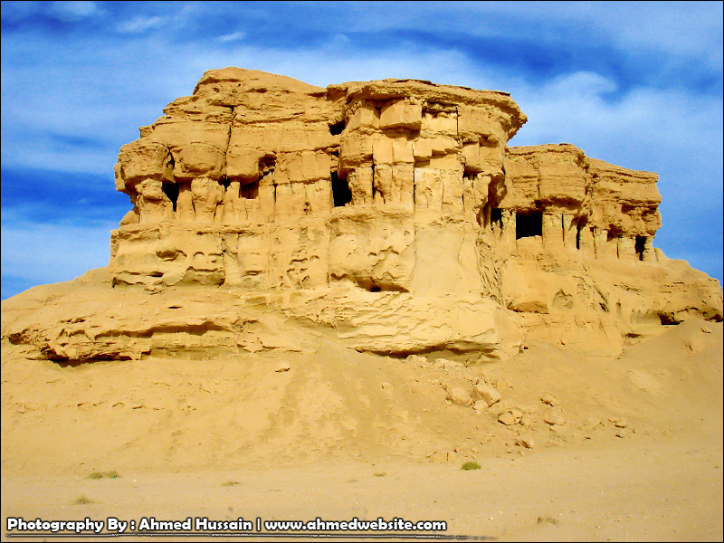

Fig.7: Caving in Tar Al-Say'ed (archeological site)
Note the blocky nature of the exposed rocks

7 CONCLUSIONS
This study achieved the following conclusions:
- The tectonic activities in different parts of Iraq have greatly influenced on lithofacial changes and geographic distribution of many formations and other stratigraphic units, like the Euphrates and Fatha formations.
- The lithofacies of the proper Euphrates Formation; in the type locality at extreme western part of Iraq is completely different from elsewhere; the essential parts and divisions are not present in the majority of the exposed areas.
- The lithofacies of the Fatha Formation in the High Folded and Imbricate Zones are not the same as those in the type locality and in the Low Folded Zone, Al-Jazira Area, and the Mesopotamia Plain.
- The age of the Ghar Formation, most likely extends to the Middle Miocene, as its uppermost part interfingers with the lowermost part of the Nfayil Formation; in the extreme western part of the Western Desert, leading us to believe that it represents an overlapping of the two deltas of Early – Middle Miocene.
- The mapped carbonates in the extreme western parts of Iraq, overlying the Euphrates Formation and underlying the Nfayil Formation represent the Jeribe Formation.
- The clastic sediments along Tar Al-Sayed and Tar Al-Najaf, most probably belong to the Upper Member of the Nfayil Formation and not to the Injana Formation.
- The Govanda Limestone and the overlying clastics are very closely correlated with both members of the Nfayil Formation, both in faunal assemblages and lithofacies.
- The assumed "Undifferentiated Fars Formation" in the extreme northern and northeastern parts of Iraq includes both Fatha and Injana formations, but with their special lithofacial developments.
- Four MFS are present in the Miocene sequence representing four sequence boundaries, three of them are very clear (Ng 10, Ng 30 and Ng 40); indicated by break in sedimentation, whereas the fourth one (Ng 20) is not.

ACKNOWLEDGMENT
The authors would like to express their thanks to Dr. Adnan Aqrawi for reviewing the manuscript and for his constructive notes. They also acknowledge the skilled work of Mrs. Zahra B. Saeed for drawing the figures and maps of this article.

REFERENCES
[1] Sissakian, V.K. and Al-Khalidy, Z.S., 2014. The Chronological Map of Iraq. In: Sissakian and Fouad (2012). The Geological Map of Iraq, scale 1:1000000, 4th edition. Iraq Geological Survey Publications, Baghdad, Iraq.
[2] Jassim, S.Z. and Karim, S.A., 1984. Final report on the regional geological survey of Iraq, Vol.4, Paleogeography. Iraq Geological Survey Library Report no. 1448.
[3] Ma'ala, Kh.A., 1977. Report on the regional geological mapping of Sinjar Area. Iraq Geological Survey Library report no. 860.
[4] Amer, R.M., 1979. Biostratigraphy of Serikagni Formation in Sinjar area, NW Iraq. Iraq Geological Survey Library report no. 806.
[5] Jassim, S.Z., Karim, S.A., Basi, M.A., Al-Mubarak, M. and Munir, J., 1984. Final report on the regional geological survey of Iraq, Vol.3, Stratigraphy. Iraq Geological Survey Library report no. 1447.
[6] Sissakian, V.K. and Fouad, S.F., 2012. Geological Map of Iraq, scale 1: 1000 000, 4th edition. Iraq Geological Survey Publications, Baghdad, Iraq.
[7] Sissakian, V.K. and Al-Jiburi, B.M., 2012. Stratigraphy. In: The geology of the Low Folded Zone. Iraqi Bulletin of Geology and Mining, Special Issue No.5, p. 63 – 132.
[8] Karim, S.A., Sissakian, V.K. and Al-Kubaysi, K.N., 2014. Oligocene – Early Miocene exposed formations in Sinjar Area, NW Iraq. Iraqi Bulletin of Geology and Mining, Vol. 10, No.3, p. 1 – 28.
[9] Khanqa, P.A., Karim, S.A., Sissakian, V.K. and Kareem, K.H., 2009. Lithostratigraphic study of a Late Oligocene – Early Miocene succession, south of Sulaimaniyah, NE Iraq. Iraqi Bulletin of Geology and Mining, Vol.5, No.2, p. 41 – 58.
[10] Kharajiani, S.O., 2014. The presence of the Early and Middle Miocene rocks (Euphrates, Dhiban and Jeribe formations) in Ashdagh Mountain, Sangaw area, Sulaimaniyah vicinity, NE Iraq. Iraqi Bulletin of Geology and Mining, Vol.10., No.1, p. 1 – 20.
[11] Bereggren, W., 2014. Cenozoic Life. Encyclopedia Britannica Article.
[12] Nazik, A., 2004. Planktonic foraminiferal biostratigraphy of the Neogene sequence in the Adana Basin, Turkey and its correlation with standard biozones. Geological Magazine, Vol.141, p. 379 – 387.
[13] Karim, A.S., 1978. Micropaleontology, Biostratigraphy, and Paleoecology of the Serikagni Formation in Jebel Gaulat Area, NW Iraq. M.Sc. Thesis, Queen's University, Kingston, Canada.
[14] Ctyrokey, P. and Karim, A.K., 1971. Stratigraphy and paleontology of the Oligocene and Miocene strata near Anah – Euphrates Valley, West Iraq. Iraq Geological Survey Library report no. 501.
[15] Ctyrokey, P., Karim, S.A. and Vessem, E.J., 1975. Miogypsina and Boralis in the Euphrates Formation in Western Desert of Iraq. Journal of Geology, Paleontology, Abh. 148.1. p. 33 – 49.
[16] Islam Oglu, Y. and Taner, G., 2002. Paleogeography and paleoecology characteristic of the Miocene aged mulluscan fauna in Antalya and Kasaba basin, West Central Taurus, SW Turkey. Mineral Resources Exploration Bulletin, Vol. 126, p. 11 – 42.
[17] Matsumara, K., Sari, B. and Ozer, S., 2010. Larger foraminiferal biostratigraphy on the Middle Tertiary of bay Doglari Autochton Menderes – Taurus Platform, Turkey. Micropaleontology, Vol.56, No.5, p. 439 – 463.
[18] Verrubbi,V. and Schiavinato, F., 2005. Miogypsina globulina (Michilotti) from Samtzai section, Lower Miocene Southern Sardonia. Bull. Della Societa Paleontologica Italiana, Vol. 44(3), p. 203 – 209.
[19] Hasani, M.J. and Vaziri, M.R., 2011. Early Miocene gastropod from Khavich Area, South Sirjan (Kerman, Iran). Biostratigraphy, Paleogeography, Paleontology, Journal of Science. Islamic Republic of Iran. 22c2: p. 125 – 133.
[20] Reuter, M., Piller, W.E., Horzhouser, M.H., Mandic, O., Berning, B., Rogl, F., Kroh, A., Aubry, P., Wielandt, U. and Hamedani, A., 2014. The Oligocene – Miocene Qom Formation (Iran). Evidence for Early Burdigalian restriction of the Tethyan Sea Way, and closure of its Iranian gateway. International Journal of Earth Science, Vol.8, Issue 3, p. 627 – 650.
[21] Jassim, S.Z. and Goff, J.C., 2006. Geology of Iraq. Dolin, Prague and Moravian Museum, Brno 341pp.
[22] I.P.C., 1964. Geological and Production Data. Iraq Geological Survey Library report no. 130.
[23] Al-Mubarak, M.A. and Youkhanna, R.Y., 1976. Report on the regional geological mapping of Al-Fatha – Mosul Area. Iraq Geological Survey Library report no. 753.
[24] Behnam, H.A.M., 1977. Stratigraphy and paleontology of Khanaqin Area, NE Iraq. GEOSURV, int. rep. no. 903.
[25] Amer, R.M., 1977. Micropaleontology and biostratigraphy of Upper Cretaceous – Pliocene rock units in Sinjar area, NW Iraq. Iraq Geological Survey Library report no. 828.
[26] Amer, R.M., 1976. Biostratigraphy and paleontology of subsurface rocks of Al-Nasiriya, Shekhiya, Shawiya and Samawa area. Iraq Geological Survey Library report no. 714.
[27] Abdul Munium, A., 1983. Biostratigraphy of Lower Eocene –Upper Miocene of west Samawa area, Iraq. Iraq Geological Survey Library report no. 1326.
[28] Al-Shwaily, A.Kh., Al-Mosawi, H.A., Al-Saffi, Ibrahim, A.I., Al-Jibouri, B.S., Al-Tamemy, N.M. and Ali, M.A., 2012. Report on the Detailed Geological Mapping of South Al-Najaf Area (First Stage). Iraq Geological Survey Library report no. 3396.
[29] Karim, S.A. and Attia, M., 1992. Facies Model based on organic constituents in the Miocene Sediments, SW Iraq, presented in the geological conference of the College of Science, Dept. of Earth Science., Baghdad University.
[30] Al-Hashimi, H. and Amer, R., 1985. Tertiary Microfacies of Iraq. Iraq Geological Survey Publications, Baghdad, Iraq, 56 pp, 159 plates.
[31] Karim, S.M., Sissakian, V.K. and Mohamed, B.S., 1994. Re-interpretation of the Middle Miocene Sequence, previously named as "Khirish Beds". Iraq Geological Survey Library report no. 2273.
[32] Sissakian, V.K. and Deikran, D.B., 1998. Neotectonic Map of Iraq, scale 1: 1000 000. Iraq Geological Survey Publications, Baghdad, Iraq.
[33] Al-Marsoomy, A.M.H., 2009. Geology of Miocene Gypsum deposition in Northern Iraq. A review. Basrah Journal of Science, Vol.27 (1) p. 17 – 39.
[34] Aqrawi, A.A.M., 1993. Miocene evaporitic sequence of Southern Mesopotamia Basin. Marine and Petroleum Geology, Vol.10, Issue 2.
[35] Sissakian, V.K., Mahdi, A.I., Amin, R.M. and Mohammed, B.S., 1997. The Nfayil Formation. A new lithostratigraphic unit in Iraq. Iraqi Bulletin of Geology and Mining, Vol. 30, No.1.
[36] Fouad, S.F., 2012. Tectonic Map of Iraq, scale 1: 1000 000, 3rd edition. Iraq Geological Survey Publications, Baghdad, Iraq.
[37] Basi, M.A., 1973. Geology of Injana Area, Hamrin South. Unpublished M.Sc. Thesis, Baghdad University.
[38] Al-Jiboury, I.A.A., 2009. The Injana (Upper Fars) Formation of Iraq, insights on Provence History. Arabian Journal of Geoscience, Vol.2, Issue 4, p. 37 – 64.
[39] Sahraeyan, M, Bahrani, M. and Hejazi, Sa. M., 2013. The Aghai Jari Formation (Upper Fars) in the folded Zagros Zone, Iran. Insights to identify facies, architectural elements, fluvial systems, petrography and provenance. ACTA GEOLOGICA SINICA (English version), Vol.87, No.4, p. 1019 – 1031.
[40] Sissakian, V.K. and Fouad, S.F., 2014. Geological Map of Sulaimaniyah Quadrangle, scale 1: 250 000. Iraq Geological Survey Publications, Baghdad, Iraq.
[41] Potter, P.E. and Szelmari, P., 2009. Global Miocene tectonics and Modern World. Elsevier Earth Science Reviews, Vol.96, Issues 4, p. 279 – 295.
[42] Al-Jumaily, R.M., 1974. The Regional geological mapping of the area between Iraqi – Syrian Borders, T₁ Oil pumping station (Western Desert). Iraq Geological Survey Library report no. 653.
[43] Al-Azzawi, A.M.N. and Dawood, R.M., 1996. Report on detailed geological survey in northwest of Kilo 160 – Rutbah area. Iraq Geological Survey Library report no. 2491.
[44] Bellen, R.C. van, Dunnington, H.V., Wetzel, R. and Morton, D., 1959. Lexique Stratigraphic International. Asie, Fasc. 10a, Iraq, Paris
[45] Al-Mubarak, M.A., 1974. Final geological report of upper Euphrates Valley. Iraq Geological Survey Library report no. 677.
[46] Tyracek, J. and Youbert, Y., 1975. Report on the regional geological survey of Western Desert between T₁ Oil pumping station and wadi Hauran. Iraq Geological Survey Library report no. 673.
[47] Hamza, N.M., 1975. Regional geological mapping of Al-Tharthar – Hit – Qasr Al-Khubaz area. Iraq Geological Survey Library report no. 678.
[48] Al-Mubarak, M. and Amin, R.M., 1983. Report on the regional gological mapping of the eastern part of the Western Desert and western part of the Southern Desert. Iraq Geological Survey Library report no. 1380.
[49] Tawfiq, J.M. and Domas, J., 1977. Report on the regional geological mapping of Duhok – Ain Zala Area. Iraq Geological Survey Library report no. 837.
[50] Mohi Ad-Din, R.M., Sissakian, V.K., Yousif, N.S., Amin, R.M. and Rofa, S.H., 1977. Report on the regional geological mapping of Mosul – Tel Afar Area. Iraq Geological Survey Library report no. 831.
[51] Hagopian, D.H., Abdul Lateef, A. and Barwary, A.M., 1982. Report on the regional geological mapping of Ain Sifni – Amadiya Area. Iraq Geological Survey Library report no. 1379.
[52] Hagopian, D.H. and Veljupek, M., 1977. Report on the regional geological mapping of Mosul – Arbil Area. Iraq Geological Survey Library report no. 843.
[53] Al-Sammarai, A.I. and Al-Mubarak, M.A., 1978. Report on the regional geological mapping of Makhmour – Kirkuk Area. Iraq Geological Survey Library report no. 905.
[54] Barwary, A.M., 1983. Report on the regional geological survey of Khazir – Gomel Area. Iraq Geological Survey Library report no. 1137.
[55] Youkhanna, R.Y. and Hradecky, P., 1978. Report on regional geological mapping of Khanaqin – Maidan Area. Iraq Geological Survey Library report no. 903.
[56] Sissakian, V.K. and Youkhanna, R.Y., 1979. Report on the regional geological mapping of Erbil – Shaqlawa – Koi Sanjaq – Raidar Area. Iraq Geological Survey Library report no. 975.
[57] Sharland, P.R., Archer, R., Casey, D.M., Hall, S.H., Heward, A.P., Horbury, A.D. and Simmons, M.D., 2001. Arabian Plate Sequence Stratigraphy. GeoArabia, Special Publication 2, Gulf Petrolink, Bahrain, 371pp.
[58] Bryant, I.D., 1996. The Application of Physical Measurements to Constrain Reservoir-Scale Sequence Stratigraphic Models. In: Howell, J.A. and Aitken, J.F (Editors). High Resolution Sequence Stratigraphy: Innovations and Applications. Geology Society Special Publication 104, p. 51 – 64.
[59] Aqrawi, A.A.M., Goff, J.C., Horbury, A.D. and Sadooni, F.N., 2010. The Petroleum Geology of Iraq. Scientific Press Ltd., UK. ISBN 978-0-901360-36-8
[60] Octavian, C., 2003. Sequence stratigraphy of clastic systems. St. John's Nfld.: Geological Association of Canada. ISBN 0-919216-90-0.
[61] Sissakian, V.K., 1978. Report on the regional geological mapping of Tuz Khurmatu – Kifri – Kalar Area. Iraq Geological Survey Library report no. 902.
[62] Ajar, Dh.k., Yousif, L.D., Zaini, M.T., Al-Shawi, S.H., Kadhum, M.A.A., Al-Kubaisi, K.N., Mohammad, R.A., Ali, M.A., Kamber, A.S. and Rahaimah, R.H., 2011. Detailed geological mapping of south Samawa region. Iraq Geological Survey Library report no. 3335.
[63] Ajar, D.K., Yousif, L.D., Mohammed, A.A., Basher, W.P., Al-Kubaysi, K.N., Ali, M.A., Mustafa, A.F., Ahmed, B.A., 2012. Geological mapping scale 1: 25 000 of south Samawa region, Second stage. Iraq Geological Survey Library report no. 3406.
[64] Al-Safi, I.K., Al-Shwaily, A.Kh. and Al-Mosawi, H.A., 2012. Report on the Detailed Geological Mapping of South Al-Najaf Area (Second Stage). Iraq Geological Survey Library report no. 3379.
[65] Zaini, M.T., Al-Shawi, S.H., Basher, W.P., Al-Kubaysi, K.N., Rahaimah, R.H., Al-Hmeedawy,F.Z., Al-Boori, A., Al-Samarraie, B.A., Al-Mousa, H., Al-Obaidy, R.A., and Qaubar, A.Sh., 2014. Report on the Geological Mapping of South Al-Nasiriyah Area (First Stage). Iraq Geological Survey Library report no. 3483.
[66] Ibrahim, Sh.B., 1984. Report on photo geological mapping of a part of Folded Zone in northeast Iraq. Iraq Geological Survey Library report no. 1379.
[67] Sissakian, V.K., 2000. Geological Map of Iraq, scale 1:1000000, 3rd edit. Iraq Geological Survey Publications, Baghdad, Iraq.
[68] Ibrahim, Sh.B. and Sissakian, V.K., 1975. Report on the Rawa – Baiji – Tikrit – Al-Baghdadi Area. Iraq Geological Survey Library report no. 675.
[69] Mahdi, A.B., Sissakian, V.K., Amin, R.M. and Mohammed, B.S., 1985. Geological report on the Hadith Project, Part I, Geology. Iraq Geological Survey Library report no. 1523
[70] Fouad, S.F., Al-Marsoumi, A.M., Said, F.S., Hassan, F.A. and Nanno, H.O., 1986. Detailed geological survey of Anah area. Iraq Geological Survey Library report no. 1527.
[71] Bolton, C.M.G., 1954a. Report on reconnaissance examination of Euphrates Valley. Iraq Geological Survey Library report no. 263.
[72] Fouad, S.F., 2007. Tectonic Evolution of the Western Desert In: The geology of the Western Desert. Iraqi Bulletin of Geology and Mining, Special Issue No.1, p. 29 – 50.
[73] Fouad, S.F. and Sissakian, V.K., 2013. Paleo-seismicity along Anah – Abu Jir Fault System, inferred from soft sediments deformation features in the uppermost part of the Euphrates Formation (Early Miocene), West Iraq. Proceedings of the Geological Conference of Iraq Geological Survey, 12 – 14/ 12/ 2013, Baghdad, Iraq.
[74] Sissakian, V.K., Fouad, S.F., Al-Ansari, N. and N. Knutsson, 2014. Deformational Style of the Soft Sediment (SEISMITES) within the Uppermost Part of the Euphrates Formation, Journal of Earth Sciences and Geotechnical Engineering, Vol. 4, No. 4, 201, 4, p. 71 – 86, ISSN: 1792-9040 (print), 1792 - 9660 (online) Science Press Ltd, 2014.
[75] Jassim, S.Z., Hagopian, D.H. and Al-Hashimi, H.A., 1986. Geological Map of Iraq, scale 1:1000000. Iraq Geological Survey Publications, Baghdad, Iraq.
[76] Jassim, S.Z., Hagopian, D.H. and Al-Hashimi, H.A., 1990. Geological Map of Iraq, scale 1:1000000, 2nd edition. Iraq Geological Survey Publications, Baghdad, Iraq.
[77] Bolton, C.M.G., 1960. Geological map of Iraq, scale 1: 1000000. Government of Iraq, Johannesburg, South Africa.
[78] Fouad, S.F.A., 1997. Tectonic and structural evolution of Anah Region, West Iraq. Unpublished Ph.D. Thesis. University of Baghdad.
[79] Fouad, S.F.A. and Nasir, W.A., 2009. Tectonic and structural evolution of Al-Jazira Area. In: Geology of the Iraqi Jazira Area. Iraqi Bulletin of Geology and Mining, Special Issue, No.3, p. 33 – 48.
[80] Maltman, A., 1984. On the term "Soft-sediment deformation". Journal of Structural Geology, Vol.6, No.5, p. 589 – 592.
[81] Berra, F. and Felletti, F., 2011. Syndepositional tectonics recorded by soft-sediment deformation and liquefaction structures (continental Lower Permian sediments, Southern Alps, Northern Italy): Stratigraphic significance, Sedimentology, Vol. 235, No.3 – 4, p. 249 – 263.
[82] Djomeni, A.L., Ntamak-Nida, M.J., Owono, F.M., Kwetche, P.G.F., Kissaaka, J.B.I. and Enougui, N., 2011. Soft-sediment deformation structures in Mid-Cretaceous to Mid-Tertiary deposits, Central East of the Douala sub-basin, Cameroon: Preliminary results of the tectonic control. Syllabus Review, Vol.2, No. 3, p. 92 – 105.
[83] Sissakian, V.K. and Mohammed, B.M., 2007. Stratigraphy. In: The geology of the Western Desert. Iraqi Bulletin of Geology and Mining, Special Issue No.1, p. 51 – 124.
[84] Sissakian, V.K. and Al-Jiburi, B.M., 2014. Stratigraphy. In: The geology of the High Folded Zone. Iraqi Bulletin of Geology and Mining, Special Issue No.6, p. 73 – 162.
[85] Panikarov, V.P., Kazmin, V.G., Mikhailov, I.A., Razvaliayev, A.V., Krasheninikov, V.A., Kozlov, V.V., Soulidi – Kondratiyev, E.D., Mikhailov, K.Ya, Kylakov, V.V., Faradzhev, V.A. and Mirzayev, K.M., 1967. The Geology of Syria, scale 1: 500 000. Technoexport, USSR.
[86] Prazak, J. 1978. The Development of the Mesopotamian Basin during the Miocene. Journal of Geological Society of Iraq, Vol.XI, p. 170 – 189.
[87] Salman, B., 1993. Revision of the Zahra Formation. GEOSURV, int. rep. no. 2199.
[88] Ashley, G., 1990. Classification of Large-Scale Subaqueous Bedforms: A New Look At An Old Problem. Journal of Sedimentary Petrology, Vol. 60, No.1, p. 160 – 172.
[89] Swinchat, J.P., 2006. Formation of large-scale cross-bedding in a carbonate unit. Sedimentology, Vol.8, No.2, p. 93 – 120.
[90] Bolton, C.M.G., 1954 b. Geological Map of Kurdistan Series, scale 1:100 000, sheet K5, Chwarta. GEOSURV, int. rep. no. 277.
[91] Tucker, S. and Shawket, M., 1980. The Miocene Gachsaran Formation of the Mesopotamian Basin, Iraq. Sabkha cycles and depositional controls. Journal of Geological Society of Iraq, Vol.13, p. 261 – 267.
[92] McCarthy, M,J., 1955. Final report on geology between Zab and Khabour and rivers. Iraq Geological Survey Library report no. 266.
[93] McCarthy, M,J., 1956. Geology of Penjwin area. Iraq Geological Survey Library report no. 269.
[95] Hall, P.K., 1956. The Geology of the Baibu area, east of Amadiya. Iraq Geological Survey Library report no. 269.
[96] Hall, P.K., 1957. The Geology of Raikan and Zaibar area. Iraq Geological Survey Library report no. 270
[97] Hall, P.K., 1958. Geological Map of Kurdistan Series, scale 1:100000, K2, Amadiya. Iraq Geological Survey Library report no. 274.
[98] McCarthy, M.J., Smith, J.S. and Hall, P.K., 1958. Geological Map of Kurdistan Series, scale 1:100000, K1, Zakho. Iraq Geological Survey Library report no. 273.
[99] Bolton, C.M.G., 1958a. Geological Map of Kurdistan Series, scale 1:100000, K4, Rania. Iraq Geological Survey Library report no. 276.
[100] Bolton, C.M.G., 1958b. Geological Map of Kurdistan Series, scale 1:100000, K5, Chwarta. Iraq Geological Survey Library report no. 277.
[101] Bolton, C.M.G., 1958c. Geological Map of Kurdistan Series, scale 1:100000, K6, Halabcha. Iraq Geological Survey Library report no. 278.
[102] Bolton, C.M.G, 1958d. The Geology of Ranya area. Iraq Geological Survey Library report no. 271.
[103] Stevenson, P.C. and Cobbett, P.G.R., 1958. Geological Map of Kurdistan Series, scale 1:100000, K3, Merga Sur. Iraq Geological Survey Library report no. 275.
[104] Cobbett, G.P.R., 1957. Geological Map of Kani Rash area. Iraq Geological Survey Library report no. 270.
[105] Buday, T., 1980. The Regional Geology of Iraq. Vol.1, Stratigraphy and Paleogeography. In: I.I., Kassab and S.Z., Jassim (Eds.). Iraq Geological Survey Publications, Baghdad, Iraq, 445 pp.
[106] Fouad, S.F. and Sissakian, V.K., 2011. In: The geology of the Mesopotamia Plain. Iraqi Bulletin of Geology and Mining, Special Issue No.4, p. 33 – 46.

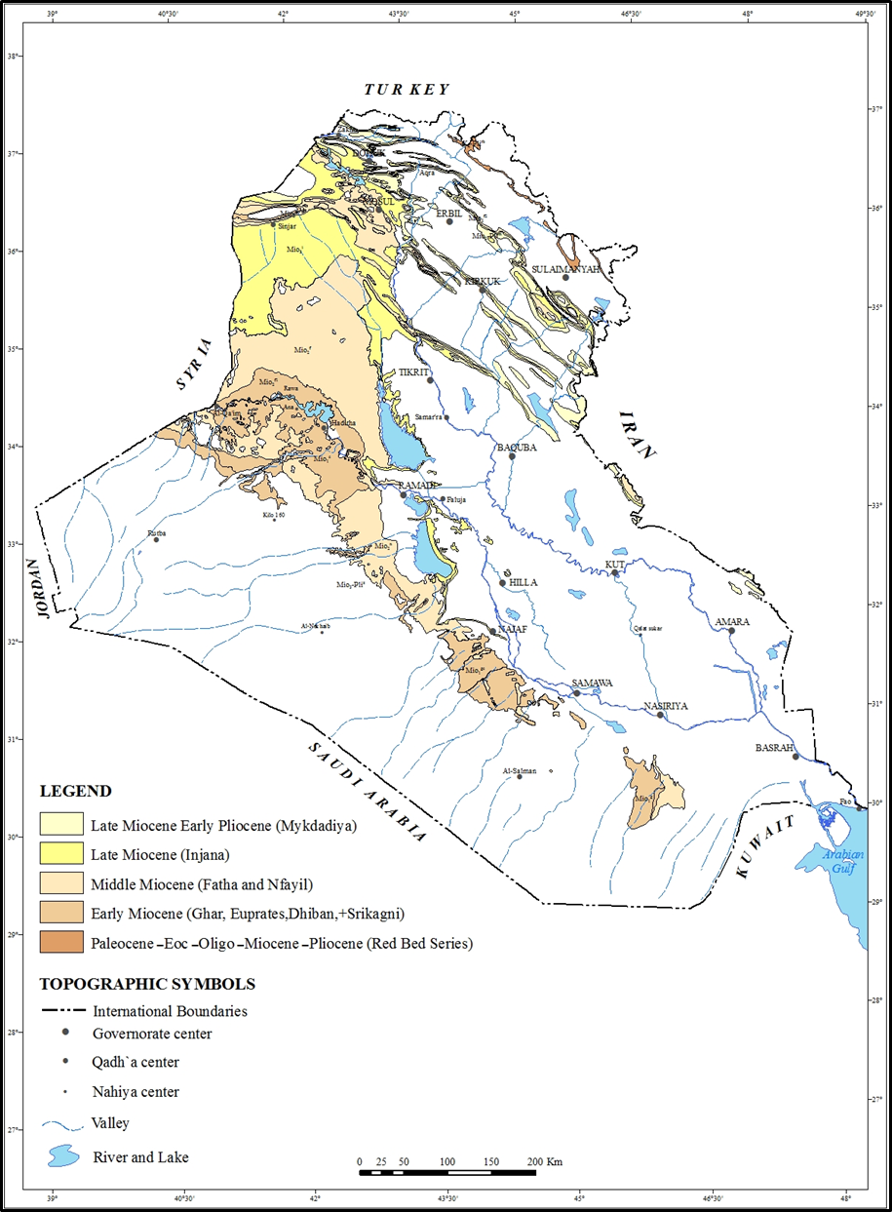

2 Geological Setting
The geological setting of the studied area is briefed as:

  - Geomorphology
The developed geomorphological units and existing features in the studied area are mentioned hereinafter and represented in generalized geomorphological map (Fig.2), based mainly on Ma'ala [12]. Those which are directly involved with the aim of this study are briefly described.

- Units of Structural – Denudational Origin: Two units are developed, these are: Plateau and Dissected Slopes.

- Units of Denudational Origin: Four units are developed, they are: Pediment, Badlands, Erosional Plains, and Mesas and Buttes.

- Units of Solutional Origin: Two units are well developed, these are: Sinkholes and Salt Marshes.

- Units of Fluvial Origin: Four units are developed, these are:

River Terraces: These are well developed along Wadi Al-Ajeej, in 3 levels: (15 – 25) m, (30 – 40) m and (50 – 60) m; above the present valley floor, respectively [16]. The fourth stage might be developed in the Syrian territory, as seen in the Google Earth and Satellite images.

Infilled Valleys: Many ephemeral valleys are potential areas for flooding during heavy rain showers and form parts of Wadi Al-Ajeej.

Depressions Fill Sediments: Several closed depressions are filled by brown and black muddy sediments rich by SO₄, underlying the salt crust, such as Snaisla, Ashqar, Geziz, Umm Dhiaba, Gat'tar Salt Marshes. Some of them have direct relation with Wadi Al-Ajeej.

Alluvial Fans: Gravel accumulations were recognized at the foot of Snaisla – Tel Abta Cliff. These accumulations are most probably relict sediments of ancient alluvial fans [12]. They might be originated from the old Jagh Jagh River.

- Units of Evaporation Origin: Three units are developed, these are:

Calcrete: Calcrete, covers the southwestern part of the extreme northern part of the studied area by uniform and compacted blanket of calcareous material, range in thickness between (0.25 – 0.5) m.

Gypcrete: The gypcrete covers many parts in the studied area, top of hills and mesas and partly their slopes, as well along the rims of salt marshes.

Halcrete: Halcrete is developed in salt marshes. It consists of light brown and black muddy sediments overlain by thin crust of NaCl (Halite) with crystals of gypsum (Tobbia, 1996, in [12]).

The first two units indicate wet climate, with presence of old streams and valleys.
- Forms of Aeolian Origin: The following two forms are developed:

Sand Dunes and Nebkhas.

- Form of Anthropogenic Origin: Only some Anthropogenic Hills are present in the studied area.

  - Stratigraphy
The exposed formations in the near surroundings of Wadi Al-Ajeej are the Fatha and Injana formations, based mainly on Hassan and Hassan [6]. They are briefly described hereinafter.

- Fatha Formation (Middle Miocene): This formation is exposed widely in the southern part of the studied area. It is well developed in cyclic nature succession; each cycle consists of marl, red claystone, limestone and gypsum.

- Injana Formation (Late Miocene): This formation is exposed widely in the studied area, covering almost the course of Wadi Al-Ajeej. The Injana Formation consists of rhythmic fining upward cycles, each cycle consists of reddish brown and grey sandstone, siltstone and claystone, thin horizon of oolitic limestones occurs too in the lowermost part of the formation [16].
- Quaternary Sediments: Terraces, depression fill and valley fill sediments; alluvial fans, gypcrete and sabkha are the main types of sediments, developed in different parts of the studied area.

3.3 Structure and Tectonics
The studied area is located within the Outer Platform of the Arabian Plate; Al-Jazira Zone, part of the Mesopotamia Foredeep. It is dominated by a network of subsurface extensional structures. These structures are mainly ENE – WSW and NW – SE trending grabens and normal faults [17].

From neotectonic point of view, Sissakian and Deikran [18] showed that the Jazira Area is uplifted with amount of (200 – 250) m, with estimated rate of uplift to be (0.1 – 0.2) cm/ 100 years.

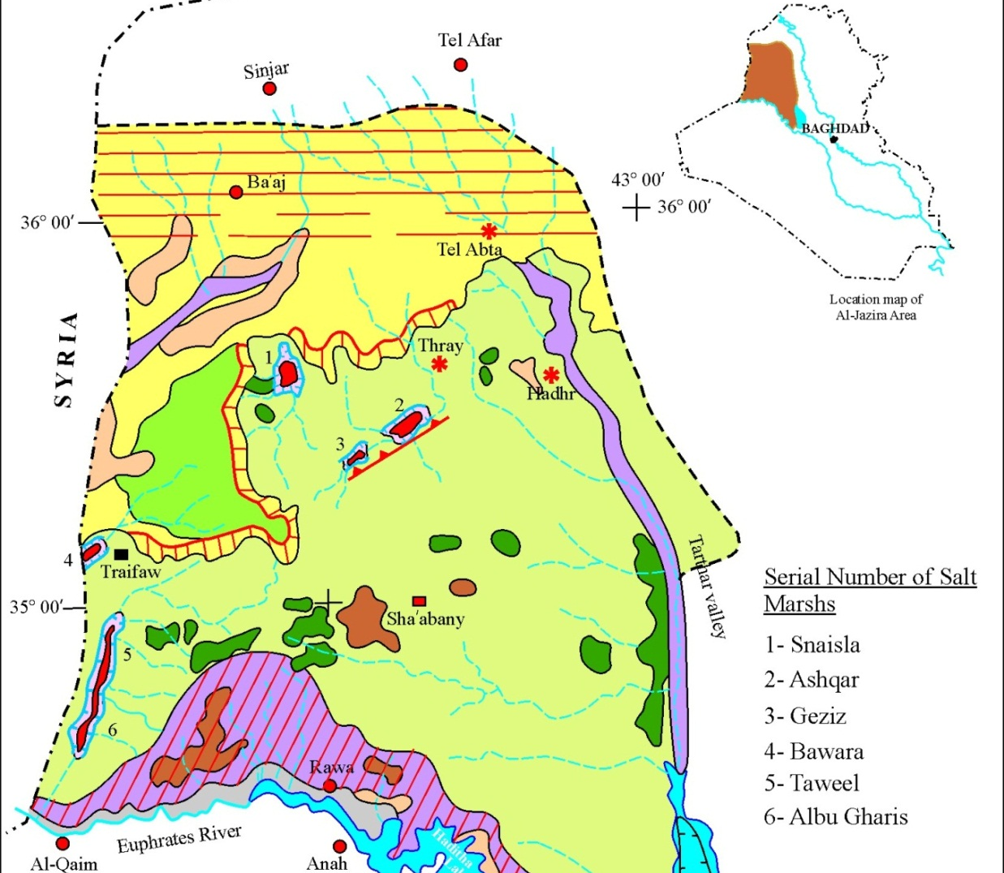
20 Km

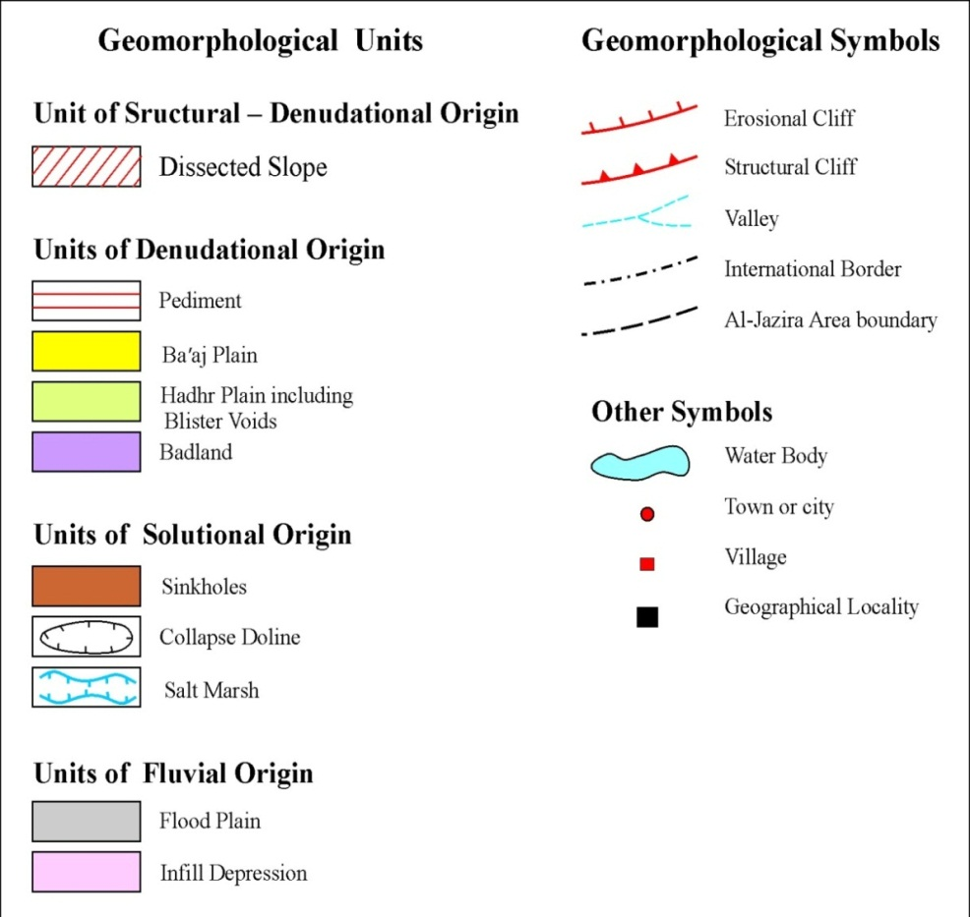

Fig.2: Geomorphological Map of Al-Jazira Area (after [12])

- Wadi Al-Ajeej
Wadi Al-Ajeej is one of the main valleys in the Jazira Area (Plain), its length ia about 35 Km as measured from the Iraqi –Syrian border; upstream until the point where it starts gathering its main branches. It extends in ENE – WSW trend; almost in a straight line (point A in Fig.3). The main branches are of two main trends N – S and NNW – SSE, the length of these branches ranges from 30 to 55 Km. The nowadays branches are flowing from the southern flank of Sinjar Mountain, they are divided into two main trends, generally east and west of the Longitude 41ᴼ 40'. However, the old course of the ancient Jagh Jagh River can still be faintly traced where it was crossing Sinjar Mountain (left of the point B in Fig.3) before abandoning its ancient course, almost parallel to the Iraqi – Syrian international border and near the small pond, which still can be observed (Point P in Fig.3).

Three terrace levels are present along Wadi Al-Ajeej [16], beside other two levels on the top of Sinjar Mountain, where the ancient Jagh Jagh River was crossing the mountain; as evidenced in Fig (3). However, tectonic forces and growing of Sinjar anticline and other small anticlines; inside Syria, have shifted the main course of Jagh Jagh River and separated it into two parts, the southern one is called Wadi Al-Ajeej.

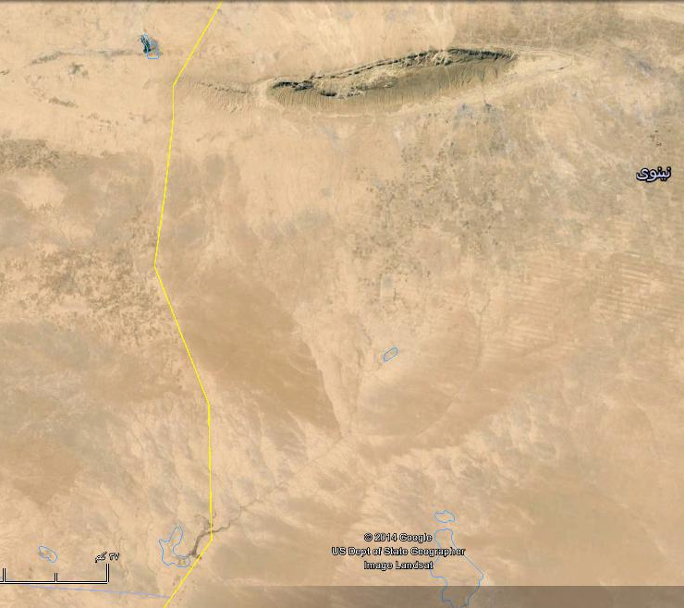
P
Syria
Iraq
B
E
A
D
C

Fig.3: Google Erth image of Wadi Al-Ajeej.
A) Represnts the gathering point of the branches,
B) Represnts the old crossing point of Jagh Jagh River to Sinjar Mountain
C – D – E) Erosional cliff, P is a small pond

The main trend of the nowadays Wadi Al-Ajeej is ENE – WSW, which is the main trend of grabens and normal Faults (Fig.4) [14]. Most probably it runs following the trace of a subsurface structure, which is located between Khlesia Graben and Tel Hajar subsurface anticline, although not recognized and presented in Fig.(4). Moreover, it is parallel to the well developed two lineaments that bound Ashqar Salt Marsh, which is believed to be formed due to subsidence of a graben associated with karstification [11].

5 Discussions
The origin and evolution of Wadi Al-Ajeej is discussed in details, based on geological and historical evidences, hereinafter.
  - Geological Evidences
The following geological evidences are used to indicate the origin and evolution of Wadi Al-Ajeej.

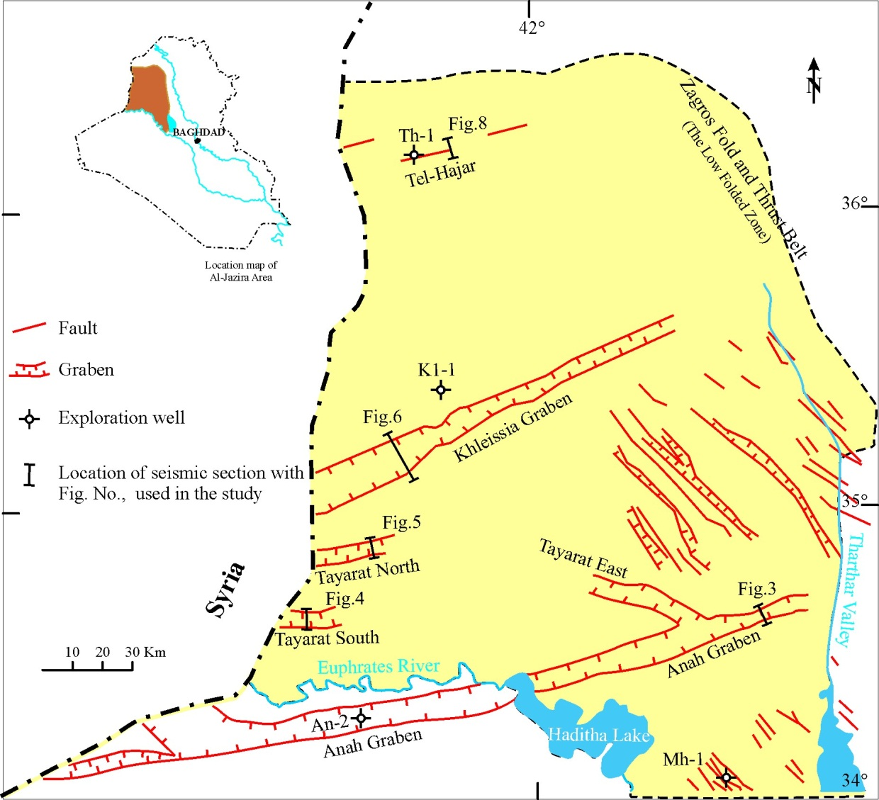

Fig.4: Structural map showing the subsurface extensional structures of Al-Jazira Area (after [14]).

- River Terraces: Along the present course of Wadi Al-Ajeej, Ma'ala [12] recognized three levels of river terraces, they are (15 – 25) m, (30 – 40) m and (50 – 60) m; above the present valley floor, respectively. They are composed mainly of limestone and chert gravels. The gravels are mainly rounded to sub-rounded. A valley with the same size and order of the present day Wadi Al-Ajeej is incapable of depositing three levels of river terraces, with the above mentioned attitudes. Moreover, Ma'ala [12] mentioned that a fourth level may be present inside Syria.

In this research however, two higher (older) levels on the top of Sinjar Mountain, where the ancient Jagh Jagh River was crossing the mountain (Point A in Fig.5) were recognised, beside the presence of a lower level along the line B – C – D (Fig.5). If not so, then how the terraces are present at those localities; on the top of the mountain. Therefore, the only explanation for the presence of the terraces is that the presence of a river capable in incising its course and depositing terraces, continuously.

- Alluvial Fans: Alluvial fans are well developed along both northern and southern limbs of Sinjar anticline, especially the northern limb, where Sissakian [19] had recognized four stages of alluvial fans and two stages along the southern limb. When inspecting thoroughly Google Earth and satellite images where the ancient Jagh Jagh River was crossing, no alluvial fans can be observed at both limbs of Sinjar anticline, (Fig.6), because there was a river course flowing from NNW – SSE and crossing the mountain. Therefore, the drainage system and the gradient were not favorable for development of alluvial fans on both limbs of the anticline.
─ Growth of Folds: The ancient Jagh Jagh River was crossing Sinjar anticline and was flowing southeast wards relative to the course of the present day Wadi Al-Ajeej. The crossing was through a water gap developed where the closure of the Fatha Formation occurs parallel to the western plunge of Sinjar anticline (Fig.7). However, the water gap was abandoned due to the growth of Sinjar anticline and another small anticline, which is north of Sinjar abticline (point A in Fig.7), besides the climatic changes during Pleistocene. The growth of Sinjar anticline is confirmed by Sissakian [19] and Ma'la [20], the latter proved the growth depending on the presence of four stages of alluvial fans along the northern limb of Sinjar anticline. Moreover, Fouad and Nasir [14] also confirmed the growth of Sinjar anticline. Abandoning of water gaps due to lateral and vertical growth of anticlines are a well know process worldwide [21, 22]. It is worth to mention that the abandoned water gap should form a wind gap, in Sinjar anticline, even the wind gap is almost vanished due to continuous growth of the anticline.
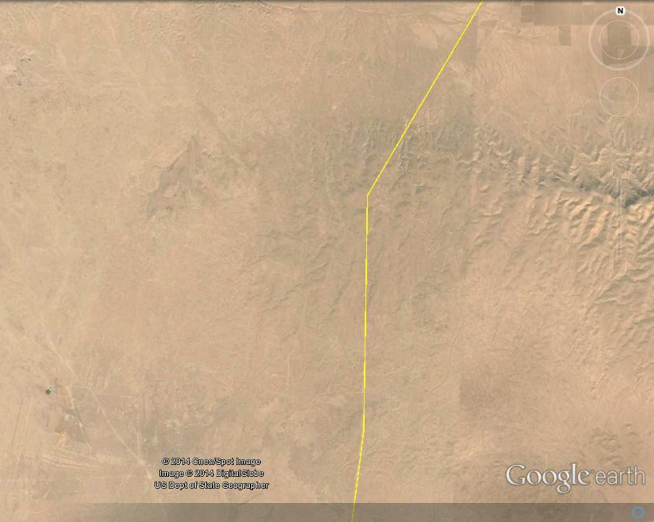
A
D
C
B

Fig. 5: Google Earth image. Two terrace levels (Dark toned patches)
at A and B. Note the scattered terraces south of the point B, along C and D

A
B

Fig.6: Google Earth image of Sinjar anticline.
Note the dens net of alluvial fans inside Iraq and their absence near points A and B

The Jagh Jagh River, after abandoning its course across Sinjar anticline, changed its course towards E – W and merged in Khabour River (of Syria), which in turn merges into the Euphrates River; inside Syria. The southern part of the abandoned river; south of Sinjar anticline; called Wadi Al-Ajeej had also truncated due to the continuous growth of Khlesia High, consequently a new course was followed in ENE – WSW trend. This trend is the main trend of the subsurface structures in Al-Ajazira Area [14]. The growth of of the Khlesia High is confirmed by the presence of a long crescent-shaped erosional cliff and the developed depressions, which have formed salt marshes (Figs.2, 3 and 8).

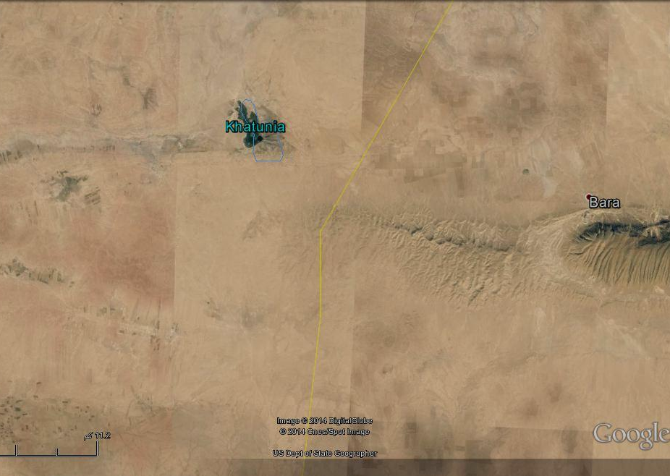
B
A

Fig.7: Google Earth image of Sinjar anticline.
A) Small growing anticline, B) Closure area of the Fatha Formation

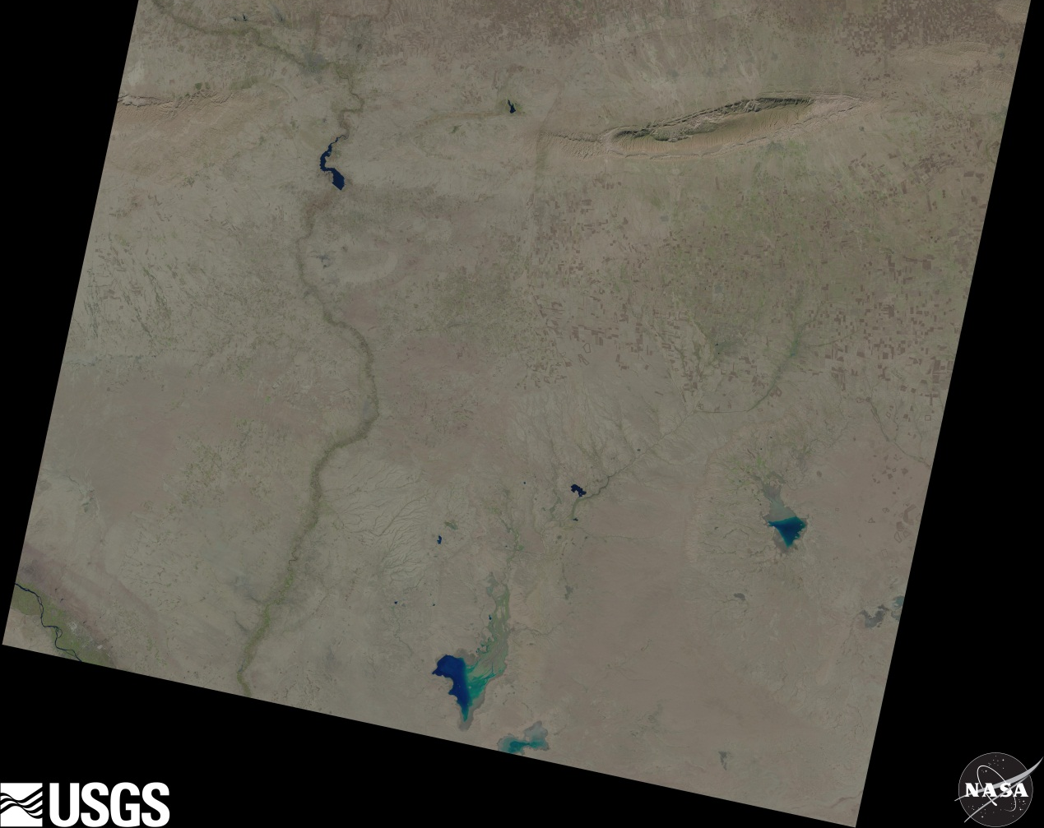
A
B
C

Fig.8: Landsat image of Wadi Al-Ajeej showing it's nowadays course.
Note the erosional cliff (A, B and C); developed due to the Khlesia High

  - Hydrogeological Evidence
Beside the present drainage system and the developed terrace system, the presence of a small and longitudinal water pond; called Kahtuniya (Figs.7 and 8) indicates the presence of old Jagh Jagh River, otherwise how the water pond was formed with extension that is parallel to the abandoned river.

  - Historical Evidences
The upper reaches of the Jagh Jagh River is in Turkey with length of 124 Km; only 100 Km is running in Syria, joining the Khabour River of Syria. It was called "Mekdonyous" by the Romans and as "Al-Harmas" by the Arabs, while the name Jagh Jagh is a Turkish term meaning a net (Internet data).

Sossa [1] pointed out that Jagh Jagh River was well headed from south of Turkey, which was crossing through the western side of Sinjar mountain and running toward south, along the Iraqi – Syrian border, to supply many sabkhas, named: Bawara, Taweel and Albu Gharis (in Iraq) and Rawdha and Qsair (in Syria), then merging into the Euphrates River (north of Al-Qaim vicinity). The Jagh Jagh River was characterized by natural formation of elongated small swamps or lakes, which were developed along middle part and downstream (Fig.2), when the river was running southwards. Later on, the river was dried, in late Holocene, due to influence of neotectonic activity in Sinjar mountain [23], which caused the development of dry marshes or small lakes. As well, because of the high evaporation, the depressions and/ or small lakes became sabkhas or salt marshes.

- Dating
To estimate the dating of the Wadi Al-Ajeej and when it was separated from Jagh Jagh River, historical data and geological data; exposure dating method [21] were used. The occurrence of three terrace levels along the course of Wadi Al-Ajeej [12] is clear indication that Wadi Al-Ajeej was not separated from Jagh Jagh River during the whole Pleistocene, because the youngest stage is estimated to be of Late Pleistocene [12]. Therefore, the separation should be after the Late Pleistocene; consequently, we estimate that the separation was during late Holocene and younger, since some historians mentioned that Jagh Jagh River was crossing Sinjar Mountain and flowing southeastward parallel to Tharthar Valley [24]. The authors also estimated the change of Wadi Al-Ajeej towards ENE – WSW was almost at the same duration; when Wadi Al-Ajeej was separated from Jagh Jagh River. This assumption is based on the same continuous tectonic events in the involved vicinity; including growth of Sinjar anticline, the small domal anticline located north of Sinjar; inside Syria, the growth of Khlesia High, and the development of the depressions of the salt marshes in the vicinity.

- Conclusions
The following could be concluded from this study:
- Wadi Al-Ajeej was a part of the Jagh Jagh River, which was crossing Sinjar anticline, about 13 Km west of the Iraqi – Syrian nowadays borders, along the plunge of the Fatha Formation.
- Two terrace levels were recognized on the top of Sinjar anticline, at the crossing area, beside three levels along the present day of Wadi Al-Ajeej course.
- No alluvial fans developed on both sides of Sinjar anticline, near the old crossing area, in contrary of tens of alluvial fans east of the old crossing area and on both limbs.
- The Jagh Jagh River was crossing Sinjar anticline through a water gap, which was abandoned due to lateral and vertical growth of the anticline, beside climatic changes.
- The old course of the Jagh Jagh River; across Sinjar anticline can still be traced faintly in Google Earth and Satellite images.
- The main trend of Wadi Al-Ajeej was NW – SE, but was changed to ENE – WSW due to the Khlesia High, and following most probably a subsurface graben, which are very common in the Jazira Area.
- The separation of Wadi Al-Ajeej from Jagh Jagh River was during late Holocen and younger.

ACKNOWLEDGMENT
The authors express their thanks to Mr. Arsalan Othman for providing the Landsat image of the studied area and Mr. Hayder H.Taha (both from Iraq Geological Survey, Baghdad) for arranging the figures in the text and pointing the required marks on them.

REFERENCES

[1] Soosa, A., 1965. Floods of Baghdad in History, Vol.1, 3rd edit. Al-Adeeb Press, Baghdad, Iraq (in Arabic).
[2] Al-Sakini, J.A., 1993. New Look on the History of the Old Tigris and Euphrates Rivers, in Light of Geological Evidences, Recent Archeological Discoveries and Historical Sources. Ministry of Oil, Iraq (in Arabic).
[3] Zuwaid, Q.A., 1988. The Geology of Al-Qayara Quadrangle, sheet NI-38-5, scale 1: 250 000. Publications of Iraq Geological Survey, Baghdad, Iraq.
[4] Sissakian, V.K. and Hafidh, Sh.Q., 1993. The Geology of Haditha Quadrangle, sheet No. NI-37-7, scale 1: 250 000. Publications of Iraq Geological Survey, Baghdad, Iraq.
[5] Sissakian, V.K. and Hafidh, Sh.Q., 1995. The Geology of Wadi Al-Miyah and Albu Kamal Quadrangles, sheets No. NI-37-7 and NI-37-8, scale 1: 250 000. Publications of Iraq Geological Survey, Baghdad, Iraq.
[6] Hassan, K.M. and Hassan, E.A., 1994. The Geology of Sur Quadrangle, sheet No. NI-38-4, scale 1: 250 000. Publications of Iraq Geological Survey, Baghdad, Iraq.
[7] Sissakian, V.K. and Ibrahim, F.A., 2005. Geological Hazards Map of Iraq, scale 1: 1000 000. Publications of Iraq Geological Survey, Baghdad, Iraq.
[8] Sissakian, V.K., Ibrahim, F.A. and Sa'ed, Z.B., 2006. Geological Hazards Map of Haditha Quadrangle, scale 1: 250 000, sheet No. NI-38-5. Iraq Geological Survey Library report no. 2993.
[9] Sissakian, V.K., Abdul Ahed, I.D. and Ibrahim, F.A., 2007. Geological Hazards Map of Al-Ramdi Quadrangle, scale 1: 250 000, sheet No. NI-38-9. Iraq Geological Survey Library report no. 3031.
[10] Sissakian, V.K. and Al-Mousawi, H.A., 2007. Karstification and Related Problems, Examples from Iraq. Iraqi Bulletin of Geology and Mining (ISSN- 1811.4539), Vol. 3, No. 2, p. 1 – 12.
[11] Sissakian, V.K., and Abdul Jabbar, M.F., 2009. Remote Sensing and GIS Applications in Detecting Geohazards in the Jazira Area, West Iraq. Iraqi Bulletin of Geology and Mining (ISSN- 1811.4539), Vol. 5, No. 1, p. 47 – 62.
[12] Ma'ala, K.A., 2009. Geomorphology. In: Geology of the Iraqi Jazira Area. Iraqi Bulletin of Geology and Mining (ISSN- 1811.4539), Special Issue, No. 3, p. 5 – 31.
[13] Ma'ala, K.A., and Al-Kubaysi, 2009. Stratigraphy, In: Geology of the Iraqi Jazira Area. Iraqi Bulletin of Geology and Mining (ISSN- 1811.4539), Special Issue, No. 3, p. 49 – 70.
[14] Fouad, S.F.A. and Nasir, W.A., 2009. Tectonic and structural evolution of Al-Jazira Area. In: Geology of the Iraqi Jazira Area. Iraqi Bulletin of Geology and Mining (ISSN- 1811.4539), Special Issue, No. 3, p. 33 – 48.
[15] Sissakian, V.K. and Fouad, S.F., 2012. Geological Map of Iraq, scale 1: 1000 000, 4th edit. Publications of Iraq Geological Survey, Baghdad, Iraq.
[16] Ma'ala, K.A., 1976. Report on the Regional Geological Mapping of Hadhr Area. Iraq Geological Survey Library report no. 742.
[17] Fouad, S.F.A., 2012. Tectonic Map of Iraq, scale 1: 1000 000, 3rd edit. Publications of Iraq Geological Survey, Baghdad, Iraq.
[18] Sissakian, V.K. and Deikran, D.B., 1998. Neotectonic Map of Iraq, scale 1: 1000 000. Publications of Iraq Geological Survey, Baghdad, Iraq.
[19] Sissakian, V.K., 2011. Alluvial fans of Sinjar Mountain, northwest Iraq. Iraqi Bulletin of Geology and Mining (ISSN- 1811.4539), Vol. 7, No. 2, p. 9 – 26.
[20] Ma'ala, K.A., 1977. Report on the Regional Geological Mapping of Sinjar Area. Iraq Geological Survey Library report no. 860.
[21] Keller, E.A. and Pinter, N., 2002. Active Tectonics, Earthquakes, Uplift and Landscape, 2nd edit. Prentice Hall, 362 pp.
[22] Ramsey, L.A., Walker, R.T. and Jackson, J., 2008. Fold Evolution and Drainage Development in the Zagros Mountains of Fars Province, SE Iran. Basin Research, Vol. 20, p. 23 – 48.
[23] Mitchell, R.C., 1957. Recent Tectonic Movements in the Mesopotamian Plain. Geographical Jour. Vol.CXXII.

[24] Soosa, A., 1966. Floods of Baghdad in History, Vol.3. Al-Adeeb Press, Baghdad, Iraq (in Arabic).

Consultant Geologist, e-mail: varoujan49@yahoo.com
Retired Expert, U.S.A., e-mail: Sakarim2005@yahoo.co.uk
3 Senior Chief Geologist, Iraq Geological Survey, e-mail: akifahnoore@yahoo.com 4 Lulea University of Technology, Sweden. e-mail: nadhir.alansari@ltu.se, Sven.Knutsson@ltu.se Article Info: Received :

