Measuring the impact of operational risk

On profitability: Case of Moroccan banks

Btissam TAHRAOUI1

Organizational Management Sciences Lab National School of Business and Management (ENCG)

Ibn Tofail University, Kenitra, Morocco

Mustapha ACHIBANE 2

Organizational Management Sciences Lab National School of Business and Management (ENCG)

Ibn Tofail University, Kenitra, Morocco

***Abstract-Today Most financial intermediaries have emphasized a focus on operational risk management, due to several bank losses worldwide. These dysfunctions reflect the operational risk impact on banks' profitability. It became clear that there is an urgent need for robust strategies to identify, measure, and target the types of operational risk according to their severity.***

**In Morocco, several performance indicators allow measuring profitability. In this case, this study aims to represent the evolution of the principal performance indicators to establish a diagnosis of the Moroccan banking sector and to analyze the impact of the seven risk categories projected by the Basel Committee on Moroccan banks profitability.**

Keywords-Operational risk; financial intermediary; profitability; Moroccan banks

# Introduction

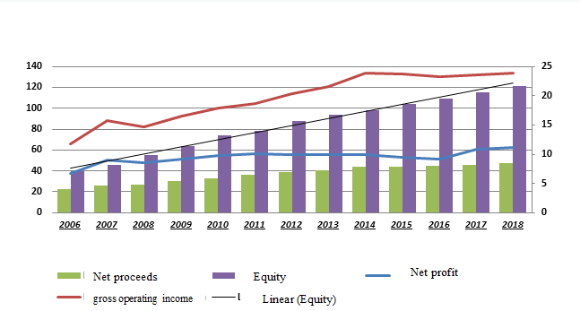The increase in financial intermediaries’ activities leads to risk exposure. Several types of risks may occur, starting from financial risks until the emergence of operational risks. The Basel Committee on Banking Supervision defined the operational risk as the loss incurred for inadequate or failed processes, human resources, and internal systems, or from external events. This type of risk may be mitigated using preventive controls. The second category includes losses caused by external events such as natural disasters, epidemics, which refer to non-negligible risks that are shifting out of bank’s jurisdiction. Banks can only provide risk-mitigating measures such as insurance covers. The increase of operational risk losses is often assessed in billions and may threaten bank’s viability and financial performance.

Considering the relationship between profitability and risks, we find it necessary to review the impact of the seven risk categories projected by the Basel Committee on bank’s performance. Several meanings were given by many theorists to specify the word « banking performance », which emphasizes the fact that performance leads to results, success, action, and abilities. For example, Pierre d’Elbee defined performance as the art of getting the best results [1], while Albanes (1978) defined performance as the reason for post-management, relying on efficiency and effectiveness [2]. Several financial performance appraisal standards using accounting data were exposed by a few French theorists such as Claire Faverjon and Alain Marion from Lyon University [3], who use usually the Return On Equity (ROE) and the Return On Assets (ROA). In the Moroccan banking sector, several indicators stand for profitability. This article will allow to represent the measurement of operational risk effects on Moroccan main bank's profitability and to identify the impacts of the seven risk categories projected by the Basel Committee on Moroccan bank's performance.

The article is structured as follows: The first part exposes the evolution of the principal performance indicators of banking activity in Morocco. The second part includes an econometric study of the impact of the operational risk on the banking sector in Morocco.Evolution of the main performance indicators of banking activity in Morocco

The objective of this part is to present, on the basis of annual data from 2006 to 2018, the evolution of the main performance indicators of the Moroccan banking sector defined above and to provide comments on significant events. Of the period of adoption of the Bale II rules.

## Evolution of net proceeds, equity, net profit, gross operating income

**Source: Data from BAM, calculated by author**

Fig.1. Evolution of the main performance indicators (2006-2018)

The graph above shows the evolution of net profit, equity, and gross operating income. At first glance, all the indicators discussed showed an increasing trend throughout the period considered.

Regarding the net banking proceeds (NP) of Moroccan banks, it recorded an upward trend throughout the period under review, Indeed, this indicator stood, on average, at 37 MM.DH during the said period and it increased from 22.2 billion dirhams in 2006, reaching 47.2 billion dirhams in 2018, an increase of 126%.

Indeed, Moroccan banks achieved net banking proceeds (NP) of 47.2 billion dirhams (MMDH) in 2018, up 1.2 billion dirhams compared to 2017. This increase of net banking proceeds recorded in 2018 was generated by the growth of 72% of the interest margin, 15% by the margin on commissions, and 13% by the result of market transactions.

However, the growth of the NP is marked by a period of slowdown, which is essentially linked to the decrease in interest and commission margins, even if the latter show a positive trend. 2015 was distinguished by a decline in net proceeds particularly due to the decline in intermediation and the return to jobs.

Regarding the net profit of Moroccan banks, this has experienced a positive evolution throughout the period considered, amounting to 23.8 MM.DH in 2018 against 6.7 MM.DH in 2006, in appreciation 65.7%. This favorable position is due to the dynamism of retail banking, as well as good control of structural costs, which made it possible to absorb the increase in the cost of risk.

The graph above shows the evolution of net profit, equity, and gross operating income. At first glance, all the indicators discussed showed an increasing trend throughout the period considered.

Also, gross operating income increased by nearly 1.4% after 1% in 2017, to stand at 23.8 billion dirhams in 2018. According to the 2018 annual report on banking supervision of Bank Al-Maghreb, the average cost / income ratio (which relates the total of general expenses and depreciation charges to net banking income) remained slightly stable (50.7%). In addition, the report also added that personnel costs increased by 2.9% to 11.4 billion dirhams from 4.7% in 2017, while external operating costs grew by 2.2%. against 4.4% in 2017. The change in gross operating income is mainly due to the favorable increase in net banking income.

Concerning equity, these recorded a favorable increase from 40 billion dirhams in 2006 to 115 billion in 2017, an increase of 81 billion dirhams. In 2018, equity continued to grow, totaling 121 billion dirhams, an increase of 5.2% (+ 6 MM.DH) compared to 2017. Admittedly, the equity of Moroccan banks has seen their rate of progress due to the carry-over of part of the results generated.

## Evolution of return on assets (ROA), return on equity (ROE) , and intermediation margin (IM).

Here, we examine the performance of the Moroccan banking system since the entry of the Basel II in Morocco in 2006 and the financial crisis in 2008 until the year 2018 for which the data are available while presenting the evolution of the main indicators used more to monitor the performance of the health of the Moroccan banking system. These indicators include in particular return on assets (ROA), return on equity (ROE), and intermediation margin (IM).

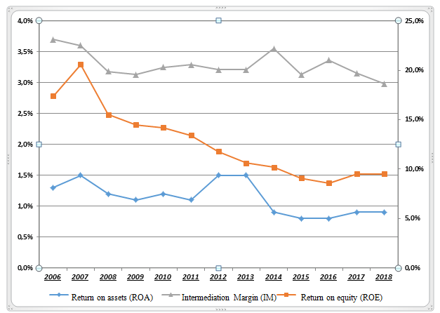

**Source: Data from BAM, calculated by the author**

Fig.1. Evolution of the main performance indicators (2006-2018)

The bank intermediation margin corresponds to the results of banks on their lending activity, varied within a range of 3% to 4%. It showed a slight decrease during the period considered, falling from 3% in 2006 to 4% in 2018, i.e. a drop of 1%. It should be said that this slight drop is mainly due to interest rate movements. Given the virtual stability of the intermediation margin, we can see that the gap between the interest received from the distribution of loans and the interest paid (cost of their resources) is stagnating at a relatively low level without giving rise to risks that weigh on the overall activity of banks. Certainly, due to the fall in interest rates on credit to Customers, the banks' overall intermediation margin was down. In 2018, banking activity showed an overall intermediation margin of 2.98%, down 17 basis points from the year before (3.15%). This comes after the average rate of return on jobs fell by 18 basis points to 4.35%; while the average cost of resources has stagnated (1.38%). This drop is due to the drop in yields on securities, according to the latest BAM report on banking supervision for 2018.

As observed in the previous graph, the profitability of Moroccan banks, measured by both ROA and ROE, recorded a downward trend during the period 2007-2018, with an exceptional increase in ROA in 2012 of almost 36%.

As for the return on assets (ROA), the latter fell from 1.30% in 2007 to 0.90% in 2017 and observed a drop of 40%. This deceleration is largely explained by the increase in total assets, reaching 175 billion dirhams in 2017 against 147 billion dirhams in 2006.

As for the return on equity (ROE), it increased in 2007 by 20.6% against 17.4% in 2006, the highest level recorded throughout the study period, followed by '' a downward trend until 2017 to reach 9.5% after 8.6% in 2016, i.e. an increase of 10.5%. Indeed, the good performance marked in 2017 is the result of the increase in the net income of banks, going from 9.2 MM.DH in 2016 to 10,8 MMDH in 2017, while the downward progression of the ROE s '' explains in large part by the gradual increase in equity, from 40 MM.DH in 2016 to 109 MM.DH in 2017.

# ECONOMETRIC STUDY OF THE IMPACT OF OPERATIONAL RISK ON THE BANKING SECTOR ACTIVITY IN MOROCCO

Monetary authorities pay particular attention to assessing the link between operational risk and bank performance. In this regard, this section aims is to measure the impact of operational risk on the performance of Moroccan banks using panel data econometric methods.

The study is based on a sample of the main banks in Morocco and the loss data covers four years period from 2015 to 2018.

Our approach consists of two main stages: the first is dedicated to the presentation of the variables and basic assumptions and the second relates to the empirical estimation of the impact of operational risk on the profitability of Moroccan banks.

## Selected variables and Basic assumptions

Before presenting the results of the estimated model, we shall recall the variables and the hypotheses to be tested. We are interested here in presenting the variables used to test the hypotheses developed in the light of the literature review developed in the first part of this study.

* Variables to be explained:
* ROA (Return On Assets or coefficient of performance): which is calculated by dividing net income by total assets on the balance sheet.

ROA = Net income / Total assets

* ROE (Return On Equity or profitability coefficient): This is the ratio between net income and equity (asset, reserves and similar items, retained earnings).

ROE = Net income / Equity

This concept is of particular interest to shareholders because it highlights the return on their investment.

* Explanatory variables:
* Internal fraud: losses due to acts aimed at defrauding, embezzling property or circumventing regulations, legislation or company policies involving at least one internal party to the company.

We expect “Internal Fraud” to have a negative effect on bank profitability. A first hypothesis can then be put forward:

H1: “Internal fraud” significantly influences the profitability of banks.

* External fraud: losses due to acts aimed at defrauding, embezzling property or circumventing regulations, legislation on the part of a third party.

We hypothesize that "External fraud" will have a negative effect on the profitability of banks.

H2: “External fraud” significantly influences the performance of banks.

* Employment practice and workplace safety: losses resulting from acts that do not comply with legislation or agreements relating to employment, health or safety, claims for compensation or equality or acts of discrimination.

We hypothesize that "External fraud" will have a negative effect on the profitability of banks.

A third hypothesis can then be:

H3: “Employment practice and workplace safety” significantly influences bank profitability.

* Customer’s products and business practices: losses resulting from an unintentional or negligent breach, a professional obligation to specific customers, or the nature or design of a product.

We hypothesize that the “Customers products and commercial practices” will have a negative effect on the profitability of Banks. A fourth hypothesis can then be:

H4: “Customers products and commercial practices” significantly influence the performance of banks.

* Damage to tangible assets: destruction or damage resulting from a natural disaster or another disaster.

We hypothesize that the “Damage to tangible assets” will have a negative effect on bank profitability.

A fifth hypothesis can then be:

H5: “Damage to tangible assets” significantly influences bank performance.

* Business and systems malfunctions: losses resulting from business or systems malfunctions (Information Technology (IT) and Telecommunications).

We hypothesize that “Business and systems dysfunctions” have a negative effect on bank profitability.

A sixth hypothesis can then be:

H6: “Business and systems malfunctions” significantly influence the performance of banks.

* Execution, delivery and management of processes: losses resulting from a problem in the processing of a transaction or in the management of processes or relations with commercial counterparties and suppliers.

A seventh hypothesis can then be:

H7: “Execution, delivery and management of processes” significantly influence the profitability of banks.

* Descriptive statistics

Before presenting the results of the estimated models, we shall start with a descriptive analysis of the statistical data. The following table presents the descriptive statistics relating to the series used in this empirical study.

The descriptive table reveals that 0.9% and 9% respectively represent the average values ​​associated with the ROA and the ROE, reflecting the average performance of the banking system recorded during the period 2006-2018. Their fairly reliable standard deviations show that the volatility of the ROA and ROE series is reliable.

This analysis also allows us to have an overview of the distribution of the different variables that we mobilize in our analysis through the Jarque-Bera test. This is a statistical test that tells us about the shape of the distribution of all observations. As for the variables related to the banking performance, ROA and ROE, we can conclude that these variables have a normal distribution in a level of 5%. About the variables relating to operational risk, according to the results of the Jarque-Bera test, we observe that the LDAC, LDAS, LELGP, LFE, LFI and LPMESLT have a Gaussian process, following a normal distribution with low standard deviations.

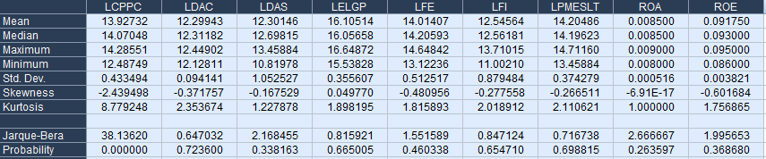

**Source: Eviews, calculated by author**

Tab.1. Descriptive statistics of continuous banking relationship variables

## Causality analysis in the sense of Granger between banking performance and operational risk

Here, we use Granger's causal theory (1988) “the causal knowledge” to analyze the relationships between banking performance and operational risks, to draw lessons and deduce implications on the causal links between these variables. Consequently, to draw the lessons that are essential in Moroccan banks, the analysis of the Granger causality test by an econometric estimate, the results of which are shown in the table below.

According to this table, several hypotheses were tested simultaneously, namely the causality between the variables relating to operational risks and the two variables relating to banking performance taken in pairs. We thus tested the hypothesis of whether operational risk does not cause banking performance.

We find that at the 5% threshold, the Granger test suggests the absence of a long-term causal link between operational risk and the performance of the banking system, supporting the thesis that the amounts committed by banks to do against the effects of operational risk do not determine long-term banking performance. Also, still at the 5% threshold, operational risks have an influence on the profitability of Moroccan banks in the short term. This observation follows from the previous one, namely that the reduction of poverty which here depends on economic growth would at the same time generate tourism development.

We find that at the 5% threshold, the Granger test suggests the absence of a long-term causal link between operational risk and the performance of the banking system, supporting the thesis that the amounts committed by banks to do against the effects of operational risk do not determine long-term banking performance. Besides, still at the 5% threshold, operational risks have an influence on the profitability of Moroccan banks in the short term. This observation follows from the previous one, namely that the reduction of poverty which here depends on economic growth would at the same time generate tourism development.

In other words, they reveal that operational risks do not cause long-term banking performance, neither in a one-way or directional sense. We can say that the amounts of losses caused by short-term operational risks could not negatively affect the performance of the banking sector in the long term.

The result of the causality test, which shows the absence of long-term effect, makes us dare to limit the analysis of the relationship between banking performance and operational risk over the short t-term horizon.



**Source: Eviews, calculated by author**

Tab.2. Granger causality test results

## Estimation and interpretation of the results

To answer the following question: "what is the impact of operational risk on the financial performance of Marcian banks", we will perform a regression analyzes from a linear model based on the approach of Pesaran et al (1999) and presented as follows:

$$y_{ijt}=β_{0j}+\sum_{i=1;j=1,2,3,4}^{7}{β_{ij}x_{ijt}}+ε_{ijt}$$

With i = 1,2,…, 7 explanatory variables; j = 1, 2,3 and 4th bank and t = 1, 2, 3,4th year

The panel data model (with an unbalanced panel) includes 4 Moroccan banks and covers a period from 2015 to 2018.

The interest of this modeling is to highlight the main factors (risks) responsible for the degradation of the performance of the banking system in Morocco. In particular, it seems interesting to determine to what extent bank profitability, measured by ROE and ROE, can be linked to different types of operational risk.

## The impact of operational risk on ROE:

* Estimation results

The first estimated fixed-effect model will aim to describe the relationship between the variables relating to operational risk and the ROE. The results of the model are expressed in the following table:

The analysis of the impact of operational risks on the ROE, allows us to observe on the one hand, that the operational risks in particular, LPMESL and LDAS, have a positive effect on the ROE, or almost zero, are 0, 2% and 0.3% respectively, indicating that these two types of risk do not significantly contribute to the deterioration of the performance of the banks in question. On the other hand, operational risks such as LFI, LFE, LELGP, LDAC and LCPPC, have negative repercussions on ROE, including LDAC which shows the greatest effect with -2.6%. Overall, a one unit increase in these risks could result in a decrease in ROE.

**Source: Eviews, calculated by author**

Tab.3. Estimation results

This analysis allows us to affirm that the majority of operational risks have a negative influence on the ROE of banks except in the case of two types of risks such as LPMESL and LDAS. Therefore, our review teaches us that operational risks significantly and negatively explain the short ROE behavior of Moroccan banks.

In terms of goodness-of-fit, the results of the model reveal that the coefficient of determination of our fixed-effect model is 74.13%, indicating that the model retained explains to few thirds of the variation of the ROE and therefore the predictive power is overall strong. Another goodness-of-fit test was carried out relating to the examination of the normality of the model (Jarque-Bera test) and which confirms that the assumption of the normality of the residuals is validated as the test probability is greater than 5%.

* Diagnostic test

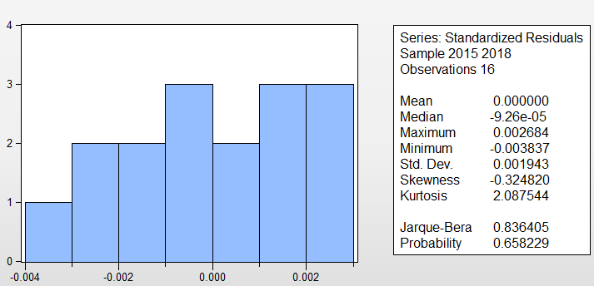

**Source: Eviews, calculated by the author**

Fig.2. Normality test

Regarding the hypothesis of the dependence between the residuals, the four tests relating to the "Residual Cross-Section Dependence" show the absence of a dependence relationship between the residuals in the estimated model.

Indeed, the results of the dependence tests show, with a confidence level of 95%, that the null hypothesis of the independence of the residuals is strongly accepted. Therefore, it is clear that there is no problem of cross-sectional dependence for the residuals of the sample under review. In this case, there are no unobserved common factors correlated between the residuals.

|  |  |  |  |
| --- | --- | --- | --- |
| Residual Cross-Section Dependence Test | | | |
| Null hypothesis: No cross-section dependence (correlation) in residuals | | | |
| Cross-section effects were removed during estimation | | | |
| Test | Statistic | d.f. | Prob. |
| Breusch-Pagan LM | 7.682674 | 6 | 0.2623 |
| Pesaran scaled LM | -0.668954 |  | 0.5035 |
| Bias-corrected scaled LM | -1.335621 |  | 0.1817 |
| Pesaran CD | -0.792278 |  | 0.4282 |

**Source: Eviews, calculated by author**

Tab.4. Results of residue dependency tests

Overall, the quality of the fit of the model used to estimate the empirical relationship between operational risk and ROE is acceptable with regard to the results of diagnostic tests. The model is statistically good.

1. *The impact of operational risk on ROA:*

* Estimation results

Before proceeding to the estimation of the model, it is necessary to test the problem of multicollinearity which stipulates the existence of a linear relationship between the explanatory variables. To identify the risk of multi-collinearity, one uses the test of Klein, while following the following approach:

* Calculation of the coefficient of determination R2 on the model with 7 variables: y = â0 + â1x1 + â2x2 +… + â7x7 ;
* Calculate the correlation matrix between the explanatory variables ;
* Compare the Coefficient of Determination with the calculated correlation coefficients.

We accept the hypothesis of the existence of the multicollinearity problem if the coefficient of determination is lower than each correlation coefficient

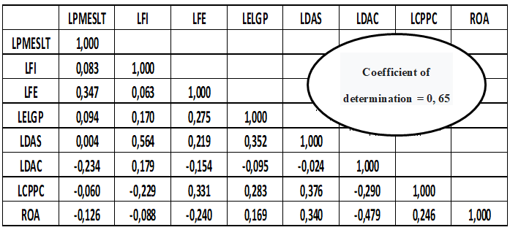

**Source: Eviews, calculated by the author**

Tab.5. Correlation matrix and coefficient of determination

By reading the table above, Klein's test showed that there is no multi-collinearity between the explanatory variables. In fact, all the correlation coefficients (expressed in the correlation matrix) between the explanatory variables are lower than the coefficient of determination R2. This allows us to perform linear modeling while avoiding spurious estimation.

The modeling of the effects of operational risk on the ROA, through the fixed effect model, gives the results reported in the following table:



**Source: Eviews, calculated by author**

Tab.6. Table: Estimation results

The variables LFI, LEGP, LFE ,and LDAC, in particular, have negative signs with a weak effect on the ROA, confirming the fact that the greater the level of losses due to these risks, the more bank profitability falls. In contrast, the remaining three types of risks (such as LPMESLT, LDAS, and LCPPC) have positive elasticity, indicating that the huge losses associated with these risks do not reduce the ROA. The positive signs must be explained by the fact that the amount promised by the bank to absorb these risks would not negatively affect its total result. Finally, the LDAC type of risk has a very strong explanatory power, indicating that the effects of losses are greater for this type of risk compared to other risks.

By comparing the elasticity of the ROA with the elasticity of the ROE, we note that the operational risks have a greater impact on the ROE than the ROA. This observation confirms that the behavior of the Moroccan banking system reacts (positively and negatively) absolutely with the amounts of losses linked to the risks of different types of operational risk.

In terms of goodness-of-fit, the results of this model show that our fixed-effect model has a coefficient of determination equal to 65.4%, indicating that the selected model strongly explains the changes in ROA, so the predictive power is generally strong. Another goodness-of-fit test (Jarque-Bera test) related to the model normality test was performed, which confirmed that the residual normality assumption had been verified as the test probability was greater than 5%.

* Diagnostic tests:

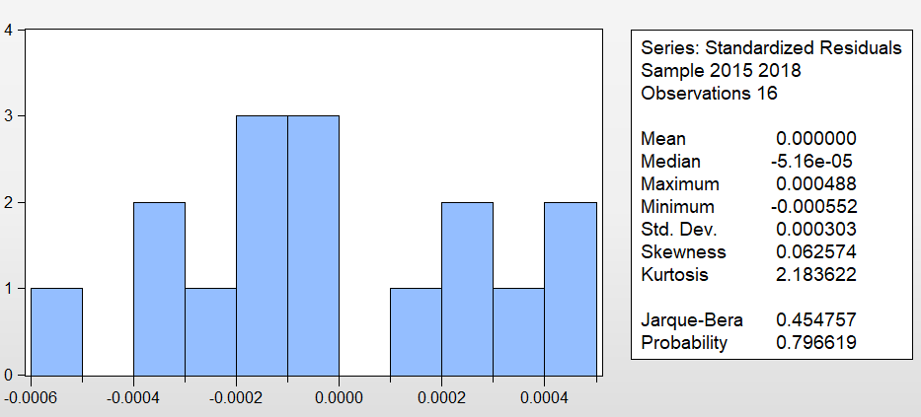

**Source: Eviews, calculated by the author**

Fig.3. Normality test

Regarding the hypothesis of the dependence between the residuals, four tests linked to the “Residual Cross-Section Dependence” indicate that there is no dependence relationship between the residuals in the model estimated at confidence level 95 %.

Indeed, the results of the dependence tests show, with a confidence level of 95%, that the null hypothesis of the independence of the residuals is strongly accepted. Therefore, it is clear that there is no problem with residue addiction. In this case, there are no unobserved common factors correlated between the residuals.

# CONCLUSION

The study carried out with Moroccan banks leads us to conclude that:

* Internal fraud has a negative impact on a bank's profitability.
* External fraud has a negative impact on a bank's profitability.
* Employment and workplace safety practices have a positive impact on a bank's profitability.
* Risks related to customers, products, and business practices negatively impact ROE and positively ROA of a bank.
* Damage to tangible assets has a negative impact on a bank's profitability.
* Business and systems dysfunction have a positive impact on a bank's profitability.
* The risks associated with the execution, delivery, and management of processes has a negative impact on a bank's profitability.

This study found that five of the seven types of risk have a negative influence on profitability. However, employment and safety practices in the workplace and the dysfunction of the activity and systems positively affect the profitability of Moroccan banks, and the risks related to customers, products and business practices negatively affect ROE positively affect ROA of a bank.

However, according to the literature even these three types of risk must negatively affect profitability. A question must therefore be asked concerning the reasons for deducing from the results of the estimates of studies that employment and safety practices in the workplace and the dysfunction of the activity and systems positively affect the profitability of banks. Moroccan, and the risks associated with customers, products, and business practices negatively affect ROE and positively ROA of a bank.

REFERENCES

[1]Albanes,Performance is the reason for management positions, 1978.

[2]C. Faverjon and A. Marion ( September 2008). Value creation and accounting indicators: lessons learned from a sample of European companies, over the period 2001-2005. Université de Lyon

[3] KPMG,Performance of major French banking groups as of 31 March 2016.

[4] M.Achibane and I.Allam ,“the management of banking risks between the prudential approach and the operational approach: Case of Moroccan banks”, Review of control, accounting and audit, “Number 10 : September 2019 / Volume 4: number 2 ”, p: 166 – 195

[5] Pierre D'Elbée, Performance: a new modern ideology? » In Performance in all its states.

[6] S. Ben othman , Influence of operational risks on the achievement of a bank's strategic objectives, 2009.

[7] Rapport annuel sur la supervision bancaire,2018