Geophysical and geotechnical assessement of
subsurface competency of a newly opened road within Osogbo, Southwestern Nigeria
Oluwole E. Ajayi ¹, Opeyemi L. Gbadamosi ¹
Email address: Oluwole.ajayi@uniosun.edu.ng, gbadamosideborahopeyemi@gmail.com
¹Department of Geological Sciences, Osun State University, Osogbo
PMB 4494, Oke-Baale, Osogbo, Nigeria.
Phone number of corresponding author: +2348139670928

ABSTRACT
Combined geophysical and geotechnical investigations were carried out along a newly opened road under construction in Osogbo. The aim of the study was to access the subsurface integrity of the road. The method adopted involves carrying out three traverses along the length of the road. Three (3) Werner array survey were also carried out while the low resistivity points along the three traverses were subjected to vertical electrical soundings (VES). Three soil samples collected at the points of low resistivity along the traverses were subjected to a series of geotechnical analysis which include the grain size, moisture content determination, Atterberg limit test and the compaction tests. Subsurface resistivity variation revealed a relatively thin clayey sand to sandy topsoil having resistivity values that range from 98.8Ωm - 258.0 Ωm. The layer is underlain by a thick slightly lateritic to pure laterite of resistivity values that range from 384.1 Ωm to 548 Ωm. Grain size analysis showed that the soil underlying the study area is rich in sand with little clay content. The moisture content is averagely low and range from 5.96% - 12.45%. This imply that the clayey sand interval has a low moisture content and a high compaction, a property which is required for a good and competent subsurface material for road construction. From the study, it was concluded that the first 1 meter of the subsurface material underlying the study area consist of a good subsurface material upon which a road can be constructed. The results of the geophysical study also supports this.

Key Words: Werner array, Traverses, Vertical Electrical Sounding, Subsurface Resistivity

INTRODUCTION
Soil is an important element in civil engineering, as it is used for the construction of civil engineering structures, such as: rocks, buildings, bridges and dams. Soil formation and its engineering behavior are influenced by the prevailing climatic condition, moisture content, topography of the region, vegetative cover, and the bed’s rock chemical composition (Okeke et al., 2021; Ngueumdjo et al., 2022). Basically, soil consists mainly of mineral and organic materials, with the organic materials causing serious alterations in the soil’s mechanical properties in most cases. According to Chavali and Reshmarani (2020), humus has the capacity of either stabilizing or altering the physical and mechanical properties of the soil. Particle size of soil is one of the factors, which determine the suitability of soil for a particular civil engineering job. Coarse particle soil has higher degree of reliance, infiltration rate, and lower swelling rate; thus, it is used to construct reinforced soil structure (Bhuiyan, 2022). Geotechnical properties are major soil engineering properties that are considered during the design and construction of civil engineering structures. Soil with poor geotechnical properties tend to fail easily; hence it is not suitable for building structural works, without adequate stabilization prior to its utilization (Roy and Bhalla, 2017; Ugwuanyi and Onyelowe, 2019; Igwe and Umbugadu, 2020). Increment in structural failures in Nigeria, is partly attributed to poor soil conditions (Awoyera et al., 2021)
Roads are essential in trade and transportation system globally and serve as links between towns, states and countries. In Africa, roads are links to access education, health and social services. Socio-economic development of a country depends on its transportation network. Thus, soils on which roads are constructed determine its stability and proper usage. Currently, more than half of the major roads in Nigeria are in deplorable state and consistent road maintenance are inactive. Rehabilitation of roadways has constituted some facial burden to the various tiers of government.
Generally, most structural failure of roads can be attributed to lack of detailed information about the physical and geologic characteristics of subsoil materials used in construction; more so this is not always taken into consideration while construction the road. The characteristics of soil determine its performance in engineering construction works. Nigeria soils for example are characterized by various problem-soils zones which several works have reported (Ola1983; Durotoye1983)
This study is aimed at characterising the subsurface geological condition of the area upon which the road is constructed by integrating geophysical and geotechnical investigations for detailed mapping of subsoil and subsurface geologic disposition towards ascertaining the integrity of the road under construction.
2. LOCAL GEOLOGY OF THE AREA
Geologically, the area under investigation falls within the Basement Complex rock of South western Nigeria but the local geology portray that of an area compose Schist and Banded gneiss rocks (Fig.1). Soil derived from such rocks are thought to be composed to lateritic as well as feldspathic materials rich in K-feldspar, quarts and mica.
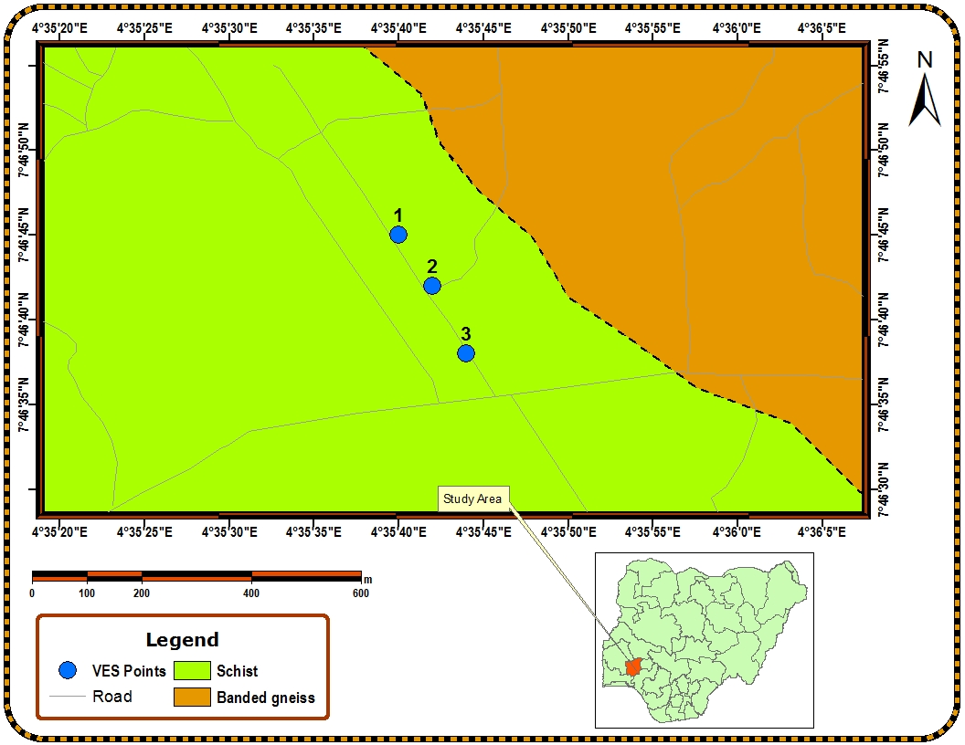
Figure 1: Lithological map of the study area with the VES points
3 METHODOLOGY
Geophysical and geotechnical examinations were carried-out in the study. Foremost, electrical resistivity was done to investigate the subsurface rock and lithology. Depth to investigation was to about 1 metre due to the fact that the thickness of any road is not more than 1 metre deep. Two techniques were used for the investigation, these include the vertical electric sounding techniques using the Schlumberger array as well as the horizontal profiling technique using the Wenner array. Instrument used involved the use of ABEM SAS 1000 resistivity metre. For the Wenner array, the first step was to identify the beginning of the first traverse and georeferenced it properly. A measuring tape was used to measure a total distance of 100 metres along the first segment of the road. Wenner array survey was first employed to take the resistivity measurement over the 100 metres interval. This is with a view to deduce how the resistivity measurements vary laterally along the traverse. This was also carried out along the second traverse and third traverse which also covered a total distance of 100 metres each from the end of the previous traverse. The resistivity measurements were recorded on recording sheet. A preliminary plot of the Wenner array profile was conducted on the field to locate the point of resistivity low (if any) on the two traverses. These two points were selected to be the points where the depth sounding were carried out and where the subsurface soil samples were collected. The Wenner profiles for the two traverses were plotted using the Microsoft word, Excel software package.
The next activity done was the used of the Schlumberger electrode array technique to investigate how resistivity varies downward into the subsurface. This was carried out where there is a resistivity low along the Wenner array survey. A total traverse distance of 300 metres were covered. The data collected were first interpreted using the partial curve matching techniques using a transparent paper superimposed on the master curve and reflected on the auxiliary curves from where the apparent resistivity and the apparent thickness of the subsurface layers were inferred. These two parametres were fed into the WinResist software for modelling and iteration. The geotechnical aspect of the study consisted in taking nine (9) bulk soil samples, that is, 3 per each traverse along the road under construction at well-georeferenced points using the hand auger to a depth to 1 metre. The soil samples were taken to the laboratory where index and engineering tests were carried out. The index and engineering properties tests were carried out at the soil laboratory of the Osun State University, Osogbo, Nigeria. These include; natural moisture content, grain size analysis, Atterberg limit (liquid limit, plastic limit, plasticity index) and compaction test.

4. RESULTS AND DISCUSSIONS
4.1 Geophysical investigation
The result of the Wenner profiling and Vertical Electric Sounding (VES) sounding showed that the first traverse is overlaid with clay and clayey sand at shallow depth (Fig. 2). These two layers were observed at depths as shallow as 0.17m and 0.69m in VES 1. The resistivity values obtained at these two layers were observed to be 98.8Ωm and 16.2 Ωm respectively, indicating that they were both composed of clay and clayey sand respectively. This has been soaked with surface water at shallow depth. However, the entire traverses 1 have been observed to be composed of competent materials. Basement rock was encountered below the thin clayey sand layer in VES 1 and traverse 1. This imply that the first traverse which covers a total distance of about 120 metres consist of subsurface materials of strong integrity except in the second layer which possess about 16.2Ωm.The result of the Wenner profiling and VES sounding showed that the first traverse is overlain with clay and clayey sand at shallow depth in VES 2 (Fig.2). The two layers were observed at depths as shallow as 0.0928m and 0.1641m in VES 2. The thickness of the first layer is 0.0928m and second layer is 0.0712m. The resistivity values obtained at these two layers were observed to be ohm and 98.8Ωm respectively. This indicating that they were both composed of clayey and clayey sand respectively. Also, the result of the Wenner profiling and VES sounding for VES 3, shows that the first layer have low resistivity compare to the second layer with the material encountered in the first layer are likely to be clayey sand(Fig. 2). The second layer shows high resistivity compare to first layer, also with high thickness compare to first layer which indicate that the second layer did not heavily fracture zone and the zone will not be suitable as water bearing formation. The third layer also shows higher resistivity but is lower compare to that of first layer and second layer, which indicate the Basement rock, the layer maybe heavily fracture and will suitable for water formation.
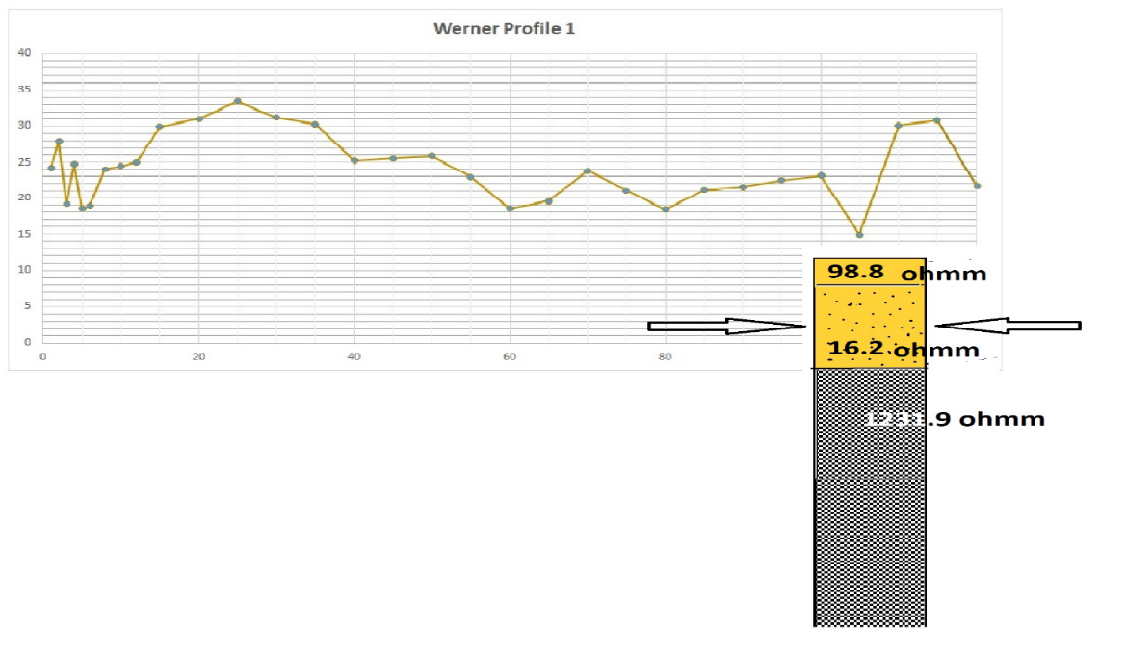

(1)

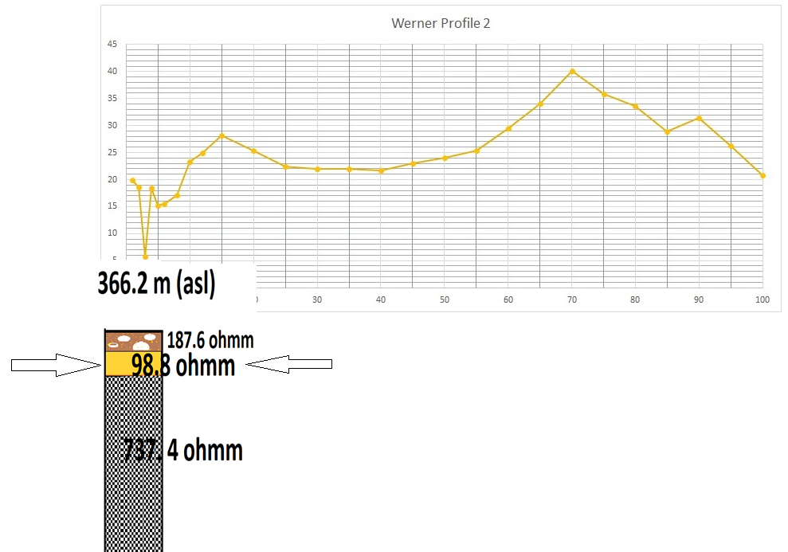

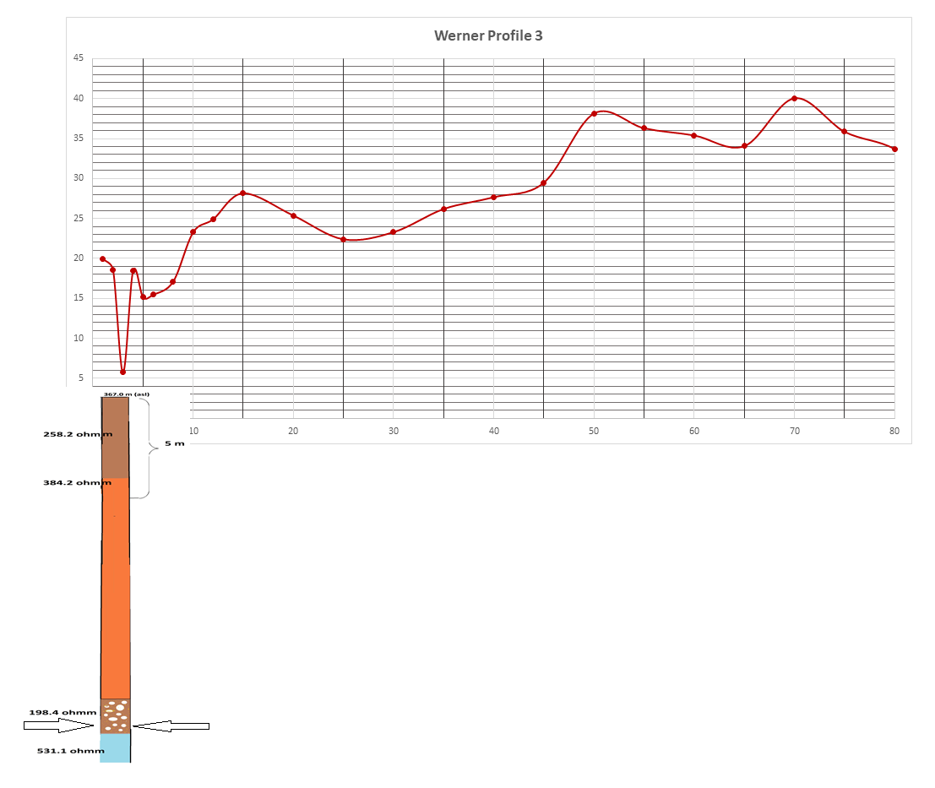
(2)

(3)
Figure 2: Wenner profiling and vertical electric soundings for the three traverses taken

4.2 Geotechnical Investigation
Geotechnical investigations were carried out on the soils around the newly road in Osogbo, Osun State to determine the suitability of the road for vehicles that will pass on it and durability of the road. Tests carried out include natural moisture content, liquid limit, plastic limit, grain size analysis and compaction test.
4.2.1 Natural Moisture content result
The result of the natural moisture content of the soil along the 3 traverses (table 1) range from 11.011 to 11.215 and 12. 037%, an average of 11.421% in traverse one. Along the second traverse, the moisture content is as low as 6.299%, to 5.957% and 6.222%, an average of 6.1593%. Along the third traverse representing the third section of the road, the moisture content is as low as 12.33%, 12.45% and 10.91%, an average of 11.90%. Since the percentage of the moisture content is low along the three sections of the road and below 15%, it is inferred that the bearing capacity of the study area while low moisture content occurs in traverse 2. This can be explained by the sloping nature of the study area. The ground surface slopes downward towards traverse 1 of the study suggesting a shallow water table for the soils while that of traverse 3 occurs at higher elevations suggesting a deep water table.
Table 1: Natural moisture content for samples from traverse 1, 2 and 3
S/N | Container No | 1a | 1b | 1c | 2a | 2b | 2c | 3a | 3b | 3c
1 | Weight of container, N₁ (g) | 14.2 | 14.0 | 14.0 | 14.2 | 13.9 | 14.1 | 14.1 | 14.0 | 14.1
2 | Weight of container + wet soil, N₂ (g) | 38.0 | 38.2 | 38.2 | 41.2 | 38.8 | 38.0 | 38.7 | 42.9 | 38.5
3 | Weight of container + dry soil, N₃ (g) | 35.6 | 35.6 | 35.8 | 39.6 | 37.4 | 36.6 | 36.0 | 39.7 | 36.1
4 | Weight of moist (N₂ - N₃) (g) | 2.4 | 2.6 | 2.4 | 1.6 | 1.4 | 1.4 | 2.7 | 3.2 | 2.4
5 | Weight of dry soil (N₃ – N₁) (g) | 21.4 | 21.6 | 21.8 | 25.4 | 23.5 | 22.5 | 21.9 | 25.7 | 22
Water Content $\frac{W_{2}-W_{3}}{W_{3}-W_{1}}X100$ (%) |  | 11.22 | 12.04 | 11.01 | 6.29 | 5.96 | 6.22 | 2.33 | 12.45 | 10.91
Average weight |  | 11.421% |  |  | 6.1593% |  |  | 11.90%

4.2.2 Index properties
The results of the sieve analysis show that the dominant grain-size of soil in traverse 1 is sand. There are 70% sand in Sample 1a, 70.6% in Sample 1b and 73.4% in Sample 1c with an average of 71.3%. Generally, 24.6% fine grained was observed in the sample. The results indicate that soils from traverse 1 (Coarse sand) shows an abundance of loosely soil particles. However, in soils of traverse 2, the soil samples is made up predominantly 67%sand with about 67.2% in Sample 2a, 65.5%in Sample 2b and 31.2% in Sample 2c with an average of 54.63%. The sample is 13.1% gravel, 18.8%clay and 13.4% silt. In the soil sample from traverse 3, the soil samples is made up predominantly sand with about 68% in Sample 3a, 68.6%in Sample 3b and 74.4% in Sample 3c with an average of 69.3. The sample is 1.3% gravel, 2.2% clay and 7.9% silt. The results indicate that soils from traverse 3 show an abundance of sandy soil. The soils collected from around the studies area are classified using the unified soil classification system (USCS) as shown in Table 2.
The plasticity chart of the soil samples shows that they all fall above the A-line but below the U-line. Hence, they can be described as inorganic clays. According to Ramamurthy and Sitharam (2005), the liquid limit of inorganic clays is generally < 100%. The liquid limit is also a measure of plasticity. Clays are known to be plastic. Hence, a medium to high plasticity is expected from the soils. Soils of liquid limit < 30% are considered to be of low plasticity, those with a liquid limit of between 30% and 50% are considered to be of a medium plasticity while those > 50% are of high plasticity. The liquid limit of the soils around the studied area ranges from 23.8 – 34.0% (average of 29.3) for soil in traverse 1 and ranges 32.2 – 54.8 (average of 40.3) for soil in traverse 2.
Table 2: Grain-size analysis of the soil samples in traverse 1, traverse 2 and traverse 3
Sample  Code | %  Gravel | %  Sand | %  Silt | %  Clay | %  Fine | %  Coarse | Liquid  Limit | Plastic  Limit | Plasticity  Index | USCS
1a | 1.5 | 70 | 19.5 | 9.0 | 28.5 | 71.5 | 30.0 | 22.5 | 7.55 | CS
1b | 2.4 | 70.6 | 13.3 | 13.7 | 27.0 | 73.0 | 34.0 | 23.5 | 10.55 | CS
1c | 8.1 | 73.4 | 12.7 | 5.8 | 18.5 | 81.5 | 23.8 | 19.9 | 3.90 | MS
2a | 18.1 | 67.2 | 11.8 | 2.9 | 14.7 | 85.3 | 33.8 | 23.5 | 10.35 | SC
2b | 20.6 | 65.5 | 8.8 | 5.0 | 13.9 | 86.2 | 32.2 | 21.6 | 10.6 | SC
2c | 0.6 | 31.2 | 19.7 | 48.5 | 68.2 | 31.8 | 54.8 | 24.3 | 34.15 | CH
3a | 1.3 | 68 | 17.5 | 7.0 | 26.5 | 69.5 | 28.0 | 21.5 | 5.55 | CS
3b | 2.2 | 68.6 | 11.3 | 11.7 | 25.0 | 71.0 | 32.0 | 21.5 | 8.55 | CS
3c | 7.9 | 71.4 | 10.7 | 3.8 | 16.5 | 79.5 | 21.8 | 17.9 | 1.90 | MS
GROUP NAME
CS- Clayey Sand
SC – Coarse Sand
SM – Silty Sand
CH - Fat Clay
A graph of percentage finer passing against sieve sizes (particular diameter) to conventional scale is plotted. Flattened slopes show finer sands or poorly graded soils. A gentle slope shows intermediate sands while steep slope shows coarser sand soil well graded. The graph below is the particle size graph for sample from traverse 1a showing coarser sand.

Gravel |  | Sand
Coarse | Fine | Coarse | medium | Fine
Figure 3: Particle size graph for sample 1

The general slope from the graph, figure 3, has the shape of the distribution and it is described by means of some constants such as effective sizes, uniformity coefficient, and coefficient of gradation. These terms are denoted as D10, Cu, Cc, respectively. The results explain the grade of the soil.
Uniformity Coefficient,
$C_{u }=D_{60}/D_{10}$
= $1/{0.4}$
=2.5
Coefficient of Curvature
$C_{c}$ = ${{(D}_{30})}^{2}$/ $D_{60}$.$D_{10}$
= ${(0.7)}^{2}$/ 1×0.5
= 0.49/0.5
$C_{c}$ = 0.98
4.2.3 Compaction test
Compaction tests are carried out with the aim of determining the moisture density relationships of soils. The table 3 below is soil compaction test result for soil along traverse 1. Results of soils from traverse 2 and 3 will be discussed.
Table 3: Compaction test on soil samples along traverse 1
Total weight of sample (3000g)
Mould type Metric Proctor Mould (1000cm³)
Wt of mould and wet soil (W₂)…. gr | 3775 | 3850 | 388.0 | 38.85 | 38.45 | 38.15
Wt of mould (W₂)…. Gr | 1975 | 1975 | 1975 | 1975 | 1975 | 1975
Wt of wet soil = (W2 – W1) gr | 1800 | 1875 | 1905 | 1910 | 1870 | 1840
Bulk density ʃ = ^{W1 – W2}/_{x} mg/cm³ | 1.80 | 1.88 | 1.91 | 1.91 | 1.87 | 1.84

Moisture Content Determination of Soils along traverse 1
Container No…. gr | 1 | 2 | 3 | 4 | 5 | 6 | 7 | 8
Wt of wet soil & container | 127.7 | 121.7 | 117.9 | 118.5 | 111.3 | 107.6 | 90.3 | 102.7
Wt of dry soil & container | 114.3 | 108.9 | 105.0 | 105.1 | 98.5 | 97.0 | 80.8 | 91.5
+Wt of container | 42.5 | 43.5 | 40.3 | 40.6 | 41.0 | 42.0 | 38.4 | 41.6
Wt of dry soil (Wd)….. gr | 72.4 | 65.2 | 64.2 | 63.8 | 57.5 | 48.4 | 42.4 | 42.9
Wt of moisture (Wm)… gr | 13.4 | 11.8 | 12.9 | 13.1 | 12.7 | 10.6 | 9.5 | 11.2
Moisture content (100). Gr | 18.6 | 18.0 | 20.1 | 20.2 | 22.2 | 22.1 | 22.4 | 22.4
Average of moisture con % | 9.0 |  | 10.9 |  | 12.9 |  | 14.1
Dry density (ʃc = 10/100m) mg/cm³ | 1.77 |  | 1.86 |  | 1.93 |  | 1.92
The compaction test analysis was carried out on three (3) samples collected along the three (3) traverses. These samples were divided into eight portions and moisture contents determination was carried out on them. In soil of traverse 1, it was observed that average moisture contents ranges from 9.0% to 14.1% while the dry density ranges from 1.77mg/cm³to 1.93mg/cm^{3.} In soil of traverse 2, the average moisture content ranges from 6.6% to 13.3% while the dry density ranges from 1.72mg/cm³ to 1.93mg/cm³. However, in soil of traverse 3 the average moisture content was observed to range from 9.0% to 14.1% while the dry density ranges from 1.77mg/cm³to 1.93mg/cm^{3.} From the study, the moisture content in soils of traverse 1, 2 and 3 are very low (lower than 20%) these implies that the soil becomes more stiff and they offer more resistance to compaction. As a result, there is increase cohesion and increase cohesion in the soil collected from sample 1, 2 and 3 to at least a depth of 1m in the pit. These means that the road constructed on such a soil would be firm and stable to at least 1m depth. Yujie and Arash (2019) observed that most soils share properties peak at water contents between 14% and 21% after which the soils lose their cohesion. From the study, the moisture contents observed are all less or equals to 14% which implies that the soil underlying the road construction would have more strength.
5.0 CONCLUSIONS
In the study, it was evidently clear that most of the soil samples were predominantly of sand and clay making the soil to be classified as clayey sand. The soil has low clay except only with sample 2c. Most of the samples are cohesive, compact, and plastic in nature. The moisture of soil samples shows lower values with typical sands in the study area. The soil samples have high compaction strength which indicates the soil was loosed in nature and can hold much water in the pores. The result of the geophysical investigation revealed that the study area is composed of competent materials for road construction.
References
Awoyera, P.O., Alfa, J., A. Odetoyan, A. and I. Akinwumi. (2021). “Building Collapse in Nigeria during recent years – Causes, effects and way forward”. IOP Conf. Series: Materials Science and Engineering 1036.
Bhuiyan, T. (2022). What is sandy soil? https://civiltoday.com/civil-engineeringmaterials/sand/213-sandy-soil-uses-of-sandy-soil.
Chavali, R.V.P. and B. Reshmarani. (2020). Characterization of expansive soils treated with lignosulfonate. Geo-Engineering 11, 17 https://doi.org/10.1186/s40703-020-00124-1.
Durotoye, B, (1983). Geomorphology and Quaternary deposits of Nigeria in Tropical soils in Engineering Practices (eds) Ola S.A Publisher AA Balkema Roiterdam Netherlands pp1-16.
Igwe, O. and A.A. Umbugadu. (2020). “Characterization of structural failures founded on soils in Panyam and some parts of Mangu, Central Nigeria”. Geoenviron Disasters 7, 7. https://doi.org/10.1186/s40677-020-0141-9.
Ngueumdjo, Y., V.H.N. Djoumbi, and V.Y. Katte. (2022). “Geomechanical characterization of lateritic hardpans from Bamendjou (West-Cameroon)”. Geo-Engineering 13, 3. https://doi.org/10.1186/s40703-021-00168-x.
Okeke, C., S. Abbey, J. Oti, E. Eyo, A. Johnson, S. Ngambi, T. Abam, and M. (2021). “Appropriate use of lime in the study of the physicochemical behaviour of stabilised lateritic soil under continuous water ingress”. Sustainability. 13(1):257. https://doi.org/10.3390/su13010257.
Ola, SA (1983). Tropical soils of Nigeria in Engineering practice. CRC Press, pp368.
Ramamurthy, T.N. and Sitharam, T.G. (2005). Geotechnical Engineering [Soil Mechanics]. S. Chand.
Roy, S and B.K. Bhalla. (2017). “Role of geotechnical properties of soil on civil engineering structures”. Resources and Environment, 7(4): 103-109. doi: 10.5923/j.re.20170704.03.
Ugwuanyi, K.K. and K.C. Onyelowe. (2019). “Suitability of Olokoro and Amaoba lateritic soil as pavement construction materials”. Nigerian Journal of Technology (NIJOTECH) 38(3): 549 – 556.
Yujie W. and Arash H. (2019). The effect of water content on the shear strength characteristics of granitic soils in South China; soil and Tillage Research; volume 187, pages 50-59.
Competing Interest
There is no competing interest associated with this research.
Referee
Dr. Charles Adebayo Oyelami
Senior Lecturer,
Department of Geology,
Federal University of Oye Ekiti,
Oye, Ekiti State.
Email: Charles.oyelami@fuoye.edu.ng

