Carbon Emission Drivers and Critical Paths in the Interaction of the "Local-Domestic-International" Economic Cycle——A case study of Beijing
Yanmei Li ª, Yue Wei ª, Xin Li ^{b, *}, Liyuan Fu ª, Tianfa Xie ª, Siyan Liu ª, Yan Kang ª

ª School of Economics and Management, Beijing University of Technology, Beijing 100124, China
^{b} Strategic Planning Department, Chinese Academy for Environmental Planning, Beijing 100043, China

Graphical Abstract
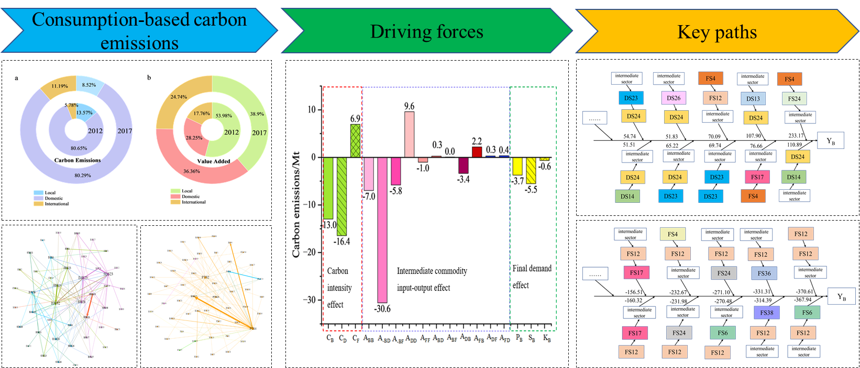

Highlights:
- SDA and SPA in "Local-Domestic-International" cycle are implemented
- Intermediate input–output effect of intra-domestic provinces are main drivers
- Electric power and chemical sectors are key nodes in cross-system key paths
- Suggestions on cross-system co-operation to reduce emissions are proposed
Abstract: Facing climate change and trade globalisation, it is crucial to study the carbon emissions worldwide induced by urban consumption activities. Taking consumption-oriented city Beijing as an example, we constructed a nested multi–regional input–output model (MRIO), and measured carbon emissions and value–added in local, domestic, and international systems. Furthermore, the structural decomposition analysis (SDA) and structural path analysis (SPA) was applied to analyse cross-system driving forces and key paths of carbon emission changes. The conclusions show: (1) Beijing's consumption leads to the highest carbon emissions in the domestic system but the highest value-added in the local system. There is spatial inconsistency in carbon emissions and value-added induced by consumption in Beijing. (2) In three systems，the intermediate commodity input–output effect (ICIOE) of intra–domestic provinces and domestic carbon intensity effect are the main driving factors contributing to the reduction of carbon emissions. In contrast, the ICIOE of inter–domestic provinces is the main factor leading to the rise. (3) In the top 10 types of key paths for Beijing’s consumption-based carbon emissions (CBCE) growth, electric power and construction sectors in domestic systems are key sectors. Chemical products, transport equipment, and food processing sectors in foreign systems are key sectors in the top 10 types of key paths for Beijing’s CBCE decrease. Our findings suggest Beijing enhancing cross-system cooperation to achieve carbon reduction targets.
Keywords: Consumption–based carbon emissions; Multi–regional input–output; Structural decomposition analysis; Structural path analysis
* Corresponding authors at: Strategic Planning Department, Chinese Academy of Environmental Planning, Beijing 100043, China.
E-mail addresses: liyanmei@bjut.edu.cn (YM. Li), weiyue@emails.bjut.edu.cn (Y. Wei), lixin@caep.org.cn (X. Li), fuliyuan@emails.bjut.edu.cn (LY. Fu), xietf@bjut.edu.cn (TF. Xie), lsiyan@emails.bjut.edu.cn (SY. Liu), kangyan0425@emails.bjut.edu.cn (Y. Kang).

- Introduction
In order to give full play to the advantages of China’s mega-market, the Chinese government proposed building a new development paradigm featuring dual circulation, including domestic and international. In addition to this, the economic cycles of local systems cannot be ignored, especially in typical cities (Chen et al., 2022a). Through frequent trade activities, cities import large quantities goods from domestic and international regions, it is therefore necessary to examine trade linkages among “Local-Domestic-International” systems.
Rapid economic growth has brought about serious environmental pollution while facilitating domestic and foreign trade (IEA, 2010; Kong et al., 2023). Over 70% of greenhouse gas (GHG) worldwide are caused by urban economic activities (Elmqvist et al., 2019). Climate change is a global issue (Chen et al., 2022b; Zhu et al., 2022), and to achieve the global goal of net zero emissions, cities must consider the carbon emissions of other economic systems caused by their consumption. Therefore, studying cross-system consumption-based carbon emissions (CBCE) of cities can recognize its driving effect on global carbon emissions. This will provide a theoretical basis for cooperation in combating climate change and formulating international carbon reduction strategies.
Clarifying the driving factors and key paths of CBCE is of significance for the scientific formulation of carbon emission reduction policies. MRIO can reflect cross-system industry linkages (Zheng et al., 2022). The SDA has been commonly applied to analyse driving factors of CBCE combined with MRIO (Liu et al., 2015; Mi et al., 2017; Pan et al., 2018; Radwan et al., 2022; Pang et al., 2023). Previous studies mainly investigated the impact of three influencing factors, including CO₂ intensity effect, intermediate commodity IO effect (ICIOE), and final demand effect (Zhang et al., 2020a; Zheng et al., 2020; Su et al., 2022; Liu et al., 2023). For the intermediate commodity IO effect, most studies consider the Leontief inverse matrix as a whole and do not decompose it in detail (production structure, the Leontief structure effect and IO technology effect), while Peng et al. (2015) decompose it into five factors due to the consideration of industrial linkages between domestic and international systems, few studies decompose it among “Local-Domestic-International” three-level systems.
Studies using SDA cannot identify critical intermediate transactions in supply chains or reflect the effects of the sectoral connection on carbon emissions (Li et al., 2020a). Structural path analysis (SPA) can make up for this shortcoming. SPA initially focused on economic issues (Lantner, 1972; Crama et al., 1984) and then extended to the environmental fields (Lenzen, 2003). SPA can decompose a specific industry’s resource consumption or environmental emissions into infinite flow pathways between industries (Lenzen and Murray, 2010; Nagashima et al., 2018; Su et al., 2019; Li et al., 2020b). Many scholars have investigated critical paths of CO₂ emissions in China, Australia, and India (Liang et al., 2014; Li et al., 2018; Zhang et al., 2020b; Zhang et al., 2021; Chen et al., 2022c; Wang et al., 2023a). Existing studies mainly identified critical paths for resource and environmental emissions within a certain country or a specific region, few studies consider cross-system critical paths, which is important for multi-system cooperation in developing carbon reduction strategies.
To fill the above gaps, we use the example of Beijing to examine the cross-system driving factors and key paths of its CO₂ emission changes, with a view to providing reference for cross-system realisation of carbon emission reductions.
Beijing is chosen as a case to be analysed for the following three reasons. (1) Beijing is a consumer centre (Kong et al., 2021). The contribution of final consumption expenditure to Beijing’s economic growth reached 60.1% in 2021 (Beijing Municipal Bureau of Statistics，2023). The Evaluation Report on International Consumer Centre Cities in 2021, released by the 21st Century Institute of Economic Research, indicated that Beijing surpassed Shanghai to become the most powerful city in China (21st Century Institute of Economic Research, 2023). Robust consumer demand generates large carbon emissions, and roughly 90% of Beijing's carbon footprint was attributed to other Chinese and international regions in 2012. (Shao et al., 2016). (2) Beijing's participation in domestic and international trade is high. As an international metropolis, Beijing occupies a critical position in both domestic and international economic system (Wang et al., 2023b). In the first half of 2023, Beijing's import and export value totalled 1.79 trillion yuan, year-on-year growth of 5.9%, higher than the national growth rate of 3.8 pp. (3) Beijing is the capital of a developing country, and its carbon reduction potential is much greater than that of a developed country's metropolis (IRP, 2020). Beijing influences key carbon emission paths by altering trade partners domestically and internationally, reshaping the global carbon emission network and further bringing about dramatic changes to the CO₂ emission pattern in China and globally. Beijing's carbon emission reduction strategy has implications for other developing country capitals.
This paper is organised around the following areas using the example of Beijing, the capital of a developing country. (1) How much carbon emissions are generated locally, domestically, and internationally due to Beijing’s participation in the domestic and international trade on consumption-based? (2) What are the driving factors of CO₂ emission changes on the consumption-based involving different systems? (3) What are the key paths of CO₂ emission changes on the consumption-based across the local, domestic, and international systems? The marginal contributions of our study are twofold. First, we further decompose the Leontief inverse matrix into 11 factors by considering forward and backward industry linkages of three systems (Figure 1), which deepens research methods of factors influencing CBCE changes. Second, most of the studies that have been done have implemented SPA within a particular system, we use SPA to identify key paths of Beijing’s CBCE changes across “Local-Domestic-International” systems, integrating domestic provinces and foreign countries into one analytical framework, expanding the research scale.
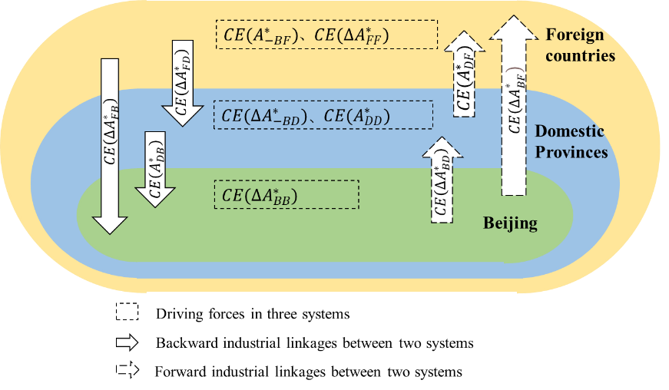
Figure 1 Decompose L into 11 factors involving three systems
- Methods and data

“Local-Domestic-International” nested input–output analysis
To analyse Beijing’s economic linkages with domestic provinces and foreign countries, China’s MRIO table (CMRIO) was nested in the world input–output table (IOT) in 2012 and 2017. According to existing nested schemes (Fry et al., 2022), a three-level nested multi-regional input–output (MRIO) model was constructed, comprising Beijing, 30 other provinces in China and 43 countries and regions worldwide. In the nested economic system, Beijing is linked to local, domestic and foreign systems, denoted by B, D and F, respectively. Z is the matrix of intermediate product flows; Y is the final demand matrix. The subscript rs (r, s=B, D and F) indicates the products supplied by region r to region s (Table 1).
Table 1
“Local-Domestic-International” nested MRIO
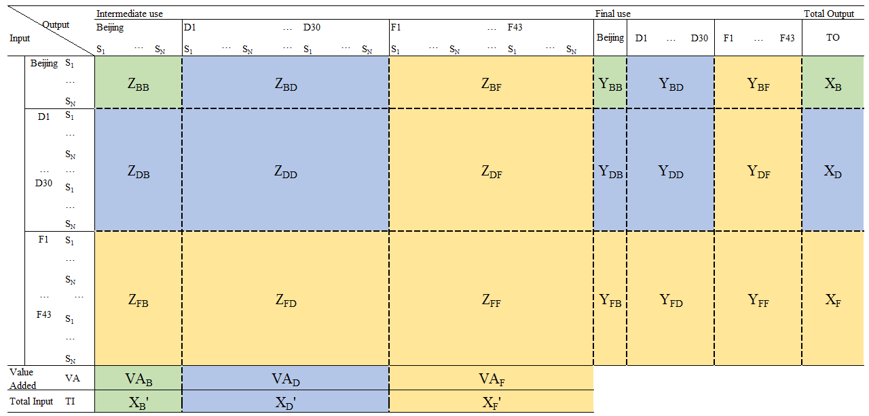
The constant coefficient assumption was referenced in the nesting process (Jiang et al., 2022). According to the structure of China’s imports and exports in the input–output (IOT), the imports and exports of each province in CMRIO were assigned to each country. The total inputs and outputs were then adjusted to balance the nested MRIO.
Taking the example of sector i in Beijing export to sector j in country F, the nested formula of Z is as follows.
$Z_{B,F}^{i,j } = \frac{Z_{CN,F}^{i,j }}{Z_{CN}^{i}}Z_{B}^{i}$ (1)
Here, $Z_{B,F}^{i,j }$ is the output or services exported from sector i in Beijing to sector j in a foreign country after nesting. $Z_{CN,F}^{i,j }$ is the output or services exported from sector i in China to sector j in a foreign country in the IOT. CN denotes China in the IOT. $Z_{CN}^{i}$ represents total exports from sector i in China in the IOT, and $Z_{B}^{i}$represents total exports from sector i in Beijing in the CMRIO.
The environmentally extended MRIO (EE-MRIO) can describe the economic linkages and show information on cross-system environmental emission. We constructed an EE-MRIO table by placing the carbon emission accounts attached to CMRIO and IOT below the three-level nested MRIO table.

Accounting for CBCE in “Local-Domestic-International” systems
This paper defines Beijing’s consumption-based carbon emissions (${TCE}_{B}$) as carbon emissions generated in three systems induced by Beijing’s final demand. Based on the three-level nested EE-MRIO built in 3.1, the total input–output balance equation follows.
$X ={ (I-A)}^{-1}Y = LY$ (2)
To calculate ${TCE}_{B}$, the matrix $\hat{c}$ was introduced.
$\hat{c} = \left[\begin{matrix}c_{B} & 0 & 0 \\ 0 & c_{D} & 0 \\ 0 & 0 & c_{F}\end{matrix}\right]$ (3)
Elements in $\hat{c} \left(c_{B}, c_{D},{ c}_{F} \right)$indicate direct carbon emission intensity, which is the ratio of $C$ (CO₂ emission of each region) to $X$. Then, we obtain the ${TCE}_{B}$.
${TCE}_{B} = \hat{c}LY_{B}$ (4)
By expanding Equation (3),
${TCE}_{B} = \left[\begin{matrix}{TCE}_{BB} \\ {TCE}_{DB} \\ {TCE}_{FB}\end{matrix}\right] = \left[\begin{matrix}c_{B}\sum_{t=B,D,F}{L_{Bt}Y_{tB}} \\ c_{D}\sum_{t=B,D,F}{L_{Dt}Y_{tB}} \\ c_{F}\sum_{t=B,D,F}{L_{Ft}Y_{tB}}\end{matrix}\right]$ (5)
${TCE}_{B}$ is equal to the sum of the first column elements in the matrix of Equation (5). ${TCE}_{BB}$ denotes the carbon emissions in the local system. ${TCE}_{DB}$ denotes the carbon emissions in the domestic system. ${TCE}_{FB}$ denotes the carbon emissions in the international system (Figure 1).
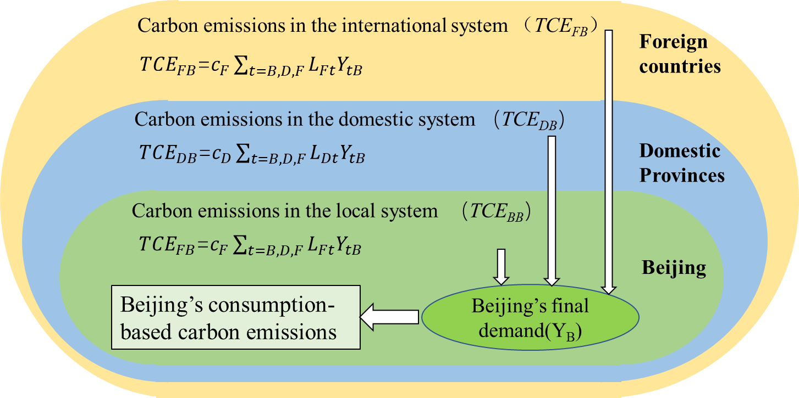
Figure 1 Accounting for Beijing’s consumption–based carbon emissions
Economic activities cause carbon emissions, and it is reasonable to consider the corresponding value–added benefits while analysing CO₂ emissions problems. Replacing $\hat{C}$ with $\hat{V}$, we obtained the value–added that Beijing’s final demand created in three systems (${TVA}_{B}$). Elements in $\hat{v}$is the ratio of $V$ (value–added of each region) to $X$. See Appendix 1 for details.

SDA of CBCE changes involving “Local-Domestic-International” systems
SDA is commonly applied to identify driving factors of environmental problems, particularly those related to CO₂ (Naspolini et al., 2020; Jiang et al., 2021).
This paper adopted SDA to clarify the causes of changes in ${TCE}_{B}$. Beijing’s final demand vector $Y_{B}$ can be expressed as $Y_{B}=P_{B}S_{B}K_{B}$ (Peng et al., 2015). $P_{B}$is the commodity structure of final demand, $S_{B}$ is the spatial structure of final demand and $K_{B}$ is the consumption scale of final demand. Formula (4) can be written as ${TCE}_{B}=\hat{c}LP_{B}S_{B}K_{B}$. From 2012 (period 0) to 2017 (period 1), the change of ${TCE}_{B}$ is shown in Equation (6).
$∆{TCE}_{B} = c^{1}L^{1}P_{B}^{1}S_{B}^{1}K_{B}^{1}-c^{0}L^{0}P_{B}^{0}S_{B}^{0}K_{B}^{0}$ (6)
Equation (6) can be decomposed as follows：
$∆{TCE}_{B} = CE\left(∆c\right)+CE\left(∆L\right)+CE\left(∆P_{B}\right)+CE\left(∆S_{B}\right)+CE\left(∆K_{B}\right)$ (7)
Here, $CE\left(∆c\right)$ is carbon intensity effect, and $CE\left(∆L\right)$ is the intermediate commodity input–output effect. We used the bipolar decomposition method suggested by Dietzenbacher and Los (1998) because it generates fewer errors than other methods (Gu and Lv, 2016).
Furthermore, from $L={(I-A)}^{-1}$ we obtain the following equation:
$$\begin{aligned}∆L ={ L}^{1}-L^{0} ={ L}^{1}∆AL^{0}\#\left(8\right)\end{aligned}$$
The L matrix contains both input–output relationships within and between three systems, so it must be decomposed further. A was decomposed into 11 factors based on Peng et al. (2015), which decomposed into five factors. Appendix 2 presents the processing steps and specific meanings.
Thus, ∆A can be written as Equation (9).
$∆A ={ ∆A}_{BB}^{*}+{∆A}_{-BD}^{*}+∆A_{-BF}^{*}+{∆A}_{DB}^{*}+∆A_{FB}^{*}+∆A_{BD}^{*}+{∆A}_{BF}^{*}+∆A_{DD}^{*}+∆A_{FF}^{*}+∆A_{DF}^{*}+∆A_{FD}^{*}$ (9)
Moreover, the carbon emission intensity $c=c_{B}^{*}+c_{D}^{*}+c_{F}^{*}$. Of which, $c_{B}^{*}=(c_{B},0,0)$, $c_{D}^{*}=(0,c_{D},0)$, $c_{F}^{*}=(0,0,c_{F})$. Therefore, the change in CO₂ emission intensity was decomposed as follows: $∆c={∆c}_{B}^{*}+∆c_{D}^{*}+{∆c}_{F}^{*}$.
Overall, the change of${TCE}_{B}$ can be decomposed into the sum of 17 factors, shown in Table 2.

Table 2
Factors influencing the change of ${TCE}_{B}$
 | Influencing factors | Implications
Carbon intensity effect | $${CE(∆c}_{B}^{*})$$ | Local
 | $$CE({∆c}_{D}^{*})$$ | Domestic
 | $$CE(∆c_{F}^{*})$$ | International
Intermediate commodity input–output effect | $${CE(∆A}_{BB}^{*})$$ | Local
 | $$CE({∆A}_{-BD}^{*})$$ | Intra–domestic provinces
 | $$CE(A_{-BF}^{*})$$ | Intra–foreign countries
 | $$CE(A_{DD}^{*})$$ | Inter–domestic provinces
 | $$CE(∆A_{FF}^{*})$$ | Inter–foreign countries
 | $$CE(∆A_{BD}^{*})$$ | From Beijing to domestic provinces
 | $${CE(∆A}_{BF}^{*})$$ | From Beijing to foreign countries
 | $$CE(A_{DB}^{*})$$ | From domestic provinces to Beijing
 | $$CE(∆A_{FB}^{*})$$ | From foreign countries to Beijing
 | $${CE(A}_{DF}^{*})$$ | From domestic provinces to foreign countries
 | $$CE(∆A_{FD}^{*})$$ | From foreign countries to domestic provinces
Final demand effect | $$CE\left(∆P_{B}\right)$$ | Commodity structure
 | $$CE\left(∆S_{B}\right)$$ | Spatial structure
 | $$CE\left(∆K_{B}\right)$$ | Consumption scale

SPA of CBCE changes across “Local-Domestic-International” systems
SPA can identify changes in upstream sector carbon emissions driven by final consumption (Treloar, 1997; Mattila, 2013; Lin and Teng, 2022). Consequently, the SPA was used to explore the key paths of ${TCE}_{B}$ change.
The SPA begins with a series expansion of the Leontief matrix,
$$L = {(I-A)}^{-1} = I+A+A^{2}+A^{3}+⋯$$
Applied to Equation (4), the total carbon flows can be expressed as the part directly and indirectly caused by Beijing’s final demand:
${TCE}_{B} = c\left(I+A+A^{2}+A^{3}+⋯\right)Y_{B} = cY_{B}+cAY_{B}+cA^{2}Y_{B}+cA^{3}Y_{B}+⋯cA^{n}Y_{B}$
(10)
Of which, $cY_{B}$ is the CO₂ emission of the first production layer (PL), describes Beijing’s direct carbon emissions, expressed as follows: $Y_{B}$← Region 1 Sector 1. $cAY_{B}$ is the CO₂ emission in the second PL, which denotes the carbon emissions triggered by PL1, expressed as follows: $Y_{B}$← Region 1 Sector 1 (R1 S1)← R2 S2. $CA^{2}Y_{B}$ is the carbon emission in the third PL, which denotes the carbon emissions triggered by PL2, expressed as follows: $Y_{B}$← R1 S1← R2 S2← R3 S3. $CA^{n}Y_{B}$ is the carbon emission in PL (n + 1), which denotes the carbon emissions triggered by PL(n), expressed as follows: $Y_{B}$← R1 S1← R2 S2←$⋯$← Rn Sn (Region 1, 2, $⋯$, n include Beijing, domestic provinces and foreign countries, Figure 3).
This study covers 74 regions, each containing 38 sectors and the A matrix is 3002-dimensional. To simplify the calculation, we combine 30 domestic provinces into D and 43 international countries into F; Beijing remains unchanged. We first find the key paths in D and F based on simplified data of 38 sectors in three regions; we then detail D and F to specific provinces and countries based on the key sectors in domestic and international key paths.
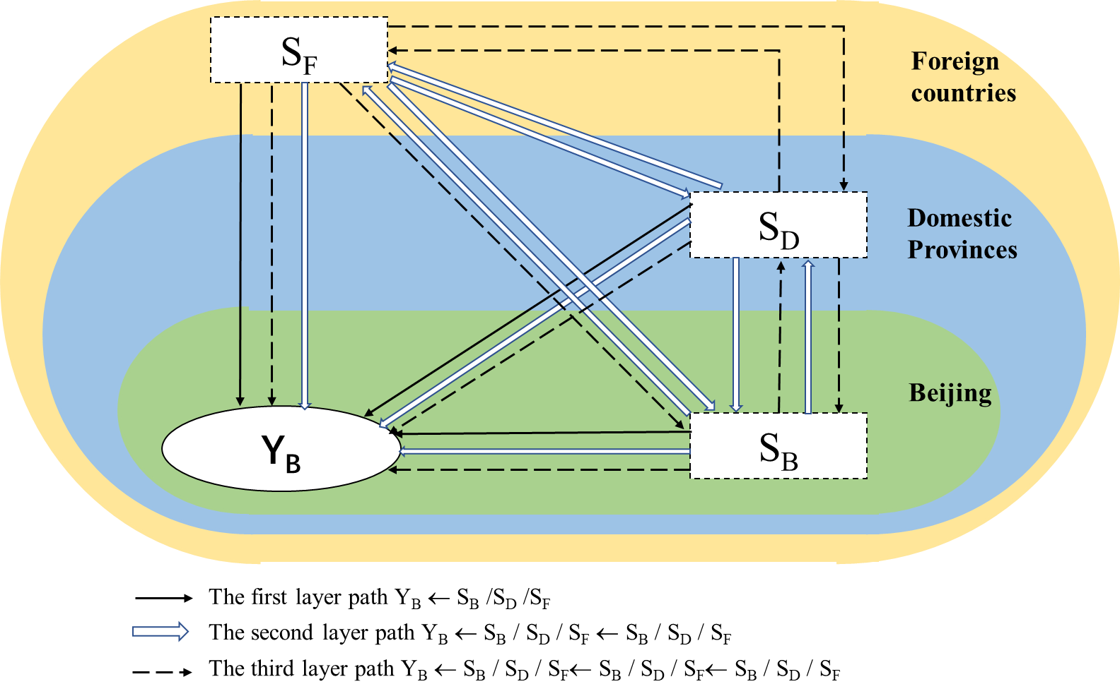
Figure 3 Key paths of Beijing’s consumption-based carbon emission changes involving three systems

Data sources
CMRIO are found in several databases including CEADs, China National Information Centre, Minjun Shi and others. The most recent data available is the 2017 CMRIO published in CEADs database. IOT data are from the EXIOBASE database. We chose 2012 to compare the change in carbon emissions over five years, i.e. 2012–2017. According to CMRIO and IOT, data are available for Beijing, 30 domestic provinces (excluding Hong Kong, Macau and Taiwan) and 43 countries. The data on CO₂ come from the corresponding satellite accounts of the two databases.
According to the Industrial Classification of National Economy, 42 sectors of CMRIO and 163 sectors of IOT were merged into 38 sectors (Appendix 4). Furthermore, region price deflators were adopted to adjust the CMRIO and IOT prices from 2012 to 2017 values. The price indices for China are available in the National Bureau of Statistics, and the GDP deflator for each country can be found on the World Bank website. IOT was converted to Chinese yuan (CNY) (million) denominated tables using annual average exchange rates provided by the State Administration of Foreign Exchange.
- Results and Discussion
  - Consumption-based carbon emissions of Beijing
According to the three-level nested EE-MRIO model, Beijing was empirically analysed using the method in 3.2. The results show that Beijing is a typical net carbon emission consumer. In 2012 and 2017, the ratio of consumption-based CO₂ to the production-side in Beijing was 2.71 and 2.06. Comparatively, Shanghai, a global financial centre, was 1.31 and 1.20 in 2012 and 2017, respectively (Shao et al., 2020). The ratio of Beijing was more than twice that of Shanghai, indicating that Beijing is a typical consumption-oriented city (Zhang et al., 2023); therefore, the city's CBCE should be given more attention.. The consumption activities in Beijing cause local, domestic and international carbon emissions. First, the PCE induced by Beijing’s consumption is the largest in the domestic system (${PCE}_{DB}$), which was 80.65% and 80.29% in 2012 and 2017, respectively, followed by the local system and the smallest was the international system. Second, ${PCE}_{BB}$ and ${PCE}_{DB}$ decreased by 5.06% and 0.36%, meanwhile ${PCE}_{FB}$ increased by 5.41% from 2012 to 2017 (Figure 4a).
In contrast, the ratio of value–added induced by Beijing’s consumption to production is 1.03, far less than the carbon emission ratio. This result indicates significant room for reducing Beijing’s consumption-based carbon emissions. Whether in 2012 or 2017, the ${PVA}_{BB}$ is the largest, followed by ${PVA}_{DB}$ and ${PVA}_{FB}$ (Figure 4b). It shows that Beijing’s economy is still predominantly involved in the domestic cycle, consistent with the findings of Zhang et al. (2022).
Figure 4 Distribution of carbon emissions (a) and value–added (b) in three systems
    - Carbon emissions changes in the local system
The local system has the largest share of value–added; however, it does not induce the highest share of carbon emissions. We can see that Beijing’s local cycle yields high economic benefits and CO₂ emissions reduction.
Among the 38 sectors in Beijing, the participation of S28, S30 (Real estate), S24 (Construction) and S38 (Public administration) in the economic cycle deepens, while carbon emissions decline, as shown in quadrant IV of Figure 5. These sectors reduced carbon emissions and brought better economic gains. Of these, the most significant is S28, whose proportion of value–added (PVA) increased by 1.86% and the proportion of carbon emissions (PCE) decreased by 20.34%. S28 is a representative of the emerging service industry, which can create high value added with low resource and environmental consumption. The development of S28 is inseparable from Beijing’s in-depth implementation of the innovation-driven development strategy and full promotion of the construction of the Science and Technology Innovation Centre. Beijing’s basic research spending accounted for 14.7% of all social research and development spending in 2017, up nearly three percentage points from 2012. Regarding the change of S30 and S24, the possible reason is the shift of Beijing’s real estate sector from an incremental development to a stock development phase. After the 2008 financial crisis, the real estate sector proliferated, creating a local small–cycle model of real estate–finance–local government infrastructure to drive economic growth; however, after 2016, real estate entered a phase of stock development. Demand for real estate has gradually declined; thus, the PCE induced by S24 and S30 declined in 2017.
In contrast, S11 (Processing of petroleum) and S26 (transport services) increased carbon emissions and reduced economic benefits, which indicates that these sectors are less technologically advanced and tend to emit more carbon. (Figure 5 quadrant II). S26 is a key energy consumption area, and S11 is a traditional high–energy sector, where large amounts of carbon dioxide accompany the extraction and processing of fossil energy. The changes in value–added and carbon emission ratios in most sectors (24 sectors in total) exhibit the same trend, which can be seen in quadrants Ⅰ and Ⅲ. The changes in other sectors are minimal, concentrating near the origin point (S3, S10, S12, S14, S15, S19, S21 and S37).
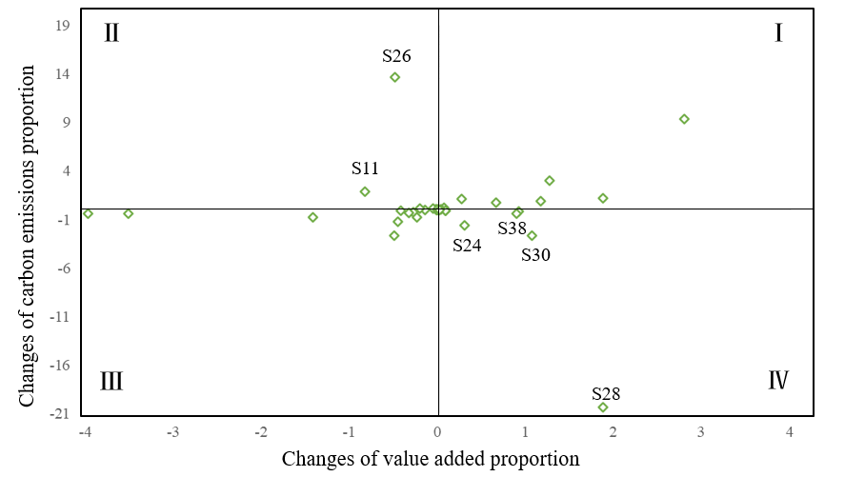
Figure 5 Changes in sectoral carbon emissions and value–added proportion in the local system
    - Carbon emissions changes in the domestic system
The domestic system has the largest share of carbon emissions, but the scale of carbon emissions has declined. The PVA_{D} increased by 8%, while the PCE_{D} decreased by 0.36%, suggesting that trading with Beijing for other provinces benefits domestic low–carbon development.
From a static view, Beijing has a tight carbon linkage with northern provinces. Regarding spatial layout, Beijing induced the most carbon emissions in provinces like Inner Mongolia, Hebei, Henan, Shanxi and Shandong, which are rich in natural resources and well-developed heavy industries. Regarding changes, the degree of carbon emission correlation between Beijing and these northern provinces decreased, except for Hebei, which increased slightly. We can look for reasons from a sectoral perspective. At the sectoral level, Beijing’s high–tech and emerging sectors (S28, S32) induced an increase of PCE in the above five provinces. In contrast, carbon-intensive sectors (S24, S30 and S17) reduced the proportion of carbon emissions in these five provinces (Figure 6). Hebei is an important heavy industry base with high steel production. Shanxi, Inner Mongolia and Shandong have abundant coal resources and are close to Beijing; providing electricity to nearby Beijing can reduce transmission losses; thus, Beijing’s carbon-intensive sectors (S24, S30 and S17) had more demand for these provinces and induced more carbon emissions in 2012. With the construction of ‘four centres’, Beijing has vigorously developed emerging industries. Beijing’s emerging industries, which consume relatively few resources, have increased demand for Shanxi, Inner Mongolia and Shandong. Simultaneously, each province is making a strong effort to develop green and low-carbon technologies and is committed to providing clean electricity. In summary, Beijing has a strong carbon linkage with neighbouring northern provinces, and the carbon correlation between Beijing’s emerging technology sector and these provinces is deepening. The carbon–intensive sector is the opposite.
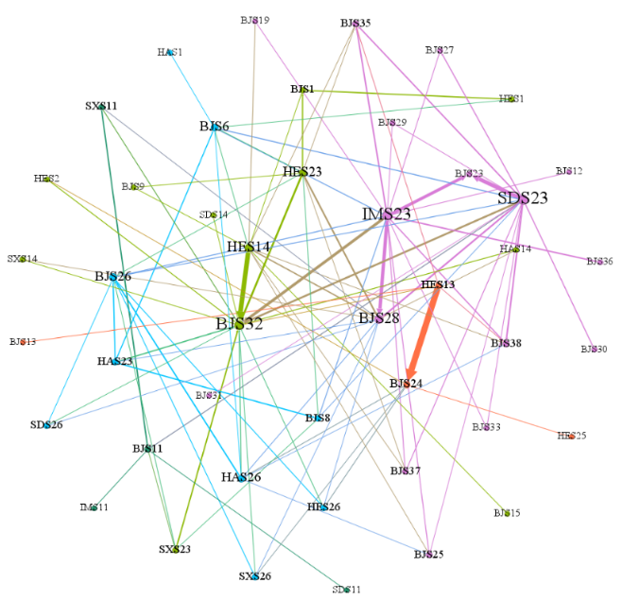
Figure 6 Changes in sectoral carbon emission ratios between Beijing and key provinces
Note: The thickness of the edge represents the magnitude of the proportional change.
Regarding economics, Beijing maintains close ties with southeast coastal regions. The proportion of value–added created by each province to TVA_{D} in 14 provinces has increased among 30 provinces. The top three are Guangdong, Jiangsu and Shanghai (Table 3), featuring prosperous economies and excellent technological innovation capabilities. Beijing deepens economic linkages with the three provinces mainly through S28, S32 and S19, which are part of the emerging service sectors and high–precision manufacturing.
Table 3
Changes in carbon emissions and value–added in the top five provinces induced by Beijing’s consumption
 | Carbon emissions (Million tonnes)
 | 2012 | 2017 | Changes in proportion
IM | 24.13 (12.34%) | 13.68 (9.73%) | -2.61%
HE | 21.70 (11.10%) | 16.32 (11.61%) | 0.51%
HA | 14.93 (7.63%) | 6.59 (4.69%) | -2.95%
SX | 13.92 (7.12%) | 7.59 (5.40%) | -1.72%
SD | 13.05 (6.67%) | 8.97 (6.38%) | -0.29%
Other 25 provinces | 107.84 (55.14%) | 87.47 (62.20%)
 | Value–added (billion)
 | 2012 | 2017 | Changes in proportion
GD | 26.12 (0.93%) | 95.43 (3.13%) | 2.20%
JS | 70.67 (2.51%) | 122.81 (4.03%) | 1.52%
SH | 37.58 (1.33%) | 70.01 (2.30%) | 0.96%
ZJ | 53.49 (1.90%) | 86.04 (2.82%) | 0.92%
HE | 60.22 (2.14%) | 80.00 (2.62%) | 0.49%
Other 25 provinces | 2,570.90 (91.20%) | 2,595.26 (85.10%)
    - Carbon emissions changes in the international system
Trading with Beijing for foreign countries is beneficial to international low-carbon development. The PCE_{F} was the smallest in 2012 but increased in 2017. The PVA_{F} PCE_{F} and rose by 7% and 5.41%, respectively, indicating that foreign countries were providing products and services to Beijing at a lower cost in carbon emissions for a greater economic benefit.
Beijing’s carbon linkages with some Western Europe Union (EU) countries are getting closer. Beijing induced the largest increase in the proportion of CO₂ emissions in some Western EU countries, such as Portugal, the Netherlands and Finland (Table 4), consistent with the findings of Jiang et al. (2023).
Table 4
Changes in carbon emissions and value–added in the top 5 countries induced by Beijing’s consumption
 | Carbon emissions (Million tonnes)
 | 2012 | 2017 | Changes in proportion
Portugal | 0.0001 (0.001%) | 5.23 (26.69%) | 26.69%
Netherlands | 2.34 (16.67%) | 4.08 (20.82%) | 4.14%
Finland | 0.42 (2.99%) | 1.06 (5.38%) | 2.39%
South Korea | 0.0002 (0.001%) | 0.0019 (0.01%) | 0.01%
Denmark | 0.0003 (0.001%) | 0.0013 (0.01%) | 0.01%
Other countries | 11.26 | 9.23
 | Value–added (Billion)
 | 2012 | 2017 | Changes in proportion
Germany | 31.00 (6.11%) | 61.41 (8.74%) | 2.63%
Australia | 5.82 (1.15%) | 19.02 (2.71%) | 1.56%
United States | 70.72 (13.94%) | 108.35 (15.42%) | 1.48%
Japan | 44.13 (8.70%) | 67.78 (9.65%) | 0.95%
South Korea | 23.13 (4.56%) | 35.95 (5.12%) | 0.56%
Other countries | 332.56 | 410.01
The results show that the proportion of Portugal’s carbon emissions induced by the demand for S17, S32 and S4 in Beijing has increased most (Figure 7). Beijing’s S6, S17 and S15 increased the Netherlands’ share of carbon emissions by 15.30%, 9.70% and 0.28%, placing them in the top three. Demand from the S32, S37 and S36 increased Finland’s proportion of carbon emissions by 7.9%, 2.3% and 2.2%, with the rest of the sectors rising by less than 2%. Portugal is rich in metallic mineral resources and is an important copper producer. The main categories of goods imported by China from Portugal are electrical and spare parts (Ceatec, 2021). Most Dutch companies investing in China are production-oriented enterprises, such as Royal Dutch Shell and the Dutch International Group. Finland’s three largest exports to China include electromechanical products, cellulose pulp and paper and base metals and products. Hence, the PCE of Portugal, the Netherlands and Finland has increased, induced by Beijing.
Beijing’s economic linkages with highly developed economies like the United States (US), Germany and Japan have become closer. The PVA_{F}, the smallest among the three systems, has increased. This growth indicates that Beijing, as an international metropolis, actively connects with international circulation. Regarding the proportion of value–added by individual countries to the TVA_{F}, 17 of the 43 countries and regions have increased this share. The top 5 countries are Germany, Australia, the US, Japan and South Korea (Table 4). At the sectoral level, value–added in the above three countries is mainly induced by Beijing’s highly sophisticated manufacturing and emerging services sectors (S17, S6 and S28).
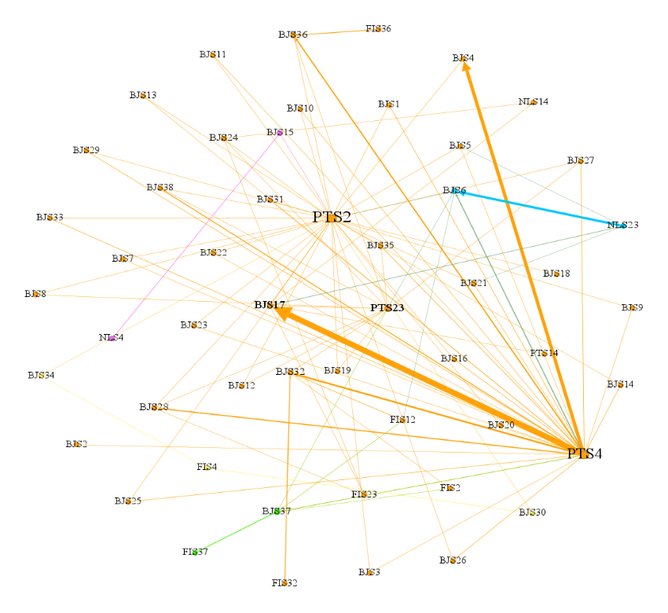
Figure 7 Changes in sectoral carbon emission ratios between Beijing and key countries
Note: The thickness of the edge represents the magnitude of the proportional change
  - SDA of CBCE reductions across “Local-Domestic-International” systems
Since 2012, Beijing has continued to optimise its consumption structure, forming a series of policies around the construction of the ‘four centres’. During the study period, Beijing’s consumption-based carbon emissions decreased by 67.36 Mt. We further use SDA to analyse the reasons for the changes in the above carbon emissions, determining that more than half of the factors contribute to the reduction of ${TCE}_{B}.$
The first type is the carbon emission intensity effect, which acts in different directions in different systems. In the local and domestic systems, the carbon intensity effect leads to a decrease, while in the international system leads to an increase (Figure 8). Since domestic production still meets most of Beijing’s final demand, the decrease in CO₂ emission intensity in the domestic production sector is the main factor effectively suppressing ${TCE}_{B}$ growth. Since 2012, China has been committed to co-regulating of pollution reduction and carbon reduction. China's 2020 carbon intensity 18.8% below 2015 (The Development and Reform Commission of China, 2020). Our results also indicate that China’s measures have achieved good carbon reduction results. Internationally, with the evolution of development stages and the shift of high-carbon industries, major developed economies have all achieved carbon peaking (The Central People’s Government of the People’s Republic of China, 2021). Nonetheless, the difficulty of reducing carbon intensity is increasing and marginal costs are increasing. For developing economies, industrialisation and urbanisation are still in progress and energy consumption will remain rigid; therefore, local and domestic carbon emissions are declining, while international emissions are rising slightly.
The second type is the intermediate commodity input–output effect, which contains 11 factors. Out of the 11 factors, 6 carry substantial weight and can be further categorized into two distinct groups. The first category includes factors that promote the decrease in carbon emissions (negative factors), and the other category includes factors that increase carbon emissions (positive factors). In negative factors, $CE({∆A}_{-BD}^{*})$, contributing 45.4% to carbon reduction. The contribution of $CE({∆A}_{-BD}^{*})$ ranking first among 17 factors, which again shows that Beijing is mainly involved in the domestic cycle. The second is ${CE(∆A}_{BB}^{*})$, contributing 10.4% to ${TCE}_{B}$ reduction. With technological progress and industrial restructuring, the input–output commodity structure in Beijing is gradually becoming low-carbon. The third is $CE(A_{-BF}^{*})$, which implies that the input–output commodity structure within countries also tends to be low–carbon. The fourth is $CE(A_{DB}^{*})$. The analysis in 4.1.2 shows that in the process of deepening the domestic cycle, Beijing’s emerging service industries and high–precision manufacturing industries have increased their domestic demand. Therefore, the effect of domestic provinces’ exports to Beijing reduces carbon emissions. In positive factors, $CE(A_{DD}^{*})$ leads to a 14.2% increase in ${TCE}_{B}$. In other words, domestic provinces contain significant carbon emissions in intermediate products when trading with other provinces. Promoting various factors in the organic linkage of production, distribution, circulation and consumption is conducive to breaking the small local cycle and opening the large domestic cycle; however, the SDA results show that the inter-provincial flow of intermediate goods generates significant carbon emissions and is an important factor in increasing carbon emissions. Therefore, reducing carbon emissions from intermediate products is essential for smoothing the economic cycle and reducing carbon emissions. $CE(∆A_{FB}^{*})$ leads to a 3.2% increase in ${TCE}_{B}$, potentially because Beijing’s processing of imported intermediate products from abroad produces more carbon emissions.
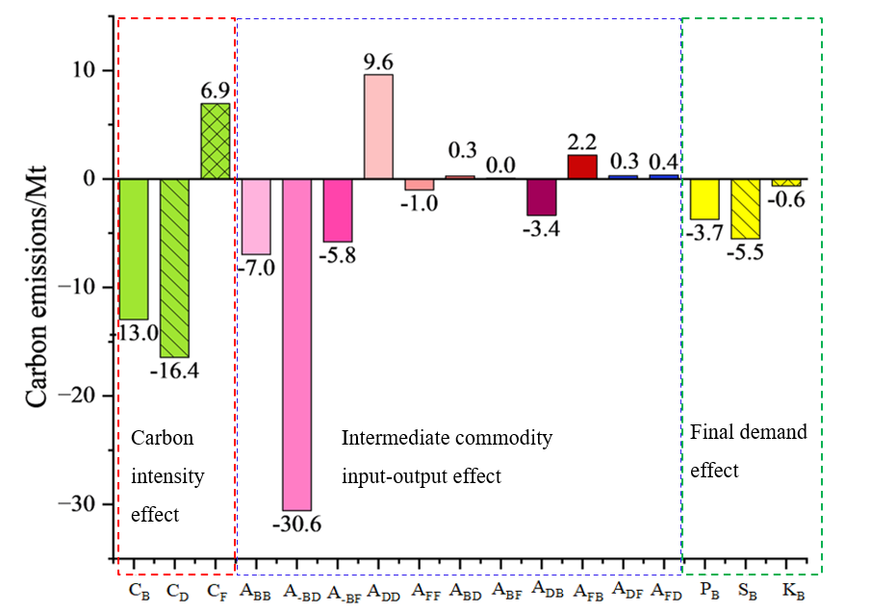
Figure 8 Driving factors for Beijing’s consumption-based carbon emissions
The final demand effect contributes to a decrease in ${TCE}_{B}$. In particular, the change in the spatial structure effect resulted in a 5.5 Mt decrease in ${TCE}_{B}$, mainly because Beijing’s main import partners are showing low-carbon development. The commodity structure effect also reduced ${TCE}_{B}$, with a contribution of 5.5%. Beijing is a service-oriented city with strong demand in the tertiary industry. Moreover, Beijing has vigorously promoted the construction of the ‘four centres’, with increasing domestic and international demand for emerging service sectors and high-precision manufacturing. These are low-carbon industries compared to wholesale and retail, accommodation, and catering sectors. Scale effect caused ${TCE}_{B}$ to drop by 0.64 Mt; according to the nested MRIO, Beijing’s final demand declined from 284.6 billion CNY in 2012 to 283.8 billion CNY in 2017, a decrease of 0.31%.
  - SPA of CBCE reductions across “Local-Domestic-International” systems
Section 4.2 showed that the intermediate commodity input–output effect significantly contributed to carbon emissions changes; however, due to SDA limitations, we were unable to conduct a detailed analysis. This study further used SPA to analyse sectoral correlations in order to obtain the key paths of ${TCE}_{B}$ changes.
The distribution results of ${TCE}_{B}$ at each PL can be obtained in 2012 and 2017, as shown in Table 5. Beijing’s consumption-based carbon emissions are concentrated in the first seven PLs, accounting for more than 90%. Carbon emissions of PL1 occupied 11.1% and 8.7% in 2012 and 2017, respectively, comprising a relatively small share. The previous analysis shows that Beijing is a typical carbon emission consumer, which the SPA results confirm. The share of carbon emissions of PL2 triggered by the first production layer (PL1) reaches 22.1% and 20.2%. The PL3 accounted for 21.2% and 22.9%. The share of carbon emissions from the first three PLs in 2012 and 2017 is more than half the total. In terms of dynamic changes, the changes in carbon emissions of the first three production layers accounted for 61.34% of the total changes; therefore, this paper takes the first three production layers as the boundaries to identify the key paths of carbon emission changes of ${TCE}_{B}$. The top 10 industrial chain types contributing to Beijing’s consumption-based carbon emissions increase and decrease in 2012–2017 are selected for analysis.
Table 5
Distribution of ${TCE}_{B}$ at different PLs in 2012 and 2017
 | Year2012 |  | Year2017 |  | Carbon reduction
Production layer | Carbon emissions | Cumulative percentage | Carbon emissions | Cumulative percentage | Carbon emissions | Cumulative percentage
PL1 | 26.99 | 11.13% | 15.29 | 8.73% | 11.70 | 17.37%
PL2 | 53.64 | 33.24% | 35.46 | 28.97% | 18.17 | 44.35%
PL3 | 51.53 | 54.48% | 40.09 | 51.85% | 11.44 | 61.34%
PL4 | 38.75 | 70.46% | 30.84 | 69.45% | 7.92 | 73.09%
PL5 | 26.26 | 81.28% | 20.73 | 81.28% | 5.53 | 81.30%
PL6 | 16.92 | 88.26% | 13.07 | 88.74% | 3.86 | 87.02%
PL7 | 10.66 | 92.66% | 7.97 | 93.28% | 2.69 | 91.02%
DS23 (electric power of domestic provinces) and DS24 (construction of domestic provinces) are key sectors in the top10 types of key paths for Beijing’s consumption-based carbon emission increase$(Figure 9)$. DS24 appeared six times, ranking first. With 51% of CO₂ emissions and 46% of energy consumption, the construction sector is the largest carbon emitter in China (Li et al., 2020c). Construction causes large CO₂ emissions from the upstream industry sector (Hou et al., 2021). This paper’s SPA results also indicate that domestic construction is a key node for the growth of Beijing’s CBCE. DS23 appeared four times, ranking second. S23 consumes significant fossil fuels and is also a major carbon emitter. Analysis of key provinces through DS23 reveals that the S23 of Inner Mongolia has the greatest carbon increase; abundant coal resources have made Inner Mongolia an important comprehensive energy and power export base in China. Despite Inner Mongolia’s commitment to transform its energy structure in recent years, coal still dominates its energy structure.
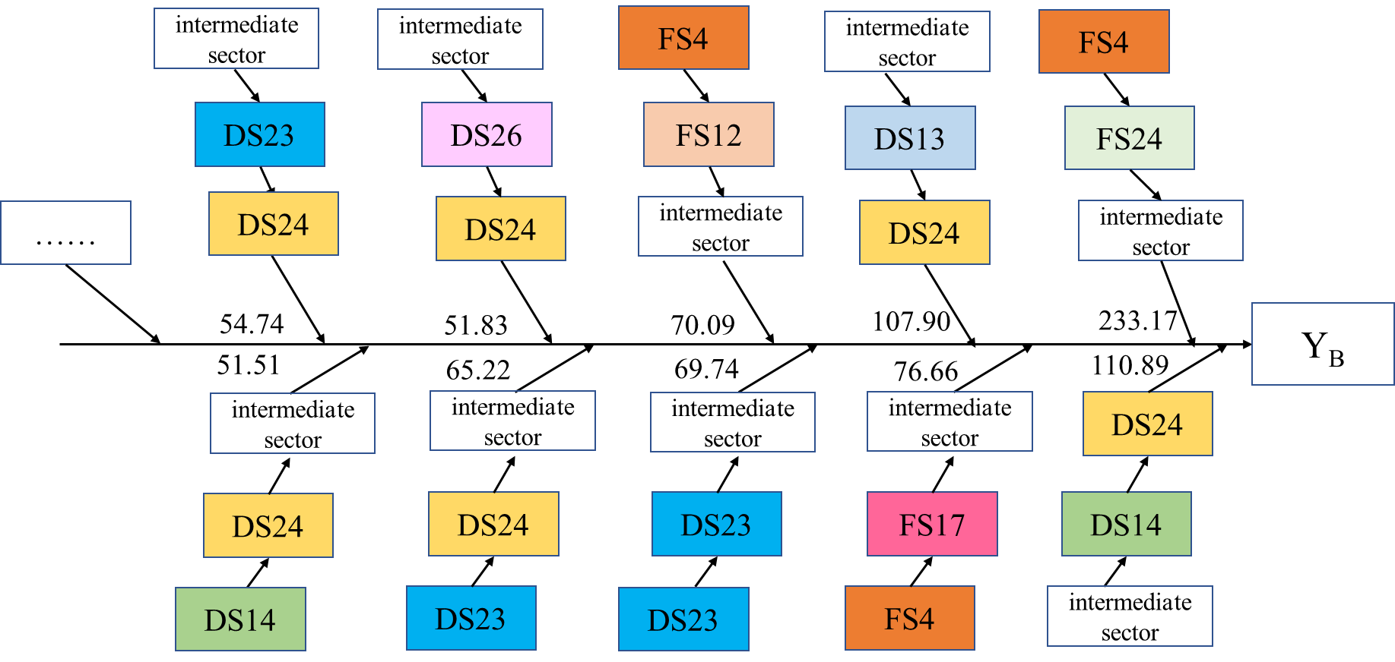
Figure 9 Top 10 types of key paths for Beijing’s consumption-based carbon emission increase in 2012–2017
Note: The numbers by the arrows indicate the average increased carbon emissions on the whole path.
FS12 (chemical products of foreign countries), FS17 (transport equipment of foreign countries), FS6 (food and tobacco processing of foreign countries) and FS24 (construction of foreign countries) appear most frequently in the top 10 types of key paths for Beijing’s consumption-based decrease in carbon emission; these are the key sectors for the reduction of ${TCE}_{B}$(Figure 10). FS12 appeared 11 times, ranking first. Analysis of key countries through FS12 reveals that Mexico’s S12 has the most significant carbon reduction in the industry chains. Mexico is rich in petroleum and has a well-developed petrochemicals manufacturing industry. S12 of Mexico supplies S6, S36 and S24 in foreign countries with pesticides, food and feed additives, construction materials and medical drugs; carbon reductions from S12 to these sectors contribute to carbon reductions along the entire pathway. FS17, FS6 and FS24 appeared twice, ranking second. In contrast to DS24, FS24 plays a crucial role in the critical paths of CO₂ reduction, primarily due to the reduction in carbon emissions from the upstream sectors.
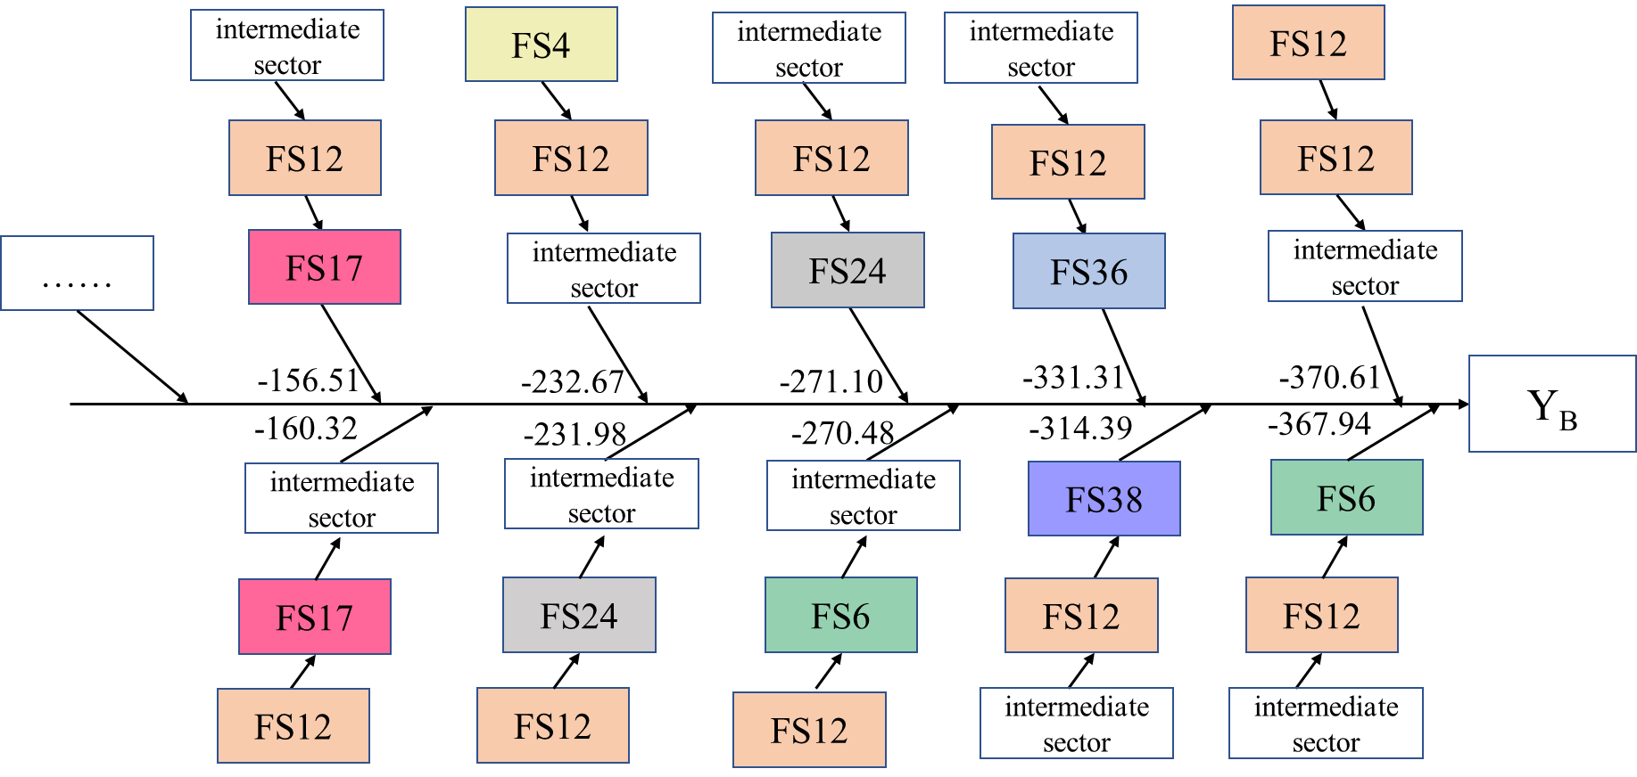
Figure 10 Top 10 types of key paths for Beijing’s consumption-based carbon emission decrease in 2012–2017
Note: The numbers by the arrows indicate the average decreased carbon emissions on the whole path.

Conclusions and Implications

Conclusions
By constructing “Local-Domestic-International” nested EE-MRIO, this paper first measured the carbon emissions and value–added in local, domestic, and international systems from a consumption perspective. We then analysed the reasons for CBCE changes using SDA. Finally, SPA was adopted to identify the cross systems key pathways of CBCE changes. Here are the main conclusions.
- The PCE induced by Beijing’s consumption in the local, domestic, and international system is 8.52%, 80.29%, 11.19%, respectively. The proportion of value-added induced by Beijing’s consumption in the local, domestic, and international system is 38.9%, 36.36%, 24.74%, respectively. From the perspective of carbon emissions and economic linkages, there is spatial inconsistency in carbon emissions and value-added induced by consumption in Beijing. Beijing has a tight carbon linkage with northern provinces at the domestic level, while Beijing maintains close ties with southeast coastal regions regarding economics. At the international level, Beijing’s carbon linkages with some Western EU countries are getting closer. However, Beijing’s economic linkages with some highly developed economies (Germany, Australia, the US, Japan and South Korea) have become closer. From the perspective of sector, Beijing's high-tech sector becomes strongly linked to carbon emissions in domestic northern provinces, carbon-intensive sectors increased the PCE in some Western EU countries.
- SDA results indicate that the ICIOE of intra-domestic provinces, followed by domestic carbon intensity effect, are the most important driving force behind the decline of Beijing’s CBCE. This is consistent with the conclusions of Dong and Zhang (2023). In addition, the decline of Beijing’s carbon intensity and the ICIOE of intra–foreign countries are also the main factors contributing to the decline of Beijing’s CBCE. This suggests a trend towards decarbonization of the intermediate goods input structure within the provinces and foreign countries, and carbon intensity of the production sector in Beijing and domestic provinces is declining. On the contrary, the ICIOE of inter–domestic provinces are the most important factor leading to the increase of Beijing’s CBCE. This demonstrates that there is a tendency for the intermediate product input structure to be highly carbonized among the domestic provinces. The comparison shows that the intermediate product input structure within provinces and countries is relatively low-carbon, while the greening of intermediate product inputs among provinces needs to be improved.
- In the top 10 types of key paths for Beijing’s CBCE growth, electric power and construction sectors in domestic systems. Construction industry is one of the largest end-use energy consumers and a major contributor to GHG emissions. This is because the construction sector drives the growth of carbon emissions in sectors such as the mining industries, the electric power industries, the transport industries, etc. At the same time, the power sector, with its high consumption of fossil fuels, is also key to the growth of carbon emissions. Chemical products, transport equipment, and food processing sectors in foreign systems are key sectors in the top 10 types of key paths for Beijing’s CBCE decrease. This suggests that the sectors mentioned above in international system can drive metropolitan areas to achieve carbon reductions through the critical chain pathway.

Implications
Based on the above conclusions, we propose policy recommendations to help Beijing's CBCE reduction across “Local-Domestic-International” three systems.
- Domestically, Beijing should further strengthen cooperation with emerging technology departments in provinces like Inner Mongolia, Hebei, Shanxi, Shandong, and Henan to promote economic development while achieving carbon reduction. Beijing can use its economic and technological advantages to develop low-carbon technologies and transfer them to regions such as Inner Mongolia and Hebei. At the international level, Beijing should strengthen cooperation with Western EU countries in emerging technology sectors. Beijing can simultaneously try to promote cooperation among governments of various countries, jointly formulate carbon tariff standards and coordinate policies.
- Based on the conclusion that the ICIOE of intra-domestic provinces, and domestic carbon intensity effect are the most important driving force behind the decline of Beijing’s CBCE, consideration could be given within provinces to further optimising the structure of intermediate product inputs, and reduce carbon emissions in the process of handling intermediate product processing. Based on the conclusion that the ICIOE of inter–domestic provinces are the most important factor leading to the increase of Beijing’s CBCE, low–carbon cooperation of intermediate products among provinces is a direction worth paying attention to in the future. Upstream provinces should provide low–carbon and clean intermediate products for downstream provinces, while downstream provinces should also enhance their technological capabilities during the intermediate product processing stage. Furthermore, Beijing should optimise its trade structure and import products from those countries with lower carbon emission intensity.
- The following policies can be considered to reduce carbon emissions in metropolises of developing countries, such as Beijing. First, the domestic electric power sector should gradually replace coal with clean energy and plan ahead for new energy consumption. The construction sector in domestic and international system should strengthen energy use efficiency, adopt energy-saving technologies, and develop green buildings. Secondly, Beijing can strengthen exchanges and co-operation with international chemical, transport equipment, and food processing sectors. Third, consideration could be given to optimizing the trade structure and strengthening technical cooperation among “Local-Domestic-International” systems to develop low-carbon technologies.
The research in this paper is instructive for developing country capitals to achieve carbon emission reduction on the consumption side, further exploiting the potential for carbon emission reductions in developing country capitals, contributing to the mitigation of global climate change. Due to data availability constraints, latest data available as of 2017. As new input-output tables become available, the data may be updated in subsequent studies.

Funding
This work was supported by the major project of Beijing Municipal Social Science Foundation [grant number 21JJA001].
Data availability
Data will be made available on request.

References
- Chen, Q.R., Xu J., Xia Y., & Ji K. X. (2022a). The Measurement and Trend Analysis of Domestic and International Dural Circulation. Chinese Journal of Management Science, 30 (1), 12–19. [in Chinese] 10.16381/j.cnki.issn1003-207x.2020.2045.
- IEA. (2010). Electricity information 2010. Paris: International Energy Agency IEA.
- Kong, L., Hu, G. W., Mu, X. Z., Li, G. H., & Zhang, Z. (2023). The energy rebound effect in households: Evidence from urban and rural areas in Beijing. Applied Energy, 343, 121151. https://doi.org/10.1016/j.apenergy.2023.121151
- Elmqvist, T., Andersson, E., Frantzeskaki, N., Mcphearson, T., Olsson, P., Gaffney, O., Takeuchi, K., Folke, C. (2019). Sustainability and resilience for transformation in the urban century. Nature Sustainability. 2, 267–273. https://doi.org/10.1038/s41893-019-0250-1.
- Chen, Z. Q., Yu, B. L., Li, Y., Wu, Q. S., Wu, B., Huang, Y., Wu, S. Y., Yu, S. Y., Mao, W. Q., Zhao, F., Wu, J. P. (2022b). Assessing the potential and utilization of solar energy at the building-scale in Shanghai. Sustainable Cities and Society, 82,103917. https://doi.org/10.1016/j.scs.2022.103917
- Zhu, M.C. Zhao, Z.B. Meng, Y., Chen, J.D. Yu, Z., Meng, C.H. (2022). Unfolding the evolution of carbon inequality embodied in inter-provincial trade of China: Network perspective analysis, Environmental Impact Assessment Review, 97, 106884, https://doi.org/10.1016/j.eiar.2022.106884.
- Zheng, H.Z., Xu, L.Y., Lu, W.Q., Huang, J.J., Sun, B.W., Dai, Y.Q., Yang, Z.F. (2022) Unbalanced PM2.5 emission and happiness effect through cross-regional trade in China, Environmental Impact Assessment Review, 96, 106834. https://doi.org/10.1016/j.eiar.2022.106834.
- Liu, Y., Lv, Y. K., & Zhou, M. F. (2015). Analysis on the Influence Factors of Computing CO₂ Emission by Input-output Method. China Population Resources and Environment, 25(09), 21-28. [in Chinese]
- Mi, Z., Meng, J., Guan, D., Shan, Y. L., Song, M. L., Wei, Y. M., Liu, Z. & Hubacek, K. (2017). Chinese CO₂ emission flows have reversed since the global financial crisis. Nature Communications, 8(1), Article 1712. https://www.nature.com/articles/s41467-017-01820-w
- Pan, C.，Glen, P. P.，& Robbie, M. (2018). Structural changes in provincial emission transfers within China. Environmental science and technology,52 (22), 12958~12967. https://doi.org/10.1021/acs.est.8b03424
- Radwan, A., Han, H., Achraf, A., & Mustafa A. M. (2022). Energy use and energy-related carbon dioxide emissions drivers in Egypt's economy: Focus on the agricultural sector with a structural decomposition analysis. Energy, 258, 124821. https://doi.org/10.1016/j.energy.2022.124821
- Pang, Q. H., Xiang, M., Zhang, L. N., & Chiu, Y. H. (2023). Indirect carbon emissions from household consumption of middle-income groups: Evidence from Yangtze River Economic Belt in China[J]. Energy for Sustainable Development, 76,101280. https://doi.org/10.1016/j.esd.2023.101280
- Zhang, P., Cai, W., Yao, M. T., Wang, Z. Y., Yang, L. Z., & Wei, W. D. (2020a). Urban carbon emissions associated with electricity consumption in Beijing and the driving factors[J]. Applied Energy, 275, 115425. https://doi.org/10.1016/j.apenergy.2020.115425
- Zheng, H. R., Zhang, Z. K., Wei, W. D., Song, M. L., Dietzenbacher, E., Wang, X. Y., Meng, J., Shan, Y. L., Ou, J. M., & Guan, D. B. (2020). Regional determinants of China’s consumption－based emissions in the economic transition. Environmental Research Letters, 15(7), 074001. http://dx.doi.org/10.1088/1748-9326/ab794f
- Su, B., Ang, B.W., Sun, Y.F. (2022) Input-output analysis of embodied emissions: Impacts of imports data treatment on emission drivers. Energy Economics, 107:105875. https://doi.org/10.1016/j.eneco.2022.105875
- Liu, M. Z., Yang, X. T., Wen, J.X., Wang, H., Feng, Y., Lu, J., Chen, H. Y., Wu, J. X., & Wang, J. F. (2023). Drivers of China's carbon dioxide emissions: Based on the combination model of structural decomposition analysis and input-output subsystem method. Environmental Impact Assessment Review, 100, 107043. https://doi.org/10.1016/j.eiar.2023.107043
- Peng, S. J., Zhang, W. C., & Sun, C. W. (2015). China’s Production-Based and Consumption-Based Carbon Emissions and Their Determinants. Economic Research Journal, 50(01), 168-182. [in Chinese]
- Li, W., Xu, D., Li, G. M., & Su, B. (2020a). Structural path and decomposition analysis of aggregate embodied energy intensities in China, 2012-2017. Journal of Cleaner Production, (276), 124185. https://doi.org/10.1016/j.jclepro.2020.124185
- Lantner R. (1972). Research on the Interpretation of the Determinant of an Input-Output Matrix. Political Economy Review, 82(2), 435–442.
- Crama, Y., Defourny, J., & Gazon, J. (1984). Structural decomposition of multipliers in input–output or social accounting matrix analysis. Applied Economics, 37, 215–222.
- Lenzen M. (2003). Environmentally important paths, linkages and key sectors in the Australian economy. Structural Change and Economic Dynamics, (14) 1-34. https://doi.org/10.1016/S0954-349X(02)00025-5
- Lenzen, M., & Murray, J. (2010). Conceptualising environmental responsibility. Ecological Economics, 70(2), 261–270. https://doi.org/10.1016/j.ecolecon.2010.04.005
- Nagashima, F. (2018). Critical structural paths of residential PM_{2.5} emissions within the Chinese provinces. Energy Economics, 70, 465–471. https://doi.org/10.1016/j.eneco.2018.01.033
- Su, B., Ang, B. W., & Li, Y. Z. (2019). Structural path and decomposition analysis of aggregate embodied energy and emission intensities. Energy Economics, 83, 345-360. https://doi.org/10.1016/j.eneco.2019.07.020
- Li, Q. P., Wu, S. M., Lei Y. L., Li, S. T., & Li, L. (2020b). Evolutionary path and driving forces of inter-industry transfer of CO₂ emissions in China: Evidence from structural path and decomposition analysis. Science of The Total Environment, 765,142773. https://doi.org/10.1016/j.scitotenv.2020.142773
- Liang, S., Zhang, C., Wang, Y. F., Xu, M., & Liu, W. D. (2014). Virtual Atmospheric Mercury Emission Network in China. Environmental Science and Technology. 48, 5, 2807–2815. https://doi.org/10.1021/es500310t
- Li, Y. Z., Su, B., & Dasgupta, S. (2018). Structural path analysis of India's carbon emissions using input-output and social accounting matrix frameworks. Energy Economics, 76, 457-469. https://doi.org/10.1016/j.eneco.2018.10.029
- Zhang, B., Zhang, Y.Q., Wu, X.F., Guan, C.H., & Qiao, H. (2020b). How the manufacturing economy impacts China's energy-related GHG emissions: Insights from structural path analysis. Science of The Total Environment, 743,140769. https://doi.org/10.1016/j.scitotenv.2020.140769
- Zhang, J. H., Wang, H. M., Ma, L., Wang, J., Wang, J. S., Wang, Z., & Yue, Q. (2021). Structural path decomposition analysis of resource utilization in China, 1997–2017. Journal of Cleaner Production, 322, 129006. https://doi.org/10.1016/j.jclepro.2021.129006
- Chen, J. D., Shi, Q., & Zhang, W. (2022c). Structural path and sensitivity analysis of the CO₂ emissions in the construction industry. Environmental Impact Assessment Review, 2022, 92, 106679. https://doi.org/10.1016/j.eiar.2021.106679
- Wang, J., Wei, L. Y., Zuo, J., Peng, S., Yu, S. X., Wang, L., Chen, C., & Wang, Z. (2023a). Heterogeneous driving effects of middle-class expansion on carbon emissions in various regions of China: A structural path decomposition analysis. Journal of Cleaner Production, 389, 136112. https://doi.org/10.1016/j.jclepro.2023.136112
- Kong, L., Mu, X. Z., & Hu, G. W. (2021). A decomposing analysis of productive and residential energy consumption in Beijing. Energy, 226,120413. https://doi.org/10.1016/j.energy.2021.120413
- Beijing Municipal Bureau of Statistics. (2023). BEIJING STATISTICAL YEARBOOK 2022. Beijing: China Statistical Publishing House.
- 21st Century Institute of Economic Research. (2023). The Evaluation Report on International Consumer Centre Cities in 2021. Beijing: 21st Century Institute of Economic Research.
- Shao, L., Chen, B., & Gan, L. (2016). Production-based and consumption-based carbon emissions of Beijing: trend and features. Energy Procedia, 104, 171–176. https://doi.org/10.1016/j. egypro.2016.12.030.
- Wang, Y., Tang, Y., Xia, N., Terrer, C., Guo, H. B., & Du, E. Z. (2023b). Urban CO₂ imprints on carbon isotope and growth of Chinese pine in the Beijing metropolitan region. Science of The Total Environment, 866,161389. https://doi.org/10.1016/j.scitotenv.2023.161389
- IRP. (2020). Resource Efficiency and Climate Change: Material Efficiency Strategies for a Low-Carbon Future. A Report of the International Resource Panel. United Nations Environment Program, Nairobi, Kenya. https://zenodo.org/records/5245528
- Fry, J., Geschke, A., Langdon, S., Lenzen, M., Li, M., Malik, A., Sun, A.Y., & Wiedmann, T. (2022). Creating multi-scale nested MRIO tables for linking localized impacts to global consumption drivers. Journal of Industrial Ecology, 26 (1), 281–293.
- Jiang, Y. Q., Tang, X., Ren, K. P., & Ding Y. (2022). Research on the drivers of pollution and carbon reduction in China based on double-layer nested SDA. Systems Engineering-Theory & Practice, 42(12), 3294-3304. [in Chinese] https://kns.cnki.net/kcms/detail/11.2267.N.20220927.0850.004.html
- Naspolini, G.F., Ciasca, B.S., La Rovere, E.L., & Pereira Jr., A.O. (2020). Brazilian environmental economic accounting for water: a structural decomposition analysis. Journal of Environmental Management, 265, 110508. https://doi.org/10.1016/j.jenvman.2020.110508
- Jiang, M., An, H., Gao, X., Jia, N., Liu, S., & Zheng, H. (2021). Structural decomposition analysis of global carbon emissions: the contributions of domestic and international input changes. Journal of Environmental Management, 294, 112942. https://doi.org/10.1016/j.jenvman.2021.112942
- Dietzenbacher E., & Los B. (1998). Structural decomposition technique：sense and sensitivity. Economic Systems Research, 10(4),307–324.
- Gu, A., & Lv Z.Q. (2016). Effects of Economic Structure Change on Carbon Emission of China: Analysis Based on IO-SDA Model. China Population Resources and Environment, 26(03),37-45. [in Chinese]
- Treloar, G. (1997). Extracting embodied energy paths from input-output tables: towards an input-output based hybrid energy analysis method. Economic Systems Research, 9, 375-391.
- Mattila, T. J. (2013). Input-output Analysis of the Networks of Production, Consumption and Environmental Destruction in Finland. Finland, Aalto University Publication.
- Lin, B.Q., & Teng, Y. Q. (2022). Structural path and decomposition analysis of sectoral carbon emission changes in China. Energy, 261(Part B),125331. https://doi.org/10.1016/j.energy.2022.125331
- Shao, L., Geng, Z. H., Wu, X.F., Xu, P. Q., Pan, T., Yu, H., & Wu, Z.(2020). Changes and driving forces of urban consumption-based carbon emissions: A case study of Shanghai. Journal of Cleaner Production, 245, 118774. https://doi.org/10.1016/j.jclepro.2019.118774
- Zhang, X. R., Cai, Z. Y., Song, W., & Yang, D. Z. (2023). Mapping the spatial-temporal changes in energy consumption-related carbon emissions in the Beijing-Tianjin-Hebei region via nighttime light data, Sustainable Cities and Society, 94, 104476. https://doi.org/10.1016/j.scs.2023.104476
- Zhang, S., Wang, Z. G., & Jin, Z. F. (2022). The Economic Growth Effect of Dual Circulation. The Journal of Quantitative & Technical Economics, 39(11), 5-26. [in Chinese]
- Jiang, M. D., Huang Y. M., Bai Y., & Wang Q. (2023) . How can Chinese metropolises drive global carbon emissions? Based on a nested multi-regional input-output model for China. Science of The Total Environment, ,856(1), 159094. https://doi.org/10.1016/j.scitotenv.2022.159094
- Ceatec. (2021). China-Europe Association for Technical and Economic Cooperation, Portugal. http://www.ceatec.org.cn/contents/524/3531.html (accessed 9 July 2023)
- The Development and Reform Commission of China, 2020. China Will Formulate an Action Plan This Year to Peak Its Carbon Emissions by 2030. https://www.gov.cn/zhengce/zhengceku/2021-10/26/content_5644984.htm(accessed 20 October 2022).
- The Central People's Government of the People's Republic of China, 2021. Overall deployment of carbon peaking before 2030- Interview with the head of the National Development and Reform Commission on the Action Plan for Carbon Peaking before 2030. https://www.gov.cn/xinwen/2021-10/27/content_5645109.htm (accessed 20 October 2022).
- Li, D., Huang, G., Zhang, G., & Wang, J. (2020c). Driving factors of total carbon emissions from the construction industry in Jiangsu Province, China. Journal of Cleaner Production, 276, 123179. https://doi.org/10.1016/j.jclepro.2020.123179
- Hou, H.M. Feng, X.Y., Zhang, Y., Bai, H.T., Ji, Y.J., Xu, H. (2021). Energy-related carbon emissions mitigation potential for the construction sector in China. Environmental Impact Assessment Review, 89, 106599. https://doi.org/10.1016/j.eiar.2021.106599.
- Dong, F. Zhang, X.Y. (2023). Consumption-side carbon emissions and carbon unequal exchange: A perspective of domestic value chain fragmentation. Environmental Impact Assessment Review, 98, 106958. https://doi.org/10.1016/j.eiar.2022.106958.

Appendix
Appendix 1 Eleven factors after A decomposition
Factors | Processing | Implications
$$A_{bb}^{*}$$ | $$All elements of A except the submatrix A_{bb} is replaced by 0$$ | Intermediate product use structure in Beijing
$$A_{-bD}^{*}$$ | $All elements of A except the submatrix A_{ii} \left(i=D1,D2,⋯D30\right) is replaced by 0$ | Intermediate product use structure within provinces
$$A_{-bF}^{*}$$ | $All elements of A except the submatrix A_{ii}\left(i=F1,F2,⋯F43\right) is replaced by 0$ | Intermediate product use structure within countries
$$A_{Db}^{*}$$ | $$All elements of A except the submatrix A_{Db} is replaced by 0$$ | Beijing's backward industry linkages with domestic
$$A_{Fb}^{*}$$ | $$All elements of A except the submatrix A_{Fb} is replaced by 0$$ | Beijing's backward industry linkages with international
$$A_{bD}^{*}$$ | $$All elements of A except the submatrix A_{bD} is replaced by 0$$ | Beijing's forward industry linkages with domestic
$$A_{bF}^{*}$$ | $$All elements of A except the submatrix A_{bF} is replaced by 0$$ | Beijing's forward industry linkages with international
$$A_{DD}^{*}$$ | $$All elements of A except the submatrix A_{DD} is replaced by 0$$ | Industry linkages between provinces
$$A_{FF}^{*}$$ | $$All elements of A except the submatrix A_{FF} is replaced by 0$$ | Industry linkages between countries
$$A_{DF}^{*}$$ | $$All elements of A except the submatrix A_{DF} is replaced by 0$$ | Domestic’s forward industry linkages with international
$$A_{FD}^{*}$$ | $$All elements of A except the submatrix A_{FD} is replaced by 0$$ | Domestic’s backward industry linkages with international

Appendix 2 Provinces, countries and territories in the three-level nested input-output table
System | Including provinces, countries and regions
Local | Beijing (BJ)
Domestic | Tianjin(TJ)、Hebei(HE)、Shanxi(SX)、InnerMongolia(IM)、Liaoning(LN)、Jilin(JL)、Heilongjiang(HL)、Shanghai(SH)、Jiangsu(JS)、Zhejiang(ZJ)、Anhui(AH)、Fujian(FJ)、Jiangxi(JX)、Shandong(SD)、Henan(HA)、Hubei(HB)、Hunan(HN)、Guangdong(GD)、Guangxi(GX)、Hainan(HI)、Chongqing(CQ)、Sichuan(SC)、Guizhou(GZ)、Yunnan(YN)、Xizang(XZ)、Shaanxi(SN)、Gansu(GS)、Qinghai(QH)、Ningxia(NX)、Xinjiang(XJ)
International | Austria、Belgium、Bulgaria、Cyprus、CzechRepublic、Germany、Denmark、Estionia、Spain、Finland、France、Greece、Croatia、Hungary、Ireland、Italy、Lithuania、Luxembourg、Latvia、Malta、Netherlands、Poland、Portugal、Romania、Sweden、Slovenia、SlovakRepublic、GreatBritain、UnitedStates、Japan、Canada、Korea、Brazil、India、Mexico、Russia、Australia、Switzerland、Turkey、Norway、Indonesia、Zuid-Afrika、Other regions of the world
Appendix 3 The sector names and codes
Code | Merged Sectors | Sectors in CMRIO
S1 | Agriculture, Forestry, Animal Husbandry and Fishery | Agriculture, Forestry, Animal Husbandry and Fishery
S2 | Mining and washing of coal | Mining and washing of coal
S3 | Extraction of petroleum and natural gas | Extraction of petroleum and natural gas
S4 | Mining and processing of metal ores | Mining and processing of metal ores
S5 | Mining and processing of nonmetal and other ores | Mining and processing of nonmetal and other ores
S6 | Food and tobacco processing | Food and tobacco processing
S7 | Textile industry | Textile industry
S8 | Manufacture of leather, fur, feather and related products | Manufacture of leather, fur, feather and related products
S9 | Processing of timber and furniture | Processing of timber and furniture
S10 | Manufacture of paper, printing and articles for culture, education and sport activity | Manufacture of paper, printing and articles for culture, education and sport activity
S11 | Processing of petroleum, coking, processing of nuclear fuel | Processing of petroleum, coking, processing of nuclear fuel
S12 | Manufacture of chemical products | Manufacture of chemical products
S13 | Manufacture of non-metallic mineral products | Manuf. of non -metallic mineral products
S14 | Smelting and processing of metals | Smelting and processing of metals
S15 | Manufacture of metal products | Manufacture of metal products
S16 | Manufacture of general and special purpose machinery | Manufacture of general purpose machinery; Manufacture of special purpose machinery
S17 | Manufacture of transport equipment | Manufacture of transport equipment
S18 | Manufacture of electrical machinery and equipment | Manufacture of electrical machinery and equipment
S19 | Manufacture of communication equipment, computers and other electronic equipment | Manufacture of communication equipment, computers and other electronic equipment
S20 | Manufacture of measuring instruments | Manufacture of measuring instruments
S21 | Other manufacturing and waste resources | Other manufacturing and waste resources
S22 | Repair of metal products, machinery and equipment | Repair of metal products, machinery and equipment
S23 | Production and distribution of electric power, heat power, gas and tap water | Production and distribution of electric power and heat power; Production and distribution of gas; Production and distribution of tap water
S24 | Construction | Construction
S25 | Wholesale and retail trades | Wholesale and retail trades
S26 | Transport, storage, and postal services | Transport, storage, and postal services
S27 | Accommodation and catering | Accommodation and catering
S28 | Information transfer, software and information technology services | Information transfer, software and information technology services
S29 | Finance | Finance
S30 | Real estate | Real estate
S31 | Leasing and commercial services | Leasing and commercial services
S32 | Scientific research and Polytechnic services | Scientific research; Polytechnic services
S33 | Administration of water, environment, and public facilities | Administration of water, environment, and public facilities
S34 | Resident, repair and other services | Resident, repair and other services
S35 | Education | Education
S36 | Health care and social work | Health care and social work
S37 | Culture, sports, and entertainment | Culture, sports, and entertainment
S38 | Public administration, social insurance, and social organizations | Public administration, social insurance, and social organizations

http://www.bjzx.gov.cn/ztzl/zxqh/zxh2021/mcjs202101/202101/t20210124_33240.html

