Managerial proposals for the A.D.R. transport industry in Greece
Afroditi Zisiopoulou¹Vasileios Vrysagotis² Aikaterini Geronikolou³
^{1,3}Department of Logistics Management, Technologίcal Education Instίtute of Sterea Ellada, Thiva, Greece .
²Phd, Department of Business Administration, University of Aegean, Chios island, Greece
¹azisiopoulou@hotmail.gr, ²vvrisagotis@mail.teiste.gr ³geronkate@gmail.com

Abstract

This paper aims to present and analyze the state of hazardous materials road transports in Greece in a business environment characterized by a severe economic crisis. By a structured questionnaire survey, descriptive statistics analysis and ANOVA analysis are employed. In addition, the paper focus on the correlations between the main features of transport operation such as cargoes, types of vehicles and drivers and the factors of transportation such as road safety, economic viability, environmental protection and drivers’ working conditions. The conclusions can be thought as a framework for policy proposals for the Greek ADR transport industry.

Keywords: ADR transport, road safety, working conditions, environmental protection, policy proposals
Introduction
Hazardous cargoes or A.D.R. cargoes, are “to be understood as any material or objects whose international carriage by road is authorised only under certain conditions laid down by the ADR convention” [1] (Blanco, 2011 p.1) .A.D.R. is derived from the French name “Accord Dangereuses Route” and concerns the treaty: “Accord européen relatif au transport international des marchandises Dangereuses par Route” concluded in Geneva on 1957 aiming to regulate the road transport of hazardous materials. (UNECE, 2015) [2]
The transported volume of hazardous materials, according to European statistics, represent about 5% of all goods transported on roads – more than half of this share being attributable to flammable liquids. This share varies according to country specificities, from a minimum of 2.2 percent in the Netherlands to a maximum of 7.7 percent in Ireland (Gemou & Bekiaris,2012 p.1) [3].In Italy, the main types of hazardous goods transporting by road are ﬂammable liquids, about 68% of the total, followed by compressed gases (which also includes ﬂammable gases, such as LPG) at 10%, and corrosive liquids, around 11%; products of greater concern, such as toxic compounds, present lower, but still signiﬁcant, percentages (1.8%) (Accettura, et al., 2014,p. 293) [4] .In Greece, 8000 ADR vehicles, 1500 ADR transportation companies and 15000 ADR drivers are operated, though relevant companies and drivers do not transport/drive exclusively ADR goods. (Gemou & Bekiaris,2012 p.10) [3] .
Our paper deals with the road transportation of ADR cargoes in Greece. Main focus is on the current situation of this transport industry and on the crucial factors affecting the transport operation whereas our aim is a set of policy proposals. The rest of our paper is organized as follows: In the first section, prior research is presented. In the second section, research methodology is analysed. The third section deals with research results whereas in the fourth section, discussion and policy proposals are offered. Conclusions are also included.

1. Previous Research
The literature on A.D.R. transports consists of three main areas: a) risk assessment b) network design and c) routing (Erkut et al.,2007) [5[.Risk assessment gains much attention from hazardous materials (hazmats) researchers. Haastrup (1994) [6] presents an overview of the problems in the risk management associated with dangerous chemicals accidents. The study focus on the risks and the magnitude of accidents during dangerous goods (D.G.) production and transportation. The paper also deals with the accident generating system,risk managmenet indicators whereas special emphasis is put on quality and uncertainty of available information and risk communication.Schröder and Prause (2016) [7] analyze the economic,ecological and social risks might occur in the context of Dangerous Goods (D.G.) handling and transportation in Baltic Sea region.The relevant risk analysis consists of accidents- case studies and expert interviews.
Further, Fabiano et al. (2002) [8] develop a model of general applicability to configure strategies for risk reduction and emergency planning.The model includes a theoretical part in which accident frequency is evaluated and a general framework which includes as a) input variables; field data,statistical elaboration and application on a pilot area b) output variables: average population density on the route and lethality rate. Fabiano et al. (2005) [9] also analyze a site- oriented framework for risk assessment and develop a theoretical approach for emergency planning optimization. The theoretical structure deals with transportation risk analysis and emergency planning. Based on the above structure a number of strategies for risk reduction and optimal emergency planning are proposed such as a) ADR transports during time particular time bounds and b) ADR transports along different routes.
Another risk assessment methodology, this of Transport Risk Analysis Tool (T.R.A.T.), is proposed by Milazzo et al. (2010).[10] T.R.AT. method assumes as input variables accident frequency,area description and census data.The outputs include individual, societal risks and identification of critical points. An application of the T.R.AT. method to the Italian region of Messina is also presented. Bersani and Roncoli (2012) [11] analyze an assessment of risk definition at four decision levels, strategic, tactical, operational and real-time.A case study presents a societal risk evaluation for the four decisional levers. Further to societal risk, Batarliene (2008) [12] deals with safety elements analysis according to ADR regulations and with an accident analysis in D.G. transport industry. Moreover, a 5-step risk management process is presented. D.G. transports safety can also be assessed based on the relative entropy aggregation method according to Wu et al. (2014).[13]
The second area of “hazmats” transport literature refers to routing process for A.D.R. vehicles. Andersson (1994) [14] presents a routing system for D.G. transports. Main system objective is the assignment of A.D.R. transports to the safer mode of transportation. Planas et al. (2008) [15] present another routing system for D.G. transportation this of M.I.T.R.A.(Monitoring and Intervention for the TRAnsportation of dangerous goods) project. M.I.T.R.A. system is an integration of sattelite management systems, telecommunication networks, Geographical Information System (G.I.S.), risk-knowledge databases and risk propagation models which offers real-time knowledge of the position and the contents for a vehicle carrying hazardous materials. Similar to the above-described IT system, Won et al. (2015) [16] present an integrated management system for Hazmat Safety Transportation applied to South Korea.The system consists of five modules, system architecture,search for safer route,safe driving,vehicle health management system and accident response system. Further, Verma and Verter (2010) [17] develop a bi-objective optimization model to manage the routes of intermodal shipments.Based on iterative decompostion method,the model considers cost and risk parameters in order to evaluate an optimal route. Batarliene (2007) [18] analyzes the three principles of a “hazmats” transportation system complexity, decomposition and hierarchy whereas new technologies on D.G transports such as telematics, software applications and location systems standards (Batarliene,2003) [19] The factor of security in the routing processes is analyzed on the paper of Accettura et al. (2014) [4]. The presented system consists of security hardware and security procedures.Last but not least, Li and Wang (2015) [20] develop another routing model for A.D.R. cargoes this of signal mining. Based on centroid-based cluster analysis, data extraction and data mining, a hazmat transportation system optimization model is developed and validated by experimental results.
The third area of A.D.R. transports Ilterature refers to network design. Berman et al.(2007) [21] present a novel methodology to determine optimal design of a specified response team network. Major objective is the response capability maximization to D.G. incidents in a specific region.The research methodology concerns a linear programming model whereas model validation includes a number of numerical results and real case studies. Network design also concerns Dangerous Goods (D.G.) inland terminals.An Analytical Hierarchical Process (A.H.P.) analysis for the criteria used for the design of a D.G. inland terminal is developed (Molero et al., 2016) [22].
A significant part of “hazmats transport” literature deals with qualitative surveys using expert interviews or semi structured interviews for ADR transport industries for a number of geographical regions. Main objective is the presentation of the ADR transport industry current state for a number of countries.Kuncyté et al. (2003) [23] deal with ADR truck drivers’ training and the differences between european and northamerican training systems. Further, Thomson (1999) [24] analyzes types of accidents per ADR class on international basis and the european legislative context for D.G. transports. Çelebi et al. (2012) [25] deal with turkish ADR transportation industry. Additionally, Muha and Sever (2010) [26] analyze the influence of societal changes on Slovenian hazmats road transports. Rechkoska et al. (2012) [27] also present the ADR transport industry in F.Y.R.O.M.Also, the issues of ADR tranports in the Baltic Sea has gained much of research attention due to the sensitivity of the regional physical enviroment.Studies concerning Polish (Nowacki, et al., 2013)[28] ,Swedish (Magnusson, 2015),[29] Lithuanian (Bazaras and Palsaitis, 2011)[30] and Finnish (Suominen et al., 2007) [31] ADR transportation industries are cited.
Concluding, our paper resembles to these of Rechkoska et al. (2012),[27] Nowacki, et al. (2013),[28] Çelebi et al. (2012) [26] given it focus on the business enviroment of greek ADR transport industry.Main contribution of the scholar is the application of stuctured questionnaires contrary to the survey of Magnusson, (2015) [29] where semi structured interviews are used and the study of Bazaras & Palsaitis, 2011) [30] in which expert interviews are employed.Policy proposals based on the findings of a questionnaire survey can also be thought a contribution.

2. Methodology
The methodological tool of our research is a questionnaire containing closed questions. The field research was conducted during the financial crisis of June 2015 in Attica province, Greece and was handed out to truck drivers and transporters. The first part of the questionnaire includes questions about for stevedoring and the use of safety consultants. The second part deals with questions about the drivers, whereas on the third part questions concerning ADR vehicles are presented. In the fourth part, questions concerning policing and capacities of auditing mechanisms are also included. The selected data were processed on SPSS 21TM statistical package.
Our sample consists of fifty (50) truck drivers and transportation entrepreneurs. Twelve (12) of them deal with the fuel transportation, seventeen (17) are transportation entrepreneurs dealing with transportation of other than fuel ADR cargoes whereas twenty one (21) are in special education programme for ADR cargoes.
From the initial sample of 56 truck drivers and transporters, 50 truck drivers and transporters responded with the achieved response rate of 89 %, to be considered satisfactory for this type of empirical research. The results of Crombach statistics tests for the parts of the questionnaires are .855 for the first part (use of safety consultants), ,579 for the second part (drivers), ,578 for the third part (ADR vehicles) which are thought adequate for this type of survey. and .440 for the fourth part being a limitation of the survey.

3. Research Results
In this section, we present the sample demographics characteristics, cross tabulations, a number of statistical tests concerning the sample and a correlation analysis between the variables of our questionnaire
3.1. Sample demographics characteristics
As far as the demographic picture of our sample concerns, more than 40% of the trucks are of age between 5 and 10 years which means that our sample consists of modern trucks. (figure 1, Appendix).The same can be argued concerning the age of the lorries used in ADR transports in Greece (figure 2, Appendix).
Further, we deal with the truck type. About 60% of our sample consists of tractors and tanks since a vast majority of the ADR cargoes transported in Greece concerns bulk liquid cargo such as fuels. (figure 3, Appendix). As far as truck technology concerns, the majority of the trucks are of EURO 5 technology which is considered the modern truck technology. Trucks of limited technology (EURO 1 & EURO 2) are only 25% of our sample (figure 4, Appendix). Concerning the ADR truck and lorry type we can argue that about 50% of our sample consists of the trucks EXI and EXII used in the transportation of liquid materials (figure 5,6 Appendix). Further, more than 60% of the sample (figure 7 Appendix) operates in a national level (Greece). About 10% of the carriers carry out transports in other countries (international). It is worth to be mentioned that the type of routes characterize and limits the business operation of the truck carriers. As a matter of fact 60% of our sample concerns national carriers whereas 10% concerns international truck carriers and 20% local truck carriers.The vast majority of “hazmats” concerns liquid bulk such as fuels. Another popular D.G. cargo concerns palletized cargo which is designated for industrial use. (figure 8 Appendix).Last but not least, about 80% of the drivers have driving experience of more than 10 years which means that our sample consists of experienced drivers. (figure 9 Appendix)

3.2. Cross tab analysis

In this section we provide the results of cross tab analysis between the demographics characteristics of our sample in order to draw interesting conclusions for decisions makers dealing with ADR cargo transportation.

3.2.1. Cross tab analysis between ADR cargo type and truck type

In order to further analyze the parameter of the assignment of ADR cargo to safe road transport, we present a cross tab analysis between ADR cargo type and ADR truck type. The most frequent cargo is liquid bulk (68%) whereas the most popular truck type refers to trailer and lorry (figure 10, Appendix). It can be concluded that the transports profile in Greece refers to liquid bulk dangerous goods such as fuels which are carried by tank trucks and lorries.

3.2.2. Cross tab analysis between ADR truck type and routes

In order to explore the distribution of ADR truck type to the Greek road network, a cross tabulation between routes and truck types is presented. The majority (26%) of ADR trucks of type EXII transport cargoes on a national level (68%) (figure 11, Appendix).

3.2.3. Cross tab analysis between ADR truck type and driving experience

Last but not least, we focus on the parameter of driving experience cross tabulation for ADR truck type and driving experience. The majority of drivers with driving experience more than 20 years (36%) drive EXii truck type (26%) (figure 12, Appendix).

3.3. Statistical Analysis of the sample- ANOVA Analysis

In this section, results derived from the ANOVA analysis are presented. Firstly, the attitudes drivers have, about their working conditions are analyzed. According to their answers
- 4,1% find the working conditions very bad,
- 20,4% find the working conditions bad,
- 38,8% have a neutral attitude about working conditions,
- 20,4% find the working conditions good, whereas
- 16,3% find the working conditions very good
From the above findings, it can be argued that 62% of the truck drivers do not consider their working conditions good. The finding is related to the survey of Bazaras & Palsaitis (2011) [30] on which the truck drivers report as a main problem the rest hours and the working conditions.
Further, we aim to explore a statistical significant difference in the attitudes of the drivers concerning working conditions in relation with their age. For this reason, a F-test analysis between the variables drivers’ age and working conditions is carried out. Main assumptions are
hypothesis H_{o} : There is no statistical significant difference in the attitudes drivers of many age groups have, concerning working conditions
hypothesis H₁ : There is statistical significant difference in the attitudes drivers of many age groups have, concerning working conditions
F tests results are shown on table 1.

Table 1. ANOVA Analysis for drivers working conditions
Test of Homogeneity of Variances
Drivers working conditions
Levene Statistic | df1 | df2 | Sig.
,267ª | 2 | 45 | ,767
a. Groups with only one case are ignored in computing the test of homogeneity of variance for drivers working conditions .

The value of Levene test is 0,267 bigger than 0,05 which is the value of statistical significance and as a matter of fact we can accept the hypothesis Ho verifying that the ages of the drivers has no impact on the attitudes concerning the working conditions , drivers have.
Secondly, the attitudes that transporters have in relation to the quality of road network are analyzed. Their answers are distributed as follows
- 4% find the road network very bad
- 48% find the road network bad
- 22% have a neutral attitude of the road network
- 12% find the road network good, whereas
- 14% find the road network very good

Main target is to observe a statistical significant difference in the attitudes transporters (local, national, international) have, concerning the quality of Greek road network. We proceed with F-test analysis between the variables routes and road network . Main assumptions are
hypothesis H_{o} : There is no statistical significant difference in the attitudes transporters of many groups have, concerning the quality of the Greek road network
hypothesis H₁ : There is statistical significant difference in the attitudes transporters of many groups have, concerning the quality of the Greek road network.
F tests results are shown on the table 2

Table 2 ANOVA analysis for Quality of road network in Greece
Test of Homogeneity of Variances
Quality of road network in Greece
Levene Statistic | df1 | df2 | Sig.
,938 | 2 | 47 | ,399

The value of Levene test is 0,938 bigger than 0,05 which is the value of statistical significance and as a matter of fact we can accept the hypothesis Ho verifying that regardless of the type of transporter the attitudes concerning the quality of road network have no difference.
On the third test transporters’ attitudes concerning the use of Safety Consultant are also presented. Their answers are distributed as following:
- 18% use safety consultant not frequent
- 18 % use safety consultant enough frequent
- 6% use safety consultant very frequent
- 14% use safety consultant very very frequent, whereas
- 44% always use safety consultant

Further, a statistical significant difference in the attitudes different types transporters have, concerning the necessity of the use of Safety consultant is presented. A F-test analysis between the variables routes and S.C. use is executed. Main assumptions are
hypothesis H_{o}: There is no statistical significant difference in the attitudes transporters of many groups have, concerning the necessity of the Safety Consultant
hypothesis H₁ : There is statistical significant difference in the attitudes transporters of many groups have, concerning the necessity of the Safety Consultant.
The results are shown on the below table.

Table 3. ANOVA analysis for safety consultant’s use
Test of Homogeneity of Variances
safety consultant’s use
Levene Statistic | df1 | df2 | Sig.
,356 | 2 | 47 | ,703

The value of Levene test is 0,356 bigger than 0,05 which is the value of statistical significance and as a matter of fact we can accept the hypothesis H_{o} verifying that regardless of the type of transporter the attitudes concerning the necessity of the Safety consultants have no difference
Last but not least, our analysis deals with transporters’ attitudes concerning investment feasibility. Their answers are distributed as following
- 4,1% find the investment feasibility in Greek ADR transport industry very high
- 2% find the investment feasibility in Greek ADR transport industry high
- 40,8 % find the investment feasibility in Greek ADR transport industry neutral
- 24,5 % find the investment feasibility in Greek ADR transport industry low whereas
- 28,5 % find the investment feasibility in Greek ADR transport industry very low
It is profound that the questioned individuals are not optimistic for the perspectives of the ADR Greek transport industry as a result of the current economic crisis. The results are in accordance to the findings of Bazaras & Palsaitis (2011) [30] which the interviewees mention “that profitability during the last five years in BSR countries decreased from its former level”.Further, a statistical significant difference in the attitudes different types transporters have, concerning the investment feasibility is explored. A F-test analysis between the variables routes and investment feasibility is carried out. Main assumptions are
hypothesis H_{o}: There is no statistical significant difference in the attitudes transporters of many groups have, concerning investment feasibility
hypothesis H₁ : There is statistical significant difference in the attitudes transporters of many groups have, concerning investment feasibility
The results are shown on table 4.
Table 4. ANOVA analysis for investment feasibility
Test of Homogeneity of Variances
investment feasibility
Levene Statistic | df1 | df2 | Sig.
1,487 | 2 | 46 | ,237

The value of Levene test is 1,487 bigger than 0,05 which is the value of statistical significance and as a matter of fact we can accept the hypothesis Ho verifying that regardless of the type of transporter the attitudes concerning investment feasibility have no difference.

3.4. Statistical Analysis of the sample- Correlation Analysis

In this section, main objective is to stress on the correlation between different ordinal variables. At the first test we aim to find the degree of correlation between operational cost, investment feasibility, truck maintenance and the fines. The results are shown on table 5.

Table 5. Correlation table for financial state of the industry
Correlations
 |  | Operational cost | investment feasibility | truck maintenance | Fines
Operational cost |  | 1 | -0,133 | -0,085 | -0,232
investment feasibility |  | -0,133 | 1 | -0,025 | -0,119
truck maintenance |  | -0,085 | -0,025 | 1 | -0,055
Fines |  | -0,232 | -0,119 | -0,055 | 1

From the results easily can be derived that there is weak correlation a) between operational cost and investment feasibility (-0.133), b) operational cost and fines (-0.232) and c) investment feasibility and fines (-0.119). Very weak correlation is detected between a) operational cost and truck maintenance (-0.085) and b) between investment feasibility and truck maintenance (-0.025)
On the second test we aim to find the degree of correlation between stevedoring controls, adequacy of stevedoring rules, legal framework, policing and level of safety in transport. The results are shown on table 6.

Table 6. Correlation table for safety and policing
Correlations
 |  | Stevedoring audits | Adequacy of stevedoring rules | Legal framework | Policing | Road safety
Stevedoring controls |  | 1 | 0,486** | -0,018 | 0,075 | -0,122
Adequacy of stevedoring rules |  | 0,486** | 1 | -0,094 | 0,203 | -0,149
Legal framework |  | -0,018 | -0,094 | 1 | -0,054 | 0,273
Policing |  | 0,075 | 0,203 | -0,054 | 1 | 0,166
Road safety |  | -0,122 | -0,149 | 0,273 | 0,166 | 1

From the above table easily can be derived that
- there is weak correlation between stevedoring controls and adequacy of stevedoring rules (.486)
- there is very weak correlation between stevedoring controls and legal framework (-0.018)
- there is very weak correlation between stevedoring controls and policing (.075).
- there is weak correlation between stevedoring controls and safety in transport (-0.122).
Concerning the adequacy of stevedoring rules, it can be documented that :
- there is very weak correlation between legal framework and adequacy of stevedoring rules (-0.094).
- there is weak correlation between policing and adequacy of stevedoring rules (.203)
- there is weak correlation between safety in transport and adequacy of stevedoring rules (-0,149)
Concerning the legal framework, the findings concern
- A very weak correlation between legal framework and policing ( -0.054)
- A weak correlation between legal framework and safety in transport (.273)

4. Discussion & Policy Proposals
Based on the findings from the questionnaire analysis a S.W.O.T.( Strengths, Weaknesses, Opportunities, Threats) analysis is employed in order policy proposals to be drawn.
The strengths of the Greek ADR transport industry concern two factors. The first advantage is the combination of the modern fleet with the experienced drivers which documents an efficient operation of the industry. As a second advantage can be thought the conformity of the Greek ADR transport industry to the regulation of safety consultant use. It is profound that the Greek haulers achieve the necessary quality standards for an ADR transport operation.
Concerning the weaknesses of the ADR transports in Greece, a main disadvantage is related to the adverse working conditions of truck drivers which impair the effectiveness of the Greek transport industry in economic and operational terms by an increased accident risk. The quality of the Greek road network is also considered a disadvantage since according to the interviewees, the ADR transports in Greece took place on a road network of poor quality. Further, Greek ADR transportation companies face managerial problems since they have no clear view about the cost structure (no correlation is detected between the factors of financial state) and the safety factors in ADR transport (no correlation is detected concerning the factors of safety and policing).
The EU economy recovery and the completion of a new motorway infrastructure in Greece on 2017 can be thought as main opportunities. The ADR cargoes (fuels, industrial materials) demand is increasing as the European economy recovers from the financial crisis of 2012.Also, the new Greek motorway network (completed on 2017) will offer cost savings in terms of fuel consumption and personnel usage.
Despite the above mentioned opportunities, the non-optimistic perspectives of the ADR transport industry in Greece as a result of the current economic crisis and the increased competition from other neighboring European ADR transport companies can be considered as the main threats. Based on the interviewees’ answers, the majority of ADR truck companies are pessimistic for the future economic performance of their industry. The Greek transporters also face problems concerning the fierce economic competition from other European truck companies especially Bulgarians and Romanians.
Based on the above SWOT analysis a number of policy proposals can be presented. In more detail, a modern regulating framework for the truck drivers’ working conditions is necessary for the improvement of ADR transport operation in Greece. Further, motives for a more competitive economic performance of the Greek ADR transport companies can be recommended. Incentives for a safer operation of Greek transporters are also necessary. Last but not least, reform policies for the improvement of the adverse economic conditions in Greece can improve the overall performance of the industry.

Conclusions
. Concluding, on our scholar the state of the ADR transport industry in Greece by employing a close form questionnaire survey is analysed. Based on the questionnaires findings, a S.W.O.T. analysis is conducted and a number of policy proposals are presented.

REFERENCES
[1] A. M. Blanco, Safety adviser for the transport of dangerous goods by road. Seguridad y Medio Ambiente, 31(123),2011 p.1-8 http://www.seguridadypromociondelasalud.com/n123/docs/Articulo4en.pdf
[2] World Health Organization.2015. “Guidance on regulations for the transport of infectious substances 2015–2016: applicable as of 1 January 2015”.http://www.unece.org/trans/danger/publi/adr/adr2015/15contentse.html
[3] M. Gemou ; E. Bekiaris. “DANGEROUS GOODS TRANSPORTATION: A European cooperative system for routing, monitoring, re-routing, enforcement and driver support, for dangerous goods vehicles”, Hellenic Institute of Transport / Centre for Research & Technology Hellas,2012.
[4] A. Accettura,R. Bubbico,F. Garzia,B. Mazzarotta,"Improving security in road Transportation of hazardous materials", Int. J. of Safety and Security Eng., vol. 4, no 4, 2014,pp. 289-305.
[5]E. Erkut,S.A.Tjandra,V.Verter, "Chapter 9 Hazardous Materials Transportation", In Handbooks in Operations Research and Management Science,Elsevier B.V.,2007.
[6] P. Haastrup,"Overview of problems of risk management of accidents with dangerous chemicals in Europe". European Journal of Operational Research, vol.75,1994, pp. 488-498.
[7] M. Schröder, G. Prause,"Transportation of dangerous goods in green transport corridors - Conclusions from Baltic Sea region",Transport and Telecommunication, vol.17, no.4, November 2016, pp. 322–334 .
[8] B.Fabiano, F. Currò,E. Palazzi,R. Pastorino,"A framework for risk assessment and decision-making strategies in dangerous good transportation",Journal of Hazardous Materials,vol. 93,no.1, July 2002,pp. 1–15.
[9]B.Fabiano,F. Curro, A. Reverberi,R. Pastorino, "Dangerous good transportation by road: from risk analysis to emergency planning", Journal of Loss Prevention in the Process Industries,vol.18,no 4-6, July–November 2005,pp. 403-413.
[10]M.F.Milazzo,L Roberto,G.Maschio, G.Antonioni,G.Spadoni. "A study of land transport of dangerous substances in Eastern Sicily",Journal of Loss Prevention in the Process Industries, vol.23, no. 3, May 2010, pp.393-403.
[11] C.Bersani, C. Roncoli, "Real-time risk definition in the transport of dangerous goods by road", Proceedings of the 7th International Conference on System of Systems Engineering (SoSE), July 2012, Genoa, Italy, pp. 131-136.
[12] N. Batarliene,"Risk analysis and assessment for transportation of dangerous freight",Transport, vol.23, no 2,February 2008,pp. 98-103.
[13]J. Wu, C. Li,Y. Huo, "Safety Assessment of Dangerous Goods Transport Enterprise Based on the Relative Entropy Aggregation in Group Decision Making Model", Computational Intelligence and Neuroscience,vol. 2014, no 28,January 2014 pp:1-7
[14]S.E. Andersson, "Safe transport of dangerous goods: road, rail or sea? A screening of technical and administrative factors". European Journal of Operational Research, vol. 75, June 1994, pp. 499-507.
[15] E. Planas,E. Pastor,F. Presutto,J.Tixier, "Results of the MITRA project: Monitoring and intervention for the transportation of dangerous goods. Journal of Hazardous Materials",vol.152,no.2., April 2008, pp. 516-526.
[16]J.-U.Won, J.-W Kim, Y.-J Kwon, "Development for the Integrated Management System for the Safe Transport of Dangerous Goods Vehicles". International Journal of Control and Automation,vol. 8, no 9, 2015, pp. 371-380.
[17]M.Verma,V. Verter,"A lead-time based approach for planning rail-truck intermodal transportation of dangerous goods", European Journal of Operational Research,vol. 202, May 2010, pp. 696–706.
[18]N.Batarliene,"Implementation of advanced technologies and other means in dangerous freight transportation" Transport, vol. 22, no.4,September 2007, pp. 290-295.
[19]N.Batarlienė,"Investigation of informational technologies in freight forwarding",Transport,vol.18, no.1,December 2002,pp.13-17.
[20]S. Li, X. Wang,"Study on Dangerous Signal Mining of Dangerous Goods Transport Vehicles".International Journal of Control and Automation, vol.8, no 2, 2015, pp.71-82.
[21]O.Berman,V.Verter,B.Kara,"Designing emergency response networks for hazardous materials transportation". Computers & Operations Research,vol. 34, no.5, May 2007, pp. 1374–1388.
[22]G.Molero,F.Santarremigia,P.Aragones-Beltran,J.-P.Pastor-Ferrando,"Total safety by design:Increased safety and operability of supply chain of inland terminals for containers with dangerous goods",Safety Science, vol.100, December 2017, pp 168-182.
[23]R.Kuncyté,C.Laberge-Nadeaua,T.G.Crainic,J.Read,"Organisation of truck-driver training for the transportation of dangerous goods in Europe and North America",Accident Analysis and Prevention,vol.35,no.2, March 2003, pp.191–200.
[24]B. Thomson,"International co-operation in hazardous materials accident prevention".Journal of Loss Prevention in the Process Industries.vol. 12, no 3,May 1999, pp. 217–225.
[25] D. Çelebi, E. Çebi, M. Klumpp,. "Benchmarking the Operational Excellence of Dangerous Goods Transporters". Proceedings of the 17th International Working Seminar on Production Economics,February 2012.Innsbruck (Eigenverlag),Austria,vol.2, pp. 165-171.
[26]R.Muha,D.Sever,"Influence of society changes on the model of hazardous goods road Transportation",Traffic &Transportation,vol. 22, no 2, March 2010,pp.133-142.
[27]G.Rechkoska,R.Rechkoski, M.Georgioska,"Transport of dangerous substances in the Republic of Macedonia". Procedia - Social and Behavioral Sciences,vol. 44,June 2012, pp. 289 – 300.
[28] G.Nowacki, A.Niedzicka,M.Walendzik,"Conception of National System of Monitoring Dangerous Goods Vehicles", Proceedings 13th International Conference on Transport Systems Telematics, TST,vol. 395, Ustroń,Poland, October 2013, pp. 392-399.

[29]C.N.Magnusson, "Transportation of Dangerous Goods: A Multiple Stakeholder Analysis for Improved Efficiency and Safety through Information Sharing", Proceedings NOFOMA 2015 conference, June 2015 , Molde Norway,pp.1-17.
[30]D.Bazaras, R. Palšaitis,"The Impact of the Market Structure on Safety and security in the BSR: Lithuania Point of View". Proceedings of the 11th Conference on Reliability and Statistics in Transportation and Communication, October 2011, Riga ,Latvia, pp. 173-175.
[31] M. Suominen, M. Häikiö, P. Lehtinen, L.Metso, T.Pernaa, L.Ojala, "Multiple case study of transport chains of dangerous goods in the baltic sea region". Safe and Reliable Transport Chains of Dangerous Goods in the Baltic Sea Region Publications, 2007.

APPENDIX

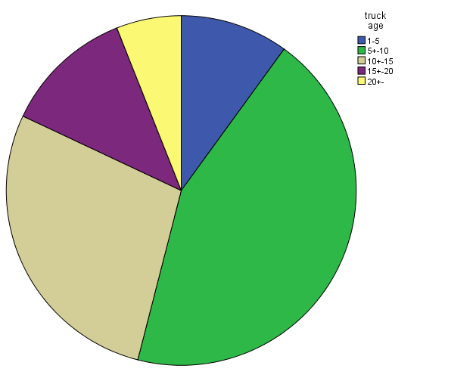
Figure 1. Truck age percentage distribution
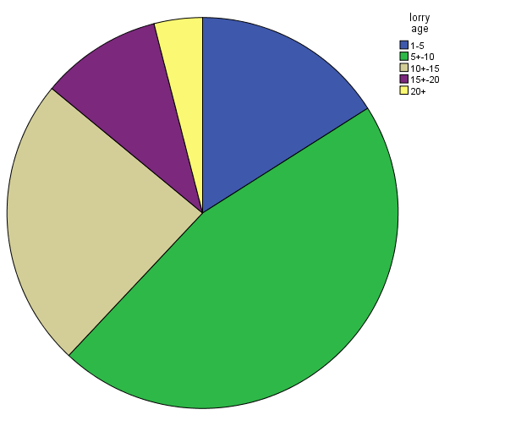
Figure 2. Lorry age percentage distribution
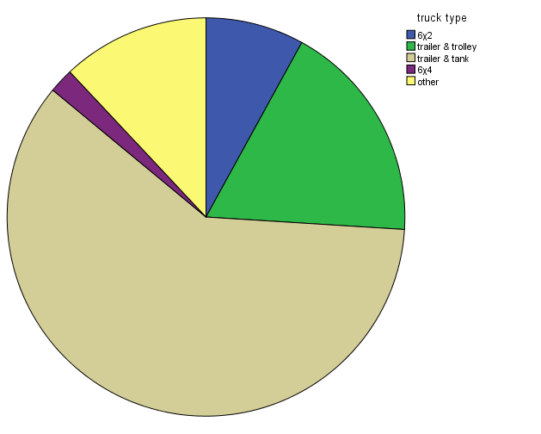

Figure 3. Truck type percentage distribution
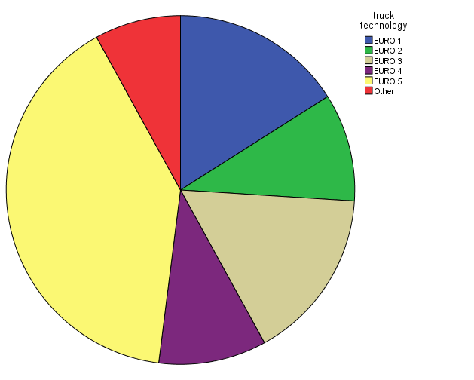
Figure 4. Truck technology percentage distribution

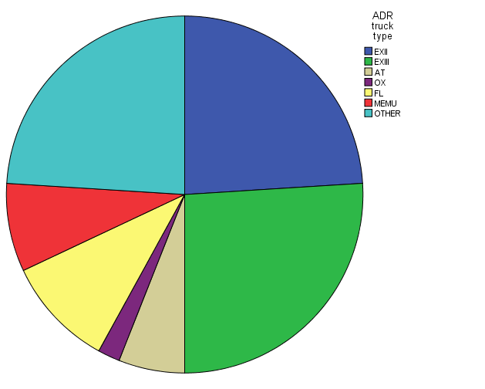

Figure 5. ADR truck type percentage distribution

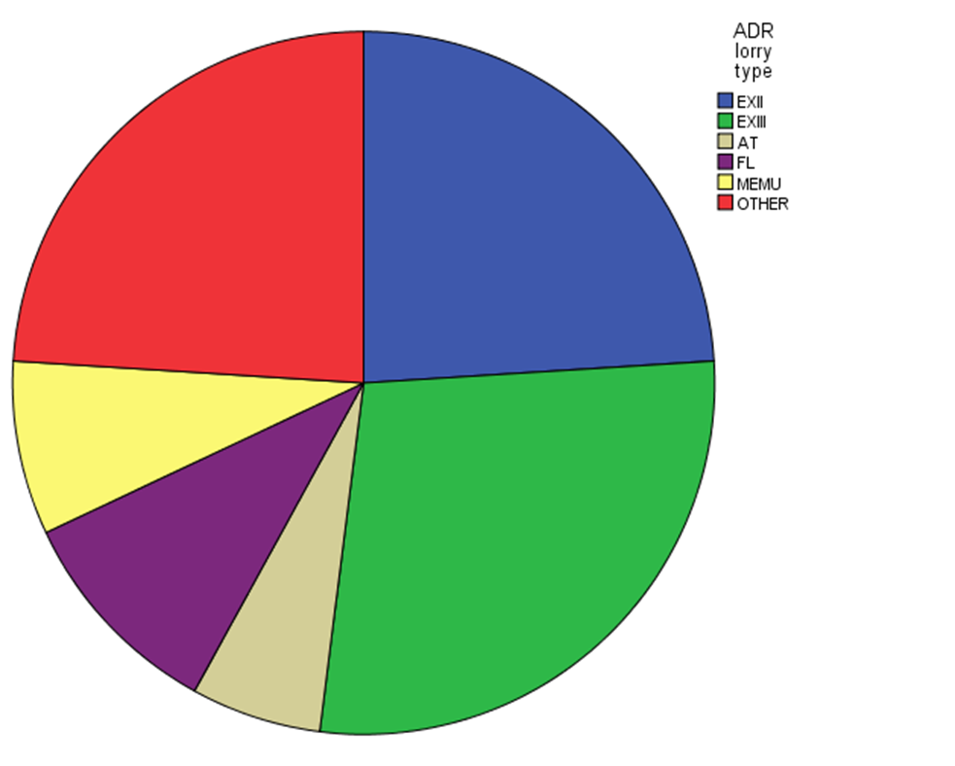
Figure 6. ADR lorry type percentage distribution
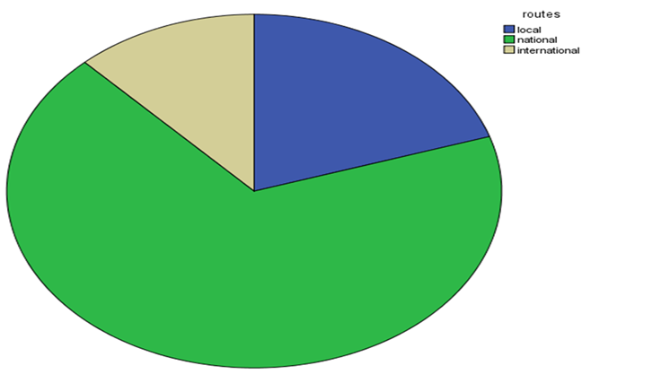
Figure 7 Routes percentage distribution

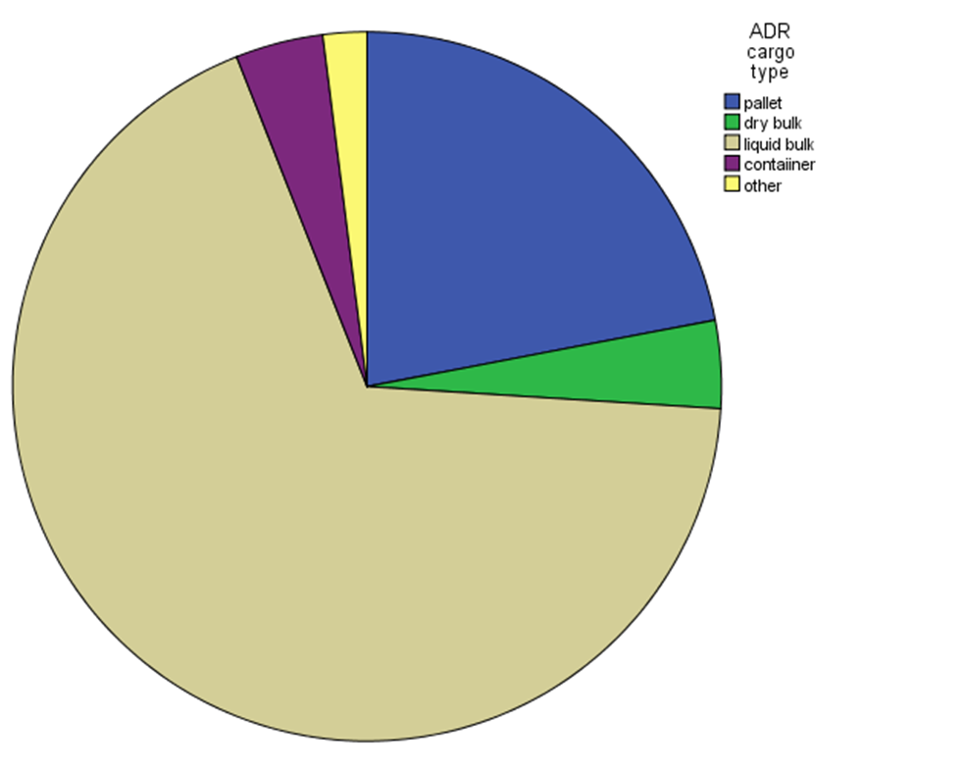
Figure 8. ADR cargo percentage distribution

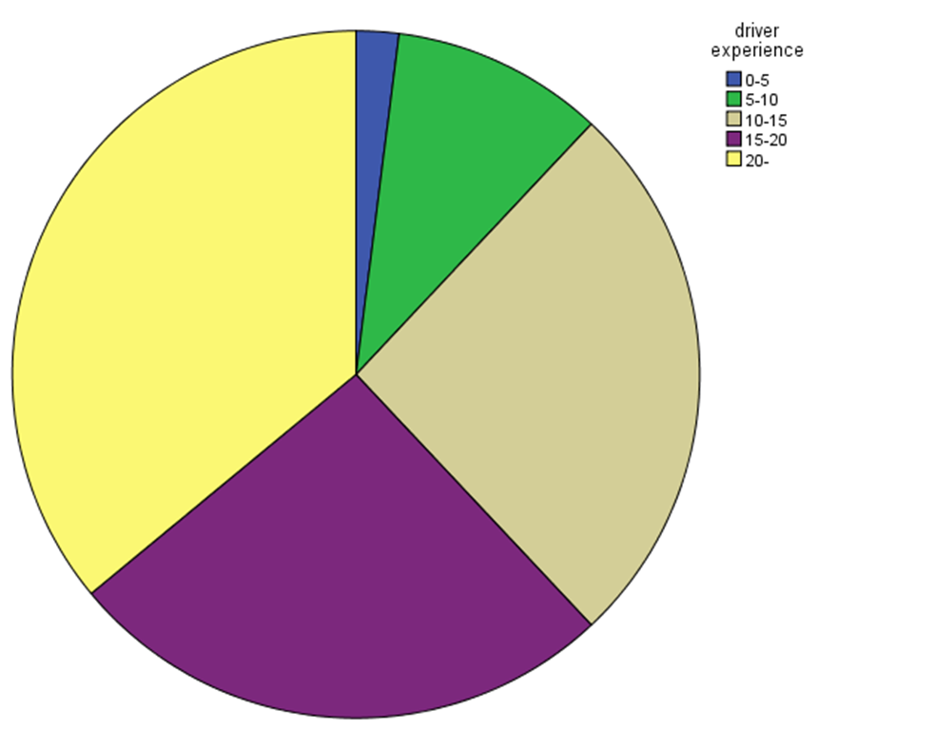
Figure 9. Drivers' experience percentage distribution
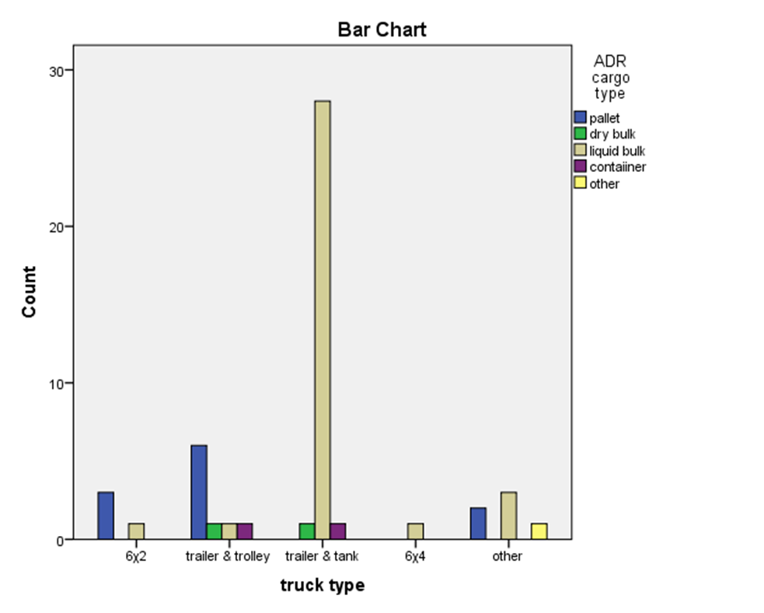
Figure 10. Cross tabulation ADR cargo type and truck type
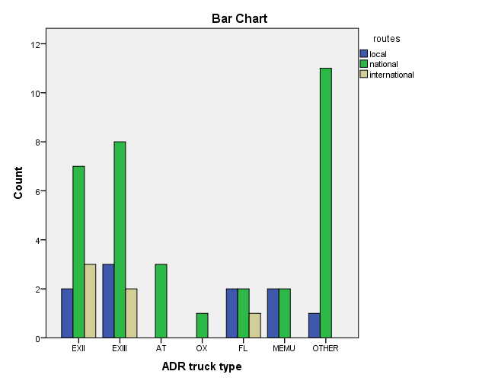
Figure 11. Cross tabulation between ADR truck type and routes
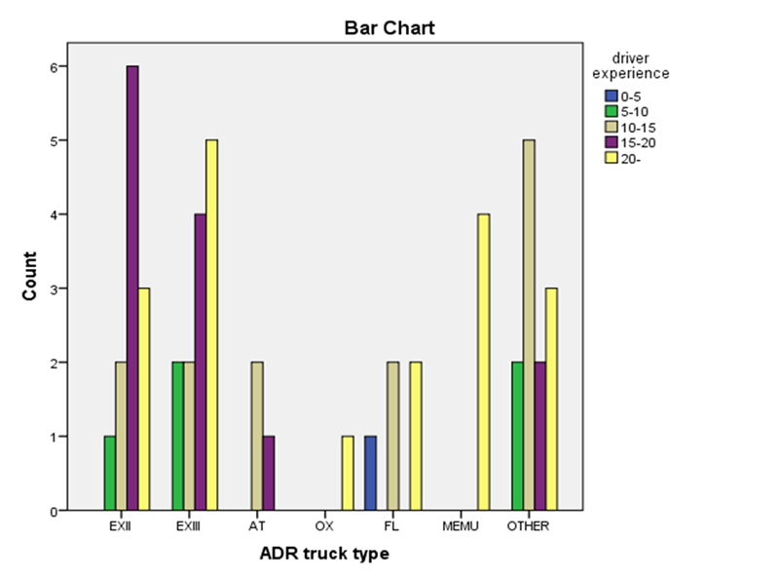
Figure 12. Cross tabulation between ADR truck type and driver experience

