**Structural interpretation of the Mamfe Basin from satellite gravity data (EGM 2008)**

Anatole E. DJIETO LORDON1, Yves N. SHANDINI2,Christopher M. AGYINGI1, Mbohlieu T. YOSSA1, Thierry S. KUISSEU1, Besong Douglas NDIFOR1

1: Department of Geology, University of Buea, P.O.Box 63, Buea, Cameroon

2: Department of Physics, Faculty of Science, University of Yaoundé 1, Yaoundé, Cameroon

**ABSTRACT**

A structural map of the Mamfe basin was produced from multi-scale analysis of EGM2008 derived gravity data. Faults usually restructure sediment architecture possibly forming structural petroleum traps. The Horizontal Gradient Magnitude (HGM) was applied to theEGM2008 gravity data to generate a structural map which exhibits the faults within the Basin. Upward continuation at different heights was first applied to the dataset and HGM later applied at each continuation height to issue a resultant grid which highlighted high gradients which corresponds to the lineaments. The results show faults to be oriented predominantly NE-SW and to a lesser extent in the E-W directions; and also suggest the basement faults could have controlled sediment architecture for the formation of structural traps. The position of the faults on this structural map highly correlates with that of faults represented on the geologic map of the study area, and this implies that this structural map could be used to update the geologic map of the study area.

**INTRODUCTION`**

The Mamfe Basin is an intracratonic inland rift basin in the South West Region of Cameroon that is bounded by latitude 5o30´-6o 10´ N and longitude 8o30´-9o 35´ E(Wilson, 1928; Reyment, 1965; Dumort, 1968). It is a potential petroliferous basindue to its structural and lithostratigraphic connection (Bassey *et al*, 2013; Njoh *et al*., 2014) to the neighboring NW petroliferous Anambra basinin Nigeria (Anothony, Ekine and Onuoha, 2008; Ugochukwu, 2010). Geochemically Eseme *et al.* (2006) reported the presence of high TOC-content mature Cretaceous organic shales in the Mamfe basin. Ndougsa-Mbarga *et al.* (2007) concluded from the processing of geophysical gravity data that there could be oil and gas migration in the Mamfe basin, thereby increasing existing speculation on petroleum possible occurrence of petroleum in the Basin.The aim of this study is to determine lineaments (faults) within the Mamfe basin by multiscale analysis EGM2008 derived gravity data. This method permits to give the position, orientation and dips of faults in the study area.Faults change sediment architecture and increase chances for entrapment of oil and gas in a basin. Hence delineating them in the basin alongside geology and organic geochemistry will help concentrate resources and energy on the most prospective areas of the basin for further exploration.

**TECTONIC SETTING AND GEOLOGY**

The Mamfe basin is the southernmost of the intracontinental rift basins that makeup the West and Central African Rift System (WCARS). It is physically linked to the Y-shaped NE-SW trending Benue Trough which is located between the West African Craton and the Congo Craton; and which runs parallel to the Cameroon Volcanic Line (CVL). The Basin formed as a result of the reactivations of pre-existing Braziliano-Pan-African lineaments by tensional or trans-tensional regime (Rand and Mabesoone, 1982; Benkhelil, 1989; Fairhead and Green, 1989, Guiraud et al., 1992) during the opening of the South Atlantic.

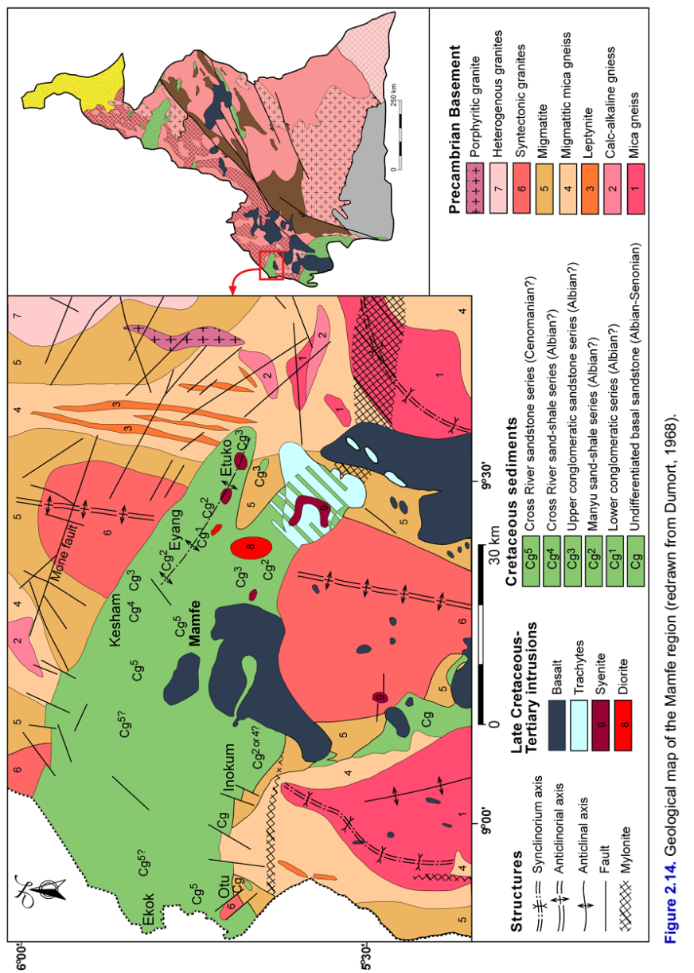The almost E-W trending Mamfe basin is bordered to the south by the Oban Massif granito-gneissic Precambrian Basement Complex which separates it from the Rio del Rey Basin and to the north by the Precambrian rocks of the Obudu Massif. To the west the Basin is open and continues as a part of Anambra basin of Nigeria and in the east and northeast it narrows and terminates under the CVL (**Fig. 1**).Sedimentation began in the Mamfe basin during the Albian (Dumort, 1968) and lithologies making-up the body of sediments are: basal conglomerates, conglomeratic sandstones, mudstones, shales, calcareous and carbonaceous rocks that are highly fractured.The Cretaceous sedimentary rocks were later intruded by syenites and extruded by trachytes and basalts, all of which are Tertiary in age (**Fig. 2**) and are related to the CVL.

**Fig 1**: Geological map of the Mamfe region (adopted from Ajonina, 2016; redrawn from Dumort, 1968).

**DATA AND METHODS**

**Data**

The Bouguer gravity data used in this study were obtainedfrom the Earth Geopotential Model (EGM) 2008 from which the World Gravity Map or Model (WGM) was produced. The World Gravity Map (WGM) denotes a set of high-resolution gravity anomaly maps and digital grids computed at global scale from available reference Earth’s gravity and elevation models. Based on rigorous computations that are consistent with geodetic and geophysical definitions of gravity anomalies, WGM provides homogeneous information on the Earth’s static gravity field at regional and global scales (also available in in digital form) for various geophysical applications in education and research (Bonvalot *et al.*, 2012). Recently, new formulations have been proposed to compute gravity anomalies based on both a realistic Earth model and rigorous geodetic definitions. More details on these modern views of anomaly computation can be found in Featherstone and Dentith (1997), Li and Götze (2001), Hackney and Featherstone (200 3), Hinze *et al*. (2005), NGA (2008) and Kuhn *et al*. (2009).

The EGM2008 model includes surface gravity measurements (from land, marine or airborne surveys), satellite altimetry and satellite gravimetry (GRACE mission) measurements. Updated information on the Arctic gravity field provided by the Technical University of Denmark (Andersen, 2010) and included in the DTU10 global gravity field model (1’x1’ resolution) are also included in the EGM 2008. Thus this makes it certain that though at a regional or global scale (scale of the data is 1:50,000,000) this gravity dataset thoroughly covers the entire world (Bonvalot *et al.*, 2012)) and has gone through the best corrections so far attainable. The Bouguer correction was done with a density of 2670kg/cm3.

**Method**

The Horizontal gradient magnitude (HGM) method is a simple approach to estimating contact locations and depth which measures change of field in x and y directions (Cordell and Grauch, 1985). If ${dg}/{dx}$ and ${dg}/{dy}$ are derivatives in the x and y directions of a gravity fieldg (x,y), then the horizontal gradient magnitude HGM (x,y) is given by:

$HGM \left(x,y\right)=\sqrt{{\left[\frac{dg}{dx}\right]}^{2}+ {\left[\frac{dg}{dy}\right]}^{2}}$ (1)

The following assumption allows the function to peak over gravity contacts:(i), the regional gravity field is vertical, (ii) contacts are vertical and (iii) sources are thick. These assumptions may break down in practice, but the approach remains the least susceptible to noise in the data.

Upward continuation at different heights was first applied to the EGM2008 derived gravity dataset. HGM was then applied to thegrid file at each continuation height and the resultant grid which highlighted high gradients was produced. Being intuitively related to the first derivative of a polynomial function, the steepest gradient locations were given by the local peaks in the gravity gradient function. A window was then passed over the HGM grid in an automated method to fit parabolic peaks that passed through the center of the window. The location of the largest number of peaks was taken as a contact location when a sufficient number (3 to 5) of lined-up peaks or maxima was found.

**RESULTS AND DISCUSSION**

Gridding of the EGM2008 Bouguer gravity data produced a Bouguer anomaly map (**Fig. 3)** which shows a major positive anomaly that trends almost N-S and gradually fades to a gravity low from West to East.

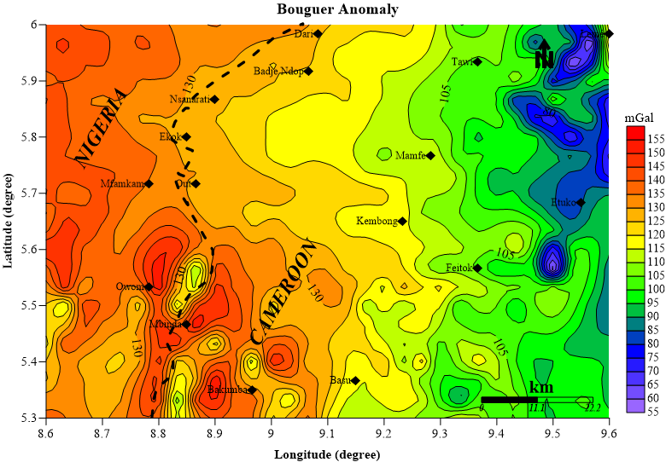

**Fig. 3:** Bouguer anomaly map of the Mamfe basin

This gradual shift of intensity from the West to the East of the map was interpreted as the progressive deepening of the basement from West to East (Nguimbous-kouoh *et al.*, 2012) which is mainly composed of granites and gneisses. The basement is also isostatically compensated in the West by the asthenosphere which is composed of dense mafic minerals (Ndougsa-Mbarga *et al.*, 2007). Variations of high and low Bouguer anomalies observed around Owum, Mbinda and Bakumba which have Bouguer anomaly from 100-140 mGal could be associated to a succession of horsts and grabens (Obi *et al.*, 2013)which are a result of the tectonic activities linked to the formation of the Basin and to the rifting and intrusion of mafic material in the crust. These have also been described from aeromagnetic data by Obi *et al*., (2013).

HGM was applied to upward-continued data at different levels (0 -10 kilometres above measurement surface) to obtain the maps with gradient maximas (**Fig. 4a**).The horizontal gradient maxima for continuation heights 0km, 2km, 4km, 6km, and 10km were superimposed and the progressive migration of the lines of maxima presumed to indicated dipping lineaments (hence their dip directions) and the depth extent of the lineaments in the study area.Digitization of map of horizontal gradient maxima produced a structural map (**Fig. 4b**) of the study area. The structural map shows lineaments in the study area that were formed during different deformational events.

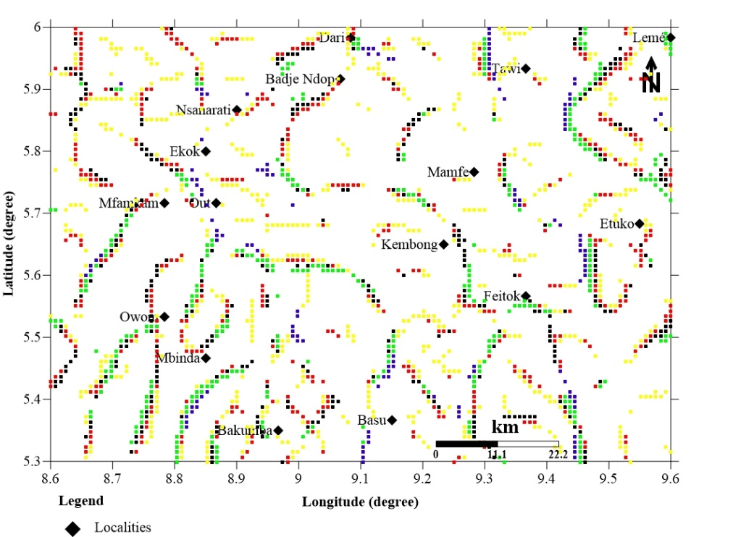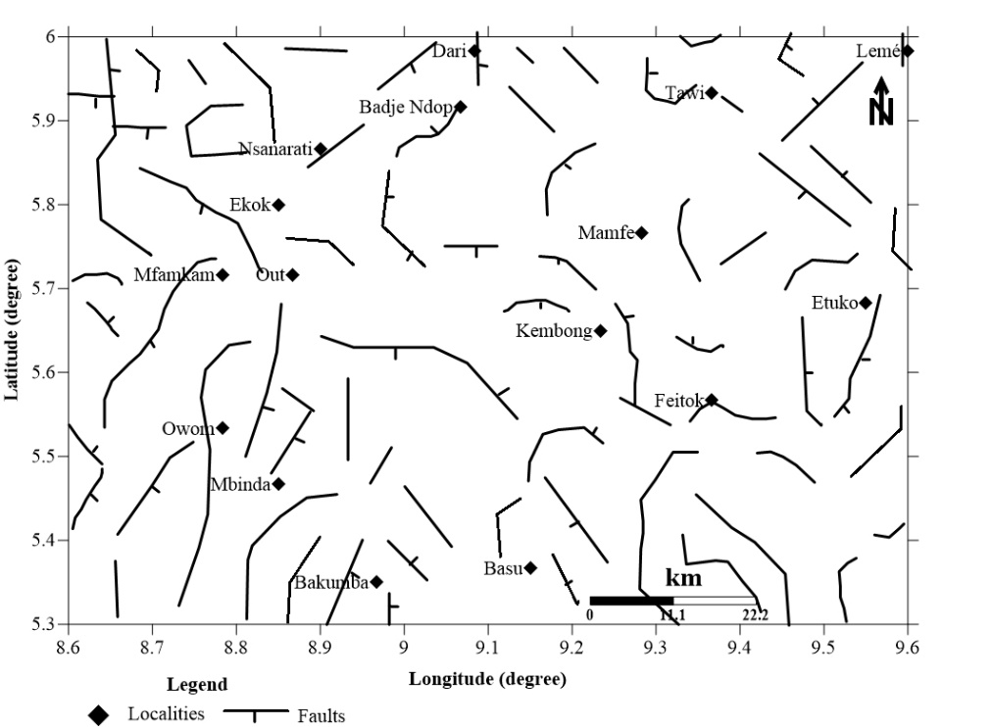

**(a)**

**(b)**

**Fig. 4: (a)**Gravity edge map at different upward continuation heights in km (yellow 0km; red 2km;black 4km; green 8km;blue 10 km). **(b)** Structural map showing the distribution of interpreted gravity faults in the study area.Ticks indicate dip direction

The rose diagram (**Fig. 6**) shows that the faults were formed by three main deformation events.

**N**

**E**

**W**

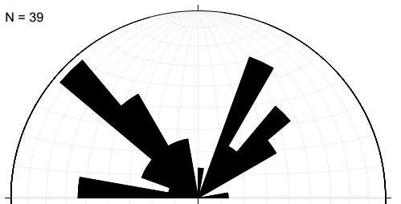

**Fig 6:** Rose diagram showing the major faulting direction (E-W, NW-SE and NE-SW)

**Faults in E-W direction**

There areseven faults with the E-W strike direction that appear principally on the west of the Basin and south to SW of Mamfe town.These faults according to Dumort (1968) were formedas a result of basement rifting associated with the reactivation of NW-SE to E–W trending mylonite zones within the Panafrican basement.

**Faults in NW-SE direction**

The faults with this orientation makeup more than 50% of the faults in the study area. These and those in the E-W direction are attributed to the opening of the Mamfe basin (Dumort, 1968). Some of these NW-SE faults within the Basin was attributed to be the fold axis of the Albian anticlinal Cg1-Cg4Seriesof sediments.Le Fur (1965) reported that the Cg1-Cg4 were folded and actually had a fold axis that trends NW-SE.

**Faults in NE-SW direction**

Most of the faults with this orientation appear in the SW and south (Oban massif) and in the eastand NE (Bamenda highlands) of the study area. They were attributed to fractures that opened during the emplacement of the NE-SW Cameroon Volcanic Line (CVL).

The dipping faults do so generally in two principal directions: SW and NE, and this has been reported by Wilson, (1928); Le Fur, (1965) and Dumort, (1968).

**CONCLUSION**

Horizontal gradient Magnitude of EGM2008 gravity data successfully produced a reliable structural map of the Mamfe basin. The position of the faults on this structural map highly correlates with that of geologically mapped faults on the geologic map of the study area, and this implies that this structural map can be used to update the geologic map of the study area.

The main tectonic events that affected the study area were traced back from the strikes of the faults in the structural map. The deep seated faults that occur within the basin like those NW of Mamfe and the one SW of Badje Ndop could have controlled sedimentarchitecture and hence form structural traps for petroleum accumulation.

**ACKNOWLEDGEMENTS**

We acknowledge the following institution for compiling and making available the dataset used in this work:

* National Geospatial-Intelligence Agency (NGA) and
* Bureau Gravimetric International (BGI)

**REFERENCES**

Ajonina, H. N. (2016): Evolution of Cretaceous sediments in the MamfeBasin, SW Cameroon: Depositional environments,Palynostratigraphy, and Paleogeography. *http://ediss.sub.unihamburg.de/volltexte/2016/8260/pdf/Dissertation.pdf*

Andersen, O., (2010): The DTU10 Global Gravity field and mean sea surface – *Improvements in the Arctic. 2nd IGFS meeting*, Fairbanks, Alaska.

Anthony, .S. Ekine, K. M., Onuoha (2008). ["Burial History Analysis and Subsidence in the Anambra Basin, Nigeria"](http://www.ajol.info/index.php/njphy/article/viewFile/38166/7325). Department of Physics University Of Port Harcourt, Nigeria; Department of Geology University of Nigeria, Nsukka, Nigeria. *www.ajol.info*.

Bassey, C. E., Oboho, O. E., Ajonina, H. N., (2013): Stratigraphy and depositional environments of the Mamfe formation and its implication on the tectono-sedimentary evolution of the Ikom-Mamfe Embayment. *West Africa. Central European Journal of Geoscience*, Vol. 5, 394-406.

Bonvalot, S., Balmino, G., Briais, A., Kuhn, M., Peyrefitte, A., Vales, N., Biancale, R., Gabalda, G., Moreaux, G., Reinquin, F., Sarrailh, M., (2012): *WORLD GRAVITY MAP 1ST EDITION*, Bureau Gravimetric international.

Cordell, L. and Grauch V. J. S., (1985): Mapping basement magnetization zones from aeromagnetic data in the San Juan Basin, New Mexico, in Hinze, W J , Ed , The utility of regional gravity and magnetic anomaly maps; *Society of Exploration Geophysicists* , 181-197

Dumort, J. C. (1968): Carte géologique de reconnaissance à l’échelle 1/50000. *Note explicative sur la feuille Douala-Ouest*. République Fédérale du Cameroun. Direction des Mines et de Géologie du Cameroun, 69.

Featherstone, W.E., Dentith, M.C., (1997). A geodetic approach *to* gravity data reduction for geophysics. *Computers & Geosciences*,Vol. 23, No. 10, pp. 1063-1070, 1997.

Hackney, R.I., Featherstone, W. E., (2003): Geodetic versus geophysical perspectives of the 'gravity anomaly'. *Geophysical Journal Int.*, 154 (1): 35-43.

Hinze, W. J., Aiken, C., Brozena, J., Coakley, B., Oater, D., Flanagan, G., Forsberg, R., Hildebrand, T., Keller, G. R., Kellogg, J., (2005): New standards for reducing gravity data: The North American gravity database. *Geophysics*, 70, J25–J32.

Kuhn, M., Featherstone, W.E., Kirby, J.F., 2009. Complete spherical Bouguer gravity anomalies over Australia. Australian.*Journal of Earth Sciences*, 56: 213-223.

Le Fur, Y. (1965): Rapport spécial sur les recherches de corindonsgemmes. Mission socle-crétacé, Mamfé YAO 666A8. *Archives Bureau des Recherches Geologique et Minieres*, 69 p.

Li, X., and Götze, H.J., (2001) Ellipsoid, geoid, gravity, geodesy and geophysics. *Geophysics*, 66 (6): 1660-1668.

Ndougsa-Mbarga, T., Manguelle-Dicoum, E., Campos-Enriquez, J. O. and Atangana, Q. Y., (2007): Gravity Anomalies, Sub-Surface Structure and Oil and Gas Migration in the Mamfe, Cameroon-Nigeria, Sedimentary Basin. *Geofísica Internacional*, Vol. 46, 129-139.

NGA (2008) Gravity station data format and anomaly computations. *Technical Report*, Geospatial Sciences Division, St Louis (Mo).

Nguimbous-Kouoh, J. J., Takougang, E. M. T., Nouayou, Tabod T. C. and Manguelle-Dicoum, E., (2012): Department of structural Interpretation of the Mamfe sedimentary basin of Southwestern Cameroon along the Manyu River using audiomagnetotellurics survey. International ScholarlyResearch Network ISRN. *Geophysics*, Vol. 2, 7 pages.

Njoh, O. A., Essien, J. A. and Tembi A., (2014): Albian-Turonian palynomorphs from Mundeck and Logbadjeck Formations, Ediki River, north-western part of the Douala Sub-basin, Cameroon. Science, *Technologies et Development*, Vol. 15, 66-77.

Obi, D., A., Obi, E. O., Okiwelu, A. A., (2013): Basinal Configuration And Intrasediment Intrusives As RevealedBy Aeromagnetics Data Of South East Sector Of Mamfe Basin,Nigeria. Journal of Applied Geology and Geophysics, Vol. 1, 1-8.

Reyment, R. A., 1965. *Aspects of the geology of Nigeria*. Ibadan University press, Ibadan, 145 pp.

Ugochukwu, I. P., (2010):[Subsurface Evaluation of Source Rock and Hydrocarbon Potential of the Anambra Basin, South Eastern Nigeria](http://www.bookpump.com/dps/pdf-b/9423391b.pdf). Dissertation.com Boca Raton, Florida, USA. [ISBN](https://en.wikipedia.org/wiki/International_Standard_Book_Number) [1-59942-339-1](https://en.wikipedia.org/wiki/Special:BookSources/1-59942-339-1). *w*ww.bookpump.com.

Wilson, R. C., 1928. *Notes on the Geology of the Mamfe Division, Cameroons Province*. Geological Survey of Nigeria Occasional Paper # **6**, 23 pp.