LITHOLOGICAL DEFORMATION AND ITS EFFECT ON MINERALIZATION IN MIGORI GREENSTONE BELT, KENYA
Odek Antony¹- odekantony@gmail.com
¹Chuka University, Physical Science Department, P.O Box 109-60400, Chuka

Abstract
Migori greenstone belt is located between the western and eastern branches of the east African rift system, due to the divergent nature of these branches; the lithosphere between the two is suspected to be under compression forces. The resultant lithological deformation is expected to directly affect the mineralization within the prospect. This study was conducted to map the structural deformations and their contribution to mineralization within the belt. 2D forward modeling of gravity data using Geosoft computer program was carried out along four profiles. This was done in an attempt to locate the anomalous structures and their parameters by attaining the best fit between the observed gravity anomalies and the calculated responses. Forward modeling reveal a series of folding and dike like structures which probably occurred as a result of the deformation of the lithosphere of which Migori greenstone belt forms part. This must have occurred from Permian times to the Miocene. From the forward models, the mineral rich layer is brought closer to the surface at a depth of approximately between 0-500 m, majorly at the crests of the folds as a result of the lithological deformation. This explains the discontinuous shallow existence and outcropping of minerals along the belt.

Key words: Lithosphere, Gravity, Anomalies, Migori greenstone belt, Modeling

1 Introduction
The success story of gold mining in Migori Greenstone belt, (especially the history of Macalder mine, situated to the north-west of Migori town, in the south western Kenya) is a clear indication of the potential of this prospect in terms of mineral production. The continuous exploration of minerals within this belt has led to depletion of the mineral outcrops which initially could be worked on by the local artisans. This has resulted in evolution of mining methods from surface to sub-surface based, hence the necessity for a better understanding of the nature of distribution of the minerals.

Migori greenstone belt is squeezed between the diapiric Migori granite batholith to the south and a felsic volcanic succession to the north. The structure of the Migori greenstone belt appears to reflect diapiric movements of the Migori Granite batholiths. The geology of the area consists of Archean greenstone belt that surrounds Lake Victoria. The Archean rocks in this area are principally of the Nyanzian system, the Kavirondian system and the post-Kavirondian granites (Shackleton, 1946).

Gravity and magnetic methods have evolved from their sole use for mapping basement structures to include a wide range of applications, such as locating intra-sedimentary faults, defining subtle lithological contacts, mapping salt domes in weakly magnetic sediments and better defining targets through 3D inversion (Nabighian et al., 2005). These physical properties can be interpreted in terms of lithology and/or geological processes and their geometric distributions can help delineate geological structures and can be used as an aid to determine mineralization and subsequent drilling target (Philips et al., 2010).

Where the shapes and depths of anomaly sources are important, gravity and magnetic data are usually interpreted by the method of forward modeling. The gravity field of a subsurface model is prepared using all available geological information and compared with the field actually observed. The model is then modified, within the limits set by the geological constraints, until a satisfactory level of agreement is reached between calculation and observation.

2 Methodology
Four gravity profiles were taken on the complete bouguer anomaly contour map of Migori greenstone belt, bounded by the latitudes 34⁰15’ E, -34⁰40’ E and longitudes 0⁰55’ S, 1⁰12’ S. Ground Gravity data from 490 gravity stations was collected using Worden gravity meter model Prospector 410. Profiles AA’, BB’ and CC’ were taken perpendicular to the belt, while profile DD’ targeted the potential variations along the belt (Figure 1.1). The observed curve and the calculated curve obtained by building a model under the profile using the available geological information were displayed.
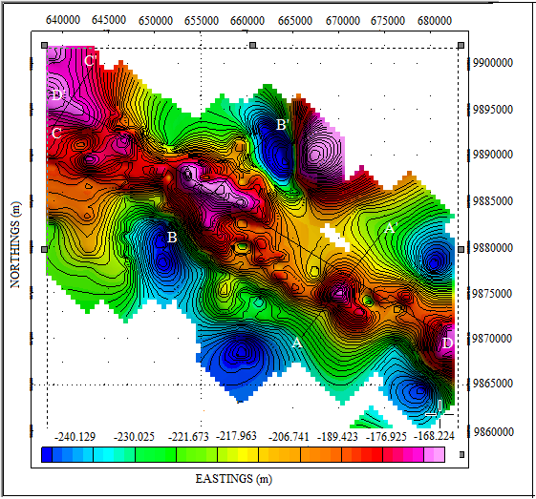

Figure 1.1: Selected profiles on the complete Buguer anomaly signature

The modifications to the models were performed interactively on a computer screen which shows both the model and the gravity data. Two-dimensional (2-D) approximations were used in which the geology was assumed not to vary at right angles to the line of profile and section. The 2-D approximation is generally adequate provided that the strike length of the anomaly is at least three times as great as the cross-strike width (Parasnis, 1986).

In this study, the startup model average depth of 500 m was obtained from the direct interpretations in spectral power analysis (Figure 1.2) and Werner deconvolution of the magnetic data (Figure 1.3). Different horizontal layers of rock were taken with the targeted mineral rich layer at a start up depth of approximately 500 m (Odek et al, 2018). Crustal densities of 2.38 g/cm³ and 2.63 g/cm³ were measured using instantaneous water immersion method from rock samples obtained at depths of approximately 20 m and 100 m respectively from an existing mine. The model shape, depth and density were modified within the limits set by the geological constraints to obtain a fit between the observed and the calculated. The mathematical background of the calculated curve is based on the Talwani dike model procedures (Keary et al, 2002); this was done using Geosoft Oasis montaj application software. The models obtained correlated well with the available geological report which documents presence of shallow dikes and mineral outcrops.

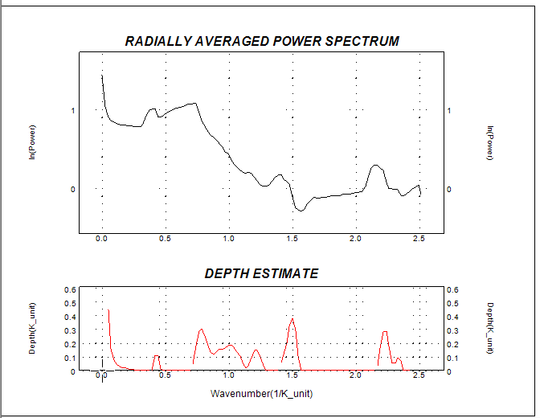
Figure 1.2: Computed power spectrum of the magnetic anomaly

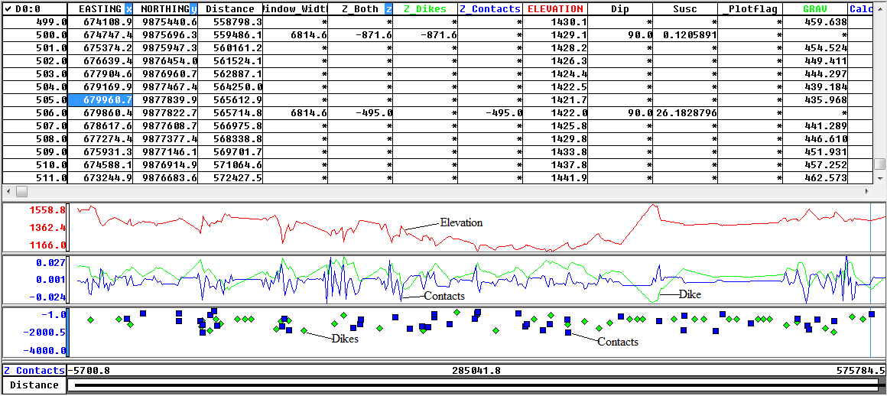

Figure 1.3: Werner solutions along profile DD’

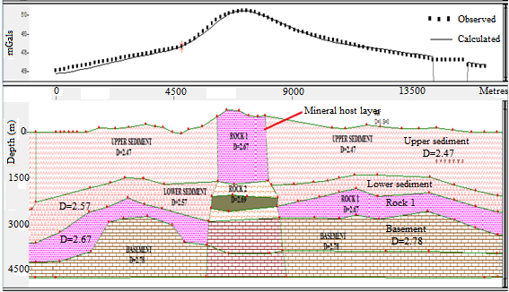

Figure 1.4: Forward model a long profile AA’

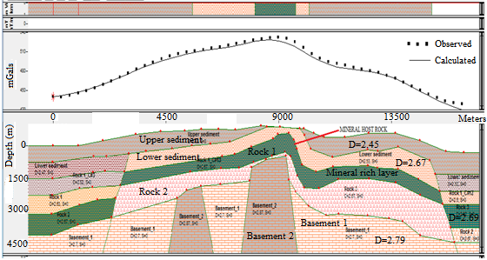

Figure 1.5: Forward model a long profile BB’

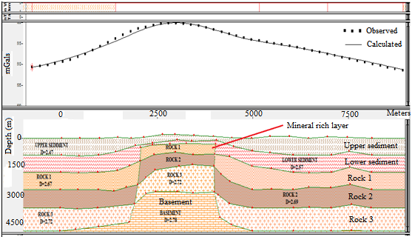

Figure 1.6: Forward model a long profile CC’

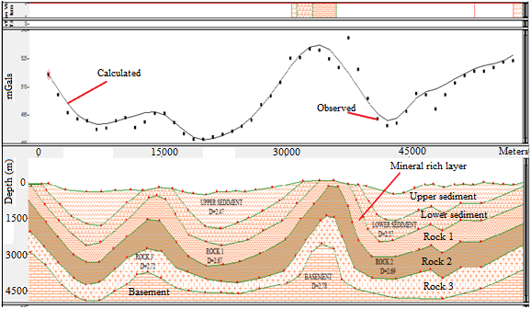

Figure 1.7: Forward model of gravity data a long profile DD’

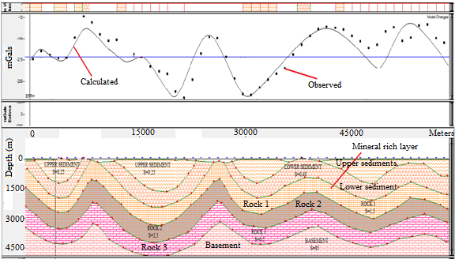
Figure 1.8: Forward model of magnetic data a long profile DD’
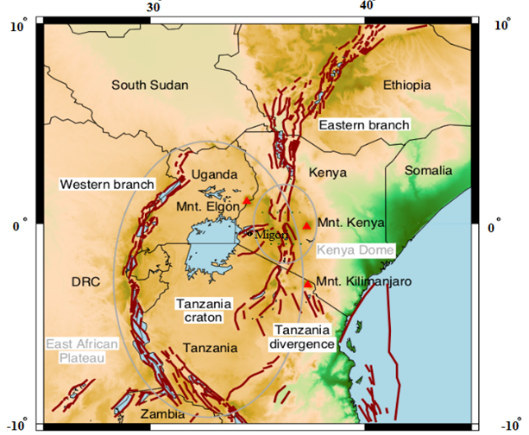

Figure 1.9: Topography (Amante & Eakins, 2009) and fault traces (GEM) of the central EARS

Discussions and Conclusion
Profiles AA’ (Figure 1.4), BB’ (Figure 1.5) and CC’ (Figure 1.6) are modeled as dikes. Profile DD’ (Figure 1.7) which was taken along the gravity anomaly was modeled as a series of folds. The crests of the fold model coincide with high mineral potential areas of Kehancha, Nyanchabo, Migori, Mukuro, Masara and Macalder. This is supported by the fact that Migori greenstone belt is located between the western and eastern branches of the east African rift system (Figure 1.8), due to the divergent nature of these branches; the lithosphere between the two is subjected to compression forces leading to folding. The folds expose the mineral reach layer to the surface.

Quantitative interpretation done using forward modelling reveals dyke like structures along profiles AA’, BB’ and CC’ with a series of folds along the anomaly profile DD’. The fold exposes the mineral rich layer at the crests. These causative structures are associated with granitic intrusive characterised by banded iron formations that also act as a host for other minerals.

Recommendation
My gratitude to National Research Fund (NRF) and Chuka University for their financial support. I am are also grateful to both Jomo Kenyatta University of Agriculture and Technology and Kenyatta University for the research equipment and technical support.

References
Amante C. and Eakins B.W., 2009, NOAA Technical memorandum NESDISNGDC-24. National Geophysical data centre, NOAA.
Geosoft (Oasis Montaj) program, Geosoft mapping and Application system. Inc. Suit 500, Richmond St. West Toronto, ON Canada N5S1V6. User’s Manual 2007.
Keary P., Brooks M. and Hill I. (2002). An Introduction to Geophysical Exploration. London: Blackwell Scientific Publications.
Nabighian M.N., Grauch V.J.S., Hansen R.O., Lafehr T.R., Li Y., Peirce J.W., Philips J.D. and Ruder M.E. (2005). The historical development of the magnetic method in exploration geophysics. Society of exploration Geophysics 70 (6).
Odek A., Githiri J.G., K’Orowe M. and Ambusso W. (2018) Spectral power analysis and edge detection of magnetic data of Migori greenstone belt, Kenya. IOSR JAGS
Philips N., Nguyen T.N.H., Thomson V., Oldenburg D., Kowalezyk P. (2010). 3D inversion modelling, integration and visualization of airborne gravity, magnetic and electromagnetic data Advanced Geophysical Interpretation centre, Vancouver, B.C. Canada.
Parasnis D.S. (1986). Principles of Applied Geophysics. Chapman and Hall, U.S.A. 61-103
Shackleton R.M. (1946). Geology of Migori Gold belt and adjoining areas. Geological survey of Kenya, Mining and Geological Department Kenya, Rept. 10: 60.

