**MATHEMATICAL MODEL OF THE IMPACT OF RETROVIRAL DRUGS AT THE EARLY STAGE OF INFECTION IN CONTROL PROGRAM OF HIV/AIDS.**

1Bruno O. Onyemegbulem, 2Joel N. Ndam 3Vincent Ele Asor 4Aguiyi J.C.

1,4African Center of Excellence in Phytomedicine Research and Development, University of Jos, Nigeria.

2Department of Mathematics, University of Jos, Nigeria.

3Micheal Okpara University of Agriculture Umudike, Abia state Nigeria

1[brunomaths1@yahoo.com](mailto:brunomaths1@yahoo.com), 2[ndamj@unijos.edu.ng](mailto:ndamj@unijos.edu.ng), [3Vincent.asor@gmail.com](mailto:3Vincent.asor@gmail.com)

**Abstract**

In this work we developed a compartmental model of HIV/AIDS. The results of this study provide some insights on the impact of early treatment on disease transmission dynamics of HIV/AIDS. The stability of the disease-free equilibrium was investigated, condition for the stability of the disease free equilibrium were determined. We also carried out sensitivity analysis to determine the relevant parameter control of the disease. Furthermore, qualitative analysis of the model was investigated using Runge Kutta scheme. From our above results, we found that treatment that commerce within 72hours of risky exposure is the best way to stop HIV proliferation.

1. **INTRODUCTION**

HIV/AIDS have remained one of the problems that has led to multidimensional crisis in the health sector [1-5]. Statistics provided by Joint United Nations Programme on HIV/AIDS (UNAIDS) shows that an estimate of 22.4 million(20.8million-24.1million) people (women account for approximate of 60%) were living with HIV in sub-Saharan Africa by the end of 2008. 68% and 91% of new HIV infections was recorded among children and adults respectively [6-8]. As of 2006, UNAIDS recorded 3.1 million deaths as a result of AIDS, 4.9 million people infected with HIV,40.3 million of people living with the virus worldwide [9,10]. After 10 years, UNAIDS recorded more than 36.7 million people living with HIV by the end of 2016 [9,10]. The other major challenge is that many people who are affected in most parts of sub-Sahara Africa, Europe and Asia are not even aware of their status and some that are aware of their infection do not always take necessary precautions when engaging in sexual interactions [4]. The challenge posed by the number of cases calls for urgent need to come up with strategies to prevent and control the spread of HIV/AIDS. In a bid to address this menace, the World health organization WHO introduced HIV medication regimen called antiretroviral therapy (ART) to prolong the lives of those already infected with the disease. Moreover, what happens when someone has been exposed to HIV? Unfortunately, most people don’t know the efficacy of anti-HIV drugs as an option in the event of a high-risk behavior that could result to being infected [11].

Research conducted by [12, 13] provided evidence on effectiveness of post exposure prophylaxis against HIV, on compliance to treatment initiated within the period of 72 hours of risky exposure. Research carried out by [15] significantly shows the impact of anti-retroviral therapy in reducing the risk of HIV transmission from mother-to child during pregnancy, labor and child birth. On this account, Post Exposure Prophylaxis is administered to HIV pregnant women to reduce their chance of transmitting the virus to their baby via breast feeding and during child delivery “The dramatic success of the prevention of mother-to child transmission with the use of anti- HIV drugs suggests that PEP may also provide protection against other routes of HIV exposure” [11]. Research conducted by [16,17,18] shows that PEP reduces risk of HIV infection based on initiation timing and to the degree in which the exposed comply to treatment.

Post-exposure prophylaxis is not cure for HIV, its servers as HIV prevention when 30 days treatment course is initiated within 72 hours of exposure to HIV. On the other hand, if HIV is diagnosed in the course of treatment, PEP is changed to HAART (Highly Active Antiretroviral Therapy) to treat the person’s HIV infection.

Once HIV enters the body, it attacks the class of lymphocytes or white blood cells known as CD4+ T Cells. Antibodies and cytotoxic lymphocytes are being produced as a response to the virus which is known as sero-conversion. Because of the central role of *CD*4+ *T* cells in immune regulation, their depletion has widespread deleterious effects on the functioning of the immune system and leads to immunodeficiency that characterizes AIDS [20]. When the age of infection increases, HIV infection leads to a severe reduction in the number of T-helper cells which are responsible for helping fight the diseases. If antiretroviral treatment is administered immediately after exposure, referred to as post-exposure prophylaxis, it reduces the risk of infection if begun as quickly as possible [21,12, 13,16,17,18]. “In the absence of HAART, progression from HIV infection to AIDS has been observed to occur at an average of between nine to ten years and the median survival time after developing AIDS is only 9.2 months”. This means that HAART is encouraged to start as early as possible to promote life expectancy [12,13,17].

Mathematical modelling over the years have been used to understand diseases dynamics, such as HIV/AIDS, Malaria and Tuberculosis., and plays an important role in the better understanding of epidemiological patterns for disease control [4]. Many studies have been developed to analyze mathematically the impact of the screening, treatment and free giving of anti-retroviral therapy on the spread of HIV infections [21].

Maimunah, Dipo Aldila (2018) [22]. Established a deterministic mathematical model to study the spread of HIV with an ART treatment intervention. The ART intervention in the model was only given to the infected humans in a chronic infected category. The results from the model established the importance of treatment to infected population.

Marsudi *Et al* (2017) [1] presented a deterministic model for the transmission dynamics of HIV/AIDS in which they concluded that condoms campaigns and antiretroviral therapy were both important for management of the disease.

Omondi *Et al* (2018) [22] on the other hand employed a deterministic model to provide a quantification of HIV prevention, testing and treatment with ART as public health measure to fight HIV infection. This study as well presented a deterministic model for predicting the epidemiological trends of HIV that exploits HIV surveillance data to model the disease evolution in Kenya.

Su*, Et al* (2016) [23] constructed a deterministic transmission model of HIV using surveillance and treatment data for the period 2005-2008. The authors then validated the model by comparing its predicted value of HIV prevalence in 2010 to the prevalence data of 2010.

Bhunu etal (2011) [24] presented a mathematical analysis of an HIV/AIDS model on Impact of educational programs and abstinence in sub Saharan Africa. They formulated a deterministic HIV/AIDS model to theoretically investigate how counselling and testing coupled with the resulting decrease in sexual activity could affect the HIV epidemic in resource-limited communities with the conclusion that formalized information, education, and communication strategy to be given prominence in educational campaigns

In a similar research, Moffat etal (2017) [8] examines a mathematical modelling and analysis of HIV/AIDS and transmission dynamics influenced by public health education campaign. Some parameter values of the system exhibit steady state bifurcation, with conclusion that infective population increases with respect to increase in rate of transmission.

R.safiel et al (2012) [25] used ordinary nonlinear differential equations to assess the effects of vaccination on the spread of HIV/AIDS in homogenous populations. From this study, it was concluded that the most effective way with incidence rate and lower prevalence rate is population education that makes them aware of the consequences of free sex and the need for preventive measures against infection. Among many others.

None of these existing models considered impact of early treatment within 72hours of exposure. On this note, we intend to examine the impact of early treatment of someone who has been exposed to an event of a high- risk behavior that could result in being exposed to HIV.

We built a mathematical model to explore the impact of initiation timing of PEP in order to address HIV infection. The model we consider in this paper is an improved model of [6,1,25,22] by the including (Exposed class, Treated un-infectives and Recovered class) with the assumption that individuals exposed to HIV recover from treatment if they enroll and adhere strictly to PEP 30days course initiated within 72hours of exposure. In this study, we intend to qualitatively analyze the nonlinear system in order to determine the positivity of the solution, sensitivity of parameters, the conditions for existence and the stability of the disease-free equilibrium points. Analysis of the model will allow us to determine the impact of early treatment on the transmission of HIV infection in a population.

The remaining parts of the paper are organized as follows: In section 2, we develope a mathematical model that describes the dynamics of HIV/AIDS and the underlying assumptions. Qualitative analysis of the nonlinear system will be carried out in order to determine the positivity and boundedness of the solution as well as existence and uniqueness of solutions. In section 3, we analyze the model using next generation matrix approach and Routh-Hurwitz criterion to determine stability of the disease-free equilibrium. Sensitivity analysis will be carried out using normalized forward index, to determine relevant parameters in the control of HIV. In section 4, we will quantitatively analyze the model using fourth order of Runge Kutta scheme. Our conclusions are presented in Section 5.

**2. MODEL FORMULATION**

**2.1 Basic Assumptions (without loss of generality):**

* Susceptible population is generated by two sources; birth rate and immigration rate.
$\frac{dE}{dt}≤72 hours$

* No individual with AIDS is receiving antiretroviral therapy.
* The disease is **only** transmitted through sexual intercourse (we have omitted transfusion and mother-to-child transmission).
* Those in the AIDS class are assumed to be too ill to have sex or they are isolated.
* The force of infection is assumed to be frequency- dependent.
* Infective will first be unaware before knowing their status, probably after going for test.
* Exposed individual that are sensitive early move to treated class due to early notification. This is normally within 72 hours. This notification is made known by an Infective who already knows his/her HIV Status.
*  explained in table 1
* No permanent immunity after treatment.
* The population is heterogeneous, i.e. in a broad sense, diversity, variety.

**2.2 Statement of The Problem**

The development to reduce the spread of HIV/AIDS infections necessitates decisive measures to curb the epidemic. Sustaining minimized number of humans with incidence of HIV with adequate control can be attained by developing a suitable mathematical model to enable us understand dynamics and control of the epidemic.  
The mathematical analysis of the compartmental models leads us to eight coupled systems of nonlinear ordinary differential equations.

In this section we develop a compartmental bio-mathematical model to examine the impact of retroviral drugs at the early stage of infection in control program of HIV/AIDS

The total population at time  is denoted by and the model has eight compartments of susceptibles, Exposed , Treated Un-infectives , Recovered , Unscreened infective, Screened infective , Treated infective , AIDS class . Where  is given as



The susceptible class , are individuals that have not contacted the infection but stand the chance of being infected through sexual contacts with infected individuals.  represents the number of unscreened infectives.  represents the number of HIV positive individuals that are diagnosed of infection by way of medical screening.  represents the number of HIV positive individuals in pre-aids stage receiving antiretroviral therapy. represents the number of individuals with full-blown AIDS.  represents the number of individuals that seek treatment within 72hours of risky exposure.  represents individuals that have recovered as a result of treatment.

Description of variables and parameters are provided in table 1 and 2 below

**Table 1 Description of Variables**

|  |  |
| --- | --- |
| **Symbol** | **Description** |
|  | Susceptible Population at time *t.* |
|  | Treated Un-infectives |
|  | Recovered Individuals. |
|  | Exposed Population. |
|  | Unscreened Infectives population at time *t* |
|  | Screened Infectives Population at time *t* |
|  | Treated Infectives |
|  | AIDS patients at time *t* |
|  | Total population at time *t* |

**Table 2 Parameters of the model**

|  |  |
| --- | --- |
| **Symbol** | **Description** |
|  | Birth and immigrant rate. |
|  | Progression rate of unaware infected to AIDS class. |
|  | Rate at which HIV infectives on treatment develop AIDS. |
|  | The rate at which unaware infective transmit infection. |
|  | The rate at which screened infective transmit infection. |
|  | Transmission rate of treated infectives. |
|  | Force of infection. |
|  | Rate at which recovered individuals become susceptible. |
| c | Number of sexual partners. |
|  | Progression rate at which screened infectives move to AIDS class. |
|  | Early treatment rate before 72hours of HIV exposure. |
|  | Recovery rate. |
|  | Rate at which infectives are recruited. |
|  | Disease induced death rate. |
|  | Treatment rate of infectives that seek treatment after 72hours of HIV exposure. |
|  | Screening rate. |
|  | Immunity loss rate of uninfected individuals. |
|  | Natural death rate |



**Figure 1; Compartmental Model of HIV**

**THE GOVERNING EQUATIONS FOR THE MODEL**

 (1)

 (2)

 (3)

(4)

 (5)**** (6)

 (7)

 (8)

Where, is the force of infection given by

, , 

Adding the system of equations (1-8) we get

 (9)

**2.4 Invariant region**

**Proposition**: There exist a domain  in which the solution set is contained.

Proof: given the solution set with non-negative initial condition.

 (10)

Solving the inequality,

****, *K* is constant.

Take limit as 



Thefeasible region for the model (1-8) confined is given by , which is positively invariant.

It remains to show that the solutions of system (1-8) are nonnegative in  for any time t > 0 since the model represents human populations.

**2.5 Positivity and boundedness of solutions**

HIV/AIDS transmition model (1-8) is epidemiological meaningful when solutions with non-negative initial data remain non-negative for all time.  
**Theorem 2**. The solutions  of the HIV/AIDS model (1-8) with non-negative initial data in the feasible domain , remain nonnegative in  for all t > 0.

**P**roof: Proving using idea of [26]

From equation (1-8)



Integrating we have, 

Following the above procedure, from equations (1-8), we obtain respectively the positivity conditions;

**,** ,,,, 

Furthermore, we need to show that the region  is positively invariant. RHS of (10) is bounded by it follows that  if , using a standard comparison theorem [26]

We have that,



If  then  which implies that  is positively invariant. Then the solution enters in finite time or  approaches  asymptotically as the infected variable  approaches zero.

**2.6 Existence and Uniqueness of Solutions for the Model**

**Theorem 3;** let denote the region ,  where and suppose that satisfies the Lipschitz condition . Whenever the pairs  and belong to , where k is a positive constant, then there exist a constant such that there exist unique continuous vector solution  of the system in the interval . It is important to note that the condition is satisfied by requirement that , , be continuous and bounded in [27].

**Theorem 4**: let  denote the region . Then the system of equations has a unique solution, if , are continuous and bounded in . Using Lipchitz condition to verify the existence and uniqueness of the system to equation (1-8).

Let

 (10)

 (11) ** (**12)

 (13)

 (14)

 (15)

 (16)

** (**17**)**

The partial derivative of yield

**;**   

As clearly shown above, the partial derivatives of the whole system of equations exist, they are finite and bounded. Hence by theorem 1, the whole model system has a unique solution.

1. **MATHEMATICAL ANALYSIS OF THE MODEL**

In this section we qualitatively analyze the nonlinear system (1-8) to enable us to determine the stability of the disease-free equilibrium points and the sensitivity of the parameters. Analysis of the model enables determine if the disease become endemic in a population or not.

**3.1 Disease Free Equilibrium**

We want to study how the population changes when it is disease free. We assume the absence of HIV; therefore, we equate.. Hence the disease-free equilibrium is given as .

The DFE indicates that in the absence of HIV, the susceptible changes in proportion to the ratio of their recruitment rate to the death rate.

**3.2 Reproduction Ratio**

An important notion in epidemiological models is the basic reproduction number, usually denoted by. This number can be understood as the average number of secondary infections by an infective individual during members of the population are susceptible. It is an important parameter that gives us whether an infection will spread through the population or not [26].   
To obtain  for model (1-8), we use the next-generation matrix technique described in [28].

Let . Then model (1-8) can be written as

, where

 and 

Finding the Jacobian matrix of F and V at the disease-free equilibrium point .

We obtain

 and



The basic reproduction number is given by , where  is the spectral radius of the product for the model (1-8), we arrive at



 (18)

 (19)

 (20)



From the equations (18)-(20) above, it is clear that



which implies that unaware infectives have a significant contribution on the transmission of  
the HIV/AIDS infection followed by Screened Infectivesand lastly treated infectives  [1].

**3.3 Stability Analysis of the Model**

**Theorem 5:** The disease-free state, , is locally asymptotically stable if and unstable if .

**Proof**

We analyze the stability of the equilibrium point  by inserting the value of  into the Jacobian matrix, we have;



Where , , , ,  , ,, , , , , ,, , , , , , , , .

We need to show that all the eigenvalues of  are negative. The first, eighth columns contain only the diagonal terms which form the two negative terms and , the other six eigenvalues can be obtained from the submatrix, , formed by excluding the first and the eighth rows and columns of , hence we have



In the same way,





The eigenvalues of the matrix  are the roots of the characteristic’s equation.

 (20)

Where











Where , , , .

Further manipulation of  in terms of the reproduction number, , yields



Evaluating the above equation we have that the coefficients  are positive; ; ;;; . And . From  it is easy to see that . Computing the Routh Hurwitz matrices for the polynomial (20) , we find that  , , , and 

Since all the coefficients  are positive and matrix  for ,

eigenvalues of the Jacobian matrix have negative real parts when . Routh-Hurwitz condition [30] implies the disease-free equilibrium point is locally asymptotically stable.

**3.4 Sensitivity Analysis**

In this section, we carry out the Sensitivity Analysis (SA) of the basic reproduction number  with respect to the model parameters to help us know the parameters that have high impact on the disease transmission. We used the normalized forward sensitivity index of a variable to parameter approach used in [31].

We compute the sensitivity of  with respect to each of the parameters described in table 3. Using the formula



Where *n* is the variable, and *m* is the parameters.



















**Table 3**; **Sensitivity Index of Parameters**

|  |  |  |
| --- | --- | --- |
| **Parameters** | **Description** | **Sensitivity Index** |
|  | Progression rate of unscreened infective to AIDS class | -0.4966 |
|  | Rate at which treated infectives move to full blown AIDS | -0.00396 |
|  | The rate at which unaware infective transmit infection | 0.4008 |
|  | The rate at which treated infective transmit infection | 0.4008 |
|  | Progression rate at which aware infective move to AIDS class | 0.0109 |
|  | Progression rate of exposed to unaware infected class | 0.3909 |
|  | The rate at which the exposed receive treatment | -0.30 |
|  | Rate at which infective seek treatment. | -0.1329 |
|  |  |  |
|  | Progression rate at which unaware infective become aware. | 0.16292 |
| c | Number of sexual partners | 1.00 |

Table 3 above shows the positive and negative impact of each parameters of the reproduction ratio. Thus increasing (decreasing) the indices of those parameters with positive sign ( ,,,) while others are kept constant, reduces or increases . That means increasing and  by 10% increases(decreases) by 4%.

**Remark**: Sensitivity indices of were evaluated at the baseline parameter values of table 4 below.

**4.0 NUMERICAL SIMULATION**

**In** this section, the behavior of the model system (1-8) was investigated numerically using a fourth order Runge-Kutta scheme. Numerical simulations were performed with values and parameters given in the table 4 below.

**Table 4; Parameters and Values.**

|  |  |  |  |  |  |
| --- | --- | --- | --- | --- | --- |
| **Parameters** | **Values** | **Reference** | **Parameters** | **Values** | **Reference** |
|  | 0.17 | Marsudi, et al |  | 0.67 | Estimated |
|  | 0.104 | Estimated |  | 0.9 | Estimated |
|  | 0.74 | Estimated |  | 0.33 | Estimated |
|  | 0.001 | Safiel, et al |  | 0.090 | Yusuf et al |
|  | 0.86 | Safiel, et al |  | 0.98 | Safiel, et al |
|  | 0.15 | Marsudi, et al |  | 0.65 | Safiel, et al |
|  | 0.72 | Estimated |  | 0.97 | Estimated |
|  | 0.02 | Safiel, et al | c | 1 | Safiel, et al |
|  | 0.01 | Yusuf, et al |

The initial values are , ,,,,,,,(Assumed Values).

The final time was . Figure 2 shows the numerical solutions to system (1-8) for the initial conditions and baseline parameter values given in table 3.

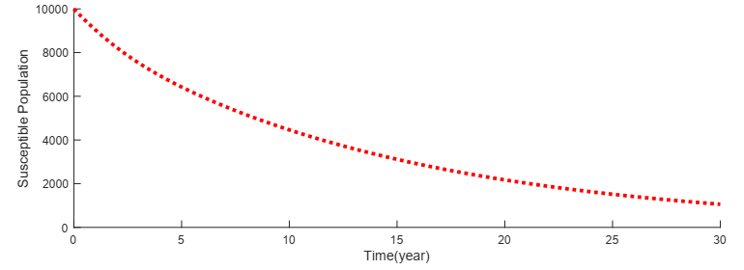

**Figure 2(a) Susceptible Population against time.**

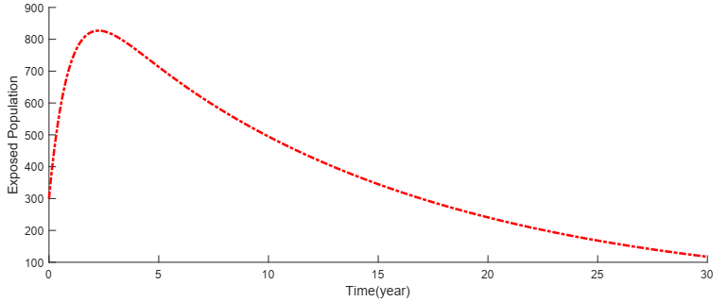

**Figure 2(b) Exposed Population against time.**

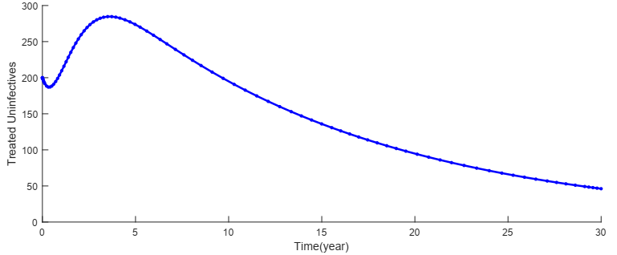

**Figure 2(c) Treated Un-infectives against time**

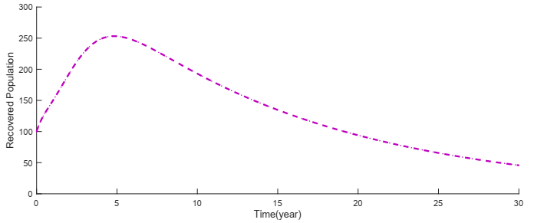

**Figure 2(d) Recovered Population against time.**

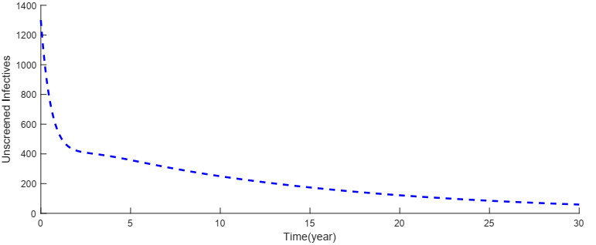

**Figure 2(e) Unscreened Infectives**

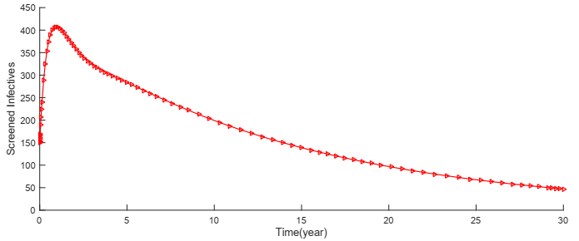

**Figure 2(f) Screened Infectives against time**

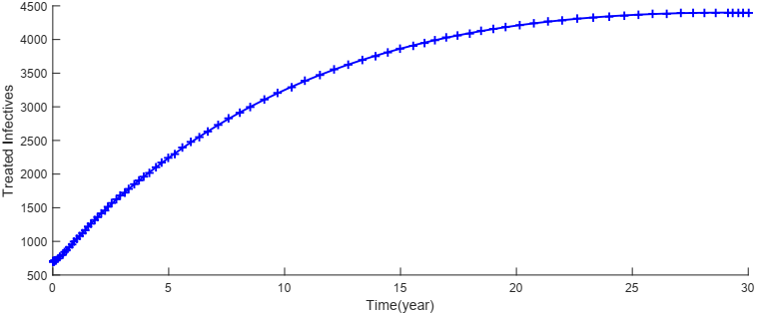

**Figure 2(g) Treated Infectives against time.**

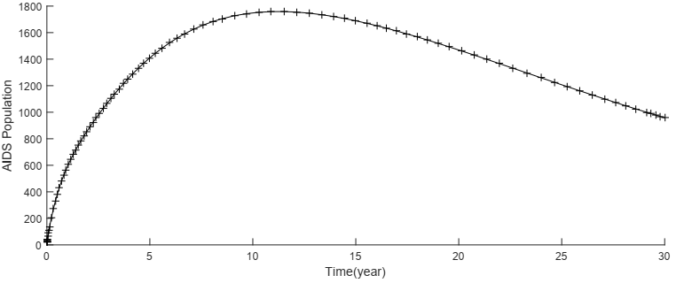

**Figure 2(h) AIDS Population against time**

IMPACT OF EARLY TREATMENT ON  and 

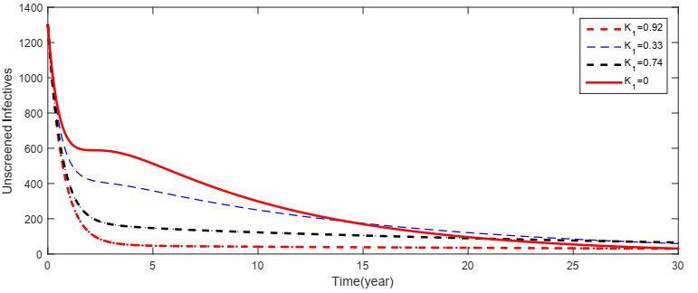

**Figure 3(a) Impact of Early Treatment on Unscreened Infectives against time.**



**Figure 3(b) Impact of Early Treatment on Reproduction Ratio.**

IMPACT OF TREATMENT ON  & 

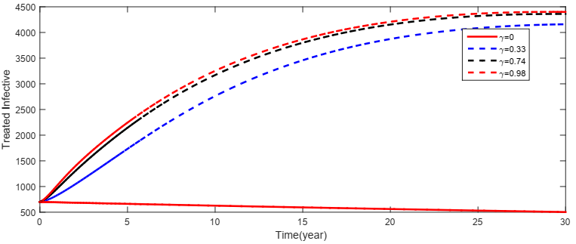

**Figure 4(a) Impact of Treatment on Treated Infectives against time**

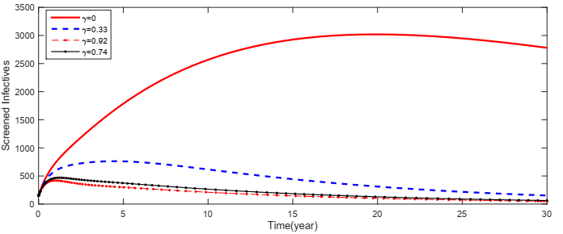

**Figure 4(b) Impact of Treatment on Screened Infectives against time**

**RESULTS AND DISCUSSION**

The Susceptible populationagainst time (Fig. 2(a)), clearly shows a rapid exponential decline from the initial value to zero. Exposed populationagainst time (Fig. 2(b)), we observe a sharp rise from the initial value to reach a maximum, and gradually declines exponentially to a steady state. Treated un-infectives population against time (Fig. 2(c)), we observe steady rise to a peak and gradually reduced. People get recovered from treatment. Treated Recovered population against time (Fig. 2(d)), we observe a sharp rise in recovered population and gradually reduce, implying that People become susceptible again since ART does not provide permanent immunity to HIV. Unscreened Infectives population against time (Fig. 2(e)), there is a sharp rise in the number of unscreened infectives and eventually drop as a result of screening and treatment respectively.Screened infectives population against time (Fig. 2(f)), we observed a sharp rise in the number of screened infectives at initial stage and gradually exhibits a decline as a result of treatment which lead to the decrease of AIDS patients. Treated infectives population against time (Fig. 2(g)), we observed a continuous rise as a result of treatment, which leads to the decline of AIDS patients. AIDS population against time (Fig. 2(h)), we observe a sharp rise as a result initial influx from unscreened infectives, screened infectives and gradually reduces as natural and disease induced death.

Figure 3 shows the impact of early treatment on unscreened infectives and on reproduction ratio. figure 3(a) shows the variation of proportion of unscreened infectives at different values of . We observed that increase in early treatment reduces the unscreened infectives. Taking drastic measure before 72hours of HIV exposure reduces the chance of becoming infectives. Figure 3(b) shows the impact factor of and  to reproduction ratio. We observed increase early treatment reduces the effective reproduction number than . If they strictly adhere to treatment to reduce viral load. We encourage treatment as early as possible to avoid being infected.

Figure 4 shows the impact of  on  and . Figure 4(a) shows the impact of variation proportion of  on treated infectives. We observe increase in  increases proportion of treated infectives. Figure 4(b) shows the impact of variation of  on screened infectives. Increase in different values reduces screened infectives. Treatment is encouraged to be given to screened infectives immediately after being diagnosed of HIV.

**5.0 CONCLUSION**

The results of this study provide some insight on the impact of early treatment on disease transmission dynamics of HIV/AIDS. The stability of disease-free equilibrium was investigated, the results showed that the disease dies out when the basic reproduction ratio is less than unity. We also carried out sensitivity analysis to determine the relevant parameter in the control of the disease. We found out that reduction of rate of transmission of exposed individual of becoming infected is best ideal in controlling the proliferation of the disease. Furthermore, qualitative analysis of the model was investigated using Runge Kutta scheme. We observe increase in early treatment reduces the rate of infection. Furthermore, we compare the impact of treatment initiated within 72 hours and after 72 hours in the control of HIV. We observed early initiation treatment within 72hours of exposure leads to a drastic decline in the reproduction number. While treatment that commences after 72hours of exposure only maintain reproduction number.

We recommend that those exposed to blood, genital secretion or body fluids of HIV potentially infected person, to enroll in post exposure prophylaxis within 48-72hours of exposure. As well as making sure that Anti-HIV drugs are made accessible to people since timing is very essential in PEP Initiation.

**CONFLICTS OF INTEREST:** The authors declare no conflicts of interest

**REFERENCE**

1. Marsudi, Noor Hidayat and Ratno Bagus Wibowo (2017) Sensitivity analysis of the parameters of an HIV/AIDS model with condom campaign and antiretroviral therapy. *American institute of physics*. Doi. Org / 10.1063//5016653.pp128-138.
2. Obinna Ositadimma Oleribe, Sani Aliyu, Simon David Taylor-Robinson (2018) Is the prevalence of HIV wrongly estimated in Nigeria? Some insights from a 2017 World AIDS day experience from a Nigerian Non-Governmental Organisation. *Pan African medical journal.* ISSN: 1937- 8688.
3. S.M. Ashrafur Rahman,Naveen K. Vaidya, Xingfu Zou(2016) Impact of early treatment programs on HIV epidemics: An immunity-based mathematical model. *Mathematical biosciences*. 280 (2016) pp 38-49.
4. Okosun K.O, O.D Makinde, I. Takaidza (2013) Impact of optimal control on the treatment of HIV/AIDS and screening of unaware infectives. *Applied mathematical modelling* 37 pp 3802-3820.
5. Hove-Musekwa and Nyabadza (2009) the dynamics of an HIV/AIDS model with screened disease carriers. *Computational and mathematical methods in medicine*. Vol 10, no.4 pp287-305.
6. Marsudi, Marjono and Ari Andari (2014) sensitivity analysis of the effect of screening and HIV therapy on the dynamics of the spread of HIV. *Applied Mathematical Sciences* vol.8,no 155 pp 7749-7763.
7. UNAIDS. AIDS epidemic update. Technical report, 2009. <http://www.unaids.org/en/KnowledgeCentre/HIVData/EpiUpdate/> EpiUpdArchive/2009/default.asp.
8. Moffat C. Nyaboe, Johana K. Sigey, Kangethe Giterere (2017). Mathematical Modelling and analysis ofHIV/AIDS and transmission dynamics influencedby public health education campaign.*International Journal of Advanced Academic Research | Sciences, Technology & Engineering* |ISSN: 2488-9849. Vol. 3, Issue 8.
9. UNAIDS. AIDS by the numbers: AIDS Is Not Over, But It Can Be. Joint United Nations Programme on HIV/AIDS (UNAIDS). 2016. *Google Scholar*
10. UNAIDS. Global AIDS Up Date 2016. Joint United Nations Programme on HIV/AIDS (UNAIDS). 2016.*Google Scholar*.
11. Harlon Davey, Laurel Challa Combe and James Wilton (2010). Can we prevent infection with HIV after an exposure? The world of post-exposure prophylaxis(pep). *Catie Canada’s Source for HIV and Hepatitis C Information.* At https//www.catie.ca/en/pif/fall-2010.
12. Tsai C., Follis K.E, Sabo A, Beck T.W, Grant R.F, Bischofberge N. et al (1995), Prevention of SIV infection in macaques by ®-9-(2-phosphonylmethoxyprophy) adenine. *Science*. 1995 Nov17:270(5239): pp1197-1199.
13. Tsai C.C, Emau P, Follis K.E, Beck T.W, Benveniste R.E,Bischofbeger N, et al (1998). Effectiveness of postinoculation ®-9-12-phosphonylmethoxyprophyl adenine treatment for prevention of persistent simian immunodeficiency virus. *Journal of virology*.;72(5):4265.
14. Otten RA, smith DK,Adams DR, Pullium JK, kim CN et al 2000. Efficacy of post exposure prophylaxis after intravaginal exposure of pig tailed macaques to a human-derived retrovirus (human immunodeficiency virus type 2) *Journal of virology.*74(20):0771.
15. Volmink J, Siegfried Nl, Van der Merwe L, Brocklehurst P. (2007). Antiretrovirals for reducing the risk of mother -to child transmission of HIV infection. *Cochrane Database System Review* 2007;(1):cd003510.
16. Cardo D.M., Culverd H., Ciesielski C.A., Srivastava P.U., Marcus R, Abitebould ET AL (1997). A case- control study of HIV sero-conversion in health care workers after percutaneous exposure. *The New England Journal of medicine*.1997;337(21):1485.
17. Schechter M., Do Lago R.F, Mendel Sohn A.B, Moreira R., Moulton LH, Harrison L.H, (2004) Behavioral impact, acceptability, and HIV incidence among homosexual men with access to postexposure chemoprophylaxis for HIV. *Journal of Acquired Immune deficiency syndrome* Apr 15: 35(5): 519-525.
18. Cardo D.M., Culverd H., CiesielskI C.A., Srivastava P.U., Marcus R, Abitebould ET AL (1997). A case- control study of HIV sero-conversion in health care workers after percutaneous exposure. *The New England Journal of medicine*.1997;337(21):1485.
19. Bryant J., Baxter L, Hird S. (2009). Non-Occupational Postexposure Prophylaxis For HIV: *A Systematic Review. Technology Assess*…Feb;13(14: iii, ix-x,1-60).
20. Perelson A.S. and P.W. Nelson. (1999) Mathematical analysis of HIV-I: Dynamics  
    in vivo. SIAM *Review*, 41(1).
21. Omondi E.O., Mbogo R.N and L.S Luobi (2018) Mathematical Modelling of the impact of testing, treatment and control of HIV transmission in Kenya. *Cogent mathematics and Statistics*.
22. Maimunah, Dipo Aldila(2018).Mathematical model for HIV spreads control program with ART treatment. IOP Conf. Series: *Journal of Physics: Conf. Series* **974** (2018) 012035 doi :10.1088/1742-6596/974/1/012035
23. Su, Z Dong, Deng H, Gong and Yang W. (2016) Mathematical modelling study of the HIV epidemic at two rural townships in the Liangshan prefecture of the Sichuan province of china. *Infectious disease modelling* 1(1) pp3-10.
24. Bhunu C.P., Mushayabas S., Kojouharov H, J.M Tchuenche (2011) Mathematical analysis of an HIV/AIDS model. Impact programs and abstinence in sub-Saharan Africa. *J.Math model* *Algorithm.* doi.10.1007/s/10852-010-9134-0
25. R. Safiel, Estomih S., Masswe, Daniel Oluwole Makinde (2012) Modelling the effect of screening and treatment on the transmission of HIV/AIDS infection in a population. *American Journal of Mathematics and Statistics* 2(4) pp75-88.
26. Olaniyi S. Maliki, Ngwu Romanus, Bruno. O. Onyemegbulem (2018). A Mathematical Modelling of the Effect of Treatment in the Control of Malaria in a Population with Infected Immigrants. Applied Mathematics 9 pp 1238-1257 doi; 10.4236/am.2018.911081.
27. Egbetade and Ibrahim (2014). Modelling the Impact of BCG Vaccine on Tuberculosis Epidemic. *Journal of Mathematical Modelling and Application* Vol1, No. 9, pp45-55.
28. Diekmann, J.A.P.Heesterbeek and J.A.J Metz (1990) On the definition and the computation of the basic reproduction ration in the model of infectious disease in heterogenous populations. *Journal of Mathematical Biology*, 365-382, (28)1
29. Hefferman, J.R.Smith and L.Wahl (2005) perspectives on the basic ratio, *Journal of Royal Society Interface 2 USA.*
30. Kirscher D., G.F. Webb (1990) a Model for treatment strategy in the chemotherapy of AIDS, *Bulletin of Mathematical Biology* pp 367-390.
31. Okosun K. O., Makinde O. D. (2011); Modeling the impact of drug resistance in malaria transmission and its optimal control analysis*. International Journal of the Physical Science*, 28,6479-6487.