Assessment of quality of life and the effective use of inhaled bronchodilator medication by patients, suffering from asthma
Quality of life & Asthma
Psarrou K¹, Kapritsou M², Papadimitriou L ³, Kouskouni E ³, Kalafati M⁴,
1. RN "G. Gennimatas" General Hospital of Athens, Greece Email: kassy_ps@yahoo.gr
2. Hellenic Anticancer Institute, ‘’Saint Savvas’’ Hospital, Day Surgery Center “N. Kourkoulos”, Athens, Greece. Email: mariakaprit@gmail.com
3. Department of Medicine, National and Kapodistrian University of Athens, Greece
4. Department of Nursing, National and Kapodistrian University of Athens, Greece
Email: mkalafat@nurs.uoa.gr

ABSTRACT
Introduction: According to World Health Organization, asthma is considered to be a disease, which is suffered from 100-150 million people.
Aim: Aim of this study was the assessment of the quality of patients’ life who suffered from chronic asthma and their conformity to the proper use and technique of inhaled bronchodilator medications.
Material and Method: In the present study, 150 patients, from 18 to 75 years old, who suffered from chronic asthma participated and Greek was their native language. Two questionnaires were used. The first questionnaire referred to the knowledge of patients on how to use inhaled bronchodilator medications and was created by the researcher according to the literature review and the second one was the Asthma Quality of Life Questionnaire which assessed the health-related quality of patients’ life. Factor analysis was performed.
Results: The first main factor of the first group of variables “how to use a bronchodilator device” was statistically significant (p<0.05) and correlated with the two main factors of the second group of variables “degree of restriction or feeling symptoms of asthma and time sense of fear, anxiety, frustration due to asthma symptoms”. The second factor in the first group of variables “easy preparation and bronchodilator use cortisone device-content” was statistically significant (p<0.05) with the two main factors of the second group of variables “degree of restriction or feeling of the symptoms of asthma and chronic sense of fear, anxiety, frustration due to asthma symptoms”.
Conclusion: The proper use of inhaled bronchodilator medications by patients suffering from asthma is directly related to the quality of life as it affects their daily life. So it would be necessary health professionals to develop instruments and methods, so as to train patients, who suffer from chronic asthma, as regards to the proper technique and the use of the inhaled bronchodilators.
Key words: quality of life, asthma, bronchodilator medications, proper technique

Introduction
Worldwide, asthma is considered to be a common condition, according to the World Health Organization (WHO), that 100-150 million people suffer from it [1,2]. It is a chronic inflammatory disorder of the airways and is associated with increased activity [3]. It is the tendency of the airways to obstruct response to stimuli which has little or no effect on non-asthmatics. Airway obstruction is also referred as bronchospasm and it is the characteristic functional disorder of asthma [4]. Asthma‘s Symptoms are shortness of breath, chest tightness, coughing (especially at night or early in the morning).
Treatment of asthma, mainly, includes bronchodilator drugs. Inhalable medications are used with: a) disposable compressed-dose inhalers or pressurized Metered-Dose Inhalers (pMDI), which contain the drug in the form of a solution or as liquefied propellant gas, b) disposable Breath Actuated Metered Dose Inhalers (BA-pMDI), c) Dry Powder Inhalers (DPI) that release the drug in the form of microparticulate powder entering the lungs with patient’s own effort, d) balloons, fitted to pMDI devices and serving as temporary storage rooms of the released [4].
However, it is important to be mentioned that the majority of patients not use the devices, properly. Due to poor education, errors, such as understanding the instructions or inapplicability in implementation, have occurred by patients [5]. It has been found that the percentage of patients made at least one mistake in the use of inhaler may exceed 80-90%, especially in the elderly [6]. In a study of D'Urzo et al., only 23-43% of patients using pMDI didn’t make mistake in everyday use. The percentage of correct use rises to 53-59% for DPI devices and 55-57% for pMDI balloon devices. After patient’s training, the percentage of patients who did not use wrong the device was increased to 63% and 65% for pMDI and DPI devices, respectively. The pMDI device, which is activated by the inhalation, was found to be used correctly in 75% of patients after training [7].
At the same time, the asthma, as chronic disease, affects the quality of patients’ life. According to the World Health Organization, the quality of life is a complex concept, which refers to individual, social, economic and environmental factors that can determine the well-being of the individual. Specifically, the physical and psychological health, the level of personal independence, social relationships, personal values and the relations with the environment are broad parameters that describe the meaning of quality of life [8].
The physical and psychological health reflect the status of a person's life Researchers at medical sciences invented the term "health related quality of life" (H.R.Q.L.), which focuses on assessment of physical and psychological health and social well-being. But, it is noteworthy that there is no commonly accepted definition of the health related quality of life, but rather is classified as a branch of the quality of life that is focused more on assessment of health in its broadest sense. [9]
The assessment of quality of life has been conducted by questionnaires consisting of health parameters, associating with a range of behavior or experience of the person, such as physical functionality, intellectual health and well-being [10].
Aim
The aim of this study was to assess the quality of life of patients suffering from chronic asthma and the conformity thereof to the proper use and technique of inhaled bronchodilator drugs.

Material and Method
The sample of the study was chronic patients with asthma, aged from 18 to 75 years old, with official language, the Greek. The study was conducted from June to December 2013, to a large clinic with asthma center.
Patients fulfilled two questionnaires, the completion of which was about ten minutes. The first questionnaire took into consideration their knowledge in the use of inhaled bronchodilator medicines and the second evaluated the health related quality of life of patients. The first part of the study involved the recording of demographic data, while the second contained: a) the questionnaire on patient compliance in the use of inhaled bronchodilator medications, which developed from the same researcher and based on the international literature and contained 10 questions that were answered with Yes or No. The second questionnaire for Asthma Quality of Life Questionnaire contained 32 questions and answered with a Likert scale, ranged from 1 to 7. The questionnaire was completed by the patient himself and the questions included asthma symptoms, limitation of activity, emotional functioning and environmental stimuli. [Juniper et al. 1992, Juniper et al. 1994] For the use of the questionnaire was given a license by the author. The questionnaire has already translated in Greek, and has tested for its reliability and validity.
The study was approved by the Committee of the Hospital and the Scientific Committee of Medical University of Athens, Greece and an informed consent was received from patients. Patient participation was voluntary and any denial or discontinuance at any stage had not any kind of impact on their treatment. Compliance with the principles of ethics, as well as the anonymity and confidentiality of information during the course of the study was occurred.
The statistical analysis of the study was operated by the Statistical Package for Statistical Programme the Social Sciences (SPSS 21.0). Factor analysis was performed. The variables, arising of the factor analysis, attempted to give a qualitative sense, in accordance with the original variables with they are more associated. This way the original factors were interpreted and attributed a specific identity to them. The variables were tested for their distribution and accordingly parametric or non-parametric methods were applied. The significance level was p < 0.05.
Results
Initially, 210 patients were approached of whom 150 participated in the study. Demographical data of the participants appeared in Table. The Cronbach a, for the questionnaire, concerning the use of inhaled bronchodilator medication was a = 0.415, while for the questionnaire of quality of life was a = 0.989.
From the multivariate analysis of a questionnaire relating to the proper use of inhaled bronchodilators drugs emerged two factors. The first factor (factor 1_1) could take the interpretation: “how to use bronchodilator device”. Namely, this factor expresses the beliefs of patients for the knowledge of the bronchodilator device‘s use. Particularly, during the process of receiving the medication, the following six variables are contained: "explanation of how to inhale the medicine by doctor", (Load: 0.758), "Deep breathing out before administrating the medicine", (Loading: 0.691), “head position slightly careened to the back” (Load: 0.418), "Slow & deep breath when receiving the medication" (Load: 0.260), “Holding breath 10 seconds” (Load: 0.873), "Immediate expiry after the administration", (Load:-0.859).
The second factor (Factor 1_2) could take the interpretation: "Easy preparation & usage of bronchodilator device– Cortisone Content". Nominally, this factor expresses the beliefs of patients for cortisone content knowledge and the easy preparation and use of bronchodilator device and contained the following variables: “easy preparation device” (Load: 0.860), "Easy to use inhaled medicine" (Load: 0.843), “Rinsing with water upon receipt” (Load:-0.239), “cortisone Content” (Load:-0.282).
Also, the multivariate analysis of a questionnaire relating to the quality of life showed two factors. The first factor (Factor 2_1) could take the interpretation: “degree of restriction or sensing symptoms of asthma” and this includes the following 22 variables: “degree of limitation in social activities” (Load: 0.803), "degree of restriction to professional activities" (Load:0.788), “degree of this limitation in moderate activities” (Load: 0.777), “time sense of avoiding the situation or the environment due to exposure to strong scents or scent in the last 2 weeks” (Load: 0.776), "time asthma symptoms due to exposure to strong scents or scent in the last 2 weeks" (Load: 0.773), "time of sense, avoiding the condition or the environment due to dust the last 2 weeks" (Load: 0.762), "degree of discomfort or distress the last 2 weeks due to cough" (Load: 0.758), "degree of discomfort or distress in the last 2 weeks due to tight chest pain" (Load: 0.752), "time of appearance asthma symptoms due to dust the last 2 weeks" (Load: 0.752), "time sense of avoiding or being limiting due to weather conditions during the last 2 weeks" (Load: 0.743)," time of appearance asthma symptoms due to tobacco smoke in the last 2 weeks" (Load: 0.733), "Time of tightness chest pain symptoms the last 2 weeks" (Load: 0.733), “Time of sense breath shortness due to asthma the last 2 weeks" (Load: 0.732), "time sense of avoiding the situation or environment due to smoke cigarettes the last 2 weeks " (Load: 0.728), "degree of restriction to high-intensity activities" (Load: 0.721)," time of sensation for more air the last 2 weeks" (Load: 0.703), "time of difficulty of breathing out air the last 2 weeks" (Load: 0.698), "time of appearance asthma symptoms due to weather conditions during the last 2 weeks "(Load: 0.673), "difficulty at night sleep the last 2 weeks" (Load: 0.66), "time sensing weight at the chest the last 2 weeks" (Load: 0.653), "time sensing fear of breathlessness the last 2 weeks" (Load: 0.642), and “degree of sleeping constrain” (Load: 0.627).
The second factor (Factor 2_2) could take the interpretation: “Time sense of fear, worry and frustration due to asthma symptoms” and included 8 variables: "time sensing fear of drug availability the last 2 weeks" ( Load: 0.849), "concerning for taking the medications the last 2 weeks" (Load: 0.828), “anger and/or frustration due to asthma in the last 2 weeks” (Load: 0.773), “time of feeling annoyance due to heavy breathing during the last 2 weeks” (Load: 0.684), " Time of waking-up with asthma symptoms the last 2 weeks" (Load: 0.662), "time of concerning due to asthma the last 2 weeks" (Load: 0.643), "time of awakening at night with asthma symptoms the last 2 weeks" (Load: 0.634), and "time sensing cough for cleaning throat the last 2 weeks" (Load: 0.621).
The main factor of the first group of variables, more specific the factor “how to use bronchodilator device” was positively associated with the two main factors of the second group of variables, “degree of restriction or feeling asthma symptoms” (p=0.000, r = 0.462) and "time of sensing fear, anxiety and frustration due to asthma symptoms" (p = 0.000, r = 0.353). The second main factor of the first group of variables "ease preparation and use of bronchodilator device with cortisone" was positively associated with the two main factors of the second group of variables, “degree of restriction or sensing asthma symptoms” (p = 0.033, r = 0.174) and "time of sensing fear, anxiety and frustration due to asthma symptoms" (p = 0.009, r = 0.211).
There were statistical significant differences between the four main factors and patients' educational level, marital level and smoking habit (p<0.001) but it does not find any statistical difference between male and female patients . Figure 1-3 shows the means differences between the variables for patients’ educational level, marital status and smoking habit and the corresponding factors.

Discussion
The use of bronchodilator device allows to target of lungs directly, achieving high concentrations of the medication in the airway, while reducing systemic side effects through minimizing the levels of the drug into the systemic circulation [11]. But there are also disadvantages, such as the inappropriate application of the technique of bronchodilator device that it is common among patients. Proper use of bronchodilator device and medication compliance, as well as quality of life is important factors of treating symptoms. [11,12]
In the research study there was a correlation between the proper use of bronchodilator device and quality of life of asthmatic which is in accordance of Sen et al., 2006 study. In spite of our study there was not found any statistical difference between male and female patients, Sen et al., 2006 evaluated the applied technique puffs and patient compliance to treatment and there was a difference between the proper technique and patient compliance between women and men [13].
Likewise, in the present study, it is noted that there was a statistically significant difference between average rates of factors for the level of education. In the study of Sen et al, 2006 there was not found a correlation between the level of patients’ education and the appropriate technical applied puffs [13]. This may be due to the fact that the higher level of education could easily use the devices and follow instructions-expert advice because they probably were aware of the complications and the side effects.
Finally, in the research study, it was observed that the average values of the factors had positive values for those who have someone in their family to suffer from asthma and negative values for those who do not. This probably lies on the fact that there is more response and support from the family. The lack of support from family, in combination with the lack of hope and living in an environment of uncertainty, it contributes to increase of asthmatic crises [14]. The existence of a stable and smooth family environment where avoiding extreme situations, helps the person who suffers from it, to create strong character without psychological swings, with result to be able to cope with the disease in the best possible way [14].
It is mandatory to establish Asthma Action Plans, as Damon and Tardif, 2015 showed that it is an important for asthma management. Education of patients indicates to be the primary tool for its management, while morbidity and quality of life are noted to be reduced as asthma complications [15]. Furthermore, Hennessy-Harstad, 2013, in his the research, observed that nurses have a major part in education of the adolescents, monitoring how they control it and managing acute asthma episodes by helding asthma action plan [16].

Limitations of study
The results cannot be generalized for the entire population of patients, with asthma, because they come from a single center, which is the main limitation of this study. A larger sample size, originating from different clinics and various hospitals would help, significantly, to generalize the results.

Conclusion
Proper use of bronchodilator medication improves the quality of life of asthmatic patients. However, a change in the way of compliance of these patients to improve the quality of life could be achieved by developing the proper relationship between the patient and the health professional. The health practitioner could properly educate the patient on the use of bronchodilator medication, such as to demonstrate the use of bronchodilator medication and to grant the patient illustrated instructions.

References
- World Health Organization (WHO). Bronchial asthma. WHO Fact Sheet no. 206. Revised January 2000, available online at www.who.int
- Viegi G, Annesi I, Matteelli G. Epidemiology of asthma in Chung F. Fabbri L.M. (editors) Asthma. European respiratory monograph (2003), (23)
- Team of Asthma of Greek Respiratory Corporation. Instructions of Greek Respiratory Corporation. (2003), (6), 5-6
- Verikaki A, Georgatou A, Gaga M, Goulekas M. Instructions for coping with asthma in adults. Respiratory themes, (2008),(8),5
- Molimard M, Raherison C, Lignot M et al. Assessment of handling of inhaler devices in real life: An observational study in 3811 patients in primary care. J Aerosol Med (2003),16,249-254
- Ram FS. Clinical efficacy of inhaler devices containing beta(2)-agonist bronchodilators in the treatment of asthma: cochrane systematic review and meta-analysis of more than 100 randomized, controlled trials. Am J Respir Med (2003),2, 349-365
- D’ Urzo A, Aldana IO, Price D. Asthma- A guide for scientific evidence based in Primary Health Care System. Vagionakis, Medical Publications, (2012) ,3-74
- World Health Organization (WHO),. Health promotion glossary. Switzeland: Geneva (electronic Version), (1998)
- Juniper E, Guyatt G, Epstein R, et al. Evaluation of impairment of health related quality of life in asthma: Development of a questionnaire for use in clinical trials. Thorax (1992),47,76-83
- Juniper E, Guyatt G,Willan A, et al. Determining a minimal important change in a disease-specific quality of life questionnaire, Journal of clinical Epidemiology (1994),47,81-87
- De Blaquiere P, Christensen DB, Carter WB. Use and misuse of metered-dose inhalers by patients with chronic lung disease: a controlled, randomized trial of two instruction methods. Am Rev Respir Dis (1989),140,910-916
- Dolovich MB, Ahrens RC, Hess DR et al. Device selection and outcomes of aerosol therapy: Evidence-based guidelines. Chest (2005),127,335-371
- Sen E, Gnollo V, Ekizi Z et al. Assessment of inhaler technique and treatment compliance of hosp hospitalized patients and outpatients in a university hospital. Ankara aniversitesi Tip Fakoltesi Mecmuasi (2006),59,1-6
- Ho SF, O’Mahony MS, Steward JA et al. Inhaler technique in older people in the community. Age and Ageing (2004),33,185-188
- Damon SA and Tardif RR. Asthma education: different viewpoints elicited by qualitative and quantitative methods. J Asthma. (2015), 52(3), 314–317
- Hennessy-Harstad E, Asthma and adolescents: review of strategies to improve control. J Sch Nurs. (2013), 29(1), 39-51

Table. Patients’ Demographic Data
 | Ν (%)
Gender
Female | 85(56.7)
Male | 65(43.3)
Education
Elementary | 53(35.3)
High school | 52(34.7)
University degree | 45(30)
Marital Status
Single | 53(35.3)
Married | 55(36.7)
Divorced | 23(15.3)
Widow | 19(12.7)
Smoking
No | 45(30)
Yes | 51(34)
Ex-smoker | 54(36)
Asthmas symptoms in the family
No | 69(46)
Yes | 81(54)

Figure 1. Mean for patients’ educational level
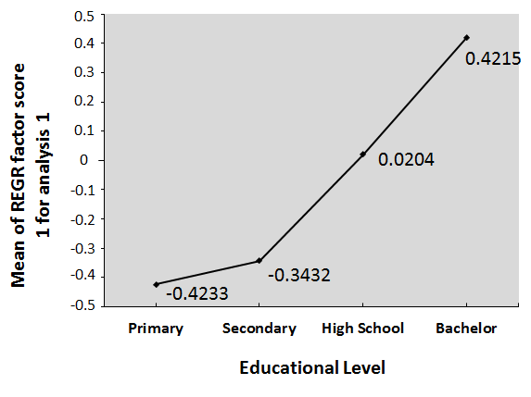 | 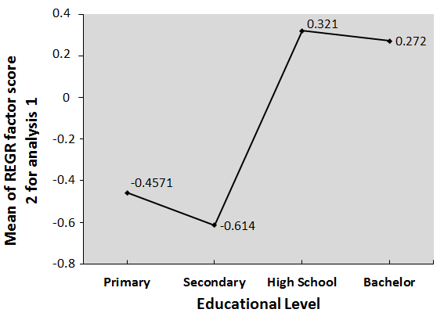
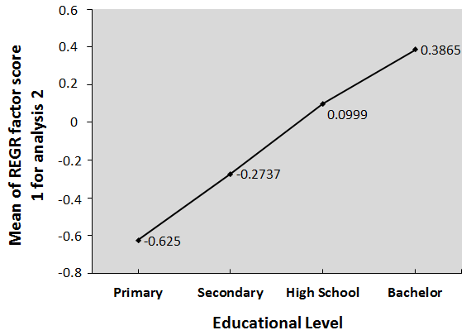 | 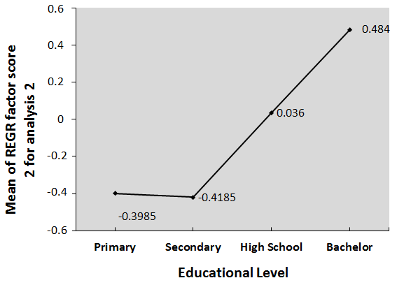

Figure 2. Mean for patients’ marital status
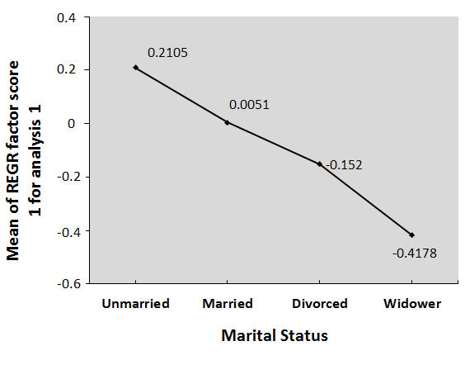 | 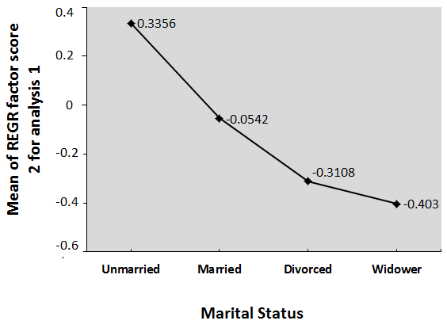
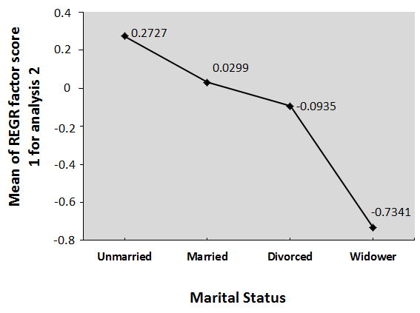 | 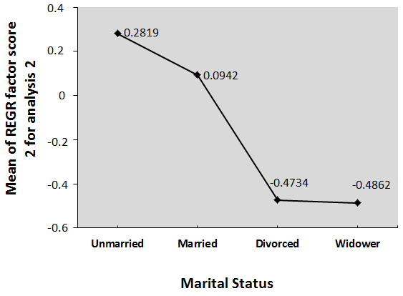

Figure 3. Mean for patients’ smoking habit
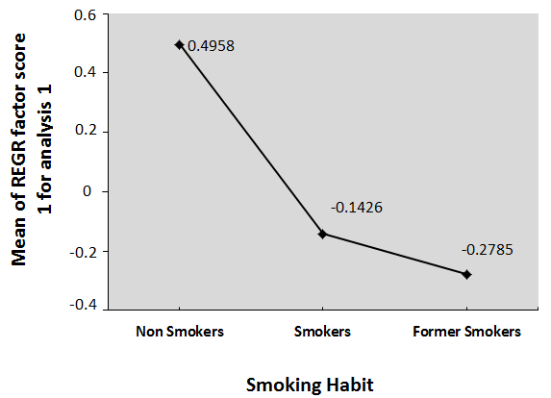 | 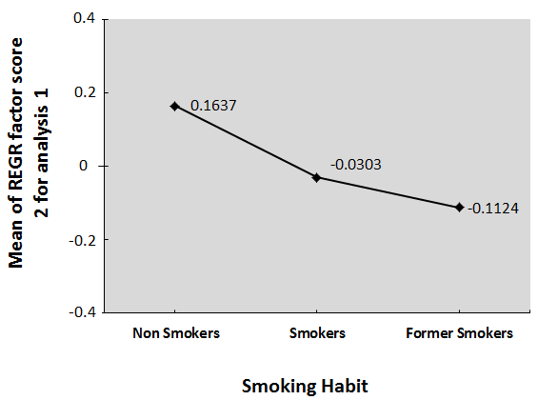
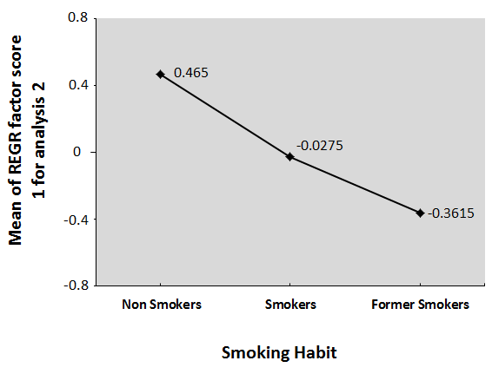 | 