**Long-term function of on-ground repositories for hazardous waste - Mechanisms in cyclic drying/wetting of top clay liners**

Roland Pusch1), Masashi Nakano2), Yong, R.N.3), Ting Yang1)

1. Luleå University of Technology, Geotechnical Dep. Luleå University of Technology, SE 971 87 Luleå, Sweden. 2) [nakano76mss@herb.ocn.ne.jp](mailto:nakano76mss@herb.ocn.ne.jp)., 3) r.nyong@shaw.ca.

**Abstract**

Landfills of hazardous waste like radioactive rest products with low activity, or ashes from incinerated organic waste, need to have top clay liners for minimizing penetration and percolation of precipitated rain and meltwater. Temperature and dry weather vary interchangeably with wet periods making the clay desiccate and fissure, and subsequently wetted etc. Top liners are commonly made of smectite clay, which is the best isolating soil material, undergoing swelling and shrinkage to an extent that depends on the clay content and density. The most important question is whether such liners, in unfrozen condition and covered by erosion-resisting coarse soil, maintain their coherence and tightness after centuries of hydration/dehydration cycles. The present study, made on physically confined soft Iraqi clay with about 30% smectite indicates that initially homogeneous dense clay shrinks and desiccates and becomes fissured at 30oC and room RH, but partly recovers by becoming water saturated by infiltrated water. A limited number of drying and wetting sequences seem to give approximately the same change, suggesting that, under common weather conditions and lack of external disturbance, such liners retain a considerable part of their initial water tightness. Thick liners with moderately to high density and exposed to loading by overlying coarse fill are expected to serve particularly well.

Key words: clay, desiccation and saturation, liners, on-ground repositories, waste disposal

**1 Scope of study**

Clay top liners of landfills of hazardous waste like low-level radioactive waste are needed for minimizing and retarding uptake and permeation of water, which does not start until the liners have reached a high degree of water saturation (cf. Figure 1). The hydraulic conductivity determines the rate of through-flow and how rapidly and uniformly water will flow into and through the waste mass. If the top liners are low-permeable and the rate of water passing through the top cover of erosion-resisting soil is low, a dry season following rain will redirect water transport to take place from below and upwards. Subsequent rain will again generate downward water migration etc.

The purpose of the study is to identify, by optical microscopy, what mechanisms and microstructural changes are caused by cyclic drying/wetting and to outline models of how the isolating potential of a typical clay top liner is affected by hydration/dehydration.

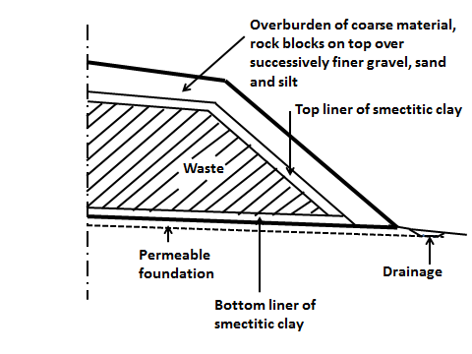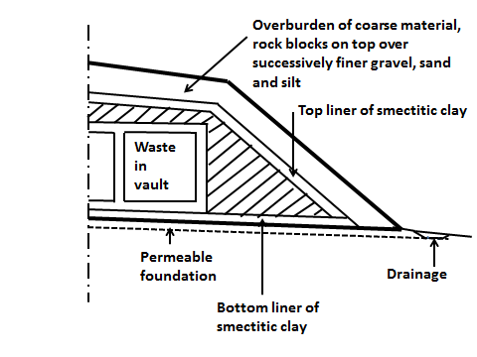

Fig. 1. Schematic sections of on-ground repositories for LLW and ILW. Left: Simple landfill for very low-level waste. Right: LLW and ILW placed in concrete vaults [1].

**2 Basics**

The main issues in cyclic transfer of water in top clay liners are:

1. Infiltration of chemical substances such as salt for repositories located close to the sea shore, or resulting from dissolution of minerals in the covering coarse erosion-protective layer. Examples of such substances are calcium and calcium/magnesium carbonates,
2. For theoretical prediction of water transfer within liners the initial water content and degree of water saturation are essential,
3. When water flow reverses its direction transfer is influenced by both water retention hysteretic phenomena and unsaturated hydraulic conductivity hysteresis phenomena, and one needs to know which processes in the hysteresis loops that are involved (cf. Fig. 2),
4. The surface of the top clay liner largely determines the evolution of its hydraulic properties, involving the accessed water, desiccation, and accumulation of chemical substances, macroscopically resulting in the formation of dry crusts and salt crusts, and the opening and closure of microstructural channels, fissures and fractures. In desert regions, liners with thin covers can be heated to several tens of centigrades, which can affect the chemical stability of the clay minerals and physical performance of particle aggregates.



**Fig. 2.** Hysteretic phenomena observed for water characteristic curves for soil. Arrows indicate wetting and drying processes [2].

**3 Composition of top liners**

**3.1 Principle**

The main design goal is to find a composition that gives very low hydraulic conductivity, for which the content of smectite should be high. Smectites with Li or Na as dominant sorbed cation are least permeable but for cost reasons they may not be favourable. Less expandable and more permeable clays like those with Ca as sorbed cation may instead be considered. Such clays are common in certain geological areas and exploited with a minimum of processing [1]. They are also usually cheaper. Strong expandability causes swelling and upheaval of the liner and overlying erosion-protecting soil takes place if the swelling pressure is not balanced by a sufficiently high overload. Swelling of smectitic top liners takes place when the effective (“grain pressure”), representing the swelling pressure, exceeds the effective (“grain”) pressure exerted by the covering soil. If this happens the expansion of the liner lowers its density and shear strength, and raises its hydraulic conductivity. Using ordinary soil physical parameters the required condition for avoiding expansion is that the product of the dry density and vertical thickness of the covering soil layer must balance the swelling pressure of the clay liner. We will deal here with natural Ca-dominated clay with an appreciable content of non-expandable clay minerals and non-clay minerals.

**3.2 Granulometry**

The ideal procedure is to select a composition implying that the voids between larger, non-clay particles are filled with smectite clay particles that make up a homogeneous gel at water saturation, and regain this state after desiccation (Fig. 3). The granular composition of top clay liners needs to be in accordance with ordinary filter criteria (“Fuller”/Weymouth”) for avoiding practically important internal erosion and transport and loss of fine particles originally proposed by Fuller and Weymouth [3].

C:\Users\R. Pusch\Documents\Mina skanningar\skanna0082.tif

Fig.3. Microstructure of low-compressible clayey soil with the voids between non-expandable coarser grains (G) filled with fully expanded smectite clay component exerting a swelling pressure on the large grains.

Table 1. Typical physical data for clays useful for sealing purposes like liners and backfills. *Kw* and *pw* represent Na state, *Ks* and *ps* refer to Ca state [4].

|  |  |  |  |  |  |  |
| --- | --- | --- | --- | --- | --- | --- |
| Smectite content, weight percent | Dry density  (kg/m3) | Density at water saturation (kg/m3) | Hydraulic conductivity in bulk, *Kw* m/s | Hydraulic conductivity in bulk, *Ks*m/s | Swelling pressure, *pw*  kPa | Swelling pressure, *ps*  kPa |
| 15-25 | 1200 | 1750 | E-10 | E-9 | 20 | 0 |
| 15-25 | 1750 | 2100 | E-11 | 5E-11 | 300 | 30 |
| 40-60 | 1650 | 2050 | 5E-12 | E-11 | 1,200 | 500 |
| 40-60 | 1750 | 2100 | E-13 | 5E-13 | 10,000 | 10,000 |

Using fundamental soil physical relationships one can express the porosity of the system of non-clay particles, i.e. those conventionally classified as being smaller than 2 m, as *ns* in Eq. (1), [3]:

*ns =* 1-d/s(1-b) (1)

where:

d = dry density of the mixture,

s = density of minerals,

*b*= content of smectite-rich clay.

Eq,1 can be used for calculating the density (*db*) of the saturated clay component in the voids between non-clay particles at different degrees of void-filling (*Sb*) as function of the degree of compaction.

|  |  |  |  |  |  |  |
| --- | --- | --- | --- | --- | --- | --- |
| Clay content  % | Degree of  Proctor density, % | d,  kg/m3 | sat,  kg/m3 | Sb | ns | db,  kg/m3 |
| 10 | 100 | 2050 | 2290 | 0.65 | 0.317 | 1600 |
| 10 | 87.5 | 1790 | 2130 | 0.54 | 0.403 | 1400 |
| 10 | 75 | 1540 | 1970 | 0.43 | 0.487 | 1200 |
| 20 | 100 | 1950 | 2230 | 0.82 | 0.42 | 1600 |
| 20 | 87.5 | 1710 | 2070 | 0.72 | 0.49 | 1400 |
| 20 | 75 | 1460 | 1920 | 0.61 | 0.57 | 1200 |
| 50 | 100 | 1750 | 2100 | 0.94 | 0.67 | 1600 |
| 50 | 87.5 | 1530 | 1960 | 1.00 | 0.72 | 1400 |
| 50 | 75 | 1310 | 1830 | **1.091)** | 0.76 | 1200 |

1. “Over-saturation”. Compaction to this density cannot be made.

Table 2. Semi-theoretical relationships between clay content, compaction degree and physical soil data [5].

**3.3 Impact of granulometry and smectite content on the hydraulic performance**

Table 2 shows that for any clay content and compaction work, the average dry density *db* of theclay component will not be higher than 1600 kg/m3,or slightly more than 2000 kg/m3 at saturation with electrolyte-poor water, giving this component a hydraulic conductivity of about 5E-13 m/s [4]. For a solution of 3.5 % CaCl2 the value is about E-12 m/s. The importance of effective compaction is obvious from the fact that 75 % Proctor density gives an average dry density of the clay component of only 1200 kg/m3 (1750 kg/m3 at water saturation). For saturation and percolation with electrolyte-poor water this reduction in density increases the hydraulic conductivity of the clay component by 100 %, i.e. to E-11 m/s, while percolation with the salt solution causes a rise in conductivity to 5E-10 m/s. The bulk dry density will be at least 1460 kg/m3 if the bulk clay content is about 20 %, for which the bulk hydraulic conductivity will be about E-10 m/s.

For all types of clays an increase in density will result in reduction of the amount of larger voids and homogenization of the microstructure because of tighter packing of the various individual particles and particle aggregates. For smectitic clay this is well demonstrated by Table 1: a clay liner with the easily achievable bulk dry density 1750 kg/m3, percolated by low-electrolyte water, has an average bulk hydraulic conductivity of less than E-11 m/s if the smectite content is at least 15 %. This conductivity is sufficiently low for most practical purposes but can be further reduced by one order of magnitude by increasing the clay content or density.

**4 Hydration/dehydration and percolation of clay top liners**

**4.1 Mechanisms**

**4.1.1 Freezing conditions**

Cyclic freezing and thawing of clays can result in significant changes in the microstructure because of the movement of water to ice nuclei and resultant growth of pore ice. Fig.4 shows the change in microstructural units from the first freeze-thaw period to the 32nd freeze-thaw cycle of soft Canadian clay. The microstructural units become more stable as the number of freeze-thaw cycles is increased for systems open to ingress of water and to closed ones. The voids in open systems are larger than in closed systems and result in greater hydraulic transmission characteristics. Observations reported by Yong et al. [6] for studies on cyclic free-thaw effects on microstructure and properties of clays include the following:

• The formation of numerous ice lenses complicates the prediction of depth of frost penetration and frost heaving pressures,

• Loss of instability of slopes are likely results of restructuring of the micro- structural units.

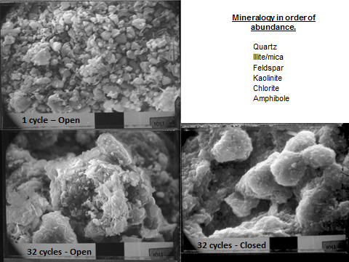

Fig.4. SEM pictures showing changes of microstructural units in clay following 1 and 32 cycles of freeze-thaw (Same scale). [6]

**4.1.2 Non-freezing conditions**

Dehydration by desiccation of a water saturated clay liner causes drainage of wider microstructural channels in the first place followed by creation of a network of fine fissures. The major question concerning the long-term isolation potential of top liners of smectitic clay is whether repeated drying/wetting will lead to permanent heterogeneity or if the expandability of the clay component will cause microstructural homogeneity at wetting. This makes it necessary to consider the various coupled processes that take place as indicated in Fig.4 and summarized here, assuming initial uniform water content and degree of water saturation in the element when the ever ongoing drying/wetting cycles in clay top liners starts [1] :

* Porewater in the clay component migrates upwards in vapour form from the upper, hottest part, and in liquid form towards the colder lower part, in warm periods. Here, the particle network expands and exerts an isotropic swelling pressure that tends to compress and push up the warmer, drying part. If there is no precipitation the process proceeds until only one hydrate layer remains in the interlamellar space and basal surfaces of the smectite particles,
* Rain and meltwater enter the upper part of the liner from above, which causes expansion of the particle network at successively increasing depth. This generates a swelling pressure that rises to a level determined by the vertical effective pressure exerted by the overlying layer of erosion-protective coarse soil,
* Freezing causes ice-lensing and microstructural heterogeneity of top liners and must be hindered by selecting a sufficiently thick soil cover, which also balances the swelling pressure,
* Strong draft in combination with infiltration of chlorides carried by fine droplets from nearby sea has the impact on the hydraulic conductivity of salt that we see in Table 1. Such positions are hence unsuitable and not considered here.

The true behaviour is much more complex and requires that the microstructural constitution is taken into consideration. The most important feature is the aggregated character of the clay that is inherited from the initial state of soil granules compacted and compressed on site. The smectite grains have a water content that is related to the relative humidity of the air in which it is stored. For pure smectite stored at 50-70 % relative humidity the water content of the grains is about 10 %, implying that the interlamellar space holds 1-2 hydration layers. Compaction of the grains under the pressure of vibrating rollers or plates welds them together, leaving only small voids between them. The voids have the form of channels of varying aperture, the tightest parts being completely filled with capillary water while wider ones also contain air. This “isothermal” state is shown in the upper part of Fig.4, which also indicates the changes of the microscopic channels caused by a thermal gradient yet with no water uptake at the cold side.

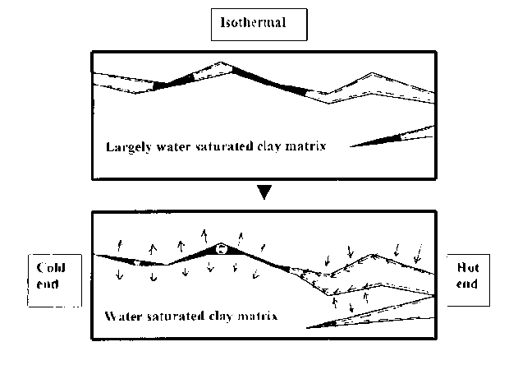

Fig.4 Schematic picture of microstructural changes in the initial process of porewater redistribution under a thermal gradient. Wide channels dry out and become desiccation cracks at the hot end [4].

Fig.5 shows, in simplified form, the difference in microstructural constitution of elements of Na and Ca smectite clay at low and high bulk densities and the associated differences in swelling pressure. *a* is a stack of smectite lamellae, *b* represents interlamellar space and c interparticle bonds of water/ion complexes including also amorphous matter.

C:\Users\R. Pusch\Documents\Mina skanningar\skanna0080.tif

Fig.5. Schematic picture of particles consisting of stacks of smectite clay lamellae at low and high water-saturated density and porewater salinity (Na or Ca), and the corresponding swelling pressure [3].

**5 Experimental**

**5.1 Scope**

Experiments were made for finding out if optical microscopy can reveal what major microstructural changes take place at cyclic drying and wetting of a relative soft smectitic clay, and if percolation tests provide evidence of them. The specific aim was to identify and quantify the hydraulic performance of permeable features, i.e. open fissures and voids, caused by temporary desiccation followed by water saturation. A low dry density of the clay samples was chosen for making processes on the microstructural scale obvious.

**5.1 Clay material**

The clay used for the study was a natural Iraqi clay with a smectite clay content (Ca-montmorillonite) of 49 % and a content of illite of 48 %. Chlorite made up 1 % and kaolinite 2 %. CEC [7] was 19.7 millieq/100 g. The specific gravity was 2.75 g/cm3. The non-clay minerals were feldspars, anhydrite, ankerite and zeolites. The liquid limit of the bulk clay was 115 %, the plasticity index was 60 % and the activity number 1.25. The geotechnical characterization is given in Table 3.

Table 3. Geotechnical properties of Iraqi Red Clay (After Al-Thaie).

|  |  |  |  |  |  |
| --- | --- | --- | --- | --- | --- |
| Dry density, kg/m3 | Density at water saturation Specific gravity, kg/m3 | Hydraulic conductivity at percolation by dist. water, m/s | Swelling pressure for saturation with dist. water, kPa | | Shear strength (undrained), kPa |
| 1000 | 1630 | E-8* | 5 | 2 | |
| 1250 | 1790 | E-10 | 20 | 8 | |
| 1500 | 1945 | 1.5E-11 | 375 | 150 | |

* Reinterpreted from Al-Thaie [7].

**5.2 Sample preparation and recording**

**5.2.1 Optical microscopy**

Samples were prepared by filling the space between parallel microscope glasses, about 150 m apart, with clay gel with a density of 1000 kg/m3, made by mixing air-dry clay powder with 125 m maximum grain size and distilled water. The glasses were confined by permeable tape and were first desiccated by storing them for 7 to 9 days at 30oC in air with RH=60 % and micrographed, followed by placing the sets in RH=100 % humidity and then under water at 5kPa pressure.

Four square areas with 7.5 mm side length were marked for repeated examination and photographing without opening the confined space. Photographs were taken of the areas by use of an ordinary Conrad LED microscope and depicted in Fig. 6 (Magnification 20 x).

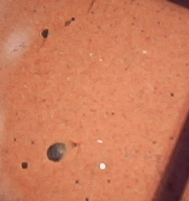 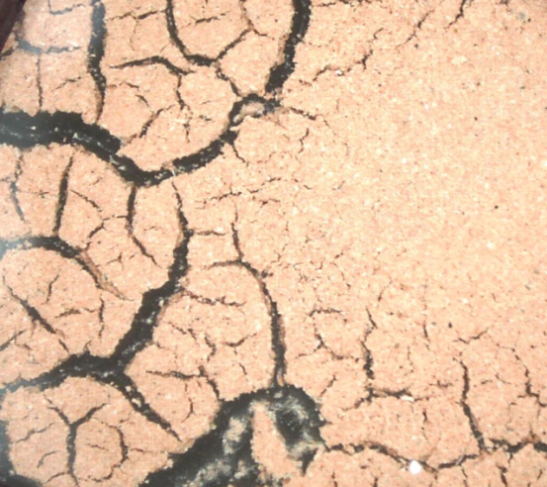

**1. Virgin 2. Dried for 9 days**

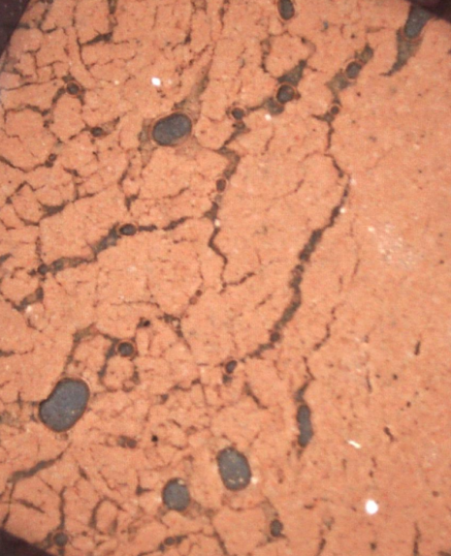 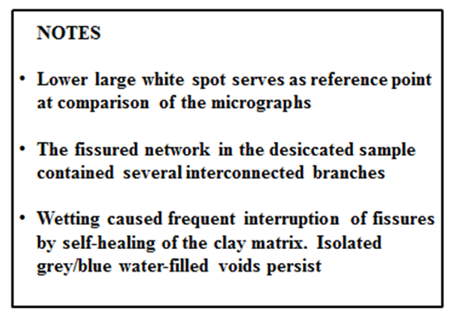

**3. Wetted to saturation for 9 days after 9 days of drying**

Fig. 6. Example of stages after drying in air for 9 days (No.2) and subsequent wetting with distilled water for 9 days. Same magnification of all micrographs: horizontal edge length of micrograph is 4 mm.

**5.2.2 Percolation tests**

Small volumes of clay were used for limiting the time for wetting and drying, which are both of diffusion type. Samples with 9 mm thickness were packed in air-dry form (RH 70%) in Teflon tubes with 15 mm diameter and kept confined between stiff filters of acrylate-stabilized silt. The dry density was 1000 kg/m3, representing a bulk density at water saturation of 1630 kg/m3. Determination of the hydraulic conductivity of the “virgin” clay was made after saturation with distilled water by letting the 9 mm long sample sorb water from one end, followed by measurement of the percolation rate by applying a hydraulic gradient of 100 m/m for 1 week using distilled water. This was followed by three consecutive test series each involving drying for 25 hours, saturation with distilled water for 50-150 hours, and percolation for 50-150 hours. The drying was made by placing the tube with the end filters removed in a microwave oven for 15 s (750 W). The test results are compiled in Table 4.

Table 4. Hydraulic conductivity (*K*) in m/s of clay sample of Red Iraqi clay with dry density 1000 kg/m3 determined in the present continuous test series.

|  |  |
| --- | --- |
| Test series | *K*, m/s |
| Virgin | 7.0E-9 |
| I | 2.4E-8 |
| II | 2.7E-8 |
| III | 6.0E-8 |

The initial (“original”) conductivity involving percolation with distilled water was on the same order as the value given in Table 3, i.e. E-8 m/s, while the first drying period led to a 3-fold increase in conductivity. The second treatment gave a further very slight increase while the third gave a conductivity value that was about 8 times higher than that of the virgin state. The reason for the first increase was incomplete homogenization after wetting as observed in the microstructural study - the large majority of the fine fissures of the network were largely closed while the widest ones were less well closed. The third rise in conductivity was caused by further loss in microstructural homogeneity. Additional large numbers of drying/wetting cycles are believed to lead to further increase in conductivity that can be estimated by applying microstructural modelling.

**6 Modelling**

**6.1 Conceptual**

The micrographs shows that the virgin smectite clay, like all clays formed from granular material, contains numerous small channels of varying persistence and degree of interconnectivity [1,3,4]. They are responsible for the bulk hydraulic conductivity and merge and grow at desiccation, which also causes consolidation of the clay matrix between wider desiccation fissures. The effect is similar to the coagulation mechanism caused by increasing the salinity of the porewater (Fig.7). The two mechanisms involve contraction of the particles and particle aggregates and widening of the void space.



Fig.7. Coagulation of smectite clay by increasing the salt content in the porewater. Left: uniformly distributed smectite particles in fresh water. Right: Coagulation in salt water yielding larger voids [3].

Densification is caused by capillary tension and raises the density of the matrix locally. The interlamellar water hydrates and the water films on basal surfaces of the stacks of smectite lamellae become thinner and for montmorillonite with Ca as major adsorbed cation, the number of hydrates can drop from 2 to 1 and even 0 at intense drying [3].The stacks have an average content of 10 smectite lamellae each, and loss of the last of the interlamellar hydrate can cause direct mineral/mineral contact and creation of strong interparticle bonds of primary valence type. If salt precipitates, cementation bonds are established and spontaneous rehydration and expansion of the stacks of lamellae may not take place when the clay is rewetted. This risk is low when the temperature in periods of drought is moderate, which is the case for top liners covered by a several meter thick covering layer of erosion-protecting coarser soil. However, in desert areas the temperature conditions, implying long periods of evaporation, the self-healing potential at intermittent wetting can be low.

**6.2 Theoretical**

We will use here the 3Dchan model [3,8] for deriving the hydraulic conductivity in 3D of the smectite components, taking as a basis the actual variation in density derived from microstructural analyses. The major feature of the model is the assumed network of channels in Fig.7. The size distribution of their cross section is taken to be statistically normal and the number being determined by the porosity of the clay. Assuming circular cross section of the channels and using the Hagen-Poiseuille law, the flow rate and flux through the channel network can be calculated for given boundary conditions [9].



Fig. 7. Channel network mapped as a cubic grid with channels intersecting at a node in the grid [8].

The channels contain numbers of bundles of capillaries with a diameter that match the porosity of the clay. In the initial state after preparing the clay (“virgin state” in Fig.6) the diameter of the gel-filled channels are assumed to have a normal size distribution with the interval 1-50 m for 1000-1200 kg/m3 dry density [3]. Table 5 gives the density, total porosity *n* and theoretical bulk hydraulic conductivity of the considered clay using the 3Dchan code.

Table 5. Hydraulic conductivity (*K*) of smectitic clay in Na or Ca form at different densities. *n* is porosity (After [3]). s = density at saturation with water, d = dry density. Hydraulic gradient 1000-3000 m/m[1].

|  |  |  |  |  |  |  |
| --- | --- | --- | --- | --- | --- | --- |
| d,  kg m3 | s  kg m3 | *n* | Theoretical *K* for Na state  m/s | Theoretical *K* for Ca state  m/s | Experimental *K* for percolation with dist. water (Na state), m/s | Experimental *K* for percolation with 3.5 % CaCl2 sol. (Ca state), m/s |
| 1800 | 2130 | 0.01 | E-14 | 3E-14 | 2E-14 | 3E-14 |
| 1350 | 1850 | 0.20 | 4E-13 | 2E-12 | 3E-13 | 2E-12 |
| 900 | 1570 | 0.47 | 8E-11 | 3E-06 | 8E-11 | 2E-09 |

1. Smectite content 70-90%

One concludes from Table 3 that the numerical code used gives fair agreement between theoretically derived and experimentally determined conductivity data for Na clay that is rich in smectite and has a higher dry density than about 1300 kg/m3. For soft Ca clay this is not the case: the theoretically derived conductivity grossly overpredicts the experimentally determined values. The reason is believed to be microstructural heterogeneity and associated dislodgement of particles and particle aggregates that combine to produce void plugging as demonstrated by experiments with repeatedly reversed direction of the percolating fluid [3,10]. Experimental data from oedometer tests using much lower hydraulic gradients (100-300 m/m) give 5-10 times higher conductivity [7] but the discrepancy is still very obvious.

The microstructural alteration caused by drying followed by resaturation, leads to a system of permanent, partly gel-filled desiccation cracks, for which it is difficult to define the geometrical measures than for “virgin” clay. Attempts are being made, however, using micrographs like the one denoted “3” in Fig.6 for estimating the permeable fraction of cross sections. The major problem is to work out microstructural models that take the varying degree of continuity of the flow paths - the desiccation cracks - into consideration in calculating the bulk theoretical hydraulic conductivity. Fig.8 illustrates the heterogeneous microstructural constitution in 3D of smectite-dominated clay with a bulk density of 1000-1300 kg/m3, the boxes representing segments of channels filled with soft clay gels in a matrix of denser clay. For the calculation of the average hydraulic conductivity we assume the microstructure to consist of a system of elements with different hydraulic conductivities represented by the schematic 2D cross section in Fig.9. This gives the expression in Eq.1 for the average hydraulic conductivity *K* where *n* is the number of elements normal to the flow direction, *m* is the number of elements in flow direction and *kij* is the hydraulic conductivity of the respective elements, following Pusch and Yong [3].

C:\Users\R. Pusch\Documents\Mina skanningar\skanna0109.tif

Fig.8. 3D system of boxes representing voids that are open or partly gel-filled in a cubical clay element with 30 m edge length [3].

C:\Users\R. Pusch\Documents\Mina skanningar\skanna0111.tif

C:\Users\R. Pusch\Documents\Mina skanningar\skanna0112.tif Eq.1

Fig.9. System of elements with different hydraulic conductivities permeated in the direction normal to the paper plane.

For the 3 times dried and subsequently resaturated Iraqi Red Clay represented by the micrograph numbered 3 in Fig.6, we find the cross section area of gel-filled desiccation cracks to be about 3.6 % of the total cross section area. The rest, being the slightly denser clay matrix than the original, makes up 96.4 %. Ascribing to this matrix the conductivity of “virgin” clay in Table 4, i.e. 7E-9 m/s, and the estimated average conductivity E-6 m/s to the clay gels, one finds the average hydraulic conductivity *K* to be in the interval 5.6E-8, which is very near the experimentally determined average conductivity after the third drying/wetting cycle (cf. Table 4). Alternative ways of estimating the average conductivity is to determine the geometric mean of the respective element conductivities, calculated by applying basic Poisseuille-type flow laws for individual members of the crack cluster [11].

**7 Practical consequences of intermittent drying/wetting of liners**

Freezing conditions permanently increase the hydraulic conductivity of any top liner and have to be avoided. For non-freezing conditions we have seen that repeated drying/wetting experiments with a moderately smectite-rich clay produce remaining desiccation fractures that will not fully self-seal and hence raise the bulk hydraulic conductivity. The increase is on the order of 10 times, which may be acceptable depending on the judgment of regulatory authorities, and probably less for initially denser clay. If this will not be the case a practical solution to compensate for the drying-generated loss in tightness can be to increase the thickness of the top liner for reducing the heat penetration depth. By increasing the thickness of the cover of coarse-grained erosion protection one gets the same effect and also the positive impact of counteracting the swelling pressure of the top liner.

**8 Referenccs**

[1] Pusch, R., Yong, R.N., Nakano, M., 2016. Geologic Disposal of Low- and Intermediate-Level Radioactive Waste. Taylor & Francis, New York (in print).

[2] Yong, R.N., Nakano, M., Pusch, R., 2012. Environmental Soil Properties and Behavior, CRC Press, Florida, U.S.A., (ISBN10: 978-1-4398-4529).

[3] Pusch, R., Yong, R.N., 2006. Microstructure of Smectite Clays and Engineering Performance. Taylor & Francis, London and New York (ISBN10: 0-415-36863-4).

[4] Pusch, R., 2015. Bentonite. Taylor & Francis, New York, -ISBN:13978-1-4822-4343-7.

[5] Börgesson, L., Johannesson, L.E., Fredriksson, A., 1993. Laboratory investigation of highly compacted benronite blocks for Buffer Material. Compaction Technique and Material Composition. SKB Technical Report PR 44-93-009. Swedish Nuclear Fuel and Waste Management (SKB), Stockholm, Sweden.

[6] Yong, R.N., Boonsinsuk, P., Tucker, A.E., 1986. Cyclic freeze-thaw influence on frost heaving pressures and thermal conductivities of high water content clays. Proc. Fifth Int. Offshore Mechanics and Arctic Engineering, 4:277-284.

[7] Al-Thaie, L., Pusch, R, Al-Ansari, N., Knutsson, S., 2013. Hydraulic properties of smectite clays from Iraq with special respect to landfills of DU-contaminated waste. Journal of Earth Sciences and Geotechnical Engineering, 3:109-125.

[8] Neretnieks, I., Moreno, L, 1993. Fluid flow and solute transport in a network of channels. Journal of Contaminant Hydrology, 14:163-192.

[9] Pusch,R., Moreno, L,, Neretnieks, I., 2001. Microstructural modellingo f transport in smectite clay buffer. Proceedings of International Symposium on suction, swelling, permeability and structure of clays. Eds: K. Adachi and M. Fukue. A A Balkema, Rotterdam/Brookfield.

[10] Pusch, R., Weston, 2003. Microstructural stability controls the hydraulic conductivity of smectite buffer clay, Journal of Applied Clay Science, 23:35-43.

[11] Witherspoon, P.A., Wang, J.S.Y., Iwai. K., Gale J.E., 1980. Validity of Cubic Law for fluid flow in a deformable rock fracture. Water Resources Research, Vol.16.

1. Difference in meter water head over flow length in meters