Karst Forms in Iraq

Varoujan K. Sissakian1, Nadhir Al-Ansari and Sven Knutsson

Abstract

Iraq is one of the countries where karst forms are densely formed in different forms, sizes and shapes. Each physiographic province has its own form(s), except the Mesopotamia Plain, which is covered by Quaternary sediments; mainly of river flood plain sediments and their enclosures. Moreover, the extreme northeastern parts, which are covered by igneous and metamorphic rocks, are also free from karst forms.
Karst forms developed in limestone beds are quite different from those developed in gypsum beds, the formers are more extensive, larger in size and depth and diverse in types than the latter. The main types are sinkholes and collapses, less abundant are caves.
Each of these forms has a name indicating a geographical location or explaining the form. Among them are: Nuqrat Al-Salman; in the Southern Desert, Um Chaimin; in the Western Desert, and Shanidar in the northern part of Iraq.
Keywords: Karst, Sinkhole, Doline, Cave, Pleistocene, Iraq

1 Introduction
1.1. General
Karst forms are well developed in different parts in Iraq; in different sizes, shapes and origin, as well in different lithologies like limestone and gypsum beds. Some geological formations are well known in including karstified rocks; such as the Bekhme (Late Cretaceous), Pila Spi (Eocene), Dammam (Eocene), Ratga (Eocene), Anah (Late Oligocene), Euphrates (Early Miocene) and Fatha (Middle Miocene). The physiographic provinces of Iraq [1] (Figure 1) has played a big role in the development of different types of karst forms, both in limestone and gypsum beds. The karst forms are well developed in the Southern Desert, Jazira, Western Desert and Low Amplitude Mountainous Provinces; in descending order. However, they rarely occur in other provinces, except the Mesopotamia Province; they are absent because the whole province is covered by flood plain sediments of Quaternary age.

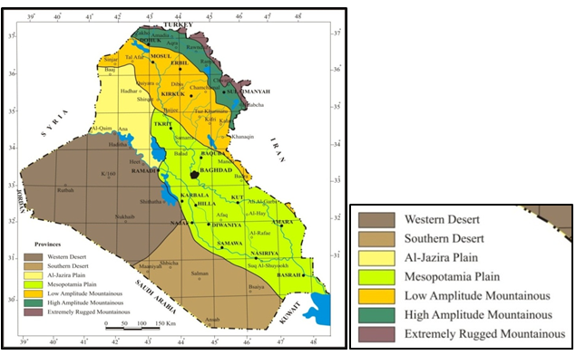

Figure 1: Physiographic Provinces Map of Iraq [1]
Large number of studies was conducted on karstification phenomenon in Iraq. The most important studies are:
• Sissakian et al. (1984) [2] conducted engineering geological mapping of Haditha Area, west of Iraq and reported about the types of karst forms.
• Witold and Hassan (1986) [3] compiled the first Geomorphological Map of Iraq and presented the karst areas in Iraq.
• Sissakian et al. (1986) [4] reported about 55 sinkholes in Haditha vicinity.
• Al-Naqash and Talabany (1988) [5] reported about karstification of limestone and gypsum beds in northern part of Iraq.
• Jassim et al. (1988) [6] reported about karstification effects on the site of Wax Plant in west of Mosul city.
• Jassim et al. (1988) [7] reported about the types of the karst forms in the Fatha Formation in Mosul Area.
• Yacoub and Sissakian (1988) [8] reported about circular collapses in recent flood plain sediments.
• Hamza (1997) [9] compiled the Geomorphological Map of Iraq and presented the main karst areas in Iraq.
• Sissakian and Abdul Jabbar (2005) [10] reported about site selection problems in karstified gypsum beds.
• Sissakian and Ibrahim (2005) [11] compiled the Geological Hazards Map of Iraq and presented the karstified areas.
• Hijab et al. (2006 and 2007) [12 and 13] conducted geophysical studies in Mosul Dam site and reported about the karstification in the dam site.
• Sissakian and Al-Mousawi (2007) [14] reported about the the karstification problems in Iraq.
• Sissakian and Abdul Jabbar (2008) [15] detected the origin of Um Chaimin Depression west Iraq; as a large karst form using GIS technique.
• Sissakian and Abdul Jabbar (2009) [16] detected about karst forms in the Jazira area, west Iraq; using GIS technique.
• Sissakian (2011) [17] reported about the origin of the Tharthar Depression; as a karst influenced by structural effect.
• Yacoub et al. (2011) [18] reported about the geomorphology of the Low Folded Zone in Iraq and presented the types of karst forms in the involved area.
• Sissakian et al. (2012) [19] reported about the influence of karst forms on the drainage style in the Iraqi Southern Desert
• Sissakian et al. (2013) [20] reported about the age estimation and genesis of Salman Depression; as a large karst, in the Iraqi Southern Desert.
• Al-Shaikh and Al-Mash'hadani (2013) [21] reported about the origin of the Nukhaib Depression; using gravity study and concluded it is of solution origin.
• Sissakian et al. (2014) [22] reported about the geomorphology of the High Folded Zone in Iraq and presented the types of karst forms in the involved area.
• Al-Shaikh and Al-Mash'hadani (2014) [23] reported about the origin of solution forms in Salman Area; using gravity study.
• Sissakian et al. (2014) [24] reported about the karstification problems on Mosul Dam and its assessment.

The aim of this article is to elucidate the karst forms in Iraq, their geographic distribution, shapes, sizes, involved geological formations, causes of development, caused hazards; both in properties as well as lives; since there are life losses.

2 Materials and Methods

The geological and topographical maps with the Google Earth and Satellite images were used to recognize the main karstified areas. Different geological maps at scale 1:250,000 [25, 26, 27, 28, 29, 30, 31, 32, and 33] were reviewed to observe the relation between the karst forms and the exposed geological formations. Moreover some scientific and historical books [34, 35, 36, 37 and 38] and published relevant articles [39, 40, 41, 42 and 43] were reviewed too. In addition, field data for the period 1984- 2012 available from the State Company of Geological Survey and Mining (previously D.G. Geological Survey and Minerals) were also used in this work.

3 Karst Forms
3.1 Karst Areas in Iraq
Karst forms are extensively formed in different parts of Iraq (Figure 2). This is attributed to favorable conditions for karst development, such as: 1) Presence of limestone beds almost everywhere in Iraq, except the Mesopotamia Plain [1]; since they cover about 27.5 % of the coverage area of the Iraqi territory [44], 2) Presence of gypsum beds, which are widely exposed in the Jazira and Low Mountainous Provinces [1], and 3) Wet phases during Pleistocene and Holocene [45]. Figure (2) shows the main karstified areas in Iraq; however, this does not mean that in other areas no karst forms occur, especially the northern and northeaster parts, where karst forms are in form of caves not sinkholes.

Figure 2: Karst areas in Iraq [43]

3.2 Karstification
Karstification process is very old in Iraq; as witnessed from Jurassic formations in the Iraqi Western Desert [46]. The last phase of karstification, however in Iraq was during Pleistocene [2, 4 and 47], when wet climate was prevailing; as indicated from different geomorphological forms and units [1, 3, and 9]. The authors; however, believe that the last phase of karstification is still continuous as it is evidenced from the development of new karst forms and the rejuvenation of others, especially in Haditha and the Southern Desert vicinities [4, 19, and 20]. Many examples occur in different parts of Iraq indicating that the karstification is still continuous; as indicated by the presence of holokarst and merokarst [19] (Figure 3).

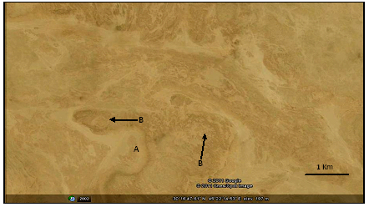

Figure 3: Google Earth image showing both holokarst (A) and merokarst (B)
Note the influence of the karst forms on the drainage system, the course of the valley hardly can be followed [From 19]

The following event is a sound indication for continuation of the karstification phase. On 5/ 3/ 1944 a large sinkhole was formed in limestone beds of the Dammam Formation (Eocene), after collapse of the roof forming beds, near Al-Shbicha police post, Iraqi Southern Desert, which is located 300 Km south of Baghdad. The collapsing of the limestone beds continued for a month, the local people, few kilometers from the formed sinkhole felt the sound of the collapse, whereas ground shocks were felt by the local people from much farther areas from the formed sinkhole. The diameter and the length of the sinkhole were 33 m and 27 m, respectively [35]; it is within Um Err Radhuma Formation (Paleocene) [1].
3.3 Distribution of Karst Forms in Iraq
For simplification of presenting different karst forms in Iraq, their main hosted geological formations, shapes, sizes, types, development causes and related hazards, the karst forms is presented in different physiographic units; hereinafter.
3.3.1 Southern Desert Province
This province is located in the southern part of Iraq (Figure 1), it is covered mainly by Dammam (Eocene) and Um Er Radhuma (Paleocene) formations [1], and both composed mainly of carbonates [44]. However, other formations are exposed too, but the intensely karstified rocks belong to the mentioned two formations. The whole area is densely karstified leading to karst morphology with different types and sizes, but the main one is collapse sinkholes. They are of two types; either active or dormant. The former has many irregular chambers in the floor; formed by draining of the rain water to the subsurface beds, whereas the latter is almost spoon shaped; the floor is covered by Quaternary sediments of alluvial type; fine clay and/ or silty clay. The in filled rain water over flows and small amount infiltrates to subsurface beds, since the in filling materials are usually fine clay.
This province is the more intensely karstified as compared to other physiographic provinces in Iraq; moreover, the karstification is still in process as indicated from the concentric karst forms (Figure 4).The dimension of the karst forms is variable; the diameter ranges from few meters up to few kilometers, whereas the depth ranges from few meters up to 30 m.

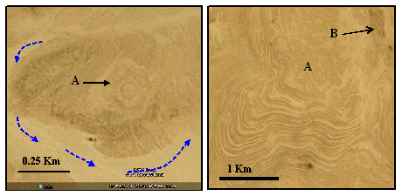

Fig.4: Google Earth images. Left) Showing continuous karstification process,
indicated by the three concentric rims (A), Right) Showing successive rims in Zahra Formation indicating continuous collapsing of the roof, note the dense karst forms on the flat area (A) and the developed doline in (B) [From 19]

The main reason for karstification in the Southern Desert Province is the dissolution of the limestone beds of both Umm Er Radhuma and Dammam formations, which leads to collapse of the roof of the subsurface cavers formed due to dissolution; therefore, the majority of karst forms are due to collapse. However, the presence of the Rus Formation (Early Eocene) between the Umm Er Radhuma and Dammam formations in large parts of the province is another reason for the development of karst forms; densely in this province [19, 20, and 48]. The Rus Formation (50 75 m) [44] consists of limestone and gypsum; both are known to be highly soluble in water; therefore the formation is totally dissolved in large parts of this province, consequently large parts are karstified by circular forms (Figure 5) representing karst morphology [20 and 48]. Therefore, subsurface is also considered in karstification of the area; consequently, the term "karst terrane" is used instead of "karst terrain" [49 and 50]. The densely karstified circular forms, irregular drainage systems and presence of concentric rims in depression (Figure 4) are attributed to the karst terrane.
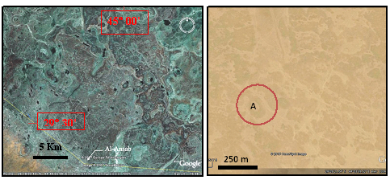

Figure 5: Google Earth images in the Southern Desert Province. Left) Near Al- Ansab, Right) Near Al-Sahan. Note the circular karst forms. Depression A has diameter of 100 m.

From the well-known depressions in the Southern Desert Province is the Salman Depression; called "Nuqrat Al-Salman", which means in Arabic Language; local slang, "Hallow of Salman". It is the largest depression in the province, with length of 20 Km, whereas, the width is variable, it is (6.5, 10 and 4.5) Km, in the northern, central and southern parts, respectively, whereas, the depth ranges from (5 – 35) m [20] (Figure 6).
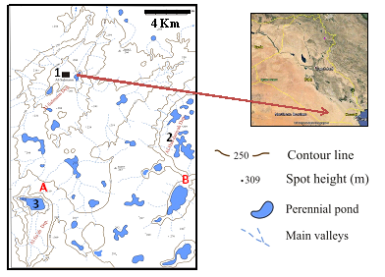
Figure 6: Topographic map of Al-Salman Depression and near surrounding. Note the other two main depressions which will coalesce all together after collapsing of the rims in between them. Also note the densely spread depressions [From 20].
Depressions: 1 = Salman, 2 = Al-Had'daniyah, 3 = Al-Sa'ah
Following the karst terminology [37], the Salman Depression is a large uvala; formed by the coalescence of several closed dolines; as it is clear from the system of the contour lines in the topographic map (Figure 6). Tens of small closed depressions can be seen obviously in Salman Depression and near surroundings (Figure 6), the depression as well the other two large depressions, Al-Had'daniyah and Al-Sa'ah are continuously growing by continuous collapsing of the rims (Figure 7), consequently coalescing each other; as it is obvious in points A and B in Figure (6). Moreover, the floor of the Salman Depression also suffers from karstification, which means the karstification process is still active and on-going. This is confirmed by the presence of many sinkholes in the floor, the thickness of the Quaternary sediments is about 9 m. They consist of three cycles, which are fining upwards, covered by gypcrete. The sediments consist of angular limestone fragments, which range in size from (1 – 10) cm, cemented by clayey and sandy materials (Figure 8).

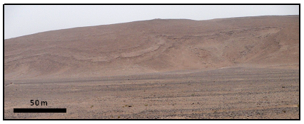
Figure 7: Western rim of the Salman Depression. Note the collapsed limestone beds.

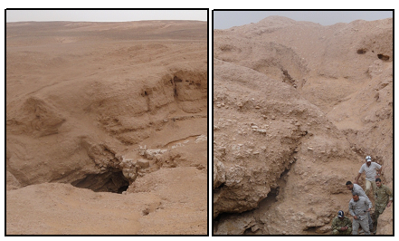
Figure 8: Left) A sinkhole in the floor of Al-Salman Depression
Right) Quaternary infill sediments indicating continuous subsidence [20].

Another well-known sinkhole is the "Chibiritiyah", which means in the Arabic language (local slang) sulphur; since sulphur was quarried from the sinkhole during forties and fifties of the last century, they are two sinkholes near to each other (Figure 9). The sinkholes are within the limestone beds of the Umm Er Radhuma Formation (Paleocene); the deeper one (30 42' 07.55"N and 43 12' 27.99"E) with sulphur showings is with diameter of about 50 m and depth of 35 m, the shape is cylindrical with steep walls, which prevent descending in the sinkhole, many irregular entrances can be seen in the floor; indicating the activity of the sinkhole and which were used for sulphur quarrying. The second one is larger but shallower and spoon shaped (Figure 10). Towards east of the two sinkholes, a large elliptical depression occur with two small circular shallow depressions (Figure 9).
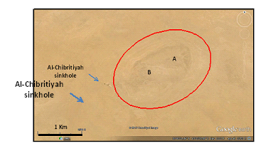
Figure 9: Google Earth image of Al-Chibritiyah sinkhole. Note the large depression; eastwards, which includes two shallow depression (A and B).
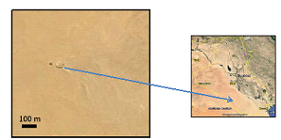
Figure 10: Enlarged Google Earth image of Al-Chibritiyah sinkhole.

3.3.2 Western Desert Province
This province is located in the southwestern part of Iraq (Figure 1), it is covered mainly by different formations that range in age from Permian (Ga'ara Formation) to the Pliocene – Pleistocene (Zahra Formation) [1], the main lithology of the exposed formations is the carbonates with less abundant clastics [44]. However, the densely karstified formations with tens of sinkholes are the Euphrates Formation (Early Miocene) and the Ratga Formation (Eocene) [1].

One of the main karstified areas in Iraq is Haditha vicinity at the Western Desert Province (Figure 2), where 55 sinkholes were observed and recorded [2 and 4]. The main shape of the sinkholes is either circular or elliptical. The formers are usually cylindrical (Figure 11) or conical in shape, active; with steep slopes; the floor is free of soil; with one or more irregular entrances, which act as water discharging gates to subsurface beds. Whereas, the latters are spoon shaped, shallow with floor covered by alluvial soil and are inactive. The diameter ranges from one meter up to 100 m, whereas, the depth ranges from one meter up to 50 m, like in the sinkhole of Salman Rosa, near Haditha (Figure 12) [4]. The name of Salman Rosa sinkhole is after a man called Salman who fall down by his car in the sinkhole with two colleagues in sixties of the last century; his mother's name is Rosa.
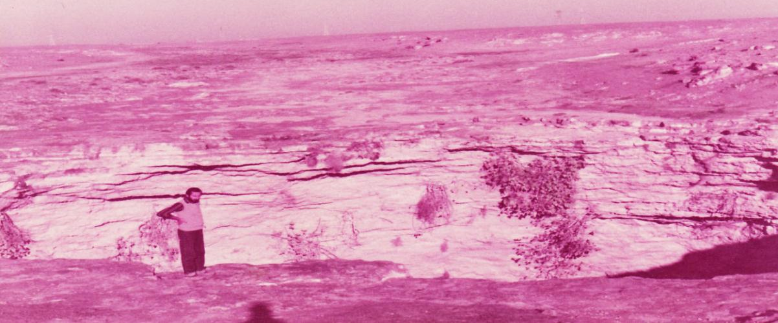
Figure 11: Cylindrical active sinkhole in the Euphrates Formation.
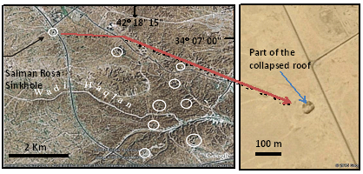
Figure 12: Left) Landsat image of sinkholes (encircled) in Haditha vicinity,
Right) Google Earth image of Salman Rosa sinkhole.

The main reason for the karstification in Haditha vicinity within the Euphrates Formation is the presence of the basal conglomerate in the lowermost part of the formation, especially where the basal conglomerate is exposed in the floor of the valleys [2 and 4] (Figure 12). This is attributed to the fact that the cementing materials of the basal conglomerate is dissolved by the movement of the infiltrated rain water that seepages out in the valley's floors; consequently, the pebbles of the basal conglomerate are left loose, then the overlying limestone beds are dissolved until the remaining roof cannot held the weight and collapse down forming the sinkholes. Such scenario is also confirmed by [40].
Besides Haditha vicinity, tens of sinkholes are formed in different parts of the Western Desert Province with the same shapes and sizes, all in limestone beds, although not due to the same reason of the basal conglomerate, but by usual dissolving of limestone beds of the Ratga (Eocene), Euphrates (Early Miocene) and Nfayil (Middle Miocene) formations.
Among the well-known sinkholes in the extreme western part of Iraq is "Um Chaimin" sinkhole (Figure 13). It is almost circular bowl in shape, with longest diameter of 2.9 Km (along N – S) and shortest one of 2.5 Km (along E – W), with depth of (28 – 38) m. The surrounding area is quite flat with elevation of (850 – 860) m (a.s.l.); therefore, it is almost invisible, unless from very close distance, about few tens of meters from the depression [15]. The term "Umm Chaimin", according to the local "Bedwin" slang language, means an ambush area. Another explanation, however is given too, which means a reservoir.
The origin of the sinkhole, which resembles a crater, was a matter of controversy since seventies of the last century [15]. Many authors have studied the characteristics, even using geophysical methods, some concluded that it is formed due to meteorite impact; others believe it is formed due to gas explosion and some attributed its formation due to karstification [15]. The karst origin was proved by using GIS techniques through studying 18 parameters [15].
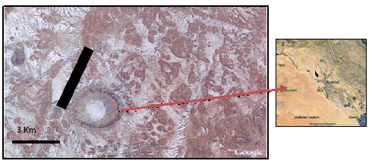
Figure 13: Google Earth image of "Um Chaimin" sinkhole. Note the dense distribution of circular forms, which represent "holo karst" and "mero karst" forms.

The floor of the sinkhole that forms a dry lake has oval shape, almost parallel to Al-Walaj valley, with longest N – S diameter of 1.8 Km and shortest E – W diameter of 1 Km. The floor is flat with elevation of 822 m (Figure 14). The area of the depression as measured from the highest closed contour (850 m) is about 5.73 Km². The ratio of the diameter at the top of the depression to the diameter at the bottom of the depression is:
Wt/ Wb = 2.9/ 1.8 = 1.6
whereas, the depth / width ratio is:
d/ Wt = 33/ 2900 = 0.001
and if the true depth is considered, then it is:
d/ Wt = 130/ 2900 = 0.045
where,
Wt is the width in the top
Wb is the width in the bottom
d is the depth
From reviewing the indicated values, it can be concluded that the depression has collapse doline shape, which resembles the "tiankengs" [40]. The volume of the Umm Chaimin Depression is about 109530000 m³, as measured by means of ARC GIS, depending on the average height of the bottom and average height of the top (Figure 14).
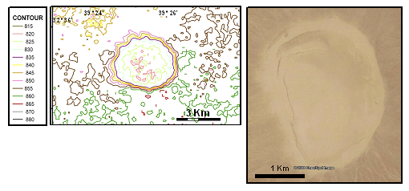
Figure 14: Left) Contour map of the crater, constructed by Spatial Analysis of DEM using ARC GIS. Right) Google Earth image of the crater, note the recent cracks in the extreme northwestern part of the floor [From 15].

3.3.3 Al-Jazira Province
This province has almost rectangular shape; west of the Tigris River; north of Euphrates River and south of Sinjar Mountain (Figure 1). The province is covered mainly by Fatha (Middle Miocene) and Injana (Upper Miocene) formations [1]. The lithology of the former is green marl, red claystone, limestone and gypsum in cyclic nature, whereas the lithology of the later is sandstone, siltstone and claystone in cyclic nature, all are reddish brown in color [25. 29, 31, 32 and 44]. However, the densely karstified formation with tens of sinkholes and large depressions is the Fatha Formation [1, 3, 5, 9, 11, 14, 16, and 17].
In the Jazira Province, the karst forms are developed in gypsum beds. The forms are of two types. Either in form of small, irregular and shallow holes, not more than few meters in diameter and depth, or in form of very large depressions; usually structurally controlled.
3.3.3.1 Small Sinkholes
These are small sinkholes formed by dissolution of gypsum beds leaving small irregular holes, which indicate solution effect on the gypsum beds. The depth of such sinkholes is not more 5 m, whereas the diameter is usually less than the depth. Down to depth of the sinkholes, usually many entrances and/ or channels can be seen; indicating the passage of the water to deeper beds. Majority of those sinkholes are used by the local people as natural water wells, although the water is nor drinkable, but it is used for cattle and livestock breeding, and local cultivation [51] (Figure 15).
The densely developed sinkholes in the Jazira Province are restricted the Lower Member of the Fatha Formation, this is attributed to: 1) The thickness of the gypsum and limestone beds is thin in the Upper Member, as compared to those in the Lower Member, 2) The cycles of the uppermost part of the Upper Member includes thick reddish brown claystone, siltstone and sandstone beds, which prevent water circulation, consequently reduces dissolution of the beds; therefore, no karstification occurs, and 3) The Injana Formation, which overlies the Fatha Formation also play a partial role in preventing water circulation in the underlying rocks of the uppermost part of the Fatha Formation.
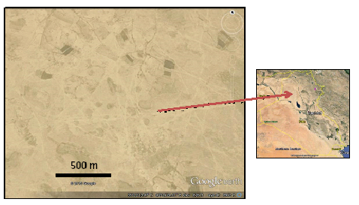
Figure 15: Google Earth image of the central part of Al-Jazira Area. Note the densely cultivated areas, which utilize water from the developed sinkholes for irrigation.

3.3.3.2 Large Depressions
Many large depressions; with coverage areas of few tens of square kilometres exist in Al-Jazira Province, they all are collapse depressions; structurally controlled [16, 17, 52 and 53]. The coverage area of the Tharthar Depression; the largest one is 2050 Km 2 [17], other main depressions are: Ashqar, Snaisla, Um Dhiyaba, Al-Taweel, and others [52], all are structurally controlled with collapse forms; forming large dolines. The depressions are surface expressions of inverted grabens [53]. Hereinafter are few examples of those depressions.
Tharthar Depression: Tharthar Depression is one of the largest closed depressions in Iraq; it is located in the central western part of Iraq, between the Jazira and Mesopotamia Plains, west of the Tigris River (Figure 16). It covers about 2050 Km2, oriented almost N – S, then changes to N35° W – S35° E, with a bowl shape, the base being in the south. The exposed rocks in the near surroundings of the depression belong to Fatha and Injana formations, with Al-Fatha Alluvial Fan sediments in its eastern bank. Tectonically, it is located in the Mesopotamia Foredeep of the Unstable Shelf, forming the contact between the Jazira and Mesopotamia Plains [54]. Geomorphologically, it is a large depression with a floor of – 3 m, above the sea level. The maximum length and width of the depression are 120 and 48 Km, respectively. The eastern rim of the depression is higher than the western one; the heights of both rims are 90 and 75 m, respectively.
The genesis of the Tharthar Depression is a matter of debit, since 1959, many ideas explain the origin of the depression. However, it is proved that the depression is of multi genesis, closed depression formed mainly by karstification, due to dissolving of gypsum rocks of the Fatha Formation and is structurally controlled; being an inverted graben. The measured parameters, depth/ width ratio, length/ width ratio and width at top/ width at bottom ratio range from 0.017 to 0.125, 27.6 to 300, and 2 to 4.5, respectively. Such ratios assume either collapse or solution doline, of multi origin.
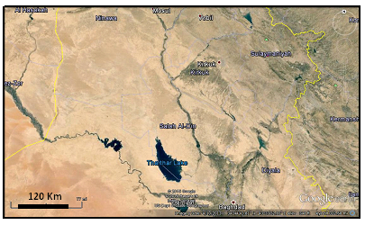
Figure 16: Google Earth image of Al-Jazira Province showing Thathar Depression.
Ashqar Depression: It is a large depression in the central part of Al-Jazira Province, with elongated shape; oriented ENE – WSW and coverage area of 25 Km 2 (Figure 17). Two main lineaments of ENE – WSW trend and length of more than 100 Km, and are only 8 Km apart from each other with escarpments of heights (8 – 15) m bound the depression. Collapses in different phases, changing the trend of a main branch of wadi Tharthar and controlling the trend of many valleys are characteristic features within the area. Three main phases of karstification are indicated, the latest phase is still active. From structural and tectonic points of view, the area is located within the Mesopotamia Zone of Outer Platform of the Arabian Plate [54].
The two main lineaments with trend of ENE – WSW extend northeastwards off Al-Jazira Province for about 60 Km, crossing the Tigris river. The area limited by the two lineaments is densely karstified; among the karst features is the Ashqar Depression, which is a large doline, with many other karst features. From neotectonic point of view, the studied area is uplifted (since the Late Miocene) with amount of (200 – 250) m. The contour line of + 200 m value exhibits clear bulging with the same trend of the aforementioned two lineaments. The estimated rate of regional uplift is about (0.1 – 0.2) cm/ 100 years [55]. The area limited by the two lineaments, however is subsided, as indicated from the topographical maps with clear southeastern rim, which is (8 – 15) m in height. The residual gravity anomalies map, scale 1: 250 000 [56] shows very clear impression for the two lineaments with full coincidence to the surface expression. The recorded negative and positive anomalies range from (–0.4 to –0.8) mg and (0.2 – 0.6) mg, respectively. The negative anomalies are good indication for the subsidence, indicating continuation of the subsidence down to depth of (750 – 1000) m (Jassim Al-Bdaiwy, personal communication). The seismic attenuation map, scale 1:1000 000 shows also very clear indication for the two lineaments and subsidence area, in between. The effect of the subsidence might be down to about 1000 m (Dr. Saffa F. Fouad, personal communication).
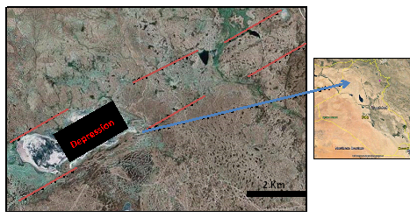
Figure 17: Google Earth image showing Ashqar Depression. Note two long lineaments (Red lines) indicating structurally controlled depression [16].
3.3.4 Low Amplitude Mountainous Province
This province has oblong shape extending from SE – NW, from the Iraq – Iranian borders; in the southeast to Iraq – Syrian borders in the northwest (Figure 1). The province is covered mainly by Neogene rocks and less abundantly by Paleogene rocks; however, only in two areas even Cretaceous rocks (Shiranish Formation) are exposed; these are Sinjar and Qara Chough anticlines. The Fatha (Middle Miocene) Injana (Upper Miocene), Mukdadiya (Late Miocene – Pliocene) and Bai Hassan (Pliocene – Pleistocene) formations are the most prevailing and cover vast areas within the province [1]. The lithology of the Fatha Formation is green marl, red claystone, limestone and gypsum in cyclic nature, whereas the lithology of the other formations is sandstone, siltstone and claystone in cyclic nature, with conglomerate beds in Bai Hassan Formation [1 and 44]. However, the densely karstified formation with tens of sinkholes is the Fatha Formation and less abundant is the Euphrates Formation, with few caves developed in Pila Spi Formation and Oligocene formations [1, 11, 18, 31, 57 and 58].
The sinkholes in the Low Mountainous Province are mainly developed in gypsum beds capped by limestone; both of the Fatha Formation, they have circular aperture, conical and/ or cylindrical form. The diameters and depths of the sinkholes range from (1 – 59) m and (1 – 35) m, respectively [5, 8, 14, 31, 57 and 58]. In those areas where only the Upper Member of the Fatha Formation is exposed, no karstification is developed in the gypsum beds [57 and 58], whereas in the remaining parts, the gypsum beds are very densely karstified, like in Mosul Dam site [8, 11, 12. 13, 14 and 24], Wax Plant site in Atshan anticline, west of Mosul city [6] (Figure 18).
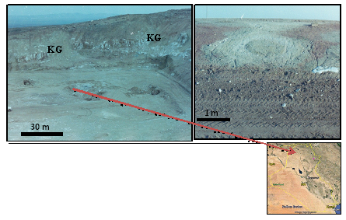
Figure 18: Left) Wax Plant site in Atshan anticline, note the karstified gypsum (KG) beds and the developed sinkholes in the floor. Right) A road cut in a karstified rocks of the Fatha Formation. Note the concentric forms of the rocks due to subsidence of the rocks in a karst form, which is not totally developed yet (Mero Karst) [6].
Other type of karst forms in the Low Mountainous Province is the caves, which are developed in limestone beds of the Sinjar and Pila Spi formations and Oligocene rocks (Kirkuk Group). Caves are developed in Sinjar Mountain, west of Mosul city, in Maqloub and Ba'sheqa Mountains northeast of Mosul city, in Qara Chough Mountain, south of Arbeel city, in Shalwer Dar, Bammu and Bazniyan Mountains, north of Khanaqeen city, along the Iraqi – Iranian borders. However, small caves are also developed within the Fatha Formation (Figure 19), and usually associated with natural bridges, which are also a type of karst forms. Such karst forms are well developed in gypsum beds west and south of Mosul city in different mountains; such as Sheikh Ibrahim, Ishkaft, Sasan, Alan, Butmah, Ain Zala, Masurah, Nuwaiqeet…etc.
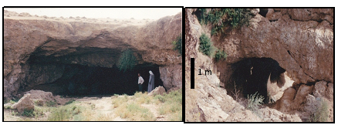
Figure 19: Left) A small cave developed in a gypsum bed of the Fatha Formation. Right) A small natural bridge developed near by the cave.
In Abu Fishga area, south of Mosul city.
The size of the entrances and chambers of the caves is variable, but generally ranges within few meters, exceptionally exceed 10 m, as in Sharwal Der Mountain [58]. They all are of single chamber, very rarely are of multi-chambers. This is attributed to:1) Small size of the caves, 2) Thinly bedded limestone and gypsym rocks, and 3) Low thinckness of the involved formations.
Another interesting possible karst feature is a group of sinkholes aligned on a one line; almost parallel to the trend of the anticlines in the northeastern part of Iraq at Zarbatya area, is the side collapse of the sinkholes forming a meandering valley (Figure 20). The valley is abnormal due to: 1) It flows almost parallel to the trend of the anticline and perpendicular on the main drainage system, 2) Many acute meanders are developed along the valley within a distance of about 800 m, and 3) No such meanders occur along the valleys in the area and near surroundings.
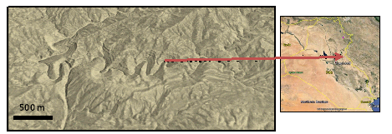
Figure 20: Google Earth image facing NW. Note the acute meanders along the valley indicating possibly a set of sinkholes conjugated together due to side collapsing; forming the valley.

3.3.5 Other Provinces
These are the High Mountainous and Extremely Rugged Provinces forming the extreme northern and northeastern parts of Iraq along the Iraqi – Turkish and Iraq – Iranian borders (Figure 1). The provinces are covered by rocks of different ages ranging from Devonian to Pleistocene, with igneous and metamorphic rocks too [1]. The main lithology of the exposed sedimentary rocks is carbonates, as well clastics, shale, marl, conglomerate, and very rarely evaporates [1 and 44].
In these two provinces, karts forms are represented mainly by caves and very rare sinkholes, this is most probably attributed to: 1) The beds are not horizontal; dipping due to tectonic forces, hence the collapsing is difficult as compared to horizontal beds, 2) Those formations which consist mainly of carbonates has usually large thicknesses; more than few hundred meters, which decreases the water circulation, consequently decreases the possibility of dissolution and collapsing, and 3) The Quaternary cover, especially soil is almost absent; therefore, the humidity is also very low, which usually accelerates the dissolution [36 and 40].
Hundreds of caves are developed in the two concerned provinces, their sizes, shapes, entrances, and the numbers of chambers are highly variable. Usually, the caves are not more than few cubic meters in size of single chamber and small entrance; however, large caves of few hundred meters are very common; like in Qara Dagh Mountain, south of Sulaimaniyah [34], in Bradost Mountain [59] (Figure 21 Left); NW of Rawandooz town, Shiranish; NE of Zakho town, Hasarost, Mateen, Gara, Khalikan, Pera Magroon, Barzanja (Figure 21 Right), Zimnako, Qandeel mountains…. etc.
Among the well know caves is Shanider in Bradost Mountain, west of Rawandooz, where skeletons of Neanderthal man were found. The estimated age of the found bones, using C14 is about 12000 years B.P. of Mesolithic Stage [59]. It is worth mentioning that eight skeletons of Neanderthal man were found in the cave. Moreover, the found skeleton fragments in Shanider cave indicate the Mousterian Stage of the Upper Paleolithic Phase of 29000 years B.P. [59]. However, this difference in the recorded ages could be attributed that the trees growing line receded down to 700 m (a.s.l.), which is lower than the cave's elevation; therefore, the cave was not habituated during the mentioned time span.
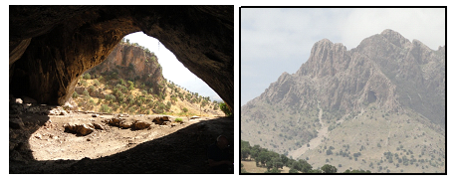
Figure 21: Left) The entrance of Shanider cave (from inside),
Right) A cave in Barzanja Mountain.
The caves are also characterized by stalactite and stalagmite and guano. Unfortunately, majority of the caves are used by shippers, they use the large caves in the Winter as shelters, and some of the caves have lost their internal structure due to waste of the breaded animals and black smokes due to burning of wood for heating (Figure 22, Left).
Another type of the karst forms is the "Karren", which is in form of channels or furrows, caused by solution on massive bare limestone surfaces; they vary in depth from a few millimeters to more than one meter. Good example is near Rawandooz town on top of Korak Mountain (Figure 22, Right).
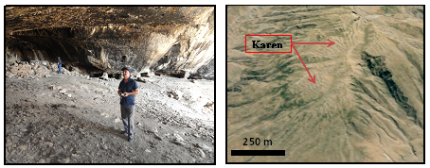
Figure 22: Left) Sealing of Shanider cave with black varnish, note the excavation debris Right) Karen form on top of Korak Mountain.

4 Karstification Induced Hazards
Karstification in Iraq has induced extreme hazards, especially in properties and precisely in strategic projects and industrial complexes, as well life losses are recorded. The main induced hazards and examples of life losses are given hereinafter.
4.1 Strategic Projects and Industrial Complexes
The following are the main strategic projects and industrial complexes that suffer from karstification, they are briefly described, and their locations are shown in Figure 23.
A. Mosul Dam: The most dangerous dam in Iraq that suffers from karstification problems; due to the intensively karstified rocks in the foundations of the dam [12, 13 and 24].
B. Wax Plant: It is located west of Mosul city within Atshan anticline. The site suffers from intense karstification (Figure 16, Left), to overcome the karstification problems; large financial allocations were spent to continue the constructions [6]
C. North Fertilizers Plant: It is located NW of Baiji town. The plant suffers from presence of gypcrete, which is dissolved by water leading to subsurface karst forms that effect on the foundations.
D. Baiji Electric Station: It is located N of Baiji town. The plant suffers from the presence of gypcrete, which is dissolved by water leading to subsurface karst forms that effect on the foundations.

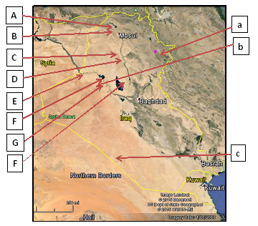

Figure 23: Google Earth image showing locations of the main
strategic projects and industrial sites that suffer from karstification problems
(marked by capital letters), and those of loss of lives due to karstification
(marked by small letters).

E. Phosphate Complex in Al-Qaim: It is one of the largest industrial complexes in Iraq; located in the extreme western part of Iraq, along the Euphrates River. It suffers from subsurface karstification developed in the limestone of the Euphrates Formation.
F. Haditha Dam: It is located W of Hadith town along the Euphrates River. The dam suffers from the intense karstification; as indicated by tens of sinkholes, which are developed in the Euphrates Formation [2 and 4]. Enormous amounts of grouting material are injected in a set of drilled boreholes to construct a subsurface curtain along the dam axis to prevent subsurface water flow through the karst channels, tunnels and caverns.
G. Haqlaniyah Rock Slab Factory: It is also located on the Euphrates Formation in the western part of Iraq. The foundations of the factory suffer from subsurface karst, which is intensely developed. The factory is abandoned [2 and 14].
H. Al-Tharathar Residential Complex: It is located east of Al-Tharthar Depression. The complex suffers from the presence of gypcrete, which is dissolved by water leading to subsurface karst forms that effect on the foundations of the built houses and other facilities [14].
4.2 Loss of Lives

The following are the recorded events in which loss of lives had happened, as related to karstification, they are briefly described; their locations are shown in Figure 23.
a. Qara Dagh Mountain: It is located south of Sulaimaniyah city. Long caves are developed within the Sinjar Formation (Paleocene) in which tens of local people were died, since they lost their way back out of the caves, which they were investigating, among them is Hazar Mard cave [34].
b. Salman Rosa Sinkhole: It is located west of Hadith town, a very large sinkhole with depth of 50 m and diameter of 100 m, located very near to Hadith – Anah road. Three persons were died due to fall of the car, which was driven by one of them called Salman [14].
c. Al-Ma’aniyah Sinkhole: Many sinkholes are located in Al-Ma’aniyah vicinity, south of Al-Najaf city; with depths of more than 10 m and diameters of (20 – 40) m. According to a police sergeant in Al-Sahan police post, a police patrol was patrolling the Iraqi – Saudi Arabian border in 1975, at a dark night, the car fall in a sinkhole in Al-Ma'aniyah vicinity, consequently, three policemen were died (Personal communication of the senior author with a police sergeant, 1979) [14].

5 Results
Large parts of the Iraqi territory are highly karstified; forming different karst forms. This is attributed to the presence of large areas covered by limestone and gypsum; both are highly soluble by water. The main karst forms are collapse sinkholes and dolines within limestone pavements, solution sinkholes in gypsum beds, large karst depressions, which are structurally controlled, and caves of different sizes. The intense karstification has effected on the foundations of many strategic projects; like Mosul and Hadith dams and industrial complexes. Enormous amounts are allocated for maintenance purposes. Losses of lives are recorded too.
6 Discussion

Iraq is characterized by different types of karts forms; this is attributed to type of the exposed rocks, which cover the majority of the Iraqi territory. Since limestone covers about 124890 Km2, which forms 23.07% of the total coverage area [44], besides the gypsum, which also covers considerable areas, especially in Al-Jazira Province. Moreover, in each physiographic province, the tectonic and structural effect has great role to contribute with the dissolution in forming different karts forms in different physiographic units.
The Southern and Northern Deserts are covered mainly by limestone [1], especially the former, where the landscape forms limestone pavement. In both Southern and Northern Deserts, the karst forms are represented by collapse sinkholes; due to dissolving of the limestone by the groundwater and surface water leading to typical karst forms (Figures 5, 6, 9, 12 and 13), which are densely developed. The collapsing of the roof (Figures 7 and 8) has resulted many large dolines, which are still growing up by continuous collapsing of the roofs and side walls to conjugate together forming very large karts forms with diameters of tens of kilometers, a good example is Al-Salman Depression (Figure 6). However, single large forms are also present, like Um Chaimin (Figures 13 and 14) and the one near Al-Chibritiyah sinkhole (Figure 9).
In Al-Jazira Province, the main formed karst forms are solution sinkholes, the gypsum of the Fatha Formation is dissolved leading irregular sinkholes, which are very densely developed (Figure. Moreover, solution sinkholes are associated with subsurface grabbens to form very large depressions, such as Ashqar, Albugharis, Al-Tawil, Um Dhiyabah Al-Tharthar Depressions, all are structurally controlled; as expressed by lineaments (Figure 17), their structural origin is also proved by geophysical data [53 and 54].
In the Low Mountainous Province, both types of sinkholes are developed, collapse and soultion in limestone and gypsum rocks, respectively. The main karstified formation is the Fatha Formation. However, in Kirkuk Embayment area, eastern part of the province, the Fatha Formation is nor karstified. This is attributed to: 1) Steep dipping of the beds, 2) Increase of claystone beds and their thicknesses, and 3) Existing of sandstone beds.
Another interesting feature is side collapsing of sinkhole's walls along a valley; leading to meandering of the valley (Figure 20). The details of a single side collapsed sinkhole are demonstrated in Figure 24. Figure 20 shows a series of meanders along the valley, no reason can be given to explain such meanders in a valley in such rock types with such gradient. Moreover, no other valley in the vicinity shows such meandering; therefore, the most relevant explanation of the meandering is the side collapse of the sinkholes, which are developed on a straight lineament. Part of the collapsed roof; during development of the sinkhole is still present, such form is also clearly seen in Salman Rosa sinkhole in Hadith vicinity (Figure 12 Right).
Side wall collapsed sinkholes is also developed in Sartaq Bammu vicinity, south of Derbendi Khan; about 35 Km (Figure 25). A series of side wall's collapsed sinkholes has formed a canyon like valley with acute meanders; hindering the true shape and size of the sinkholes. Another very clear side collapsed sinkhole is in Lolan valley (Figure 26), in the extreme northern part of Iraq.
Caves, are also well developed in the High Mountainous and Extremely Rugged Mountainous Provinces. They are developed in limestone beds within different geological formations (Figures 21 and 22 Left), where the thickness of the formations ranges from (50 – 1000) m, whereas the thickness of the individual bed ranges from (1 – 7) m. Some of the caves are very large with multi chambers, such as Chami Raizan (Zarzi) cave and Hazar Merd cave (Figure26). Hazar Merd is a group of Paleolithic cave sites excavated by Dorothy Garrod in 1928, a dark cave has a single lofty chamber 11 by 12 m wide [60]. The caves are located south-southwest of Sulaimaniyah city. Garrod's soundings in two caves in the Hazar Merd group provided evidence of Middle and Epi-Paleolithic occupation.
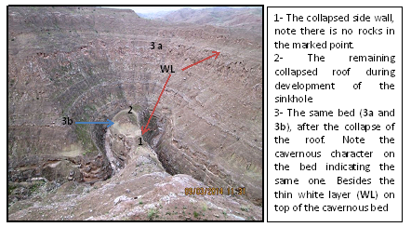
Figure 24: A side wall collapsed sinkhole in Shishireen valley, eastern part of Iraq.
Note the details of side collapsed sinkhole.
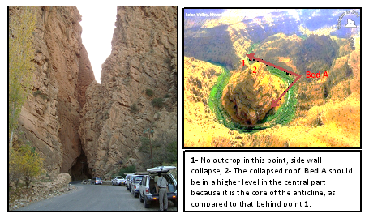
Figure 25 Left): A side collapsed sinkhole in Sartaq Bammu area,
Right) Side collapsed sinkhole in Lolan valley within a core of anticline.
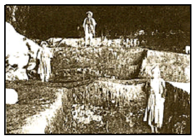
Figure 26: Hazar Merd (1928). Three Kurdish boys standing on
different levels of excavation trenches.

7 Conclusions
The following can be concluded from this study:
The Southern Desert Province is the most karstified part in Iraq, it forms a large limestone pavement are. Karst forms are of solution sinkholes; mainly of doline type. Some of the forms are enlarged by side collapses reaching few kilometers; with depth ranges (1 – 35) m.

The Western Desert Province is also characterized by collapsing sinkholes in limestone beds, mainly within the Euphrates Formation and less common in Ratga and Nfayil formations. The size ranges within few tens of meters with spoon or funnel shapes.
The Jazira Province is characterized by two types of karst forms: In gypsum beds solution sinkholes are very common, with small sizes not more than few meters and irregular shapes. The second type; however, is a combination of solution collapse accompanied with structural effect; due to activity of some subsurface grabbens forming large depressions with coverage of few square kilometers.
The Lo w Mountainous Province is characterized by solution and collapse sinkholes in gypsum and limestone beds; representing mainly the Fatha and Euphrates formations, respectively.
The High Mountainous and Extremely Rugged Mountainous Provinces are characterized by development of caves; some of them are of multi chambers and few tens of meters in size. Few of them include archeological evidences for prehistoric life.
Karstification has caused serious problems to many strategic projects with severe damages. Loss of lives also had recorded due to karst forms.

References

[1] Sissakian, V.K. and Fouad, S.F., Geological Map of Iraq, scale 1: 1000000, 4th edition. Iraq Geological Survey publications, Baghdad, Iraq, 2012.
[2] Sissakian, V.K., Mashkoor, M., Al-Ani, S,Sh., Yassin, J.M. and Abdul Ahad, A.D., Report on Haditha Project, Part П, Engineering Geological Survey. Iraq Geological Survey Library report no. 1524, 1984.
[3] Witold, F.J. and Hassan, A.A., The Reconnaissance Geomorphology Mapping of Iraq. Iraq Geological Survey Library report no. 1482, 1986.
[4] Sissakian, V.K., Mahdi, A.I. and Amin, R.M., Sinkholes of Haditha area. Journal of Water Resources, 5, 1, (1986), 707 – 714.
[5] Al-Naqash, A.B and Al-Talabani, N.J., Karst Features in Limestone and Gypsum Area in North Iraq, Journal of Geological Society of Iraq, 21, 2, (1988), 23 – 26.
[6] Jassim, S.Z., Sissakian, V.K. and Taufiq, J.M. (1988) Final Report on the Detailed Geological mapping of Atshan Wax Plant Area. Iraq Geological Survey Library report no. 1522.
[7] Yacoub, S.Y. and Sissakian, V.K., Recent collapses in the flood plain sediments of Euphrates River in Al-Qaim vicinity, Proceedings of the 8th Iraqi Geological Congress, 23 – 26/ 5/ 1988, Baghdad, Iraq.
[8] Jassim, S.Z., Jibril, A.S. and Mouman, N.S., Gypsum karstification in the Middle Miocene Fatha Formation, Mosul area, northern Iraq, Geomorphology, 18, 2, (1997), 137 – 1497.
[9] Hamza, N.M., Geomorphological Map of Iraq, scale 1: 1000 000. Iraq Geological Survey Pubications, Baghdad, Iraq, (1997).
[10] Sissakian, V.K. and Abdul-Jabbar, M.F. Site selection problems in gypsum-bearing formations. A case study from north of Iraq, Iraqi Bulletin of Geology and Mining ,1, 2, (2005), 45 – 52.
[11] Sissakian, V.K. and Ibrahim, F.A., Geological Hazards Map of Iraq, scale 1: 1000 000, GEOSURV, Baghdad, Iraq, (2005).
[12] Hijab, S.R. and Al-Jabbar, M. A., Geophysical Investigation on Mosul Dam Area, Stage One. Emergency Microgravity Survey. Iraq Geological Survey Library, internal report, (2006).
[13] Hijab, S.R., Al-Qadir, A.S.O. and Musa, A.S., Geophysical Investigation on Mosul Dam, Second Stage. Detailed Geophysical Survey, Iraq Geological Survey Library, internal report, (2007).
[14] Sissakian, V.K. and Al-Mousawi, H.A., Karstification and related problems, examples from Iraq. Iraqi Bulletin of Geology and Mining, 3, 2, (2007), 1 – 12.
[15] Sissakian, V.K. and Abdul-Jabbar, M.F., Using remote sensing and GIS techniques in detecting the origin of Umm Chaimin Depression, Iraqi Western Desert. Iraqi Bulletin of Geology and Mining, 4, 2, (2008) ,51 – 72.
[16] Sissakian, V.K. and Abdul-Jabbar, M.F., Remote sensing techniques and GIS applications in detecting Geohazards in the Jazira Area, West Iraq. Iraqi Bull. Geol. Min., 5, 1, (2009), 47 – 62.
[17] Sissakian, V.K., Origin of the Tharthar Depression, Central part of Iraq. Iraqi Bulletin of Geology and Mining, 7, 3, 47 – 62.
[18] Yacoub, S.Y. Othman, A.A. and Kadhum, T.H., Geomorphology, In: Geology of the Low Folded Zone, Iraqi Bull. Geol. Min., Special Issue 5, (2011), 7 – 38.
[19] Sissakian, V.K., Ajar, Dh. K. and Zaini, M.T., The influence of karstification on the drainage system in south of Iraq. Iraqi Bulletin of Geology and Mining, 8, 2, (2012), 99 – 115.
[20] Sissakian, V.K., Mahmoud, A.A. and Awda, A.M. Genesis and age determination of Al-Salman Depression, south Iraq. Iraqi Bulletin of Geology and Mining, 9, 1, (2013), 1 – 16.
[21] Al-Shaikh, Z. and Al-Mash'hadani, A., A gravity study of the Nukhaib Depression Area. Western Desert, Iraq. Iraqi Bulletin of Geology and Mining , 9, 1, (2013), 35 – 49.
[22] Sissakian, V.K., Kadhum, T.H. and Abdul Jab'bar, M.F., The Geomorphology of the High Folded Zone, Iraqi Bulletin of Geology and Mining, Special Issue No.6, (2014), 7 – 56.
[23] Al-Shaikh, Z. and Al-Mash'hadani, A., Gravity evidence of widespread solution below Salman Area, the Iraqi Southern Desert. Iraqi Bulletin of Geology and Mining, 10, 2, (2014), 87 – 98.
[24] Sissakian, V.K., Al-Ansari, N. and Knutson, S., Karstification problems in Mosul Dam and its assessment, North Iraq, Engineering, 6, 2, (2014), 84-92.
[25] Zuwaid, Q.A., Geological Map of Al-Qayara Quadrangle, scale 1: 250000. Iraq Geological Survey publications, Baghdad, Iraq, 1992.
[26] Sissakian, V.K., Geological Map of Al-Bireet Quadrangle, scale 1: 250000. Iraq Geological Survey publications, Baghdad, Iraq, 1994.
[27] Deikran, D.B., Geological Map of Al-Rukhaymiyah and Kuwait Quadrangles, scale 1: 250000. Iraq Geological Survey publications, Baghdad, Iraq, 1995.
[28] Hassan, K.M. and Hassan, E.A., Geological Map of Al-Salman Quadrangle, scale 1: 250000. Iraq Geological Survey publications, Baghdad, Iraq, 1995.
[29] Sissakian, V.K. and Qanber, S.H., Geological Map of Albu Kamal Quadrangle, scale 1: 250000, Iraq Geological Survey publications, Baghdad, Iraq, 1995.
[30] Deikran, D.B., Geological Map of Sooq Al-Shiyookh Quadrangle, scale 1: 250000. Iraq Geological Survey publications, Baghdad, Iraq, 1995.
[31] Sissakian, V.K. (1995) Geological Map of Mosul Quadrangle, scale 1: 250000. Iraq Geological Survey Publication, Baghdad, Iraq, 1995.
[32] Sissakian, V.K. and Qanber, S.H., Geological Map of Haditha Quadrangle, scale 1: 250000. Iraq Geological Survey publications, Baghdad, Iraq, 1996.
[33] Barwary, A.M. and Slewa, N.A., Geological Map of Al-Ma'aniyah Quadrangle, scale 1: 250000, Iraq Geological Survey publications, Baghdad, Iraq, 1996.
[34] Noori, B.D., The Travel of Ridge in Iraq in 1820. Vol. 1 (translated to Arabic), Iraqi Railways Press, Baghdad, Iraq,1951.
[35] Soosa, A., Floods of Baghdad in History, Vol.3. Al-Adeeb Press, Baghdad, Iraq (in Arabic), 1966.
[36] Huggett, R.J., Fundamentals of Geomorphology, 2nd edit. Routlege Taylor and Francis Group, London and New York, 458pp, 2007.
[37] MONROE, W.H., A Glossary of Karst Terminology. Library of Congress catalog-card No. 75-607530, 1972.
[38] Blair, R.W., Geomorphology from Space, Karst landforms and lakes. Internet Data, 2007.
[39] NEDECO, Report on Wadi Tharthar study. Iraq Geological Survey Library report no. 153, 1959.
[40] White, W.B. and White, E., Size scales for closed depression landforms, Speleogenesis and Evolution of Karst Aquifers, The Online Scientific Jour., 4,1, (2006), 1-10.
[41] Kranjc, A., Some large dolines in the Dinaric karst, Speleogenesis and Evolution of Karst Aquifers. The Online Scientific Jour., 4,1, (2006), 1-4.
[42] Ma'ala, Kh.A., Geomorphology. In: Geology of Al-Jazira Area. Iraqi Bulletin of Geology and Mining, Special Issue, 3, (2009), 5 – 32.
[43] Sissakian, V.K., Abdul Ahad, A.D. and Hamid, A.T., Geological Hazards in Iraq, Classification and geographical distribution. Iraqi Bulletin of Geology and Mining, 7, 1, (2011), 1 – 28.
[44] Sissakian, V.K. and Saeed, Z.B., Lithological Map of Iraq, Compiled using GIS Techniques. Iraqi Bulletin of Geology and Mining, 8, 3, (2012), 1 – 13.
[45] Jado, A.R. and Zofl, J.G, Quaternary Period in Saudi Arabia, 1: Sedimentological, Hydrogeological, Hydrochemical, Geomorphological, and Climatological Investigations in Central and Eastern Saudi Arabia Springer Verlag, New York, (1978), 280 – 294.
[46] Mustafa, M.M., Naif, A. M., Shamoun, E., Ali, D. and Muikil, W., Results of bauxite exploration works in North Hussainiyat. Iraq Geological Survey Library report no. 2086 (in Arabic), 1994.
[47] Tyracek, J. and Youbert, Y., Report on the Regional Survey of Western Desert, between T1 oil pumping station and wadi Hauran. Iraq Geological Survey Library report no. 673, 1975.
[48] Ma'ala, Kh. A., Geomorphology. In: The Geology of the Iraqi Southern Desert, Iraqi Bulletin of Geology and Mining, Special Issue, 2, 2009, 7 – 33.
[49] Field, M.S. (1999) Karst Glossary. A lexicon of cave and karst terminology with special reference to environmental karst hydrology. U.S. Environmental Protection Agency, National Center for Environmental Assessment, 201pp.
[50] Ford, D.C., Karst Landforms, The Canadian Encyclopedia, Internet data, 2003. http://www.thecanadianencyclopedia.ca/en/article/karst-landform/
[51] Ibrahim, Sh. B. and Sissakian, V.K., Report on the Al-Jazira area – Rawa – Baiji – Tikrit – Al-Baghdadi, Iraq Geological Survey Library report no. 675, 1975.
[52] Ma'ala, Kh. A., Geomorphology. In: Geology of Al-Jazira Area, Iraqi Bulletin of Geology and Mining, Special Issue, 3, (2009), 5 – 32.
[53] Fouad, S.F. and Nasir, W.A., Tectonic and structural evolution. In: Geology of Al-Jazira Area, Iraqi Bulletin of Geology and Mining, 3, (2009), 33 – 48.
[54] Fouad, S.F., Tectonic Map of Iraq, scale 1: 1000000, 4th edition, Iraq Geological Survey Publications, Baghdad, Iraq, 2012.
[55] Sissakian, V.K. and Deikran, D.G., Neotectonic Map of Iraq, scale 1: 1000000. Iraq Geological Survey Publications, Baghdad, Iraq,1998.
[56] Al-Kadhimi, J.A.M., Fattah, A.S. and Abbas, M.J., Residual gravity anomalies map, scale 1: 250 000. Iraq Geological Survey Library, manuscript report, 1974.
[57] Sissakian, V.K., Geological Map of Kirkuk Quadrangle, scale 1: 250000. Iraq Geological Survey Publication, Baghdad, Iraq, 1995.
[58] Barwary, A.M. and Slewa, N.A., Geological Map Khanaqeen Quadrangle, scale 1: 250000. Iraq Geological Survey Publication, Baghdad, Iraq, 1995.
[59] Wright, H.E., Pleistocene Glaciation in Kurdistan, Translated to Arabic by: F.H., Khorshid. Al-Bidleesi Book Shop, Baghdad, 88 pp., 1986.
[60] Garrod, D., Hazar Merd Cave, Wikipedia, the free encyclopedia, 1928. Internet data. http://en.wikipedia.org/wiki/Hazar_Merd_Cave

Private Consultant,Erbil, Iraq. e-mail: varoujan49@yahoo.com
^{,3} 2Lulea University of Technology, Lulea, Sweden. e-mail: , nadhir.alansari@ltu.se , Sven.Knutsson@ltu.se
Article Info: Received :

