**Investigating the effectiveness of a ground support system implemented on Block A: A case study of Southern Africa Metalliferous Mine.**

Kamogelo Manyelo1, Peter Kolapo2

*1School of Mining Engineering, Faculty of Engineering and Built Environment (FEBE),*

*University of Witwatersrand, Johannesburg, South Africa.*

E-mail: [michellemanyelo@gmail.com](mailto:michellemanyelo@gmail.com) or Kamogelo Manyelo@students.wits.ac.za

*2Department of Mining Engineering, College of Engineering,*

*University of Kentucky, Lexington, United States of America.*

E-mail: [kolapopeter@gmail.com](mailto:kolapopeter@gmail.com) or Poko222@uky.edu

**ABSTRACT**

This study aims to investigate the effectiveness of the ground support systems that are planned to be implemented on Block A, which will be excavated through the Marikana fault zone. The block of ground being prepared for mining has been physically affected by the presence of the Marikana fault and is therefore geomechanically and geotechnically weaker than the normal stoping conditions on the rest of the shaft. Joint mapping conducted in Block A raiselines indicated that there is a high concentration of shallow dipping joints which are dipping in opposite directions. Such conditions present special challenges in the planned excavations because they can lead to sudden and uncontrolled collapses unless appropriate action is taken to mitigate such instances. This is particularly because joint sets dipping in opposite directions tend to form keyblocks, which can collapse provided their weight exceeds the support load bearing capacity or if they are located in between support units. Therefore, stoping in the Marikana fault zone requires a more intensive support with a higher than normal support resistance. The existing ground control strategies, the processes, tools, techniques, and methods that are currently being used for support design were investigated and incorporated into the new system where applicable. Various techniques were used to quantify the quality of the ground conditions, predict the rock mass behaviour, and to identify the appropriate support type.

1. **Introduction**

Accidents in the mining sector continue to threaten the sustainability of the mining industry. Injuries and fatalities are still a major concern, with the destruction of property being a secondary effect (Bonsu, et al., 2017). There has, undeniably, been a substantial improvement in the fatality records within the South African mining industry from 1994 to 2017 as a whole, with a decline in fatalities recorded in hard rock tabular mines (Kotze, 2018). Regardless of these improvements, the loss of life is still too high compared to other large mining countries like the USA, Canada and Australia. The significant causes of injuries and fatalities in the gold and platinum mines in South Africa are due to Falls of Grounds (FOGs), mine ventilation, and transport and machinery issues. According to Shaft P2’s Fatality and Injuries Register, 32% of all fatalities at the shaft are due to FOGs. This is a significantly high number, followed by Machinery at 22%. The register further indicates that a majority of these FOGs highlight the stope face area as the dominant risk area.

As a result of an increased number of discontinuities in Block A, poor ground conditions are expected and the strength of the rock mass surrounding the excavation is expected to be lower than normal as a result. Various empirical methods are available to estimate the rock mass strength of jointed rock in order to determine the optimum support. The most prominent methods are rock mass classification systems such as the “Q” and Rock Mass Rating (RMR) systems. Such systems assess and rate the conditions affecting the stability or instability of rock masses surrounding underground excavations and provide support recommendations. In addition to these rating systems, a stereographic projection program (DIPS) was used in conjunction with a probabilistic analysis program (JBlock) to determine unstable wedges that may form in the proposed excavations. The study includes both probability analysis and empirical methods in determining the optimum support design, which was used to form a new standard.

The block of ground being prepared for mining has been physically affected by the presence of the Marikana fault and is therefore likely to be geomechanically and geotechnically weaker than the normal stoping conditions on the rest of the shaft. To be able to investigate the challenges associated with the extraction of the UG2 reef in Block A which will be excavated through the Marikana fault zone, it is important to provide answers to these questions. How effective is the ground support systems that are planned to be implemented on Block A? Is the support configuration effective? Is the ground over-supported?

This study discusses the challenges faced when extracting ore from the UG2 reef in Block A and provides safe and productive mining conditions in the geotechnically poor ground located in Block A, with the aim of achieving zero harm and providing an efficient and cost-effective support design. The workings developed across Block A are planned to extract only the UG2 Reef. Therefore, this study will focus predominantly on the support design for the stratigraphy above the UG2 Reef.

1. **Description of the study area**

Shaft P2 and Shaft P3 at Mine X form part of the mine’s second-generation shafts. That is, the newer shafts to be sunk and operated. The shafts are located approximately 25 km West-South-West of Brits (North West Province of South Africa). The shafts fall within the western limb of the Bushveld Igneous Complex, a large igneous intrusion which is host to some of the Platinum Group Elements (PGEs). Mine X exploits PGEs from the UG2 and Merensky reefs. Shaft P2’s operation faces the challenge of rapidly depleting ore reserves for both UG2 Chromitite and Merensky reef types within its current shaft boundaries. However, exploration and feasibility studies (conducted by the Geology department) led to the extension of Shaft P2 operations beyond the Marikana fault zone into the mineral resource area of the P3 Shaft block (see Figure 1). Mining on the other side of the fault is expected to increase the life-of-mine of Shaft P2 by another 5 years i.e. until 2026. Stopes and haulages are planned to be developed through the Marikana fault zone which is dipping in a SSE-NNW direction. The Marikana fault is a reverse fault (dipping approximately 80°) with an up-throw displacement to the west of approximately 10-20 meters. Stoping in the Marikana fault zone requires a more intensive support with a higher than normal support resistance. Several types of support such as grout packs and roof bolts are planned to achieve the projected safety requirement.

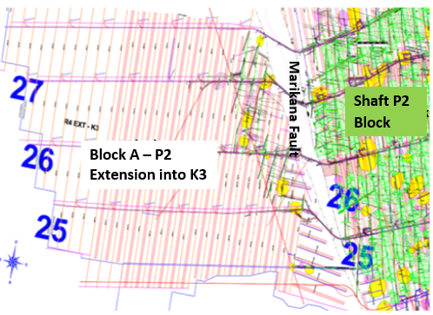

Figure 1: Image showing the Marikana fault zone

At Mine X, the UG2 underlies the Merensky Reef by approximately 130 m to 210 m, increasing from west to east across the Marikana operations (Du Plessis, 2016). As a result of the variable stratigraphic distance between these ore bearing horizons, each of these reef horizons is influenced by different geological features (Balakrishna, 2006). The geological sequence in Figure 2 shows alternating layers of pyroxenite, norite, mottled anorthosite and chromitite. Across the mine, the general mining layout is an up-dip configuration with dip stabilizing pillars, stoping through two panels on either side of a center raise at a panel length of 15 meters. Block A is planned to exploit the UG2 Chromitite Reef in this type of stoping configuration.

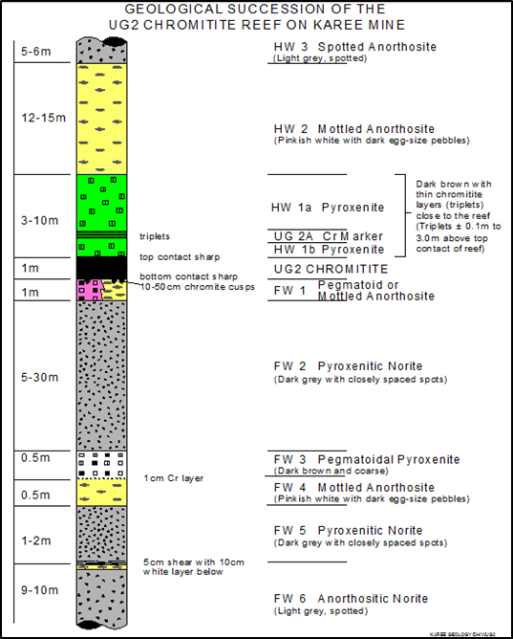

Figure 2: Typical stratigraphic column showing the lithology of the UG2 Reef in Block A.

The strike of the UG2 orebody in Block A is on average East to West and dipping towards the North at an average angle of 9°, with a thickness variance of 0.4 m to 1 m. The geotechnical environment most likely to be encountered by mining in Block A include:

* Geological structures;
* Alteration zones; and
* Parting planes.

The following section provides a general description of the geotechnical environment in which key design parameters for support design will be described.

**2.1 Jointing**

Joints are naturally occurring planar geological discontinuities across which there has been no displacement. Joint structures are a predominant feature in most underground operations across the Mine X lease area. The stability of underground mining excavations is highly dependent on the occurrence and orientation of jointing in the surrounding rockmass. An unfavorable intersection of joints may lead to blocky hangingwall conditions, which can lead to instability and failure if not supported. The presence of joints in the hangingwall causes a discontinuous rockmass which contains interlocking blocks that are bounded by the joint surfaces or infilling material. Natural rock joints infilled with soil-like materials may show a reduced shear strength, which influences rock mass stability.

Both open (i.e. open fractures) and sealed (filled by various materials) joints were identified during the underground joint mapping along the raiselines in the Visser Block. Like the faults, joints vary in strike, and dip orientations as well as filling and persistency characteristics. Low angle joints i.e. shallow dipping joints cutting into the hangingwall can cause FOGs, particularly when these joint sets dip in opposite directions because of the formation of keyblocks.

**2.2 Potholes**

Potholes are roughly circular or elliptical structures where the UG2 reef and lithologies immediately above it slumped to a lower level during geological processes, causing the UG2 chromitite to occur below its normal stratigraphic elevation. The thinning of the reefs and increased joint densities often marks the rims of potholes. Pothole occurrences are not predictable, and their presence in the Visser Block has been partially determined by cover drilling and mining development. When mining approaches a pothole, the joint density usually increases. Where visible, low angle jointing was found on the edges of the potholes. This should be taken into consideration when approaching a pothole. In such situations, hangingwall beam stability becomes more challenging.

**2.3 Faulting**

Faults are planes of weakness in the rockmass where movement has occurred along the plane. Three types of faults are encountered in the Mine X Marikana lease area; normal faults, reverse faults and strike-slip faults (Du Plessis, 2016). Faulting presents a challenge when mining towards or through it, as an increase in jointing can occur and the infilling material may create an unstable work environment. Historical information shows that adverse ground conditions are encountered when mining areas of a fault and can cause falls of ground, as some faults have very little cohesion on the plane of weakness where movement has occurred. A trend of minor faulting occurs within both the shaft P2 and K3 block areas; these faults have an east-southeast to west-northwest striking direction and are mostly reverse faults, but rarely with more than 2 meters displacements. There are indications of smaller faults with the same orientation as the Marikana fault. These faults are increased in frequency closer to the Marikana fault. This indicates the high stress concentrations within the surrounding rock mass.

**2.4 Alteration**

Alteration occurs when there is a change in the structure of a rock or rockmass where water and other minerals have intruded into planes of weakness to change the structure and minerality of the rock mass surrounding the plane. Often referred to as weathering, these changes can make the rock mass weak and brittle. Alteration is typically present in the vicinity of dykes, faults and joint zones. The alteration of the rock surrounding geological structures depends on the mineralogy of the joint infilling and in the Mine X Marikana lease area, chlorite and serpentine are the most susceptible. This is most prominent in the pyroxenite hangingwall. The Block A is expected to have a large alteration area influenced by the Marikana fault striking through the mining block. Observations made in the haulages show that the area around the fault is altered and is expected to present a number of mining difficulties. Figure 3 shows the alteration occurring through hangingwall layers above the UG2 Reef in the Block A. Alteration can be seen in jointing and the layer contact plane in between the Hangingwall 1 (HW1b) and Hangingwall 2 (HW2).



Figure 3: 27C West 103 Raiseline

1. **Literature review**

This chapter provides an in-depth review of existing rating systems that can be used to determine the support requirements for Block A. The focus is on contributions made by relevant experts in rock mechanics on qualitative and quantitative analysis.

Hoek, et al. (1995) stated that great improvements can be achieved in the underground excavations through the use of design and timeous installation of support, taking into account excavation sequences and availability of materials. Rock mass classification systems, particularly the Q-system developed by Barton, et al. (1974) express the quality of the rock mass using an empirical formula. The Q-value is determined from the grouping of six quantifiable geological parameters, in order to provide a value to quantify the rock quality in stable and unstable geotechnical conditions. Based on the following parameters, the Q-value for a rock mass can be calculated using the following equation (after Barton et al, 1974):

Q = $\frac{RQD}{Jn}$ × $\frac{Jr}{Ja}$ × $\frac{Jw}{SRF}$…………………………………………………………Equation 1

Where:

* *Jn*: Joint set number
* *Jr*: Joint roughness number. According to Watson (2004), “such a critical joint set that is planar and either slicken sided or with a smooth or gouge infilling could cause a panel collapse”.
* *Ja*: Joint alteration number. Panel collapses frequently occur when Ja is larger than 3 when making use of the Q- system. (Roberts 1985, cited in Watson, 2004, p. 230).
* *Jw*: Joint water reduction factor. This value indicates the quantity of water present in a joint, which has an adverse consequence of reducing the strength of the host rockmass.
* *SRF*: Stress Reduction Factor is “a measure of the loosening load in cases of excavations with shear zones and clay bearing rocks” (Darling, 2011).
* TheRock Quality Designation (RQD) is a measure of the degree of jointing and was modified by Palmstrong (1982) for use in rockmass exposure i.e. where no core is available. The equation is as follows:

RQD = 115 - 3.3Jv ………………………………………………………………Equation 2

Low quality rock has an RQD of less than 50% whereas high quality rock has an RQD of above 75%. Equation 2 is estimated from the number of joints encountered per unit volume (Jv) of the rockmass, where blast induced discontinuities are omitted. This concept was introduced by Palmstrȍm (1982) and provides an easy approach of approximating the degree of jointing from standard joint mapping data or observations.

Additionally, Rock Mass Rating (RMR) derived by Bieniawski (1976) consider the summing 5 parameter values and adjusting this total by taking into account the joint orientations. The parameters included in the rating include the Uniaxial Compressive Strength (UCS), rock quality designation (RQD), spacing of discontinuities, conditions of discontinuities, groundwater conditions, and orientation of discontinuities. The RMR system is described by Bieniawski (1976) as follows:

RMR = 9 ln Q + 44…………………………………………………………….. ….. Equation 3

Swart, et al. (2005) stated that rock mass classification approaches cannot be adequately used to analyze structurally controlled failures such as beam, block and wedge. They further state that “although rock mass classification should form a fundamental part in the process of designing stable stope panels, particular emphasis should be placed on identifying the most likely failure planes and potential modes of failure”. Both the Q- and RMR system are internationally accepted and used in rock engineering as empirical design tools for stable excavations.

More recently, existing rock mass classification systems have been developed and even modified to suit local conditions. Watson (2004) reviewed several systems and concluded that the modified stability graph by Potvin (1988) only described unsupported stopes. The study designed a hybrid of several current systems and termed it the ‘New Modified Stability Graph’ (N”) system. The system is intended specifically for span and support design in stopes of the Bushveld Complex Platinum. Subsequently, databases of failed and unfailed stopes were collected for the Merensky Reef with various support resistances. A logistical regression analysis was used to determine the line between stable and unstable stopes, with various degrees of confidence. The system makes use of aspects from various rating systems and is currently used by Impala Platinum. The system also incorporates the Q-system and the Stability Graph method as revised by Hutchinson and Diederichs (1996). It consists of the following five factors (Watson, 2004) :

* “A measure of block size for a jointed rock mass (RQD/Jn).
* A measure of joint surface strength and stiffness (Jr/Ja).
* A measure of the stress condition (Jw/SRF)
* A measure of the joint orientation relative to the excavation hangingwall (B-factor); and
* A measure of the influence of gravity on the hangingwall blocks (C-factor). ”

Although the system is designed specifically for mines in the Bushveld complex, it cannot be used to fully meet the objectives of this project. Its limitations are that it focuses predominately on panel spans in the Merensky Reef. It is the opinion of the experts in underground excavations that rockmass classification systems as a designing tool on their own should be used for preliminary designs of underground openings, that is, for planning purposes and not for final excavation support.

1. **Materials and Methods**

The objective of this study was to provide a support design based on a proper knowledge of the inclination, orientation and intensity of the geological features that exist in Block A. Data on the inclinations and orientations of geological features, particularly faults and joints were collected from existing raiselines in the area of Block A. Five meter long scanlines were conducted at 30 m intervals along each of the seven raiselines and winzes in Block A. Measurements were taken with a Silva foldable geological compass and frequently checked with a 1 m clino-rule to ascertain the possible influence of magnetic substances on the readings shown in Figure 4 and Figure 5 respectively. The clino-rule is a 1 m long device fitted with a water bubble and a linear scale used for the estimation of the length and dip orientation of discontinuities. The Silva compass is an instrument used to magnetically determine dip and dip-direction. The following parameters were determined from the joint mapping.

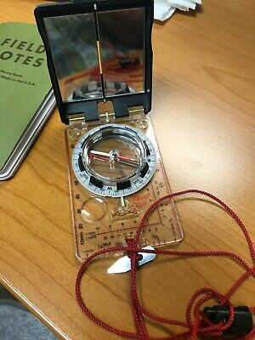

Figure 4: Image of Silva foldable geological compass

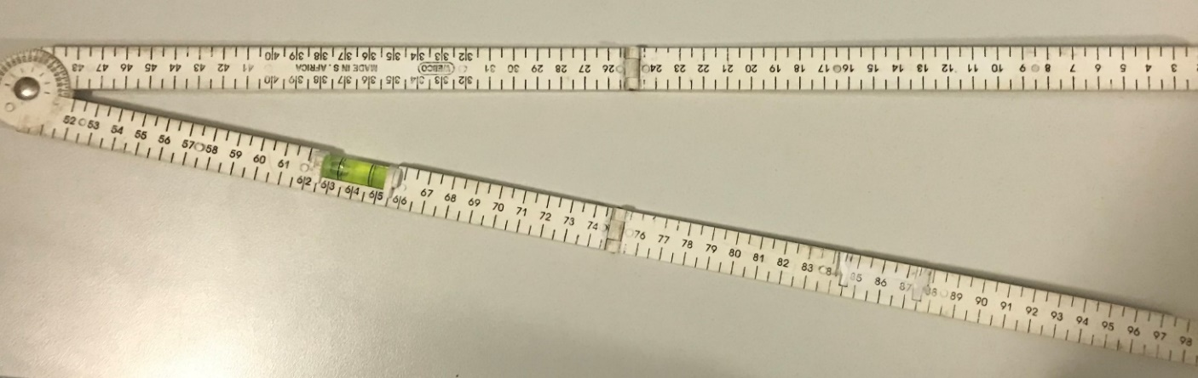

Figure 5: Image of 1 m clino-rule

Joint sets were delineated based on observations i.e. classified according to their orientations. These joint sets and the above-mentioned parameters within the block were geotechnically evaluated and the results entered into the form reproduced in Table 1.

Table 1: Joint mapping table template

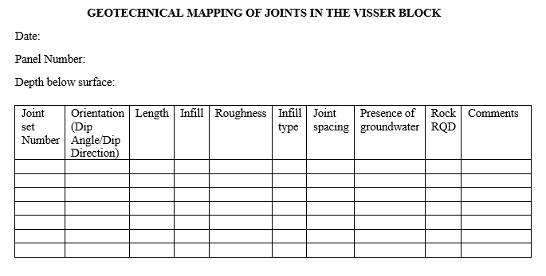

The joint set most likely to result in hangingwall failure was distinguished and used in defining the joint roughness and alteration. Blasting fractures and structures with a trace length of less than 0.5 m were not considered. From observations, such structures can be easily identified and addressed by barring or areal coverage support where required, provided entry examination is conducted correctly. The RQD was estimated from the number of discontinuities per unit volume as suggested by Palmstrom (1985). Joint roughness was determined by measuring offsets across the joint, such that the largest offset is related to the ‘joint roughness number’ (Jr) as described by (Watson, 2004).

The results from underground joint mapping were used as input data into DIPS software so as to analyze and graphically represent structural data by the use of stereonet. Stereographic projections provide a means of representing the 3D orientations of planes in 2D. Joint sets can be clustered and analysed from a pole plot generated in DIPS. This was done by drawing a window set around the poles concentrated in a specific area to group data related to a specific joint set. Figure 5 depicts a pole and contour plot from DIPS. Orientation, true spacing, trace lengths and friction angles were calculated from data related to specific joint sets. The orientation of the parting planes was also used as input into the software. This was done in order to determine the possibility of intersection of these parting planes and joint sets, and the geometry of their intersection. The data on joint orientations collected in a joint mapping exercise were plotted on a polar plot (indicating dip and dip directions).

JBlock software was used as a primary method of analysis in order to determine the frequency of different sized keyblocks and their stability. A multiple block analysis was run so as to evaluate blocks which are randomly created as a result of natural joints and stress fractures in the hangingwall. The spacing between the joints, orientation and length of the joints was used data. Additionally, the support properties in terms of spacing, support load bearing capacity and length were used. A histogram was produced as an output from the exercise and blocks with different volumes plotted. These blocks had different probabilities of failure in different size intervals. The exercise was done at different input parameters of length, spacing and capacity in order to determine the optimum support standard.

* 1. **Results**

The results of the study with regards to the rock mass classification, JBlock and Dips simulations are described below. All measurements and derived results are tabulated and plotted graphically.

**4.1.1 Rockmass Rating**

The Barton et al (1974) approach was used to classify the rock mass in narrow reef stopes prior to excavation to establish the underground excavation which is termed raiseline (RSE). A total number of seven raiselines (RSE) were classified (RSE 1 to RSE 7) and their respective rock mass ratings were presented as shown in Table 2.

Table 2: Rockmass Rating

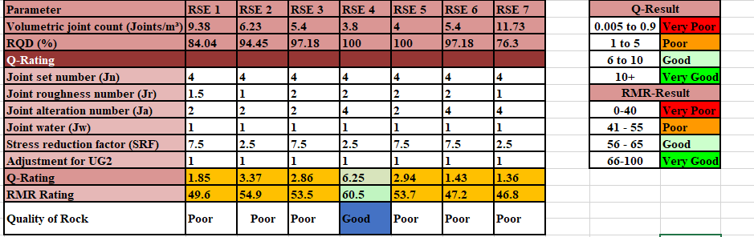

The RMR rating results indicate that only one raiseline had good ground conditions, with the rest of the six raiselines having a poor rating. A majority of these raiselines are close to the boundaries of poor and good rock categories.

**4.1.2 Numerical Modelling**

The software analysis indicated that there is a major scatter of joint orientations in Block A. However, three joint sets were defined. The dominant set is termed set 1m followed by set 2m and set 3m, where the latter set is the least dominant. The remaining joints mapped are random joints. Average orientations of sets 1m and 2m and 3m are 276°/14°, 174°/11° and 69°/14° respectively, implying that they are shallow dipping. Joint set 1m and 3m are dipping in opposite directions and can form keyblocks. Where these joints intersect with the triplets (labeled as 1 on the stereonet with the orientation of 360°/9°), keyblocks are formed. These keyblocks can cause the collapse of the strata below the triplets if not supported correctly. The triplets is a colloquial term for chromitite stringers which characterize the hangingwall of the UG2 reef. The triplets are taken into consideration when designing a support standard because of their weak cohesive properties.

Most of the joints in the stopes were unfilled. However, the few filled joints observed were steeply dipping and chlorite and serpentine as the filling material, with a thickness ranging between 1 cm and 3 cm. Table 3 describes the joint properties of the three major joint sets defined. These properties were used as input data in JBlock in order to generate keyblocks to determine probabilities of failure.

Table 3: Summary of the major joint sets characteristics

|  |  |  |  |  |  |  |  |  |
| --- | --- | --- | --- | --- | --- | --- | --- | --- |
| **Joint Set** | **Orientation** | | **Spacing (m)** | | | **Length (m)** | | |
| **Dip** | **Dip Direction** | **Min** | **Mean** | **Max** | **Min** | **Mean** | **Max** |
| J1 | 14 | 276 | 0.1 | 0.94 | 1 | 2 | 2.2 | 2.5 |
| J2 | 11 | 174 | 0.05 | 1.2 | 3 | 1.8 | 2.1 | 3 |
| J3 | 14 | 69 | 0.1 | 0.9 | 1 | 1.5 | 1.8 | 2.2 |

From the joint mapping result, underground joint mapping were plot as input data into DIPS software to provide the structural data as shown in Figure 6.

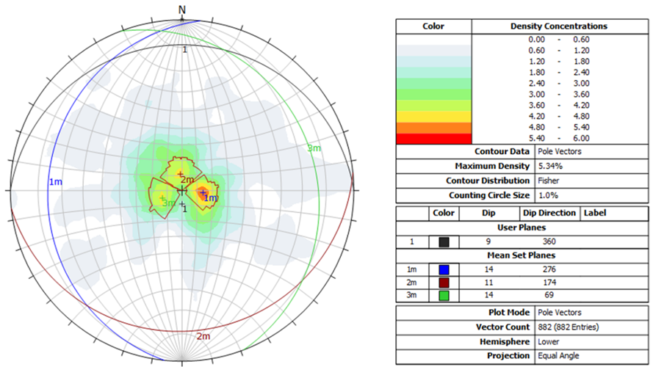

Figure 6: Stereonet projections of major joint sets identified

The results of JBlock simulations are indicated in Figure 7 and Figure 8. These results represent the frequencies of different sized keyblock distributions and probabilities that these keyblocks would fail. Geotechnical data was collected using scanline mapping methods. The joint data was analysed using Rocscience’s Dips. Jblock was then used to compare the different support scenarios. Potential keyblocks are generated based on the geotechnical file and an excavation file in JBlock. The geotechnical file describes the ground conditions to assess. Due to insufficient fall out thickness data to dictate the parameters of the design, the highest value was used from the surrounding Ground Control Districts (GCD’s) to account for the worst expected scenario based on recorded data. The thickness used was therefore 1.2 metres as found in the surrounding GCD’s.

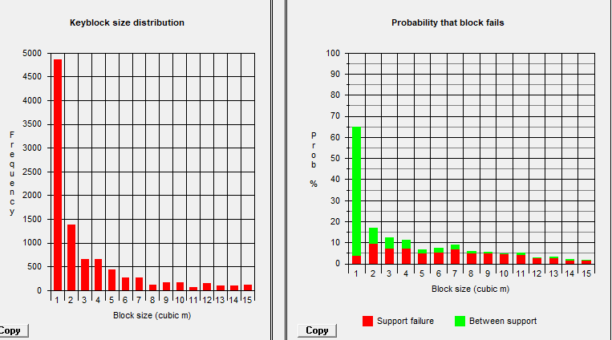

Figure 7: Probability of block failure based on the current support system

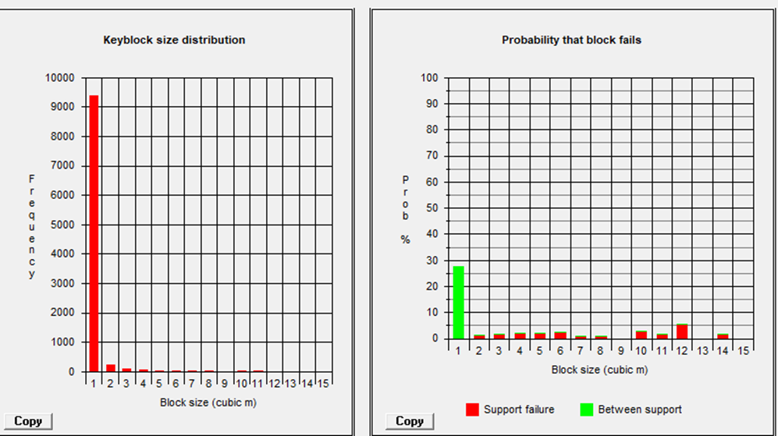

Figure 8: Probability of block failure based on the new support system

In order to determine the optimum load bearing capacity for the roof bolts, simulations were done at different support spacings and different support bearing capacities. The results are indicated in Figure 9 and Figure 10. It is evident that at a load bearing capacity of 160 kN, there is a reduced probability of failure at 26% in between support as opposed to a 60% probability using 100 kN capacity. Furthermore, Figure 5-5 indicates that at a spacing of 0.5 m x 1.2 m and a load bearing capacity of 160 kN, the probability of keyblock failure as a result of support is 5% as opposed to 17% at a capacity of 100 kN.

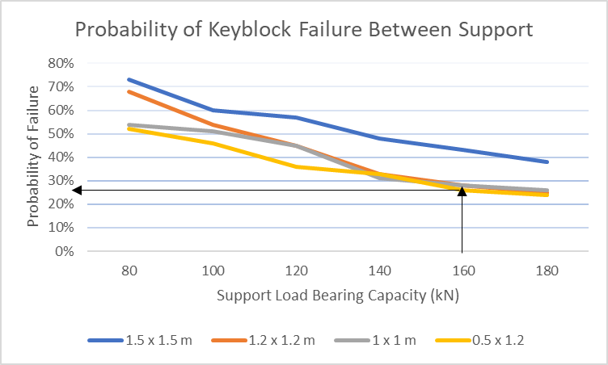

Figure 9: Probability of Keyblock failure in between support elements

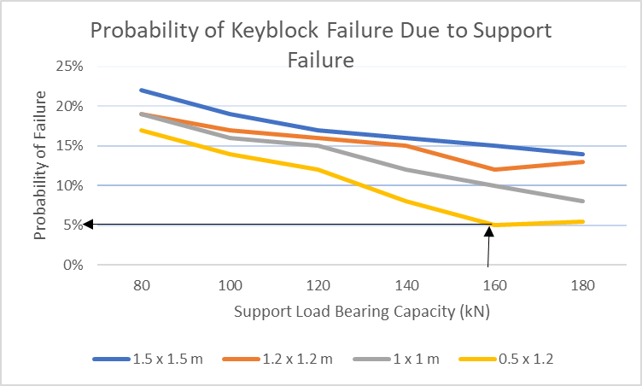

Figure 10: Probability of Keyblock failure in between support elements

1. **Discussions**

Results from the rock mass classification approach showed that the average RMR calculated was below 50, which indicates that the quality of the rockmass in Block A is relatively poor. From this, it can be reasoned that the ground conditions in this area pose a high risk of rock falls due to high probability of unstable blocks.

Plotting the dip and dip directions allowed for the visual depiction of the variability of joint orientations. Contouring the pole plots also allowed for the dominant joint sets to be identified. The stereonet results from DIPS indicated that there are three prominent joint sets dipping in opposite directions and intersecting triplets. Where these joint sets (set 1m and set 3m) intersect the triplets, a wedge is formed. This means that the support designed has to be able to support the hangingwall beam up to 2m into the hangingwall where the triplets are encountered.

JBlock was used to determine the probability of failure of keyblocks in the stope. The structural data for the three joint sets, together with tendon and grout pack data, were used to simulate unstable keyblocks. The mechanism of failure for this analysis is either due to the keyblock size being less than the support spacing, or the keyblock being of such a size that it causes the support unit to be overloaded. The J-Block model used joint data collected from Mine X underground workings, which included three joint sets as well as a parting plane in the hanging wall at an average depth of 1.9 metres above the hangingwall surface, as indicated in the block A’s isopach layout. A standard deviation of 1.2 in terms of the parting plane depth was included in the model.

The unstable keyblocks were simulated by first using the current support system of 1.6 m long ungrouted roof bolts spaced 1.2 m by 1.2 m, with a 100 kN load bearing capacity and 750 mm diameter grout packs with a load bearing capacity of 2200 kN. The area simulated is a stoping panel with a 15 m face length and a 30 m back length. A total number of 10 000 keyblocks were generated and the probability of failure was highest for 1 m3 at a 60% probability of failure in between support. This suggests that the probability of block failure obtained is high, thus indicating that the support is insufficient. The support spacing was too wide and resulted in a greater percentage of 1 m3 keyblocks falling in between support. The findings indicated that the planned support system for Block A is not sufficient and requires a higher support resistance.

The recommended support system consists of grouted tendons with a load bearing capacity of 160 kN, 2.2 m length, and spaced at 0.5 x 1.2 m. The new support system yields the results shown in Figure 7. The probability of block failure for 1 m3 blocks decreases to 27%, and the maximum support failure to 5%. The JBlock analysis shows that the support spacing implemented at Mine X does not sufficiently account for all rockfalls that can occur due to keyblock formation in the hangingwall.

1. **Conclusion and Recommendations**

This study demonstrated that the current support system using ungrouted tendons 1.6 m in length spaced at 1.5 m by 1.5 m in Block A will not be effective. After the FOS was determined to comply with the required standards, a J-Block analysis had to be done to show whether the support spacing successfully keeps fall of ground from occurring as a result of keyblock failure. The mechanism of failure for this analysis is either due to the keyblock size being less than the support spacing, or the keyblock being of such a size that it causes the support unit to be overloaded. The results from JBlock simulations indicated that there was a high probability of unstable blocks of rock found in the hangingwall in the study raiselines, which are delineated by naturally occurring joints and fractures. These blocks, identified as keyblocks, will collapse if their weight exceeds the support load bearing capacity or if they are located between support units. It is recommended that the mine considers the probabilistic approach in order to determine the suitability and effectiveness of support systems particularly in circumstances where large numbers of discontinuities or stress fractures are exposed in excavations. The results from the DIPS analysis proved that the interaction of the low angle joint sets with the triplets can result in large collapses considering the formation of wedges.

It is recommended that a further study is conducted on the recommended support standard. Longer grouted coupling roof bolts of 2 m length spaced at 1 × 1.2 m are proposed, as opposed to the current mechanical end-anchors (ungrouted) of 1.6 m length spaced at 1.5 m × 1.5 m. The 2 m roof bolts would prove to be more expensive than the current roof bolts because of the need for grouting and the increase in support density. However, there is an improvement in safety when considering the recommended support system. Mining in Block A has proven to be geotechnically challenging as compared to other stoping conditions at Shaft P2. Ground conditions should therefore be assessed regularly. It must be noted that mining strategy and support regime might be reviewed depending on prevalent ground conditions as panels advance due to extreme variations in properties of the Marikana fault zone. Welded mesh, cable anchors, shotcrete and trusses should be considered depending on the change in ground conditions. The main conclusion that can be drawn from Figure 4 and 5 and Tables 2 and 3 is that increasing support spacing may not result in unsafe conditions provided entry examination procedure is followed.

# **References**

Balakrishna, M., 2006. *An assessment of the economic viability of mining the UG2 Reef within the no.12 Shaft lease area, Impala Platinum Limited. MSc Thesis,* Pretoria, RSA: University of Pretoria .

Barton, N., Lien, R. & Lunde, J., 1974. Engineering classification of rock masses for the design of tunnel support. Rock Mechanics. *Rock Mechanics,* Volume 6, pp. 189-236.

Bieniawski, Z., 1976. *Engineering Rock Mass Classification.* First ed. New York, USA: Wiley.

Bonsu, J., Van Dyk, W., Franzidis, J.-P. & Petersen, F., 2017. A Systemic Study of Mining Accident Causality: An Analysis of 91 Mining Accidents from a Platinum Mine in South Africa. *The Journal of The Southern African Institute of Mining and Metallurgy,* Volume 117, pp. 59-66.

Darling, P., 2011. *SME Mining Engineering Handbook.* Third ed. Englewood, Colorado USA: Society for Mining, Metallurgy, and Exploration..

Du Plessis, M., 2016. *Marikana General Geotechnical Information (unpublished).* North west, RSA: s.n.

Hoek, E., Kaiser, P. & Bawden, W., 1995. *Support of Underground Excavations in Hard Rock.* Rotterdam: AA Balkema..

Hutchinson, D. & Diederichs, M., 1996. *Cablebolting in underground mines.* Canada: BiTech Publishers Ltd.

Kotze, C., 2018. *Mining Review Africa.* [Online]   
Available at: https://www.miningreview.com/health-and-safety/dmr-decrease-fatalities-2018-safety/  
[Accessed 12 April 2019].

Palmstrong, A., 1985. *Application of the volumetric joint count as a measure of rock mass jointing.* Björkliden, Norway, Proceedings of the International Symposium on Fundamentals of Rock Joints, Sweden, pp. 97-10.

Potvin, Y., 1988. *Empirical Open Stope Design in Canada, Ph.D Thesis,* Columbia, Vancouver: University of British .

Swart, A., Human, J. & Harvey, F., 2005. Rock engineering challenges. *The Journal of The South African Institute of Mining and Metallurgy,* Volume 105, p. 104.

Watson, B., 2004. A rock mass rating system for evaluating stope stability on the Bushveld Platinum mines. *The Journal of The South African Institute of Mining and Metallurgy,* p. 230.

Watson, B., 2004. A Rock Mass Rating System for Evaluating Stope Stability on the Bushveld Platinum Mines. *The Journal of The South African Institute of Mining and Metallurgy,* Volume 101, p. 230.