Mapping of Case Studies of Startup Businesses
in Healthcare Sector

Efstathios Kaloulis, Dimitrios Zarakovitis, Athina Lazakidou

Department of Economics, Digital Health Applications and Health Economics Analytics Laboratory
University of Peloponnese, School of Economy, Management and Informatics
Tripolis, Greece

Corresponding Author:
University of Peloponnese
School of Economy, Management and Informatics
Department of Economics
Digital Health Applications and Health Economics Analytics Laboratory
Tripolis, Greece
E-mail: dzarkovit@uop.gr

Abstract
The present thesis was conducted in order to study the progress made in healthcare sector with new technologies. Entrepreneurship seems to be taking strong action with ambitious researchers who dare to undertake professional initiatives for the treatment of diseases, such as cancer, and any kind of problems patients address today. After the analysis of the basic elements regarding the development of startups, current trends in healthcare are categorised and cases are in turn studied. The breakthroughs developed in healthcare primarily regard technologies such as Artificial Intelligence, Neurotechnology and Biotechnology while Digital Health gains ground applied by several startups worldwide. By surveying their data, useful conclusions are drawn concerning the investment process of healthcare startups. In the attempt of analysing the perspectives of establishing such companies in Greece, the Greek healthcare startups are presented. Through an empirical survey carried out in the Greek companies, Greek reality is thus documented and data are presented in a plot. The perspectives in Greece are major due to the fact that there are qualified members comprising the innovation teams although support of larger scale and funding are required. In order to enhance innovations in Greek business world, steps need to be taken for the approach of innovation behemoths and qualified executives in Greece.

Keywords: Healthcare Entrepreneurship, Artificial Intelligence, Biotechnology, Neurotechnology, Digital Health, Innovation, Greek Entrepreneurship, Startup Companies, Startup Mapping.
.

1 Introduction
The role of startup companies in modern societies is really challenging and important at the same time [1], [2]. Based on the vision of their founder, companies are supposed to take the risk of creating a product or service relatively innovative and completely different from the existing ones [3], [4], [5], [6].
On most occasions, these business ventures are shipwrecked and everything goes up in smoke, but there is a considerable number of startups that have succeeded and prevailed with great success [7], [8], [9], [10]. Such startups were Google, Paypal, Amazon, and other behemoths of the international business world [11], [12], [13], [14]. A small startup can take a big risk and face a lot of barriers, but vision and innovation can make a business succeed and change the so far established norms through its activity.
As a logical consequence of the new technologies being developed and continuously changing our reality, more and more people are trying to do something new and innovative. The knowledge they have gained through their fields of study and their previous business experience is another component for the next success. Interest lies not only with the founders, but there are also many investors who can be successful entrepreneurs, who, based on their capital, aim to invest in other startups as Angel Investors or through Venture Capital funds [15], [16], [17], [18] .
The most difficult part for an entrepreneur and a startup is funding [19], [20], [21]. It is quite a major obstacle because most of the time founders are new in the field and may not acquire the knowledge and the funds they need to get their business to its final form.
In order to overcome these obstacles that arise, there are enough structures to support young people and encourage them to improve their ideas, create groups and dare to develop them. Various business acceleration programmes are carried out quite at regular intervals. They last several months and provide support to teams in different fields [22], [23]. Depending on the dynamics of the team and the maturity of the study, they can be integrated, grow rapidly and attract investors to receive some funding

2 Object
The purpose of this paper is to analyze the perspectives of establishing a Greek healthcare startup company. The survey discusses the significant components of attracting potential investors and offers evidence-based to healthcare funding. It also summarizes on the fundamental principles of forming a startup company that mainly concerns health sector.

3 Material and Method
An empirical research was performed with the use of a questionnaire for 34 Greek startups, either headquartered in Greece or abroad. The questionnaires were created online through Google forms and sent electronically via e-mail as well as social networks and business pages of the parties concerned. The research was conducted in the last six months and contacts were made with business mentors as well as entrepreneurs, such as co-working spaces and accelerators. In addition, open call was made to any interested person-founder in online entrepreneurship groups. The questionnaire consists of 41 qualitative and quantitative questions. Moreover, ArcGIS software as well as Zeemaps.com free online platform are used to map the results. An analysis of the data collected from the companies was performed with dashboards of Visualizefree.com, free visualization software.

4 Results
The responses received from 34 businesses demonstrate rather important facts about the current situation in Greece and it is worth mentioning that most of the questions were answered by almost all respondents. The main results are as follows:
- As far as the year of establishment is concerned, the responses received by the 33 companies are for the year 2012, with one exception established in 2005. It is worth noting that the majority of them were set up in 2017 at a rate of 27.3%. 2016 follows with a foundation rate of 21.2%, while at a rate of 15.2% come 2014 and 2015. However, at rates less than 10% are the other years, such as 2018. During the last year there is no significant increase according to the answers to the questionnaire, the establishment of new companies is remarkable in recent years though.

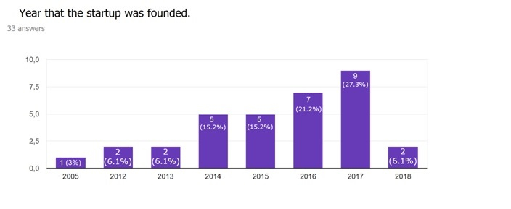
Figure 1: Statistical results of the year the startup was founded
- The next question regards the incentive of establishment for the startups. 34 responses were received, of which the highest rate (85.3%) stated that they wanted to exploit an idea. The second highest rate (64.7%) said they found a gap in the market and so wanted to promote their own innovative idea. Then 20.6% indicated that they wanted to realize their idea in order to earn some income and have a job, while 14.7% agreed that they did it for livelihood in order to improve their economic situation. Therefore, most of the founders begin to establish a startup company with main goal the implementation of an idea to offer to society and fewer dare it for purely livelihood reasons.
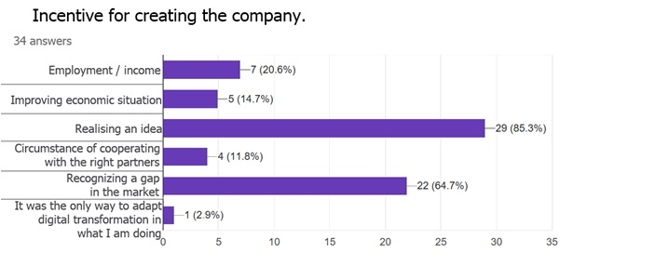
Figure 2: Statistical results of the incentive for creating the company
- According to the 34 responses given about the startup ownership pattern, the majority (76.5%) seem to have worked with other people to set up the company. Only 23.5% said they did not make any kind of cooperation and are the sole proprietors of the company.

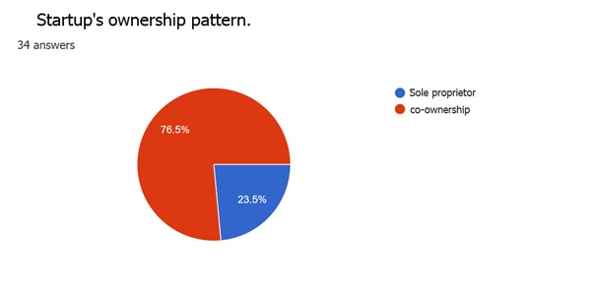
Figure 3: Statistical results of startup’s ownership pattern
- As for the question about the legal form of the company, 50% set up a private capital company (IKE), which is a new form of company and has no asset freezing. 17.6%, as the second largest rate, have an individual business, while 11.8% are Societe Anonyme (SA). Therefore, through the responses of the 34 companies, it appears that the founders of the startups forming a company themselves establish an individual company and do not prefer to make a single-person company such as a limited liability company (LLC).

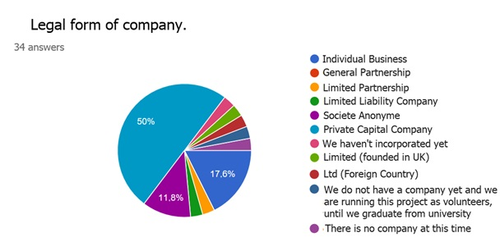
Figure 4: Statistical results of legal form of company
- The next question made was about the current state of the startup companies. At this point it was found out that 76.5% have not completed the development of the company and the product and therefore they are still evolving. 14.7% say they have successfully survived, while the remaining 5.9% and 2.9% are either those who say they are in a difficult situation or that they will certainly not survive. All companies were willing to answer even this question.

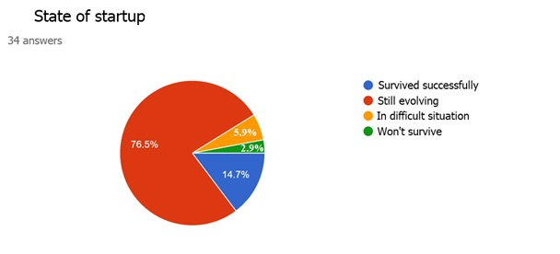
Figure 5: Statistical results of startup’s state
- Furthermore, to the question about the background of the founding members and their possible experience in startup businesses, 61.8% said that they had never dealt with startups before, while only 38.2% stated they had a previous experience therein. All companies responded to this question.

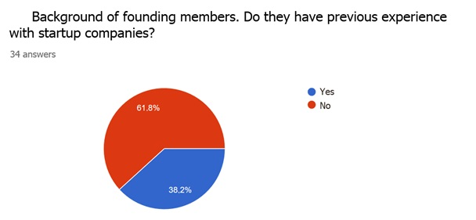
Figure 6: Statistical results of the background of founding members
- In the matter of the educational attainment of the founders, all the companies helped giving their response in order to form the final result. The majority of founders point out that by 55.9% they hold a Master’s degree while 29.4% have received a Bachelor’s degree. PhD holders are only 20%. The other rates of secondary school graduates and graduates of compulsory education are quite low. However, most of them have gained significant and educational expertise.
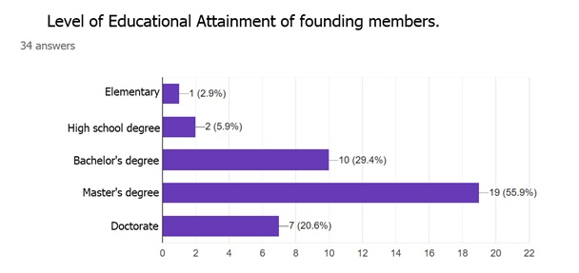
Figure 7: Statistical results of educational level
- In the main startup market, 55.9% regard global activity, followed by 29.4% orientated in the European market. Only 8.8% are engaged in the domestic market, while there is a 2.9% targeting the US market and another 2.9% the local market. It is concluded that it has prevailed for the Greek founders the view that they should engage in services that improve the quality of life of a wide range of people. Answers also in this case were provided by the thirty-four companies.

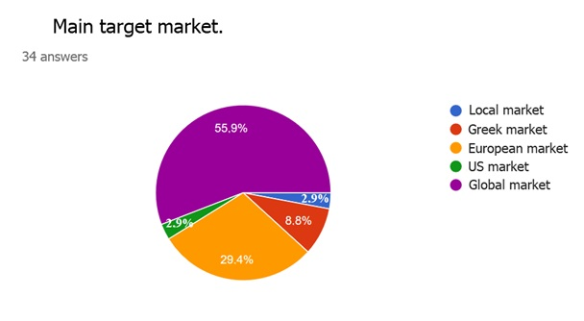
Figure 8: Statistical results of main target market
- Apropos the use of external consultants or other support mechanisms in the research and development process of products or services of the startups for all companies, 70.6% stated that they used some consultants, such as mentors and other specialists, in order to form their own business. Only 29.4% said they did not use any external consultant or support mechanism. It is actually obvious that companies expecting to enter the global and leave the local market use the available mechanisms, such as consultants, in order to promptly achieve their goal.

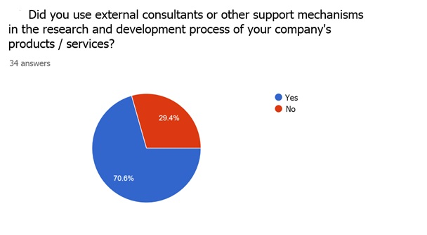
Figure 9: Statistical results of external consultants
- Thirty out of the thirty-four companies responded to the question about the use of business incubation mechanisms or other startup support mechanisms. Most appealed to a business incubator at a rate reaching 53.3%, while 46.7% turned to accelerators. 26.7% however, turned to the university, while co-working space seems to have received 20%. The actions taken place over the last years with accelerators and business incubators have greatly supported young entrepreneurs as they mainly use them.
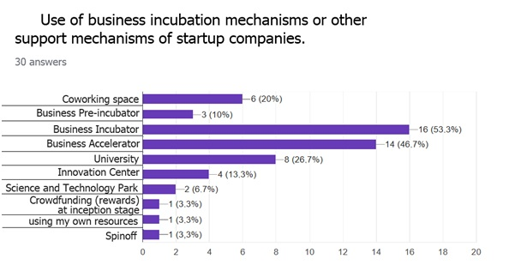
Figure 10: Statistical results of support mechanisms
- Regarding the years to achieve the breakeven point, from the 32 answers received a frequency table was formed with each year comprises one class interval. Therefore, most stated that up to 2 years are required to reach the breakeven point at a rate of 59.37%, based on the sum of the two class intervals. 40.62% estimated this period to be 1 to 2 years and 25% to be 2 to 3 years in order to reach the breakeven point. Greek startups may encounter difficulties but are rewarded relatively early since they mainly start being profitable after the second year. A good business plan, hence, and a qualified team can directly lead to profits.

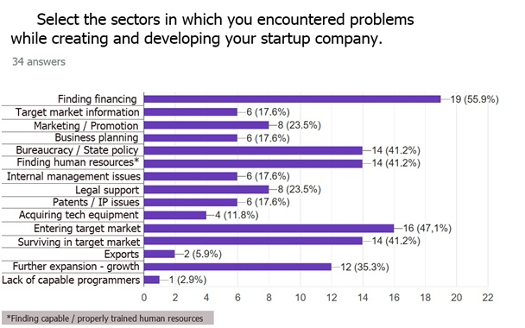
Figure 11: Statistical results of the problems encountered in the survey

Conclusions
Innovations developed on a daily basis are of utmost importance and significant changes will take place in years to come, with the improvement of quality of daily life and the longevity of the residents of this planet being the steady point of reference and gravity. New scientists have special sensibilities towards this direction, which is actually proved through nuclei formed by investors and other enthusiastic supporters. Vision is in the forefront and all cooperate in harmony to achieve the plans for the future of mankind.
The thorough analysis of the data about the most important startup companies and the subsequent plot distinguish three global centers where innovations in healthcare sector are concentrated. The biggest is located in the US with California as the main pillar followed by Massachusetts. Then come London as European centre of development and innovation and China. In these areas are concentrated most of the available capitals to be invested. The large return on investment capital and the constant investments have turned the aforementioned areas into global centers of new technologies and startup companies.
As far as the Greek reality is concerned, startup companies demonstrate a high level of expertise and their personnel is quite qualified, but normally a bigger number of experts are required to support the evolving innovations. Healthcare is a sector that requires specialization and there are thus several examples of successful companies. The target market for Greek startups is not limited only within the borders of Greece; the lack of support and funds though makes their development rather hard. Several Greek founders have transferred their businesses abroad, in one of the pillars of new technologies. Some of them are in the United States and others in the United Kingdom. This fact occurs either due to funding received by these areas or to avoid high taxation and to achieve a better positioning in the target market. Equity capitals are mainly used while crucial are also European funds when available. The increased demand in capital and the reluctance of investment funds to proceed to investments hinder Greek startups’ progress.
Success emerges when something great and quite specialized is created by a group of members with advanced knowledge in the case developed. As found out with small groups and far from the big Greek business centers, such as Athens or Thessaloniki, Greek companies manage to cope with the circumstances and further evolve. Evolvement never stops and in many cases there is a remarkable investment from an investment fund located in Greece or abroad.
Support structures of entrepreneurship have been enhanced over the last years and have come to fruition while a lot of information is available. The issues around the organization and support of new services and products have been resolved to a great extent and it is logical that small business groups subsequently make great progress. The challenge today is detected in funding and economic policy.
The support of startup companies demands a change in state policy as a whole and a larger concentration of expertise in the country. The former makes businesses sustainable and equity capitals be reused for a bigger progress and development. In order to attract expertise in Greece, its comparative advantages, such as climate and quality of life, should be exploited. A great solution would be big companies to come to Greece from abroad and create research and development teams. Through this action experts are attracted and the field of innovation further evolves. The objective is the country to be supported by scientists from abroad engaged in Greece and thus the phenomenon of experts going abroad to be reversed. Among the other advantages, there is the possibility that big companies come in contact with startups and support them financially.

Acknowledgements: The authors have no funding or conflicts of interest to disclose.

References
- Klotins, E., Unterkalmsteiner, M., & Gorschek, T. (2015, June). Software engineering knowledge areas in startup companies: a mapping study. In International Conference of Software Business(pp. 245-257). Springer, Cham. Available at: https://link.springer.com/chapter/10.1007/978-3-319-19593-3_22.
- Salamzadeh, A., & Kawamorita Kesim, H. (2017). The enterprising communities and startup ecosystem in Iran. Journal of Enterprising Communities: People and Places in the Global Economy, 11(4), 456-479. Available at: https://www.emeraldinsight.com/doi/abs/10.1108/JEC-07-2015-0036.
- Acs, Z. J., Szerb, L., & Lloyd, A. (2017). The global entrepreneurship and development index. In Global Entrepreneurship and Development Index 2017 (pp. 29-53). Springer, Cham. Available at: https://link.springer.com/chapter/10.1007/978-3-319-65903-9_3.
- Gonzalez, G. (2017). Risk Analysis for Initial Needs (RAIN): Im-proving a Time Zero Startup Plan through Resource Based Auditing (RBA) and a Launch Focused Strategy. Risk Analysis, 1(8). Available at: http://pubs.mumabusinessreview.org/2017/MBR-2017-081-095-Gonzalez-RAIN.pdf.
- Ladd, T., & Kendall, L. (2017). Resolving the Risk Paradox: Entrepreneurial Cognition in the Lean Startup Method. The Journal of Applied Business and Economics, 19(11/12), 28-42. Available at: http://search.proquest.com/openview/2b6578f09c541a4cfa699550cd1c711c/1?pq-origsite=gscholar&cbl=38282.
- Gonzalez, G. (2017). Startup Business Plans: Academic Researchers and Expert Practitioners Still Disagree?. Muma Business Review. Available at: http://pubs.mumabusinessreview.org/2017/MBR-2017-189-197-Gonzalez-StartupPlans.pdf.
- Triebel, C., Schikora, C., Graske, R., & Sopper, S. (2018). Failure in Startup Companies: Why Failure Is a Part of Founding. In Strategies in Failure Management (pp. 121-140). Springer, Cham. Available at: https://link.springer.com/chapter/10.1007/978-3-319-72757-8_9.
- Gerpott, F. H., & Kieser, A. (2017). It’s not charisma that makes extraordinarily successful entrepreneurs, but extraordinary success that makes entrepreneurs charismatic. Managementforschung, 27(1), 147-166. Available at: https://link.springer.com/article/10.1365/s41113-017-0013-8.
- Cohen, M. S. (2017). Enhancing surgical innovation through a specialized medical school pathway of excellence in innovation and entrepreneurship: Lessons learned and opportunities for the future. Surgery, 162(5), 989-993. Available at: https://www.sciencedirect.com/science/article/pii/S0039606017304312.
- Ries, E. (2017). The Startup Way: How Modern Companies Use Entrepreneurial Management to Transform Culture and Drive Long-term Growth. Currency.
- Ester, P., & Maas, A. (2016). Silicon Valley, Planet Startup: Disruptive Innovation, Passionate Entrepreneurship and Hightech Startups. Amsterdam University Press.
- Beverly, H. T. (2017). Navigating Your Way to Start-Up Success: The Key to a Successful Startup. Walter de Gruyter GmbH & Co KG.
- Cohan, P. S. (2018). Boosting Your Startup Common. In Startup Cities (pp. 219-235). Apress, Berkeley, CA. Available at: https://link.springer.com/chapter/10.1007/978-1-4842-3393-1_8.
- Borins, S., & Herst, B. (2018). Insanely Great: The Dominant IT Fable. In Negotiating Business Narratives (pp. 13-22). Palgrave Pivot, Cham. Available at: https://link.springer.com/chapter/10.1007/978-3-319-77923-2_2.
- Collewaert, V., & Manigart, S. (2016). Valuation of angel‐backed companies: The role of investor human capital. Journal of Small Business Management, 54(1), 356-372. Available at: https://onlinelibrary.wiley.com/doi/abs/10.1111/jsbm.12150.
- Wu, A. (2016). Organizational decision-making and information: Angel investments by venture capital partners. In Academy of Management Proceedings (Vol. 2016, No. 1, p. 11043). Briarcliff Manor, NY 10510: Academy of Management. Available at: https://journals.aom.org/doi/abs/10.5465/ambpp.2016.4.
- Hathaway, I. (2016). Accelerating growth: Startup accelerator programs in the United States. Advanced Industry Series, 81. Available at: http://www.ianhathaway.org/s/Accelerating-growth_-Startup-accelerator-programs-in-the-United-States-_-Brookings-Institution.pdf.
- Mason, C., Botelho, T., & Harrison, R. (2016). The transformation of the business angel market: empirical evidence and research implications. Venture Capital, 18(4), 321-344. Available at: https://www.tandfonline.com/doi/abs/10.1080/13691066.2016.1229470.
- Coleman, S., Cotei, C., & Farhat, J. (2016). The debt-equity financing decisions of US startup firms. Journal of Economics and Finance, 40(1), 105-126. Available at: https://link.springer.com/article/10.1007/s12197-014-9293-3.
- Viswanadham, N. (2017). Alternative Strategies on Improving Small and Medium Enterprises Access to Seed Capital. A case of Dodoma Municipal, Tanzania. International Journal of Research Granthaalayah, 5(9), 1-5. Available at: http://granthaalayah.com/Articles/Vol5Iss9/01_IJRG17_A07_545.pdf.
- Iliev, P., & Lowry, M. (2017). Venturing beyond the ipo: Financing of newly public firms by pre-ipo investors. Available at: https://papers.ssrn.com/sol3/papers.cfm?abstract_id=2766125.
- Prashantham, S., & Yip, G. S. (2017). Engaging with startups in emerging markets. Available at: https://spiral.imperial.ac.uk/bitstream/10044/1/45924/6/Prashantham%20%26%20Yip%20SMR%202017%20for%20Spiral.pdf.
- Cohen, S. L., Bingham, C. B., & Hallen, B. L. (2018). The Role of Accelerator Designs in Mitigating Bounded Rationality in New Ventures. Administrative Science Quarterly, 0001839218782131. Available at: https://journals.sagepub.com/doi/abs/10.1177/0001839218782131.

