Financial Derivatives and Firm Performance: Empirical Evidence from Financial and Non-Financial Firms

Torbira, Lezaasi Lenee¹ & Joshua Oki²

¹Finance and Banking Department, University of Port Harcourt, Port Harcourt, Nigeria. torbiralezasi@yahoo.com
²BPP University, Birmingham, United Kingdom, joshua_oki@yahoo.com

Abstract
There is a general perception that financial derivatives have significant impact on firm performance when they are used to hedge financial risks. The study attempted to examine the effect of the use of forwards, futures, options and swaps to hedge interest rate and foreign exchange rate risks of 5 financial and 5 nonfinancial firms selected from the UK FTSE 100 index, between the years 2005—2014, with the objectives of supporting or refuting extant literature on the benefits of hedging, testing the impact of hedging on return on assets and capital employed, as well as revealing which financial derivative assert the highest influence in the period. The panel least squares (PLS) regression analysis was used on a balanced panel dataset of 100 observations. The results revealed the following: (1) financial firms tend to hedge more of interest rate risks while nonfinancial firms hedge more of foreign exchange rate risks;(2) hedging interest rate risks by both groups with the use of a combination of forwards and futures derivatives was found to be positive and statistically significant with return on assets, hence increases firm performance, but directly has a reverse effect when only swap derivatives are used; and (3) the use of one or more of any financial derivatives to hedge foreign exchange rate risk is seen to be negative and statistically significant with return on capital employed, which translates to a decrease in firm performance. Nevertheless, the study supports the financial distress and stakeholder theories of financial risk management, with recommendations of a comparative study and a longer time frame to be employed, in order for models to be subjected to long run performance analysis and other robust tests.

Keywords: risk, hedging, interest rate, foreign exchange, commodity price, forwards, futures, options, swaps.

1.0 Introduction
The tenets of business successes and making high corporate profits are often conceived as a derivative of the provision of quality goods and services to a needful target market. There is nothing wrong with that notion, except that in today’s modern financial community dominated by global and multinational firms, ‘Derivatives’ have also become derivatives of corporate gains and losses. These are complex financial instruments in the form of contracts, often used as tools for strategic risk management activities by various companies and sophisticated investors (Chui, 2012). Financial derivatives have grown so much in popularity that they are also regarded as asset classes, although they most often derive their values from one or more underlying security that may belong to different asset classes. As Valdivia-Velarde (2010) pointed out, they are sometimes embedded in new investment vehicles of debt and equities, which is typically one of the reasons why the complexities of these instruments make them highly risky. To buttress this fact, the total notional amount of all financial derivatives held by the 25 world’s largest holding companies was valued at $308 trillion in 2012 as revealed by Abdel-khalik and Chen (2015). That is more than four times the world’s GDP combined, which is valued at only $74 trillion according to the International Monetary Fund (IMF, 2013).
Globalisation has created strong linkages in financial markets that risks can spill over very quickly, especially when one considers the havoc caused by the 2007—2008 financial crisis. There is therefore need to develop better risk management strategies that can withstand the test of times. In existing literatures like that of Fender (2000), Bartram, Brown and Fehle (2009), Chernenko and Faulkender, (2011), hedging is considered a noble activity by many in the finance industry as it is an effective way for reducing, mitigating and transferring risks. The four major types of financial derivatives popularly known include forwards, futures, options and swaps, which are used to manage credit default, operational, transaction, interest rate, foreign exchange and commodity price risks.
Hedging can also be performed without the use of derivatives, but these methods are generally not considered as effective and profitable as the use of financial derivatives. A recent study by Murungi, Murage and Wanjau (2014) observed that the heads of the risk management departments of 39 nonfinancial firms listed in the Nairobi Stock Exchange (NSE), recognised the corporate advantages of the use of derivatives in the management of risks, but have not used derivatives up to the optimal level in their respective industries. However, they admitted that they use other risk managing strategies like “price adjustments, sales in foreign currency, buying and saving currency in advance, delay payments, prepayment/advance payments and nettingD” As Adams (2011) rightly puts it, the activity of hedging varies from industry to industry, company to company and derivative to non-derivatives techniques. This directly supports the views of Ahmed, Azevedo and Guney who also posit that risk management practices differs significantly across the type of financial risks, corporate strategies and the tools used to manage them.
The connectivity between the use of financial derivatives and firm performance is abundant in a wide array of research works. The studies mentioned earlier have generally found mixed evidences. For instance, financial derivatives reduces the impact of credit worthiness of companies and reduce monetary policy transmissions (Fender, 2000); financial derivative hedging significantly reduces systematic risk, create larger profits and give abnormal returns to nonfinancial firms from 47 countries (Bartam, Brown and Fehle, 2009); and the use of options derivative trading increases innovative productivity and short term performance (Blanco and Wehrheim, 2015). Although the merits of derivative hedging are enjoyed mostly by multinational organisations today, scholars, researchers and academicians alike have warned of the potential of making large losses as a result of their reckless use, due to the fact that some firms use them for speculative purposes, which automatically creates new risks. Little wonder why Buffet (2002:15) refer to them as “financial weapons of mass destruction.”
The UK as a developed country has a very large and sophisticated economy with a lot of global companies being among the best in the world (Judge, 2006). The use of financial derivatives has been described as two-faced of been favourable and adverse at the same time, because firms tend to increase risk exposures by mixing genuine use of hedging with speculation (Chernenko and Faulkender, 2011). However, the basic questions are: What is the nature and extent of relationship between the hedging of risk using financial derivatives and the performance of financial and nonfinancial firms of the UK FTSE 100?. Is there a specific derivative or number of derivatives that have the greatest impact on the performance of UK FTSE 100 firms? Many studies have explored the relationship between derivatives and firm performance across countries, industries and business sectors with various complex econometric techniques. However, there is a lack of literature focusing on the effect of derivatives on firm constituents of established financial market indices, which is seen as a gap in in the field. More so, it is observed that many studies have focused more on the use of financial derivatives by nonfinancial companies, probably due to an assumption that financial companies are highly involved in speculative activities. It is however possible that a risk management attitude pattern in the use of financial derivatives, may exist between large and well established financial and nonfinancial firms that are grouped into an index, being that they share like characteristics. It is therefore the broad aim of the study to investigate how the use of financial derivatives to hedge risk has affected the performance of firms in the UK FTSE 100 index for the past 10 years.
In order to realise the aim of the study, the following specific objectives would be achieved.
- To evaluate whether hedging with derivatives by financial and nonfinancial firms of the UK FTSE 100 can improve performance.
- To identify which specific derivatives have the greatest impact on the performance of UK FTSE 100 firms.

The study is significant as it tries to extend the work of others in checking how the use of financial derivatives have improved firm performance across the years of 2005—2014. More so, it will add to the existing knowledge in corporate finance, and therefore become invaluable to managers, researchers and investors alike.

The study is structured into five sections. The Introduction is this current section. The next section is a review of related literature. The Methodology follows with a description of the data and statistical tests to be applied. Next comes the Discussion of Findings with analysis and interpretation of the results. The Concluding section then summarises the evidences of the study.

2.0 Literature Review

The ancient love story of Jacob and Laban’s daughters: Leah and Rachel, has been identified as an historical incident that denoted the use of financial derivatives which go as far back as 1700 BC. Chance (1995) in Chanzu and Gekara (2014) was of the opinion that contracts were being written on stones which suggest that Jacob must have entered into a contract of hard labour with Laban to work for him for 7 years before marrying his daughter, Rachel, of which Leah was given. He made a ‘loss’ on this contract since Laban did not honour his request, and had to re-enter into another contract for 7 more years. Financial derivatives has also been traced back in literature to 2000 BC in the Middle East, 332 BC during the Greek civilisation, 12th CE in Venice, Italy and 5th-15th CE medieval era of England according to studies of Riederova and Ruzickova (2011), Poitras (2001), Chui (2012) and Donkin (2001) respectively.
Today, financial derivatives have become popular as instruments used to hedge financial risk of loss. This statement was only absolute when derivatives were used in the commodities trading on the floors of the Chicago Board of trade (CBOE) and Chicago Mercantile Exchange (CME) during the 70s, to lock-in the price of agricultural products of farmers and businessmen. However, its rapid growth and development, along with the integration and interconnectedness of financial markets across national and regional borders has also made it a frantically profit-making investment vehicle especially in the cases of firms that use it for speculative purposes. Financial derivatives should be viewed as ‘insurance’ on potential loss involving a direct or indirect payment between two parties (Chance, 2008:15) who assume the opposite sides of risk. Strategic risk management applied differently at a point in time guides the decisions of insuring these opposing ‘beliefs’ of future losses.
This section lays the groundwork by first examining old and new theoretical frameworks of extant literature on the need for financial risk management, and tries to justify the use of financial derivatives over time through the review of a host of other related studies. The forms of financial risk and tools, the UK derivatives market and hedging behaviour in business industries are the other issues in which the chapter attempts to address.
2.1 Financial Risk Management Theories
A number of research studies have been too focused on hypotheses for the tests of the usage of financial derivatives by firms without actually linking results back to founded theories, argued Klimczak (2007). He suggests that there are certain presumptuous notions of scholars regarding financial risk management in the past that can actually be tested in order to draw correct conclusions for financial markets and company policy implications. The four major theories he identified are: financial economics, agency cost, new institutional economics and the stakeholder paradigm.
2.1.1 Financial Economics Theory
This theory relates to the irrelevancy of hedging first posited by Miller and Modigliani (1958, 1963). The theory states that the capital structure of a firm comprising equity, debt financing and/or preference stock is independent of its performance which is mainly affected by the company’s underlying assets. Hence, as far as financial markets are perfectly efficient, corporate financial policy which includes rules, guidelines and strategies regarding hedging of financial risk is not necessary. In order words, anyhow a company chooses to fund its operations will not affect its financial value or performance with the assumptions that there is absence of government intervention, quality and quantity of information is the same, and no taxes or other unnecessary fees are present, i.e. a ‘laissez faire’ economic system. The overall sense behind this theory is that shareholders are sophisticated investors, and have the expertise to hedge company risks themselves at relatively the same cost which has already been factored into their investment. But how can there be perfection in financial markets when man himself is not perfect? Little wonder Frankfurter and McGoun (1999) argue that the financial economics theory is unnecessarily impregnated, as it is impossible to have a perfect market economy.
A study by Carter, Rogers and Simkins (2002) on 26 airline companies in the US between the years of 1994—2000 refutes the irrelevancy of firm hedging based on their findings that there was a 14.94-16.08% increase in the Tobin’s Q ratios used to represent the value of these firms. They concluded that the cost of jet fuel significantly affected cash flow, in that high jet fuel costs led to lower cash flows and vice versa. They further revealed that because changes in cash flow are largely affected by negative exposures to high prices of jet fuel of airline companies, their stocks are also negatively affected on average, especially for bigger airlines.
Jin and Jorion (2006:915) on the other hand strongly supported this theory in their study which was a composition of a dataset of 119 U.S. companies, with 330 firmyear observations in the oil and gas industry between years 1998—2001. They used a pooled-OLS estimation technique with the Tobin’s Q ratio as the dependent variable, and hedging activity dummies as the independent variables. They concluded that there were no differences between the Tobin’s Q ratios representing firm values of firms that hedged with those that did not. Therefore, “hedging by firms does not confer a special advantage since investors can hedge on their own.” Although more than 90% of the firms in the sample showed a significant relationship between exposures to oil and gas commodity prices and stock prices, in that an increase in commodity prices led to an increase in stock prices, this relationship became negatively effective on firm value when the exposures were hedged.
2.1.2 Agency Cost Theory
In describing agency cost theory, Ammon (1998) in his study identified four groups of people with different interests namely: Owner-managers holding some company shares (internal shareholders), current and prospective buyers of shares (external shareholders), debt holders and other stakeholders. He opined that agency cost arises when there is a decrease in value of the principal’s asset as compared to its value without agency conflicts. This theory is a presupposition of an inherent conflict of interests between Managers (agents) and Owners (principals) of firms, meaning that decisions taking by managers are not to be primarily for the maximising of shareholder value which has always been a fundamental objective in financial management. In order words, managers are said to be affected by short termism in such a way that they would seek to achieve current year profits for example, more likely because their bonuses are linked to their salaries. Although ways have been devised through incentives to better align managers’ interests with that of shareholders, there has still been an existence of conflicts of interests identified in research literature. The Agency cost theory therefore is a direct opposite of the financial economics theory and supports the hedging of financial risks, which should be an action taken by an agent to reduce these costs since a principal would have already factored in the costs of any potential conflict of interests when going into business with an agent in the first place, which is line with the opinion of Jensen and Meckling (1976).
This theory seemed to affect Australian and Japanese companies differently in 2 research studies. The former, a paper by Nguyen and Faff (2002) on a sample of 460 firms drawn from the Australian Stock exchange between the years of 1999—2000 led credence to the theory based on their regression results, which revealed that there was indeed an incentive for managers to hedge in order to increase firm value. The authors however were of the opinion that the Management labour market was intensely competitive in those 2 years which may have contributed to the results.
The latter study by Buchanan, Chai and Deakin (2014) focused on hedge fund activism in Japan with qualitative research design of new primary data via 43 interviews for 6 years (2007—2012) and previous primary data spanning 2003—2006. The aim was to gain insights into the thinking of managers and investors regarding corporate governance issues which revealed that both managers and investors share a long term view of increasing the overall value of a firm and therefore, hedging is unnecessary due to the absence of agency conflicts. It was noted that managers do not see themselves as agents neither do investors see themselves as principals.

2.1.3 New Institutional Economics Theory
According to Dequech (2005), the new institutional economics (NIE) theory is very diverse and some parts of it can link both neoclassical school of thought and heterodox economist views. The theory is based on the paradigm that risk management is carried out based on the influence of institutional factors in the same business segment or industry, or because it is an accepted practice in a market segment between 2 parties. One of these institutional factors may be the influence of the invisible hands of governments. In simple terms, hedging is said to be carried out by managers of firms because it is ‘common’ or already infused into a specific security or asset purchase. For example, securitisation of debts has called for certain financial products to be purchased like asset backed securities (ABS), collaterised debt obligations (CDO), collaterised mortgage obligations (CMO), collaterised loan obligations (CLO), collaterised bond obligations (CBO), collaterised insurance obligations (CIO), credit linked notes (CLN), credit default swaps (CDS) and other numerous synthetic products. It is argued by Petersen and Wiegelmann (2013) that experienced industry market players were often even over burdened by these floods of financial products especially with regards to their complex risk structures, and would often buy financial derivatives to hedge their positions. According to Ferguson (2010) in the Inside Job, one of the most common financial derivative instrument used to hedge securitised products before the financial crisis of 2007/2008 was CDS which almost led to the bankruptcy of American Insurance Group (AIG).
Klimczak (2008) was of the opinion that that the NIE theory is still relatively new with a dearth of empirical evidence, linking one of the earliest development of its ideas to the work of Williamson (1987, 1998). Testing it for the first time, he formulated hypotheses to reveal the (i) differences in popularity of hedging between industries, (ii) change in the frequency of hedging relative to time, (iii) relationship of hedging to individual block ownership of shares and (iv) influence of hedging based on ownership structure of government, institutional and foreign investors. His sample was composed of 537 firm-year observations of Polish nonfinancial public-listed companies between years 2001—2005 with pooled ANOVA (analysis of variance) testing technique. The results revealed that there was partly support for the theory based on the fact that there was significant relationship between individual block ownership of shares and hedging, as well as the influence of hedging by ownership structure of the government, institutional and foreign investors. However, no statistically significant differences were noticed in the popularity of hedging between industries and changes in the frequency of hedging relative to time. The author suggests that new models with advanced econometric tests will have to be developed in order for stronger analysis to be performed.

2.1.4 Stakeholder Theory
This theory originally developed by Freeman (1984), states that corporate entities should be treated as major social institutions as they have grown to affect every day economic life. He conjectures again in Freeman (2010) that the “21st century is for managing stakeholders” namely: governmental bodies, political groups, trade associations, trade unions, customers, suppliers, employees, communities and financiers—because the value maximising objective of businesses for shareholders no longer works, drawing support from the problems of corporate governance that was noticed in the aftermath of the financial crisis. There should therefore be a balance between satisfying stakeholder interests by aligning them with the direction of a business. This is because there is an implicit assumption of consumer behaviour that every consumer expects the same level of satisfaction every time from consuming a specific product or service of a firm. Maintaining this value therefore is difficult and expensive and can lead to potential financial distress, which is why hedging is necessary. The theory is more common in Hi-tech industries and service businesses.
Two studies provide indirect evidences in support of this theory. First, a very early study by Smith and Stulz (1985) suggests that even the smallest forms of bankruptcy costs can induce large firms to hedge their financial risks as far as the cost of hedging with financial derivatives is significantly lower than these costs of bankruptcy. In fact, it is argued that shareholders and bondholders alike benefit from hedging even if this is expensive only because a bankruptcy event involves real costs and a loss of debt tax shields.
The second study is Judge’s (2006) research on 400 nonfinancial UK firms of both hedgers and non-hedgers for the year 1995, primary data through the use of Questionnaires and secondary data from Annual reports and accounts of companies were used to compose a full dataset, and a logit regression testing technique was used on the models created with a binary measure of hedging. It was observed that 5 out of all 7 variables used to represent expected financial distress costs in models 1-5 namely: tax loss carry forwards dummy, gross gearing, interest cover, net interest receivable dummy, credit rating, foreign sales and cash ratio were positive and significant at a 1% level with firms hedging decisions, thereby directly affecting firm value and performance. He suggested that bigger firms with export and import activities as well as companies with high short term debts, which are susceptible to volatile earnings more commonly, apply derivatives risk management to limit their downside risk of financial distress.

2.2 Forms of Financial Risk
The categorisation of financial risk into various types and forms can be quite difficult to comprehend and cumbersome to understand. The classification by Eshna (2015) is perhaps best in the context of the study. Financial risks are broadly categorised into market, credit, liquidity and operational risk. Figure 2.1 further breaks down each of these risks into sub-categories. The area of interest is market risk, as this is the type that mainly affects business assets, calling for the use of financial derivatives. Lopez (2003) describes market risk as the “possibility of incurring large losses from adverse changes in financial asset prices”, while World Finance (2015) succinctly identified market risk management as a practice that deals with interest rate, commodity and currency (foreign exchange) risks.
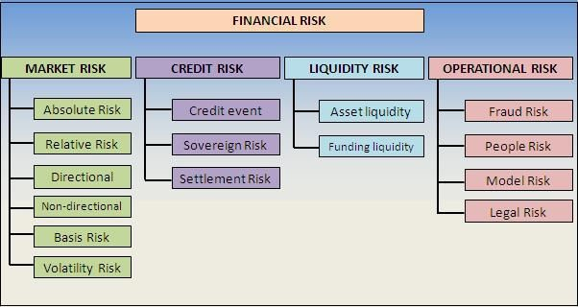
Figure 2.1:
Forms of financial risks

Source: Adapted from Eshna (2015)
The tools used to manage these risks are financial derivative instruments of forwards, futures, options and swaps. These instruments which are bought in the form of contracts between 2 parties assuming the opposite sides of the same risk are not absolutely mutually exclusive and can be used simultaneously based on a company’s risk assessment of exposure and/or its risk management strategy. It is pertinent at this point to understand here that a financial derivative contract is only worthwhile because it derives its value from an underlying asset.
According to Chui (2012), a forward or futures contract is an agreement to buy or sell a specific asset at a specific price on a specific date. Forwards are customised to serve the specific risk needs of 2 parties (counterparties) and are commonly traded in over-the-counter (OTC) markets, while futures are standardised contracts traded in organised financial market exchanges with the market usually being an intermediary between the counterparties. Option contracts on the other hand can be either customised or standardised and are defined as the right but not the obligation of a purchaser to buy (in the case of a call option) or sell (in the case of a put option) a specific asset before (in the case of an American-style option) or on a specified date (in the case of a European-style option); while Swaps are generally contracts that are created to facilitate the exchange of a series of payments as opposed to a one-off settlement either in the form of 2 different currencies or 2 different interest payments. Swaps are more long term in nature than Forwards, Futures and Options which can sometimes be constructed to reach their maturity tenure in less than a year.
Another use of financial derivatives today is Speculation. A crude way to understand speculative activity is to realise that it involves one party putting forward a supposition about potential risk that will occur in the future and then hedging his position solely based on this belief. The volatility in interest rate, foreign exchange and commodity prices are just typical examples of risks that can warrant the usage of forwards, futures, options and swaps if (i) a genuine risk exposure is uncovered after a thorough risk assessment is carried out by a company or (ii) a strong motive to make abnormal profits usually with the willingness to deliberately expose a firm to higher risk. In a nutshell, hedging relates to existing risk, while speculation creates risk.
2.2.1 Interest Rate Risk
This is perhaps the single most inevitable financial risk with exposure to both individual and institutional investors. Any interest bearing asset like a debt instrument is open to this risk (Simon, 2015). According to Beets (2004), this risk arises when there is potential for changes in interest rates to adversely affect earnings and reduce a company’s net asset value. The source of this risk can evolve from timing differences in the revaluation of assets, liabilities and off-balance-sheet instruments; negative correlation between the rates earned and paid on securities; and the presence of embedded options within an investment product. The reference or benchmark rate usually used in interest rate risk management is the London Interbank Offer Rate (LIBOR).
Hon (2012) study of the use of interest rate derivatives of 46 companies listed on the Hang Seng index of Hong Kong revealed that about 59% (27) of these companies used interest rate swaps to hedge their risk exposure in 2010, while Chernenko and Faulkender (2011) argues that their study being the most comprehensive at that time should be able to reveal the consistency of the use of interest rate swaps to hedge and speculate based on the composition of 10 years panel dataset of 1,854 firms. After decomposing the variance of the interest rate risk exposure and the use of interest rate swaps in the cross-sectional observations and across time, their statistical test of the difference of means revealed relatively equal standard deviations across both subsamples. Hence, they conclude that firms use interest rate swaps to hedge risk just as much as they use it to speculate. They also posit that high investment firms who are sensitive to the variation of short term interest rates are more likely to use floating rate debt, while those with more long term debts as well as those that spend significantly more on R&D are more likely to use fixed rate debt in their corporate management policy funding strategy. Finally, firms with favourable interest rate risk exposure of operating and investing cash flows would more likely swap to a floating interest rate exposure than those with an unfavourable interest rate exposure, who would most likely swap to a fixed rate exposure.
2.2.2 Foreign Exchange Risk
The need for multinational firms to transact businesses across national and regional borders has given rise to foreign exchange risk, based on the variation in values of currencies from time-to-time. Harper (2015) defines it as “the risk that a change in currency exchange rates will adversely impact business results". The need to hedge against currency risk is imperative if the incoming cash flows of a business are denominated in a different currency than that of the outgoing cash flows; there is a time gap between receiving monies from abroad and making corresponding payments; a certain rate of exchange is used in the pricing of products to achieve consistency; and the anticipation of payments of a specific volume of production with uncertainty as to when these payments will be received.

Allayannis, Lel and Miller’s (2011) study had the objective of investigating the impact of currency derivatives on firm value, with a view to checking how corporate governance affect decisions regarding the hedging of foreign exchange risk. They composed an unbalanced panel dataset containing over 370 firms from 39 countries giving a total of 1,546 observations for 10 years (1990—1999). Their regression test results yields some interesting findings: (i) there is a positive and significant association between firms who use foreign exchange derivatives and the Tobins Q ratio, implying that the hedging of foreign exchange risk exposure adds value to a firm; (ii) firms with strong corporate governance who hedge their risk exposure with the use of foreign exchange derivatives are rewarded with a premium, but those with weak corporate governance do not receive a significant premium; and (iii) there is a much more significant relationship between the use of foreign exchange derivatives and firm’s value, the stronger a firms’ internal corporate governance is aligned with her external country’s governance.
2.2.3 Commodity Price Risk
Commodities that are commonly traded in financial markets today are numerous and are broadly classified into 2 groups namely, hard and soft commodities. Hard commodities are natural products that are mined from the ground, while soft commodities imply those that are grown and cultivated. Examples of both groups include cotton, soybeans, coal, wheat, copper, aluminium, oranges, rice, cocoa, gold, silver and steel etc. Barned (2012) defines commodity risk as the fluctuations in the prices of commodities that can adversely affect the revenue levels that companies would receive in the future, and can be classified into price risk (changes in the price of the commodity by uncontrollable factors); quantity risk (changes in the availability of commodities); input risk (potential increase in business cost as a result of price risk) and political risk (policy changes regarding compliance of businesses in the production and supply of commodities). The most significant risk that affects businesses is obviously price risk, as this has a knock-on effect on quantity produced and input costs. Political risk on the other hand is uncontrollable.
Since most commodities are priced in US dollars, it usually goes in tandem with foreign exchange risks, although it is said to be more volatile and harder to manage. This is because the risk of default of a counterparty is larger due to the presence of basis risk, and supply can be volatile due to long lead times or unfavourable weather conditions—especially in the case of soft commodities (Wallace, 2008).
Evidence of the impact of the use of financial derivatives to hedge against commodities price risk has not been as abundant as those relating to interest rate and foreign exchange risks. A case study of Anheuser-Busch, a manufacturer of aluminium beverage containers and its subsidiary, Metal Container Corporation (MCC) by Singh (2004) is one of the few studies that provide direct result of hedging commodity price risk exposure. A simulation model was used by mapping out production quantities and prices of aluminium products that were to be delivered on a certain date, with price differentials from original estimates, while hedging with futures, options and a portfolio of a combination of both futures and options. The results reveal that it is relatively cheaper to hedge commodity price risk with a portfolio consisting only of futures, than with portfolios of options or a combination of both futures and options. This is apparently because there is an upfront premium paid on options contract that is factored in as a cost when the contract is being made. However, the author argued that if AnheuserBusch wishes to utilise the highest return from a hedged position, it may be more efficient to use a portfolio consisting of options or the one with a combination of both futures and options.
Nevertheless, the author pointed out some challenges that the company might face if these simulation strategies are actually implemented which include: (i) the extreme difficulty to integrate operational decision-making with financial systems such as option pricing models; (ii) with a lot of assumptions made, results from the model may not be optimal and (iii) parameters used in the model are likely to change as the aluminium futures market develops further. He recommended the use of other empirical statistical measures in order to get more reliable estimates.
An earlier study by Varangis, Larson and Anderson (2002) argued that much of the emphasis on commodity price risk centres on how countries hedge their trade exposures and not necessary just sectors or companies. They posit it is better for producers to use put option strategies to hedge commodity price risk exposures because of the limited risk in counterparty default. Additionally, developing countries can benefit greatly from the use of financial instruments to hedge commodity price risks but are faced with regulatory, institutional and legal constraints.
2.3 The UK Derivatives Market
Participants in the UK derivatives market include market makers, the market itself which is divided into an organised exchange and an over-the-counter (OTC) market, as well as the end-users of corporations and individuals. Financial derivatives are more likely to be used in the corporate world than in the investment world largely controlled by fund managers argues Chance (2008). Financial derivatives have grown widely in the UK since 2005, there is greater coverage of information on its use and overall data quality has improved (Semken, 2005). When classified broadly by sector usage, financial derivatives are used more by financial companies than non-financial firms for hedging and general risk management.

2.3.1 Recent Statistics
The UK derivatives organised exchange and over-the counter (OTC) markets are grouped together as part of the London Stock Exchange (LSE) which is referred to as the London Stock Exchange Derivatives Market or LSEDM. As at 2015 year-to-date, list of contracts available for trade are Norwegian, International order book (IOB) and UK derivatives, with some having a physical settlement type and others cash. The Bank of International Settlements (BIS, 2015) has revealed some interesting statistics for Europe with the UK derivatives market as a major influencer. Interest rate futures contracts outstanding, although volatile, has gradually surged throughout the years and is currently seen to have grown by more than 2000%, while options has not rebounded since the financial crisis and is currently at the same level of mid-2003. For Foreign exchange futures, its peak was reached during the financial crisis and is still the highest point to date, while options growth is the poorest of them all.

2.3.2 Regulation
According to the European Union Committee of the House of Lords (2010), the future of the UK derivatives market will be fraught with tight regulatory policies owing to lack of oversight in the past that largely contributed to the global financial crisis— although derivatives were argued to be a part of the solution of reducing the risk in financial markets, as they were widely employed as tools to implement and ease policies of quantitative fiscal programmes. Structured products, mortgage lending, rating agencies, accounting standards, were identified as the major causes of the crisis. Increased oversight therefore should be centred on OTC derivatives trades, and reporting of daily transactions should be encouraged just like in organised exchanges, which will go a long way in making the derivatives market more transparent.
2.4 Hedging Behaviour In Business Industries
Specific risk management strategies tends to be infectious among companies in the same business segment or industry. As some schools of thought of the NIE theory argues, firms may be inclined to hedge simply because it is an acceptable practice. According to Adam, Dasgupta and Titman (2007), competition in an industry helps set an equilibrium output price and this price is a function of total corporate finance and hedging decisions in the industry. A firm’s risk management decision therefore is determined by other firms’ investment and risk management decisions in identical business spheres. Conversely, some firms will hedge to stabilise cash flow that may be needed for capital intensive investments, while some others will not hedge if the potential volatility of cash flows based on their risk assessment exposure will provide higher operating revenues. This automatically creates equilibrium across different business industries of hedgers and non-hedgers. There are other numerous studies that focus on hedging behaviour in different business industries, but for simplicity, these are grouped into financial and non-financial firms.
2.4.1 Financial Firms
The study of domestic top-tier US banks by Begenau, Piazzesi and Schneider (2013) had a composition of data on banks’ fixed income portfolios, risk exposures and performance between 1995Q1—2011Q4. Interest rates and default risk is viewed as the 2 major risks that affect bank assets. When these risks are hedged with interest rate swaps and other credit derivative instruments, the net positions banks gain are much higher than the risk exposures that was assessed, which suggests that banks not only use derivatives for hedging risks, but to speculate as well, so as to boost profit margins. In contrast, Chang, Ho and Hsiao (2012) studied the effect of the usage of derivatives on 355 banks across 25 European countries, between the years of 20042008 and found that the use of derivatives for both trading and hedging purposes tend to increase bank risk, but was also positively significant with the increase in their value across those years. Therefore, if derivatives are used properly by financial companies to hedge other than speculate, the benefits of firm value maximisation will be at par with non-financial companies. Likewise Shiu, Moles and Shin (2010) argues that their observed risk exposure of banks in Taiwan between the years of 1998—2005 did not seem to have any positive association with their use of derivatives and so does not affect bank value.
Zou (2010) observed a 1.5% hedging premium on average when he tested the effect of corporate risk management practices on firm value on the purchase of property insurance for companies in the real estate industry in China; while Sun, Mungan and Corrigan et al reveals that hedging activities has been more than 90% effective for US life insurance companies with an increase in hedge returns of up to $40 billion between the months of September to December, 2008.
2.4.2 Non-Financial Firms

Tufano (1996) tries to lend credence to the agency cost theory by creating variables to represent shareholder maximisation, and managerial utility maximisation in the test of hypotheses of financial distress, disruption of investment opportunities, firm size, tax savings, risk aversion and alternative financial policies on 48 firms in the Gold mining industry between 1991—1993. The test results using a pooled OLS regression technique refutes the shareholder maximisation argument that hedging increases shareholders’ value, because there was no relationship between the extent of risk management practices in the industry and financial distress, tax savings and investment opportunities. The managerial utility hypothesis on the other hand found significant associations between hedging gold price risk and wealth maximisation of managers, implying that managers who have more options in the company they manage tend to hedge more and vice versa.
In Haushalter’s (2000) study of oil and gas producers between years 1992-1994, the use of primary data through a survey of about 100 companies that hedge their commodity price risk and foreign exchange exposures reveals that corporate risk management is sufficient enough to enable companies to alleviate financial costs, while helping them achieve significant economies of scale, especially in relation to establishing hedging strategies. He also finds that the extent to which oil and gas producers’ hedge can significantly help to also reduce basis risk in the use of commodity price derivative instruments. Similarly, MacKay and Moeller (2007) posits that the firm values of 34 oil firms increased significantly when they hedge with the motive of reducing financing costs—although this result is much beneficial for larger firms in the same industry. Jin and Jorion (2006) and another study by Haushalter (2001) also focused on the oil, and oil & gas industries respectively with no much differences in findings.
A study on the US airline industry by Treanor, Simkins and Rogers et al (2014) suggests that financial derivatives are more likely to be used as an additional and secondary risk management tool, after the use of operational hedging strategies to reduce the risk exposure of volatile commodity prices of jet fuel. Therefore, operational risk management hedging more commonly affect company’s financial performance positively. They conclude that the use of financial derivatives by large and low-cost carriers is for the primary purpose of fine-tuning risk.
Furthermore, Bartram and Bodnar (2007) also advocated that foreign exchange rate risk exposure did not affect values of nonfinancial companies that hedge differently from those that did not while Bartram, Brown and Conrad (2011) in a later study of 6,888 nonfinancial firms from 47 countries, found that the use of financial derivatives to hedge actually significantly reduced systematic and total risk, and also does not tend to affect firm value negatively.

2.5 Further Empirical Findings
In the work of El-Masry (2006), primary data was collected on 401 nonfinancial firms between March and May 2001 in a bid to evaluating the decisions regarding the use of specific financial derivatives in hedging risk exposures. The results from 43% (172) of the questionnaire respondents indicate that bigger companies as well as multinational firms, are more likely to use financial derivatives to hedge foreign exchange and interest rate risks. The major concern for corporate management was identified to be cash flow management. Further analysis of derivatives usage by specific industry sector shows that 80%, 75%, 70%, 65%, 80%, 50% 30% and 60% are users of derivatives in the communications, electrical, transportation, chemical, automobiles, utilities, retailers and other unclassified industries respectively.
In testing whether commodity risk management is associated with financial distress, Hankins and Williams (2015) provides new unexplored evidence of hedging with purchase obligations forward contracts on a comprehensive dataset containing 29,640 firm year observations of nonfinancial company suppliers and purchasers between 2003—2010. They argue that these purchase obligations are a perfect substitute to other derivative tools and most of the companies in their sample preferred their use in comparison to futures contracts. Surprisingly, it is generally observed that as companies get close to financial distress, their reliance increases on the use of forward contracts.
Bacha (2014) crucially analysed many theories of financial risk management and applied them to the modern context of organisations and their environment. He concludes by stating that hedging allows good variability of cash flow and prevents financial distress. This position correlates with that of Magee (2013) who tested the distance to default measure of financial distress, and found that the extent to which companies hedge foreign currency risks actually tend to reduce financial distress.
Largely, findings have been mixed. While some authors strongly argue for the use of financial derivatives because it increases firm performance, others have found an adverse relationship instead, leading credence to the fact that it reduces overall company profits. Still, others have inferred that the relationship whether positive or negative is not standalone, but can be mainly affected by key business activity indicators like size, asset base, risk exposure, liquidity and funding structure. The next section goes on to describe the statistical methods that would be employed on the data collected of 10 FTSE 100 UK financial and nonfinancial firms’ use of derivatives between years 2004— 2014.
3.0 Methodology
The study adopts the longitudinal research design in conjunction with econometric procedure in the composition of a balanced panel dataset and sampled 5 financial and 5 nonfinancial companies, randomly selected from the UK FTSE 100 index. As Posesta (2002) opined, this type of research design is advantageous as it has the potential of increasing the validity of estimated results. In a bid to providing answers to the research questions and objectives stated ab initio. First, quantitative proxies of risk, derivative use and firm performance with justifications to some studies are introduced, then the operational measures of the variables, hypotheses formulation, data collection procedure and testing technique are further discussed.

3.1 Quantitative Proxies For Risk and Derivatives
The work of Ahmed, Azevedo and Guney (2014) is yet the most extensive using up to 43 different variables in their study of the effect of hedging on the value and performance of 288 nonfinancial companies in the FTSE all-share index. These variables are explained below.
3.1.1 Risk and Derivative Use
The use of derivatives presupposes that some certain risk has already been identified and appropriate strategies have been suggested to deal with them. Since risk is based on uncertainty about the outcome of some futuristic event, the identification of such risk cannot necessarily be quantified in absolute financial loss terms. Therefore the creation of dummy variables is used to denote the presence or absence of some form of risk a company wishes to hedge. In its creation, a value of “1” is assigned when a specific risk is identified and “0” otherwise. Similarly, a value of “1” is also assigned when a specific derivative is used and “0” otherwise.

Common dummy variables that have been used in many studies include Hedge dummy, representing the hedging or non-hedging activity of a company at a particular time; interest rate, foreign exchange and commodity price dummies denoting the presence or absence of their individual risks as well. Similarly, the actual usage of derivatives instruments to hedge these risks are represented by dummies of interest rate, foreign exchange and commodity price derivative instruments of forwards, futures, options and swaps.

3.1.2 Firm Characteristics
Unlike risk, firm characteristics at a point in time can actually be measured in absolute monetary terms. Common proxies used include: Revenue, representing total company sales; Total assets, representing the total book value or market value of a firm’s current and non-current assets; Return on Invested Capital, representing earnings before interest and taxes divided by the total capital employed on the firm’s operations; Return on Assets, representing earnings before interest and taxes divided by total assets; Return on Equity, representing earnings before interest and taxes divided by net assets or shareholders’ funds; Operating Income, representing revenue less total operating expenditure; Profit Margin, representing revenue divided by net profit; and Earnings per Share, representing net profit divided by number of shares outstanding.
Other performance variables too numerous to define, used to represent firm characteristics in Judge (2006), Aretz and Bartam (2009) as well as Chanzu and Gekara (2014) include Firm market value, Tobin’s Q, Firm size, Firm age, Leverage, Floating rate debt, Fixed rate debt, Dividends, Dividends dummy, Capital expenditure ratio to total assets, Research & development ratio to total assets, Business diversification, Geographical diversification, Multinational segments, Foreign sales ratio, Foreign expenditures, Commodity purchases, Commodity raw materials, Commodity oil & gas, mining and energy. This list is by no way exhaustive.
3.2 The Variables
Operational measures of the variables divided into groups of dependent, independent and control variables are explained below. A number of these variables are primarily adapted and adjusted accordingly to fit from the studies of Judge (2006) and Ahmed, Azevedo and Guney (2014).
3.2.1 Dependent Variables
Return on assets and return on capital employed are the two main variables used to proxy firm performance. It is suggestive that the independent and control variables would be able to predict or explain changes in these 2 proxies throughout the 10-year time period.
L_ROAT: This is the logarithm of return on firm’s asset calculated as net profit divided by total assets.
L_ROCE: This is the logarithm of return on capital employed calculated as net profit divided by total invested capital. The importance of ROCE to ROIC is that it takes all invested funds into consideration (i.e. equity and debt), while ROIC only considers one or the other.

3.2.2 Independent Variables
Dummy variables for the use of derivatives in the presence or absence of respective types of risks are used as measures qualified as independent variables, with the assumption that changes in the dependent variables are caused by these hedging activities.
FOW: This represents forwards contract derivative dummy with the value of 1 if forwards was used in a particular year or 0 otherwise.
FUT: This is futures contract derivative dummy with the value of 1 if futures were used in a particular year or 0 otherwise.
OPT: This represents options contract derivative dummy with the value of 1 if options was used in a particular year or 0 otherwise.
SWP: This is swaps contract derivative dummy with the value of 1 if swaps was used in a particular year or 0 otherwise.
IRDEV: This represents interest rate derivative dummy with the value of 1 if one or more of interest rate derivative instruments of forwards, futures, options and swaps was used in a particular year to hedge interest rate risk or 0 otherwise.
FXDEV: This represents foreign exchange rate derivative dummy with the value of 1 if one or more of foreign exchange rate derivative instruments of forwards, futures, options and swaps was used in a particular year to hedge foreign currency risk or 0 otherwise.

3.2.3 Control Variables
Other variables that proxy firm characteristics are also factored as they are assumed to indirectly affect the dependent variables. Adding these variables therefore denotes that their influence are adequately controlled.
L_MKCAP: This represents firm market capitalisation calculated as annual average share price multiplied by annual number of shares outstanding. This is used to control for firm size with the notion that larger and bigger firms use derivatives more as they are more likely to be exposed to more risks from international business activities.
L_BOOKS: This is log of book value, another measure of firm size calculated as book value per share multiplied by number of shares outstanding, with the notion that market capitalisation may not adequately represent true firm size, as share prices are mostly driven by investor sentiments.
L_ASIZE: This represents the log of asset size, yet another measure of firm size that uses total assets as its measure. Total assets are acquired from equity and debt funding which is a better measure as market capitalisation and book size only reflects equity capital.
L_COAGE: This is log of company age, calculated as current year less the year of incorporation. It controls how well established a firm is using the number of years of existence, with the assumption that older firms would most likely use derivatives as they are more experienced in managing risks over time.
L_LEVER: This represents log of leverage calculated as total debts divide total assets, used to control for a firm’s funding structure.
DIVPO: This is dividend policy, a dummy variable that takes the value of 1 if a firm pays dividend in a particular year or 0 otherwise. This is used due to the fact that payments of dividends reduces profits or reserves and can therefore seem to falsify results of the performance of a firm in a particular year.
L_DIVID: This represents log of dividends, calculated as dividends per share multiplied by number of shares outstanding, used to control for the actual amount of dividends paid or unpaid.
L_CRATO: This is current ratio, calculated as current assets divided by current liabilities. This is used as a control for liquidity to check how well a firm can meet its short term obligations using the value of its current assets.
CRSD: This represents financial crisis dummy with the value of 1 for the years of 2007, 2008 and 2009 and 0 otherwise. It controls the fact that unexpected uncontrollable events of the crisis would have affected firms’ financial performance.
QSCOR: This is QuiScore, a measure of a firm’s credit rating that attempts to also measure a firm’s ability to pay its debts. The QuiScore takes a set of values between 1 to 100, with the groups of 0—20, 21—40, 41—60, 61— 80 and 81—100 representing high risk, unstable, normal, stable and secure respectively. This is a better proxy for liquidity as it takes account of long term liability.
3.3 Hypotheses and Models
Following the theoretical postulates and the empirical review earlier made in this study, we can hypothesize that the performance of firms(financial and non financial) in the FTSE 100 are positive functions of the use of derivatives to hedge risk. These can be negative depending on the prevailing conditions in the firms.
A universal model strictly representing the above hypothesis is therefore specified in its functional form as:
FPERFORM_{i,t}= f(DEUSE_{i,t} , RISKS_{i,t,} CONTS_{i,t}) (1)
Where:
i, t represents firm i in time t.
FPERFORM is a specific measure of firm performance which is the dependent variable
DEUSE and RISKS are the independent dummy variables that proxy for the use of one or more ββfinancial derivative instruments to hedge one or more identified risk.
CONTS are firm characteristic variables used as controls
Thus, specifying equation (1) in explicit terms gives an estimable model expression of the regression equation as:
FPERFORM_{i,t} = α₁ +β₂DEUSE_{i,t} + β₃RISKS_{i,t} + β4CONTS_{i,t} +µ_{t} (2)
Where:
α₁ is the intercept of the regression line or constant term β₂, β₃, and β₄ are the slopes of the regression line or coefficient of the independent and control variables to be estimated
µ is the stochastic term assumed to be independent and identically normally distributed
Subsequently, equation (2) gives the 2 main models for the study objectives. FPERFORM becomes L_ROAT and L_ROCE; DEUSE becomes FOW, FUT, OPT and SWP; RISKS becomes IRDEV and FXDEV; while CONTS are the controls.
    - MODEL 1

L_ROAT_{i,t} = δ₁+ γ₂IRDEV_{i,t}+ γ₃FXDEV_{i,t} + γ₄FOW_{i,t +} γ₅FUT_{i,t} + γ₆OPT_{i,t} + γ₇SWP_{i,t} + γ₈L_MKCAP_{i,t} + γ₉L_BOOKS_{i,t} + γ₁₀L_ASIZE_{i,t} + γ₁₁L_COAGE_{i,t} + γ₁₂L_LEVER_{i,t} + γ₁₃DIVPO_{i,t} + γ₁₄L_DIVID_{i,t} + γ₁₅L_CRATO_{i,t} + γ₁₆CRSD_{i,t} + γ₁₇QSCOR_{i,t} + ν_{t} (3)
In Equation (3), the result of the estimation is expected to provide answers as to whether derivative usage improves return on assets, and which derivatives have the greatest impact on return on assets of UK FTSE 100 firms.

MODEL 2
L_ROAT_{i,t} = δ₁+ θ₂IRDEV_{i,t} + θ₃FXDEV_{i,t} + θ₄FOW_{i,t +} θ₅FUT_{i,t} + θ₆OPT_{i,t} + θ₇SWP_{i,t} + θ₈L_MKCAP_{i,t} + θ₉L_BOOKS_{i,t} + θ₁₀L_ASIZE_{i,t} + θ₁₁L_COAGE_{i,t} + θ₁₂L_LEVER_{i,t} + θ₁₃DIVPO_{i,t} + θ₁₄L_DIVID_{i,t} + θ₁₅L_CRATO_{i,t} + θ₁₆CRSD_{i,t} + θ₁₇QSCOR_{i,t} + ν_{t} (4)
The result of the estimation of Equation (4) similarly will provide answers to whether derivative usage improves return on capital employed, and which derivatives have the greatest impact on return on capital employed of UK FTSE 100 firms.
Table 3.1: Summary of the operational variables and models
Models | Dependent Variables | Independent and Control Variables | Respective Notations | Expected Impact Sign
1.  2. | Return on assets  L_ROAT = ƒ  or  Return on capital employed  L_ROCE = ƒ | Interest rate derivatives, foreign exchange rate derivatives, forwards, futures, options, swaps,  market capitalisation, book value,  total assets, company age, leverage, dividend policy, dividends, current ratio, crisis dummy, quiscore | IRDEV,  FXDEV, FOW,  FUT,  OPT,  SWP,  L_MKCAP, L_BOOKS,  L_ASIZE,  L_COAGE,  L_LEVER,  DIVPO,  L_DIVID,  L_CRATO,  CRSD,  QSCOR | + +  + + +  +/- +/-  +/- +/- +/- +/-  +/- - +/-
Source: Researcher’s illustration

Table 3.1 above summarises the variables used in the specification of the models. The expected impact sign column simply illustrates the effect that is probable on the dependent variable by the independent and control variables. Therefore, “+” signs simply means positive impact while “-“ signs denotes negative impact. But “+/-“ signs signifies that the variable is capable of causing either a positive or negative impact on the dependent variable based on its definition. For example, the quiscore (QSCOR) variable would be expected to cause a positive impact on return on assets (L_ROAT) or return on capital employed (L_ROCE) if a company’s ability to pay its debts is rated as ‘secure’ and vice versa. Similarly, the dividend policy (DIVPO) variable would be expected to also positively increase a firm’s performance if no dividend is paid for the time period and vice versa.

3.4 Data
The study employs the longitudinal research design in the composition of a balanced panel dataset containing 5 financial and 5 nonfinancial companies, randomly selected from the UK FTSE 100 index. As Posesta (2002) opined, this type of research design is advantageous as it has the potential of increasing the validity of estimated results. The data were mainly sourced from secondary sources namely FAME (Financial Analysis Made Easy) by Thomson Reuters, and individual annual reports and accounts of the firms in the sample spanning a 10-year period of 2005—2014. Companies in the FTSE 100 index was selected because they are more likely to be well established, as there are very strict requirements for companies to fulfil before becoming constituents of this index.
The first phase of data collection involved identifying companies in the FTSE 100 index from the Thomson Reuters Eikon web tool, and thus randomly choosing 10 of these companies to avoid non-selection bias. Then, there was collection of the companies’ characteristic measures of dependent and control variables from FAME. These data were subsequently exported to Microsoft Office Excel were they were inspected for any errors or missing values. Companies with even a single missing value are dropped from the sample and another replacement is made to ensure a total number of 10 firms. Luckily, the 5 biggest Banks of the index were part of the selection with complete values of the respective variables. The other 5 companies however belonged to 5 different industry classifications.
The next phase involved hand collection of risk management and derivative related data from the annual reports and accounts of the 10 companies, sourced from their individual websites for the 10-year period. This was the most painstaking part of the research as it required careful reading in between the lines of risk management related notes. Interestingly, all the companies in the sample sufficiently disclosed information regarding their derivative activities, especially relating to the specific risks hedged. This was not surprising due to Judge’s (2006:17-18) words of how derivative data started becoming sufficiently disclosed from 1993, as an adherence to rules of the Financial Accounting Standards Board (FASB) for public companies. However, some firms were not expressly clear about the specific derivative instruments used to hedge specific risks identified. Hence, for any derivative instrument not disclosed, the respective company is classified as not using that particular instrument in that particular year.
The final phase involved the restructuring of the data by transposing rows of data of each company into a panel structure format, in order to be understood by the statistical software. This restructuring was done in Microsoft Excel as well. Then the company age (COAGE) variable, dividend policy (DIVPO) and financial crisis dummies were created. The variables were then transformed into their log forms. For variables with negative values, a constant of 100 is added when computing across the entire series to ensure consistency and preserve validity. With 10 cross-sections of 10 years each, the total number of observations was 100, with a total of 1,800 data points of 18 variables.
Table 3.2: Excerpt summary of data sourced (2005—2014) (Averages)
 |  | Percentage |  |  |  |  |  |  |  |  |  | $’million
YEAR | ROAT | ROCE | LEVER | CRATO | FOW | FUT | OPT | SWP | IRDEV | FXDEV | MKCAP | BOOKS | ASIZE | DIVID | COAGE | DIVPO | CRSD | QSCOR
2005 | 9.89 | 23.81 0.84 |  | 1.00 | 0.40 | 0.30 | 0.40 | 1.00 | 0.80 | 0.50 | 61 | 679 532 |  | 187.96 | 48 | 0.90 | 0.00 | 88
2006 | 9.97 | 23.60 0.82 |  | 0.85 | 0.50 | 0.30 | 0.60 | 0.60 | 0.80 | 0.60 | 73 | 44 662 |  | 2.75 | 49 | 0.90 | 0.00 | 82
2007 | 8.58 | 19.20 0.85 |  | 1.01 | 0.60 | 0.20 | 0.60 | 0.80 | 1.00 | 0.70 | 70 | 39 985 |  | 3.31 | 50 | 1.00 | 1.00 | 85
2008 | 6.68 | 8.16 0.88 |  | 0.84 | 0.50 | 0.60 | 0.70 | 0.60 | 1.00 | 0.80 | 40 | 29 1,028 |  | 10.38 | 51 | 1.00 | 1.00 | 84
2009 | 7.15 | 11.82 0.86 |  | 0.82 | 0.50 | 0.60 | 0.30 | 0.60 | 0.70 | 0.90 | 61 | 47 964 |  | 2.00 | 52 | 1.00 | 1.00 | 87
2010 | 8.89 | 14.82 0.83 |  | 1.19 | 0.60 | 0.40 | 0.20 | 0.70 | 0.70 | 0.70 | 64 | 52 932 |  | 5.63 | 53 | 0.90 | 0.00 | 88
2011 | 8.79 | 14.94 0.82 |  | 1.12 | 0.50 | 0.60 | 0.20 | 0.80 | 0.70 | 0.90 | 54 | 54 958 |  | 2.23 | 54 | 0.80 | 0.00 | 87
2012 | 8.68 | 14.08 0.83 |  | 1.11 | 0.60 | 0.30 | 0.30 | 0.80 | 0.70 | 0.80 | 67 | 55 931 |  | 2.47 | 55 | 0.90 | 0.00 | 89
2013 | 7.71 | 13.21 0.84 |  | 1.08 | 0.50 | 0.40 | 0.30 | 0.80 | 0.80 | 0.80 | 78 | 54 878 |  | 2.79 | 56 | 0.90 | 0.00 | 84
2014 | 6.74 | 12.45 0.83 |  | 1.03 | 0.50 | 0.50 | 0.20 | 0.90 | 0.80 | 0.80 | 75 | 55 866 |  | 2.86 | 57 | 0.90 | 0.00 | 86
Source: Researcher’s illustration

3.5 Testing Technique and Limitations
The models are tested with the panel least squares (PLS) regression analysis. This is one of the common methods that have been employed in existing literature. The Econometric Views (E-Views) version 8 statistical software was used for the estimations. Again, this is one of the state-of-the-art software that has been employed in many existing literature and is classed among the likes of STATA, SPSS and Gretl. The PLS regression analysis shares some common limitations of the ordinary least squares (OLS) regression namely, Autocorrelation, Normality, Multi-collinearity and Heteroscedasticity.
The normality problem was partly solved in the conversion of most of the variables into their log forms. This ensures that they are normally distributed with no abnormal skewness or fat tails. However, the normality assumption will still be tested with descriptive statistics before actual estimation is performed. The Multicollinearity problem on the other hand involves high correlation between two or more independent variables. A correlation matrix would be plotted to check for this, and any sign of high correlation will lead to the dropping of one or more of the affected variables. Finally, to ensure homoscedastic estimates, the PLS regression is estimated with the so-called ‘White’ diagonal test of standard errors and co-variance. Autocorrelation or serial correlation as it is sometimes called does not affect the dataset as it is a balanced panel with a short time frame (less than 20 years). Finally, the parsimony of the model will be checked though the estimation of diagnostic tests, in order to ensure that results were estimated with the highest precision of robust specifications.

4.0 Discussion of Findings
The models has been estimated. This section now discusses the result of the findings. First and foremost, preliminary analyses on the dataset would be presented, then descriptive statistics, regression analysis and diagnostic tests results would be interpreted.

4.1 Preliminary Results
When the dataset was shared between financial and nonfinancial companies, as shown in Tables 4.1 and 4.2, some interesting findings were unravelled.

<Tables 4.1 and 4.2 about here>

4.1.1 ROAT and ROCE
Nonfinancial companies seem to record far higher return on assets and return on capital employed than financial companies as shown in Figure 4.1. The blue bars represent financial firms while the dark-orange bars represents nonfinancial firms.

<Figure 4.1 about here>

4.1.2 Risk and Derivatives
In the use of derivatives surprisingly, Figures 4.2 and 4.3 shows that nonfinancial companies too seemed to have used more of forwards, futures, options and swaps than financial companies. It is seen that nonfinancial companies use derivatives up to 10% more than financial companies (compare 55% to 45% respectively). Swaps also seem to be the most used financial derivative instrument of them all especially in 2005 and 2006. In hedging risks also, Figure 4.4 show that interest rate is the most hedged by financial companies, while foreign exchange risks is the most hedged by nonfinancial companies.

<Figures 4.2, 4.3 and 4.4 about here>

4.1.3 Firm Characteristics
In analysing firm size, financial companies had the highest average market capitalisation of $77 million in 2007 and 2013 respectively. Nonfinancial companies on the other hand recorded the highest average market capitalisation in 2014 of $70 million. Overall average book value of financial companies stood at $67 million, while that of nonfinancial companies was $141 million for the entire 10-year period. As for total assets overall, financial firms’ value is $1.4 billion, while that of nonfinancial firms is $36 million.
The average age of firms in the financial companies group is 40, while that of nonfinancial companies is 58. Leverage is also very low at an average of less than 1% for both financial and nonfinancial firms. There are big differences in dividends payments. While financial firms record an average payout amount of about $3.7 million, nonfinancial firms paid an average of $40 million for the 10-year period.
It also appears that financial firms are less liquid than nonfinancial firms with an average current ratio of 0.7, implying that their total average current assets only represents 70% of their current liabilities. For nonfinancial firms, this ratio is 1.17 or 117%. The credit rating of financial firms’ debt with an average quiscore of 69 is seen as ‘stable’, while that of nonfinancial firms with an average quiscore of 89 is ‘secure’.

4.2 Descriptive Statistics
Common sample statistics for the dataset is presented below and the test of normality using Jarque Berra is also interpreted.
4.2.1 Common Sample
The group statistics for the dependent and independent variables as shown in Table 4.3 reveals that all observations are complete with no missing data. The Jarque Berra results also show that the variables are highly normally distributed, but some variables like L_ROCE, IRDEV, FXDEV and others are slightly negatively skewed.
<Table 4.3 about here>
For the control variables, Table 4.4 shows that all observations are also complete at 100, with no missing data. The Jarque Berra normality results also show that all the control variables are normally distributed. Also, only a few of them are negatively skewed like L_ASIZE, L_LEVER, DIVPO and others.
<Table 4.4 about here>
4.2.2 Normality Distribution
In further evidencing the normality test results, the histogram of the individual variables are plotted against the theoretical standard normal distribution curves, as shown in Figure 4.5. All the respective variables are seen to be normally distributed.
Only L_ROAT and L_BOOKs are seen to have wider and slimmer tails respectively.

< Figures 4.5 about here>

4.3 Correlation Analysis
In the analysis of the correlation and covariance of the variables as shown in Tables 4.5 and 4.6, there is no cause for concern. Most of the variables are negatively correlated with very low covariance values. An in depth eyeball of the results however showed that the highest positive correlation exists between two variables in the risk and derivatives group, FOW and L_ROCE with only 45%. As for the control variables, only L_ASIZE and L_BOOKS are highly correlated at 90% with each other. Since both of these variables control firm size, one can be dropped without necessarily affecting the model specification.

<Table 4.5 and 4.6 about here>
4.4 Regression Estimation
Model 1 (M1) and Model 2 (M2) were estimated with the panel least squares (PLS) regression. There was no need for a cross-section or period effect specification as all parameters are homogenous. That is, there is no concern that some unobserved factors could affect the estimation results. More so, the financial crisis dummy variable is already contained in the equation to control for the only unobserved factor in the period. However, White’s diagonal standard errors and covariance are applied to both model tests to treat any heteroscedasticity in the error terms.

4.4.1 M1: ROAT AND DERIVATIVES
In testing the association that exists between derivative use and return on assets, the regression test results of M1 as shown in Table 4.7 reveals some interesting findings. Only IRDEV and FUT are observed to be positive and significant with L_ROAT, while FOW yields a negative and significant value with L_ROAT. These evidenced associations are significant at the 10% level. The results of the control variables were largely mixed. In re-estimating the model however by dropping the insignificant control variables, the results as presented in Table 4.8 goes on to show that only IRDEV, FOW and FUT association with L_ROAT is now positive and significant at 5%. SWP is also seen to be significant at the 10% level but with an evidenced negative relationship. On the other hand, control variables L_ASIZE, L_CRATO and QSCOR are all significant with L_ROAT at the 1% level, with only L_ASIZE showing a negative relationship.
Table 4.7: M1 PLS Regression test results
Dependent Variable: L_ROAT Method: Panel Least Squares Date: 07/19/15 Time: 10:06
Sample: 2005 2014 Periods included: 10
Cross-sections included: 10
Total panel (balanced) observations: 100
White diagonal standard errors & covariance (d.f. corrected)
Variable | Coefficient | Std. Error | t-Statistic | Prob.
C | 18.10106 | 15.77563 | 1.147406 | 0.2545
IRDEV | 0.004017 | 0.002072 | 1.939328 | 0.0559
FXDEV | -0.002477 | 0.003194 | -0.775377 | 0.4403
FOW | 0.005628 | 0.003159 | 1.781402 | 0.0785
FUT | 0.004432 | 0.002694 | 1.645419 | 0.1037
OPT | -0.001500 | 0.004478 | -0.334945 | 0.7385
SWP | -0.000922 | 0.002648 | -0.348284 | 0.7285
L_MKCAP | 0.005171 | 0.004839 | 1.068687 | 0.2883
L_BOOKS | -0.010383 | 0.009005 | -1.153045 | 0.2522
L_ASIZE | -0.027632 | 0.004295 | -6.434136 | 0.0000
L_COAGE | -0.005001 | 0.008724 | -0.573230 | 0.5680
L_LEVER | -10.02833 | 7.458364 | -1.344575 | 0.1824
DIVPO | -0.008614 | 0.007014 | -1.228070 | 0.2229
L_DIVID | 0.005933 | 0.004395 | 1.349812 | 0.1807
L_CRATO | 2.080583 | 0.892108 | 2.332210 | 0.0221
CRSD | -0.000830 | 0.003195 | -0.259681 | 0.7958
QSCOR | 0.000298 | 0.000148 | 2.020524 | 0.0466
R-squared | 0.865193 Mean dependent var |  |  | 2.033301
Adjusted R-squared | 0.839206 S.D. dependent var |  |  | 0.034384
S.E. of regression | 0.013788 Akaike info criterion |  |  | -5.576393
Sum squared resid | 0.015779 Schwarz criterion |  |  | -5.133514
Log likelihood | 295.8197 Hannan-Quinn criter. |  |  | -5.397152
F-statistic | 33.29333 Durbin-Watson stat |  |  | 1.196614
Prob(F-statistic) | 0.000000

Source: Researcher’s illustration using Eviews version 8

Table 4.8: M1 PLS Re-estimated Regression test results
Dependent Variable: L_ROAT Method: Panel Least Squares
Date: 07/19/15 Time: 11:33
Sample: 2005 2014 Periods included: 10
Cross-sections included: 10
Total panel (balanced) observations: 100
White diagonal standard errors & covariance (d.f. corrected)
Variable | Coefficient | Std. Error | t-Statistic | Prob.
C | -4.998395 | 2.253962 | -2.217603 | 0.0291
IRDEV | 0.005410 | 0.002266 | 2.388030 | 0.0190
FXDEV | -0.003068 | 0.003065 | -1.001043 | 0.3195
FOW | 0.008237 | 0.003525 | 2.336828 | 0.0217
FUT | 0.005919 | 0.002643 | 2.239182 | 0.0276
OPT | -0.003853 | 0.003468 | -1.110986 | 0.2695
SWP | -0.004308 | 0.002408 | -1.788885 | 0.0770
L_ASIZE | -0.030919 | 0.002059 | -15.01487 | 0.0000
L_CRATO | 3.566115 | 1.119596 | 3.185180 | 0.0020
QSCOR | 0.000515 | 0.000148 | 3.471424 | 0.0008
R-squared | 0.837024 Mean dependent var |  |  | 2.033301
Adjusted R-squared | 0.820726 S.D. dependent var |  |  | 0.034384
S.E. of regression | 0.014559 Akaike info criterion |  |  | -5.526634
Sum squared resid | 0.019076 Schwarz criterion |  |  | -5.266117
Log likelihood | 286.3317 Hannan-Quinn criter. |  |  | -5.421198
F-statistic | 51.35855 Durbin-Watson stat |  |  | 1.094197
Prob(F-statistic) | 0.000000

Source: Researcher’s illustration using Eviews version 8
Discussion and Implications: The statistical results provide conclusive evidences that hedging interest rate risks with any one or more of interest rate derivatives generally does not affect return on assets, but the specific use of a combination of forwards and futures derivative contracts seemed to increase return on assets, while the use of only swaps to hedge interest rate risks reduces return on assets. Also, the current ratio and quiscore as control measures of liquidity and solvency is strongly related to increases in return on assets. Particularly, on the derivatives side of the issue, a 1% increase in the use of forwards and futures corresponded to a 0.8% and 0.6% respective increases in return on assets, while a 1% increase in the use of swaps reduces return on assets by 4% in the 2005—2014 period under analysis. All though these values are minimal, it is of good point to note that the R-squared or coefficient of determination of the re-estimated model is high at 84%. This implies that interest rate derivative risk (IRDEV), forwards (FOW), futures (FUT), total asset (L_ASIZE), current ratio (L_CRATO) and quiscore credit rating (QSCOR) were jointly able to explain up to 84% of the total changes in return on asset (L_ROAT) of financial and nonfinancial firms in the UK FTSE 100. The model is also seen to be fit as the F-statistic has a coefficient value of 51 with a probability that is significant at the 1% level.
Thus, the null hypothesis (H₀₁) of non-significance between derivative use to hedge risks and firm performance is not accepted here, which automatically leads to the acceptance of the alternate hypothesis (H_{A1}), at a statistical confidence level of 95%. These results is in contrast to Singh’s (2004) case study simulation model of Anheuser-Busch in which a portfolio of only options contracts were favoured—although in hedging commodity price risk. Nevertheless, the model estimates are partly in line with Judge (2006) who used a multinomal logit regression analysis in his statistical tests. Although his results were far more conclusive because of a wide array of variables and a dataset of only nonfinancial firms, it also partly lends credence to the Stakeholder theory that hedging with financial derivatives is able to prevent financial distress as a result of ensuring the creation of value for all Stakeholders related to a business system, which was originally conjectured and argued by Freeman (1984, 2010).

4.4.2 M2: ROCE AND DERIVATIVES
The M2 estimation of the use of derivatives to hedge risks and return on capital employed shows far more different results than that of M1. None of the values of the independent variables of hedging financial risk with the use of derivative instruments yields significant associations with L_ROCE as shown in Table 4.9. But L_BOOKS, L_ASIZE, L_DIVID, L_CRATO and QSCOR out of the 10 control variables were associated with L_ROCE at varying degrees of significance and arithmetic signs. The insignificant control variables are hence dropped also and M2 is re-estimated, this time with better results. As shown in Table 4.10, only FXDEV is seen to be negatively related to L_ROCE with a 10% level of significance. L_BOOKS and L_CRATO control variables now becomes negative and insignificant, leaving L_ASIZE, L_DIVID and QSCOR which were significant at 1%, 1% and 5% respectively.
Table 4.9: M2 PLS Regression test results
Method: Panel Least Squares
Dependent Variable: L_ROCE
Date: 07/19/15 Time: 10:56
Sample: 2005 2014 Periods included: 10
Cross-sections included: 10
Total panel (balanced) observations: 100
White diagonal standard errors & covariance (d.f. corrected)
Variable | Coefficient | Std. Error | t-Statistic | Prob.
C | 9.750429 | 32.78905 | 0.297368 | 0.7669
IRDEV | -0.004178 | 0.007277 | -0.574123 | 0.5674
FXDEV | -0.020947 | 0.014928 | -1.403205 | 0.1643
FOW | 0.017151 | 0.011874 | 1.444391 | 0.1524
FUT | -0.004851 | 0.008424 | -0.575919 | 0.5662
OPT | -0.001442 | 0.009337 | -0.154476 | 0.8776
SWP | 0.019035 | 0.013230 | 1.438742 | 0.1540
L_MKCAP | 0.046415 | 0.030823 | 1.505855 | 0.1359
L_BOOKS | -0.035361 | 0.012763 | -2.770452 | 0.0069
L_ASIZE | -0.046794 | 0.013869 | -3.373947 | 0.0011
L_COAGE | 0.031264 | 0.052778 | 0.592353 | 0.5552
L_LEVER | 0.709119 | 15.29054 | 0.046376 | 0.9631
DIVPO | -0.011603 | 0.013539 | -0.857025 | 0.3939
L_DIVID | 0.019013 | 0.007843 | 2.424103 | 0.0175
L_CRATO | -4.453587 | 2.247032 | -1.981987 | 0.0508
CRSD | -0.011857 | 0.007754 | -1.529070 | 0.1300
QSCOR | -0.001066 | 0.000497 | -2.143883 | 0.0350
R-squared | 0.602999 Mean dependent var |  |  | 2.059656
Adjusted R-squared | 0.526469 S.D. dependent var |  |  | 0.056218
S.E. of regression | 0.038686 Akaike info criterion |  |  | -3.513012
Sum squared resid | 0.124218 Schwarz criterion |  |  | -3.070133
Log likelihood | 192.6506 Hannan-Quinn criter. |  |  | -3.333771
F-statistic | 7.879234 Durbin-Watson stat |  |  | 1.809357
Prob(F-statistic) | 0.000000

Source: Researcher’s illustration using Eviews version 8
Table 4.10: M2 PLS Re-estimated Regression test results
Method: Panel Least SquaresS
Dependent Variable: L_ROCE
Date: 07/19/15 Time: 11:20
Sample: 2005 2014 Periods included: 10
Cross-sections included: 10
Total panel (balanced) observations: 100
White diagonal standard errors & covariance (d.f. corrected)
Variable | Coefficient | Std. Error | t-Statistic | Prob.
C | 7.930050 | 4.642928 | 1.707985 | 0.0912
IRDEV | -0.005975 | 0.007536 | -0.792780 | 0.4300
FXDEV | -0.017877 | 0.011542 | -1.548958 | 0.1250
FOW | 0.016106 | 0.009815 | 1.640928 | 0.1044
FUT | -0.011123 | 0.007875 | -1.412366 | 0.1614
OPT | -0.010251 | 0.011248 | -0.911363 | 0.3646
SWP | 0.015242 | 0.010353 | 1.472277 | 0.1445
L_BOOKS | -0.024250 | 0.013672 | -1.773716 | 0.0796
L_ASIZE | -0.039209 | 0.006458 | -6.071761 | 0.0000
L_DIVID | 0.020698 | 0.004574 | 4.525367 | 0.0000
L_CRATO | -2.748287 | 2.314369 | -1.187489 | 0.2382
QSCOR | -0.001053 | 0.000480 | -2.192773 | 0.0310
R-squared | 0.553082 Mean dependent var |  |  | 2.059656
Adjusted R-squared | 0.497218 S.D. dependent var |  |  | 0.056218
S.E. of regression | 0.039863 Akaike info criterion |  |  | -3.494575
Sum squared resid | 0.139836 Schwarz criterion |  |  | -3.181955
Log likelihood | 186.7288 Hannan-Quinn criter. |  |  | -3.368052
F-statistic | 9.900394 Durbin-Watson stat |  |  | 1.622671
Prob(F-statistic) | 0.000000

Source: Researcher’s illustration using Eviews version 8

Discussion and Implications: By interpretation, the evidenced results point to the fact that hedging foreign exchange rate risk with foreign exchange rate derivatives is generally not beneficial to realising returns on capital employed. In fact, a 1% rise in the use of foreign exchange rate derivatives will cause return on capital employed to fall by 1.8%. Subsequently, it is revealed that the assumption that the size of firms can affect hedging activity is true, but with an adverse effect on capital employed return. The rating of firms’ debt too as measured by the quiscore credit rating proxy is also seen to negatively impacting, although the payment of dividends is observed to increase return on capital employed by more than 2%. Nevertheless, R-squared coefficient of determination value is also quite reasonable at 55%, implying that the independent variables of the re-estimated equation are able jointly explain the variability in return on capital employed for the period. Hence, the model also has a very high fit that is significant at 1%.
Again, the null hypothesis (H₀₁) of non-significance between derivative use to hedge risks and firm performance is also not accepted, which implies the non-rejection of the alternate hypothesis (H_{A1}), at a statistical confidence level of 90%. This model results still provides partial support to some findings in literature. For example, Ahmed Azevedo and Guney (2014) also found an association between foreign exchange risk hedging and different measures of firm performance, although a positive one instead. Additionally, the global crisis is seen to be non-significant with firms’ hedging activities for both models, which is in line with the above cited study.
Table 4.11: Summary of test results of re-estimated models 1 and 2
Models | Dependent Variables | Independent and Control Variables | Respective Notations | Evidenced Impact Sign
1. | Return on assets  L_ROAT = ƒ | Interest rate derivatives, foreign exchange rate derivatives, forwards, futures, options, swaps, total assets, current ratio, quiscore | IRDEV,  FXDEV,  FOW,  FUT,  OPT,  SWP,  L_ASIZE,  L_CRATO,  QSCOR | + (0.0190)** NS  + (0.0217)**  + (0.0276)**  NS  + (0.0770)***  - (0.000)*  + (0.0020)*  + (0.0008)*
2. | Return on capital employed  L_ROCE = ƒ | Interest rate derivatives, foreign exchange rate derivatives, forwards, futures, options, swaps, book value, total assets, dividends, quiscore | IRDEV,  FXDEV,  FOW,  FUT,  OPT,  SWP,  L_BOOKS,  L_ASIZE,  L_DIVID,  QSCOR | NS  NS  - (0.1044)***  NS  NS  NS  - (0.0796)***  - (0.0000)*  + (0.0000)*  + (0.0008)*
Source: Researcher’s illustration
In Table 4.11 above, the positive and negative signs respectively imply increases and decreases. The probability values are in brackets, and “NS” denotes non significance. “*”, “**” and “***” are significant at 1%, 5% and 10% respectively.

4.5 Diagnostic Tests
In order to ensure the consistency and reliability of the coefficient estimates, the redundant variables coefficient diagnostic tests were carried out for both of the re-estimated models. According to the results presented in Table 4.12 and 4.13, both models are robust, and highly fit for the test of relationship as revealed in the probability values of the F-statistic and Likelihood ratio which are significant at all 3 confidence levels.

Table 4.12: M1 Redundant variables diagnostic test results
Redundant Variables Test Equation: UNTITLED
Specification: L_ROAT C IRDEV FXDEV FOW FUT OPT SWP L_MKCAP
L_BOOKS L_ASIZE L_COAGE L_LEVER DIVPO L_DIVID L_CRATO
CRSD QSCOR
Redundant Variables: L_MKCAP L_BOOKS L_COAGE L_LEVER DIVPO
L_DIVID CRSD

Value
df
Probability

(7

, 83)
0.0232
F-statistic
2.477648
7
Likelihood ratio

0.0083
18.97590

F-test summary:

Mean
Sum of Sq. df Squares

Test SSR | 0.003297 | 7 | 0.000471
Restricted SSR | 0.019076 | 90 | 0.000212
Unrestricted SSR | 0.015779 | 83 | 0.000190
Unrestricted SSR | 0.015779 | 83 | 0.000190

LR test summary:

Value
df

Restricted LogL 286.3317 90
Unrestricted LogL 295.8197 83
Restricted Test Equation: Dependent Variable: L_ROAT Method: Panel Least Squares Date: 07/19/15 Time: 11:38
Sample: 2005 2014
Periods included: 10
Cross-sections included: 10
Total panel (balanced) observations: 100
White diagonal standard errors & covariance (d.f. corrected)
Variable | Coefficient | Std. Error | t-Statistic | Prob.
C | -4.998395 | 2.253962 | -2.217603 | 0.0291
IRDEV | 0.005410 | 0.002266 | 2.388030 | 0.0190
FXDEV | -0.003068 | 0.003065 | -1.001043 | 0.3195
FOW | 0.008237 | 0.003525 | 2.336828 | 0.0217
FUT | 0.005919 | 0.002643 | 2.239182 | 0.0276
OPT | -0.003853 | 0.003468 | -1.110986 | 0.2695
SWP | -0.004308 | 0.002408 | -1.788885 | 0.0770
L_ASIZE | -0.030919 | 0.002059 | -15.01487 | 0.0000
L_CRATO | 3.566115 | 1.119596 | 3.185180 | 0.0020
QSCOR | 0.000515 | 0.000148 | 3.471424 | 0.0008
R-squared | 0.837024 Mean depende nt var |  |  | 2.033301
Adjusted R-squared | 0.820726 S.D. dependent var |  |  | 0.034384
S.E. of regression | 0.014559 Akaike info criterion |  |  | -5.526634
Sum squared resid | 0.019076 Schwarz criterion |  |  | -5.266117
Log likelihood | 286.3317 Hannan-Quinn criter. |  |  | -5.421198
F-statistic | 51.35855 Durbin-Watson stat |  |  | 1.094197
Prob(F-statistic) | 0.000000

Source: Researcher’s illustration using Eviews version 8

Table 4.13: M2 Redundant variables diagnostic test results
Redundant Variables Test Equation: UNTITLED
Specification: L_ROCE C IRDEV FXDEV FOW FUT OPT SWP L_MKCAP
L_BOOKS L_ASIZE L_COAGE L_LEVER DIVPO L_DIVID L_CRATO
CRSD QSCOR
Redundant Variables: L_MKCAP L_COAGE L_LEVER DIVPO
CRSD

Value
df
Probability
2.087208

(5
0.0751
, 83)
F-statistic
11.84365

0.0370
5
Likelihood ratio

F-test summary:

Mean
Sum of Sq. df Squares

Test SSR | 0.015619 | 5 | 0.003124
Restricted SSR | 0.139836 | 88 | 0.001589
Unrestricted SSR | 0.124218 | 83 | 0.001497
Unrestricted SSR | 0.124218 | 83 | 0.001497

LR test summary:

Value
df

Restricted LogL 186.7288 88
Unrestricted LogL 192.6506 83
Restricted Test Equation:
Dependent Variable: L_ROCE
Method: Panel Least Squares
Date: 07/19/15 Time: 11:25
Sample: 2005 2014
Periods included: 10
Cross-sections included: 10
Total panel (balanced) observations: 100
Variable | Coefficient |  | Std. Error | t-Statistic | Prob.
C | 7.930050 |  | 5.686301 | 1.394589 | 0.1667
IRDEV | -0.005975 |  | 0.010680 | -0.559420 | 0.5773
FXDEV | -0.017877 |  | 0.010339 | -1.729150 | 0.0873
FOW | 0.016106 |  | 0.010538 | 1.528374 | 0.1300
FUT | -0.011123 |  | 0.010194 | -1.091081 | 0.2782
OPT | -0.010251 |  | 0.009098 | -1.126783 | 0.2629
SWP | 0.015242 |  | 0.010062 | 1.514737 | 0.1334
L_BOOKS | -0.024250 |  | 0.024633 | -0.984449 | 0.3276
L_ASIZE | -0.039209 |  | 0.006229 | -6.294389 | 0.0000
L_DIVID | 0.020698 |  | 0.007539 | 2.745226 | 0.0073
L_CRATO | -2.748287 |  | 2.830014 | -0.971121 | 0.3341
QSCOR | -0.001053 |  | 0.000461 | -2.283032 | 0.0248
R-squared |  | 0.553082 Mean dependent var |  |  | 2.059656
Adjusted R-squared |  | 0.497218 S.D. dependent var |  |  | 0.056218
S.E. of regression |  | 0.039863 Akaike info criterion |  |  | -3.494575
Sum squared resid |  | 0.139836 Schwarz criterion |  |  | -3.181955
Log likelihood |  | 186.7288 Hannan-Quinn criter. |  |  | -3.368052
F-statistic |  | 9.900394 Durbin-Watson stat |  |  | 1.622671
Prob(F-statistic) |  | 0.000000

Source: Researcher’s illustration using Eviews version 8

The normality tests for the residual error terms as a way of providing emphatic evidence to the homoscedastic property of the model, is also tested with the histogram normality residual test as shown in Figures 4.6 and 4.7. The Jarque Berra estimates are seen to be highly significant at 1% although with some skewness and fat tails, which is acceptable under this level of statistical analysis.
Figure 4.6: M1 Residual diagnostic test result
0
4
8
12
16
20
24
Series: Standardized Residuals
Sample 2005 2014 Observations 100
Mean 3.93e-16
Median 0.000518 Maximum 0.041041 Minimum -0.065425 Std. Dev. 0.013881 Skewness -1.085632 Kurtosis 8.180569
Jarque-Bera 131.4695
Probability 0.000000
-0.06 -0.04 -0.02 0.00 0.02 0.04
Source: Researcher’s illustration using Eviews (version, 8)
Figure 4.7: M2 Residual diagnostic test result
Series: Standardized Residuals
Sample 2005 2014 Observations 100
Mean -1.37e-15
Median 0.004551 Maximum 0.066746 Minimum -0.254731 Std. Dev. 0.037583 Skewness -3.347748 Kurtosis 22.90869
Jarque-Bera 1838.273
Probability 0.000000

0
4
8
12
16
20
-0.25 -0.20 -0.15 -0.10 -0.05 0.00 0.05
Source: Researcher’s illustration using Eviews (version, 8)
5.0 Concluding Remarks
Generally, risk management is fraught with a lot of complex mathematical and econometric applications in modelling uncertainties and the likely outcomes from the use of various hedging strategies. However, the use of financial derivatives to hedge risks among companies today has become more contagious in modern times, with attendant merits and demerits on the financial performances of the applicants. But it is noticed that extant literature have largely focused more on country and cross-section studies of nonfinancial companies. It was therefore a new twist to fill up the gap in the field, by composing a dataset of 10 financial and nonfinancial companies drawn at random from UK FTSE 100 index, which represents the biggest companies by market capitalisation in the UK economy. The specific objectives of the research hence was to critically analyse and check how financial derivatives have affected firm performance and also identify one or more of the financial derivatives that has principally caused the most impact, whether favourable or adverse. This was done by keeping the statistical testing techniques as simple and descriptive as possible.
A brief assessment of each group of 5 financial and 5 nonfinancial firms of the FTSE 100 index showed a huge difference in their account level data. Nonfinancial firms seem to record far higher return on assets and capital employed, as well as use more of forwards, futures, options and swaps to hedge more of foreign exchange risks. Financial firms on the other hand are seen to manage more of interest rate risks with financial derivatives. Nonfinancial firms are also found to be bigger in book size, older in firm age and more liquid than financial firms.
In attempting to answer the research questions and provide solution to the objectives, the research unravelled a concentration of past academic works on the identification of specific financial risk types of interest rate, foreign exchange and commodity price, and the use of forwards, futures, options, swaps or a combination of more than one of them to hedge these risks. It is observed that the results of a few works were slightly consistent in reaching a common consensus, but many had mixed results. While Hon (2012) found that interest rate swaps were used more to hedge interest rate risks by 59% of firms in Hong Kong’s Hang Seng index, Chernenko and Faulkender (2011) concluded that the rate of use of interest rate derivatives to hedge and speculate by 1,854 firms are approximately the same. Similarly, Allayannis, Lel and Miller (2011) revealed that the use of foreign currency derivatives to hedge foreign exchange rate risks increases the Tobin’s Q ratio of firm value for 370 firms from 39 different countries. Also, Singh (2004) and Varangis, Larson and Anderson (2002) both argued that the use of options derivatives to manage commodity price risks seem to be most advantageous in increasing firms returns.
For the objectives, the observed results show that the hedging of interest rate risks by the 10 financial and nonfinancial companies with a combination of forwards and futures derivatives increases firm performance as measured by return on assets, but the use of only interest rate swap does the opposite. From the perspective of return on capital employed however, the significant resulting evidences points to the fact that foreign exchange rate derivatives adversely affect firm performance. It was also surprising to see the firm age negatively affects return on capital employed. The result was in direct contrast to Singh (2004) mentioned earlier but tend to agree with some of the findings of Judge (2006) and Ahmed, Azevedo and Guney (2014), and consequently a support for the financial distress and Stakeholder hedging theories.
The strongest effect of hedging financial risks with financial derivatives on firm performance in a bid to solving the objective, showed that the use of interest rate swaps mostly impacts firm performance negatively, when hedging interest rate risks. The use of forwards and futures too are seen to have direct effects on firm performance, but not nearly as close as the impact of swap contracts.

References
Abdel-Khalik, A. R. and Chen, P. C. (2015) “Growth in financial derivatives: The public policy and accounting incentives” Journal of Accounting and Public Policy, Vol.
34, Issue 3, Pp. 291-318, May—June 2015, [online] Available from http://www.sciencedirect.com/science/article/pii/S0278425415000113 [16 July, 2015].
Adam, T. Dasgupta, S. and Titman, S. (2007) “Financial Constraints, Competition, and Hedging in Industry Equilibrum.” The Journal of Finance, Vol. 62, Issue 5, Pp.
2445-2473, October 2007, [online] Available from http://edoc.huberlin.de/oa/articles/re4YsSi1vRcUM/PDF/250Z8LpSLC5Pg.pdf
Ahmed, H. Azevedo, A. and Guney, Y. (2014) “The Effect of Hedging on Firm Value and Performance”. Journal of Economic Literature [online] Available from
http://www.efmaefm.org/0EFMAMEETINGS/EFMA%20ANNUAL%20MEETI NGS/2014-Rome/papers/EFMA2014_0342_fullpaper.pdf
Allayannis, G. Lel, U and Miller, D. P. (2011) “The Use of Foreign Currency
Derivatives, Corporate Governance and Firm Value around the world”. Journal of International Economics [online] Vol. 81 (1), 2012, pp 65-67. Available from http://www.sciencedirect.com/science/article/pii/S0022199611001668
Allayannis, G. Lel, U and Miller, D. P. (2011) “The Use of Foreign Currency
Derivatives, Corporate Governance and Firm Value around the world”. Journal of International Economics [online] Vol. 81 (1), 2012, pp 65-67. Available from http://www.sciencedirect.com/science/article/pii/S0022199611001668
Ammon, N. (1998) “Why Hedge? – A Critical Review of Theory and Empirical Evidence”. ZEW Discussion Paper No. 98-18, Mannheim [online] Available from http://www.zew.de/en/publications/100
Aretz, K. and Bartram, S. M. (2009) “Corporate Hedging and Shareholder Value”.
Journal of Financial Research [online] Vol. 33, No. 4, pp. 317-371, Winter 2010.
Available from http://onlinelibrary.wiley.com/doi/10.1111/j.1475-
6803.2010.01278.x/abstract [18 April 2015]
Aretz, K. and Bartram, S. M. (2009) “Corporate Hedging and Shareholder Value”.
Journal of Financial Research [online] Vol. 33, No. 4, pp. 317-371, Winter 2010.
Available from http://onlinelibrary.wiley.com/doi/10.1111/j.1475-
6803.2010.01278.x/abstract [18 April 2015]
Bacha, S. (2014) “Does Hedging Financing Ensure Shareholder Value: The Case of Investment Decision”. International Journal of Empirical Finance [online] Vol. 3, No. 5, 2014. Pp 225-233 Available from http://www.rassweb.com/wpcontent/uploads/PDF/IJEF/Vol-3/Issue-5/Paper%201.pdf [18 July 2015]
Bank of International Settlements (BIS) (2015) “OTC derivatives statistics at endDecember 2014”, BIS Statistical release, Monetary and Economic department,
April, 2015 [online], Available from http://www.bis.org/publ/otc_hy1504.pdf
Barned, J. (2012) Guide to managing commodity risk. CPA Australia [online], Available from
http://www.cpaaustralia.com.au/~/media/corporate/allfiles/document/profe ssional-resources/business/managing-commodity-risk.pdf
Bartram, S. M. Bodnar, G. (2007) “The Exchange Rate Exposure Puzzle.” Managerial Finance, 33 (2007), Pp. 642-666 [online] Available from http://mpra.ub.unimuenchen.de/6482/1/Exposure_Puzzle_SSRN.pdf
Bartram, S. M. Brown, G. W. and Conrad, J. (2011) “The Effects of Derivatives on
Firm Risk and Value.” Journal of Financial and Quantitative Analysis, 46 (2011), Pp. 967-999 [online] Available from http://mpra.ub.unimuenchen.de/9831/1/MPRA_paper_9831.pdf
Bartram, S. M. Brown, G. W. and Fehle, F. R. (2009) “The Effects of Derivatives on
Firm Risk and Value”. Financial Management [online] Vol. 38, (1) pp/ 185-206,
2009. Available form http://papers.ssrn.com/sol3/papers.cfm?abstract_id=1210422
Beets, S. (2004) “The Use of Derivatives to Manage Interest Rate Risk in Commercial
Banks”. Investment Management and Fiznancial Innovations, 2/2004, Pp. 60-
74 [online], Available from http://businessperspectives.org/journals_free/imfi/2004/imfi_en_2004_02_ Beets.pdf
Benhamou, E. (undated) Basis Risk. Fixed Income Clearing Corporation, Goldman Sachs International [online], Available from http://www.ericbenhamou.net/documents/Encyclo/Basis%20risk.pdf
Blanco, I. and Wehrheim, D. (2015) “The Bright Side of Financial Derivatives: Options
Trading and Innovation” Social Science Research Network (SSRN). [online] Available from http://papers.ssrn.com/sol3/papers.cfm?abstract_id=2586441 [16 July, 2015].
Buchanan, J. Chai, D. H. and Deakin, S. (2014) “Agency Theory in Practice: A Qualitative Study of Hedge Fund Activism in Japan”. European Corporate
Governance Institute (ECGI) Law Working Paper series, No. 237/2014 [online]
Available from http://dx.doi.org/10.2139/ssrn.2394698
Buffet, W. (2002) Chairman’s Letter to Shareholders, Berkshire Hathaway Inc.,
[online] 2002 Annual Report. Available from http://www.berkshirehathaway.com/letters/2002pdf.pdf
Carter, D. A. Rogers, D. A. and Simkins, B. J. (2002) “Does Fuel Hedging Make Economic Sense? The Case of the US Airline Industry”. AFA 2004 San Diego
Meetings [online] Available from http://dx.doi.org/10.2139/ssrn.325402
Chance (1995) in Chanzu, L. N. and Gekara, M. (2014) “Effects of Use of Derivatives on Financial Performance of Companies Listed in the Nairobi Security
Exchange”. International Journal of Academic Research in Accounting, Finance and Management Sciences [online] Vol. 4, No. 4, October 2014, pp. 27-43. Available from
http://hrmars.com/hrmars_papers/Article_04_Effects_of_Use_of_Derivativ es_(2).pdf
Chance, D. M. (1995) “A Chronology of derivatives.” Derivatives Quarterly 2 (Winter), 53-60.
Chance, D. M. (2008) Essays in Derivatives: Risk-Transfer Tools and Topics Made Easy, 2nd Ed. USA, New Jersey: John Wiley & Sons, Inc. Available from http://samples.sainsburysebooks.co.uk/9780470283097_sample_410476.p df
Chang, C. C. Ho, K. Y. and Hsiao, Y. J. (2012) “The Effect of Financial Derivatives Usages on Commercial Banks Values and Risks: Evidence from European Markets.” Proceeding of the 2012 NTU International Conference on Finance, Chinese University of Hong Kong. [online] Available from http://www.fin.ntu.edu.tw/~conference/conference2012/proceedings/files/ A88_The_Effect_of_Financial_Derivatives_Usages_on_Commercial_Bank s_Risk_and_Value_2012_A88.pdf
Chanzu, L. N. and Gekara, M. (2014) “Effects of Use of Derivatives on Financial Performance of Companies Listed in the Nairobi Security Exchange”.
International Journal of Academic Research in Accounting, Finance and Management Sciences [online] Vol. 4, No. 4, October 2014, pp. 27-43.
Available from
http://hrmars.com/hrmars_papers/Article_04_Effects_of_Use_of_Derivativ es_(2).pdf
Chernenko, S. and Faulkender, M. (2011) “The Two Sides of Derivatives Usage: Hedging and Speculating with Interest Rates Swaps”. Journal of Financial and Quantitative Analysis [online] Vo. 46, No. 6, Dec. 2011, pp. 1727-1754. Available from http://www.people.fas.harvard.edu/~schernen/papers/swaps.pdf
Chui, M. (2012) “Derivatives markets, products and participants: an overview”. International Finance Corporation (IFC) Bulletin No. 35, 2012 [online], Available from http://www.bis.org/ifc/publ/ifcb35a.pdf
Dequech, D. (2005). “The new institutional economics and the theory of behaviour under uncertainty”. Journal of Economic Behaviour & Organisation, Vol. 59 (2006) 109-131 [online] Available from http://static.luiss.it/hey/ambiguity/papers/Dequech_2006.pdf.

Donkin, R. A. (2001). “Cistercian Sheep-Farming and Wool-Sales in the Thirteenth Century” In: British Agricultural History Society [online]. Available from www.bahs.org.uk/06n1a1.pdf

El-Masry, A. A. (2006). “Derivatives use and risk management practices by UK nonfinancial companies”. Managerial Finance [online] Vol. 32, Issue 2, pp. 137-159.
Available from http://www.emeraldinsight.com/doi/abs/10.1108/0307435061064191 18 July 2015]
Eshna V. (2015). Financial Risk and Its Types. Simplilearn.com [online], Available from http://www.simplilearn.com/financial-risk-and-types-rar131-article
European Union Committee of the House of Lords (2010). The future regulation of derivatives markets: is the EU on the right track? Report with Evidence, House of Lords, 10th Report of Session 2009-10 [online], Available from
http://www.publications.parliament.uk/pa/ld200910/ldselect/ldeucom/93/93 .pdf
Fender, I. (2000). “Corporate Hedging: The Impact of Financial Derivatives on the Broad Credit Channel of Monetary Policy”. BIS Working Papers [online] No. 94—November 2000. Available from http://www.bis.org/publ/work94.pdf

Ferguson C. (2010). Inside Job. Documentary, Crime [online] Available from http://www.imdb.com/title/tt1645089/
Flashcard Machine (2010). FRM – Schweser – Topic 1: The need for risk management, Shared Flashcard Set, created 04/05/2010 [online], Available from http://www.flashcardmachine.com/frm-schweser-topic1.html
Frankfurter, G. M. and McGoun, E. G. (1999). “Ideology and the theory of financial economics”. Journal of Economic Behaviour & Organisation, Vol. 39, Issue 2, June 1999, Pp. 159-177 [online] Available from http://www.sciencedirect.com/science/article/pii/S016726819900030X#
Freeman, R. E. (1984). Strategic management: A stakeholder approach. USA, New Jersey: Prentice-Hall, Englewood Cliffs.
Freeman, R. E. (2010). Strategic management: A stakeholder approach. Reprint. USA: Cambridge University Press.
Hankins, K. W. and Williams, R. (2006). “Risk Management and Distress: Hedging with Purchase Obligations”. University of Kentucky [online] Available from
http://www.efmaefm.org/0EFMAMEETINGS/EFMA%20ANNUAL%20MEETI
NGS/2015-Amsterdam/papers/EFMA2015_0468_fullpaper.pdf 18 July 2015]
Harper, D. (2015). How Companies Use Derivatives to Hedge Risk, Investopedia [online], Available from http://www.investopedia.com/articles/stocks/04/122204.asp
Haushalter, G. D. (2000, 2001). “Financing Policy, Basis Risk, and Corporate Hedging: Evidence from Oil and Gas Producers.” Journal of Finance, Vol. LV, No. 1, February 2000, [online] Available from http://citeseerx.ist.psu.edu/viewdoc/download?doi=10.1.1.199.7841&rep=r ep1&type=pdf

Hon, T. (2012). “Managing Financial Risk by Using Derivatives: A Study of Hong Kong
Listed Companies”. Hong Kong Shue Yan University Working Paper Series, February 2012 [online], Available from http://www.hksyu.edu/economics/working_paper/2012/Hon_Feb2012.pdf
Hull, J. C. (2009). Options, Futures and Other Derivatives. USA, New Jersey: Pearson
Prentice Hall. 2nd Ed., ISBN-13: 978-0-13-500994-9
International Monetary Fund (IMF) (2013). World Economic Outlook (April, 2015) IMF Data Mapper, International Monetary Fund [online], Available from http://www.imf.org/external/datamapper/index.php?db=WEO&indicator=N GDP_RPCH&year=2016&geoitems=EURO [16 July, 2015].
Jensen, M. C. and Meckling, W. H. (1976). “Theory of the Firm: Managerial Behaviour, Agency Costs and Ownership Structure”. Journal of Financial Economics, Vol. 3, 305-360
Jin, Y. and Jorion, P. (2006). “Firm Value and Hedging: Evidence from US Oil and Gas Producers”. The Journal of Finance [online] Vol. 61, No. 2, pp. 893-919. Available from http://citeseerx.ist.psu.edu/viewdoc/download?doi=10.1.1.505.3789&rep=r ep1&type=pdf

Judge, A. (2006). “Why and How UK Firms Hedge”. European Journal of Finance [online] Vol. 12, No. 3, pp. 407-441. Available from http://papers.ssrn.com/sol3/papers.cfm?abstract_id=899528.

Judge, A. (2006).“Why and How UK Firms Hedge”. European Journal of Finance [online] Vol. 12, No. 3, pp. 407-441. Available from http://papers.ssrn.com/sol3/papers.cfm?abstract_id=899528.

Klimczak, K. M. (2007). “Risk Management Theory: A comprehensive empirical assessment. Leon Kozminski Academy of Entrepreneurship and Management, Munich Personal RePEc Archive (MPRA) [online] No. 4241. Available from http://mpra.ub.uni-muenchen.de/4241/
Klimczak, K. M. (2008). “Corporate Hedging and Risk Management Theory: Evidence from Polish Listed Companies”. The Journal of Finance [online] Vol. 9 (1), pp. 20-39. Available from http://www.emeraldinsight.com/doi/abs/10.1108/15265940810842393.

London Stock Exchange Group (LSEG) (2015). London Stock Exchange Derivatives Market. (LSEDM) [online], Available from http://www.lseg.com/marketsproducts-and-services/our-markets/london-stock-exchange/derivatives-0
Lopez, J. A. (2003). How Financial Firms Manage Risk. Federal Reserve Bank of San Francisco (FRBSF) Economic Letter, February 14, 2003 [online], Available from
http://www.frbsf.org/economic research/publications/economicletter/2003/february/how-financial-firms-manage-risk/#subhead1
MacKay, P. and Moeller, S. (2007). “The Value of Corporate Risk Management.” Journal of Finance, 62 (2007), Pp. 1379-1419 [online] Available from http://www.fsa.ulaval.ca/nfa2003/papiers/Peter%20MacKay.pdf

Magee, S. (2013). “The Effect of Foreign Currency Hedging on the Probability of Financial Distress”. Accounting & Finance [online] Vol. 53, Iss. 4, 2014. Pp 1107-1127, 2013. Available from http://papers.ssrn.com/sol3/papers.cfm?abstract_id=2360839 [18 July 2015]

Miller, M. H. and Modigliani, F. (1958). “The Cost of Capital, Corporate Finance and the Theory of Investment”. American Economic Review Vol. 48 (1958), 261297.
Miller, M. H. and Modigliani, F. (1958). “The Cost of Capital, Corporate Finance and the Theory of Investment”. American Economic Review Vol. 48 (1958), 261297.
Miller, M. H. and Modigliani, F. (1963). “Corporate Income Taxes and the Cost of Capital: A Correction”. American Economic Review Vol. 53, pp. 433-443.
Miller, M. H. and Modigliani, F. (1963). “Corporate Income Taxes and the Cost of Capital: A Correction”. American Economic Review Vol. 53, pp. 433-443.
Murungi, C. M. Murage, K. and Wanjau, K. (2014). “Challenges facing nonfinancial firms in hedging financial risks using derivatives” International Journal of Social
Sciences and Entrepreneurship, Vol. 1, Issue 10, Pp. 361-374, 2014. [online] Available from http://www.ijsse.org/articles/ijsse_v1_i10_361_374.pdf [16 July, 2015].
Nguyen, H. and Faff, R. (2002). “On the Determinants of Derivatives Usage by Australian Companies”. Australian Journal of Management [online] Vol. 27, No.
1, pp. 1-24. Available from http://aum.sagepub.com/content/27/1/1.abstract
Nguyen, H. and Faff, R. (2002). “On the Determinants of Derivatives Usage by Australian Companies”. Australian Journal of Management [online] Vol. 27, No.
1, pp. 1-24. Available from http://aum.sagepub.com/content/27/1/1.abstract
Oxford Advanced Learner’s Dictionary (2015). Hedge, Oxford Dictionaries: Language matters, Oxford University Press, 2015 [online], Available from http://www.oxforddictionaries.com/definition/learner/hedge
Petersen H. G and Wiegelmann A. M. (2013). “Institutional Economics, Risk Management, and Breakdown of Corporate Social Responsibility: Towards a New Architecture of Financial Markets”. iBusiness, 2013, 5, 190-199 [online] Available from http://dx.doi.org/10.4236/ib.2013.53B039
Podestà, F. (2002). “Recent Developments in Quantitative Comparative Methodology: The Case of pooled Time Series Cross-Section Analysis”. DSS Papers SOC
[online] 3-02. Available from http://localgov.fsu.edu/readings_papers/Research%20Methods/Podesta_ Pooled_Time_Series_Cross_Section.pdf
Poitras, G. (2001) Risk Management, speculation, and derivative securities. USA, San
Diego, Cal.: Elsevier Science, p. 601. ISBN 978-81-317-2817-8
Ruzickova, S. and Riederova, K. (2011) “Historical Development of Derivatives’ Underlying Assets”. Acta Universitatis Agriculturae et Silviculturae Mendelianae Brunensis [online] Vol. LIX, No. 7, 2011, pp. 521-526. Available from http://acta.mendelu.cz/pdf/actaun201159070521.pdf
Semken, G. (2005). “Financial Derivatives in the UK Sector Balance Sheets and Financial Accounts”. Economic Trends, 618, May 2005, Office of National Statistics (ONS) [online], Available from
http://webcache.googleusercontent.com/search?q=cache:dtWNsRwo3U0 J:www.ons.gov.uk/ons/rel/elmr/economic-trends--discontinued-/no--618-may-2005/financial-derivatives-in-the-uk-sector-balance-sheets-andfinancial-accounts.pdf+&cd=1&hl=en&ct=clnk&gl=uk
Shiu, Y. M. Moles, P. and Shin, Y. C. (2010). “What Motivates Banks to Use Derivatives: Evidence from Taiwan.” Journal of Derivatives, Vol. 17, Issue 4, Pp. 47-78 [online] Available from https://www.cass.city.ac.uk/__data/assets/pdf_file/0006/76929/Shiu115.pdf
Simon, H. (2015). Managing Interest Rate Risk, Investopedia [online], Available from http://www.investopedia.com/articles/optioninvestor/08/manage-interestrate-risk.asp
Singh, K. (2004). “Risk Management Hedging Commodity Exposure”. Wharton Research Scholars Journal [online] Vol. 4 (1), 2004. Available from http://repository.upenn.edu/cgi/viewcontent.cgi?article=1009&context=wh arton_research_scholars
Skrivanek, S. (2009). (Moresteam.com LLC, 2015) The Use of Dummy Variables in Regression Analysis [online] Available from https://www.moresteam.com/whitepapers/download/dummy-variables.pdf
Smith, C. W. and Stulz R. M. (1985). “The Determinants of Firm’s Hedging Policies”.
Journal of Finance and Quantitative Analysis, Vol. 20, No. 4, December 1985, pp. 1097-1137 [online] Available from http://fisher.osu.edu/supplements/10/10402/determinants-firms.pdf
Sun, P. Mungan, K. and Corrigan, J. et al (2009). Performance of insurance company hedging programs during the recent capital market crisis. Milliman Research Report, European Ed. 2009 [online] Available from
http://www.milliman.com/insight/insurance/Performance-of-insurancecompany-hedging-programs-during-the-recent-capital-market-crisis/
Treanor, S. D. Simkins, B. J. and Rogers, D. A. et al (2014). “Does Operational and Financial Hedging Reduce Exposure? Evidence from the U.S. Airline Industry”. The Financial Review [online] Vol. 49, Iss. 1, Feb., 2014. Pp 149-172 Available from http://onlinelibrary.wiley.com/enhanced/doi/10.1111/fire.12029/ [18 July 2015]
Tufano, P. (1996). “Who Manages Risk? An Empirical Examination of Risk
Management Practices in the Gold Mining Industry.” Journal of Finance, 51
(1996), Pp. 1097-1137 [online] Available from http://schwert.ssb.rochester.edu/f533/jf96_pt.pdf
Valdivia-Velarde, E. (2012) “The treatment of financial derivatives in BPM6”.
International Finance Corporation (IFC) Bulletin No. 35, 2012 [online], Available from http://www.bis.org/ifc/publ/ifcb35d.pdf [16 July, 2015].
Varangis, P. Larson, D. and Anderson, J. R. (2002) Agricultural Markets and Risks: Management of the Latter, not the Former. U.S.A., Washington, D.C.: World Bank [online], Available from http://web.worldbank.org/archive/website01066/WEB/IMAGES/13253232.P DF
Wallace, J. (2008) Corporate Commodity Risk Management. Greenwich Treasury Advisors LLC [online], Available from http://greenwichtreasury.com/download/GTA_Corporate_Commodity_Risk_
Management.pdf

Williamson, O. E. (1998), “The institutions of Governance”. The AEA Papers and Proceedings Vol. 88, No. 2, pp. 75-79.
World Finance.com (2015) Types of Risk Management. Finance Maps of World [online], Available from http://finance.mapsofworld.com/riskmanagement/types/
Zou, H. (2010) “Hedging Affecting Firm Value via Financing and Investments: Evidence from Property Insurance Use.” Financial Management, 39 (2010), Pp. 965-996 [online] Available from http://hub.hku.hk/bitstream/10722/188464/1/content.pdf?accept=1

APPENDICES

TABLES

Table 4.1: Average values of financial company variables
FINANCIAL COMPANIES
YEAR | ROAT | ROCE | FOW | FUT | OPT | SWP | IRDEV | FXDEV | MKCAP | BOOKS | ASIZE | COAGE | LEVER | DIVPO | DIVID | CRATO | CRSD | QSCOR
- 0.91 13.94 0.33 0.17 0.33 0.83 0.50 0.33 65 38 864 36 0.80 0.67 2.68 0.64 0.00 71
- 0.90 15.86 0.50 0.17 0.67 0.17 0.50 0.50 81 65 1,080 37 0.80 0.67 2.96 0.30 0.00 69
- 0.75 11.77 0.33 0.17 0.50 0.67 0.83 0.50 77 55 1,612 38 0.80 0.83 3.79 0.81 1.00 68
- 0.04 -3.00 0.17 0.67 0.83 0.50 0.83 0.50 32 46 1,685 39 0.81 0.83 15.64 0.55 1.00 67
- 0.29 2.49 0.17 0.67 0.17 0.67 0.83 0.67 64 71 1,576 39 0.79 0.83 1.52 0.38 1.00 72 2010 0.39 3.86 0.33 0.50 0.17 0.50 0.83 0.33 67 76 1,521 40 0.79 0.67 2.43 0.91 0.00 69 2011 0.32 3.84 0.17 0.83 0.17 0.67 0.67 0.67 44 79 1,564 41 0.79 0.50 1.60 0.86 0.00 68 2012 0.23 2.76 0.33 0.33 0.17 0.67 0.50 0.50 64 81 1,519 42 0.79 0.67 1.91 0.87 0.00 71 2013 0.20 3.09 0.17 0.50 0.17 0.83 0.50 0.50 77 80 1,429 43 0.79 0.67 2.26 0.85 0.00 67
2014 0.32 3.93 0.17 0.67 0.00 0.83 0.50 0.50 68 83 1,410 44 0.78 0.67 2.35 0.86 0.00 72

Source: Researcher’s illustration using Microsoft Office Excel 2013

Table 4.2: Average values of nonfinancial company variables
NONFINANCIAL COMPANIES
YEAR | ROAT | ROCE | FOW | FUT | OPT | SWP | IRDEV | FXDEV | MKCAP | BOOKS | ASIZE | COAGE | LEVER | DIVPO | DIVID | CRATO | CRSD | QSCOR
- 18.69 30.90 0.40 0.40 0.40 1.00 1.00 0.60 43 1,312 26 54 0.73 1.00 372.70 1.22 0.00 90
- 18.87 28.17 0.40 0.40 0.40 1.00 1.00 0.60 49 10 29 55 0.69 1.00 1.94 1.33 0.00 81
- 16.26 24.28 0.80 0.20 0.60 0.80 1.00 0.80 48 11 35 56 0.74 1.00 2.06 1.04 1.00 88
- 13.30 19.92 0.80 0.40 0.40 0.60 1.00 1.00 41 3 35 57 0.79 1.00 1.99 1.02 1.00 86
- 13.95 20.65 0.80 0.40 0.40 0.40 0.40 1.00 45 9 38 58 0.77 1.00 2.19 1.18 1.00 87
- 17.31 25.00 0.80 0.20 0.20 0.80 0.40 1.00 48 13 38 59 0.71 1.00 8.34 1.30 0.00 93
- 17.20 25.27 0.80 0.20 0.20 0.80 0.60 1.00 54 13 39 60 0.70 1.00 2.54 1.21 0.00 92
- 17.08 24.85 0.80 0.20 0.40 0.80 0.80 1.00 57 13 39 61 0.71 1.00 2.64 1.17 0.00 92
- 15.18 22.71 0.80 0.20 0.40 0.60 1.00 1.00 64 13 42 62 0.73 1.00 2.86 1.15 0.00 88
- 13.09 20.19 0.80 0.20 0.40 0.80 1.00 1.00 70 12 41 63 0.72 1.00 2.91 1.04 0.00 87

Source: Researcher’s illustration using Microsoft Office Excel 2013

Table 4.3: Common Sample of the Dependent and Independent Variables
L_ROAT L_ROCE | IRDEV | FXDEV | FOW | FUT | OPT | SWP
Mean 2.033301 2.059656 | 0.800000 | 0.750000 | 0.520000 | 0.420000 | 0.380000 | 0.760000
Median 2.006179 2.071024 | 1.000000 | 1.000000 | 1.000000 | 0.000000 | 0.000000 | 1.000000
Maximum 2.109040 2.199826 | 1.000000 | 1.000000 | 1.000000 | 1.000000 | 1.000000 | 1.000000
Minimum 1.992583 1.725028 | 0.000000 | 0.000000 | 0.000000 | 0.000000 | 0.000000 | 0.000000
Std. Dev. 0.034384 0.056218 | 0.402015 | 0.435194 | 0.502117 | 0.496045 | 0.487832 | 0.429235
Skewness 0.424406 -2.021856 | -1.500000 | -1.154701 | -0.080064 | 0.324176 | 0.494451 | -1.217562
Kurtosis 1.659809 13.98192 | 3.250000 | 2.333333 | 1.006410 | 1.105090 | 1.244482 | 2.482456
Jarque-Bera 10.48581 570.6420 | 37.76042 | 24.07407 | 16.66684 | 16.71268 | 16.91571 | 25.82365
Probability 0.005285 0.000000 | 0.000000 | 0.000006 | 0.000240 | 0.000235 | 0.000212 | 0.000002
Sum 203.3301 205.9656 | 80.00000 | 75.00000 | 52.00000 | 42.00000 | 38.00000 | 76.00000
Sum Sq. Dev. 0.117046 0.312891 | 16.00000 | 18.75000 | 24.96000 | 24.36000 | 23.56000 | 18.24000
Observations 100 100  Source: Researcher’s illustration using Eviews version 8 | 100 | 100 | 100 | 100 | 100 | 100
Table 4.4: Common Sample of the Control Variables

L_MKCAP L_BOOKS L_ASIZE L_COAGE |  |  | L_LEVER | DIVPO | L_DIVID | L_CRATO | CRSD | QSCOR
Mean 4.718799 5.159486 5.311836 2.168428 |  |  | 2.003633 | 0.920000 | 3.316168 | 2.004338 | 0.300000 | 85.79000
Median 4.721415 5.084356 5.060072 2.122064 |  |  | 2.004019 | 1.000000 | 3.337564 | 2.004495 | 0.000000 | 90.00000
Maximum 5.322003 6.821522 6.580652 2.357935 |  |  | 2.004498 | 1.000000 | 6.191246 | 2.008657 | 1.000000 | 96.00000
Minimum 4.044191 4.823469 3.629503 2.033424 |  |  | 2.001962 | 0.000000 | 2.000000 | 2.000177 | 0.000000 | 52.00000
Std. Dev. 0.279071 0.214042 0.895071 0.115597 |  |  | 0.000621 | 0.272660 | 0.647781 | 0.001648 | 0.460566 | 9.897755
Skewness 0.048021 4.828943 -0.048945 0.658773 |  |  | -0.675149 | -3.096281 | 0.790565 | -0.510653 | 0.872872 | -1.373403
Kurtosis 2.919437 37.46307 1.481599 1.698491 |  |  | 2.196637 | 10.58696 | 7.321019 | 3.900110 | 1.761905 | 4.466797
Jarque-Bera 0.065478 5337.407 9.646351 14.29106 |  |  | 10.28623 | 399.6239 | 88.21322 | 7.721936 | 19.08541 | 40.40181
Probability 0.967791 0.000000 0.008041 0.000788 |  |  | 0.005839 | 0.000000 | 0.000000 | 0.021048 | 0.000072 | 0.000000
Sum 471.8799 515.9486 531.1836 216.8428 |  |  | 200.3633 | 92.00000 | 331.6168 | 200.4338 | 30.00000 | 8579.000
Sum Sq. Dev. 7.710190 4.535564 79.31413 1.322912 |  |  | 3.82E-05 | 7.360000 | 41.54243 | 0.000269 | 21.00000 | 9698.590
Observations 100 100 100 100 |  |  | 100 | 100 | 100 | 100 | 100 | 100

Source: Researcher’s illustration using Eviews version 8

Figure 4.5: Correlation and covariance matrix of the independent and dependent variables
Covariance Analysis: Spearman rank-order Date: 07/19/15 Time: 02:40
Sample: 2005 2014
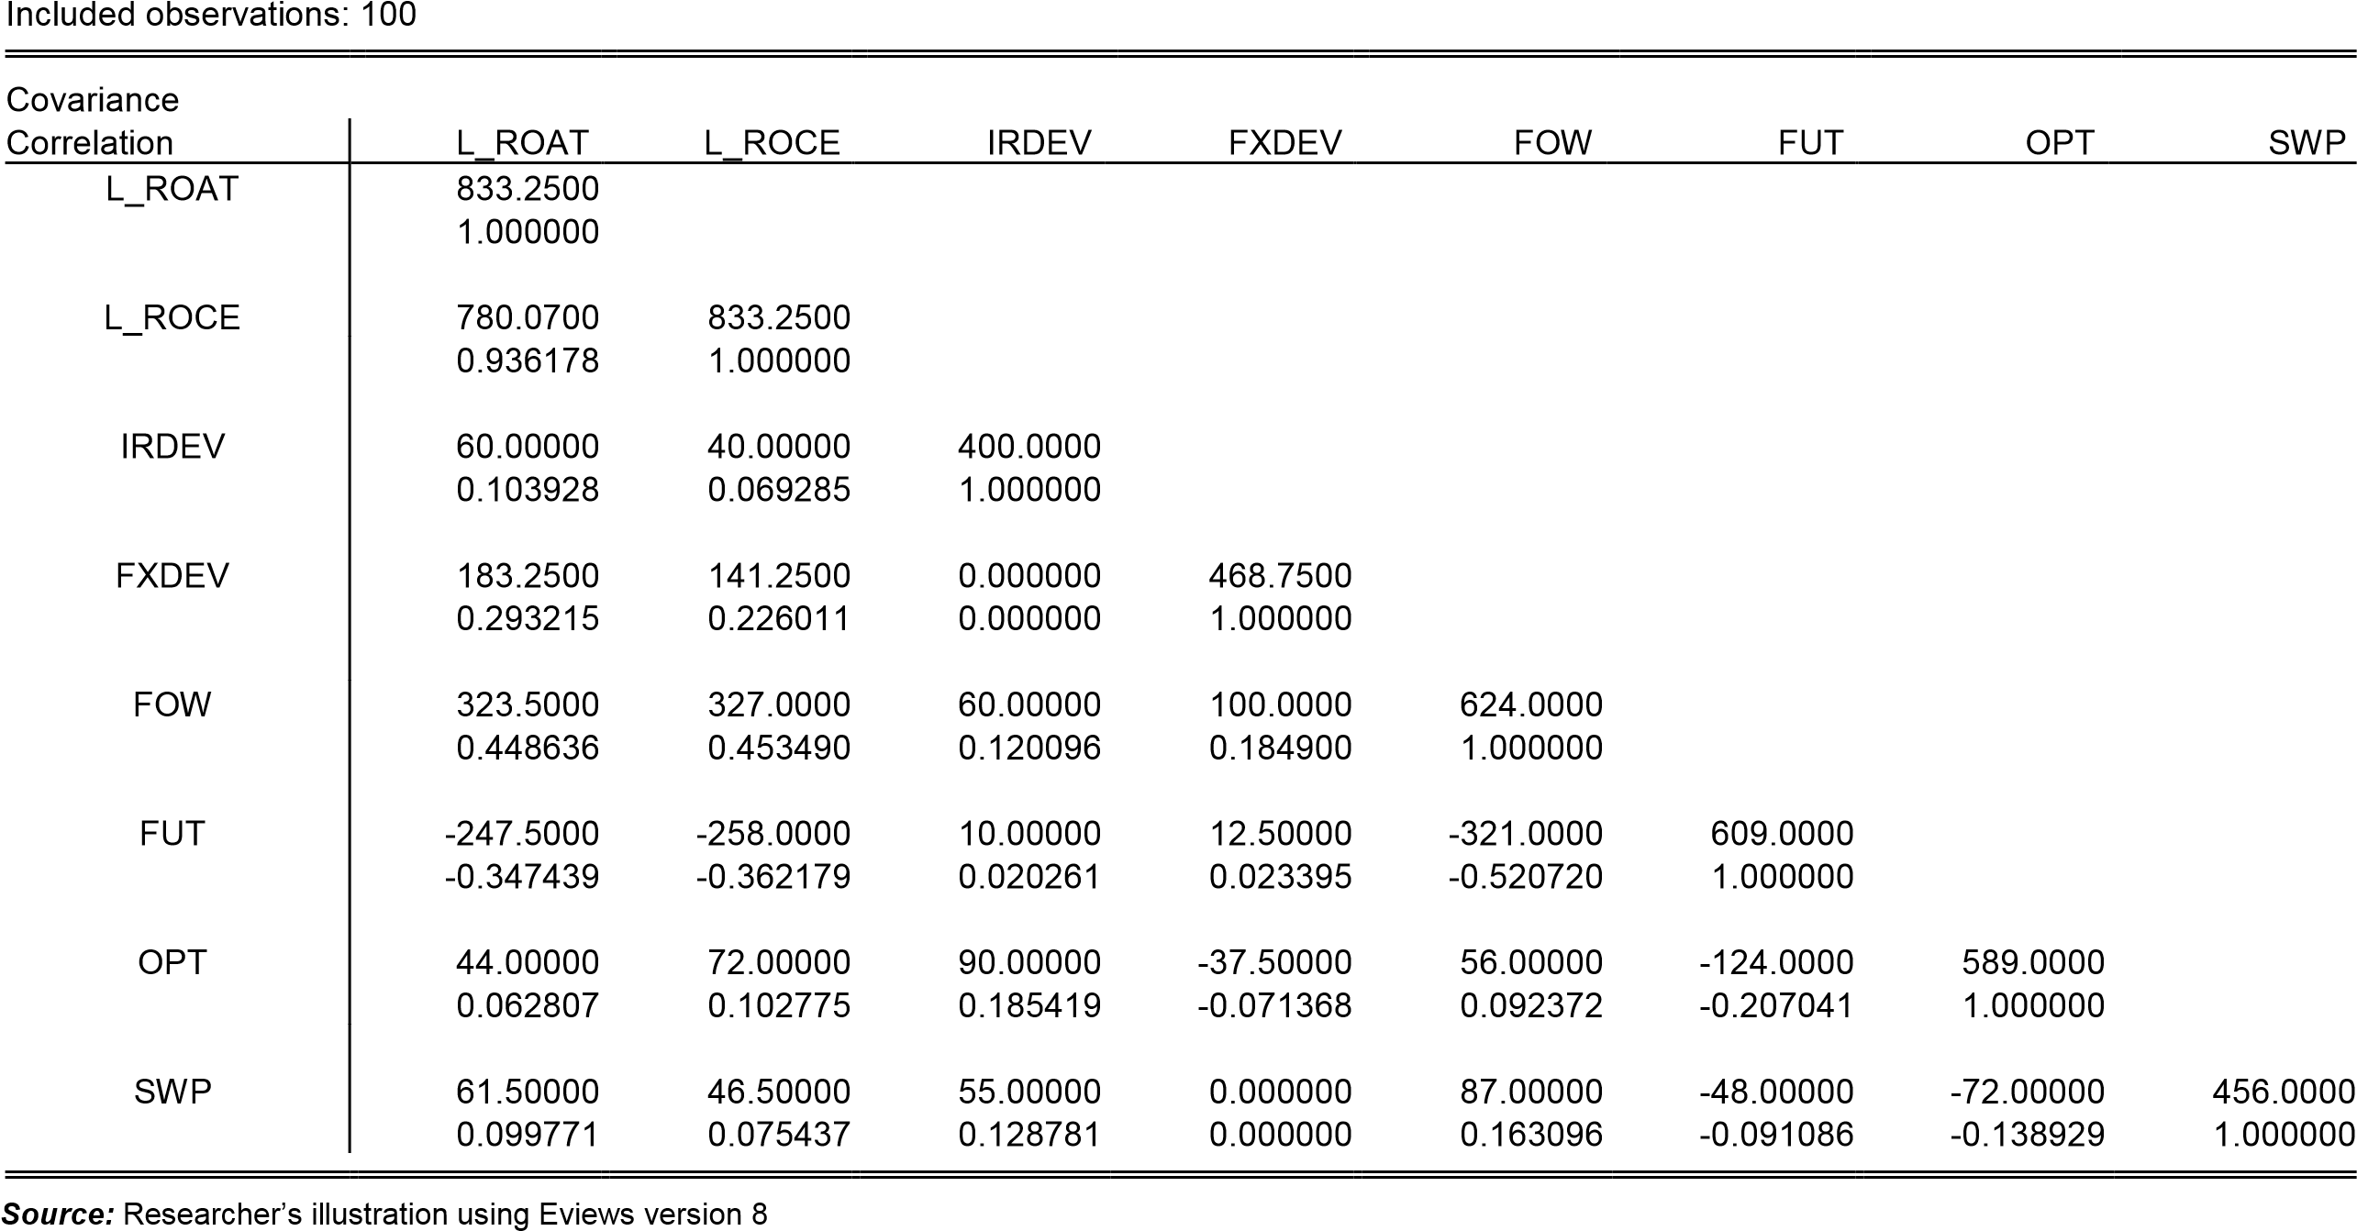

Figure 4.6: Correlation and covariance matrix of the control variables
Covariance Analysis: Spearman rank-order Date: 07/19/15 Time: 02:51
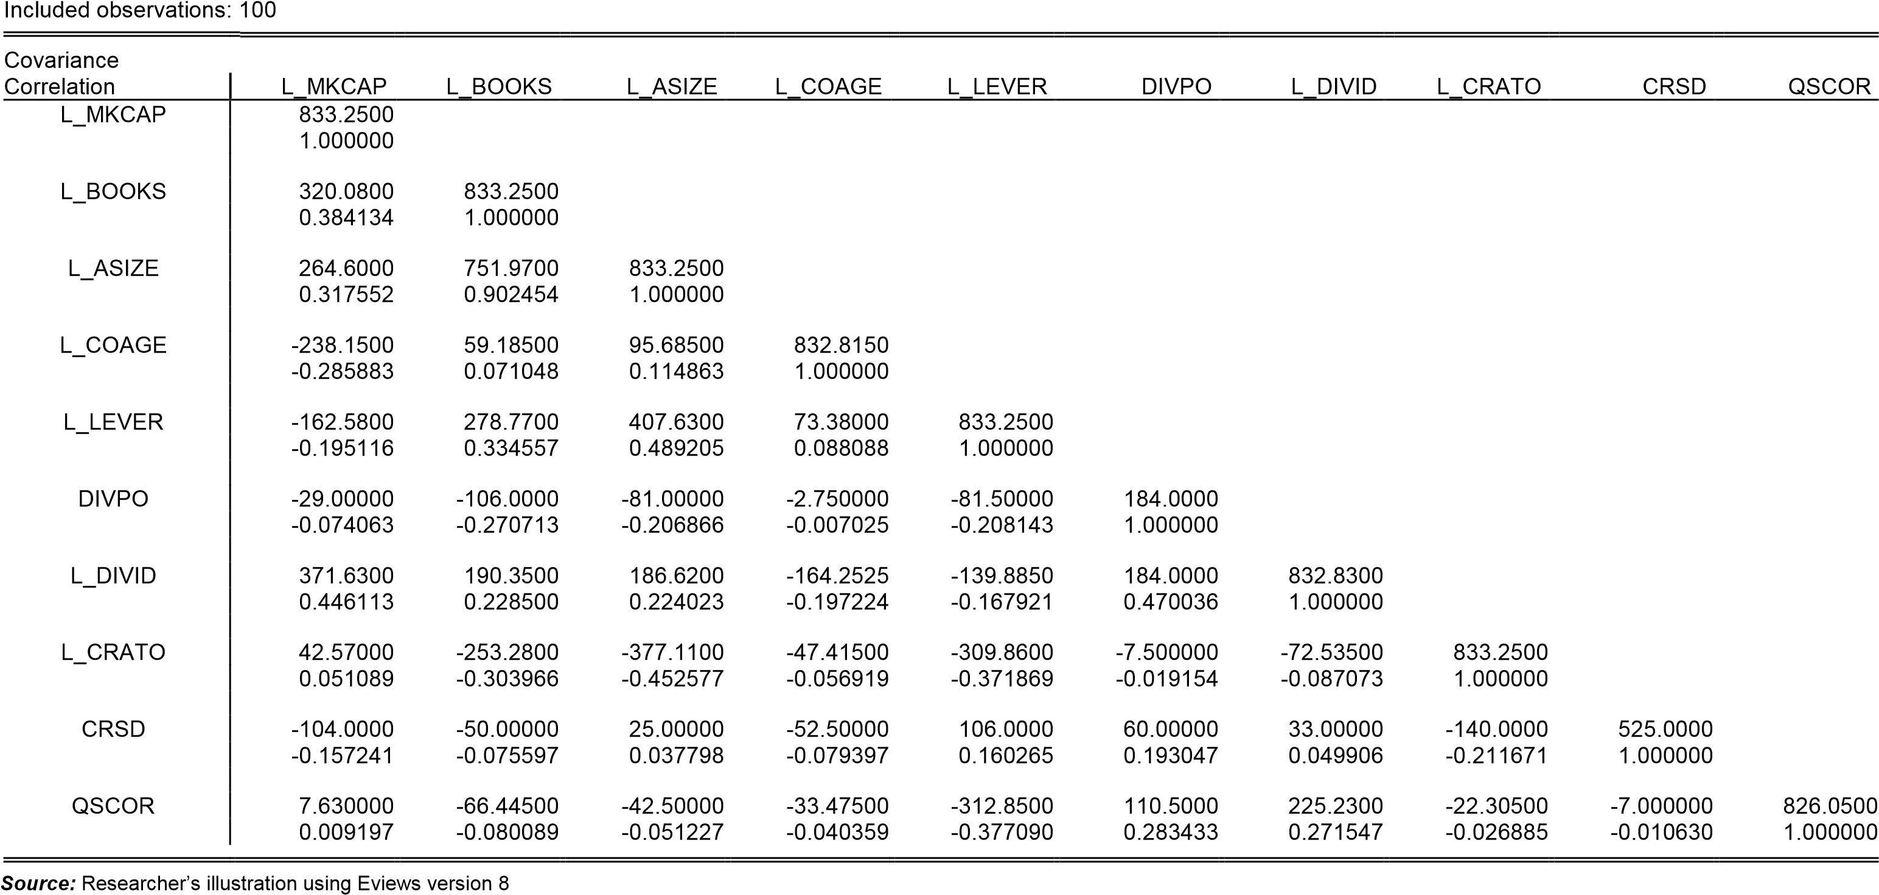
Sample: 2005 2014

FIGURES

Figure 2.2: Growth in number of futures contracts outstanding (Mar. 93—15)
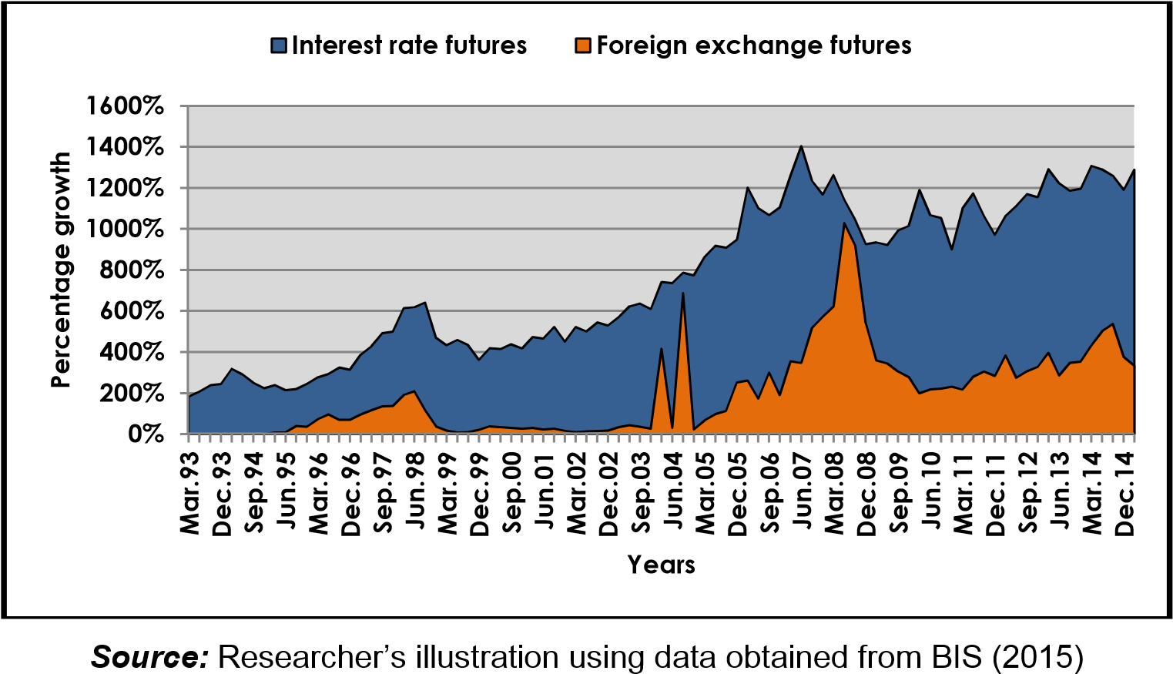
Figure 2.3: Growth in number of options contracts outstanding (Mar. 93—15)
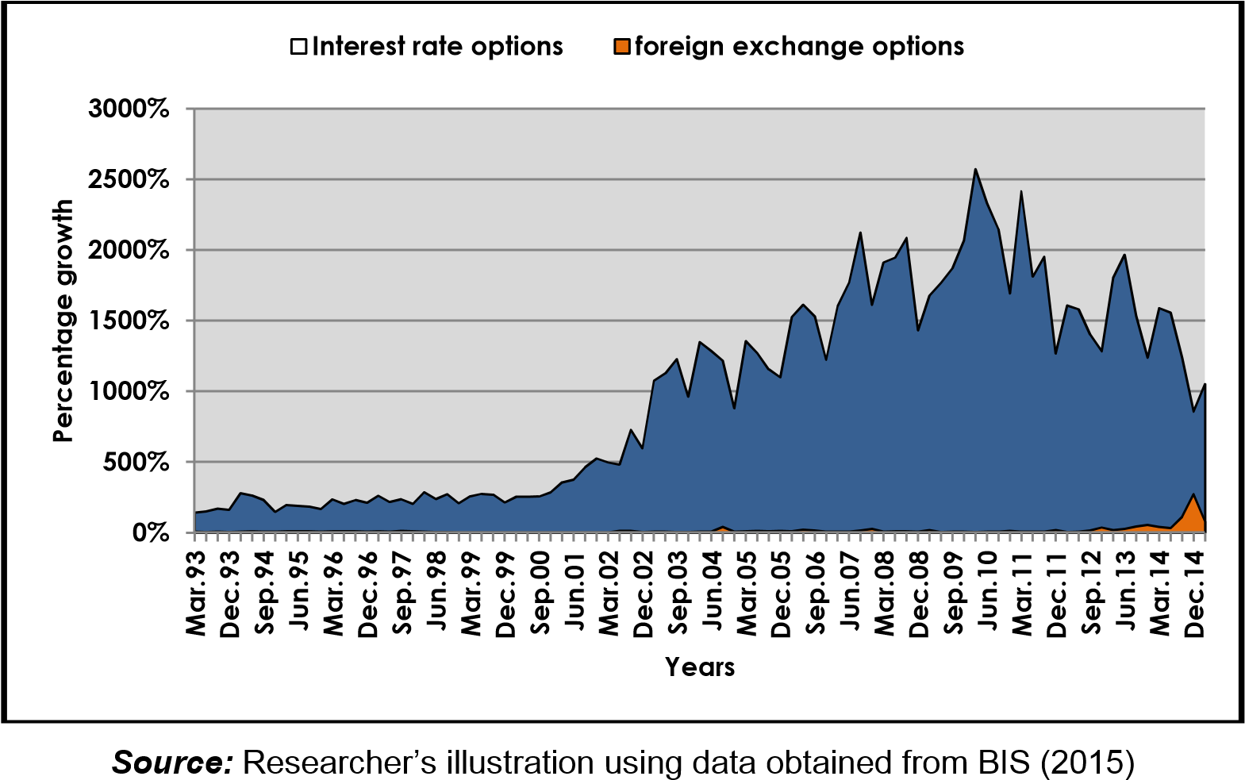

Statistics of The LSEDM
Since the beginning of the year, there have been some significant trends in the trades of futures and options contract on the LSEDM. Lack of data prevented the analysis of forwards and swaps.
Figure 2.4: Monthly Futures and Options contracts traded (2015 YTD)
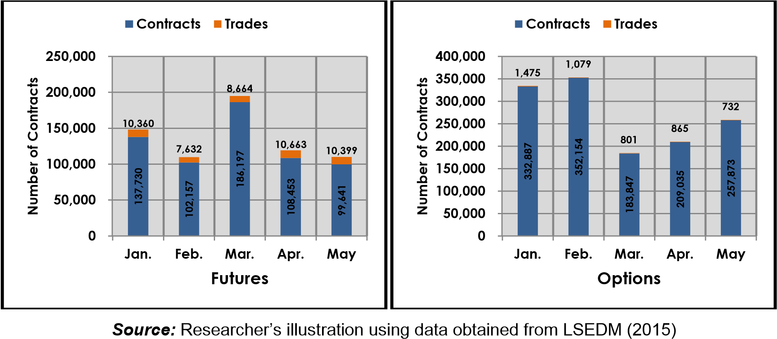
As shown in Figure 2.2 above, total futures contracts traded across the months of January to May are 137,730, 102,157, 186,197, 108,453 and 99,641 respectively, while that of options were 332,887, 352,154, 183,847, 209,035 and 257,873 respectively. The average growth rates of futures was 1.31%, while that of options was -0.99% which implies that options contracts trades fell overall since January by approximately 1%.
Figure 2.5: Total Derivatives traded (2015 YTD) vs. Historical trends in trades
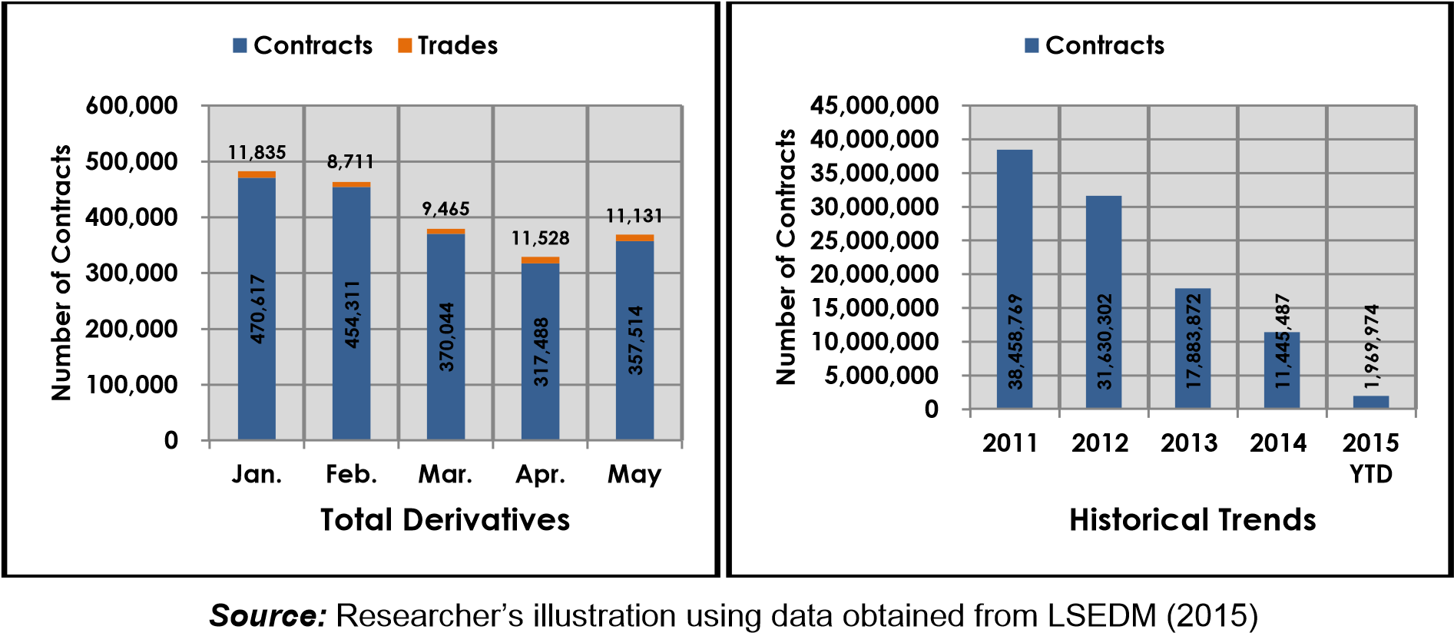
Total contracts to date have also fallen by almost 5%. This is as a result of a decline in trades across January to May of 470,617, 454,311, 370,044, 317,488 and 357,514 respectively. When the historical data is analysed however, total contracts traded has had a steep fall since 2011, with an overall average growth of -36%.
Figure 4.1: ROAT and ROCE of financial and nonfinancial firms
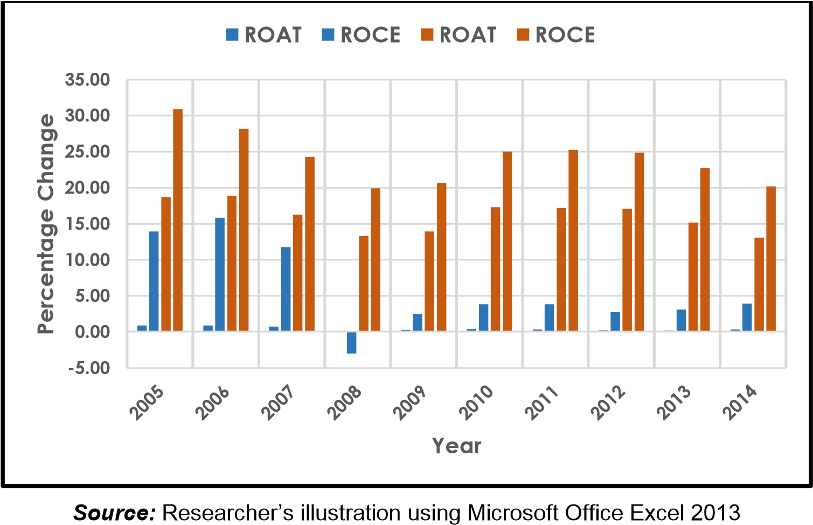

Figure 4.2: Total Derivative use of financial and nonfinancial firms
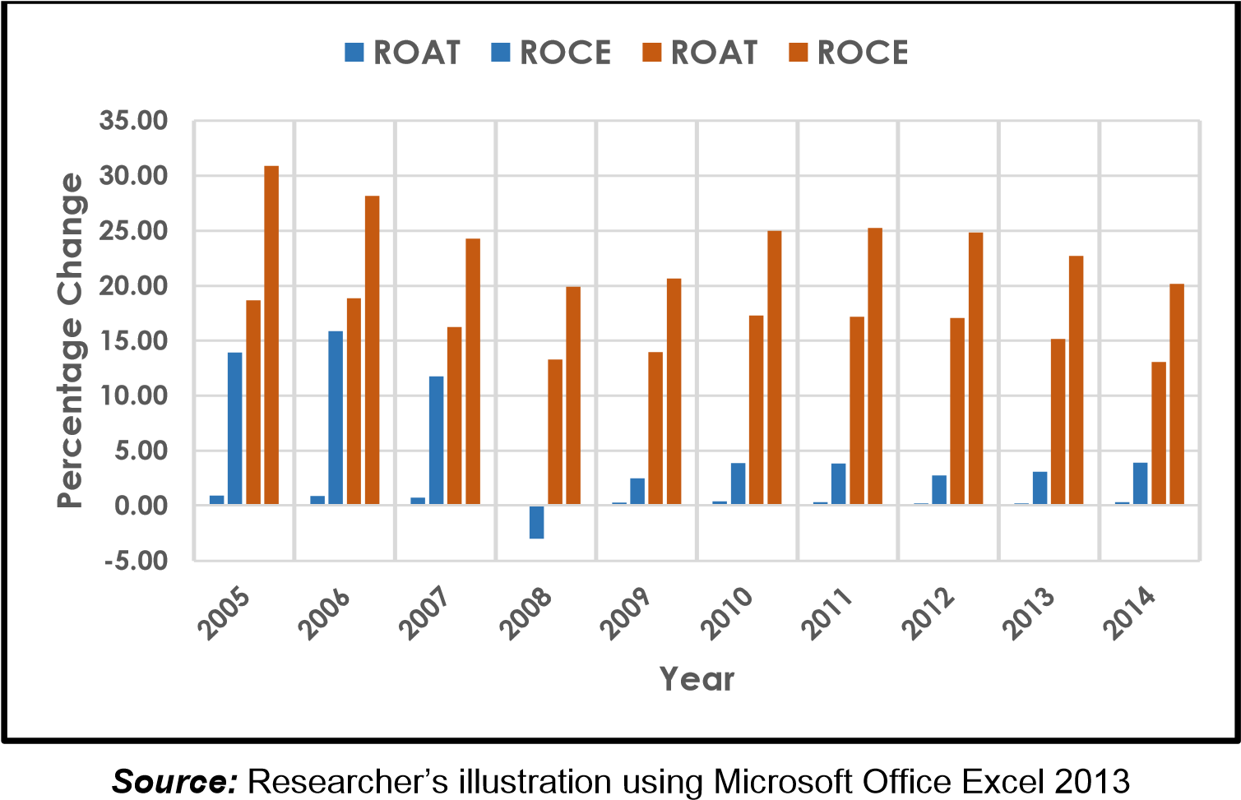
Figure 4.3: Individual Derivative use of financial and nonfinancial firms
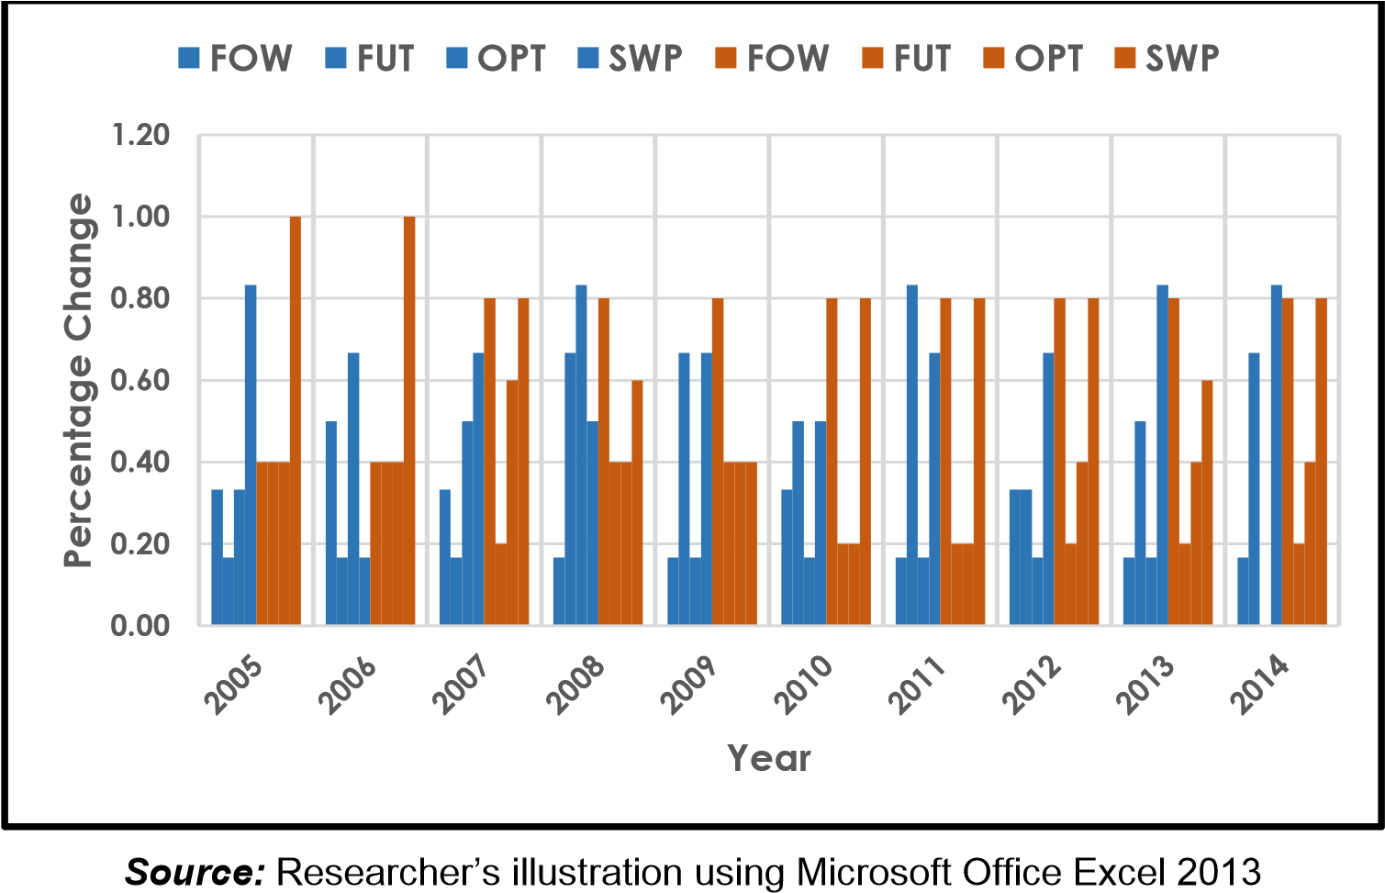

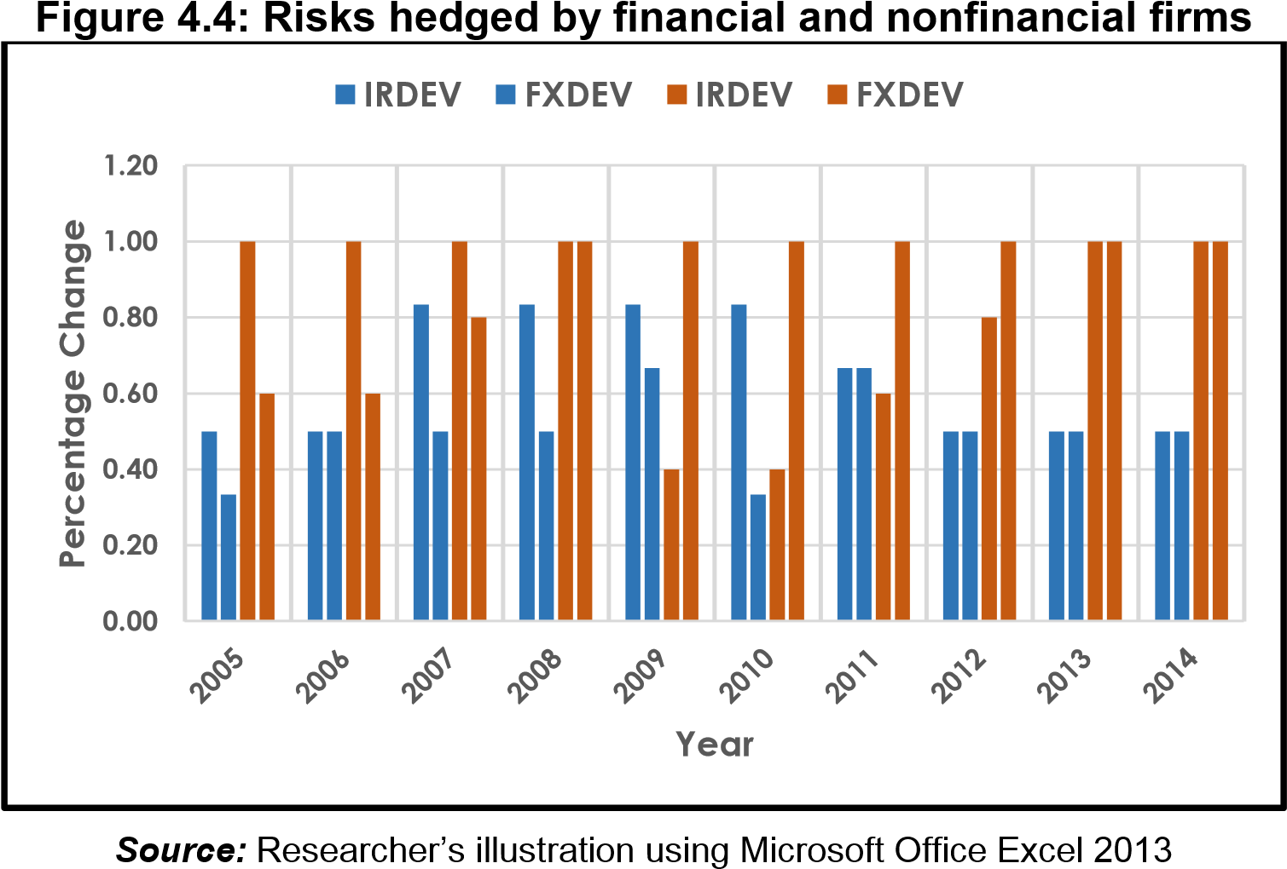

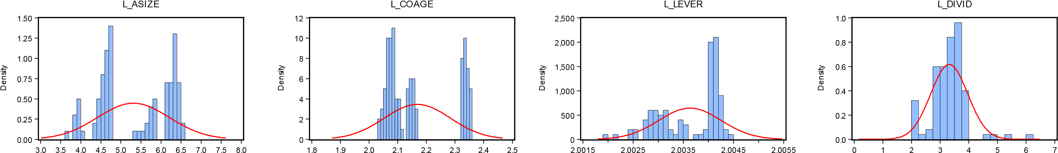
Figure 4.5: Normality distribution graphs of the variables
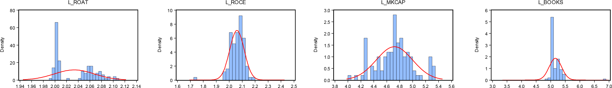
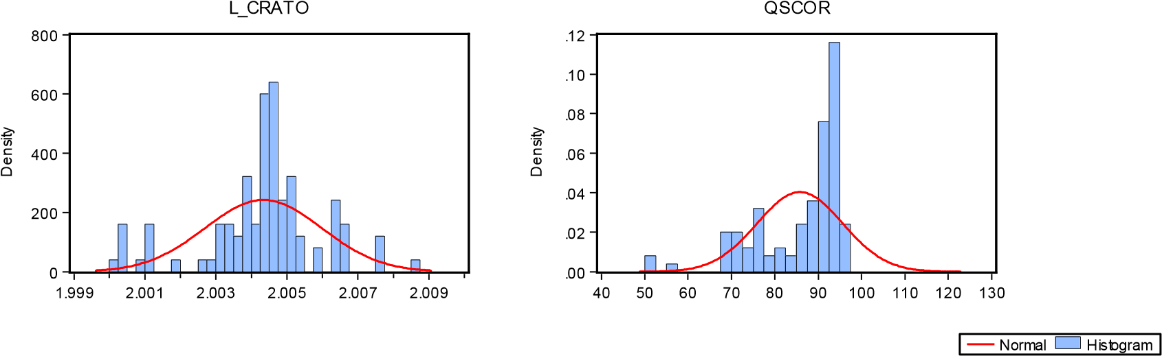
Source: Researcher’s illustration using Eviews (version, 8)

The first agreement of 7years labour entered by Jacob with Laban to marry Rachel was described as an ‘Options contract’ in Chance (1995) which is a type of derivative in financial risk management. For clarity and simplicity, more explanations of the different types of derivatives is left to other parts of this chapter.
The second definition of the word “hedge” referring to ‘hedging against something’, is defined in the Oxford Advanced Learner’s Dictionary (2015) online as a way to protect oneself from making a loss especially relating to money.
The CBOE and CME merged in the fall of 2006 which marked an end in their competition and an important point in history for the financial derivatives market (Chance, 2008:13)
Speculation creates risk which increases profit-making potential, while hedging aims to reduce already existing risk.
See Footnote 12.
The order of the theories listed in this section has been especially curled from this cited study.
The efficient market hypothesis (EMH) states that all prices of securities are intrinsic or fair as long as the same information is available to everyone.
A free and fair market economy with perfect competition, without the regulation or interference of Government.
A credit default swap (CDS) is a synthetic product and also serves as a hedging instrument to protect against the risk of default of a financial asset. In this context, CDS contracts are mainly used for credit risk management which is beyond the scope of this study.
Judge’s (2006), description of his binary measure of hedging is slightly similar to that of dummy variables in that a value of 1 is assigned to companies that hedge and 0 for companies that did not.
In Eshna’s (2015) sub-categorisation of Market risk to absolute, relative, directional, non-directional, basis and volatility risks; she explained that ‘directional risk’ is caused due to movement in stock prices and interest rates, while ‘non-directional risk’ concerns volatility. In an attempt to merge this understanding with World Finance’s (2015) description, interest rate, foreign exchange rate and commodity price risk can be classed as directional risk. But however, in Wallace (2008) a sub-categorisation of market risk is classed to be foreign exchange, interest rate, commodity, equity and inflation.
This is why derivative contracts are regarded as ‘zero-sum games’ because the gain of one party results in the loss of another (Flashcard Machine, 2010).
OTC markets are financial markets that do not exist in a physical location like an organised exchange or capital market, and are usually less regulated than organised exchanges (Chui, 2012). Trades in OTC markets are mainly done through telephone and other communication media over computer networks.
Basis risk is “the market risk mismatch between a position of a risk instrument and the underlying asset in which its value is derivedD” (Benhamou, undated); or the difference between the spot and futures price of a commodity (Hull, 2009:766). In the context of commodities price risk management, basis risk arise when there is a difference between the commodity’s price and the derivative instrument used for hedging. When there is a daily movement of these prices, the basis risk can be quite substantial upon maturity of the contract. There are ways of hedging this risk itself, but is beyond the scope of the study.
Derivatives statistics from data of the BIS and LSEDM are illustrated in Figures 2.2—2.5 in the Appendix.

