CORRELATION OF EVAPOTRANSPIRATION WITH CLIMATIC PARAMETERS IN SOME SELECTED CITIES IN NIGERIA
Isikwue, B. C.,¹ Audu, M. O.² and Eweh, E. J.³
Physics Department, Federal University of Agriculture Makurdi, Nigeria
Email of corresponding author: bcisikwue@gmail.com
ABSTRACT
Reference evapotranspiration (ETo) is an important agro-meteorological parameter for climatological and hydrological studies, as well as for irrigation planning and management. It is a climatic parameter and can be computed from weather data. This work evaluated the correlation of ETo with climatic parameters for Ibadan, Sokoto and Kano; in order to assess their effect on ETo since the rate of ETo depend on the available climatic parameters. The climatic data used were obtained from International Institute of Tropical Agriculture, Ibadan (1977-2010). The ETo was estimated using the FAO-56 Penman-Monteith Method. The results show that solar radiation, sunshine hour, air temperature, wind speed and clearness index were positively correlated with ETo while relative humidity and cloudiness were negatively correlated. The correlation coefficients obtained ranged from 0.538 – 0.871, 0.164 – 0.953 and 0.031 – 0.994 for Ibadan, Sokoto and Kano respectively. The result also shows that the correlation of each parameters with ETo depend on the pravailing climatic condition of the location. This work has shown the degree of the relationship between ETo and climatic parameter, which depend on the prevailing climatic conditions of the study area. The results obtained can help agriculturists and engineers for effective irrigation planning and management. The results obtained were compared with that of other researchers.

Key words: climatic parameter, correlation, climatic condition, evapotranspiration, Nigeria

- INTRODUCTION
Evapotranspiration (ET) is the combination of two separate processes (i.e. evaporation and transpiration) by which water is lost from the soil surface by evaporation and from the crop by transpiration. The evaporation power of the atmosphere is expressed by the reference crop evapotranspiration (ETo), which represents the evapotranspiration from a standardized vegetated surface. The concept of the ETo was introduced to study the evaporative demand of the atmosphere independent of crop type, crop development and management practices. ETo is important for understanding regional water balance, irrigation requirements, atmospheric boundary layer stability and weather forecasting. It is difficult to measure ETo directly, so in most applications ETo is estimated using models (Gad and El-Gayar, 2010a).

Evaporation and transpiration are affected by weather parameters, crop characteristics, management and environmental conditions. The major factors affecting ETo are climatic parameters. Consequently, ETo is a climatic parameter and can be computed from weather data. The principal weather parameters affecting evapotranspiration are solar radiation, air temperature, humidity and wind speed (Isikwue et al., 2014). Hence, the main objective of this research is to evaluate the correlation of ETo with climatic parameters, in order to assess their effect on ETo; since the rate of ETo depend on the available climatic parameters.

Many analytical and empirical equations are currently used to estimate reference evapotranspiration (ETo) involving one or more climatic data. The Food and Agricultural Organization (FAO) Penman-Monteith method is recommended as the sole standard method (Allen et al., 1998). Several researchers have used the FAO Penman-Monteith Method to estimate evapotranspiration (Buttafuoco et al., 2010; McVicar et al., 2007; Ram and Anju 2012).

Many scientists have attempted to establish the relationship between evaporation and evapotranspiration with weather parameters and have shown that weather parameters may have positive or negative correlation with evapotranspiration and can significantly influence it depending on the climatic conditions of the location (Singh et al., 1992a; and 1995b; Shrivastava et al., 2001; Khanikar and Nath, 1998). Singh et al., (1992) observed that wind speed, sunshine hours, mean air temperature and solar radiation were positively correlated with evaporation, while relative humidity was negatively correlated with evaporation. The highest correlation value (r = 0.78) was obtained with relative humidity. Also, El-Bably (2003), reviewed that air temperature, sunshine hours and solar radiation had strong and positive correlation with evapotranspiration, but relative humidity and cloudiness were negatively correlated. While Khanikar and Nath, (1998) noted that the coefficient of determination for maximum temperature (0.64), minimum temperature (0.65), wind speed (0.53) and soil temperature at 5 cm depth (0.68) were positively correlated.

The effect of climatic parameters on evapotranspiration has also been studied by Ram and Anju, (2012); Mamassis et al., (2014); Gad and El-Gayar, (2010a); and (2010b). However, none of these works has assessed the correlation of ETo with climatic parameters over the location considered in this work. Hence, in this work, these cities were chosen because of their peculiar climatic and atmospheric conditions which may influence the rate of evapotranspiration in the areas. Also, this research work is limited to these cities due to non availability of data for other areas. Table 1 gives the study areas and their respective climatic zones.

- SOURCES OF DATA AND METHOD OF ANALYSIS
The maximum and minimum temperature, maximum and minimum relative humidity, sunshine hour, solar radiation and wind speed data used in this work were obtained from the International Institute of Tropical Agriculture, Ibadan. The data spanned for 34 years (1977 – 2010). The model for shortwave solar energy balancing at the edge of the Earth’s atmosphere by Babatunde (2003), was adapted in computing the cloudiness and clearness index, while the ETo was evaluated using the guidelines and equations for computing ETo as recommended by the FAO-56 paper (Allen et al., 1998). Hence, the daily average reference evapotranspiration (ETo) is given in (mm/day) as,
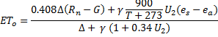 (1)
Where:
𝐸𝑇_{𝑜} - reference evapotranspiration (mmday⁻¹), 𝑅_{𝑛} - net radiation at the crop surface (MJm⁻²day⁻¹), 𝐺 - soil heat flux (MJm⁻²day⁻¹), T- mean daily air temperature at 2 m height (°C), 𝑈₂ - wind speed at 2 m height (ms⁻¹), 𝑒_{𝑠} - saturated vapour pressure (kPa), 𝑒_{𝑎} - actual vapour pressure (kPa),
𝑒_{𝑠}−𝑒_{𝑎} - saturated vapour pressure deficit (kPa), Δ - slope of vapour pressure curve (kPa) and
𝛾 - psychrometric constant (kPa °C⁻¹).
The mean saturated vapour pressure derived from air temperature is given by (Allen et al., 1998) as:
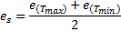 (2)
where
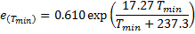 (3a)
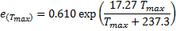 (3b)
The actual vapour pressure derived from relative humidity was computed using the expression:
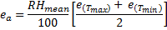 (4)
The slope of saturated vapour pressure curve was calculated using the relation:
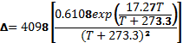 (5)
The psychrometric constant is related to the atmospheric pressure P as:
(6)
Where
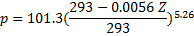 (7)
Z is the station elevation above sea level.
The net radiation, 𝑅_{𝑛} was computed using equation (8):
(8)
and are the net shortwave and net longwave radiation calculated according to the FAO Irrigation and Drainage paper No 56 (Allen et al., 1998). The wind speed data obtained from meteorological state measured at 10 m was converted to the 2 m required for agrometeorology according to (Allen et al., 1998).

Finally, ETo was computed by substituting the values of 𝑒_{𝑠}, 𝑒_{𝑎}, Δ, 𝛾, and 𝑅_{𝑛} calculated from equations (2), (4), (5), (6) and (8) respectively and the values of the mean temperature, T and the converted values of wind speed, 𝑈₂ into equation (1).

- RESULTS
Figures 1-3 present the correlation of wind speed, sunshine hour, air temperature, solar radiation, relative humidity, clearness index and cloudiness, with ETo from 1977-2010 in Ibadan, Sokoto and Kano respectively. The statistical relationships between these parameters and ETo in the study areas are shown in Table 2. According to Brown (2000), correlation coefficient, r and coefficient of determination, R² are related by $r=\sqrt{R^{2}}$ and a correlation greater than 0.8 is generally described as strong, whereas a correlation less than 0.5 is generally described as weak. Also, the correlation may be positive or negative, implying that the relationship between two variables may be direct or inverse. This is the bases of the discussion in this work.

- DISCUSSION

Figure 1 presents the correlation of wind speed, sunshine hour, air temperature, solar radiation, relative humidity, clearness index and cloudiness with ETo in Ibadan, Nigeria. It could be observed that ETo has a very strong correlation with all the parameters considered, with a correlation coefficient (r) greater than 0.5 as shown in Table 2 (Brown, 2000). However, relative humidity and cloudiness were strongly but negatively correlated with ETo with the correlation coefficents of -0.871 and -0.591 respectively. This negative correlations depict that both relative humidity and cloudiness have direct inverse relationships with ETo. This may probably be due to the influence of the warm tropical-maritime air mass (which originates from the Atlantic Ocean) on the climate of Ibadan; making it to be cool, cloudy and humid, because of its location in the Tropical rain forest (Ekpoh and Ekpenyong, 2011).
The correlation of wind speed, sunshine hour, air temperature, solar radiation, relative humidity, clearness index and cloudiness with ETo in Sokoto is shown in Figure 2. Air temperature, solar radiation, and clearness index were positively and highly correlated with ETo. However, wind speed and sunshine hour were also positively but weakly correlated, while relative humidity and cloudiness were negatively but strongly correlated. The relative contribution of relative humidity, clearness index, cloudiness, air temperature, solar radiation, sunshine hour and wind speed to ETo ranged from 24.88% and 4.28% (Table 2).
From Figure 3, it could be obsered that The correlation coefficients of relative humidity, clearness index, cloudiness, sunshine hour, air temperature, solar radiation, and wind speed to ETo in the period under study in Kano were 0.994, 0.818, 0.818, 0.678, 0.632, 0.374, and 0.031 respectively. This shows that sunshine hour, air temperature, and clearness index were positively and highly correlated with ETo, wind speed and solar radiation were also positively but weakly correlated, while relative humidity and cloudiness were negatively but strongly correlated.

From the foregoing, it is interesting to note that solar radiation, sunshine hour, air temperature, wind speed and clearness index were positively correlated with ETo. This implies that the rate of ETo depend directly on these parameters. On the other hand, relative humidity and cloudiness were negatively correlated with ETo, meaning that they are inversely related to ETo. This is because the rate of ETo is low when it is cool, cloudy and humid while high ETo is obtained when it is hot, sunny and dry. It is interesting to note that the correlation of each parameters to ETo depend on the influence of the dry, dusty, tropical-continental air mass (which originates from the Sahara region), and the warm, tropical-maritime air mass (which originates from the Atlantic Ocean) that prevail in the study areas (Ekpoh and Ekpenyong, 2011). The results obtained from this work are in agreement with that obtained by Singh et al. (1992); El-Bably (2003); and Khanikar and Nath (1998).

- CONCLUSION
From this research, the following conclusions could be drawn:
- All the parameters considered in Ibadan were strongly and positively correlated with ETo except relative humidity and cloudiness which were negatively correlated with ETo.
- In Sokoto, air temperature, solar radiation, clearness index were positively and highly correlated with ETo, wind speed and sunshine hour were also positively but weakly correlated while relative humidity and cloudiness were negatively but strongly correlated.
- The correlation coefficients of relative humidity, clearness index, cloudiness, sunshine hour, air temperature, solar radiation, and wind speed to ETo in the period under study in Kano were 0.994, 0.818, 0.818, 0.678, 0.632, 0.374, and 0.031 respectively.
- Among the parameters considered, only relative humidity and cloudiness were negatively correlated with ETo in all the cities considered.
- The highest correlation of sunshine hour, relative humidity, clearness index, and cloudiness with ETo and the lowest correlation of wind speed and solar radiation with ETo were observed in Kano. This may be due to the influence of the dry, dusty, tropical-continental air mass (which originates from the Sahara region), on the climate of Kano.
- The lowest correlation of air temperature and sunshine hour were recorded in Sokoto due to its location in the semi-arid region of the country.
- The highest correlation of wind speed, air temperature and solar radiation and the lowest correlation of relative humidity, clearness index, and cloudiness with ETo were observed in Ibadan. This may be due to the influence of the warm, tropical-maritime air mass, on the climate of Ibadan, because of it location in the tropical rain forest.
- The necessary information about the degree of the relationship between ETo and climatic parameters have been given in this work.

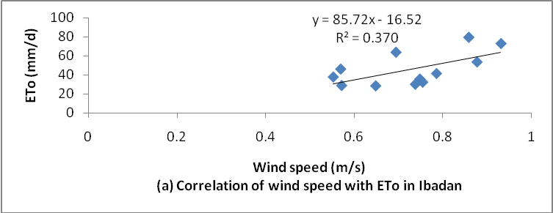
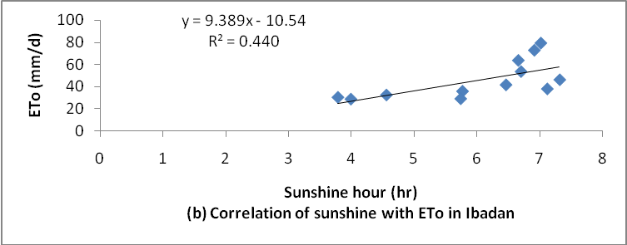
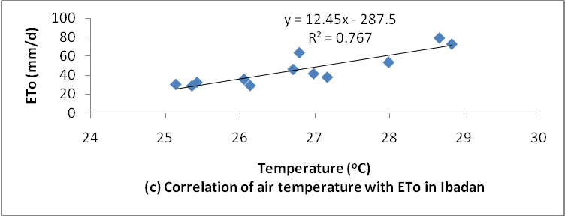
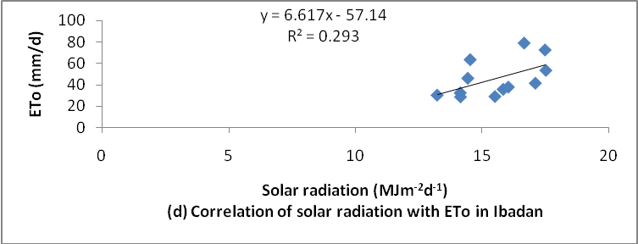
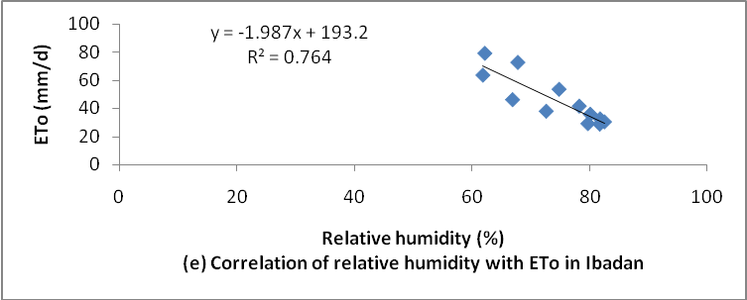
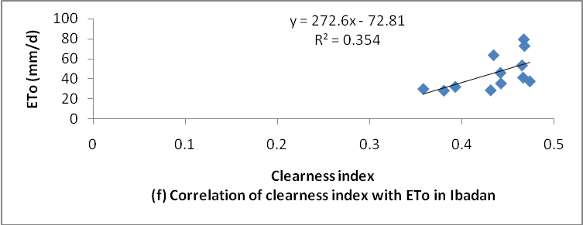
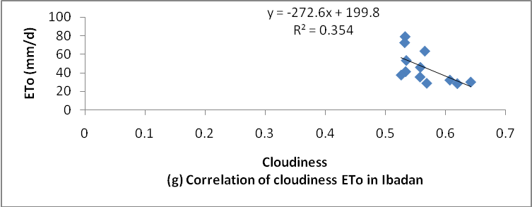
Figure 1: Correlation of daily mean monthly climatic parameters with ETo in Ibadan, Nigeria (1977-2010)
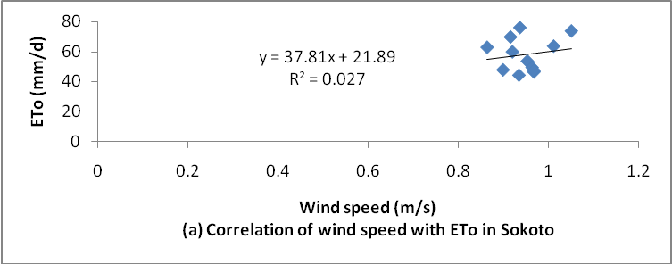
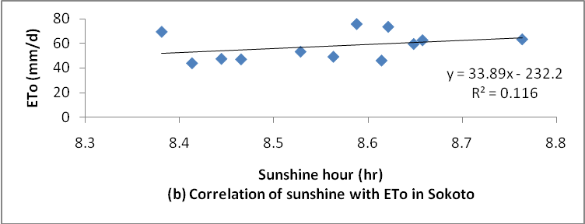
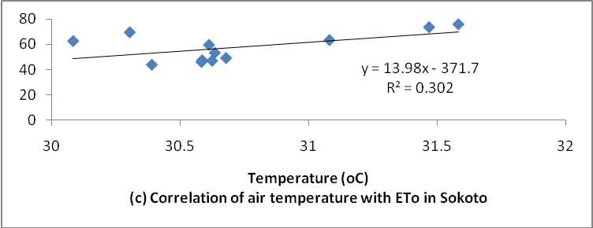
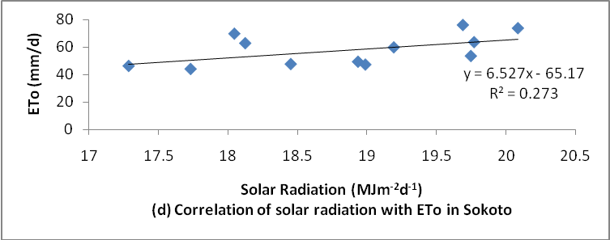
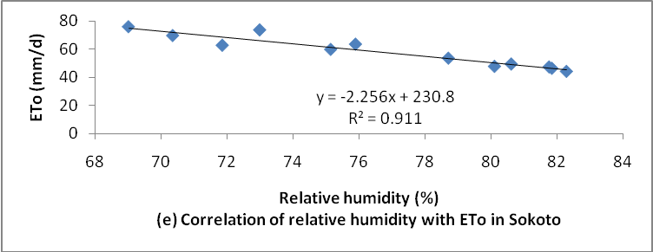
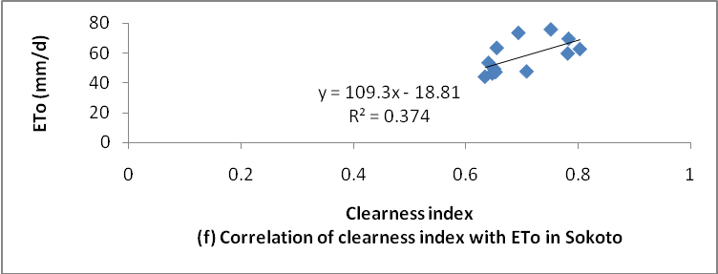
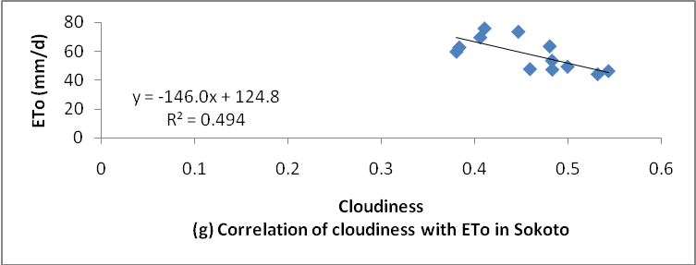
Figure 2: Correlation of daily mean monthly climatic parameters with ETo in Sokoto, Nigeria (1977-2010)
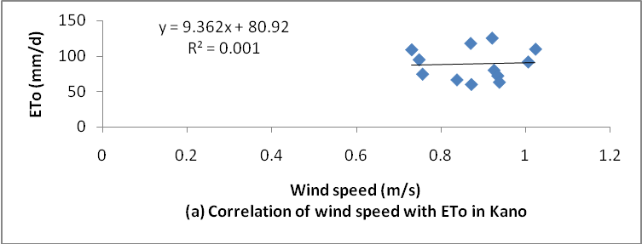
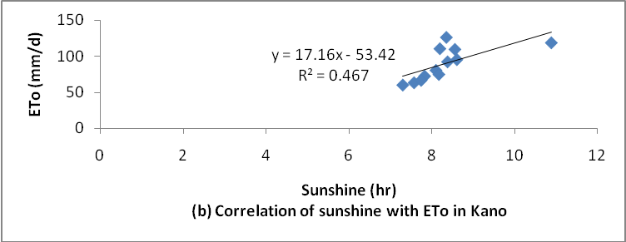
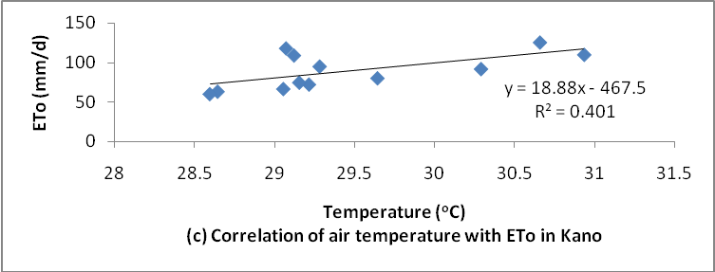
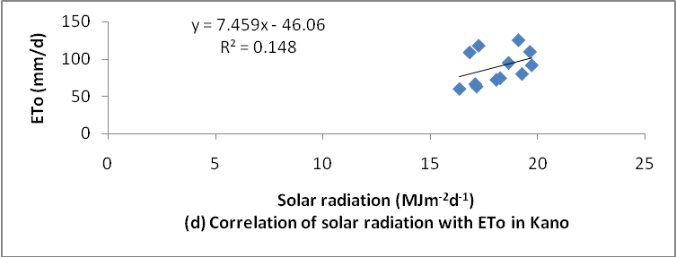
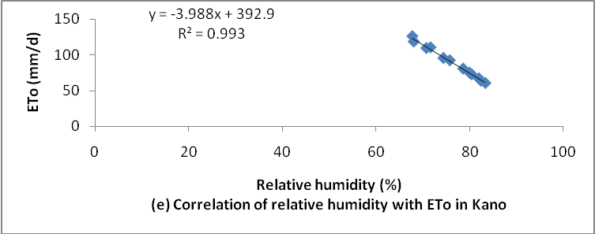
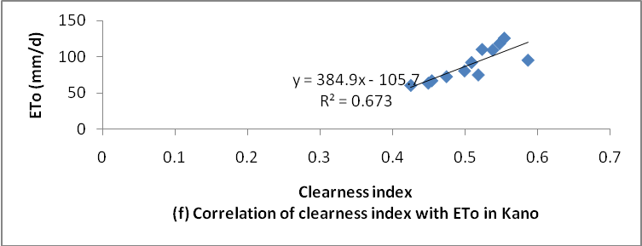
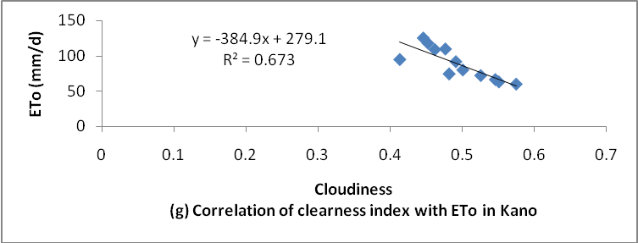
Figure 3: Correlation of daily mean monthly climatic parameters with ETo in Kano, Nigeria (1977-2010)

Table 1: Characteristics feature of the selected cities
Location | Climatic Zone | Latitude | Longitude | Altitude
Ibadan | Tropical rain forest | 7.38⁰ N | 3.92⁰ E | 287 m
Sokoto | Sudan Savannah | 13.08⁰N | 5.23⁰ E | 263 m
Kano | Sahel Savannah | 12⁰ N | 8.3⁰ E | 472 m

Table 2: Statistical relationships between the atmospheric parameters and ETo in the study areas (1977-2010)
Climatic parameters | Ibadan |  | Sokoto |  | Kano
 | Correlation coefficient (r) | RC (%) | Correlation coefficient (r) | RC (%) | Correlation coefficient (r) | RC (%)
Wind speed | 0.608 | 12.85 | 0.164 | 4.28 | 0.031 | 0.71
Sunshine hour | 0.663 | 14.01 | 0.340 | 8.87 | 0.678 | 15.60
Mean air Temperature | 0.871 | 18.40 | 0.547 | 14.28 | 0.632 | 14.54
Solar radiation | 0.538 | 11.37 | 0.519 | 13.55 | 0.374 | 8.61
Relative humidity | - 0.871 | 18.40 | 0.953 | 24.88 | 0.994 | 22.88
Clearness index | 0.591 | 12.49 | 0.700 | 18.27 | 0.818 | 18.83
Cloudiness | - 0.591 | 12.49 | 0.608 | 15.87 | 0.818 | 18.83
Total | 4.733 | 100.00 | 3.831 | 100.00 | 4.345 | 100.00

REFERENCES
Allen, G.R., Walter, I.A., Elliot, R.L. Howell, T.A. Itenfizu, D. Jensen, M.E.; and Snyder, R.L (2005). The ASCE standarized reference evapotranspiration equation. Comittee of standarization of reference evapotranspiration of the enviromental and Water Resources Institute of the American Society of Civil Engineers.

Allen, G.R., Pereira, Raes, S.L.D. and Smith. M. (1998). Crop evapotranspiration: Guidelines for computing crop water requirements. Food and Agricultural Organization of the United Nations (FAO). Publication No. 56. Rome. 300 pp.

Babatunde, E.B. (2003). Some Solar Radiation ratios and their Interpretations with regards to Radiation Transfer in the Atmosphere. Nig. J. of Pure and Appl.Sc. In press. 4, 139-145.

Brown, A.M. (2000). A step-by-step guide to non-linear regression analysis of experimental data using a Microsoft Excel spreadsheet. Computer Methods and Programs in Biomedicine 65 (2001) 191–200.

Ekpoh, I. J. and Ekpenyong, N. (2011). The Effects of Recent Climatic Variations on Water Yield in the Sokoto Region of Northern Nigeria. International Journal of Business and Social Science 2 (7): 251-256.

El Bably, A. Z. (2003). Estimati on of evapotran spi rati on u si n g stati sti cal model . In: Camarda, D. (ed.), Grassin, I. L. (Ed.). Local resources and global trades: Environments and agriculture in the Mediterranean region. Bari: CIHEAM. 441-449

Gad, H. E. and El-Gayar, S. M. (2010a): Effect of solar radiation on the crops evapotranspiration in Egypt. Fourteenth International Water Technology Conference, IWTC, Cairo, Egypt. 769-783.

Gad, H. E. and El-Gayar, S. M. (2010b): Climate parameters used to evaluate the evapotranspiration in Delta Central Zone of Egypt. Fourteenth International Water Technology Conference, IWTC14 2010 Cairo, Egypt.

Isikwue, C. Bernadette, Audu, O. Moses, and Isikwue, O. Martin (2014). Evaluation of Evapotranspiration using FAO Penman-Monteith Method in Kano Nigeria. International Journal of Science and Technology, 3(11): 698-703.

Khanikar P.G. and Nath, K.K (1998). Relationship of open pan evaporation rate with some important meteorological parameters. J. Agril. Sci. Soc. N - E India, 11(1):46-50.

Mamassis N., Panagoulia D. and Novkovic A. (2014), Sensitivity analysis of Penman evaporation method, Global NEST Journal, 16(4), 628-639.

Ram, K. S and Anju, B. (2012). Monitoring of Evapo-transpiration in Major Districts of Haryana Using Penman Monteith Method. International Journal of Engineering Science and Technology, 4(7): 3419-3433.
Singh, R; Bishnoi, O.P. and Ram, N. (1992). Relationship between evaporation from class ‘A’ open pan evaporimeter and meteorological parameters at Hisar. Haryana Agri. Univ. J. Res. 22(2):97-98.
Singh, R; Prakash, O; Khicher, M.L, Singh, R. and Prakash, O. (1995b). Estimation of evaporation from different meteorological parameters. Ann. Arid-Zone, 34(4):263-265.

Shrivastava, S.K; Sahu, A.K; Dewangan, K.N; Mishra, S.K; Upadhyay, A.P. and Dubey, A.K (2001). Estimating pan evaporation from meteorological data for Jabalpur. Ind. J. Soil Cons. 29(3):224-228.

