Cosmic Theories and Greenhouse Gases as Explanations of Global Warming

Antero Ollila

Abstract
According to the IPCC’s simplest model based on the anthropogenic driving forcing factors, the temperature increase up to 2011 from 1750 is 1.15 °C, which is 35 % greater than the observed temperature 0.85 °C. In this study two other models have been analysed. The first model is a cosmic model, which is based on the galactic cosmic rays (GCR) changes and space dust amount. This model gives correlation r₂=0.972. The second model is the combination of space dust changes, the calculated warming impacts of greenhouse gases and the Total Solar Irradiance (TSI) changes giving correlation r₂=0.971. The third model is the combination of space dust and TSI changes giving correlation r₂=0.948. All these models have negligible error in 2010. The atmospheric water has a decisive role in the real impacts of greenhouse gases. It remains uncertain, because the first global humidity measurements start from 1948. The final conclusion of this study is: the greenhouse gases cannot explain the ups and downs of the Earth’s temperature trend since 1750 and the temperature pause since 1998, but the space dust changes can do it extremely well.

Keywords: Anthropogenic global warming, Climate change, Cosmic dust, Cosmic model, Greenhouse gases, Solar activity

1 Introduction
The prevailing model and explanation for the recent global warming since the start of industrialization 1750 is that it is caused by human actions. It is called anthropogenic global warming (AGW). This model is strongly supported by Intergovernmental Panel on Climate Change (IPCC).

The primary effect of the AGW model is that increased greenhouse (GH) gas concentrations have absorbed 95% of the infrared radiation (IR) emitted by the Earth's surface up to 2 km high [1], [2]. The secondary effect is that the outgoing longwave radiation (OLR) at the top of the atmosphere (TOA) is reduced, and IPCC [3] names this OLR change the Radiative Forcing (RF). Because the Earth must reach the radiative energy balance, the third effect is the increase in the surface temperature until the OLR is the same as the incoming shortwave radiation. The changes of IR radiation are so small, they can be analysed only by computational methods.

The major competing theory is that the main reasons originate outside of the Earth. In this approach the Sun has the major role, but the biggest planets of our solar system have been suggested to have an influence on our climate. I call this theory by name “Cosmic Model”. In this model galactic cosmic rays (GCR) and clouds have important roles. In Table 1 is listed all the symbols, abbreviations, and acronyms used repeatedly in this paper.

Table 1: List of symbols, abbreviations, and acronyms.

Acronym | Definition
AHCM  AGW  CI  CMIP  CS  GCM  GCR  GH  OLR  IPCC  RF  RCP  SDI  TOA  TPW  TSI  λ | Astronomical Harmonic Climate Model  Anthropogenic Global Warming  Cosmic Index  Coupled Model Intercomparison Project  Climate Sensitivity  Global Climate Model or General Circulation Model  Galactic Cosmic Rays  Greenhouse  Outgoing Longwave Radiation  Intergovernmental Panel on Climate Change  Radiative Forcing  Representative Concentration Pathway  Space Dust Index  Top of the Atmosphere  Total Precipitable Water  Total Solar Irradiance  Climate sensitivity parameter

The objectives of this paper are firstly to analyse the calculations and explanations of IPCC and to show that the AGW model contains serious problems in explaining the warming trend and fluctuations from 1750 to 2014, and secondly to show that the cosmic model alone or combined with the impacts of GH gases and the Sun activity changes can explain warming much more accurately. The analyses include both mathematical calculations and physical relationships explaining underlying causes and effects.

2 Analysis of Anthropogenic Global Warming Model
One qualitative observation can be found in the Earth’s temperature trend. Since the year 1880 there has been two periods, when the temperature has been decreasing: 1880-1927 and 1938-1977 (Fig. 1). Since 2002 the temperature increase has paused. Together these periods represents 73-75 % of the elapsed time, when the natural forces have not only overcome the anthropogenic driving forces but also been able to decrease the temperature.

The Earth’s climate system is very complex and even chaotic by nature. Therefore, the minimum time period should be at least 11 years, which is the average solar cycle length. This fact has been considered in the analyses of this research, for example utilising 11 years smoothing for yearly measurement values.

The IPCC’s model and observations equate each other exactly in the year 1950. Thereafter the error starts to grow as can be seen in Fig. 1 and according to the latest values of the year 2011 the model value is about 35 % greater than the observed temperature [4]. According to IPCC, other factors than the anthropogenic drivers increase temperature less than 3 %. Because the error is so big, the dependency of the surface temperature solely on the GH gas concentrations is not any more justified.
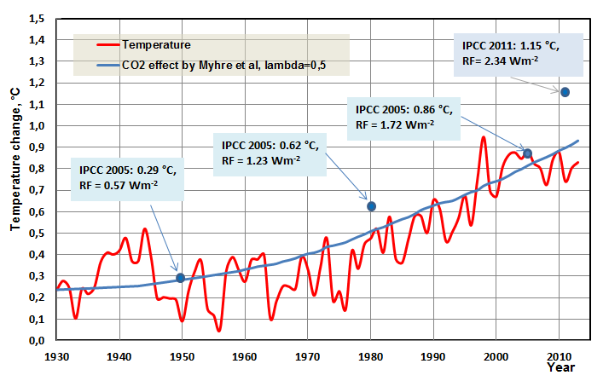
Figure 1: The Earth’s temperature trend and the calculated temperatures according to the IPCC’s model. The assessed temperature values of IPCC are calculated using the climate sensitivity parameter value 0.5 K/(Wm⁻²).

Scafetta [5] has analysed statistically that the Global Climate Models (GCM) cannot reproduce the fluctuations of the observed temperature.

There is also another essential feature in the IPCC’s model which shows incoherency and that is the value of climate sensitivity parameter λ. This parameter has an important role in the IPCC’s model and also in GCMs. In all these models the longwave or shortwave radiation change is calculated at the Top of the Atmosphere (TOA). There is a simple linear relationship between the surface temperature change dTs of the Earth and RF:

dTs = λ*RF (1)

IPCC states [3] that λ is a nearly invariant parameter having a typical value about 0.5 K/(Wm⁻²). As we can see in Fig.1, this value gives a temperature increase in 2011, which is much higher that the observed temperature.

IPCC [4] has introduced future scenarios for different CO₂ concentration increases. These scenarios (starting from the year 1750) are called Representative Concentration Pathways (RCP). The numerical value in an acronym represents the RF value of each scenario, like RCP4.5. In Table 2 are depicted the RCPs, mean temperature increases in 2100, and the λ values [4].

Table 2: The RCPs, mean temperature increases in 2100, equivalent CO₂ concentrations (ppm) and the climate sensitivity parameter values [6].

Name | Temperature in 2100, °C | Equival. CO₂ concentr. (ppm) | λ, K/(Wm⁻²)
RCP3 | 1.0 | 475 | 0.33
RCP4.5 | 1.8 | 630 | 0.40
RCP6 | 2.2 | 800 | 0.37
RCP8.5 | 3.7 | 1313 | 0.44

As we can see, the λ values vary between 0.33 and 0.44 K/(Wm⁻²). IPCC does not show or comment on these variations of λ values, and the λ values in Table 2 are calculated by the author based on the forcing and temperature change values as reported by IPCC [6]. IPCC [6] states that the assessed contributions of the anthropogenic forcings observed over the period 1951 to 2010 are consistent with warming of approximately 0.6 °C to 0.7 °C. According to Fig.1 this is not possible using the official λ value of IPCC.
The climate sensitivity (CS) is the temperature change in °C caused by a doubling of the CO₂ concentration. The equilibrium CS takes even thousands of years before the temperature is fully settled, because it includes several feedbacks like Earth’s albedo changes. Therefore, transient CS is more practical. It is defined as transient climate response [3] in the global annual mean surface air temperature change averaged over a 20-year period centered at the time of CO₂ doubling at 1 % per year. If IPCC really uses a smaller λ value, then this same value should be used for calculating the transient CS, because both RCPs and the transient CS do not include other feedbacks than water [7].
IPCC’s approach concentrates on the future effects of the anthropogenic driving forcings. Equation (2) is still applicable according to IPCC [6] in calculating the transient climate sensitivity (CS)

RF = 5.35*ln(C/280) (2)

where C is the CO₂ concentration (ppm). Using the CO₂ concentration 560 ppm and λ value of 0.5 K/(Wm⁻²), the transient CS is 1.85 °C. Equation (2) includes water feedback, which doubles the warming effect of CO₂ [8].

Researchers have published recently many studies of CS and a common feature is that the CS values are lower than that of IPCC. Usually researchers have used some other methods than the specification of CS, which requires using spectral analysis methods. Harde [9] and Ollila [7] have used the spectral analysis method, the average global atmosphere, and the specification of CS. In both studies the CS is 0.6 °C. Ollila [7] shows that this same CS value can be calculated from the energy balance of the Earth.

Ollila [7] shows also what the reasons for this big gap are: 1.85 °C versus 0.6 °C. The reasons are in water feedback. The RF value without water feedback is

RF = 3.12*ln(C/280) (3)

Equation (3) is calculated in the atmosphere of constant absolute humidity [7] but equation (2) is probably calculated in the atmosphere of constant relative humidity, which means water feedback. Myhre et al. [10] estimate that the uncertainty of the constant 5.35 in equation (2) is only 1%, and Ollila [7] does not give any error value for his constant. Myhre et al. [10] estimate that the uncertainty in the CO₂ forcing is about 5 %, and the author evaluates that this figure is a realistic estimate of the accuracies of equations (2) and (3).

In Fig. 2 is depicted the RF values of CO₂ according to four different studies [10]-[12], and [7]. Shi [12] specifies that the constant relative humidity was used in the calculations. Because water’s warming impact in respect to CO₂ is about 15:1 in the present climate [7], it has a crucial impact on the temperature changes, if the absolute amount of water varies along with the time.

The relative humidity measurements [13] show that the relative humidity trend is not constant but decreasing since 1948, see Fig. 11. Miskolczi [14] has analysed that the absolute amount of water in the atmosphere has a slight negative trend of -0.019 % with the average value 2.6 cm of total precipitable water (TPW). Eliminating of water feedback means that the λ value [7] should be 0.27 K/(Wm⁻²). Using water feedback twice explains why the IPCC’s CS is about 200 % too high.

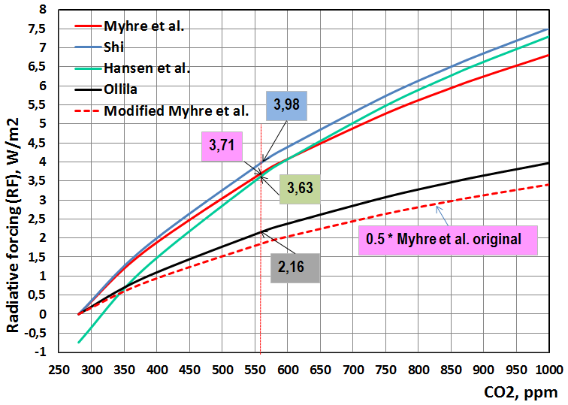
Figure 2: Radiative forcing values of CO₂ according to four different studies.

Von Storch et al. [15] has analysed that 23 Global Climate Models (GCM) could estimate the present temperatures 1998 to 2012 only with 2 % confidence level.

Based on these findings and studies, it is justified to analyse whether there are alternative theories or approaches of the global warming, which can provide better explanation for the observed temperature trends. As Scafetta [5] also realizes, if the IPCC’s model cannot produce the historical temperature trend correctly, there is no trust that it could produce the future temperature correctly.

3 Qualities of Cosmic Model

The only natural radiative forcing driver according to the Assessment Report 5 of IPCC [4] is the Sun having a positive RF value of 0.05 Wm⁻² which is only 2.2 % of the total RF 2.34 Wm⁻² since 1750. According to Lean [16] the Total Solar Irradiance (TSI) increase has been 1.5 Wm⁻² since 1750 as one can see in Fig. 3 [17], [18]. This change has as a RF value 0.38 Wm⁻² and it is 16.7 % of the latest total anthropogenic forcing of 2.29 Wm⁻².

Many researchers [19]-[22] have come into conclusion that there have been at least two warmer periods than the present period and these periods have happened about 1000 and 2000 years ago. Therefore, all researchers do not accept the IPCC’s claim that the present warming is unprecedented.

The general idea of the Sun theory is that the cause for the warmer periods during the last two millenniums originates from the Sun’s activity changes. Because the direct irradiance changes have not been big enough, researchers have introduced different mechanisms, which increase the direct effects of the Sun activity. The pioneer research of Svensmark and Friis-Christensen [23], [24] introduced evidence about the phenomena in which solar cycle variations modulate galactic cosmic ray fluxes in the earth’s atmosphere, which phenomenon could cause clouds to form.

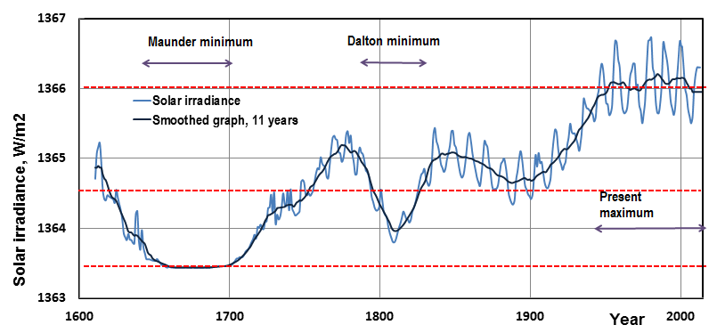
Figure 3: Total Solar Irradiance (TSI) from 1610 to 2014.

They argued that cosmic ray particles collide with particles in atmosphere, inducing electrical charges on them and nucleating clouds. Kernthaler et al. [25] and Jorgensen and Hansen [26] presented doubts about the existence of this mechanism claiming that the evidence was too weak. Svensmark and Friis-Christensen [27] dispelled these doubts and later Marsh and Svensmark [28] found out that the correlation is good and valid for low level clouds (< 3km) only. Palle et al. [29] have confirmed these findings. Svensmark et al. [30] have found further evidences about this mechanism by studying the coronal mass ejections from the Sun. They found that low clouds contain less liquid water following cosmic ray decreases caused by the Sun. This mechanism amplifies the impacts of the original changes in the Sun’s activity on the Earth’s climate.

Kauppinen et al. [31] and Ollila [32] have found the same cloudiness forcing of 0.1 °C/cloudiness-% using different approaches. According to the satellite measurements since 1983 [33], cloudiness has varied between ±3 percent and thus this mechanism could explain the observed temperature change of 0.6 °C.

There is another cosmic model which is not well-known and it can be called an astronomical harmonic climate model (AHCM). Ermakov et. al [34] firstly have introduced an idea that the planets of our solar system have an influence on our climate. Later on, they have developed further this theory and its effects on cloudiness, albedo, and climate [35]. This same approach has proposed also Scafetta [36]. The AHCM assumes that the climate resonates with, or synchronized to a set of natural harmonics that are associated mostly with the planetary motions of Jupiter and Saturn.

The orbital periods of Jupiter and Saturn are 11.87 and 29.4 years respectively. These periods create three cycles, which have the greatest effect on the climate. Jupiter and Saturn have the opposition cycle 10-10.5 years, the synodic cycle 20-21 years (the planets align in their orbits, when looking from the Sun), and the repetition of the combined orbits 60-62 years [5]. Besides these three major harmonics a shorter cycle of 9.1 years has been found probably caused by the Moon [5].

Ermakov et al. [35] have proposed a mechanism, which could cause the actual climate effects of the AHCM theory. The amount of dust entering daily the Earth’s atmosphere varies from 400 to 10 000 tons. The Earth passes annually through a dust cloud situated between the Sun and the Mars. The particle sizes vary from 0.001 µm to several hundreds of micrometres. The cosmic dust particles contain common elements like Fe, Mg, S, Al, Ca, and Na. Mg, S, and Na are efficient condensation nuclei of the atmospheric water vapour [35]. Variations in dust amounts happen during a longer time scale depending on the periodicities of the planets, which can move the dust cloud position. In the same way that galactic cosmic rays (GCR) cause ionization in the atmosphere, dust particles can do the same phenomenon. In this respect the cosmic ray model and the cosmic dust model have a common meeting point but the original reasons are different: the Sun activity changes and planetary periodical motions as illustrated in Fig. 4.

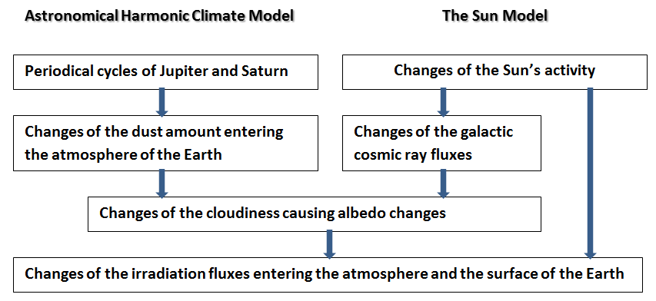
Figure 4. Schematic flow chart of the AHCM and the Sun model.

Ermakov et al. [35] have found four major periods by carrying out a spectral analysis on the Earth’s temperature data: 20.7, 33.4, 62.7, and 197.9 years. These periods are in line with harmonic cycles represented by Scafetta [36]. Based on this analysis Ermakov et al. [35] created a fit to the Earth’s temperature [37] and also a forecast for the next 50 years. Forecast is easy to calculate, because it is based on the same mathematical analysis of the planets’ orbits like the historical analysis. I have digitized this graphical presentation and prepared Fig. 5. for the period 1880-2010, and I call it Space Dust Index (SDI). SDI is simply a smoothed signal calculated by Ermakov et al. [35] and it is composed from the four main harmonics.

I have used 11 years smoothing in the Earth’s temperature graph, and this same smoothing procedure is used in other smoothed signals as well. According to my regression analysis, the best fit can be achieved when the calculated SDI is delayed three years. The regression analysis between the original SDI and the temperature gives r₂ = 0.945, and for the three years delay r₂ = 0.957.

The reason for this slightly better fitting seems to be in two points: 1) the delayed SDI signal follows more accurately the temperature peak values around the year 1940 and 2) the original SDI signal turns sharply downwards in 2010, when the real temperature stays at the present level up to 2015. In the later analyses I have used the delayed SDI form.

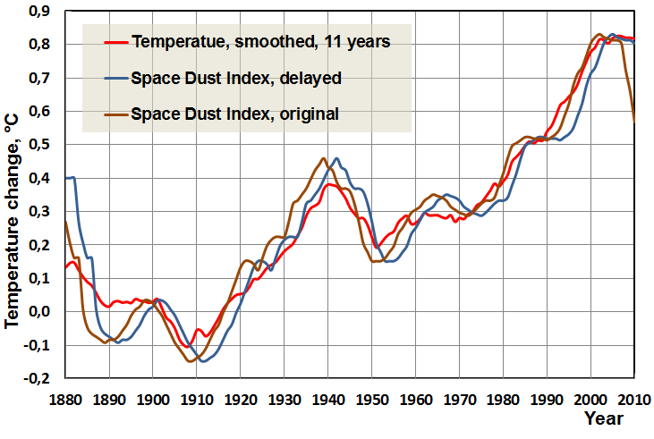
Figure 5: The SDI (Space Dust Index) graph in its original and delayed form in respect to the Earth’s smoothed temperature graph.

The correlation coefficient is very high. The SDI has a capability to explain the ups and downs of the temperature variations. The AGW model cannot do this, because it is depending on the monotonically increasing concentrations of GH gases. The major weakness of SDI is that there are no measurements about the existence of the space dust cloud on the Earth’s orbit. On the other hand, there are no measurements indicating that there is no dust cloud.

4 Cosmic and Anthropogenic Theories as Explanations of the Latest Global Warming

The SDI model already gives a very good fit for the Earth’s temperature. Scafetta [5] has found the same kind of accurate fitting by using his AHCM with an average error of 0.05 °C.

I have prepared three models: The first model I call a Cosmic Index, which combines the SDI and the signal representing the Galactic Cosmic Rays activity changes. This signal originates from the study [38] in which the combination of aa-index (a geomagnetic activity index (=AA) measuring the changes of geomagnetic variations on the opposite sides of the Earth) and the ion chamber measurements (=ION) indicate the GCR flux changes. The signal AA+ION is formed from the AA-signal from 1880 to 1950 and from 1950 to 2013 the ION-signal. The combination of these two signals (AA+ION) happens in the beginning of 1950.

I have calculated the arithmetic average of SDI and AA+ION signals, which I call Cosmic Index (CI). All these signals are depicted in Fig. 6.

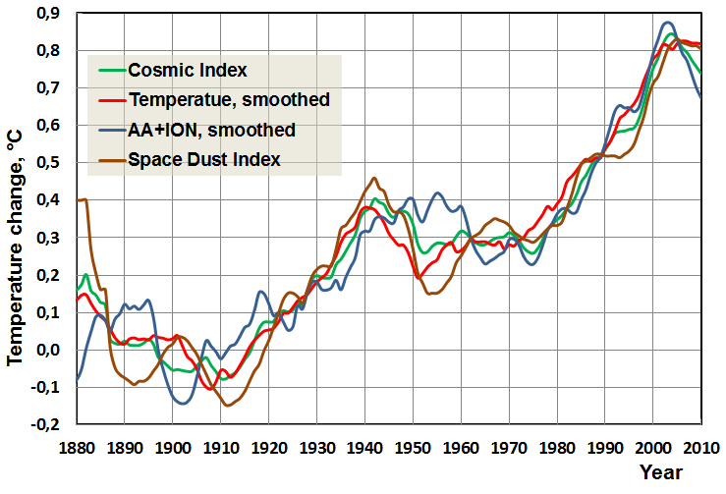
Figure 6: The graphs of SDI, AA+ION and Cosmic Index in respect to the Earth’s temperature.

The correlation coefficient r₂ of AA+ION is 0.890 and r₂ of CI is 0.972. The correlation of CI is better than that of SDI and it is extremely good. This analysis does not give a direct measure, as to which one of these two signals has a stronger impact. By comparing the original r₂ values 0.890 and 0.957, it looks like that the SDI signal has a dominant role. This analysis supports the idea that both the Sun and the space dust have their impacts on the Earth’s temperature.

The second model combines the effects of SDI, the Sun and the impacts of the GH gases. Scafetta [5] has used the warming impacts of GH gases according to the IPCC model [3]. Because I keep these warming impacts highly overestimated [7], [39], I have calculated the warming effects of CO₂ by applying equation (3) and the λ value of 0.27 K/(Wm⁻²). The reasons for this λ value are explained in the former section.

The warming effects of methane (CH₄) and dinitrogen oxide (N₂O) are based on the spectral analysis of warming effects of these gases [39]. The concentrations of CO₂, CH₄, and N₂O are the same as reported by IPCC [6].

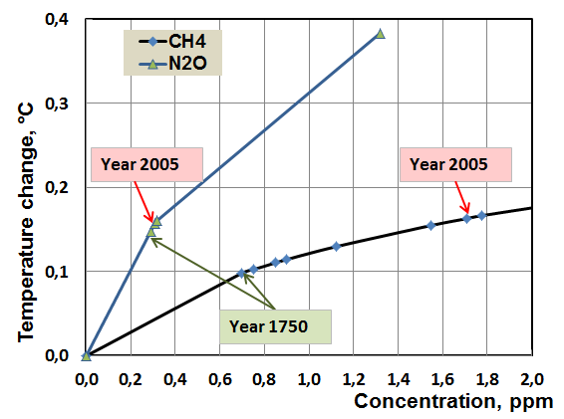
Figure 7: The warming impacts of CH₄ and N₂O.

The warming impacts of CH₄ and N₂O are almost linear as illustrated in Fig. 7. Therefore I have combined these warming effects into a linear relationship from year 1750 to 2010 as

dT = -0,3088+0.0003176*Year (4)

The warming according to equation (4) is 0.247 °C in 1750 and 0,328 °C in 2005 giving the total temperature increase of 0.081 °C.

I have calculated the direct warming impacts of the Sun utilising the data bank values of the Sun irradiance changes from 1880 to 2010 [17]-[18] according to the formula

dT = 0.27*(1 – α)*(TSI - 1364.5)/4 (5)

where α is the average albedo of the Earth [32].

In equation (5) I have used the λ value of 0.27 K/(Wm⁻²) and the Sun irradiance is divided by four in transforming the irradiance to correspond to RF value at TOA [7]. The warming impacts are depicted in Fig. 8. The Sun irradiance values have been assumed to stay at the level of 2010 from 2010 to 2050, even though the present solar cycle activity value is smaller.

I have calculated the warming impacts of space dust by correlating SDI with the modified temperature. This temperature is calculated by subtracting from the Earth’s smoothed temperature the temperature effects of GH gases and the Sun irradiance variations. The SDI follows the same forms in Fig. 8 as in Fig. 5 but at the lower level.

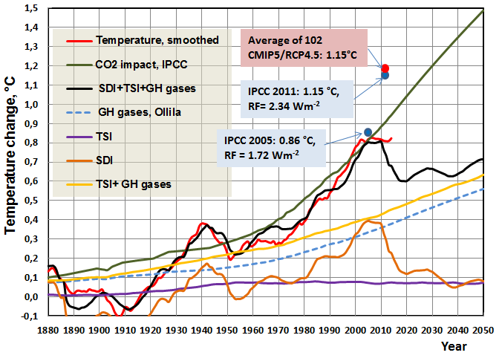
Figure 8: The estimated temperature based on SDI, Sun Irradiance and the impacts of GH gases together with the Earth’s temperature. The black curve is the combined effect of SDI, the Sun and GH gases. As a reference is depicted the warming impacts of IPCC’s CO₂-model and GH gas impacts by Ollila.

The estimated temperature based on the calculated warming impacts of GH gases, the Sun irradiance variations, and the SDI is depicted in Fig. 8. This temperature follows very closely the trend of the Earth’s temperature, and the correlations coefficient r₂ = 0.971.

It is easy to conclude that the warming impacts of GH gases and the Sun irradiance changes (a yellow line) cannot alone explain the temperature variations. By adding the SDI impact, the estimated temperature follows well the observed temperature. The gap between the yellow line and the black line is due to the SDI impact.

The impact of GH gases increases steadily. In the year 2005 the estimated temperature change 0.8 °C is the sum of three major elements: the direct Sun irradiance change 9 %, the GH gases 42 %, and the space dust 49 %. It should be noted that the Sun irradiation impacts include only the direct irradiation changes and the possible effects of cloudiness changes are not included. The GH gas impact calculations are based on the assumption of the constant absolute water vapour amount in the atmosphere, and in this respect it is in the midway of IPCC (positive feedback of water vapour) and Miskolczi [14] (negative feedback of water vapour).

The third model combines the effects of SDI and the Sun. In this model the impacts of GH gases are completely eliminated as explained by Miscolczi [40] that the Earth has a constant GH effect, where the humidity changes compensate the increased warming effects of GH gases. The results of this model are depicted in Fig. 9.

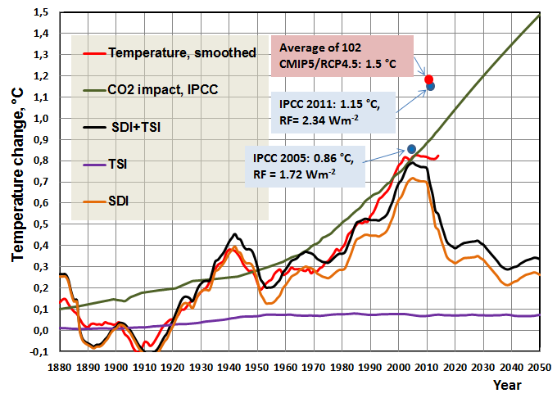

Figure 9: The estimated temperature based on SDI and Sun Irradiance together with the Earth’s temperature. The black curve is the combined effect of SDI and TSI. As a reference it is also depicted the warming impacts of IPCC’s CO₂-model.

Also, in this model the temperature follows very closely the trend of the Earth’s temperature, and the correlations coefficient r₂ = 0.948. The major difference is in the future temperature projections. In the years from 2020 to 2030 the model including GH gas effects gives the temperature level, which is about 0.2-0.25 °C higher than that of the model including only cosmic effects.

Both the Sun and the space dust have an influence mechanism, which is based on the cloudiness changes. The potentiality of cloudiness changes and the direct TSI changes can be analysed and illustrated, whether they can explain the measured temperature changes of the Earth.

The temperature dependency on the albedo and the TSI can be easily calculated as shown by Ollila [7]:

T = (TSI * (1-α)/(4s))^{0.25} (6)

where α is albedo, and s is Stefan-Bolzmann constant. The Earth’s albedo depends mainly on cloudiness. Ollila [32] has fitted the second order polynomial based on the three pairs of cloudiness and albedo values:

α = 0.15497 + 0.0028623 * CL -0.000009 * CL² (7)
where CL is cloudiness-%. Using these two equations the relationship between the temperature, albedo and cloudiness can be calculated. These results are depicted in Fig. 10.

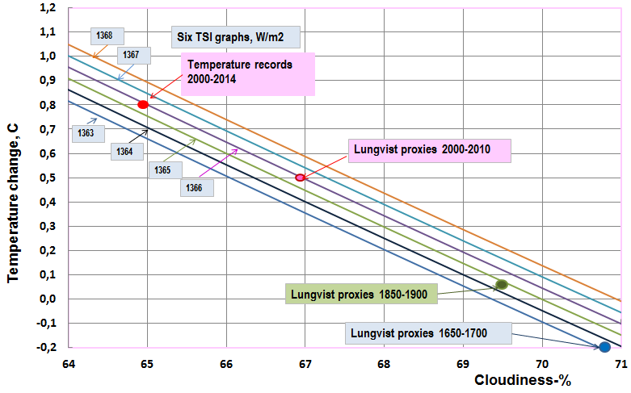
Figure 10: The Earth’s temperature based on Total Sun Irradiance (TSI) and cloudiness-% changes. The Lungvist proxies are from the reference [22].

From Fig. 10 it can be concluded that the observed temperature change between the coldest period (Maunder minimum) and the present warm period could be based on only the TSI and cloudiness changes. The cloudiness changes have a much higher impact than by the TSI changes. The absolute values of cloudiness are not important, but the observation that the cloudiness change of six percentage units can cause a temperature change of 0.9 °C. According to the ISCCP [33], the change of about six percentage units has happened during the period from 1983 to 2010.

The study of Lungvist [22] reveals that the temperature proxies cannot estimate accurately enough the instrumental temperature records of the last 50 years. The reason may be in nonlinear relationships between proxies and the real temperatures in the extreme cold and warm conditions.

The IPCC’s CO₂ model follows the overall increasing growth rate of the Earth’s temperature up to 2010. This model has two major weaknesses. Firstly, the high warming impacts are based on the double water feedback effect. In this analysis the warming value of CO₂ according to Ollila’s formula is 0.232 °C in the year 2000, and the IPCC’s eq. (2) gives 0.742 °C, which is 210% higher. Secondly, IPCC’s model has no elements to explain the ups and downs of the Earth’s temperature trend. It should also be remembered that the IPCC’s model [6] containing all the anthropogenic values gives the estimated temperature 1.15 °C, which is 35 % higher than the observed temperature.

General belief is that computer models are more accurate than simpler models. In Fig. 8 and Fig. 9 the temperature increase calculated as an average value of 102 CMIP5 models [41] gives the temperature increase of 1.15 °C in 2011, which is the same as estimated by IPCC’s simple model. The CMIP5 models are based on RCP4.5 projection, which is closest to the present growth rate of the CO₂ concentration. The divergence between the simple model and RCP projections occurs after 2030. The GCMs give [6] the equilibrium CS of 3.0 °C (range 1.5 °C to 4.5 °C), and the transient CS of 1.75 °C (range 1.5 °C to 4.5 °C).

The estimates of temperature of these two major approaches, supported by IPCC, deviate so much from the observed temperature that there is no justification to trust that they could forecast the temperatures for the next 100 years.

The future forecast of the temperature development is depicted also in Fig. 8 and Fig. 9. I have used the following predictions of the major driving forces from 2010 to 2050: CO₂ growth rate 2,5 ppm/year, CO₂ impact according to equation (3), CH₄ and N₂O temperature impact according to equation (4), the Sun irradiance according to the year 2010 as depicted in Fig. 3, and the delayed SDI according to Ermakov et al. [35]. As analysed before, the difference of the fitting between the original and delayed SDI is very small, and the delay is only three years.

The tempereature forecast shows in Fig. 8 that there should be decrease of 0.2 °C from the present temperature level up to 2020 and thereafter a slight increase to 0.72 °C. In the year 2050 the estimated temperature increase 0.72 °C would be the sum of four major elements: the Sun irradiance change 10 %, CO₂ & CH₄ & N₂O 79 %, and the space dust 11 %. IPCC’s model based on CO₂ growth rate shoots up to 1.5 °C in 2050, and by including the other anthropogenic forcing elements, the temperature forecast is much higher.

The temperature forecast in Fig. 9 shows much greater temperarture decrease after 2020 based on the SDI decrease because there are no warming impact of GH gases included.

5 Conclusions

The correlation of SDI is high (0.957) which means that the impact mechanism of space dust should be considered seriously as one of the potential causes for the global warming.

The SDI model and the aa-index are the only models offering explanations for the strong temperature decrease from 1880 to 1910 and for the strong temperature increase from 1910 to 1940. The SDI model explains almost perfectly the temperature peak from 1930 to 1950, and there is no other model which can do that so well. The SDI model offers also a good explanation for the temperature pause starting in 2000 that is still continuing.

A big uncertainty concerns the impacts of GH gases. The background information is represented in Fig. 10. The decreasing relative humidity values mean that the IPCC’s assumption of positive water vapour feedback is not justified. The decreasing trends start from 1948, which can compensate the warming impact of GH gases.

There is no information available about the relative humidity (RH) trends starting from year 1750. Therefore the analysis, where the impacts of GH gases are included according to Fig. 8, remains uncertain. Miskolczi [40] has developed further his original theory [14] that the atmosphere has a capability to maintain a constant GH effect. This theory has not yet received a common acceptance so far.

The question of humidity impacts can be also expressed by the value of CS. Constant RH means CS of 1.85 °C [4], constant absolute humidity means CS of 0.6 °C [7], and the constant GH phenomenon means 0 °C [40]. Kauppinen et al. [42] have calculated CS value of 0.24 °C based on the empirical model.

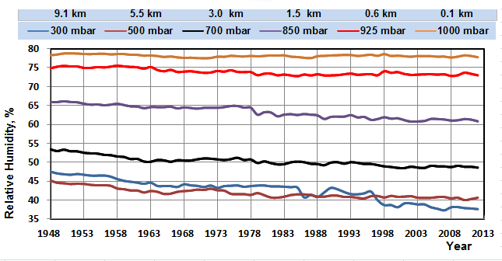
Figure 11: he relative humidity values in the average global atmosphere.

It is quite easy to forecast that the period 2015-2020 can be decisive concerning the evidence of the two major approaches: the AGW model of IPCC and the cosmic model variations represented in this paper. If the temperature starts to increase and to approach the calculated IPCC’s model values, it would support the impacts of anthropogenic reasons. If the temperature starts to decrease, it is evidence that the warming impacts of GH gases are overestimated by IPCC, and the cosmic force changes have a major impact on the Earth’s temperature.

The Sun activity has decreased quite strongly during the latest solar cycle and is now at the same level as during the period 1903-1915. The SDI shows also a deep decrease from the year 2015 forward. If the cosmic model is correct, the temperature should start to decrease during the next five years. Because the impact of GH gases is from 0.5 °C to 0.6 °C, the decrease below 0.6 °C after 2015 would mean that the effects of GH gases are smaller than estimated above. It would be an undeniable piece of evidence that Miskolczi’s theory about the constant GH phenomenon is correct, because the only explanation for the temperature decrease would be the cosmic forces.

The third option is that the temperature pause continues essentially at the present level. In this case the AGW theory will lose its credibility, because the gap between the model and the reality grows too big. The cosmic model and the impacts according to the revised warming impact of CO₂ and the CS parameter of 0.27 K/(Wm⁻²) would be close enough to offer a scientific explanation.

Is the AHCM a complete explanation to the Earth’s climate variations? Analysing the long term changes of the latest 2000 years or even longer period, the big changes like Maunder minimum are linked to the Sun’s activity changes. Therefore the astronomical harmonic climate model (AHCM) needs the Sun’s activity changes alongside it. The two dynamo model of the Sun [43] explains almost perfectly the Sun’s cycle behaviour during the last three solar cycles. This model predicts very low Sun activity for the next solar cycle during 2030-2040 approaching the conditions during the Maunder minimum in 17th century.

The impacts of GH gases are totally depending on the behaviour of atmospheric water content. If the constant relative humidity is assumed to be like IPCC´s theories, then the warming impacts are doubled. The temperature pause since 1998 has shown that the error is so big that this model is not justified and the warming impacts of the GH gases by IPCC are overestimated.

The theory of Miskolczi [41] proposes that the greenhouse phenomenon could have a constant value and the nature could compensate the impact of other GH gases through the negative feedback of the water vapour. This theory has had a strong observational support during the last 60 years. This study has introduced cosmic forces, which offer excellent explanations for the historical temperature trends. The next ten years will show, if the global temperature starts to decline as forecasted according to these theories.

references

[1] A. Ohmura, “Physical basis for the temperature-based melt-index method,” Journal of Applied Meteorology, vol. 40, 1997, pp. 753-761.

[2] A. Ollila, “The roles of greenhouse gases in global warming,” Energy & Environment, vol. 23, 2012, pp. 781-799.

[3] IPCC, “Climate response to radiative forcing,” IPCC Fourth Assessment Report (AR4), The Physical Science Basis, Contribution of Working Group I to the Fourth Assessment Report of the Intergovernmental Panel on Climate Change, Cambridge University Press, Cambridge, 2007.

[4] IPCC, “Summary for Policymakers. In: Climate Change 2013: The Physical Science Basis. Contribution of Working Group I to the Fifth Assessment Report of the Intergovernmental Panel on Climate Change,” Cambridge University Press, Cambridge, United Kingdom and New York, NY, USA, 2013.

[5] N. Scafetta, “Testing an astronomically based decadal scale empirical harmonic climate model versus the IPCC general circulation models,” Journal of Atmospheric and Solar-Terrestrial Physics, vol. 80, 2011, pp. 124-137. DOI:10.1016/j.jasstp.2011.12.005.

[6] IPCC, “Technical Summary. In: Climate Change 2013: The Physical Science Basis. Contribution of Working Group I to the Fifth Assessment Report of the Intergovernmental Panel on Climate Change,” Cambridge University Press, Cambridge, United Kingdom and New York, NY, USA, 2013.

[7] A. Ollila, “The potency of carbon dioxide (CO₂) as a greenhouse gas,” Development in Earth Sciences, vol. 2, 2014, pp. 20-30.

[8] IPCC, “Water vapor and lapse rate,” IPCC Fourth Assessment Report (AR4), The Physical Science Basis, Contribution of Working Group I to the Fourth Assessment Report of the Intergovernmental Panel on Climate Change, Cambridge University Press, Cambridge, 2007.

[9] H. Harde, “Advanced two-layer climate model for the assessment of global warming by CO₂,” Open Journal of Atmospheric and Climate Change, vol. 1, 2014, pp. 1-50.
[10] G. Myhre, E. J. Highwood, K. P. Shine and F. Stordal, “New estimates of radiative forcing due to well mixed greenhouse gases,” Geophysical Research Letters, vol. 25, 1998, pp. 2715-2718.

[11] J. Hansen, I. Fung, A. Lacis, D. Rind, S. Lebedeff, R. Ruedy, G. Russell and P. Stone, “Global Climate Changes as Forecast by Goddard Institute for Space Studies, Three Dimensional Model,” Journal of Geophysical Research, vol. 93, 1998, pp. 9341-9364.

[12] G-Y. Shi, “Radiative forcing and greenhouse effect due to the atmospheric trace gases,” Science in China (Series B), vol. 35, 1992, pp. 217-229.

[13] NOAA, “Relative humidity trends. NOAA Earth System Research Laboratory.” http://www.esrl.noaa.gov/gmd/aggi/

[14] F. Miskolczi, “The stable stationary value of the Earth’s global average atmospheric Planck-weighted greenhouse gas optical thickness,” Energy & Environment, vol. 21, 2010, pp. 242-262.

[15] H. von Storch, A. Barkhordarian, K. Hasselmann and K. E. Zorita, “Can climate models explain the recent stagnation in global warming?” Accessed January, 2014. http://www.academia.edu/4210419/
Can_climate_models_explain_the_recent_stagnation_in_global_warming.

[16] J. Lean, “Evolution of the Sun’s spectral irradiance since the Maunder minimum,” Geophysical Research Letters, vol. 27, 2000, pp. 2425-2428.
[17] J. Lean, ”Solar Irradiance Reconstruction, IGBP PAGES/World Data Center for Paleoclimatology Data Contribution Series # 2004-035,” NOAA/NGDC Paleoclimatology Program, Boulder CO, USA, 2004.

[18] C. Froehlich, "Solar irradiance variability since 1978: Revision of the {PMOD} composite during solar cycle 21," Space Science Revision, vol. 125, 2006, pp. 53-65. Data accessed February 2015 from the PMOD server: ftp://ftp.pmodwrc.ch/pub/Claus/ISSI_WS2005/ISSI2005a_CF.pdf

[19] R. B. Alley, “The Younger Dryas cold interval as viewed from central Greenland,” Quaternary Science Reviews, vol. 19, 2000, pp. 213-226.

[20] S. McIntyre and R. McKitrick, “Corrections to the Mann et al., (1998) proxy data base and Northern Hemispheric average temperature series,” Energy & Environment, vol. 14, 2003, pp. 751– 771.

[21] J. Esper, D. C. Frank, M. Timonen, E. Zorita, R. Wilson, J. Luterbacher, S. Holzkämper, N. Fischer, S. Wagner, D. Nievergelt, A. Verstege, and Ü. Büntgen, “Orbital forcing of tree-ring data,” Nature Climate Change, vol. 2, 2012, pp. 862–866. DOI:10.1038/nclimate1589

[22] F. C. Lungvist, “A new reconstruction of temperature variability in the extra-tropical Northern Hemisphere during the last two millennia,” Geografiska Annaler: Series A, vol. 92 A, no. 3, 2010, pp. 339–351.

[23] H. Svensmark, “Influnce of cosmic rays on Earth’s climate,” Physical Review Letters, vol. 81, 1998, pp. 5027-5030.

[24] H. Svensmark and E. Friis-Christensen, “Variation of cosmic ray flux and global cloud coverage – a missing link in solar-climate relationships,” Journal of Atmospheric and Solar-Terrestrial Physics, vol. 59, 1997, pp. 1225-1232.

[25] C. Kernthaler, R. Toumi and J. D. Haigh, “Some doubts concerning a link between cosmic ray fluxes and global cloudiness,” Geophysical Research Letters, vol. 26, 1999, pp. 863-865.

[26] T. S. Jørgensen and A. W. Hansen, “Comment on Variation of cosmic ray flux and global coverage – a missing link in solar-climate relationships”. Journal of Atmospheric and Solar-Terrestrial Physics, vol. 62, 2000, pp. 73-77.

[27] H. Svensmark and E. Friis-Christensen, “Reply to the comments on “Variations of cosmic ray flux and global cloud coverage – a missing link in solar-climate relationship,” Journal of Atmospheric and Solar-Terrestrial Physics, vol. 62, 2000, pp. 79-80.

[28] N. D. Marsh and H. Svensmark, “Low cloud properties influenced by cosmic rays,” Physical Review Letters, vol. 85, 2000, pp. 5004-5007.

[29] E. Palle, C. J. Butler and K. O. O’Brien, “The possible connection between ionization in the atmosphere by cosmic rays and low level clouds,” Journal of the Atmospheric and Solar-Terrestrial Physics, vol. 66, 2004, pp. 1779-170.

[30] H. Svensmark, T. Bondo and H. Svensmark, “Cosmic ray decreases affect atmospheric aerosols and clouds,” Geophysical Research Letters, vol. 36, 2009, pp. L15101. doi:10.1029/2009GL038429,DOI: 10.1029/2009GL038429.

[31] J. Kauppinen, J. T. Heinonen and P. J. Malmi, ”Influence of clouds on the global mean temperature,” International Review of Physics, vol. 5, 2011, pp. 260-270.
[32] A. Ollila, Dynamics between clear, cloudy, and all-sky conditions: Cloud forcing effects. Journal of Chemical, Biological and Physical Science, vol. 4, 2014, pp. 557-575.

[33] ISCCP, “The ISCCP D2 cloudiness image.” Accessed January, 2015. http://isccp.giss.nasa.gov/info.html.

[34] V. Ermakov, V. Okhlopkov and Y. Stozhkov, “Influence of zodiac dust on the Earth’s climate,” Proceedings of 20th European Cosmic Ray Symposium, Lisbon, 2006.

[35] V. Ermakov, V. Okhlopkov, Y. Stozhkov and I. Yu, “Influence of cosmic rays and cosmic dust on the atmosphere and Earth’s climate.” Bulletin of Russian Academy of Sciences: Physics, vol. 73, 2009, pp. 434-436.

[36] N. Scafetta, “Empirical evidence for a celestial origin of the climate oscillations and its implications,” Journal of Atmospheric and Solar-Terrestrial Physics, vol. 72, 2019, pp. 951–970, DOI:10.1016/j.jastp.2010.04.015

[37] JonesCRU, “Global temperature data bank of CDIAC,” 2013. Data accessed in February 2015. http://cdiac.esd.ornl.gov/ftp/trends/temp/jonescru/global.txt
[38] A. Ollila, “Changes in cosmic ray fluxes improve correlation to global warming.” International Journal of the Physical Sciences, vol. 7(5), 2012, pp. 822-826.

[39] A. Ollila, “Analyses of IPCC’s warming calculation results,” Journal of Chemical, Biological and Physical Science, vol. 4, 2013, pp. 2912-2930.

[40] F. Miskolczi, “The greenhouse effect and the infrared radiative structure of the Earth's Atmosphere,” Development in Earth Sciences, vol. 2, 2014, pp. 31-52.
[41] J. R. Christy, “CEQ Draft Guidance for GHG Emissions and the Effects of Climate Change Committee on Natural Resources, 13 May 2015,” Testimony of John R. Christy.

[42] J. Kauppinen, J. Heinonen and P. Malmi, ”Influence of relative humidity and clouds on the global mean surface temperature,” Energy & Environment, April 15, 2015. DOI: http://dx.doi.org/10.1260/0958-305X.25.2.389

[43] V. Zharkova, “Irregular heartbeat of the Sun driven by double dynamo”, Proceedings National Astronomy Meeting, 5-9 July, 2015, Llandudno, UK.

Aalto University, e-mail: aveollila@yahoo.com

