**Fuzzy Inference System towards Risk Assessment of Personal Care Robots**

**Mitka, Eleftheria**

***PhD Candidate, Department of Electrical and Computer Engineering, Democritus University of Thrace, University Campus, Xanthi, 67100 Greece, em3933@ee.duth.gr***

**Abstract**

*Direct human robot interaction and cooperation in uncertain environment is recently expanding robotics research and challenging safety engineers by involving consumer product applications with high degree of autonomy, mobility and flexibility. Assessing the standardization’s requirements associated especially for Personal Care- Mobile servant (PCMS) robots is an open research question since safety standards are not available, except for ISO 13482. The objective of this study is the risk assessment on the base of ISO 13482 concerning the safety requirements established for PCMS robots using a Fuzzy Inference System (FIS). This paper is a brief and easily understood overview of PCMS robots, of ISO organisation and fundamental constraints that had already been established in ISO 13482. The challenging endeavour is the defuzzification of safety constraints applying special computer software as MATLAB in order to quantify the results of risk assessment and to achieve the overall hierarchy of the requirements.*

**Key words:** Personal Care- Mobile servant robot, standardization, MATLAB, fuzzy, safety requirements, risk assessment.

**1. Introduction**

Personal care robot performs aiding actions with aim to contribute directly and reliably towards the upgrading of the quality of life style of human beings. In other words, it is indented for personal use, marketed towards non-commercial situations and purchased for individual buyers. Personal robots have been categorised at three subgroups: mobile servant, people carrier and physical assistant. Mobile servant robot is a robot able to control the motion of its base in the world (or absolute) co-ordinate system. People carrier robot is a personal robot for the purpose of transporting people. Physical assistant robot is a personal robot which assists a person physically, to handle housekeeping tasks, by providing the capabilities needed. A subset of extremely demanding applications that perform for ordinary, elderly and handicapped people might include: dishwashing, tidying up, laundry, carrying heavy objects. Also may assist in cooking, feeding, monitoring health and activity, fetch and carry tasks, grocery shopping, retrieving things, car washing, companionship and fire protection (Mouroutsos and Mitka 2012). More specifically, PCMS robots that were studied in this paper (Figure 1), moving freely and handling objects, demonstrate high degree of autonomy, mobility and flexibility. They are indented for a member of general public such as inexperienced users of all ages, handling small and medium sized objects avoiding collisions with stationary and moving objects ISO 13482 (ISO 13482, 2014). The primary goal of this paper is the risk assessment on the base of ISO 13482 (ISO 13482, 2014) concerning the safety requirements established for PCMS robots. In order to achieve this goal, a FIS system is used for the defuzzification, risk assessment and risk reduction.



Figure 1: The mobile servant personal care robot.

**2. ISO organization efforts towards the standardization of safety in personal care robots**

Nowadays, as personal care robots tend to invade in every day life, there is a necessity to produce relative international standards. ISO establish ISO TC 184 Technical Committee that has the responsibility for developing standards on automation systems and integration. A Subcommittee called SC2 that deals with robots and robotic devices has also been established. The scope of SC2 is the standardization of manipulating robots and robotic devices (except for toys and military ones). SC2 (Figure 2) is developing a group of novel and/or revised standards in order to incorporate aspects of industrial robotics to personal care and domestic service ones. Standardization efforts of SC2 are carried out by four active working groups including: WG7 on developing safety requirements concerning non-medical personal care robots and WG8 on developing service robots standards. In WG8, the standards currently under construction are carried out concerning the most urgent areas such as software, coordinate system, modularity, performance criteria, safety assurance, user interface and characteristics of mobile robots (Seungbin and Gurvinder, 2009). The first standard to be updated is ISO 8373 (ISO 8373, 2007) that covers a vocabulary of terms and definitions used in robotics standards. The new ISO 10218-1, 2011 and ISO 10218-2, 2011 standards in conjunction with new standards developed for personal care service robots that are being established by WG7, touch existing robotic domains and extended them to novel domains such as the domestic robotics (Harper et al., 2009). Yet, due to the lack of the existence of international standards for such an emerging domain, the respective standard organizations in South Korea and Japan defined their own safety standards with aim to assist the rapid development of viable global markets in these conceivable future applications (Mitka et al., 2012).

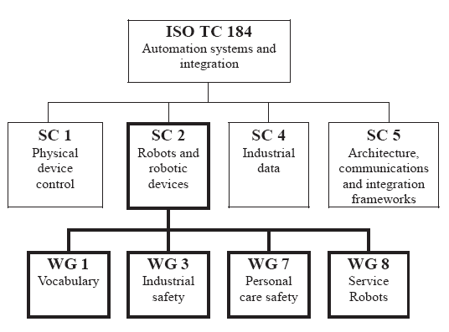

Figure 2: The ISO organization of Technical Committee ISO TC 184.

**3. Fuzzy Inference System using Matlab Simulink**

The objective of this study is the defuzzification of safety constraints and requirements that have already been established by ISO 13482 (ISO 13482, 2014). Based on ISO 14121 (ISO 14121, 1999), risk is estimated counting severity of a harmful incident, frequency to happen, probability of harm occurring and avoidance ability (possibility to avoid harm). As a result, in the Fuzzy Inference System, four variables are taken account. Parameter of “Severity” is described with two discrete levels: Major and Minor (Figure 3), parameter of “Frequency”: Frequent and Infrequent, parameter of “Probability”: High and Low, parameter of “Possibility”: Likely and Unlikely those are shown in Table I. The output variable is risk and arranged within two levels: High and Ordinary (Figure 4).

Table 1: THE DISCRETE LEVELS OF INPUT VARIABLES

|  |  |  |  |
| --- | --- | --- | --- |
| Severity | Frequency | Probability | Possibility |
| Major  Minor | Frequent  Infrequent | High  Low | Likely  Unlikely |

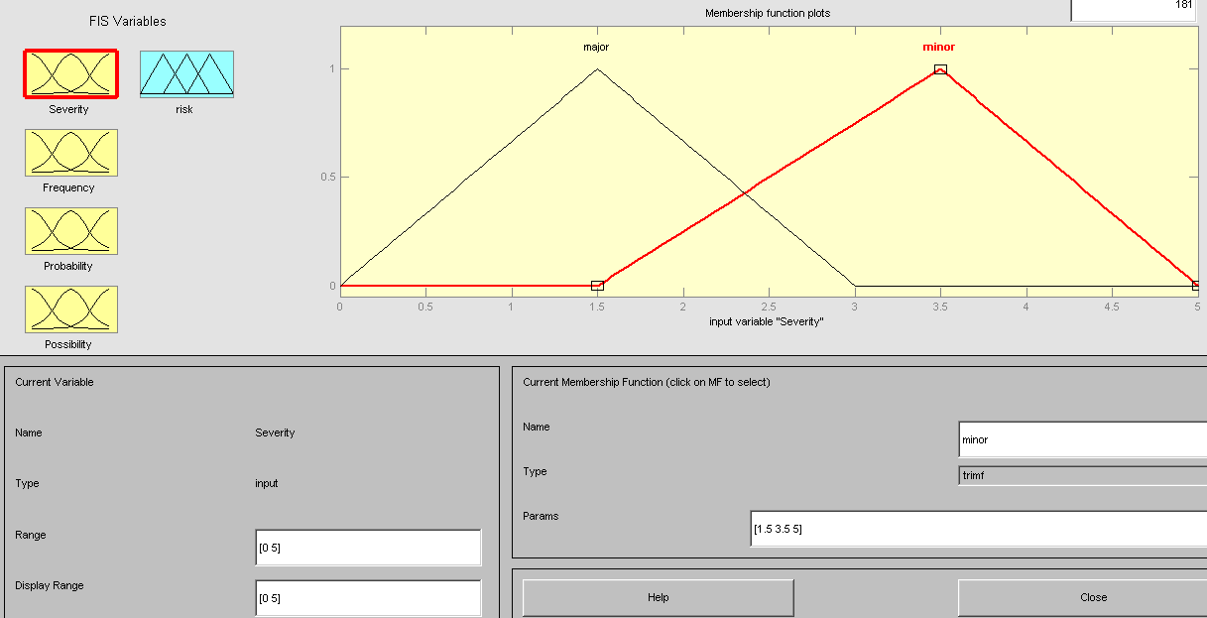

Figure 3: The first variable severity is arranged within a range [0 5] using Fuzzy Inference System of MATLAB simulink software with two discete levels minor/ major while the other three variables are settled in the same way.

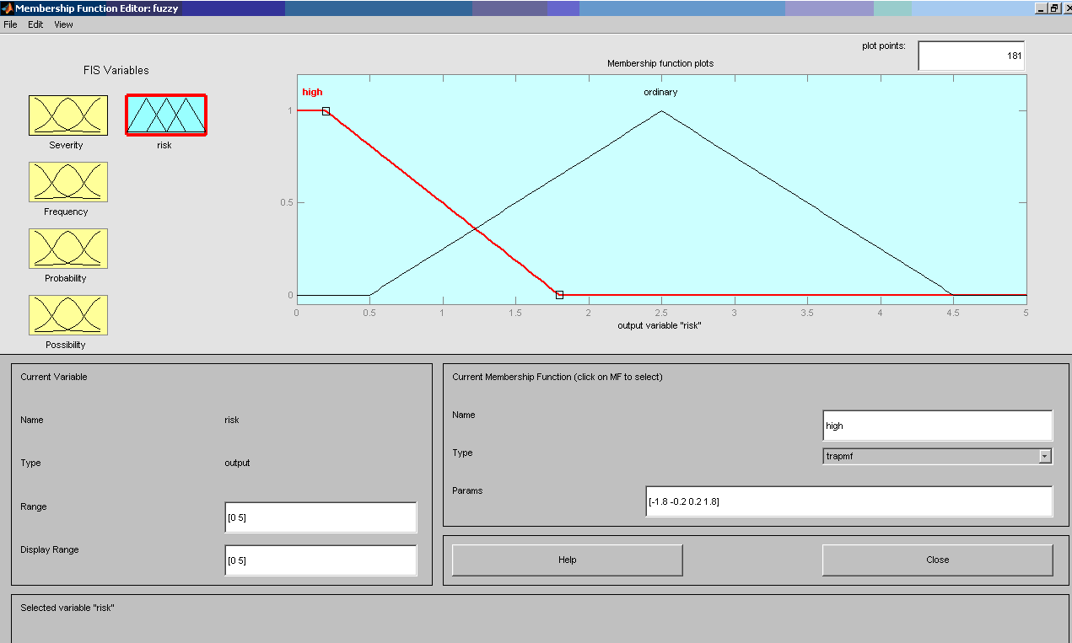

Figure 4: The output variable risk is arranged within a range [0 5] and two levels High/ Ordinary.

Taking account of the estimation of output variable and ISO 13482 (ISO 13482, 2014), rules and safety constraints are established in order to quantify the results of risk assessment and to achieve the safety of user and operational environment robot. The rules and safety requirements for every rule respectively are given below according to ISO 13482 (ISO 13482, 2014) for a PCMS robot:

**Rule 1:** If severity of harm is major and frequency of crushing of body parts between arm joints is frequent, probability is high and possibility is likely then:

* Manufacturer shall embed tactile sensors with opener elements, implement fixed/movable guards from inserting body part
* Designer shall document residual risk and put warning signs for users

**Rule 2:** If severity of harm is major and frequency of crushing body parts inside the robot’s structure is frequent, probability is low and possibility is unlikely then:

* Manufacturer shall restrict power/force of arm and shield arm with robot’s body
* Designer shall monitor and restrict the velocity of the arm

**Rule 3:** If severity of harm is major and frequency of crushing body parts between arm joints and environment is frequent, probability is low and possibility is unlikely then:

* Manufacturer shall shield the arm with robot’s body
* Designer shall monitor and restrict the velocity of arm

**Rule 4:** If severity of harm is major and frequency of crushing body parts between grippers is frequent, probability is low and possibility is unlikely then:

* Manufacturer shall use different mechanical principle such as magnets or suction cups
* Manufacturer shall embed tactile sensors with contact opening elements
* Designer shall document residual risk

**Rule 5:** If severity of harm is major and frequency of robots losing balance and fall is infrequent, probability is low and possibility is unlikely then:

* Manufacturer shall increase mechanical stability
* Designer shall design the center of mass as low as possible

**Rule 6:** If severity of harm is major and frequency of collision of body parts with objects due to arm joints/grippers is frequent, probability is low and possibility is unlikely then:

* Manufacturer shall use arm path planning to ensure collision free paths
* Manufacturer shall embed tactile sensors to detect collisions
* Designer shall monitor and restrict velocity of arm

**Rule 7:** If severity of harm is major and frequency of handling over a wrong object is infrequent, probability is low and possibility is unlikely then:

* Manufacturer shall unique identifiers to identify an object
* Designer shall implement robust algorithms to ensure that is grasped the right object

**Rule 8:** If severity of harm is major and frequency of dropping an object on a human is frequent, probability is low and possibility is unlikely then:

* Manufacturer shall constrain the scenario of operation to objects which cannot be handled
* Designer shall monitor grasping force
* Designer shall provide information about types of objects that may not be handled

**Rule 9:** If severity of harm is major and frequency of damaging an object is infrequent, probability is low and possibility is unlikely then:

* Manufacturer shall constrain the scenario of operation to objects which cannot be handled
* Designer shall monitor grasping force

**Rule 10:** If severity of harm is major and frequency of grasped human body parts is frequent, probability is low and possibility is unlikely then:

* Manufacturer shall shield the arm and grippers with robot’s body
* Designer shall implement robust algorithms to ensure that is grasped the right object

After setting the rules and respective safety guidelines, the MATLAB simulink exports an output with the overall perspective of the rules (Figure 5) and the surface of the problem of risk assessment (Figure 6).

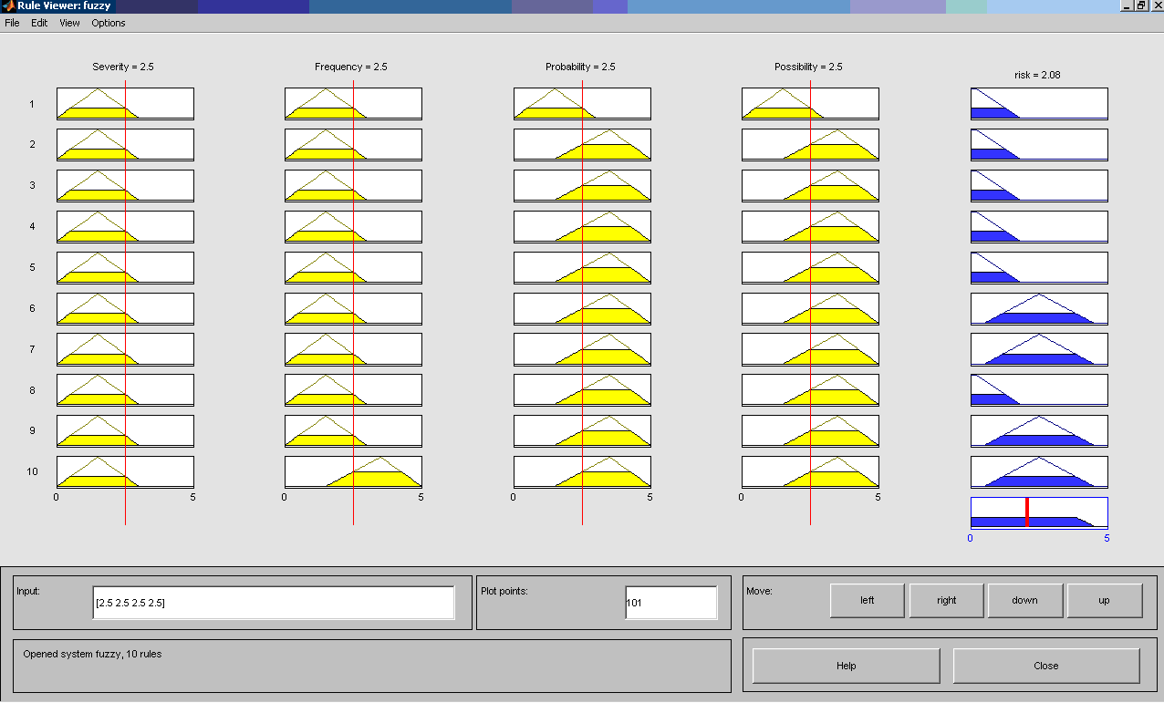

Figure 5: The overall perspective of the rules.

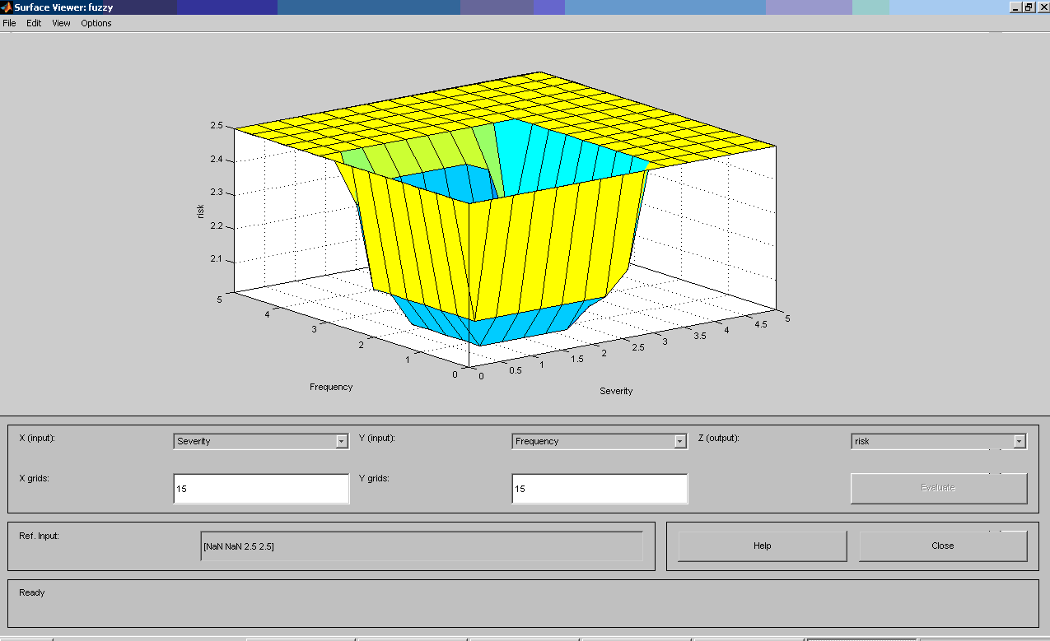

Figure 6: The surface of the problem as an export of MATLAB simulink.

**4. Conclusions**

Fuzzy logic is an established scientific theory that focuses on optimized solutions to problems and it is considered effective on dealing with problems with high degree of fuzziness. In the last decades, theory and applications of fuzzy logic have presented a great success in many scientific fields. The fuzzy system is designed using many variables and parameters supporting decision making. Through this research, the application of fuzzy logic has succeeded in defuzzification of safety guidelines via a fuzzy inference system. This system automates the decision making and quantifying the risk counting four input variables: severity, frequency, avoidance ability and probability of hazardous condition to take place. The new framework has proven that support risk assessment in optimized way reorganizing the work of standardization based on well-established standard as ISO 13482 (ISO 13482, 2014).

**References**

Anderson, S., (2008), Asimov’s “Three Laws of Robotics” and Machine Metaethics, *AI & Society*, **22** (4).

Harper, C., Dogramadzi, S., Tokhi, O., (2009), “Developments in vocabulary standardisation for robots and robotic devices”, *Twelfth International Conference on Climbing and Walking Robots and the Support Technologies for Mobile Machines*, Istanbul, Turkey.

ISO 13482 (2014), Robots and robotic devices – Safety requirements for personal care robots.

ISO 14121 (1999), Safety of machinery – principles of risk assessment.

ISO 10218-1 (2011), Robots for industrial environments – safety requirements – Part I: Robot.

ISO 10218-2 (2011), Robots and robotic devices, Safety requirements for industrial robots, Part 2: Robot systems and integration.

ISO Standard, ISO 8373:2007(E). Manipulating Industrial Robots – Vocabulary.

Mitka, E., Gasteratos, A., Kyriakoulis, N. and Mouroutsos, G.S. (2012), “Safety certification requirements for domestic robots”, *Safety Science, (Elsevier),* **50** (9), pp. 1888-1897.

Mouroutsos, G.S. and Mitka, E. (2012), “Classification of domestic robots”, *1st Virtual International Conference Advanced Research in Scientific Areas* (ARSA-2012), Slovakia.

Seungbin, M., Gurvinder, S.V., (2009), “Survey on ISO Standards for Industrial and Service Robots”. *ICROS-SICE International Joint Conference*, Japan.