Factors affecting the level of depositors’ satisfaction towards the services of commercial bank: Evidence from Vietcombank, Can Tho branch, Vietnam

Van-Thep Nguyen and Day-Yang Liu

Abstract

This study aims to analyze factors affecting the level of depositors’ satisfaction in Vietcombank, Can Tho brand (Vietnam). The data of this study was collected by a convenient sampling method from 65 customers who came to the bank for opening the savings account. By using the Cronbach's Alpha analysis to test the reliability of the scale, the exploratory factor analysis (EFA) to test the factors that affect depositors' satisfaction and determine the factors that are relevant for each factor, the confirmatory factor analysis (CFA), a special case of the structural equation modeling (SEM) to confirm the theoretical model of a measurement and test the correlations between the factors whether they are an explicit part of the analysis or not, and regression analysis to determine the impact factors (including controlling factors) to the level of depositors' satisfaction, we find a piece of evidence that the satisfaction of depositors towards the services of Vietcombank, Can Tho branch (Vietnam) mainly depends on the service quality. Therefore, to attract more depositors, the bank needs to pay attention to the quality of service to have a better service for customers.

JEL classification numbers: G15, G21, G28
Keywords: Bank, depositor, satisfaction, service quality

1 Introduction
Commercial banks are identified as the backbone of the economy, playing an important role in regulating the economy, stabilizing the financial market and managing the economy. In the context of globalization, however, the competition between local banks as well as domestic and foreign banks becomes stronger. As a result, banks are now striving to improve service quality, expand their operations networks, and modernize their banks to attract funds, especially funding from customers. Capturing the level of depositors' satisfaction, therefore, is always a matter of concern for banks so that they can meet the needs of existing customers and attract more potential customers as well. Compared to other banks, Vietcombank is considered as the largest commercial joint stock bank in Vietnam. Although it owns a wide network, funding from customers is still difficult due to compete to other commercial banks in the area. In addition, the operation of the bank also depends on the area of operation of each branch. Therefore, Vietcombank, Can Tho branch (Vietnam) also confront many challenges in meeting the needs of customers. This paper aims to analyze the factors affecting the level of depositors' satisfaction at Vietcombank, Can Tho branch (Vietnam). The research results are aimed at helping the bank better meet customers' expectations for the savings deposit service at the branch. Moreover, research results also help the bank to retain existing customers and have appropriate strategies to attract potential customers.
The rest of the paper is structured as follows. Section 2 provides a literature review on the level of depositors’ satisfaction towards the services of commercial banks. Section 3 describes the data sampling and the methodology, respectively. Section 4 presents the empirical results. Finally, section 5 offers some conclusions.

2 Literature review
Parvin and Hossain (2010) study on the satisfaction of users towards debit card in some private commercial banks in Bangladesh. The authors find that the higher the banks improve network service, provide receipt after transactions and solve of problems promptly, the greater debit card users satisfy.
Chavan and Ahmad (2013) study on factors affecting customer satisfaction in retail banking in Western Maharashtra in India. Their findings revealed that customer satisfaction is dependent on eight factors, namely Tangibility, E- fulfillment, Convenience & Availability, Accuracy, Responsiveness, Empathy, Promptness, and Personal Assistance.
Parvin et al. (2014) study on the satisfaction level of the individual customers from deposit management services of different commercial banks of Bangladesh. The authors employ five group factors named as reliability, responsiveness, assurance, empathy and tangible with many subfactors. They find a piece of evidence that the responsiveness, assurance, and tangible have statistically significant effect on satisfaction level from deposit management services in case of regression between satisfaction-specific factors and overall satisfaction from deposit management services, whereas the only type of bank respondents use and experience of banking of the respondents have statistically significant effect on the overall satisfaction level in case of regression between customer-specific factors and overall satisfaction from deposit management services.
In the same year, Adeniran and Junaidu (2014) study on the satisfaction of customers towards ATM services in the Nigerian banking sector. The sample in this study is employed by 100 respondents who are users of the ATM services. By use of multiple logistic regression analysis, the authors find that the perceived ease of use, transaction cost, and service security have a significantly positive effect on ATM services. However, the result also indicates that the relationship between ATM services and the availability of money is positive but insignificant. In the light of Adeniran and Junaidu (2014) contributions, Olusanya and Fadiya (2015) have an empirical study of ATM service quality on customer satisfaction in the United Bank of Africa. They also find that necessary input to the bank management to increase customers’ satisfaction through improving ATM service quality
In addition, Mutahar et al. (2017) study on the major factors contributing to customer intention to use mobile banking services in Yemen. The authors utilize Structure Equation Modelling (SEM) to determine the levels of association and interaction between group factors examined. They find that perceived usefulness, perceived ease of use, self-efficacy and perceived risk are significant predictors of intention to use mobile banking in the initial stage of adoption.

3 Data sampling and methodology
To apply the research model into reality, the data of this study was collected by a convenient sampling method by passing the questionnaire to customers who came to Vietcombank, Can Tho Branch (Vietnam) for opening the savings account. Analysis methodology in this paper consists of four steps: (1) use the Cronbach's Alpha analysis to test the reliability of the scale, (2) use the Exploratory Factor Analysis (EFA) to test the factors that affect depositors' satisfaction and determine the factors that are relevant for each factor, (3) use the Confirmatory Factor Analysis (CFA) to confirm the theoretical model of a measurement, and (4) use regression analysis to determine the impact factors (including controlling factors) to the level of depositors' satisfaction.

4 Empirical results
4.1 Sample descriptive analysis
The sample consists of 65 savings depositors in Vietcombank, Can Tho branch (Vietnam). Characteristics of the survey sample included gender, age group, level of education, occupation and monthly income are shown in Table 1.
Table 1: Descriptive Statistics of the sample
Variables | Count | Percentage (%)
Gender | 65 | 100
- Male | 28 | 43.1
- Female | 37 | 56.9
Age | 65 | 100
- 18 – 25 | 10 | 15.4
- 26 – 30 | 15 | 23.1
- 31 – 40 | 21 | 32.3
- More than 40 | 19 | 29.2
Level of education | 65 | 100
- High school | 18 | 27.7
- Bachelor | 24 | 36.9
- Master | 8 | 12.3
- Other | 15 | 23.1
Occupation | 65 | 100
- Business | 15 | 23.1
- Office worker | 16 | 24.6
- Teacher | 4 | 6.2
- Other | 30 | 46.2
Monthly income | 65 | 100
- Below 10 million VND | 35 | 53.8
- 10 – 15 million VND | 19 | 29.2
- 15 – 20 million VND | 6 | 9.2
- More than 20 million VND | 5 | 7.7
Source: Self-collected data
Descriptive statistics showed that customers are classified by the male and female ratio of 43.1% and 56.9%, respectively. These ratios show that women often hold household expenditures, so they often have deposits and transactions with banks. This is quite suitable for Asian and Vietnamese culture. In particular, the results show that customers aged 31 to 40 account for the majority with over 32.3% of the total number of observations because they are people of working age and make income, so they can desire to save for the future. Data from this study shows that these depositors are mainly holders of Bachelor’s degree (36.9%), High school (27.7%), a few with Master’s degree (12.3%), and other (46.2%). This group of the customer has jobs in a wide range of occupation such as office workers (24.6%), business (23.1%), teacher (6.2%) and other such as retired staffs, housewife, etc (46.2%). In addition, savings customers have an average monthly income of between 10 million VND and 15 million VND, accounting for 29.2% of the total. Most of them earn less than 10 million VND (53.8%), the rest of the sample has income is higher than 15 million (16.9%). The depositing of savings at any bank depends a lot on the source of information of the bank itself. The results of the information provided to depositors are shown in Figure 1.
Figure 1 shows that customers who come to open the savings account have many sources of information about deposit products such as from relatives, bank websites, bank employees, or other sources of information (television, radio, etc). However, the source of information they the most approach was from the bank's website (43.08%), the remaining from relatives accounted for 27.69%, from other sources accounted for 18.46%, and from bank employees account for 2.6%. This means that to attract customers to open a savings account depends a lot on the bank's website. The bank, therefore, should design a website with attractive and full information about the deposit service as well as promotions.

Figure 1: Do you know Vietcombank through which information source?
Source: Self-collected data
To determine the factors affecting the satisfaction of customers deposited in Vietcombank, Can Tho branch (Vietnam), the author has conducted a survey of customers who have come to the bank. Factors affecting the satisfaction of bank depositors are divided into four groups of factors, with a total of 14 factors, namely (1) Brand (Vietcombank is a well-known bank; Vietcombank is a reputable bank; and Vietcombank has operated in the banking industry for a long time), (2) Distribution Channel (Transaction network (branch, transaction office) of Vietcombank is wide; Vietcombank's transaction locations are convenient and safe for customers; Facilities of Vietcombank modern, comfortable, and clean; and Online distribution channels (Vietcombank online) convenient, safe, and high security), (3) Service Quality (Deposit procedures are simple, easy to understand, and implement; Time to process deposit is quick; Service attitude of Vietcombank staff is professional and polite; and Savings products at Vietcombank are diverse, and useful), and (4) Promotion (Vietcombank has many attractive promotions for customers; Promotions of Vietcombank are practical; and Vietcombank has good customer care policy). Savings depositors at the bank are asked to give their assessment of the importance of the factors (each factor is measured by 5 levels, from strongly disagree to strongly agree). The results of statistical analysis related to these factors are presented in Table 2.
Based on Table 2 show that the factor has the lowest mean of 3.25 with a standard deviation of 1.225, the factor has the highest mean of 4.43 with a standard deviation of 0.612. This means that customers are generally satisfied with the savings deposit service of the bank. In particular, these customers evaluate the following factors with relatively high point including “Deposit procedures are simple, easy to understand and implement”, and “Savings products at Vietcombank are diverse and useful” factors with mean of 4.43, “Transaction network (branch, transaction office) of Vietcombank is wide” factor with mean of 4.35.

Table 2: The level of customer satisfaction on the factors of the deposit service at Vietcombank
Variable | N | Minimum | Mean | Maximum | Std. Deviation
BR1 - Vietcombank is a well-known bank | 65 | 3 | 4.26 | 5 | 0.691
BR2 - Vietcombank is a reputable bank | 65 | 3 | 4.32 | 5 | 0.709
BR3 - Vietcombank has operated in the banking industry for a long time | 65 | 2 | 4.32 | 5 | 0.727
DC1 - Transaction network (branch, transaction office) of Vietcombank is wide | 65 | 3 | 4.35 | 5 | 0.648
DC2 - Vietcombank's transaction locations are convenient and safe for customers | 65 | 3 | 4.34 | 5 | 0.619
DC3 - Facilities of Vietcombank modern, comfortable, and clean | 65 | 3 | 4.22 | 5 | 0.599
DC4 - Online distribution channels (Vietcombank online) convenient, safe, and high security | 65 | 3 | 4.35 | 5 | 0.571
SQ1 - Deposit procedures are simple, easy to understand, and implement | 65 | 3 | 4.43 | 5 | 0.612
SQ2- Time to process deposit is quick | 65 | 2 | 4.22 | 5 | 0.739
SQ3 - Service attitude of Vietcombank staff is professional and polite | 65 | 3 | 4.34 | 5 | 0.619
SQ4 - Savings products at Vietcombank are diverse and useful | 65 | 3 | 4.43 | 5 | 0.585
PRO1 - Vietcombank has many attractive promotions for customers | 65 | 2 | 4.31 | 5 | 0.683
PRO2 - Promotions of Vietcombank are practical | 65 | 2 | 4.17 | 5 | 0.762
PRO3 - Vietcombank has good customer care policy | 65 | 2 | 4.15 | 5 | 0.795
Note: BR denotes for Brand; DC denotes for Distribution Channel; SQ denotes for Service Quality; and PRO denotes for Promotion
Source: Self-collected data
4.2 Cronbach’s Alpha analysis
Firstly, we conduct testing the reliability of the scale (Cronbach's Alpha) for levels of depositors' satisfaction with savings service quality of four groups with 14 variables and three variables belonging to the dependent variable (Depositor’s Satisfaction).
Table 3: Results Cronbach's Alpha scale
Variables | Scale mean if item deleted | Scale variance if item deleted | Corrected item total correlation | Cronbach’s alpha if item deleted
Brand – Cronbach’s Alpha = 0.783
BR1 | 8.63 | 1.705 | 0.542 | 0.789
BR2 | 8.57 | 1.405 | 0.744 | 0.568
BR3 | 8.58 | 1.559 | 0.590 | 0.742
Distribution Channel – Cronbach’s Alpha = 0.830
DC1 | 12.91 | 2.241 | 0.662 | 0.785
DC2 | 12.92 | 2.353 | 0.636 | 0.796
DC3 | 13.05 | 2.295 | 0.712 | 0.762
DC4 | 12.91 | 2.491 | 0.626 | 0.800
Service Quality – Cronbach’s Alpha = 0.761
SQ1 | 12.98 | 2.422 | 0.549 | 0.711
SQ2 | 13.20 | 2.225 | 0.485 | 0.758
SQ3 | 13.08 | 2.260 | 0.643 | 0.661
SQ4 | 12.98 | 2.422 | 0.590 | 0.692
Promotion – Cronbach’s Alpha = 0.737
PRO1 | 8.32 | 1.878 | 0.510 | 0.709
PRO2 | 8.46 | 1.627 | 0.562 | 0.650
PRO3 | 8.48 | 1.472 | 0.619 | 0.578
Depositor’s Satisfaction – Cronbach’s Alpha = 0.789
DS1 | 8.09 | 1.585 | 0.518 | 0.823
DS2 | 8.48 | 1.285 | 0.686 | 0.649
DS3 | 8.45 | 1.282 | 0.692 | 0.642
Source: The authors’ calculation
The test results show that Cronbach's Alpha coefficients for all factor groups are 0.737 or higher, ranging from 0.7 to 1.0, indicating that the scales are acceptable. Consider the corrected item total correlation of the 17 variables with no variable less than 0.3, this proved that the 17 variables are well used and very suitable. Thus, these 17 variables will continue to be used in the next exploratory factor analysis (EFA).
4.3 Exploratory factor analysis (EFA)
After analyzing factor groups for independent variables, we obtain the following results and is shown in Table 4.
Table 4: KMO and Bartlett’s Test (independent variables)
Kaiser-Meyer-Olkin Measure of Sampling Adequacy. |  | 0.880
 | Approx. Chi-Square | 461.440
Bartlett's Test of Sphericity | Df | 91
 | Sig. | 0.000
Source: The authors’ calculation
The results of the factor analysis show that the KMO is 0.880> 0.5, which proves that the data used for factor analysis is perfectly appropriate. Barlett's test result is 461,440 with a significance level (p-value) sig = 0.000 <0.05, which means that the variables are correlated and satisfy the condition of the factor analysis. For exploratory factor analysis for the dependent variable group, we obtain the following results: Validation of the model has a KMO coefficient of 0.664> 0.5 and Bartlett's test for the correlation of Observing variables (Sig. = 0.000 <0.05) demonstrated that the model used the appropriate analysis.
Table 5: KMO and Bartlett’s Test (dependent variables)
Kaiser-Meyer-Olkin Measure of Sampling Adequacy. |  | 0.664
 | Approx. Chi-Square | 61.229
Bartlett's Test of Sphericity | Df | 3
 | Sig. | 0.000
Source: The authors’ calculation
In the next step, we will perform principal components factor analysis with varimax rotation, and the results are shown in Table A (Appendix).
The value of the cumulative variance test (of 58.78% and greater than 50%) in Table A shows that two factors were extracted and these two factors explained 58.78% variance of the data (according to the eigenvalue standard greater than 1). This means that the model is capable of explaining about 60% of actual satisfaction. In particular, factor 1 has the highest explanatory power, the total variance of the sample is explained by factor 1 of 46.15% and factor 2 is only capable of explaining 12.63%. For the dependent variable, the results showed that three survey variables were initially classified into one group. The total variance is 70.35%> 50%, which is satisfactory, it can be said that this factor accounts for 70.35% of the variance of the data (as shown in Table B (Appendix)).
In the next step, to verify the reliability of the observed variables, we will consider the factor loading in the rotated component matrix to eliminate the non-conforming variables in the model (elements with factor loading less than 0.4). The factor loading of formed factors gives the minimum value of 0.486. Thus, these factors satisfy the conditions for the study to reach practical significance and thus 14 variables will be retained for clustering and interpretation. After analyzing the exploratory factor (EFA), the resulting 14 variables initially allowed the grouping of variables into two-factor groups. New element groups are named according to the content of the observation variables belonging to that factor group and are formed in Table 6.
Table 6: Rotated Component Matrix
Variables | Component
 | 1 | 2
SQ4 - Savings products at Vietcombank are diverse and useful | 0.832
PRO1 - Vietcombank has many attractive promotions for customers | 0.815
SQ3 - Service attitude of Vietcombank staff is professional and polite | 0.812
PRO3 - Vietcombank has good customer care policy | 0.678
PRO2 - Promotions of Vietcombank are practical | 0.642
DC2 - Vietcombank's transaction locations are convenient and safe for customers | 0.512
SQ1 - Deposit procedures are simple, easy to understand, and implement | 0.509
SQ2 - Time to process deposit is quick | 0.486
BR2 - Vietcombank is a reputable bank |  | 0.880
BR3 - Vietcombank has operated in the banking industry for a long time |  | 0.767
DC3 - Facilities of Vietcombank modern, comfortable, and clean |  | 0.719
BR1 - Vietcombank is a well-known bank |  | 0.701
DC4 - Online distribution channels (Vietcombank online) convenient, safe, and high security |  | 0.677
DC1 - Transaction network (branch, transaction office) of Vietcombank is wide |  | 0.512
Source: The authors’ calculation
With principal component and varimax rotation method show that the first-factor group consisted of eight observation variables. The content of these eight variables is related to the service quality, so the name of the first factor is Service Quality (SQ). The second factor consists of six observation variables, the contents of which are generic in terms of the bank's brand, so the second group's name is Brand (BR).
4.4 Confirmatory factor analysis (CFA)
Due to EFA is unable to incorporate substantively meaningful constraints, we continue to use confirmatory factor analysis (CFA), a special case of SEM, to confirm the theoretical model of measurement and test the correlations between the factors whether they are an explicit part of the analysis or not. The results are shown in the following figures.

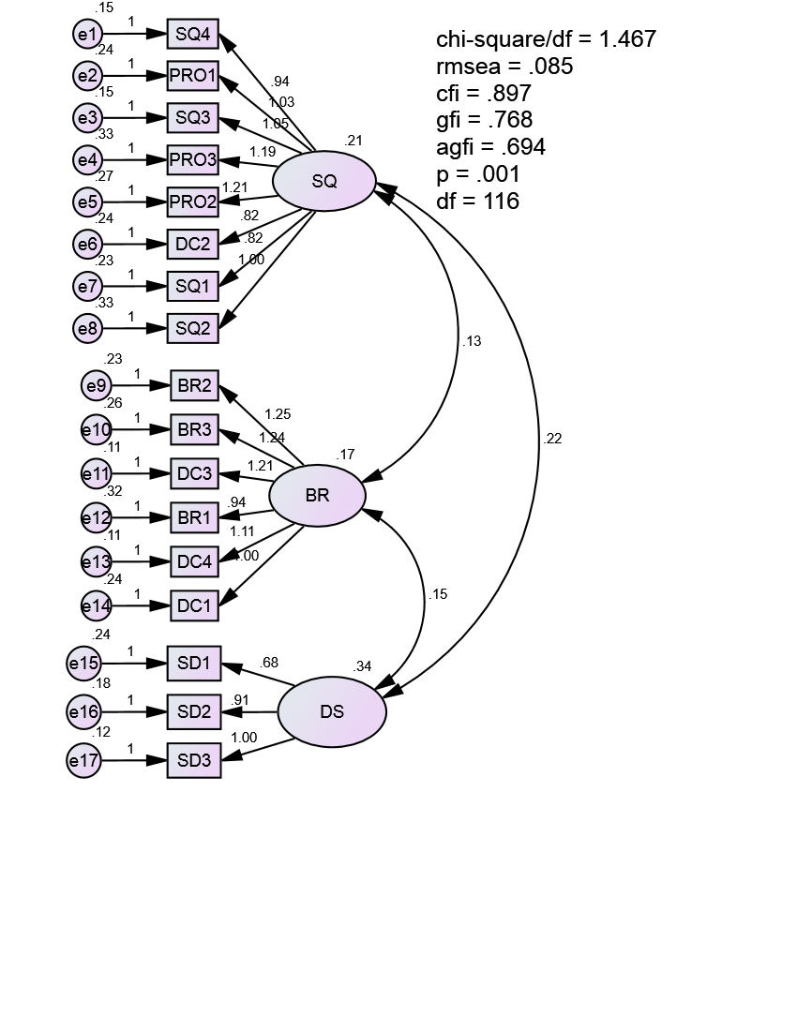
Figure 2: CFA analysis results of the research model
The CFA results (Figure 2) show that the model has CMIN/df = 1.467 (p = 0.001); GFI = 0.768; CFI = 0.897; RMSEA = 0.085, which prove the model is compatible with market data. The CFA results also show that the weights of all observed variables are > 0.5, thus confirming the unidirectional and convergent values of the scales.
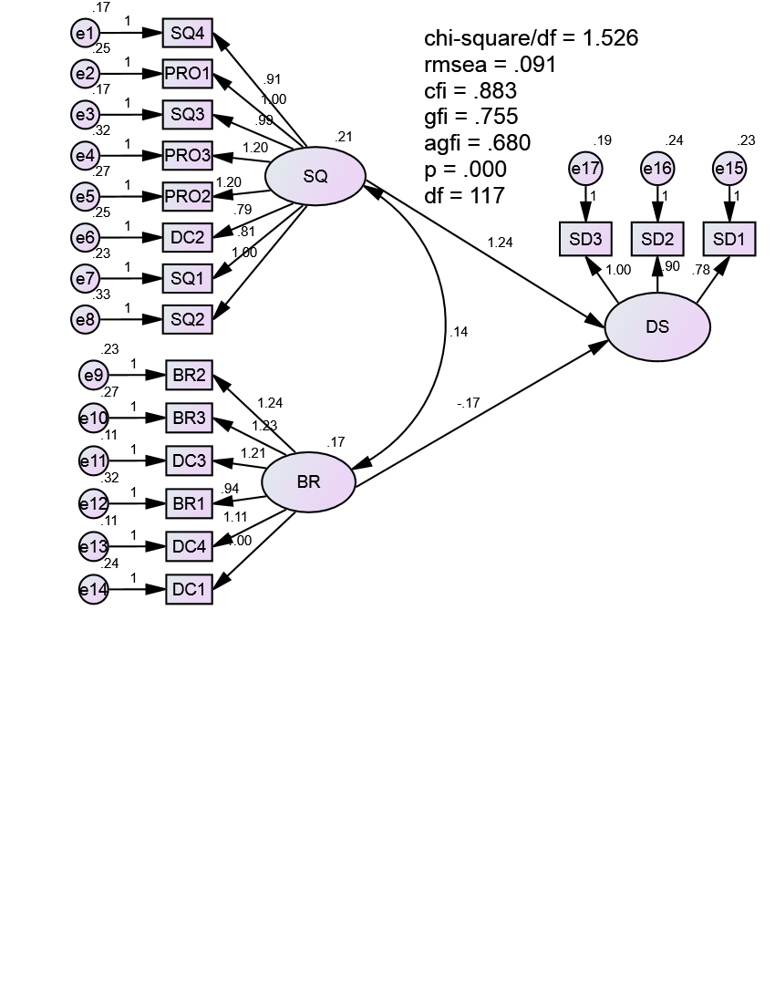
Figure 3: SEM analysis results of the research model
The SEM results (Figure 3) show that the model has CMIN/df = 1.526 (p = 0.000); GFI = 0.755; CFI = 0.883; RMSEA = 0.091, which prove the model is compatible with market data. Estimated results (Table 7) show that the service quality factor group (SQ) is statistically significant at 1% level, while the brand factor group (BR) is not statistically significant, even 10% level. This indicates that the factor affecting the decision to make a savings account at the bank is mainly from the quality of services, such as savings products, promotion, service attitude, and customer care policy.
Table 7: The coefficient between the dependent and independent variable
 | Estimate  (Unstandardized) | Estimate  (Standardized) | S.E | C.R | p
SQ DS | 1.244 | 1.093 | 0.284 | 4.384 | ***
BR DS | -0.165 | -0.130 | 0.203 | -0.812 | 0.417
Source: The authors’ calculation
4.5 Hypothesis using independent samples t-test
An independent-samples t-test was conducted to compare the level of depositors’ satisfaction between male and female gender. In this analysis, we want to know whether there is any difference in the level of depositors’ satisfaction between male and female. The results are reported in Table 8 and Table 9.
Table 8: Compare mean - Group statistics
What is your gender |  | N | Mean | Std. Deviation | Std. Error Mean
DS | Female | 37 | 4.1802 | 0.59106 | 0.09717
 | Male | 28 | 4.1548 | 0.52495 | 0.09921
Source: The authors’ calculation
Table 9: Compare mean – Independent samples test
 |  | Levene’s test for Equality of Variances |  | t-test for Equality of Means
 |  | F | Sig. | t | Df | Sig. (2-tailed) | Mean Diff. | Std. Error Diff.
DS | Equal variances assumed | 0.776 | 0.382 | 0.180 | 63 | 0.858 | 0.02542 | 0.14119
 | Equal variances not assumed |  |  | 0.183 | 61.324 | 0.855 | 0.02542 | 0.13887
Source: The authors’ calculation
Based on Levene’s test for Equality of Variances results show that equal variances assumed (F=0.776, p=0.382). Besides, the t-test for equality of means results show that we fail to reject the null hypothesis (t=0.180, p=0.858), it means that there was no significant difference in the level of depositors’ satisfaction between male (M=4.1548, SD=0.52495) and female (M=4.1802, SD=0.59106) conditions.
4.6 Regression analysis results
Table 10 presents the results of regression analysis (1) the regression model with control variables only and (2) the regression model with the factors affecting depositors' satisfaction, respectively, and control variables.
Table 10: Summary of regression analysis for variables predicting the level of depositors' satisfaction
Variables | The levels of depositors' satisfaction
 | Model 1 | Model 2 | Model 3
Constant | 3.953*** | 0.344 | -0.025
 | (10.999) | (0.719) | (-0.048)
Control variables
Gender | 0.026 | 0.130 | 0.168
 | (0.165) | (1.234) | (1.569)
Age group | 0.073 | 0.024 | 0.035
 | (0.950) | (0.459) | (0.678)
Educational background | -0.030 | 0.009 | 0.012
 | (-0.446) | (0.213) | (0.265)
Occupation | 0.026 | -0.024 | -0.017
 | (0.413) | (-0.581) | (-0.415)
Main effects
SQ – Service quality |  | 0.872*** | 0.748***
 |  | (8.705) | (5.854)
BR – Brand |  |  | 0.194
 |  |  | (1.547)
F | 0.256 | 15.617*** | 13.720***
R² | 0.017 | 0.570 | 0.587
Adj. R² | -0.049 | 0.533 | 0.544
Δ R² | 0.017 | 0.053 | 0.017
N | 65 | 65 | 65
Note: *** is statistical significance at the 1% level; t value in parentheses
Source: The authors’ calculation
Regression analysis was performed to test research hypotheses whether service quality, brand variables, and control variables impact on depositors’ satisfaction or not. As seen in model 3 in Table 10, the regression highlights an acceptable power of the model to explain the level of depositors’ satisfaction (F=13.720, p=0.000), which explains 58.7% of the variance of the level of depositors’ satisfaction (R²=0.587). The results showed that only service quality variable has a positive relationship with depositor’s satisfaction (β=0.748, p=0.000), whereas other variables, including control variables, are insignificant with depositors’ satisfaction. With the addition of the brand variable, the model explains an additional 1.7% of the variance in the level of depositors’ satisfaction. However, this R squared change is insignificant. Therefore, the bank needs to pay attention to the quality of service to have a better service for customers, thereby improving the quality of savings deposit services at the bank, attracting more depositors.

5 CONCLUSION
Determining the level of depositors' satisfaction is vital for banking operations. In this paper, by using the Cronbach's Alpha analysis to test the reliability of the scale, the exploratory factor analysis (EFA) to test the factors that affect depositors' satisfaction and determine the factors that are relevant for each factor, the confirmatory factor analysis (CFA), a special case of the structural equation modeling (SEM) to confirm the theoretical model of a measurement and test the correlations between the factors whether they are an explicit part of the analysis or not, and regression analysis to determine the impact factors (including controlling factors) to the level of depositors' satisfaction, we find a piece of evidence that the satisfaction of depositors towards the services of Vietcombank, Can Tho branch (Vietnam) mainly depends on the service quality. Therefore, in order to improve the level of depositors' satisfaction, the bank should actively encourage employees to provide services as committed, and the employees' attitude always towards building trust for customers.

6 REFERENCES
[1] Adeniran, L. M. A. R., and Junaidu, A. S. (2014). An empirical study of automated teller machine (ATM) and user satisfaction in Nigeria: A study of United Bank for Africa in Sokoto Metropolis. International Journal of Management Technology, 2, 1-11.
[2] Chavan, J., and Ahmad, F. (2013). Factors affecting on customer satisfaction in retail banking: An empirical study. International Journal of Business and Management Invention, 2, 55-62.
[3] Mutahar, A. M., Daud, N. M., Ramayah, T., Isaac, O., and Alrajawy, I. (2017). Examining the intention to use mobile banking services in Yemen: An integrated perspective of technology acceptance model (TAM) with perceived risk and self-efficacy. Asian Journal of Information Technology, 16, 298-311.
[4] Olusanya, A. I., and Fadiya, S. O. (2015). An empirical study of automated teller machine service quality on customer satisfaction: A case study of United Bank of Africa. International Journal of Scientific Research in Information Systems and Engineering, 1, 61-68.
[5] Parvin, A., and Hossain, S. (2010). Satisfaction of debit card users in Bangladesh: A study on some private commercial banks. Journal of Business and Technology, 5, 88-103.
[6] Parvin, A., Perveen, R., and Afsana, J. (2014). Evaluation of individual depositor’s satisfaction from deposit management services of commercial banks of Bangladesh. European Journal of Business and Management, 6, 128-137.

Appendix
Table A: Total Variance Explained (independent variables)
Component | Initial Eigenvalues |  |  | Extraction Sums of Squared Loadings |  |  | Rotation Sums of Squared Loadings
 | Total | % of Variance | Cumulative % | Total | % of Variance | Cumulative % | Total | % of Variance | Cumulative %
1 | 6.461 | 46.152 | 46.152 | 6.461 | 46.152 | 46.152 | 4.282 | 30.586 | 30.586
2 | 1.767 | 12.625 | 58.777 | 1.767 | 12.625 | 58.777 | 3.947 | 28.191 | 58.777
3 | 0.912 | 6.514 | 65.291
4 | 0.844 | 6.030 | 71.321
5 | 0.727 | 5.190 | 76.511
6 | 0.644 | 4.602 | 81.112
7 | 0.513 | 3.664 | 84.776
8 | 0.475 | 3.396 | 88.172
9 | 0.395 | 2.823 | 90.995
10 | 0.306 | 2.187 | 93.183
11 | 0.299 | 2.133 | 95.315
12 | 0.233 | 1.667 | 96.982
13 | 0.228 | 1.630 | 98.612
14 | 0.194 | 1.388 | 100.000
Source: The authors’ calculation

Table B: Total Variance Explained (dependent variables)
Component | Initial Eigenvalues |  |  | Extraction Sums of Squared Loadings |  |  | Rotation Sums of Squared Loadings
 | Total | % of Variance | Cumulative % | Total | % of Variance | Cumulative % | Total | % of Variance | Cumulative %
1 | 2.111 | 70.353 | 70.353 | 2.111 | 70.353 | 70.353 | 1 | 2.111 | 70.353
2 | 0.589 | 19.633 | 89.985 |  |  |  | 2 | .589 | 19.633
3 | 0.300 | 10.015 | 100.000 |  |  |  | 3 | .300 | 10.015
Source: The authors’ calculation

Corresponding author. Graduate Institute of Finance, National Taiwan University of Science and Technology (NTUST), Taiwan, email: nvthep@ctu.edu.vn
Graduate Institute of Finance, National Taiwan University of Science and Technology (NTUST), Taiwan, email: LIUDY@mail.ntust.edu.tw

