Pro-cyclical banking leverage in France: on its existence and management
Carmela D’Avino
University of East London
Stratford Campus
Water Lane
London
E15 4LZ
E-mail : c.davino@uel.ac.uk
Tel.: 020 8223 2647

The paper proposes several facts in support of the evidence that French banks actively manage their leverage. Impulse responses estimated from multivariate models allow assessing which balance sheet claims are used by banks to fine-tune their leverage. It is found that leverage adjustments are primarily attained through changes in domestic and foreign credit. The dynamic pattern of leverage is less affected by shocks to securities holdings, implying that the amplifying mechanism on the real economy that occurs via leverage adjustment is expected to work directly via bank credit rather than via asset markets.

Keywords: Banks, financial-real sector linkages, leverage management, shock transmissions.
JEL Classification: E02, E32, G21.

- Introduction
According to monetary policy theory, banks directly transmit unexpected policy shocks exclusively through the bank lending channel of the credit view. Pioneered by [1], this channel describes the amplifying effect that banks have on the real economy through changes in credit supply, resulting from variations in liquidity provided by the central bank. Studies on the bank lending channel have, however, showed that its empirical relevance is rather weak. In particular, this channel tends to fail whenever a bank is large and/or liquid ([2]), has high capital ([3]), operates in a highly concentrated market ([4]), engages in securitisation ([5]) or has important foreign branches ([6]). Moreover, the burgeoning of non-banks financial institutions observed in the last two decades represents a further obstacle to the functioning of this channel. Indeed, even if bank loans can be successfully altered by the monetary policy shock, economic agents’ spending might be financed by other unregulated non-bank lenders, offsetting the desired effect of the central bank on economic activity.
Nevertheless, the latest financial crisis has highlighted the strength of the inter-linkages between the banking sector and the real economy, leading many researchers to investigate the existence of alternative transmission channels in which banks have a prominent role ([7]). Most of the attention has been devoted to the amplification mechanisms set off by the feedbacks between banks balance sheets and asset markets (a good survey is provided by [8]). A major contribution has been provided by [2] who have advanced the hypothesis that banks can amplify business cycle fluctuations via active leverage management. As the value of assets changes with cyclical conditions, and so does leverage, banks might, indeed, decide to actively act either to restore a desired fixed leverage threshold or to allow the leverage follow the cycle. Indeed, book leverage, measured as total assets over net worth, if left unmanaged, is countercyclical: it falls during booms and increases during slumps. This is because the value of banks’ assets tends to be pro-cyclical and the net worth grows at a faster rate than total assets, assuming that the value of liabilities stays roughly constant. However, if leverage is actively managed, banks will increase (decrease) the leverage ratio during booms (slumps) amplifying business cycle fluctuations.
Based on this very recent literature, this paper aims to test empirically whether cyclical variations in balance sheet size result in active leverage adjustment by banks for the French case. How the leverage management takes place is also of central interest in this research. The expansion (reduction) of balance sheet size, which happens if banks decide to increase (decrease) their leverage during an economic boom (slump), can, indeed, be carried out in several ways. Banks might, for instance, increase (reduce) loans issuance having a direct effect on the real economy. Or, instead, they can decide to invest (fire-sale) in asset markets, putting pricing pressure on selected securities. In this case, the propagation effects caused by banks’ behaviour on the real economy are more complex and difficult to quantify as the transmission will work via asset prices and the net worth of the players in asset markets.
This paper is the first attempt to focus exclusively on the pro-cyclicality of the French banking system. Available empirical evidence is primarily based on results obtained for a large panel of banks belonging to several European countries ([12]) or focusing on the Canadian ([13]) and German ([14]) banking systems.
The paper is structured as follows. Section 2 presents the underpinnings of the liquidity channel and of the new financial accelerator. Section 3 provides some preliminary statistics on the balance sheet variables of French banks and in Section 4 multivariate models are formally estimated alongside relevant impulse response functions. Section 5 concludes.

- The new financial accelerator
The subprime financial crisis brought about a profound reconsideration on how the banking sector can transmit shocks to the real economy. The classical bank lending channel has, indeed, proved to be badly supported by empirical models mainly because the banking sector is little affected by monetary policy shocks, which are, hence, merely transmitted by banks to the real economy. Researchers have then focused their attention to other shocks (i.e. other than monetary policy ones) which might have a substantial impact on business cycle via the banking sector. Most notably, a large consensus has been reached about the fact the roots of the observed amplifications of economic cycle via the banking sector are to be found in assets and funding markets dynamics.
In [8] the liquidity channel is defined as the mechanism that transmits shocks from the banking system to the real economy which is set off by self-reinforcing mutual feedbacks between assets markets and banks’ balance sheets. As detailed formally in [15], the liquidity channel works in the following way: let’s assume that a drainage of liquidity in banks’ funding markets occurs and that this leads banks to fire sale their claims in order to meet their debt obligations. The consequential downward pressures in asset prices results in balance sheet corrosion for all those agents that hold the same assets who will, in turn, sell more assets depressing prices even further. When the liquidity channel is set off by this pro-cyclical and self-reinforcing interaction between market and funding liquidity, i.e. the liquidity spiral, banks will be compelled to cut their lending to the economy. The mechanism also works in the reverse: during an economic boom, banks can expand their balance sheet at ease given the high liquidity in funding markets (and lower costs of borrowing), causing pricing inflation in some asset markets. Stronger balance sheets of economic agents will, in turn, put further inflationary pressure on asset prices and so on.
Along the lines of [15], [9] have stressed that an initial shock to asset values (due to the liquidity spiral, the standard asset price channel or any other exogenous factor) can be amplified even more by the banking system, depending on whether banks actively adjust their leverage either pro-cyclically or to target a fixed level. This amplification mechanism set off by leverage adjustments has been referred to as the new financial accelerator by [10], as it is similar to the financial accelerator ([16]) but operates through banks’ net worth rather than through that of borrowers.
[9] argue that the increase (decrease) in asset prices and in balance sheet size typically observed during an economic boom (recession) causes book leverage to fall (increase), if left unmanaged. This is particularly true for those agents, such as financial intermediaries, that have an important share of asset claims in their balance sheet that are valued at fair value. However, banks might actively adjust their leverage by further expanding (reducing) their balance sheet which, in turn, will magnify the effects of the cycle on the real economy and asset markets. In particular, if banks adjust their leverage by expanding their size through an increase in credit, then, shock are directly transmitted by banks to the real economy; if instead, banks expand their size via an increase in their securities holdings, then, the shock propagation to the real economy works through assets prices and markets’ liquidity.
Next section aims at providing some statistical evidence on whether French banks actively adjust their leverage, providing some scope for the existence of the new financial accelerator. The choice to focus on the French banking system is dictated by a number of reasons. Firstly, the French banking system is highly concentrated with the largest banks featuring a universal business model, implying that balance sheets are more sensitive to changes in asset prices given the inclusion of investment banking business units in the consolidated accounts. Secondly, French banks are characterised by a higher reliance, compared to EMU average, on non-deposit funding (Figure 1), implying that the feedbacks between the banking system and asset markets could be relatively more important.

- Some preliminary evidence on the French case

Figure 2 shows that French banks’ assets have followed an overall pro-cyclical pattern, despite the high volatility observed for the de-trended series in real terms. Also, the cyclical behaviour of banking assets is characterised by a very close co-movement with the level of leverage; this is particularly evident since the early 2000s. The co-movement between leverage and assets cycles suggests that banks actively manage their leverage in a pro-cyclical manner. Indeed, if banks did not adjust their leverage, the observed relationship between leverage and business cycle would be negative. This result is further confirmed by the striking positive relation between the annual growth rate of leverage and real assets (Figure 3). Granger causality tests (Table 1) also confirm the evidence of mutual feedbacks between leverage and total assets. Moreover, they reveal that mutual feedbacks between leverage and foreign loans, both with counterparties in the euro area and in the rest of the world.
Cross-correlation analysis is a useful preliminary tool for understanding whether leverage adjustments by banks occur by fine-tuning the balance sheet size either in an orderly manner, (i.e. by fine-tuning a particular asset-side item) or in an unsystematic manner (i.e. by adjusting the whole composition of banks’ assets). Table 2 reports the cross-correlations of the cyclical component of leverage with that of several balance sheet asset-side variables. The cyclical component of total assets shows the highest correlation coefficient which reaches its peak at time t, implying the contemporaneous (i.e. intra-quarter) co-movement of the two cycles. The cross-correlation of the leverage cycle with other asset-side items, such as loans and securities are relatively lower, never reaching a coefficient higher than ±0.4. In all cases the cross-correlations with the majority of other claims also reach their peak at time t; this is probably due to the low frequency of the data. This evidence also indicates a very dynamic system in which balance sheet claims respond promptly to leverage changes.
- Empirical impulse-response analysis from a multivariate model

Active leverage management is attained by banks through variations in both assets and liabilities. In particular, the process works in the following way. Let’s imagine that the value of some asset (A) increases, strengthening the balance sheet of banks having those assets among their claims. If the value of liabilities (L) stays roughly constant, then, book leverage (lev) will fall. Leverage is, indeed, equal to the following ratio:
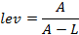

If banks do not react to the change in asset prices, then, there is a negative relationship between the value of assets and leverage. If, instead, banks decide to restore a given leverage target ratio or to increase leverage in a pro-cyclical manner, then they will take on additional liabilities which allow the purchase of more assets.
In order to understand the extent of shocks transmissions to the real economy via the banking system it is important to gauge which type of claims allow banks to fine-tune their leverage. If banks, for instance, choose to purchase selected securities that have markets which are not perfectly liquid, then, assets prices increase even further and leverage falls, as described above. Then, banks in order to restore their leverage will purchase even more assets, putting further pressure on asset prices. In this case, banks will transmit shocks to the real economy in a rather indirect way as the transmission mechanism will work mainly through changes in the net worth of financial counterparties caused by the increased demand for the asset.
If banks, instead, choose to issue more credit to the private sector, then, the transmission to the real economy will be immediate and will resemble to the bank lending channel and the inter-linkages between asset markets and banks’ balance sheets will be weaker.
Lastly, banks might have no predefined strategy to adjust the size of their balance sheet; in this case, an upward adjustment in assets will be achieved by increasing credit supply and assets holdings to different degrees.
In order to establish how leverage is managed, selected impulse response functions are estimated from a Vector Auto Regressive model (VAR, [18]) for the French data. Given the large number of asset-side items which can be used by the banking system to adjust the leverage, several VARs are estimated. In particular, each VAR contains a set of fixed variables, that is, book-leverage, total banking assets and real GDP, to which is added one (or more) asset-side banking claim which varies with each model. The rationale behind the choice of the fixed variables are found in the model described in [9], as explained in the Section 2. Among the several banking claims considered, are found: domestic credit and to the banking sector, foreign loans (both to the euro area and the rest of the world), inter-bank securities (both short and long term) and other claims (such as securities issued by the private sector, mutual funds and other shares). Summary statistics on all the endogenous variables considered are found in Table 3. The endogenous variables included in multivariate models are in log-levels in order to allow for implicit cointegration relations between the series. Impulse responses are generated based on each of the VAR^{i}(p_{i}) model of the following form:
(1)
Where is a vector of endogenous variables, is a constant term and is a vector
of white noise disturbances. The vector includes the following variables:
Table 4 reports the specifications and model adequacy tests for each VAR^{i}(p_{i}) model. The seven models have unit roots smaller than one and disturbances behave fairly well. The LM test for serial correlation indicates no autocorrelation at 5% confidence level in all models; however, the White test reveals some heteroskedasticity in a limited number of models.
Models in (1) are used to estimate generalised impulse response functions (Pesaran and Shin, 1996), which allow estimating the dynamic pattern of a variable x_{t} to a shock to another system’s variable through orthogonal innovations which are invariant to variable ordering.
In order to understand how the balance sheet is adjusted to fine-tune the leverage pro-cyclically, it is of primary importance to analyse the dynamic pattern of leverage following shocks in different asset-side variables. However, beforehand, a check test of (1) is necessary to confirm that the model estimated adequately supports the variables’ dynamics as described in Section 2 and the stylised facts advanced in Section 3. Figures 4.a and 4.b report the estimated responses of the systems’ variables when assets and leverage are shocked. The impulse response functions shown refer to the specification of model (1) in which is total domestic credit; nevertheless, impulse responses are broadly robust among models. Figure 4a shows the cumulated generalised impulse responses to a one standard deviation shock in total assets, equal to about 1.6% increase on impact. The shock causes a contemporaneous and significant increase in leverage of about 1.5%. The effect on leverage increases over the 24-months horizon, following closely the dynamic path of the exogenous shock in total assets, increasing by as much as 20%. This evidence supports the fact French banks actively adjust their leverage as an unexpected shock to asset value has a positive and significant effect on leverage.
Figure 4.b shows the cumulated generalised impulse responses to an exogenous shock to leverage. The estimates show a positive and significant effect of total assets which, in cumulated terms, reaches over 25% after 2 years.
The insignificant effect on real GDP in both cases is surely due to the fact that shocks to banking assets and leverage have an indirect effect on the real economy via selected banking claims, the net worth of borrowers and/or asset markets. Overall, the evidence showed in Figures 4.a and 4.b confirms the existence of mutual feedbacks between banking leverage and total assets as suggested by the preliminary analysis in the previous section.
Figure 5 reports the generalised impulse responses of leverage when shocking the asset-side item(s) in each of the seven VAR^{i}(p_{i}) models (see Table 4 for specification). As previously mentioned, this approach allows understanding which type of claim banks typically use to adjust their leverage. Model 1 includes as asset claim all domestic credit. As it can be noticed in the top graph of Figure 5, a one-standard deviation shock to domestic credit (to all sectors) has a positive and significant effect to leverage which increases by about 6% after one year. When the two sub-categories of total domestic credit are considered separately into credit to the private sector and to the banking sector (Model 2) it can be noticed that credit to the private sector has a relatively larger effect on leverage than the latter. Altogether, these pieces of evidence suggest that a shock to credit to the private sector has a relatively large effect on leverage. When considering foreign loans, split into loans to the euro area and to the rest of the world (Model 3), it can be noticed that also these variables have a relatively large positive effect on leverage. In particular, a positive shock to loans to the rest of the world causes leverage to increase by 20% after 2 years. On the other hand, the response of leverage to shocks in interbank claims, both short and long term maturities, is rather small and significant only within the first six months of the horizon (model 4). Shocks to securities issued by the private sector (model 5) and mutual funds shares (model 6) see no significant response on leverage. Therefore, the evidence proposed in Figure 5 shows that the increase in leverage occurs mainly through the increase in credit, both domestic and foreign. This implies that the transmission channel activated by banks’ leverage adjustments barely works thorough asset markets and thus, should not put considerable pressures on asset prices. The effect on asset prices might only be indirect through borrowers’ investment decisions and the self-reinforcing spiral between asset size and leverage spiral should not be relevant.
- Conclusion

Understanding whether the banking system in a country actively adjusts its leverage with the business cycle is of crucial importance to gauge the strength of the linkages between the financial and the real sectors. This is mostly true for those countries in which a liquidity channel is potentially important as banks, the real sectors and assets markets can be particularly interrelated.
This paper provides evidence on pro-cyclical leverage management practices by the French banking system. The results point to a limited role of banks to amplify business cycle fluctuations via assets markets and to self-reinforcing feedbacks between the leverage and the credit cycles. Pro-cyclical leverage adjustments occur mainly through traditional loans, suggesting that business cycle fluctuations are directly amplified via claims to the private sector. Furthermore, leverage is also actively adjusted through foreign claims, suggesting the set-off of an international propagation channel via cross-border bank lending.
The mutual feedbacks that exist between balance sheet size and leverage for the French case, therefore, are not entirely explained by the mechanism by [9] in which banks, when adjusting actively their leverage put significant pricing pressure on assets markets, setting off mutual feedbacks between bank leverage and asset markets.

References

[1] B. S. Bernanke and A. S. Blinder, “Credit, money, and aggregate demand,” The American Economic Review, vol. 78, no.2, May 1988, pp. 435-439.
[2] A. K. Kashyap and J. C. Stein, “What do a million observations on banks say about the transmission of monetary policy?,” The American Economic Review, vol. 90, no. 3, June 2000, pp. 407-428.
[3] S. J. Van den Heuvel, "Does bank capital matter for monetary transmission?," Economic Policy Review, vol. 8, no. 1, May 2002, pp. 259-26.
[4] R. M. Adams and D. F. Amel, “The Effects of local banking market structure on the bank-lending channel of monetary policy,” 2005, Federal Reserves Working Paper No. 16.
[5] E. Loutskina and P. E. Strahan, “Securitization and the declining impact of bank finance on loan supply: evidence from mortgage acceptance rates,” Journal of Finance, vol. 64, no. 2, April 2009, pp. 861-889.
[6] N. Cetorelli and L. S. Goldberg, "Banking globalization and monetary transmission," Journal of Finance, vol. 67, no. 5, October 2012, pp. 1811-1843.
[7] M. Woodford, “Financial intermediation and macroeconomic analysis,” Journal of Economic Perspectives, vol. 24, no. 4, Fall 2010, pp. 21-44.
[8] Basel Committee on Banking Supervision, “The transmission channels between the financial and real sectors: a critical survey of the literature,” BCBS Working Papers, no. 18, February 2011.
[9] T. Adrian and H. S. Shin, “Liquidity and leverage,” Journal of Financial Intermediation, vol. 19, no. 3, July 2010, pp. 418–437.
[10] P. Angelini and F. Panetta, "Financial sector pro-cyclicality: lessons from the crisis," Bank of Italy Occasional Papers, No.44, 2009.
[11] J. A. Bikker and H. Hu, “Cyclical patterns in profits, provisioning and lending of banks,” DNB Staff Reports, no. 86, 2002.
[12] R. Gropp and F. Heider, “The Determinants of bank capital structure,” Review of Finance, vol. 14, 2010, pp. 587-622.
[13] H. E. Damar, C. E. Meh and Y. Terajima, "Leverage, balance sheet size and wholesale funding," Journal of Financial Intermediation, vol. 22, no. 4, October 2013, pp. 639-662.
[14] C. Memmel and P. Raupach, “How do banks adjust their capital ratios?,” Journal of Financial Intermediation, vol. 19, no. 4, October 2010, pp. 509-528.
[15] M. K. Brunnermeier and L. K. Pedersen, “Market liquidity and funding liquidity,” Review of Financial Studies, vol. 22, no. 6, June 2009, pp. 2201-2238.
[16] N. Kiyotaky and J. Moore, “Credit cycles,” Journal of Political Economy, vol.105, no. 2, April 1997, pp. 211-248.
[17] F. S. Mishkin, “The monetary transmission mechanism: lessons for policy,” NBER working paper, no. 5464, February 1996.
[18] C. A. Sims, “Interpreting the macroeconomic time series facts: The effects of monetary policy,” European Economic Review, vol. 36, no. 5, June 1992, pp. 975-1000.
[19] M. H. Pesaran and Y. Shin., “Generalized impulse response analysis in linear multivariate models,” Economics Letters, vol. 58, no. 1, January 1998, pp.17-29.

Figures
Figure 1: Selected balance sheet ratios: France and the euro area
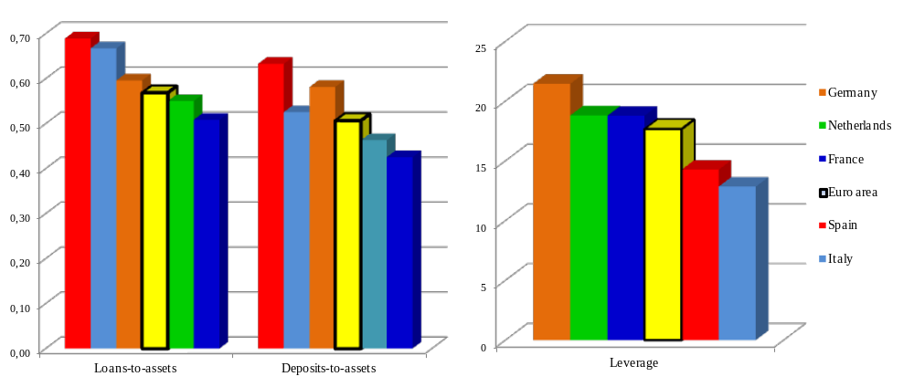
Source: ECB. Figure 1 shows a snapshot of the three series in January 2008. Data refer to Monetary Financial Institutions (MFIs) balance sheets. Leverage is calculated as the ratio of total assets to capital (book leverage).

Figure 2: Cyclical fluctuations in real GDP and assets versus leverage
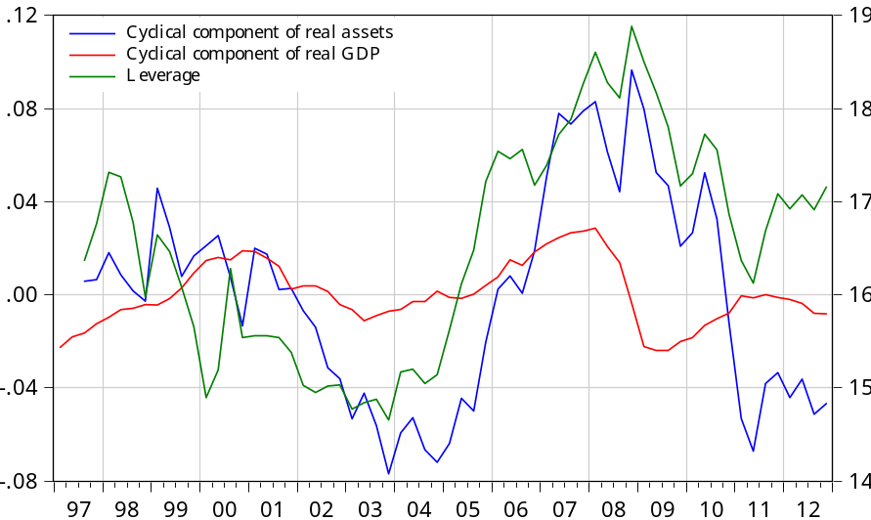
Note: The cyclical component of the series is extracted using the Hodrick-Prescott (HP) filter. Real assets and GDP (left-hand scale) are in logs, leverage (right-hand scale) in levels. Assets are deflated by the CPI (INSEE).

Figure 3: Annual growth rates of assets and banking sector leverage
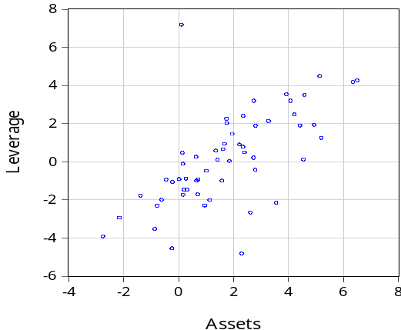
Note: Annual growth rates are computed for quarterly data over the period 1998-2012.

Figure 4.a: Generalised impulse response functions with respect to a one-standard deviation shock to Total Assets
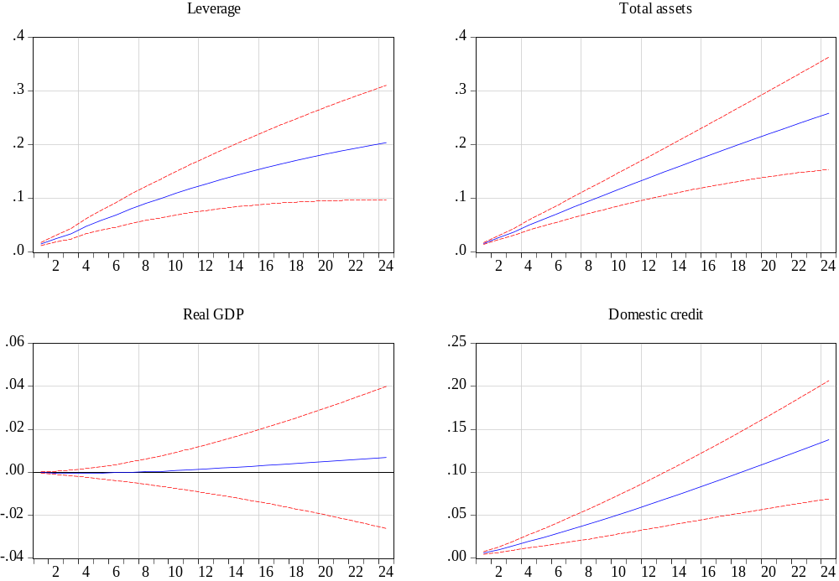
Figure 4.b: Generalised impulse response functions with respect to a one-standard deviation shock to Leverage
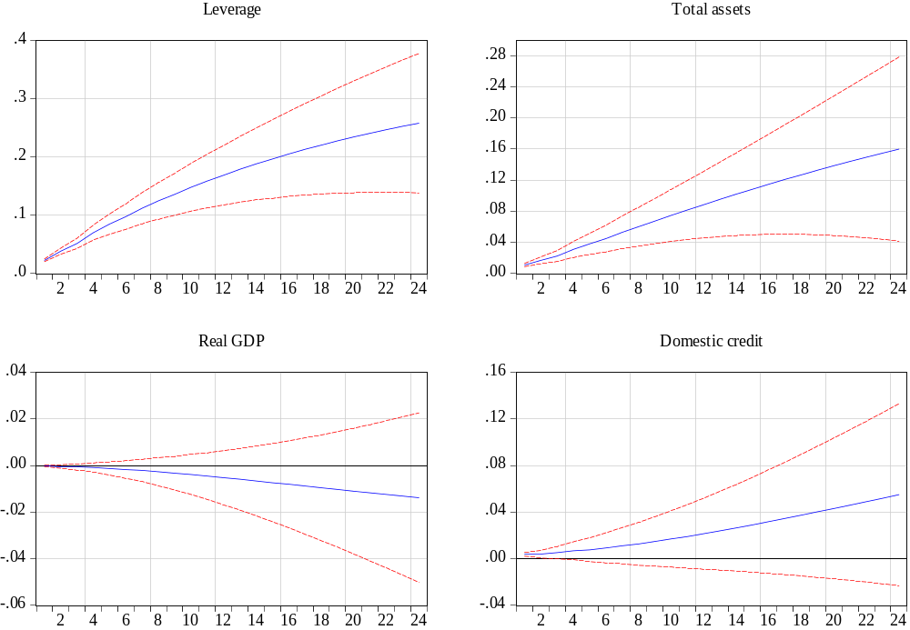
Note: Figures 4.a and 4.b show the accumulated responses of the variables in the system following a one-standard deviation positive shock to the structural error of the total assets and leverage equations respectively. The endogenous variables included in the VAR(4) in logs are: leverage, total assets, total domestic credit and real GDP. Monthly data covers the period 1997-2012. Details of the estimated VAR(4) model are reported in Table 4, specification 1.

Figure 5: Generalised impulse response functions of leverage in various models with respect to a one-standard deviation shocks to selected claims
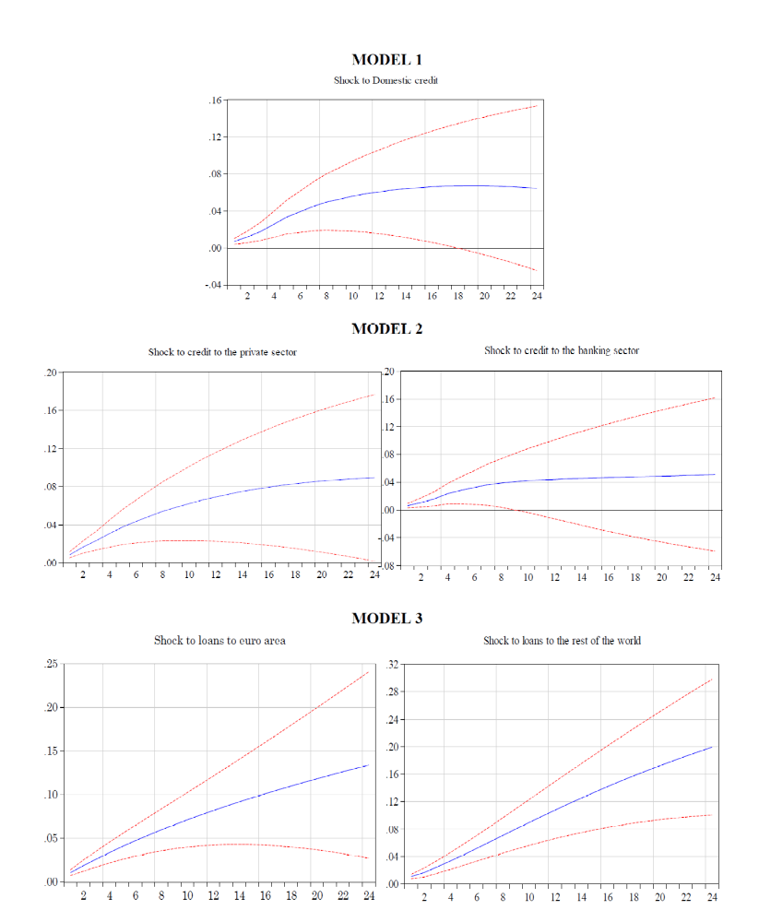

Figure 5: Generalised impulse response functions of leverage in various models with respect to a one-standard deviation shocks to selected claims
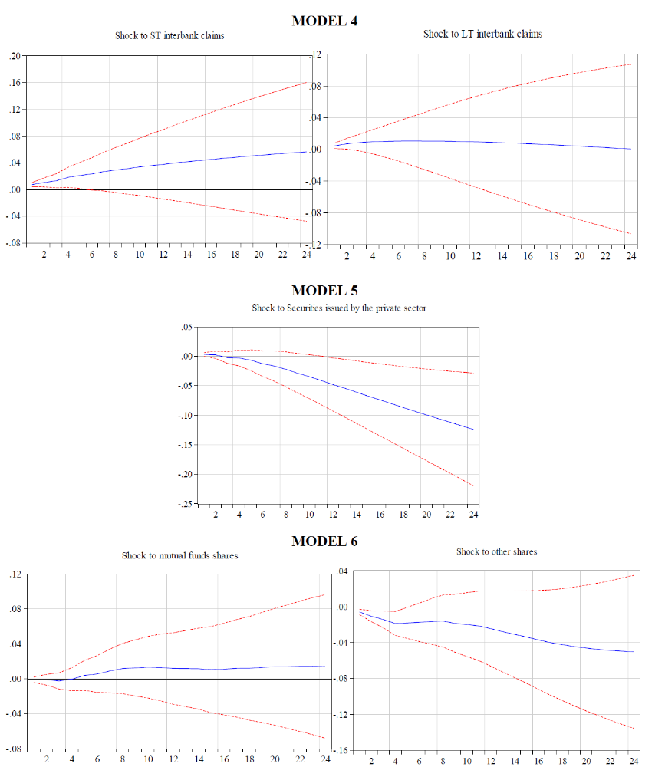

Tables
Table 1: Pairwise Granger Causality Tests
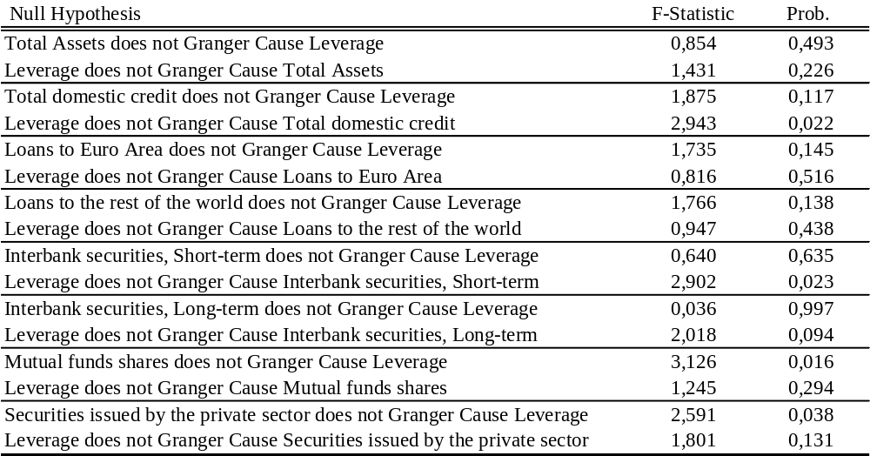
Notes: Four lags used for the Granger causality test.

Table 2: Cross-correlations between the leverage cycle and the cyclical component of assets
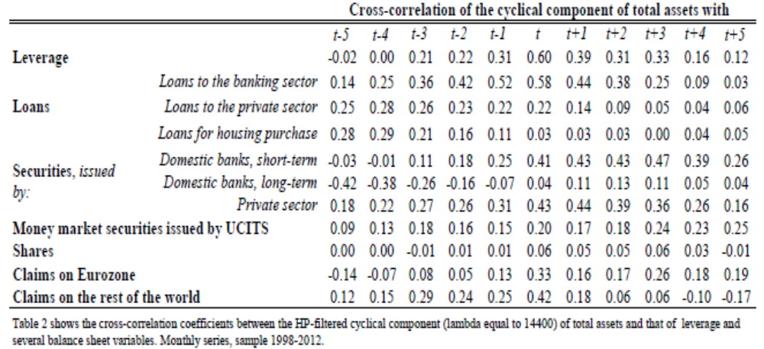

Table 3: Summary statistics
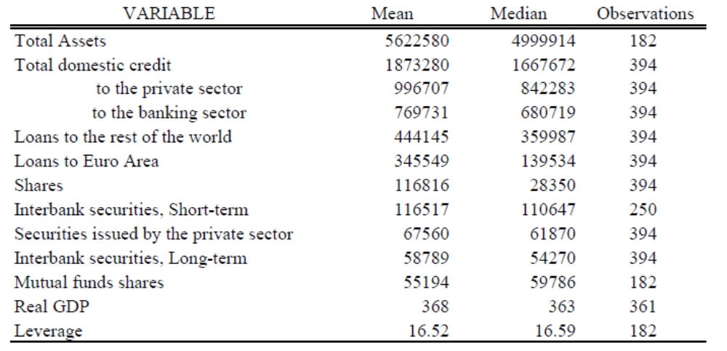
Source: Banque de France. Balance sheet variables are expressed in millions, Real GDP in billions.

Table 4: VAR^{i}(p_{i}) models specifications
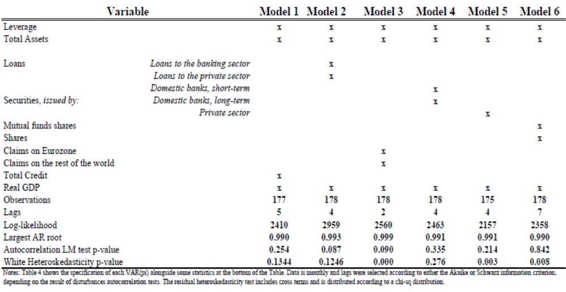

Financial market frictions and imperfect substitutability between banks’ liabilities are the pre-requisites for the existence of the bank lending channel.
The reasons why banks might decide to actively adjust their leverage are many and discussing them is out of the scope of this paper. [10] provide an extensive analysis on this issue.
In particular, [9] argue that the pro-cyclicality of assets is mainly due to the fact that a large portion of security claims are marked-to-market. The literature, however, proposes several other motives other than accounting standards for which banks balance sheets are pro-cyclical, most notably: Basel capital regulations and change in risk perception (see [11], for a survey).
See [17].
A simple example can help clarify this. Leverage (lev) is equal to assets (a) to net worth (nw), i.e. assets minus liabilities (l): . If a=100, l=90, then nw=10, then, leverage is equal to 10. Say assets increase in value by 10 then a=110, l=90 and nw=20. Leverage is now down to 5.5.
Tables with models’ estimated parameters are available from the author upon request.

