The Relationship between Enterprise Financing and Enterprise Life Cycle
Weishen He, Business Administrative Department of Yunnan University ，hws@mail.ynu.edu.cn

Abstract: In today's market economy era, the financing activities of enterprises are facing many new challenges. In order to ensure the effective financing management of enterprises, it is necessary to change the traditional management mode so that enterprises can better cope with various unknown risks and promote the development of enterprises. According to the theory of enterprise life cycle, enterprises have a process from growth to death, from prosperity to decline. The theory personifies the enterprise and regards the enterprise organization as the life body. The theory uses the concept of organism life cycle to analyze the emergence, growth, development and decline of enterprise organization. Therefore, enterprises in different life stages show corresponding characteristics in financing activities. Based on the financing data of more than 14000 enterprises established in the United States from the 20th century to the 21st century, this paper uses regression analysis and fixed effect model to analyze the relationship between enterprise financing and enterprise life cycle.

Key words: Financing; enterprise life cycle; American enterprise; fixed effect model

1. Introduction
In recent years, with the continuous improvement of the international market economy system, enterprises are facing increasingly fierce competition environment. The impact of financing on the survival and development of enterprises has reached an unprecedented level. In 2015, US start-ups raised $59 billion, 200 times more than in 1970. About 20% of the listed companies in the United States are supported by venture capital funds, which account for about 20% of the total market value. Today, 15% of the jobs in the United States are provided by venture capital fund companies, which was only 2% 40 years ago. Financing activities also provide important opportunities for technological innovation. In the United States, 40% of invention patents are invested by various investment funds. On the other hand, enterprises need to minimize their search cost and time to match the appropriate financing, which is necessary to consider the enterprise life cycle. Enterprises in different life stages have special needs for financing indicators. In the United States with mature capital market, when capital chooses enterprises, enterprises also choose capital matching with themselves.
In the process of business operation and production, financing is one of the most important strategic activities. In order to give full play to the value of enterprises in the limited enterprise life cycle, it is very important to study the relationship between enterprise financing and enterprise life cycle. By exploring the indicators of 14000 U.S. enterprises since their establishment, this paper puts forward reliable reference basis to find the potential relationship between financing activities, enterprise life cycle theory and enterprise performance. Through the study of American enterprises, we can help enterprises to improve their understanding of financing activities, and then improve their own core competitiveness, so that the economic benefits of enterprises can be improved. In addition, the theory of enterprise life cycle is effectively applied to the financing management of enterprises to help enterprises make more scientific financing management decisions and promote the continuous development of enterprise financing management in a better direction.

2. Data collation
Through the financing data of more than 14000 enterprises in the United States from the 20th century to the beginning of the 21st century, use R Studio to clean up and classify the data, and then build a new database.

(1) "Company" stands for the name of the enterprise.
（2）“LR_ Date "represents the time of the last round of financing.
（3）“R1_ Date "represents the time of the first round of financing.
（4）“Founding_ Date "represents the time of establishment of the enterprise.
（5）“Company_ Age "represents the age of the enterprise to date.
（6）“R1_ Age "represents the age of the enterprise at the first round of financing.
（7）“LR_ Age "represents the age of the business at the time of the last round of financing.
(8) "Rounds" represents the total number of financing rounds of the enterprise so far.
（9）“Total_ Foundation "represents the total financing scale of the enterprise up to now.
(10) "IPO" represents the listed state of the enterprise, 1 represents listed and 0 represents unlisted.
（11）“R1_ Size represents the scale of the first round of financing.
（12）“LR_ Size represents the scale of the last round of financing for the enterprise.
(13) "Location" represents the location of the enterprise.
(14) "Industry" represents the industry of the enterprise.

3. Analysis of enterprise financing and enterprise life cycle
3.1 Regression analysis of total life time and total financing scale of enterprises
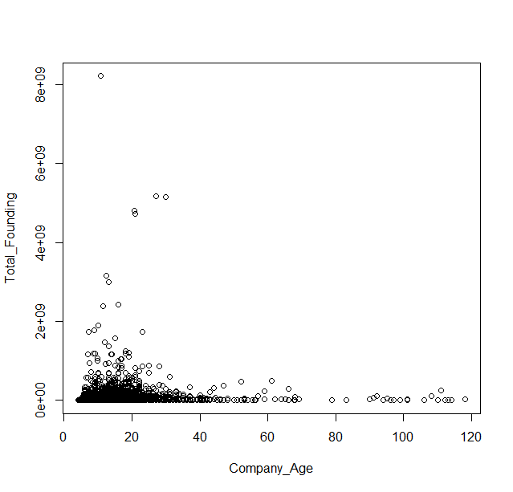
Figure1
Table 1
Coefficients: | Estimate | Std. Error | t value | Pr(>丨t丨)
(Intercept) | -14118957 | 3303629 | -4.274 | 1.93e-05 | ***
X1 | 4359069 | 306357 | 14.229 | <2e-16 | ***
I(x1^2) | -41421 | 4574 | -9.057 | <2e-16 | ***

The value of R-squared is 0.01569. The result of F-test is 118.4 on 2 and 14723 DF. Through the regression analysis of age and total financing scale, I find that there is a strong correlation between them. R-squared equals

3.2 The relationship between the age of the first round of financing and the scale of the first round of financing

3.2.1 Regression analysis of the age of the first round of financing and the scale of the first round of financing
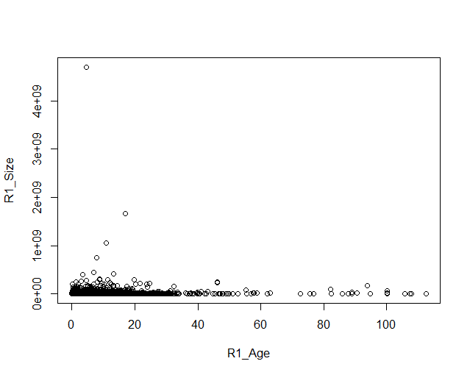
Figure2

Table2

Coefficients: | Estimate | Std. Error | t value | Pr(>丨t丨)
(Intercept) | 2765812 | 482742 | 5.729 | 1.03e-06 | ***
X2 | 1196719 | 107946 | 11.086 | <2e-16 | ***
I(x2^2) | -11853 | 1719 | -6.895 | 5.62e-12 | ***

The value of R-squared is 0.009208. The result of F-test is 69.42 on 2 and 14723 DF .Through the regression analysis of the first round financing scale and the first round financing age, I found that there is a strong correlation between them. In addition, it can be seen from the scatter diagram that most enterprises complete the first round of financing within 10 years after establishment

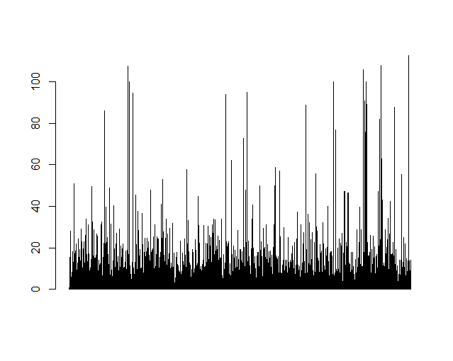
Figure 3
R1 Age
Companies

From the histogram above, it is found that the enterprises that have completed the first round of financing within ten years of establishment account for a large proportion. Therefore, the data of the first round of financing completed within 10 years after the establishment of the enterprise are extracted and analyzed again.
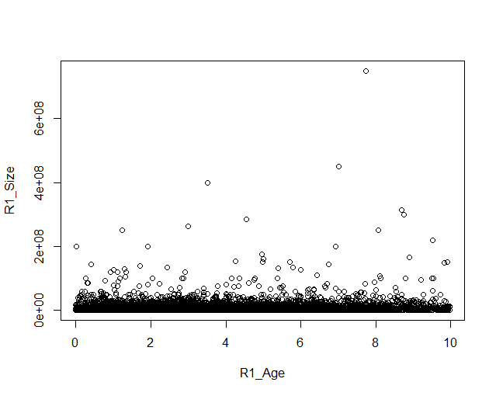
Figure4
It can be seen from the figure that with the first round financing age (R1_ Age) growth, first round financing scale (R1_ Size) also grows linearly. This is due to the high risk of start-up enterprises, and the development prospect is not optimistic. In this stage, not only the demand for funds is large, but also the sources of funds are required to be long-term and stable. On the one hand, enterprises should constantly meet the continuous needs of internal long-term investment for funds; on the other hand, they should avoid the fixed pressure of repayment of principal and interest to increase financial risk, which leads to the short-term behavior of enterprises. With the longer the enterprise lasts, the survival ability of the enterprise appears. At this time, it will be easier to obtain financing than when the enterprise was just founded

3.2.2 Fixed effect model of the age of the first round of financing and the scale of the first round of financing

In order to better explore the relationship between the age of the first round of financing and the scale of the first round of financing, we introduce the fixed effect model. Among them, the factors that we consider to affect the financing scale are (1) the year of establishment of the enterprise (2) the place where the enterprise is located (3) the industry where the enterprise is located. In order to establish the model conveniently, let's get the logarithm of the first round of financing size(Log R1_Size).

We build a model to run a regression of the first round of financing size on the age of the first round and company’s founded year, location, industry.
Table3
Coefficients: | Estimate | Std. Error | t value | Pr(>丨t丨)
R1_Age | 0.018952 | 0.006948 | 2.728 | 0.00638 | ***

The value of R-squared (full model) is 0.3467. The result of F-test (full model) is 10.28 on 806 and 13283 DF .Through the fixed effect model of the first round financing scale and the first round financing age, I found that there is a strong correlation between them.

3.3 The relationship between the last round of financing and the age of the last round of financing

3.3.1 Regression analysis on the age of the last round of financing and the last round of financing
Figure5
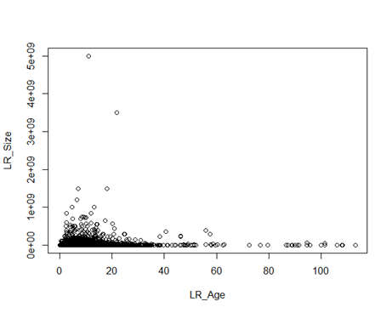

Coefficients: | Estimate | Std. Error | t value | Pr(>丨t丨)
(Intercept) | 3895477 | 907498 | 4.293 | 1.78e-05 | ***
X3 | 1832892 | 143314 | 12.789 | <2e-16 | ***
I(x3^2) | -19811 | 2362 | -8.387 | <2e-16 | ***
Table 4

The value of R-squared is 0.1162. The result of F-test is 87.55 on 2 and 14723 DF. Through the regression analysis of the last round of financing age and the last round of financing scale, it is found that there is a strong correlation between the two. The life cycle of most enterprises is between 40-60 years. When the enterprises enter the mature period, the idea of initial entrepreneurship has lagged behind the new generation of enterprises. Moreover, the growth potential of the enterprise will decrease with the growth of the enterprise age, so the financing demand will also be reduced.

3.3.2 Fixed effect model of the last round of financing scale and the last round of financing age

In order to better explore the relationship between the age of the last round of financing and the scale of the last round of financing, we introduce the fixed effect model. Among them, the factors that we consider to affect the financing scale are (1) the year of establishment of the enterprise (2) the place where the enterprise is located (3) the industry where the enterprise is located. In order to establish the model conveniently, let's get the logarithm of the last round of financing size.(Log LR_Size)

We build a model to run a regression of the last round of financing size on the age of the last round and company’s founded year, location, industry.

Table 5
Coefficients: | Estimate | Std. Error | t value | Pr(>丨t丨)
LR_Age | 0.096510 | 0.007398 | 13.05 | <2e-16 | ***

The value of R-squared (full model) is 0.2372. The result of F-test (full model) is 6.435 on 806 and 13283 DF .Through the fixed effect model of the last round financing scale and the last round financing age, I found that there is a strong correlation between them. Through the establishment of fixed effect model, we can clearly see that there is a significant relationship between the financing scale and the life cycle of an enterprise. The traditional industries have always occupied an absolute dominant position in the national economy of the United States. After the end of the civil war, the formation of a unified domestic market created conditions for the expansion of enterprise scale. A number of large enterprises were established in the late 19th century to the early 20th century. Especially in the field of manufacturing, many large enterprises give full play to the advantages of scale economy. Even so, businesses face financing difficulties when they are first established. As a result, many small and medium-sized enterprises make use of their own geographical advantages to continuously open up market segments, fill in vacancies, or seek survival and development in areas where scale economy cannot play a role.
In the 1970s, small and medium-sized enterprises (SMEs) developed rapidly in the United States, and their GDP accounted for an increasing proportion of GDP. Small and medium-sized enterprises have become an important part of American economy. They not only play an important role in increasing employment and promoting exports, but also play an important role in technological innovation. American economic growth has made remarkable achievements in the past decade, which is attributed to the transformation of its economic paradigm. In recent decades, biotechnology, information industry and other industries in the United States have grown from scratch, from small to large, and finally become the leading industrial group that determines the speed of economic development. To a large extent, it is the result of the efforts of enterprises to carry out technological innovation on the premise of solving the capital gap. The history of economic development in developed countries shows that industrial technology has a great restrictive effect on the upgrading of industrial structure. The longer the period of technological invention and innovation, the slower the upgrading of industrial structure; the shorter the period, the faster the upgrading of industrial structure. Technological change has brought confidence to investors in the United States, which has indirectly helped many enterprises from the start-up stage to the growth stage. Under the guidance of market demand, a new financing method was born in the United States, and has become the "engine" of American economic development in the development of decades, which is called "venture capital". To a great extent, the formation and development of venture capital has solved the problem of venture financing for small and medium-sized high-tech enterprises in the United States, promoted the rapid development of high-tech industries in the United States, and made the economy of the United States reach a new peak. The important link of venture capital is that venture capital withdraws from the invested enterprise and obtains high return. It created the second board Market -- NASDAQ Market. Since its establishment in 1971, NASDAQ Market has made great contributions to the financing of large and small enterprises in the United States, mainly high-tech enterprises.
In the 1990s, the booming development of some new high-tech small and medium-sized enterprises in the United States and their successful listing in the GEM market attracted the attention of investors all over the world. A large number of Internet based software and financial companies have been established. However, it is worth noting that the Internet is still in its infancy at this time, and the information asymmetry generally exists between investors and fundraisers, which is an important reason for the difficulty of enterprise financing. It is difficult to form smooth information transmission between enterprises and investors, which will lead to adverse selection and moral hazard. Most of the capital goes to big, well capitalized companies. In the early stage of an enterprise, this phenomenon will lead to the inability of the enterprise to obtain low-cost financing or postpone financing, so they bear high interest rate debt.
In the 21st century, with the rapid development of Internet technology, the IT industry in the western region is also strongly supported by capital. As the core financial zone, the eastern part is still the capital gathering place under the influence of regional culture. In the new era, people's living standards are generally rising, and a large number of leisure and entertainment companies have been established. In addition, the financing system is of great significance for economic development, because it directly affects the process of economic development by giving full play to the mobilization ability and allocation efficiency of financial resources, thus becoming an important factor to promote or restrict the economic development of a country. The viewpoint of financial deepening theory is that financial mechanism will promote the restrained economy to get rid of the stagnant situation and accelerate the economic growth. On January 4, 1999, the house and Senate of the United States passed the Financial Services Act of 1999, which repealed the Glass Steagall Act of 1933 and completely ended the situation of separate operation and supervision of banks, securities and insurance. Since then, the United States has opened up the financial world economic integration and financial liberalization. A large amount of capital flows into the United States, and the financing situation of enterprises is very good. In this period, American enterprises entered the mature period of enterprises by virtue of their financing advantages and the wave of globalization. Great changes in the business environment have resulted in the rise of many service industries, such as consulting and accounting. At present, the United States has the most effective financing system in the world: innovative financial institutions, developed financial markets, advanced financing tools and financing technology. No matter its financing mode or financing system arrangement, it can effectively improve the efficiency of the start-up period and help the enterprises that have entered the recession to transform and upgrade.

3.4 The relationship between IPO and number of corporate financing rounds
Whether an enterprise is listed or not has a very important impact on the long-term development of the enterprise, especially in the aspect of financing. In the process of analysis, we distinguish the listed companies from the unlisted ones in the database.

First, the number of financing rounds of listed enterprises is analyzed:
Figure6
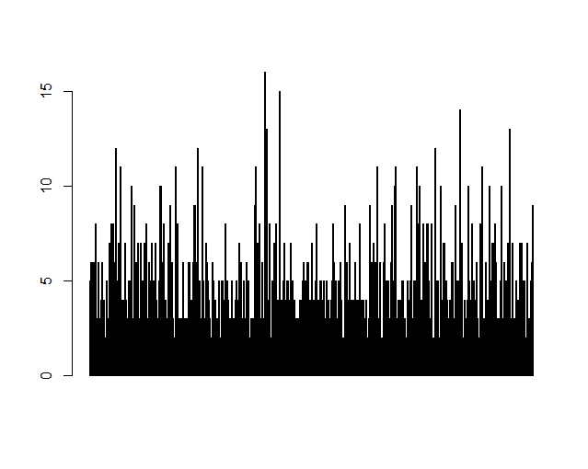

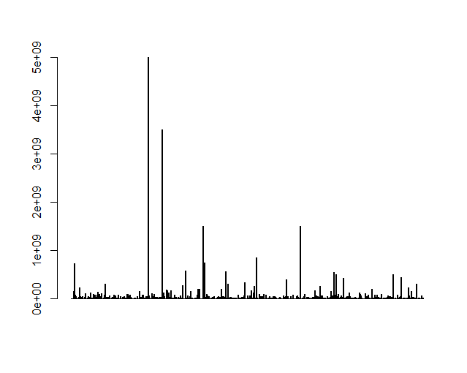
Analyze the last round of financing scale of Listed Enterprises:
Figure7

Then analyze the number of financing rounds of unlisted enterprises:

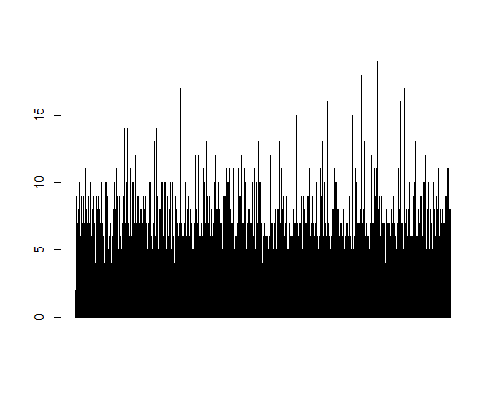
Figure8
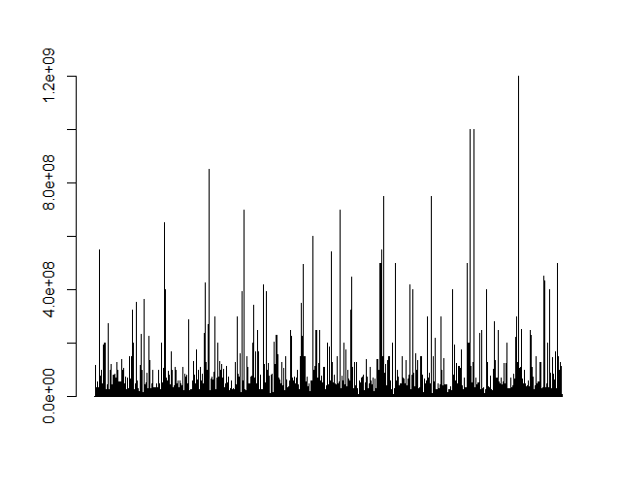
Then analyze the last round of financing scale of unlisted enterprises:
Figure9

It can be seen from the above chart that the number of financing rounds of most listed enterprises is 1-4, while the number of financing rounds of most unlisted enterprises is 4-6. The last round of financing scale of listed enterprises is far larger than that of unlisted enterprises. This is because most of the listed companies expand their market through a large number of financing in the growth period, and listed with the vitality of the growing enterprises. After listing, the main way to complete the financing is through the securities market, which can not only obtain more financing, but also reduce the cost of financing, thus extending the life cycle of the enterprise. In addition, the last round of financing scale of listed enterprises tends to be more consistent than that of unlisted enterprises, in other words, almost equal except for individual enterprises. This is because the stability of the securities market ensures the smooth operation of listed enterprises. However, unlisted enterprises have different financing scales because of their different stages, different internal economic environment and different development strategies.

3.5 Impact of early financing characteristics on future performance of enterprises

3.5.1 Fixed effect model of early financing characteristics on total financing scale
In order to explore the influence of early financing characteristics on the future performance of enterprises, we introduce fixed effect model. First, we choose the age and scale of the first round financing to represent the early financing characteristics. Then select the total financing scale and IPO status to represent the future performance of the enterprise. Finally, we choose (1) the establishment time of the enterprise (2) the location of the enterprise (3) the industry of the enterprise as the influencing factor of the fixed effect model.

In the first fixed effect model, we first study the influence of the first round financing scale and the first round financing age on the total financing scale of enterprises. In order to facilitate the establishment of the model, let's get the logarithm of the first round of financing size，the age of the first round financing and the total financing scale.
We build a model to run a regression of total funding on the company age of the first round , size of the first round , and company’s founded year, location, industry.

Table 6
Coefficients: | Estimate | Std. Error | t value | Pr(>丨t丨)
Log R1_Age | -0.158082 | 0.009883 | -15.99 | <2e-16 | ***
Log R1_Size | 0.682162 | 0.005942 | 114.80 | <2e-16 | ***

The value of R-squared (full model) is 0.6794. The result of F-test (full model) is 38.04 on 806 and 13283 DF. From the result analysis of the influencing factors, we find that the influencing factors we choose are significantly correlated with our analysis.
From the results of the model, we can see that the first round of financing age and the first round of financing scale have significant correlation with the total financing scale. Among them, the impact of the scale of the first round of financing is very obvious. The success of the first round of financing is very important for the initial growth of enterprises. First of all, due to the lack of competitiveness, some enterprises withdraw from the market before obtaining the first round of financing, because in the long process of operation, the cash flow is interrupted. Then, those enterprises that get enough funds in the first round of financing have the opportunity of rapid development. With sufficient financial support, we will actively produce, develop and occupy market share. Finally, the first step in the enterprise life cycle is to lead the same group of enterprises, and continue to gain the leading advantage in the future development.

3.5.2 Fixed effect model of corporate early financing characteristics on corporate listing status.

In the second fixed effect model, we study the impact of the first round of financing scale and the first round of financing age on the state of IPO. We use "1" for listed company and "0" for Unlisted. In this case, we refer to logistic regression. In order to facilitate the establishment of the model, let's get the logarithm of the first round of financing size and the age of the first round financing.
We build a model to run a logic regression of the state of IPO on the company age of the first round , size of the first round , and company’s founded year, location, industry.
Table 7
Coefficients: | Estimate | Std. Error | z value | Pr(>丨z丨)
Log R1_Age | -0.210191 | 0.055765 | -3.7692 | 0.000265 | ***
Log R1_Size | 0.413548 | 0.046718 | 8.8530 | <2.2e-16 | ***

The value of Squared Cor is 0.18792. The value of Log-likelihood is -1693.77. The value of Adj. Pseudo-R2 is 0.16924. The value of BIC is 7471.02.It can be seen from the results that the first round of financing scale and the first round of financing age have a significant impact on the state of IPO. As mentioned in the previous model, the advantage of early financing can help enterprises lead the same batch of enterprises, which is sustainable. IPO, as a symbol of the success of an enterprise, is the result of years of business accumulation. Capital is the blood of enterprises and the basis for enterprises to increase R &amp; D investment, expand reproduction and integrate sales channels to carry out M &amp; A. At this stage of business development, a large number of companies are capital driven, or even if they are not capital driven (such as technology driven), they always need a large amount of capital investment to realize the business model of enterprises, and to enable enterprises to obtain their own competitive advantages in the turbulent business competition of market economy. In the life cycle of an enterprise, if an enterprise can obtain sufficient financing in the initial stage, it will have a competitive advantage compared with other companies' equity financing channels or loan financing channels.
In addition, IPO of the company is not only a demonstration of the strength of the company, but also a sign of opening up new financing channels. By issuing stocks to the public and raising a large amount of funds at one time, enterprises can obtain a rapid development opportunity to surpass their competitors. After listing, enterprises can also use a number of very rich equity financing tools for financing, including public issuance, private issuance of preferred shares, convertible bonds, corporate bonds and other products. New financing channels will help enterprises to obtain more large-scale funds. In this case, promote the technology research and development or market development of enterprises, so that enterprises once again obtain sustainable competitive advantage. To sum up, the early financing characteristics of enterprises have a significant positive correlation with the future performance of enterprises.

3.6 conclusions and suggestions

When the enterprise is in the initial stage (< 5 years), the enterprise basically has no cash inflow from operation, but only the cash outflow from investment and operation. In addition, the development prospect is very uncertain, so the investors are unwilling to make additional investment. In addition, its scale is small, the product quality, process, cost and other aspects of the enterprise are not mature, the market share is low, the general profit is naturally not high, or even may lose money, coupled with less contact with the outside world, the information transparency is low, and the possibility of financing through the outside world is relatively small. Therefore, in this stage, enterprises rely on internal financing, that is, the financing mode that the founders or their family members, relatives and friends provide venture capital. Venture capital and venture capital are also suitable financing methods for start-ups, but for a large number of start-ups, such funds are not easy to obtain. Therefore, there are financing problems in this stage.

When the enterprise is in the growth period (5-10 years), on the one hand, it needs to expand its scale to meet the market’ demand, on the other hand, it needs to meet the short-term capital demand such as working capital, so the enterprise at this time urgently needs to open up financing channels. At this stage, the product market has been expanded, various risks have been reduced, the development prospects of enterprises are good, and the financing environment has been improved. Therefore, the financing scale of enterprises will be larger than that of the start-up period and the recession period. With the gradual development and expansion of enterprises in business, with a certain scale of assets and business performance, in order to seek further development and maintain this rapid development trend, enterprises need to expand and expand themselves. It is necessary for the growing enterprises to use financial leverage to borrow. First of all, at this time, the scale of the enterprise began to gradually change from small to large, the strength was gradually increasing, the development was rapid, and the profits increased significantly, which enabled the enterprise to have the ability to repay debts. Secondly, it has more contacts with the outside world, and its information transparency has been improved accordingly. It can smoothly transmit the information with good development momentum to the outside world, and the channels of borrowing have been increased accordingly. Driven by the interests, banks and various financial institutions will correspondingly reduce the threshold of borrowing and are willing to provide funds. Finally, because the cost of debt capital is generally lower than the cost of equity capital, and the enterprises in the growing period should seize the market opportunity, expand their strength, improve their production capacity, and increase their production investment, which requires raising debt funds matching the scale of expansion. In addition, private equity, venture capital funds, mutual funds and so on provide external equity financing channels for enterprises. But this stage is the key stage of enterprise development, so the development should be fast and stable. Excessive debt will undoubtedly increase the financial risk of the enterprise, which is not conducive to the healthy development of the enterprise. The enterprise must do what it can.

After entering the mature stage (10-30 years), the business performance has made great progress. The company's product sales have grown steadily, and considerable cash flow and profits have been formed. Various risks (technical risks, operational risks, market risks, etc.) have been reduced. The financing environment has been greatly improved, and funds are relatively sufficient. In this case, corporate financing no longer needs too much financing, because it may cause the increase of corporate liabilities. At this time, the enterprise can adopt the residual dividend policy, and give priority to retaining as much profit as possible for technological innovation. In addition, for those enterprises that have formed a considerable scale and have certain core competitiveness, they have obtained sustainable capital supply from the securities market by issuing bonds and other means. Entering a stable period is a sign that the core business of the enterprise has reached its peak. The sales volume continues to grow, the financial situation is good, the development is stable, and the products are widely known by the society. If there is no need to make a large amount of capital investment in the original products, the enterprise will have surplus funds. In addition, at this time, the enterprise's credit is high, and the enterprise can obtain more favorable loan opportunities and financing treatment, and even issue stocks, bonds and commercial bills in the open market to meet its financing needs. However, the main problem of this stage is not survival, but how to extend the maturity period. Because the stability of this stage is only a kind of illusion to some extent, there may be a certain crisis behind this kind of maturity. Due to the rapid expansion of the growing enterprises, managers have no time to take into account the long-term development of the enterprises. There must be a lot of problems in enterprise management, and if not remedied in time, the problems will become more and more prominent, even threaten the survival of the enterprises, which should not be ignored. At this time, the enterprise should adjust the organizational structure of the company, and take "the development strategy of the enterprise" into account. The main task of the enterprise is to consolidate the foundation, strengthen its competitive strength, rather than expand its business scale and scope. Therefore, enterprises in the mature period should not over borrow. Firstly, at this time, enterprises have certain equity funds through the accumulation of the previous stage, and do not rely on the funds raised by external borrowing very much. Second, although the sales and profits of the enterprise are growing, the slowdown is the precursor of the enterprise's gradual contraction. If there is no very favorable investment project, excessive debt is unnecessary. If the enterprise does not do well in the mature period of reform, it is likely to fall into crisis. The sales volume of products declines, the profits decrease, and even losses may occur, the competitiveness of products weakens, the consciousness of innovation is weak, various enterprise diseases appear one after another, all kinds of adverse results and conditions will make the enterprise into a dilemma, the capital problem once again becomes the bottleneck of the development of the enterprise, and the financing will become a major difficulty again. Not only that, creditors will even ask for early repayment of debts for fear of bankruptcy and liquidation. Most of the funds accumulated in the early stage of the enterprise will be used to repay the debts and realize the related expenditures of smooth transition. At this time, enterprises are likely to be merged or acquired. This is going into a so-called recession.
When the enterprise enters the recession stage (> 30 years), the enterprise either dies, or enters the recovery and redevelopment stage. If the enterprise can take drastic measures to reverse the situation, it will continue to survive. At this time, some enterprises find a new breakthrough point, which will increase the financing scale to meet the enterprise transformation. However, most of the enterprises are lack of operation power at this time, and then reduce the scale of financing, and only retain the funds to maintain the survival of enterprises. In fact, most enterprises will choose to be acquired or directly bankrupt soon after entering the recession period to end the enterprise life cycle.

Generally speaking, financing activity is one of the three major financial activities of an enterprise, which is related to the source of capital for production, operation and investment of the enterprise, the risks the enterprise bears, and the enterprise value. If enterprises want to achieve long-term development, they must raise financing activities to a strategic height in order to establish competitive advantages and achieve sustainable development. The periodicity of enterprise growth determines the nature and scale of the capital needed by enterprises in different stages of enterprise life cycle because of the different risks they face. According to the requirements of internal and external environment in different stages, enterprises should adopt financing strategies suitable for this stage, so as to improve the efficiency of capital utilization, solve the problem of capital shortage, reduce capital cost and avoid financial risks. In different stages of the enterprise life cycle, because of the different business environment and financial environment, the financing means and scale are different. In other words, each financial market plays a different role in different stages of enterprise growth. Enterprises should deeply understand the characteristics and operation mechanism of each financial market and use positive factors to avoid the influence of adverse factors. On the other hand, enterprises should be based on their own strategic objectives and comprehensive strength in financing, and do what they can. That is to say, enterprises in different stages of the growth process must, according to the internal law of enterprise development, explore different financing channels and financing strength, and limit the financing risk within the scope that the financing subject can bear; at the same time, try to achieve self-improvement, self -accumulation and ultimate realization under the role of market competition mechanism and in accordance with the development objectives of enterprises to the maximum extent The transition of enterprise scale from small to large.

Supplementary Materials:
Figure S1：Scatter diagram of total life time and total financing scale of enterprises
Figure S2: Scatter chart of the first round financing age and financing scale
Figure S3: The age of the first round of financing
Figure S4: The scale of the first round financing of enterprises that have completed the first round of financing within ten years after the establishment of enterprises
Figure S5: Scatter chart of the size and age of the last round of financing
Figure S6: Financing rounds of Listed Enterprises
Figure S7: The last round financing scale of Listed Enterprises
Figure S8: Financing rounds of unlisted enterprises
Figure S9: The last round financing scale of unlisted enterprises

Table 1：Regression result of total life time and total financing scale of enterprises
Table2: Regression result of the first round financing age and financing scale
Table3: The result of the fixed effect model of the first round financing scale and the first round financing age.
Table 4 Regression analysis of the size and age of the last round of financing
Table 5 The result of the fixed effect model of the last round financing scale and the last round financing age.
Table 6 The result of the fixed effect model of the Total financing size and the first round financing age and scale.
Table 7 The result of the fixed effect model of the IPO and the first round financing age and scale.

Funding: This research received no external funding.

References:
[1] Zhu Biqin. The choice of financing strategy based on enterprise life cycle theory -- Taking BG Company as an example. Western Finance and Accounting. 2020.
[2] Zhang Suqin. On the Choice of Financial Strategy of Enterprise Life cycle theory. Chinese and Foreign Entrepreneurs. 2020.
[3] Ma Weimin; Zhang Ranran. Financial technology innovation helps the financing of small and medium-sized technology-based enterprises: an analysis based on the perspective of enterprise life cycle. Science and Technology Management Research. 2019.
[4] Zhu Pengfei; Tao Siqi. Financial strategy analysis of Yunnan Baiyao based on life cycle theory. China business theory. 2019.
[5] Xu Xiaotong. Research on Tencent financing strategy based on enterprise life cycle theory. Qingdao University. 2019.
[6] Meng Xiangying. Enterprise life cycle theory and its relationship with enterprise financing. Economic Forum. 2005.
[7] Tang Lanshu. Research on corporate financing preference from the perspective of life cycle. Xiamen University. 2008.
[8] Wu Qiuming. Resistance to change from the top management. Management scientist. 2013.
[9] Chen Jiagui. Discussion on enterprise life cycle and enterprise transformation. China industrial economy. 1995.
[10]Larry.E.Greiner. The evolution and transformation of organizational growth. Harvard Business Review.1992.
[11]Samuel Antill, Investment timing with costly search for financing. Working paper,2017.
[12]Patrick Bolton, Hui Chen, and Neng Wang. Market timing, investment, and risk management. Journal of Financial Economics, 2013.

