Iron-Roselle: A Progressive Nuclear Stain For Skin Morphology And Connective Tissue
Benard SA¹, Muhammed AO², Afolabi OO^{3,} Fowotade AA¹, Olutunde OA¹

- Histopathology Laboratory Unit, Department of Pathology, University of Ilorin Teaching Hospital, Ilorin, Kwara State
- Department of Histopathology, Faculty of Medical Laboratory Science, Usman Danfodiyo University, Sokoto, Sokoto State, Nigeria
- Department of Pathology, College of Health Sciences, University of Ilorin, Ilorin, Kwara State, Nigeria
Abstract
Objective: This is a comparative experimental study aimed at exploring the efficiency of Hibiscus sabdariffa (roselle) as natural staining dye mordanted with 10% iron chloride solution for the histological demonstration of skin morphology and its connective tissue as compared to the routinely used haematoxylin and eosin.
Methods: 10% neutral buffered formalin fixed, paraffin embedded tissue blocks of skin were retrieved from the tissue block archive of the Pathology Department, Unilorin Teaching Hospital, Ilorin, Kwara State, Nigeria. Two blocks were randomly selected. Twelve serial sections were cut from each and divided into two groups of six labeled A & B. Sections labeled A were stained with 5% concentration of H. sabdariffa solution and B stained with H&E as parallel control.

Result: Photomicrographs from each group demonstrated the histo-morphology and connective tissue component of skin in comparable manner. The epidermis and dermis of skin were distinctly stained with nucleus appearing black and cytoplasm pink. Red blood cells were stained red. Sweat glands, collagen fibres and adipocytes were also well demonstrated.

Conclusion: This study established the capability of Hibiscus-iron (Iron-Roselle) counterstained with eosin to replace H&E in the morphological and connective tissue demonstration of skin. Hibiscus sabdariffa is readily available locally, safe, easily prepared and resists fading.

Key Words: Hibiscus Sabdariffa, iron-Roselle, Histological Staining, Skin

Introduction
Development of new histological staining method remains justified especially if the new stain is harmless, easy to use, cheap, commercially favorable, and gives the desired practical results [1]. Hematoxylin and Eosin (H&E) stains play a critical role in tissue-based diagnosis [2].The two, are the commonest stains being used in histopathology laboratories all over the globe which colour the nuclei a dark blue or purple, and the cytoplasm and connective tissue a shades of pink [3]. By colouring tissue structures (cytoplasm, nucleus, organelles, and extra-cellular components); these stains allow the sections to be viewed in details under the microscope, tissue morphology and/or any present abnormalities can then be easily detected [4]. Even when advanced staining methods are used, the H&E stain still forms a critical part of the diagnostic picture as it displays the underlying tissue morphology which allows correct interpretation to be made [5]. Most histological stains in current use are of synthetic origin; however, natural dyes are still promising to be cheaper potential sources [6].
Hibiscus sabdariffa belongs to the vascular flowering plants, known as Roselle or Red Sorrel in English and Karkade in Arabic [7]. Hibiscus Sabdariffa is a plant cultivated in many countries in the world; Sudan and Nigeria are among these countries. In Sudan, it is called Karkade; the extract is usually used as a drink, hot tea-like in winter and cold in summer. In Nigeria, it is called zobo and used as refreshment [8,9].
The skin is the largest organ in the body, both in weight and surface area, and shows marked variation in structure at different sites in the body surface {10}.
The extraction and application of colouring matters from Hibiscus sabdariffa (Roselle) will be a great contribution to the exploitation of natural dyes in the demonstration of skin histomorphology and dermatological studies. This research want to contribute to the use of natural dyes from H. sabdariffa (Roselle) as a substitute to haematoxylin in H&E in the staining of human and animal skin tissues especially in the field of dermatology.

Methodology
Dry leaves of Hibiscus sabdariffa were purchased at a local market in Ilorin, Kwara State, Nigeria and were identified by a Botanist in the Botany department of Obafemi Awolowo University, Ile-Ife, Oyo State, Nigeria. They were processed using the technique of Benard (9). 10% neutral buffered formalin fixed paraffin processed skin tissues were sectioned at 4 microns. Slides of serial sections produced were tagged A and B. A: Haematoxylin and Eosin B: Hibiscus and Eosin.
The slides were further coded and reviewed by three blinded histopathologists for staining quality and intensity. This was done semi-quantitatively by assigning grades + for satisfactory, ++ for good and +++ for very good staining quality and intensity. The parameters assessed include nucleus /cytoplasm contrast, tissue contrast (cells versus background) and vasculature.
- PREPARATION OF STAIN EXTRACTS
  - HIBISCUS EXTRACT SOLUTION
The dry calyces of Hibiscus sabdariffa were ground using a Binatone blender to a fairly powdery form. To 10g of the ground red calyces of H. sabdariffa in a conical flask, 200ml of distilled water was added and brought to boil to give a brilliant red coloured extract which was immediately allowed to cool and filtered to give a clear H. sabdariffa extract. The staining formular was compounded as follows:
H. sabdariffa extract: 100ml
NaCl 5.0g
10% Ferric Chloride solution 1.2ml
Glacial acetic acid 3.0ml

  - 1% ALCOHOLIC EOSIN
1g of eosin yellow was weighed on a digital Ohaus balance, dissolved in 95% ethanol and made up to 100ml.
- STAINING PROCEDURES
  - H&E Staining Procedure
1. Dewax in xylene and hydrate through 100%, 90%, 70%, 50% alcohol to water
2. Stain section in Harris haematoxylin for 15 minutes
3. Rinse in water
4. Differentiate in 1% acid alcohol
5. Blue in running tap water for 10 minutes
6. Counter-stain in 1% alcoholic eosin for 60 seconds
7. Dehydrate in ascending grades of alcohol
8. Clear in xylene
9. Mount in DPX
2.2. Hibiscus/Eosin Staining Procedure
1. Dewax in xylene and hydrate through 100%, 90%, 70%, 50% alcohol to water
2. Stain in Hibiscus extract solution for 5 minutes
3. Wash in running tap water for 2 minutes
4. Counter-stain in 1% alcoholic eosin for 30 secs
5. Dehydrate in ascending grades of alcohol
6. Clear in xylene
7. Mount in DPX

Result
The Hibiscus-eosin staining shows blue-black nuclear staining while the H&E staining shows purplish-blue nuclear staining. Cytoplasm component stains red with Hibiscus-eosin as for H&E. Histomorphology of skin is clearly demonstrated with the new technique and distinct presentation of intercellular membranes comparable with H&E (Fig. I&II).

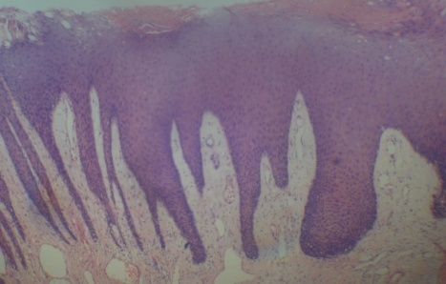  A  Connective tissue fibres + cells  Fig. Ia: H&E x 40 | 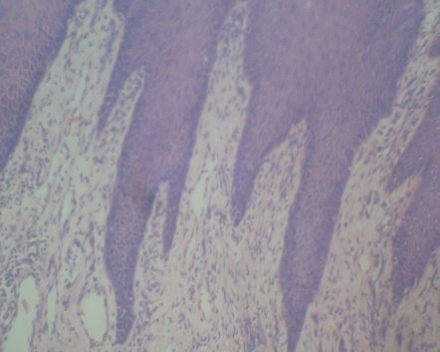  A  Connective tissue fibres + cells  Fig. Ib: H&E x 100 | 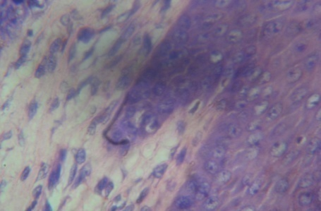  A  Connective tissue fibres + cells  Fig. Ic: H&E x 400
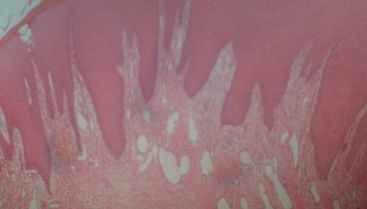  B  Connective tissue fibres + cells  Fig.I Ia: Hib/Eosin x 40 | 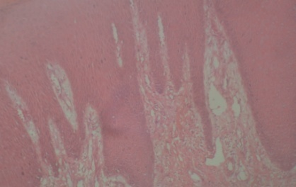  B  Connective tissue fibres + cells  Fig.I Ib: Hib/Eosin X 100 | 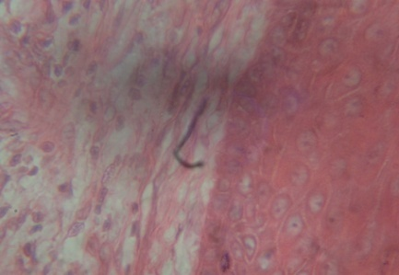  B  Connective tissue fibres + cells  Fig. IIc: Hib/Eosin X 400

Discussion
Few works exist on the application of iron-Roselle as a progressive nuclear stain in histopathology. Some earlier workers tried to use the watery extract of Hibiscus sabdariffa (Roselle) as cytoplasmic stain to substitute for eosin in H&E staining technique{11, 12, 13}.
Another group of early researchers canvassed the use of H. sabdariffa extract as nuclear stain for histological demonstration of tissues {9, 12,14, 15, 16}. Benard et al{16} recommended its use as a progressive nuclear stain while Egbujo et al{12} reported its use as regressive nuclear stain.
Quality of staining in histology depends on the microscopic appearance of cell membrane, nuclear membranes, cytoplasm transparency, and extracellular matrix {17}
H. sabdariffa renders vibrant colour owing to the presence of anthocyanins and is well known for the colur stability and fastness {18}. Researchers have applied this property of Hibiscus dyes in histopathology and have used it for staining fungal species, parasites, neural tissue, and sperm cells. They found the staining properties to be satisfactory {18}. Hibiscus extract-iron solution has also been found useful in the staining of lymphnode, appendix, liver, kidney, brain and hippocampus {15, 16}.
The present study attempted to use the extract of locally available H. sabdariffa extract –mordanted with iron chloride solution counterstained with eosin as a histological stain to demonstrate connective tissue and morphology of skin.
Independent assessment by three histopathology experts scored connective staining by the iron-Roselle technique as good (++). Nucleus –cytoplasm contrast was also rated to be satisfactory (+) and good (++). Similar assessment was apportioned for red blood cells. An unsuspecting observer does not usually question whether the section under his microscope is stained with H&E or Iron-Roselle/Eosin.
Details of the mechanism of staining need to be further investigated but it is suggested that the ferric ions which make the dye more nucleus – specific combine with the anthocyanin pigment (flavonoids) of Roselle which confers a net positive charge on the dye{9}. The cationic dye metal complex binds with the anionic nuclear chromatin to give blue-black colour. The counterstain eosin, which is an anionic dye combines electrostatically with the cytoplasm and other tissues. Optimal staining of 5-20 minutes was earlier recommended {9}. However, this work has achieved 5 minutes optimal staining thus confirming its applicability as a progressive stain. The staining solution is best stored at 4⁰C where it remains viable for three months or more. The main limitation of using Iron-Roselle (Hibiscus) progressive stain would be the pathologists’ preference for haematoxylin due to habituation.
According to Benard et al {9}, Egbujo et al {12} and Muhammed et al {16} iron-Roselle (Hibiscus) can be substituted for haematoxylin in H&E procedure. However, Egbujo et al {12}, Eman et al {12} Ihuma {19} Ibnouf et al {15} and Suheedra et al {18} reported its counterstaining applicability and recommended its replacement for eosin. These divergent recommendations necessitate a new research which is underway to investigate the applicability of H. sabdariffa as both nuclear and cytoplasmic stains simultaneously at different manipulations.
In conclusion, Hibiscus/eosin could be a substitute to H&E staining technique in dermatological studies because of the distinct demonstration of epidermal and dermal components. It could therefore be a useful tool in diagnostic dermatology.

REFERENCES
{1} Penney DP, Powers JM, Frank M and Churukian C. Analysis and testing of Biological Stains–the Biological Stain Commission Procedures. Biotechnic and Histochemistry, 2002; 77: 237-275.
[2] J. A Kiernan, Histological and Histochemical Methods: Theory and Practice. 4th ed, Bloxham, UK: Scion, 2008.
[3] Cellpath, Staining theory. 2006,67-72
[4] S. Iyiola and O. G Avwioro,“Alum haematoxylin stain for the demonstration of nuclear and extra
uclear substances”. Journal of Pharmacy and Clinical Sciences, 1, (2011),20-23.
[5] O. GAvwioro,“Histochemical Uses of Haematoxylin - A Review”. Journal of Pharmacy and
Clinical Sciences,1, (2011), 24-34.
[6] H. I Mattuk, Studies on the utilization of natural colorants extracted from some plant sources.
Egypt J. Appl.Sci., 13, (1998), 286-303.
{7}B. H Ali, N. Al-Wabel and G. Blunden, Phytochemical, pharmacological and toxicological
aspects of a Hibiscus Sabdariffa; a review. Phytotherapy Research, 19(5), (2005), 369- 375.
{8}B. B. Mohamed, A. A. Sulaiman and A. A. Dahab: Roselle (Hibiscus Sabdariffa L.) in Sudan,
Cultivation and Their Uses. Bull. Environ. Pharmacol Life Sci., 2012; 1 (6): 48 – 54.
{9} S.A. Benard ., Iron-Roselle: A Progressive nuclear stain substitute for hematoxylin. The Journal
of Histotechnology, 31(2), (2008), 57-59.
{10} B. Young ., J.S. Lowe, A. Stevens and J.W. Heath.: Wheater’s Functional Histology, A Text
and Colour Atlas. Fifth edition: Churchill Livingstone. 2006: 167
{11} E.A. Harshim: The use of watery extract of kujarat flowers ;Hisbiscus sabdariffa as a
natural histological stain. Iraq. J. of Med. Sci.Vol. 5 (1) (2006): 29-33.
{12}E.C. Egbujo, O.J. Adisa , A.B. Yahaya: A Study of the Staining Effect of Roselle (Hibiscus
sabdariffa) on the Histologic Section of the Testis; Int. J. Morphol., 26(4): (2008)927-930.
{13} A., E Ibnouf. E. A. Raheem, M. SeedAhmed, D. Dahab: Assessment Of Staining Quality Of Roselle (Hibiscus sabdariffa) On Formalin Fixed Paraffin-Embedded Renal Tissue
Sections : Int J. Cur. Res. Rev. Vol 6:21, (2014)26-28.
{14} S.A. Benard, A.O. Muhammed , A. A. Fowotade, O.O. Afolabi , O.A. Olutunde: Hibiscus
Sabdariffa Etract As Haematoxylin Substitute In The Histological Demonstration Of Brain
Tissues: African Journal Of Cellular Pathology: (2015)5:32-35
{15} S.A. Benard, O.O. Afolabi, O.A. Olutunde: Hibiscus Extract-Iron –Van Gieson: A new
Morhological Staining Technique In Neuro-Histology:African Journal Of Cellular Pathology: (2016) 7:30-34
{16} A.O. Muhammed, O.A. Olutunde, S.A. Benard, A.T. Muhammad Ahmad and B.T. Omoowo
:Hibiscus-Shorgum: A New Morphological Stain in Neuro-Histology: International Journal of Health Research and Innovation, vol.4. no.1, 31-38 ISSN: (2016)2051-5057
{17} M. A. Esam Raheem, A.O. Ibnouf, O. H. Shingeray, J.M. Hamza Farah: Using of Hibiscus Sabdariffa extract as a natural histological stain of the Skin: American Journal of Research Communication;3 (5) (2015): 212-216
{18} S.U. Sridhara, S. Raju, H. Aparna. C. Gopalkrishna, V. Haragannavar, D. Latha, Reshma
Mirshad: Hibiscus: A different hue in histopathology; Journal of Medicine, Radiology,
Pathology & Surgery, 2, (2016): 9-11.
{19} J.O. Ihuma, G.H. Asenge, J.O.K. Abioye and S.K. Dick, Application of Methanolic extracts
from Hibiscus Sabdariffa Linn as a biological staining agent for some fungal species.
International Journal of Plant, Animal and Environmental Sciences, 2(2), (21012), 254-259

