INDIAN STARTUP ECOSYSTEM - A WAY FORWARD FOR YOUNG ENTREPRENEURS

¹Mr. Pawan Yadav
¹Adjunct Faculty, Entrepreneurship Development Program,
Army Institute of Technology, Dighi Hills,Pune -15

²Brig Abhay Bhat
²Director, Army Institute of Technology, Dighi Hills,Pune -15

³Dr Sharaddha Oza
³Associate Professor, Army Institute of Technology, Dighi Hills,Pune -15

Abstract:
Job opportunities for the youngsters have become very low in this competitive world, and the youth unemployment is growing at an alarming rate. Young professionals who choose to be aspiring entrepreneurs face rigorous problems like bringing out ideas, ﬁnancial requirements, and implementing the products to the market when compared to experienced entrepreneurs. Right from finding employees for the business to the decision-making process, lack of experience puts the young entrepreneurs in a disadvantageous position. The study presented here focuses on the problems that young entrepreneurs encounter in the business domain.
The Indian start-up ecosystem is thriving in the recent past with initiatives taken by the Government of India like Start-up India, Ease of Doing Business, and Special Privileges being a start-up. Youth is willing to innovate challenges in this domain, but uncertainties of failure are becoming hindrances to peruse Entrepreneurship as a Career. The work here proposes a new 10S Integrated Start-up success model for aspiring entrepreneurs. This study aims to guide the youth through strategic approach and case studies, which were actually implemented at Army Institute of Technology, Pune, under the guidance of experts.
Based on the success of these case studies, it was observed that using step-by-step methodologies reduced the uncertainties and enhanced the success probability. The entrepreneurship path might look longer to peruse but imparting the proper knowledge & skills, mentorship, checkpoints, handholding at every step of this journey will enhance the success rate. Thus, the study presented here will surely motivate youth to opt for Entrepreneurship as a career more optimistically to build up India as the emerging start-up nation.
Keywords:
Start-up Ecosystem, Start-up India, Start-up Policies, Young Entrepreneurs, Entrepreneurship, Strategic approach, Mentorship

- Introduction
An entrepreneur is a person who spots opportunities in societal problems and blends technologies to discover innovative solutions, thus contributing to national and global development. The entrepreneur should be energetic, intellectual, and creative. The risk and rewards go hand in hand for being an entrepreneur. Here youth come into the picture and ready to take up challenges for providing innovative solutions.
However, still, the question remains the same in everyone’s mind. Do the prerequisites mentioned above or qualities are good enough to run a start-up successfully? Does it need a cohesive approach where internal traits and external start-up environments should synergize with each other?
India is a populous country where 54% of the population are under the age of 35 and close to 15 million people enter the workforce every year (https://blog.mygov.in/, 2019). There is no other way other than to foster the environment for entrepreneurship and innovation to meet this employability demand. The young innovative minds who are willing to take the path of entrepreneurship as a career are game-changers.
Understanding the need of the hour, the Government of India has taken many initiatives and floated programs like Make in India, Digital India, Mudra Yojana, Atal Innovation Mission, 59-minute loan, Stand up India, and Start-Up India (StartupIndia, 2021) . These initiatives are aimed to encourage aspiring and ambitious young Indians. Also, with the number of incubators increasing by 40% every year, start-ups are staring at a bright future.
In a nutshell, India has become the preferred destination for many global investors because of this growing entrepreneurship ecosystem in funding support, creation of new incubators, capacity building of existing incubators, ease of doing business, and tax benefits. This entrepreneurial ecosystem has the most significant potential to create employment across sectors and geographies for all socio-economic categories of our youth.
With this vision, Army Institute of Technology, Pune, established Innovation and Entrepreneurship Cell to encourage and nurture entrepreneurship amongst students. The institute took conscious efforts to identify and nurture student startup ideas and built ecosystem to nurture the same. This paper presents a detailed study of start-ups failure analysis and proposes a new 10S model to enhance success rate of the start ups. This model was implemented with eight student start-up teams at the institute, out of which three start ups are formally launched and six have started working successfully with client. Based on the observations, the paper recommends usage of the proposed model in other higher educational institutes (HEIs) as it will increase the start up success rate.
- Uncertainties in start-up domain
India has the third-largest ecosystem for start-ups, yet 80-90% of Indian start-ups fail within the first five years of their inception (Padhiar, n.d.). This is the point of concern and it might be developing the uncertainties among young innovative minds. Somewhere the expected pace is missing out instead of ample potential among youth.
Inspired entrepreneurs, especially the first-timers, launch a start-up invest time, money, and energy and sail through this challenging process and hoping for rewards and recognition in days to come. But in most cases, they come across unexpected failures. Managing the failure and living with it becomes another major challenge for an entrepreneur. It creates psychological, social, and financial turmoil. However, entrepreneurs also carry a financial, social, and emotional burden associated with failure (Ucbasaran, Shepherd, Lockett, & Lyon, 2012). On the one hand, entrepreneurial failure offers an invaluable opportunity for entrepreneurs to learn about their ventures and themselves (Cope, 2005). On the other hand, entrepreneurial failure is associated with substantial financial, psychological, and social costs (Ucbasaran, Shepherd, Lockett, & Lyon, 2012).
- Start-up failure analysis
3.1 Poor Market Research
There are various factors contributing to failure of a start-up. The research says that 42% of Start-ups fail because of Poor market research (Shokurova, 2020). Most of the young start-up founders come from technical backgrounds. Either they do not give weightage to market research or do not possess the skills to carry out in-depth market research, once an idea gets crop up in their minds. Thus, it became the biggest contributor to many start-ups.
Too often founders rely only on their own vision and on the opinions of friends and family, or/and don’t pay enough attention to the realities of the existing market. (Zwilling, 2012) The importance of market research cannot be ignored. Otherwise, it can lead to a disability to solve market needs and a high rate of failures. Market research helps to understand the viability of an idea in the marketplace. Broadly, it supports to understand on facts like uniqueness of an idea or demand in the marketplace, market size, competition analysis and commercial viability of product /service.
Market research is the foundation of many other blueprints like business planning, business model, and pitch Deck to attract investors.
3.2 Lack of Financial Resources
There are various organizations to fund your idea provided a start-up has in-depth market research, Concrete business plan, and robust business model with Proof of Concept (POC), to demonstrate traction to the investment partner.
Most of the founders put efforts to gather funding from Government Schemes, Angel Investors, or Venture capitalists in their early stages. In case one gets successful even without POC, the lack of a profitable business model led to the start-up shutting down.
Lack of funding is one of the key reasons why start-ups fail and research says that it contributes to 29% out of total failure factors. Thus, insufficient cash is a roadblock that leads many start-ups to shut down. For those start-ups that receive seed funding, the inability to raise follow-on funds has become one of the major challenges.
3.3 Other Factors contributing to a Start-up failure
There are other factors that contribute to a start-up failure apart from poor market research and lack of financial resources. These are enormous and contributing to the remaining 29%.
One of the biggest reasons for a Start-up failure is Team Dynamics because of poor communications and misunderstandings, lack of passion, no clear-cut vision, underrated talent, and skills. Sometimes it contributes up to 23%. Thus, creating the right team is often a great challenge for many start-ups in available budgets and resources.
Sometimes everything is in place but innovation or quality is missing for offered products or services. This puts the whole ideal planning of any start-up into bitter reality. The worst situation arises when competition is offering more innovative solutions at the scale of a greater economy.
Defining the right Core Value Proposition (CVP) is the most ignored area for many start-ups. Core Value Proposition (CVP) of any product or service is the key to success while opting for Integrating Marketing Strategies (IMS) and their executions at the various promotional platforms. Start-ups should choose the right platforms or mediums for Integrated Marketing Strategies (IMS), post finalization of right Core Value propositions (CVP).
Last but not the least, if a start-up launches successfully and starts generating the revenue, and in order to scale up, mostly they forget to serve existing clients or customers ( a source of 80% plus revenue ) which brings negative publicity.

- The way forward (Integrated Start-up Success Model)
A start-up starts their journey from a great idea to serve existing problems in society, can be scaled up to a greater extent if it addresses the real problem whereas traditional businesses cannot be scaled up to such a great extent(Fundersclub, n.d.).
Assumptions before moving to integrated Start-up Success Model is that the founder is a young entrepreneur who already has an idea, is associated with Professional Institute to get assistance on their entrepreneurship journey
4.1 Role of Indian Government for Fostering Young Entrepreneurship at Institutional Level
To flourish start up innovation and start culture Ministry of Human Resource Development (MHRD), Govt. of India has established ‘MHRD’s Innovation Cell (MIC)’ to systematically foster the culture of Innovation amongst all Higher Education Institutions (HEIs). The primary mandate of MIC is to encourage, inspire and nurture young students by supporting them to work with new ideas and transform them into prototypes while they are informative years. (Central University of Tamil Nadu, n.d.)

Proposed Work - 10S STARTUP SUCCESS MODEL (Integrated Start-up Success Model)
Every Start-up needs huge commitments in terms of time, resources and skills. It’s a game of Passion with Patience and Perseverance (3Ps). Based on the experiential journey of the Army Institute of Technology in building up Entrepreneurship Culture with support of IIC, Management, Faculty, Alumni and Industry experts, we propose the 10S Start-up Success Model for Young Entrepreneurs across the globe.
This is one among the proven model to raise up start-up at the institutional level and it minimizes the chances of failure up to a greater extent. Keeping this model as core, we have raised many start-ups successfully and now most of these start-ups are in registration or execution phase.
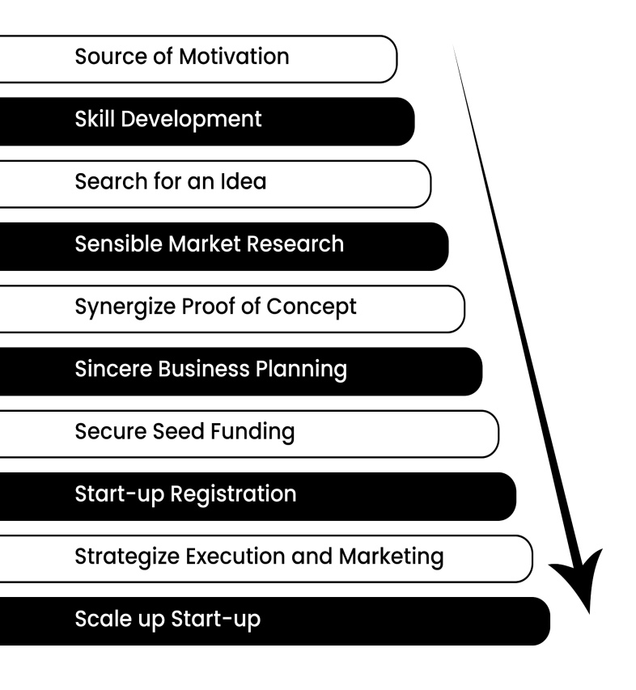
Figure 1: 10S Start-up Success Model
4.2.1 Source of Motivation
Without a deep understanding of the roots of motivation, one should not move forward because it might be temporary or instantaneous. It should not be a rat race and motivation should be intrinsic to have a long-lasting effect (Trivikram, 2020).
Motivation makes entrepreneur by fulfilling higher-level needs such as money, flexibility, recognition, esteem, and self-actualization. Maslow’s need hierarchy theory, Hertzberg’s two-factor theory, and David MC Clelland’s acquired needs theory proved that motivation can bring energy, enthusiasm, creativity and efficiencies in fulfilling the desired objectives.
4.2.2 Skill Development
If motivation is intrinsic, the next step should be understanding the concept of entrepreneurship through different sources like books, case studies, workshops, and interaction with young start-up entrepreneurs.
As an entrepreneur, one has to work various stakeholders like own team, customers, suppliers, shareholders, investors, and other stakeholders. To manage the entrepreneurship show, one should know the fundamentals of skills like Creative thinking, recognizing opportunities, goal setting, decision making, problem solving, Leadership, Communication skill, Team building, Business planning, managing seed fund, Project Execution and many others to build a happy, productive business. (Mind Tools, n.d.)
    - Search for an Idea
A successful start-up needs a lot of aspects to be at the right place but none are more important than the right business idea. Behind every successful start-up is Product or Service and in its nascent stage, it was just an idea. So, a business idea is a great foundation for any profitable start-up (Matthews, 2019).

If a business idea lies in Blue Ocean, it helps to define its unique core value proposition and entice the target audience to buy the product or service. Even its uniqueness attracts investors in the later stage thus supports a start-up in scaling up. An idea in Red Ocean might face huge competition, thus reduced sales and profits, meaning the business is less likely to grow and may struggle to survive.

A young entrepreneur should come out with an idea that is unique, difficult to copy at least for 7 years, and should add value to the life of the target audience. Thus, targeting any specific problem in the society, finding efficient and innovative solutions, and if possible, commercially viable. At this level, intuition is good enough to understand the demand of a business idea. Since it’s a very crucial stage, young entrepreneurs should take the time to confirm their start-up ideas, get some feedback from potential customers.
    - Sensible Market Research
Post finalization of an idea, sensible market research should be the next step during the start-up journey. Deep and sensible market research unravels the various facts and throws light on all assumptions whether right or wrong, taken during the idea generation phase (Lieberman, 2017). It is the most important tool to put young entrepreneurs from dreams to reality. It can be considered a gateway from dreams to reality.
Market research surely builds a sturdy foundation for a business to be built upon. Market research should be focussed to understand, Total Market Size and Growth Potential, Target audience, Competition, and many others. Market research should become an indicator for a promising target audience with scope expansion.
Around 42% of start-up businesses fail because of poor market research (Lieberman, 2017). Thus, it always looks scary to venture into the domain of entrepreneurship.
    - Synergise Proof of Concept
Information gathered through Market Research supports in building up the Proof of Concept (POC) to validate functional and technical assumptions of product or service idea (Hasa, 2020). It is the first step on your journey to the final product
Proof of concept (POC) is basically reaching the target audience (select a lot size) and understanding their point of concerns (Problems or Pain Points) in a particular domain, suggesting them alternative and innovative solution. The main purpose is to gather useful feedback. If demand from the target audience indications is on higher side and if budget allows, an entrepreneur can proceed for prototype to have User Acceptability Test (UAT).
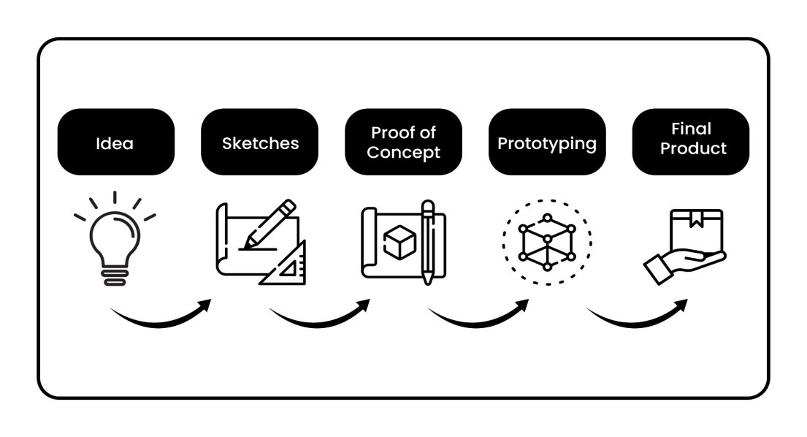
Figure 2: Process chart for ‘Idea to Product’
    - Sincere Business Planning
Information gathered through Market Research and Proof of Concept (POC) become content for business planning. A concrete business plan becomes a road map (Lesonsky, 2019) for the entrepreneurship journey. Thus, it helps in maintaining focus throughout their journey and keeps the company’s short-term and long-term goals in hindsight. Crafting the right business plan will surely make young entrepreneurs' life much easier.
Young entrepreneurs will come to know various facets of Start-ups during the business planning process like Mission, Vision, Core Value Propositions and Market Scenario like Market Size, Obtainable Market, Serviceable Market, Competition, and Scaling up possibilities and many others.It also supports in defining the execution or production process and people skills required to execute it. It also throws light on defining the Product or Services Value Canvas and accordingly the pricing strategies. Above all, it helps young entrepreneurs to define the Integrated Marketing Strategies (IMS) or go-to marketing strategies to connect with the target audience through the STP process. Also, it becomes an indicator for sales and revenue projection.
Last but not the least, it highly focuses on your financial needs whether it’s Capital Expenditure (CAPEX) or Operational Expenditure (OPEX). Thus, an indicator to manage finances internally or through the support of external sources like Angel Investor or Venture Capitalist, to manage the start-up show at least for 18 months seamlessly (Baldridge & Curry, 2021).
Therefore, a Business Planning forces a young entrepreneur to think through all aspects of a start-up like marketing, managing, financing, and more (Nouman Ali, 2020). Undoubtedly, the business plan gives a start-up a blueprint for success.
    - Secure Seed Funding
This is the most important phase of an entrepreneur’s life i.e., managing funds or raising up the seed capital as per projections made into the business planning. Start-up companies need funds to register themselves, purchase equipment, rent offices, and hire staff, and many more. More importantly, they need to grow. In almost every case they will require outside capital to do these things. The initial capital raised by a company is typically called “seed” capital (Ralston, n.d.).
Without start-up funding, the vast majority of start-ups will die. The amount of money needed to take a start-up to profitability is usually well beyond the ability of founders and their friends and family to finance. A few start-ups companies do successfully bootstrap (self-fund) themselves, but they are the exception. Thus, most start-ups will almost certainly want to raise money.
The good news is that government of India has taken many initiatives to foster entrepreneurship culture including the finances with the support of incubation centres, established by the Indian Government. Even lots of angel investors and venture capitalists are in the market to support this ecosystem. Young entrepreneurs should be ready with their Pitch Deck, Business Model, POC, and Business Planning documents to attract the seed capital. The process of raising that money is often long, arduous, complex, and ego-deflating. Nevertheless, it is a path almost all companies and founders must walk.
Investors might demand 10% to 25% stake in the start-up. This all depends on the negotiation skills of the Start-up team. Any investor receives quarterly almost 5000 ideas on his desk, only 5% of these ideas get funding. Thus, young entrepreneurs should work relentlessly on this. Rejection should be treated as redirection to improve upon (Ralston, n.d.).
4.2.8 Start-up Registration
This is the most exciting part of the start-up journey. Assuming that a young entrepreneur got the seed funding, it’s time to convert your business idea into a legal entity.
On 16 January 2016, the Indian Government launched a scheme of a start-up. It has now become very popular in India because of various benefits associated with it like Tax exemption, tender participation, participation in various start-up challenges at the national and international levels etc. The objective of Start-up India scheme is to boost employment in the country. It also supports innovation and research by providing the base for new business ideas seeking funds to thrive in the competitive space (Korreck, 2019).
The type of registration depends upon the founders’ choice, based on business objectives and future expansion plans. For example, a private limited company considered to be more authentic by investors compared to OPC and LLP.
4.2.9 Strategize Execution and Marketing
Even though seed funding is in place and a start-up is availing many benefits driven by government, Strategies are very crucial for a Start-up success in the long run.
To achieve vision, mission and the defined objectives, strategies play a crucial role. Strategies could be created around the production or marketing because these two things count for a start-up. The start-up strategies should be built around innovation, capabilities, product or service differentiation, or cost advantage (Gans, Scott, & Stern, 2018).
4.2.10 Scale up Start-up
A start-up can be defined as a new company with big growth plans and without geographic restrictions. It’s on a mission to find its repeatable scalable business model. They are still experimenting with things like segmentation, customer acquisition costs, and product features.
So basically, a start-up is a start-up until and unless it proves its business model. Once the business model is proven, the start-up moves into a phase of scale-up (Harnish, n.d.). In the scale-up phase, the complexity of decision-making changes. There are more and more stakeholders involved and the level of risk the company can afford declines. Thus, in this phase, , the founders should redefine the leadership, infrastructure, and marketing into a more robust and organized way for seamless and quantum growth.

Observations from Case Studies

To encourage innovation amongst students and nurture their ideas for entrepreneurial ventures, Army Institute of Technology established it’s Innovation and Entrepreneurship Cell in the year 2019. By undertaking different activities and training programs, the institute was able to build an ecosystem to initiate and nurture eight start ups in different domains. The proposed model in this paper has been evolved based on these case studies. For the sake of protecting individual start-up privacy, we are identifying them as A, B, C etc. In this section, we give our observations and comparative analysis for all the team using the proposed 10S model, the integrated start-up success model.

Motivation, Skill Development: All the aspiring founders from these teams, were from different streams of engineering, and were extremely motivated to work with new technology. They always explored, experimented and built a lot of skills during internships, competitions. They always were inclined to work on their own idea.

Search for an idea: All the teams started working on their own idea in their third year itself. The idea evolved during their individual respective journey of exploring technology. Out of the 8 teams, 2 teams have filed for a patent, which further confirms innovativeness of their proposed idea.

The faculty mentors and alumni mentors together guided the teams on whether the idea can be commercialized and if so, how to convert it into a venture. The institute started consciously building an ecosystem for domain mentors, patent experts and legal experts. As a result the teams today are in different phase of incubation.

5.3 Market Research: Except two teams, all the teams did extensive market research under the guidance of experts and confirmed the significance of their proposed idea. This helped them each to draft a good business plan.

Table 1 shows team performance for the rest of the criteria from the proposed model.

Table 1: performance of start up teams for the criteria in proposed 10S model
Domain of Product | Team A | Team B | Team C | Team D | Team E | Team F | Team G | Team H
 | Logistics automation | Security | Artificial Intelligence | Deep learning | Energy | E vehicle | Online Library | Supply Chain Management

Criteria
Market Research | Yes | Yes | Yes | Yes | Yes | Yes | Yes | Not rigorously
Seed Funding | Mentor Company +Self | Self financed | Institute + Self | Self | Department of Science and Technology | Institute + Self | Not required | Self
Start-up Registration | Not yet | Not yet | Yes - LLP | Yes - Private Limited | Yes - Private Limited | Not yet | No | Yes as proprietary
Execution | Product ready | Product ready | Product ready | Product ready | Product in process | Product ready | Product ready. Built good customer base but could not sustain | Product ready, launched but could not sustain in the market

Marketing: For marketing the product, all the teams were extended support by Institute Industry network and Alumni network. This helped the teams to get their first client. Out of all the eight teams, team G and H could not sustain due to lack of sufficient market research and good marketing plan.
Army Institute of Technology took conscious and rigorous efforts in building the eco system to nurture entrepreneurship amongst students. The institute promoted collaborative model which comprised of aspiring start up funders, alumni entrepreneurs and mentor faculty. All the teams periodically discussed their respective struggles in an informal meet with alumni entrepreneurs. This helped them to get a solution and progress to make their venture a success. Though all the start-ups are still in the initial stage but still the institute is sure that they will be successful in the coming years.

Conclusion
At Army Institute of technology, the proposed 10S model which was implemented under the guidance of expert was observed to be successful. Out of eight start-up ventures, three registered their company and all of them are working with clients. Only two start-ups could not sustain as they did not take enough efforts in market research and business plan. Though these teams failed, but this failure is actually not a failure as this experience has given them enough confidence to get back to their careers.
The institute is taking the measures with a proactive approach and proposing a collaborative model of aspiring start up founders who understand each other’s needs, provide support and be successful. The 10S integrated model may be recommended for other Higher Educational Institutes for building successful start up culture amongst students.
It is observed that most start-ups are not able to compete with large companies in terms of funding, infrastructure, and attracting the right team to build the competitive environment. Being a young entrepreneur more precautions need to take at every step of the entrepreneurship journey. The proposed collaborative efforts with 10S model may give the start ups the required support under such competitive conditions.
However, many enterprising talents are still being discouraged from pursuing their passions as an entrepreneur by their families because of discouraging data. Instead, the culture needs to be more encouraging towards such people, who would like to take deep dive into the ocean of entrepreneurship. We believe that willingness to take risks should be more appreciated and failure should be seen with less negative judgment, to foster innovative ideas with the right skills and the right knowledge.

References
Baldridge, R., & Curry, B. (2021, April 1). Forbes. Retrieved from ForbesAdvisor: https://www.forbes.com/advisor/investing/what-is-a-startup/
Cope, J. (2005). Toward a Dynamic Learning Perspective of Entrepreneurship. Sage Journals.
Central University of Tamil Nadu. (n.d.). Retrieved from MHRD Innovation Council: https://cutn.ac.in/mhrd-institution-innovation-council/
Fundersclub. (n.d.). Retrieved from Fundersclub guide: https://fundersclub.com/learn/guides/vc-101/the-risks-and-rewards-of-startup-investing/
Gans, J., Scott, E., & Stern, S. (2018, May). Strategy for Start-ups. Harvard Business Review.
Harnish, V. (n.d.). Growth Institute. Retrieved from https://blog.growthinstitute.com/scale-up-blueprint/startup-to-scaleup
Hasa, M. (2020, February 11). Pixelfield. Retrieved from https://pixelfield.co.uk/blog/proof-of-concept-the-complete-guide-for-startups/
https://blog.mygov.in/. (2019, August 16). Retrieved from youth-entrepreneurship-an-emerging-trend-in-india/: https://blog.mygov.in/youth-entrepreneurship-an-emerging-trend-in-india/
Korreck, D. S. (2019, September 12). The Indian startup ecosystem: Drivers, challenges and pillars of support. ORF Ocassional Paper, 44.
Lesonsky, R. (2019, April 6). Score. Retrieved from https://www.score.org/blog/5-reasons-your-startup-needs-business-plan
Lieberman, M. (2017, October 11). Sqaure 2 Marketing. Retrieved from https://www.square2marketing.com/blog/why-market-research-is-so-important-when-starting-a-new-business
Matthews, D. (2019, September 16). Better Marketing. Retrieved from https://bettermarketing.pub/why-your-business-idea-is-the-most-important-thing-in-your-startup-48d0c7728888
Mind Tools. (n.d.). Retrieved from Entrepreneurial Skills: https://www.mindtools.com/pages/article/newCDV_76.htm
mygovblog. (2019, August 16). Retrieved from https://blog.mygov.in/youth-entrepreneurship-an-emerging-trend-in-india/
Nouman Ali. (2020, September 19). Feedough. Retrieved from https://www.feedough.com/importance-startup-business-plan/
Padhiar, J. (n.d.). MYHQ DIGEST. Retrieved from https://digest.myhq.in/: https://digest.myhq.in/9-reasons-why-startups-fail/
Ralston, G. (n.d.). Ycombinator. Retrieved from https://www.ycombinator.com/library/4A-a-guide-to-seed-fundraising
Shokurova, K. (2020, June 6). Shakuro. Retrieved from shakuro Website: https://shakuro.com/blog/why-do-startups-fail-its-all-about-marketing-and-team
StartupIndia. (2021). Retrieved from Startup India Hub: https://www.startupindia.gov.in/content/sih/en/about-startup-india-initiative.html
Trivikram, S. (2020, October 12). My Venture Pad. Retrieved from Entreprenurial Motivation: https://myventurepad.com/entrepreneurial-motivation/
Ucbasaran, D., Shepherd, D. A., Lockett, A., & Lyon, J. (2012). Life After Business Failure: The Process and Consequences of Business Failure for Entrepreneurs. Journal of Management.
Zwilling, M. (2012, September 14). Entrepreneur India. Retrieved from entrepreneur website: https://www.entrepreneur.com/article/224397

Source: Experiential Journey of E-Cell, Army Institute of Technology to foster Entrepreneurship culture at AIT under guidelines of IIC
Note: It’s not the time to go for Minimum Viable Product (MVP), simplest version of a product or service that brings at least part of a products or service’s core value to the target audience is aligned with the mission of a start-up, and is market-ready. It’s a stage between Prototyping and Final product or service and sometimes referred as pilot run.

