Original Research: Relationship between Career Anchors and Demographic Characteristics among Occupational Health Nurses in Japan

Yoshiko Kubo 1

Yoko Hatono 2

Tomohide Kubo 3

Satoko Shimamoto 4

Junko Nakatani 5

1School of Nursing, The Jikei University, Tokyo, Japan

2Graduate School of Medical Science, Kyushu University, Fukuoka, Japan

3National Institute of Occupational Safety and Health, Kawasaki, Japan

4School of Health Science, Tokai University, Kanagawa, Japan

5School of Occupational Health Science, University of Occupational and Environmental Health, Kitakyushu, Japan

Correspondence concerning this article should be addressed to Yoshiko Kubo, Department of Nursing, The Jikei University School of Medicine, 8-3-1 Kokuryo, Chofu, Tokyo 182-8570, Japan. Email: [yoshiko@jikei.ac.jp](mailto:yoshiko@jikei.ac.jp)

Abstract: 227

Text: 2789

No. of tables: 3

**Abstract**

Objectives: This study examined the relationship between career anchors and demographic characteristics among occupational health nurses (OHNs) in Japan.

Methods: Seven-hundred forty-five OHNs participated in the questionnaire survey. Measurements included demographic data and the Career Anchors: Self-Assessment Scale.

Results: We found the following career anchor scores: TF = 13.7 (SD = 2.7), LS = 13.3 (SD = 2.6), CH = 12.7 (SD = 2.8), SV = 12.7 (SD = 2.9), AU = 12.3 (SD = 2.7), SE = 12.2 (SD = 2.4), EC = 10.0 (SD = 2.9), and GM = 9.0 (SD = 2.6). OHNs from graduate school had the highest score in seven career anchors (excluding SE); OHNs from vocational school had the lowest score in six career anchors (excluding AU and EC). OHNs with PHN qualifications had the highest score in six career anchors (excluding SV). There were no significant differences between marriage, child-care experience, and family-care experience and LS type. OHNs aged in their 20s had the highest score in six career anchors (excluding LS). OHNs who worked full-time had the highest score in six career anchors (excluding CH).

Conclusions: The characteristics of career anchors among OHNs resembled those found in previous studies. It is necessary to develop an educational and social system that addresses the differences between working full-time and not. The ability of OHNs in managerial positions is a prominent issue.

**Key words**: Career anchor, Career development, Occupational health nurse

**Introduction**

The Japanese Nursing Association (JNA) stated the importance of designing career plans and goals according to the ability, life, and life cycles of each nurse, and the needs of society regarding the career development of nursing staff. Furthermore, the JNA states that each nurse must work hard to achieve his or her own goals. Moreover, for nurses to continue to learn and maintain and develop their abilities, they require educational support, which must be provided by the organization [1].

In the 2010 fiscal year in Japan, the Act on Public Health Nurses, Midwives, and Nurses and the Act on Assurance of Work Forces of Nurses and Other Medical Experts were revised, and more effort on workplace education became an obligation [2]. However, under these policies, the person in charge of workplace education was the hospital director; consequently, the revisions centered on hospitals. Therefore, companies and health insurance associations that employ occupational health nurses (OHNs) were not obligated to provide workplace education and career support systems.

The career development of OHNs has faced many challenges [3, 4]. In Japan, employers who employ over 50 workers must hire at least one certified occupational health physician (OHP) and an occupational safety and health manager, which is stated in the Occupational Health and Safety Law. In accordance with this law, OHNs do not need to be hired and the roles of OHNs are unclear [5]. However, according to the JNA [6], the number of OHNs in Japan has increased; there were approximately 8800 OHNs in 1995, which has increased to approximately 12300 in 2012. The Occupational Health Nursing Research Centerindicated that, while about 70% of OHNs have both registered nurse (RN) and public health nurse (PHN) qualifications, the other 30% have only a RN qualification. OHNs with only RN qualifications were intermingled; some OHNs had an RN qualification and were educated by the Japan Society for Occupational Health, whereas others had not received an RN qualification. OHNs with a PHN qualification are educated in not only personal support (e.g., health consultations and reinstatement support), but also public health (e.g., group education and population health approaches). The undergraduate education for OHNs in Japan differs significantly among nursing universities. Consequently, significant differences exist in the qualifications and undergraduate education of OHNs [3].

Furthermore, about 30% of OHNs work alone, without OHPs and colleague OHNs, thereby limiting opportunities for on-the-job training and role expansion. Many OHNs work full-time, whereas most OHPs work part-time. About 50% of OHNs are supervised by non-healthcare staff, who may not fully understand the OHN role and may not value continuing professional development and the importance of being promoted and hired as full-time staff [3]. Therefore, OHNs in Japan may find it difficult to plan and develop their careers [3, 4].

Previous studies have examined three areas: organization and professional orientations [7], generalist and specialist orientations [8], and diverse orientations that capture professional life, including the individual’s personal life [9]. Schein defined a career anchor as a person’s self-concept consisting of aspects pertaining to the career such as self-perceived talents, values, and an evolved sense of motives [9]. A career anchor reflects the direction that a worker wants to go [10]. Reflection on career anchors and career development management is essential to researching OHNs [11]. To develop the careers of healthcare workers, career anchors lead to the acquisition of competency, knowledge, and the improvement of techniques [12].

Therefore, this study focused on career anchors as a principal factor in career development. Previous studies on career orientations in nursing have focused on administrative public health nurses (APHNs) [13, 14]and hospital nurses (HNs) [15–17]; there are no studies on OHNs. Consequently, this study examined the relationship between career anchors and demographic characteristics among OHNs in Japan. In this paper, careers were related to attitudes and actions developed through objective aspects such as job title, status, and employment history, but also through the processes of employment-related experience and activities. Consequently, careers were defined as life-long self-realizations, and career anchoring, which incorporates individual lifestyles, was a vital component of occupational health nursing. OHNs were defined as those practicing occupational health nursing services in a corporation, health insurance association, industrial health organization, or as self-employed business owners.

**Materials and Methods**

*Participants*

We recruited OHNs affiliated with the Japan Society for Occupational Health. First, half the sample were selected through random sampling by the secretariat of the Japan Society for Occupational Health. Those not currently working as OHNs were excluded. Finally, 745 anonymous questionnaires were mailed in May 2015 with a letter describing the aims and procedure of the study, and assuring potential participants that participation was completely anonymous. Three-hundred thirty-seven questionnaires were returned (response rate = 45.2%). After excluding OHNs with at least one missing data point on the Career Anchors: Self-Assessment Scale (CASAS), 325 questionnaires were included in the analyses.

*Demographic information*

Demographic data included sex, age, years as an OHN, education level, qualification, position, affiliation, employment, supervisor, marital status, child-care experience, and family-care experience.

*CASAS*

The CASAS is a 40-item measure for general workers developed by Schein [9]; the Japanese version of the CASAS was translated by Kanai [18]. The CASAS comprises eight subscales: Technical/functional Competence (TF), General Managerial Competence (GM), Autonomy/independence (AU), Security/stability (SE), Entrepreneurial/creativity (EC), Service/dedication to a Cause (SV), Pure Challenge (CH), and Lifestyle (LS). Response options were: 1 (“*never true*”), 2 (“*sometimes true*”), 3 (“*mostly true*”), and 4 (“*always true”*) (range = 1–4).

*Statistical analyses*

The data of 325 participants were scored for each subscale of the CASAS via a Likert scale score. The scores of each subscale with the highest score defined the career anchor type. Therefore, the strongest career anchor types were investigated for each subscale. Furthermore, characteristics and subscale scores were calculated to analyze the relationship between characteristics and subscale scores. For two groups, such as national qualification and qualification, a non-paired t-test was conducted. For more than three groups, such as age and supervisor, a one-way analysis of variance (ANOVA) and a hypostasis Bonferroni test were conducted.

Multiple regression analyses were used to assess the relationship between career anchor and demographic characteristics. First, each independent variable was calculated as a candidate correlation coefficient via the Spearman method; therefore, the correlation coefficient of age (real number) and years as an OHN (real number) was 0.5 or more (r = 0.719). Consequently, “years as an OHN” was left as an independent variable because correlation coefficients were higher with career anchor scores. Moreover, the nominal scale was converted into dummy variables of 0 and 1, and a scale with three or more categories was created as a reference category, such as national qualification (1: public health nurse, 0: registered nurse) and qualification (1: yes, 0: no).

Stepwise method multiple regression analyses were used to assess the relationship between each career anchor scores as the dependent variables, as well as the independent variables of years as an OHN, dummy variables of nominal scale national qualification and qualification, and so on. Because we calculated the variance inflation factor value at the time of analysis, the value was always around 1 to 2 levels, as there were no variables that were more than 10; in other words, there were no problems regarding multiple collinearity. All statistical analyses were conducted using SPSS Version 23.0 for Windows (IBM Corp., NY, USA).

*Ethical considerations*

This study was approved by the ethical review board of the author’s institution (ID number 7823). This study was approved by the Japan Society for Occupational Health. Participants were informed of the purpose, procedures, potential publication of this study, and their rights of refusal and confidentiality. Written informed consent was obtained from participants.

**Results**

*Participants’ characteristics*

Table 1 shows participants’ characteristics. The mean age of participants was 45.3 years (SD = 9.3). The mean length of career as an OHN was 15.3 years (SD = 9.1).

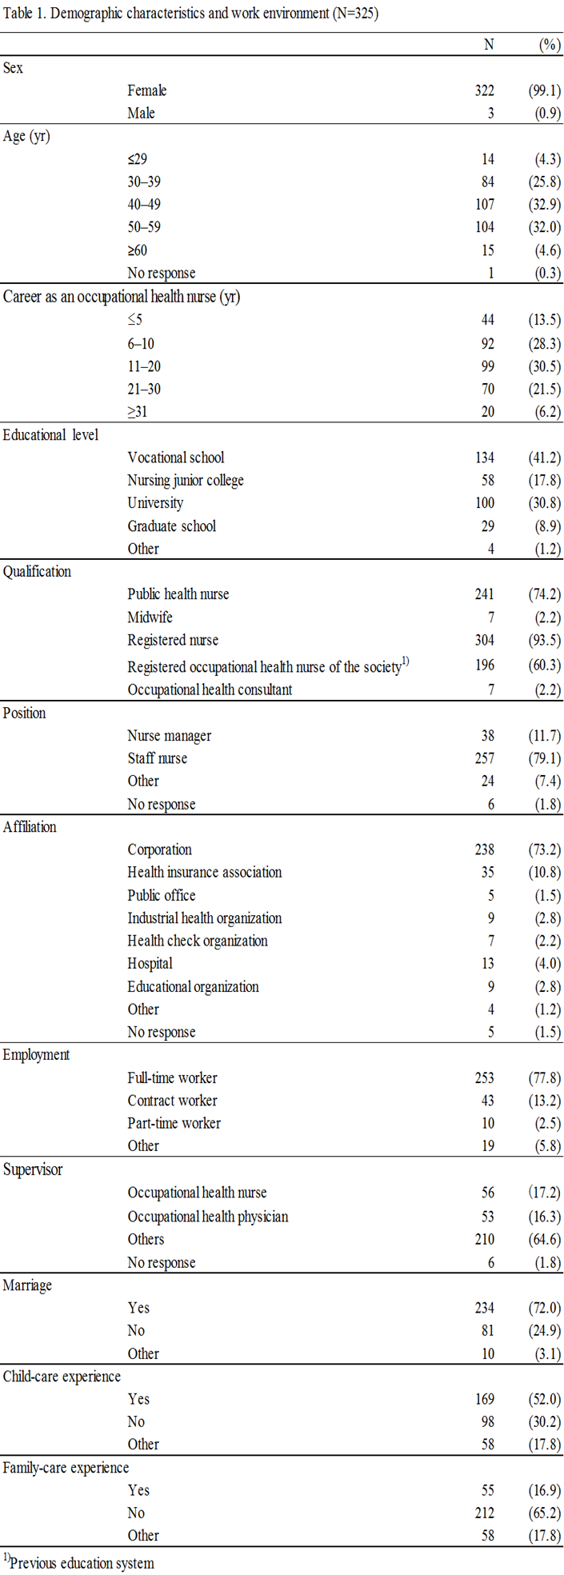

*Relationship between career anchor scores and demographic characteristics*

Table 2 shows the relationship between career anchor scores and demographics. Regarding career anchor scores, TF = 13.7 (SD = 2.7), LS = 13.3 (SD = 2.6), CH = 12.7 (SD = 2.8), SV = 12.7 (SD = 2.9), AU = 12.3 (SD = 2.7), SE = 12.2 (SD = 2.4), EC = 10.0 (SD = 2.9), and GM = 9.0 (SD = 2.6).

There was no significant difference regarding age; OHNs aged in their 20s had the highest score in six career anchors (excluding LS). The one-way ANOVA revealed significant differences in TF and CH types per educational level. There was no significant difference in TF type per the Bonferroni test. There was a significant difference in CH type between vocational school and graduate school per the Bonferroni test. OHNs from graduate school had the highest score in seven career anchors (excluding SE); OHNs from vocational school had the lowest score in six career anchors (excluding AU and EC). There were significant differences in GM, EC, SV, CH, and LS types regarding national qualification. OHNs with PHN qualifications had the highest score in six career anchors (excluding SV). There were significant differences in TF and GM types regarding qualification. There were significant differences in GM types regarding position. Nurse managers had the highest score in six career anchors (excluding SE and LS). There were significant differences in GM types regarding employment. OHNs who worked full-time had the highest score in six career anchors (excluding CH). There was no significant difference between marriage, child-care experience, and family-care experience and LS type.

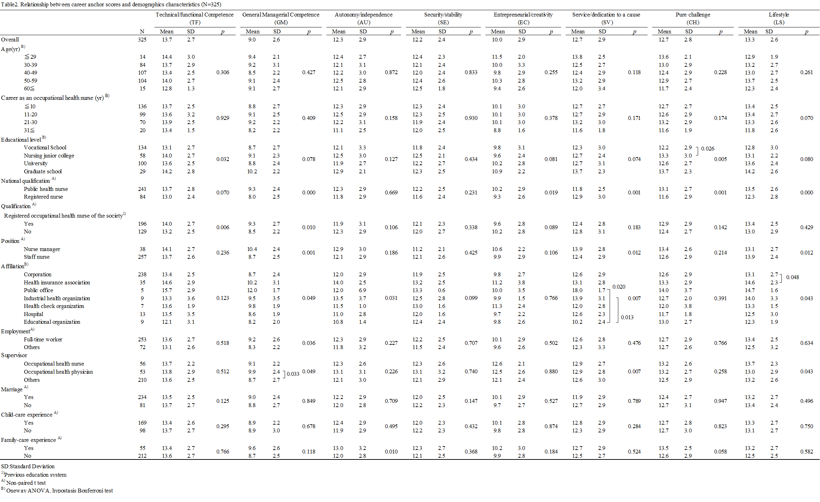

*Multiple regression analyses of career anchors*

Table 3 shows the multiple regression analyses of career anchors. The selected independent variable that explained TF scores was qualification (adjusted R2 = 0.023). The selected independent variables that explained GM scores were national qualification, supervisor, occupational physician, position, educational level, and graduate school (adjusted R2 = 0.109). The selected independent variables that explained AU scores were family-care experience, supervisor, and occupational physician (adjusted R2 = 0.023). The selected independent variable that explained SE scores was years of experience as an OHN (adjusted R2 = 0.013). The selected independent variables that explained EC scores were national qualification, educational level, and graduate school (adjusted R2 = 0.026). The selected independent variables that explained SV scores were national qualification, position, and years of experience as an OHN (adjusted R2 = 0.065). The selected independent variables that explained CH scores were national qualification, educational level, graduate school, educational level, nursing junior college, and family-care experience (adjusted R2 = 0.079). The selected independent variables that explained LS scores were national qualification, position, years of experience as an OHN, and position (adjusted R2 = 0.086).

SE, SV, and LS types were lower when OHNs had more years of experience. Education level was related to GM, EC, and CH, and those who attended graduate school had career anchor scores higher than those who attended vocational school. National qualification was related to GM, EC, SV, CH, and LS type; the career anchor score of those with a PHN qualification was higher. Qualification was related to TF type; career anchor score with qualification was higher. Position was related to GM, SV, and LS type; career anchor score with nurse managers was higher than career anchor score with staff nurses.



**Discussion**

*Characteristics among OHNs regarding each career anchor score*

In a previous study of nurses at university hospitals, the scores of LS type were highest in eight career anchor types in the following order: SE, TF, SV, CH, AU, EC, and GM [19]. Furthermore, for nurses at general hospitals, the scores of LS type were the highest in eight career anchor types, in this order: SE, SV, TF, CH, AU, EC, and GM [15]. Another study of nurses had highest scores in this order: SE, SV, TF, AU, EC, and GM at university hospitals, and TF, SV, SE, AU, GM, and EC at emergency departments [11]. In a survey of career anchors for full-time male workers, the order of career anchor scores was SE, GM, AU, EC, and TF [20]. Comparing previous research to our results, the characteristics of career anchors among OHNs resembles those of emergency department nurses: the TF score was the highest. As in previous studies among HNs [15, 20], LS score was the highest and GM score was the lowest.

OHNs are often asked for specialized advice and support; therefore, many OHNs and emergency department nurses want to exercise professional knowledge and skills in the workplace. In addition, the substantial number of LS type likely reflected the high proportion of women in this study. In previous studies of HNs [15] and APHNs [13, 14], the results were similar; therefore, when obtaining qualification, they likely chose a job that offers balance between work and private life. Moreover, there were a small number of GM type compared to full-time male workers. In addition, only approximately 10% of the OHNs worked in managerial positions, which is negligible compared to APHNs [13, 14]. In recent years, the Japanese government has tried to increase the number of female managers; however, likely related to Japan’s specific culture, only a small number of women wish to be promoted to managerial positions. This issue is prominent among OHNs .

*Characteristics of career anchors among OHNs regarding demographic characteristics*

OHNs aged in their 20s had the highest score in six career anchors (excluding LS). SE, SV, and LS types were lower when OHNs had more years of experience. The results contrasted with previous studies regarding age and career as an OHN. OHNs in 20 ages need to professional education while motivating work. Qualification was related to TF type, career anchor score with qualification was higher by multiple regression analyses. It is necessary to educate the young generation firmly while utilizing the educational system such as academic society.

OHNs from graduate school had the highest score in seven career anchor types (excluding SE); OHNs from vocational school had the lowest score in six career anchor types (excluding AU and EC). This difference per educational level was consistent with previous research [15]. In that study, two educational groups were compared: university (university and graduate school) and non-university (vocational school and nursing junior college), and the overall career anchor scores of the university group were higher than those of the non-university group. Therefore, perhaps career anchors increase as educational level increases. In addition, OHNs with PHN qualifications had the highest score in six career anchor types (excluding SV). Similar to education level, the scores tend to increase when nurses had a PHN qualification rather than only an RN qualification.

Moreover, there were significant differences regarding position: managers had higher scores than did staff nurses per GM and SV types, which was similar to previous research [11, 15]; however, we cannot infer a causal relationship (OHNs could have become managers because of high GM scores or vice versa). In previous research[11], SV was more common than GM among nurse managers; consequently, we considered that OHNs become managers and they would like to serve supervisor, staff, corporation, and employee by degrees.

OHNs who worked full-time had the highest scores in six career anchors (excluding CH). This contrasted a previous study [3], where employment concerns among OHNs was a critical factor of career crisis. Therefore, it is necessary to develop an educational and social system.

There were significant differences related to marriage and child-care experience in previous research [15, 19]; however, there were no significant differences related to marriage and child-care experience in this research. Many OHNs change the job the opportunity of marriage and childbirth because OHNs are day shift work. Therefore, we considered many OHNs prefer LS type by marriage and childbirth.

*Limitations and future directions*

Admittedly, we did study OHNs with a certain level of professional awareness as we targeted members of the Japan Society for Occupational Health. According to a survey by the Japanese Nursing Association, there are 12,300 nurses working in other offices. Therefore, our study only addressed a small fraction of OHNs. Previous studies have had response rates around 15%, comprising approximately 400 OHNs. In addition, when planning surveys with OHNs, it can be difficult to determine where they work; therefore, surveys are often conducted among those who are members of the Japan Society for Occupational Health. In this survey, the response rate was below 60%; therefore, subject-related bias is a potential limitation. Furthermore, it is not possible to derive any causal relationships, because this study was a cross-sectional survey. Moreover, career anchors are not universal indicators; they change depending on the number of years of experience as an OHN, their position, and so on. Consequently, it is necessary to conduct a longitudinal examination. In the future, we hope to examine the various effects of job satisfaction and the formation of career anchors, which may contribute to OHNs’ career development.

**Acknowledgments**

We gratefully acknowledge the very helpful participation of the OHNs. This work was supported by a grant-in-aid from The Jikei University and the Japan Society of Private College and Universities of Nursing.

**Conflicts of Interest**

The authors declare that there was no financial support or relationships that may pose a conflict of interest.

**Authors’ Contributions**

YK, YH, TK, SS, and JN contributed to the conception and design of the study, as well as the statistical analyses and drafting of the manuscript. All authors read and approved the final manuscript.

**References**

[1]Japanese Nursing Association, “Continuing education,” 2014, http://www.nurse.or.jp/nursing/ed"cation/keizoku/index.html

[2]Ministry of Health, Labor and Welfare, “Act on Public Health Nurses, Midwives, and Nurses and the Act on Assurance of Work Forces of Nurses and Other Medical Experts were revised,” 2014, http://www.mhlw.go.jp/stf/seisakunitsuite/bunya/0000095525.html

[3]Occupational Health Nursing Research Center, “Occupational Health Nursing Education Survey Among Nursing Universities,” Yokkaichi: Yokkaichi Nursing and Medical Care University Press, 2014. [in Japanese]

[4]Y. Hara, K. Yamada, A. Shiraishi, Y. Hachiya, J. Nakatani and I. Ishihara, “Evaluation of programs of continuing education regarding occupational health nursing for university graduates,” Proceedings of the 1stAsia Conference on Occupational Health Nursing, 2008, pp. 89-90.

[5]S. N. Arino, “Occupational Health Nursing in Japan: Current Practice and Future Perspectives,” American Association of Occupational Health Nurses, vol. 52, no. 2, 2003, pp. 58-64.

[6]Japanese Nursing Association, “Japanese Nursing Association Research Report,” 2012, <http://www.nurse.or.jp/home/publication/toukei/pdf/toukei01.pdf>. [in Japanese]

[7]A. W. Gouldner, “Cosmopolitans and Locals: Toward an analysis of latent social roles,” Administrative Science Quarterly, vol. 2, no. 3, 1957, pp. 281-306.

[8]J. P. Kotter, “The Psychological Contract: Managing the joining-up process,” California Management Review, vol. 15, no. 3, 1973, pp. 91-98.

[9]E. H. Schein, “Career dynamics: Matching individual and organizational needs,” Addison-Wesley Publishing, 1978.

[10]H. Ota, “Professional and organization: Indirect assimilation of the organization and the individual,” Doubunkan Publishers, 1993. [in Japanese]

[11]M. Sakaguchi, “Formation of career anchors and job characteristics of hospital nurses,” Bulletin of Nursing College, Wakayama Medical University, vol. 3, 2000, pp. 11-19. [in Japanese]

[12]N. Iino, “Competency of pharmacists at pharmacies,” Journal of the National Institute of Public Health, vol. 55, no. 2, 2006, pp. 133-146. [in Japanese]

[13]M. Okura, K. Saeki and T. Kido, “Major structural factors of orientation for public health nurses working in administration agencies,” Journal of the Tsuruma Health Science Society, Kanazawa University, vol. 30, no. 2, 2006, pp. 11-21.

[14]M. Okura, C. Noro, M. Ogita and H. Arai, “Development of a scale to measure career orientation in public nurses working in Japanese administrative agencies and relationships with demographic characteristics,” Japan Journal of Public Health, vol. 58. no. 12, 2011, pp. 1026-1039. [in Japanese]

[15]Y. Asano, “Nurses’ Career Orientation and Related Factors: A survey at large general hospitals. Japan Journal of Nursing Research, vol. 25, no. 1, 2002, pp. 45-56. [in Japanese]

[16]Y. Honda, S. Haruyama, H. Asano, H. Ueno, J. Fukuda and Y. Takaku, “The characteristics of the career needs of nurses in a large-scale hospital: From an investigation of the university hospital of a Local City,” Jichi Medical University Journal of Nursing, vol. 10, 2012, pp. 47-56. [in Japanese]

[17]K. Ruth, S. Carmela and R. Dennie, “Reaching the top career anchors and professional development in nursing,” International Journal of Nursing Education Scholarship, vol. 6, no. 1, 2009, pp. 1-21.

[18]E. H. [Schein](http://www.amazon.co.jp/s/ref=dp_byline_sr_book_2?ie=UTF8&text=Edgar+H.+Schein&search-alias=books-jp&field-author=Edgar+H.+Schein&sort=relevancerank) and T. Kanai, “Career anchors: Self-assessment,” Hakutou Publishers, 2009. [in Japanese]

[19]Y. Sumita, M. Sakaguchi, I. Morioka and Y. Suzuki, “Tendencies in the career anchor formation of nurses,” Japan Journal of Nursing Research, vol. 33, no. 2, 2010, pp. 77-83. [in Japanese]

[20]M. Hirano, “Career development–psychological dynamics. Bunshidou Publishers, 1994. [in Japanese]