Geological and Geotechnical investigation of the residual swelling soils of Rufisque (Senegal)
Meissa FALL¹, Mapathe NDIAYE¹, Isabelle NIANG²,
¹Laboratoire de Mécanique et Modélisation, UFR Sciences de l’Ingénieur, Université de Thiès, Sénégal
²Département de Géologie, Faculté des Sciences et Techniques, Université Cheikh Anta Diop de Dakar, Sénégal

Email: mapathe.ndiaye@univ-thies.sn

Received ****

Abstract
Rufisque soils have been for a longtime considered as formed from attapulgites that have no swelling capacity. Therefore, structural causes have been advanced to explain numerous building damages. The difference in the scales of the damage on the structures and the faulting of the substratum lead us to revisiting the question. A wide combination of investigation methods allowed revealing that Rufisque soils have actually expansive properties due to the possible neogenesis of montmorillonite from attapulgites. Moreover the presence of swelling clays must be combined to particular geomorphologic and hydrologic factors to imply significant damages.

Keywords: Attapulgite, montmorillonite, marls, marly limestone, swelling, expansion, clays, damage.
1. Introduction
The City of Rufisque, located in western Senegal (14°43’ N, 17°16’ W) has for many decades focused the attention of researchers for its vulnerability to coastal erosion linked to its geographic location with regard to the Atlantic Ocean and to its geological setting (Niang-Diop, 1995). More recently early building cracks observed in many localities opened a new investigation area in the region (Cisse et al, 1999).
For a long while, Rufisque soils have been considered as mainly resulting from the weathering of the Eocene attapulgites, which have no swelling power (Grim, 1962). However, the numerous and early building damages seemingly linked to swelling clays lead to think that this consideration have to be revisited as it is not be relevant with in situ observations.
To explain the soil instability, it has been first advocated that the observed building damages have geological causes and are linked to local tectonic activities. Using techniques from photogrammetry, Lompo (1987) showed that the area is intensively sliced by a set of local fractures. This affirmation has to be revisited given that the scale of the damages, which is metric, is not consistent with the observed geological discontinuities.
We carry out this research to better understand the causes of the soil instability in Rufisque. Our approach consists in a first step, to perform a building damage mapping, to evaluate the spatial extend of the observed damages in Rufisque. In a next step, wide geotechnical investigations will allow to obtain detailed parameters on the Rufisque soils. Additionally to field characterization based on the lithology, color, texture, smell, etc., many available laboratory investigations have been used. Finally, the obtained damage map is replaced in the geotechnical setting in the aim to unravel the link between the observed building damage and the geotechnical properties of the substratum.
2. Geological setting
The investigated area in Rufisque is located in the Western part of the Senegalese passive margin basin. This part of the basin shows a set of sedimentary terrains aged from Cretaceous to present with most of them aged Eocene. The sedimentary terrains are sliced by North-South oriented faults delimiting a series of horsts and grabens, settled during the Miocene tectonic stage (Bellion, 1987; Ritz et al, 1987). The City of Rufisque occupies a graben surrounded by two horsts : Dias in the Eastern part and Pikine-Thiaroye in the West. A secondary tectonic activity phase is described in the early Pleistocene and is associated to the fissural volcanism observed in the region (Crevola, 1994).
The sedimentary rocks in the investigated area correspond to the Bargny Formation aged Lutetian, showing alternation of marls and limestone directly deposited on the Ypresian marls and attapulgites. This Formation is partly crossed by fissural volcanic formations. Volcanic rocks are composed by a nepheline massive lava flows and a set of basanite dykes and sills (Crevola, 1994).

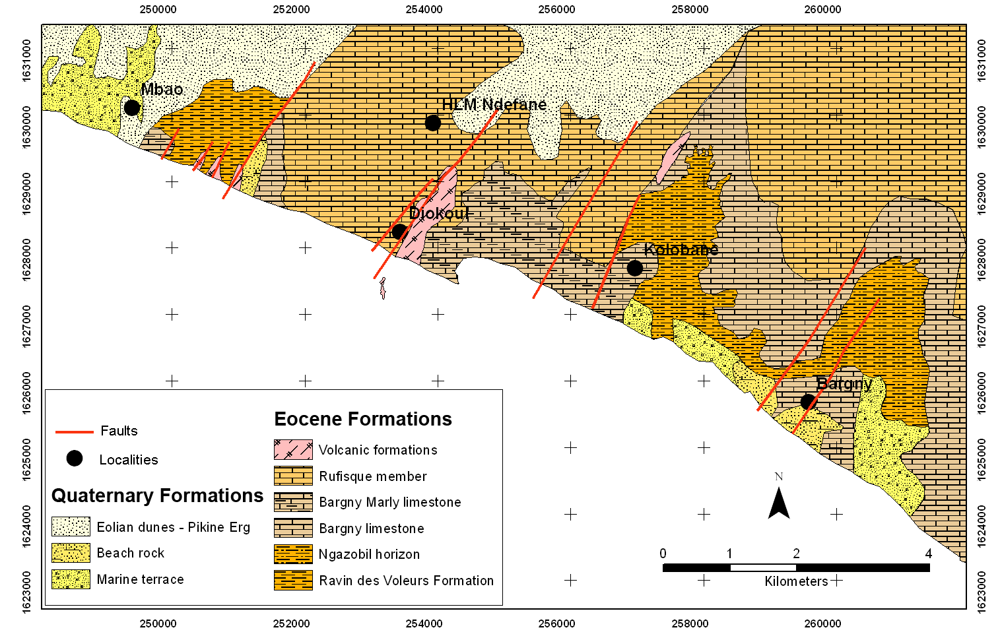
Figure 1. Geological map of Rufisque (Elouard, 1976. Modified)
2.1. The Bargny Formation
The Bargny formation is subdivided into two members (Elouard et al., 1976): The Cap des Biches member, and the Rufisque member.

The Cap des Biches Member also referred as the Bargny limestones is formed of grey, yellowish pluridecimetric mudstone layers, alternating with marly laminae. At the top of the Cap des Biches member, we have silicified wackestone containing phosphate clasts, coproliths, peloids with the presence of Discocyclinae (Discocyclina senegalensis). The bottom of the Cap des Biches member shows several planktonic foraminfera associations (Acarinina cf. praetopilensis, A. collactea, Subbotina linaperta, S. cf. hagni, S. eocaena, S. roesnaesensis, Morozovelloides cf. crassatus, Guembelitrioides nuttali) and common benthic foraminifera indicating the bottom of the Lutetian P10 biozone. The existence of ripple marks and hummocky cross stratifications leads to associate these facies to high-energy deposit environment (Pasmi, 2009).

The Rufisque Member shows marly layers alternating with thin carbonates laminae. The fossil content consists in fish scales, bones and teeth. The Rufisque Member contains planktonic foraminifera (Acarinina bullbrooki, A. cf. praetopilensis, A. cf. collactea, Subbotina linaperta, S. cf. hagni, S. eocaena, Parasubbotina griffinae, Pseudoglobigerinella bolivariana, Morozovelloides crassatus) or benthic foraminifera associated to the Lutetian P10 to P12 biozones.
More recently, it has been shown that the marls of the Rufisque member shows three differents facies basing on the microfossil content : the Frondicularia, the Planularia and the Radiolaria facies. Although, identifying this three facies in the field is still tedious (Pasmi, 2009).
According to many authors (Diop, 1983; Pasmi, 2009), the deposition of these marls is linked to a deepening of the depositional environment.

2.2. The volcanic formations
The volcanic formations show a massive nephelinite flow at Diokoul. At the Cap de Biches, basanitic dykes and sills outcrop and stay visible along the beach in low tide between 14,71399 N - 17,28947 W and 14,72530 N - 17,31603 W).
Locally, we found associated to the lava, tuffs, volcanic breccia with large fragments than can exceed 1m³. This breccia is associated to an explosive phreatic volcanism (Crevola, 1978). Radiometric ages indicate respectively 20.9±0.6 and 13.5±0.2 MA (Cantagrel et al., 1976), for the Dioukoul nephelines and 23.74 ± 0.50 MA for the Cap des Biches dykes (Guillou 2008)

2.3. The quaternary formations
Four main quaternary formations are found in the region
- The beach rocks outcropping along the beach, with and altitude varying from 1 to 2 m over the sea level. They can be 1 to 1.3 meters thick in angular unconformity with the Ypresian marls. At least three sedimentary facies are found in the beach rocks: cemented sandstones with cross bedding, coarse calcareous conglomerates and coquina.
- The eolian dunes aged Ogolian are part of the Pikine erg aligned NE-SW and migrating in the Southern direction towards the Rufisque depression (Nguer et al, 1989). They show a microtopography with an altitude varying from 3 to 7 meters.
- The marine terraces aged Nouakchottian are wide clayey-sandy plains with a mean altitude of 2.5 m above the sea level. They occupy the basins (Mbao and Bargny pools) and formed of sands and sandy shales with shells dominated by Anadara senilis.
- The littoral dunes present sandy layers alternating with shell fragments formations of Cymbium sp., Meretrix sp., Pitaria tumens, Cardium sp., etc. (Chamard, 1973). They are present along the entire coast from Hann, in the West to Bargny. Their altitudes vary from 2 to 4 meters with a width ranging from 10 to 50 meters.

3. Damages mapping
The damages mapping was performed observing physically the damages on structures. Observations were focused on the opening of cracks in walls, beams and slabs of the buildings. For special buildings like bridges or electric plants, observing the general state of the structure allowed defining the damage rate. Basing on the importance of the damage on the structures, we defined four damage mapping classes ranging from no damage to high damage rate as indicated in the table 1. The results of the building damages in the whole city of Rufisque are mapped on figure 2.

Table 1: Building damage classification
Class | Degree of damage
High damage rate | The damages are visible and well developed on the structure
Medium damage rate | The damages exists and are visible on the structure
Negligible damage rate | Some damages exist on the structure but are not visible without careful observation
No damage | No significant damage is visible on the structure

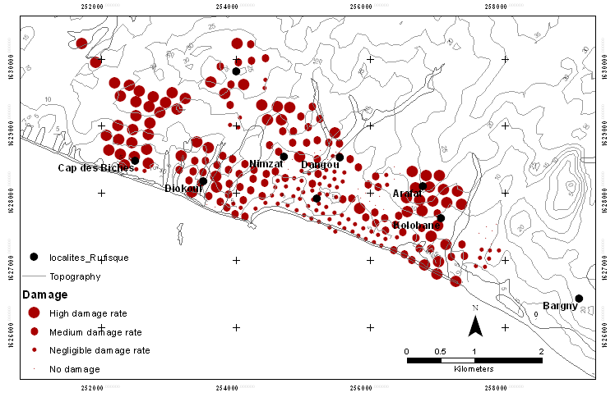
Figure 2. Building damages map of Rufisque.

The building damages are more important in the North-West of Rufisque from Diokoul to Cap des Biches. Additionnaly to the building, roads to Sicap, HLM Ndefane and Cite Asecna are affected. We noticed also a high destruction rate in the Eastern side of Rufisque from Arafat to Colobane Kao. The Center of Rufisque including the localities of Diokoul, Santiaba, Keury Kao, Keury Souf, Thiawlene, Thiawlene Boutou are weakly or not affected by damages. In the locality of HLM Ndéfane, we can distinguish that the high destruction rates are in the Western part compared to East. We also noticed that a frontier between damaged and stable area exists between Western and Eastern parts of Kolobane (figure 2).
The building damage seems to be linked to the topography. In fact, the morphology of Rufisque shows high topographic levels forming two plateaus in the North-West (Cap des Biches) and the South-East (Kolobane, Arafat) separated by a depression in the centre (Keury Souf). The building damages are also important in the Northern part of this central depression occupied by elevated zones (Nimzat, HLM Ndéfane).

4. Soils investigation
4.1 Drilling
Drilling from the North to the South of Rufisque allowed identifying the existing soils (tables 2 and 3). Three main soil horizons are to be considered: superficial clayey-sandy horizon, clayey horizon and the marly to marly-limestone source rock.
- The superficial clayey-sandy horizon is mainly composed of clays or sandy clays with low sand content. The sandy clays contains lateritic, calcareous or flint nodules. The organic matter content of this horizon is important and the colors vary from dark to light gray, dark brown to black, yellow ochre to gray ochre, beige to yellow ochre. The thickness does not generally exceed 2 meters excepted in the North of Rufisque where it can reach 4 meters. This horizon shows very pronounced mudcracks with cracks of 1 to 2 centimeters wide during the dry season. This horizon is locally named “poto-poto” due to its muddy aspect during the rainy season.
- The clayey horizon have a thickness varying from 2 to 4 meters and is composed of high plasticity clays with very low sand content. The colors are mainly yellowish to grey, grey greenish to green, reddish or multicolored with almost always calcareous inclusions. These soils are the product of the weathering of calcareous or marly source rocks. The surfaces of these clays are shiny and present many mudcracks or microcracks in a gilgai microrelief. Inside this horizon, we can have lateritic gravel layers in varying facies : a hard ferruginous concretions facies with a rusty to ochre color, a reddish lateritic gravel facies, a crumbly multicolored facies with a wide range of densities.
- The calcareous or marly source rock presents nodular and marly-limestone beds. Marls are met at varying depth.

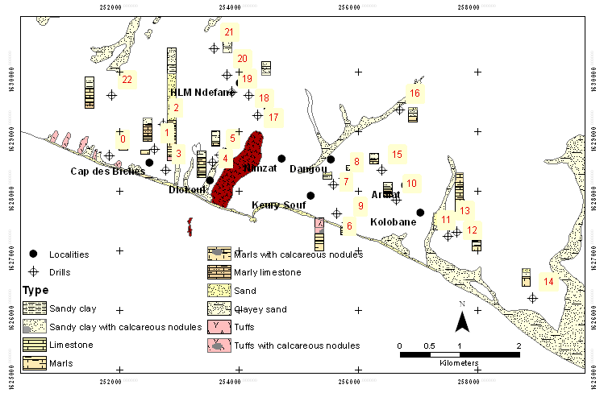
Figure 3: Rufisque Soils profile obtained from drills (labeled 0 to 22)
Table 2: Soil characteristics in the whole region of Rufisque

Drill | Thickness (m) | Soil type | Soil characteristics
 |  |  |  (kg/m³) | _{d} (kg/m³) | Wl (%) | Ip (%) | '_{C} (bars) | Cc | '_{g} (bars)
1 | 1 | Marl |  | 1.8 |  |  | 3 | 0.025 | 2.5
2 | 0.7 | Marl |  |  |  |  |  |  | 1.3
3 | 1.2 | Clays with calcareous nodules |  | 1.81/1.79/1.91 | 31/31.5/34 | 20/17/21 | 1.85/0.9/1.3 | 0.15/0.2/0.114 | 0.4/0.6/0.2
 | 2.2 | Limestone |  | 1.82 | 44.5 | 17
 | 0.6 | Marl |  | 1.33/1.59 | 100/115.5 | 63/68 | 1.7/5.2 | 0.142/0.09 | 1/4
 | 0.5 | Marl |  | 1.59 | 64 | 37
4 | 1.2 | Clay |  | 1.77/1.68 | 38.3/34/44.7
 | 1.3 | Marl |  |  |  |  | 2 |  | 0.8
 | 2.5 | Marly limestone |  |  |  |  | 1.2/1.9 |  | 0.3/1.5
5 | 2 | Clay
 | 0.9 | Marly limestone | 1.97 | 1.72 | 33.5 | 20.8 | 0.9
6 | 2 | Sand and tuff | 2.05/2 | 1.83/1.77 | 42.6/46.4 | 25.5/29.4
 | 1.1 | Tuff with calcareous nodules | 2.09/2.03 | 1.81/1.76 | 51.3/64 | 33.8/43.4
 | 1.5 | Marl | 1.71/1.69 | 1.23/1.18 | 118.5/119 | 47.5/53
 | 0.5 | Limestone | 1.65 | 1.1 | 119.7/112.6 |  |  |  | 4.5
 | 1.4 | Marl | 1.69/2.83/1.78/1.75 | 1.19/1.36/1.34/1.24 | 145.5/125/128.5 | 91.5/76.2/70.9
7 | 0.35 | Sand |  | 4.95 | 33
 | 0.85 | Clay | 1.66/1.84 | 1.34/1.64/1.47 | 14.5/44/31.5
 | 0.3 | Marl with calcareous nodules |  | 1.53 | 33
8 | 1.1 | Clay | 1.69 | 1.12 |  |  | 1.5 | 0.18 | 1
9 | 0.9 | Limestone | 1.88 | 1.66 |  |  | 1.1 | 0.7
 | 0.6 | Clay | 1.72 | 1.245 | 43.5 | 24.5 | 0.021 | 0.3
10 | 1.25 | Clay | 1.85/1.73 |  | 73/58/83/36 | 43/36/38/92 | 2.8/5.3 | 0.113/0.097 | 2/4.3
 | 0.95 | Marly limestone | 1.78/1.9/1.825 |  | 126/196/55 | 66/112/32 | 2.5/5/5.6 | 0.114/0.05/0.135 | 1.8/5/3.9
 | 0.6 | Marl | 1.793/2.02 |  |  |  | 2.6/2.7 | 0.148/0.19 | 2.5

Table 3: Soil characteristics in the whole region of Rufisque

Drill | Thickness (m) | Soil type | Soil characteristics
 |  |  |  (kg/m³) | _{d} (kg/m³) | Wl (%) | Ip (%) | '_{C} (bars) | Cc | '_{g} (bars)
11 | 2.5 | Sand | 1.84/1.95/2.01/2.04 |  | 54.4/46.4 | 31.9/28.4 |  |  | 0
 | 0.5 | Marl |  |  |  |  |  |  | 0.6/2.04
12 | 0.9 | Sandy limestone | 1.74 | 1.43 | 78 | 75.5 | 1.6 | 0.12 | 0.8
 | 1.6 | Marl | 1.9 | 1.535 | 48.5 | 29.5 | 1.4 | 0.18 | 0.25
 | 0.8 | Clay | 1.98 | 1.595 | 59.5 | 41.5 | 1.1 | 0.13 | 0.3
 | 0.9 | Marl | 1.94 | 1.555 | 60 | 41.5 | 1.3 | 0.14 | 0.3
13 | 2 | Marl with calcareous nodules | 2.03 | 1.695 | 58 | 32.5 | 1.2 | 0.1 | 0.25
 | 0.8 | Marl | 1.965/1.94/1.955/1.985 | 1.59/1.545/1.635/1.64
 | 3.4 | Marl |  |  |  |  | 5.6 | 0.122 | 4
 | 1.9 | Marl | 1.965/1.96 | 1.67/1.63 |  |  | 5.8/3.8 | 0.063/0.083 | 3.5/2.5
14 | 0.6 | Sand | 1.79 | 1.565 | 50.5 | 29.5 | 1.9 | 0.252
 | 0.8 | Clay with calcareous nodules | 1.84 | 1.34 | 65/122/195 | 39.5/79/103 | 6 | 0.154 | 4.8
 | 1.8 | Marl | 1.87 | 1.47 | 133.5/200 | 73/105 | 4.8 | 0.13 | 3.1
15 | 1 | Clay | 1.78 | 1.345 | 1.075 | 39.5 | 1.3 | 0.12 | 1
 | 1 | Marl | 1.62 | 1.075 | 1.51 | 57 | 0.9 | 0.2 | 0.5
16 | 0.4 | Sand | 2.15 | 1.19
 | 1.4 | - | 2.205/2.135/2.135 | 1.19 | 35 | 20 | 2.4 | 0.217
 | 1 | Marl |  | 1.7/2 | 34/37 | 21.22 | 2.4 | 0.087
17 | 1.4 | Clayey sand | 1.98/1.93 | 1.7/1.9 | 42/39 | 26/28.5 | 43 | 0.115 | 3.6
 | 0.4 | Clay | 1.93 | 1.7 | 39 | 26 | 15 | 0.18 | 0.7
 | 0.7 | Marl | 1.73 | 1.5 | 62 | 40
 | 0.4 | Marly limestone | 1.9 | 2.03 | 62 | 36
 | 2.1 | Marl with calcareous nodules | 2.41/2.8/1.54 | 1.3/1.5 | 75 | 42 | 13.2/12 | 0.1/0.13 | 0.6/0.8/1.2
18 | 0.8 | Sandy clay | 1.64 | 1.7 | 40.8 | 25.3
 | 0.5 | Clayey sand | 2.6/2.03 | 1.74/1.74 | 41.8/41.8 | 28.2/28.2
 | 0.7 | Clay with calcareous nodules | 2.04 | 1.705 | 54.2 | 40
 | 0.6 | Sandy clay with calcareous nodules | 2.02 | 1.64 | 63.2 | 48.1
19 | 0.5 | Clayey sand | 1.67 | 1.57 | 25 | 1.15
 | 0.8 | Sandy clay | 1.855 | 1.68 | 32 | 1.9 | 1.2 | 0.115
 | 1.3 | Clayey sand | 2.06 | 1.87 | 33 | 2.15 | 1.1 | 0.075
 | 1.5 | Sandy clay with calcareous limestone | 2.23/2.09 | 2.01/1.77 | 39/48 | 2.7/3.55 | 2.1 | 0.065
20 | 2.1 | Clay
 | 1.9 | Marl | 1.92 | 1.68 | 79 | 53 | 4.7 | 0.15 | 3.5
 | 1 | Marl | 1.86 | 1.42 | 109 | 70 | 5.39 | 0.168 | 4.6
 | 1 | Marly limestone | 2.4 | 2.2

4.2. Grain size distribution
Grain size distributions were determined on soil samples at 0.3 to 1.2 meters, 1.2 to 2.20 meters and 2.20 to deeper. The obtained curves are shown respectively on figures 4, 5 and 6.

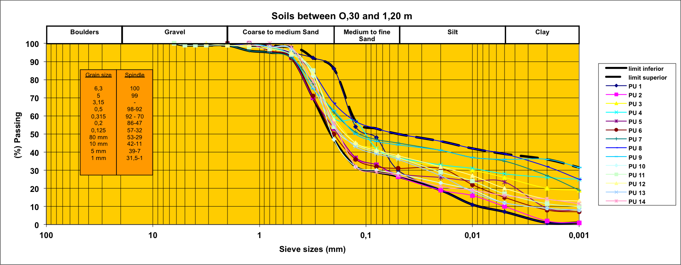

Figure 4. Particle size distribution of soil samples from 0.30 to 1.20 meters for the whole city of Rufisque.

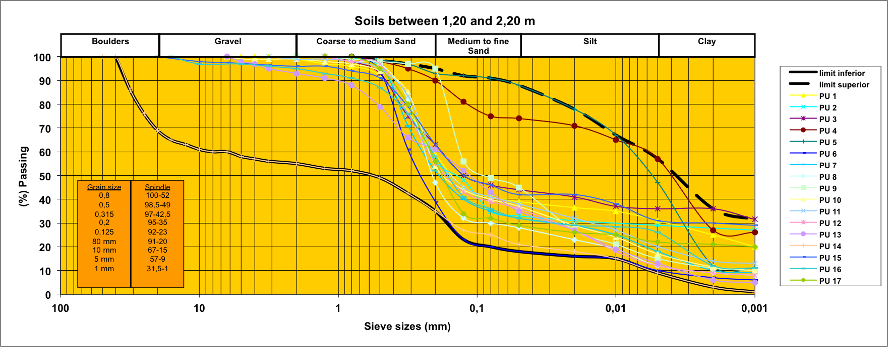

Figure 5. Particle size distribution of soil samples from 1.2 to 2.20 m for the whole city of Rufisque.

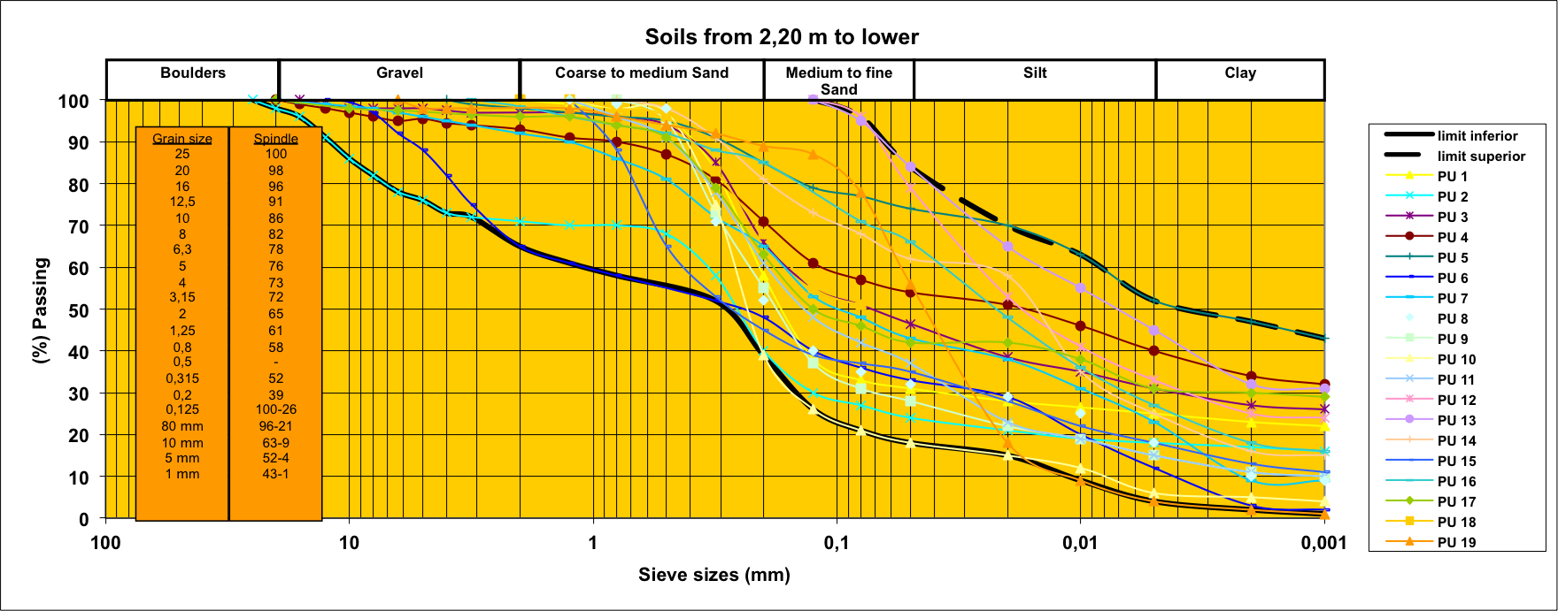
Figure 6. Particle size distribution of soil samples from 2.2 and deeper for the whole city of Rufisque.

Grain size distribution curves show that Rufisque soils are mainly formed by more than 50% of fine particles ranging from medium or fine sands to clays. The distribution is uniform for gravels and sandy type of soils and wider for fine sands, silts and clays. Fine particles are mainly clays and can exceed 35%.
Moreover, the particle size distribution is continuous and wider for soils at 0.3 to 1.2 meters depth. This is not the case for 1.2 to 2.2 meters and 2.2 to deeper curves that are discontinuous for some soils samples. The Grain size distribution curves show also that the proportion of gravels and boulders increases with depth. This situation may allow to the Rufisque substratrum to be a good supporting soil.

4.3. Soils classification
The Rufisque soils have been classified using Casagrande diagram. The results are shown on figures 7 and 8 respectively for clays-silts-sands and marls-marly limestone-volcanic ashes.

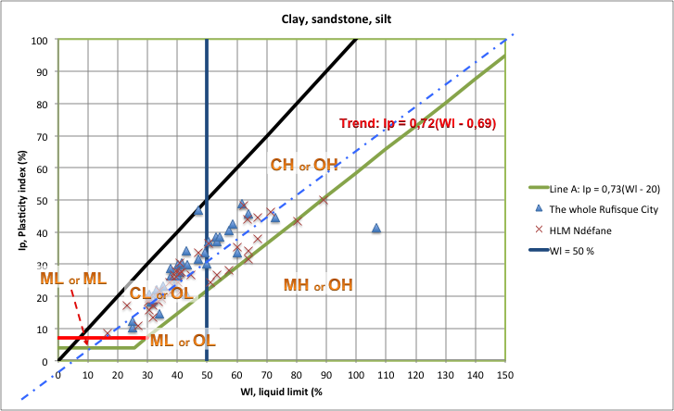
Figure 7. Classification of clays, sandstones and silts of Rufisque

A classification of Rufisque clays, silts and sands using Casagrande diagram shows that they are formed of more than 50% of low plasticity and less than 45% of high plasticity clays. These soils, located over the line A in the Casagrande diagram, are high plasticity and swelling soils.

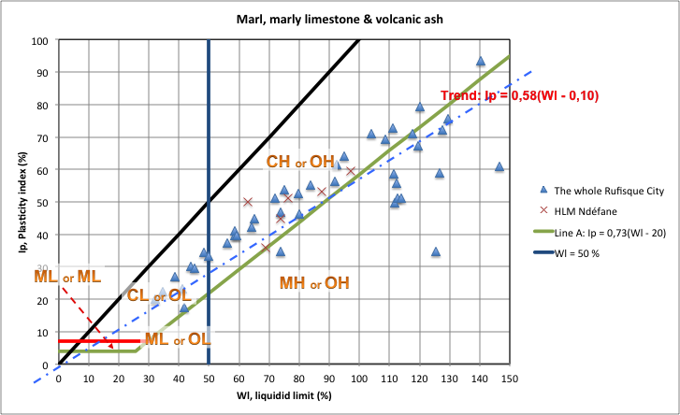
Figure 8. Classification of marls, marly limestones and volcanic ashes of Rufisque

The Casagrande classification applied to marls, marly limestone and tufs shows that they are formed of 20% of low plasticity and low swelling clays and 80% of high plasticity clays. The high plasticity clays are formed with 30% of non swelling silts and 50% of swelling clays.
The plasticity of Rufisque soils lead them to be sensitive to swelling particularly during the rainy season and shrinkage in the dry season.

4.4. Compressibility
The expansive capacity of Rufisque soils has been investigated using oedometer test. The tested samples are collected from various depths at HLM Ndéfane. The results are shown below (figure 9).

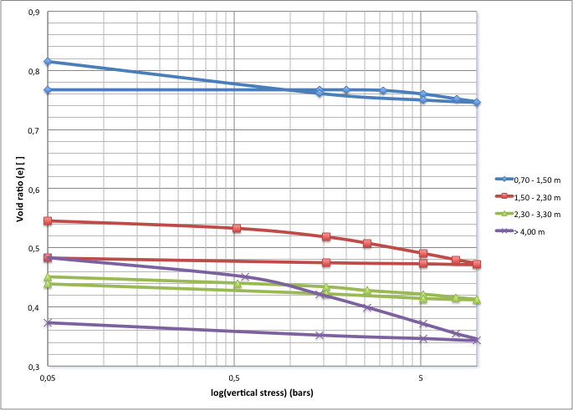

Figure 9. An example of compressibily in a soil profile in HLM Ndéfane

Compressibility curves show that the expansive pressure decreases with depth. Moreover, only superficial samples (0.7-1.5 m) present primary and secondary expansion pressure shown by the intersection of loading and unloading paths. This confirms that the superficial horizon of HLM Ndéfane is a swelling soil. This should be the case for the other parts in Rufisque.

4.5. Clay mineral identification using X ray diffraction
Due to their microcrystalline structure, the identification of clay materials is tough. Structural analysis shows that their chemical composition is complex and may vary, even at the scale of the mineral primitive cell. The crystalline structure is not perfect, and may contain faults. This situation leads to a high variety of chemical bonds and mineral types (Grim, 1962).
To avoid clay sheet rearrangement, we used freeze-drying techniques. Nevertheless, to avoid identification errors due to swelling, it was necessary to treat the samples with glycerol, ethylene glycol and potassium chloride. Samples are analyzed using X ray diffraction. The analysis was performed on the clayey decarbonated part spred on a glass slide. The purpose of the determination of the mineral composition is to be compared to the obtained mechanical properties. The analysis of the X ray spectrum allows identifying the clay type and brings a discussion on its swelling capacity. We expect that Rufisque soils have swelling capacity as shown in Casagrande classification (figure 7 and 8). In fact, plotted swelling soils are located in the domain of high plasticity corresponding to swelling minerals.

Figure 10. Mineral Composition of the clay fraction from the drill # 1 in Kolobane-Kao.

Figure 11. Mineral Composition of the clay fraction from the drill # 2 in Kolobane-Kao.

Figure 12. Mineral Composition of the clay fraction from the drill # 3 in Kolobane-Kao.

Figure 13. Mineral Composition of the clay fraction from the drill # 4 in Kolobane-Kao.

These results show that the clayey fraction of the source rock is exclusively constituted of attapulgite. In the weathered rock, the clayey fraction is partly formed of montmorillonite with Kaolinite traces. In the intermediate horizon, the montmorillonite content increases considerably with a maximum attapulgite content of 10%. In the superficial layer, the attapulgite disappears and the montmorillonite becomes abundant.

5. Discussion
The Geology of Rufisque shows a succession of limestone marls and attapulgites. Clasts from these petrographic facies are found in the soils. But the high proportion of clays formed from attapulgites source rocks has to be noticed.
The Grain size distribution in Rufisque soils shows a high proportion of fine clayey particles mainly in the top horizons.
Classifying Rufisque soils using Casagrande diagram shows that they contain high plasticity clays, with swelling capactiy. Oedometer test confirms the existence of high expansive pressure clays, particularly in the superficial horizons. The observed clay identified using Xray diffractometry show the possible neogenesis of montmorillonite with swelling capacity from attapulgite containing soils.
The degree of damage is varying and is linked to soil lithology, hydrogeological context and topography. The pronounced damages in Rufisque extremities, occupied by two plateaus, are due not only to the presence of high plasticity and high expansive pressure clays (figures 7 and 8), but also to the hydrological and topographical context. Disaggregated and weathered marls to marly-limestone occupy the surface of these plateaus. The measured expansive pressures are the highest in the investigation area and range from 4 bars around the Cap des Biches to 13 bars at Kolobane. The groundwater table is low to inexistent except in the talwegs. This situation leads to high fluctuation of soil saturation implying permanent wet-dry cycles in the soils. The versatility of the presence of water table or the desiccation observed during the dry season emphasizes clay formations withdrawal and implies important volume variations that causes differential settling and cracks in the structures.
Towards the center of Rufisque, the low topography in the vicinity of the ocean, make permanent the water table. Soils are always saturated and expansive pressures are null. It results into low expansive pressure and therefore low volume variation and differential settling. This is the case for the localities of Takhi Kao, Guindel, Keury Souf, Diokoul, Thiawlène and Thiawlène boutou where the structures are preserved with a damage rate negligible to null.

6. Conclusion
Our investigations allowed a better understanding of swelling phenomenon in Rufisque soils that is linked to the combination of several physical factors. We noticed misleadingly that the presence of swelling clays, mainly montmorillonite is not always correlated with existence of building damage due to swelling. Other in situ factors as geomorphology, hydrology and even seasonality play an important role. To understand the phenomenon a combination of several investigation approaches was necessary.

Acknowledgements
Special thanks to SN HLM and CEREEQ SA who funded this research and to Michel Maurice who helped us in this interesting research topic.

6. References
Bellion, Y. (1987). Histoire géodynamique post-paléozoique de l'Afrique de l'Ouest d'après l'étude de quelques bassins sédimentaires (Sénégal, Taoudenni, Iullemmeden, Tchad). Thesis, Université d’Avignon, France, 302 p.

CISSE, M. FALL, A. RAHAL (1999) – Un cas d’instabilité de sol de fondation : Exemple des marnes gonflantes de Rufisque, Sénégal. Geotechnics for Developping Africa, Wardle, Blight & Fourie (eds), Balkema (1999), Rotterdam.

Diop, A., 1982. Contribution à l’étude de la plateforme carbonatée paléocène de la région de Diass, Sénégal occidental. Thèse de 3è cycle, Université Paris-Sud, Orsay.

Cantagrel, J.-M., (1976). Nouvelles données géochronologiques sur le volcanisme ouest-africain.- 4e Réun. Ann. Sci. Terre, Paris, p. 93.

Chamard P. et Morin S. (1973) - Les grès calcaires et les grès ferrugineux de la tête de la presqu'île du Cap- Vert (République du Sénégal) Travaux et documents de Géographie tropicale, Centre d'Etudes de Géographie Tropicale (CEGET), n°8, 1-27, 1 pl. annexe

Crevola, G., (1978). Sills, dykes et pipes de tufs volcaniques bréchiques fluidifiés dans la presqu'île du Cap-Vert (Senegal). C.R. Somm. Soc. Géol. Fr., 3, p 135-139.

CREVOLA G., CANTAGREL J. & MOREAU C. (1994).- Le volcanisme cénozoïque de la presqu'île du Cap-Vert (Sénégal) : cadre chronologique et géodynamique.- Bulletin de la Société géologrique Française , 165, 5, p. 437-446.

ELOUARD P., BRANCART R. & HEBRARD L. (1976) – Cartes géologiques à 1/20 000 et Notices explicatives des cartes de Bargny et Rufisque (Presqu’île du Cap-Vert). Ministère du développement industriel et de l’environnement, Direction des Mines et de la Géologie, République du Sénégal, 43 et 35 pages.

Grim, R. E., (1962). Applied clay mineralogy, New York: McGraw-Hill. 321 p.

Guillou, H., (2008) Datation par la méthode potassium-argon sans traceur de roches volcaniques du Sénégal, rapport Volcanisme LSCE 10_08, 15p.

Lompo, M (1987). – Méthodes et étude de la fracturation et des filons : Exemple de la région du Cap-Vert (Sénégal). Mém. DEA, Dakar, 59 p.

Nguer, M., et Rognon, P. (1989). Homogénéité des caractères sédimentologiques des sables ogoliens entre Nouakchott (Mauritanie) et Mbour (Sénégal). Géodynamique, 4, 2, 119-133.

NIANG-DIOP, I. (1995). Erosion côtière sur la petite côte du Sénégal à partir de l’exemple de Rufisque. Passé. Présent. Futur. Thesis, Université d’Angers, 475 p.

Pasmi, (2009), Carte géologique de la zone d’activité du Cap-Vert à 1/50 000, FORMATIONS SUPERFICIELLES, représentation de la feuille de Rufisque. Rapport GTR/PASMI/0309-374.

Ritz, M., Bellion, Y., and Flicoteaux, R. (1987). Magnetotelluric soundings and the geological structure and tectonics of the Senegalo-Mauritanian basin in the northern Senegal. - West Africa Tectonics, 6, p 395-409.

Roger J., Banton O., Barusseau J.P., Castaigne P., Comte J-C., Duvail C., Nehlig P., Noël B.J., Serrano O., Travi Y. (2009d). Notice explicative de la cartographie multi-couches à 1/50 000 et 1/20 000 de la zone d’activité du Cap-Vert. Ministère des Mines, de l’Industrie et des PME, Direction des Mines et de la Géologie, Dakar, 245 p.

